Influence of Nutrient Solution Concentration and Substrates on Basil Production in Hydroponics

Abstract
Hydroponic cultivation is gaining importance as a sustainable and efficient method for crop production under controlled environmental conditions. The present study was conducted to standardize nutrient solution concentration for different growing substrates in hydroponic basil cultivation under a naturally ventilated polyhouse at Dr. NTR College of Agricultural Engineering, Bapatla, Andhra Pradesh. The experiment consisted of four nutrient concentrations viz., 900 ppm, 1000 ppm, 1100 ppm and 1200 ppm, and four growing media namely rockwool, clay balls, perlite and vermiculite. The experiment was carried out during four different seasons to evaluate the interaction effect of nutrient concentration and growing media on sweet basil (Ocimum basilicum) yield. Statistical optimization and analysis were performed using Design-Expert employing a split plot-multilevel categoric factor design. Analysis of variance (ANOVA) indicated that nutrient concentration, growing media and their interaction significantly influenced basil yield (p<0.05). The developed regression models showed high coefficients of determination (R² > 0.87), indicating good model adequacy and prediction accuracy. The results revealed that 1100 ppm nutrient concentration produced superior yield compared to other concentrations across seasons. Vermiculite performed better during summer conditions, whereas rockwool and clay balls showed improved performance during cooler seasons due to better aeration and moisture balance. The optimization study demonstrated that suitable nutrient concentration combined with appropriate growing media significantly enhanced sweet basil productivity in hydroponic systems. The study concluded that 1100 ppm nutrient concentration with suitable substrate selection can be recommended for maximizing basil yield under protected hydroponic cultivation.
Key words: Hydroponics, Nutrient Concentration, pH, Electrical Conductivity (EC), Design Expert-13, Growing Media

Introduction
Hydroponics is a method of growing plants without soil, using mineral nutrient solutions in an aqueous solvent. With the increasing demand for sustainable and space-efficient farming techniques, hydroponic systems have gained prominence due to their potential to optimize resource use and enhance crop productivity. In addition to using water efficiently and avoiding the need for pesticides, hydroponic culture eliminates soil-borne diseases (Ragaveena et al., 2021). The objective of maximizing food production per unit area through smart agricultural technologies is therefore receiving increasing attention (Ragaveena et al., 2021). The type and concentration of nutrient solution and the type of growing media, along with light and temperature, are the primary factors determining plant growth in hydroponics. Different substrates such as rockwool, clay balls, perlite, and vermiculite possess unique physical characteristics that influence water retention, aeration, and nutrient availability to plant roots.
Hydroponic cultivation, which typically is a recirculating system, is water efficient and the nutrient solution can be formulated to meet the target crop’s needs. Typically, the healthy plants resist disease and insect damage, so use of pesticides is eliminated or minimized and herbicides are not needed since there is little week growth (Pala et al., 2014; Lakhiar et al., 2018; Lakhiar et al., 2020). Water chemistry measures needed to maintain desired conditions include pH which influences nutrient uptake, and electrical conductivity (EC) an index to nutrient density Variations in nutrient concentration or unsuitable substrate properties may adversely affect nutrient uptake, resulting in poor growth and reduced yield. Therefore, the selection of suitable growing media along with proper nutrient concentration becomes essential for successful hydroponic cultivation under controlled environments.
The aim of this study was to test different concentrations of standard nutrient solution with different substrates in order to identify the optimum combination for sweet basil growth in different seasons. The study also aimed to evaluate the interactive effects of nutrient concentrations and growing media.
Materials and Methods
The study was conducted during the year 2021 under in a naturally ventilated 20 m × 12 m polyhouse at Dr. NTR College of Agricultural Engineering. The structure was designed with side openings that can be adjusted to facilitate the entry of cool air and the removal of warm air, thereby maintaining a favorable growing environment. The study was carried out in four seasons, namely Season 1 (April-May), Season 2 (August-September), Season 3 (October-November), and Season 4 (January-February).
The experimental design followed a split-plot arrangement analyzed using Design-Expert 13 software. In the experimental layout, the nutrient solution concentration served as the whole-plot factor, while the growing media served as the subplot factor and each treatment replicated three times. Four nutrient concentrations were tested: 900 ppm, 1000 ppm, 1100 ppm, and 1200 ppm. Separate reservoirs were maintained for each nutrient concentration treatment to avoid mixing of nutrient solutions. Each reservoir supplied nutrient solution continuously to a designated set of NFT channels; therefore, each nutrient concentration treatment represented one whole plot.
Within each nutrient concentration treatment, four growing media treatments namely rockwool, clay balls (Hydroton), vermiculite, and perlite were assigned to smaller experimental units (subplots). The actual subplot experimental unit consisted of an individual planting hole/net pot position within the NFT channel. Each planting hole contained one basil plant grown in a specific medium. Thus, the growing media treatments were randomized within the NFT channels receiving the same nutrient concentration. Sweet basil (Ocimum basilicum) seedlings were first raised in nursery trays under controlled conditions using a common starter nutrient solution. The seedlings were ready for transplanting 15 days after sowing into the hydroponic NFT system.
Nutrient Film Technique (NFT)
The hydroponic NFT system consisted of a nutrient reservoir placed at the bottom of the A-frame structure. The reservoir was connected to the top of the rectangular growing channels using a 0.1 hp electric pump. The nutrient solution was pumped from the tank to the top channel and allowed to flow through the channels arranged in a slight zig-zag slope. All channels were interconnected at the ends, enabling the nutrient solution to flow continuously from the top channel to the bottom channel and finally return to the reservoir for recirculation.
Sweet Basil seedlings were transplanted into net cups filled with growing media and placed in holes provided on the top of the channels. The plant roots remained suspended inside the channels where they came in contact with a shallow film of nutrient solution. This thin layer of nutrient solution supplied essential nutrients while also allowing adequate oxygen availability to the roots, thereby preventing waterlogging and promoting healthy plant growth. After transplanting, the seedlings were introduced into the experimental units containing different nutrient solution concentrations and growing media combinations. The nutrient solutions corresponding to each treatment were prepared separately and maintained throughout the crop growth period. The plants were grown under continuous recirculating hydroponic conditions with regular monitoring of pH and electrical conductivity (EC).
Growing Mediums in hydroponics
In most hydroponic systems, various growing media are used to provide root support and to maintain an optimum balance between water availability and oxygen supply to the roots.
Rock wool
Hydroponics Rockwool is one of the most commonly used growing media in hydroponic systems. It is manufactured by melting basaltic rock and spinning it into fine fibres. Due to its biologically and chemically inert nature, it is free from pests, diseases, and weed seeds (Putra and Yuliando, 2015). It serves as an inert substrate suitable for both free-drainage and recirculating hydroponic systems. Rockwool is produced through the aerosolization of molten mineral materials, forming a fibrous structure that promotes capillary action and resists microbial decomposition. The medium possesses high water-holding capacity while maintaining adequate aeration. Its ability to retain large amounts of water provides an added advantage during power interruptions or equipment failures, as illustrated in Fig. 1.

Clay balls (Hydroton)
Hydroton, also known as lightweight expanded clay aggregate (LECA), is a suitable growing medium for hydroponic systems where nutrients are supplied through a controlled water solution. It is produced by heating clay pellets at high temperatures (around 1200 °C) in rotary kilns, causing them to expand and develop a porous structure, as shown in Fig. 2. These clay pellets are inert, pH neutral, and contain no nutritional value. The major advantage of Hydroton is its lightweight nature and resistance to compaction over time. It is also considered an environmentally friendly and reusable medium because it can be cleaned and sterilized using white vinegar, chlorine bleach, or hydrogen peroxide solutions followed by thorough rinsing. However, some researchers suggest avoiding reuse of clay pebbles due to root penetration and accumulation within the medium even after cleaning.
Perlite
Perlite is a lightweight material derived from a siliceous volcanic mineral (Hussain et al., 2014). It retains less water while providing greater aeration. Perlite is formed from volcanic materials such as granite, obsidian, pumice, and basalt (George and George, 2016). Perlite is a porous growing medium that provides excellent water retention and drainage properties, which are highly beneficial in hydroponic systems, as shown in Fig. 3. It is an inert and sterile medium, making it safe for use without the risk of introducing pests, unlike soil-based media. Perlite is produced by superheating volcanic rock, causing it to expand into lightweight glass-like particles. It can be used either loosely or in plastic sleeves immersed in water. Perlite is also commonly incorporated into potting soil mixtures to reduce soil compaction and improve drainage. However, when used in flood-and-drain systems without proper containment, it may float. This volcanic material undergoes natural high-temperature fusion, a process known as “Fusionic Metamorphosis.”
Vermiculite
Like perlite, vermiculite is a mineral that is heated at high temperatures to expand into lightweight particles. Vermiculite retains more water than perlite and possesses a natural wicking property, which helps in the movement of water and nutrients in passive hydroponic systems, as shown in Fig. 4. However, excessive water retention with limited air around the roots may affect plant growth; therefore, the water-holding capacity of the medium can be gradually reduced by mixing higher proportions of perlite. Vermiculite also enhances the availability and absorption of essential nutrients such as magnesium, calcium, and potassium by plants. In addition, it can be mixed with other soilless materials like perlite and pumice to prepare customized hydroponic growing media. The physical properties like bulk density and porosity of bedding materials used are presented in Table.1.
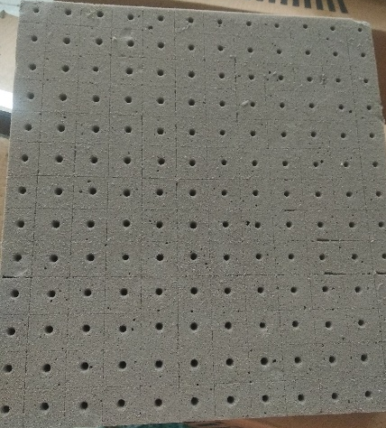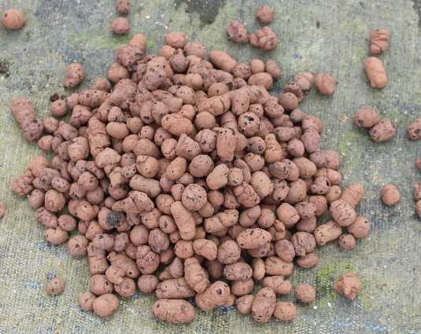
Fig.1 Rock wool Fig.2 Clay balls (Hydrotons)
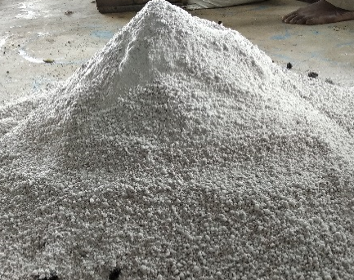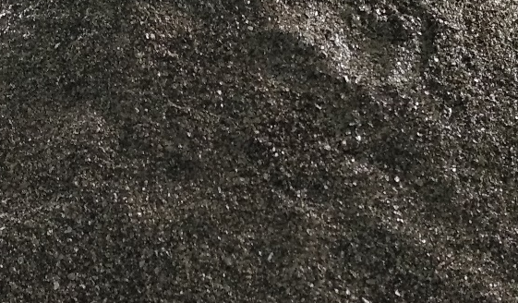
Fig.3 Perlite Fig.4 Vermiculite
Table.1 Bulk density and porosity of growing media
Substrates | Bulk density (kg/m³) | Total porosity(%v/v)
Vermiculite | 90-150 | 90-95
Perlite | 80-120 | 85-90
Rockwool | 80-90 | 94-97
Expanded clay | 600-900 | 85-90
Source: Pardossi et al. (2011)
Hydroponic Nutrient Solution
In the present study, four nutrient solution concentrations were prepared and maintained throughout the crop growth period. For each treatment, 150 L of water was filled into the nutrient reservoir. To obtain 900 ppm concentration, 1.7 L each of nutrient solution A and B were added. Similarly, 2.6 L, 3.25 L, and 4.4 L of nutrient solutions A and B were added to prepare 1000 ppm, 1100 ppm, and 1200 ppm concentrations, respectively. The nutrient solution concentrations were monitored regularly using a TDS/EC meter and adjusted whenever necessary to maintain the desired treatment levels.
pH Meter
The pH of the nutrient solution was monitored regularly using a digital pH meter as shown in Fig. 5 throughout the experimental period. During basil cultivation, the pH of the nutrient solution was maintained within the optimum range of 5.8-6.5 to ensure proper nutrient availability and uptake by plants. Whenever the pH exceeded the desired range, phosphoric acid solution was added dropwise to reduce the pH. Similarly, potassium hydroxide solution was added whenever the pH decreased below the optimum level. The pH was checked daily before nutrient circulation in the hydroponic system to maintain uniform growing conditions across all treatments. The suitable pH range may vary depending on the crop species (Hussain et al., 2014).
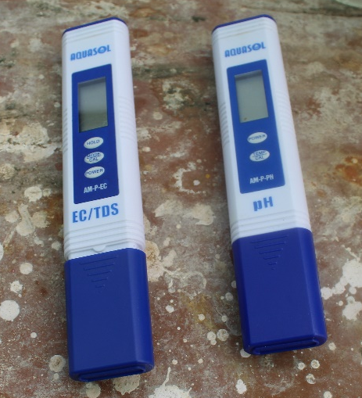
Fig.5 Electrical conductivity meter/TDS and pH Meter
Electrical Conductivity
Electrical conductivity (EC) of the nutrient solution was measured regularly using an Aquasol EC/TDS meter as shown in Fig. 5 during the experiment. The EC levels were maintained according to the treatment concentrations of 900 ppm, 1000 ppm, 1100 ppm, and 1200 ppm. Fresh water was added whenever EC increased beyond the required level due to evaporation and nutrient accumulation, while additional nutrient solution was supplied whenever EC dropped below the desired concentration. Continuous monitoring of EC helped maintain uniform nutrient availability for basil plants under hydroponic conditions.
Polyhouse Environmental Control
During the experimental period, environmental parameters inside the naturally ventilated polyhouse were continuously monitored to maintain favorable growing conditions for basil cultivation. Temperature, relative humidity and carbondioxide were recorded using a Rotronic CP11 data logger at one-hour intervals. To reduce excessive temperature and increase humidity during summer conditions, four-way foggers were operated inside the polyhouse. A dehumidifier was also used during winter and high humidity periods to remove excess moisture and maintain suitable environmental conditions. The temperature inside the polyhouse was maintained approximately between 25-30°C and relative humidity between 65-70% for better plant growth and nutrient uptake.
Design Expert-13 Software
The experimental data were statistically analyzed using Design-Expert 13 software. Analysis of variance (ANOVA) was performed, and the critical difference (CD) at the 5% level of significance was calculated to determine the significance of differences among the independent parameters. The online statistical software Design-Expert 13 was utilized for the analysis and interpretation of the experimental data.
Results and discussions
The optimization of nutrient solution concentration and growing media was carried out using Design-Expert version 13 under a split-plot multilevel categorical factor design. The experimental analysis was performed to evaluate the combined effect of nutrient concentration and growing media on basil yield under hydroponic conditions during different seasons. The statistical analysis included analysis of variance (ANOVA), regression equations, and three-dimensional response surface plots to determine the significance of individual and interaction effects of the factors. The experimental results revealed that both nutrient concentration and growing media significantly influenced crop yield. The interaction between the factors also showed variations in yield performance across different seasons.
Season1 (April and May)
During Season1 (April-May), the effect of different nutrient concentrations and growing media combinations on basil yield was studied under a hydroponic system.
Table.2 ANOVA showing the effects of nutrients concentrations and growing media on yield (Season1)
Source | Term df | Error df | F-value | p-value
Whole-plot | 3 | 30.00 | 26.64 | < 0.0001 | Significant
a-concentration | 3 | 30.00 | 26.64 | < 0.0001
Subplot | 12 | 30.00 | 15.76 | < 0.0001 | Significant
B-media | 3 | 30.00 | 54.04 | < 0.0001
aB | 9 | 30.00 | 3.01 | 0.0112
Std. Dev. | 0.0535 |  | R² | 0.8909
Mean | 0.8698 |  | Adjusted R² | 0.8233
C.V (%) | 6.16
Analysis of variance (ANOVA) shows that the model P-values are less than 0.05 (p<0.05) indicating that model terms are significant. In this case a, B, aB are significant model terms. Values greater than 0.1000 indicate the model terms are not significant (Table.2). The coefficient of determination (R²) values of all responses is quite high (>0.89), indicating a high proportion of variability explained by the data and the Multilevel categoric factor model was adequate.
The equation describing the effects of nutrients concentration and growing media on yield in terms of coded values of variable is given as:
Yield (kg) =0.869772 + (-0.0207956 * a[1]) + (-0.00714262 * a[2]) + 0.105795 * a[3] +
0.0213761 * B[1] + (-0.0206513 * B[2]) + (-0.132827 * B[3]) + (-0.00790711 *
a[1]B[1]) + 0.0126652*a[2]B[1] + (-0.0105577 * a[3]B[1]) +( -0.0216758 *
a[1]B[2] )+ 0.0114875 * a[2]B[2] +( -0.0096821 * a[3]B[2]) + 0.0582051 *
a[1]B[3] + 0.0273958 * a[2]B[3] + (- 0.0747208 * a[3]B[3]) …(1)
Positive sign in front of the term indicates synergistic effect, whereas negative sign indicates antagonistic effect (Hameed et al., 2008). The linear positive terms eqn. (1) indicated that yield was found more in 1100ppm of rockwool than other concentration and medial also it shows different results in different growing media and inside the structure.
The graphical representation of 3-D dimensional plot is shown as in Fig.6. The 3-D dimensional plot representing the effect concentrated nutrient solution and growing media on the yield. The results showed that 1100ppm concentrated nutrient solution with vermiculite media gave the highest yield. (Karne et al. 2018) reported that effect of growing media and structure on yield of spinach. Green hydroponics structure with the liquid media shows the better result than the open field.
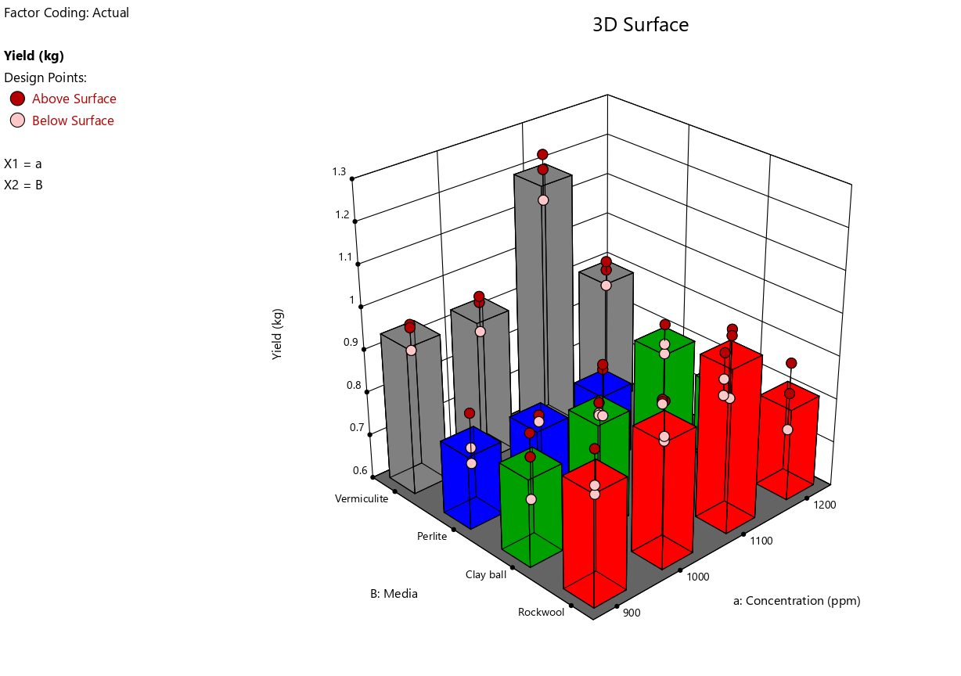
Fig. 6 Effect of nutrient concentration of solution and growing media on yield (Season1)
Season2(August and September)
Analysis of variance (ANOVA) shows that the model P-values less than 0.05 (p<0.05) indicate model terms are significant. In this case a, B, aB are significant model terms. Values greater than 0.1000 indicate the model terms are not significant (Table.3). The coefficient of determination (R²) values of all responses is quite high (>0.87), indicating a high proportion of variability was explained by the data and the Multilevel categoric factor model were adequate.
Table.3 ANOVA showing the effects of nutrients concentrations and growing media on yield (Season2)
Source | Term df | Error df | F-value | p-value
Whole-plot | 3 | 8.00 | 14.60 | 0.0013 | Significant
a-concentration | 3 | 8.00 | 14.60 | 0.0013
Subplot | 12 | 24.00 | 13.32 | < 0.0001 | Significant
B-media | 3 | 24.00 | 48.67 | < 0.0001
aB | 9 | 24.00 | 1.53 | 0.1934
Std. Dev. | 0.0614 |  | R² | 0.8795
Mean | 0.8428 |  | Adjusted R² | 0.8048
C.V (%) | 7.29
The equation describing the effects of nutrients concentration and growing media on yield in terms of coded values of variable is given below.
The equation in terms of coded factors can be used to make predictions about the response for given levels of each factor. By default, the high levels of the factors are coded as +1 and the low levels are coded as -1. The coded equation is useful for identifying the relative impact of the factors by comparing the factor coefficients.
Yield (kg) =0.842831 + 0.0164894 * a[1] + 0.00162919 * a[2] + 0.0993179 * a[3] +
0.121957 * B[1] + 0.0550306 * B[2] + (-0.0658237 * B[3]) + 0.00450248 *
a[1]B[1] + (-0.0285324 * a[2]B[1]) + 0.0205239 * a[3]B[1] + (-0.0196754 *
a[1]B[2]) + (-0.00806327 * a[2]B[2]) + 0.0624066 * a[3]B[2] + 0.000883896 *
a[1]B[3]+0.0335407*a[2]B[3]+(-0.030662* a[3]B[3]) …(2)
Positive sign in front of the term indicates synergistic effect, whereas negative sign indicates antagonistic effect (Hameed et al., 2008). The linear positive terms eqn. (2) indicated that yield was found more in 1100 ppm of rockwool than other concentration and media also it shows different results in different growing media and inside the structure.
The graphical representation of the equation for the optimization of yield is shown as 3-D dimensional plot in Fig. 7. Less yield was found in 1200 ppm concentrated nutrient solution with perlite.
Chhetri et al, 2022 concluded that Cocopeat was found to be the best growing medium in the NFT hydroponic system, producing the highest yield, leaf width, root length, and number of leaves. Sponge medium resulted in the tallest shoot height, while perlite showed the lowest growth and yield performance. Among the crops tested, lettuce performed better than pakchoi under NFT conditions. Although the interaction between crops and growing media was not significant, cocopeat followed by sponge proved most suitable for leafy vegetable cultivation in NFT hydroponics. Mixing perlite with cocopeat may improve media properties and crop growth performance.
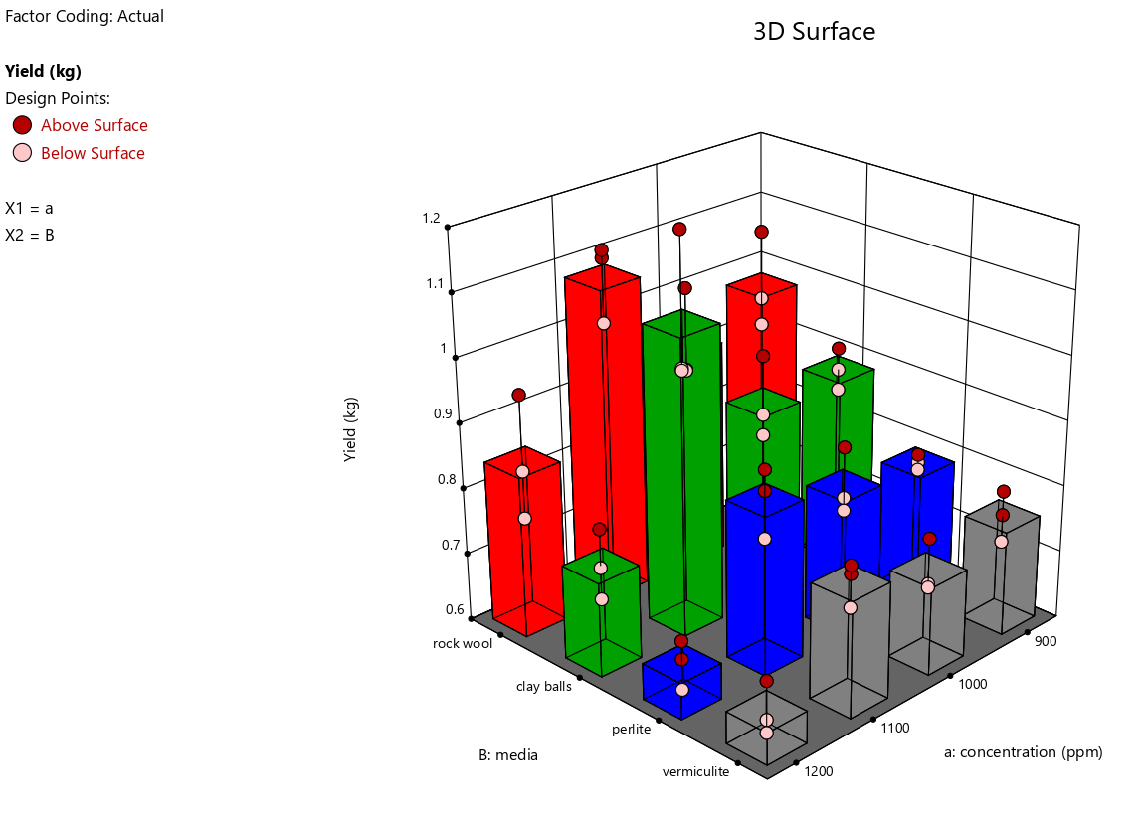
Fig.7 Effect of nutrient concentration of solution and growing media on yield (Season2)
Season3(October and November)
Analysis of variance (ANOVA) shows that the model P-values less than 0.0500 (p<0.05) indicate model terms are significant. In this case a, B, aB are significant model terms. Values greater than 0.1000 indicate the model terms are not significant (Table.4). The coefficient of determination (R²) values of all responses is quite high (>0.89), indicating a high proportion of variability was explained by the data and the Multilevel categoric factor model were adequate.
Table.4 ANOVA showing the effects of nutrients concentrations and growing media on yield (Season3)
Source | Term df | Error df | F-value | p-value
Whole-plot | 3 | 32.00 | 18.33 | < 0.0001 | significant
a-concentration | 3 | 32.00 | 18.33 | < 0.0001
Subplot | 12 | 32.00 | 18.53 | < 0.0001 | significant
B-media | 3 | 32.00 | 69.61 | < 0.0001
aB | 9 | 32.00 | 1.51 | 0.1880
Std. Dev. | 0.0634 |  | R² | 0.8966
Mean | 0.8103 |  | Adjusted R² | 0.8324
C.V (%) | 7.83
The equation describing the effects of nutrients concentration and growing media on yield in terms of coded values of variable is given below.
Yield (kg) =0.810277 + -0.0471721 * a[1] + 0.000664813 * a[2] + 0.110204 * a[3] +
0.11474 * B[1] + 0.133006 * B[2] + (-0.0588581 * B[3]) + 0.0343103 *
a[1]B[1] + (-0.0436213 * a[2]B[1]) + ( -0.0175976 * a[3]B[1]) + (-0.0481098 *
a[1]B[2]) + 0.0693113 * a[2]B[2] + 0.0326264 * a[3]B[2] + (-0.0023139 *
a[1]B[3]) + 0.0148942 * a[2]B[3] + (-0.0139997 * a[3]B[3]) …(3)
The graphical representation of 3-D dimensional plot is shown as in Fig.8. The 3-D dimensional plot representing the effect concentrated nutrient solution and growing media on the yield. The results showed that 1100 ppm concentrated nutrient solution with clay balls media shows the high yield. The less yield was found in vermiculite growing media and 1200 ppm concentration. Because vermiculite has a higher water holding capacity and is cooler in the fall and winter months (October and November), it might impacted the plant roots.
The production during the basil cultivation reduced considerably with the increase in electrical conductivity. (Parida and Das, 2005) result demonstrated that exposure time to saline stress interferes in fundamental plant functions, such as photosynthesis and protein synthesis.
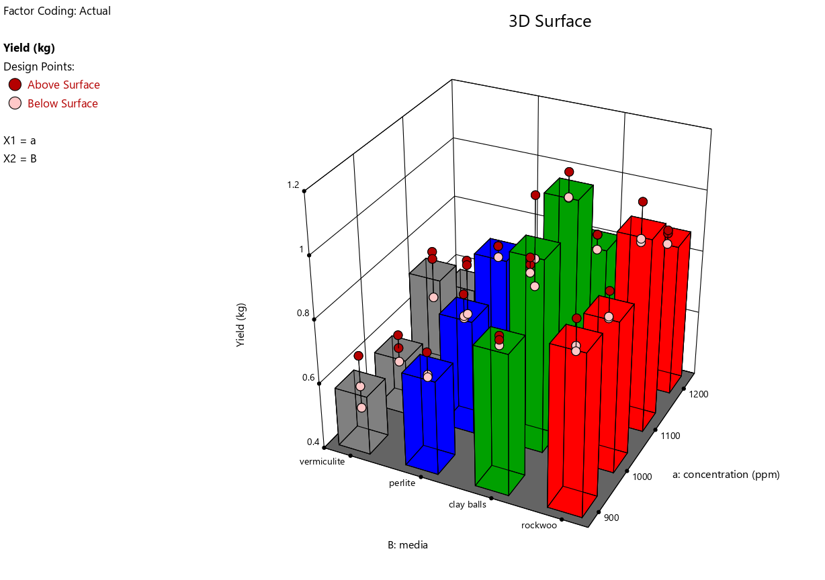
Fig. 8 Effect of nutrient concentration of solution and growing media on yield (Season3)
Season4(January and February)
Analysis of variance (ANOVA) shows that the model P-values less than 0.0500 (p<0.05) indicate model terms are significant. In this case a, B, aB are significant model terms. Values greater than 0.1000 indicate the model terms are not significant (Table.5). The coefficient of determination (R²) values of all responses is quite high (>0.87), indicating a high proportion of variability was explained by the data and the Multilevel categoric factor model were adequate.
Table.5 ANOVA showing the effects of nutrients concentrations and growing media on yield (Season4)
Source | Term df | Error df | F-value | p-value
Whole-plot | 3 | 8.00 | 4.98 | 0.0309 | significant
a-concentration | 3 | 8.00 | 4.98 | 0.0309
Subplot | 12 | 24.00 | 18.91 | < 0.0001 | significant
B-media | 12 | 24.00 | 18.91 | < 0.0001
aB | 9 | 24.00 | 1.24 | 0.3204
Std. Dev. | 0.0559 |  | R² | 0.8784
Mean | 0.7538 |  | Adjusted R² | 0.8029
C.V (%) | 7.42
The equation describing the effects of nutrients concentration and growing media on yield in terms of coded values of variable is given as:
Yield (kg) =0.753811 + (-0.0112658 * a[1]) + 0.0221459 * a[2] + 0.0457704 * a[3] +
0.135225 * B[1] + 0.0638547 * B[2] + (-0.0530555 * B[3]) + (-0.0111805 *
a[1]B[1]) + (-0.0374782 * a[2]B[1]) + 0.0547436 * a[3]B[1] + (-0.00829946 *
a[1]B[2]) + 0.0138569 * a[2]B[2] + (-0.0268823 * a[3]B[2]) + (-0.0174105 *
a[1]B[3]) + 0.0103758 * a[2]B[3] + (-0.00847004 * a[3]B[3]) …(4)
The graphical representation of 3-D dimensional plot is shown as in Fig.9. The 3-D dimensional plot representing the effect concentrated nutrient solution and growing media on the yield. The results showed that 1100 ppm concentrated nutrient solution with rock wool media shows the high yield. The less yield was found in 1200 ppm concentrated nutrient solution with vermiculite growing media. Because vermiculite has a higher water holding capacity and is cooler in the winter months (January and February), it has an impact on plant roots. And if the nutrient concentration is higher than ideal, the yield will suffer.
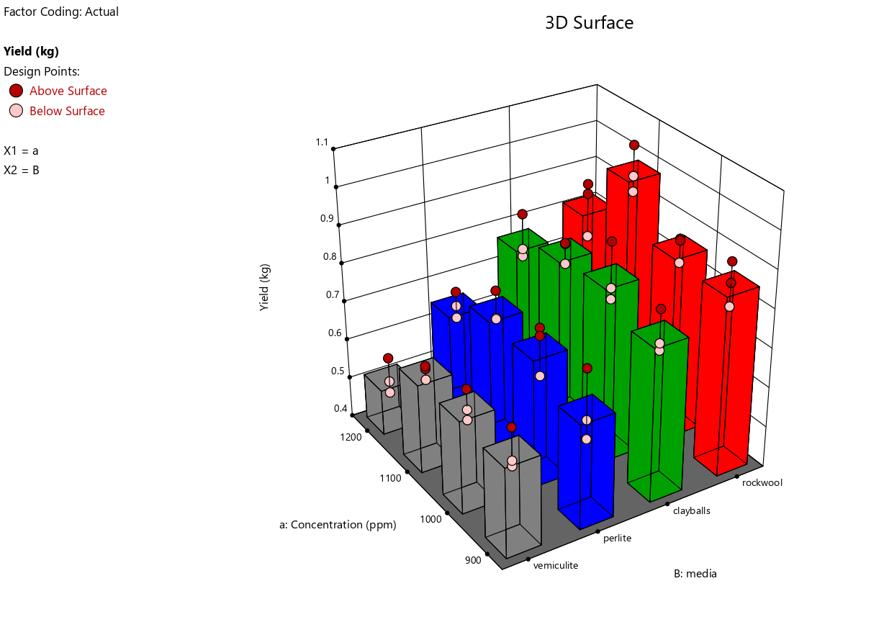
Fig. 9 Effect of nutrient concentration of solution and growing media on yield (Season4)
Conclusion
The present study successfully standardized nutrient solution concentration and growing media combinations for basil cultivation under hydroponic conditions using Design-Expert analysis. The experimental results revealed that nutrient concentration and growing media significantly influenced basil yield across different seasons under naturally ventilated polyhouse conditions. The ANOVA results indicated that the developed models were statistically significant with high coefficient of determination (R² > 0.87), confirming the adequacy of the models for predicting yield responses.
Among the different nutrient concentrations tested, 1100 ppm nutrient solution consistently produced higher yields in most seasons compared to 900 ppm, 1000 ppm and 1200 ppm concentrations. Seasonal variation also influenced the performance of growing media. Vermiculite performed better during summer conditions due to its higher moisture retention capacity, whereas rockwool and clay balls showed superior performance during cooler seasons because of better aeration and balanced moisture availability. Higher nutrient concentration (1200 ppm) resulted in reduced yield, possibly due to osmotic stress and nutrient imbalance affecting nutrient uptake by basil plants.
The interaction effects between nutrient concentration and growing media were effectively visualized using 3-D response surface plots generated through Design Expert-13 software. The optimization study demonstrated that 1100 ppm nutrient concentration combined with suitable growing media such as vermiculite, rockwool, or clay balls depending on the season, provided optimum yield performance.
Overall, the study confirmed that proper management of nutrient concentration, EC, pH, and growing media selection plays a vital role in improving basil yield in hydroponic systems. The findings of this research can be useful for commercial hydroponic growers, researchers, and protected cultivation systems aiming to achieve sustainable and efficient basil production under controlled environment agriculture.
Disclaimer (Artificial intelligence)

Author(s) hereby declare that NO generative AI technologies such as Large Language Models (ChatGPT, COPILOT, etc.) and text-to-image generators have been used during the writing or editing of this manuscript.

References
Ragaveena, S., Shirly Edward, A. and Surendran, U., 2021. Smart controlled environment agriculture methods: A holistic review. Reviews in Environmental Science and Bio/Technology, 20(4), pp.887-913.
Pala, M., Mizenko, L., Mach, M. and Reed, T., 2014. Aeroponic greenhouse as an autonomous system using intelligent space for agriculture robotics. In Robot Intelligence Technology and Applications 2: Results from the 2nd International Conference on Robot Intelligence Technology and Applications (pp. 83-93). Springer International Publishing.
Lakhiar, I.A., Gao, J., Syed, T.N., Chandio, F.A. and Buttar, N.A., 2018. Modern plant cultivation technologies in agriculture under controlled environment: A review on aeroponics. Journal of plant interactions, 13(1), pp.338-352.
Lakhiar, I.A., Gao, J., Syed, T.N., Chandio, F.A., Tunio, M.H., Ahmad, F. and Solangi, K.A., 2020. Overview of the aeroponic agriculture–An emerging technology for global food security. International Journal of Agricultural and Biological Engineering, 13(1), pp.1-10.
Putra, P.A. and Yuliando, H. 2015. Soilless culture system to support water use efficiency and product quality: a review. Agriculture and Agricultural Science Procedia. 3: 283-288.
Hussain, A., Iqbal, K., Aziem, S., Mahato, P. and Negi, A.K. 2014. A review on the science of growing crops without soil (soilless culture)-a novel alternative for growing crops. International Journal of Agriculture and Crop Sciences. 7(11): 833-842.
George, P. and George, N. 2016. Hydroponics-(Soilless Cultivation of Plants) For Biodiversity Conservation. International Journal of Modern Trends in Engineering and Science: 3(6): 97-104.
Pardossi, A., Carmassi, G., Diara, C., Incrocci, L., Maggini, R. and Massa, D. 2011. Fertigation and substrate management in closed soilless culture. Pisa: University of Pisa.
Hameed, B.H., Tan, I.A.W. and Ahmad, A.L. 2008. Preparation of activated carbon from coconut husk: Optimization study on removal of 2, 4, 6-trichlorophenol using response surface methodology. Journal of Hazardous Materials. 153: 709-717.
Chhetri, S., Dulal, S., Subba, S. and Gurung, K., 2022. Effect of different growing media on growth and yield of leafy vegetables in nutrient film technique hydroponics system. Archives of Agriculture and Environmental Science, 7(1), pp.12-19
Karne, S.C., Gupta, S.V., Patil, B.N. and Kakade, S.R. 2018. Effect of different colour of shadenet and growing media on the biometric characteristics and yield of spinach cultivated by hydroponics. International Journal of Pure and Applied Bioscience. 6(3): 419-425.
Parida, A.K. and Das, A.B. 2005. Salt tolerance and salinity effects on plants: a review. Ecotoxicology and environmental safety. 60(3): 324-349.

