Cytomorphology of transmissible venereal tumors in male and female non-descript dogs
: A case report

Abstract
Transmissible venereal tumors are among the most common skin tumors in dogs, frequently encountered in clinical practice. It is mainly transmitted through coitus and most commonly occurs in young, sexually mature dogs. Two dogs, a 7-year-old non-descript male and a 2-year-old non-descript female dog, were presented to the Department of Veterinary Gynaecology, Institute of Veterinary Sciences and Animal Husbandry, SOA (DU), Bhubaneswar, with a history of cauliflower-like growth in the prepuce of the male dog and vagina in the female dog. Fine needle aspiration biopsy (FNAB) was performed, and a Giemsa-stained smear was examined. Cytological examination revealed typical round- to slightly polyhedral-shaped cells with the presence of distinct, clear cytoplasmic vacuoles, often referred to as punctuate vacuolation, along with the presence of numerous neutrophils. Based on the cytological diagnosis, appropriate therapeutic management was initiated, and both cases responded well.

Keywords.CTVT, Non-descript, male, female, cytology

1. Introduction
Canine transmissible venereal tumour (TVT), also referred to as infectious sarcoma, transmissible lymphosarcoma, or “sticker tumour”, is a benign round-cell neoplasm of reticuloendothelial origin in dogs. It predominantly involves the external genitalia and, less frequently, the internal reproductive tract.It has a low metastatic rate and no breed or sex predilection (Bendas et al., 2022). It is mainly transmitted through coitus and most commonly occurs in young, sexually mature dogs (Rogers, 1997). The horizontal transmission of the transmissible venereal tumor of dogs can also be spread by biting, licking and smelling the tumor-affected area (Kucukbekiret al., 2021). The prepuce, vagina and penis show an irregular, multi-nodular to cauliflower-like appearance (Jangir et al., 2019). TVT tumor cells have an abnormal number of chromosomes, averaging 59 and ranging from 57 to 64, compared to the normal species 78 (Thangathurai et al., 2008). In India, it is the most common tumor of dogs owing to uncontrolled breeding practices (Singh et al., 1991), which has led to a higher incidence of this disease among the canine population, particularly in areas where stray dog populations are prevalent and breeding is unregulated. The presented case report describes the occurrence of canine transmissible venereal tumors in male and female non-descript breeds of dogs.
2. Case presentation
2.1. Case History and Clinical Observation
A 7-year-old male non-descript dog and a 2-year-old non-descript female dog were presented to the Department of Veterinary Gynaecology, Institute of Veterinary Sciences and Animal Husbandry, SOA (DU), Bhubaneswar. On clinical examination, the tumor masses were irregular, cauliflower-like, 5 cm in diameter, and reddish in color, observed on the prepuce of male dog (Figure 1) and 7 cm in diameter in the vagina of female dog (Figure 2).
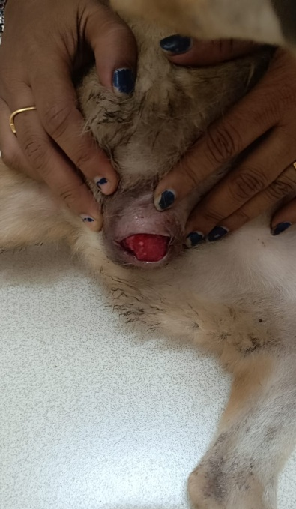
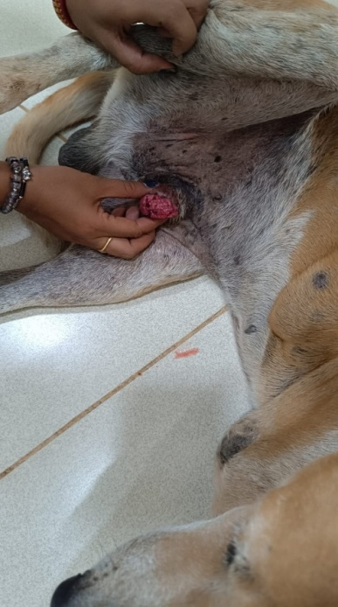
Fine needle aspiration biopsy (FNAB) was performed on the mass and was subjected to cytological examination. A Giemsa-stained smear was prepared from the collected tissue, air-dried, and fixed with methanol. Cytological examination revealed typical round- to slightly polyhedral-shaped cells with the presence of distinct, clear cytoplasmic vacuoles, often referred to as punctuate vacuolation, along with the presence of numerous neutrophils (Figure 3 & 4).

Fig1:Male non-descript dog : TVT showing cauliflower-like growth on the preputial region
Fig 2:Female non-descript dog: TVT showing cauliflower like growth on the vaginal region

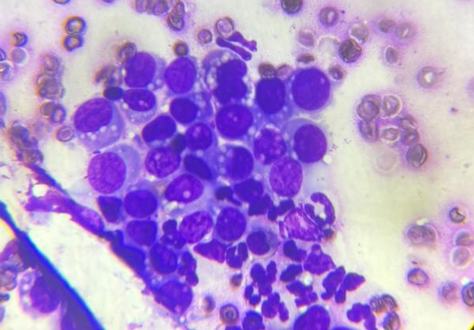
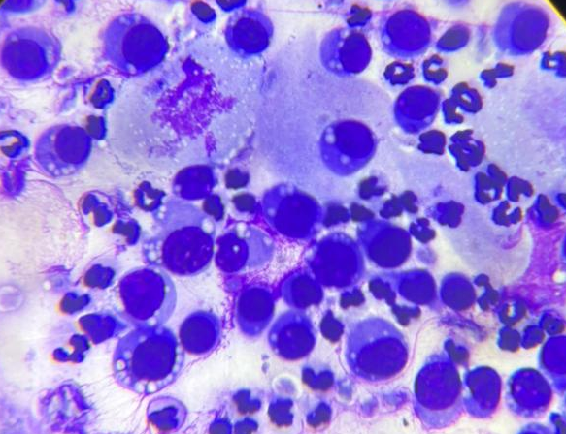

Fig.3 - FNAB smear of male non-descript dog: TVT showing numerous round cells containing round to oval nuclei with presence of cytoplasmic vacoulation. Giemsa, 100x
Fig.4-FNAB smear of female non-descript dog: TVT showing numerous round cells containing round to oval nuclei with presence of cytoplasmic vacoulation. Giemsa, 100x

3. Discussion
Transmissible venereal tumor is one of the most common round cell tumors in dogs that is transmitted through coitus. Females are found to be more susceptible than male dogs. One possible reason is that a single affected male often mates with more females and thus spreads the tumor (Das and Das, 2000). Less frequently, sniffing or licking can also spread the tumor to the skin, rectum, nasal or oral cavities (Park et al., 2006). Metastasis of TVT in the mammary glands of dogs following chemotherapy was reported by Temitope et al. (2010). Canine transmissible venereal tumor was more common in non-descript breeds of dogs, which supports our findings. Uncontrolled breeding may be the cause of the higher occurrence of CTVT in non-descript breeds (Khan et al., 2009). Dogs with CTVT are usually recorded at 5.6 years of age. The age group between 2 and 8 years had the highest number of cases. Our findings are in accordance with the earlier work of Schectman et al. (2022). However, dogs of any breed, age or sex are susceptible to CTVT (Das and Das, 2000). On clinical examination, the tumor masses wereirregular, cauliflower-like, 5 cm in diameter, and reddish in color, seen on the prepuce of a male dog and 7 cm in diameter on the vagina of a female dog. Our findings are in accordance with the earlier work of Olaifiaet al. (2025) and Ramesh et al. (2025).
Cytological examination revealed typical round to slightly polyhedral-shaped cells with the presence of distinct, clear cytoplasmic vacuoles, often referred to as punctuate vacuolation. Our findings are in accordance with the earlier work of Ramesh et al. (2025). Cytology was the primary method for diagnosis of CTVT since it is quite faster and less expensivethan histopathology (Pimentel et al., 2025). However, histopathology and immunohistochemistry are required for confirmation, grading, staging, and prognosis.
4. Conclusion
The basis of CTVT management is cytological examination, which provides a quick and highly accurate alternative to histopathological examination. The cytological confirmation provides a reliable predictor of a good prognosis since CTVT therapeutic treatment is highly effective with vincristine sulfate. This case report summarizes the occurrence ofCTVT innon-descript breeds of dogsthat affects the external genitalia of female and male dogs.
Consent
The samples were collected from the Department of Veterinary Gynaecology, Veterinary Clinical Complex, IVS&AH, with consent from the owner for diagnostic purposes.

Disclaimer (Artificial intelligence)

Author(s) hereby declare that NO generative AI technologies such as Large Language Models (ChatGPT, COPILOT, etc.) and text-to-image generators have been used during the writing or editing of this manuscript.

References
- Bendas, A.J.R., das Neves Moreto, P.L., Coxo, A.B., Holguin, P.G., & do Vale Soares, D. (2022). Intra-abdominal transmissible venereal tumor in a dog: a case report. Brazilian Journal of Veterinary Medicine, 44, e001422.
- Das, U., & Das, A. K. (2000). Review of canine transmissible venereal sarcoma. Veterinary research communications, 24(8), 545-556.
- Jangir, B.L., Deepika, L., Sandeep, S., & Jakhar, K.K. (2019). Pathomorphological and immunohistochemical studies on transmissible venereal tumours in dogs. Haryana Vet,58 (1), 82- 85.
- Khan, L.A., Khante, G.S., Raut, B.M., Bodkhe, A.M., Chavan, M.S., Pagrut, N.S., & Bobde, S.P. (2009). Incidence of Venereal Granuloma and its Medicinal treatment in stray Dogs of Nagpur City. Veterinary World, 2(1), 13.
- Küçükbekir, Ç.N., Uçmak, Z.G., & Tek, Ç. (2021). Canine transmissible veneral tumor: etiology, diagnosis and treatment. Journal of Istanbul Veterinary Sciences, 5(1), 57-65.
- Olaifa, O.S., Usman, A.A., Adebiyi, T.K., Ogunro, B.N., Osereime, A., Antia, R.E., &Soneye, T.O. (2025). Case of metastatic canine transmissible venereal tumor in a dog: Clinical and cytological evaluation. Media Kedokteran Hewan, 36(1), 77-87.
- Park, M. S., Kim, Y., Kang, M. S., Oh, S. Y., Cho, D. Y., Shin, N. S., & Kim, D. Y. (2006). Disseminated transmissible venereal tumor in a dog. Journal of Veterinary Diagnostic Investigation, 18(1), 130-133.
- Pimentel, P. A. B., Costa, M. P., de Oliveira, I. M. S., Oliveira, A. R., Paes, P. R. O., Pereira, A. W., & Horta, R. D. S. (2025). Chemoresistance cytological score for canine transmissible venereal tumour: A proposed system of predicting vincristine resistance. Veterinary and Comparative Oncology, 23(2), 278-289.
- Ramesh, S., Vijayendran, V., Balakumar, A., & Preetha, S. (2025). Cytological diagnosis of transmissible venereal tumour in a dog-A report. Indian Journal of Veterinary Pathology, 49(2), 172-174.
- Rogers, K.S. (1997): Transmissible venereal tumour. CompediumContinuning Education Practicing for Veterinarians,19, 1036-1045.
- Schectman, S.J., Khanam, A., Walters, M.N., Kirwan, E., Sylvester, W.R., & Khan, F.A. (2022). A retrospective study of canine transmissible venereal tumour in Grenada, West Indies. Veterinary Medicine and Science, 8(3), 1008-1012.
- Singh, P., Singh, K., Sharma, D.K., Behl, S.M., & Chandna, I.S., (1991). A survey of tumours in domestic animals. Indian Journal of Veterinary Sciences & Biotechnology, 68:721-725.
- Temitope, A.A., Adetola, A.R., Folashade, M.A., Olutayo, O.T., Edem, A.R., Olubukola, N.H., & Babajide, K.O. (2010). Radiographic assessment of canine transmissible venereal tumor metastases. Communications in Theriogenology, 4(1), 1.
- Thangathurai, R., Amirthalingam Balasubramaniam, G., Dharmaceelan, S., Balachandran, P., Srinivasan, P., Sivaseelan, S., & Murali Manohar, B. (2008). Cytological diagnosis and its histological correlation in canine transmissible venereal tumour. Veterinarskiarhiv, 78(5), 369-376.

