Case Report
Pleural Ewing’s Sarcoma in Young Women: A Report of Two Cases with Review of the Literature

ABSTRACT
Background: Ewing's sarcoma (ES) arising from the pleura is an exceedingly rare entity, accounting for fewer than 2% of all ES cases. Its rarity and non-specific clinical presentation frequently result in diagnostic delays and therapeutic challenges.
Presentation of Cases: We report two young Moroccan female patients with histologically confirmed pleural ES managed at our institution. The first, a 25-year-old woman, presented with a large locally advanced left pleural ES and received six cycles of VIDE (vincristine, ifosfamide, doxorubicin, etoposide) neoadjuvant chemotherapy, achieving an initial response followed by metastatic progression requiring second-line gemcitabine-docetaxel. The second, an 18-year-old woman, presented with a locally advanced right latero-thoracic soft-tissue ES with pleural involvement and was treated with three cycles of VDC-IE (vincristine, doxorubicin, cyclophosphamide alternating with ifosfamide and etoposide), achieving a 73% partial response; surgical resection was declined and she was referred for consolidative radiotherapy.
Discussion: Pleural ES is an aggressive malignancy requiring multidisciplinary management. Immunohistochemical confirmation (CD99 positivity) and cytogenetic analysis are essential for diagnosis. Multimodal treatment including chemotherapy, surgery, and radiotherapy remains the cornerstone of management.
Conclusion: Our cases highlight the rarity of this tumor, the importance of early diagnosis, and the significant therapeutic challenges posed by locally advanced disease in resource-limited settings.

Keywords: Sarcoma, Ewing; Pleural Neoplasms; Neuroectodermal Tumors, Primitive, Peripheral; Antineoplastic Combined Chemotherapy Protocols; Thoracic Neoplasms
1. INTRODUCTION
Ewing’s sarcoma (ES) is the second most common primary malignant bone tumour in children and young adults, following osteosarcoma [1]. It belongs to the Ewing sarcoma family of tumours (ESFT), which encompasses a spectrum of small round-cell tumours including primitive neuroectodermal tumours (PNET) and Askin tumours of the chest wall, all unified by specific chromosomal translocations predominantly involving the EWS gene on chromosome 22 [2].
Although ES most commonly arises in the diaphysis of long bones, primary extraskeletal ES involving soft tissues or serosal surfaces has been increasingly recognized. Pleural ES is an exceptionally rare subtype, with fewer than 100 cases reported in the world literature to date [3]. The pleural location presents distinctive diagnostic and therapeutic challenges: the tumor must be distinguished from other aggressive pleural malignancies such as malignant mesothelioma, synovial sarcoma, and metastatic carcinoma, and the extensive local involvement frequently precludes complete surgical resection [4].
The prognosis of extraskeletal ES remains poor, particularly in cases with locally advanced disease or metastatic dissemination. Multimodal therapy—incorporating intensive systemic chemotherapy and local control through surgery and/or radiotherapy—represents the standard of care; however, the optimal treatment strategy for pleural ES has not been established given the paucity of cases [5].
Herein, we report two young female patients with histologically confirmed pleural ES managed at our institution, with a comprehensive review of the existing literature. The objectives of this report are: (1) to describe the clinicopathological features, diagnostic workup, and treatment course of two cases of pleural ES in young women; (2) to compare our findings with published cases; and (3) to highlight the diagnostic and therapeutic challenges of this rare entity, particularly in resource-limited settings. All procedures were performed in compliance with the ethical standards of the Declaration of Helsinki. Written informed consent was obtained from both patients prior to the initiation of any treatment. Institutional ethical approval was obtained in accordance with the standards of our institution (Hassan II University Hospital Center, Fez, Morocco).

2. CASE PRESENTATION
2.1 Case Report 1
2.1.1 Clinical Presentation
A 25-year-old woman with no significant past medical or surgical history presented with a two-month history of progressive dry cough, exertional dyspnea, and left-sided chest pain associated with weight loss. Chest radiography performed by the referring physician revealed a large left pleural effusion. She was hospitalized locally where three non-diagnostic pleural taps were performed before being referred to our center for further evaluation.
On physical examination, the patient had an Eastern Cooperative Oncology Group (ECOG) performance status of 1. Computed tomography (CT) of the chest, abdomen, and pelvis demonstrated a massive left pleural process with an associated loculated pleural effusion. The CT findings are illustrated in Fig. 1, which reveals a large heterogeneous soft-tissue mass with gross left pleural effusion, collapse of the left lung, and cortical destruction with expansion of the adjacent 7th rib.
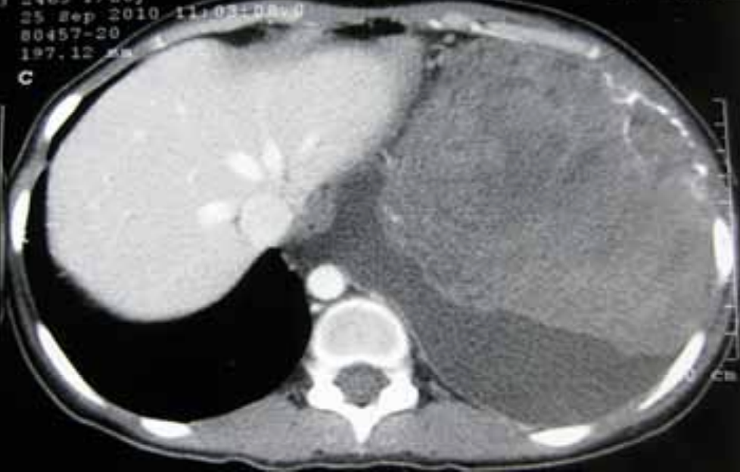
Fig. 1. Computed tomography (CT) of the thorax demonstrating a large heterogeneous soft-tissue mass with gross left pleural effusion, collapse of the left lung, cortical destruction, and expansion of the adjacent 7th rib. The findings are consistent with a locally advanced pleural malignancy with osseous involvement.
A CT-guided pleural biopsy confirmed the diagnosis of pleural Ewing’s sarcoma/PNET. Histological sections, as shown in Fig. 2, demonstrated cells with scanty cytoplasm, hyperchromatic nuclei and rosette formation (Haematoxylin and Eosin, ×125 digital magnification).
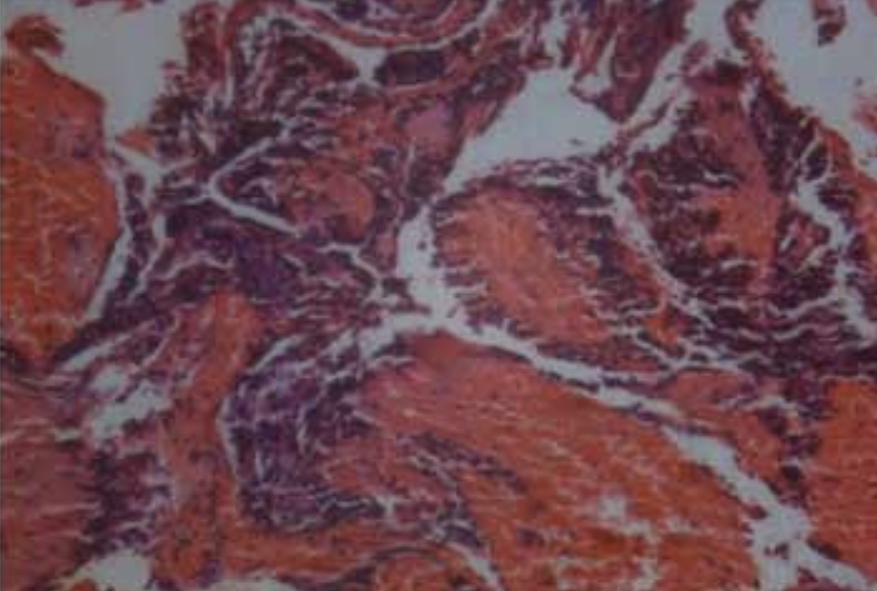
Fig. 2. Histopathological examination (Haematoxylin and Eosin stain, ×125 digital magnification). The biopsy specimen shows sheets of small, uniform tumour cells with scanty cytoplasm, hyperchromatic nuclei, and rosette formation, characteristic of Ewing’s sarcoma/PNET.
Immunohistochemistry (IHC) demonstrated strong and diffuse membranous CD99 positivity, as illustrated in Fig. 3. Fluorescence in situ hybridization (FISH) analysis for EWSR1 gene rearrangement [t(11;22)] was requested to confirm the diagnosis. A bone marrow trephine biopsy showed no medullary infiltration, and bone scintigraphy revealed no skeletal secondary lesions.
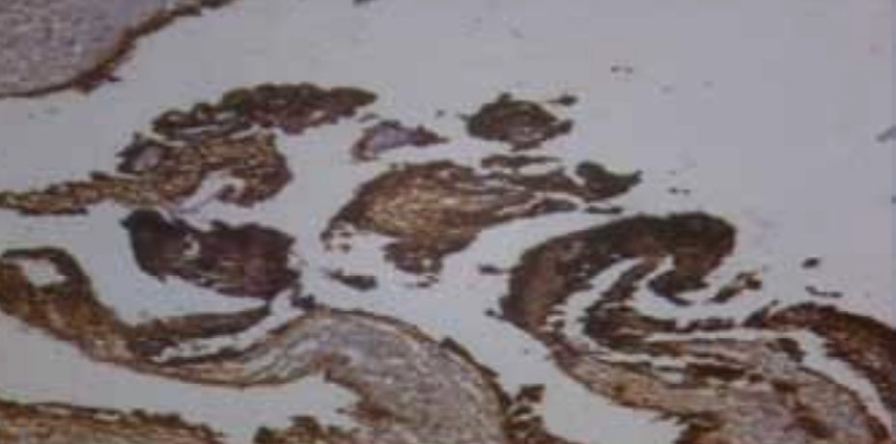
Fig. 3. Immunohistochemistry demonstrating strong and diffuse membranous CD99 positivity, the most sensitive immunohistochemical marker for Ewing’s sarcoma, present in over 95% of cases.
After multidisciplinary team (MDT) discussion, the patient commenced neoadjuvant chemotherapy with the VIDE protocol (vincristine 1.5 mg/m², ifosfamide 3 g/m²/day for 3 days, doxorubicin 20 mg/m²/day for 3 days, etoposide 150 mg/m²/day for 3 days), administered every 21 days. Following three cycles, re-evaluation demonstrated a significant clinical and radiological response, and the decision was made to complete a total of six cycles before reassessing surgical feasibility.
After completing six cycles of VIDE, restaging CT showed apparent stability of the left pleural tumor process but with the new appearance of left pulmonary secondary nodules—consistent with frank metastatic progression. Second-line chemotherapy with gemcitabine (900 mg/m² on days 1 and 8) and docetaxel (75 mg/m² on day 8) every 21 days was initiated. The patient experienced significant haematological toxicity including grade 3 thrombocytopenia necessitating dose reductions, anaemia requiring red blood cell transfusion, and a febrile pancytopenia episode complicated by Escherichia coli bacteraemia, which was managed with broad-spectrum intravenous antibiotics with full recovery. Given the metastatic progression and cumulative toxicity, palliative care was ultimately recommended. The patient's condition deteriorated progressively and she died from disease progression.
2.2 Case Report 2
An 18-year-old woman with no relevant personal or family medical history presented with a 12-month history of a rapidly enlarging right sub-mammary paracostal soft-tissue swelling. Initial plain radiography revealed a right basal pleural homogeneous opacity, as shown in Fig. 4, and recommended CT or MRI for further characterization.
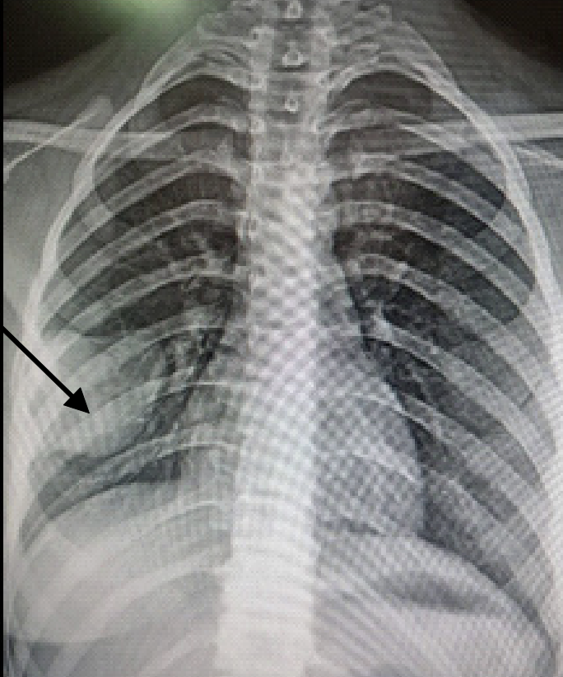
Fig. 4. Posterior-anterior chest radiograph demonstrating a right-sided basal pleural homogeneous opacity (black arrow), which prompted further cross-sectional imaging for characterization.
CT of the chest, abdomen, and pelvis revealed a large right-sided pleural mass, as demonstrated in Fig. 5. The multi-plane CT acquisition confirmed the extent of the lesion without associated mediastinal adenopathy. A soft-tissue biopsy performed at the referring institution showed an undifferentiated malignant small round-cell tumor consistent with Ewing's sarcoma (Fig. 6). IHC confirmed strong CD99 membrane positivity (Fig. 7). A bone scan suggested secondary osseous involvement of the right eighth rib by contiguity, with no evidence of further distant bone metastases. Thoracocentesis drained a straw-colored exudative pleural fluid. Echocardiography confirmed preserved biventricular function with a left ventricular ejection fraction of 65%.
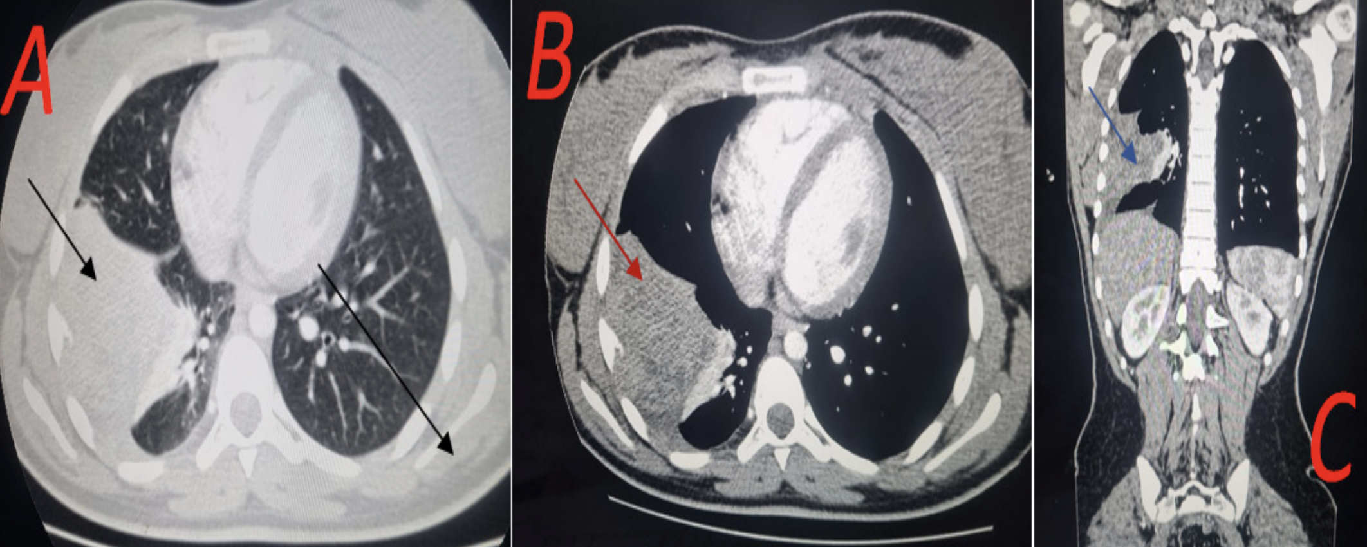
Fig. 5. Multi-planar computed tomography (CT) of the thorax with contrast injection. (A) Axial parenchymal window showing a right-sided pleural mass (black arrow). (B) Axial mediastinal window revealing the extent of the right chest mass (red arrow) without associated mediastinal adenopathy. (C) Coronal reconstruction demonstrating the craniocaudal extent of the right-sided pleural mass (blue arrow) with heterogeneous post-contrast enhancement.
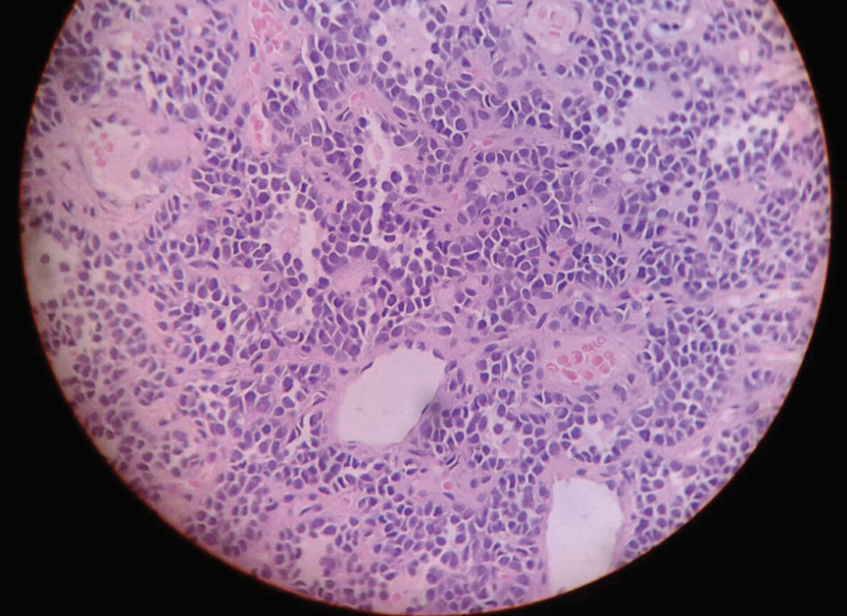
Fig. 6. Trucut biopsy specimen showing uniform small round cells with hyperchromatic nuclei, inconspicuous nucleoli, and scanty cytoplasm, with foci of necrosis. These histological features are characteristic of a malignant small round-cell tumour compatible with Ewing’s sarcoma/PNET.
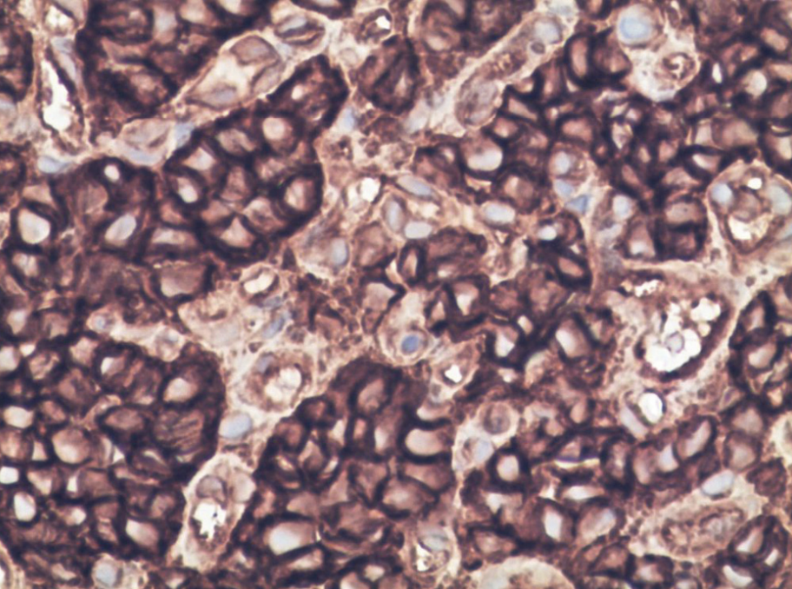
Fig. 7. Immunohistochemistry showing strong and diffuse membranous CD99 positivity, confirming the diagnosis of Ewing’s sarcoma.
Following MDT discussion, chemotherapy was initiated with the alternating VDC-IE protocol: vincristine (2 mg flat), doxorubicin (75 mg/m²), and cyclophosphamide (1,200 mg/m²) alternating every three weeks with ifosfamide (1,800 mg/m²/day for 5 days) and etoposide (100 mg/m²/day for 5 days), with granulocyte colony-stimulating factor (G-CSF) support. Three cycles were completed with good clinical tolerance (ECOG PS 1), and doxorubicin was replaced by dactinomycin after the cumulative dose of 375 mg/m² was reached.
Restaging CT demonstrated a marked partial response with significant regression of the primary mass (30 × 38 × 49 mm versus 115 × 111 × 89 mm at baseline—a reduction of approximately 73% in longest diameter), together with partial regression of the right pleural effusion. Surgical resection was declined given the very high surgical morbidity and limited oncological benefit, and the patient was referred for consolidative radiotherapy. The patient is currently under regular follow-up.
Table 1 summarizes the key clinicopathological characteristics and treatment details for both patients.
Table 1. Clinicopathological and treatment characteristics of both patients
Characteristic | Case 1 | Case 2
Age (years) | 25 | 18
Sex | Female | Female
Symptom duration | 2 months | 12 months
Primary symptoms | Dry cough, dyspnea, left chest pain, weight loss | Right sub-mammary paracostal swelling
Tumor location | Left pleura (locally advanced) | Right pleura / latero-thoracic soft tissue
Imaging (CT) | Large heterogeneous mass, loculated pleural effusion, 7th rib involvement | Large right pleural mass, rib contiguity involvement
IHC: CD99 | Strong membranous positivity | Strong membranous positivity
Molecular testing | FISH for EWSR1 rearrangement [t(11;22)] requested | Not reported
Bone marrow biopsy | No medullary infiltration | Not performed
Bone scan | No distant skeletal metastases | Right 8th rib involvement by contiguity; no distant metastases
Chemotherapy regimen | VIDE (6 cycles neoadjuvant) | VDC-IE (3 cycles), then dactinomycin substituted for doxorubicin
Best response | Significant initial response, then metastatic progression | 73% partial response (longest diameter)
Second-line treatment | Gemcitabine-docetaxel | N/A
Local control | Surgery not performed; palliative care | Surgery declined; referred for radiotherapy
Toxicities | Grade 3 thrombocytopenia, anaemia, febrile pancytopenia, E. coli bacteraemia | Good clinical tolerance (ECOG PS 1)
Outcome | Death from disease progression | Alive, under regular follow-up
ECOG PS: Eastern Cooperative Oncology Group Performance Status; FISH: Fluorescence In Situ Hybridization; IHC: Immunohistochemistry; CT: Computed Tomography; VIDE: vincristine, ifosfamide, doxorubicin, etoposide; VDC-IE: vincristine, doxorubicin, cyclophosphamide alternating with ifosfamide and etoposide.
3. DISCUSSION
Ewing’s sarcoma of the pleura is a rare and aggressive malignancy that poses substantial diagnostic and therapeutic challenges. Our two cases align with the established literature regarding the typical patient profile: young women in their second or third decade of life presenting with large, locally advanced thoracic masses [6]. The rarity of this condition—estimated at fewer than 2% of all ES cases—means that most published data derive from case reports and small series, and no prospective randomized trial has specifically addressed the management of pleural ES [3]. The present report adds two well-documented cases to this limited body of evidence, with detailed clinicopathological, radiological, and therapeutic characterization.
The clinical presentation of pleural ES is non-specific, with dyspnea, chest pain, and weight loss being the most frequently reported symptoms, as observed in both our patients. Pleural effusion, often of large volume, is a characteristic radiological finding [7]. CT demonstrates a large, heterogeneous, extra-pleural mass with variable osseous involvement; periosteal sunburst reaction may be identified when rib involvement is present, as in our second patient [8]. Magnetic resonance imaging (MRI) may complement CT by better delineating soft-tissue extent, though it was not performed in our cases due to resource constraints. The differential diagnosis includes malignant mesothelioma, synovial sarcoma, desmoplastic small round-cell tumor, and metastatic carcinoma, all of which must be excluded by appropriate histopathological and molecular studies.
The definitive diagnosis of pleural ES rests on histopathological and immunohistochemical analysis. Morphologically, ES is characterized by sheets of small, monotonous round cells with scant cytoplasm, fine chromatin, and inconspicuous nucleoli, often with foci of necrosis [9]. CD99 strong membranous positivity is the most sensitive immunohistochemical marker, present in more than 95% of ES cases; it was demonstrated in both our patients [10]. However, CD99 expression is not specific to ES and may be seen in other small round-cell tumors; therefore, a comprehensive immunohistochemical panel including NKX2.2, FLI-1, ERG, and PAX7, alongside molecular testing, is essential [12]. Molecular confirmation of EWSR1-ETS gene rearrangement—most frequently t(11;22)(q24;q12) producing the EWS-FLI1 fusion transcript—is the gold standard for diagnosis and was requested by FISH in our first case, though results remained pending at the time of this report [11]. The absence of molecular confirmation in our second case represents a diagnostic limitation that reflects the constraints of our resource-limited setting.
The standard chemotherapy regimens for ES—VIDE/VAIA in the European tradition and VDC-IE in the North American approach—were both employed in our patients, reflecting current international guidelines [13,14,22]. An objective clinical and radiological response was documented in both cases, consistent with published series reporting response rates of 60–80% to first-line chemotherapy in ES [15]. Notably, our two patients received different regimens (VIDE versus VDC-IE), reflecting both institutional protocol evolution and the absence of a universally established standard for extraskeletal pleural ES specifically. Our first patient ultimately developed frank metastatic progression after six VIDE cycles, requiring second-line gemcitabine-docetaxel; this combination has demonstrated modest activity in relapsed/refractory ES, with overall response rates of approximately 17–37% in small series [16]. The chemotherapy response observed in our second case (73% partial response by longest diameter) is particularly noteworthy and highlights the chemosensitivity of this tumor even in locally advanced disease.
Local control in ES is achieved through surgery, radiotherapy, or a combination of both. Complete surgical resection with adequate margins is associated with improved event-free and overall survival [17]. However, the pleural location frequently renders complete excision technically impossible or associated with unacceptable morbidity, as was the case in both our patients. Extrapleural pneumonectomy or extensive chest wall resection may be considered in selected cases, but carries substantial perioperative risk. Definitive radiotherapy to doses of 45–56 Gy represents the standard alternative for unresectable ES, with local control rates of approximately 60–70% [18]. In our second patient, radiotherapy was planned as consolidative treatment following the excellent chemotherapy response, though initiation was delayed due to administrative and logistical barriers. This delay underscores the important role of social determinants of health in oncological outcomes, particularly in resource-limited settings where access to radiotherapy infrastructure remains a significant challenge.
Haematological toxicity—including febrile neutropenia, anaemia, and thrombocytopenia—represents the most clinically significant treatment complication, as documented in our first patient, who required transfusional support, dose reductions, and antibiotic therapy for bacteraemic neutropenic fever. These findings emphasize the importance of close haematological monitoring, prophylactic G-CSF, and prompt management of infectious complications during intensive chemotherapy [19].
The prognosis of localized ES treated with multimodal therapy is relatively favorable, with 5-year overall survival rates of 60–70%; however, metastatic or unresectable disease carries a substantially worse prognosis, with 5-year survival rates below 30% [20]. The specific prognostic impact of pleural location is difficult to assess given the small number of reported cases. Prognostic factors that have been identified in ES more broadly—including tumor volume, metastatic status at diagnosis, and quality of surgical resection—are likely applicable to pleural ES but remain unvalidated in this specific subtype [21,22]. Our first patient, who developed metastatic progression after six cycles of neoadjuvant chemotherapy, illustrates the poor prognosis of the metastatic form, while our second patient, who achieved a near-complete response and was referred for radiotherapy, may represent a more favorable trajectory. Longer follow-up and multicenter data are required to draw definitive conclusions.
4. LIMITATIONS
This report has several important limitations. First, the retrospective nature of the case series and the inclusion of only two patients preclude any definitive conclusions regarding optimal treatment strategies for pleural Ewing’s sarcoma. Second, molecular confirmation by FISH for EWSR1 rearrangement was only requested for Case 1, and results were not available at the time of reporting; Case 2 lacked molecular testing altogether. Third, as a single-institution experience from a resource-limited setting, our cases may not reflect the full spectrum of clinical presentations or the range of treatment options available in higher-resource centers. Fourth, the heterogeneity in chemotherapy regimens between the two cases—reflecting both protocol evolution and individual clinical considerations—limits direct comparison of outcomes. Finally, long-term follow-up data are unavailable for Case 2, and survival data for Case 1 are limited by early disease progression. These limitations underscore the need for prospective multicenter registries and collaborative international studies to generate higher-quality evidence for this exceptionally rare malignancy [21,22].
5. CONCLUSION
Pleural Ewing's sarcoma is an exceptionally rare and aggressive malignancy that should be considered in the differential diagnosis of young patients presenting with large thoracic masses and pleural effusion. Diagnosis requires a combination of histopathological, immunohistochemical (CD99), and molecular analyses. Multidisciplinary management incorporating intensive chemotherapy and local control—through surgery when feasible, or radiotherapy for unresectable disease—remains the cornerstone of treatment. Our two cases illustrate both the diagnostic challenges and the therapeutic complexity of this entity, and highlight the need for international collaborative studies to optimize treatment strategies in this rare tumor.

Ethical Approval
Ethical approval was obtained from institution (Hassan II University Hospital Center, Fez, Morocco).
CONSNET
Written informed consent was obtained from both patients and preserved by the author(s).

Disclaimer
This paper is an extended version of a preprint document of the same author.
The preprint document is available in this link: https://www.researchsquare.com/article/rs-9067566/v1
[As per journal policy, preprint /repository article can be published as a journal article, provided it is not published in any other journal]

Disclaimer (Artificial intelligence)

Author(s) hereby declare that NO generative AI technologies such as Large Language Models (ChatGPT, COPILOT, etc.) and text-to-image generators have been used during the writing or editing of this manuscript
REFERENCES
[1] Grünewald, T.G.P., Cidre-Aranaz, F., Surdez, D., et al. (2018). Ewing sarcoma. Nature Reviews Disease Primers, 4, 5. https://doi.org/10.1038/s41572-018-0003-x
[2] Delattre, O., Zucman, J., Plougastel, B., et al. (1992). Gene fusion with an ETS DNA-binding domain caused by chromosome translocation in human tumours. Nature, 359, 162–165. https://doi.org/10.1038/359162a0
[3] Sbaraglia, M., Bellan, E., & Dei Tos, A.P. (2021). The 2020 WHO Classification of Soft Tissue Tumours: news and perspectives. Pathologica, 113, 70–84. https://doi.org/10.32074/1591-951X-213
[4] Woo, O.H., Park, Y.S., Cha, S.H., et al. (2007). Primary pleural Ewing's sarcoma/primitive neuroectodermal tumor: a case report and review of the literature. Journal of Thoracic Oncology, 2, 874–876. https://doi.org/10.1097/JTO.0b013e31814b9f2a
[5] Biswas, B., Shet, T., Laskar, S., et al. (2014). Extraskeletal Ewing's sarcoma: results of treatment and predictive factors for outcome. Clinical Oncology (Royal College of Radiologists), 26, 22–29. https://doi.org/10.1016/j.clon.2013.09.008
[6] Grier, H.E., Krailo, M.D., Tarbell, N.J., et al. (2003). Addition of ifosfamide and etoposide to standard chemotherapy for Ewing's sarcoma and primitive neuroectodermal tumor of bone. New England Journal of Medicine, 348, 694–701. https://doi.org/10.1056/NEJMoa020890
[7] Hamid, S.A., El Fadl, A.A., & Al Faqeeh, H. (2018). Pleural Ewing sarcoma presenting as massive hemorrhagic pleural effusion. Respiratory Medicine Case Reports, 23, 90–93. https://doi.org/10.1016/j.rmcr.2018.01.008
[8] Gomes, A., Guimarães, M., Gomes, M., et al. (2016). A rare pleural Ewing's sarcoma in a young woman. Respiratory Medicine Case Reports, 18, 1–3. https://doi.org/10.1016/j.rmcr.2016.02.005
[9] Ushigome, S., Machinami, R., & Sorensen, P.H. (2002). Ewing sarcoma/primitive neuroectodermal tumour (PNET). In C.D.M. Fletcher, K.K. Unni, & F. Mertens (Eds.), World Health Organization Classification of Tumours: Pathology and Genetics of Tumours of Soft Tissue and Bone (pp. 298–300). IARC Press.
[10] Folpe, A.L., Goldblum, J.R., Rubin, B.P., et al. (2005). Morphologic and immunophenotypic diversity in Ewing family tumors: a study of 66 genetically confirmed cases. American Journal of Surgical Pathology, 29, 1025–1033. https://doi.org/10.1097/01.pas.0000167617.40070.e8
[11] Riggi, N., Suva, M.L., Suva, D., et al. (2008). EWS-FLI-1 expression triggers a Ewing's sarcoma initiation program in primary human mesenchymal stem cells. Cancer Research, 68, 2176–2185. https://doi.org/10.1158/0008-5472.CAN-07-1761
[12] Stockman, D.L., Miettinen, M., Suster, S., et al. (2012). Malignant gastrointestinal neuroectodermal tumor: clinicopathologic, immunohistochemical, ultrastructural, and molecular analysis of 16 cases. American Journal of Surgical Pathology, 36, 857–868. https://doi.org/10.1097/PAS.0b013e31824644ac
[13] Juergens, C., Weston, C., Lewis, I., et al. (2006). Safety assessment of intensive induction with vincristine, ifosfamide, doxorubicin, and etoposide (VIDE) in the treatment of Ewing tumors in the EURO-E.W.I.N.G. 99 clinical trial. Pediatric Blood & Cancer, 47, 22–29. https://doi.org/10.1002/pbc.20690
[14] Granowetter, L., Womer, R., Devidas, M., et al. (2009). Dose-intensified compared with standard chemotherapy for nonmetastatic Ewing sarcoma family of tumors: a Children's Oncology Group Study. Journal of Clinical Oncology, 27, 2536–2541. https://doi.org/10.1200/JCO.2008.19.1478
[15] Paulussen, M., Craft, A.W., Lewis, I., et al. (2008). Results of the EICESS-92 Study: two randomized trials of Ewing's sarcoma treatment. Journal of Clinical Oncology, 26, 4385–4393. https://doi.org/10.1200/JCO.2008.16.5720
[16] Stahl, M., Ranft, A., Paulussen, M., et al. (2011). Risk of recurrence and survival after relapse in patients with Ewing sarcoma. Pediatric Blood & Cancer, 57, 549–553. https://doi.org/10.1002/pbc.23040
[17] Bacci, G., Ferrari, S., Longhi, A., et al. (2004). Role of surgery in local treatment of Ewing's sarcoma of the extremities in patients undergoing adjuvant and neoadjuvant chemotherapy. Oncology Reports, 11, 111–120. https://doi.org/10.3892/or.11.1.111
[18] Laskar, S., Bahl, G., Muckaden, M.A., et al. (2008). Definitive radiation therapy for Ewing sarcoma family of tumors. Cancer, 113, 2503–2510. https://doi.org/10.1002/cncr.23866
[19] Cesaro, S., Toffolutti, T., Messina, C., et al. (2004). Safety and efficacy of caspofungin and liposomal amphotericin B, followed by voriconazole in young patients affected by refractory invasive mycosis. European Journal of Haematology, 73, 50–55. https://doi.org/10.1111/j.1600-0609.2004.00255.x
[20] Ladenstein, R., Pötschger, U., Le Deley, M.C., et al. (2010). Primary disseminated multifocal Ewing sarcoma: results of the Euro-EWING 99 trial. Journal of Clinical Oncology, 28, 3284–3291. https://doi.org/10.1200/JCO.2009.22.9864
[21] Khoury, J.D., Solary, E., Abla, O., et al. (2022). The 5th edition of the World Health Organization Classification of Haematolymphoid Tumours: Myeloid and Histiocytic/Dendritic Neoplasms. Leukemia, 36, 1703–1719. https://doi.org/10.1038/s41375-022-01613-1
[22] Gaspar, N., Hawkins, D.S., Dirksen, U., et al. (2022). Ewing Sarcoma: Current Management and Future Approaches Through Collaboration. Journal of Clinical Oncology, 40, 3520–3531. https://doi.org/10.1200/JCO.22.00051

