Adsorption Isotherms Behaviors of Phosphorus with Langmuir Equation for Some Acid Soils in South Kalimantan, Indonesia

.

ABSTRACT

Background: Phosphorus availability in acidic mineral soils is often limited due to strong adsorption onto iron and aluminum oxides, reducing its effectiveness for plant uptake. Understanding phosphorus adsorption behavior in different soil types is essential for improving fertilizer efficiency. This study applies the Langmuir isotherm model to compare phosphorus sorption characteristics in Oxisols, Inceptisols, and Ultisols of South Kalimantan.
Aims: To examine the natural characteristics of adsorption in newly opened paddy fields on the solubility of macronutrient P by using the adsorption isotherm equation.
Study design: This research was a laboratory incubation study using soil samples from three different soils in South Kalimantan Province, Indonesia.
Place and Duration of Study: Soil samples were from three different locations (Oxisols, Tanah Laut Regency), Inceptisols (Barito Kuala Regency), and Ultisols (Banjarbaru City). The research was conducted from January to May 2025.
Methodology: After soil preparation, the adsorption isotherm of P was measured using the established method using six soil samples with three replicates. Added P (0, 2, 5, 10, 15, 30, and 50 mg P kg⁻¹) from KH₂PO₄ were applied in 1 g soil in 25 mL 0.01 M CaCl₂. The suspension was shaken in a 50 mL centrifuge tube at 25 ℃ for 17 hours. The tube was centrifuged at 3,000 rpm for five minutes, and the supernatant was filtered (Whatman #42) for P analysis. P remained in the solution after equilibration was measured. The common adsorption isotherm equation (Langmuir) was used to fit the adsorption data and to compare their behaviors among the soils.
Results: The comparison of Langmuir equation variables in three soil types (Oxisols, Inceptisols, and Ultisols) demonstrated the importance of soil chemical characteristics influencing P cycle in soils. This study found that the maximum P sorption capacity (x_{m}) follows the order Inceptisols > Oxisols > Ultisols, indicating significant variability driven by intrinsic soil properties. Phosphorus adsorption was most efficient at low to medium dissolved P concentrations, following the Langmuir isotherm model. Environmental aspects and plant interactions are necessary to assess the relevance of P in acid mineral soils such as leaching risk and long-term sorption-desorption dynamics.
Conclusion: The maximum P sorption capacity (x_{m}) follows the order Inceptisols > Oxisols > Ultisols, indicating significant variability driven by inherent soil properties, especially chemical properties. Further implication may also be useful to generate recommendation doses of P precision fertilization in such soils.

Keywords: Acid soils, Fe and Al-oxides, Langmuir isotherm, maximum sorption capacity, P adsorption.

1. INTRODUCTION

Developing sustainable agriculture and utilizing critical land, facing a major challenge due to the predominance of acidic mineral soils such as Oxisols, Inceptisols (acid sulphate), and Ultisols. These soils share common nutrient limitations, particularly P, which plays a role in various plant physiological processes. P in soil solution binds to soil particles through adsorption process, which involves the attachment of P ions to the surface of soil particles containing Fe and Al oxide minerals (1). Other factors include environmental conditions such as soil pH, solution concentration, contact time, and the adsorbate to adsorbent ratio, which reduces its availability to plants (2).
The P adsorption process is influenced by various factors, including the physical and chemical properties of the soil, the P concentration in the solution, and environmental conditions such as pH and temperature. The sorption process itself is the interaction between P in solution and the surface of soil particles (3). In laboratory experiments, when soil is agitated with a P-containing solution, the amount of adsorbed-P increases with increasing dissolved-P concentration until it reaches saturation, which can be depicted by an adsorption isotherm curve.
The Langmuir isotherm model was used in this study to systematically model this relationship. This model produces two main parameters: the maximum sorption capacity (x_{m}) and the binding energy constant (K_{L}). The x_{m} indicates the maximum amount of P that can be adsorbed by the soil, while the K_{L} reflects the bond strength between the P and the soil sorption site (4,5).
Studies of P sorption in acid mineral soils, particularly studies directly comparing the maximum P sorption capacity of the three main soil types in South Kalimantan using the Langmuir model, are very limited. Acid sulfate soils (Inceptisols) of South Kalimantan have a maximum isothermal P adsorption of approximately 31% of the added P (6). According to the other study, Ultisols of South Kalimantan had a maximum P adsorption capacity of about 24% (7). This limited data hinders a thorough understanding of the differences in P sorption capacity between these soil types, yet this information is crucial for designing more appropriate and efficient fertilization strategies. Therefore, this study aims to fill this gap by comparing the maximum P absorption capacity of the three types of acidic mineral soils.

2. material and methods

This research was conducted in the Soil Science Laboratory, Lambung Mangkurat University, Banjarbaru. P sorption characterization was performed using Microsoft Excel to obtain a curve corresponding to secondary data analyzed using the Langmuir equation model from January to May 2025. Previously, soil samples were collected from three locations (Tanah Laut Regency (Oxisols), Barito Kuala Regency (Inceptisols), and Banjarbaru City (Ultisols)). Each soil had three replicates (500 g each), about 1 m apart, taken from 0-20 cm, then composited and air-dried.
The addition of KH₂PO₄ to Oxisols, Inceptisols, and Ultisols was conducted to observe how these soils absorb P. In this experiment, 1 g of soil (in three replicates) was mixed with KH₂PO₄ solution as a P source at various concentrations (0, 2, 5, 10, 20, 30, and 50 mg P L⁻¹). The purpose was to determine changes in the amount of P absorbed by the soil at each addition level. P was then added in a CaCl₂ electrolyte to maintain the ionic stability of the solution and minimize the effects of other ions that could affect the adsorption process (8). A 100 mL plastic vial with a tight lid was used for every 1 g of soil sample. This concentration was determined in a preliminary experiment to check the appropriate concentration range, considering the high P absorption capacity of the sampled soil. Replications were performed to obtain a more accurate mean value. The suspension (soil + KH₂PO₄ + 0.01 M CaCl₂) was shaken at 25 ℃ for 17 hours. The supernatant was filtered with filter paper (Whatman #42) for P analysis. The remaining P in the solution after the equilibration process was measured using the method described in (4).
The adsorbed-P values obtained were used to calculate the added-P and dissolved-P values. After obtaining the P values for the solution and-adsorbed P, each was entered into the Langmuir equation
$x=\frac{(K_{L}x_{m}c)}{(1+K_{L}c)}$ 1
to become linear after rearrangement:
$\frac{c}{x}=\frac{1}{K_{L}x_{m}}+\frac{1}{x_{m}}c$ 2
From these equations, the coefficient of determination (R²) was obtained, which describes the strength of the regression equation (6).

3. results and discussion

The main problems with P in acid soils are high soil acidity and the presence of toxic substances (Al and Fe). Land with high acidity levels causes an increase in Al and Fe to be harmful to plants and inhibit the availability of essential nutrients.
Al and Fe are two elements that absorb significant amounts of P in the soil. This is due to the high solubility of Al and Fe ions, which allow them to bind P strongly. As a result, P can be fixed in the soil and is not readily available to plants, thus inhibiting plant growth. Although P is not easily removed from the soil through leaching, it remains bound to the surface of soil particles, known as colloids. Maximum P availability in most soils occurs between a pH of 5.5 and 7.0. If the soil pH is lower than 5.5 or higher than 7.0, P availability decreases. This also applies to soil solutions containing Al and Fe oxides. P is highly susceptible to binding in both acidic and alkaline soil conditions. The longer the P is in contact with the soil, the more P is fixed.
The gradual addition of P also followed standard P adsorption research methods for determining maximum adsorption capacity and binding energy constants. The graph below uses the Langmuir isotherm equation model to illustrate the relationship between dissolved-P and the amount of adsorbed-P in various soil types. Figures 1-3 show the analysis results in the form of Langmuir isotherm curves with logarithmic and linearized patterns
The relationship between dissolved-P and adsorbed-P concentrations in Oxisols can be seen in Figure 1. The graph shows that the more dissolved-P was formed, the more adsorbed-P in the soil, but the increase slowed and tended to plateau at higher concentrations. This indicated that Oxisols had a moderate capacity to adsorb P and would reach saturation if P was added further. This pattern consisted of soils containing moderate amounts of Fe and Al oxides, which provide sufficient but not excessive adsorption sites (9).

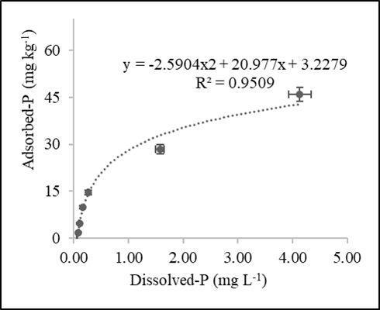
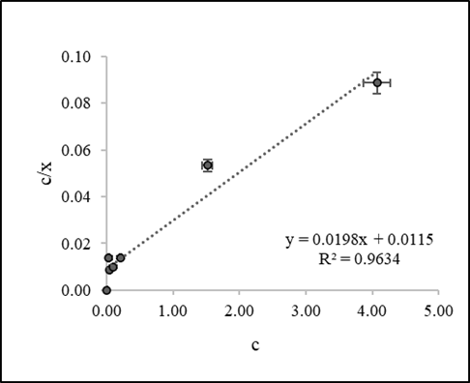

Figure 1. The relationship between dissolved-P and adsorbed-P in Oxisols in Langmuir equation.
In acid soils, a decrease in Al and Fe in the soil increases available-P. In addition to a decrease in Al and Fe, changes in pH also affect available-P in the soil. An increase in available-P indicates mineralization, converting P from an unavailable form to a plant-available form, resulting from the decomposition process of organic matter. Unavailable-P occurs due to the fixation of Fe-P and Al-P. The higher the Fe and Al concentrations, the higher the P fixation capacity (10).
P uptake caused by P fixation by Fe and Al can be measured using isothermal sorption. Many researchers have proposed determining the amount of P needed at the optimal level to achieve maximum yields by quantitatively describing isothermal sorption using the most popular method, the Langmuir equation (11). The Langmuir isotherm adsorption model is a theoretical model that describes the adsorption process under real-world conditions (12).
Based on this research, the P adsorption isotherm in untreated Oxisols had a quadratic polynomial equation: y = -2.5094x2 + 20.977x + 3.2279 (Figure 1). The isothermal P sorption in Oxisols soil follows the linearized Langmuir equation of y = 0.0198x + 0.0115, where x_{m} (maximum adsorption) is 50.5051, and this relationship yields a coefficient of determination R² = 0.96 (Table 1).
Furthermore, acid sulfate soil (Inceptisols) had a moderate exchangeable-Al (5.81 mg kg⁻¹). Meanwhile, the soluble-Fe value was 137.69 mg kg⁻¹, which was very high. High soluble Fe values indicate that there was a significant amount of Fe capable of binding P in the soil. This could be a contributing factor to low P availability in acid sulfate soils. P fixation by Fe is a major factor contributing to low P availability in acid soils. A significant relationship between P availability and Fe-P fixation indicates that the higher the Fe-P fixation value, the lower the P availability in the soil. This was due to the dominance of P adsorption by Fe in acid soils (1,13,14)
Isothermal sorption is a very useful method for measuring P sorption in soil. This is crucial for understanding how P is bound to the soil and its availability to plants. In acid sulfate soils, P sorption is largely influenced by P fixation by Al and Fe. This fixation occurs because Al and Fe have a high affinity for P, making P tightly bound and less readily available to plants. Isothermal sorption can help determine the amount of P needed to achieve optimal levels for plant growth by understanding P sorption patterns.
The isothermal sorption results measured using Langmuir equation in this study were rearranged, and the components of the equations were adjusted to form a single equation. The maximum sorption of P in acid sulfate soil at the addition of 50 mg P kg⁻¹ to 1 g of control soil was 1.67 mg kg⁻¹. The adsorption of P was 48.33 mg P kg⁻¹. So, with the addition of 50 mg P kg⁻¹ P, approximately 3% of P becomes dissolved and 97% of P becomes adsorbed by the soil.
P adsorption is the ability of the soil to bind P in the form of PO₄³⁻. P adsorption occurs through various mechanisms, such as adsorption on the surface of soil particles, precipitation, and complexation with organic matter. The level of P uptake in soil varies depending on soil type, soil pH, organic matter content, and the presence of other compounds that can bind P. P availability is the amount of P that can be absorbed by plants from the soil. P availability is important for optimal plant growth. P that is trapped in the soil is not always available to plants. Only a small portion of the trapped P can be released and absorbed by plants. High P uptake in the soil can reduce P availability for plants. This is because P that is strongly adsorbed on soil particles is difficult to release and absorb by plants. Conversely, low P uptake in the soil can increase P availability for plants. This is because P that is weakly adsorbed on soil particles is easily released and absorbed by plants. Fixation activity is the process of binding P by acid mineral soils. Acid mineral soils have a P uptake capacity (15,16).

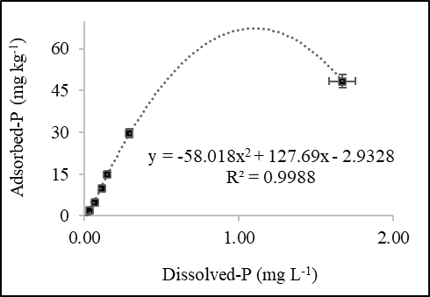
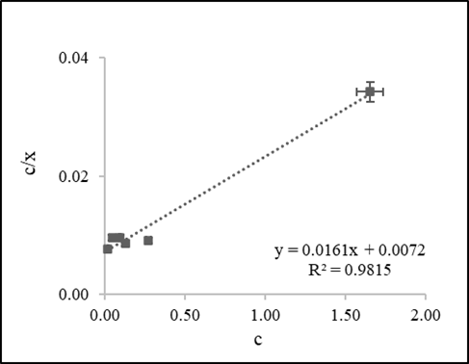
Figure 2. The relationship between dissolved-P and adsorbed-P in Inceptisols in Langmuir equation.
In Figure 2, the relationship between dissolved-P and adsorbed-P in Inceptisols formed a parabolic curve. Initially, the addition of P caused a rapid increase in adsorbed-P. However, after reaching a peak, the amount of adsorbed-P decreased despite the increase in dissolved-P. This indicated that Inceptisols rapidly adsorbed P, but at a certain point, their adsorption capacity declined. According to (17), this decrease occurs at saturation and desorption sites at high dissolved-P levels.

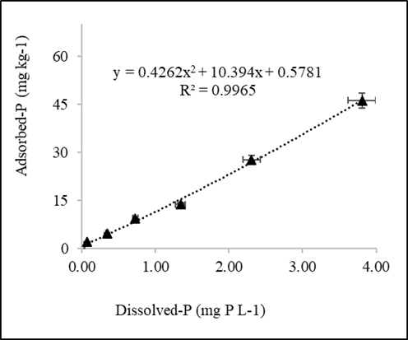
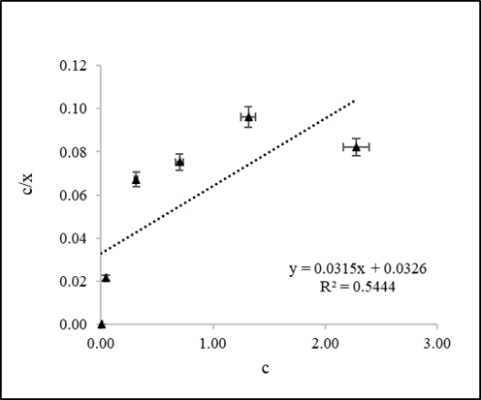
Figure 3. The relationship between dissolved-P and adsorbed-P in Ultisols in Langmuir equation.
Figure 3 shows the relationship between dissolved-P and adsorbed-P in Ultisols appeared nearly linear. Each addition of P was immediately accompanied by an increase in adsorbed-P. This pattern indicated that Ultisols had a lower P adsorption capacity than the other two soils, and the adsorption process proceeded more steadily toward saturation at the observed concentrations. The linear relationship was associated with soil characteristics such as acidic pH and relatively low Fe and Al-oxide content, resulting in a limited number of active adsorption sites. Consequently, the amount of adsorbed P increased proportionally with dissolved P without reaching complex saturation stages. The characteristics of soils with lower Fe and Al-oxide contents indicated the maximum adsorption capacity and relatively low bond energy in Ultisols. Based on Figures 1-3, the Langmuir equation variables were obtained, as shown in Table 1.
According to (18) the availability of P in the soil is closely related to soil acidity (pH). The availability of P will decrease if the soil pH is lower than 6.0 and higher than pH 8. In Ultisols soil containing high Al and Fe, it absorbs a lot of P so that the solubility of Al and Fe ions is relatively high, so it can fix P in the soil which causes plant growth to be less good (19). This is in line with the opinion of (20) that the high pH of rice husk charcoal can neutralize the pH of acidic soil. According to (21) that the provision of rice husk charcoal as a soil conditioner is widely used to overcome problems in the soil, namely increasing pH, maintaining soil moisture, and can also provide nutrients in N, P, and K in the soil. The higher the Fe-P fixation value that occurs, the lower the availability of P in the soil. This is because the increase in P fixation by Fe is the most dominant adsorption that occurs in acidic soils (1,13,14). Many researchers recommend quantitatively describing the adsorption isotherm to determine the optimum level for maximum crop yield. The most popular are the Langmuir and Freundlich equations (11). In this study, the adsorption isotherm was measured using the Langmuir equation. After rearranging the components of the Langmuir equation and fitting the curve, an equation was obtained that describes P sorption with a higher R² in Ultisols. The maximum P uptake that Ultisols can perform isothermally when adding 50 mg kg⁻¹ P to 1 g of untreated Ultisols was 42.08 mg kg⁻¹ of P. Therefore, with the addition of 50 mg kg⁻¹ P, approximately 15.8% of the P becomes dissolved and 84.2% of the P was adsorbed in Ultisols.
The results of the study showed that the amount of P adsorbed is suspected to be due to Al and Fe toxic substances, increasing with each increase in the stock of P. However, the increase in adsorbed P over time experienced an insignificant or very small increase. This was because the amount of P adsorbed by toxic substances at any time would increase, and P would accumulate on the Al-P and Fe-P surfaces until it reaches equilibrium. High P adsorption indicates low P availability. In other words, fixation activity in acidic mineral soils can result in a decrease in the amount of P available to plants (7).

Table 1. Langmuir equation parameters for Oxisols, Inceptisols, and Ultisols in South Kalimantan
Soils | x_{m} | K_{L} | R²
Oxisols | 50.5051 | 1.7217 | 0.9634
Inceptisols | 62.1118 | 2.2361 | 0.9815
Ultisols | 30.6504 | 1.0362 | 0.5444
Remark: X_{m} = maximum adsorption (µg P g⁻¹); K_{L} = coefficient related to binding energy; R² = coefficient of determination describing the strength of the regression equation obtained from the x/c plot, and c has a slope of 1/x_{m} and an intercept of 1/K_{L} x_{m}.

The Langmuir model for P sorption equations in untreated Oxisols, Inceptisols, and Ultisols was considered to adequately describe the relationship between soluble-P and adsorbed-P. Based on Table 1, Inceptisols had the best ability to absorb and bind P, but it was not readily available to plants. Oxisols occupied an intermediate position, while Ultisols were more readily available due to their lower P adsorption capacity and binding strength, making P more readily available.
The high R² value indicates that this equation can predict P sorption capacity and binding strength well in Oxisols and Inceptisols (7). However, in Ultisols, the low R² value indicated that the Langmuir model was less accurate because of other influencing factors, such as pH, Al and Fe-oxides, CEC, and organic matter content (6,22,23). Thus, the chemical characteristics of the soil determined how the Langmuir equation describes the P adsorption process, at least at the range of additional low P added to the soil (0, 2, 5, 10, 20, 30, and 50 mg P L⁻¹). This mechanism was suggested by (24,25).

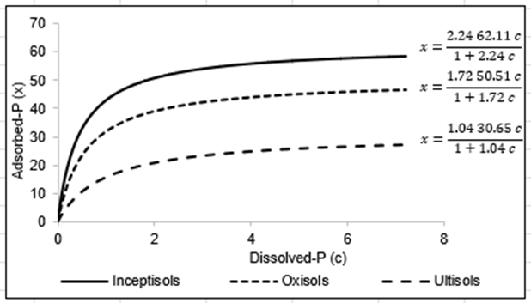
Figure 4. The relationship between dissolved-P and adsorbed-P with Langmuir equation.
The Langmuir equation applied to Oxisols, Inceptisols, and Ultisols showed significant differences in maximum P sorption capacity where sorption occurred in a monolayer until maximum capacity was reached (Figure 4). The Langmuir curve for Inceptisols showed the highest P adsorption capacity (x_{m} = 62.11), followed by Oxisols (x_{m} = 50.51), and the lowest in Ultisols (x_{m} = 30.65). This indicated that Inceptisols had a greater ability to adsorb P before reaching saturation, while P in Ultisols reached saturation more quickly. P adsorption at low to medium dissolved doses was highly efficient, reaching monolayer saturation as described by the Langmuir model. Differences in adsorption capacity were related to soil chemical characteristics such as Fe and Al-oxide content, soil minerals, and pH, which affect the number of active adsorption sites. The linear relationship between dissolved and adsorbed P underscores the importance of adjusting P fertilizer doses according to soil adsorption capacity to optimize uptake and minimize P loss.

4. Conclusion

The comparison of Langmuir equation variables in three soil types (Oxisols, Inceptisols, and Ultisols) demonstrated the importance of soil chemical characteristics in influencing P cycle in soils. This study found that the maximum P sorption capacity (x_{m}) follows the order Inceptisols > Oxisols > Ultisols, indicating significant variability driven by intrinsic soil properties. Phosphorus adsorption was most efficient at low to medium dissolved P concentrations, following the Langmuir isotherm model. Environmental aspects and plant interactions are necessary to assess the relevance of P in acid mineral soils such as leaching risk and long-term sorption-desorption dynamics.

COMPETING INTERESTS DISCLAIMER:
Authors have declared that they have no known competing financial interests OR non-financial interests OR personal relationships that could have appeared to influence the work reported in this paper.
Disclaimer (Artificial intelligence)
Author(s) hereby declare that NO generative AI technologies such as Large Language Models (ChatGPT, COPILOT, etc.) and text-to-image generators have been used during the writing or editing of this manuscript.

References

1. Hanyabui E, Apori SO, Frimpong KA, Atiah K, Abindaw T, Ali M, et al. Phosphorus sorption in tropical soils. AIMS Agriculture and Food. 2020. doi:10.3934/AGRFOOD.2020.4.599
2. Croat SJ, DeSutter TM, Casey FXM, O’Brien PL. Phosphorus Sorption and Desorption in Soils Treated by Thermal Desorption. Water Air Soil Pollut. 2020;231(5). doi:10.1007/s11270-020-04579-x
3. Borggaard OK, Raben-Lange B, Gimsing AL, Strobel BW. Influence of humic substances on phosphate adsorption by aluminium and iron oxides. In: Geoderma. 2005. doi:10.1016/j.geoderma.2004.12.011
4. Yusran FH. The Relationship between Phosphate Adsorption and Soil Organic Carbon from Organic Matter Addition. Journal of Tropical Soils. 2010;15(1):1–10. doi:10.5400/jts.2010.v15i1.1-10
5. Yusran FH, Mariana ZT, Juhrian. The Phosphorus Availability Due to Various Ameliorants in a New Rice Field of Barito Kuala Regency South Kalimantan. Int J Plant Soil Sci. 2023;35(7). doi:10.9734/ijpss/2023/v35i72869
6. Yusran FH, Mariana ZT. National Seminar Proceeding on Wetland Environment. Vol. 9. 2024.
7. Asnandi M, Yusran FH, Syarbini M. Phosphate adsorption isotherm in Ultisols. Acta Solum. 2023 Mar;1(2):85–9.
8. Bolan NS, Barrow NJ, Posner AM. Describing the effect of time on sorption of phosphate by iron and aluminium hydroxides. Journal of Soil Science. 1985;36(2). doi:10.1111/j.1365-2389.1985.tb00323.x
9. Hartono A, Funakawa S, Kosaki T. Phosphorus sorption-desorption characteristics of selected acid upland soils in Indonesia. Soil Sci Plant Nutr. 2005;51(6). doi:10.1111/j.1747-0765.2005.tb00113.x
10. Nurjaya. Phosphorus fixation problems in highly developed soils (Ultisols and Oxisols) and alternatives for their mitigation. In: Prosiding Seminar Nasional Agroinovasi Spesifik Lokasi untuk Ketahanan Pangan pada Era Masyarakat Ekonomi ASEAN. 2017.
11. Essington ME. Soil and Water Chemistry: An Integrative Approach. Second Edition. Soil and Water Chemistry: An Integrative Approach, Second Edition. 2015. doi:10.1201/b18385
12. Dermawan P. Evaluation of the BET Equation and Its Modifications in Representing Experimental Gas Adsorption Data at High Pressures. Jakarta; 2008.
13. Han J, Kim M, Ro HM. Factors modifying the structural configuration of oxyanions and organic acids adsorbed on iron (hydr)oxides in soils. A review. Environmental Chemistry Letters. 2020. doi:10.1007/s10311-020-00964-4
14. Wang Q, Liao Z, Yao D, Yang Z, Wu Y, Tang C. Phosphorus immobilization in water and sediment using iron-based materials: A review. Science of the Total Environment. 2021. doi:10.1016/j.scitotenv.2020.144246
15. Fahmi A, Hairani A, Alwi M, Nurzakiah S. Fe-P pools as phosphorus source for rice in acid sulfate soils. Chil J Agric Res. 2023 Oct;83(5):626–34. doi:10.4067/s0718-58392023000500626
16. A. McConnell C, P. Kaye J, R. Kemanian A. Reviews and syntheses: Ironing out wrinkles in the soil phosphorus cycling paradigm. Biogeosciences. 2020;17(21). doi:10.5194/bg-17-5309-2020
17. Santoso UT, Umaningrum D, Nurmasari R, Harianti A. Dissolution of phosphate adsorbed on acid mineral soils by fulvic acid from peat soils. Sains dan Terapan Kimia. 2015;9(1).
18. Suarjana IW, Supadna AAN, Arthagama IDM. Assessment of paddy soil fertility status to determine site-specific balanced fertilization recommendations for rice crops in Manggis District. Jurnal Agroekoteknologi Tropika. 2015;4(4):314–23.
19. Dierolf TS, Arya LM, Yost RS. Water and cation movement in an Indonesian ultisol. Agron J. 1997;89(4). doi:10.2134/agronj1997.00021962008900040007x
20. Putra AB, Andalasari TD, Ginting YC, Rugayah R. The effect of planting media composition and paclobutrazol concentration on the variability of chili plants (Capsicum annuum L.) cv “Candlelight” under hydroponic cultivation. Jurnal Agrotek Tropika. 2017;5(3). doi:10.23960/jat.v5i3.1818
21. Putri VI, Mukhlis, Hidayat B. Application of various biochar types to improve the chemical properties of Ultisol soils and the growth of maize plants. Jurnal Agroekoteknologi FP USU. 2017;5(4):824–8.
22. Habi M La, Nendissa JI, Marasabessy D, Kalay AM. Availability of phosphate, phosphate uptake, and yield of corn (Zea mays L.) due to application of Ela sago granule compost with phosphate fertilizer on Inceptisols. Agrologia. 2018 Apr;7:42–52.
23. Nopriani LS, Ramadhani F, Ishaq RM, Kurniawan S, Hidayat MT, Albarki GK. Effect of dolomite on soil chemical properties, phosphate solubilizing bacteria, uptake of Ca, Mg, P and Sweet Corn Production. Jurnal Tanah dan Sumberdaya Lahan. 2025 Jan 1;12(1):211–21. doi:10.21776/ub.jtsl.2025.012.1.20
24. Amaechi PU, Elenwo, CE, Dimkpa, SON. Langmuir and Freundlich Isotherm Models’ Description of P. Adsorption Capacity of Wetland and Upland Soil in Rivers State. Global Journal of Agricultural Research. 2024 Mar 26;12(3):14–29. doi:10.37745/GJAR.2013/VOL12N31429
25. Zafar A, Sarwar G, Sarfraz M, Manzoor MZ, Gul S, Luqman M. Standardization of phosphorus isotherms through Langmuir and modified Freundlich equation to compute P-doses for different textured soils. SABRAO J Breed Genet. 2025;57(2):729–39. doi:10.54910/sabrao2025.57.2.29

