Case report
Transmesenteric Internal Hernia: A case report

Abstract
Transmesenteric internal hernias are a rare cause of small bowel obstruction and are most frequently described in pediatric patients. Their occurrence in adults, particularly in the elderly, is exceptional and often associated with diagnostic difficulty because of non-specific clinical and radiological findings. We report the case of an 80-year-old man with no previous medical or surgical history who presented with acute diffuse abdominal pain associated with vomiting and obstipation. Imaging findings suggested small bowel obstruction without a clearly identified etiology. Emergency surgical exploration revealed a congenital transmesenteric defect of the terminal ileum with incarceration of a small bowel loop. The herniated bowel was congested but viable, allowing reduction without intestinal resection, and the mesenteric defect was closed with interrupted sutures. The postoperative course was uneventful, and the patient was discharged on postoperative day two. Congenital transmesenteric internal hernia should be considered in cases of unexplained small bowel obstruction in patients without prior abdominal surgery, and early surgical management is crucial to prevent bowel ischemia and ensure favourable outcomes.
Keywords
Transmesenteric hernia, Internal hernia, Small bowel obstruction, Congenital mesenteric defect.
Introduction
Internal hernias are an uncommon cause of small bowel obstruction and are often difficult to diagnose because of their non-specific clinical presentation. Among them, transmesenteric hernias are particularly rare and usually related to congenital mesenteric defects, most frequently identified in pediatric patients(1). In adults, and especially in the elderly, this condition is exceptional and frequently diagnosed only at surgery. Internal hernias account for approximately 0.5–1% of all cases of small bowel obstruction, with transmesenteric hernias representing 5–10% of these cases(1). Despite their rarity, they are associated with a high risk of strangulation and bowel ischemia due to the absence of a hernia sac. We report a rare case of acute small bowel obstruction caused by a congenital transmesenteric internal hernia in an elderly patient, highlighting the diagnostic challenges and surgical management.

Case Presentation
We report the case of an 80-year-old man with no notable past medical or surgical history who presented with a four-day history of acute-onset diffuse abdominal pain. The clinical presentation was accompanied by vomiting and obstipation.
On physical examination, vital signs showed blood pressure 98/62 mmHg, heart rate 88 bpm, temperature 36,8°C. The patient was dehydrated and had abdominal distension with diffuse tenderness and tympany. Bowel sounds were decreased. Digital rectal examination was unremarkable, and no abnormalities were found at the hernial orifices.
Laboratory tests revealed mild leukocytosis (11,3 ×10⁹/L), with no significant electrolyte imbalance.
A standing abdominal radiograph demonstrated multiple air–fluid levels wider than tall, consistent with small bowel obstruction. Enhanced-contrast abdominal computed tomography (CT) revealed a small bowel transition zone with an abrupt cutoff at the right paramedian pelvic level, associated with upstream alternation of distended small bowel loops containing air–fluid levels, with a maximal diameter of 31.5 mm, and collapsed distal ileal loops downstream. A small amount of free peritoneal fluid was noted between the pelvic bowel loops and in the perihepatic space. (Figure 1).
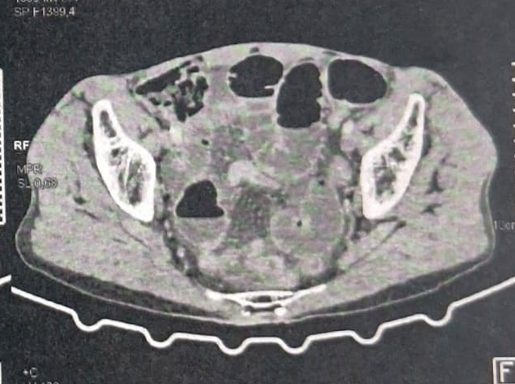
Figure 1 : Contrast-enhanced axial abdominal CT scan showing alternation of distended small bowel loops containing air–fluid levels.
The patient was prepared for an emergency exploratory laparotomy that revealed dilated small bowel loops measuring up to 4 cm in diameter proximal to a loop incarcerated through a 2-cm round defect in the mesentery of the terminal ileum (Figure 2). The findings were consistent with a congenital transmesenteric internal hernia of the terminal ileum. Following gentle reduction and careful assessment, the herniated bowel was found to be congested but viable (Figure 3), and bowel resection was deemed unnecessary. The mesenteric defect was closed using simple interrupted 4/0 Vicryl sutures.

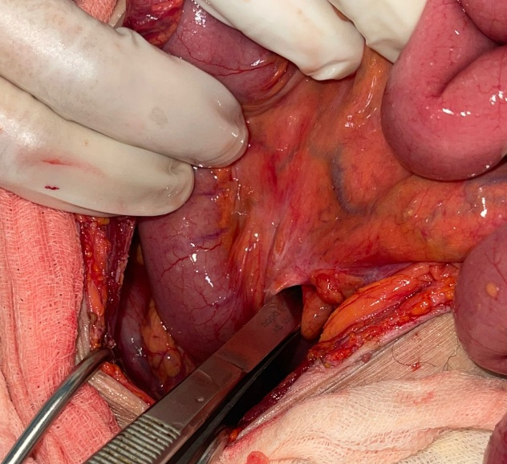
Figure 2 : The 2 cm defect in the mesentery of the terminal ileum.
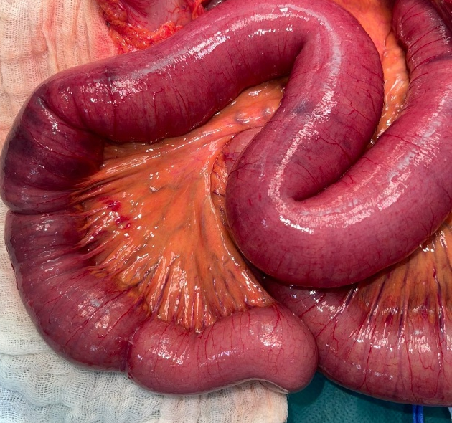
Figure 3 : The herniated bowel loop after reduction.

The postoperative course was uncomplicated. The patient was discharged on postoperative day 2 following the restoration of bowel function. Subsequent follow-up revealed no adverse events or recurrence of symptoms.
Discussion
Internal hernias are an uncommon cause of bowel obstruction, accounting for approximately 0.5% to 1% of all cases (1). They are broadly categorized based on the origin of the orifice, which may be a pre-existing normal foramen, a paranormal peritoneal fossa, or an abnormal opening in a mesentery or peritoneal ligament. (2).
Internal hernias are classified according to the anatomical location of the hernial orifice(3). The most common type is the paraduodenal hernia, accounting for more than half of all internal hernias (53%), followed by pericecal (13%), foramen of Winslow (8%), intersigmoid (6%), and transomental hernias (1-4%). Each type has distinct anatomical and clinical features. Paraduodenal hernias result from congenital anomalies of midgut rotation and are typically located to the left of the ligament of Treitz(4). Pericecal hernias occur around the cecum and may present with right lower quadrant obstruction(5). Herniation through the foramen of Winslow is rare and involves protrusion of bowel into the lesser sac, often associated with nonspecific symptoms(6). Intersigmoid hernias arise from a congenital peritoneal recess at the sigmoid mesocolon, whereas transomental hernias involve defects in the greater omentum and are more frequently acquired.(2)
Transmesenteric hernias are particularly uncommon, accounting for approximately 5–10% of all internal hernias. Around 35% of cases occur in children up to 10 years of age, in whom they represent the most frequent type of internal herniation (2,7). The occurrence of a congenital transmesenteric hernia in an elderly patient, as in our case, is exceptional and may explain the frequent diagnostic delay.
They lack a true hernial sac; however, they behave similarly to true internal hernias. The associated mesenteric defects are typically small, measuring about 2–5 cm in diameter, and are most often situated near the ligament of Treitz or the ileocecal valve (2,7).
Several hypotheses have been advanced to explain the pathogenesis of mesenteric defects, although their exact aetiology remains unclear. The most widely accepted theory suggests that relative intestinal ischemia during foetal development results in thinning of the peritoneal layers, ultimately leading to the formation of a mesenteric defect (2,7,8). Another proposed mechanism involves partial regression of the dorsal mesentery during embryonic development (9). Additional theories include rapid elongation of a mesenteric segment, intrauterine compression of the mesentery by the colon during midgut herniation, or abnormal fusion of two epithelial layers with insufficient interposed connective tissue (7,10). A genetic predisposition has also been suggested, supported by reported associations with inherited conditions such as cystic fibrosis, Hirschsprung’s disease, and intestinal atresia (7,11).
The clinical presentation is that of an acute small bowel obstruction(12). Standing abdominal radiography usually shows a non-specific obstruction of the distal small intestine. However, several dilated small bowel loops are often seen clustered in the right iliac fossa, a finding that, according to some authors, should raise suspicion of this diagnosis in patients without signs of infection or a history of abdominal surgery(13).
Even when a small bowel follow-through confirms distal small bowel obstruction, the underlying mechanism cannot be clearly identified with this examination. Contrast-enhanced abdominal computed tomography is therefore currently the best imaging(14) modality to determine the cause of obstruction, by demonstrating thickened and fixed small bowel loops located posterior to the mesentery, which itself is displaced anteriorly. Nevertheless, due to its rarity, a preoperative diagnosis of transmesenteric hernia remains exceptional in clinical practice (1).
The laparoscopic approach is advantageous, both diagnostically and therapeutically, since the defect is anterior, easy to identify, and can be repaired without difficulty (8). However, a midline laparotomy may be immediately preferred in cases of poorly tolerated, overt bowel obstruction syndrome (1). In our case, given the prolonged evolution and signs of significant bowel distension, a midline laparotomy was preferred.
Intra-operative diagnosis is generally straightforward and does not pose any particular problem(10,12,14).
The procedure consists of a gradual reduction of the herniated small bowel using gentle traction. However, the frequent delay in diagnosis in such cases means that intestinal ischemia is common, and the hernial orifice often appears too narrow to allow safe reduction of the incarcerated bowel. In this situation, it is necessary to enlarge the defect, either superiorly(1)—taking care to first identify the superior mesenteric artery—or inferiorly, while avoiding injury to the marginal arcade of the terminal ileum, for example by using mesenteric transillumination. In our case, the enlargement of the defect was not necessary and the gentle traction of the herniated bowel was sufficient to the reduction of the hernia.
In all cases, incision of the peritoneal layer of the hernial neck should be performed before complete division to avoid injury to a feeding vessel located at the edge of the defect. Finally, when intestinal necrosis is present, surgical management follows the standard principles of bowel resection(1).
Preventive treatment consists of closing the mesenteric defect with interrupted sutures using absorbable or non-absorbable material, while carefully preserving the mesenteric vessels that most often border the defect. It should be noted that transverse closure of the defect is preferable(14), as it widens the base of the intestinal loop; in contrast, longitudinal suturing may expose the patient to a risk of secondary volvulus of the adjacent bowel loop(1). In our case, the mesenteric defect was closed with interrupted absorbable sutures after reduction of the herniated bowel, with careful preservation of the adjacent mesenteric vessels.
Conclusion
Congenital transmesenteric internal hernia is a rare but potentially life-threatening cause of acute small bowel obstruction, particularly exceptional in elderly patients. Its clinical and radiological presentation is often non-specific, making preoperative diagnosis challenging despite advances in imaging. Early surgical exploration remains essential to prevent bowel ischemia and necrosis. Careful reduction of the herniated bowel and systematic closure of the mesenteric defect are crucial to ensure a favourable outcome and prevent recurrence.
Consent
As per international standards or university standards, patient(s) written consent has been collected and preserved by the author(s).
Ethical Approval:

As per international standards or university standards written ethical approval, has been collected and preserved by the author(s).

COMPETING INTERESTS DISCLAIMER:
Authors have declared that they have no known competing financial interests OR non-financial interests OR personal relationships that could have appeared to influence the work reported in this paper.
Disclaimer (Artificial intelligence)

Author(s) hereby declare that NO generative AI technologies such as Large Language Models (ChatGPT, COPILOT, etc.) and text-to-image generators have been used during the writing or editing of this manuscript.

References
1. Masson E. EM-Consulte. 2013. Traitement chirurgical des hernies internes.
2. Ghahremani GG. Internal abdominal hernias. Surg Clin North Am. 1984 Apr;64(2):393–406. doi:10.1016/s0039-6109(16)43293-7 PubMed PMID: 6729672.
3. Sinha P, Chauhan VS, Gupta S. Internal Transmesenteric Hernia Causing Small Bowel Obstruction: A Case Report. Cureus. 2025 Jun;17(6):e86498. doi:10.7759/cureus.86498 PubMed PMID: 40551730; PubMed Central PMCID: PMC12183535.
4. You Y, Wan F, Song G. Paraduodenal Hernia With Intestinal Obstruction During Pregnancy. Am J Case Rep. 2026 Feb 5;27:e951298. doi:10.12659/AJCR.951298 PubMed PMID: 41642772; PubMed Central PMCID: PMC12888419.
5. Kleyman S, Ashraf S, Daniel S, Ananthan D, Sanni A, Khan F. Pericecal hernia: a rare form of internal hernias. J Surg Case Rep. 2013 Feb 1;2013(2):rjs021. doi:10.1093/jscr/rjs021 PubMed PMID: 24964406; PubMed Central PMCID: PMC5912703.
6. Chrabalowski Jury MG, Begue Pons PM, Corvatta FA. Cecal internal hernia through Winslow’s hiatus: Laparoscopic resolution. Rev Fac Cienc Médicas. 2024 Sep 27;81(3):587–97. doi:10.31053/1853.0605.v81.n3.44555 PubMed PMID: 39352847; PubMed Central PMCID: PMC11536814.
7. Willems E, Willaert B, Van Slycke S. Transmesenteric hernia: a rare case of acute abdominal pain in children: a case report and review of the literature. Acta Chir Belg. 2018 Dec;118(6):388–91. doi:10.1080/00015458.2017.1399662 PubMed PMID: 29115904.
8. Newsom BD, Kukora JS. Congenital and acquired internal hernias: unusual causes of small bowel obstruction. Am J Surg. 1986 Sep;152(3):279–85. doi:10.1016/0002-9610(86)90258-8 PubMed PMID: 3752377.
9. Moudgil A, Pandove PK, Singh A, Pandove M, Sharda D, Sharda VK. An unusual case of transverse mesocolic internal hernia with abnormality of both hands and high arched feet. Int J Surg Case Rep. 2015 Jan 1;6:226–9. doi:10.1016/j.ijscr.2014.10.040
10. Nouira F, Dhaou BM, Charieg A, Ghorbel S, Jlidi S, Chaouachi B. Small bowel obstruction caused by congenital transmesenteric defect. Afr J Paediatr Surg AJPS. 2011;8(1):75–8. doi:10.4103/0189-6725.78934 PubMed PMID: 21478592.
11. Martin LC, Merkle EM, Thompson WM. Review of internal hernias: radiographic and clinical findings. AJR Am J Roentgenol. 2006 Mar;186(3):703–17. doi:10.2214/AJR.05.0644 PubMed PMID: 16498098.
12. Miskin G, Sabag H, Fardousi T, Kamari S, Kassab O. A transmesenteric hernia as a reason for small bowel obstruction in an adult: a case report. Int J Surg Case Rep. 2026 Feb;138(2):96–100. doi:10.1097/RC9.0000000000000021 PubMed PMID: 41815443; PubMed Central PMCID: PMC12974383.
13. He K, Ju Y, Cheng P, Xu P. Strangulated internal hernia via a congenital posterior gastric antral mesenteric defect in an adolescent: a rare case report and literature review. BMC Surg. 2025 Dec 30;25(1):620. doi:10.1186/s12893-025-03334-5 PubMed PMID: 41469651; PubMed Central PMCID: PMC12755002.
14. Jamal T, Biswas S. Small Bowel Strangulation in an Adult From an Internal Hernia Caused by a Rare Congenital Mesenteric Defect. Cureus. 2025 Jun;17(6):e85247. doi:10.7759/cureus.85247 PubMed PMID: 40605865; PubMed Central PMCID: PMC12221305.

