Case report

Late isolated abdominal wall recurrence of uterine carcinosarcoma: A favorable Outcome of a case report treated with wide surgical excision and prosthetic reconstruction

Abstract
Introduction
Uterine carcinosarcoma is a rare and highly aggressive malignancy with a high risk of recurrence. Recurrences typically involve the pelvis or distant organs, while isolated abdominal wall recurrence is exceptionally rare. We report a case of late isolated abdominal wall recurrence and its surgical management. This presentation emphasizes the necessity of prolonged and vigilant follow-up in affected patients.
Case report:
A 71-year-old postmenopausal woman presented with metrorrhagia. Diagnostic curettage revealed grade 2 endometrioid adenocarcinoma. She underwent radical hysterectomy with bilateral salpingo-oophorectomy and pelvic lymphadenectomy. Final histopathology confirmed uterine carcinosarcoma, and the patient received adjuvant radiotherapy, brachytherapy, and chemotherapy. After more than two years of complete remission, she developed an isolated sub-umbilical abdominal wall mass. Histopathological and immunohistochemical analyses confirmed recurrence of a poorly differentiated carcinoma of gynecologic origin. The patient underwent wide en bloc resection with dual-layer mesh reconstruction. The postoperative course was uneventful, with no evidence of recurrence at follow-up.

Conclusion:
Isolated abdominal wall recurrence of uterine carcinosarcoma is rare. Aggressive surgical resection with prosthetic reconstruction may provide effective local control in selected patients. Long-term surveillance is essential due to the aggressive nature of this malignancy

.Keywords:
Uterine carcinosarcoma; Abdominal wall recurrence; Prosthetic reconstruction; Immunohistochemistry; Case report.

Introduction

Uterine carcinosarcoma, also known as malignant mixed Müllerian tumor, accounts for less than 5% of uterine malignancies but is responsible for a disproportionate number of uterine cancer–related mortality [1,2]. It is currently classified as a high-grade endometrial carcinoma due to its aggressive clinical behavior and poor prognosis [3]. Despite advances in multimodal treatment strategies, recurrence rates remain high [4], with most relapses occurring in the pelvis or at distant sites such as the lungs and peritoneum [5]. In contrast, isolated abdominal wall recurrence is exceptionally rare and has been reported only sporadically in the literature [6]. The aim of this case report is to describe the clinical presentation, diagnostic approach, and surgical management of this rare pattern of recurrence, and to highlight its therapeutic implications.

Case report
A 71-year-old postmenopausal woman with a history of hypertension and gout presented with postmenopausal bleeding. Endometrial biopsy revealed grade 2 endometrioid adenocarcinoma. Pelvic magnetic resonance imaging suggested stage IA disease.
In July 2021, she underwent radical hysterectomy with bilateral salpingo-oophorectomy and bilateral pelvic lymphadenectomy. Final histopathological examination revealed uterine carcinosarcoma with a predominant endometrioid carcinomatous component, myometrial invasion greater than 50%, cervical stromal involvement, lymphovascular space invasion, negative pelvic lymph nodes, and clear vaginal margins. The tumor was staged pT2 according to the TNM 2017 classification of the American Joint Committee on Cancer (AJCC), 8th edition.
After multidisciplinary discussion, adjuvant treatment consisting of external beam pelvic radiotherapy, vaginal brachytherapy, and six cycles of paclitaxel–carboplatin chemotherapy was administered and completed in April 2022. Follow-up remained uneventful for more than two years.
In March 2025, routine surveillance imaging revealed a median sub-umbilical abdominal wall mass that was not present on previous examinations. Abdominal magnetic resonance imaging demonstrated a parietal lesion hypointense on T2-weighted sequences, with peripheral enhancement after gadolinium administration and diffusion restriction, suggestive of abdominal wall metastasis (Fig.1).
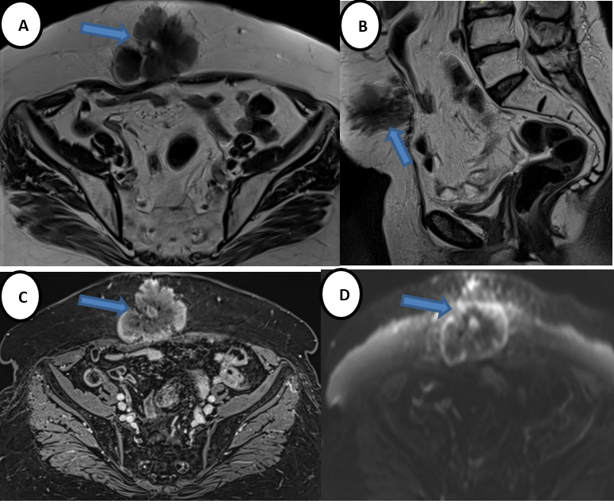
Fig.1 : Preoperative abdominal magnetic resonance imaging (MRI) showing a median abdominal wall mass.
(A) Axial T2-weighted sequence without fat suppression demonstrating a hypointense parietal lesion.
(B) Sagittal T2-weighted sequence confirming the anterior abdominal wall location.
(C) T1-weighted sequence after gadolinium administration showing peripheral enhancement.
(D) Diffusion-weighted imaging demonstrating peripheral diffusion restriction, consistent with abdominal wall metastasis

Core needle biopsy showed a poorly differentiated carcinoma. Immunohistochemical staining revealed positivity for CK7 and PAX8, with negativity for estrogen and progesterone receptors, supporting recurrence of the known gynecologic malignancy.
Following multidisciplinary discussion, surgical management was recommended. Wide en bloc excision of the abdominal wall tumor was performed through a midline incision (Fig.2), including the involved soft tissues and fascia (Fig. 3-4).
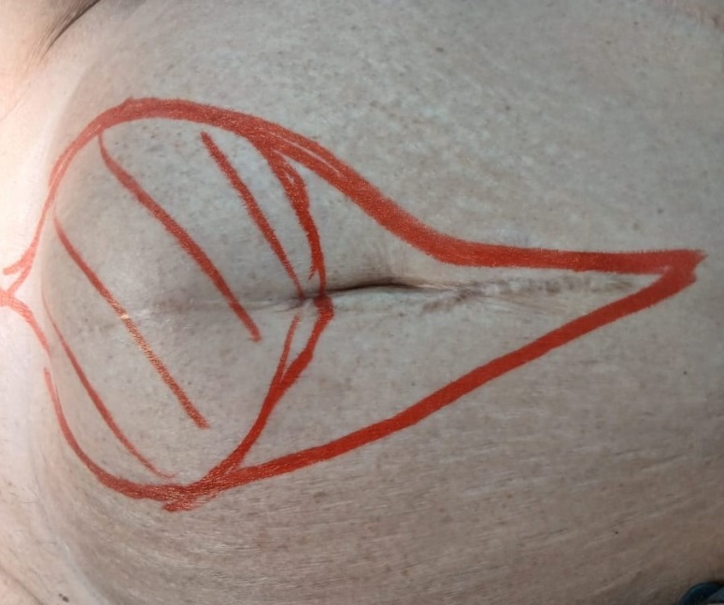
Fig.2 : Preoperative cutaneous marking of the sub-umbilical abdominal wall recurrence, outlining the planned wide oncologic excision with safety margins.

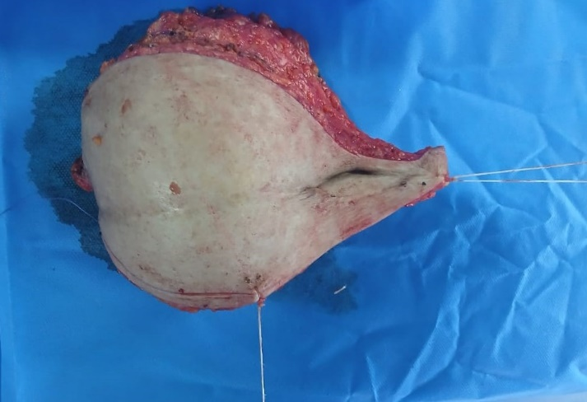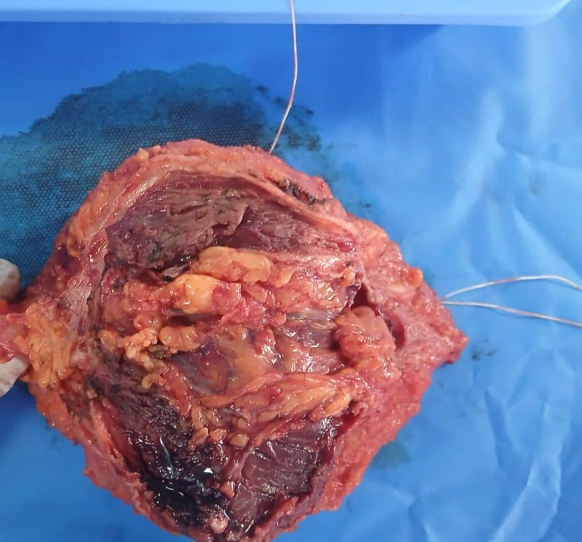
Fig 3 & 4 : Macroscopic appearance of the surgical specimen corresponding to the abdominal wall recurrence, sent for histopathological examination

No peritoneal carcinomatosis or ascites was observed intraoperatively (Fig. 5).

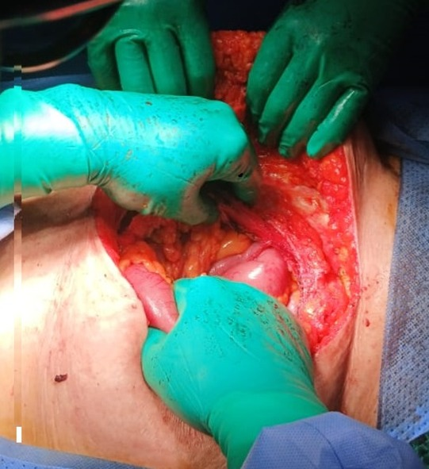
Fig.5 : Intraoperative view showing en bloc resection of the abdominal wall tumor through a midline iterative showing no ascites and no peritoneal carcinomatosis
The resulting abdominal wall defect was reconstructed using a dual-layer intraperitoneal mesh measuring 30 × 30 cm (Fig. 6).
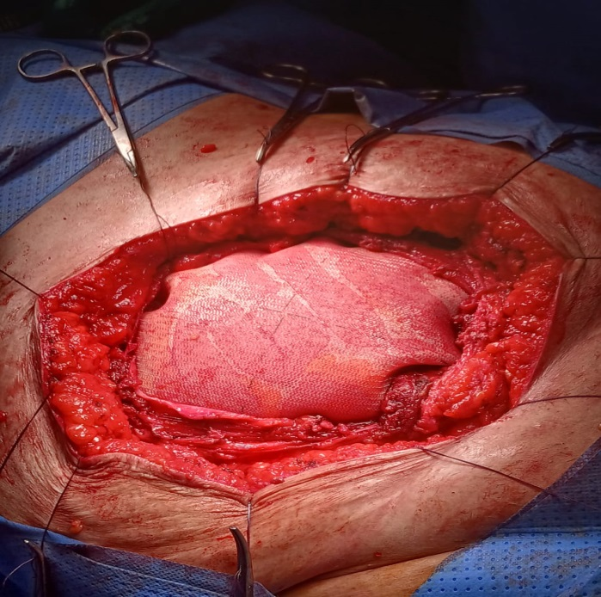
Fig.6 : Abdominal wall reconstruction using a dual-layer intraperitoneal mesh following wide tumor excision.
The postoperative course was uneventful.
Final Histopathological examination of the surgical specimen revealed : abdominal wall localization of spindle cell sarcoma with heterologous osteosarcomatous differentiation, without an epithelial component ; findings that are consistent with metastasis from known gynecologic carcinoma ; tumor size= 9,6cm and complete surgical resection (R0).

Discussion and literature review
Uterine carcinosarcoma is a rare but highly aggressive gynecologic malignancy associated with poor prognosis and high recurrence rates despite multimodal treatment. Although historically classified as a mixed epithelial–mesenchymal tumor, it is now widely regarded as a high-grade endometrial carcinoma with sarcomatous differentiation. This biological behavior accounts for its aggressive clinical course and propensity for early dissemination and recurrence [5,6].
Recurrence of uterine carcinosarcoma most commonly involves the pelvis, peritoneal cavity, lungs, liver, or lymph nodes. In contrast, abdominal wall recurrence is exceedingly rare and has only been sporadically reported in the literature. Similarly, uterine carcinosarcoma has demonstrated the ability to metastasize to unusual and unexpected sites, as illustrated by recent reports of isolated gastrointestinal metastasis [16]. These observations further emphasize the aggressive and biologically unpredictable nature of this tumor subtype. The present case is therefore remarkable for a late, isolated abdominal wall recurrence, occurring more than two years after completion of adjuvant therapy and in the absence of intra-abdominal or distant metastases.
Several mechanisms have been proposed to explain abdominal wall recurrence in gynecologic malignancies, including hematogenous dissemination, lymphatic spread, and iatrogenic tumor implantation during prior surgery. Abdominal wall recurrence has been increasingly recognized in rare case reports involving soft tissue and gynecologic tumors, supporting the hypothesis of tumor seeding along surgical tracts or areas of tissue vulnerability [7,8,15]. In a recently reported case of abdominal wall recurrence in soft tissue sarcoma, complete surgical excision with reconstruction was required, highlighting the complexity of local disease control in this anatomical site [15]. In the present patient, the absence of peritoneal carcinomatosis and ascites makes direct tumor seeding less likely, favoring hematogenous or lymphatic spread.
Diagnosis of abdominal wall recurrence can be challenging, particularly in patients with prolonged remission. Imaging findings are often non specific, making histopathological confirmation essential. Immunohistochemistry plays a critical role in distinguishing metastatic gynecologic malignancy from primary soft-tissue tumors or metastases of other origins. In the present case, positivity for CK7 and PAX8, combined with negativity for estrogen and progesterone receptors, supported the gynecologic origin of the lesion, in line with previously published data [10,11].
Due to the rarity of isolated abdominal wall recurrence, no standardized management strategy exists. Nevertheless, when recurrence is localized and complete resection is achievable, aggressive surgical management with negative margins remains the cornerstone of treatment. Several retrospective studies and case series suggest that secondary cytoreductive surgery may improve local disease control and potentially survival in carefully selected patients with isolated recurrence [12,13].
Radical resection of abdominal wall tumors frequently results in large parietal defects, necessitating complex reconstruction. Prosthetic mesh reconstruction allows restoration of abdominal wall integrity while preserving acceptable functional and oncologic outcomes. Dual-layer meshes are particularly advantageous when intraperitoneal placement is required, as they reduce the risk of visceral adhesions [14]. In this case, prosthetic reconstruction enabled complete oncologic resection without postoperative complications.

Limitations

This report is limited by its single-case nature, which restricts generalizability. Additionally, long-term comparative data are not available, and there are no established standardized guidelines for the management of isolated abdominal wall recurrence of uterine carcinosarcoma.

conclusion

Isolated abdominal wall recurrence of uterine carcinosarcoma is an exceptionally rare clinical entity that may occur after a prolonged disease-free interval. This case highlights that, in carefully selected patients, complete surgical excision with negative margins combined with prosthetic abdominal wall reconstruction can achieve effective local disease control.
Given the aggressive nature of uterine carcinosarcoma and its high risk of recurrence, long-term surveillance is essential, even after prolonged disease-free intervals. This case highlights the importance of maintaining a high index of suspicion for atypical recurrence patterns and reinforces the value of a multidisciplinary approach to management.

Ethics approval and consent

Ethical review and approval were waived for this study in accordance with institutional requirements for single case reports. Written informed consent was obtained from the patient for publication of this case report and accompanying images.

Disclaimer (Artificial intelligence)
Author(s) hereby declare that NO generative AI technologies such as Large Language Models (ChatGPT, COPILOT, etc.) and text-to-image generators have been used during the writing or editing of this manuscript.

COMPETING INTERESTS:
Authors have declared that they have no known competing financial interests OR non-financial interests OR personal relationships that could have appeared to influence the work reported in this paper.

References
[1] Amant F, Cadron I, Fuso L, et al. Endometrial cancer. Lancet Oncol. 2005;6:103–111.
doi:10.1016/S1470-2045(05)70089-3

[2] Cantrell LA, Blank SV, Duska LR. Uterine carcinosarcoma: A review of the literature. Gynecol Oncol. 2015;137:581–588. doi:10.1016/j.ygyno.2015.03.020

[3] Seagle BL, Shilpi A, Buchanan S, et al. Low-grade and high-grade uterine carcinosarcoma: A National Cancer Database study. Gynecol Oncol. 2017;146:254–262.
doi:10.1016/j.ygyno.2017.05.021

[4] Galaal K, van der Heijden E, Godfrey K, et al. Adjuvant chemotherapy and radiotherapy for uterine carcinosarcoma. Cochrane Database Syst Rev. 2013;CD006812. doi:10.1002/14651858.CD006812.pub2

[5] Matsuo K, Takazawa Y, Ross MS, et al. Significance of histologic pattern of carcinoma and sarcoma components on survival outcomes of uterine carcinosarcoma. Gynecol Oncol. 2018;149:547–553. doi:10.1016/j.ygyno.2018.03.055

[6] Nemani D, Mitra N, Guo M, Lin L. Patterns of recurrence and survival outcomes in uterine carcinosarcoma. Gynecol Oncol Rep. 2020;33:100610. doi:10.1016/j.gore.2020.100610

[7] Bendifallah S, Ouldamer L, Lavoue V, et al. Patterns of recurrence and survival after relapse in uterine carcinosarcoma. Ann Surg Oncol. 2019;26:111–120.
doi:10.1245/s10434-018-6907-3

[8] Tanner EJ, Garg K, Leitao MM Jr, et al. Histologic features associated with outcomes in uterine carcinosarcoma. Int J Gynecol Cancer. 2012;22:1166–1172.
doi:10.1097/IGC.0b013e318266a3f0

[9] Berton-Rigaud D, Devouassoux-Shisheboran M, Ledermann JA, et al. Gynecologic carcinosarcomas: Clinical and pathological characteristics. Eur J Cancer. 2014;50:144–152.
doi:10.1016/j.ejca.2013.09.003

[10] Amant F, Mirza MR, Koskas M, Creutzberg CL. Cancer of the corpus uteri. Int J Gynecol Obstet. 2018;143(Suppl 2):37–50. doi:10.1002/ijgo.12613

[11] McCluggage WG. My approach to the interpretation of endometrial biopsies and curettings. J Clin Pathol. 2006;59:801–811. doi:10.1136/jcp.2005.031989

[12] Bristow RE, Puri I, Chi DS. Cytoreductive surgery for recurrent gynecologic cancer. Gynecol Oncol. 2009;112:265–274. doi:10.1016/j.ygyno.2008.11.026

[13] Salani R, Backes FJ, Fung MF, et al. Posttreatment surveillance and diagnosis of recurrence in women with gynecologic malignancies. Gynecol Oncol. 2011;122:368–374. doi:10.1016/j.ygyno.2011.07.011

[14] Burger JW, Luijendijk RW, Hop WC, et al. Long-term follow-up of a randomized controlled trial of suture versus mesh repair of incisional hernia. Ann Surg. 2004;240:578–583. doi:10.1097/01.sla.0000078609.37538.3e

[15] Zuo X, et al. A case report of recurrent leiomyosarcoma with chondrosarcoma differentiation in the abdominal wall and a review of the literature. Pathol Oncol Res. 2023;29:1610795. doi:10.1007/s12253-023-01161-x (verify in journal portal if needed)

[16] Xiao L, et al. Rare case of duodenal metastasis of endometrial carcinosarcoma. Front Oncol. 2024;14:1338456. doi:10.3389/fonc.2024.1338456

