Neuroprotective Effect of Low-Dose of vitamin A on the Prefrontal Cortex of Methamphetamine Induced Adult Male Wistar Rats
ABSTRACT
Methamphetamine is a potent psychostimulant known to induce oxidative stress and neurodegeneration, particularly in the prefrontal cortex, which is responsible for executive and cognitive functions. Vitamin A, an essential antioxidant, may offer neuroprotection by modulating oxidative balance and preserving neuronal integrity. This study investigated the effect of low-dose vitamin A on the prefrontal cortex of adult male Wistar rats exposed to toxic doses of methamphetamine. Twenty adult male Wistar rats were divided into four groups consisting of five rats for each group. Group A received distilled water and normal feed; Group B received 10 mg/kg methamphetamine; Group C received 1.2 mg/kg vitamin A; and Group D received 10 mg/kg of methamphetamine and 1.2 mg/kg vitamin A. Treatment lasted for 28 days. Body weight, oxidative stress biomarkers [malondialdehyde (MDA), glutathione (GSH), and superoxide dismutase (SOD)], and behavioral performance using the Morris Water Maze test were assessed. Data were analyzed using one-way ANOVA and considered statistically significant when P <0.05. Methamphetamine exposure (Group B) led to significant weight loss (p = 0.001), elevated MDA levels, and reduced GSH and SOD activities, indicating oxidative stress. Co-administration of vitamin A (Group D) significantly improved antioxidant enzyme levels (p < 0.05) and reduced escape latency in the Morris Water Maze test, reflecting enhanced cognitive performance. Histological examination of the prefrontal cortex revealed that vitamin A mitigated methamphetamine-induced neuronal necrosis, cytoplasmic vacuolation, and perivascular edema, suggesting structural recovery. In conclusion, low-dose vitamin A may exert neuroprotective effects against methamphetamine-induced oxidative damage and cognitive impairment in the prefrontal cortex of adult male Wistar rats. These findings support the potential therapeutic role of vitamin A in managing methamphetamine-induced neurotoxicity.
Keywords: Toxic dose, Vitamin A, Wistar rat, Neuroprotective, Methamphetamine

Introduction
Methamphetamine (METH) is a potent central nervous system stimulant with neurotoxic effects on the brain, particularly in areas involved in cognition, behavior, and memory, such as the prefrontal cortex (PFC). The PFC plays a crucial role in executive functions, including decision-making, attention, working memory, and inhibitory control. Chronic exposure to METH is associated with significant damage to dopaminergic and glutamatergic systems within the PFC, leading to cognitive deficits, impulsivity, and emotional dysregulation (Kalivas and Volkow 2005).
Research has shown that the neurotoxic effects of METH exposure are partially mediated through oxidative stress, inflammation, and excitotoxicity (Ricaurte et al., 2005). METH-induced neurotoxicity can result in neuronal death, synaptic damage, and loss of dendritic spines, especially in areas of the brain like the PFC (Cadet et al., 2003). Consequently, the neurotoxic consequences of METH exposure represent a significant challenge for treating addiction and cognitive deficits in affected individuals.
Vitamin A, and its active form retinoic acid (RA), is known for its role in neurodevelopment and neuroprotection. Retinoic acid modulates various molecular pathways, including those involved in neuroplasticity, antioxidant defense, and neuronal survival (Maden 2007). Low doses of vitamin A have shown potential as a therapeutic agent for mitigating neuronal damage in different neurological conditions, including Alzheimer’s disease and other neurodegenerative disorders (Ochoa et al., 2012).
Retinoic acid influences synaptic plasticity and can regulate gene expression involved in neuronal function and repair (Maden 2007). The interplay between vitamin A and neurotoxic substances, such as METH, has been an emerging area of interest. Previous studies have indicated that vitamin A supplementation may attenuate neuroinflammation and oxidative damage associated with METH exposure, possibly by enhancing antioxidant defense mechanisms in the brain (Maden 2007).
However, the specific effects of low-dose vitamin A supplementation on the PFC following a toxic dose of METH have not been thoroughly explored, particularly in animal models. The prefrontal cortex is especially vulnerable to the neurotoxic effects of METH, given its high density of dopamine receptors and sensitivity to oxidative stress. Exploring the potential of low-dose vitamin A to counteract the harmful effects of METH in this region of the brain could provide insights into novel therapeutic strategies for neuroprotection and cognitive restoration in METH users.
Thus, the objective of this study is to investigate the effect of a low dose of vitamin A on the prefrontal cortex of adult male Wistar rats exposed to a toxic dose of methamphetamine. This research may contribute to the development of therapeutic interventions aimed at reducing cognitive impairments and protecting brain regions from METH-induced damage.
Materials and Methods
Location of the Study
This study was carried out at the Animal House of the College of Health Sciences, Nnamdi Azikiwe University, Nnewi Campus, Anambra State Nigeria.
Materials of the Study
During this investigation, the following materials were utilized. Twenty-four adult Wistar rats, Iron cages with iron nettings, sawdust (litters), Animal feed (grower and finisher mash), laboratory coat and gloves, dissecting kit, one stopwatch, digital video recorder, measuring cylinder, weighing balance, water bath, sample bottle, 10% Neutral Buffered Formalin (Sodium Phosphate Monobasic 4.0gm, Sodium Phosphate Dibasic 6.5gm, Formaldehyde 37% 100.0ml, Distilled Water 900.0ml), Cotton and anaesthesia (chloroform), Graded Alcohol (50%,70%,95% and absolute alcohol), Glass slides and slide rack, Hot plate, Xylene, Paraffin wax, Embedding plate, and pot, Deepex (DPX) Mountant, Hematoxylin and eosin, Coverslips, Light Microscope, Orbit shake, Diamond pencil, Rotatory microtome, Ethanol for tissue processing, Micropipette, Specimen labels, and bottles, Trays, Paraffin dispenser, Cassette and slide storage, Pipette tips (various sizes), Knife sharpener, Notebook, and biro.
Procurement and Housing of Experimental Animals
Twenty (20) adult Wistar rats weighing 180-250g were procured from Research Enterprise Farm, University of Ibadan, Oyo State. Perspex cages were used to house four (4) groups of six (6) animals each for routine experiments. Each cage had a wire gauze top for cross-ventilation. The animals were allowed for two weeks for acclimatization under normal temperatures (27-30⁰) at the Animal House of the Basic Medical Sciences. Nnamdi Azikiwe University, Nnewi Campus. They were fed ad libitum with water and Grower feed.
Procurement of Methamphetamine
Methamphetamine was procured from a local vendor and authenticated at the Department of Industrial Chemistry Nnamdi Azikiwe University Awka Anambra State.
Experimental Design and Protocols
Twenty adult male Wistar rats were randomly grouped into Four(4) groups with five (5) rats each.
Group A served as the control group which received feed and water only
Group B were administered 10mg/kgbw of Methamphetamine
Group C were administered 1.2mg/kgbw of Vitamin A (low dose)
Group D were administered 10mg/kgbw of Methamphetamine + 1.2mg/kgbw of Vitamin A (low dose)
Administration was done orally using oral gavage method. All experimental protocols were observed under strict supervision, the experiment lasted for 28 days, methamphetamine and vitamin A administration was done daily.

Morris Water Maze Test
Spatial learning and memory were assessed using the Morris Water Maze. The apparatus consisted of a circular pool measuring 120 cm in diameter and 50 cm in height, filled with water to a depth of 30 cm. The water temperature was maintained at 24 ± 1 °C and rendered opaque using non-toxic white paint. A circular escape platform measuring 10 cm in diameter was submerged 2 cm below the water surface in the target quadrant of the pool. Visual cues were placed around the testing room to aid spatial navigation. Animals underwent three training trials per day for five days. During each trial, each rat was gently released into the pool facing the wall from different starting points and allowed a maximum of 60 seconds to locate the hidden platform. Rats that failed to locate the platform within the allotted time were gently guided to the platform and allowed to remain on it for 20 seconds. Escape latency (time taken to locate the hidden platform) was recorded manually using a stopwatch. Shorter escape latency was interpreted as improved spatial learning and memory performance.
Termination of Treatment
Twenty-four hours (24) after the last administration, the animal were weighed first using a-weighing balance to get the final weight before the animals were sacrificed. The animals were anesthetized with chloroform, blunt scissors were used to make a midline incision along the abdomino-pelvic region in each rat to avoid damage to the visceral organs. The rats were dissected lying on their back, abdomen facing upwards and limbs pinned laterally to the board for easy dissection. The skull was gently opened, and the brain was removed intact. The prefrontal cortex was subsequently identified and excised with care. Tissue samples intended for histological analysis were fixed in 10% neutral buffer saline, while those designated for biochemical assays were processed and homogenized for analysis in the laboratory of Anatomy Department, Nnamdi Azikiwe University, Nnewi campus.
Tissue Processing
For easy study of sections under a microscope, the tissues were passed through several processes of fixation, dehydration, clearing, infiltration, embedding, sectioning, and staining.

Fixation
The essence of fixation is to preserve the various constituents of the cells in a life-like state and to prevent autolytic changes and putrefaction. Fixation was carried out in 10% Neutral Buffered Formalin (Sodium Phosphate Monobasic 4.0gm, Sodium Phosphate Dibasic 6.5gm, Formaldehyde 37% 100.0ml, Distilled Water 900.0ml). The tissues remained in the fluid for 48 hours. After fixation, the tissues were washed overnight under stream tap water to remove any surplus fixatives.
Dehydration
Dehydration of the fixed tissues was done to remove water and other substances. This was carried out in different percentages of alcohol 50%, 70%, and 95% absolute. In each grade of alcohol, tissues were changed twice for two (2) hours and one (1) hour for each change.
Clearing
The tissues were then cleared in two changes of xylene for two hours to remove the absolute alcohol that was used to dehydrate the tissues thereby replacing the absolute alcohol in the tissues with xylene. Xylene is usually miscible with absolute alcohol and paraffin wax; therefore, xylene was used as the clearing agent. After clearing, infiltration was carried out.
Infiltration
The tissues were transferred to two changes of molten paraffin wax for 2 hours each. I ensured that the amount of wax was 25-50 times the volume of the tissue. Infiltration was carried out to replace xylene in the tissue spaces with molten paraffin wax. The temperature of the paraffin was kept at 60ºC.
Embedding
The tissues were embedded by submerging them in two changes of molten paraffin wax contained in cassette metal moulds at a constant temperature of 52-60C in an oven of paraffin wax for 2 hours each time. The tissues were well-oriented in the moulds to ensure the presentation of the desired parts of the tissues to be examined in the tissue sections.
Sectioning
This is the process by which a thin slice of the tissue of about 4µm thick is made using a rotatory microtome (Leica RM 2125 RST).
Staining
Hematoxylin & Eosin Staining (H&E)
Sections were dewaxed using xylene for one (1) minute and then rehydrated by alcohol through descending grades of ethyl alcohol and thereafter washed in distilled water. The sections were stained with Hematoxylin for twenty (20) minutes and differentiated with 2% acid alcohol for two (2) seconds. The acid alcohol was washed off with tap water and the sections passed through running tap water for ten (10) minutes to regain the blue colour. The sections were counterstained in 1% aqueous eosin for thirty (30) seconds and were dehydrated through ascending grades of ethyl alcohol, cleared in xylene, and mounted using DPX. After which, the sections were viewed under a light microscope.
Data Analysis
Data was analysed using the SPSS version 27.0.1 software package. Mean and Standard Error of mean (SEM) were obtained, and one-way analysis of variance (ANOVA) was used to compare values between groups. Data was expressed as Mean + Standard Error of Mean (SD) and then considered statistically significant when P <0.05.
RESULTS
Physical and Behavioral Changes
At the beginning of the experiment, all the animals appeared healthy and agile. During the two weeks of acclimatization, their stools were observed to be normal.
Following the administration of methamphetamine, varying degrees of toxicity were observed. Generally, the signs of toxicity included:
- Bulging of the eyes
- Staggering / loss of balance
- Aggressiveness
These signs were not observed following the administration of vitamin A.

Table 1: Body Weight Result

GROUPS | WEIGHT (g) | MEAN± SEM | p-value
GROUP A | Initial  Final | 130.40±2.03  145.96±0.02 | 0.007
GROUP B | Initial  Final | 136.20±4.83  121.04±6.01 | 0.001
GROUP C | Initial  Final | 135.94±3.92  160.00±1.09 | 0.000
GROUP D | Initial  Final | 135.90±0.50  147.80±0.92 | 0.001

Table 2: Oxidative Stress Biomarkers Result
 | Groups | Mean ± SEM | p-value | F-value
MDA (nmol/mg protein) | Group A | 3.55± 0.02 |  | 1.842
MDA (nmol/mg protein) | Group B | 3.60 ± 0.18 | 0.087
MDA (nmol/mg protein) | Group C | 3.52 ± 0.53 | 0.214
MDA (nmol/mg protein) | Group D | 3.54± 0.71 | 0.176
GSH (umol/mg protein) | Group A | 1.60 ± 0.02 |  | 12.645
GSH (umol/mg protein) | Group B | 1.54 ± 0.01 | 0.002
GSH (umol/mg protein) | Group C | 1.60 ± 0.03 | 0.001
GSH (umol/mg protein) | Group D | 1.58± 0.02 | 0.001
SOD (U/mg protein) | Group A | 8.15 ± 0.02 |  | 15.672
SOD (U/mg protein) | Group B | 7.80 ± 0.02 | 0.001
SOD (U/mg protein) | Group C | 8.10 ± 0.01 | 0.003
SOD (U/mg protein) | Group D | 8.05 ± 0.03 | 0.011

MDA= Malondialdehyde, GSH= gluthathione, SOD= superoxide dismutase

Table 3: Morris Water Maze Test Result
 | Groups | Mean ± SEM | p-value | F-value
Morris Water Maze Test- Escape latency  (Seconds) | Group A | 23.60 ± 3.46 |  | 5.045
Morris Water Maze Test- Escape latency  (Seconds) | Group B | 37.31± 0.05 | 0.004
Morris Water Maze Test- Escape latency  (Seconds) | Group C | 24.70 ±0.05 | 0.003
Morris Water Maze Test- Escape latency  (Seconds) | Group D | 24.02± 0.66 | 0.001

Histology Results

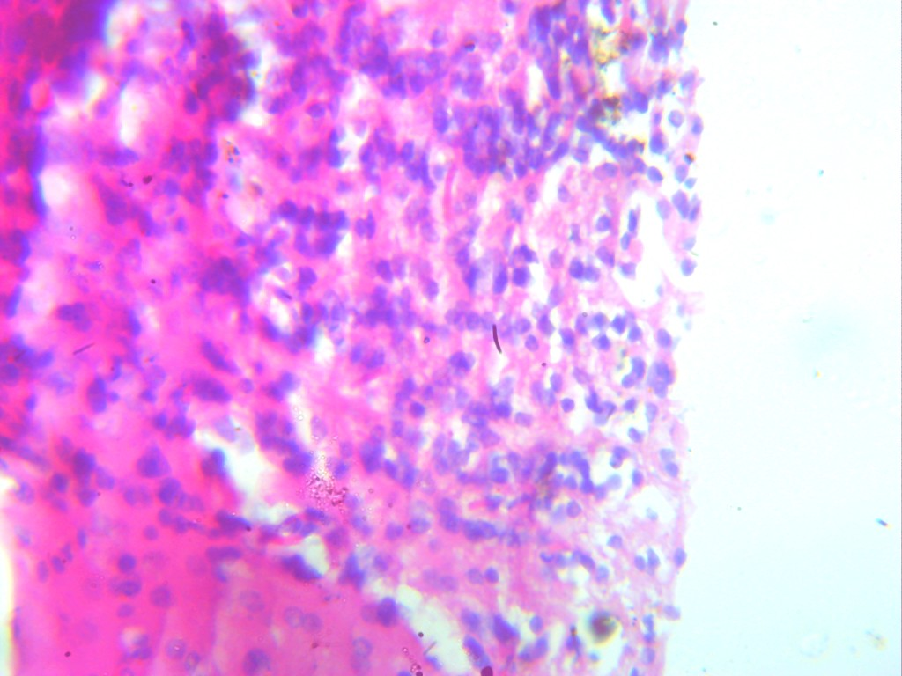
NC

Fig 1: Photomicrograph of Group A section of prefrontal lobe (x400)(H/E) shows
prefrontal lobe with active neuronal cell (NC)

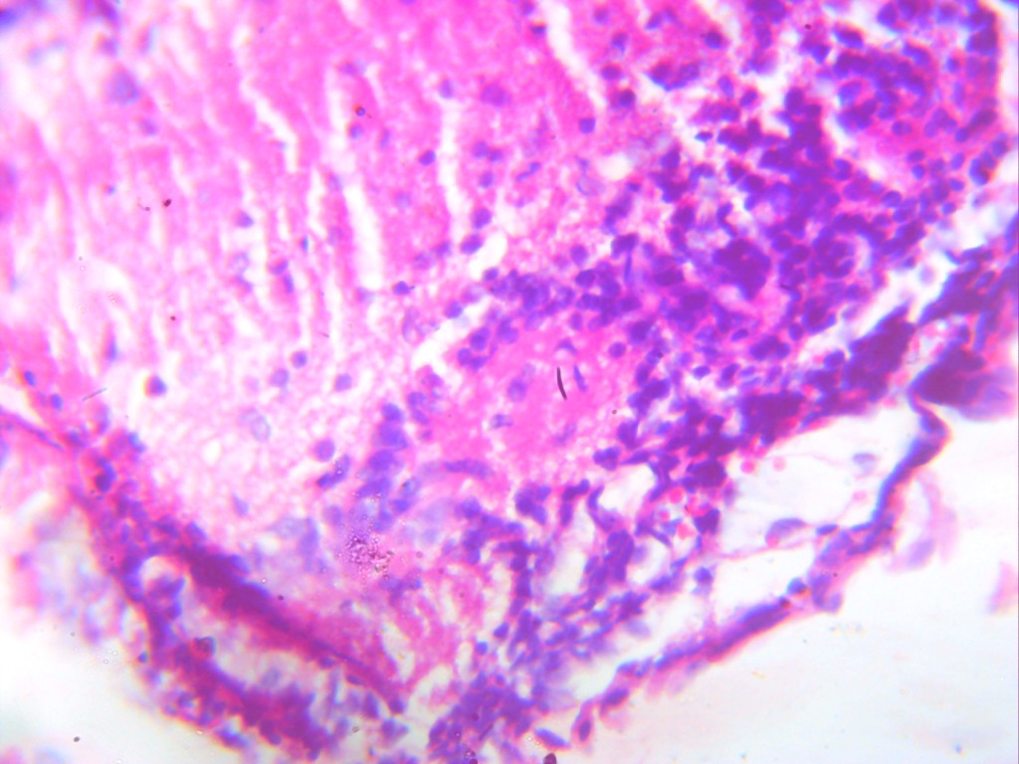
NC

PE

CV

Fig 2: Photomicrograph of group B section of prefrontal lobe induced with meth only (x400)(H/E)
shows severe neuronal damage with severe necrotic cells(NC) , cytoplasmic vacuolation (CV)
and perivascular edema (PE)

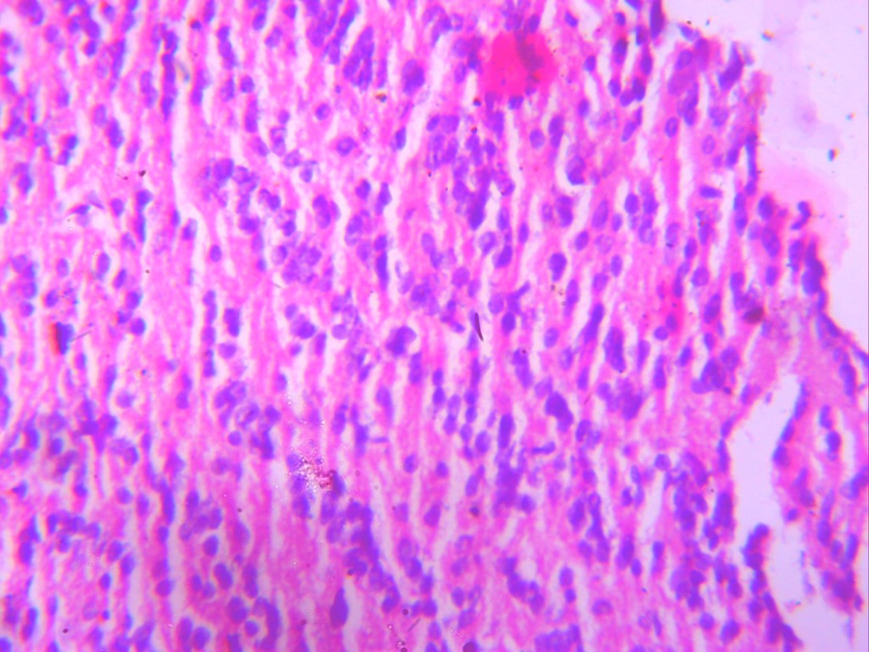

NC

Fig 3: Photomicrograph of ggroup C section of prefrontal lobe administered with
Vit A low dose (x400)(H/E) shows prefrontal lobe with active neuronal cell (NC)

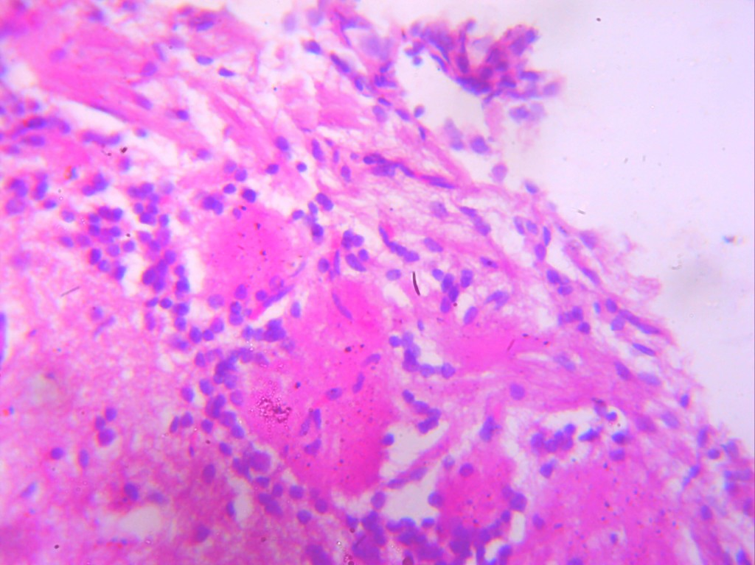
PE
F

Fig 4: Photomicrograph of ggroup E section of prefrontal lobe induced with meth and treated with
low dose vit A (x400)(H/E) shows mild healing with moderate perivascular edema (PE)
and fibrosis (F)

Discussion of Findings
The prefrontal cortex (PFC) plays a central role in executive functions, decision-making, and cognitive control. Exposure to neurotoxic substances such as methamphetamine (METH) has been reported to cause oxidative stress, neuronal damage, and cognitive impairment, particularly within the PFC. Recent studies demonstrate that METH disrupts redox homeostasis and induces neuroinflammation and apoptosis in cortical neurons (Robison et al., 2011). Conversely, vitamin A (retinol and its active metabolite, retinoic acid) has been recognized for its antioxidant and neuroprotective roles, which support neuronal survival and plasticity (Maden, 2007)
This study investigated the effect of low-dose vitamin A on the prefrontal cortex of adult male Wistar rats exposed to a toxic dose of methamphetamine, focusing on body weight changes, oxidative stress biomarkers, cognitive performance (Morris Water Maze test), and histological alterations.
The analysis of relative body weight revealed significant differences among experimental groups. Rats in the control group (Group A) showed a steady increase in body weight, reflecting normal physiological growth. In contrast, rats exposed to methamphetamine alone (Group B) experienced a reduction in final body weight, indicating the adverse metabolic effects of the drug. Methamphetamine-induced weight loss has been linked to appetite suppression, altered metabolism, and increased oxidative burden (Courtney and Ray 2014).
Groups treated with vitamin A alone (Group C) showed an increase in body weight, suggesting enhanced metabolic balance and growth-promoting effects of vitamin A. Interestingly, the group treated with both methamphetamine and vitamin A (Group D) exhibited partial restoration of body weight compared to the methamphetamine-only group, suggesting that vitamin A ameliorated the drug’s catabolic effects. These results align with findings that vitamin A supplementation can support tissue recovery and improve metabolic function during oxidative stress (Tanumihardjo 2016).
Methamphetamine exposure is known to increase oxidative stress and impair antioxidant defenses. In this study, MDA levels were elevated in the methamphetamine group, indicating enhanced lipid peroxidation and cellular membrane damage. This finding is consistent with earlier reports showing methamphetamine-induced oxidative stress and neuronal degeneration (Cadet and Bisagno 2020).
Conversely, glutathione (GSH) and superoxide dismutase (SOD) levels were reduced in the methamphetamine group compared to control, confirming depletion of endogenous antioxidants. However, vitamin A-treated groups (C and D) showed significant improvement in GSH and SOD levels, suggesting that vitamin A supported antioxidant enzyme activity and mitigated oxidative imbalance.
These results are supported that retinoic acid reduces oxidative injury by enhancing redox enzyme activity in neuronal tissues. Similarly, it is reported that vitamin A supplementation protects against neurotoxicant-induced oxidative stress by improving mitochondrial function and reducing reactive oxygen species (ROS) generation. (Maden 2007; Lane and Bailey 2005)
The Morris Water Maze test assessed spatial learning and memory functions associated with the prefrontal cortex. Rats exposed to methamphetamine alone (Group B) displayed significantly longer escape latencies, indicating impaired learning and cognitive performance. This aligns with findings that chronic methamphetamine exposure alters prefrontal cortical gene expression and impairs cognitive flexibility.
Rats treated with vitamin A (Groups C and D) showed shorter escape latencies comparable to the control, reflecting preserved cognitive ability. The improvement in the methamphetamine + vitamin A group suggests that vitamin A conferred cognitive protection, possibly by stabilizing synaptic integrity and reducing oxidative neuronal damage. Similar neuroprotective outcomes were observed that improved spatial memory and neuronal function following antioxidant therapy in drug-exposed rodents (Hritcu et al., 2012).
Histological observations further corroborated the biochemical and behavioral results. The control group exhibited normal neuronal cytoarchitecture with active neuronal cells. The methamphetamine-only group showed severe neuronal degeneration characterized by necrosis, cytoplasmic vacuolation, and perivascular edema, indicating marked neurotoxicity. These findings are consistent with reports that methamphetamine-induced cortical neuron loss through oxidative and inflammatory mechanisms (Cadet and Bisagno 2020).
In contrast, the vitamin A-treated group exhibited normal neuronal morphology, while the methamphetamine + vitamin A group showed mild healing with reduced vacuolation and moderate perivascular edema, indicating partial tissue recovery. Vitamin A’s role in promoting neuronal repair and preventing apoptosis may explain this outcome. Studies have shown that retinoic acid enhances neuronal differentiation and regeneration through gene modulation of neurotrophic factors (Maden 2007).
Conclusion
Methamphetamine exposure resulted in weight loss, oxidative imbalance, impaired learning, and histological degeneration. However, vitamin A treatment improved antioxidant defense, restored body weight, enhanced cognitive function, and supported neuronal integrity.
These findings suggest that vitamin A, through its antioxidant and neurotrophic properties, can mitigate methamphetamine-induced oxidative and neuronal damage. Nevertheless, the observed histological abnormalities in the treated group indicate that protection was incomplete, emphasizing the need for dose optimization and long-term evaluation.
Recommendations
- Mechanistic Studies: Further research should explore the molecular pathways underlying vitamin A’s neuroprotective effect, especially its interaction with oxidative and inflammatory mediators.
- Combined Therapy: Co-administration of vitamin A with other antioxidants such as vitamins C or E could be explored for synergistic neuroprotective effects.
- Longitudinal Studies: Extended-duration studies should assess whether vitamin A’s protective effects are sustained over time.
- Translational Relevance: Since methamphetamine abuse is a major public health issue, translating these findings into clinical or preventive strategies may offer therapeutic insights into managing stimulant-induced neurotoxicity.
Disclaimer (Artificial intelligence)

Author(s) hereby declare that NO generative AI technologies such as Large Language Models (ChatGPT, COPILOT, etc.) and text-to-image generators have been used during the writing or editing of this manuscript.

Ethical Approval
Ethical approval was obtained from the Ethical Committee, Faculty of Basic Medical Sciences, College of Health Sciences, Nnamdi Azikiwe University.

REFERENCES

- Cadet, J.L. and Bisagno, V., 2020. Neurotoxic effects of methamphetamine: mechanisms of oxidative stress, inflammation and neuronal injury. Neuropharmacology, 167, p.107972. Available at: https://doi.org/10.1016/j.neuropharm.2019.107972

- Cadet, J.L., Jayanthi, S. and Deng, X., 2003. Speed kills: cellular and molecular bases of methamphetamine-induced nerve terminal degeneration and neuronal apoptosis. FASEB Journal, 17(13), pp.1775–1788. Available at: https://doi.org/10.1096/fj.03-0098rev

- Courtney, K.E. & Ray, L.A., 2014. Methamphetamine: an update on epidemiology, pharmacology, clinical phenomenology, and treatment literature. Drug and Alcohol Dependence, 143, pp.11–21. Available at:https://doi.org/10.1016/j.drugalcdep.2014.08.003
- Hritcu, L., Ciobica, A., Stefan, M. and Mihasan, M., 2012. Neuroprotective effect of the antioxidant treatment on spatial memory deficits and oxidative stress induced by experimental neurotoxicity in rats. Behavioural Brain Research, 236(1), pp.117–124. Available at: https://doi.org/10.1016/j.bbr.2012.08.034

- Kalivas, P.W. and Volkow, N.D., 2005. The neural basis of addiction: a pathology of motivation and choice. American Journal of Psychiatry, 162(8), pp.1403–1413. Available at: https://doi.org/10.1176/appi.ajp.162.8.1403

- Lane, M.A. and Bailey, S.J., 2005. Role of retinoid signaling in the adult brain. Progress in Neurobiology, 75(6), pp.389–407.Available at: https://doi.org/10.1016/j.pneurobio.2005.04.005

- Maden, M., 2007. Retinoic acid in the development, regeneration and maintenance of the nervous system. Nature Reviews Neuroscience, 8(10), pp.755–765. Available at: https://doi.org/10.1038/nrn2211
- Maden, M., 2007. Retinoic acid in the development, regeneration and maintenance of the nervous system. Nature Reviews Neuroscience, 8(10), pp.755–765. Available at: https://doi.org/10.1038/nrn2211

- Ochoa, B., Synold, T.W. and Menter, D.G., 2012. Retinoic acid and neurodegenerative diseases: role in neuronal differentiation and neuroprotection. Current Neuropharmacology, 10(4), pp.355–364. Available at: https://doi.org/10.2174/157015912804143477

- Ricaurte, G.A., Yuan, J. and McCann, U.D., 2005. (Amphetamine-type) neurotoxicity: mechanisms and implications for human methamphetamine abuse. Annals of the New York Academy of Sciences, 1053, pp.209–218. Available at: https://doi.org/10.1196/annals.1344.018

- Robison, A.J. & Nestler, E.J., 2011. Transcriptional and epigenetic mechanisms of addiction. Nature Reviews Neuroscience, 12(11), pp.623–637. Available at: https://doi.org/10.1038/nrn3111
- Tanumihardjo, S.A., 2016. Vitamin A: biomarkers of nutrition for development. The American Journal of Clinical Nutrition, 104(Suppl 1), pp.953S–957S. Available at: https://doi.org/10.3945/ajcn.115.122713

