Effect of Tryptophan Supplementation in Commercial Feed on the Growth Performance of Mutiara Catfish Juveniles (Clarias gariepinus)

.
ABSTRACT

Aims: To determine the effect of tryptophan supplementation on growth parameters, FCR, PER, and protein retention, and to identify the optimal dose of tryptophan supplementation in commercial feed for the growth of juvenile Mutiara catfish
Study design: This research used an experimental method with a completely randomized design (CRD) in 4 treatments and 3 repetitions. The treatments given in this study consisted of treatment A (0%), treatment B with the addition of 0.15%, treatment C with the addition of 0.3% and treatment D with the addition of 0.45%.
Place and Duration of Study: This research was conducted in December 2025-March 2026, at the Hatchery Building 4, Faculty of Fisheries and Marine Sciences, Padjadjaran University.
Methodology: The research subjects were juvenile Mutiaral catfish (Clarias gariepinus) measuring 10–13 cm. The fish were reared in aquariums (40 × 24 × 25 cm) at a stocking density of 4 fish per aquarium. Acclimatization in the aquariums lasted 14 days. During the rearing period, the fish were fed a diet supplemented with tryptophan using the coating method. Feeding was conducted twice daily at 08:00 and 16:00 WIB. The amount of feed provided was 5% of the fish biomass, and the feeding rate was adjusted weekly based on the fish biomass weight. Data were analyzed using ANOVA and Duncan’s Multiple Range Test at a 95% confidence level.
Results: Tryptophan supplementation in commercial feed gave the best results on the growth of juvenile Mutiara catfish in treatment C with the addition of 0.3% tryptophan, resulting in absolute weight gain (222.70 g), FCR (1.46), PER (11.74%), and protein retention (51.25%).
Conclusion: Tryptophan supplementation has been shown to increase weight gain, decrease the protein conversion ratio (FCR), increase the protein efficiency ratio (PER), and increase protein retention. The best tryptophan supplementation dose was found in treatment C, with an addition of 0.3% of the feed.

Keywords: [Essential amino acids, growth, protein retention, protein efficiency ratio}

1. INTRODUCTION
Fish feed must contain essential amino acids to be converted into proteins, which are essential for tissue repair and growth. Amino acid deficiencies in fish can lead to poor growth and low feed efficiency (Pianesso et al., 2015). Essential amino acids are amino acids that cannot be synthesized in the body. Amino acids contained in feed in small amounts are limiting amino acids, such as lysine, methionine, and tryptophan (Anggorodi, 1994; NRC, 1993). Hoseini et al., (2020) stated that tryptophan is the amino acid with the lowest abundance in bony fish. This indicates that the need for tryptophan for protein synthesis is low.
Tryptophan supplementation in feed at a dose of 0.5% is beneficial for improving growth performance in rainbow trout, with the effect of reducing fish stress when reared at a high density of 15 kg/m³ (Hoseini et al., 2020). According Tang et al., (2013) tryptophan helps activate the amylase and lipase enzymes so that nutrients in the feed can be optimally utilized by the fish's body. Ahmed et al., (2024) lso explained that 0.4 g/kg tryptophan supplementation for rainbow trout Oncorhynchus mykiss showed an optimal growth value of 374.42% based on the results of the live weight gain (%). Several other studies on tryptophan supplementation have been conducted, including on white snapper, freshwater lobster, and even vannamei shrimp with positive results on growth, stress suppression and cannibalism levels (Mainisa et al., 2024; Trisnasari et al., 2020; Rachmawati et al., 2021).
On the other hand, excessive doses of tryptophan can inhibit fish growth. Miao et al., (2021) stated that excess tryptophan can cause decreased digestive enzyme activity. Ji et al., (2019) explained that insufficient tryptophan intake can cause eye cataracts in juvenile blunt snout bream. To prevent similar problems in fish, tryptophan should be added to the feed at an optimal dose According to the fish's growth requirements. This study aims to determine the effect of tryptophan supplementation in commercial feed on growth parameters, FCR, PER, and Protein Retention, and the optimal dose of tryptophan supplementation in commercial feed on the growth of juvenile Mutiara catfish.

2. MATERIALS AND METHODS
This research was conducted in December 2025-March 2026, at the Hatchery Building 4, Faculty of Fisheries and Marine Sciences, Padjadjaran University. The tools used in this research include: aquarium (40 x 24 x 25) cm, aerator installation, heater, dissolved oxygen (DO) meter, pH meter, digital scale, label paper, ruler, and siphon tool. The materials used in this research were juvenile catfish measuring 10-13 cm, commercial feed Prima Feed 1000 (39-41%), tryptophan powder, progol, and silica gel.

2.1 Research Design
This research was conducted experimentally using a Completely Randomized Design (CRD) with four treatments and four (Five replication required) replications. The treatments used were the addition of tryptophan: (A) 0% (control), (B) 0.15%, (C) =0.3% and (D) 0.45%.

2.1.1 Preparation for Implementation
The aquariums were thoroughly cleaned, dried, and labeled according to the treatment. Each aquarium was filled with 16 L of water and aerated for 24 hours before the fish were introduced. The fish were measured for length and weight, then placed in the aquariums at a stocking density of four. Acclimatization was carried out for 14 days to reduce stress levels.

2.1.2 Implementation of Research
This study was conducted over 56 days, with sampling every seven days. Tryptophan supplementation was performed using a coating method. Feeding was carried out twice daily, at 8:00 AM and 4:00 PM WIB. The amount of feed given was 5% of the fish biomass in each aquarium and adjusted according to their growth every seven days. Proximate analysis was conducted at the beginning (Add Reference od standard method) and end of the study at the Central Laboratory of Padjajaran University.

2.3 Observation Parameters
2.3.1 Average Weight Gain
The average weight growth is calculated using the Masyahoro & Setiawan (2023) formula is:
$$AWG=Wt-W0$$
Keterangan:
AWG : Average Weight Gain (g)
Wt : Final fish weight of the research (g)
W0 : Initial fish weight of the research (g)

2.3.2 Feed Conversion Ratio (FCR)
The feed conversion ratio is calculated according to Ridlo & Subagiyo (2013) is:
$$FCR=\frac{F}{\left(Wt+D\right)-W0}$$
Keterangan
FCR : Feed Conversion Ratio
F : Weight of Feed given (g)
Wt : Final fish weight of the research (g)
W0 : Initial fish weight of the research (g)
D : Weight of fish that died during the research (g)

2.3.3 Protein Efficiency Ratio (PER)
The calculation of the protein efficiency ratio value uses the formula Karapanagiotidis et al., (2022) is:
$$PER=\frac{Bt-B0}{Pi}$$
Keterangan:
PER : Protein Efficiency Ratio (%)
Bt : Final fish weight of the research (g)
Bo : Initial fish weight of the research (g)
Pi : Weight of feed consumed x % feed protein

2.3.4 Protein Retention
Protein retention can be determined by conducting a proximate analysis of fish body protein at the beginning and end of culture. The protein retention formula according to Biswas et al., (2019) is:
$$RP=\frac{(Fp-Lp)}{P}x100\%$$
Keterangan:
RP : Protein Retention
Fp : The amount of body protein at the end of research (g)
Lp : The amount of body protein at the start of research (g)
P : Amount of protein consumed during research

2.3.6 Proximate Analysis
Proximate analysis was conducted at the beginning and end of the study to determine the nutritional composition of the fish meat. One catfish was taken from each aquarium and the meat was then filleted. A 15 g sample of the meat was analyzed at the Central Laboratory of Padjajaran University. Analysis of the composition of water, ash, protein, fat, and carbohydrates in the fish was performed according to the AOAC (1990) method (Food and Agriculture Organization, 2006).
2.3.8 Add Method of Feed Preparation with stanard Reference
2.3.8 Water Quality
Water quality parameters include temperature, pH, and dissolved oxygen (DO). These parameters were measured every seven days before sampling (Add reference of standard method)

2.4 Analisis Data
The data obtained were analyzed using Analysis of Variance (ANOVA). If there was a significant difference between the treatments, the Duncan Multiple Range Test (DMRT) was performed with a 95% confidence level using SigmaPlot 16.0 software.

3. RESULTS AND DISCUSSION
3.1 Proximate Analysis
Proximate analysis is used to determine the nutritional composition of a sample. This nutrient content consists of moisture, ash, lipid, protein, and carbohydrates. The results of the proximate test are shown in Table 1.

Table 1 Results of Proximate Analysis of Mutiara Catfish Juveniles at the Beginning and End of the Research*
Parameters | Mutiara Catfish Juveniles
Parameters | Initial | Final
Parameters | Initial | A | B | C | D
Moisture (%) | 77,1 | 75,88 | 76,08 | 77,94 | 75,13
Ash (%) | 0,69 | 2,30 | 1,23 | 1,02 | 1,11
Lipid (%) | 2,07 | 3,01 | 1,47 | 0,49 | 1,59
Protein (%) | 14,4 | 17,96 | 18,53 | 18,96 | 18,56
Carbohydrate (%) | 5,74 | 0,85 | 2,69 | 1,59 | 3,61
*Proximate Analysis of Central Laboratory of Padjajaran University

Protein was measured using the Kjeldahl method, which determines protein levels by binding to non-protein nitrogen compounds such as urea, purine nucleic acids, and so on (Yunisa et al., 2023). The proximate test results, based on Table 1, show that the highest protein levels were found in fish treated with treatment C, with a value of 18.96%. This indicates that tryptophan can accelerate protein synthesis, so that when tryptophan levels in the feed are adequate, the amount of protein in the body will also increase (Ahmed, 2012).

3.2 Absolute Weight Gain
Based on the results of the research that has been done, tryptophan supplementation in artificial feed has an effect on the weight growth of Mutiara catfish. After conducting the ANOVA analysis of variance test, the absolute weight growth of juvenile Mutiara catfish ranged from 100.850±11.417 g - 222.700±21.149 g. In the further Duncan test, it was found that treatment C (0.3%/kg feed) was significantly different from treatment A (0%/kg feed), treatment B (0.15%/kg feed) and treatment D (0.45%/kg feed). Treatment D was significantly different from treatments A and B while treatment B was not significantly different from treatment A.
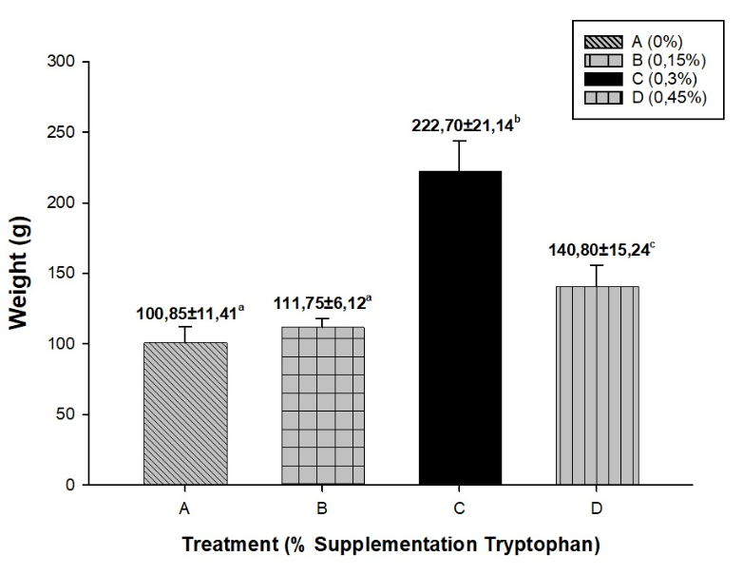
Figure 1 Absolute weight gain value of Mutiara catfish with the addition of different doses of tryptophan
Treatment C (3 g/kg feed) showed the highest weight growth with a result of 222.700 ± 21.149. This is in line with the research of Agustiana et al., 2022) which stated that the optimal dose of tryptophan addition to feed is 2.98 g/kg feed which produces a relative growth rate of 5.13%/day. Ahmed (2012) explained that tryptophan produces 5-hydroxytryptamine (5-HTP) which is converted into serotonin in the brain so that it can affect the behavior and appetite of fish. Therefore, when the appetite of fish is good, fish growth is optimal. Serotonin will in turn regulate the secretion of pituitary growth hormone (GH) which can trigger insulin-like growth factor-I (IGF-I) produced by the liver (Glass 2003).

3.3 Feed Conversion Ratio (FCR)
Feed conversion ratio (FCR) is an index of total feed utilization for growth or the number of grams of feed required by fish to produce 1g of wet weight of fish.

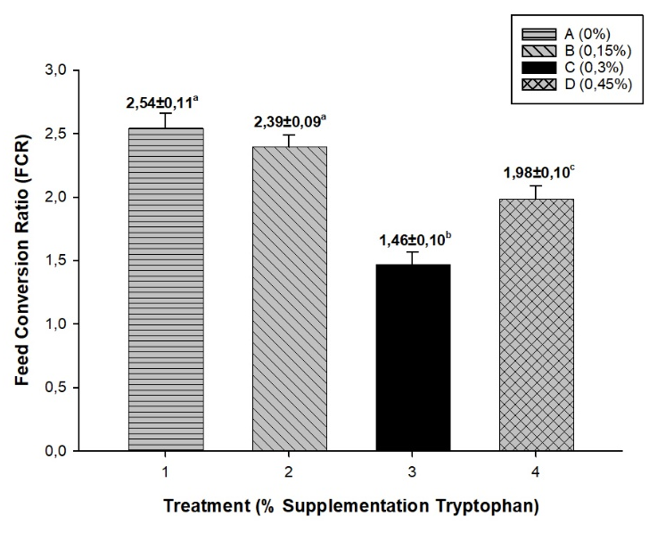

Figure 2 Feed conversion ratio value of Mutiara catfish with the addition of different doses of tryptophan
Treatment C showed the best FCR results compared to other treatments, with an FCR value of 1.468 (Figure 2). Effendie (1997) stated that catfish were able to utilize the feed given effectively for their growth and convert it into meat. The low FCR value in this treatment indicated that the fish's feed efficiency was higher (Pinto et al., 2019). Tryptophan supplementation with an appropriate dose (0.3%) will have an effect in suppressing the stress response, where cortisol and glucose levels decrease so that energy from feed can be utilized efficiently to increase fish growth as shown by weight growth (Figure 1), protein content (Table 1), and PER value of fish (Figure 3). The addition of 0.3% tryptophan in the feed provides an optimum feed use efficiency value compared to other treatments, because the final weight of the fish is higher compared to the amount of feed consumed leading to a low FCR value. (Hoseini et al. 2020). The low FCR value is also influenced by the addition of appropriate tryptophan which induces GH activity to break down feed into protein which causes increased fish growth but the feed consumed by the fish is not excessive (Winberg et al.,1997).

3.4 Protein Efficiency Ratio (PER)
The protein efficiency ratio is an indicator of the level of protein utilization in feed. A higher protein efficiency ratio indicates that the fish are effectively utilizing the protein contained in the feed.
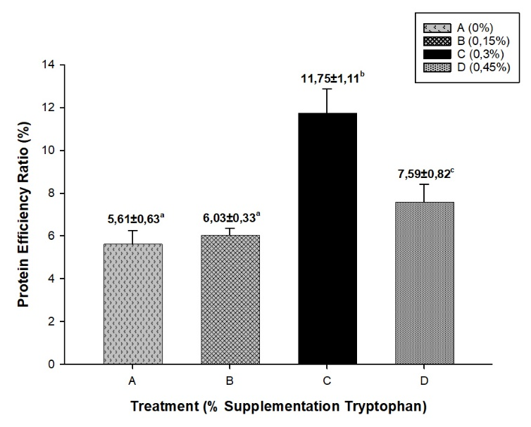
Figure 3 Protein efficiency ratio value of Mutiara catfish with the addition of different doses of tryptophan
Based on the ANOVA analysis results in Figure 3, treatment C (0.3%) demonstrated the highest protein efficiency ratio. This high value indicates that the protein was absorbed by the fish and utilized for optimal growth. This is supported by the results of the proximate analysis and body weight growth (Table 1 and Figure 1). Based on proximate test results, treatment C feed showed the highest protein content, at 11.742%. This is thought to occur because tryptophan can improve feed quality by increasing protein content, and the tryptophan content in treatment C met the Mutiara catfish's needs, resulting in optimal growth. The addition of 0.3% tryptophan in fish feed is very important because it is related to fish appetite, protein synthesis, and increased fish growth as shown in Table 1 and Figure 1.
Menurut Olusola dan Nwanna (2014) stated that the protein efficiency ratio is related to the growth rate of fish, where the higher the value of fish body weight growth indicates that the protein content and intake in the feed given meets the fish's needs for growth. Ji et al., (2019) also added that tryptophan helps increase protein synthesis, enabling fish to utilize their feed effectively for growth. A higher protein efficiency ratio indicates that the feed can be utilized efficiently and optimally for growth (Pinandoyo et al., 2021).
3.5 Protein Retention
Protein retention is a description of the amount of protein given, which can be absorbed and used to build or repair damaged body cells and is used by the fish's body for daily metabolism (Dani et al., 2005). Protein retention was calculated by analyzing the protein levels of the fish at the beginning and end of the study and then dividing by the amount of protein consumed during maintenance.
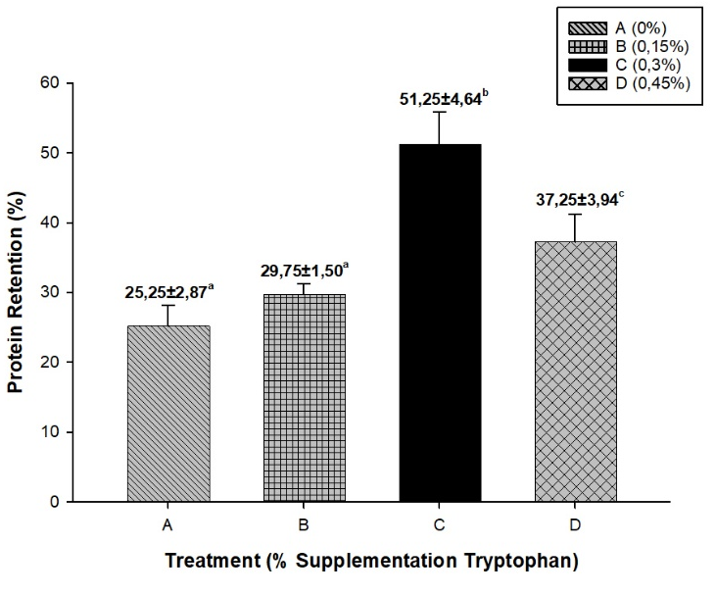
Figure 4 Protein retention value of Mutiara catfish with the addition of different doses of tryptophan
The results of the protein retention analysis also showed the same pattern as the protein efficiency ratio, where treatment C (0.3%) produced the highest protein retention value of 51.25% and was significantly different from treatments A, B, and D as shown in Figure 4. This indicates that treatment C with the addition of 0.3% tryptophan was able to utilize feed protein most efficiently to build body tissue. Protein retention was also in line with the results of the proximate analysis, where the protein in treatment C showed the highest results compared to other treatments. Ahmed (2012) states that tryptophan is an exogenous amino acid that promotes the conversion of other amino acids, increasing the rate of protein utilization and accelerating protein synthesis. Therefore, when tryptophan levels in the feed are adequate, the total protein content in the body also increases significantly. The high protein retention value in treatment C also indicates that the fish are significantly decomposing non-protein energy sources (fat and carbohydrates).
The appropriate tryptophan content in treatment C also plays a crucial role because tryptophan is an amino acid that can stimulate growth hormone secretion by increasing protein synthesis through the breakdown of fat and carbohydrates. Fat in the form of triglycerides must first be hydrolyzed into fatty acids and glycerol. Then glycerol can be used to produce a little energy which will later be converted into 3-phosphoglyceraldehyde, and this can be degraded into pyruvic acid which will later produce energy or amino acids which will become proteins in the Krebs cycle. Likewise, carbohydrates in the form of glycogen must first be hydrolyzed into glucose and go through a process like triglycerides which ultimately become amino acids or enter the Krebs cycle to become metabolic energy (Melzer, 2011). These changes in fat and carbohydrates resulted in increased growth which can be proven through the absolute weight growth parameter (Figure 1) where treatment C produced the highest value compared to other treatments.
3.6 Water Quality
Good water quality is water that can be tolerated by fish in their breeding tanks. Based on measurements during the study, the temperature, pH, and DO values ​​are shown in the table 2.
Table 2 Water Quality
Treatments | Temperature (°C) | pH | DO (mg/l)
A (0%/kg) | 30,8 | 7,0 | 5,8
B (0,15%/kg) | 31,1 | 7,1 | 5,7
C (0.30%/kg) | 30,9 | 7,1 | 6,1
D (0,45%/kg) | 31,1 | 7,1 | 5,7

Water temperature can affect fish growth and development. An appropriate water temperature can increase appetite, resulting in faster growth. According to SNI No. 3 of 2014 concerning catfish production, the optimum temperature range is 25-30°C. This indicates that the temperature conditions during the study for each treatment were appropriate. The degree of acidity, or pH, is the ability of water to bind or release hydrogen ions, indicating whether the water is acidic or basic. A pH value <5 will cause mucus to clump on the gills, leading to death, while a pH value >9 will reduce appetite. It can be seen that the pH values ​​during the study for all treatments were still considered safe based on the Indonesian National Standard No. 3 for catfish production, which is 6.5-8.5. The DO values ​​in the study showed results that were considered safe, ranging from 5.8 to 6.1. This is in accordance with concerning catfish production, which states that a safe DO value is >3 mg/l. (Cahyo 2009) also explained that the ideal dissolved oxygen content in water for the life and growth of catfish is above 4 mg/l.

4. CONCLUSION
Tryptophan supplementation significantly improved growth performance and other parameters. Treatment C (0.3%) demonstrated the best results, producing absolute weight gain (222.70 g), the best feed efficiency or feed conversion ratio (1.46), protein efficiency ratio (11.74%), and protein retention (51.25%).

DISCLAIMER (ARTIFICIAL INTELLIGENCE)
Author(s) hereby declare that NO generative AI technologies such as Large Language Models (ChatGPT, COPILOT, etc) and text-to-image generators have been used during writing or editing of this manuscript.

AcknowledgEments
The author would like to thank all parties involved in the implementation of this research.

Competing interests
Authors have declared that no competing interests exist.

Authors’ Contributions
Authors may use the following wordings for this section: IDB designed the study, performed the statistical analysis, wrote the protocol, and wrote the first draft of the manuscript. INP and I managed the analyses of the study. All authors read and approved the final manuscript. This work was carried out in collaboration among all authors. All authors read and approved the final manuscript

REFERENCES
Agustiana, A. B., Rachmawati, D., & Herawati, V. E. (2022). The Effect of Tryptophan in Artificial Feed on Feed Utilization Efficiency and Growth Performance of Sangkuriang Catfish (Clarias gariepinus) Fingerlings. Sains Akuakultur Tropis: Indonesian Journal of Tropical Aquaculture; Vol 6, No 2 (2022): SAT September Issue – DOI: 10.14710/Sat.V6i2.13903, 6(2), 202–215. https://doi.org/https://doi.org/10.14710/sat.v6i2.13903
Ahmed, I. (2012). Dietary amino acid l-tryptophan requirement of fingerling Indian catfish, Heteropneustes fossilis (Bloch), estimated by growth and haemato-biochemical parameters. Fish Physiology and Biochemistry, 38(4), 1195–1209. https://doi.org/10.1007/s10695-012-9609-1
Ahmed, I., Ahmad, I., & Malla, B. A. (2024). Effects of dietary tryptophan levels on growth performance, plasma profile, intestinal antioxidant capacity and growth related genes in rainbow trout (Oncorhynchus mykiss) fingerlings. Aquaculture, 585, 740710. https://doi.org/10.1016/J.AQUACULTURE.2024.740710
Anggorodi, R. (1994). General Animal Nutrition. PT. Gramedia.
Biswas, A., Araki, H., Sakata, T., Nakamori, T., & Takii, K. (2019). Optimum fish meal replacement by soy protein concentrate from soymilk and phytase supplementation in diet of red sea bream, Pagrus major. Aquaculture, 506, 51–59. https://doi.org/10.1016/J.AQUACULTURE.2019.03.023
Cahyo, B. (2009). *Budidaya Lele dan Betutu (Ikan Langka Bernilai Tinggi)* [Cultivation of Catfish and Betutu (A Rare, High-Value Fish)]. Pustaka Mina. Jakarta, 131.
Council, N. R. (1993). *Nutrient Requirements of Fish*. The National Academies Press. https://doi.org/10.17226/2115
Dani, N. P., Budiharjo, A., & Listyawati, S. (2005). Komposisi pakan buatan untuk meningkatkan pertumbuhan dan kandungan protein ikan tawes (*Puntius javanicus* Blkr.) [Artificial feed composition to enhance growth and protein content in Tawes fish (*Puntius javanicus* Blkr.)]. Biosmart, 7(2), 83–90.
Effendie, M. I. (1997). *Fisheries Biology* (Yogyakarta: Yayasan Pustaka Nusantara).
Food and Agriculture Organization. (2006). *FAO Yearbook: Fishery Statistics, Aquaculture Production*.
Glass, D. J. (2003). Molecular mechanisms modulating muscle mass. Trends in Molecular Medicine, 9(8), 344–350. https://doi.org/10.1016/S1471-4914(03)00138-2
Hoseini, S. M., Taheri Mirghaed, A., Ghelichpour, M., Pagheh, E., Iri, Y., & Kor, A. (2020). Effects of dietary tryptophan supplementation and stocking density on growth performance and stress responses in rainbow trout (*Oncorhynchus mykiss*). Aquaculture, 519, 734908. https://doi.org/10.1016/J.AQUACULTURE.2019.734908
Ji, K., Liang, H., Ren, M., Ge, X., Liu, B., Xi, B., Pan, L., & Yu, H. (2019). Effects of dietary tryptophan levels on antioxidant status and immunity for juvenile blunt snout bream (Megalobrama amblycephala) involved in Nrf2 and TOR signaling pathway. Fish & Shellfish Immunology, 93, 474–483. https://doi.org/10.1016/J.FSI.2019.08.006
Karapanagiotidis, I. T., Metsoviti, M. N., Gkalogianni, E. Z., Psofakis, P., Asimaki, A., Katsoulas, N., Papapolymerou, G., & Zarkadas, I. (2022). The effects of replacing fishmeal by Chlorella vulgaris and fish oil by Schizochytrium sp. and Microchloropsis gaditana blend on growth performance, feed efficiency, muscle fatty acid composition and liver histology of gilthead seabream (Sparus aurata). Aquaculture, 561, 738709. https://doi.org/10.1016/J.AQUACULTURE.2022.738709
Mainisa, M., Juliana, J., Khalil, M., Mahdaliana, M., & Salamah, S. (2024). Use of Tryptophan in Feed to Reduce Cannibalism in White Sea Bass (Lates calcarifer). Jurnal Laot Ilmu Kelautan, 6(1), 28. https://doi.org/10.35308/jlik.v6i1.9561
Masyahoro, A., & Setiawan, M. A. B. (2023). Growth of White Snapper (Lates calcarifer, Bloch 1790) Fingerlings at Various Salinities and Shrimp Head Waste Feed Dosages in Controlled Containers. Jurnal Ilmiah AgriSains, 24(2), 103–113.
Melzer, K. (2011). Carbohydrate and fat utilization during rest and physical activity. E-SPEN, 6(2), e45–e52. https://doi.org/10.1016/j.eclnm.2011.01.005
Miao, S., Chang, E., Han, B., Zhang, X., Liu, X., Zhou, Z., & Zhou, Y. (2021). Dietary tryptophan requirement of northern snakehead, Channa argus (Cantor, 1842). Aquaculture, 542, 736904. https://doi.org/10.1016/J.AQUACULTURE.2021.736904
Olusola, S. E., & Nwanna, L. C. (2014). Growth Performance of Nile Tilapia (Oreochromis niloticus) Fed Processed Soybean Meal Based Diets Supplemented With Phytase. International Journal of Aquaculture. https://doi.org/10.5376/ija.2014.04.0008
Pianesso, D., Radünz Neto, J., da Silva, L. P., Goulart, F. R., Adorian, T. J., Mombach, P. I., Loureiro, B. B., Dalcin, M. O., Rotili, D. A., & Lazzari, R. (2015). Determination of tryptophan requirements for juvenile silver catfish (Rhamdia quelen) and its effects on growth performance, plasma and hepatic metabolites and digestive enzymes activity. Animal Feed Science and Technology, 210, 172–183. https://doi.org/10.1016/J.ANIFEEDSCI.2015.09.025
Pinandoyo, P., Syakirin, M. B., & Mardiana, T. Y. (2021). Utilization of Trash Fish and Fermented Chicken Manure in Catfish Feed on the Growth and Survival of Sangkuriang Catfish (Clarias sp.). Pena Akuatika: Jurnal Ilmiah Perikanan Dan Kelautan, 20(1).
Rachmawati, D., Hutabarat, J., Fiat, A. I., Elfitasari, T., Windarto, S., & Dewi, E. N. (2021). The Addition of the Amino Acid Tryptophan in Feed on Cannibalism Rates and Growth of *Litopenaeus vannamei*. Jurnal Kelautan Tropis, 24(3), 343–352.
Ramos-Pinto, L., Martos-Sitcha, J. A., Reis, B., Azeredo, R., Fernandez-Boo, S., Pérez-Sánchez, J., Calduch-Giner, J. A., Engrola, S., Conceição, L. E. C., Dias, J., Silva, T. S., & Costas, B. (2019). Dietary tryptophan supplementation induces a transient immune enhancement of gilthead seabream (*Sparus aurata*) juveniles fed fishmeal-free diets. Fish and Shellfish Immunology, 93, 240–250. https://doi.org/10.1016/j.fsi.2019.07.033
Ridlo, A., & Subagiyo, S. (2013). Growth, Feed Conversion Ratio, and Survival Rate of *Litopenaeus vannamei* Shrimp Fed with FOS (Fructooligosaccharide) Prebiotic Supplementation. Buletin Oseanografi Marina, 2(4), 1–8.
Tang, L., Feng, L., Sun, C. Y., Chen, G. F., Jiang, W. D., Hu, K., Liu, Y., Jiang, J., Li, S. H., Kuang, S. Y., & Zhou, X. Q. (2013). Effect of tryptophan on growth, intestinal enzyme activities and TOR gene expression in juvenile Jian carp (Cyprinus carpio var. Jian): Studies in vivo and in vitro. Aquaculture, 412–413, 23–33. https://doi.org/10.1016/J.AQUACULTURE.2013.07.002
Trisnasari, V., Subandiyono, & Hastuti, S. (2020). The Effect of Tryptophan in Artificial Feed on Cannibalism Rates and Growth of Freshwater Lobster (Cherax quadricarinatus). Sains Akuakultur Tropis: Indonesian Journal of Tropical Aquaculture, 4(1), 19–30.
Winberg, S., Winberg, Y., & Anastasio, R. D. (1997). Effect of social rank on brain monoaminergic activity in a cichlid fish. Brain, Behavior and Evolution, 49(4), 230–236. https://doi.org/10.1159/000112994
Yunisa, Y., Suhaera, S., & Sari, S. (2023). Proximate Analysis of Bronok (Acaudina Malpadioides). The Journal General Health and Pharmaceutical Sciences Research, 1(2), 31–40. https://doi.org/10.57213/tjghpsr.v1i2.224

