Standardize Concentration of the Nutrient Solution for Different Substrates in Hydroponics System

Abstract
Hydroponic cultivation is gaining importance as a sustainable and efficient method for crop production under controlled environmental conditions. The present study was conducted to standardize nutrient solution concentration for different growing substrates in hydroponic basil cultivation under a naturally ventilated polyhouse at Dr. NTR College of Agricultural Engineering, Bapatla, Andhra Pradesh. The experiment consisted of four nutrient concentrations viz., 900 ppm, 1000 ppm, 1100 ppm and 1200 ppm, and four growing media namely rockwool, clay balls, perlite and vermiculite. The experiment was carried out during four different seasons to evaluate the interaction effect of nutrient concentration and growing media on basil yield. Statistical optimization and analysis were performed using Design-Expert employing a split plot-multilevel categoric factor design. Analysis of variance (ANOVA) indicated that nutrient concentration, growing media and their interaction significantly influenced basil yield (p<0.05). The developed regression models showed high coefficients of determination (R² > 0.87), indicating good model adequacy and prediction accuracy. The results revealed that 1100 ppm nutrient concentration produced superior yield compared to other concentrations across seasons. Vermiculite performed better during summer conditions, whereas rockwool and clay balls showed improved performance during cooler seasons due to better aeration and moisture balance. The optimization study demonstrated that suitable nutrient concentration combined with appropriate growing media significantly enhanced basil productivity in hydroponic systems. The study concluded that 1100 ppm nutrient concentration with suitable substrate selection can be recommended for maximizing basil yield under protected hydroponic cultivation.
Key words: Hydroponics, Nutrient Concentration, pH, Electrical Conductivity (EC), Design Expert-13, Growing Media

Introduction
Hydroponics is a method of growing plants without soil, using mineral nutrient solutions in an aqueous solvent. With the increasing demand for sustainable and space-efficient farming techniques, hydroponic systems have gained prominence due to their potential to optimize resource use and enhance crop productivity. In addition to using water efficiently and avoiding the need for pesticides, hydroponic culture eliminates soil-borne diseases (Ragaveena et al., 2021). The objective of maximizing food production per unit area through smart agricultural technologies is therefore receiving increasing attention (Ragaveena et al., 2021). Among the important factors influencing hydroponic crop performance, nutrient solution concentration and growing media play a major role in determining plant growth, nutrient uptake, and yield. Different substrates such as rockwool, clay balls, perlite, and vermiculite possess unique physical characteristics that influence water retention, aeration, and nutrient availability to plant roots.
In hydroponic cultivation, the nutrient solution directly supports plant growth by supplying essential nutrients to exposed roots, thereby reducing weed growth and minimizing the use of chemicals and pesticides (Pala et al., 2014; Lakhiar et al., 2018; Lakhiar et al., 2020). Nutrient solution sprays also help in root sterilization and improve nutrient contact with the root surface (Cho WooJae et al., 2018). Efficient management of nutrient concentration, pH, and electrical conductivity (EC) is essential for maintaining balanced nutrient availability and achieving optimum plant performance. Variations in nutrient concentration or unsuitable substrate properties may adversely affect nutrient uptake, resulting in poor growth and reduced yield. Therefore, the selection of suitable growing media along with proper nutrient concentration becomes essential for successful hydroponic cultivation under controlled environments.
The aim of this study is to standardize the nutrient solution concentration for different hydroponic substrates in order to identify the optimum combination that enhances crop growth and yield under hydroponic conditions. The study also aims to evaluate the interactive effects of nutrient concentrations and growing media using statistical optimization through Design-Expert, thereby developing efficient, sustainable, and precision-based hydroponic production practices for high-value crops grown in controlled environments.

Materials and Methods
The present investigation was carried out in a naturally ventilated polyhouse established at Dr. NTR College of Agricultural Engineering, having dimensions of 20 m × 12 m. Naturally ventilated polyhouses are most suitable in regions with moderate climatic conditions, where temperatures are neither extremely high nor extremely low. The structure was designed with side openings that can be adjusted to facilitate the entry of cool air and the removal of warm air, thereby maintaining a favorable growing environment. The experiment consisted of four nutrient solution concentrations, namely T1 (900 ppm), T2 (1000 ppm), T3 (1100 ppm), and T4 (1200 ppm), along with four growing substrates: M1 (Rock wool), M2 (Clay balls), M3 (Vermiculite), and M4 (Perlite).
Growing Mediums in hydroponics
In most hydroponic systems, various growing media are used to provide root support and to maintain an optimum balance between water availability and oxygen supply to the roots.
Rock wool
Hydroponics Rockwool is one of the most commonly used growing media in hydroponic systems. It is manufactured by melting basaltic rock and spinning it into fine fibres. Due to its biologically and chemically inert nature, it is free from pests, diseases, and weed seeds (Putra and Yuliando, 2015). It serves as an inert substrate suitable for both free-drainage and recirculating hydroponic systems. Rockwool is produced through the aerosolization of molten mineral materials, forming a fibrous structure that promotes capillary action and resists microbial decomposition. The medium possesses high water-holding capacity while maintaining adequate aeration. Its ability to retain large amounts of water provides an added advantage during power interruptions or equipment failures, as illustrated in Fig. 1.
Clay balls (Hydroton)
Hydroton, also known as lightweight expanded clay aggregate (LECA), is a suitable growing medium for hydroponic systems where nutrients are supplied through a controlled water solution. It is produced by heating clay pellets at high temperatures (around 1200 °C) in rotary kilns, causing them to expand and develop a porous structure, as shown in Fig. 2. These clay pellets are inert, pH neutral, and contain no nutritional value. The major advantage of Hydroton is its lightweight nature and resistance to compaction over time. It is also considered an environmentally friendly and reusable medium because it can be cleaned and sterilized using white vinegar, chlorine bleach, or hydrogen peroxide solutions followed by thorough rinsing. However, some researchers suggest avoiding reuse of clay pebbles due to root penetration and accumulation within the medium even after cleaning.
Perlite
Perlite is a lightweight material derived from a siliceous volcanic mineral (Hussain et al., 2014). It retains less water while providing greater aeration. Perlite is formed from volcanic materials such as granite, obsidian, pumice, and basalt (George and George, 2016). Perlite is a porous growing medium that provides excellent water retention and drainage properties, which are highly beneficial in hydroponic systems, as shown in Fig. 3. It is an inert and sterile medium, making it safe for use without the risk of introducing pests, unlike soil-based media. Perlite is produced by superheating volcanic rock, causing it to expand into lightweight glass-like particles. It can be used either loosely or in plastic sleeves immersed in water. Perlite is also commonly incorporated into potting soil mixtures to reduce soil compaction and improve drainage. However, when used in flood-and-drain systems without proper containment, it may float. This volcanic material undergoes natural high-temperature fusion, a process known as “Fusionic Metamorphosis.”
Vermiculite
Like perlite, vermiculite is a mineral that is heated at high temperatures to expand into lightweight particles. Vermiculite retains more water than perlite and possesses a natural wicking property, which helps in the movement of water and nutrients in passive hydroponic systems, as shown in Fig. 4. However, excessive water retention with limited air around the roots may affect plant growth; therefore, the water-holding capacity of the medium can be gradually reduced by mixing higher proportions of perlite. Vermiculite also enhances the availability and absorption of essential nutrients such as magnesium, calcium, and potassium by plants. In addition, it can be mixed with other soilless materials like perlite and pumice to prepare customized hydroponic growing media. The physical properties like bulk density and porosity of bedding materials used are presented in Table.1.
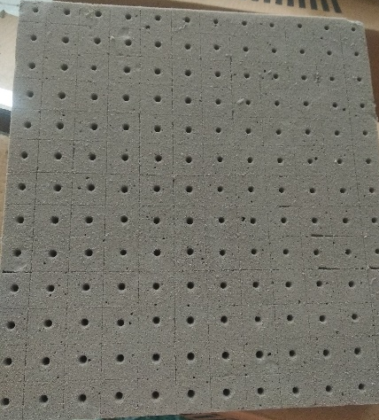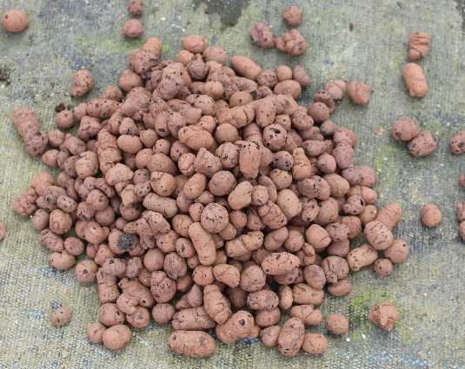
Fig.1 Rock wool Fig.2 Clay balls (Hydrotons)
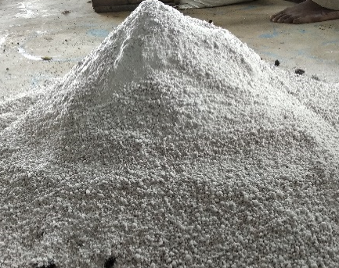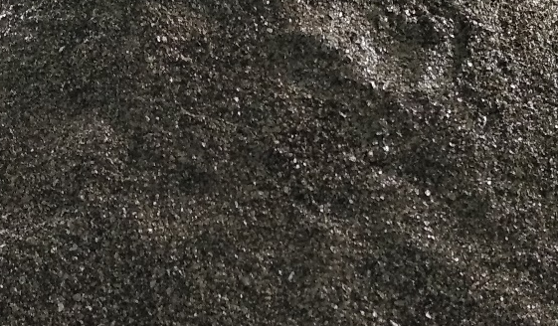
Fig.3 Perlite Fig.4 Vermiculite
Table.1 Bulk density and porosity of growing media
Substrates | Bulk density (kg/m³) | Total porosity(%v/v)
Vermiculite | 90-150 | 90-95
Perlite | 80-120 | 85-90
Rockwool | 80-90 | 94-97
Expanded clay | 600-900 | 85-90
Source: Pardossi et al. (2011)
Hydroponic Nutrient Solution
In hydroponic systems, all essential plant nutrients are supplied through the nutrient solution. Seventeen elements are considered essential for proper plant growth, and these are classified into macronutrients and micronutrients (Khan, 2018). Macronutrients include carbon, hydrogen, oxygen, nitrogen, phosphorus, potassium, sulfur, calcium, and magnesium, whereas micronutrients include iron, manganese, zinc, boron, molybdenum, chlorine, copper, and nickel. The composition of nutrient solutions used in hydroponics differs significantly from those designed for soil cultivation because plants grown in soil obtain several nutrients directly from the soil (El-Kazzaz and El-Kazzaz, 2017). In hydroponic crop production, the supply of nutrient solution mainly depends on two important parameters, namely pH and electrical conductivity (EC) (Khan, 2018). The preparation of the nutrient solution involves mixing the required nutrients in a specified volume of water as described below.
The nutrient solution was prepared in the reservoir according to the recommended dose for each treatment. Four different nutrient concentrations were maintained during the experiment: T1 (900 ppm), T2 (1000 ppm), T3 (1100 ppm), and T4 (1200 ppm).
To standardize the nutrient concentration of 900 ppm, the reservoir was first filled with 150 L of water, followed by the addition of 1.7 L each of nutrient solution A and nutrient solution B.
For the 1000 ppm concentration, the reservoir was filled with 150 L of water, and 2.6 L each of nutrient solution A and nutrient solution B were added.
To obtain the 1100 ppm concentration, 150 L of water was taken in the reservoir, and 3.25 L each of nutrient solution A and nutrient solution B were mixed into it.
Similarly, for the 1200 ppm concentration, the reservoir was filled with 150 L of water, and 4.4 L each of nutrient solution A and nutrient solution B were added.
pH of Water
The pH of the nutrient solution was measured using a pH meter as shown in Fig. 5 to determine the acidity or alkalinity of the solution on a scale of 1 to 14. pH plays an important role in the availability of essential plant nutrients in the nutrient solution (Hussain et al., 2014). The optimum pH range for hydroponic cultivation is between 5.8 and 6.5 (Khan, 2018). Potassium hydroxide was used to increase the pH of the nutrient solution when it fell below the optimum range, while phosphoric acid solution was added to reduce the pH when it exceeded the desired level. If the pH is higher than the optimum range, nutrient deficiencies or toxicity symptoms may occur in plants. The suitable pH range may vary depending on the crop species (Hussain et al., 2014).
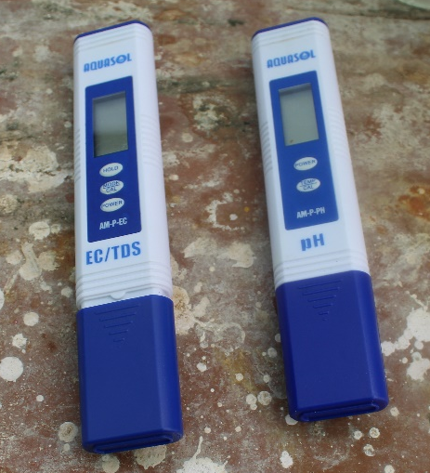
Fig.5 Electrical conductivity meter/TDS and pH Meter
Electrical Conductivity
Electrical conductivity (EC) represents the strength of the nutrient solution and is measured using an EC meter. It is directly related to the concentration of dissolved salts in water; therefore, EC indicates the total concentration of nutrients present in the solution. The optimum EC range for hydroponic cultivation is generally between 1.5 and 2.5 dS/m. If the EC exceeds the optimum range, nutrient uptake by plants may be restricted due to increased osmotic pressure. Conversely, if the EC falls below the recommended range, plant growth, health, and yield may be adversely affected. As plants absorb water and nutrients from the solution, the total salt concentration and EC of the nutrient solution continuously change. When the EC becomes higher than the recommended level, fresh water should be added to dilute the solution. If the EC is lower than the desired range, additional nutrients should be supplied to increase it (Hussain et al., 2014). The electrical conductivity was measured using an EC/TDS meter manufactured by Aquasol, as shown in Fig. 5.
Phosphoric Acid
Most hydroponic growers reduce the pH of the nutrient solution by using phosphoric acid (H₃PO₄). Phosphoric acid contains phosphorus (P) and serves multiple functions, including plant nutrition, pH adjustment, and cleaning of irrigation equipment such as dripper lines by preventing lime precipitation. It is a rich source of phosphorus for plants and is suitable for use in polyhouse crops, open field crops, and fruit trees. Phosphoric acid is widely used in fertilizers, where it represents the “P” component in the N-P-K ratio. Food-grade phosphoric acid can also be used to decrease the pH of soil or nutrient solutions. However, it is highly caustic at high concentrations and should be handled carefully. In the present study, phosphoric acid solution was added drop by drop into the nutrient reservoir whenever the pH of the nutrient solution increased above the desired level, until the required pH range was achieved.
Potassium Hydroxide
Potassium hydroxide is commonly available as white, odorless pellets, making it relatively safe and easy to handle. It is frequently prepared and used in aqueous solution form. Potassium hydroxide (KOH), is one of the most widely used bases for pH adjustment. When the water pH falls below 5.8, a base should be added to increase the pH level. The KOH solution can be gradually added to the nutrient tank until the pH of the water, before adding nutrients, reaches the desirable range of 5.8 to 6.5. This base solution, formulated using potassium hydroxide, should be applied in small quantities whenever the nutrient solution pH becomes too low, thereby maintaining the proper pH level.
Design Expert-13 Software
The experimental data were statistically analyzed using Design-Expert 13 software. Analysis of variance (ANOVA) was performed, and the critical difference (CD) at the 5% level of significance was calculated to determine the significance of differences among the independent parameters. The online statistical software Design-Expert 13 was utilized for the analysis and interpretation of the experimental data.
Results and discussions
The optimization of nutrient solution concentration and growing media was carried out using Design-Expert version 13 under a split-plot multilevel categorical factor design. The experimental analysis was performed to evaluate the combined effect of nutrient concentration and growing media on basil yield under hydroponic conditions during different seasons. The statistical analysis included analysis of variance (ANOVA), regression equations, and three-dimensional response surface plots to determine the significance of individual and interaction effects of the factors. The experimental results revealed that both nutrient concentration and growing media significantly influenced crop yield. The interaction between the factors also showed variations in yield performance across different seasons.
Season1 (April and May)
During Season1 (April-May), the effect of different nutrient concentrations and growing media combinations on basil yield was studied under a hydroponic system.
Table.2 ANOVA showing the effects of nutrients concentrations and growing media on yield (Season1)
Source | Term df | Error df | F-value | p-value
Whole-plot | 3 | 30.00 | 26.64 | < 0.0001 | Significant
a-concentration | 3 | 30.00 | 26.64 | < 0.0001
Subplot | 12 | 30.00 | 15.76 | < 0.0001 | Significant
B-media | 3 | 30.00 | 54.04 | < 0.0001
aB | 9 | 30.00 | 3.01 | 0.0112
Std. Dev. | 0.0535 |  | R² | 0.8909
Mean | 0.8698 |  | Adjusted R² | 0.8233
C.V (%) | 6.16
Analysis of variance (ANOVA) shows that the model P-values are less than 0.05 (p<0.05) indicating that model terms are significant. In this case a, B, aB are significant model terms. Values greater than 0.1000 indicate the model terms are not significant (Table.2). The coefficient of determination (R²) values of all responses is quite high (>0.89), indicating a high proportion of variability explained by the data and the Multilevel categoric factor model was adequate.
The equation describing the effects of nutrients concentration and growing media on yield in terms of coded values of variable is given as:
Yield (kg) =0.869772 + (-0.0207956 * a[1]) + (-0.00714262 * a[2]) + 0.105795 * a[3] +
0.0213761 * B[1] + (-0.0206513 * B[2]) + (-0.132827 * B[3]) + (-0.00790711 *
a[1]B[1]) + 0.0126652*a[2]B[1] + (-0.0105577 * a[3]B[1]) +( -0.0216758 *
a[1]B[2] )+ 0.0114875 * a[2]B[2] +( -0.0096821 * a[3]B[2]) + 0.0582051 *
a[1]B[3] + 0.0273958 * a[2]B[3] + (- 0.0747208 * a[3]B[3]) …(1)
Positive sign in front of the term indicates synergistic effect, whereas negative sign indicates antagonistic effect (Hameed et al., 2008). The linear positive terms eqn. (1) indicated that yield was found more in 1100ppm of rockwool than other concentration and medial also it shows different results in different growing media and inside the structure.
The graphical representation of 3-D dimensional plot is shown as in Fig.6. The 3-D dimensional plot representing the effect concentrated nutrient solution and growing media on the yield. The results showed that 1100ppm concentrated nutrient solution with vermiculite media gave the highest yield. (Karne et al. 2018) reported that effect of growing media and structure on yield of spinach. Green hydroponics structure with the liquid media shows the better result than the open field.
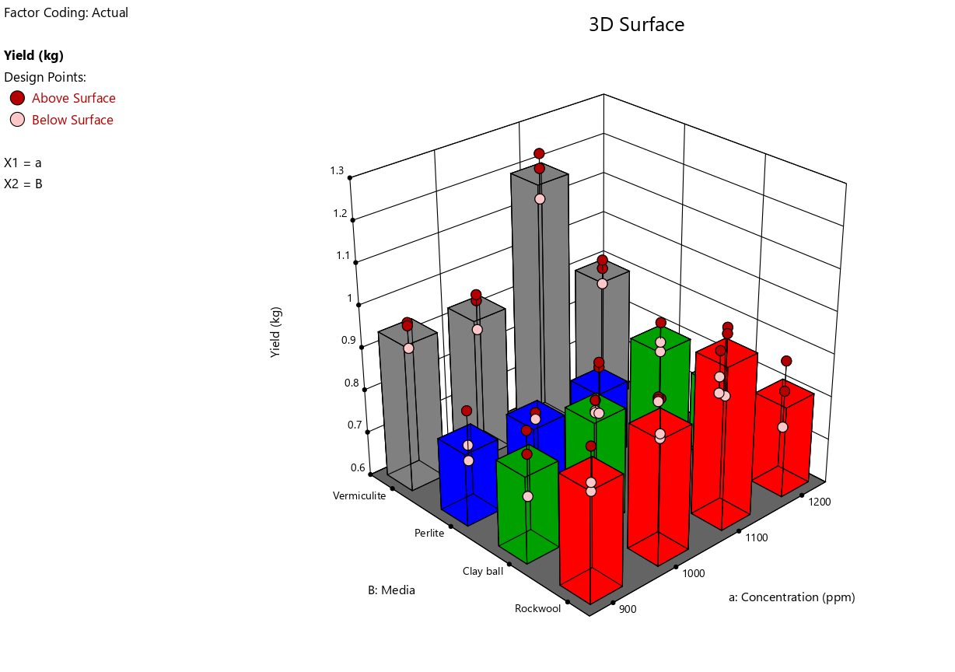
Fig. 6 Effect of nutrient concentration of solution and growing media on yield (Season1)
Season2(August and September)
Analysis of variance (ANOVA) shows that the model P-values less than 0.05 (p<0.05) indicate model terms are significant. In this case a, B, aB are significant model terms. Values greater than 0.1000 indicate the model terms are not significant (Table.3). The coefficient of determination (R²) values of all responses is quite high (>0.87), indicating a high proportion of variability was explained by the data and the Multilevel categoric factor model were adequate.

Table.3 ANOVA showing the effects of nutrients concentrations and growing media on yield (Season2)
Source | Term df | Error df | F-value | p-value
Whole-plot | 3 | 8.00 | 14.60 | 0.0013 | Significant
a-concentration | 3 | 8.00 | 14.60 | 0.0013
Subplot | 12 | 24.00 | 13.32 | < 0.0001 | Significant
B-media | 3 | 24.00 | 48.67 | < 0.0001
aB | 9 | 24.00 | 1.53 | 0.1934
Std. Dev. | 0.0614 |  | R² | 0.8795
Mean | 0.8428 |  | Adjusted R² | 0.8048
C.V (%) | 7.29
The equation describing the effects of nutrients concentration and growing media on yield in terms of coded values of variable is given below.
The equation in terms of coded factors can be used to make predictions about the response for given levels of each factor. By default, the high levels of the factors are coded as +1 and the low levels are coded as -1. The coded equation is useful for identifying the relative impact of the factors by comparing the factor coefficients.
Yield (kg) =0.842831 + 0.0164894 * a[1] + 0.00162919 * a[2] + 0.0993179 * a[3] +
0.121957 * B[1] + 0.0550306 * B[2] + (-0.0658237 * B[3]) + 0.00450248 *
a[1]B[1] + (-0.0285324 * a[2]B[1]) + 0.0205239 * a[3]B[1] + (-0.0196754 *
a[1]B[2]) + (-0.00806327 * a[2]B[2]) + 0.0624066 * a[3]B[2] + 0.000883896 *
a[1]B[3]+0.0335407*a[2]B[3]+(-0.030662* a[3]B[3]) …(2)
Positive sign in front of the term indicates synergistic effect, whereas negative sign indicates antagonistic effect (Hameed et al., 2008). The linear positive terms eqn. (2) indicated that yield was found more in 1100 ppm of rockwool than other concentration and media also it shows different results in different growing media and inside the structure.
The graphical representation of the equation for the optimization of yield is shown as 3-D dimensional plot in Fig. 7. Less yield was found in 1200 ppm concentrated nutrient solution with perlite.
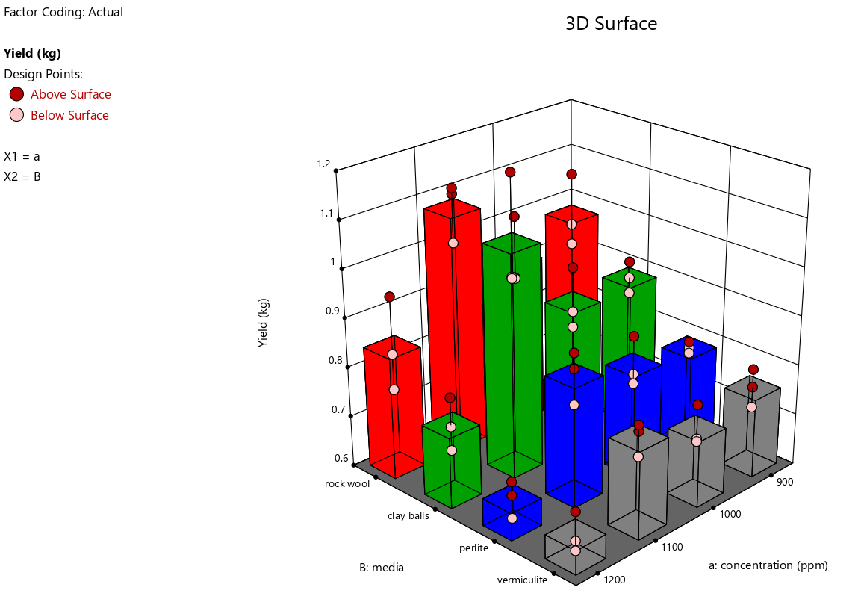
Fig.7 Effect of nutrient concentration of solution and growing media on yield (Season2)
Season3(October and November)
Analysis of variance (ANOVA) shows that the model P-values less than 0.0500 (p<0.05) indicate model terms are significant. In this case a, B, aB are significant model terms. Values greater than 0.1000 indicate the model terms are not significant (Table.4). The coefficient of determination (R²) values of all responses is quite high (>0.89), indicating a high proportion of variability was explained by the data and the Multilevel categoric factor model were adequate.
Table.4 ANOVA showing the effects of nutrients concentrations and growing media on yield (Season3)
Source | Term df | Error df | F-value | p-value
Whole-plot | 3 | 32.00 | 18.33 | < 0.0001 | significant
a-concentration | 3 | 32.00 | 18.33 | < 0.0001
Subplot | 12 | 32.00 | 18.53 | < 0.0001 | significant
B-media | 3 | 32.00 | 69.61 | < 0.0001
aB | 9 | 32.00 | 1.51 | 0.1880
Std. Dev. | 0.0634 |  | R² | 0.8966
Mean | 0.8103 |  | Adjusted R² | 0.8324
C.V (%) | 7.83
The equation describing the effects of nutrients concentration and growing media on yield in terms of coded values of variable is given below.
Yield (kg) =0.810277 + -0.0471721 * a[1] + 0.000664813 * a[2] + 0.110204 * a[3] +
0.11474 * B[1] + 0.133006 * B[2] + (-0.0588581 * B[3]) + 0.0343103 *
a[1]B[1] + (-0.0436213 * a[2]B[1]) + ( -0.0175976 * a[3]B[1]) + (-0.0481098 *
a[1]B[2]) + 0.0693113 * a[2]B[2] + 0.0326264 * a[3]B[2] + (-0.0023139 *
a[1]B[3]) + 0.0148942 * a[2]B[3] + (-0.0139997 * a[3]B[3]) …(3)
The graphical representation of 3-D dimensional plot is shown as in Fig.8. The 3-D dimensional plot representing the effect concentrated nutrient solution and growing media on the yield. The results showed that 1100 ppm concentrated nutrient solution with clay balls media shows the high yield. The less yield was found in vermiculite growing media and 1200 ppm concentration. Because vermiculite has a higher water holding capacity and is cooler in the fall and winter months (October and November), it might impacted the plant roots.
The production during the basil cultivation reduced considerably with the increase in electrical conductivity. (Parida and Das, 2005) result demonstrated that exposure time to saline stress interferes in fundamental plant functions, such as photosynthesis and protein synthesis.
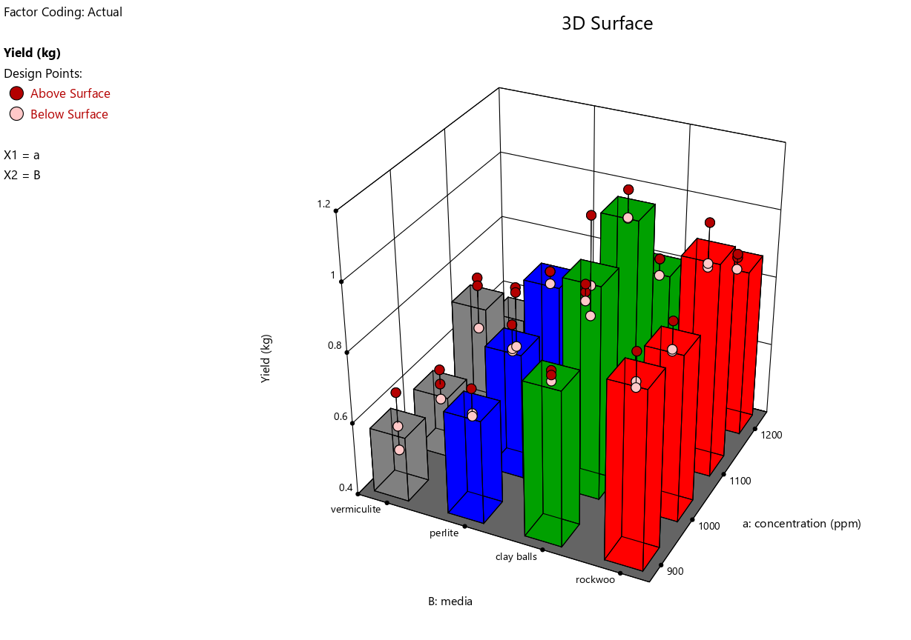
Fig. 8 Effect of nutrient concentration of solution and growing media on yield (Season3)
Season4(January and February)
Analysis of variance (ANOVA) shows that the model P-values less than 0.0500 (p<0.05) indicate model terms are significant. In this case a, B, aB are significant model terms. Values greater than 0.1000 indicate the model terms are not significant (Table.5). The coefficient of determination (R²) values of all responses is quite high (>0.87), indicating a high proportion of variability was explained by the data and the Multilevel categoric factor model were adequate.
Table.5 ANOVA showing the effects of nutrients concentrations and growing media on yield (Season4)
Source | Term df | Error df | F-value | p-value
Whole-plot | 3 | 8.00 | 4.98 | 0.0309 | significant
a-concentration | 3 | 8.00 | 4.98 | 0.0309
Subplot | 12 | 24.00 | 18.91 | < 0.0001 | significant
B-media | 12 | 24.00 | 18.91 | < 0.0001
aB | 9 | 24.00 | 1.24 | 0.3204
Std. Dev. | 0.0559 |  | R² | 0.8784
Mean | 0.7538 |  | Adjusted R² | 0.8029
C.V (%) | 7.42
The equation describing the effects of nutrients concentration and growing media on yield in terms of coded values of variable is given as:
Yield (kg) =0.753811 + (-0.0112658 * a[1]) + 0.0221459 * a[2] + 0.0457704 * a[3] +
0.135225 * B[1] + 0.0638547 * B[2] + (-0.0530555 * B[3]) + (-0.0111805 *
a[1]B[1]) + (-0.0374782 * a[2]B[1]) + 0.0547436 * a[3]B[1] + (-0.00829946 *
a[1]B[2]) + 0.0138569 * a[2]B[2] + (-0.0268823 * a[3]B[2]) + (-0.0174105 *
a[1]B[3]) + 0.0103758 * a[2]B[3] + (-0.00847004 * a[3]B[3]) …(4)
The graphical representation of 3-D dimensional plot is shown as in Fig.9. The 3-D dimensional plot representing the effect concentrated nutrient solution and growing media on the yield. The results showed that 1100 ppm concentrated nutrient solution with rock wool media shows the high yield. The less yield was found in 1200 ppm concentrated nutrient solution with vermiculite growing media. Because vermiculite has a higher water holding capacity and is cooler in the winter months (January and February), it has an impact on plant roots. And if the nutrient concentration is higher than ideal, the yield will suffer.
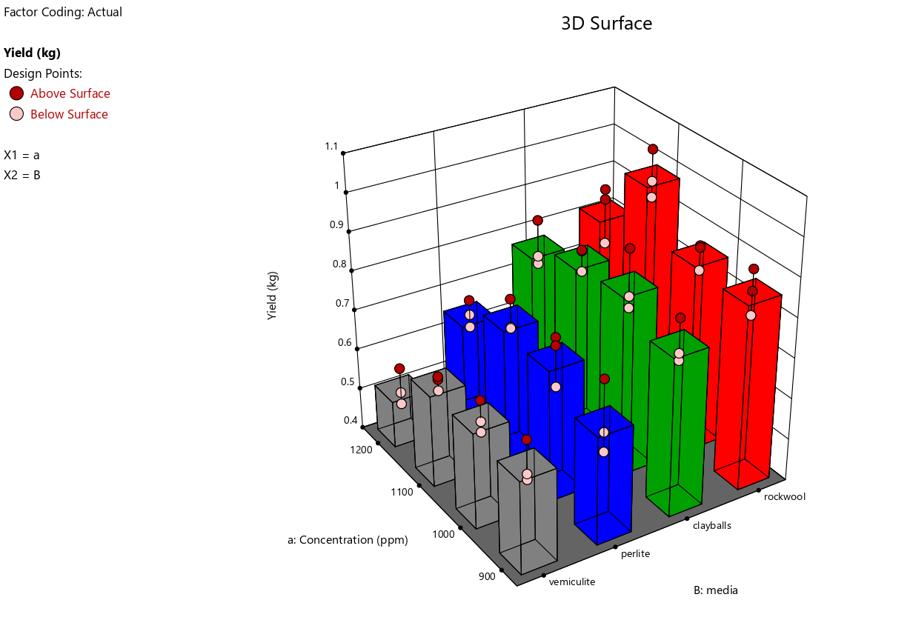
Fig. 9 Effect of nutrient concentration of solution and growing media on yield (Season4)
Conclusion
The present study successfully standardized nutrient solution concentration and growing media combinations for basil cultivation under hydroponic conditions using Design-Expert analysis. The experimental results revealed that nutrient concentration and growing media significantly influenced basil yield across different seasons under naturally ventilated polyhouse conditions. The ANOVA results indicated that the developed models were statistically significant with high coefficient of determination (R² > 0.87), confirming the adequacy of the models for predicting yield responses.
Among the different nutrient concentrations tested, 1100 ppm nutrient solution consistently produced higher yields in most seasons compared to 900 ppm, 1000 ppm and 1200 ppm concentrations. Seasonal variation also influenced the performance of growing media. Vermiculite performed better during summer conditions due to its higher moisture retention capacity, whereas rockwool and clay balls showed superior performance during cooler seasons because of better aeration and balanced moisture availability. Higher nutrient concentration (1200 ppm) resulted in reduced yield, possibly due to osmotic stress and nutrient imbalance affecting nutrient uptake by basil plants.
The interaction effects between nutrient concentration and growing media were effectively visualized using 3-D response surface plots generated through Design Expert-13 software. The optimization study demonstrated that 1100 ppm nutrient concentration combined with suitable growing media such as vermiculite, rockwool, or clay balls depending on the season, provided optimum yield performance.
Overall, the study confirmed that proper management of nutrient concentration, EC, pH, and growing media selection plays a vital role in improving basil yield in hydroponic systems. The findings of this research can be useful for commercial hydroponic growers, researchers, and protected cultivation systems aiming to achieve sustainable and efficient basil production under controlled environment agriculture.
References
Ragaveena, S., Shirly Edward, A. and Surendran, U., 2021. Smart controlled environment agriculture methods: A holistic review. Reviews in Environmental Science and Bio/Technology, 20(4), pp.887-913.
Pala, M., Mizenko, L., Mach, M. and Reed, T., 2014. Aeroponic greenhouse as an autonomous system using intelligent space for agriculture robotics. In Robot Intelligence Technology and Applications 2: Results from the 2nd International Conference on Robot Intelligence Technology and Applications (pp. 83-93). Springer International Publishing.
Lakhiar, I.A., Gao, J., Syed, T.N., Chandio, F.A. and Buttar, N.A., 2018. Modern plant cultivation technologies in agriculture under controlled environment: A review on aeroponics. Journal of plant interactions, 13(1), pp.338-352.
Lakhiar, I.A., Gao, J., Syed, T.N., Chandio, F.A., Tunio, M.H., Ahmad, F. and Solangi, K.A., 2020. Overview of the aeroponic agriculture–An emerging technology for global food security. International Journal of Agricultural and Biological Engineering, 13(1), pp.1-10.
Cho WooJae, C.W., Kim HakJin, K.H., Jung DaeHyun, J.D., Kim DongWook, K.D., Ahn TaeIn, A.T. and Son JungEek, S.J., 2018. On-site ion monitoring system for precision hydroponic nutrient management.
Putra, P.A. and Yuliando, H. 2015. Soilless culture system to support water use efficiency and product quality: a review. Agriculture and Agricultural Science Procedia. 3: 283-288.
Hussain, A., Iqbal, K., Aziem, S., Mahato, P. and Negi, A.K. 2014. A review on the science of growing crops without soil (soilless culture)-a novel alternative for growing crops. International Journal of Agriculture and Crop Sciences. 7(11): 833-842.
George, P. and George, N. 2016. Hydroponics-(Soilless Cultivation of Plants) For Biodiversity Conservation. International Journal of Modern Trends in Engineering and Science: 3(6): 97-104.
Pardossi, A., Carmassi, G., Diara, C., Incrocci, L., Maggini, R. and Massa, D. 2011. Fertigation and substrate management in closed soilless culture. Pisa: University of Pisa.
Khan, F.A. 2018. A review on hydroponic greenhouse cultivation for sustainable agriculture. International Journal of Agriculture Environment and Food Sciences. 2(2): 59-66.
El-Kazzaz, K.A. and El-Kazzaz, A.A. 2017. Soilless agriculture a new and advanced method for agriculture development: an introduction. Agricultural Research and Technology. 3(7): 63-72.
Hussain, A., Iqbal, K., Aziem, S., Mahato, P. and Negi, A.K. 2014. A review on the science of growing crops without soil (soilless culture)-a novel alternative for growing crops. International Journal of Agriculture and Crop Sciences. 7(11): 833-842.
Hameed, B.H., Tan, I.A.W. and Ahmad, A.L. 2008. Preparation of activated carbon from coconut husk: Optimization study on removal of 2, 4, 6-trichlorophenol using response surface methodology. Journal of Hazardous Materials. 153: 709-717.
Karne, S.C., Gupta, S.V., Patil, B.N. and Kakade, S.R. 2018. Effect of different colour of shadenet and growing media on the biometric characteristics and yield of spinach cultivated by hydroponics. International Journal of Pure and Applied Bioscience. 6(3): 419-425.
Parida, A.K. and Das, A.B. 2005. Salt tolerance and salinity effects on plants: a review. Ecotoxicology and environmental safety. 60(3): 324-349.

