TEMPORAL DYNAMICS OF MAJOR COCOA DISEASES IN ANDHRA PRADESH: A TWO-YEAR SURVEILLANCE STUDY

ABSTRACT
Aims: This study aimed to quantify year-to-year and seasonal variation in the incidence of six major cocoa diseases in Andhra Pradesh, assess year × season interaction effects, and determine relationships between weather parameters and disease incidence.
Study Design: Two-year longitudinal roving survey (2024–2025).
Place and Duration of Study: Twelve geo-tagged cocoa farms, Eluru district, Andhra Pradesh, India (16°42′N, 81°06′E); January 2024 to December 2025.
Methodology: Monthly disease incidence of stem canker, black pod rot, Lasiodiplodia dieback, charcoal pod rot, cushion gall, and cherelle wilt was recorded from 100 randomly selected trees per farm. Temporal and seasonal variation was analysed using a two-factor completely randomised design (CRD) with year and season as fixed factors; means were separated using Fisher's LSD test (P = .05). Pearson's correlation analysis quantified weather–disease associations.
Results: Stem canker declined from 30.67% (2024) to 18.92% (2025; F = 118.67, P < .001) while cushion gall increased from 13.94% to 20.75% (F = 61.79, P < .001). Black pod rot peaked during monsoon (17.68 ± 7.93%) and was strongly correlated with rainfall (r = 0.55, P < .01) and relative humidity (r = 0.63, P < .01). Lasiodiplodia dieback correlated positively with mean temperature (r = 0.62, P < .01). Significant year × season interactions (P < .01 for most diseases) indicated that seasonal dynamics differed between years.
Conclusion: Cocoa disease dynamics in Andhra Pradesh are governed by complex temporal, seasonal, and climatic interactions. Weather-informed, adaptive management strategies are essential as climate variability increases in this non-traditional cocoa-growing region.

Keywords: Theobroma cacao, disease epidemiology, seasonal variation, stem canker, black pod rot, charcoal pod rot, Lasiodiplodia dieback, cherelle wilt, climate–disease interaction.
1. INTRODUCTION
Cocoa (Theobroma cacao L.) is a vital cash crop supporting smallholder farmers across tropical regions. In India, cultivation has traditionally been concentrated in Kerala, Karnataka, and Tamil Nadu; however, strategic expansion into non-traditional areas such as Andhra Pradesh has created new challenges, particularly regarding disease management in regions with limited baseline epidemiological data (Ploetz, 2007).
Cocoa productivity is significantly constrained by different fungal diseases. Stem canker and black pod rot caused by Phytophthora spp., Lasiodiplodia dieback and charcoal pod rot caused by Lasiodiplodia theobromae (Pat.) Griffon and Maubl., cushion gall caused by bacterial complex, and cherelle wilt collectively result in yield losses ranging from 20–30% in managed plantations to over 70% under severe disease pressure, jeopardising farmer livelihoods and the long-term sustainability of cocoa production (Ploetz, 2016).
Temporal variation in disease incidence reflects both seasonal weather patterns and year-to-year climatic variability, which can significantly alter pathogen infection dynamics, sporulation patterns, and disease spread (Appiah et al., 2004). Systematic temporal surveillance is essential for identifying shifts in disease prevalence and developing timely management strategies, particularly under changing climatic conditions.
The present study monitored the temporal dynamics of six major cocoa diseases in Eluru district, Andhra Pradesh over two years (2024–2025). Specific objectives were to: (i) quantify year-to-year variation in disease incidence; (ii) identify seasonal patterns across monsoon, post-monsoon, and summer seasons; (iii) assess year × season interaction effects; and (iv) determine relationships between weather parameters and disease incidence. Findings are expected to provide baseline data for disease management planning and contribute to understanding how temporal and climatic factors influence disease occurrence in non-traditional cocoa-growing regions.
2. MATERIALS AND METHODS
2.1 Study Area and Sampling
Monthly roving surveys were conducted over two years (2024–2025) across 12 geo-tagged cocoa farms in Eluru district, Andhra Pradesh (16°42′N, 81°06′E). At each farm, disease incidence was assessed from 100 randomly selected trees following a systematic sampling pattern to ensure representative coverage.
2.2 Disease Assessment
Six major diseases were recorded based on characteristic symptoms: stem canker, black pod rot, Lasiodiplodia dieback, charcoal pod rot, cushion gall, and cherelle wilt. Disease incidence (DI) was calculated as:
DI (%) = (Number of infected plants / Total number of plants observed) × 100
Monthly data from all 12 farms were pooled to obtain mean disease incidence values for each month. Descriptive statistics (mean, standard deviation, and coefficient of variation) were computed to characterise disease trends over the two-year period.
2.3 Seasonal Variation
The year was divided into three major seasons based on the climatic conditions of Andhra Pradesh: (i) summer (February–May), (ii) monsoon (June–September), and (iii) post-monsoon (October–January). Temporal and seasonal variation was analysed using a two-factor completely randomised design (CRD) with year and season as fixed factors. Data were subjected to analysis of variance (ANOVA), and treatment means were compared using Fisher's Least Significant Difference (LSD) test at P = .05. Statistical analyses were performed using RAISINS software.
2.4 Weather Data Collection and Correlation Analysis
Monthly weather data including mean temperature (°C), total rainfall (mm), and mean relative humidity (%) were obtained from the NASA/POWER (Prediction of Worldwide Energy Resources) database. Pearson's correlation analysis was performed to quantify relationships between weather parameters and disease incidence over the two-year period. Correlation matrices were visualised using a correlogram.
3. RESULTS AND DISCUSSION
3.1 Prevalence and Temporal Variation of Cocoa Diseases
The two-year survey revealed the occurrence of six major diseases in cocoa plantations of Eluru district viz., stem canker, black pod rot, charcoal pod rot, Lasiodiplodia dieback, cushion gall, and cherelle wilt (Fig.1). Analysis of variance demonstrated highly significant temporal variation for stem canker, Lasiodiplodia dieback, cushion gall, and cherelle wilt; significant variation for black pod rot; while charcoal pod rot showed no significant temporal variation (Table 1).
A 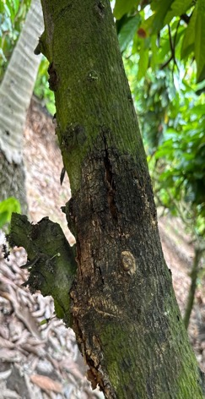 B 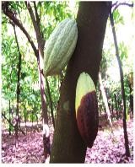
C 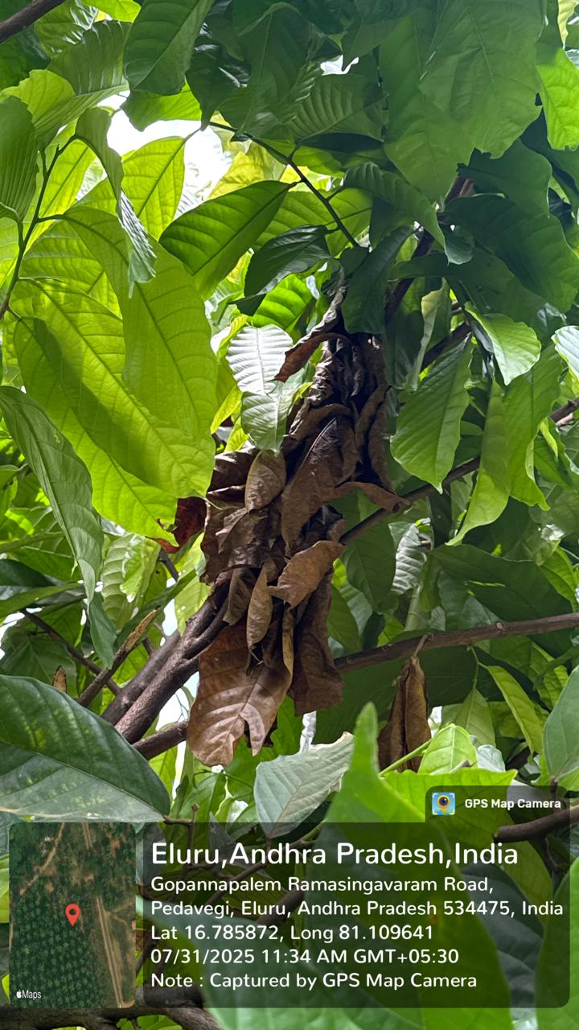 D 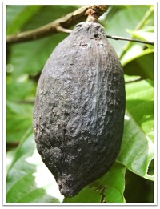

E 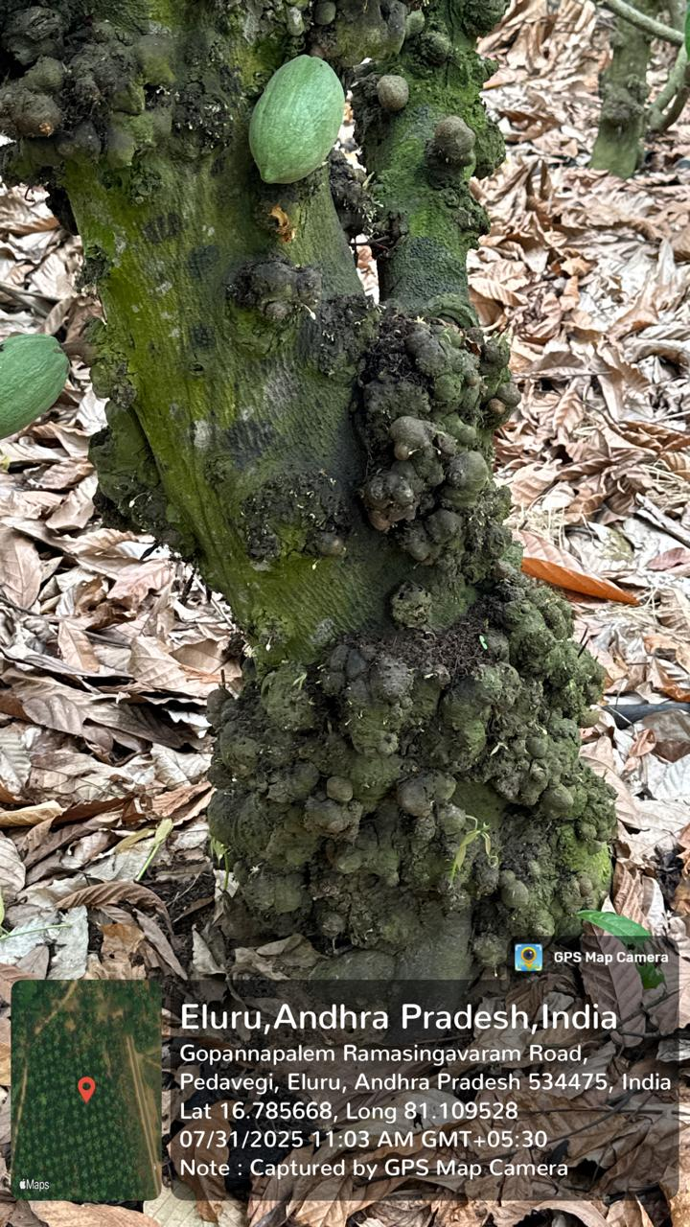 F 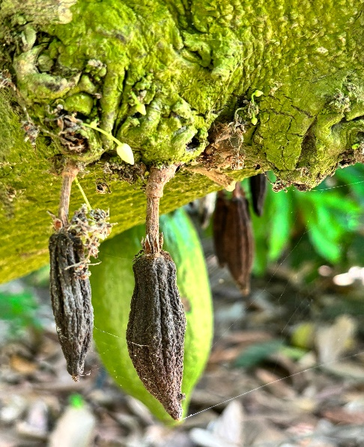
Fig. 1. Major cocoa diseases observed during the survey in Andhra Pradesh: (A) stem canker, (B) black pod rot, (C) Lasiodiplodia dieback, (D) charcoal pod rot, (E) cushion gall, and (F) cherelle wilt.

Stem canker was the most prevalent disease in 2024 (30.67 ± 11.51%) but showed a dramatic decline in 2025 (18.92 ± 6.66%), representing a 38.3% reduction (F = 118.67, P < .001). Similarly, cherelle wilt decreased from 30.75 ± 10.25% in 2024 to 24.17 ± 9.57% in 2025, a reduction of 21.4% (F = 37.55, P < .001). Conversely, cushion gall showed a marked increase from 13.94 ± 9.50% to 20.75 ± 5.94%, representing a 48.9% increase (F = 61.79, P < .001), and Lasiodiplodia dieback also increased significantly from 11.83 ± 9.08% to 14.78 ± 7.15% (F = 11.32, P < .001). Black pod rot incidence remained relatively stable between years (12.96% vs. 14.45%; F = 3.82, P = .053), while charcoal pod rot showed minimal variation (13.09% vs. 13.44%; F = 0.10, P = .754).
Table 1. Year-wise mean disease incidence (%) in cocoa plantations of Eluru district, Andhra Pradesh
Year | Stem Canker | Black Pod Rot | Lasiodiplodia Dieback | Charcoal Pod Rot | Cushion Gall | Cherelle Wilt
2024 | 30.67 ± 11.51ᵃ | 12.96 ± 8.00ᵃ | 11.83 ± 9.08ᵇ | 13.09 ± 12.73 | 13.94 ± 9.50ᵇ | 30.75 ± 10.25ᵃ
2025 | 18.92 ± 6.66ᵇ | 14.45 ± 8.32ᵃ | 14.78 ± 7.15ᵃ | 13.44 ± 5.05 | 20.75 ± 5.94ᵃ | 24.17 ± 9.57ᵇ
F stat | 118.67** | 3.82* | 11.32** | 0.10NS | 61.79** | 37.55**
p value | 0.000 | 0.053 | 0.001 | 0.754 | 0.000 | 0.000
Values represent mean ± standard deviation. Means followed by different superscript letters within a column are significantly different at P = .05 (LSD test). *P < .05; **P < .01; NS, not significant.
3.2 Seasonal Variation in Disease Incidence
Significant seasonal variation was observed for all diseases except charcoal pod rot (Table 2). Black pod rot exhibited the highest incidence during the monsoon season (17.68 ± 7.93%), significantly exceeding both post-monsoon (14.89 ± 8.44%; P < .001) and summer (8.55 ± 4.88%; P < .001) periods, reflecting the critical influence of rainfall and humidity on Phytophthora-driven disease development (Guest, 2007).
Cherelle wilt showed peak incidence during summer (30.58 ± 11.12%), significantly higher than monsoon (26.21 ± 8.97%) and post-monsoon (25.58 ± 10.48%) periods, likely attributable to moisture stress and increased resource competition (Zuidema et al., 2005). Lasiodiplodia dieback demonstrated dual peaks during monsoon (14.83 ± 8.01%) and summer (16.18 ± 9.10%) seasons, while post-monsoon incidence was significantly lower (8.91 ± 5.52%; P < .001), consistent with its stress-associated etiology (Mohali et al., 2005).
Cushion gall peaked during post-monsoon (20.03 ± 8.40%), followed by monsoon (17.82 ± 8.40%), with lowest incidence in summer (14.18 ± 8.09%; F = 15.52, P < .001). Stem canker showed relatively uniform incidence across monsoon (25.62 ± 10.93%) and post-monsoon (26.56 ± 9.88%) seasons, with a slight reduction during summer (22.21 ± 11.96%; F = 6.02, P = .003).
Table 2. Seasonal variation in disease incidence (%) across cocoa plantations of Eluru district, Andhra Pradesh
Season | Stem Canker | Black Pod Rot | Lasiodiplodia Dieback | Charcoal Pod Rot | Cushion Gall | Cherelle Wilt
Monsoon | 25.62 ± 10.93ᵃ | 17.68 ± 7.93ᵃ | 14.83 ± 8.01ᵃ | 13.99 ± 9.00ᵃᵇ | 17.82 ± 8.40ᵇ | 26.21 ± 8.97ᵇ
Post-monsoon | 26.56 ± 9.88ᵃ | 14.89 ± 8.44ᵇ | 8.91 ± 5.52ᵇ | 11.33 ± 6.44ᵇ | 20.03 ± 8.40ᵃ | 25.58 ± 10.48ᵇ
Summer | 22.21 ± 11.96ᵇ | 8.55 ± 4.88ᶜ | 16.18 ± 9.10ᵃ | 14.47 ± 12.42ᵃ | 14.18 ± 8.09ᶜ | 30.58 ± 11.12ᵃ
F stat | 6.02** | 49.99** | 25.82** | 3.11* | 15.52** | 8.57**
p value | 0.003 | 0.000 | 0.000 | 0.049 | 0.000 | 0.000
Values represent mean ± standard deviation. Means followed by different superscript letters within a column are significantly different at P = .05 (LSD test). *P < .05; **P < .01; NS, not significant.
3.3 Year × Season Interaction Effects
Significant year × season interactions were observed for all diseases (P < .01 for black pod rot, Lasiodiplodia dieback, charcoal pod rot, cushion gall, and cherelle wilt; P = .024 for stem canker), indicating that seasonal disease dynamics differed meaningfully between years (Table 3). These interactions emphasise that disease forecasting cannot rely solely on fixed seasonal calendars, as annual climatic variability modifies pathogen behaviour (Läderach et al., 2013).
For stem canker, the highest incidence was recorded during the 2024 monsoon season (33.52 ± 10.16%), significantly different from all 2025 treatments. Black pod rot peaked during the 2025 post-monsoon period (20.21 ± 6.84%), more than double the 2024 post-monsoon incidence (9.56 ± 6.28%), reflecting inter-annual variation in rainfall timing and intensity.
Lasiodiplodia dieback remained relatively stable across seasons in 2024 (8.79–13.85%), but in 2025, summer incidence surged to 19.52 ± 7.73%, the highest value recorded across all treatment combinations, likely indicating severe heat or drought stress predisposing trees to infection. Cherelle wilt remained consistently high during all 2024 seasons (29.23–32.08%) but declined in 2025, particularly during monsoon (21.48 ± 4.18%) and post-monsoon (19.08 ± 8.42%) periods. However, 2025 summer showed a resurgence (31.94 ± 9.74%), comparable to 2024 levels.
Table 3. Year × Season interaction effects on disease incidence (%) in cocoa plantations of Eluru district, Andhra Pradesh
Treatment | Stem Canker | Black Pod Rot | Lasiodiplodia Dieback | Charcoal Pod Rot | Cushion Gall | Cherelle Wilt
2024 × Monsoon | 33.52 ± 10.16ᵃ | 19.25 ± 8.54ᵃ | 13.85 ± 10.08ᵇ | 16.60 ± 11.86ᵃ | 12.15 ± 7.04ᵈ | 30.94 ± 9.97ᵃ
2024 × Post-monsoon | 30.88 ± 11.69ᵃᵇ | 9.56 ± 6.28ᶜᵈ | 8.79 ± 7.05ᶜ | 8.46 ± 6.04ᶜ | 18.98 ± 11.04ᵇᶜ | 32.08 ± 8.04ᵃ
2024 × Summer | 27.62 ± 12.05ᵇ | 10.06 ± 4.66ᶜ | 12.83 ± 9.21ᵇ | 14.21 ± 16.73ᵃᵇ | 10.69 ± 7.96ᵈ | 29.23 ± 12.30ᵃ
2025 × Monsoon | 17.73 ± 3.31ᵈ | 16.10 ± 7.02ᵇ | 15.81 ± 5.12ᵇ | 11.38 ± 3.03ᵇᶜ | 23.50 ± 5.22ᵃ | 21.48 ± 4.18ᵇ
2025 × Post-monsoon | 22.25 ± 4.76ᶜ | 20.21 ± 6.84ᵃ | 9.02 ± 3.45ᶜ | 14.21 ± 5.51ᵃᵇ | 21.08 ± 4.30ᵃᵇ | 19.08 ± 8.42ᵇ
2025 × Summer | 16.79 ± 9.16ᵈ | 7.04 ± 4.68ᵈ | 19.52 ± 7.73ᵃ | 14.73 ± 5.60ᵃᵇ | 17.67 ± 6.64ᶜ | 31.94 ± 9.74ᵃ
F stat | 3.86* | 35.92** | 4.82** | 8.22** | 9.50** | 19.60**
p value | 0.024 | 0.000 | 0.009 | 0.000 | 0.000 | 0.000
Treatments with the same superscript letter within a column are not significantly different at P = .05 (LSD test). *P < .05; **P < .01.
3.4 Correlation Analysis of Cocoa Diseases and Weather Parameters
Pearson correlation analysis revealed significant relationships between cocoa diseases and meteorological variables (Fig. 2). Black pod rot showed the strongest associations with weather parameters, exhibiting strong positive correlations with relative humidity (r = 0.63, P < .01) and rainfall (r = 0.55, P < .01), confirming the critical role of moisture in Phytophthora-driven epidemics (Akrofi et al., 2015).
Lasiodiplodia dieback exhibited a strong positive correlation with mean temperature (r = 0.62, P < .01), consistent with the known heat-stress etiology of this disease (Mohali et al., 2005). Stem canker showed weak correlations with most weather variables, with minor negative associations with mean temperature (r = −0.31) and Lasiodiplodia dieback (r = −0.38). Cushion gall and cherelle wilt demonstrated moderate negative correlations with mean temperature (r = −0.37 for both), suggesting that additional biotic or management factors govern their occurrence beyond temperature alone.
The strong year × season interactions, combined with the observed shift toward temperature-driven pathogens, are particularly relevant under warming climate scenarios. If temperature extremes increase, stress-associated diseases such as Lasiodiplodia dieback may become more dominant, potentially altering the disease complex in cocoa ecosystems. Weather-based monitoring of rainfall and humidity could enable prediction of black pod rot pressure 7–14 days in advance, while temperature monitoring during summer could serve as an early warning system for Lasiodiplodia dieback outbreaks (Läderach et al., 2013).
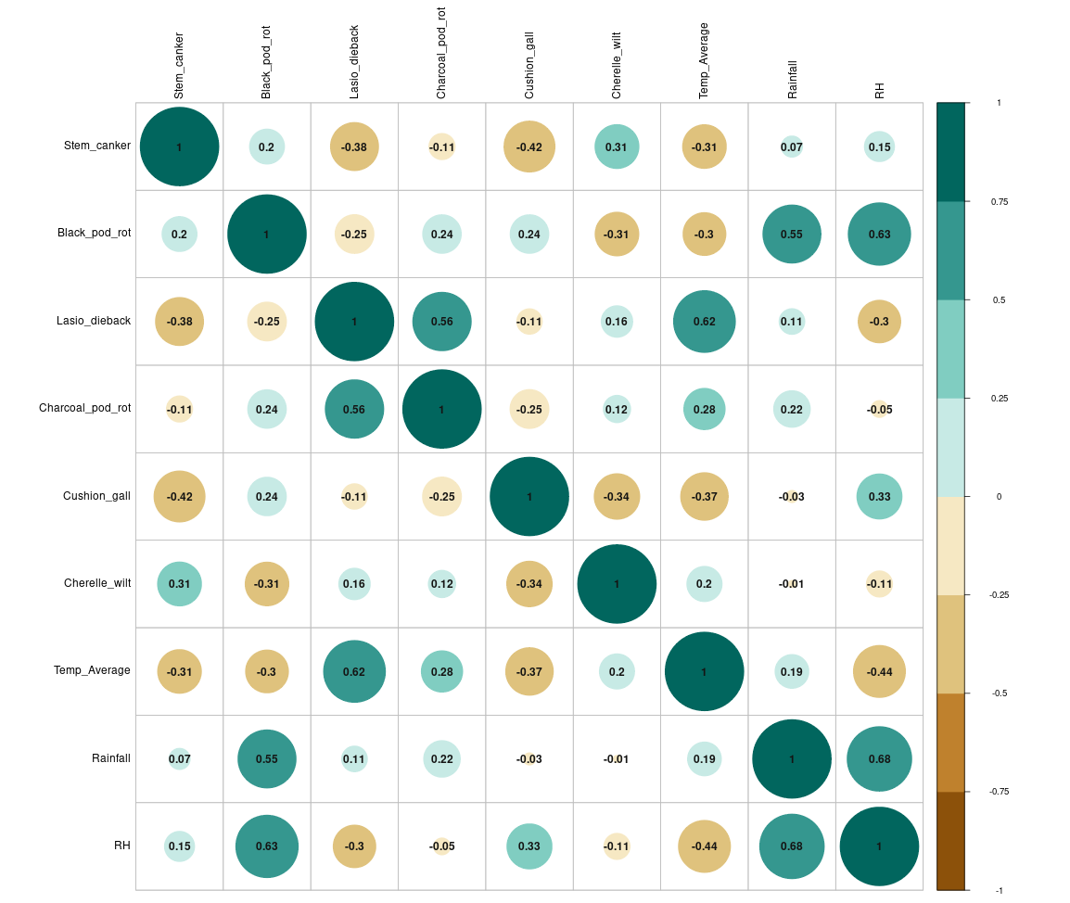 Fig. 2. Pearson's correlogram depicting interrelationships among cocoa diseases and weather parameters (pooled over two years).
Circle size represents magnitude of correlation (r); colour intensity indicates direction (positive or negative).

4. CONCLUSION
The study demonstrates that cocoa disease dynamics in Andhra Pradesh are governed by complex interactions among temporal, seasonal, and environmental factors. The significant year-to-year variation in disease incidence, coupled with distinct seasonal patterns and strong weather associations, underscores the need for adaptive, weather-informed disease management strategies. The strong positive correlation between moisture-related variables and black pod rot, contrasted with temperature-driven Lasiodiplodia dieback, indicates that climate change may fundamentally alter disease pressure landscapes in cocoa production systems.
The emergence of cushion gall as an increasing threat and the concerning rise in dieback diseases highlight the dynamic nature of pathogen communities in perennial cropping systems. As climate variability increases and traditional seasonal patterns become less predictable, flexible management approaches based on real-time weather monitoring and disease risk assessment will become increasingly important. Ultimately, sustainable cocoa production will require integrated strategies that simultaneously address multiple diseases while building overall tree resilience through improved cultural practices, stress management, and genetic enhancement.

COMPETING INTERESTS
Authors have declared that no competing interests exist.

ETHICAL APPROVAL
Not applicable. The study did not involve human subjects, vertebrate animals, or endangered species.
REFERENCES
1. Akrofi, A.Y., Amoako-Atta, I., Assuah, M., & Asare, E.K. (2015). Black pod disease on cacao (Theobroma cacao L.) in Ghana: spread of Phytophthora megakarya and role of economic plants in the disease epidemiology. Crop Protection, 72, 66–75.
2. Appiah, A.A., Flood, J., Archer, S.A., & Bridge, P.A. (2004). Molecular analysis of the major Phytophthora species on cocoa. Plant Pathology, 53(2), 209–219.
3. Guest, D. (2007). Black pod: diverse pathogens with a global impact on cocoa yield. Phytopathology, 97(12), 1650–1653.
4. Läderach, P., Martinez-Valle, A., Schroth, G., & Castro, N. (2013). Predicting the future climatic suitability for cocoa farming of the world's leading producer countries, Ghana and Côte d'Ivoire. Climatic Change, 119(3–4), 841–854.
5. Mohali, S., Burgess, T.I., & Wingfield, M.J. (2005). Diversity and host association of the tropical tree endophyte Lasiodiplodia theobromae revealed using simple sequence repeat markers. Forest Pathology, 35(6), 385–396.
6. Opoku, I.Y., Appiah, A.A., Akrofi, A.Y., & Owusu, G.K. (2000). Phytophthora megakarya: a potential threat to the cocoa industry in Ghana. Ghana Journal of Agricultural Science, 33(2), 237–248.
7. Ploetz, R.C. (2007). Cacao diseases: important threats to chocolate production worldwide. Phytopathology, 97(12), 1634–1639.
8. Ploetz, R. (2016). The impact of diseases on cacao production: a global overview. In B. Bailey & L. Meinhardt (Eds.), Cacao Diseases (pp. 33–59). Springer, Cham. https://doi.org/10.1007/978-3-319-24789-2_2
9. Zuidema, P.A., Leffelaar, P.A., Gerritsma, W., Mommer, L., & Anten, N.P. (2005). A physiological production model for cocoa (Theobroma cacao): model presentation, validation and application. Agricultural Systems, 84(2), 195–225.

