Review Article

Valorisation of Passion Fruit Rind: Formation of Eco-Friendly Edible Coatings

Abstract
Valorising agro-industrial by products is an essential strategy for promoting sustainability and addressing waste management challenges. Passion fruit (Passiflora edulis), predominantly grown for its pulp, produces significant residual biomass in the form of pomace and peels. These byproducts, rich in compounds such as dietary fibre, pectin, and polyphenols, offer diverse functional properties suitable for various innovative applications. This review explores the potential of passion fruit residues, focusing on their use in creating biodegradable edible coatings. Edible coatings derived from passion fruit waste present a sustainable and eco-friendly alternative to synthetic packaging. The high pectin and fibre content in these residues allow for the development of edible films and coatings with excellent mechanical properties and preservation capabilities, effectively enhancing food shelf life and reducing dependency on plastic materials. This approach not only minimises waste but also meets the growing demand for sustainable and health-oriented food options. By converting fruit processing waste into value-added edible coatings, this approach aligns with circular economy principles and supports the reduction of plastic dependency in food packaging. While the functional benefits are promising, further research is needed to optimize extraction methods, improve coating formulations, and assess consumer acceptance for large-scale application. This review underscores the potential of passion fruit by-products as sustainable materials for edible coating development, contributing to waste valorisation and environmentally conscious food preservation strategies.
Keywords: Passion fruit, Waste valorisation, Edible coating, Pomace, Pectin, Bioactive compounds

- Introduction
Passion fruit (Passion Fruit), native to Brazil, is a widely appreciated tropical fruit recognized for its distinctive flavour, aroma, and nutritional properties. It is extensively cultivated in tropical and subtropical regions, with Brazil, Ecuador, and Colombia being the major producers (Tripathi et al., 2014). The fruit is highly valued for its juice, which is commonly utilized in beverages, desserts, and various culinary products. Passion fruit is rich in several beneficial components, including dietary fibre, minerals, vitamins, pectin, antioxidants, flavonoids, and other bioactive compounds (Correa et al., 2016; Deshmukh et al., 2017; He et al., 2020; Biswas et al., 2021). In India, the cultivation of passion fruit is mainly concentrated in the Western Ghats regions such as Coorg, Nilgiris, and Malabar, along with the northeastern states including Manipur, Mizoram, and Nagaland. Kerala has also emerged as an important producer due to its favourable climatic and soil conditions, particularly in districts like Wayanad and Idukki. The increasing popularity of the fruit in the Indian market is attributed to its versatility and health-promoting properties (Deshmukh et al., 2017). Food waste and the generation of food by-products have become major global concerns because of their adverse environmental, economic, and social impacts. Growing awareness regarding these issues has encouraged several countries and organizations to implement strategies aimed at minimizing food waste. Initiatives such as the Farm to Fork Strategy, Circular Economy Action Plan, and EU Waste Legislation introduced by the European Union are examples of such efforts. Reducing food waste can help lower production costs, improve the efficiency of food systems, support environmental sustainability, and strengthen food security and nutrition (Brennan et al., 2021).
- Composition and nutritional profile of passion fruit byproducts
Processing passion fruit (Passiflora edulis) produces a lot of byproducts, including peels, seeds, and pulp leftovers, which are frequently thrown away even though they have rich nutritional and bioactive profiles. Making around 50–60% of the fruit's weight, peel is rich in dietary fibres including cellulose and pectin that support healthy digestion and cholesterol control. It also includes phenolic chemicals, like flavonoids and gallic acid, which have antioxidant qualities that fight oxidative stress and may lower the risk of chronic illnesses. (Dos Reis et al., 2018; Kawakami et al., 2021). Nutritionally, passion fruit peels provide essential minerals. For instance, 100 grams of fresh yellow passion fruit peel contains approximately 44.51 mg of calcium, 0.89 mg of iron, 43.77 mg of sodium, 27.82 mg of magnesium, 0.32 mg of zinc, 0.04 mg of copper, and 178.40 mg of potassium. ​Passion fruit seeds are also nutritionally valuable, containing high levels of proteins and oils. They are rich in essential fatty acids, predominantly linoleic acid (approximately 72.69%) and oleic acid. Additionally, the seeds are a good source of minerals such as sodium, magnesium, potassium, and calcium. They also contain various amino acids, with essential amino acids accounting for 34% of the total amino acids ( Liu et al., 2008). Furthermore, passion fruit seeds are particularly rich in piceatannol, a stilbene compound with antioxidant, anti-cancer, and anti-inflammatory properties. These diverse compositions underscore the potential of passion fruit by-products in functional foods, nutraceuticals, and cosmetic formulations, promoting health and adding value to passion fruit processing industries.
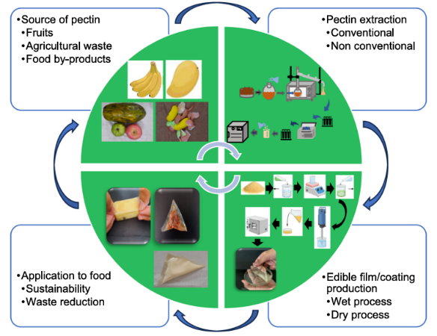
Fig. 1. The circular economy of pectin-based edible films and coating ( Syarifuddin et al., 2025)
Pectin-based edible coatings fit well into a circular economy because they are produced from food industry by-products such as fruit peels and pomace, which reduces waste and adds value to discarded materials. Using eco-friendly extraction methods like ultrasound- or microwave-assisted techniques further cuts down water and energy use. Once applied to foods, these coatings extend shelf-life and reduce the need for synthetic packaging. After use, they naturally biodegrade without leaving harmful residues, returning safely to the environment. This creates a sustainable loop where waste is transformed into useful products and reintegrated into the ecosystem.
- Composition of edible coatings
Nowadays, due to the environmental concerns, synthetic and petroleum materials applied in the packaging industry are being replaced by eco-friendly components, with the current films and coatings being formulated using ingredients obtained from natural sources (Luangapai et al., 2019). Edible films and coatings are prepared from solutions that comprise different component groups (Fig. 2).
- A biopolymer or matrix that is formed by a cohesive structured biopolymer;
- Additives like plasticizers, cross-linkers, surfactants and nano reinforcements that enhance the packaging functional properties; and
- A solvent that, due to the final product requirements in terms of edibility, can only be water or ethanol.

  - Biopolymers (Matrix)
The use of biopolymers in edible film and coating formulations has been growing steadily due to their renewable origins, biocompatibility, and biodegradable properties. Along with their cost-effectiveness, these materials offer advantages such as reducing the transport of moisture, oxygen, aromas, and solutes, enhancing sensory qualities, and prolonging shelf life—making them an appealing and practical choice for the packaging industry. Biopolymers consist of macromolecules derived from various natural sources, including by-products from agriculture, fishing, and livestock industries. Hydrocolloids (polysaccharide and proteins) and lipids are the biopolymers most commonly used in the synthesis of edible films and coatings. Hydrocolloids are formed by large molecules with many hydroxyl groups, which leads to a hydrophilic nature. This chemical configuration makes the water vapour migration difficult to control, leading to the use of polysaccharide and protein films only as sacrificial barriers, in which the water movement occurs in the packing instead of the food surface (Parreidt et al., 2018; Luangapai et al., 2019).
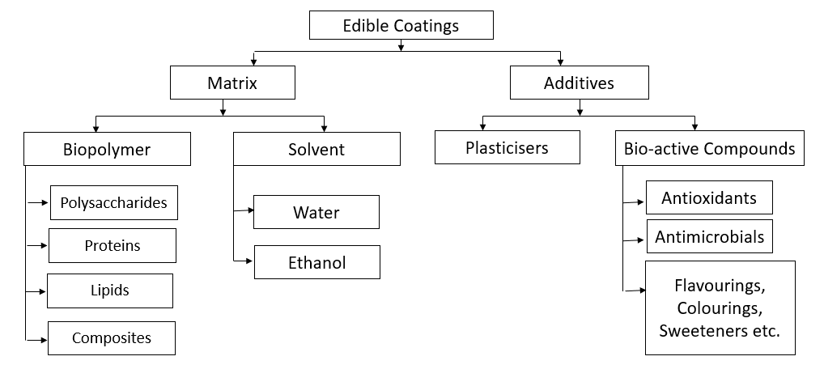
Fig. 2. Composition of edible coatings

  - Types of bio-polymers for making edible coatings
The use of biopolymers in food packaging, bottle containers, and edible coatings is receiving growing interest due to their sustainability, biodegradability, and compatibility with living systems. Common types of biopolymers include polysaccharides (like starch, cellulose, pectin, alginate, and chitosan), proteins (such as soy protein, caseinates, corn, and whey protein), and lipids (including beeswax, oils, and free fatty acids). These materials play a crucial role in creating environmentally friendly and innovative food packaging solutions. Biopolymers offer various advantages, including enhancing food safety, preserving food quality, and prolonging shelf life. Furthermore, they contribute to reducing the reliance on and waste from conventional non-degradable plastics (Han et al., 2020).
3.3 Polysaccharide-Based Coatings
Polysaccharides, such as pectin, cellulose, starch, chitosan, alginates, and pullulan, are commonly used in edible coatings. They effectively block oxygen due to their hydrogen bonding network but have limited moisture resistance. Despite this, they are widely applied to preserve meat, vegetables, and fruits (Saidi et al., 2024).
- Pectin: Found in plant cell walls and fruit peels (e.g., passion fruit, citrus), pectin forms biodegradable coatings with good film-forming ability. It consists of α-1-4 d-galacturonic acid units with functional sugar branches (Lara-Espinoza et al., 2018).
- Starch: Derived from sources like potatoes, corn, and cassava, starch-based coatings reduce spoilage and improve texture. Composed of amylose and amylopectin, starch coatings can be enhanced with Aloe vera gel for antifungal properties and improved physical characteristics. These coatings extend the shelf life of fresh produce (Ortega et al., 2017).
- Cellulose Derivatives (e.g., Carboxymethyl Cellulose) Cellulose, a plant cell wall component, has a highly crystalline structure that limits its solubility. Chemically modified variants, such as carboxymethyl cellulose (CMC), methylcellulose, and hydroxypropylmethyl cellulose, are excellent for edible coatings due to their strength, oxygen barrier, and anti-senescence properties (Suput et al., 2015; Saikia, 2025).
- Chitosan: Derived from crustacean shells, chitosan has strong antimicrobial and antioxidative properties, making it effective for extending food shelf life. It is biodegradable, biocompatible, and regulates food transpiration and ripening rates (Du et al., 2009; Khatri et al., 2020). As a semi-permeable coating material, chitosan-based films help regulate internal food structures by reducing transpiration rates and slowing down the ripening process in fresh produce (Qi et al., 2011). Chitosan coatings and films are most commonly applied into cucumbers, strawberries, bell peppers, apples, peaches, pears and plums, due to their ability to retard ripening in fruits and vegetables (Hassan et al., 2018). For example, chitosan was applied in the form of extract or as chitosan nanoparticles into bioactive coatings with pomegranate peel extract, to protect fruits against different types of fungi (Alotaibi et al., 2019). A research involving the production of edible coatings using chitosan together with extracts of olive oil residues was also performed by Khalifa et al. (2016), which leads to control of the microbiological activity and, consequently, to protection of apple and strawberry fruits against degradation.
- Alginate: Alginate is a natural polysaccharide, commonly derived from brown algae species, that is widely applied in the film and coating formulation field, due to its distinctive colloidal characteristics, such as thickener, gel former, film former and emulsion stabilizer (Estevinho et al., 2014). It is used to improve the quality and extend the shelf life of fruits, vegetables, meat, poultry, seafood and cheese (Parreidt et al., 2018). A study of 2019 evaluated the effect of applying edible films and coatings with sodium alginate to papaya purees (Rangel-Marrón et al., 2019), while, in the same year, another research focused on the characterization of sodium alginate coatings incorporated with lemongrass essential oil to be applied into fresh-cut apples (Cofelice et al. 2019), conducting both of them to successful results, which were translated by a shelf life extension of the food products.
3.4 Protein-Based Coatings
Proteins, classified as fibrous or globular, are used in edible coatings for their film-forming properties. Fibrous proteins are structural components in animal tissues, while globular proteins (e.g., corn zein, whey protein, wheat gluten, soy protein) are commonly used in food coatings (Payal et al., 2025). These coatings are prepared using water, ethanol, or their combinations. Protein-based films act as effective oxygen barriers, preventing oxidative deterioration while offering good mechanical and gas barrier properties (Mihalca et al., 2021).
- Gelatin: Derived from animal collagen, gelatin forms transparent films with excellent oxygen barrier properties. Its characteristics depend on the gelatin source, additives, and processing conditions such as temperature and pH. (Liu et al., 2024; Aguilar-Palazuelos et al., 2025).
- Whey & Casein: Dairy-derived proteins create strong, glossy coatings that extend the shelf life of perishable foods. Whey protein films are effective oxygen barriers and can carry antioxidants and antimicrobials (Kumar et al., 2023). Casein coatings reduce respiration rates and slow ripening; incorporating beeswax enhances their preservation effects (Khan et al., 2021).
- Soy & Corn Proteins: Plant-based alternatives for biodegradable food packaging. Soy protein isolate (SPI) forms transparent, flexible films with good oxygen and oil barrier properties, though mechanical strength and water resistance can be improved with plasticizers or cross-linking agents (Akrami et al., 2023). Zein-based coatings offer excellent moisture and gas barrier properties, making them suitable for fruits, vegetables, meat, and dairy preservation (Yadav et al., 2025).

3.5 Lipid-Based Coatings
Lipids, due to their hydrophobic nature, effectively prevent moisture migration in fresh food products, reducing deterioration ( Yousuf et al., 2021 ). Though lipid coatings provide excellent moisture resistance, they are less effective in blocking oxygen transfer.
- Beeswax & Carnauba Wax: Beeswax, secreted by Apis cerana and Apis mellifera, forms a protective barrier that minimizes moisture loss and enhances fruit texture and gloss (Hosseini et al., 2023). Carnauba wax, derived from Copernicia prunifera, reduces water loss and respiration rates, commonly applied to fruits like oranges and apples to extend shelf life (Jo et al., 2014).
- Plant Oils (Sunflower, Palm, Coconut): Sunflower oil, rich in unsaturated fatty acids, improves moisture and gas barrier properties (Schmid et al., 2025). Palm oil contributes to semi-solid coatings, though sustainability concerns drive interest in alternatives. Coconut oil, with antimicrobial properties, reduces microbial growth and prolongs food freshness (Moghadas et al., 2024).
3.6 Composite Coatings
Combining polysaccharides, proteins, and lipids enhances coating functionality. For instance, pectin-based coatings blended with chitosan or essential oils add antimicrobial benefits (Dhumal et al., 2024). Chitosan-pectin composites offer both microbial inhibition and a strong physical barrier, prolonging food freshness. Gelatin–pectin composites also improve postharvest quality, with garlic essential oil incorporation further boosting antimicrobial effectiveness, benefiting perishable foods like red chili (Heristika et al., 2023).
3.7 Additives
The mechanical, functional, organoleptic and nutritional characteristics of edible films and coatings can be enhanced with the addition of some natural or chemical additives, like plasticizers, surfactants and cross-linkers, that allow to improve the basic functionality of the package (Parreidt et al., 2018). Reinforcements and emulsifiers can also be applied, for upgrading the mechanical properties and stabilizing the different film components, respectively (Hassan et al. 2018). On the other hand, the quality, stability and safety of the package foods can also be improved with the incorporation of some antimicrobial, antioxidant, flavours and colour agents into the film and coating formulation (Hassan et al., 2018). This is called active packaging and will be detailed in later sections.
3.8. Plasticizers
Plasticizers used in edible coatings are generally divided into three categories: (1) mono-, di-, and oligosaccharides; (2) polyols such as glycerol, polyethylene glycol, and sorbitol; and (3) lipids and their derivatives (Guilbert et al., 1995). Polyols are known for their ability to absorb moisture, their suitable molecular weight, and low toxicity. Sorbitol, a reduced form of glucose produced through glucose oxidation, is crystalline, water-soluble, and remains stable even under prolonged heating . The primary role of plasticizers in coating formulations is to prevent cracking on the coated product. Their concentration should range from 0.1% to 10% of the total formulation weight (Suppakul et al., 2013). Water is considered the most effective plasticizer; however, its performance in hydrophilic biopolymers can be affected by environmental factors such as relative humidity and temperature (Parreidt et al., 2018). As a result, glycerol has become the most widely used plasticizer in this context. Other substances like sorbitol, glycols, and various sugars have also been explored in food coating research (Calva-Estrada et al. 2019; Mkandawire and Aryee 2018). For instance, (Toth and Halasz., 2019) used glycerol and poly(ethylene glycol) as plasticizers to reduce brittleness in edible biocomposite films made from psyllium husk and husk flour. Similarly, (Alves et al. (2019) investigated the use of chitosan-based coatings to protect seeds, nuts, and fruits from fungal contamination, incorporating glycerol and sorbitol as plasticizers at concentrations of 5%, 10%, and 20%. Both studies reported positive outcomes, highlighting the significant role of plasticizers in enhancing the mechanical strength, barrier functions, and thermal stability of the final packaging materials. Aloe vera is used as a plasticizer that can decrease weight loss and inhibit the maturity stage, as shown in the titratable acidity, pH, and total soluble solids. It has also been studied in several foods, such as tomatoes and apples ( Farina et al., 2020).
3.8.1 surfactants
One effective approach to increasing surface energy is by incorporating surface-active agents, or surfactants. These substances enhance the wettability of a product, which in turn improves the adhesion between the coating and the surface, helps prevent surface roughness, and promotes the formation of smooth, uniform edible films and coatings (Parreidt et al., 2018). In 2019, two separate studies explored the use of Tween 80—a widely used surfactant—in edible film and coating formulations. Due to their capacity to alter both intermolecular and intramolecular interactions within the film matrix, surfactants enhanced the dispersion and stability of the film solutions. As a result, researchers successfully developed chitosan and catechin-based coatings (Cheng et al., 2019) and gelatin films containing mint essential oil (Scartazzini et al., 2019), offering an environmentally friendly option for protecting various food products. Surface-active agents (surfactants) such as glycerol monostearate (Kowalczyk and Baraniak 2014) sucrose ester, sodium stearoyl lactate, sodium dodecyl sulfate, ethyl lauroyl arginate, Span 20 to 80 , Tween-20 to 80 and soy lecithin are usually used as modifier for the biopolymer-based films (Villalobos et al., 2006). Surfactants possessed an amphiphilic character that has hydrophilic and hydrophobic properties (Shojaee-Aliabadi et al., 2014). The modification of the films and coatings by surfactants not only decreases water vapor permeability but also improve the moisture barrier property of the films and coatings (Ma et al., 2016). Table 1 outlines the various surfactant types and the film-forming agents used in creating biopolymer-based films and coatings. Among these, non-ionic surfactants such as Span and Tween are extensively applied in producing solution- and emulsion-based films.
Table1. Types of surfactants and film-forming used in the preparation of biopolymer-based films.
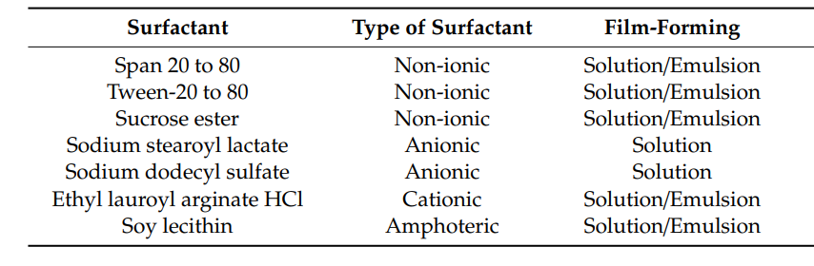
3.8.2 Cross-linkers
A cross-linker is a substance that creates chemical or physical bonds between molecules or polymer chains, effectively linking them together to form a network or matrix. This process, called cross-linking, can significantly improve the stability, strength, and durability of materials like polymers, proteins, and starches. Cross-linked coatings provide notable benefits, particularly by reducing the penetration of external substances into the coating layers. They also enhance the coating’s mechanical strength, chemical resistance, and thermal stability (Guo et al., 2014). Commonly used cross-linking agents are symmetrical bifunctional compounds that contain reactive groups targeting specific functional groups within the matrix macromolecules ( Balaguer et al., 2011). Cross-linking is especially advantageous for biopolymers, such as those made from proteins or polysaccharides. However, it is more frequently applied to proteins due to their higher number of reactive functional groups ( Azeredo et al., 2016). The process typically involves a variety of cross-linking agents, as listed in Table 2.
Table 2. Cross-linking agents commonly used in different types of edible coating
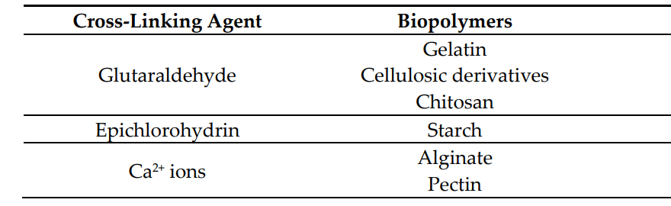
3.9 Bio-active compounds
Active edible films and coating can be created by the addition of functional compounds as anti-browning agents, colorants, flavors, sweeteners, nutrients, probiotics, nutraceuticals, antimicrobial and antioxidant compounds, etc. (Pereira et al., 2017). Table 3 summarizes the main functional and bioactive ingredients of active films and coatings. Edible films and coatings offer several advantages and potential economic benefits for the meat industry. They help prevent moisture and weight loss, as well as undesirable sensory changes such as alterations in texture, flavor, odor, and color. Additionally, by reducing dripping, they contribute to improved product appearance and quality. Their low oxygen permeability also plays a key role in minimizing lipid and myoglobin oxidation, slowing the growth of spoilage and pathogenic microorganisms, and partially inactivating proteolytic enzymes responsible for meat deterioration (Sanchez-Ortega et al., 2014). The incorporation of plant extracts and essential oils in edible films and coatings has become increasingly important due to their strong antimicrobial and antioxidant properties. These natural antioxidants are primarily used to prevent lipid oxidation, slow the formation of off-flavours, and maintain colour stability (Aminzare et al., 2019)Their mechanisms of action include halting the chain reactions that lead to peroxidation, neutralizing reactive oxygen species, inhibiting pro-oxidative enzymes, interrupting auto-oxidative cycles, capturing superoxide radicals (O2−), preventing peroxide formation, and chelating metal ions that could trigger the production of reactive species or the breakdown of lipid peroxides (Verni et al., 2019).
Table 3. Examples of bioactive ingredients of active films and coatings (Mehdizadeh and Langroodi 2019).
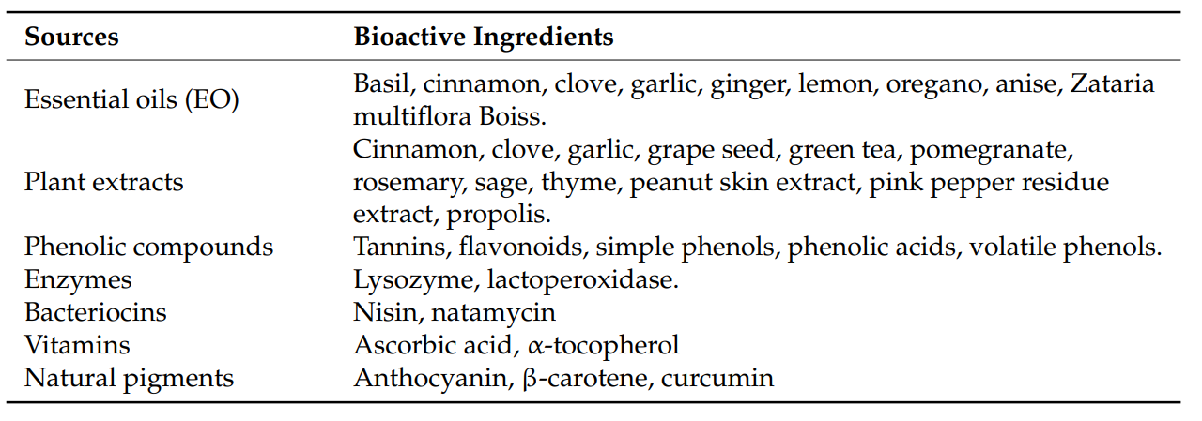
- Pectin
Pectin is an acidic heteropolysaccharide and is widely distributed in the primary and middle lamella as well as the cell walls of terrestrial plants (Mohnen, 2008). The main constituents of pectin include galacturonic acid, a sugar acid made from galactose. Pectin was first isolated and described by Henri Braconnot in 1825 (Keppler et al., 2006). Pectin has a molecular weight of approximately 60,000–130,000 g/mol. Pectin is a gelling substance widely utilized in the food and baking industries, as well as in medicine and cosmetics. Pectin is found in the main cell walls of higher plants. Further, pectin is a source of dietary fibre (Induru, 2021). Pectin possesses a complex structure primarily composed of a linear chain of α-(1,4)-linked D-galacturonic acid units, forming what is known as the homogalacturonan (HG) domain. This main chain is periodically interrupted by rhamnose units, giving rise to rhamnogalacturonan I (RG-I) regions. Additional complexity is introduced by highly branched domains such as rhamnogalacturonan II (RG-II) and xylogalacturonan (XG). The galacturonic acid residues in the HG region are partially methyl-esterified at the carboxyl group on carbon 6 and can also be acetylated at the O-2 or O-3 positions. The extent of methyl esterification, referred to as the degree of methylation (DM), significantly influences the functional behavior of pectin. Based on DM, pectins are categorized into high-methoxyl (HM) types with DM greater than 50%, and low-methoxyl (LM) types with DM below 50 per cent (Wang et al., 2018; Fares et al., 2012 ; Zhao et al., 2024).
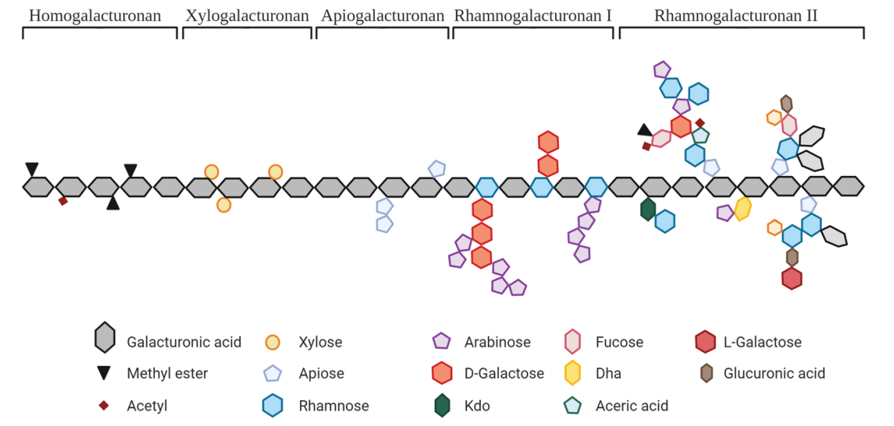
Fig 3. Structural characteristics of pectin molecules.
The physicochemical properties of pectin are diverse and largely influenced by its structural characteristics. One of the most important properties is its ability to form gels, with HM pectins forming gels in acidic conditions and high sugar concentrations, while LM pectins can gel in the presence of divalent cations, particularly calcium, over a wider pH range ( Said et al., 2023). In solution form, pectin exhibits non-Newtonian, pseudoplastic behavior, with viscosity influenced by factors such as concentration, molecular weight, pH, and temperature (Schmidt et al., 2014). Some pectin types, particularly those with high protein content or specific structural features, can act as emulsifiers, stabilizing oil-in-water emulsions ( Sayah et al., 2016). This rheological behaviour is essential in understanding pectin’s performance in various processing conditions and end-use applications. Pectin’s functional versatility is further enhanced by its ability to interact with other molecules. It can form complexes with polysaccharides, proteins, and multivalent cations, leading to various potential applications. In the food industry, pectin finds applications as a gelling agent for jams and jellies, a thickener and stabilizer in various products, an emulsifier, a fat and sugar replacer in low-calorie foods, and a functional ingredient in fruit products, dairy products, desserts, frozen foods, bakery products, beverages, confectionery, and salad dressings.
- Pectin extraction
Pectin was extracted using a modified method based on the procedure by Canteri-Schemin et al. (2005). The process involved placing 4 g of passion fruit peel flour into 100 mL of distilled water in a 600 mL beaker, followed by the addition of 100 mL of an acidic solution adjusted to maintain a final pH of 2. The mixture was heated in a CCE model Me304 microwave oven for 3, 6, or 9 minutes, with the beaker partially covered. Due to partial exposure, some water evaporated during heating, so distilled water was periodically added to maintain a consistent suspension. The warm mixture was vacuum-filtered using synthetic fabric, with the solid residue discarded. The filtrate, containing the soluble pectin, was cooled to 4 °C. To isolate pectin, the filtrate was slowly added to two volumes of absolute ethanol (also at 4 °C) under magnetic stirring, stirred for 10 minutes, then left undisturbed for 30 minutes to allow the pectin to float. The pectin was then collected by vacuum filtration. Next, the gel-like pectin was immersed in absolute ethanol for about 12 hours, followed by a brief immersion in acetone for partial dehydration. Finally, the pectin was dried in an air-circulated oven at 40 °C for about five hours until it reached a constant weight. The dried pectin was then ground into powder. The percentage yield of the fruit peel pectin was determined as gram of product obtained per 10 g of fruit peel powder used:
$$Pectin Yield (\%)=\frac{Pectin obtained in (g)}{ Passion Fruit Rind Powder (g)}×100$$
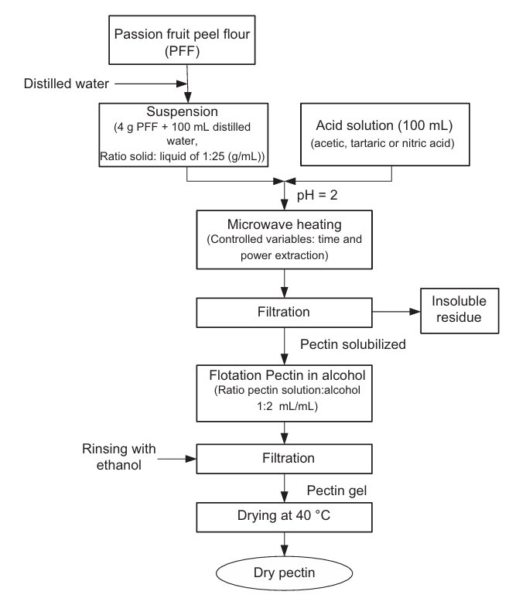
Fig. 4. Flow diagram for the extraction of pectin.
- Determination of degree of esterification (DE)
The degree of esterification (DE) is a critical property of pectin that significantly influences its gelling property, solubility, and application in food and pharmaceutical industries. Although the DE of pectin largely depends on the botanical source and the method of extraction, pectin extracted under acidic conditions typically contains approximately 60% methyl ester group. The acidity of the extraction medium plays a pivotal role in modifying the chemical structure of pectin. (Yapo & Koffi, 2014). Pectins are typically classified as either high methoxyl pectin (HMP), with a DE greater than 50%, or low methoxyl pectin (LMP), with a DE less than 50% (May, 1990). HMP forms gels in the presence of high sugar concentrations and acidic pH (around 2.0–3.5), making it suitable for traditional jam and jelly applications. In contrast, LMP requires the presence of divalent cations, such as calcium ions (Ca²⁺), to form gels, and does so over a broader pH range (2.5–6.5), allowing for reduced-sugar or sugar-free product formulations (Voragen et al., 1995). The esterification pattern affects the molecular interactions within the pectin network during gel formation. In HMP, the methyl ester groups promote hydrophobic interactions and hydrogen bonding under low pH and high sugar conditions, facilitating the formation of a rigid gel matrix. In LMP, non-methylated carboxyl groups interact with calcium ions to create "egg-box" structures that link pectin chains, leading to gelation even in the absence of sugar (Rolin, 1993). Thus, the DE not only influences the functional properties of pectin but also its application in various food and pharmaceutical products, where specific gelling behavior is required. Most commonly employed techniques is the titrimetric method, which quantifies free and esterified carboxyl groups through a two-step neutralization and saponification process. For example, Koubala et al. (2008) applied this method to pectin extracted from yellow passion fruit (Passiflora edulis f. flavicarpa) peels, reporting a DE value of 59%, classifying the extracted pectin as high methoxyl pectin. This method remains widely used due to its simplicity and cost-effectiveness, despite its moderate precision compared to modern spectroscopic techniques. Fourier-transform infrared (FT-IR) spectroscopy, which uses characteristic absorption peaks to differentiate esterified and non-esterified carboxyl groups. Peaks around 1740 cm⁻¹ and 1630 cm⁻¹ correspond to ester carbonyl (C=O) and carboxylate ion (COO⁻) vibrations, respectively. In a study by Sriamornsak (2003), FT-IR analysis of pectin extracted from jackfruit and durian rinds revealed DE values ranging from 50 to 72 per cent , supporting the classification of these pectins as high methoxyl types. Similarly, Gnanasambandam and Proctor (2000) used FT-IR to characterize pectin from citrus peel and peanut hulls, reporting that peak ratios could effectively estimate DE and differentiate between HMP and LMP (Gnanasambandam and Proctor, 2000).
- Preparation of Edible Coating
To prepare the edible coating, a 3% (w/v) solution of pectin was formulated by gradually dispersing the dried pectin powder in distilled water heated to 70–90 °C under constant magnetic stirring to ensure complete solubilization and to prevent clumping. Glycerol, used as a plasticizer, was added at 30% (w/w) of the pectin content to improve film flexibility and reduce brittleness (Rojas-Grau et al., 2009 ; Menezes and Athmaselvi, 2016). In some formulations, bioactive compounds such as essential oils (e.g., cinnamon or thyme oil), natural antimicrobials (e.g., nisin), or plant polyphenol extracts (e.g., green tea or pomegranate peel) were incorporated to enhance antimicrobial and antioxidant properties, depending on the intended application. (Tharanathan, 2003). Recent studies have explored blending pectin with various biopolymers such as proteins to improve mechanical and barrier properties. For instance, pectin–gelatin composite films or coatings have demonstrated enhanced tensile strength and reduced water vapour permeability due to improved polymer interaction (Nisar et al., 2018). Similarly, pectin–whey protein films have been reported to exhibit better flexibility and oxygen barrier characteristics, making them suitable for perishable food packaging (Almasi et al., 2010). Dávalos-Saucedo et al., (2018) prepared an edible coating solution was prepared by mixing 1.2 g of whey protein isolate (WPI) with 0.6 g of sorbitol in 25 mL of distilled water and stirring for 2 hours, while 1.2 g of pectin was dissolved separately in 25 mL of water and stirred for the same time. The WPI–sorbitol mixture was then heated to 80 °C for 25 minutes, and the preheated pectin solution was added to achieve a 4:1 WPI-to-pectin ratio. After cooling with continuous stirring, the pH was adjusted to 5.1 using 0.1 N HCl, transglutaminase (8 U per gram of WPI) was added, and the solution was stirred for 16 hours before use. They used egg for this experiment and reported that, uncoated eggs lost about 4.7% ± 0.3% of their weight after 15 days at 25 °C, while coated eggs lost only 1.1% ± 0.35%. The whey protein–pectin coating reduced weight loss more effectively than whey protein alone, as reported by Caner, (2005) where whey-based coatings resulted in 2.1% loss compared to 3.4% in uncoated eggs. In addition, the inclusion of cross-linking agents such as calcium chloride, particularly in low-methoxyl pectin systems, further enhances film stability and cohesion by promoting ionic gelation (Sriamornsak, 2003). Furthermore, composite films or coatings based on pectin and soy protein isolate have shown promising results in extending shelf life of fruits by modulating gas exchange and reducing microbial load (Zambrano-Zaragoza et al., 2014). These approaches underscore the versatility of pectin as a base material in edible coatings, especially when synergistically combined with other biopolymers.

  - Application methods edible coatings
The selection of the application method depends on the characteristics of the surface and the geometry of the product to be coated. Regarding this, it can be stated that physical properties such as surface tension and plasticity modify the mechanical properties of edible coatings (Pavlath and Orts, 2009).

- Casting
Edible films and coatings can be produced using two primary methods: casting and extrusion (Figure 5). Casting is a widely used laboratory technique valued for its simplicity and ease of application. This method involves three main stages: solubilization, casting, and drying. Initially, a solution or dispersion is prepared using a suitable solvent. This mixture is then spread onto a flat surface (for edible films) or applied directly to food surfaces (for edible coatings). The drying step allows the solvent to evaporate, increasing the viscosity and leading to the formation of a continuous, thin layer with desirable mechanical and barrier properties ( Cheng 2023).
The strength and effectiveness of the resulting edible film or coating depend significantly on factors such as processing time, temperature, and drying conditions. However, the casting technique generally involves long processing and drying times, making it less practical for industrial-scale or commercial production. Despite this limitation, casting is frequently used in research and has been applied to a variety of foods, including okra leaves, cherry tomatoes, and mangoes, as well as plant materials like yerba mate ( Sharma et al., 2022).
- Dipping (Immersion)
Dipping, or immersion, is a widely adopted method even at the laboratory level due to its operational simplicity (Figure 3). In this technique, the food product is submerged into a pre-prepared coating solution for a specific duration (Saez-Orviz et al., 2023). After immersion, the coated item is allowed to dry at room temperature, during which any excess coating is drained off to avoid the formation of an overly thick layer (Cheng et al., 2022). If needed, the dipping step can be repeated with a different solu tion to enhance coating quality. This method is favoured for its low cost, straightforward procedure, and short processing time. However, a notable drawback is the relatively high consumption of coating solution, which can prolong preparation time (Popescu et al., 2022).

- Electrospinning
Electrospinning, predominantly applied in edible film development for packaging purposes (Figure 5), is recognized for its cost-effectiveness, ease of use, and versatility. The technique relies on an electric field to elongate a polymer solution, producing nanofibrous films with high surface-area-to-volume ratios and fine pore distributions. These nanofibers are capable of forming a coating over the material. Despite its benefits, electrospinning is limited by the weak bonding between the fibers, which can result in poor mechanical strength of the final film ( Tampau et al., 2020).

- Spraying
Spraying involves atomizing the coating solution into fine droplets and applying it to the food surface via a nozzle, making it the most common method in industrial food processing (Figure 5). This approach ensures a uniform and consistent coating layer, requires less solution, minimizes contamination risks, and is especially effective for coating food items with large or irregular surfaces.In addition to the main methods discussed, there are other techniques for applying edible coatings. One such approach is pouring, where the coating solution is simply poured over the food surface. Another technique is the foam method, in which foam is generated and applied as the product moves through a cylinder, followed by brushing to ensure even distribution over the surface (Okcu et al., 2018).

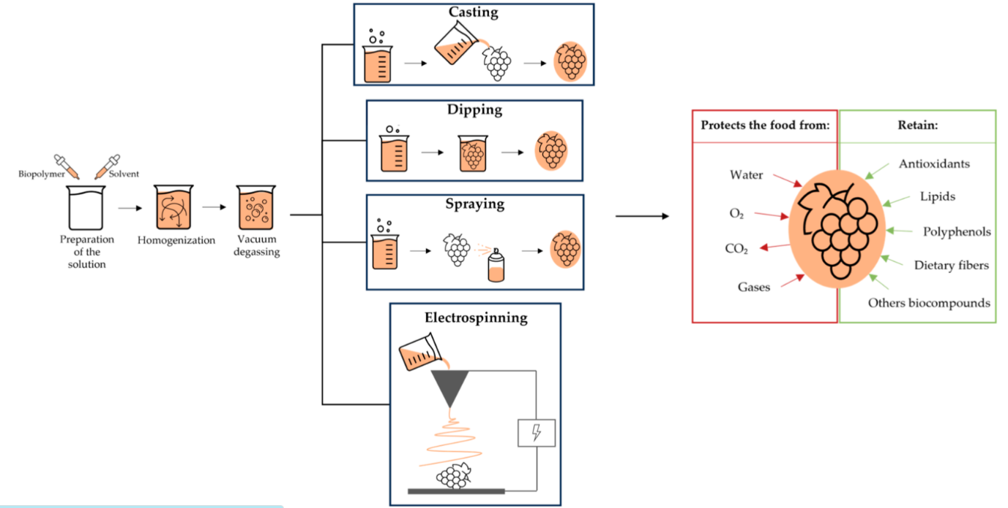

Fig 5. Illustration of the application of edible coatings
- Physico chemical analysis of fruits on storage

Weight loss
The weight loss in control and the coated fruit samples is measured using the following formula (Qayyum et al., 2014).
`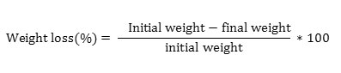
Total soluble solids (TSS)
The TSS content of the fruits is determined using the hand refractrometer. A drop of fruit juice is placed onto the plate surface of the refractrometer and the reading is taken directly as ^{º} Brix (Padmaja et al., 2015).
pH
The pH of the fruit pulp is measured using the digital pH meter. Initially the pH meter is calibrated using the pH 7 buffer solution and then the probe of the pH meter is placed into the fruit juice and reading is taken directly (Ranganna, 1986).
Titratable acidity
Acidity is measured by the titration method using 0.1 N NaOH solution. The acidity is measured using the following formula (Ranganna, 1986).
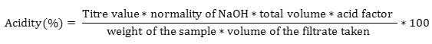
Colour
The L*, a* and b* values of the fruit peel is measured during the storage using the Hunter Colourimeter. The L* values depicts the lightness, a* values represent the extent of the redness or greenness and b* values represent the extent of blueness or yellowness (Ranganna,1986).
Ascorbic acid
Ascorbic acid is the acid which is present in the highest amount in the sapota fruits. It is measured by the titration method using 2, 6 dichlorophenol indophenol (Ranganna,1986).
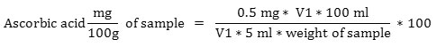
Where,
V₁ is the titre value of standard ascorbic acid
V₂ is the titre value of fruit pulp.
Firmness
The firmness of both control and the coated sapota fruits was measured during the storage period by using the texture analyzer. The penetration test was used to determine the firmness of fruits. A probe of 2 mm diameter was allowed to penetrate through the fruits upto 10 mm depth. During the analysis, the load cell of 50Kg, pretest speed 1.5mm/sec, test speed 1.0mm/sec, post test speed 10mm/sec was maintained. The force that is required to penetrate through the surface of fruits was measured in terms of gram (Ranganna, S. (1986).
pH
The pH value of both coated and control sapota fruits decreased during the storage (Ranganna, S. (1986).
- Discussion
The pectin-based edible coating helped sapota fruits stay fresh for up to 11 days by slowing down changes in physical and chemical properties such as weight loss, TSS, pH, total acidity, ascorbic acid, firmness, and colour. In comparison, uncoated fruits remained consumable only until the 5th day at room temperature (30 ± 3ºC) (Menezes, & Athmaselvi, 2016). According to Panahirad et al., (2020) pectin coatings (especially at higher concentrations, e.g. ~1–1.5 %) plasticised with glycerol help significantly reduce weight loss in fruits compared to uncoated controls. For example, in plums, coatings with 1–1.5 % pectin + 0.3 % glycerol showed markedly better retention of moisture over 8 days. Adhikari et al., (2023) reported that composite coatings that include proteins or a multilayer system often perform even better; for instance, strawberries coated with chitosan–pectin multilayers exhibited only about 13 % weight loss after nine days of storage compared to approximately 44.5 % for uncoated fruits.
- Conclusion
Edible coatings made from natural, biodegradable materials are a safe, eco-friendly alternative to synthetic preservatives and plastic packaging. They help extend the shelf life of fruits and vegetables by preserving texture, colour, nutrients, and preventing microbial growth. Blended biopolymers, like chitosan with gelatin or pullulan with pectin, often perform better than single materials. More research is needed to understand how active ingredients affect strength, sensory quality, and functionality. Future studies should explore new biopolymer combinations, greener crosslinkers like NADES, and underused materials such as cellulose derivatives, plant gums, inulin, zein, and natural waxes. For real-world success, coatings must not only protect produce but also appeal to consumers in taste, texture, and appearance.
References

- Adhikari, M., Koirala, S., & Anal, A. K. (2023). Edible multilayer coating using electrostatic layer-by-layer deposition of chitosan and pectin enhances shelf life of fresh strawberries. International Journal of Food Science and Technology, 58(2), 871-879.
- Aguilar-Palazuelos, E., Fitch-Vargas, P. R., Delgado-Nieblas, C. I., López-Diaz, A., Gastélum-Ávila, A., Sánchez-Chilero, M. A., ... & Calderón-Castro, A. (2025). Edible films based on corn starch and gelatin obtained by the combination of extrusion and casting process: characterization and applications. Food Biophysics, 20(1), 2.
- Aguilar-Veloz, L. M., Calderón-Santoyo, M., Carvajal-Millan, E., Martínez-Robinson, K., & Ragazzo-Sánchez, J. A. (2022). Artocarpus heterophyllus Lam. leaf extracts added to pectin-based edible coating for Alternaria sp. control in tomato. Lwt, 156, 113022.
- Akrami, S., Saki, M., Marashi Hossaeini, S. M., Sabahi, S., & Noori, S. M. A. (2023). Application of soy protein-based films and coatings on the shelf life of food products: a mini-review of recent publications with emphasis on nanotechnology. Journal of Food Measurement and Characterization, 17(2), 1393-1401.
- Alotaibi, M. A., Tayel, A. A., Zidan, N. S., & El Rabey, H. A. (2019). Bioactive coatings from nano‐biopolymers/plant extract composites for complete protection from mycotoxigenic fungi in dates. Journal of the Science of Food and Agriculture, 99(9), 4338-4343.
- Alves, A. C. R. S., Lima, A. M. F., Tiera, M. J., & Tiera, V. A. d. O. (2019). Biopolymeric films of amphiphilic derivatives of chitosan: a physicochemical characterization and antifungal study. International Journal of Molecular Sciences, 20, 1–20.
- Aminzare, M., Hashemi, M., Ansarian, E., Bimakr, M., Hassanzad Azar, H., Mehrasbi, M. R., ... & Afshari, A. (2019). Using natural antioxidants in meat and meat products as preservatives: A review. Advances in Animal and Veterinary Sciences, 7(5), 417-426.
- Azeredo, H. M., & Waldron, K. W. (2016). Crosslinking in polysaccharide and protein films and coatings for food contact–A review. Trends in Food Science & Technology, 52, 109-122.
- Balaguer, M. P., Gómez-Estaca, J., Gavara, R., & Hernandez-Munoz, P. (2011). Functional properties of bioplastics made from wheat gliadins modified with cinnamaldehyde. Journal of Agricultural and Food Chemistry, 59(12), 6689-6695.
- Beyza, H., Fatma, K., & Hecer, C. (2018). Edible films and coatings: A good idea from past to future technology. J. Food Technol, 5, 28-33.
- Biswas, S., Mishra, R., & Bist, A. S. (2021). Passion to profession: A review of passion fruit processing. Aptisi Transactions on Technopreneurship, 3(1), 48–57.
- Brennan, L., Langley, S., Verghese, K., Lockrey, S., Ryder, M., Francis, C., Phan-Le, N. T., & Hill, A. (2021). The role of packaging in fighting food waste: A systematised review of consumer perceptions of packaging. Journal of Cleaner Production, 281, 125276.
- Calva-Estrada, S. J., Jiménez-Fernández, M., & Lugo-Cervantes, E. (2019). Protein-based films: Advances in the development of biomaterials applicable to food packaging. Food Engineering Reviews, 11, 78-92.
- Caner, C. (2005). Whey protein isolate coating and concentration effects on egg shelf life. Journal of the Science of Food and Agriculture, 85(13), 2143-2148.
- Canteri-Schemin, M. H., Fertonani, H. C. R., Waszczynskyj, N., & Wosiacki, G. (2005). Extraction of pectin from apple pomace. Brazilian archives of biology and technology, 48, 259-266.
- Cheng, C., Chen, S., Su, J., Zhu, M., Zhou, M., Chen, T., & Han, Y. (2022). Recent advances in carrageenan-based films for food packaging applications. Frontiers in Nutrition, 9, 1004588.
- Cheng, H., Mou, Z., Wang, W., Zhang, W., Wang, Z., Zhang, M., ... & Sun, D. (2019). Chitosan–catechin coating as an antifungal and preservable agent for postharvest satsuma oranges. Journal of food biochemistry, 43(4), e12779.
- Cheng, Y., Zhai, X., Wu, Y., Li, C., Zhang, R., Sun, C., ... & Hou, H. (2023). Effects of natural wax types on the physicochemical properties of starch/gelatin edible films fabricated by extrusion blowing. Food chemistry, 401, 134081.
- Chong, K. Y., & Brooks, M. S. L. (2022). Development of pea protein-based films and coatings with haskap leaf extracts. Applied Food Research, 2(1), 100102.
- Cofelice, M., Lopez, F., & Cuomo, F. (2019). Quality control of fresh-cut apples after coating application. Foods, 8(6), 189.
- Corrêa, R. C. G., Peralta, R. M., Haminiuk, C. W. I., Maciel, G. M., Bracht, A., & Ferreira, I. C. F. R. (2016). The past decade findings related to nutritional composition, bioactive molecules, and biotechnological applications of Passiflora spp. (passion fruit). Trends in Food Science & Technology, 58, 79–95.
- Dávalos-Saucedo, C. A., Rossi-Márquez, G., Regalado-González, C., Alonzo-Macías, M., & Di Pierro, P. (2018). Application of transglutaminase crosslinked whey protein–pectin coating improves egg quality and minimizes the breakage and porosity of eggshells. Coatings, 8(12), 438.
- Deshmukh, N., Patel, R., Okram, S., Rymbai, H., Roy, S., & Jha, A. (2017). Passion fruit (Passiflora spp.). Magnesium, 100, 200.
- Dhumal, C. V., & Sarkar, P. (2018). Composite edible films and coatings from food-grade biopolymers. Journal of food science and technology, 55(11), 4369-4383.
- Dos Reis, L. C. R., Facco, E. M. P., Salvador, M., Flôres, S. H., & de Oliveira Rios, A. (2018). Antioxidant potential and physicochemical characterization of yellow, purple and orange passion fruit. Journal of Food Science and Technology, 55, 2679-2691.
- Du, Y., Zhao, Y., Dai, S., & Yang, B. (2009). Preparation of water-soluble chitosan from shrimp shell and its antibacterial activity. Innovative Food Science & Emerging Technologies, 10(1), 103-107.
- Emragi, E., Kalita, D., & Jayanty, S. S. (2022). Effect of edible coating on physical and chemical properties of potato tubers under different storage conditions. LWT, 153, 112580.
- Estevinho, B. N., Damas, A. M., Martins, P., & Rocha, F. (2014). Microencapsulation of β-galactosidase with different biopolymers by a spray-drying process. Food Research International, 64, 134-140.
- Fares, M. M., Maayta, A. K., & Al-Qudah, M. M. (2012). Pectin as promising green corrosion inhibitor of aluminum in hydrochloric acid solution. Corrosion Science, 60, 112-117.
- Farina, V., Passafiume, R., Tinebra, I., Palazzolo, E., & Sortino, G. (2020). Use of aloe vera gel-based edible coating with natural anti-browning and anti-oxidant additives to improve post-harvest quality of fresh-cut ‘fuji’apple. Agronomy, 10(4), 515.
- Ganiari, S., Choulitoudi, E., & Oreopoulou, V. (2017). Edible and active films and coatings as carriers of natural antioxidants for lipid food. Trends in Food Science & Technology, 68, 70-82.
- Gnanasambandam, R., & Proctor, A. J. F. C. (2000). Determination of pectin degree of esterification by diffuse reflectance Fourier transform infrared spectroscopy. Food chemistry, 68(3), 327-332.
- Grimaldi, M., Pitirollo, O., Ornaghi, P., Corradini, C., & Cavazza, A. (2022). Valorization of agro-industrial byproducts: Extraction and analytical characterization of valuable compounds for potential edible active packaging formulation. Food Packaging and Shelf Life, 33, 100900.
- Guilbert, S., Gontard, N., & Cuq, B. (1995). Technology and applications of edible protective films. Packaging technology and science, 8(6), 339-346.
- Guo, Q., Paliy, M., Kobe, B., Trebicky, T., Suhan, N., Arsenault, G., ... & Yang, J. (2015). Characterization of cross‐linking depth for thin polymeric films using atomic force microscopy. Journal of Applied Polymer Science, 132(8).
- Han, K., Liu, Y., Liu, Y., Huang, X., & Sheng, L. (2020). Characterization and film-forming mechanism of egg white/pullulan blend film. Food chemistry, 315, 126201.
- Hassan, Bilal, Shahzad Ali Shahid Chatha, Abdullah Ijaz Hussain, Khalid Mahmood Zia, and Naseem Akhtar. "Recent advances on polysaccharides, lipids and protein based edible films and coatings: A review." International journal of biological macromolecules 109 (2018): 1095-1107.
- He, X., Luan, F., Yang, Y., Wang, Z., & Zhao, Z. (2020). Passiflora edulis: An insight into current research on phytochemistry and pharmacology. Frontiers in Pharmacology, 11, 617.
- Heristika, W., Ningrum, A., Munawaroh, H. S. H., & Show, P. L. (2023). Development of composite edible coating from gelatin-pectin incorporated garlic essential oil on physicochemical characteristics of red chili (Capsicum annnum L.). Gels, 9(1), 49.
- Hosseini, S. F., Mousavi, Z., & McClements, D. J. (2023). Beeswax: A review on the recent progress in the development of superhydrophobic films/coatings and their applications in fruits preservation. Food chemistry, 424, 136404.
- Induru, J. (2021). Pectin-based nanomaterials in drug delivery applications. In Biopolymer-Based Nanomaterials in Drug Delivery and Biomedical Applications (pp. 87-117). Academic Press.
- Iniguez-Moreno, M., Santiesteban-Romero, B., Flores-Contreras, E. A., Scott-Ayala, S., Araújo, R. G., Iqbal, H. M., ... & Parra-Saldívar, R. (2024). Sustainable solutions for postharvest berry protection: natural edible coatings. Food and Bioprocess Technology, 17(11), 3483-3505.
- Istiqomah, A., Prasetyo, W. E., Firdaus, M., & Kusumaningsih, T. (2025). Multivariate Optimization of Chitosan/Starch/Aloe Vera Packaging Film for Beef Fillet Preservation: Insights into Interaction Mechanisms and Evaluation of Sustainability Metrics. Food Biophysics, 20(1), 36.
- Jo, W. S., Song, H. Y., Song, N. B., Lee, J. H., Min, S. C., & Song, K. B. (2014). Quality and microbial safety of ‘Fuji’apples coated with carnauba-shellac wax containing lemongrass oil. LWT-Food Science and Technology, 55(2), 490-497.
- Karnwal, A., Kumar, G., Singh, R., Selvaraj, M., Malik, T., & Al Tawaha, A. R. M. (2025). Natural biopolymers in edible coatings: Applications in food preservation. Food Chemistry: X, 102171.
- Kawakami, S., Morinaga, M., Tsukamoto-Sen, S., Mori, S., Matsui, Y., & Kawama, T. (2021). Constituent characteristics and functional properties of passion fruit seed extract. Life, 12(1), 38.
- Keppler, F., Hamilton, J. T., Braß, M., & Röckmann, T. (2006). Methane emissions from terrestrial plants under aerobic conditions. Nature, 439(7073), 187-191.
- Khalifa, I., Barakat, H., El-Mansy, H. A., & Soliman, S. A. (2016). Improving the shelf-life stability of apple and strawberry fruits applying chitosan-incorporated olive oil processing residues coating. Food Packaging and Shelf Life, 9, 10-19.
- Khan, M. R., Volpe, S., Valentino, M., Miele, N. A., Cavella, S., & Torrieri, E. (2021). Active casein coatings and films for perishable foods: structural properties and shelf-life extension. Coatings, 11(8), 899.
- Khatri, D., Panigrahi, J., Prajapati, A., & Bariya, H. (2020). Attributes of Aloe vera gel and chitosan treatments on the quality and biochemical traits of post-harvest tomatoes. Scientia Horticulturae, 259, 108837.
- Kowalczyk, D., & Baraniak, B. (2014). Effect of candelilla wax on functional properties of biopolymer emulsion films–a comparative study. Food Hydrocolloids, 41, 195-209.
- Kumar, N., Tripathi, S., Pratibha, Mehra, M., Heena, & Trajkovska Petkoska, A. (2023). Whey Protein Based Edible Coatings: Recent Trends. Whey Valorization: Innovations, Technological Advancements and Sustainable Exploitation, 187-209.
- Lara-Espinoza, C., Carvajal-Millán, E., Balandrán-Quintana, R., López-Franco, Y., & Rascón-Chu, A. (2018). Pectin and pectin-based composite materials: Beyond food texture. Molecules, 23(4), 942.
- Liu, S., Qiao, S., Zhu, J., Yang, Y., Chen, H., Dai, H., ... & Wang, H. (2024). Enhanced barrier and antioxidant properties of gelatin films by structural-colored bioactive materials for food packaging. Food Hydrocolloids, 150, 109744.
- Liu, S., Yang, F., Li, J., Zhang, C., Ji, H., & Hong, P. (2008). Physical and chemical analysis of Passiflora seeds and seed oil from China. International journal of food sciences and nutrition, 59(7-8), 706-715.
- Luangapai, F., Peanparkdee, M., & Iwamoto, S. (2019). Biopolymer films for food industries: Properties, applications, and future aspects based on chitosan. Reviews in Agricultural Science, 7, 59-67.
- Ma, Q., Zhang, Y., & Zhong, Q. (2016). Physical and antimicrobial properties of chitosan films incorporated with lauric arginate, cinnamon oil, and ethylenediaminetetraacetate. LWT, 65, 173-179.
- Mehdizadeh, T., & Langroodi, A. M. (2019). Chitosan coatings incorporated with propolis extract and Zataria multiflora Boiss oil for active packaging of chicken breast meat. International journal of biological macromolecules, 141, 401-409.
- Mendy, T. K., Misran, A., Mahmud, T. M. M., & Ismail, S. I. (2019). Application of Aloe vera coating delays ripening and extend the shelf life of papaya fruit. Scientia Horticulturae, 246, 769-776.
- Menezes, J., & Athmaselvi, K. A. (2016). Study on effect of pectin based edible coating on the shelf life of sapota fruits. Biosciences Biotechnology Research Asia, 13(2), 1195-1199.
- Mihalca, V., Kerezsi, A. D., Weber, A., Gruber-Traub, C., Schmucker, J., Vodnar, D. C., ... & Pop, O. L. (2021). Protein-based films and coatings for food industry applications. Polymers, 13(5), 769.
- Mkandawire, M., & Aryee, A. N. (2018). Resurfacing and modernization of edible packaging material technology. Current Opinion in Food Science, 19, 104-112.
- Moghadas, H. C., Chauhan, R., & Smith, J. S. (2024). Application of plant oils as functional additives in edible films and coatings for food packaging: A review. Foods, 13(7), 997.
- Mohnen, D. (2008). Pectin structure and biosynthesis. Current opinion in plant biology, 11(3), 266-277.
- Munhoz, D. R., Moreira, F. K., Bresolin, J. D., Bernardo, M. P., De Sousa, C. P., & Mattoso, L. H. (2018). Sustainable production and in vitro biodegradability of edible films from yellow passion fruit coproducts via continuous casting. ACS sustainable chemistry & engineering, 6(8), 9883-9892.
- Okcu, Z., Yavuz, Y., & Kerse, S. (2018). Edible film and coating applications in fruits and vegetables. Alinteri Journal of Agricultural Sciences, 33, 221–226.
- Oluwole, O., Fernando, W. B., Lumanlan, J., Ademuyiwa, O., & Jayasena, V. (2022). Role of phenolic acid, tannins, stilbenes, lignans and flavonoids in human health–a review. International Journal of Food Science and Technology, 57(10), 6326-6335.
- Ortega-Toro, R., Collazo-Bigliardi, S., Roselló, J., Santamarina, P., & Chiralt, A. (2017). Antifungal starch-based edible films containing Aloe vera. Food Hydrocolloids, 72, 1-10.
- Padmaja, N., Bosco, S. J. D., & Rao, J. S. (2015). Physico chemical analysis of sapota (Manilkara zapota) coated by edible aloe vera gel. International Journal of Applied Sciences and Biotechnology, 3(1), 20-25.
- Panahirad, S., Naghshiband-Hassani, R., & Mahna, N. (2020). Pectin-based edible coating preserves antioxidative capacity of plum fruit during shelf life. Food Science and Technology International, 26(7), 583-592.
- Parreidt, T. S., Müller, K., & Schmid, M. (2018). Alginate-based edible films and coatings for food packaging applications. Foods, 7(10), 170.
- Passafiume, R., Gaglio, R., Sortino, G., & Farina, V. (2020). Effect of three different aloe vera gel-based edible coatings on the quality of fresh-cut “Hayward” kiwifruits. Foods, 9(7), 939.
- Pavlath, A. E., & Orts, W. (2009). Edible films and coatings: why, what, and how?. Edible films and coatings for food applications, 1-23.
- Payal, A., Sandeep, G. D. S., Bammidi, M., Narayandas, A., Syed, I., & Rao, M. V. (2025). Recent advances in plant protein-based edible coatings for shelf-life enhancement of perishable and high nutritive value foods–A Review. Food Packaging and Shelf Life, 48, 101465.
- Pereira, J. O., & Pintado, M. M. (2017). Edible Packaging A Vehicle for Functional Compounds. In Edible Food Packaging (pp. 215-242). CRC Press.
- Popescu, P., Palade, L., Nicolae, I., Popa, E., Miteluț, A., Drăghici, M., Matei, F., & Popa, M. (2022). Chitosan-based edible coatings containing essential oils to preserve the shelf life and postharvest quality parameters of organic strawberries and apples during cold storage. Foods, 11, 3317.
- Qayyum, M. M. N., Butt, M., Khan, M. A., Muhammad Shahnawaz, M. S., Sharif, M. K., Muhammad Yasin, M. Y., ... & Farhan Saeed, F. S. (2014). Effects of different coatings on preserving fruit quality of sweet cherries grown in Skardu valley of Gilgit-Baltistan during storage.
- Qi, H., Hu, W., Jiang, A., Tian, M., & Li, Y. (2011). Extending shelf-life of fresh-cut ‘Fuji’apples with chitosan-coatings. Innovative Food Science & Emerging Technologies, 12(1), 62-66.
- Ranganna, S. (1986). Handbook of analysis and quality control for fruit and vegetable products. Tata McGraw-Hill Education.
- Rangel-Marrón, M., Mani-López, E., Palou, E., & López-Malo, A. (2019). Effects of alginate-glycerol-citric acid concentrations on selected physical, mechanical, and barrier properties of papaya puree-based edible films and coatings, as evaluated by response surface methodology. Lwt, 101, 83-91.
- Ranjith, F. H., Adhikari, B., Muhialdin, B. J., Yusof, N. L., Mohammed, N. K., Ariffin, S. H., & Hussin, A. S. M. (2022). Peptide-based edible coatings to control postharvest fungal spoilage of mango (Mangifera indica L.) fruit. Food Control, 135, 108789.
- Rohasmizah, H., & Azizah, M. (2022). Pectin-based edible coatings and nanoemulsion for the preservation of fruits and vegetables: A review. Applied food research, 2(2), 100221.
- Rojas-Grau, M. A., Soliva-Fortuny, R., & Martín-Belloso, O. (2009). Edible coatings to incorporate active ingredients to fresh-cut fruits: a review. Trends in food science & technology, 20(10), 438-447.
- Rolin, C. (1993). Pectin. In Industrial gums (pp. 257-293). Academic Press.
- Saez-Orviz, S., Rendueles, M., & Díaz, M. (2023). Impact of adding prebiotics and probiotics on the characteristics of edible films and coatings—A review. Food Research International, 164, 112381.
- Said, N. S., Olawuyi, I. F., & Lee, W. Y. (2023). Pectin hydrogels: Gel-forming behaviors, mechanisms, and food applications. Gels, 9(9), 732.
- Saidi, L., Wang, Y., Wich, P. R., & Selomulya, C. (2024). Polysaccharide-based Edible Films-Strategies to Minimize Water Vapor Permeability. Current Opinion in Food Science, 101258.
- Saikia, P. (2025). Cellulose and its derivatives: Fundamental chemistry, structure, properties, and applications. In Cellulose-Based Hydrogells (pp. 1-21). Elsevier.
- Sánchez-Ortega, I., García-Almendárez, B. E., Santos-López, E. M., Amaro-Reyes, A., Barboza-Corona, J. E., & Regalado, C. (2014). Antimicrobial edible films and coatings for meat and meat products preservation. The scientific world journal, 2014(1), 248935.
- Sani, I. K., Masoudpour-Behabadi, M., Sani, M. A., Motalebinejad, H., Juma, A. S., Asdagh, A., ... & Mohammadi, F. (2023). Value-added utilization of fruit and vegetable processing by-products for the manufacture of biodegradable food packaging films. Food chemistry, 405, 134964.
- Sayah, M. Y., Chabir, R., Benyahia, H., Rodi Kandri, Y., Ouazzani Chahdi, F., Touzani, H., & Errachidi, F. (2016). Yield, esterification degree and molecular weight evaluation of pectins isolated from orange and grapefruit peels under different conditions. PloS one, 11(9), e0161751.
- Scartazzini, L., Tosati, J. V., Cortez, D. H. C., Rossi, M. J., Flôres, S. H., Hubinger, M. D., ... & Monteiro, A. R. (2019). Gelatin edible coatings with mint essential oil (Mentha arvensis): Film characterization and antifungal properties. Journal of food science and technology, 56, 4045-4056.
- Schmid, T., Gillich, E., André, A., Kinner, M., Chetschik, I., & Müller, N. (2025). Physically Modified Plant Oils as Alternatives to Palm Fat: Effects on Physical and Flavour Properties of Chocolate Fillings. Foods, 14(7), 1179.
- Schmidt U., Schmidt K., Kurz T., Endreß H.-U., Schuchmann H. Pectins of different origin and their performance in forming and stabilizing oil-in-water-emulsions. Food Hydrocoll. 2015;46:59–66.
- Shafiei, R., & Mostaghim, T. (2022). Improving shelf life of calf fillet in refrigerated storage using edible coating based on chitosan/natamycin containing Spirulina platensis and Chlorella vulgaris microalgae. Journal of Food Measurement and Characterization, 16(1), 145-161.
- Sharma, S., Perera, K. Y., Pradhan, D., Duffy, B., Jaiswal, A. K., & Jaiswal, S. (2022). Active packaging film based on poly lactide-poly (Butylene Adipate-Co-Terephthalate) blends incorporated with tannic acid and gallic acid for the prolonged shelf life of cherry tomato. Coatings, 12(12), 1902.
- Shojaee-Aliabadi, S., Hosseini, H., Mohammadifar, M. A., Mohammadi, A., Ghasemlou, M., Hosseini, S. M., & Khaksar, R. (2014). Characterization of κ-carrageenan films incorporated plant essential oils with improved antimicrobial activity. Carbohydrate polymers, 101, 582-591.
- Suppakul, P., Chalernsook, B., Ratisuthawat, B., Prapasitthi, S., & Munchukangwan, N. (2013). Empirical modeling of moisture sorption characteristics and mechanical and barrier properties of cassava flour film and their relation to plasticizing–antiplasticizing effects. LWT-Food Science and Technology, 50(1), 290-297.
- Suput, D. Z., Lazić, V. L., Popović, S. Z., & Hromiš, N. M. (2015). Edible films and coatings–sources, properties and application. Food and feed research, 42(1), 11-22.
- Syarifuddin, A., Muflih, M. H., Izzah, N., Fadillah, U., Ainani, A. F., & Dirpan, A. (2025). Pectin-based edible films and coatings: From extraction to application on food packaging towards circular economy-A review. Carbohydrate Polymer Technologies and Applications, 100680.
- Tampau, A., González-Martínez, C., & Chiralt, A. (2020). Polyvinyl alcohol-based materials encapsulating carvacrol obtained by solvent casting and electrospinning. Reactive and Functional Polymers, 153, 104603.
- Tharanathan, R. N. (2003). Biodegradable films and composite coatings: past, present and future. Trends in food science & technology, 14(3), 71-78.
- Torres-Leon, C., Vicente, A. A., Flores-Lopez, M. L., Rojas, R., Serna-Cock, L., Alvarez-Pérez, O. B., & Aguilar, C. N. (2018). Edible films and coatings based on mango (var. Ataulfo) by-products to improve gas transfer rate of peach. Lwt, 97, 624-631.
- Tóth, A., & Halász, K. (2019). Characterization of edible biocomposite films directly prepared from psyllium seed husk and husk flour. Food Packaging and Shelf Life, 20, 1–9.
- Tripathi, P. C., Karunakaran, G., Sakthivel, T., Sankar, V., & Senthilkumar, R. (2014). Passion fruit cultivation in India. Indian Inst. Hortic. Res. 14p.
- Valdés, A., Burgos, N., Jiménez, A., & Garrigós, M. C. (2015). Natural pectin polysaccharides as edible coatings. Coatings, 5(4), 865-886.
- Verni, M., Verardo, V., & Rizzello, C. G. (2019). How fermentation affects the antioxidant properties of cereals and legumes. Foods, 8(9), 362.
- Villalobos, R., Hernández-Muñoz, P., & Chiralt, A. (2006). Effect of surfactants on water sorption and barrier properties of hydroxypropyl methylcellulose films. Food Hydrocolloids, 20(4), 502-509.
- Voragen, A. G., Pilnik, W., Thibault, J. F., MAV, M. A., & Renard, C. M. (1995). Pectins. Food polysaccharides and their applications, 67.
- Wang, D., Yeats, T. H., Uluisik, S., Rose, J. K., & Seymour, G. B. (2018). Fruit softening: revisiting the role of pectin. Trends in plant science, 23(4), 302-310.
- Yadav, P., Mahapatra, U., Sharma, R., Rustagi, S., Katyal, M., Sharma, M., ... & Sridhar, K. (2025). Recent advances in plant protein-based sustainable edible film and coatings for applications in the food-pharma industry–Opportunities and challenges: A review. International Journal of Biological Macromolecules, 139698.
- Yapo, B. M., & Koffi, K. L. (2006). Yellow passion fruit rind a potential source of low-methoxyl pectin. Journal of agricultural and food chemistry, 54(7), 2738-2744.
- Yousuf, B., Wu, S., & Siddiqui, M. W. (2021). Incorporating essential oils or compounds derived thereof into edible coatings: Effect on quality and shelf life of fresh/fresh-cut produce. Trends in Food Science & Technology, 108, 245-257.
- Zhang, Y., Shen, Y., Chen, C., Gan, Z., Chen, J., & Wan, C. C. (2022). Loquat leaf extract and alginate based green composite edible coating for preserving the postharvest quality of Nanfeng tangerines. Sustainable Chemistry and Pharmacy, 27, 100674.
- Zhao, W., Xu, Y., Dorado, C., Chau, H. K., Hotchkiss, A. T., & Cameron, R. G. (2024). Modification of pectin with high-pressure processing treatment of fresh orange peel before pectin extraction: Part I. The effects on pectin extraction and structural properties. Food Hydrocolloids, 149, 109516.

