Case report

Late isolated abdominal wall recurrence of uterine carcinosarcoma treated with wide surgical excision and prosthetic reconstruction : A case report

Abstract
Objective:
Uterine carcinosarcoma is a rare and highly aggressive malignancy with a high recurrence rate. Recurrence usually involves the pelvis or distant organs; isolated abdominal wall recurrence is exceptionally rare. We report a case of late isolated abdominal wall recurrence.
Case report:
A 71-year-old postmenopausal woman presented with postmenopausal metrorrhagia. Diagnostic curettage revealed grade 2 endometrioid endometrial adenocarcinoma. She underwent radical hysterectomy with bilateral salpingo-oophorectomy and pelvic lymphadenectomy, followed by adjuvant radiotherapy, brachytherapy, and chemotherapy. After more than two years of complete remission, an isolated sub-umbilical abdominal wall mass developed. Histopathological and immunohistochemical analyses confirmed a poorly differentiated carcinoma of gynecologic origin. Wide en bloc resection with dual-layer mesh reconstruction was performed, with an uneventful postoperative course.

Conclusion:
Isolated abdominal wall recurrence of uterine carcinosarcoma is rare. Aggressive surgical resection with prosthetic reconstruction may provide effective local control in selected patients. Long-term surveillance is essential due to the aggressive nature of this malignancy.

Keywords:
Uterine carcinosarcoma; Abdominal wall recurrence; Prosthetic reconstruction; Immunohistochemistry; Case report
Introduction
Uterine carcinosarcoma, also known as malignant mixed Müllerian tumor, accounts for less than 5% of uterine malignancies but contributes disproportionately to uterine cancer–related mortality [1,2]. It is currently classified as a high-grade endometrial carcinoma [3]. Despite multimodal treatment, recurrence rates remain high [4], with most recurrences occurring in the pelvis or at distant sites [5]. Isolated abdominal wall recurrence is exceedingly rare and has only been sporadically reported [6].

Case report
A 71-year-old postmenopausal woman with a history of hypertension and gout presented with postmenopausal bleeding. Endometrial biopsy revealed grade 2 endometrioid adenocarcinoma. Pelvic magnetic resonance imaging suggested stage IA disease.
In July 2021, she underwent radical hysterectomy with bilateral salpingo-oophorectomy and bilateral pelvic lymphadenectomy. Final histopathological examination revealed uterine carcinosarcoma with a predominant endometrioid carcinomatous component, myometrial invasion greater than 50%, cervical stromal involvement, lymphovascular space invasion, negative pelvic lymph nodes, and clear vaginal margins. The tumor was staged pT2 according to the TNM 2017 (8th edition) classification.
After multidisciplinary discussion, adjuvant treatment consisting of external beam pelvic radiotherapy, vaginal brachytherapy, and six cycles of paclitaxel–carboplatin chemotherapy was administered and completed in April 2022. Follow-up remained uneventful for more than two years.
In March 2025, routine surveillance imaging revealed a median sub-umbilical abdominal wall mass that was not present on previous examinations. Abdominal magnetic resonance imaging demonstrated a parietal lesion hypointense on T2-weighted sequences, with peripheral enhancement after gadolinium administration and diffusion restriction, suggestive of abdominal wall metastasis (Fig.1).
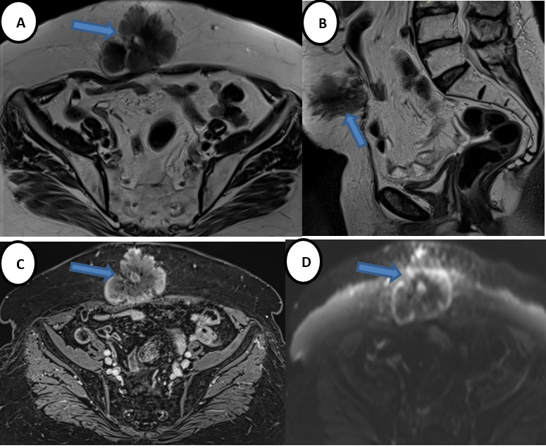
Fig.1 : Preoperative abdominal magnetic resonance imaging (MRI) showing a median abdominal wall mass.
(A) Axial T2-weighted sequence without fat suppression demonstrating a hypointense parietal lesion.
(B) Sagittal T2-weighted sequence confirming the anterior abdominal wall location.
(C) T1-weighted sequence after gadolinium administration showing peripheral enhancement.
(D) Diffusion-weighted imaging demonstrating peripheral diffusion restriction, consistent with abdominal wall metastasis

Core needle biopsy showed a poorly differentiated carcinoma. Immunohistochemical staining revealed positivity for CK7 and PAX8, with negativity for estrogen and progesterone receptors, supporting recurrence of the known gynecologic malignancy.
Following multidisciplinary discussion, surgical management was recommended. Wide en bloc excision of the abdominal wall tumor was performed through a midline incision (Fig.2), including the involved soft tissues and fascia (Fig. 3-4).
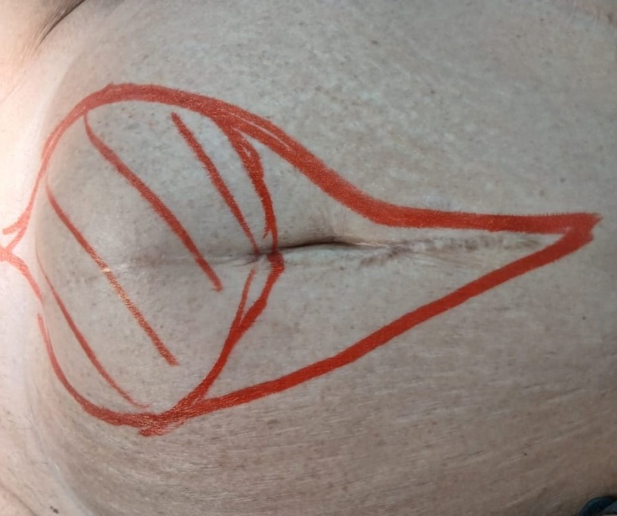
Fig.2 : Preoperative cutaneous marking of the sub-umbilical abdominal wall recurrence, outlining the planned wide oncologic excision with safety margins.

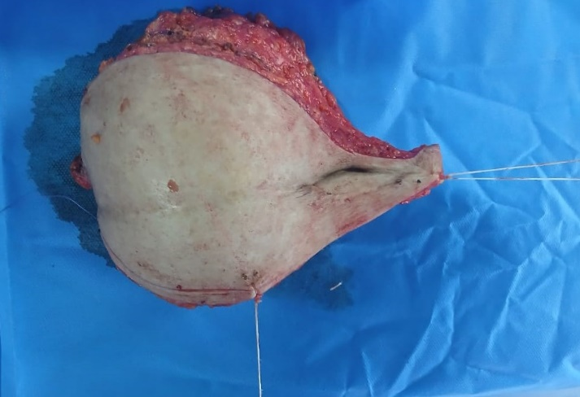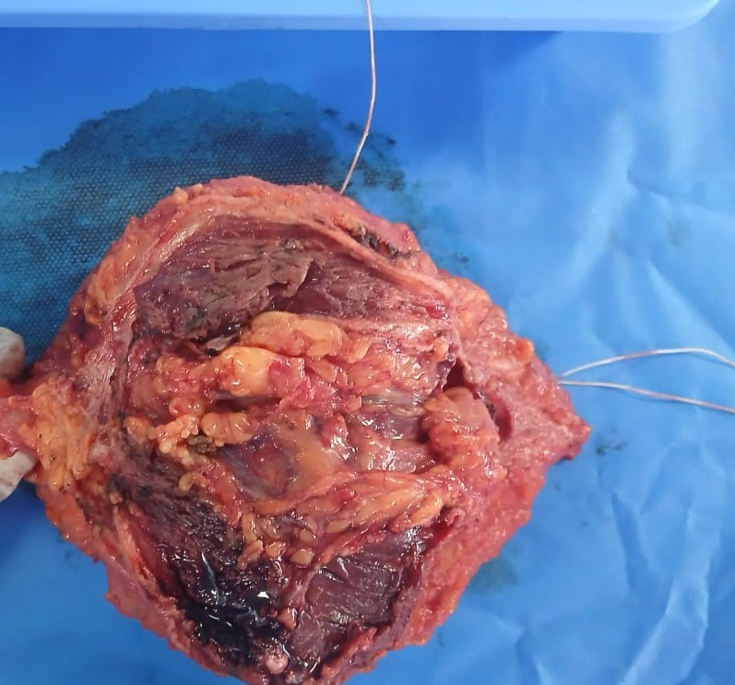
Fig 3 & 4 : Macroscopic appearance of the surgical specimen corresponding to the abdominal wall recurrence, sent for histopathological examination

No peritoneal carcinomatosis or ascites was observed intraoperatively (Fig. 5).

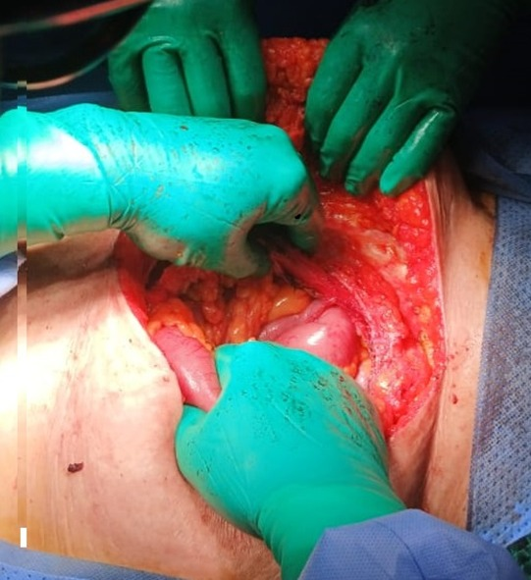
Fig.5 : Intraoperative view showing en bloc resection of the abdominal wall tumor through a midline iterative showing no ascites and no peritoneal carcinomatosis
The resulting abdominal wall defect was reconstructed using a dual-layer intraperitoneal mesh measuring 30 × 30 cm (Fig. 6).
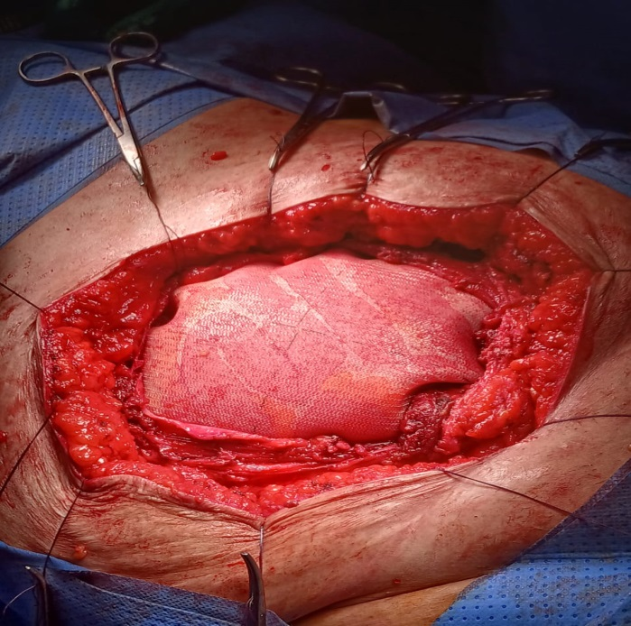
Fig.6 : Abdominal wall reconstruction using a dual-layer intraperitoneal mesh following wide tumor excision.
The postoperative course was uneventful.
Final Histopathological examination of the surgical specimen revealed : abdominal wall localization of spindle cell sarcoma with heterologous osteosarcomatous differentiation, without an epithelial component ; findings that are consistent with metastasis from known gynecologic carcinoma ; tumor size= 9,6cm and complete surgical resection (R0).

Discussion and literature review
Uterine carcinosarcoma is a rare but highly aggressive gynecologic malignancy associated with poor prognosis and high recurrence rates despite multimodal treatment. Although historically classified as a mixed epithelial–mesenchymal tumor, it is now widely regarded as a high-grade endometrial carcinoma with sarcomatous differentiation. This biological behavior accounts for its aggressive clinical course and propensity for early dissemination and recurrence [5,6].
Recurrence of uterine carcinosarcoma most commonly involves the pelvis, peritoneal cavity, lungs, liver, or lymph nodes. In contrast, abdominal wall recurrence is exceedingly rare and has only been sporadically reported in the literature. When present, it is often associated with disseminated disease or implantation along previous surgical tracts [7,8]. The present case is therefore remarkable for a late, isolated abdominal wall recurrence, occurring more than two years after completion of adjuvant therapy and in the absence of intra-abdominal or distant metastases.
Several mechanisms have been proposed to explain abdominal wall recurrence in gynecologic malignancies, including hematogenous dissemination, lymphatic spread, and iatrogenic tumor implantation during prior surgery. In this patient, the absence of peritoneal carcinomatosis and ascites makes direct tumor seeding less likely, favoring hematogenous or lymphatic spread. Moreover, the long disease-free interval supports the hypothesis of dormant micrometastatic disease with delayed clinical manifestation [9].
Diagnosis of abdominal wall recurrence can be challenging, particularly in patients with prolonged remission. Imaging findings are often nonspecific, making histopathological confirmation essential. Immunohistochemistry plays a critical role in distinguishing metastatic gynecologic malignancy from primary soft-tissue tumors or metastases of other origins. In the present case, positivity for CK7 and PAX8, combined with negativity for estrogen and progesterone receptors, supported the gynecologic origin of the lesion, in line with previously published data [10,11].
Due to the rarity of isolated abdominal wall recurrence, no standardized management strategy exists. Nevertheless, when recurrence is localized and complete resection is achievable, aggressive surgical management with negative margins remains the cornerstone of treatment. Several retrospective studies and case series suggest that secondary cytoreductive surgery may improve local disease control and potentially survival in carefully selected patients with isolated recurrence [12,13].
Radical resection of abdominal wall tumors frequently results in large parietal defects, necessitating complex reconstruction. Prosthetic mesh reconstruction allows restoration of abdominal wall integrity while preserving acceptable functional and oncologic outcomes. Dual-layer meshes are particularly advantageous when intraperitoneal placement is required, as they reduce the risk of visceral adhesions [14]. In this case, prosthetic reconstruction enabled complete oncologic resection without postoperative complications.
Given the aggressive nature of uterine carcinosarcoma and its high risk of recurrence, long-term surveillance is essential, even after prolonged disease-free intervals. This case highlights the importance of maintaining a high index of suspicion for atypical recurrence patterns and reinforces the value of a multidisciplinary approach to management.

Ethics approval and consent to participate

Ethical review and approval were waived for this study

COMPETING INTERESTS DISCLAIMER:
Authors have declared that they have no known competing financial interests OR non-financial interests OR personal relationships that could have appeared to influence the work reported in this paper.

References
[1]
F. Amant, I. Cadron, L. Fuso, et al.
Endometrial cancer
Lancet Oncology, 6 (2005), pp. 103–111
[2]
L.A. Cantrell, S.V. Blank, L.R. Duska
Uterine carcinosarcoma: A review of the literature
Gynecologic Oncology, 137 (2015), pp. 581–588
[3]
B.L. Seagle, A. Shilpi, S. Buchanan, et al.
Low-grade and high-grade uterine carcinosarcoma: A National Cancer Database study
Gynecologic Oncology, 146 (2017), pp. 254–262

[4]
K. Galaal, E. van der Heijden, K. Godfrey, et al.
Adjuvant chemotherapy and radiotherapy for uterine carcinosarcoma
Cochrane Database of Systematic Reviews, 2 (2013), CD006812

[5]
K. Matsuo, Y. Takazawa, M.S. Ross, et al.
Significance of histologic pattern of carcinoma and sarcoma components on survival outcomes of uterine carcinosarcoma
Gynecologic Oncology, 149 (2018), pp. 547–553
[6]
D. Nemani, N. Mitra, M. Guo, L. Lin
Patterns of recurrence and survival outcomes in uterine carcinosarcoma
Gynecologic Oncology Reports, 33 (2020), 100610
[7]
S. Bendifallah, L. Ouldamer, V. Lavoue, et al.
Patterns of recurrence and survival after relapse in uterine carcinosarcoma
Annals of Surgical Oncology, 26 (2019), pp. 111–120

[8]
E.J. Tanner, K. Garg, M.M. Leitao Jr, et al.
Histologic features associated with outcomes in uterine carcinosarcoma
International Journal of Gynecological Cancer, 22 (2012), pp. 1166–1172
[9]
D. Berton-Rigaud, M. Devouassoux-Shisheboran, J.A. Ledermann, et al.
Gynecologic carcinosarcomas: Clinical and pathological characteristics
European Journal of Cancer, 50 (2014), pp. 144–152
[10]
F. Amant, M.R. Mirza, M. Koskas, C.L. Creutzberg
Cancer of the corpus uteri
International Journal of Gynecology & Obstetrics, 143 (Suppl 2) (2018), pp. 37–50
[11]
W.G. McCluggage
My approach to the interpretation of endometrial biopsies and curettings
Journal of Clinical Pathology, 59 (2006), pp. 801–812
[12]
R.E. Bristow, I. Puri, D.S. Chi
Cytoreductive surgery for recurrent gynecologic cancer
Gynecologic Oncology, 112 (2009), pp. 265–274
[13]
R. Salani, F.J. Backes, M.F. Fung, et al.
Posttreatment surveillance and diagnosis of recurrence in women with gynecologic malignancies
Gynecologic Oncology, 122 (2011), pp. 368–374
[14]
J.W. Burger, R.W. Luijendijk, W.C. Hop, et al.
Long-term follow-up of a randomized controlled trial of suture versus mesh repair of incisional hernia
Annals of Surgery, 240 (2004), pp. 578–583

