Original Research Article

Neural network-based DDoS attack detection in
the context of unbalanced classes: a comparative study of resampling methods

ABSTRACT
Cyberattacks have been steadily increasing for the past twenty years. DDoS attacks, in particular, represent one of the greatest threats to organizations. A DDoS attack aims to render an information system's resources unavailable by overwhelming them with numerous requests originating from networks known as "botnets."
In this study, we propose an automatic DDoS attack detection model based on neural networks. The objective is to classify network traffic into two categories: normal traffic and abnormal traffic. However, in real-world scenarios, abnormal cases are often marginal within network traffic, leading to class imbalance. Most machine learning algorithms tend to predict the majority of normal cases more accurately. To mitigate the negative effects of this imbalance, methods exist to rebalance the classes before training the model. Among these, we can mention: 1) the choice of evaluation metrics, 2) data resampling, and 3) algorithm tuning. In this work, we opted for the resampling method to balance the data.
The study was conducted within the Department of Mathematics and Computer Science at the National Pedagogical University of the Democratic Republic of Congo.
The experimental data used comes from the Kaggle platform and shows an imbalance between normal (benign) cases (80%) and DDoS attack cases (20%). Resampling was performed to rebalance the classes. After training the model using oversampled, undersampled, and hybrid sampling data, the results revealed few differences in the outcomes obtained. However, the model trained with oversampled data using the SMOTE technique demonstrated better learning and generalization capabilities to new data.

Conclusion:

Detecting DDoS attacks presents a significant challenge for organizations. A neural network-based DDoS detection model appears to be a reliable and effective solution to this threat. By using unbalanced class data to train the model, we simulated real-world conditions where anomalous cases are rare and in the minority. Therefore, resampling was necessary to avoid bias. The model trained with oversampled data using the SMOTE technique yielded better results in terms of learning speed and its ability to generalize to unknown data.

Keywords: DDoS detection, neural network, oversampling, undersampling, backpropagation of gradient, confusion matrix, SMOTE, RandomUndersampling

1. INTRODUCTION

[Cyberattacks have been growing significantly for the past twenty years. Thanks to the internet, online solutions have developed and enabled businesses to increase their revenue. However, criminal organizations have also developed increasingly complex and dangerous cyberattack techniques that threaten organizations' information systems. Distributed Denial of Service (DDoS) is a form of cyberattack perpetrated with the aim of rendering a computer system, service, or network unavailable. In a compromised system, legitimate users no longer have access to the organization's information resources.

“To detect DDoS attacks, several solutions are available on the market:

- Detection based on IP address filtering,
- Detection based on signatures,
- Detection based on behaviour or geographic location, and, increasingly” (Boin, 2003),
- Solutions based on artificial intelligence.

Our approach is to develop a model capable of detecting DDoS attacks among millions of data points from network traffic. The goal is to correctly classify network traffic into two classes: one class of normal traffic and another class of abnormal traffic.

In a binary classification, the label y can only take one of two values ​​(0, 1). Assuming that a population P is composed of k subpopulations P1, P2, ..., Pk, we can obtain a training sample DN = {(Xi, Yi), 1 ≤ i ≤ N}, where the Xi, i ∈ {1, ..., Y}. ., N} are independent variables on N individuals, and the y_{i} come from the random variable Y which assigns to each individual i its subpopulation of origin: in other words, y_{i} = j if individual i belongs to the subpopulation Pj.

A function that classifies each element x into a predicted class is represented as follows:

ƒ: Rm → {0,1}

Updating Weights (Gradient Descent)
$$∆w= -n \frac{∂E}{∂w}$$
Where n is a Learning Rate

$$Wnouveau= Wancien-n \frac{∂E}{∂w}$$

$\frac{∂E}{∂w}$is the gradient of the error with respect to the weight W

Calculating the Gradient (Chain Rule)

For a weight Wij linking neuron i (layer l) to neuron j (layer l+1), the gradient is calculated as follows:

$\frac{∂E}{∂wij}$ = $\frac{∂E}{∂yj}$ . $\frac{∂yj}{∂sj}$ . $\frac{∂sj}{∂wij}$

Sj is the weighted sum of the inputs of neuron j (sj = ∑▒w_i a_(i ) + b_(i ))

yj is the output of neuron j after the activation function (yj = ƒ(sj))
$\frac{∂yj}{∂sj}$ is the derivative of the activation function (e.g., Sigmoid).

Backpropagation of the error

$$δ_{j}^{o}= \frac{∂E}{∂yj}. \int^{'}{(s_{j}})$$
(The difference between the desired output and the predicted output multiplied by the activation derivative).
For a hidden layer H:

$$δ_{j}^{H}= {\int{\left(sj\right).\sum_{k}{(δ_{k}^{sup}}}}^{}. ω_{{yk}^{}}$$
(The sum of errors of the neurons in the upper layer, weighted by the connection weights)

1.1. Definition of an unbalanced set

A dataset is said to be unbalanced when the population size of the classes is not approximately equal. Let C1 be the majority class and C2 the minority class; we have |C1| >> |C2|: Class C1 is much larger than class C2.

Formal notation of imbalance:

E = {x_{i}}}^{N}_{i=1}
Où
E = C₁ U C₂ | C₁ ∩ C₂ = ∅ and |C₁| > |C₂|

D = {(x_{i}, y_{i})} N_{i}=1, where X represents the features and y_{i} ∈ {0,1} represents the label
C1 = {x_{i} ∈ D | y_{i} = 0, majority class
C2 = {x_{i} ∈ D | y_{i} = 1, majority class

In supervised learning, when the data is unbalanced, the model tends to predict mostly represented cases, that is, normal cases. This problem can be addressed in two ways. The first is to assign distinct costs to the training samples by penalizing the majority class. The second is to resample the initial dataset, either by oversampling the minority class and/or undersampling the majority class. There is also a third approach, which involves combining oversampling and undersampling.

2. Literature Review and Theoretical Concepts

Several studies have been conducted on the detection of DDoS attacks when classes are unbalanced.

“There are various classic DDoS attack detection methods. These include signature-based detection, behavior-based detection, detection based on IP filtering and geolocation, detection based on statistical anomalies, and cloud protection-based detection” (Boin, 2003). Each of these methods has advantages and disadvantages. "Current static and dynamic methods do not allow for effective detection, especially when dealing with zero-day attacks”. (Maleh, 2021).

However, during model training, various variables are provided, but not all are necessary, as some variables may lack information that could affect the model's performance and outcome. Data from network traffic exhibits numerous characteristics when it comes to DDoS attacks. Most machine learning algorithms struggle to identify the model pattern when the data consists of multiple variables. “Therefore, it is not necessary to use all the characteristics of network traffic for DDoS attack detection” (Maabreh M O. I., 2022), Selecting the relevant characteristics can help the model learn more effectively.

In machine learning, a clear problem arises: class imbalance. Very often, there is a majority class of normal cases and one or more minority classes of abnormal cases that are the focus of the study. In this context, training a model with data from unbalanced classes is inefficient and introduces bias. “There are four ways to rebalance the classes. Python's "imbalanced-learn" package offers four different strategies to solve the problem of unbalanced datasets:
(i) Undersampling,
(ii) Oversampling,
(iii) A combination of two, and
(iv) Ensemble learning”. (Lemaître, 2017)
In addition to these four methods of class rebalancing, there is another strategy that consists of weighting the class weights by modifying the cost function to penalize errors in the minority class more heavily. The model thus gives more weight to rare examples.

2.1. Distributed Denial of Service (DDoS)

A DDoS attack aims to render the services of an information system, such as a website or computer network, inaccessible. The malicious attacker sends massive requests, often from a network of infected computers that are remotely controlled.

Figure 1: How a DDoS attack with a botnet works (Gilles Roudière, 2018)

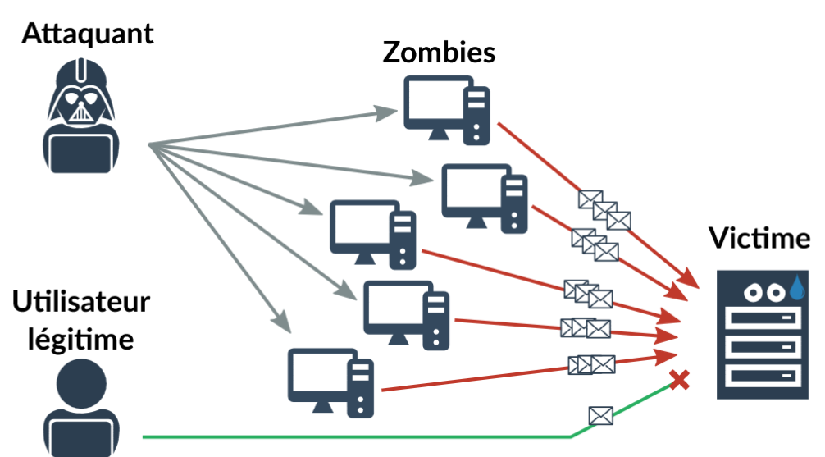

DDoS attacks most typicaly exploit existing vulnerabilities in the protocol layers of the OSI model to attempt to render a system resource unavailable. The network, transport, and application layers are the most exposed.

“As with intrusion detection systems (IDS) in general, DoS attack detection techniques can be divided into two categories: signature-based detection and anomaly-based detection. Signature-based detection relies on well-known DoS attack patterns [16], primarily malformed packets and protocol attacks. Anomaly-based detection, on the other hand, is based on traffic deviations from the norm, which constitute the most common form of DoS attack” (Martin, 2012).

2.2. Machine Learning: Fundamental Concepts and Principles

Machine learning is a field of artificial intelligence in which machines are taught to perform tasks requiring human reasoning using mathematical models.

There are three types of machine learning: supervised learning, where data is labelled; unsupervised learning, where data is unlabelled; and reinforcement learning, where rewards are used to boost performance. Neural networks are a supervised learning method by which algorithms can learn from input data to solve prediction or classification problems. The learned model must be able to analyze large amounts of data, recognize existing relationships or patterns to make predictions without being explicitly programmed to perform a specific task (Kaspersky, 2022).

Figure 2: Diagram of a DDoS attack classification model

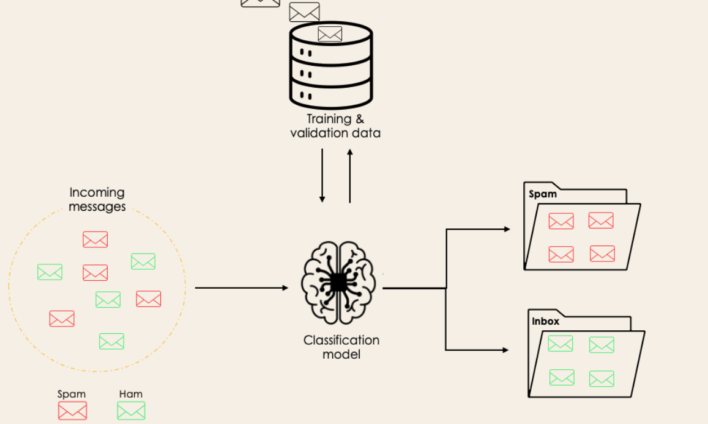

2.3. Resampling

Resampling is a technique that involves modifying the sample of the initial dataset, either by adding more data with the same characteristics or by removing others. There are two ways to perform resampling: oversampling creates additional data with the characteristics of the minority class, while undersampling removes the predominantly represented data.

2.3.1. Undersampling

Undersampling is a technique that allows for rebalancing unbalanced classes by reducing the number of observations of the majority class in an unbalanced dataset.

Mathematical Formalism

Consider a classification dataset D={(x_i, y_i)} (_i^n)=1' composed of two classes:

Minority class (Cmin): Set of observations x_i where y_i = Cminority

Majority class (Cmaj): Set of observations x_i where y_i = Cmajority

|Cmaj| >> |Cmin|: exhibits an initial imbalance

Subsampling defines a selection function S that generates a subset C’maj such that: C’maj ⊂ Cmin and |C’maj| ≈ |Cmin|

The new training dataset will be D’= Cmin ∪ C’maj

2.3.1.1. Subsampling Methods

Several methods and techniques exist for subsampling a dataset. We will mention a few:
- Near Miss Subsampling

Near Miss is a subsampling technique that involves rebalancing the classes by reducing the number of samples from the majority class.

- Random Subsampling

“Random subsampling is a technique that involves randomly selecting individuals from the majority class, removing them from the dataset without replacement.” (Abdelaziz K. A., November 2023);

- Condensed Nearest Neighbor Subsampling

The condensed nearest neighbor technique involves finding a subset of a dataset that can be used to train the model without compromising performance.

- Tomek Link

The ‘Tomek links’ algorithm identifies and removes even-numbered data points where one belongs to the majority class and the other to the minority class, and where these two points are adjacent. By eliminating these boundary points, which are potentially a source of confusion within the majority class.

2.3.2. Oversampling

Oversampling is a technique that rebalances the classes in an unbalanced dataset by adding new data. The original samples of the minority class are added until the classes are balanced.

Mathematical Formalism

Consider a dataset D = {(x_{i}, y_{i})}n_{i}=1 composed of n samples, where

Xi ∈ Rd is the feature vector of dimension d

y_{i} ∈ {Cmaj, Cmin} is the label, with Cmaj the majority class and Cmin the minority class.

The goal is to obtain a dataset D’ = D ∪ Dnew such that the distribution of y in D’ is balanced with |Dnew| > 0

2.3.2.1. Oversampling Methods

- Random Oversampling

The random oversampling technique involves duplicating random observations in the minority class until the minority and majority classes are balanced.

- SMOTE

The SMOTE (Synthetic Minority Oversampling Technique) is an oversampling method. The SMOTE algorithm generates "synthetic" data that it adds to the minority class until the classes are balanced. “The minority class is over-sampled by taking each minority class sample and introducing synthetic examples along the line segments joining any/all of the k minority class nearest neighbors” (Chawla, 2002)

Mathematical Formalism

For a set of samples from the minority class,

- X_{min} = {x₁, . . . . , x_{Nm}} ⊂ R^{d}

And for each x, its k-neighbor {xi(1), . . ., xi(k) }, the new sample will be:
- x_{new} = x_{i} + λ(x_{i}^{(j)} - x_{i}), λ Uniform(0,1), j ∈ {1, . . . , k}
The procedure is iterative until the target minority/majority ratio is reached. The default parameters are k=5 and a strategy that perfectly balances the minority and majority classes.

2.3.2.2. Operation of SMOTE

The SMOTE operation process is carried out in three steps:

-. In the minority class set A, for each x ∈ A, the k nearest neighbors of x are obtained by calculating the Euclidean distance between x and all samples in set A.

-. The sampling rate N is set according to the imbalance ratio. For each variable x belonging to the minority class A, N observations are randomly selected from its k nearest neighbors, which constitute set A1.

-. For each x_{k} ∈ A1 with k ∈ N, the following formula is used to generate a new observation:

x′ = x + rand(0, 1) ∗ |x − x_{k}|

Where x′ is the new sample of data and rand (0, 1) indicates a random number between 0 and 1.

2.3.3. Hybrid Resampling Method

Hybrid sampling is an approach that combines oversampling and undersampling to leverage the advantages of both techniques. This is achieved sequentially by first adding data to the minority class and then removing samples from the majority class. Since oversampling can add data until class balance is reached, it is preferable to define a fill rate so that the remaining majority data are removed by the undersampling technique.]

3. methodology

[ 3.1. Data Collection

The study was conducted using data downloaded from the Kaggle platform. This experimental data shows a class imbalance, with 6,321,980 normal cases and 1,294,529 abnormal cases, representing a proportion of 80% normal cases and 20% abnormal cases. We randomly selected one-third of the initial data to train the model. This yielded 941,135 samples for the minority class and 1,882,270 samples for the majority class, while maintaining the same proportion of imbalance.
Figure 3: Histogram of class distribution

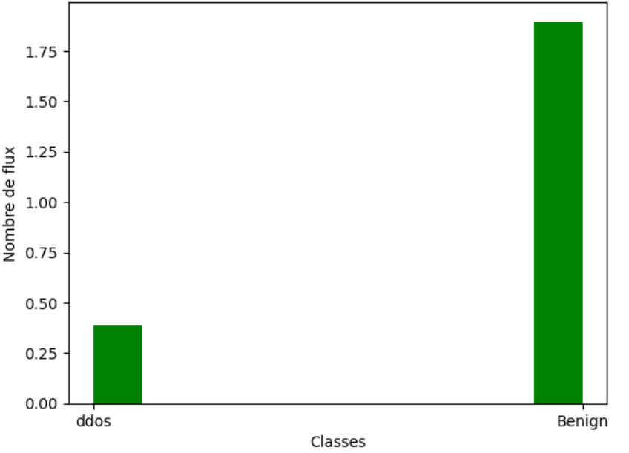

3.2. Data Preprocessing

Removing categorical data

df1 = df.drop(['Timestamp','Src IP','Flow ID','Dst IP'],axis=1)

Reducing excessive memory usage

large_array = np.zeros((2284953 , 81)), dtype=np.float32)

print(df1.shape)

Result: (2284953, 81)

Checking for 'Infinite' and 'NaN' values ​​and removing 'Infinite' values

inf_mask = np.isinf(df.select_dtypes(include=[np.number]))

inf_columns = inf_mask.any()

df1 = df1.replace([np.inf, -np.inf], np.nan).dropna()

Checking values Missing counts

missing_counts = df1.isnull().sum()
Checking and removing duplicates
duplicates = df1[df1.duplicated()]

df2 = df1.drop_duplicates()

Result after preprocessing

Observation = 2284953
Variables = 80

3.3. Handling Unbalanced Classes
We used the `train_test_split` technique to separate the training data from the test data, which represents 30% of the total dataset.

`from sklearn.model_selection import train_test_split`
`X_train, X_test, y_train, y_test = train_test_split(X, y, stratify=y, test_size = 0.3, random_state = 42)`

3.3.1. Oversampling with SMOTE

Initial Class Distribution
Class ‘Benign’ = 1,896,594
Class ‘ddos’ = 388,359

SMOTE Code

def HybridSMOTETOMEK (x_train, y_train):

x_sm, y_sm = SMOTE(k_neighbors=5, sampling_strategy='auto').fit_resample(x_train, y_train)

return x_sm, y_sm

Result after oversampling

Observation = 3,749,710
Variables = 80

Observation: SMOTE generated 1,464,757 synthetic data points

The class distribution after oversampling is:

Class ‘Benign’ = 1,874,855
Class ‘ddos’ = 1,874,855

3.3.2. Random Subsampling

Initial Class Distribution
Class 'Benign' = 1,896,594
Class 'ddos' = 388,359
Result After Oversampling

Observation = 2262720
Variables = 80

Distribution of classes after oversampling

Class ‘Benign’ = 387,865
Class ‘Ddos’ = 387,865

3.3.3. Hybrid Resampling Method (TOMEK) and RandomUnderSampling

We used two resampling methods: SMOTE for oversampling and RandomUnderSampling for undersampling.
def HybridSMOTETOMEK (x_train, y_train):

x_sm, y_sm = SMOTE(k_neighbors=5, sampling_strategy=0.5).fit_resample(x_train, y_train)

return x_sm, y_sm

The “HybridSMOTETOMEK” function generates 50% of the synthetic data relative to the majority class. The result of SMOTE is fed into the undersampling algorithm, which randomly removes the data from the remaining majority class.

Initial sample
Observation = 2262720
Variable = 80

Class distribution after resampling:

Class ‘Benign’ = 1,874,687
Class ‘ddos’ = 1,874,687

3.4. Labeled Multivariate Analysis

Multivariate analysis is a statistical method used to simultaneously analyze numerous variables in order to synthesize complex data or explain relationships of dependence. Pearson's correlation coefficient (r) indicates the strength and direction of the linear relationship between several pairs of quantitative variables. It ranges from -1 to +1, where:
- If the correlation value is (+1), this indicates a perfect positive correlation. In this case, the variables vary in the same direction.
- And if the correlation value is -1, this means that the correlation is negative and perfect. The variables move in opposite directions.
- A value of zero (0) indicates that there is no linear relationship between the variables.

The correlation is calculated using the formula.

$r=\frac{\sum{ \left(x_{i-}\bar{x}\right)}(y_{i-}\overline{y})}{\sqrt{\sum{\left(x_{i-}\bar{x}\right)}²+\sum{(y_{i-}\overline{y}})²}}$
- r = correlation coefficient
- xi = values ​​of variable x from a sample
- X̄ = mean of the values ​​of variable x
- yi = values ​​of variable y from a sample
- ȳ = mean of the values ​​of variable y

All the correlations between pairs of variables are well summarized in a correlation matrix for quickly visualizing the relationships. This led us to separate the data into six matrices for better visualization of the correlation.

Figure 4: Correlation matrices with the label ‘Label’

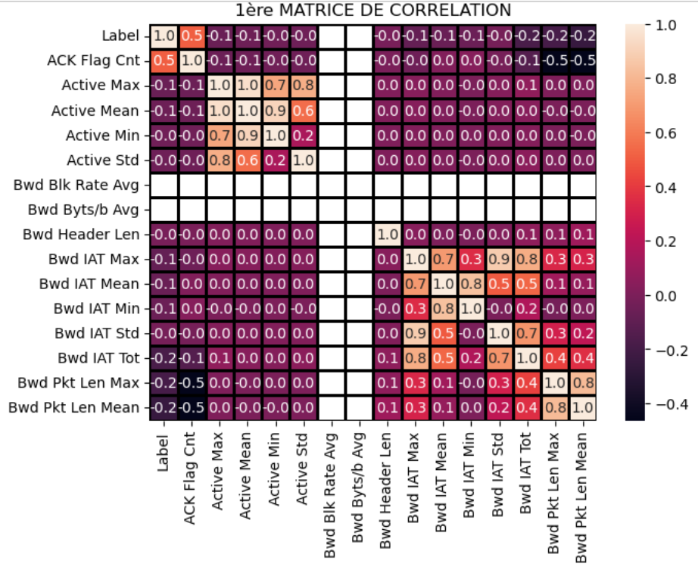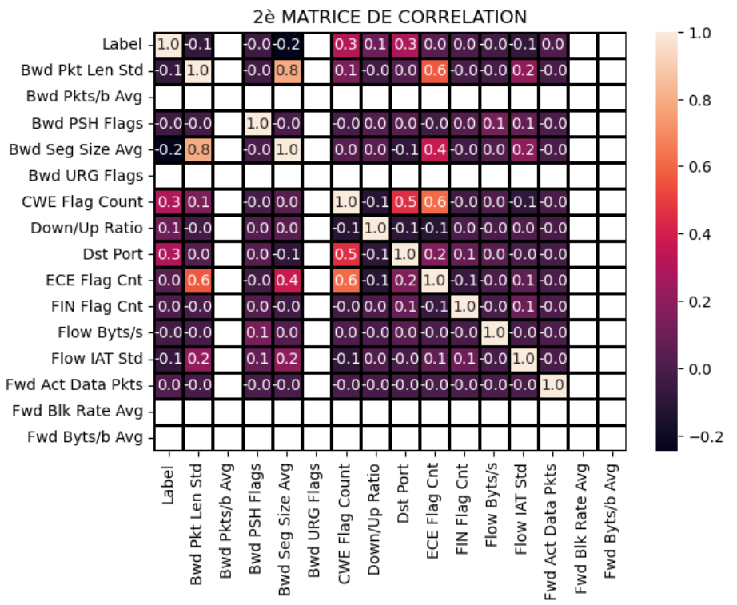
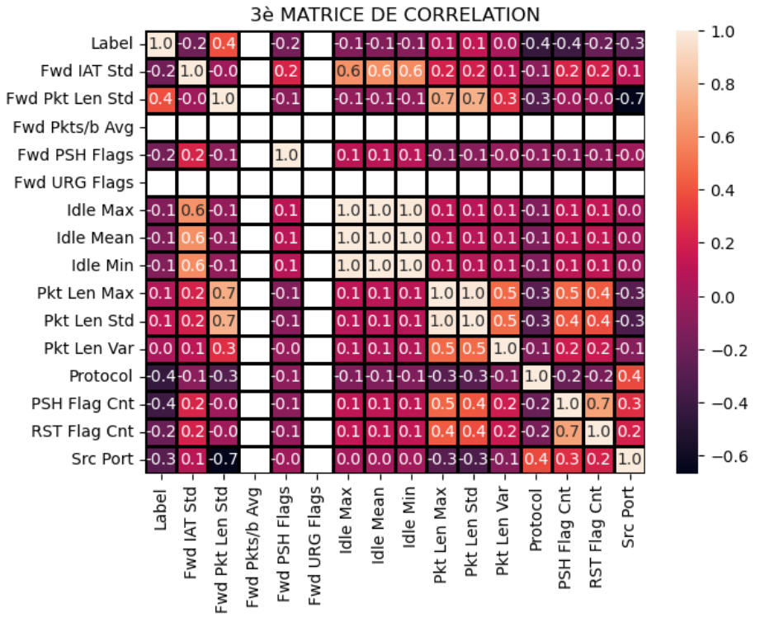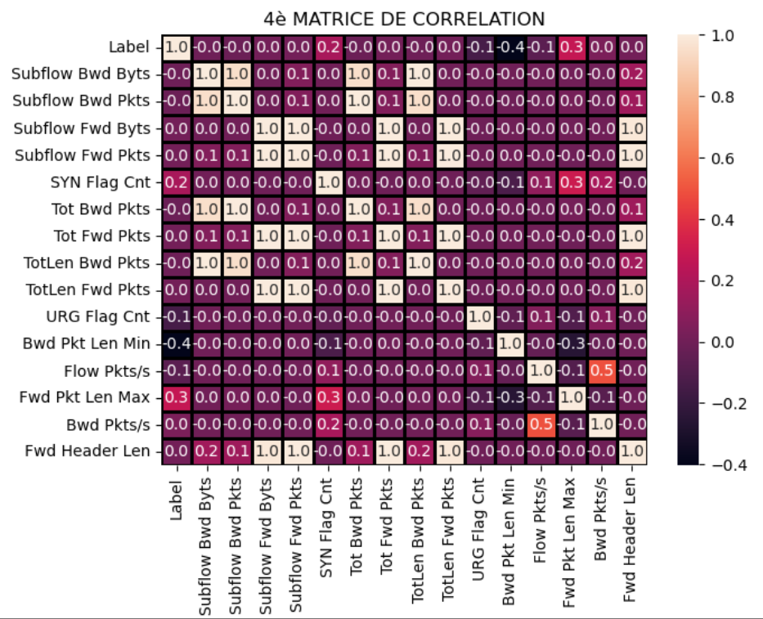
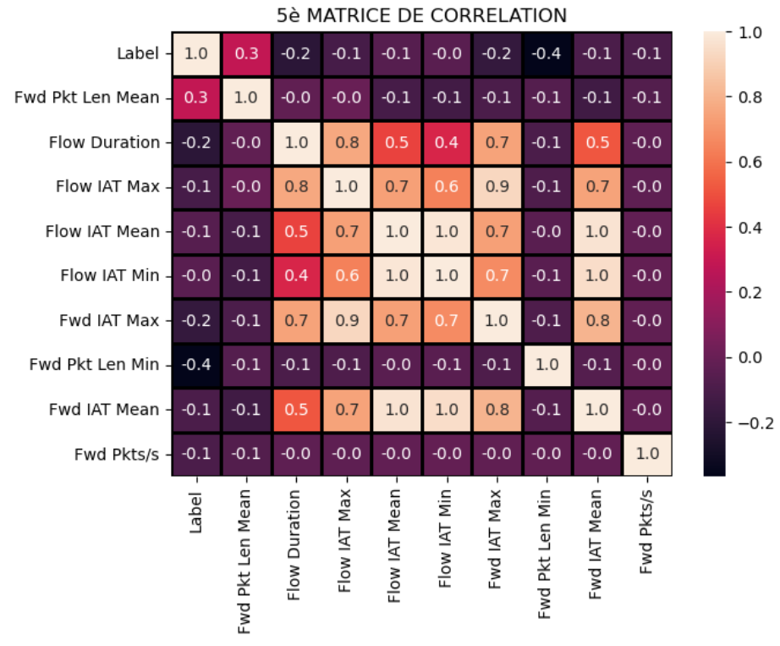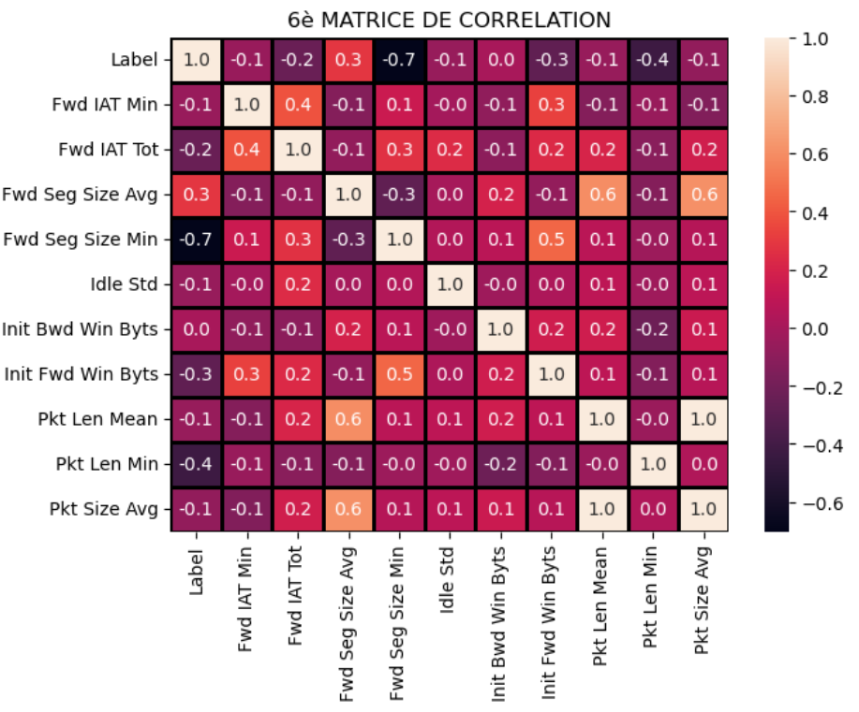
Conclusion of the multivariate analysis: The variables presented in table 1 have a positive correlation with the dependent variable "Label".

Table 1: Correlation with respect to the variable "Label"

N° | Nom Variables | Description | Corrélation positive
1 | ACK Flag Cnt | Nombre de paquets avec ACK | 0.5
2 | Fwd Seg Size Min | Taille minimale du segment observée dans le sens direct | 0.3
3 | Fwd Pkt Len Mean | Taille moyenne du paquet dans le sens direct | 0.3
4 | Fwd Pkt Len Max | Taille maximale du paquet dans le sens direct | 0,3
5 | SYN Flag Cnt | Nombre de paquets avec SYN | 0,2
6 | Pkt Len Max | Longueur maximale d'un paquet | 0,1
7 | Pkt Len Std | Écart type de la longueur d'un paquet | 0,1
8 | Dst Port | Port de destination | 0.3
9 | CWE Flag Count | Nombre de paquets avec CWE | 0,3
10 | Fwd Pkt Len Std | Écart type de la taille du paquet dans le sens direct | 0,4

3.5. Model Selection and Hyperparameter Setting

The problem to be solved is the classification of network traffic into two classes: a class of normal (benign) traffic and a class of traffic representing a DDoS attack. The neural network-based model is trained using the gradient propagation algorithm. The neural network consists of:

- an input layer with 10 neurons,
- two hidden layers with 12 and 10 neurons respectively, and
- an output layer with one neuron corresponding to the class.

Figure 5: Neural network model with two hidden layers

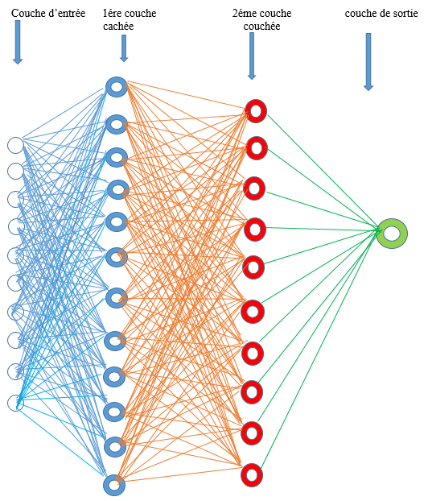

In this model, we used two activation functions to train the model. The ReLU (Rectified Linear Unit) function will be used in the hidden layers because of its non-linearity, and the Sigmoid function for the output layer in the sense that the Sigmoid function is considered a "threshold function," that is, a function that allows the output to be determined based on the defined threshold.

3.5.1. Convergence Parameters

The following parameters are defined to enable model convergence:

- Binary crossentropy: This function calculates the difference between predicted and actual values.

The formula for the "binary_crossentropy" function
$BCE=-\frac{1}{N}\sum_{n=1}^{N}{\left[y_{i}\log{(p_{i}}\right)}+\left(1-y_{i}\right)log⁡(1- p_{i}$ )$]$,
where y_{i} is the label and Ÿ_{i} is the predicted probability.

- Adam (Adaptive Moment Estimation): is the neural network optimizer. It allows the weight of each neuron to be adjusted during the model training.

3.6. Model Training

The backpropagation algorithm is used to train neural networks by adjusting the weights to minimize error. Training is done in two phases: forward propagation and backpropagation.

“The multi-layer perceptron (MLP), trained by the backpropagation algorithm is one of the most widely used neural models for classification problems. A backpropagation neural network is composed of one input layer, one output layer, and one or more hidden layers. Each layer is composed of one or more “neurons”. Each neuron in a layer is connected to each neuron of the prior and the next layers. There are no activation functions in the neurons in input layer, but every neuron in hidden layer or output layer has its activation function. The activation function makes the output of the neuron nonlinear, scaled and differentiable (continuous)” (Sun Y., 2009)

Figure 6: How backpropagation works (stackoverflow.com)

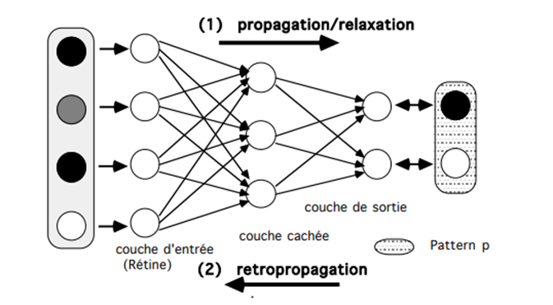
- Forward pass: The input layer receives the data and passes it to the next layer.
- Loss calculation: The model compares the predicted values ​​to the actual values ​​(targets/labels), then calculates the loss using a predefined loss function.
- Backpass: The backpropagation algorithm calculates the gradients for all parameters.
- Weight update: The 'adam' optimizer updates the weights.
- Iteration: This process is repeated for the specified number of iterations, progressively improving the model's accuracy.$E=\frac{1}{2}+\sum_{n=1}^{i=N}{\left(y_{i}- \right) }\sum_{j=0}^{j=P}{w_{j}x _{ij}) 2}$
Calculating the gradient (partial derivative)

$$\frac{∂E}{∂w_{j}}=\frac{∂}{∂w_{j}}\left[\frac{1}{2}\sum_{i=1}^{i=N}{{(y}_{i}-φ(x_{i}))}\right]$$
$$\frac{∂E}{∂w_{j}}=\frac{1}{2}\frac{∂}{∂w_{j}}\left[\sum_{i=1}^{i=N}{{(y}_{i}-φ(x_{i}))^{2}}\right]$$
$$\frac{∂E}{∂w_{j}}=\frac{1}{2}\sum_{i=1}^{i=N}{\frac{∂}{∂w_{j}}}\left[{(y}_{i}-φ(x_{i}))^{2}\right]$$
$$\frac{∂E}{∂w_{j}}=\frac{1}{2}\sum_{i=1}^{i=N}{2(y_{i}-φ\left(x_{i}\right))\frac{∂}{∂w_{j}}(y_{i}-φ(x_{i}))}$$
$$\frac{∂E}{∂w_{j}}=\sum_{i=1}^{i=N}{{(y}_{i}-φ(x_{i}))}\frac{∂}{∂w_{j}}\left[(y_{i}-\sum_{k=0}^{k=P}{w_{k}x_{i}k}\right]$$

3.6.1. Activation Functions

The activation functions used are:

- ReLU (Rectified Linear Unit): transforms the output using the following algorithm:
- If the input value x is less than 0, return 0.
- If the input value x is greater than or equal to 0, return the input value.
The ReLU function can be mathematically represented using the max() function:

$F(x)=max⁡(0,x)$

Figure 7: Graph of the ReLU function (https://www.researchgate.net))

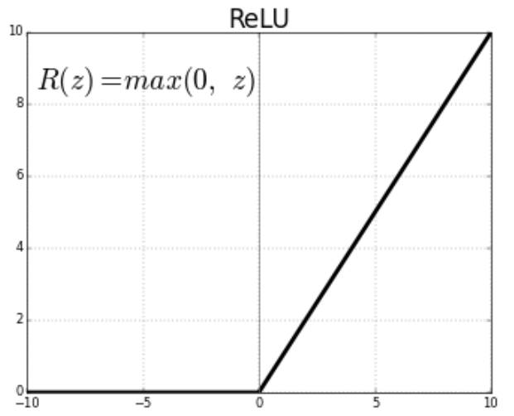

The Sigmoid Function

The sigmoid function is a mathematical function in the shape of an S, with multiple uses, ranging from 0 to 1. It is used in many areas of mathematics and computer science. It can be written in the form:
$σ\left(x\right)= \frac{1}{1+ x^{-2}}$

We first fix the variable z to the weighted sum of the inputs.

$z=b+ \sum_{i}{w_{i}x_{i^{ }} }$

The variable z will be passed to the sigmoid function.
$σ\left(z\right)= \frac{1}{1+ x^{-z}}$

Figure 8: Sigmoid function graph (https://www.researchgate.net)

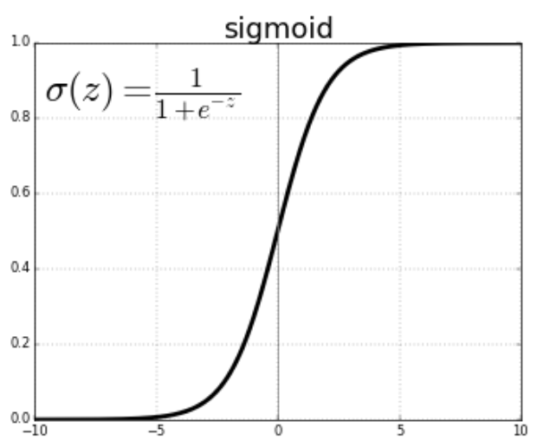

3.7. Model Performance Evaluation

“The performance of machine learning algorithms is generally evaluated using their predictive accuracy. However, this method is not appropriate when the data is unbalanced and/or the cost of different errors varies considerably”. (LEMBERGER Pirmin et al., 2019)

3.7.1. Confusion Matrix

A confusion matrix resembles a contingency table in which the different values ​​of correct and incorrect predictions are organized according to well-defined rules. The results of the confusion matrix are classified into four groups:
True Positives (TP), when the predicted cases perfectly match the expected output;
True Negatives (TN), these are cases detected as negative when they are actually negative;
False Positives (FP), these are cases where the model incorrectly predicts a "Positive" result when it is actually "Negative";
False Negatives (FN), these are cases where the model indicates that a class is "negative" when it is actually "positive".

Figure 9: Confusion Matrix

PREDICTED VALUES
REAL VALUES |  | POSITIVE | NEGATIVE
REAL VALUES | POSITIVE | TP | FN
REAL VALUES | NEGATIVE | FP | TN

Accuracy
Accuracy refers to the percentage of observations correctly predicted across all data.

$Accuracy= \frac{TP+TN}{TP+TN+FP+FN}$

Accuracy provides truly positive predictions for all predicted positive records.

$Precision= \frac{TP}{FP+TP}$

The recall: The recall allows us to know the ratio of correctly detected cases to all truly positive and truly negative cases.
$Recall= \frac{TP}{FN+TP}$

Specificity

In our case, Specificity represents the number of correctly predicted DDoS attacks divided by the actual number of DDoS attacks.
$Specificity= \frac{TN}{TN+FP}$

4. results and discussion

[ After training the model with the three types of resampled data, the following results were observed.

Figure 10: Comparison of the precision curve (AUC))

Oversampling undersampling resampling hybrid

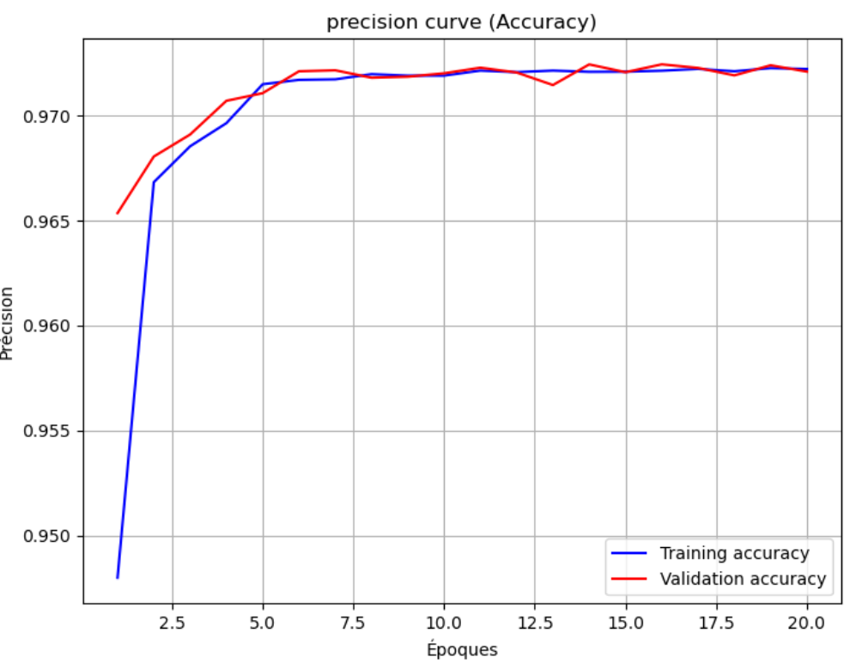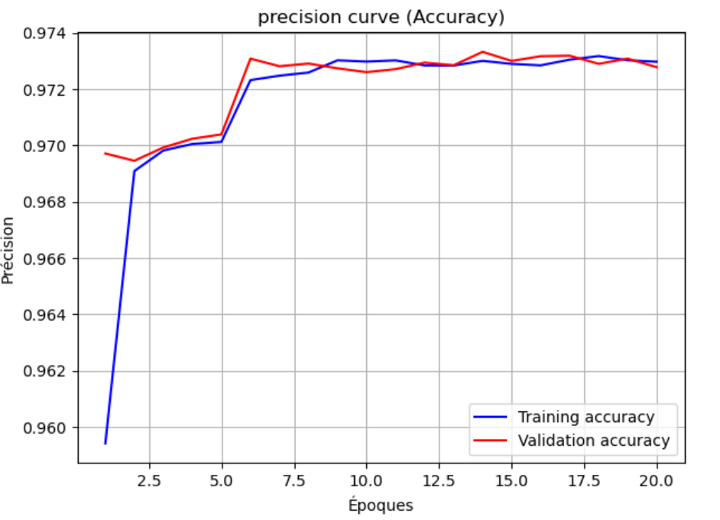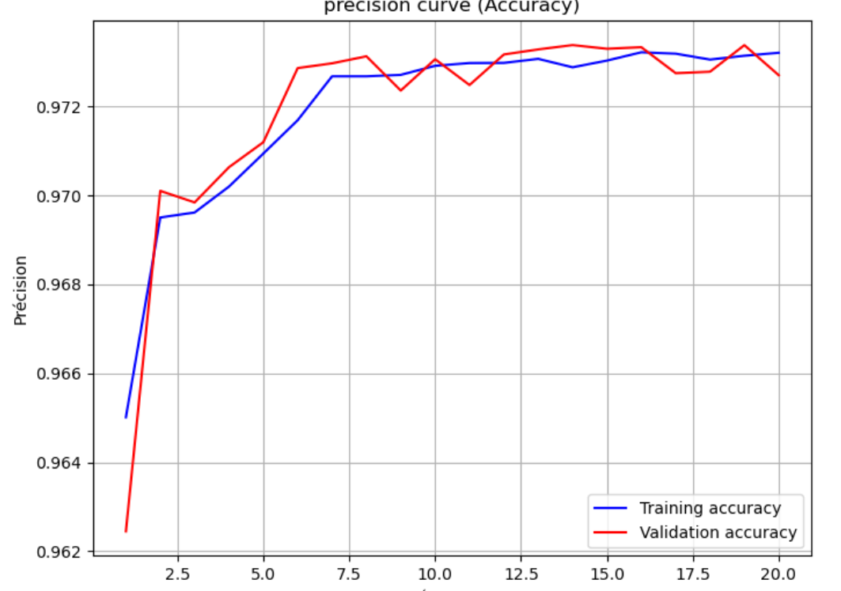

In Figure 10, all three models show good improvement in learning accuracy and validation. However, the validation curve for the accuracy of the model trained with the oversampled data closely follows the training accuracy curve. This suggests that the model can be generalized very well.

Figure 11: Comparison of MSE Curves

Oversampling undersampling resampling hybrid

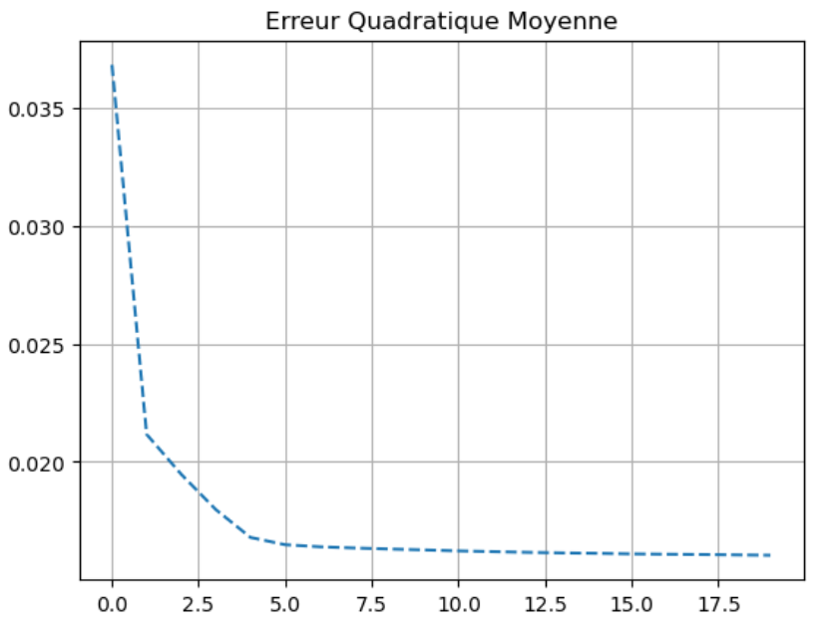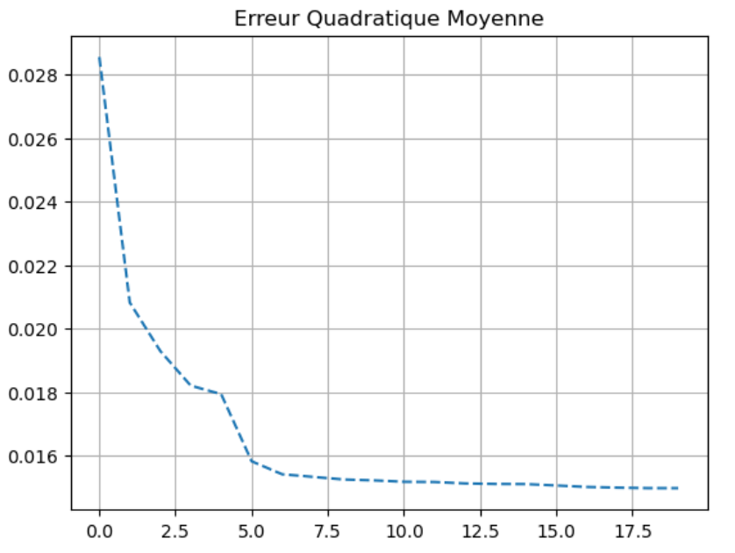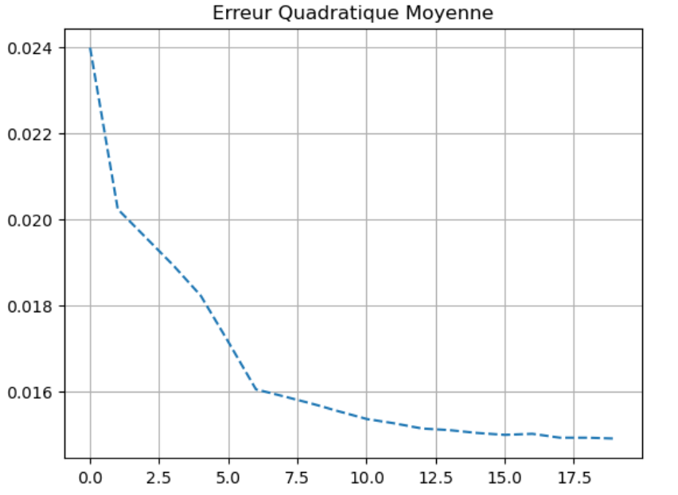

In Figure 11, all three models effectively reduce the gap between predicted and actual outputs; however, the oversampling model appears to quickly reduce the preference error.

Table 2: Comparison of metrics

Métrics | Oversampling | Undersampling | Hybrid sampling
Loss 0,52% 0,47% 0,47%
Accuracy 97% 97% 97%
MSE 0,1% 0,1% 0,1%
In the Table 2, all three models have 97% accuracy, but the hybrid model shows a 0.6% loss.

Table 3: Comparison of Confusion Matrix Values

Métrics | Oversamplig | Undersampling | Hybrid sampling
Accuracy 0,93% 0,93% 0,93%
Precision 0,89 % 0,89 % 0,89%
Rappel 0,98 % 0,98% 0,98%
Specificity 0,88 % 0,88% 0,88%

In Table 3, In 98% of cases, all models are able to accurately detect DDoS attacks and genuine anomalies. The models are accurate in 89% of detected cases (true positive or true negative).

Figure 12: Comparison of the area under the ROC curve (AUC)

ROC oversampling ROC undersampling ROC hybrid sampling

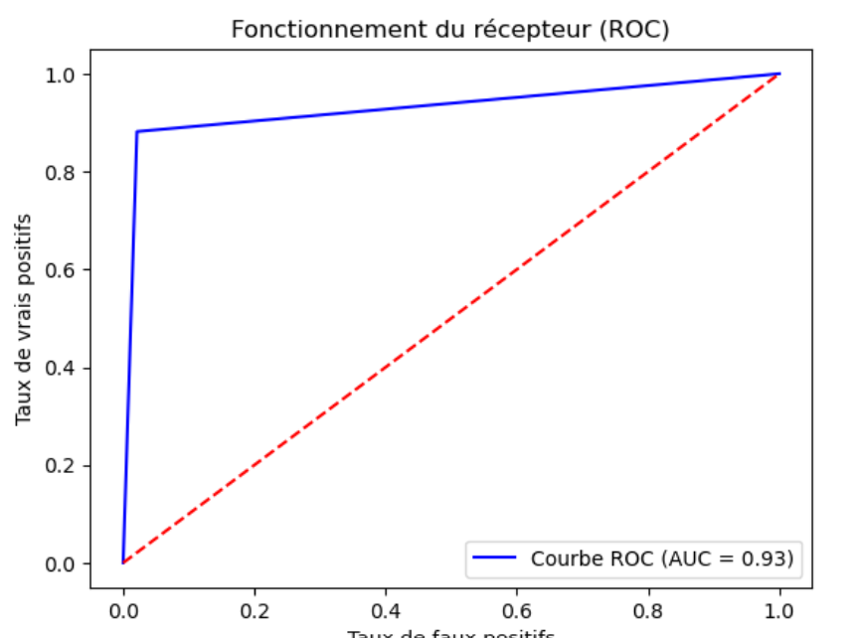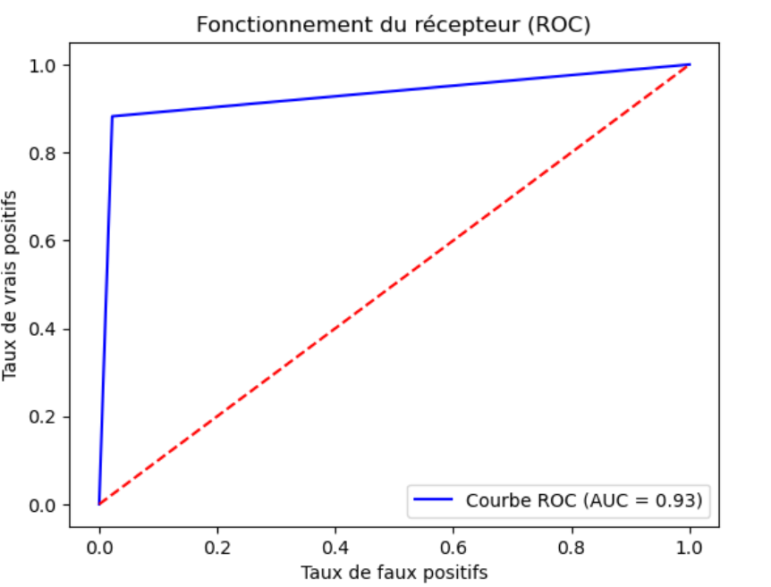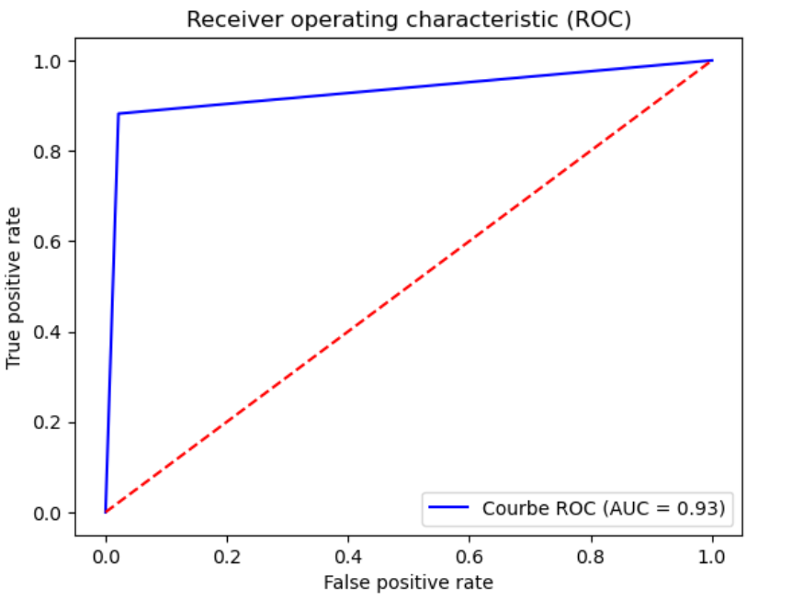
The AUC is a value between 0.5 and 1 that quantifies the model's ability to classify data.

- If the AUC value = 0.5: The model is not able to predict correctly.
- If the value 0.5 < AUC < 0.5: The classification ability is considered passable, or even acceptable.
- If the value 0.8 ≤ AUC < 0.9: The model is considered excellent and performs well.
- If the AUC value ≥ 0.9: The model is excellent and has the ability to discriminate.
- If the AUC value = 1: The model is considered perfect (the curve passes through the upper left corner).

In the Figure 12, all models have an AUC of 0.93, which is greater than 0.9, meaning that all models have excellent discrimination capabilities.]

5. Conclusion

[Automatic detection of DDoS attacks based on neural networks when training data contains unbalanced classes requires, first and foremost, addressing the imbalance problem. Among the possible methods, we used the SMOTE method for oversampling the data. This method has the advantage of creating synthetic data instead of simple copies from the existing data. However, since the training data is large, creating additional data through oversampling poses another problem: model performance and, above all, the consumption of machine resources (memory and computing power). To minimize this problem, we used a sample representing 30% of the dataset. Based on previous studies on feature dimensionality reduction (Maabreh M O. I., 2022), we selected 10 features that impact model learning after multivariate analysis using Pearson's correlation coefficient.

We trained the model with three types of data from the sample. The model trained with oversampled data offers significant advantages for model performance.

The model was trained using the gradient descent backpropagation (BGD) algorithm in a neural network composed of an input layer with 10 neurons representing the 10 characteristics of a DDoS attack, and two hidden layers for processing the input variables. The first layer has 12 neurons, and the second layer has 11 neurons. The number of neurons was chosen due to the limited number of input characteristics for the model. The ReLU activation function was used in the hidden layers because it introduces non-linearity to the model, thus improving computational performance. In the output layer, we used the sigmoid function, which transforms the input value into a probability between 0 and 1, enabling binary classification.

Given the results obtained, all the evaluation metrics are almost the same. For our part, we prefer the model trained with oversampled data (SMOTE), which offers training accuracy equivalent to validation accuracy. This means that the model can be generalized to new, unknown data.]

References

Abdelaziz, K. A. (20223). Machine Learning for Imbalanced Data: Tackle imbalanced datasets using machine learning and deep learning techniques. ‎Packt Publishing.
ALENEZI Mohammed et REED Martin J. (s.d.). « Methodologies for detecting dos/ddos attacks against network servers »,. The Seventh International Conference on Systems and Networks.
Boin, C. (2003). Detection d’attaques DDoS dans le contexte d’un fournisseur cloud de grande envergure. (U. d. Lille, Éd.) Lille.
Chawla, N. (2002). SMOTE: Synthetic Minority Over-sampling, Available at the following URL . Carnegie Mellon University , https://www.cs.cmu.edu/afs/cs/project/jair/pub/volume16/chawla02a-html/node6.html.
Devendra. (2018). Ddos datasets, Available at the following URL: https://www.kaggle.com/datasets/devendra416/ddos-datasets,. Récupéré sur https://www.kaggle.com/: https://www.kaggle.com/datasets/devendra416/ddos-datasets,
Gilles Roudière. (2018). Détection d’attaques sur les équipements d’accès à Internet, thèse de doctorat, Université de Toulouse, décembre 2018. Toulouse: Université de Toulouse.
https://www.kaggle.com/datasets/devendra416/ddos-datasets,. (2025). Récupéré sur www.kaggle.com: https://www.kaggle.com/datasets/devendra416/ddos-datasets,
Kaggle. (2025). https://www.kaggle.com/datasets/devendra416/ddos-datasets,. Récupéré sur Kaggle: https://www.kaggle.com/
Lemaître, G. N. (2017). Imbalanced-learn: A python toolbox to tacle the curse of imbalanced datasets in machine learning. Journal of Machine Learning Research, 18(17), 1-5(2017).
LEMBERGER Pirmin (at al.). (2019). ,Big Data et Maning Learning : Les concepts et les outils de la data science, Paris, Dunod, 2019, . Paris: Dunod.
Maabreh M, O. I. ( 2022 ;16(14):123–35.). Towards data-driven network intrusion detection systems: features dimensionality reduction and machine learning. I. nt J Interact Mobile Technol.
Maabreh M, O. I. (2022). Towards data-driven network intrusion detection systems: features dimensionality reduction and machine learning. Int J Interact Mobile Technol, 16(14):123–35.
Maleh, Y. S. (2021). Machine Intelligence and Big Data Analytics for Cybersecurity Applications. Edited book, Springer Studies in Computational Intelligence, Vol 919, ISBN 978-3-030-57024-8. Springer.
Martin, A. M. (2012). Methodologies for detecting dos/ddos attacks against network servers »,. The Seventh International Conference on Systems and Networks Communications, (pp. 1-7). Bangalore, India: IARIA.
Nitesh V. Chawla at. ((2002). SMOTE: Synthetic Minority Over-sampling Technique. Journal of Artificial Intelligence Research, 321–357.
Robert, J. (2025). https://liora.io/train-test-split-tutoriel). Récupéré sur https://liora.io: https://liora.io
Sun Y., W. A. (2009). Classification of imbalanced data: a review. International Journal of Pattern Recognition and Artificial Intelligence, vol. 23(4), 687-719, 2009.
V. Bolon-Canedo, N. S.-M.-B. (2014). A review of microarray datasets and applied feature selection methods," Information Sciences, vol. 282, pp. 111–135, 2014. Information Sciences, 111–135.

