ASSESSMENT OF URBAN AIR QUALITY IN DIMAPUR: A GEOSPATIAL ANALYSIS OF RSPM

Abstract
Air pollution is a significant concern in rapidly urbanizing regions. Dimapur, being the most urbanised district and also the commercial capital of Nagaland consequently making it the most polluted region in the state, requires a comprehensive assessment of ambient air quality, particularly Respirable Suspended Particulate Matter (RSPM), which poses risks to both the environment and human health. This study examines the spatial distribution and seasonal variations of RSPM levels across Dimapur in 2023 to identify pollution hotspots and analyze influencing factors.
The findings indicate that locations with heavy traffic and commercial activities recorded the highest RSPM levels, whereas, residential areas and open green spaces, exhibited lower pollution concentrations. Seasonal patterns reveal that peak RSPM levels occurred during the winter/dry months while monsoon months recorded the lowest concentrations, due to rainfall reducing airborne particulates.
This study employs Geographical Information System (GIS) and the Geostatistical Technique Inverse Distance Weighted (IDW) interpolation to model RSPM distribution. Results obtained are also compared with the National Ambient Air Quality Index (NAAQ) standards to assess compliance and identify critical pollution levels.
The findings underscore the urgent need for targeted air quality management strategies, including traffic regulation, expansion of urban green spaces, and stricter emission controls, particularly in areas with high exposure. The integration of geospatial techniques and environmental monitoring provides valuable insights for urban planners and policymakers, supporting sustainable air quality management in Dimapur.
Keywords: Ambient Air Quality; Respirable Suspended Particulate Matter RSPM; Inverse Distance Weighted (IDW); Seasonal Variation

- INTRODUCTION
Urbanization, the process by which rural landscapes are transformed into urban environments, has accelerated globally over the past few decades, particularly in developing regions. This transformation is primarily driven by population growth, economic expansion, and infrastructural development, resulting in rapid land-use changes and shifts in socio-economic structures. While urbanization leads to economic growth, improved access to services, and enhanced infrastructure, it simultaneously imposes substantial environmental burdens, particularly on air quality, water resources, and overall ecological balance (United Nations, 2017; WHO, 2025). Among the various environmental challenges, air pollution has emerged as one of the most critical concerns in urban areas due to increase in emissions from transportation, industry and energy consumption, contributing to severe health risks and environmental degradation (Zhan et al., 2023; Bui et al., 2025).
GIS-based interpolation techniques have been widely applied to analyze and map air pollution patterns (Jerrett et al., 2005). Studies have shown that interpolation effectively visualizes pollutant distribution in regions with limited sampling points (Li & Heap, 2008, 2014). Interpolation methods estimate values at unsampled locations based on nearby known data points, relying on the principle of spatial dependence, which states that features closer together tend to be more similar than those further apart (Tobler, 1970). However, the accuracy of interpolated results depends on the density, distribution, and quality of input data. Research indicates that denser and more evenly distributed data points produce more reliable estimates, while large gaps between observations can lead to uncertainties, regardless of the interpolation method used (Li & Heap, 2008, 2014).
Rapid urban expansion increases industrial activities, vehicular emissions, and construction, leading to heightened levels of air pollutants such as nitrogen oxides (NOx), sulfur dioxide (SO2), carbon monoxide (CO), and particulate matter (PM). According to the World Health Organization (World Health Organization, 2021; The Lancet Commission on pollution and health). approximately 99% of the global population breathes air that exceeds WHO air quality limits, posing significant health risks, including respiratory diseases, cardiovascular disorders, and premature mortality. Studies have shown that air pollution is responsible for nearly 7 million deaths annually worldwide (WHO, 2021). While much research has been conducted on air pollution in megacities, smaller urban centers, particularly in developing countries, remain underexplored (United Nations, 2018). These mid-sized cities are expected to experience the highest urban growth in the coming decades, making it imperative to examine their air quality trends.
India, one of the fastest-growing economies, is witnessing unprecedented urbanization, with over 35% of its population residing in urban areas as of 2021 (World Bank, 2022). The urban population is projected to reach 50% by 2050, (United Nations Department of Economic and Social Affairs, 2018), intensifying air pollution concerns. Indian cities, including Delhi, Mumbai, and Kolkata, consistently report PM2.5 and PM10 levels exceeding national and international safety standards (IQAir, 2022). While significant attention has been given to metropolitan regions, small- and mid-sized cities are now experiencing similar pollution trends due to increased industrialization and vehicular growth. In Northeast India, urbanization is expanding rapidly, particularly in commercial hubs like Guwahati and Dimapur, contributing to rising air pollution levels (Bhunia et al., 2020; Das, 2025)
Dimapur, the largest and most urbanized district of Nagaland, serves as a crucial economic and transportation hub in Northeast India. Over the past two decades, Dimapur has witnessed a surge in population, infrastructure development, and vehicular traffic, leading to increased environmental stress (Census of India, 2011). The city’s air quality has deteriorated due to rapid urban sprawl, various unregulated activities, and increased vehicular emissions. Studies indicate that Dimapur records the highest air pollution levels in Nagaland, with rising concentrations of Respirable Suspended Particulate Matter (RSPM), particularly in densely populated areas and commercial zones (Nagaland State Pollution Control Board, 2022). Dimapur has been identified as a "non-attainment city" because its air quality consistently exceeds the National Ambient Air Quality Standards for PM10 over a prolonged period (Central Pollution Control Board, 2023).
The primary sources of air pollution in Dimapur include:
1. Vehicular Emissions: The city's growing dependence on motor vehicles contributes to rise in air pollution levels.
2. Construction and Infrastructure Development: Large-scale urban projects, including road expansion and real estate developments, contribute significantly to dust pollution.
3. Waste Burning: Burning of municipal waste, garden waste, and other materials is a common practice, releasing harmful pollutants into the air.
4. Emissions from Industries: Small-scale industries like stone crushers, sand mahals, and tyre vulcanization units also contribute to air pollution.
Given the alarming rise in air pollution, a comprehensive assessment of ambient air quality is essential to formulate effective mitigation strategies. RSPM, a key air pollutant, poses serious health risks, particularly affecting vulnerable populations such as children, the elderly, and individuals with pre-existing respiratory conditions. According to the National Ambient Air Quality Standards (NAAQS) set by the Central Pollution Control Board (CPCB, 2023), the permissible limit for PM10 (which includes RSPM) is 100 µg/m³ for a 24-hour period and 60 µg/m³ for annual. However, recent monitoring data suggest that Dimapur frequently exceeds these limits (CPCB, 2023).
This study aims to analyze the spatial distribution and seasonal variations of RSPM levels across Dimapur in 2023, identifying pollution hotspots and examining influencing factors. By employing Geographical Information System (GIS) techniques, specifically Inverse Distance Weighted (IDW) interpolation, and exceedance analysis, this research provides critical insights into urban air quality patterns. The findings will assist policymakers and urban planners in designing sustainable air pollution mitigation measures, such as improved traffic management, industrial regulations, and the expansion of urban green spaces.
- OBJECTIVES:
- Evaluate the spatial and seasonal distribution of RSPM using Inverse Distance Weighted (IDW) interpolation to identify pollution trends.
- To assess air pollution severity using Exceedance Factor (EF) based on NAAQS and CPCB guidelines.
- To analyze pollution trends and urbanisation using LULC and annual average IDW Map.

- DATABASE AND METHODOLOGY
3.1 Study Area
Dimapur, the commercial capital and largest urban centre of Nagaland, is located in the northeastern region of India. It serves as a critical hub for trade, transportation, and economic activities in the state. The city lies between latitude 25.91°N to 25.95°N and longitude 93.71°E to 93.76°E, covering an area of approximately 210 square kilometers.
Dimapur is characterized by a humid subtropical climate, with distinct seasonal variations influencing air quality. The pre-monsoon (March-May) period is marked by rising temperatures and dust-laden winds, while the monsoon (June-September) brings heavy rainfall, reducing airborne pollutants. The post-monsoon (October-November) transition period is followed by winter (December-February), which experiences lower temperatures and increased atmospheric stability, leading to pollutant accumulation.
The city has experienced rapid urbanization and infrastructural expansion, leading to increased vehicular emissions, industrial activities, and construction dust, all of which contribute to deteriorating air quality. In recognition of its worsening pollution levels, Dimapur has been designated a Non-Attainment City by the Central Pollution Control Board under the National Clean Air Programme (NCAP). This classification highlights the city’s failure to meet National Ambient Air Quality Standards (NAAQS) for particulate matter over a prolonged period.
3.2 Database and Methodology
This study relies on multiple datasets to assess air quality in Dimapur. RSPM (PM10) concentration data for the year 2023 was obtained from seven monitoring stations across the city through Nagaland Pollution Contol Board. Land Use Land Cover (LULC) data was derived from Landsat 9 satellite imagery (Bands 5,4,3) to analyze urban spatial patterns and their correlation with pollution levels. Inverse Distance Weighted (IDW) Interpolation method was employed to generate a continuous surface of RSPM distribution, allowing for spatial analysis of pollution concentration. Exceedance Factor (EF) analysis was performed to compare the observed Respirable Suspended Particulate Matter (RSPM) levels against the National Ambient Air Quality Standards (NAAQS) set by the Central Pollution Control Board (CPCB). The NAAQS permissible limit for PM10 (which includes RSPM) is 60 µg/m³ (annual average) for residential, rural, and other areas.
The Exceedance Factor (EF) is calculated using the formula:
$$EF= \frac{C_{observed}}{C_{standard}}$$
Where:
- $C_{observed}$ = Observed RSPM concentration
- $C_{standard}$ = NAAQS Standard for PM10 (60 µg/m³)

Based on the value of the exceedance factor, the air quality has been divided into four categories as given in Table.
Table 1: Exceedance factor as per CPCB guidelines (CPCB 2016)
Exceedance Factor (EF) | Air Quality Category | Pollution Level
EF ≤ 0.5 | Low Pollution | Clean Air
0.5 < EF ≤ 1.0 | Moderate Pollution | Satisfactory
1.0 < EF ≤ 1.5 | High Pollution | Polluted
EF > 1.5 | Critical Pollution | Severe

- RESULTS AND ANALYSIS
4.1 Air Pollution Trends in Dimapur
Air pollution is a consequence of urbanization, with modern urban living and increased industrial activities leading to higher levels of pollutants in the air (Venkatappa et al., 2018). Air pollution in Dimapur has seen a significant increase in recent years, influenced by rapid urbanization, vehicular emissions, and industrial growth. Dimapur's geographic and climatic conditions further exacerbate the concentration of pollutants. The city's uneven terrain, including its proximity to hills, affects air circulation, trapping pollutants in certain areas and contributing to higher pollution levels in specific pockets. Additionally, seasonal factors play a role, with the pre-monsoon months experiencing elevated levels of suspended particulate matter due to limited rainfall, which otherwise aids in settling airborne particles. In recent years, Dimapur’s air quality has deteriorated, with rising concentrations of Respirable Suspended Particulate Matter (RSPM or PM10) exceeding the permissible limits set by the National Ambient Air Quality Standards (NAAQS).
4.2 Spatial Distribution of RSPM Levels
Table 2: Ambient Air Quality (RSPM) Across Monitoring Stations in Dimapur (2023)
Month | Dhobinala (448) | Bank Colony (317) | NPCB Office (1003) | Tenyiphe (1004) | Nagarjan (1005) | Viola (1006) | Burma Camp (1007)
January | 177 | 133 | 140 | 135 | 154 | 135 | 158
February | 174 | 119 | 121 | 131 | 123 | 126 | 127
March | 158 | 117 | 115 | 120 | 117 | 116 | 124
April | 145 | 131 | 90 | 84 | 98 | 81 | 116
May | 126 | 91 | 84 | 81 | 87 | 74 | 110
June | 125 | 89 | 71 | 61 | 87 | 61 | 91
July | 96 | 63 | 54 | 59 | 59 | 54 | 66
August | 96 | 58 | 58 | 59 | 52 | 55 | 68
September | 100 | 66 | 60 | 55 | 50 | 61 | 79
October | 106 | 86 | 76 | 63 | 68 | 76 | 98
November | 119 | 107 | 102 | 99 | 106 | 96 | 113
December | 120 | 101 | 90 | 94 | 107 | 101 | 100
Annual average | 130 | 95 | 88 | 86 | 89 | 81 | 114
Source: NPCB, 2023
  - Exceedance Analysis of RSPM
To evaluate the severity of pollution, the observed RSPM levels were compared against the NAAQS standard for PM10 (100 µg/m³ for a 24-hour average and 60 µg/m³ for an annual average). All locations recorded annual average RSPM levels exceeding the NAAQS limit of 60 µg/m³, with values ranging from 81 µg/m³ (Viola) to 130 µg/m³ (Dhobinalla). Out of which the most polluted locations were Dhobinalla (130 µg/m³) and Burma Camp (114 µg/m³), where pollution levels were more than twice the permissible limit. Winter months (December–February) recorded peak RSPM levels, with Dhobinalla reaching 177 µg/m³ in January, exceeding the daily standard by 77%. The lowest RSPM concentrations were observed in monsoon months (July–September), indicating the rainfall's role in pollutant dispersion.
Table3: Exceedance Factor (EF) for RSPM in Dimapur (2023)
Location | Annual Avg. RSPM (µg/m³) | Exceedance Factor (EF) | Pollution Category
Dhobinalla | 130 | 2.17 | Critical Pollution
Burma Camp | 114 | 1.90 | High Pollution
Nagarjan | 89 | 1.48 | Moderate Pollution
NPCB Office | 88 | 1.46 | Moderate Pollution
Tenyiphe | 86 | 1.43 | Moderate Pollution
Bank Colony | 95 | 1.58 | Moderate Pollution
Viola Colony | 81 | 1.35 | Moderate Pollution
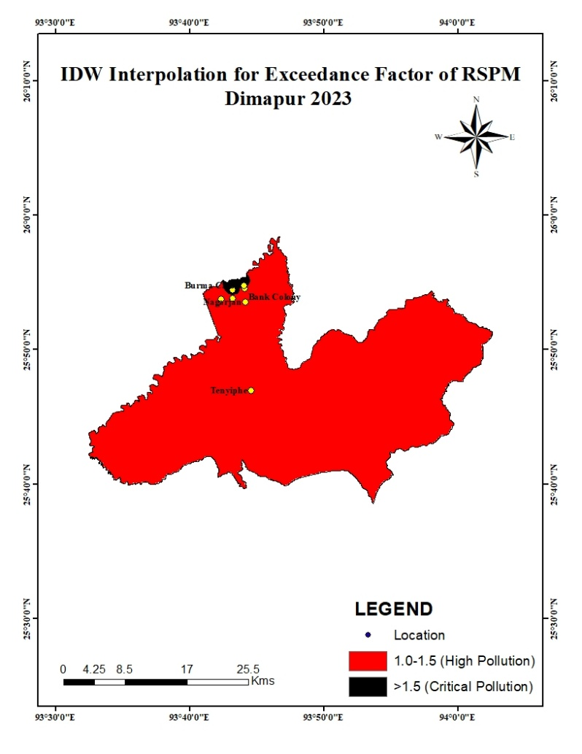
Fig 1: IDW Interpolation map for Exceedance Factor of RSPM Dimapur, 2023

The results show that Dhobinalla and Burma Camp recorded EF values above 1.9, classifying them as "Critical Pollution" zones. We can also observe moderate pollution levels in NPCB Office, Nagarjan, and Bank Colony. But overall, all locations exceeded the permissible limits, reinforcing the need for urgent air quality control measures.

  - Seasonal Variation in RSPM Levels
The seasonal trend analysis of RSPM levels indicates that winter months (Dec–Feb) recorded the highest RSPM levels (140-177 µg/m³) due to low atmospheric dispersion, increased biomass burning, and dry weather conditions. Monsoon months (July–September) had the lowest RSPM concentrations (50-75 µg/m³) as rainfall washed out airborne particulates. Post-monsoon (October–November) saw a gradual increase in pollution levels (100-120 µg/m³) as rainfall declined and dust levels rose.

Table 4: Seasonal Variation of RSPM Levels in Dimapur (2023)
Season | Dhobinalla | Bank Colony | NPCB Office | Tenyiphe | Nagarjan | Viola | Burma Camp
Winter (Dec, Jan, Feb Avg) | 157 | 118 | 117 | 120 | 128 | 121 | 128
Pre-Monsoon (Mar, Apr, May Avg) | 143 | 113 | 96 | 95 | 101 | 90 | 116
Monsoon (Jun, Jul, Aug Avg) | 106 | 70 | 61 | 60 | 66 | 57 | 75
Post-Monsoon (Sep, Oct, Nov Avg) | 108 | 86 | 79 | 72 | 91 | 78 | 97

Fig 2: Seasonal Variation of RSPM Levels in Dimapur

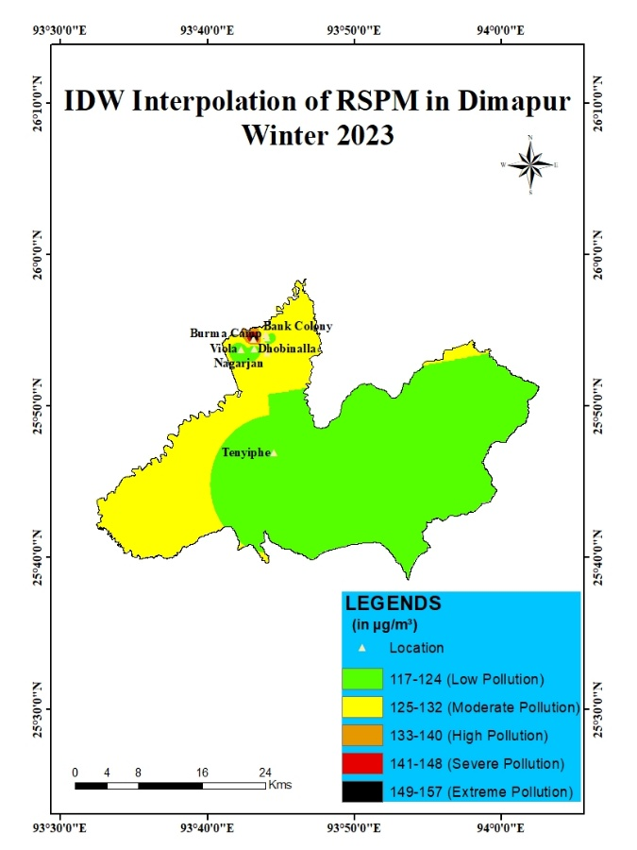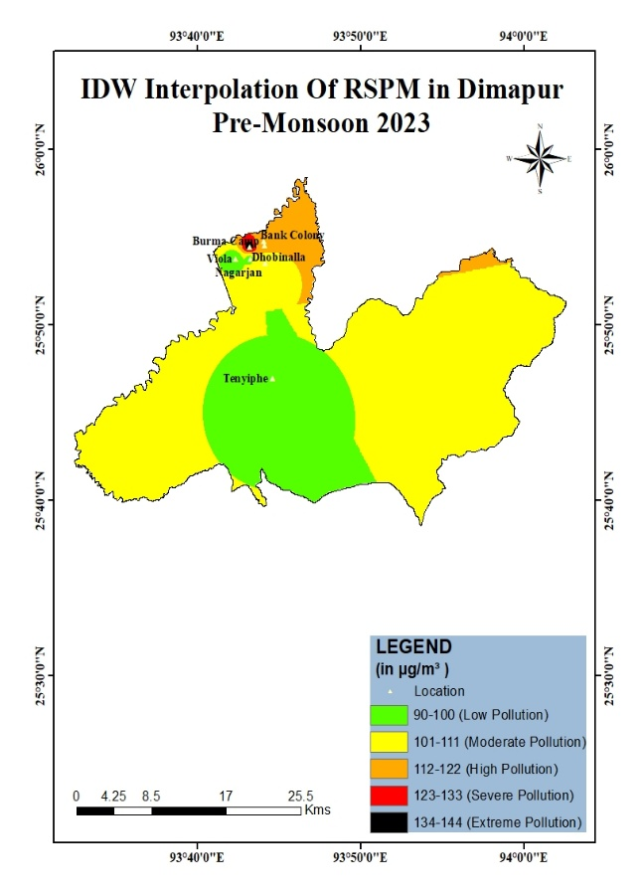
A B
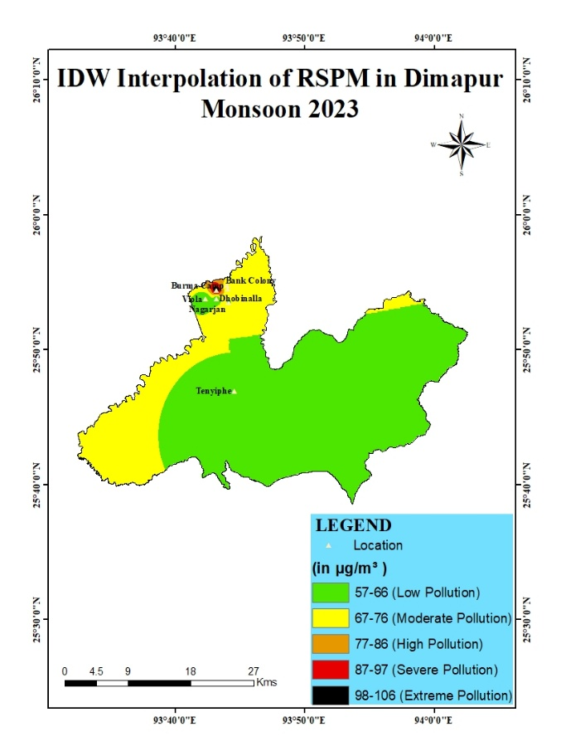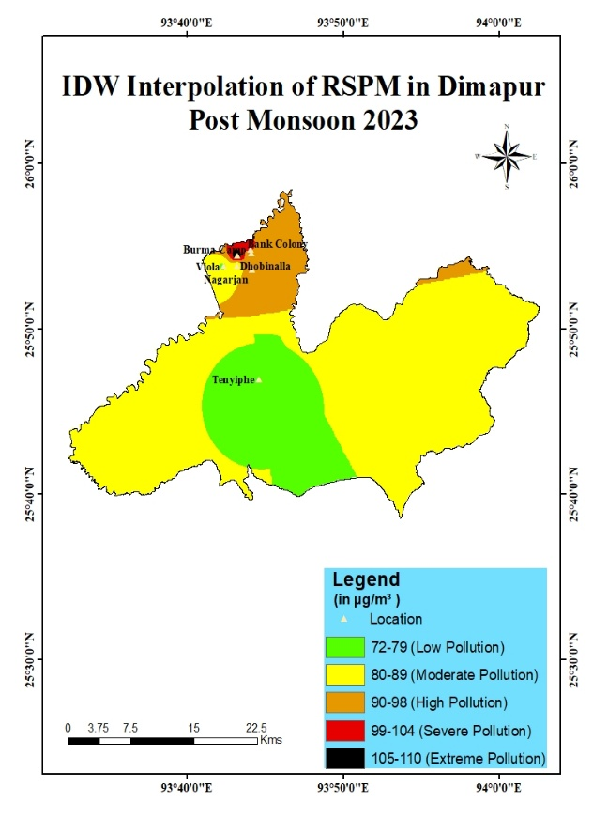
C D
Fig 3: IDW Interpolation Seasonal Variation Map of RSPM Dimapur
A) Winter 2023 B) Pre Monsoon 2023 C) Monsoon D) Post Monsoon

  - Correlation Between Land Use and Air Pollution
To understand how urban land cover affects pollution, spatial correlation analysis was performed between RSPM concentrations and Land Use Land Cover (LULC) types. The result shows that commercial and traffic-dense areas exhibited higher RSPM levels, with Dhobinalla (130 µg/m³) and Burma Camp (114 µg/m³) showing peak pollution. While Residential and green spaces recorded lower RSPM levels, with Viola Colony (81 µg/m³) and NPCB Office (88 µg/m³) exhibiting better air quality.

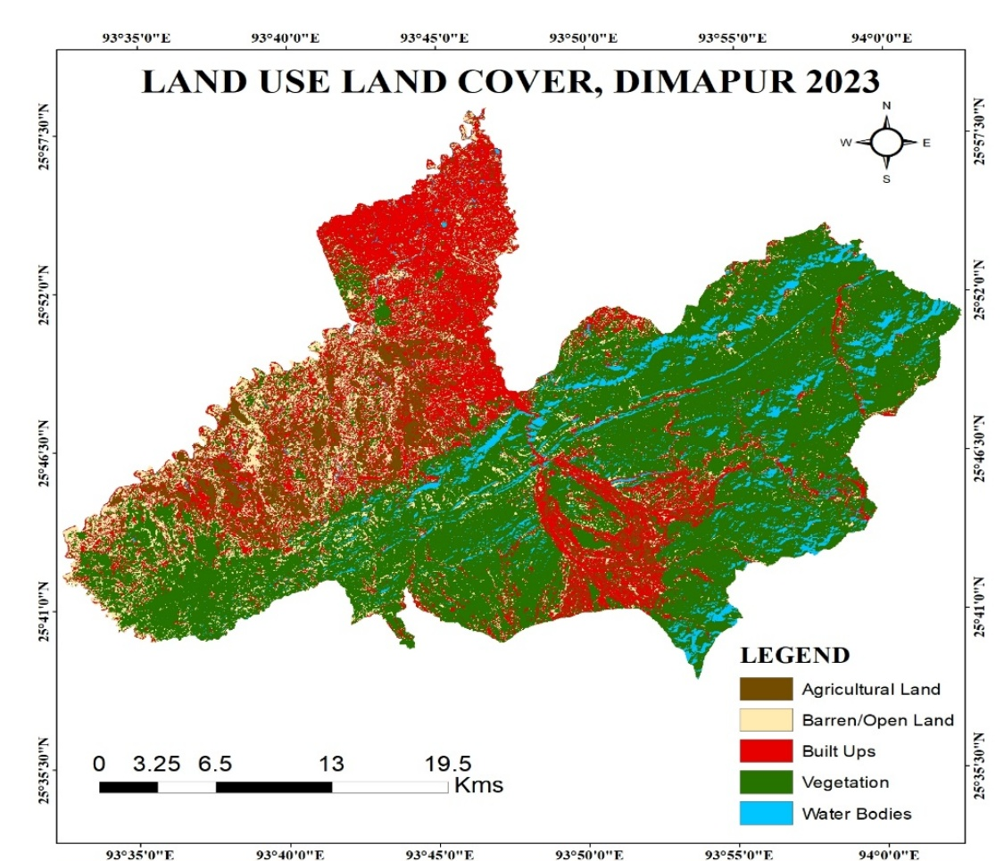
Fig 4: Land Use Land Cover Map of 2023
Table5: RSPM Levels by Land Use Type
Land Use Type | Avg. RSPM (µg/m³)
Dense Commercial (Dhobinalla, Burma Camp) | 130-114
Mixed Residential-Commercial (Nagarjan, Bank Colony) | 95-89
Residential & Green Spaces (NPCB Office, Viola) | 88-81

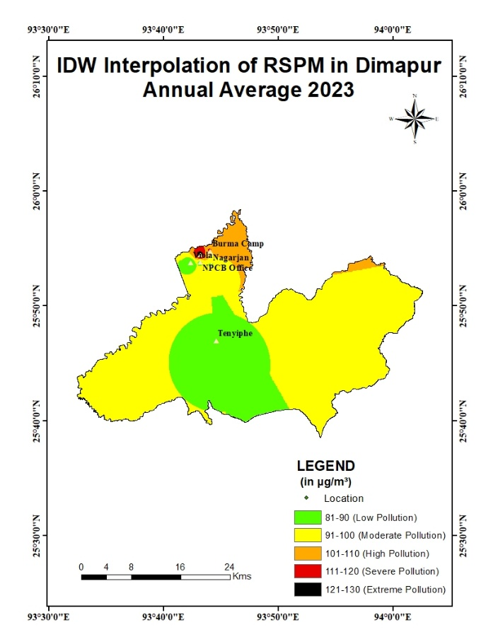
Fig 5: IDW Interpolation Map of RSPM Dimapur, Annual Average 2023
It is observed that all locations in Dimapur exceed the NAAQS limit of 60 µg/m³, with critical pollution observed in Dhobinalla and Burma Camp. These locations are the most urbanising area and junctions of traffic points with high vehicular movements which release massive amount of volatile organic compounds and carbon monoxide with high confestion. Frequent stops and engine idling outside commercial buildings also causes intense builup of pollutants in these areas. Presence of high rising commercial buildings and ongoing development of commercial complexes and offices and surrounding infrastructure and construction create high levels of dust and emissions from heavy machinery. Not only that there are also presence of non-exhaust emissions like road dust from vehicular movement, tire wear and braking. Seasonal variations show winter peaks and monsoon reductions in RSPM levels. Commercial and traffic-heavy areas exhibit the highest pollution, necessitating targeted mitigation strategies.

- CONCLUSION
This study assessed the spatial and seasonal variations of Respirable Suspended Particulate Matter (RSPM) in Dimapur, Nagaland, using Geographical Information System (GIS)-based IDW interpolation and exceedance factor analysis. The findings reveal that RSPM levels in Dimapur consistently exceed the National Ambient Air Quality Standards (NAAQS), highlighting severe air pollution concerns. The study identified Burma Camp and Dhobinalla as the most polluted locations due to high vehicular emissions, industrial activities, and commercial congestion. In contrast, Viola Colony and NPCB Office recorded lower RSPM levels, attributed to their residential and institutional land-use characteristics. Seasonal variations were also evident, with winter (December-February) experiencing the highest RSPM concentrations due to temperature inversion and reduced atmospheric dispersion, while monsoon months (June-September) showed the lowest levels due to rainfall-induced pollutant washout. The correlation between land use and pollution levels underscores the impact of urbanization, traffic density, and industrialization on air quality. The exceedance analysis confirmed that pollution levels in most locations significantly surpass NAAQS limits, posing severe health risks, particularly respiratory illnesses.
Based on the findings and given the increasing levels of particulate pollution, interventions are necessary to address the pollution problem. Vehicular emissions are a major contributor to air pollution in the study area, it is important to necessitate stricter traffic regulation & emission control by promoting public transportation, and introducing low-emission zones in high-risk areas. Another significant contributer is rapid urbanisation in forms of increasing commercial and built up areas. It is important to have proper urban planning approaches & Green Spaces. Increase tree cover and urban vegetation to enhance natural air filtration and improve air quality. Continuous Air Quality Monitoring is another important aspect to look into. So furthermore it is recommended to establish real-time air monitoring stations and integrate GIS-based spatial analysis for early pollution detection. It is essential to implement proper public awareness & policy enforcement by conducting awareness campaigns and enforce environmental regulations to encourage sustainable urban practices. Overall, this study demonstrates the effectiveness of GIS and spatial analysis techniques in monitoring urban air pollution. The results serve as a valuable resource for urban planners, policymakers, and environmental authorities in formulating evidence-based pollution mitigation strategies.

REFERENCE
- Bhunia, G. S., et al. (2020). Temporal and spatial statistical analysis of ambient air quality in Guwahati, Assam. https://pubmed.ncbi.nlm.nih.gov/32442037/.
- Bui, D. H., et al. (2025). Urbanization and PM2.5 pollution impacts on health.
- Census of India (2011) https://censusindia.gov.in
- Central Pollution Control Board (CPCB). (2023). National Air Quality Monitoring Programme. https://cpcb.nic.in
- CPCB. (2009). National Ambient Air Quality Standards (NAAQS) https://cpcb.nic.in/uploads/National_Ambient_Air_Quality_Standards.pdf
- Das, B. (2025). Spatial and temporal dynamics of air pollution in Guwahati. https://doi.org/10.1007/s44274-025-00418-0.
- IQAir. (2022). World Air Quality Report. https://www.iqair.com/world-air-quality-report.
- Jerrett, M., Arain, A., Kanaroglou, P., Beckerman, B., Crouse, D., Gilbert, N. L., Brook, J. R., Finkelstein, N., & Finkelstein, M. M. (2005). A review and evaluation of intraurban air pollution exposure models. Journal of Exposure Analysis and Environmental Epidemiology, 15(2), 185–204. https://doi.org/10.1038/sj.jea.7500388
- Landrigan, P. J., et al. (2018). The Lancet Commission on pollution and health. https://doi.org/10.1016/S0140-6736(17)32345-0
- Li, J., & Heap, A. D. (2008). A review of spatial interpolation methods for environmental scientists. Geoscience Australia. https://www.ga.gov.au/bigobj/GA12526.pdf
- Li, J., & Heap, A. D. (2014). Spatial interpolation methods applied in the environmental sciences: A review. Environmental Modelling & Software, 53, 173–189. https://doi.org/10.1016/j.envsoft.2013.12.008
- Nagaland State Pollution Control Board (NSPCB). (2022). Air quality reports https://nspcb.nagaland.gov.in
- National Clean Air Programme (NCAP) https://moefcc.gov.in
- Tobler, W. R. (1970). A computer movie simulating urban growth in the Detroit region. Economic Geography, 46(sup1), 234–240. https://doi.org/10.2307/143141
- United Nations. (2017). Sustainable Development Goals Report – Goal 11.
- United Nations. (2018). World Urbanization Prospects. https://population.un.org/wup/
- World Bank. (2022). Urban population (% of total population) -India. https://data.worldbank.org/indicator/SP.URB.TOTL.IN.ZS?locations=IN
- World Health Organization (WHO). (2025). Urban health
- World Health Organization. (2021). Air quality guidelines & global air pollution data. https://www.who.int/news-room/fact-sheets/detail/air-pollution
- World Health Organization. (2021). WHO global air quality guidelines. https://www.who.int/publications/i/item/9789240034228
- Zhan, C., et al. (2023). Impacts of urbanization on air quality and health risks. Atmospheric Chemistry and Physics.

