Original Research Article

Design and Performance Analysis of Vibration Reduction Scheme for Prestressed Pier under Flood-earthquake Coupling Action Introduction

Abstract: The coupling effect of flood discharge and earthquake places the prestressed gate pier in an extremely complex stress state, making it difficult for traditional design methods to meet the safety requirements of sluice projects in high seismic zones. In this paper, a tuned mass damper (TMD) vibration reduction scheme is designed for the dynamic response characteristics of prestressed gate piers under flood discharge-earthquake coupling conditions, and its vibration reduction performance is systematically analyzed through numerical methods. First, based on structural dynamics theory, the optimal frequency ratio and damping ratio of the TMD are determined, and a vibration reduction device with a mass of 2000 kg, a stiffness of 1.5×10⁵ N/m, and a damping coefficient of 4.2×10³ N·s/m is designed. Then, a three-dimensional finite element model of the prestressed gate pier is established using ANSYS, where the mechanical behavior of the TMD is simulated using spring elements and mass points, and the variation patterns of dry and wet modal frequencies of the gate pier before and after TMD installation are analyzed. Finally, two typical working conditions—the check flood-earthquake coupling condition and the normal earthquake condition—are selected to calculate the time-history responses of gate top displacement and maximum principal stress in the gate pier, and to evaluate the vibration reduction effect of the TMD and its spatial distribution. The results show that after TMD installation, the natural frequencies of each order of the gate pier decrease, with higher-order frequencies significantly decreasing and becoming denser, which is beneficial for broadening the vibration reduction frequency band. Under the most unfavorable working condition, the dynamic displacement at the gate top decreases from 4.81 mm to 2.08 mm, achieving a reduction rate of 56.7%, and the maximum dynamic tensile stress decreases from 0.57 MPa to 0.53 MPa, a reduction of approximately 7.0%. The vibration reduction effect exhibits a clear spatial distribution characteristic: the reduction rate at the top nodes of the gate pier is about 58%–60%, that at the middle nodes drops to 24%–25%, and that at the bottom nodes is only about 8%. The TMD vibration reduction scheme designed in this paper has a significant control effect on the displacement response of prestressed gate piers and can provide a reference for the seismic design of similar sluice projects in high seismic zones.

1. Introduction
China is one of the countries with the largest scale of hydropower and water conservancy project construction in the world. With the continuous advancement of the 13th Five-Year Plan and subsequent planning, many major hydropower and water conservancy projects play irreplaceable roles in power generation, water supply, irrigation, and flood control^{[1]}. However, these projects are mostly distributed in the southwestern region, where geological activity is frequent, and the contradiction between seismic threats and the safety of hydraulic structures is becoming increasingly prominent^{[2]}. As a key load-bearing structure of discharge works, the gate pier undertakes the important function of the normal opening and closing of gates^{[3]}. Under conditions of super-large discharge openings and high water heads, the radial gate bears enormous hydraulic thrust. Ordinary reinforced concrete structures cannot effectively limit the tensile stress distribution, so prestressed gate piers have become a common choice in engineering practice^{[4]}. At the same time, the coupling effect of earthquakes and flood discharge places the gate pier in an extremely complex stress state, and traditional structural mechanics methods can no longer meet the requirements for accurate analysis^{[5]}.
The seismic performance of prestressed gate piers has always been a focus of academic attention. In recent years, domestic and international scholars have explored various technical paths to improve the mechanical performance of gate piers through numerical simulations and experimental studies. In terms of vibration reduction devices, Zou et al.^{[6]} proposed a function-separated isolation device (FSID), which combines friction sliding bearings with high-damping rubber bearings to achieve multi-level seismic goals, verifying its effectiveness in prefabricated segmental assembled piers. Research has shown that the equivalent load and boundary parameters of this device are difficult to solve accurately under nonlinear foundation conditions, and traditional seismic wave input methods have significant errors^{[7]}. Yu et al.^{[8]} proposed an improved nonlinear seismic wave input method for earth-rockfill dams on overburden foundations. By using a shear box model and nonlinear viscous coupling boundaries, they significantly improved calculation accuracy, with the maximum peak acceleration deviation controlled within 5%.
In terms of numerical simulation methods, finite element technology has become the core tool for prestressed gate pier analysis. Zhang Bo^{[9]} used ANSYS to establish a three-dimensional finite element model of a super-large tonnage prestressed gate pier, improved the traditional equivalent load method to more accurately simulate prestress application, and systematically analyzed the stress and deformation patterns under various working conditions during construction and operation periods. He pointed out that temperature drop and temperature rise have significant effects on displacement, and the tensile stress concentration area in the neck section requires special attention. Liang Jiahui^{[10]} conducted a seismic safety evaluation of a drop lock chamber structure based on ADINA. Through natural vibration characteristic analysis and dynamic time-history calculations, he evaluated the tensile stress state at the junction between the gate pier and the base slab and proposed targeted seismic reinforcement schemes. For high-rise thin-walled structures such as intake towers, Zhang Xuelin et al.^{[11]} used the mode decomposition response spectrum method to analyze the dynamic response under seismic action, finding that the maximum displacement is located at the top of the tower, and tensile stress is concentrated in the waist area, but the overall strength meets the code requirements.
The influence of fluid-structure interaction effects on the seismic performance of hydraulic structures cannot be ignored. Liu Ruijun et al.^{[12]} pointed out that traditional wet mode methods have contradictions in handling the singularity of the fluid stiffness matrix and proposed two improved schemes: the direct method and the fixed-point method. They verified the influence of different oil volumes on modal frequencies using an oil pan structure. Behroozi and Vaghefi^{[13]} further coupled the radial basis function differential quadrature method (RBF-DQM) with the finite element method (FEM) to establish a time-domain analysis method for a two-dimensional dam-reservoir system. This method does not require mesh generation and is suitable for reservoirs with irregular geometries, and the numerical results are in good agreement with benchmark solutions. In the analysis of more complex radial gate structures, Ma Bin et al.^{[14]} studied the damage vibration response characteristics of high roller-compacted concrete arch dams, finding that increases in the strength, thickness, and number of weak layers amplify the vibration response, and the interaction between crack damage and the layered structure further exacerbates the dynamic displacement of the dam body.
The reasonable selection of damping models directly affects the accuracy of nonlinear dynamic analysis. Huang et al.^{[15]} proposed a novel filtering-based damping model capable of achieving uniform energy dissipation within a specified frequency range. This model is orthogonal to rigid body motion, and the damping force automatically attenuates after large deformations, overcoming the frequency sensitivity of Rayleigh damping and the need for preset stiffness in the Biot model. This model provides theoretical support for the nonlinear response analysis of prestressed gate piers under strong earthquakes. At the material level, Rosa et al.^{[16]} fabricated 316L stainless steel lattice structures using selective laser melting technology and found that their damping capacity was significantly higher than that of solid materials, with energy dissipation mainly concentrated in the nodes and longitudinal members. This provides new material ideas for the design of local vibration reduction structures for gate piers. Ma and Chen^{[17]} studied the damping characteristics of translating bubbles in a strong acoustic field from the perspective of bubble dynamics, revealing the influence of the initial Bjerknes force on the cavitation effect and providing a microscopic explanation for the energy dissipation mechanism in fluid media.
The durability of prestressed gate piers is closely related to seismic performance. Han et al.^{[18]} used multi-scale finite element analysis to study the influence of steel reinforcement corrosion on the seismic damage of underground reinforced concrete culverts. They found that corrosion of side wall reinforcement leads to increased overall deformation, especially when shear reinforcement is insufficient, and irreversible shear cracks accumulate continuously. This finding is of great significance for long-term service prestressed gate piers, as stiffness degradation caused by corrosion may significantly reduce their seismic margin. Under extreme disaster scenarios, Peramuna et al.^{[19]} proposed a finite element model-based method for deriving earthquake-induced dam breach parameters. Combining peak accelerations for return periods of 475 years and 2475 years, they established a two-dimensional hydrodynamic model to analyze flood risks under combined rainfall and earthquake events, providing boundary conditions for the safety assessment of gate piers under dam breach conditions.
At the micro-scale flow control level, Aissa-Berraies et al.^{[20]} numerically studied the fluid-structure interaction characteristics of a pilot-operated microfluidic valve. They found that the severe pressure drop and Venturi effect at the valve seat gap can induce self-excited vibration, a mechanism similar to the local stress concentration phenomenon in the neck of a prestressed gate pier under strong earthquakes. In the field of power systems, Chen et al.^{[21]} proposed an online damping assessment method based on dissipative energy flow. Using phasor measurement data from 2–3 oscillation cycles, they could identify negative damping units and implement emergency control. This concept can be analogously applied to hydraulic structure health monitoring for real-time assessment of the damping state of gate piers and triggering of vibration reduction measures.
In summary, current research on prestressed gate piers has mostly focused on static and dynamic analysis under single working conditions, while research on vibration reduction scheme design under flood discharge-earthquake coupling conditions remains insufficient. Existing literature indicates that function-separated isolation devices, improved seismic wave input methods, high-precision fluid-structure interaction models, and novel damping materials provide technical reserves for gate pier vibration reduction design. However, systematic performance evaluation and optimization design methods for prestressed gate piers under flood discharge-earthquake coupling conditions still require further investigation. Therefore, this paper aims to combine the above research findings to explore a vibration reduction scheme for prestressed gate piers suitable for flood discharge-earthquake coupling conditions, in order to provide theoretical basis and technical support for the safety design of sluice gate projects in high seismic zones.

2. Principle and Parameter Design of Vibration Reduction Scheme
Under the coupling action of flood discharge and earthquake, the dynamic response amplitude of the pier is large, and the principal tensile stress at the root of the pier is much higher than standard value of concrete tensile strength, so there is a high risk of cracking, and it is necessary to take vibration reduction and reinforcement measures for the pier. Combined with the actual situation, in order not to affect the normal opening and closing of the gate of the flood discharge structure, a vibration absorber composed of a mass block and a spring-damping element is attached to the top of the pier, and its natural frequency is matched with the basic frequency of the pier by setting stiffness and damping to achieve the purpose of vibration reduction. This chapter first describes the damping principle of tuned mass damper, and then introduces its simulation and layout method in ANSYS, and then carries out modal analysis and flood-earthquake coupling dynamic response analysis of the pier after damping, and finally verifies the damping effect by comparing the calculation results before and after damping.
TMD (Tuned Mass Damper) is a passive control device which is widely used in structural vibration control. The basic principle is to add a substructure composed of mass ${\text{m}}_{\text{d}}$ spring stiffness ${\text{k}}_{\text{d}}$ and damping coefficient ${\text{c}}_{\text{d}}$ to the main structure. By adjusting the natural frequency ${\text{ω}}_{\text{d}}\text{=}\sqrt{\frac{{\text{k}}_{\text{d}}}{{\text{m}}_{\text{d}}}}$of the substructure to be close to the natural frequency ${\text{ω}}_{\text{0}}$of the main structure, when the external excitation (such as earthquake) acts on the main structure, the substructure produces an inertial force in the opposite direction to the main structure, thus absorbing and dissipating the vibration energy of the main structure. For a single-degree-of-freedom primary structure, the equations of motion with the additional TMD are:
$$\begin{aligned}\left\{\begin{aligned}{\text{m}}_{\text{0}}{\ddot{\text{x}}}_{\text{0}}\text{+}{\text{c}}_{\text{0}}{\dot{\text{x}}}_{\text{0}}\text{+}{\text{k}}_{\text{0}}{\text{x}}_{\text{0}}\text{-}{\text{c}}_{\text{d}}\text{(}{\dot{\text{x}}}_{\text{d}}\text{-}{\dot{\text{x}}}_{\text{0}}\text{)-}{\text{k}}_{\text{d}}\text{(}{\text{x}}_{\text{d}}\text{-}{\text{x}}_{\text{0}}\text{)=}\text{F}\text{(}\text{t}\text{)} \\ {\text{m}}_{\text{d}}{\ddot{\text{x}}}_{\text{d}}\text{+}{\text{c}}_{\text{d}}\text{(}{\dot{\text{x}}}_{\text{d}}\text{-}{\dot{\text{x}}}_{\text{0}}\text{)+}{\text{k}}_{\text{d}}\text{(}{\text{x}}_{\text{d}}\text{-}{\text{x}}_{\text{0}}\text{)=0}\end{aligned}\right.\#\text{（}\text{1}\text{）}\end{aligned}$$
When the frequency of the TMD is precisely tuned to the fundamental frequency of the main structure (i.e., ${\text{ω}}_{\text{d}}$=${\text{ω}}_{\text{0}}$), the vibration response of the main structure can be significantly suppressed. The introduction of appropriate damping can also broaden the damping frequency band and improve the robustness. According to the theory of structural dynamics, the optimal frequency ratio and damping ratio of TMD can be estimated by the following formulas:
$$\begin{aligned}f_{opt}=\frac{ω_{d}}{ω_{0}}=\frac{1}{1+μ}, ζ_{opt}=\sqrt{\frac{3μ}{8(1+μ)^{3}}}\#\text{（}\text{2}\text{）}\end{aligned}$$
Among$μ=\frac{m_{d}}{m_{0}}$ is the mass ratio and,${\text{ m}}_{\text{0}}$is the modal mass of the primary structure. In engineering practice, the mass ratio is usually 1% to 5%. For this pier, the fundamental frequency $ω_{0}=2πf_{0}≈2π×1.39=8.73rad/s$。Take the mass block${\text{m}}_{\text{d}}$=2000kg,and the mass ratio $μ≈$0.02 can be obtained after extracting the modal mass, then:
$$f_{opt}≈0.98, ζ_{opt}≈0.12$$
The stiffness and damping coefficients of the TMD can be obtained as follows:
$$k_{d}=m_{d}⋅{\left(ω_{0}f_{opt}\right)}^{2}≈1.5×10^{5}N/m, c_{d}=2ζ_{opt}m_{d}ω_{0}f_{opt}≈4.2×10^{3}N⋅s/m$$
3. Simulation and Arrangement of Damper
A cuboid with a very small size is created on the top surface of the pier as the mass block of the TMD. Make sure that the mass and pier are two separate entities (no Boolean merging). A Point Mass is used to impart mass to the mass, and a displacement constraint is imposed on the mass to constrain it to move only in the vertical direction: the displacement in the X and Z directions is limited to 0, and the Y direction is free. See Fig. 1 for the arrangement position of the mass block.
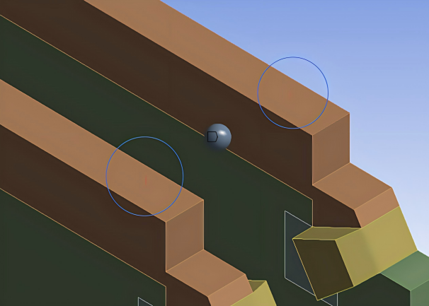
Fig. 1 Layout of Mass Blocks
Use the Spring connection to simulate the spring and damping of the TMD. Set Longitudinal Stiffness =$k_{d}$，and Longitudinal Damping =$c_{d }$to ensure that the spring orientation is vertical.
4. Analysis of Damping Performance
(1) Modal analysis
The dry and wet modal analysis of the pier after the installation of TMD is carried out, and the first 10 frequencies are shown in Table 1. Compared with the undamped model, the mass block of TMD shows obvious local vibration in the low-order mode, and the vibration mode of the main body of the pier is basically unchanged, but the fundamental frequency is slightly changed.

Table 1 Comparison of the First 10 Orders Frequencies of Sluice Pier Before and
After Vibration Reduction
Working  condition | Wet Mode |  | Dry Mode
Working  condition | After damping (Hz) | Before damping (Hz) | After damping (Hz) | Before damping (Hz)
1 | 1.352 | 1.371 | 1.371 | 1.391
2 | 1.359 | 1.513 | 1.488 | 1.530
3 | 1.359 | 2.737 | 1.488 | 2.804
4 | 1.490 | 2.897 | 1.506 | 2.916
5 | 1.897 | 2.930 | 2.078 | 3.000
6 | 1.898 | 3.205 | 2.079 | 3.205
7 | 1.900 | 3.787 | 2.081 | 3.787
8 | 1.902 | 4.800 | 2.082 | 4.833
9 | 2.198 | 4.991 | 2.407 | 4.993
10 | 2.199 | 5.846 | 2.409 | 5.928

From Table 1, it can be seen that after installing the Tuned Mass Damper (TMD), the natural frequencies of each order of the gate pier show varying degrees of reduction, indicating that the additional mass and stiffness of the TMD have changed the dynamic characteristics of the system. After vibration reduction, whether in dry mode or wet mode, the first ten natural frequencies are all lower than the corresponding frequencies before vibration reduction, and the reductions in higher-order frequencies are more significant.
After vibration reduction, the second and third frequencies in dry mode are both 1.488 Hz, and the fifth to eighth frequencies are extremely close (ranging from 2.078 to 2.082 Hz). In wet mode, the second and third frequencies are both 1.359 Hz, and the fifth to eighth frequencies range from 1.897 to 1.902 Hz. This frequency clustering phenomenon indicates that the TMD introduces new local vibration modes, which couple with the main modes of the gate pier, allowing the system to effectively dissipate energy at multiple close frequencies, thereby broadening the vibration reduction frequency band.
After vibration reduction, the low-order frequencies of the gate pier decrease slightly (approximately 1.4% to 2.7%), but the higher-order frequencies decrease significantly and become denser, indicating that the TMD has a good effect on controlling broadband ground motions. In actual earthquakes, energy is typically concentrated in the low-frequency range. The tuning of the TMD to the fundamental frequency can significantly reduce the displacement at the top of the gate pier. Meanwhile, the energy in the high-frequency range is quickly dissipated through dense local modes, which helps reduce stress concentration in areas such as the hinge support. Therefore, the frequency variation pattern shown in the table verifies the scientific validity and effectiveness of the TMD vibration reduction scheme.
(2) Dynamic response analysis under flood-discharge-earthquake coupling conditions
From the previous analysis results, the most unfavorable condition among the flood-discharge-earthquake coupling conditions is the check flood-earthquake coupling condition, with the Taft wave as the seismic wave. This condition is selected here to calculate the dynamic response of the gate pier after vibration reduction. The time history of gate top displacement and the time history of tensile stress (maximum principal stress) in the gate pier are extracted and compared with the results before vibration reduction to investigate the improvement effect of the TMD arrangement on the dynamic response of the gate pier.
In the flood-discharge-earthquake coupling analysis, the water pressure load is first applied to the structure as a static load, resulting in a non-negligible initial static displacement of the gate pier. The damping mechanism of the damper acts only on the dynamic response caused by ground motion and has no suppression effect on the static initial displacement. Therefore, when evaluating the damping efficiency of the damper, the initial displacement caused by the static flood discharge load must be subtracted from the total displacement time history under coupling conditions to isolate the pure ground motion displacement. Adopting this treatment method can truly reflect the control capability of the damper on the structural dynamic response and avoid underestimating or masking the actual damping effect of the damper due to the inclusion of static displacement in the comparison.
The time history of gate top displacement after vibration reduction is shown in Figure 2, the time history of tensile stress in the gate pier after vibration reduction is shown in Figure 3, and the comparison of peak dynamic responses of the gate pier before and after vibration reduction is presented in Table 2.

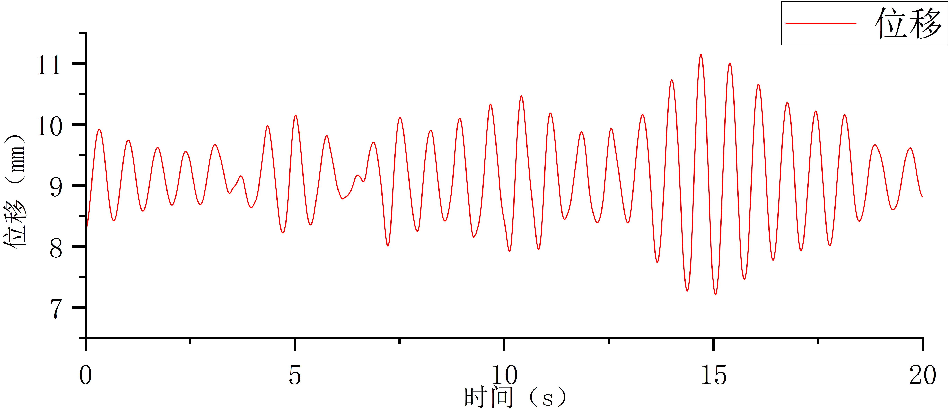
Fig. 2 Displacement Time History Curve of Pier Top After Vibration Reduction
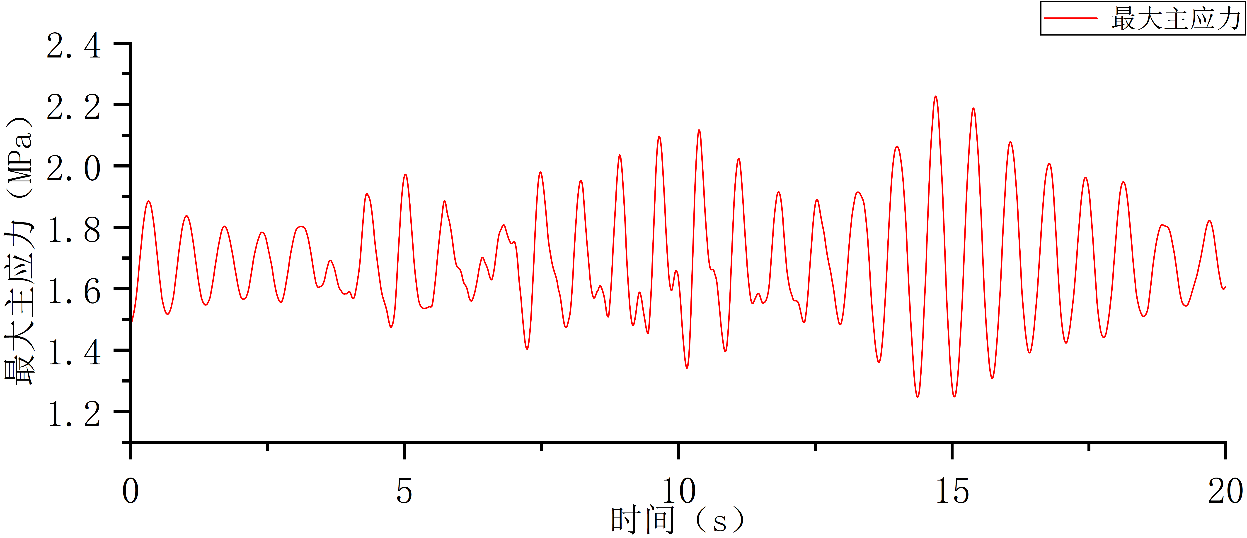
Fig. 3 Maximum Principal Stress Time History Curve of Sluice Pier After Vibration Reduction

Table 2 Comparison of Dynamic Response Peak Values of Sluice Pier Before and
After Vibration Reduction
Response Indicator | Without Vibration Reduction | With Vibration Reduction | Reduction Rate
Maximum displacement at gate top (mm) | 13.81 (4.81+9.00) | 11.08 (2.08+9.00) | 56.7%
Maximum tensile stress in gate pier (MPa) | 2.23 (0.57+1.66) | 2.19 (0.53+1.66) | 7.5%

From the analysis of the calculation results, it can be concluded that the arrangement of the TMD has a very significant effect on suppressing the dynamic displacement at the top of the gate pier, reducing it from 4.81 mm to 2.72 mm, a decrease of 56.7%. However, because the TMD is connected to the prestressed gate pier structure as an integrated unit, its impact on the maximum tensile and compressive stresses of the structure is not significant, decreasing from 2.23 MPa to 2.19 MPa, a reduction of 5.7%. Nevertheless, as seen from the time-history diagrams, the overall tensile stress level of the structure has also decreased.
Based on the previous calculation results, the primary function of the TMD is to limit the displacement response of the prestressed gate pier under seismic action, and the dynamic response on the left gate pier is generally greater than that on the right gate pier. Therefore, in order to obtain the spatial distribution pattern of the TMD's effectiveness under the combined check flood-earthquake condition, the displacement time histories of nine nodes (a to i) on the left gate pier during the first 20 seconds under this condition were monitored. The distribution of the nodes is shown in Figure 4, and the node displacement time-history diagrams are presented in Figure 5.

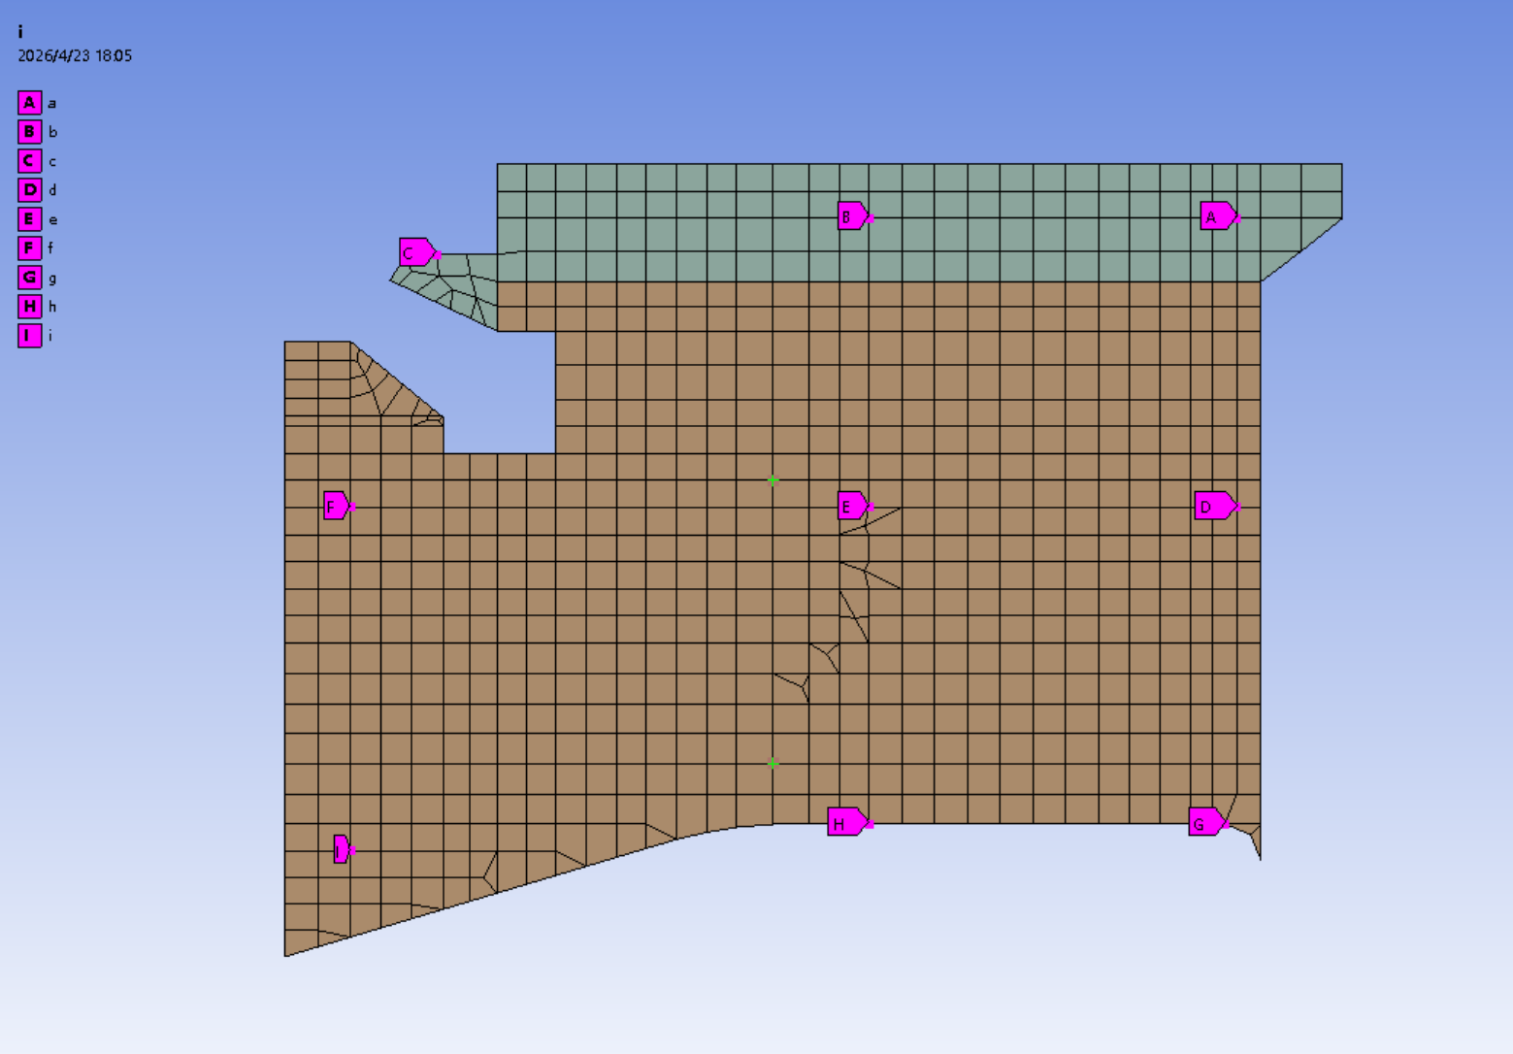
Fig.4 Node distribution diagram

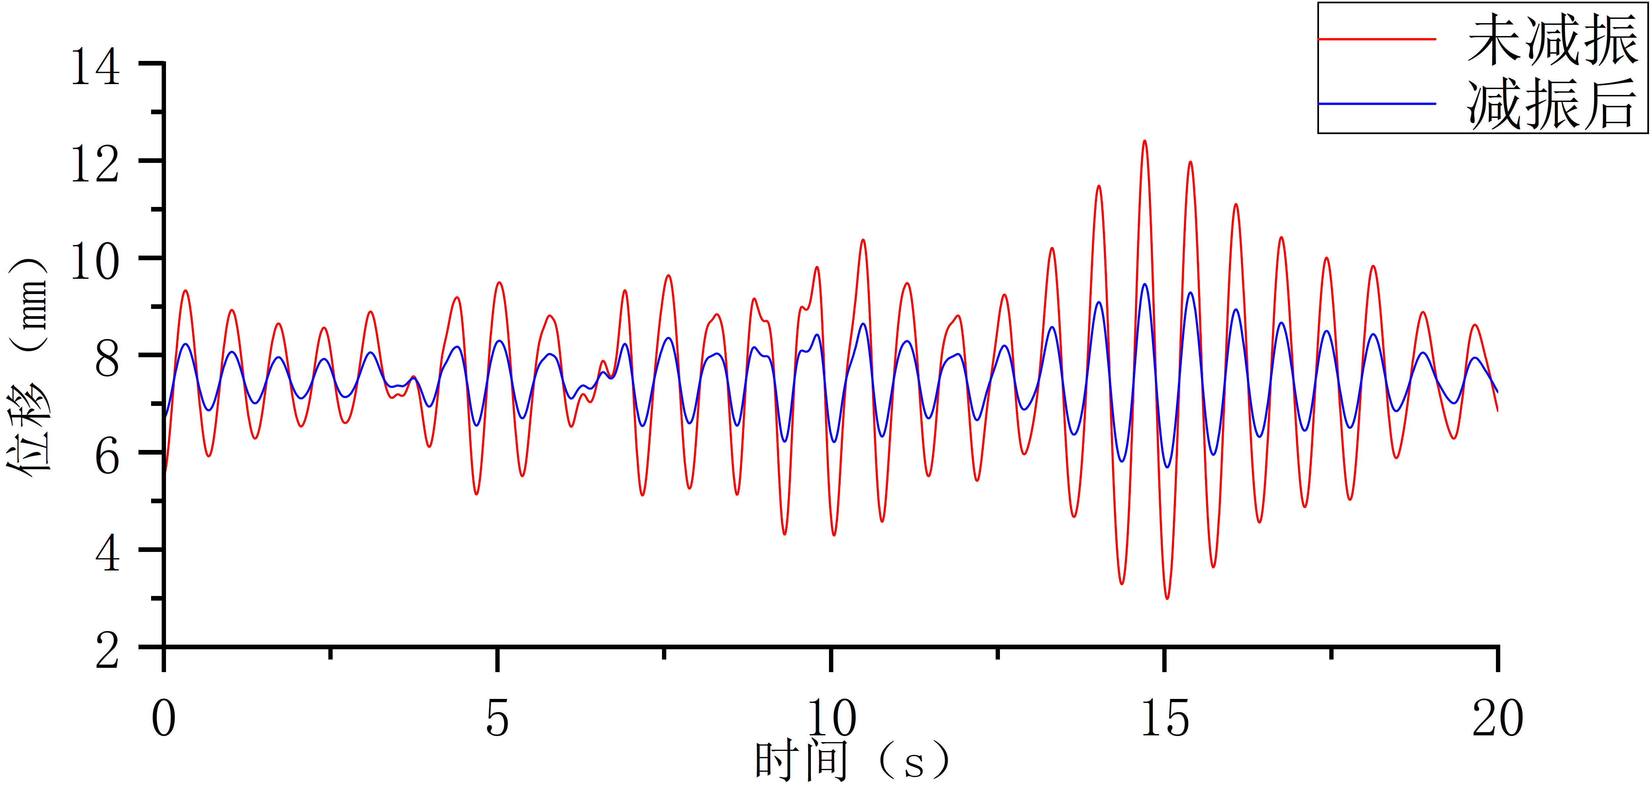 | 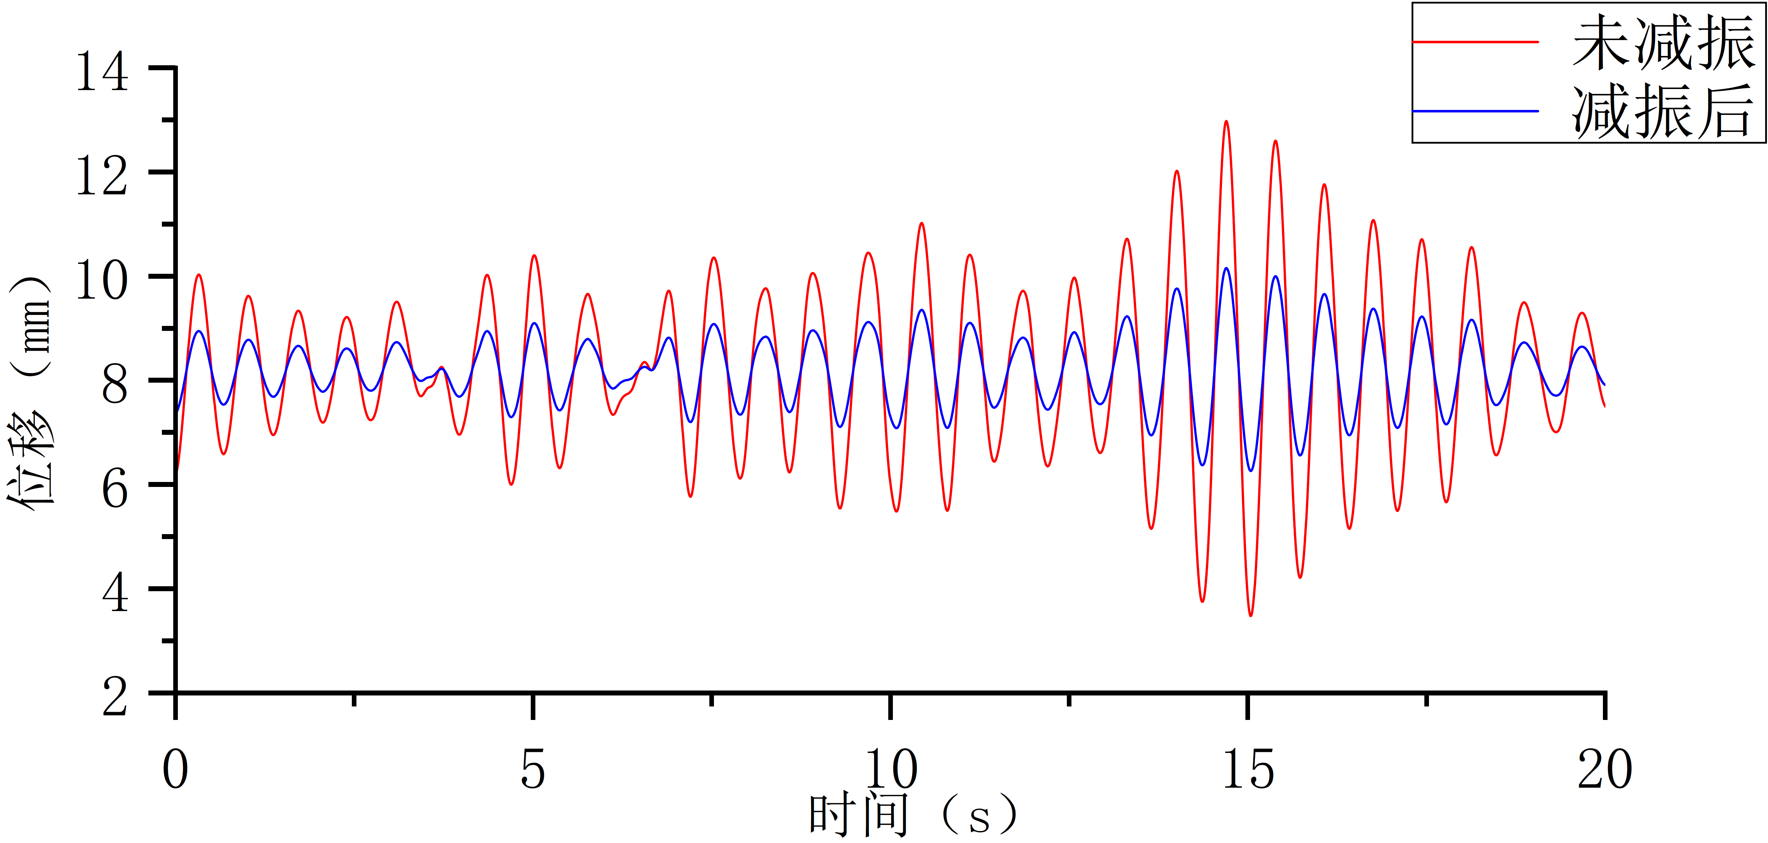
a | b
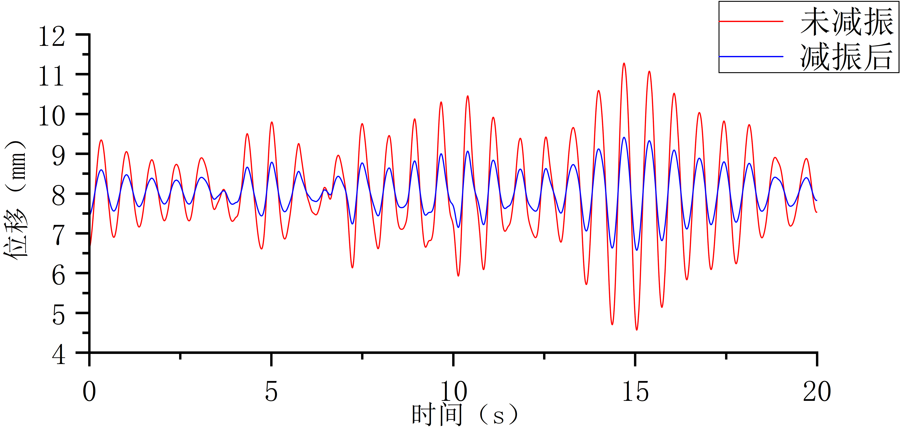 | 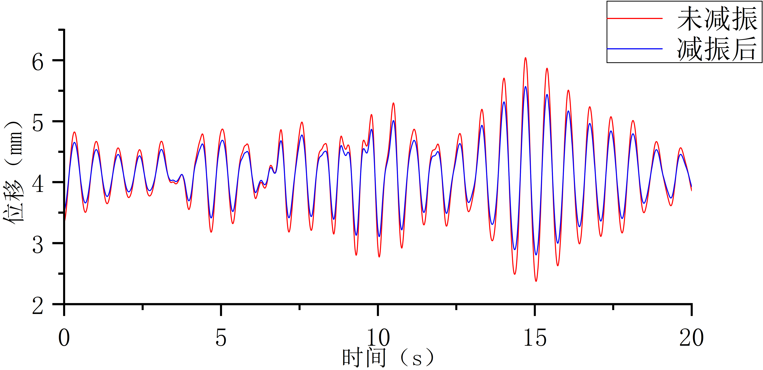
c | d
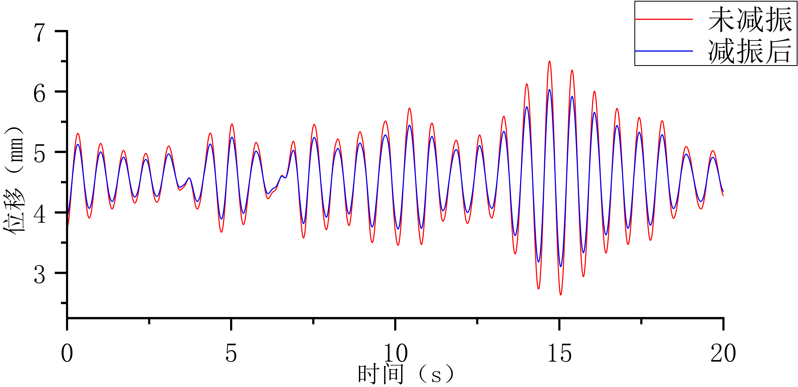 | 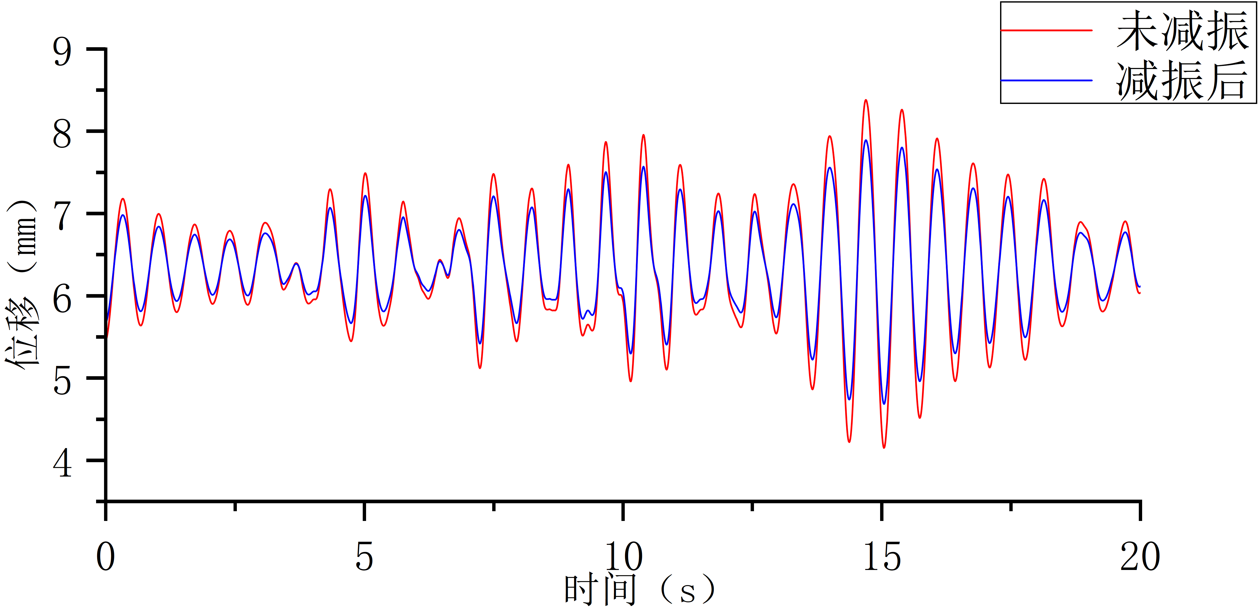
e | f
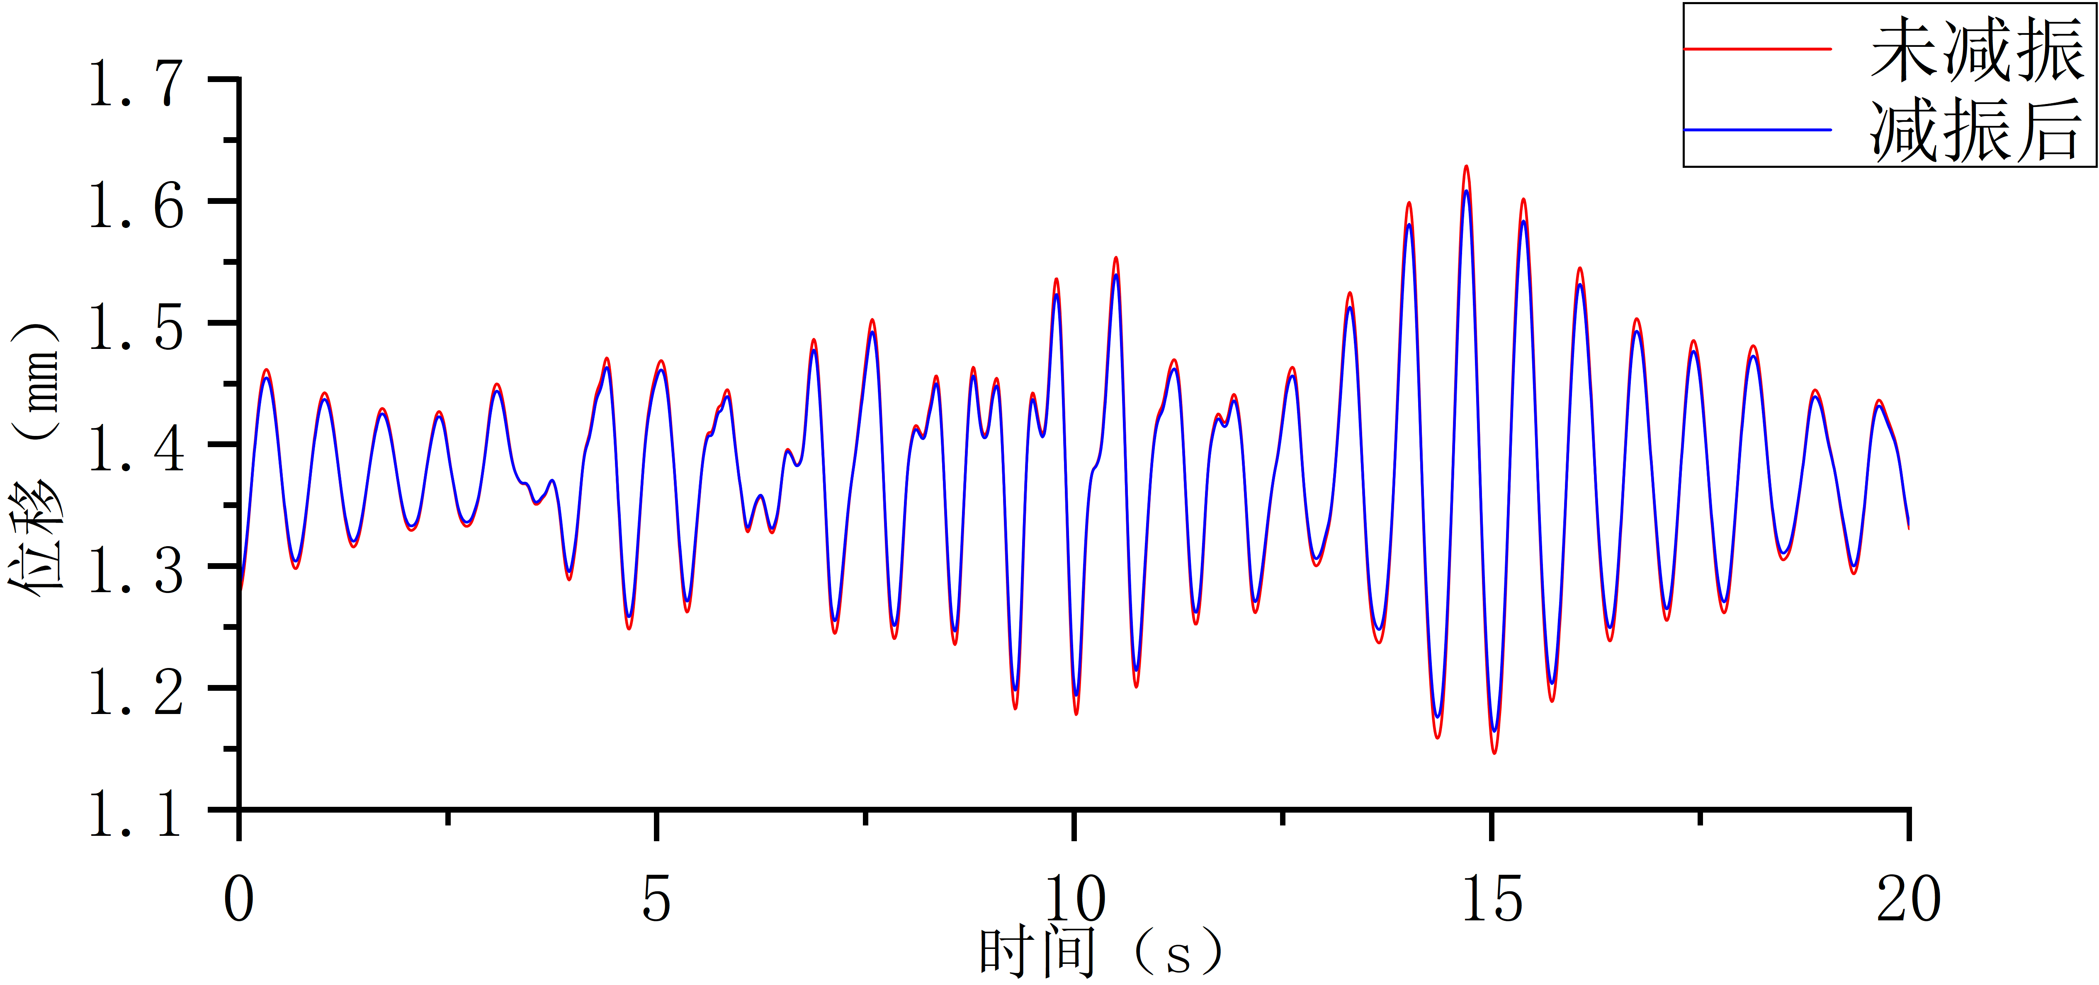 | 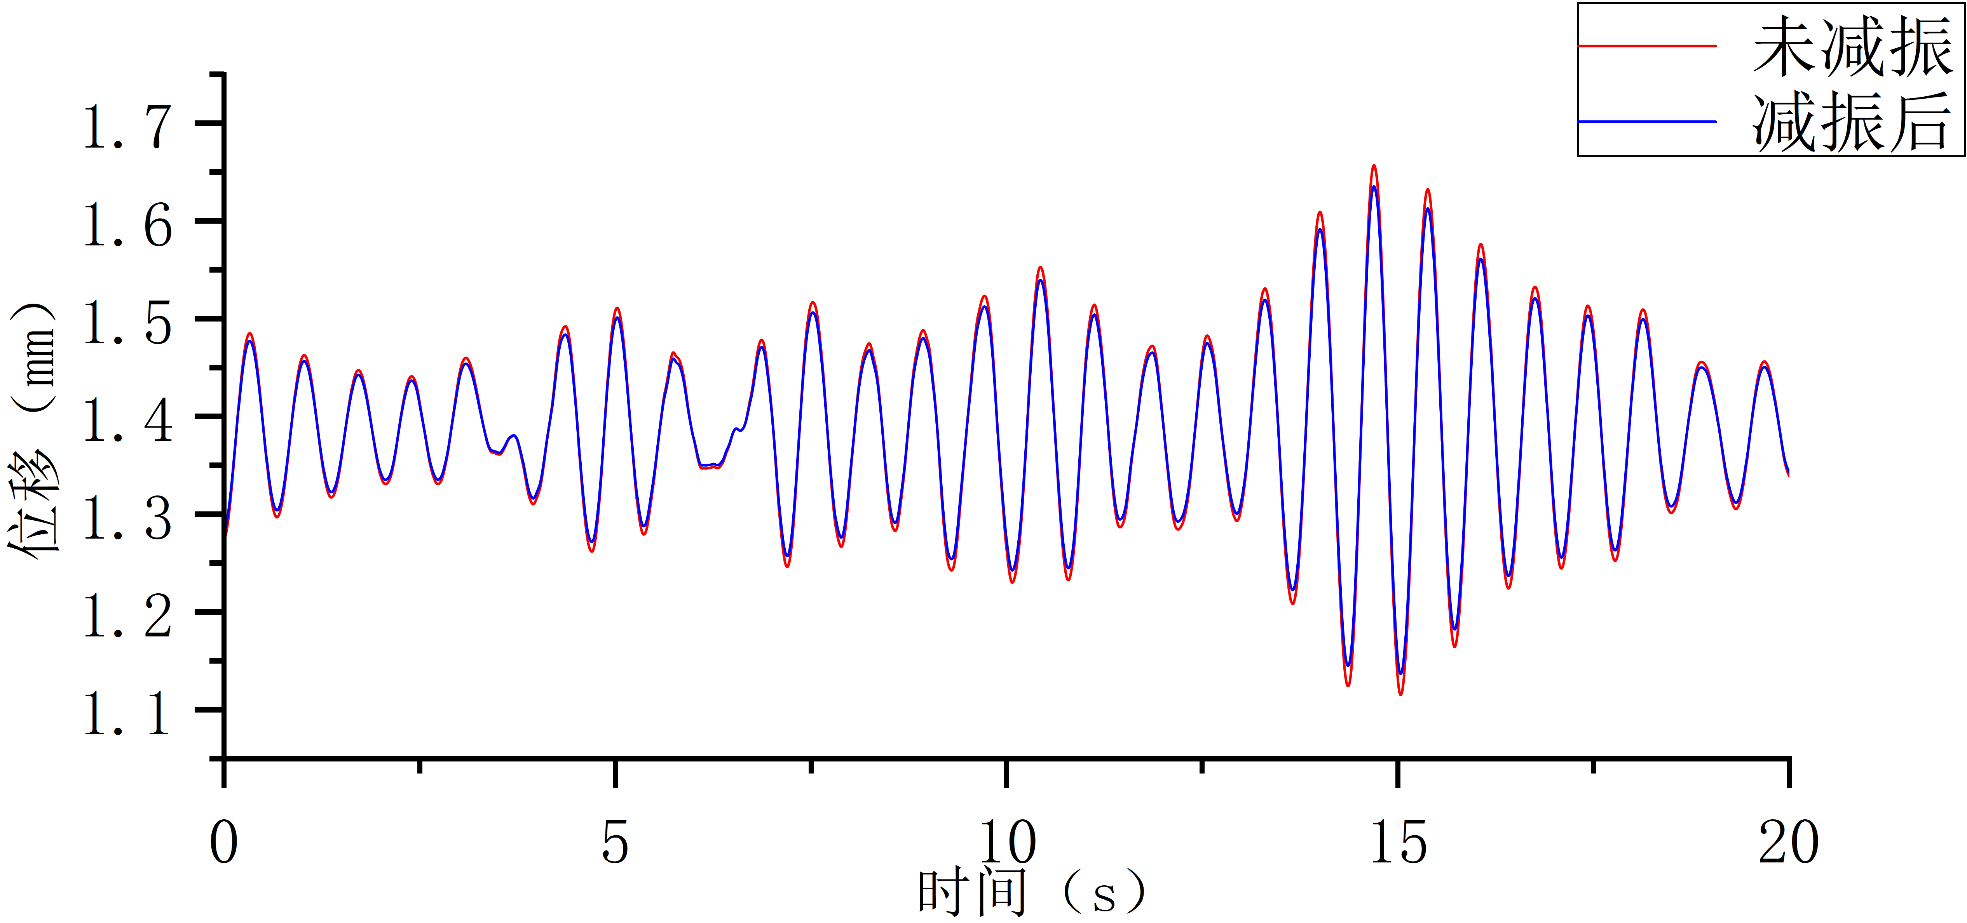
g | h
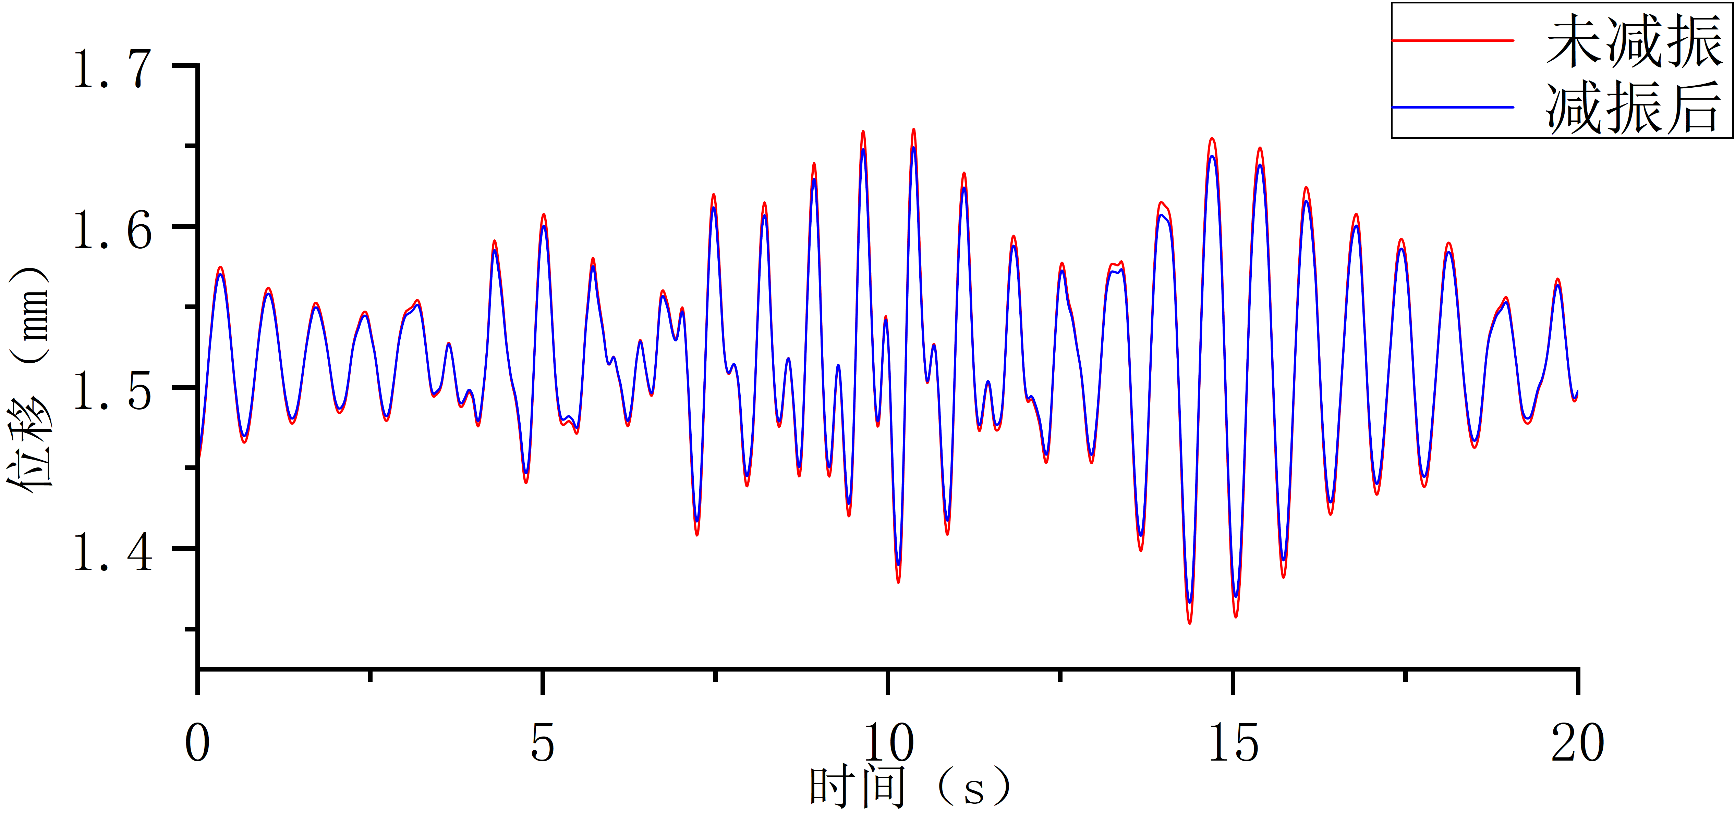
i
Fig. 5 Displacement time-history diagram of nodes a to i

Extract the maximum displacement of each node in Figure 5 before and after vibration reduction, calculate the vibration reduction rate for each node, and make a comparison. The comparison results are shown in Table 3.
Table 3 Comparison of vibration reduction rates for each node
Node | Maximum displacement before vibration reduction (mm) | Maximum displacement after vibration reduction (mm) | Vibration reduction rate
a | 12.41 | 9.46 | 59.9%
b | 12.98 | 10.16 | 58.9%
c | 11.28 | 9.41 | 57.7%
d | 6.04 | 5.57 | 24.7%
e | 6.50 | 6.03 | 24.3%
f | 8.38 | 7.89 | 24.2%
g | 1.63 | 1.60 | 8.3%
h | 1.65 | 1.63 | 8.3%
i | 1.66 | 1.65 | 8.1%

Based on Figures 4, 5, and Table 3, the following conclusions can be drawn:
The vibration reduction rate of each node shows considerable variation with the spatial distribution of different nodes. The vibration reduction rates of nodes located at the same or similar horizontal levels are relatively close. For example, nodes a, b, and c at similar heights near the top of the gate pier have vibration reduction rates of 59.9%, 58.9%, and 57.7%, respectively, with a maximum relative difference of about 3.7%. Moreover, these rates are arranged from large to small in order of increasing horizontal distance from the damper. At the same time, at the same vertical line position, the vibration reduction rate shows a significant drop as the elevation decreases. For instance, for nodes a, d, and g on the same vertical line, the vibration reduction rates from top to bottom are 59.9%, 24.7%, and 8.3%, respectively, decreasing rapidly as the vertical distance from the damper increases, and the rate of decrease slows down with further distance. This rapid attenuation of the vibration reduction rate with decreasing elevation is highly consistent with the quadratic distribution pattern of the first-order mode displacement amplitude of the gate pier. This proves that the damper arrangement scheme can precisely act on the dominant mode of the structure and significantly suppress the displacement response of the main vibration mode, indicating that the vibration reduction design is effective and well-matched to the check flood-earthquake coupling condition of this gate pier.
(3) Dynamic response analysis under non-flood earthquake conditions
To study the vibration reduction performance of the damper, it is also necessary to calculate the vibration reduction effect of the damper during a sudden earthquake under non-flood earthquake conditions, i.e., the vibration reduction performance of the damper under this working condition in this paper. The Taft wave under this condition is taken as the input seismic wave to calculate the dynamic response of the gate pier after vibration reduction. The time history of gate top displacement and the time history of tensile stress (maximum principal stress) in the gate pier are extracted and compared with the results before vibration reduction to investigate the improvement effect of the TMD arrangement on the dynamic response of the gate pier.
The time history of gate top displacement after vibration reduction is shown in Figure 6, the time history of tensile stress in the gate pier after vibration reduction is shown in Figure 7, and the comparison of peak dynamic responses of the gate pier before and after vibration reduction is presented in Table 4.

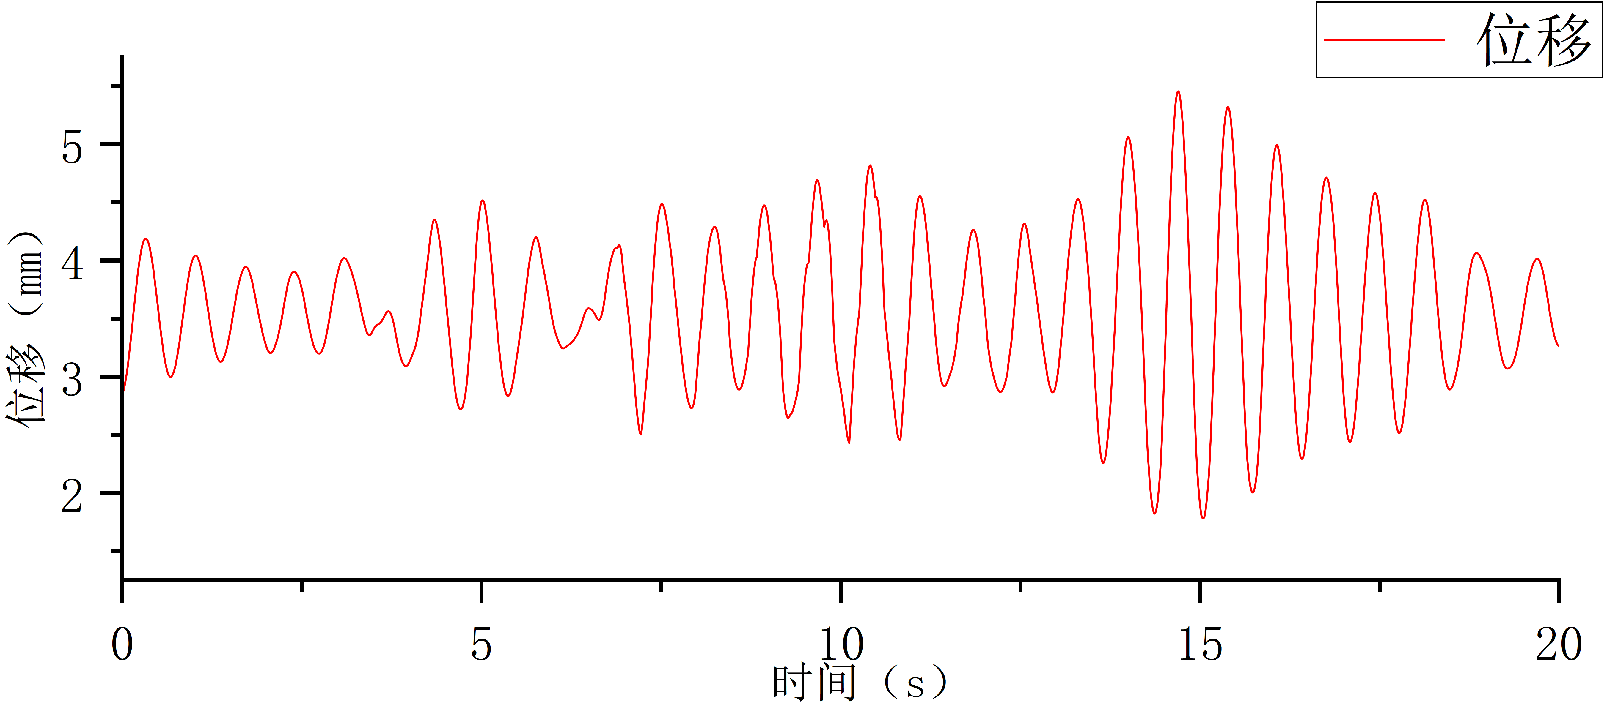
Fig. 6 Displacement Time History Curve of Pier Top After Vibration Reduction
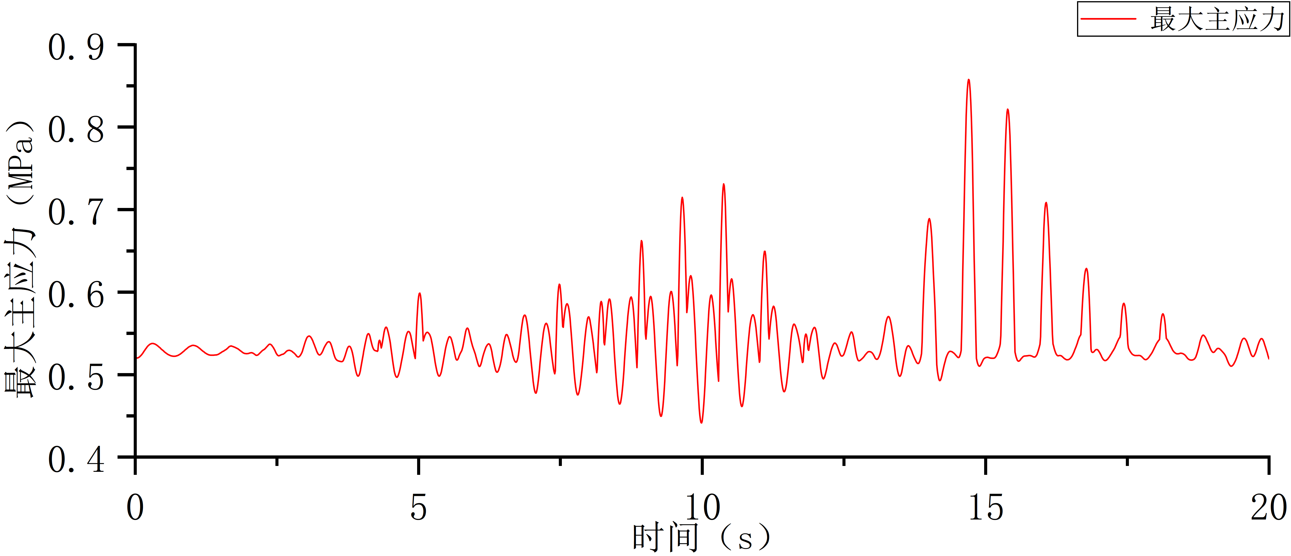
Fig. 7 Maximum Principal Stress Time History Curve of Sluice Pier After Vibration Reduction

Table 4 Comparison of Dynamic Response Peak Values of Sluice Pier Before and
After Vibration Reduction
Response Indicator | Without Vibration Reduction | With Vibration Reduction | Reduction Rate
Maximum displacement at gate top (mm) | 8.47 (5.07+3.40) | 5.45 (2.05+3.40) | 59.5%
Maximum tensile stress in gate pier (MPa) | 0.86 | 0.82 | 5.9%

From the analysis of the calculation results, it can be concluded that the arrangement of the TMD has a very significant effect on suppressing the dynamic displacement at the top of the gate pier, reducing it from 5.07 mm to 2.05 mm, a decrease of 59.0%. However, because the TMD is connected to the prestressed gate pier structure as an integrated unit, its impact on the maximum tensile stress of the structure is not significant, decreasing from 0.86 MPa to 0.82 MPa, a reduction of 5.9%. Nevertheless, as seen from the time-history diagrams, the overall tensile stress level of the structure has also decreased.
The reason is that during the design of the damper, the dominant mode frequency selected was the first-order frequency in the dry mode. Therefore, the lower the water level, the closer its first-order frequency is to 1.391 Hz, and the better the vibration reduction effect of the damper.
To obtain the spatial distribution pattern of the TMD's effectiveness under a sudden earthquake during non-flood earthquake conditions, the displacement time histories of nodes a to i within the first 20 seconds under this condition were also selected. The node distribution positions are the same as above, and the node displacement time-history diagram is shown in Figure 8.

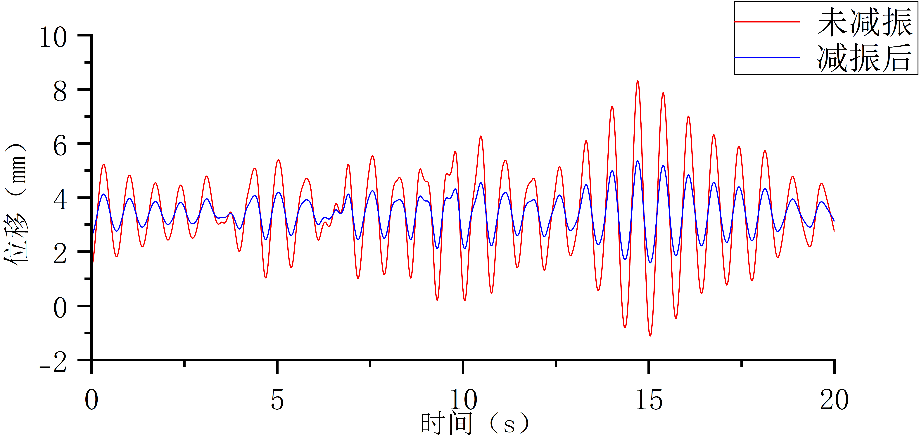 | 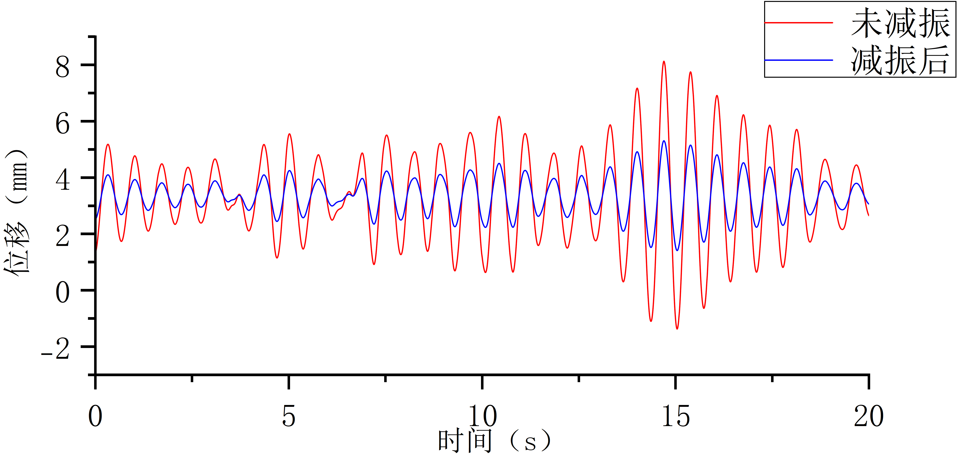
a | b
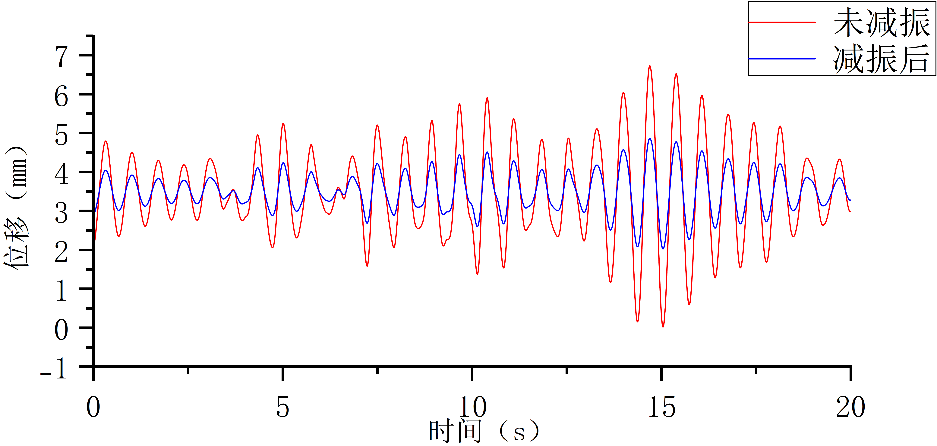 | 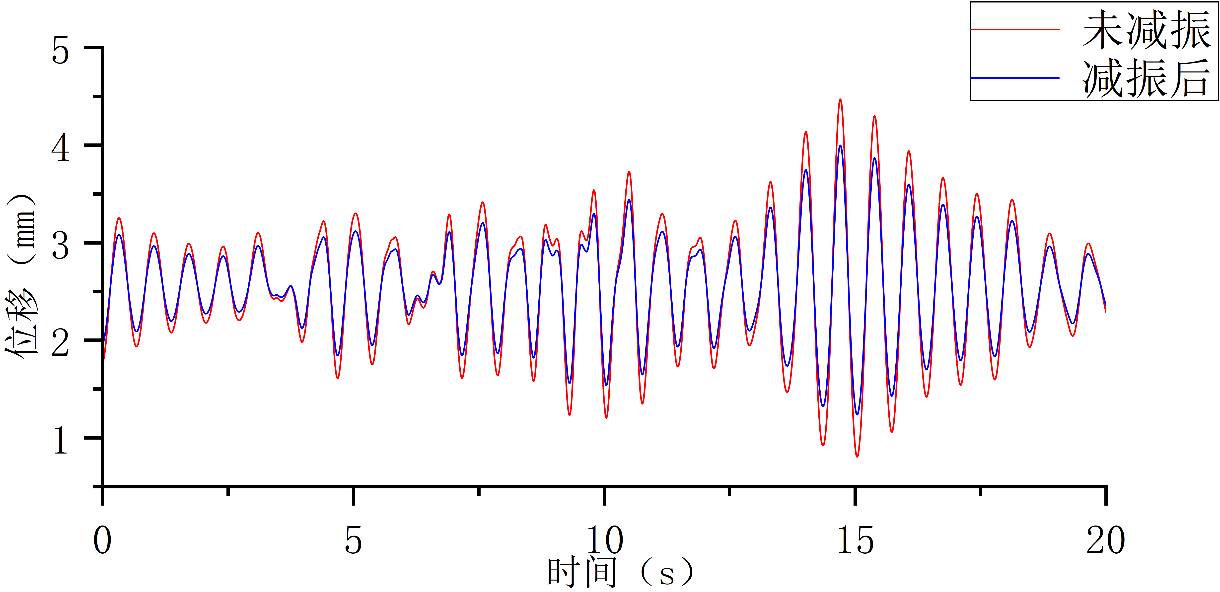
c | d
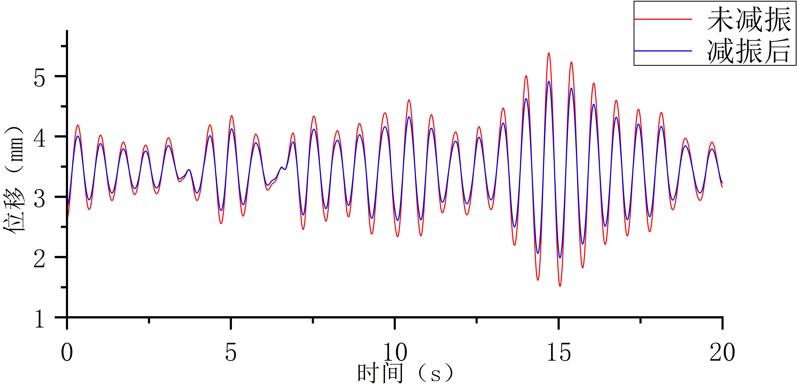 | 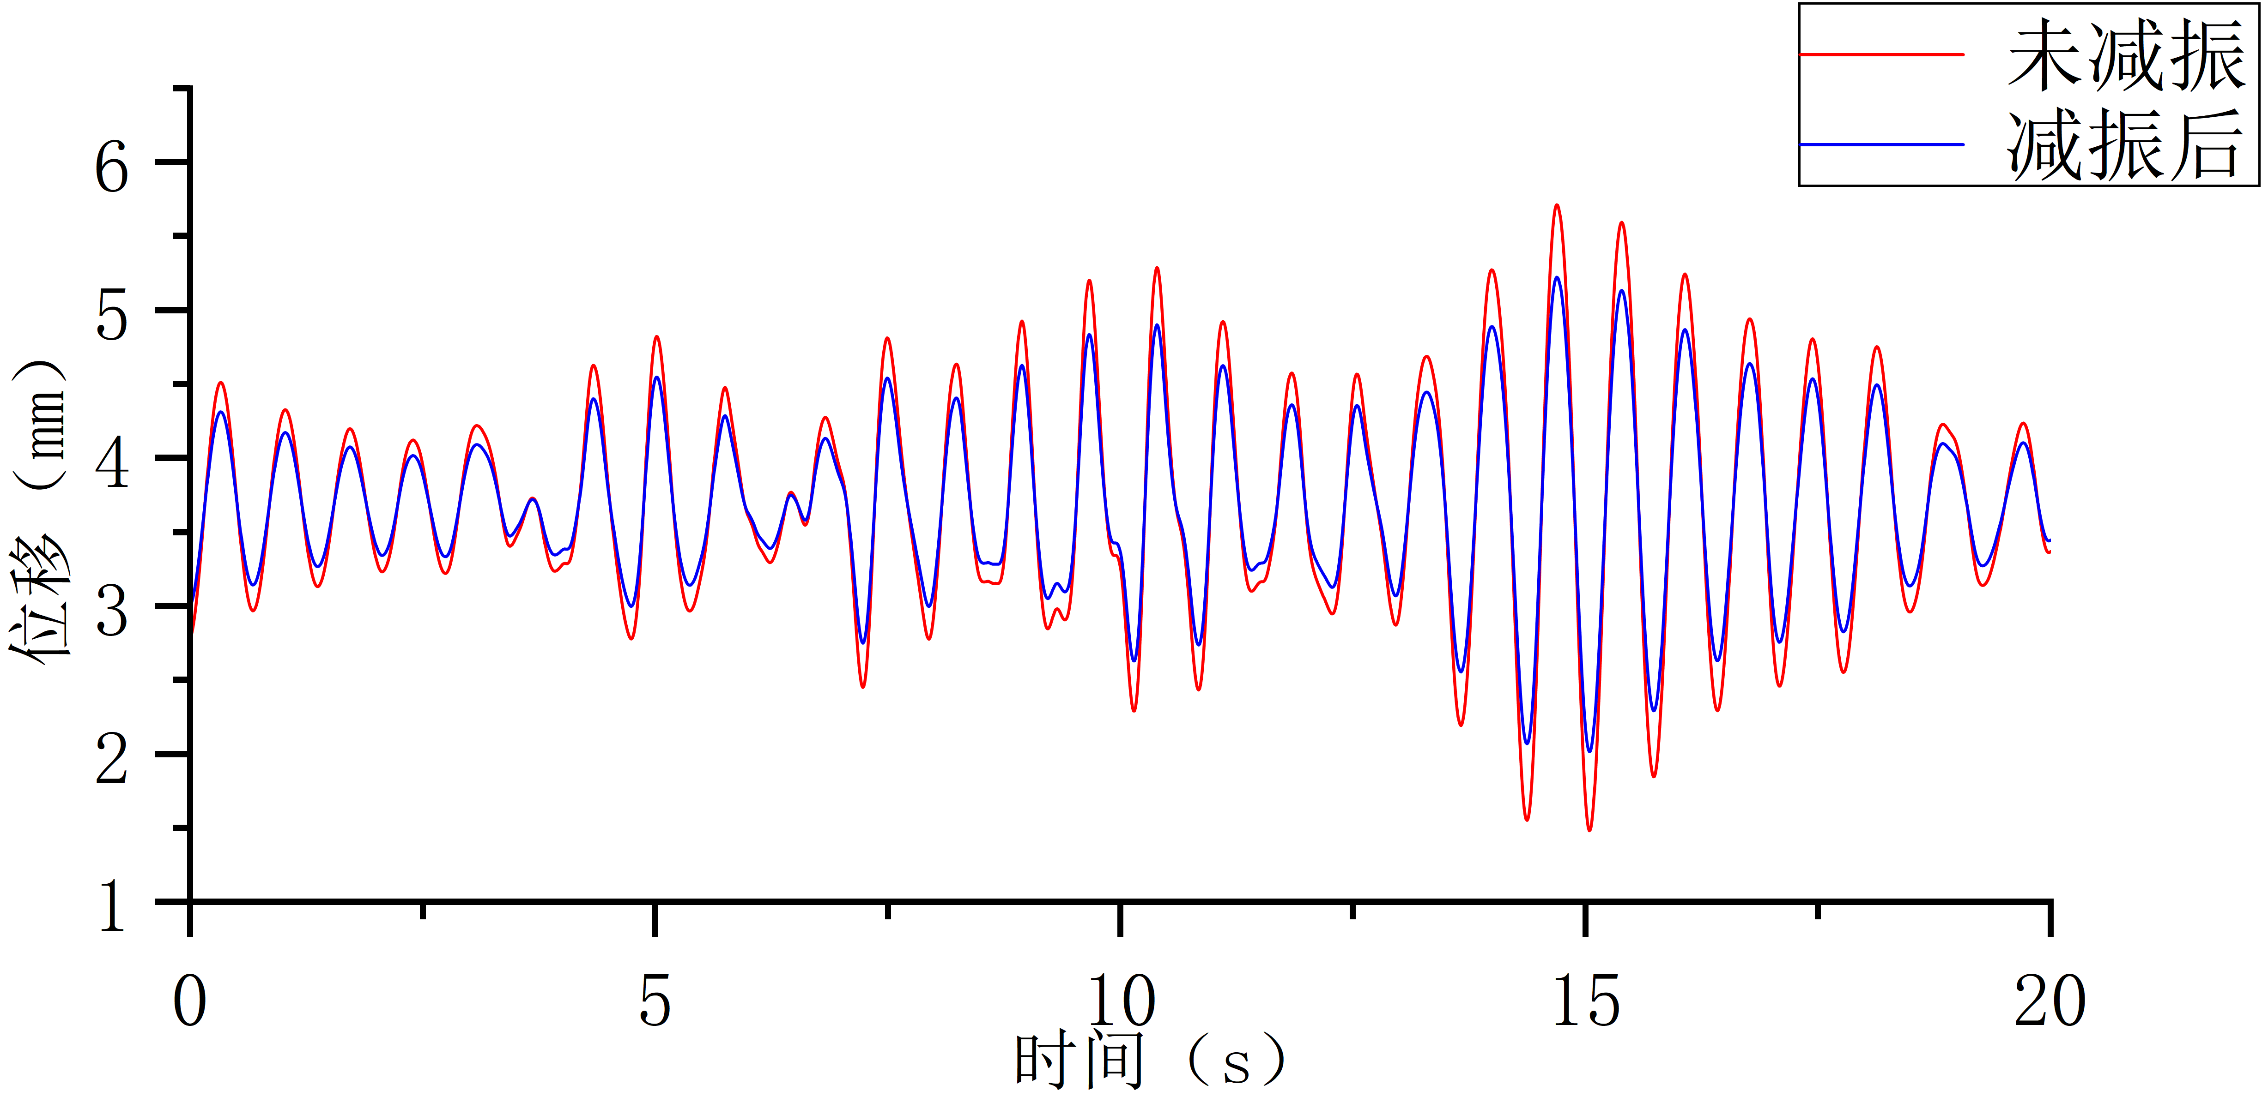
e | f
g | h
i
Fig. 8 Displacement time-history diagram of nodes a to i

Extract the maximum displacement of each node in Figure 8 before and after vibration reduction, calculate the vibration reduction rate for each node, and make a comparison. The comparison results are shown in Table 5.
Table 5 Comparison of vibration reduction rates for each node
Node | Maximum displacement before vibration reduction (mm) | Maximum displacement after vibration reduction (mm) | Vibration reduction rate
a | 8.32 | 5.37 | 60.1%
b | 8.13 | 5.31 | 59.2%
c | 6.73 | 4.87 | 58.2%
d | 4.47 | 4.00 | 25.0%
e | 5.39 | 4.91 | 24.8%
f | 5.71 | 5.22 | 24.5%
g | 1.63 | 1.60 | 8.3%
h | 1.65 | 1.63 | 8.3%
i | 1.66 | 1.65 | 8.1%

From Figure 8 and Table 5, it can be seen:
The vibration reduction rate of each node shows considerable variation with the spatial distribution of different nodes. The vibration reduction rates of nodes located at the same or similar horizontal levels are relatively close. For example, nodes a, b, and c at similar heights near the top of the gate pier have vibration reduction rates of 60.1%, 59.2%, and 58.2%, respectively, with a maximum relative difference of about 3.3%. Moreover, these rates are arranged from large to small in order of increasing horizontal distance from the damper. At the same time, at the same vertical line position, the vibration reduction rate shows a significant drop as the elevation decreases. For instance, for nodes a, d, and g on the same vertical line, the vibration reduction rates from top to bottom are 60.1%, 25.0%, and 8.4%, respectively, decreasing rapidly as the vertical distance from the damper increases, and the rate of decrease slows down with further distance. This rapid attenuation of the vibration reduction rate with decreasing elevation is highly consistent with the quadratic distribution pattern of the first-order mode displacement amplitude of the gate pier. This proves that the damper arrangement scheme can precisely act on the dominant mode of the structure and significantly suppress the displacement response of the main vibration mode, indicating that the vibration reduction design is also effective and well-matched to the normal earthquake condition of this gate pier.
Table 3 and Table 5 are compiled into Figure 9.

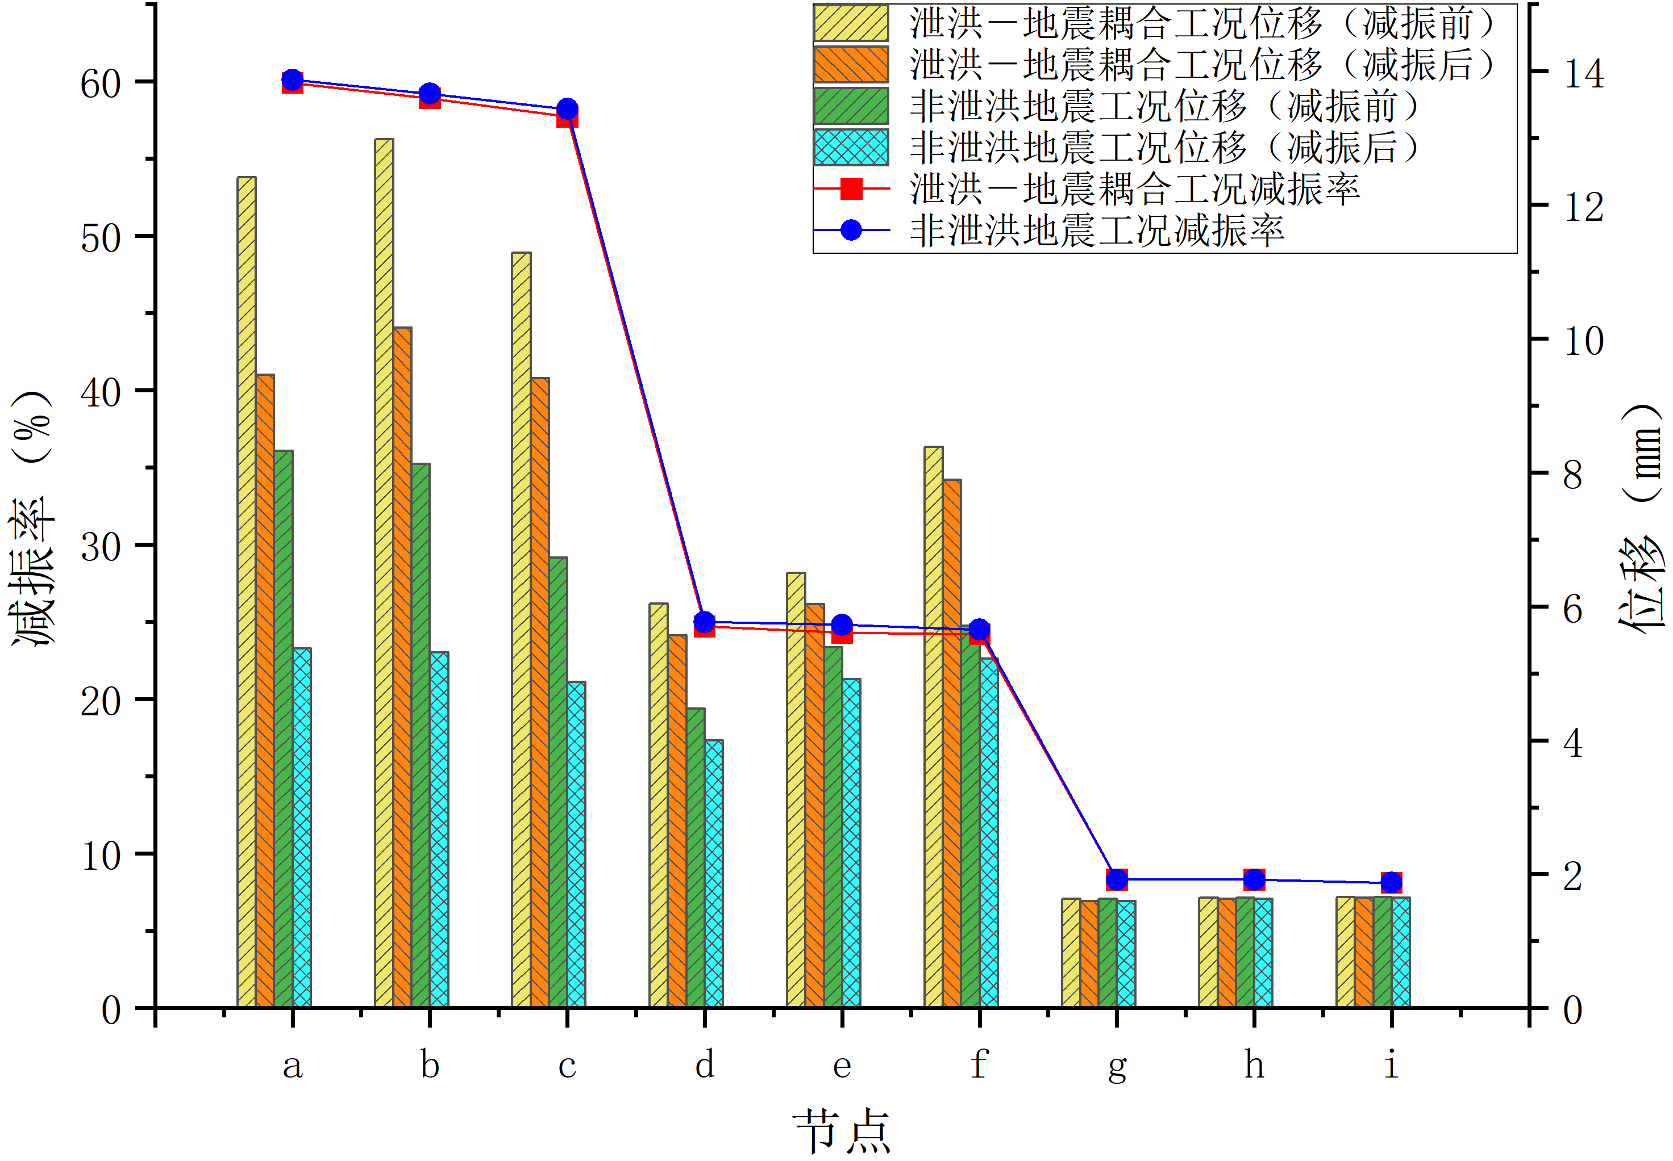
Fig. 9: Comparison of vibration reduction effect under two working conditions

From Figure 9, it can be seen:
The coupling effect of flood discharge and earthquake significantly amplifies the displacement response of the sluice structure, especially at key load-bearing nodes. Vibration reduction measures can effectively reduce the displacement amplitude, and the vibration reduction effect (absolute reduction magnitude) is more prominent for nodes under coupled conditions with high displacement responses. In engineering design, special attention should be paid to high-response nodes under flood-discharge-earthquake coupling conditions. By reasonably arranging vibration reduction devices (such as TMD), the risk of structural displacement exceeding limits can be effectively controlled, thereby improving the seismic safety of the sluice.
At the same time, because the dominant mode frequency selected during the design of the damper is the first-order frequency in the dry mode, the lower the water level, the closer its first-order frequency is to 1.391 Hz, and the better the vibration reduction effect of the damper. Therefore, the vibration reduction rates of each node under non-flood earthquake conditions are higher than those under flood-discharge-earthquake coupling conditions, indicating that the vibration reduction effect of the damper is more excellent under normal earthquake conditions.

4. Conclusion

(1) The damper has a significant control effect on the dynamic response of the gate pier. Under the most unfavorable condition (check flood – Taft wave), after using TMD for vibration reduction, the dynamic displacement at the gate top decreased from 4.81 mm to 2.08 mm, a reduction rate of 56.7%; the dynamic tensile stress in the gate pier decreased from 0.57 MPa to 0.53 MPa, a reduction rate of approximately 7.0%. Under the non-flood earthquake condition, the dynamic displacement at the gate top decreased from 5.07 mm to 2.05 mm, a reduction rate of 59.5%; the tensile stress decreased from 0.86 MPa to 0.82 MPa, a reduction rate of 5.9%. The suppression effect of TMD on displacement is much better than its control effect on stress.
(2) The spatial distribution pattern of the vibration reduction effect is obvious. The vibration reduction rate attenuates rapidly with decreasing elevation: the reduction rate at the top nodes of the gate pier (a, b, c) is about 58%–60%, that at the middle nodes (d, e, f) drops to 24%–25%, and that at the bottom nodes (g, h, i) is only about 8%. At the same horizontal level, nodes closer to the damper have a slightly better reduction effect. Moreover, the lower the water level (i.e., under non-flood earthquake conditions), the better the vibration reduction effect, which is related to the TMD design frequency being closer to the fundamental frequency of the structure in dry mode.
(3) Engineering recommendations: It is recommended to take the most unfavorable combination, and use the positive displacement envelope of 26.49 mm, the negative displacement envelope of 8.14 mm, the tensile stress envelope of 4.57 MPa, and the plastic strain envelope of 0.616 mm/m as the limit state check indicators. Methods such as arranging a Tuned Mass Damper (TMD) can be used to optimize the seismic performance of prestressed gate piers to better cope with extreme conditions such as sudden earthquakes during flood discharge in the flood season.
Reference
[1] Ministry of Environmental Protection of the People's Republic of China. 2017 Annual Report on the Prevention and Control of Environmental Pollution by Solid Waste in Large and Medium-Sized Cities[R]. Beijing: Ministry of Environmental Protection, 2017.
[2] Li Yadong, Xu Zheng, Fan Xingxiang, et al. Resource Treatment and Comprehensive Utilization of Metallurgical Solid Waste[J]. Chemical Engineering Design Communications, 2021, 47(9): 170-171.
[3] Sun Wanli. Research on Resource Comprehensive Disposal and Utilization Technology of General Industrial Solid Waste[J]. China Petroleum and Chemical Standards & Quality, 2024, 44(3): 178-180.
[4] Li Yancang, Chu Qingtao, Wang Yude, et al. Study on Preparation and Properties of Artificial Aggregate from Solidified Reservoir Sediment[J/OL]. China Rural Water and Hydropower, 1-17[2024-12-07].
[5] Zhang Bo. Deformation and Strength Analysis of Super-Tonnage Prestressed Pier[D]. Dalian: Dalian University of Technology, 2017.
[6] Zou S., Wenliuhan H.S., Liu Y.H., et al. Seismic Isolation Technology for Prestressed Segmental Precast Piers[J]. Structures, 2024, 68: 107105.
[7] Liang Jiahui. Seismic Safety Evaluation and Analysis of Drop Weir Sluice Chamber Structure Based on ADINA[J]. Water Conservancy Science and Technology and Economy, 2024, 30(11): 34-38.
[8] Yu X., Lai Y.P., Wang Y.K., et al. Study on the Seismic Wave Input Method for Earth-Rock Dam on Overburden Foundation with Dynamic Nonlinearity Based on Nonlinear Artificial Boundary[J]. Structures, 2024, 68: 107105.
[9] Zhang Xuelin, Zhu Shaokun, Chen Conghao. Dynamic Response Analysis of Water Intake Tower Under Seismic Action Based on ANSYS[J]. Journal of Yellow River Conservancy Technical Institute, 2024, 36(4): 29-34.
[10] Liu Ruijun, Hao Zhiyong, Zheng Xu, et al. The Application of an Improved Wet Mode Method in Fluid-Structure Interaction[J]. Journal of Vibration and Shock, 2017, 36(15): 134-139.
[11] Behroozi A.M., Vaghefi M. Application of Coupled RBFDQ-FEM as a Meshless Method for Time-Domain Analysis of Dam-Reservoir Systems Subjected to Earthquake Excitation[J]. Engineering Analysis with Boundary Elements, 2023, 152: 160-171.
[12] Ma Bin, Zhao Zhao, Hu Jianchao. Vibration Response Properties of Damage of High Roller Compacted Concrete Arch Dam[J]. Water Resources and Hydropower Engineering, 2018, 49(5): 114-119.
[13] Huang Y., Sturt R., Wilford M. A Damping Model for Nonlinear Dynamic Analysis Providing Uniform Damping over a Frequency Range[J]. Computers & Structures, 2019, 212: 101-109.
[14] Rosa F., Manzoni S., Casati R. Damping Behavior of 316L Lattice Structures Produced by Selective Laser Melting[J]. Materials & Design, 2018, 160: 1010-1018.
[15] Ma Y., Chen H. Dynamic Research of a Translational Bubble in a Strong Acoustic Field[J]. Applied Acoustics, 2019, 146: 76-80.
[16] Han S.J., Ishida T., Tsuchiya S. Multiscale Finite Element Analysis of Earthquake-Induced Damage on Underground RC Culverts: The Role of Reinforcing Bar Corrosion[J]. Engineering Structures, 2024, 303: 117432.
[17] Peramuna P.D.P.O., Neluwala N.G.P.B., Wijesundara K.K., et al. Novel Approach to the Derivation of Dam Breach Parameters in 2D Hydrodynamic Modeling of Earthquake Induced Dam Failures[J]. Science of the Total Environment, 2024, 927: 171505.
[18] Aissa-Berraies A., van Brummelen E.H., Auricchio F. Numerical Investigation of Fluid–Structure Interaction in a Pilot-Operated Microfluidic Valve[J]. Journal of Fluids and Structures, 2025, 132: 104226.
[19] Chen L., Min Y., Lu X.M., et al. Online Emergency Control to Suppress Frequency Oscillations Based on Damping Evaluation Using Dissipation Energy Flow[J]. International Journal of Electrical Power & Energy Systems, 2018, 103: 536-545.
[20] Du Y.Q., Wang J.T., Jin F., et al. A Rapid and Automated Analysis Procedure for Seismic Response of Arch Dams[J]. Advances in Engineering Software, 2024, 197: 103738.
[21] Zhang Kan. Study on Construction Technology and Structure Optimization of High-Efficiency Flood Control Gate[J]. Water Conservancy Science and Technology and Economy, 2023, 29(8): 31-37.

