Original Research Article
Dietary Supplementation with Chlorella vulgaris Confers Protection against Streptococcus agalactiae in Nile Tilapia: An NMR-Based Metabolomics Approach

ABSTRACT
Background: Disease outbreaks, particularly those caused by Streptococcus agalactiae, represent a significant challenge in Nile tilapia (Oreochromis niloticus) aquaculture. While Chlorella vulgaris is recognized as a promising immunostimulant due to its rich nutrient profile, the molecular mechanisms underlying its protective effects during a live bacterial challenge require further elucidation.
Objective: This study aimed to evaluate the efficacy of a prophylactic diet incorporated with C. vulgaris in enhancing the survival of Nile tilapia challenged with Streptococcus agalactiae and to characterize the associated metabolic signatures using an NMR-based metabolomics approach.
Methodology: Juvenile Nile tilapia were fed a commercial diet supplemented with 125 mg/kg body weight of C. vulgaris biomass for 21 days. Each group of fish receiving treatment and the control group consist of six (6) fish and replicated three (3) times and one-way ANOVA was used for statistical analysis. Following the feeding period, the fish were subjected to a bacterial challenge via the immersion method using a 1x10⁸ CFU/mL concentration of S. agalactiae (exceeding the calculated LC₅₀ of 9x10⁷ CFU/mL). Spleen samples were collected on day 29 for ¹H NMR spectroscopy and multivariate data analysis (MVDA), including PCA and OPLS-DA, to identify differentiating biomarkers between control and treated groups. Data were expressed as Mean ± Standard Error of the Mean (SEM). Survival rates were analyzed using the Kaplan-Meier method and compared via the Log-Rank test. For metabolomics data, normalized spectral intensities were subjected to one-way ANOVA followed by Tukey's HSD post-hoc test (q < 0.05). MVDA models (PCA and OPLS-DA) were validated using 7-fold cross-validation (Q²) and a 100-fold permutation test. All univariate statistical analyses were performed using Software, SPSS Version 17.0 (SPSS Inc., Chicago, IL, USA), and multivariate modeling was conducted using Software, SIMCA Umetrics 14.1 (Sartorius Stedim Biotech, Sweden) and an online database, MetaboAnalyst 6.0.
Results: The C. vulgaris treatment significantly improved survival rates, with the treated challenged group (CVC) exhibiting a 90% survival rate compared to only 13.3% in the control challenged group (CFC). Metabolomics analysis identified 21 metabolites in the spleen, with significant up-regulation of key biomarkers in C. vulgaris-fed fish, including palmitic acid (11.55-fold), riboflavin (6.51-fold), arginine (2.62-fold), and alanine (2.12-fold). Conversely, S. agalactiae challenge in control fish led to a severe down-regulation of essential metabolites, most notably linoleic acid (33.28-fold reduction) and stearic acid (18.46-fold reduction). This drastic metabolic depletion was effectively mitigated in fish previously fed with C. vulgaris, where metabolite levels remained stable despite the bacterial challenge.
Conclusion: Prophylactic supplementation with C. vulgaris at 125 mg/kg bw effectively primes the innate immune system of Nile tilapia, providing robust protection against S. agalactiae infection. The sustained levels of vital amino acids and fatty acids in treated fish suggest that C. vulgaris maintains metabolic homeostasis and immune cell viability, offering a sustainable alternative to traditional disease management in aquaculture.
Keywords: Chlorella vulgaris; Streptococcus agalactiae; Nile tilapia; NMR-based metabolomics; Prophylactic treatment; Innate immunity.

1.0 INTRODUCTION
Microalgae are increasingly recognised as innovative and promising food ingredients due to their rich nutritional composition, which includes high-value proteins, polyunsaturated fatty acids, carotenoids, vitamins, minerals, chlorophylls, phenolic compounds, and a wide range of other bioactive constituents (Batista et al., 2017; Pantami et al., 2020). In the previous years some researches focused on innovative and healthy food products integrated with micro algal biomass such as pasta, biscuits and vegetarian dessert (Batista et al., 2012). High value microalgae species produce an array of different classes of compounds that contribute to improvement of immunity in living organisms. In this regard, economic affordability and pharmacological potentials of microalgae-derived drugs, have gain prominent and current research interest worldwide especially in tropical countries due to suitability of culturing conditions. Metabolomics as a science field that characterizes endogenous and exogenous low molecular mass metabolites within various samples, is also applicable in studies involving cells, tissues, and bio fluids of an organism in response to external stimuli such as diseases, contaminants, nutritional imbalance and immune stimulants (Lankadurai et al., 2013). Metabolomics approach can generate comprehensive data sets of the sample being analyzed. This is simply because the metabolites within a cell, tissue, organ, biological fluid or the entire organism constitute the metabolome (Webb-robertson et al., 2005).
The principal bioactive constituents of C. vulgaris include pigments, fatty acids/lipids, amino acids, vitamins, and simple sugars. Among these, pigments are broadly categorised into three major groups: carotenoids, chlorophylls, and phycobilins. Carotenoids are widely distributed among various microalgal species, whereas chlorophylls are synthesised by both green microalgae and higher plants. In contrast, phycobilins are predominantly associated with cyanobacteria and certain species of red algae (Markou & Nerantzis, 2013). Carotenoid composition in the Chlorophyceae is like that of higher plants, and includes α-carotene, β-carotene, neoxanthin, lutein, violaxanthin, antheraxanthin and zeaxanthin, integrated in chloroplast and generally considered as primary carotenoids (Gouveia et al., 1996). Chlorella spp. are found to be high in lutein and chlorophylls a, b, composition amounting to about 0.45% and 4.5% dry weight respectively, which make them suitable for commercial production of pigments (Kim, 2015). In addition to primary carotenoids; C. vulgaris biomass also accumulates a high level of secondary carotenoids (Gupta et al., 2007).
It has been demonstrated that the level of microalgal supplementation in fish diets constitutes a major determinant of its effects on fish performance. Several studies have reported reductions in fish growth and overall performance at elevated inclusion levels of C. vulgaris (Enyidi, 2017). Nevertheless, the underlying mechanisms responsible for the decline in growth performance at higher C. vulgaris inclusion levels remain unclear. Previous investigations have indicated that beneficial effects on growth performance, fillet quality, physiological functions, disease resistance, and related attributes are generally achieved only when microalgae are incorporated at relatively low dietary levels (below 12.5%) (Valente et al., 2006; Dallaire et al., 2007). A similar trend has also been observed with respect to gut microbiota modulation (Norambuena et al., 2015). In practical aquaculture applications, and largely for economic considerations, microalgae are typically included in fish feeds at low concentrations (2.5–10%) to optimise positive effects on fish health and nutritional performance (Norambuena et al., 2015).

Streptococcus agalactiae is a pathogenic bacterium that infects tilapia and causes streptococcosis across all developmental stages, from larvae to adulthood, often resulting in high mortality rates (Sukenda & Rahman, 2018; Ahmadifar et al., 2021). No developmental stage of tilapia is entirely exempt from susceptibility to infection by this virulent pathogen. However, mortality is particularly pronounced in younger fish, whose immune systems are not yet fully developed. At these early growth stages, tilapia possess limited immunological competence and are therefore less capable of mounting effective immune responses against pathogenic challenges (Magnadottir et al., 2005; Elshopakey & El-Gohary, 2021). The physical symptoms associated with S. agalactiae infection include the lack of appetite, slow or no movement at the bottom of the tank, appearance of whitish mucus on the skin, gills and eyes (corneal opacity) of tilapia fish.
Incorporation of immunostimulants such as microalgal biomass into fish feed is one of the recent developments in mitigating disease outbreak in fish (Ahmad et al., 2018; Abdel-Latif et al., 2022). Nevertheless, the available scientific evidence in using microalgae as immunostimulants depends largely on reports of conducted immune assays (Dawood, 2021). Most of the knowledge of the mechanisms involved with the actual immunogenesis at molecular level is still largely undiscovered. Metabolomics studies of endogenous biomarkers involved in immune enhancement, together with pathway analysis, hold significant promise for advancing future research in understanding and regulating the mechanisms involved in immunogenesis leading to mitigating disease outbreak.
In previous research, it was evidently proven that C. vulgaris incorporation into fish feed enhances innate immunity of tilapia fish via regulation of some biochemical pathways (Pantami et al., 2023; Lulijwa et al., 2020). But that was not enough to justify that the immunity boosted as a result of C. vulgaris feeding was responsible in preventing the treated fish from massive death unless a real bacterial challenge is carried out. Streptococcus agalactiae, a considerably strong virulent bacteria, is one of the major concern of possible infections in most of tilapia fish culture farms (Zamri-Saad et al., 2010; Amal et al., 2018; Hoseinifar et al., 2020). And hence it was used in bacterial challenge in this study.
In this research, we also considered a pressing issue which may arise from the concept of the overall studies. This issues arises from the queries; whether the innate immune boost in fish will be sustained when C. vulgaris incorporated diet feeding is terminated, and the experimental fish are challenged with bacteria. This has to do with trying to see the actual effect of bacterial challenge on the experimental fish, evaluation of the metabolite fold changes as a result of C. vulgaris feeding in fish, the effect of environment on the fish with respect to zero day-point and lastly, the effect of bacterial challenge on C. vulgaris fed fish. These were achieved via the metabolomics multivariate data analysis (MVDA) of the resulting spleen samples from 0 day-point fish, bacterial challenged fish, control fish and treated fish groups. Hence the specific aim of this study was to confirm the immune signatures of C. vulgaris in tilapia fish assessed in previous studies via prophylaxis and bacterial challenge studies.
NMR-based metabolomics have some advantages in analysis of bio fluids such as blood serum and plasma, especially in researches involving disease diagnostics. It is a nondestructive method and there is no physical contact between the sample and the sensor. NMR data interpretation may be simpler compared to MS but mostly require additional information by running two-dimensional spectra such as heteronuclear single quantum correlation (HSQC), heteronuclear multiple bond correlation (HMBC), correlation spectroscopy (COSY), J-resolved etc. especially when dealing with complex samples. This is because more details about mixture composition are necessary for comparison with databases. The resulting data from NMR can always be simply interpreted directly when compared to the analysis done by MS on the same sample. The main steps in NMR-based metabolomics are sample storage, sample preparation (Smolinska et al., 2012; Beckonert et al., 2007; Bernini et al., 2011), data acquisition and processing of spectra (Izquierdo-garcía et al., 2011; Euceda et al., 2015), multivariate statistical data analysis (Worley & Powers, 2015), search for key-metabolites by metabolic profiling and finally identification of potential biomarkers.

2.0 MATERIALS AND METHODS

2.1 Instruments
700 MHz Bruker Ascend Nuclear Magnetic Resonance Spectrometer (NMR) with cryo-probe (Bruker Inc., Billerica, Massachusetts, USA) for spleen analysis, Chenomx NMR Suite (Chenomx Inc., Edmonton, Canada), MestRenova (version 6.02-5475 Mestrelab Research, Santiago de Compostella, Spain) for NMR data processing, SIMCA Umetrics 14.1 (Sartorius Stedim Biotech, Sweden) for MVA.

2.2 Chemicals
MS2, Methanol, Deuterated water, Phosphate buffer, Sodium azide (NaN₃), Trimethylsilyl propanoic acid (TSP).

2.3 Fish acclimatization
One hundred and ten juvenile Nile tilapia Oreochromis niloticus (O. niloticus) with an average weight of 60 ± 0.5 g (mean ± SE) were obtained from Taman Pertanian Universiti (TPU), Universiti Putra Malaysia. The fish were acclimatized in glass aquaria (80 x 40 x 30 cm) for 2 weeks and fed a 1% body weight (bw) commercial diet daily before the initiation of the experiment. The water temperature was kept at 25-28 °C, while pH and dissolved oxygen were maintained at 6.9-7.3 and 9-12 mg/L, respectively (Gilcreas, 1966).

2.4 Bacterial challenge LC₅₀
The bacteria used for challenge test was Streptococcus agalactiae (S. agalactiae) and its concentration used was assessed by first determining the 50% lethal concentration (LC₅₀) via immersion method.

2.5 Bacterial strain
The pathogenic strain of S. agalactiae SAK2 was obtained from a previous study conducted by Kahieshesfandiari et al. (2019). The bacterium was subcultured on blood agar (Oxoid, Basingstoke, Hampshire, UK), and a single pure colony was subsequently inoculated into 1.5% (w/v) tryptone soya broth (TSB; HiMedia, Mumbai, India). The culture was incubated overnight at 37 °C in a shaking incubator. Bacterial cells were then harvested by centrifugation at 10,000 rpm for 10 min. The resulting pellet was resuspended in 1.5% TSB supplemented with 18% glycerol to prepare stock cultures, which were stored at −20 °C until further use. Prior to the commencement of the experiment, the identity of the isolates was confirmed through biochemical characterisation using the API Rapid ID Strep32 system and 16S rRNA gene sequencing, following the manufacturer’s instructions.

2.6 Preparation of live bacteria inoculums and preparation of its different concentrations for challenge
Streptococcus agalactiae was sub cultured in blood agar and incubated at 37 °C for 24 h, before sub culturing further in brain heart infusion broth (BHIB) at the same temperature for the next 18 h with gentle shaking. To activate the virulence of the bacteria, about 3 mL of broth was passed into the tilapia by intraperitoneal inoculation. Streptococcus agalactiae was then isolated from the eye, brain and kidney of the dead tilapia within 24 h. The identity of the isolates were confirmed by biochemical tests and inoculated into 100 mL of BHIB until the logarithmic phase. Subsequently, a tenfold serial dilution and colony counting technique were performed to determine the bacterial concentration. Briefly, 1 mL of S. agalactiae broth was added into 9 mL of peptone water with a series of highest dilution (101) to the lowest (109). Again, blood agar was used to spread 0.1 mL of each dilution before incubation at 37 °C for 24 h. Colonies between 25 and 250 were counted before the concentration was expressed as colony-forming unit per millilitre (CFU/mL) (Kahieshesfandiari et al., 2019). The different concentrations of the bacteria; 10⁵, 10⁶, 10⁷ and 10⁸ CFU/mL was prepared by referencing to MacFarland standard of the same concentration and used for the bacterial challenge via immersion method. The choice of immersion method of bacterial challenge over intraperitoneal injection was due to consideration that in practical fish contract diseases via contact with water.
The LC₅₀ was conducted using the varying bacterial concentrations ranging from 1x10⁵–1x10⁸ CFU/mL and each test was performed with 10 fish group in 3 replicates and a control (also 10 fish). The plot of bacterial concentrations against the corresponding mortality was generated and the linear equation of the plot was used to calculate the LC₅₀.

2.7 Prophylactic treatment and bacterial challenge
For the prophylactic treatment with C. vulgaris incorporated diet and the bacterial challenge with S. agalactiae, all experimental fish were grouped according to overall schematic diagram shown in Figure 1. In addition, for statistical MVDA to be valid, each group consist of six (6) fish and replicated three (3) times and then a randomized sampling was exercised in selecting representative fish for analysis from each group.
To evaluate the effect of environment on the experimental fish, 6 fish were sacrificed at zero-day (0D) point, and their spleen was sampled for NMR and MVDA for correlation with control fish at the end of prophylactic experiment and also for correlation with bacterial challenged fish which was carried out via immersion method. The control fish were further categorized into 2 groups, the control fish (CF) and the control fish challenged (CFC). CF was fed with commercial diet and was not challenged with bacteria while CFC was fed with commercial diet and challenged with bacteria after feeding duration. Similarly, the C. vulgaris fed fish were also categorized into C. vulgaris (CV) fish group and C. vulgaris challenged (CVC) fish group. The categorization was to understand the effect of variable experimental factors such as the C. vulgaris feeding, bacterial challenge and environment as mentioned earlier. CV was fed with commercial diet incorporated with 125 mg/kg bw C. vulgaris biomass as this concentration proved to be more efficient from previous study (Pantami et al., 2023) while CVC was fed with commercial diet incorporated with 125 mg/kg bw C. vulgaris biomass and subsequently challenged with bacteria after the feeding duration of 21 days. Chlorella vulgaris concentration of 125 mg/kg bw was used in this research by referring to the findings of recent researches on C. vulgaris which suggests its incorporation into diet at lower concentrations, probably due to its hard cell wall which makes it difficult to digestion (Ahmad et al., 2018).
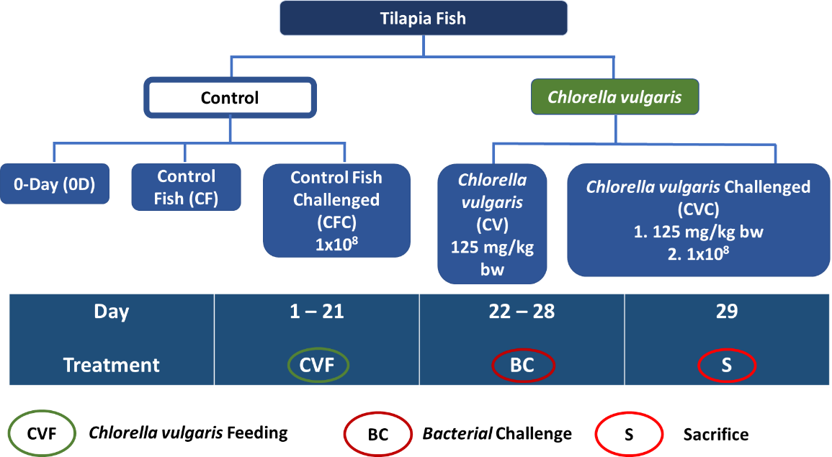
Figure 1 : Overall schematic diagram of the methodology showing fish groupings, C. vulgaris treatment concentration, bacterial challenge, and sacrifice day.

The prophylactic experiment was conducted according to the illustration in Figure 1. Feeding control fish groups with commercial diet and treatment groups with C. vulgaris lasted for 21 days and preceded with bacterial challenge with S. agalatiae concentration of 1x10⁸ CFU/mL (> LC₅₀). Mortality was observed on the 22nd–28th days and all experimental fish were sacrificed on the 29th day (Figure 1) and samples were taken for metabolomics studies.

2.8 Spleen preparation for NMR analysis
Spleen (10 mg) was added a 250 µL 0.2 M Na₂HPO₄, 0.175 M NaH₂PO₄, 0.25% TSP and 0.75 mM NaN₃ in D₂O (pH 7.4), homogenized, vortexed for 1 min, centrifuged at 1800 rpm and the supernatant was dispensed into 3 mm NMR tubes for analysis. All spleen samples were made into six replicates from biological replicates and ran with 700 MHz Bruker Ascend NMR spectrometer (Bruker Inc., Billerica, Massachusetts, USA) for multivariate analysis. In addition, 2D NMR; (J-resolved), ¹H-Hetero-nuclear Single Quantum Coherence (HSQC) and Hetero-nuclear Multiple Bond Coherence (HMBC) were performed on representative sample from each group and was used for metabolite detection and identification.

2.9 ¹H NMR spectra processing and multivariate analysis
The ¹H NMR spectra of all replicate samples were binned to ASCII files using Chenomx software (version 6.2, Edmonton, Alberta, Canada). The spectral region 0.50 to 14.00 ppm was bucketed into integrated regions with spectral width of δ 0.04. The residual signals for water, chloroform and methanol in the ranges 4.68 - 4.88 ppm, 3.29 - 3.32 ppm and 7.50 - 7.60 ppm respectively, were excluded from the analysis. The standardized bucketed data were then pareto-scaled (Par) and subjected to principal component analysis (PCA) and partial least square discriminant analysis (PLS-DA) using SIMCA-P+ software (version 12.0.1.0, Umetrics AB, Umea, Sweden). The 2D NMR spectra was viewed using MestRenova (version 6.02-5475, Mestrelab Research, Santiago de Compostella, Spain).
In general, the variable importance of projection (VIP) plots in this research suggests the most contributing metabolites responsible for the separation of comparable samples within an OPLS-DA model: metabolites with VIP ≥ 1 were considered the most contributors for the separation of groups by PC1 and or PC2 in a given OPLS-DA model. The detected metabolites were sorted out with reference to compounds which were reported to contribute to immune improvements (Gray et al., 2015; Everts, 2018; Alqarni et al., 2019; Marcinkiewicz & Kontny, 2014; De Oliveira et al., 2016; Lin et al., 2013; Van Zanten et al., 2015; Bettina et al., 1999; Mazur-Bialy et al., 2015; Branco et al., 2018; Owens et al., 2011; Tucey et al., 2018).

3.0 RESULTS AND DISCUSSION

3.1 LC₅₀
The symptoms observed with S. agalactiae infected fish include lack of appetite, movement at the bottom of the tank, appearance of whitish mucus on the skin, gills, and eyes (corneal opacity) (Fazio, 2022). In addition, many of the affected tilapias were observed to show red discoloration of the internal organs along with acute inflammations as shown in Figure 2.
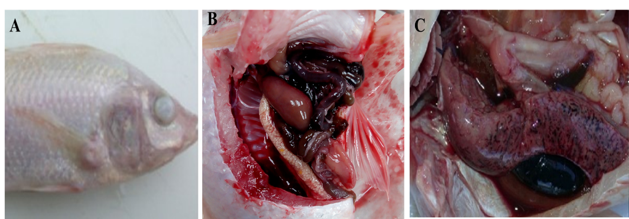
Figure 2 : Tilapia infected by S. agalactiae showing: A; corneal opacity, B; darkening of internal organs and C; swelling of spleen and liver

The following Figure 3 shows the plot of bacterial concentrations against observed mortality from bacterial challenged test. The linear equation was used to calculate the S. agalactiae concentration responsible for 50% mortality of the experimental fish from 3 replicates of each concentration, LC₅₀. The calculated LC₅₀ = 9x10⁷ CFU/mL.
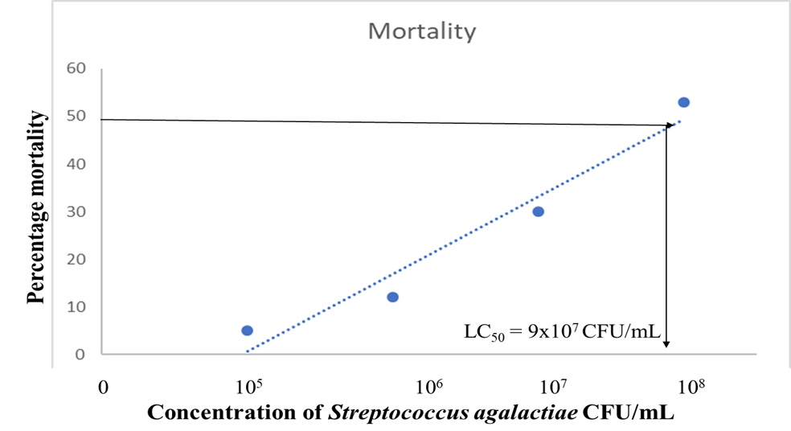
Figure 3 : Plot of bacterial concentration and mortality for determination of LC₅₀

3.2 Bacterial challenge mortality and survival rate
The mortality results after 7 days of bacteria challenge test with S. agalactiae concentration of 1x10⁸ CFU/mL (> LC₅₀) via immersion method from 3 replicates of each fish group was summarized in Table 1.
Table 1 : Percentage mortality from bacterial challenge test

Fish group | Replicate | Number of dead fish (%)
Control Fish  Challenged  (CFC) | R1 = 10 | 10
Control Fish  Challenged  (CFC) | R2 = 10 | 10
Control Fish  Challenged  (CFC) | R3 = 10 | 6
% Mortality | 30 | 86.7%
C. vulgaris  Challenged  (CVC) | R1 = 10 | 3
C. vulgaris  Challenged  (CVC) | R2 = 10 | 0
C. vulgaris  Challenged  (CVC) | R3 = 10 | 0
% Mortality | 30 | 10%
Control  Fish  (CF) | R1 = 10  R2 = 10  R3 = 10 | 0  0  0
% Mortality | 30 | 0%

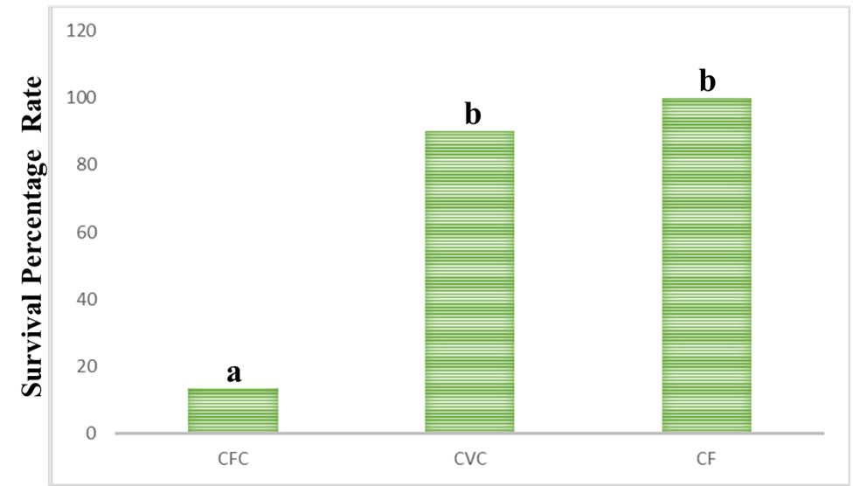
Figure 4 : Survival percentage rate of challenged experimental fish with S. agalactiae concentration of 10⁸ CFU/mL (p≤0.005)

The bacterial challenge test results showed 90% survival rate with respect to challenged fish which were previously fed with C. vulgaris (CVC). The result suggested no significant difference with that of control fish which was without bacterial challenge (CF). The results also showed only 13.3% survival rate of control fish challenged (CFC) (Figure 4). This indicate high immune improvements in treated fish as a result of feeding with C. vulgaris incorporated diet. The control fish without been challenged (CF) showed 100% survival rate.

3.3 Identification of metabolites from spleen samples
Analysis of spleen samples using ¹H NMR spectroscopy was carried out to study the possible metabolic variation related to immune improvement signals. The metabolites detected in spleen samples were identified based on the ¹H NMR spectra of both control and microalgae fed fish spleen, collected through the experimental period. In total, 21 metabolites were successfully identified. The metabolites were assigned by referring to Chenomx software database (Version 8.3, Alberta, Canada), the human metabolome database (HMDB) (http://www.hmdb.ca/) (Wishart et al., 2007), Nuclear Magnetic Resonance database (NMRDB) (http://www.nmrdb.org/), PubChem (https://pubchem.ncbi.nlm.nih.gov/) and literature data. Table 2 shows the identified metabolites and their corresponding chemical shifts.
Table 2 : Identified metabolites from spleen samples of experimental fish and their corresponding 700 MHz ¹H NMR chemical shifts

S/No. | Metabolites | Chemical shifts (ppm)
1 | Linoleic acid | δ 0.86(t)  δ 1.26(m)  δ 2.30(t)  δ 5.35(m)
2 | Riboflavin | δ 0.91(t)  δ 1.65(m)  δ 1.68(m)  δ 2.30(t)  δ 2.34(s)  δ 4.33(d)  δ 4.47(d)
3 | Proline | δ 4.14(m)  δ 4.22(s)
4 | Glucose | δ 5.22(s)  δ 4.62(s)  δ 3.82(m)  δ 3.46(m)  δ 3.23(d)
5 | Glycolate | δ 3.92(s)
6 | Isoleucine | δ 0.84(t)  δ 3.43(d)
7 | Choline | δ 4.00(m)  δ 3.50(dd)  δ 3.20(s)
8 | Glycine | δ 3.60(s)
9 | Leucine | δ 1.51(m)  δ 3.44(t)
10 | Taurine | δ 3.42(t)  δ 3.25(t)
11 | Histamine | δ 8.0(s)  δ 7.9(s)  δ 7.1(s)  δ 3.3(t)  δ 3.0(m)
12 | Methionine | δ 3.85(dd)  δ 2.63(t)  δ 2.15(m)
13 | Creatine | δ 3.9(s)  δ 3.0(s)
14 | Glutamic acid | δ 3.74(t)  δ 2.22(dd)  δ 2.04(m)
15 | Arginine | δ 3.76(d)  δ 3.23(t)  δ 1.93(t)  δ 1.76(m)
16 | Alanine | δ 1.5(d)  δ 3.8(m)
17 | Valine | δ 3.6(d)  δ 12.3(m)  δ 1.0(d)
18 | Stearic acid | δ 0.86(t)  δ 1.24(m)  δ 1.25(m)  δ 1.55(m)  δ 2.30(t)
19 | Linolenic acid | δ 1.25(m)  δ 1.26(m)  δ 2.30(t)  δ 5.30(m)  δ 5.34(m)
20 | Oleic acid | δ 0.86(t)  δ 1.24(m)  δ 1.25(m)  δ 1.26(m)  δ 2.30(t)  δ 5.33(m)
21 | Palmitic acid | δ 0.86(t)  δ 1.24(m)  δ 1.25(m)  δ 1.55(m)  δ 2.30(t)

3.4 Effect of environment on the experimental fish
In order to rule out the possibility of environmental factors that might have affected observations during the experiment with fish, a set of randomly selected 6 fish were sacrificed at zero-day (0D) point and was sampled for NMR analysis before the beginning of the experiment. The results of NMR analysis from these fish spleen (0D) were then compared with that of control fish (CF) at the end of the experiment. Figure 5 shows the PCA score plot of the zero-day fish (0D) and the control fish (CF). The model gives a total fitness, R2X of 0.92 and predictability, Q2 of 0.501.
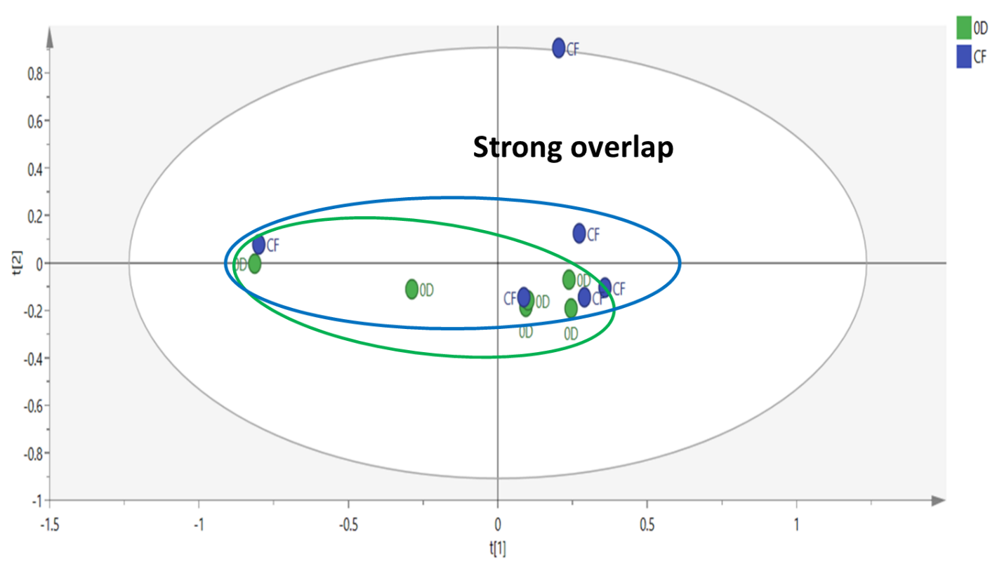
Figure 5 : PCA score plot of the zero-day fish (0-D) and the control fish (CF) showing no effect of environment on the experimental fish.

From the PCA score plot, it can be observed that the fish from 0D and CF groups were clustered together near the origin without obvious separation between them. This indicates that there was no difference in the metabolome of fish at the beginning and at the end of the experiment regardless of group (Figure 5). Hence, there was no effect of environment on the overall experimental fish and none has affected the results generated at the end of the experiment (all experimental fish were not affected by the environment throughout the experiment).

3.5 Effect of Chlorella vulgaris on experimental fish
It was previously established that modulation of some biochemical pathways as a result of C. vulgaris feeding led to immune improvements in tilapia (Pantami et al., 2023). In the present experiment, it was designed to show the detected metabolite fold changes as a result of incorporating a single concentration of 125 mg/kg bw into fish feed fed for 3 weeks in a prophylactic experiment. The MVDA was conducted with reference to the identified VIP metabolites because they have high hits and impact factors in the relevant analysed pathways (Pantami et al., 2023).

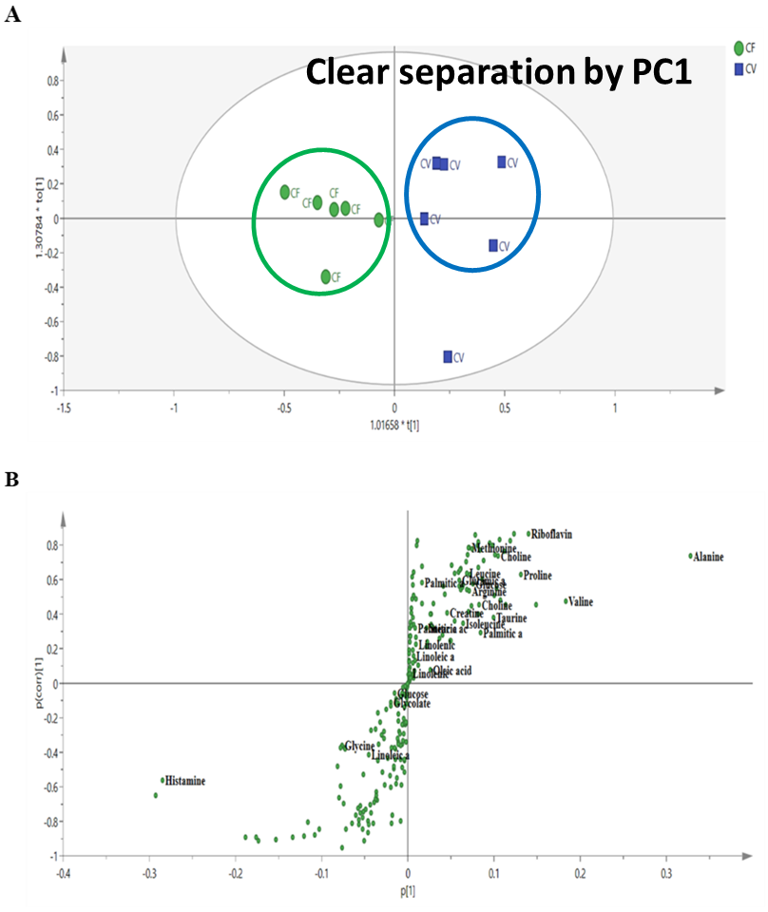
Figure 6 : OPLS-DA score plot (A) and S-plot (B) of C. vulgaris (CV) fish and the control fish (CF) showing their variability by PC1 and up regulated/down regulated metabolites.

Figure 6 shows the OPLS-DA score plot (A) and S-plot (B) of C. vulgaris (CV) fed fish and the control fish (CF). The model exhibited a high fitness, R2X of 0.839 and predictability, Q2 of 0.784 in which the PC1 explained a total variance of 40.1% and PC2 16.7%. The biomarkers for immune improvements in tilapia fish as a result of C. vulgaris feeding was identified based on the chemical shift data of the standard compounds available in the Chenomx library. The supervised orthogonal projection to latent structure discriminant analysis (OPLS-DA) was applied to reveal the clear separation about the significant metabolites associated with CV and CF (Figure 6A, 6B). There was an obvious separation between CV and CF by PC1. This result provides the suggested metabolites that were significantly affected by the treatment. The S-plot is the covariance and correlation loading diagnostics of the OPLS-DA model, which provides an overview of the affecting variables on the model by filtering the important metabolites in the projection. The significantly increased metabolites by the treatment are found in the upper-right quadrant of the S-plot which have the positive correlation and covariance as shown in Figure 6B. These are the suggested biomarkers of immune improvements in tilapia as a result of C. vulgaris feeding and they include alanine, riboflavin, methionine, choline, proline, valine, leucine, glutamic acid palmitic acid, arginine, creatine, taurine, isoleucine, linolenic acid and oleic acid. However, the very few decreased metabolites as a result of the same treatment are found in the lower-left quadrant of the same S-plot.
The CV and CF fish are well separated into 2 clusters by PC 1, which explained maximum metabolite variability. The importance of the metabolites resulting from the separation of these two groups are suggested by the variable importance of projection (VIP) analysis of the OPLS-DA model (Table 3). Metabolites with VIP ≥ 1 were considered the most contributors for separation of the groups by PC1. The detected VIP metabolites were also used in the determination of metabolite’s fold changes.
Table 3 : OPLS-DA VIP analysis showing metabolites with VIP ≥ 1 resulting from the separation of CV and CF by PC1

S.No. | Metabolites | Chemical shifts (ppm) | VIP values
1 | Histamine | δ 7.90(s) | 4.7
2 | Alanine | δ 3.89(m) | 4.3
3 | Valine | δ 3.60(d) | 2.6
4 | Oleic acid | δ 2.30(t) | 2.1
5 | Choline | δ 3.5(dd) | 2.0
6 | Palmitic acid | δ 0.86(t) | 1.9
7 | Riboflavin | δ 1.65(m) | 1.8
8 | Glycine | δ 3.60(s) | 1.8
9 | Proline | δ 4.14(m) | 1.7
10 | Glucose | δ 5.22(s) | 1.4
11 | Taurine | δ 3.42(t) | 1.3
12 | Isoleucine | δ 3.43(d) | 1.2
13 | Arginine | δ 3.76(d) | 1.2
14 | Leucine | δ 3.44(t) | 1.2
15 | Creatine | δ 3.90(s) | 1.1
16 | Methionine | δ 2.63(t) | 1.1
17 | Glutamic acid | δ 2.04(m) | 1.0
18 | Linoleic acid | δ 2.30(t) | 1.0

Metabolite fold change is a measure describing how many times the quantity of a metabolite is changed between an original and a subsequent measurement with respect to the associated treatment. It is defined as a ratio between the two quantities; for example, the fold change of CV with respect to CF is CV/CF.

Metabolite fold change (FC) of the VIP metabolites in the present research, was assessed using MetaboAnalyst 4.0 online tools for metabolomics data. The fold change (CV/CF) was found to be significantly high in four of the subjected metabolites. Table 4 show the NMR signal assignment for major biomarkers of immune improvement by C. vulgaris with the highest FC, their fold change values and the associated metabolic pathways on day 28 after 21 days of 125 mg/kg bw treatment. These compounds were palmitic acid, riboflavin, arginine and alanine with palmitic acid having the highest FC of more than 11 times in CV fish population as compared to CF.
Table 4 : Metabolite fold changes as a result of C. vulgaris feeding (CV/CF)

Metabolite | Chemical shift (ppm) | Fold change  (CV/CF) | Metabolic pathway
Palmitic acid | δ 0.74 | 11.554 | Linoleic acid metabolism
Riboflavin | δ 4.58 | 6.5142 | Riboflavin metabolism
Arginine | δ 1.58 | 2.6196 | Arginine and proline metabolism
Alanine | δ 1.34 | 2.1184 | Alanine, aspartate and glutamate metabolism

The high values of the FCs (CV/CF) in the metabolites in Table 4 suggests that the 3 weeks treatment with C. vulgaris indicated high significant improvement in the up regulation of important metabolites which were known to improve innate immunity in fish; Intra cellular levels of many amino acids were reported to significantly enhanced, indicative of increased biosynthesis required for T-cells growth and proliferation (Everts, 2018; Wei et al., 2024). In addition, intracellular pools of fatty acids like palmitic acid, are also elevated, presumably acting as a pool to generate cell membranes suitable for immune cells proliferation (Everts, 2018; Sheikhzadeh et al., 2023). Thus, the levels of alanine, arginine and palmitic acid in this research, were noticed to greatly increase in the treated groups as compared to the control fish population. In addition, most member compounds from Krebs cycle (TCA cycle) especially the amino acids, their abundance is critically involved in inflammatory processes and immune responses of the cells (Alqarni et al., 2019).

3.6 Effect of Streptococcus agalactiae bacteria on the experimental fish
To evaluate the effect of the bacterial challenge on the experimental fish using MVA, spleen samples from control fish (CF) was plotted against spleen samples from control fish challenged (CFC) in an OPLS-DA score plot model. Figure 7A shows that there was clear obvious separation between CF and CFC as suggested by PC1, with great class discriminant statistical values of R2X and Q2 of 0.819 and 0.734 respectively, in which the PC1 explained a total variance of 27.4% and PC2 25.8%.
The most significant metabolites responsible for the variation of these two groups are shown in the S-plot of the OPLS-DA model (Figure 7B).
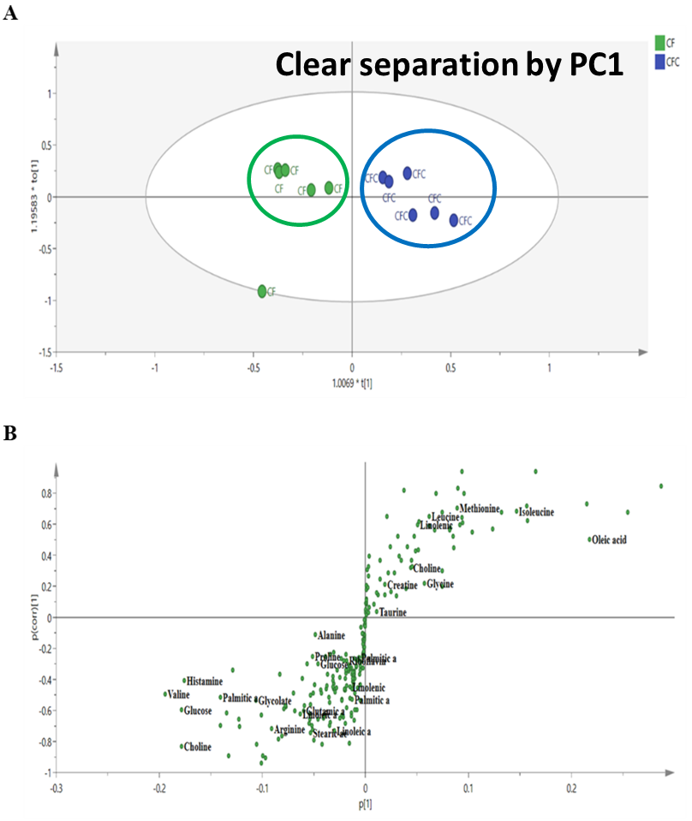
Figure 7 : A; OPLS-DA score plot of control fish challenged (CFC) and the control fish (CF) showing their variability by PC1, B; OPLS-DA S-plot showing metabolites which are greatly affected by the bacterial challenge and which contributed for the separation of CFC and CF by PC1 and suggested up regulated/down regulated metabolites..

It can be deduced from figure 7B that most distinguishing metabolites between CF and CFC are found in the lower left quadrant of the S-plot. This indicate that most of the important distinguishing metabolites were significantly decreased as a result of bacterial challenge on the experimental fish. This can be viewed as a negative effect of bacterial challenge on experimental tilapia fish.
The metabolites which made the criteria for VIP due to bacterial challenge on the experimental fish in decreasing order of VIP values include oleic acid, histamine, valine, glucose, choline, alanine, palmitic acid, isoleucine, taurine, glycine, glycolate, proline, arginine, methionine, linoleic acid, glutamic acid, leucine, stearic acid, linolenic acid, creatine and riboflavin. These VIP metabolites which play the most important role in discriminating CFC from CF were also subjected to metabolite fold change assessment to investigate their regulation as a result of bacterial challenge. The metabolite fold change as a result of bacterial challenge in control fish (CF/CFC) was found to be significantly high with five of the VIP metabolites. Table 5 shows the NMR signal assignment for major biomarkers of bacterial challenge by S. agalactiae with the highest FC, their fold change values and the associated metabolic pathways on day 28 after 7 days of bacterial challenge with concentration of 1x10⁸ CFU/mL S. agalactiae. These compounds are linoleic acid, stearic acid, arginine, palmitic acid and linolenic acid with a highest down regulation in linoleic acid level of more than 33 times in CFC due to the bacterial challenge as compared to CF (Table 5).
Table 5 : Metabolite fold changes as a result of S. agalactiae challenge on control fish

Metabolite | Chemical shift (ppm) | Fold change  (CF/CFC) | Metabolic pathway
Linoleic acid | δ 0.78 | 33.275 | Linoleic acid metabolism
Stearic acid | δ 1.14 | 18.457 | Linoleic acid metabolism
Arginine | δ 1.58 | 3.2914 | Arginine and proline metabolism
Palmitic acid | δ 0.90 | 2.7551 | Amino acid metabolism
Linolenic acid | δ 1.10 | 2.0481 | α-Linolenic acid  metabolism

The high fold change values (CF/CFC) in Table 5 which represent extreme down regulation of the corresponding metabolites in control fish as a result of bacterial challenge is an indication of severe negative effects of S. agalactiae bacteria on the control fish. This effect was seen to be negligible on fish previously fed with C. vulgaris prior to bacterial challenge as discussed below.

3.7 Effect of Streptococcus agalactiae bacteria on Chlorella vulgaris fed fish
Challenging the immunity of C. vulgaris fed fish with the bacteria S. agalactiae gives an insight to whether the improved innate immunity was sustained and prevent the occurrence of bacterial infection. This was achieved via the assessment of metabolites fold changes in the bacterial challenged C. vulgaris fed fish (CVC) as compared to C. vulgaris (CV) fed fish without bacterial challenge. An OPLS-DA score plot of CV and CVC shows that there are maximum variations between the two groups suggested by their separation by PC1 (Figure 8A). Figure 8A shows the variation between CV and CVC in an OPLS-DA score plot and Figure 8B shows the regulated metabolites responsible for their separation by PC1 in an S-plot. The model exhibited a high fitness, R2X of 0.709 and predictability, Q2 of 0.835 in which the PC1 explained a total variance of 35.7% and PC2 35.1%.
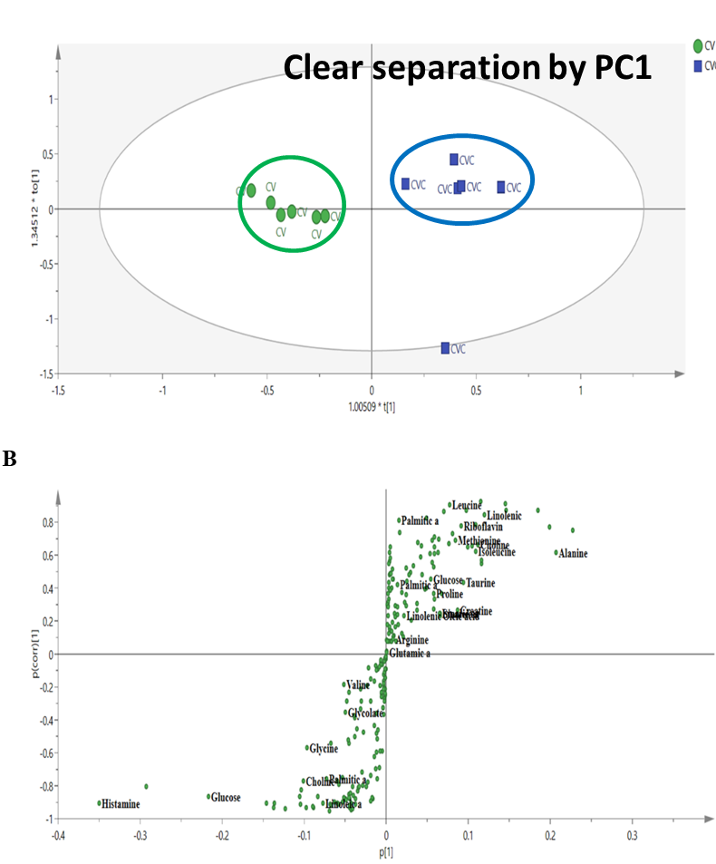
Figure 8 : A; OPLS-DA score plot of C. vulgaris (CV) fed fish and the C. vulgaris challenged fish (CVC) showing their variability by PC1, B; OPLS-DA S-plot showing regulated metabolites which contributed for the separation of CV and CVC by PC1 and suggested up regulated/down regulated metabolites..

From Figure 8B, it is obvious that most of the metabolites that were altered as a result of bacterial challenge on fish initially fed with C. vulgaris, are in the upper-right quadrant of the S-plot with few in the lower-left quadrant. The result suggests that most of the discriminating metabolites were up regulated after 7 days of bacterial challenge, indicating the possibility of mild negative effect of bacterial challenge on the experimental fish which were initially fed with C. vulgaris (CVC). This suggestion was further verified via the assessment of metabolite regulation by bacterial challenge via VIP metabolite fold changes. The metabolites that made the VIP criteria in this regard in decreasing VIP values include histamine, alanine, glucose, creatine, linoleic acid, stearic acid, valine, choline, isoleucine, linolenic acid, oleic acid, glycine, methionine, taurine, riboflavin, leucine, palmitic acid, glycolate, proline, arginine and glutamic acid. This findings were in line with previously published results (Wang et al., 2020).
The metabolites fold changes as a result of bacterial challenge on fish previously fed with C. vulgaris (CV/CVC) was found to be significantly lower in this case as compared to the FC noticed as a result of bacterial challenge on fish which was not initially fed with C. vulgaris (CF/CFC). Table 6 shows the NMR signal assignment for major biomarkers of bacterial challenge by S. agalactiae, their fold change values and the associated metabolic pathways on day 28 after 7 days of bacterial challenge having concentration of 1x10⁸ CFU/mL over C. vulgaris fed fish. These compounds are linolenic acid, stearic acid, linoleic acid, palmitic acid, creatine, linoleic acid, riboflavin, taurine and alanine. This findings were in line with previously published results (Wang et al., 2020). The FC as a result of bacterial challenge on C. vulgaris fed fish (CV/CVC) did not amount to a whole unit or whole number in all the affected metabolites.
Table 6 : Metabolite fold changes as a result of S. agalactiae challenge on C. vulgaris fed fish

Metabolite | Chemical shift (ppm) | Fold Change  (CV/CVC) | Metabolic pathway
Linolenic acid | δ 1.1 | 0.045015 | α-Linolenic acid metabolism
Stearic acid | δ 1.14 | 0.046743 | Linoleic acid metabolism
Linoleic acid | δ 0.74 | 0.048606 | Linoleic acid metabolism
Palmitic acid | δ 0.90 | 0.057401 | Amino acid metabolism
Creatine | δ 3.1 | 0.093333 | Glycine, serine & Threonine metabolism
Riboflavin | δ 4.58 | 0.28154 | Riboflavin metabolism
Taurine | δ 3.3 | 0.43943 | Taurine & hypotaurine metabolism
Alanine | δ 1.34 | 0.46334 | Alanine, aspartate and glutamate metabolism

The FCs in Table 6 which represent the effect of bacterial challenge on fish initially fed with C. vulgaris didn’t amount to whole numbers. This is a clear indication that there was a mild negative effect of bacterial challenge on fish initially fed with C. vulgaris before been challenged with S. agalactiae. The deficiency of some selected vitamins like riboflavin (vitamin B₂), could affect the induction of proper innate as well as adaptive immune responses. As a result of riboflavin deficiency, typical symptoms called oro-oculo-genital syndrome are observed. In lymphoproliferation LPS-stimulation model, riboflavin deprived cells were reported to release significantly fewer anti-inflammatory agents. While reduction of the release of proinflammatory factors as well as enhancement of anti-inflammatory mediators were both recorded with riboflavin enriched model (Mazur-Bialy et al., 2015). It was observed in this study that the level of riboflavin was not seriously down regulated due to bacterial challenge on fish initially fed with C. vulgaris. High level of taurine present in leucocytes, may hypothesise that taurine deficiency will affect the immune cell functions. In fact, prolonged taurine deficiency leads to profound abnormalities in the immune system including significant leukopenia; a decreased respiratory burst in neutrophils and depletion of B cells from lymph nodes and spleen (Marcinkiewicz & Kontny, 2014; Wang et al., 2020; Sheikhzadeh et al., 2023). In addition to the above information, it was also reported that taurine upregulation is responsible for the smooth antioxidant activity, osmoregulation, membrane stability and maintenance of Ca²⁺ stability. Hence, the non-down regulation of taurine level in CVC treated group is an indication of maintained innate immunity.
The common affected metabolites (in terms of down regulation) as a result of bacterial challenge with 1x10⁸ CFU/mL concentration of S. agalactiae on both control fish challenged (CFC) and C. vulgaris challenged (CVC) fish were summarized in Table 7 to show the mild negative bacterial effect on fish fed with C. vulgaris as compared to fish without treatment
Table 7 : Comparison between metabolite fold changes as a result of bacteria S. agalactiae challenge on control fish (CFC) and on C. vulgaris fed fish (CVC)

Metabolite | Fold change  (CF/CFC) | Fold change  (CV/CVC)
Linoleic acid | 33.275 | 0.048606
Stearic acid | 18.457 | 0.046743
Palmitic acid | 2.7551 | 0.057401
Linolenic acid | 2.0481 | 0.045015

There is a huge difference between the two FCs compared, indicating there was no effect of bacterial challenge on the immune improvements induced by C. vulgaris incorporation into fish diet as compared with fish which did not received the micro algal treatment (Table 7).

3.8 MVDA Models validation
The goodness of fit and predictability of a MVDA model are determined by calculating the R2 and Q2 which stands for fitness and predictability respectively (Verpoorte et al., 2007). Generally, R2 determines how well the training data set are statistically reproducible and when R2 intercept is less than 0.4 and Q2 intercept is less than -0.05 along Y-axis, the model is said to exhibit good fitness and predictability. The above MVDA models in this studies fulfil the requirements for both R2 and Q2 suggesting that the models meet the criteria for the validation and prediction performance. The permutation tests with 100 permutations and external validation indicated that the models were valid (Figure 9).
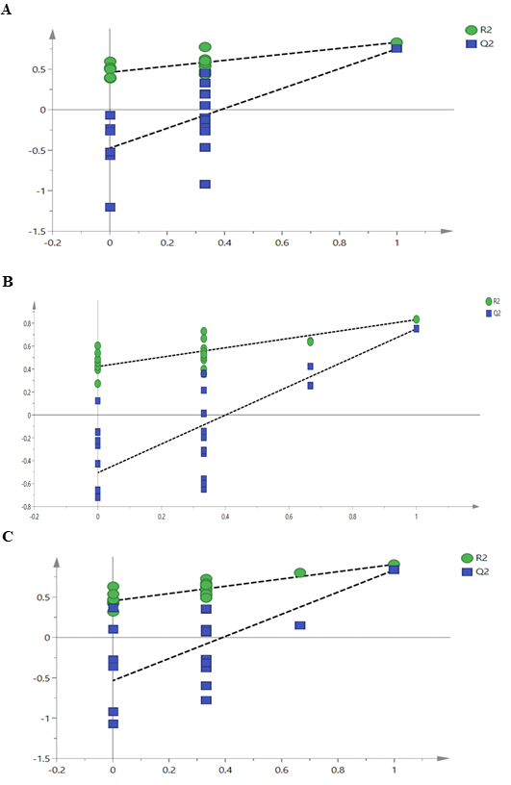
Figure 9 : The PLS-DA; CV and CF (a) OPLS-DA; CF and CFC (b) OPLS-DA; CV and CVC (c) models validation with 100 permutations for prophylaxis study analysis.

4.0 CONCLUSION
The research findings shows that there was a mild negative effect of S. agalactiae bacteria on the fish pre-fed with C. vulgaris in terms of metabolite down regulation. This substantiate the findings and provide basis that immune improvement provided by C. vulgaris incorporation into fish feed for tilapia was sustained even when the fish was challenged with a virulent bacterium, S. agalactiae. In addition, the MVA findings agree with the results that showed 90% survival rate of fish fed with C. vulgaris in a bacterial challenge study. This maybe an indication why such high survival rate was obtained with fish population previously fed with C. vulgaris prior to bacterial challenge.
In conclusion, 125 mg/kg bw concentration of C. vulgaris incorporated into fish feed exerts potential immuno-modulatory effects in tilapia fish in 3 weeks which was sustained even after the fish was challenged with S. agalactiae. To the best of our knowledge, the present study was among the first attempts that proposed the application of ¹H NMR-based metabolomics approach to study animal metabolome in order to support bacterial challenge findings that ensured prophylactic experiments.

5.0 STUDY LIMITATIONS
“While this study demonstrates that prophylactic dietary supplementation with Chlorella vulgaris significantly improves survival and stabilizes vital metabolic signatures in Nile tilapia challenged with Streptococcus agalactiae, several limitations were acknowledged:
- Single Concentration and Duration Evaluation: This investigation evaluated only a single inclusion level of C. vulgaris (125 mg/kg body weight) over a fixed feeding duration of 21 days. Because microalgae supplementation outcomes are highly dependent on inclusion levels and higher concentrations have historically been linked to declines in fish growth performance, this study did not determine the absolute optimal dietary dosage or the long term metabolic impacts of extended feeding regimens. Although our previous studies included that aspect.
- Restricted Sample and Replicate Size: For the multivariate data analysis (MVDA) to be statistically viable, each experimental group was restricted to six (6) fish per group across three (3) replicates. While sufficient for robust NMR-based metabolomic profiling and standard variance clustering, a larger sample size would have yielded tighter statistical distributions and captured broader biological variance inherent within larger aquaculture populations.
- Organ Specific Analysis: Metabolic profiling in this study was confined strictly to spleen tissues. Although the spleen serves as a primary peripheral lymphoid organ crucial for capturing blood borne pathogens and driving systemic adaptive immunity in teleosts, it does not completely reflect the overall systemic response. Multi-tissue metabolomics incorporating other vital immune and metabolic organs such as the liver, head kidney, or blood plasma would provide a more comprehensive overview of systemic immunogenesis and metabolic homeostasis. Although some of our previously published articles involved some of those aspects.
- Analytical Constraints of ¹H NMR: The characterization of the fish metabolome relied on ¹H NMR spectroscopy. While NMR offers unique advantages, such as being nondestructive technique, highly reproducible, and straightforward for direct mixture quantification, it suffers from inherently lower sensitivity compared to Mass Spectrometry (MS). Consequently, lower-abundance signaling molecules, trace fatty acids, or subtle biochemical intermediates may have remained undetected beneath the baseline or behind complex chemical shift overlaps.
- Mechanistic Upstream Verification: Although NMR-based metabolomics successfully pinpointed 21 distinguishing biomarkers and key pathway fluxes like; palmitic acid, riboflavin, and amino acid regulations, these downstream metabolic endpoints were not matched against upstream molecular mechanisms. The study did not addressed parallel transcriptomic (gene expression) or proteomic validation to conclusively map out the precise cellular receptors and signaling cascades driving C. vulgaris-mediated immunostimulation”.
Ethical approval

All experiments were approved by the Universiti Putra Malaysia Institutional Animal Care and Use Committee (UPM/IACUC/AUP-R080/2018).

Disclaimer (Artificial intelligence)

Author(s) hereby declare that NO generative AI technologies such as Large Language Models (ChatGPT, COPILOT, etc.) and text-to-image generators have been used during the writing or editing of this manuscript.

REFERENCES
- Abdel-Latif, H. M. R., Yilmaz, S., Dawood, M. A. O., Ringø, E., & Ahmadifar, E. (2022). Microalgae-based feed ingredients as immunostimulants in aquaculture: A review. Aquaculture Reports, 22, 100964.
https://doi.org/10.1016/j.aqrep.2021.100964
- Ahmad, M. T., Shariff, M., Md. Yusoff, F., Goh, Y. M., & Banerjee, S. (2018). Applications of microalga Chlorella vulgaris in aquaculture. Reviews in Aquaculture, 1–19. https://doi.org/10.1111/raq.12320
- Ahmadifar, E., Dawood, M. A. O., Moghadam, M. S., Sheikhzadeh, N., Hoseinifar, S. H., & Musthafa, M. S. (2021). Modulation of immune parameters and disease resistance in fish via microalgae supplementation: A review. Fish & Shellfish Immunology, 111, 1–12.
https://doi.org/10.1016/j.fsi.2021.01.013
- Alqarni, A. M., Dissanayake, T., Nelson, D. J., Parkinson, J. A., Dufton, M. J., Ferro, V. A., & Watson, D. G. (2019). Metabolomic profiling of the immune stimulatory effect of eicosenoids on PMA-differentiated THP-1 cells. Vaccines, 7(4). https://doi.org/10.3390/vaccines7040142
- Amal, M. N. A., Koh, C. B., Nurliyana, M., Suhaiba, M., Nor-Amalina, Z., Santha, S., Diyana-Nadhirah, K. P., Yusof, M. T., Ina-Salwany, M. Y., & Zamri-Saad, M. (2018). A case of natural co-infection of Tilapia Lake Virus and Aeromonas veronii in a Malaysian red hybrid tilapia (Oreochromis niloticus × O. mossambicus) farm experiencing high mortality. Aquaculture, 485(July 2017), 12–16. https://doi.org/10.1016/j.aquaculture.2017.11.019
- Batista, A. P., Niccolai, A., Fradinho, P., Fragoso, S., Bursic, I., Rodolfi, L., Biondi, N., Tredici, M. R., Sousa, I., & Raymundo, A. (2017). Microalgae biomass as an alternative ingredient in cookies: Sensory, physical and chemical properties, antioxidant activity and in vitro digestibility. Algal Research, 26(June), 161–171. https://doi.org/10.1016/j.algal.2017.07.017
- Batista, A. P., Nunes, M. C., Fradinho, P., Gouveia, L., Sousa, I., Raymundo, A., & Franco, J. M. (2012). Novel foods with microalgal ingredients - Effect of gel setting conditions on the linear viscoelasticity of Spirulina and Haematococcus gels. Journal of Food Engineering, 110(2), 182–189. https://doi.org/10.1016/j.jfoodeng.2011.05.044
- Beckonert, O., Keun, H. C., Ebbels, T. M. D., Bundy, J., Holmes, E., Lindon, J. C., & Nicholson, J. K. (2007). Metabolic profiling, metabolomic and metabonomic procedures for NMR spectroscopy of urine, plasma, serum and tissue extracts. Nature Protocols, 2(11), 2692–2703. https://doi.org/10.1038/nprot.2007.376
- Bernini, P., Bertini, I., Luchinat, C., & Turano, P. (2011). Standard operating procedures for pre-analytical handling of blood and urine for metabolomic studies and biobanks. Journal of Biomolecular NMR, 49, 231–243. https://doi.org/10.1007/s10858-011-9489-1
- Bettina, M., Dennis, C. G., Herndon, D. N., & Wolfe, R. R. (1999). Accelerated Glutamine Synthesis in Critically [I] Patients Cannot Maintain Normal Intramuscular Free Glutamine Concentration. Journal of Parenteral and Enteral Nutrition, 23(5), 243–252.
- Branco, A. C. C. C., Yoshikawa, F. S. Y., Pietrobon, A. J., & Sato, M. N. (2018). Role of Histamine in Modulating the Immune Response and Inflammation. Mediators of Inflammation, 2018. https://doi.org/10.1155/2018/9524075
- Dallaire, V., Lessard, P., Vandenberg, G., & Noüe, J. De. (2007). E V ect of algal incorporation on growth , survival and carcass composition of rainbow trout ( Oncorhynchus mykiss ) fry. 98, 1433–1439. https://doi.org/10.1016/j.biortech.2006.05.043
- Dawood, M. A. O. (2021). Nutritional immunity of fish intestines: Important insights for sustainable aquaculture. Reviews in Aquaculture, 13(1), 642–663.
https://doi.org/10.1111/raq.12492
- de Oliveira, D. C., da Silva Lima, F., Sartori, T., Santos, A. C. A., Rogero, M. M., & Fock, R. A. (2016). Glutamine metabolism and its effects on immune response: molecular mechanism and gene expression. Nutrire, 41(1), 1–10. https://doi.org/10.1186/s41110-016-0016-8
- Elshopakey, G. E., & El-Gohary, M. S. (2021).
Protective role of dietary algae against bacterial infection in Nile tilapia (Oreochromis niloticus). Aquaculture International, 29, 1509–1525.
https://doi.org/10.1007/s10499-021-00692-8
- Enyidi, U. D. (2017). Chlorella vulgaris as Protein Source in the Diets of African Catfish Clarias gariepinus. Fishes, 2(17), 1–12. https://doi.org/10.3390/fishes2040017
- Euceda, L. R., Giskeødegård, G. F., & Bathen, T. F. (2015). Preprocessing of NMR metabolomics data. Scandinavian Journal of Clinical & Laboratory Investigation, 75, 193–203. https://doi.org/10.3109/00365513.2014.1003593
- Everts, B. (2018). Chapter 2 Metabolomics in Immunology Research. In Clinical Metabolomics: Methods and Protocols, Methods in Molecular Biology (Vol. 1730, Number Lc, pp. 29–42).
- Gilcreas, F. W. (1966). Standard methods for the examination of water and waste water. American Journal of Public Health and the Nation’s Health, 56(3), 387–388. https://doi.org/10.2105/AJPH.56.3.387
- Fazio, F. (2022). Fish hematology analysis as an important tool of aquaculture: A review. Aquaculture, 500, 734770.
https://doi.org/10.1016/j.aquaculture.2018.10.030
- Gouveia, L., Veloso, V., Reis, A., Fernandes, H., Novais, J., & Empis, J. (1996). Evolution of pigment composition in Chlorella vulgaris. Bioresource Technology, 57(2), 157–163. https://doi.org/10.1016/0960-8524(96)00058-2
- Gray, D. W., Welsh, M. D., Doherty, S., Mansoor, F., Chevallier, O. P., Elliott, C. T., & Mooney, M. H. (2015). Identification of systemic immune response markers through metabolomic profiling of plasma from calves given an intra-nasally delivered respiratory vaccine. Veterinary Research, 46(7), 1–16. https://doi.org/10.1186/s13567-014-0138-z
- Gupta, S. K., Jha, A. K., Pal, A. K., & Venkateshwarlu, G. (2007). Use of natural carotenoids for pigmentation in fishes. 6(1), 46–49.
- Izquierdo-garcía, J. L., Villa, P., Kyriazis, A., Puerto-nevado, L., Pérez-rial, S., Rodriguez, I., Hernandez, N., & Ruiz-cabello, J. (2011). Descriptive review of current NMR-based metabolomic data analysis packages. Progress in Nuclear Magnetic Resonance Spectroscopy, 59, 263–270. https://doi.org/10.1016/j.pnmrs.2011.02.001
- Hoseinifar, S. H., Sun, Y. Z., Wang, A., & Zhou, Z. (2020).
Probiotics as means of diseases control in aquaculture, a review of current knowledge and future perspectives. Frontiers in Microbiology, 11, 590046.
https://doi.org/10.3389/fmicb.2020.590046
- Kahieshesfandiari, M., Sabri, M. Y., Ina-salwany, M. Y., Hassan, M. D., Noraini, O., Ajadi, A. A., & Isiaku, A. I. (2019). Streptococcosis in Oreochromis sp.: is feed-based biofilm vaccine of Streptococcus agalactiae effective? Aquaculture International, 27, 817–832. https://doi.org/10.1007/s10499-019-00372-8
- Kim, S. (2015). Handbook of marine microalgae biotechnology advances (2015th ed.). Elsevier Academic Press.
- Lankadurai, B. P., Nagato, E. G., & Simpson, M. J. (2013). Environmental metabolomics : an emerging approach to study organism responses to environmental stressors. Environmental Review, 205(21), 180–205.
- Lin, J. J., Chung, X. J., Yang, C. Y., & Lau, H. L. (2013). A meta-analysis of trials using the intention to treat principle for glutamine supplementation in critically ill patients with burn. Burns, 39(4), 565–570. https://doi.org/10.1016/j.burns.2012.11.008
- Lulijwa, R., Rupia, E. J., & Alfaro, A. C. (2020).
Antibiotic use in aquaculture, policies and regulation, health and environmental risks: A review of the top 15 major producers. Reviews in Aquaculture, 12(2), 640–663.
https://doi.org/10.1111/raq.12344
- Magnadottir, B., Lange, S., Gudmundsdottir, S., Bøgwald, J., & Dalmo, R. A. (2005). Ontogeny of humoral immune parameters in fish. Fish and Shellfish Immunology, 19(5 SPEC. ISS.), 429–439. https://doi.org/10.1016/j.fsi.2005.03.010
- Marcinkiewicz, J., & Kontny, E. (2014). Taurine and inflammatory diseases. Amino Acids, 46(1), 7–20. https://doi.org/10.1007/s00726-012-1361-4
- Markou, G., & Nerantzis, E. (2013). Microalgae for high-value compounds and biofuels production : A review with focus on cultivation under stress conditions. Biotechnology Advances, 31(8), 1532–1542. https://doi.org/10.1016/j.biotechadv.2013.07.011
- Mazur-Bialy, A. I., Pochec, E., & Plytycz, B. (2015). Immunomodulatory effect of riboflavin deficiency and enrichment - Reversible pathological response versus silencing of inflammatory activation. Journal of Physiology and Pharmacology, 66(6), 793–802.
- Norambuena, F., Hermon, K., Skrzypczyk, V., Emery, J. A., Sharon, Y., Beard, A., & Turchini, G. M. (2015). Algae in Fish Feed : Performances and Fatty Acid Metabolism in Juvenile Atlantic Salmon. PLoS ONE, 10(4), 1–17. https://doi.org/10.1371/journal.pone.0124042
- Owens, G., Rao, C., & Traister, R. (2011). Regulation of the immune response and inflammation by histamine and histamine receptors. Journal of Allergy and Clinical Immunology, 128(6), 1163–1164. https://doi.org/10.1016/j.jaci.2011.07.026
- Pantami, H. A., Bustamam, M. S. A., Lee, S. Y., Ismail, I. S., Faudzi, S. M. M., Nakakuni, M., & Shaari, K. (2020). Comprehensive GCMS and LC-MS/MS metabolite profiling of chlorella vulgaris. Marine Drugs, 18(7). https://doi.org/10.3390/MD18070367
- Pantami, H. A., Safwan, M., Bustamam, A., Min, C. C., Ismail, I. S., Lee, S. Y., Abubakar, S., & Mohammed, U. Y. (2023). Integration of Spleen 1H NMR-Based Metabolomics Revealed the Immunomodulatory Effect of Chlorella vulgaris on Nile Tilapia (Oreochromis niloticus). Bima Journal of Science and Technology, 7(1), 165–189. https://doi.org/10.56892/bima.v7i01.396
- Sheikhzadeh, N., Tayefi-Nasrabadi, H., Oushani, A. K., Enferadi, M. H. N., & Shabanzadeh, S. (2023). Dietary microalgae and fish immune system modulation: Recent advances and future perspectives. Aquaculture Nutrition, 2023, 1–18.
https://doi.org/10.1155/2023/8845127
- Smolinska, A., Blanchet, L., Buydens, L. M. C., & Wijmenga, S. S. (2012). NMR and pattern recognition methods in metabolomics : From data acquisition to biomarker discovery : A review. Analytica Chimica Acta, 750, 82–97. https://doi.org/10.1016/j.aca.2012.05.049
- Sukenda, S., & Rahman, R. (2018). The efficacy of Streptococcus agalactiae vaccine preparations , administered to tilapia broodstock , in preventing streptococcosis in their offspring , via transfer of maternal immunity. Aquaculture International, 26(3), 785–798.
- Tucey, T. M., Verma, J., Harrison, P. F., Snelgrove, S. L., Lo, T. L., Scherer, A. K., Barugahare, A. A., Powell, D. R., Wheeler, R. T., Hickey, M. J., Beilharz, T. H., Naderer, T., & Traven, A. (2018). Glucose Homeostasis Is Important for Immune Cell Viability during Candida Challenge and Host Survival of Systemic Fungal Infection. Cell Metabolism, 27(5), 988-1006.e7. https://doi.org/10.1016/j.cmet.2018.03.019
- Valente, L. M. P., Gouveia, A., Rema, P., & Matos, J. (2006). Evaluation of three seaweeds Gracilaria bursa-pastoris , Ulva rigida and Gracilaria cornea as dietary ingredients in European sea bass ( Dicentrarchus labrax ) juveniles. 252, 85–91. https://doi.org/10.1016/j.aquaculture.2005.11.052
- van Zanten, A. R. H., Dhaliwal, R., Garrel, D., & Heyland, D. K. (2015). Enteral glutamine supplementation in critically ill patients: A systematic review and meta-analysis. Critical Care, 19(1). https://doi.org/10.1186/s13054-015-1002-x
- Verpoorte, R., Choi, Y. H., & Kim, H. K. (2007). NMR-based metabolomics at work in phytochemistry. Phytochemistry Reviews, 6(1), 3–14. https://doi.org/10.1007/s11101-006-9031-3
- Wang, W., Zhou, Z., He, S., Liu, Y., Cao, Y., Shi, P., Yao, B., & Ringø, E. (2020).
Identification of metabolic biomarkers in fish immune responses using metabolomics technologies. Fish & Shellfish Immunology, 98, 731–742.
https://doi.org/10.1016/j.fsi.2019.11.056
- Webb-robertson, B. M., Lowry, D. F., Jarman, K. H., Harbo, S. J., Meng, Q. R., Fuciarelli, A. F., Pounds, J. G., & Lee, K. M. (2005). A Study of spectral integration and normalization in NMR-based metabonomic analyses. Journal of Pharmaceutical and Biomedical Analysis, 39, 830–836. https://doi.org/10.1016/j.jpba.2005.05.012
- Wei, X., Chen, F., Chen, C., & Huang, Z. (2024). Application of metabolomics in aquaculture research: Current status and future trends. Reviews in Fisheries Science & Aquaculture, 32(1), 45–68.
https://doi.org/10.1080/23308249.2023.2211458
- Wishart, D. S., Tzur, D., Knox, C., Eisner, R., Guo, A. C., Young, N., Cheng, D., Jewell, K., Arndt, D., Sawhney, S., Fung, C., Nikolai, L., Lewis, M., Coutouly, M. A., Forsythe, I., Tang, P., Shrivastava, S., Jeroncic, K., Stothard, P., … Querengesser, L. (2007). HMDB: The human metabolome database. Nucleic Acids Research, 35(SUPPL. 1), 521–526. https://doi.org/10.1093/nar/gkl923
- B. Worley and R. Powers, “Multivariate Analysis in Metabolomics,” Current Metabolomics, Vol. 1, No. 1, 2013, pp. 92-107.
http://dx.doi.org/10.2174/2213235X11301010092
- Zamri-Saad, M., Amal, M. N. A., & Siti-Zahrah, A. (2010). Pathological changes in red tilapias (Oreochromis spp.) naturally infected by Streptococcus agalactiae. Journal of Comparative Pathology, 143(2–3), 227–229. https://doi.org/10.1016/j.jcpa.2010.01.020

