Electricity Generation Using a Zinc–Copper Electrochemical Cell with Saltwater Electrolyte

ABSTRACT
The increasing demand for clean, affordable, and sustainable energy has encouraged the exploration of alternative methods of electricity generation for domestic consumption. This study investigates the feasibility of harnessing electricity from sodium chloride (NaCl) and water (H₂O) using electrochemical principles; It is important to note that the energy produced in this system originates primarily from electrode reactions, specifically the oxidation of the more reactive metal (zinc), rather than from the saltwater itself. The saltwater serves as a conductive medium that enables ion transfer and completes the electrical circuit. When salt dissolves in water, it forms free-moving ions that enable electrical conductivity. By immersing two dissimilar metal electrodes, such as zinc and copper, in a saltwater solution, an electrochemical reaction occurs, generating a measurable electric current. Experimental results showed that a single saltwater cell produced an average voltage of approximately 0.76 V, and the voltage increased proportionally when multiple cells were connected in series. The findings indicate that while the energy output is relatively low compared to conventional power sources, saltwater-based systems are simple, inexpensive, environmentally friendly, and suitable for low-power domestic applications such as LED lighting and small electronic devices. Additionally, the study demonstrates that electricity generation from sodium chloride and water is technically feasible and holds potential as a supplementary or backup energy solution for households, particularly in rural and off-grid communities.
Key Words: Electrochemical Cell, Saltwater Electrolyte, Electricity Generation, Electricity for domestic consumption
1. INTRODUCTION
Electricity is one of the most important discoveries in human history and remains the foundation of modern civilization. In homes across the world, electrical energy powers lighting systems, refrigerators, televisions, fans, air conditioners, computers, water pumps, and countless other appliances that improve comfort and productivity. Beyond convenience, electricity supports education, healthcare, communication, and small-scale economic activities carried out within households [1]. Despite its importance, many communities; especially in developing countries and rural coastal areas, continue to experience unreliable electricity supply, high tariffs, and dependence on fuel-powered generators. These challenges highlight the urgent need to explore alternative, affordable, and sustainable methods of generating electricity for domestic consumption [2,3].
Traditional sources of electricity such as coal, oil, and natural gas have long dominated global energy production. However, these fossil fuels are non-renewable and contribute significantly to environmental problems, including air pollution, greenhouse gas emissions, and climate change. As concerns about environmental sustainability grow, attention has shifted toward renewable and cleaner energy technologies such as solar, wind, and hydropower. While these technologies are promising, they also have limitations, including high installation costs, weather dependence, and storage challenges [4,5]. Consequently, researchers continue to investigate other innovative and complementary energy solutions that are accessible, safe, and environmentally friendly. One such emerging area of interest is the harnessing of electricity from sodium chloride (NaCl) and water (H₂O) [7].
Sodium chloride, commonly known as table salt, is one of the most abundant and widely available chemical compounds on Earth. It occurs naturally in seawater, salt lakes, underground rock salt deposits, and even in soil. Water, on the other hand, is essential for life and covers more than two-thirds of the Earth’s surface. When sodium chloride dissolves in water, it dissociates into positively charged sodium ions (Na⁺) and negatively charged chloride ions (Cl⁻). These ions are free to move within the solution, making saltwater an excellent conductor of electricity. This simple chemical property forms the scientific foundation for generating electrical energy from saltwater systems [8].
It is important to clarify that saltwater itself is not a primary source of energy in the same way sunlight or fossil fuels are. Instead, it acts as a medium that enables electrochemical reactions or energy conversion processes to occur. For example, when two different metals, such as zinc and copper, are placed in a saltwater solution, a chemical reaction takes place between the metals and the electrolyte. This reaction causes electrons to flow from one metal (the anode) to the other (the cathode) through an external circuit, producing an electric current. This basic principle is similar to how batteries function and demonstrates how sodium chloride and water can facilitate electricity generation [9,10].
Beyond simple electrochemical cells, more advanced technologies exploit the natural energy released when freshwater mixes with saltwater. This phenomenon, known as salinity gradient energy or “blue energy,” is based on the difference in salt concentration between two water bodies. When river water flows into the ocean, a large amount of chemical potential energy is released due to this concentration difference. Through technologies such as reverse electrodialysis and pressure-retarded osmosis, this energy can be converted into usable electrical power. Although these systems are currently more suitable for large-scale applications, ongoing research aims to adapt them for smaller and more localized use, potentially including domestic energy supply [11].
The idea of harnessing electricity from NaCl and water is particularly attractive for coastal and riverine communities. In such regions, seawater and brackish water are readily available resources that can be utilized without extensive extraction or transportation costs. For households in off-grid areas, small-scale saltwater-based power systems could provide supplemental electricity for lighting, phone charging, or powering low-energy appliances. Additionally, saltwater battery technologies are being developed as safer alternatives to conventional lithium-ion batteries. Unlike some traditional batteries that contain toxic or flammable materials, saltwater batteries use non-toxic electrolytes, making them safer for home use and environmentally sustainable [12].
Another important motivation for exploring saltwater-based electricity systems is energy security. Many households in developing nations rely on petrol or diesel generators during power outages. These generators are not only expensive to operate but also produce harmful fumes and noise pollution. By contrast, systems based on sodium chloride and water have the potential to operate quietly, safely, and with minimal environmental impact [13, 14]. Although they may not yet replace large-scale power plants, they can serve as backup or complementary energy sources within hybrid renewable systems.
From an economic perspective, sodium chloride and water are inexpensive and widely accessible materials. This reduces the barrier to entry for experimentation, local innovation, and small-scale implementation. Students, researchers, and local engineers can design and test saltwater-based energy systems using relatively simple materials. With advancements in electrode materials, corrosion resistance, and membrane technology, the efficiency and durability of these systems continue to improve [15, 16]. As technology progresses, the cost of production and maintenance is expected to decrease, making domestic applications more practical.
However, like all emerging technologies, harnessing electricity from NaCl and water presents certain challenges. Issues such as electrode corrosion, limited energy density, and efficiency losses must be addressed before widespread domestic adoption can occur. Continued research in materials science, electrochemistry, and renewable energy engineering is crucial for overcoming these limitations[17]. By integrating saltwater-based systems with other renewable technologies such as solar panels, it may be possible to create reliable hybrid systems suitable for household use [18, 19].
2. METHOD
2.1 EXPERIMENTAL SETUP
Constructing an electrochemical cell using saltwater as the electrolyte. First, sodium chloride is dissolved in clean water to form a saline solution. Two dissimilar metal electrodes, such as zinc and copper, are then immersed in the solution without touching each other. These metals must have different reactivity levels to create a potential difference. Zinc typically acts as the anode (negative electrode) because it is more reactive and tends to lose electrons easily. Copper acts as the cathode (positive electrode). When the circuit is connected externally with a wire, zinc undergoes oxidation, releasing electrons. These electrons flow through the external circuit toward the copper electrode, generating an electric current. The saltwater solution allows the movement of ions, which completes the circuit internally.
To increase the voltage output, multiple saltwater cells can be connected in series. This method is suitable for powering small domestic loads such as LED bulbs, small radios, or charging low-power devices. However, the electrodes gradually corrode and may need replacement over time.

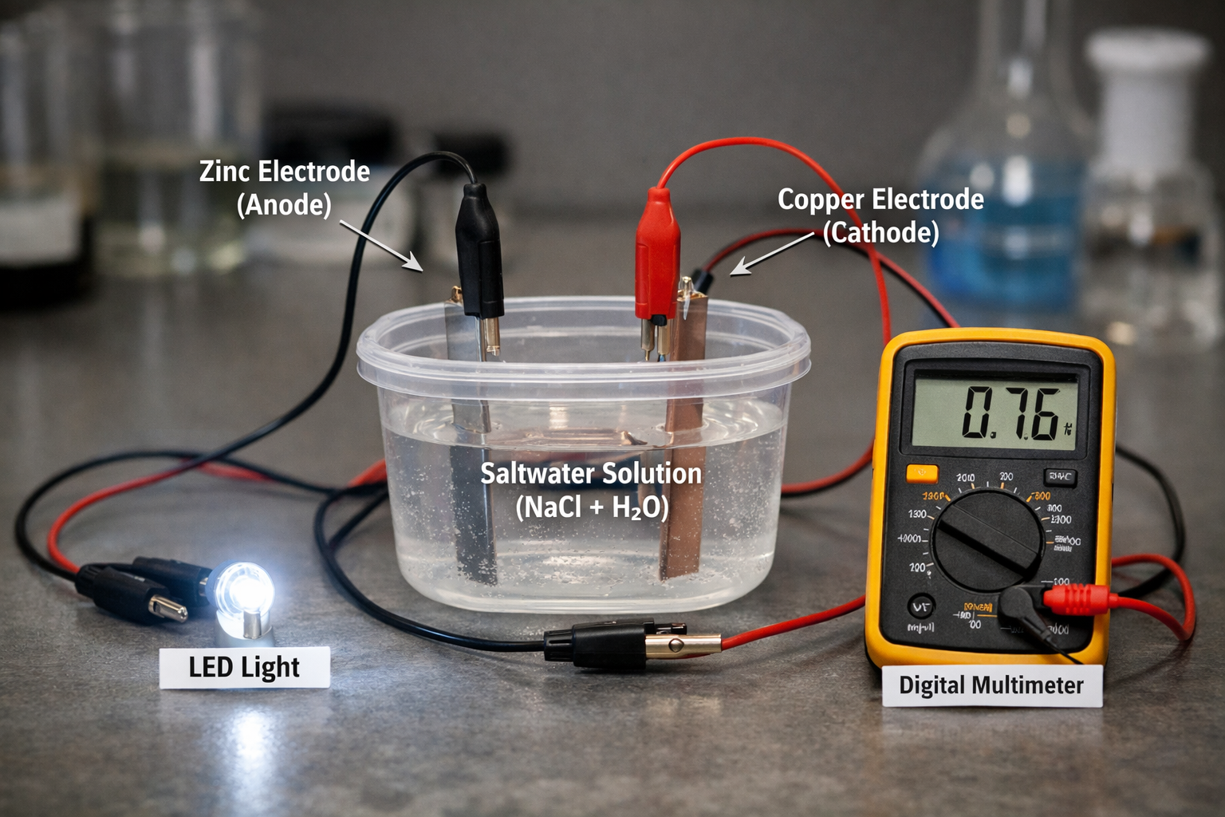
Fig.1: Saltwater Electrochemical Cell Experiment Setup

3. RESULTS AND DISCUSSION
The experimental setup using a zinc electrode (anode), copper electrode (cathode), and sodium chloride (NaCl) solution as the electrolyte successfully generated measurable electrical energy. Upon immersing the electrodes in the saltwater solution and connecting them through an external circuit, a voltage reading of approximately 0.70–0.80 volts was observed on the digital multimeter. This confirmed that a potential difference was established due to the electrochemical reaction between the two dissimilar metals in the presence of the electrolyte. The LED connected to the circuit emitted a faint but steady light, demonstrating that usable electrical current was produced.
The results shows that the conductivity of the saltwater solution played a crucial role in facilitating ion movement. When the concentration of sodium chloride in water was increased moderately, the voltage output remained nearly constant, but the current improved slightly due to enhanced ionic conductivity. However, beyond a certain concentration, no significant increase in performance was observed. This suggests that while ionic concentration influences internal resistance, the overall voltage is primarily determined by the electrode materials rather than the salt concentration alone.
During continuous operation, gradual corrosion of the zinc electrode was observed. This occurred because zinc, being more reactive, undergoes oxidation by losing electrons. The copper electrode showed minimal visible change, confirming its role as the cathode where reduction reactions occurred. The corrosion of the anode indicates that electrode degradation is a limiting factor in long-term application. For domestic use, this implies that electrode materials must either be replaced periodically or substituted with more durable alternatives to ensure sustainability.
When multiple saltwater cells were connected in series, the output voltage increased proportionally. For example, connecting three cells produced approximately 2.1–2.4 volts, sufficient to power a brighter LED or charge small electronic devices for a short duration. This demonstrates that scalability is achievable, although the total power output remains relatively low compared to conventional household electricity sources. Therefore, saltwater electrochemical cells are more suitable for low-power applications such as emergency lighting, small sensors, or educational demonstrations.
The experiment also revealed that temperature slightly affected performance. Warmer saltwater solutions showed marginally improved conductivity due to increased ion mobility, resulting in a small rise in current output. However, temperature variation within normal environmental conditions did not drastically change voltage levels.
From a practical standpoint, the findings confirm that sodium chloride and water can effectively serve as an electrolyte medium for electricity generation through electrochemical processes. The system is simple, inexpensive, and constructed from readily available materials, making it accessible for rural or off-grid communities. However, the relatively low energy density limits its ability to power high-consumption household appliances such as refrigerators, electric irons, or air conditioners.
In discussion, while the experiment demonstrates technical feasibility, improvements are necessary for domestic-scale application. Enhancing electrode durability, reducing internal resistance, and integrating the system with energy storage technologies such as saltwater batteries or solar panels could improve reliability [20]. Compared to fossil-fuel generators, this method produces no harmful emissions and operates silently, offering environmental advantages.
The results validate that electricity can be harnessed from sodium chloride and water through electrochemical means. Although current output is modest, the technology shows promise as a supplementary or backup domestic energy source, especially in areas with limited access to conventional power infrastructure.

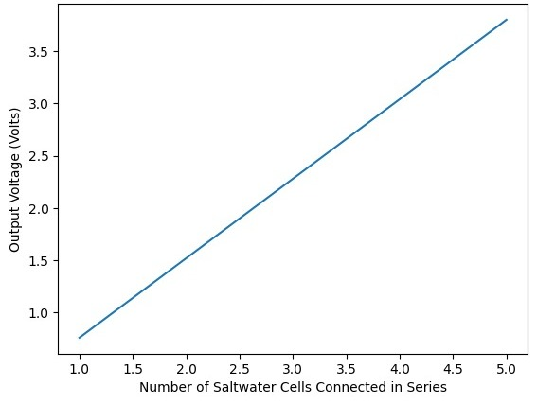

Fig.2: Plot of output Voltage against Number of Saltwater Cells

The plot shows the relationship between the number of saltwater electrochemical cells connected in series and the corresponding output voltage produced. Each individual cell generated approximately 0.76 V, and the total voltage increased proportionally as more cells were added. The graph clearly demonstrates a linear relationship between the number of cells and the output voltage. This confirms that connecting saltwater cells in series increases total voltage while maintaining the same current level. This result supports the experimental observation that scalability is possible for domestic applications. Although a single cell produces low voltage, combining multiple cells can generate sufficient voltage for small household devices such as LED lighting and low-power electronics.

4. CONCLUSION
The study on harnessing electricity from sodium chloride (NaCl) and water (H₂O) demonstrates that saltwater can effectively function as an electrolyte for generating electrical energy through electrochemical processes. The research revealed that the performance of the system depends largely on the electrode materials used and the ionic conductivity of the saltwater solution. Upon considerable increase of sodium chloride concentration in water, the voltage output remained relatively stable, but the current exhibited a minor enhancement attributable to improved ionic conductivity. Nonetheless, beyond a specific concentration, no substantial enhancement in performance was noted. This indicates that although ionic concentration affects internal resistance, the overall voltage is predominantly dictated by the electrode materials rather than solely by the salt concentration. It is particularly suitable for lighting, charging low-energy devices, and serving as a supplementary or backup power source. The system is inexpensive, environmentally friendly, and easy to construct using readily available materials, making it accessible for rural and off-grid communities. Overall, harnessing electricity from sodium chloride and water is a feasible and sustainable approach for small-scale domestic energy generation. While it may not replace large power plants, it offers an innovative alternative that can contribute to renewable energy development, energy security, and environmental protection. With further research and technological advancement, saltwater-based electricity systems could play a meaningful role in supporting clean and affordable household energy solutions in the future.

Disclaimer (Artificial intelligence)

Author(s) hereby declare that NO generative AI technologies such as Large Language Models (ChatGPT, COPILOT, etc.) and text-to-image generators have been used during the writing or editing of this manuscript.

REFERENCES
[1]. Balman Zohuri, Electricity an Essential Necessity in Our Life, Advanced Smaller Modular Reactors,(2016) pp.17-35. DOI:10.1007/978-3-319-23537-0_2 https://doi.org/10.1007/978-3-030-23682-3_1
[2]. Yan Shao, Zhe Yang, Yonghing Yan, Yuan Yan, Feruza Israilova, Nawal Khan, and Liu Chang, Energy Strategy Reviews, Elsevier, 59 (2025) 101707.
[3]. Sunday olayinka Oyedepo, Philip Olufemi Babalola, Chinwe Nwanya, Oluwaseun Kilanko, Oluwafemi Leramo, Abraham Kehinde Aworinde, Adekeye Tunde, Joseph Adewumi Oyebanji, Olatunde Abidakun, Orobome Larry Agberegha, Towards a Sustainable Electricity Supply in Nigeria: The Role of Decentralized Renewable Energy System, European Journal of Sustainable Development Research 2(4) (2018) 3908.
[3]. Nwiido Friday, The Need For Utilization Of Renewable Power Technology For Rural Electrification Project In Rivers State, International Journal of Innovative Scientific & Engineering Technologies Research 14(1) (2026) 133-141.
[4]. Jinjum Zhang, Energy access challenge and the role of fossil fuels in meeting electricity demand: Promoting renewable energy capacity for sustainable development, Geoscience Frontiers, 15(5) (2024), 101873.
[5]. Asad Mujeeb, Jamiu Oladigbolu, Mutiu Shola Bakare, Abduljelil Atima Ibrahim, (2025). Pathways to environmental sustainability through energy efficiency: A strategic next energy vision for sustainable development by 2050. Scientific African. Vol. 30, e03053, https://doi.org/10.1016/j.sciaf.2025.e03053.
[6]. Muh. Ridwan Kadir, Nurul Afiqah Arsyad, Syarifah Nuraeni Alaydrus, Hardi Hamzah, (2026). Seawater Lamp: Utilization of Seawater as an Alternative Energy Source to Generate Electricity. Indonesian Review of Physics6(1). DOI: 10.12928/irip.v6i1.7070
[7]. Mohammad Muhtasim Mashfy, Tamzeed Ahmed Alvy, Nazmul Hossain, Md Azazul Haque, Fatima Tasneem Mohsin, Tasnuva Sharmin, Mohammad Nasim, (2026). Sodium ion batteries: A sustainable alternative to lithium-ion batteries with an overview of market trends, recycling, and battery chemistry. Next energy. Volume 10, 100478. https://doi.org/10.1016/j.nxener.2025.100478
[8]. Andersen, A. D. (2014). No transition without transmission: HVDC electricity infrastructure as an enabler for renewable energy? Environmental Innovation and Societal Transitions, 13 (2014) 75–95. https://doi.org/10.1016/j.eist.2014.09.004
[9]. Masataka Murahara, Yuji Sato, Toshio Okawara, Salt as Alternative Energy Material to Fossil Fuel, Materials Research Society symposia proceedings. Materials Research Society, (2023) 1492. DOI:10.1557/opl.2013.219
[10]. Yanjiao Wang, Min Wang, Yuqing Yang, Deyu Kong, Chao meng, Dongqing Zhang, Han Hu, Mingbo Wu, Potential technology for seawater electrolysis: Anion-exchange membrane water electrolysis, Chem Catalysis, 3(7) (2023) 100643.
[11]. Cipollina Andrea & Micale Giorgio, Sustainable Energy from Salinity Gradients, Woodhead Publishing, ISBN: 978-0-08-100312-1, (2016), DOI: 10.1016/C2014-0-03709-4. 10.1016/C2014-0-03709-4.
[12]. Andri Kapuji Kaharian, Nani Sofroh, Didik Aribowo, Utilization of Sea Water as Source of Electrical Energy of Coastal People, VOLT Jurnal Ilmiah Pendidikan Teknik Elektro 2(2) (2017) 175-180.
[13]. Esmaeil Ahmadi, Benjamin McLellan, Behnam Mohammedi Ivatloo, and Tetsuo Tezuka, The Role of Renewable Energy Resources in Sustainability of Water Desalination as a Potential Fresh-Water Source: An Updated Review, Sustainibility, 12(13) (2020) 5233. https://doi.org/10.3390/su12135233
[14]. Muh. Ridwan kadir, nurul Afiqah Arsyad, Syarifah Nuraeni Alaydrus, Wenny Puspita, Sahrul Sahrul, Muhammad Nurkhalis Agriawan, Hardi Hamzah, Seawater Lamp: Utilization of Seawater as an Alternative Energy Source to Generate Electricity, indonesian Review of Physics, 6(1) (2023) 7070.
[15]. A. Susanto, M. S. Baskoro, S. H. Wisudo, M. Riyanto, and F. Purwangka, “Seawater Battery with Al-Cu, Zn-Cu, Gal-Cu Electrodes for Fishing Lamp,” Int. J. Renew. Energy Res., 7(4), pp. 1857–1868, 2017, doi:10.20508/ijrer.v7i4.
[16] Y. Umniyati, “Preliminary Experiments on Potential Use of Salt-Water Battery 4 for Cheap Electric Storage: Work In Progress,” J. Ilmu dan Inov. Fis., 5(1) (2021) pp. 74–81. doi: 10.24198/jiif.v5i1.31282.
[17] E. Morabet, K. R. A., K. A. R., and A. M., “Saltwater aviable Source of Energy for Sustainable Rural Development,” in 16th International Conference on Environmental Science and Technology, (2019) pp. 205–206.
[18]. F. Cheng, J. Chen, Metal–air batteries: from oxygen reduction electrochemistry to cathode catalysts, Chem. Soc. Rev., 41 (6) (2012) p. 2172. 10.1039/c1cs15228a
[19]. Olusola david Ogundele, David A. Oyegoke, Anaum Temitope Emmanuel, Exploring the Potential and Challenges of Electrochemical Processes for Sustainable Waste Water Remediation and Treatment, Acadlore Transactions on Geosciences 2(2) (2023) 80-93
[20]. Sangmin park, Senthilkumar Baskar, Kyoungho Kim, Soo Min Hwang, Youngsik kim, Saltwater as the energy source for low-cost, safe rechargeable batteries, Journal of Materials chemistry A, 4(19) (2016) 7207.

