PHYSICOCHEMICAL AND BACTERIOLOGICAL QUALITY ASSESSMENT OF WELL AND SPRING WATER IN THE FOKONTANY OF AMBATOHARANANA, HAUTE MATSIATRA REGION

ABSTRACT
Introduction: Access to safe drinking water remains a major public health challenge in rural areas of Madagascar, where groundwater sources are widely used despite limited information on their quality. This study aimed to evaluate the physicochemical and bacteriological quality of well and spring water consumed by the population of Ambatoharanana.
Methods: Two well water samples and two spring water samples were collected in polyethylene bottles and transported to the laboratory in a cooler maintained at 6°C. The samples were analyzed at the DREAH Haute Matsiatra laboratory. Parameters such as pH and temperature were measured in situ, while electrical conductivity, turbidity, manganese, iron, ammonium, aluminum, nitrite, nitrate, fluoride, and fecal coliforms were analyzed under laboratory conditions.
Results: The results reveal that both well and spring waters are environmentally polluted. The water is acidic (pH ranging from 4.59 to 6.15), likely due to the decomposition of organic matter in the soil. High levels of ammonium (0.93 mg/L for well 01; 0.57 mg/L for spring 01), aluminum (0.68 mg/L for well 02; 0.34 mg/L for spring 01), nitrite (0.105 mg/L for well 01), and nitrate (69.34 mg/L for well 02) indicate chemical pollution. Furthermore, the presence of fecal coliforms (ranging from 10 to 85 CFU/100 ml) confirms fecal contamination. Conclusion: The quality of well and spring water is degraded by human activities, such as the use of chemical fertilizers and wastewater discharge near water points. Immediate measures, including chlorination, filtration, boiling, and public awareness campaigns on hygiene and contamination risks, are necessary to improve water safety.
Keywords: Well and spring water, Physicochemical analysis, Bacteriological quality, Fecal coliforms, Fokontany Ambatoharanana, Madagascar.
1. INTRODUCTION
Access to safe drinking water is a critical public health challenge, particularly in rural regions where populations rely predominantly on wells and springs for their daily supply. According to the World Health Organization (WHO), approximately 2.2 billion people globally lack access to safely managed drinking water services. Contaminated water remains a primary vector for waterborne diseases, including diarrhea, cholera, and various parasitic infections (Pluym et al., 2024; Czerniejewska et al., 2023).
In rural communities, such as the Fokontany of Ambatoharanana in the Haute Matsiatra region of Madagascar, wells and natural springs are frequently vulnerable to both anthropogenic and natural contaminants. The lack of adequate water treatment infrastructure, the proximity of unimproved latrines, and the leaching of agricultural pesticides and fertilizers significantly degrade water quality, posing substantial health risks to the local population. While global water scarcity and groundwater contamination are well documented, localized data regarding groundwater quality in peripheral rural areas of Madagascar, particularly within the Haute Matsiatra region, remain extremely scarce. Despite the complete reliance of the Ambatoharanana community on these local wells and springs for daily domestic use, no previous systematic physicochemical or bacteriological assessment has been conducted to evaluate their safety. This lack of scientific information constitutes a critical knowledge gap for regional public health planning and water resource management.
Previous research has demonstrated that groundwater may harbor microbiological contaminants, such as coliform bacteria and Escherichia coli, as well as chemical pollutants including nitrates and heavy metals, at levels exceeding international drinking water standards (Rawat & Joshi, 2019; Barakat et al., 2018; Ibolobolo Kayiba et al., 2024). Consequently, a rigorous assessment of water quality in these rural areas is imperative to mitigate health risks and develop effective intervention strategies.
The primary objective of this study is to evaluate the physicochemical and microbiological quality of well and spring water within the Fokontany of Ambatoharanana. Specifically, this research aims to:
- Analyze key physicochemical parameters (including pH, turbidity, nitrates, and conductivity);
- Assess microbiological contamination levels, specifically the presence of fecal coliforms;
- Benchmark the findings against WHO and Malagasy national water quality standards;
- Identify potential sources of contamination and associated public health risks;
- Provide evidence-based recommendations to improve water safety and quality in the study area.
2. MATERIALS AND METHODS
2.1. Description of Sampling Sites
Fokontany Ambatoharanana is located within the urban commune of Fianarantsoa, in the District of Fianarantsoa I, Haute Matsiatra Region. It is situated approximately 3 km southeast of the city center. Its geographic coordinates are 47°6’11’’ East longitude and 21°27’30’’ South latitude, as shown in Figure 1.
For this study, four sampling sites within this Fokontany were selected. These sites are designated as follows:
- Pts 01: E47.106169° and S21.460292°
- Pts 02: E47.102819° and S21.459306°
- Src 01: E47.102464° and S21.460775°
- Src 02: E47.102683° and S21.465608° (as illustrated in Figure 1).
These locations are situated in close proximity to various agricultural areas, including rice paddies, vegetable plots, and banana plantations (see Figure 2). These water points are regularly utilized by the local population for both domestic consumption and agricultural irrigation.

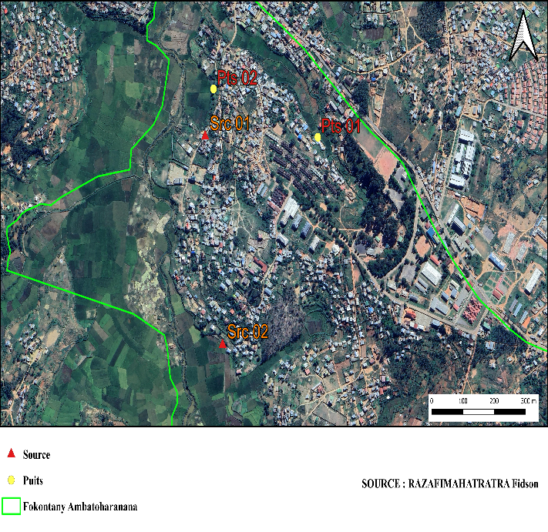
Source
Well
Village of Ambatoharanana
Village of Ambatoharanana
Commune in the District of Fianarantsoa I
Haute Matsiatra Region
Madagascar Regional Boundary

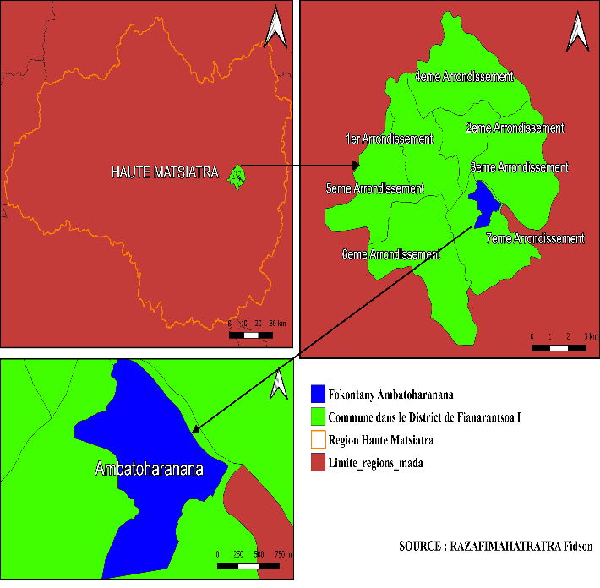

Figure 1: Location of the study area and sampling sites

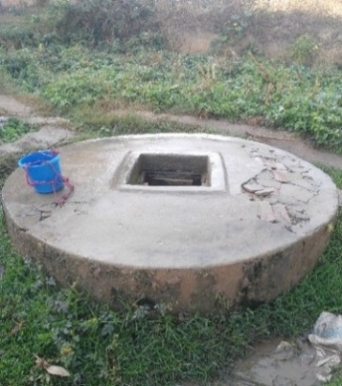
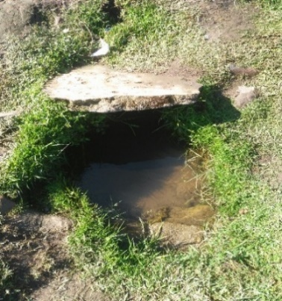
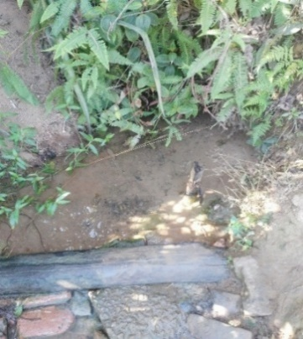
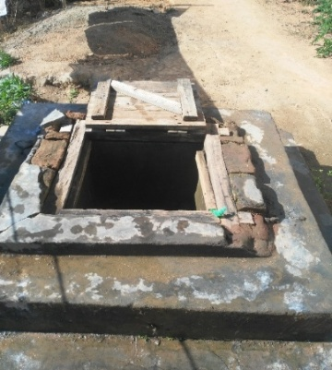

Figure 2 : Presentation of the sampling sites
2.2. Sampling
On August 1, 2024, at the end of the dry season, four well water samples and four spring water samples were collected in Ambatoharanana using precise geographical coordinates. During this sampling campaign, water samples were collected from four sites (Well 01, Well 02, Spring 01, and Spring 02) and transferred into 1 L polyethylene plastic bottles. Prior to sampling, the bottles were thoroughly cleaned with nitric acid, followed by rinsing with tap water, and then rinsed three to four times before use.
The samples were collected by immersing the bottles below the water surface and carefully filling them to the brim. Subsequently, the samples were labeled and transported to the laboratory in a cooler maintained at 6°C. Before analysis, the samples were stored in a refrigerator at 4°C.
2.3. Physicochemical Analyses
During sampling, the physical parameters of the water, including pH and temperature, were measured in situ. Field instruments used included a Palintest® pH meter and thermometer. Physicochemical parameters, namely electrical conductivity, turbidity, manganese, iron, ammonium, aluminum, nitrite, nitrate, and fluoride, were analyzed at the DREAH Haute Matsiatra laboratory. Electrical conductivity was measured using a Palintest® conductivity meter, while turbidity was determined using a Palintest® turbidimeter (Fishman & Robinson, 1969; Rodier et al., 2016). Chemical analyses of manganese, iron, ammonium, aluminum, nitrite, nitrate, and fluoride were carried out using Wagtech kits [Wagtech WTD 7100 photometer (Wag-WE-10441), Palintest® type] (Rodier et al., 2016).
2.4. Bacteriological Analyses
Bacteriological analysis was performed for the identification and enumeration of fecal coliforms present in well and spring water samples. Detection of these bacteria was carried out by filtering 100 mL of water through a 0.45 μm membrane filter, followed by placement onto sterile Petri dishes containing a specific culture medium. The Petri dishes were incubated for 24 hours at 44°C.
The culture medium used consisted of a selective medium (m-FC agar). The selection of this medium complies with standardized recommendations to ensure accurate identification and adequate growth of the target bacteria during the analytical process.

3. RESULTS
3.1. Physicochemical Quality
The results of the physicochemical analyses, presented in Table 1, reveal that the pH of the water ranged from 4.59 to 6.15. However, these values do not comply with the standards established by the WHO and the Malagasy State, indicating an acidic nature of both well and spring water.
Electrical conductivity values ranged from 211 μS/cm to 275 μS/cm, indicating low mineralization and remaining within the limits recommended by the WHO and the Malagasy State.
Water temperature varied from 17.6°C to 18.3°C. These values comply with WHO and Malagasy standards, which recommend temperatures below 25°C.
Well and spring water showed slight turbidity, ranging from 1.33 NTU to 4.59 NTU. These values remained below the maximum limits recommended by the WHO and the Malagasy State.
Manganese concentration in the water was undetectable, indicating the complete absence of this element in the samples. These values are far below the standards established by the WHO and the Malagasy State.
Iron concentrations in well and spring water ranged from 0 mg/L to 0.15 mg/L, complying with WHO and Malagasy standards.
Ammonium and aluminum concentrations varied respectively from 0.05 mg/L to 0.93 mg/L and from 0.05 mg/L to 0.68 mg/L. However, values recorded in some water sources exceeded the maximum permissible limits recommended by the WHO and the Malagasy State.
Nitrite and nitrate concentrations ranged respectively from 0 mg/L to 0.105 mg/L and from 0.141 mg/L to 69.34 mg/L. Nevertheless, the highest values exceeded the standards established by the WHO and the Malagasy State.
Fluoride concentrations ranged from 0.26 mg/L to 0.78 mg/L, all remaining below the maximum permissible limits recommended by the WHO and the Malagasy State.
Table 1: Physicochemical characteristics of well and spring water
Parameters | Unit | Well 01 | Well 02 | Spring 01 | Spring 02 | Malagasy Standard | OMS Standard
pH | - | 5,74 | 4,59 | 5,06 | 6,15 | 6,5 - 9 | 6,5 – 8,5
Electrical conductivity | μs/cm | 241 | 275 | 214 | 211 | ˂ 3000 | ˂ 3000
Temperature | °C | 17,5 | 17,9 | 18,3 | 17,6 | ˂ 25 | ˂ 25
Turbidity | NTU | 3,52 | 1,33 | 4,38 | 4,59 | ˂ 5 | ˂ 5
Manganese | mg/L | 0 | 0 | 0 | 0 | 0,05 | 0,05
Iron | mg/L | 0,15 | 0,15 | 0 | 0,05 | 0,5 | 0,3
Ammonium | mg/L | 0,93 | 0,14 | 0,57 | 0,05 | 0,5 | 0,5
Aluminum | mg/L | 0,05 | 0,68 | 0,34 | 0,15 | 0,2 | 0,2
Nitrite | mg/L | 0,105 | 0,012 | 0 | 0,035 | 0,1 | 0,1
Nitrate | mg/L | 0,336 | 69,34 | 0,270 | 0,141 | 50 | 50
Fluoride | mg/L | 0,47 | 0,26 | 0,78 | 0,64 | 1,5 | 1,5

3.2. Bacteriological Quality
The results of the bacteriological analyses, presented in Table 2, revealed that fecal coliform levels did not comply with the standards established by the WHO and the Malagasy State, with values ranging from 10 CFU/100 mL to 85 CFU/100 mL.
Table 2: Bacteriological characteristics of well and spring water
Parameters | Unit | Well 01 | Well 02 | Spring 01 | Spring 02 | Malagasy Standard | OMS Standard
Fecal coliforms | ufc/100 mL | 53 | 85 | 10 | 67 | 0 | 0

4. DISCUSSION
The primary objective of this study was to evaluate the quality of well and spring water in Ambatoharanana. This assessment is based on the physicochemical and bacteriological characteristics of these water sources.
The physicochemical quality of well and spring water is defined by several parameters, including pH, electrical conductivity, temperature, turbidity, and the concentrations of manganese, iron, ammonium, aluminum, nitrite, nitrate, and fluoride. The pH level measures the acidity or alkalinity of the water, determined by the concentration of acidic or basic chemical elements. According to the WHO, the pH of drinking water should range between 6.5 and 8.5, while the Malagasy State standards specify a range between 6.5 and 9. However, the analyses reveal that the well and spring waters are acidic, with pH values ranging from 4.59 to 6.15, thus failing to meet the recommended standards. These values are lower than those reported in other studies, such as the research by El Kory et al. (2011) on water in the city of Tijkja (pH = 6.19). Conversely, the values reported by Ndong et al. (2022) for groundwater during the dry season in Cameroon corroborate these findings, with pH levels ranging from 4.3 to 5.8.
Consequently, the well and spring water in Ambatoharanana is unsuitable for consumption. Furthermore, the prolonged consumption of acidic water may lead to an increased incidence of gastric conditions, such as gastrointestinal irritation and digestive disorders, as well as the potential ingestion of dissolved toxic metals.
Electrical conductivity is used to assess the mineralization of water. The analyses reveal that the well and spring waters contain few mineral elements, with values ranging from 211 µS/cm to 275 µS/cm, thus complying with both WHO and Malagasy State standards (˂ 3000 µS/cm). These values fall within the same ranges as those reported by Diallo (2021), who found an average conductivity of 250 µS/cm in the groundwater of Mali (Foto et al., 2022), and those observed by Ouédraogo (2020) in the groundwater of Burkina Faso (conductivity ranging from 200 µS/cm to 400 µS/cm) (Ibolobolo Kayiba et al., 2024). Although these conductivity levels are acceptable for human consumption, they may suggest a low concentration of essential minerals such as calcium and magnesium, which are necessary for human health. The low conductivity observed can be an indicator of the absence of significant contamination by anthropogenic pollutants, such as industrial effluents. However, it could also reflect a low nutrient supply for local aquatic ecosystems, thereby limiting biodiversity in these waters. When the conductivity value is between 100 µS/cm and 250 µS/cm, the water is considered weakly mineralized. It is estimated that the levels of mineralization (potassium, sodium, calcium, bicarbonate) in the well and spring water are less abundant. This may be due to soil characteristics. Consequently, the water in these wells and springs has low electrical conductivity.
Temperature plays a crucial role in the solubility of gases and mineral salts in water (Rodier et al., 2016). It also influences the multiplication and metabolism of microorganisms (Pluym et al., 2024). The analyses revealed that the temperature varies between 17.6°C and 18.3°C, remaining below the limit tolerated by the WHO and the Malagasy State (<25°C). These values are similar to those found by Abdoulaye (2019) in well and spring water in Northern Cameroon (temperatures between 17.5°C and 18.5°C) (Rawat & Joshi, 2019) and to those observed by Nwachukwu et al. (2018) in the groundwater of Nigeria (temperature varying between 17°C and 19°C) during the dry season (Barakat et al., 2018). Other authors, such as Tan et al. (2022) studying groundwater in Southeast Asia, reported an average temperature of approximately 18°C during the dry season (Ibolobolo Kayiba et al., 2024), which is also similar to these results. These findings confirm the concept of stable groundwater temperature, although certain areas closer to urban zones show higher temperatures, likely due to pollution or the influence of human activities. The observed temperatures are compatible with an environment where the risk of pathogenic bacterial proliferation is limited. In general, temperatures below 20°C are less favorable for the growth of pathogenic microorganisms such as Escherichia coli or fecal coliforms, which are often present under inadequate sanitary conditions (Czerniejewska et al., 2023). These results reflect a low thermal variability of groundwater during the dry season, indicating a probable supply from aquifers that are well-protected from the direct influence of external temperatures. However, any anthropogenic increase (e.g., intensive agriculture) could alter this fragile balance (Richardson & Ternes, 2024).

Turbidity provides visual information about the water (whether it is turbid or clear). It also helps determine the water's capacity to conduct electricity (Rodier et al., 2016). Water is turbid when the turbidity value is high. In this case, the turbidity of the analyzed well and spring water conforms to the WHO and Malagasy State standards (< 5 NTU), ranging from 1.33 NTU to 4.59 NTU. These levels are relatively low and correspond to the expected characteristics of groundwater during the dry season, when reduced precipitation leads to less runoff and, consequently, fewer suspended solids in the water (Rawat & Joshi, 2019). However, the springs exhibit higher turbidity than the wells, likely due to more direct exposure to environmental contaminants. The values found by Ouedraogo et al. (2019) in well water (3.8 NTU) and spring water (4.9 NTU) in Burkina Faso during the dry season (Barakat et al., 2018) confirm that springs are more vulnerable to contaminants than wells. A study on groundwater in India conducted by Patel (2017) showed an average turbidity of 3.5 NTU (Ibolobolo Kayiba et al., 2024), which is similar to these results. Turbidity exceeding 1 NTU may indicate the presence of microbial pathogens that attach to suspended particles. High turbidity can also reduce the efficiency of disinfection (chlorination) by shielding microorganisms from disinfecting agents. This could increase the risk of waterborne diseases such as diarrhea and cholera. The turbidity of sources 01 and 02 (> 4 NTU) could reflect soil leaching or ecological degradation due to agricultural activities near these sources. Persistent turbidity can affect the aquatic ecosystem by reducing light penetration, disrupting photosynthesis, and decreasing dissolved oxygen, which impacts aquatic fauna (Richardson & Ternes, 2024).
Manganese levels in the studied waters are 0 mg/L. These values indicate a total absence or a negligible concentration of manganese in the water, which complies with the maximum standards limited by the WHO and the Malagasy State (0.05 mg/L). These concentrations are lower than those found by Nkansah et al. (2010) in well water in Sub-Saharan Africa, with a concentration of 0.4 mg/L (Foto et al., 2022), and those observed by Smedley et al. (2002) in West African groundwater, with manganese concentrations ranging from 0.01 mg/L to 0.3 mg/L (Ibolobolo Kayiba et al., 2024). The absence of manganese in these water sources reduces the risks associated with excessive consumption. Indeed, elevated levels of this element can cause neurological disorders, particularly in children, as well as symptoms such as fatigue and memory impairment. However, a total absence of manganese may be problematic in certain local nutritional contexts where dietary manganese intake is insufficient, as this trace element plays an essential role in human metabolism, notably in bone formation and enzymatic functions (Rodier et al., 2016).
The zero concentration of manganese in the studied wells and springs could indicate a low natural presence of manganese in local soils or an absence of leaching in these regions. However, this low concentration could also limit the manganese supply required for certain biological processes within the aquatic ecosystem.
Iron concentrations in the studied well and spring waters range between 0 mg/L and 0.15 mg/L. These results remain below the guideline values of the WHO (0.3 mg/L) and the Malagasy State (0.5 mg/L). They show a higher concentration of iron in wells compared to springs. These values remain lower than those found by Kumar et al. (2020) in Indian groundwater (iron content ranging from 0.3 mg/L to 1.2 mg/L) (Foto et al., 2022). Other researchers, such as Mbang (2020) (Ibolobolo Kayiba et al., 2024) and Ndjama et al. (2021) (Barakat et al., 2018), found lower iron concentrations in spring water than in well water, which corroborates these findings. Based on these results, there is no direct toxic risk for human consumption. However, a concentration exceeding 0.1 mg/L, as observed in wells 01 and 02, can impart a metallic taste to the water and cause brownish staining of containers. Prolonged consumption of water containing high iron levels can cause gastrointestinal dysfunction and interfere with the absorption of other essential trace elements, such as zinc and copper. An excess of iron in surface water can be toxic to certain aquatic organisms, particularly fish, by altering their respiration and metabolism.
Ammonium is often an indicator of organic pollution, generally originating from the decomposition of organic matter, domestic effluents, or the infiltration of agricultural fertilizers. Ammonium levels in the studied water vary between 0.05 mg/L and 0.93 mg/L. The values observed in well 01 (0.93 mg/L) and spring 01 (0.57 mg/L) exceed the potability standards of the WHO and the Malagasy State (0.5 mg/L), but they are lower than those found by Kouamé et al. (2020) (Foto et al., 2022) and Nguyen et al. (2021) (Ibolobolo Kayiba et al., 2024). The higher levels of this element in these water sources suggest significant contamination, likely due to the proximity of agricultural activities, non-watertight latrines, and untreated domestic discharges. The excessive presence of ammonium at these water points can promote the formation of nitrites and nitrates, which pose health risks, notably methemoglobinemia (blue baby syndrome) in infants (Rodier et al., 2016). Furthermore, the critical coexistence of elevated chemical parameters and fecal indicators in Ambatoharanana mirrors the hydrochemical degradation identified in the Piedmont of Béni-Mellal Atlas in Morocco, where intensive agricultural practices and lack of rural sanitation severely stress drinking supply springs (Barakat et al., 2018).
Aluminum is a metal naturally present in the environment and can be found in drinking water due to rock erosion, runoff, or anthropogenic activities such as water treatment using aluminum salts (Rodier et al., 2016). The measured aluminum concentrations in the water sources range from 0.05 mg/L to 0.68 mg/L, with the maximum value observed in well 02. According to the WHO and the Malagasy State, the recommended maximum level for aluminum in drinking water is 0.2 mg/L. The values found in well 01 and spring 02 comply with this recommendation, while those in well 02 and spring 01 exceed this limit. These results are lower than those found by Ngatcha (2017) in certain water sources in Cameroon during the dry season (exceeding 1 mg/L) (Foto et al., 2022). Other authors, such as Nogueira et al. (2019) (Ibolobolo Kayiba et al., 2024) and Ouedraogo (2019) (Barakat et al., 2018), reported aluminum concentrations of 0.45 mg/L and 0.4 mg/L, respectively, which are similar to these results. The presence of elevated levels of this element in these water sources is attributed to soil characteristics. The consumption of water from well 02 and spring 01 may pose risks to human health. According to Exley (2016), excessive accumulation of aluminum in the body can be associated with neurological disorders, notably Alzheimer's disease (Richardson & Ternes, 2024). Furthermore, prolonged ingestion of high aluminum concentrations could cause renal disorders, particularly in individuals suffering from kidney failure (Rodier et al., 2016). An excess of aluminum in surface waters can also affect aquatic fauna, particularly fish, as it precipitates in the gills and disrupts their respiration (Bletsou et al., 2024).
Nitrite concentrations in the studied waters vary between 0 mg/L and 0.105 mg/L. These levels indicate a certain heterogeneity in the quality of the water sources. The levels in well 02, spring 01, and spring 02 remain below or close to the maximum limit tolerated by the WHO and the Malagasy State (0.1 mg/L). Only well 01 exceeds this limit, which may pose a risk to the population using this water source, particularly for infants and pregnant women, as nitrites can cause issues such as methemoglobinemia (blue baby syndrome) (Rodier et al., 2016). The observed nitrite contamination, particularly in well 01, may be linked to poor infrastructure design, wastewater infiltration, or nearby agricultural activities. These observed values are lower than those found by Ndiaye (2022) in the Sahelian zone (0.2 mg/L) (Foto et al., 2022). Other authors, such as Kouadio et al. (2020), recorded similar nitrite levels during the dry season, ranging from 0.01 to 0.12 mg/L in shallow wells in Côte d'Ivoire (Ibolobolo Kayiba et al., 2024), and Diallo et al. (2020) reported average nitrite concentrations ranging between 0.05 mg/L and 0.15 mg/L in Sahelian wells (Barakat et al., 2018), which correspond to the levels observed in wells 01 and 02.
Nitrate levels fluctuated between 0.141 mg/L and 69.34 mg/L, showing considerable variation among the analyzed water sources. Notably, Well 02 exhibited an alarmingly high nitrate concentration (69.34 mg/L), significantly exceeding the WHO and Malagasy drinking water safety threshold of 50 mg/L, whereas Well 01 presented a much lower concentration (0.336 mg/L). This pronounced difference strongly suggests localized point-source contamination. The elevated nitrate concentration observed in Well 02 is likely hydrogeologically linked to its close proximity to intensive banana and vegetable cultivation areas, where synthetic nitrogen-based fertilizers are extensively used, combined with shallow groundwater leaching during the dry season. Such high nitrate levels pose serious public health risks, particularly for infants, as exposure to excessive nitrate concentrations may lead to methemoglobinemia (blue baby syndrome), metabolic acidosis, and circulatory disorders resulting from the conversion of nitrates into nitrites, which interfere with oxygen transport in the blood (Rodier et al., 2016).
The high concentration of this element in well 02 can also lead to eutrophication in this water source, affecting water quality and aquatic biodiversity. The increase in nutrients, such as nitrates, promotes algal proliferation, which can destabilize aquatic ecosystems and render the water unfit for consumption and other uses (Richardson & Ternes, 2024). Leclerc, H. et al. (2020) reported an average nitrate concentration in wells of 25 mg/L (Foto et al., 2022), which is much lower than that observed in well 02 (69.34 mg/L).
The fluoride concentrations recorded at the various water points vary between 0.26 mg/L and 0.78 mg/L. These values are below the limit recommended by the WHO and the Malagasy State (1.5 mg/L) for drinking water, indicating an absence of immediate risk of dental or skeletal fluorosis for consumers. However, a concentration below 0.5 mg/L, as observed in wells 01 and 02, may be insufficient for optimal protection against dental caries, which could justify public health interventions such as fluoride supplementation. The observed results are similar to those found by Tchinda, P. (2017) in water sources in Northern Cameroon during the dry season (concentrations ranging from 0.2 to 1.1 mg/L) (Mohamed EL Kory & Kacem, 2011) and those reported by Guissou et al. (2017) in water sources in Burkina Faso during the dry season (concentrations ranging from 0.2 mg/L to 2 mg/L) (Barakat et al., 2018).
Microbiological analysis is crucial for assessing the microbiological quality of water. Fecal coliforms serve as indicators of contamination by fecal matter (Czerniejewska et al., 2023). The observed results show fecal coliform levels ranging from 10 CFU/100 ml to 85 CFU/100 ml. These values exceed the potability standards of the WHO and the Malagasy State, indicating contamination by pathogens and an increased risk of diarrheal infections, cholera, typhoid, and other waterborne diseases (Pluym et al., 2024). The values observed in the wells and spring 02 are similar to those found by Kouadio et al. (2014) in springs and wells in West Africa (ranging from 50 CFU/100 ml to 100 CFU/100 ml) (Ibolobolo Kayiba et al., 2024).
Other authors, such as Levy et al. (2018), have documented more frequent and intense contamination during the dry season (Rawat & Joshi, 2019). Similar baseline dynamics and high microbial vulnerabilities in rural spring profiles have also been widely monitored across diverse geographical terrains, including the central Himalayan region (Rawat & Joshi, 2019).
This intense contamination during the dry season aligns with the findings of Levy et al. (2018), who noted that reduced groundwater recharge concentrates both chemical and microbial pollutants within limited water resources. Similarly, the results obtained from the wells and springs in this study suggest that the water sources may pose significant health risks to the population of Ambatoharanana, particularly in the absence of appropriate purification treatments. These water sources may harbor pathogens responsible for diarrheal diseases and other waterborne infections, which are common in rural and urban areas with inadequate sanitation infrastructure. During the dry season, reduced groundwater recharge and contaminant concentration may further aggravate these health risks as water resources become increasingly limited and polluted (Pluym et al., 2024).
Fecal contamination can also have repercussions on local ecosystems. The introduction of organic matter and pathogens into surface waters can disrupt aquatic ecosystems, trigger algal blooms, and reduce aquatic biodiversity (Brumfield et al., 2025).
This study was limited by several challenges, such as financial and logistical constraints that restricted the number of sampling points. Additionally, certain aspects were not covered, such as the absence of comprehensive seasonal data; the analysis was limited to the dry season, whereas the rainy season could show significant variations due to aquifer recharge (Ceperley et al., 2024).
5. CONCLUSION

The results obtained in this study reveal that the well and spring waters of Ambatoharanana exhibit degraded quality due to microbiological and chemical contamination linked to human activities, such as the use of chemical fertilizers in agricultural fields and wastewater discharges near these water sources (Barakat et al., 2018; Foto et al., 2022). Consequently, these waters pose risks to both human health and aquatic fauna (Richardson & Ternes, 2024). The observed results indicate significant variations in physicochemical and bacteriological parameters, notably an acidic pH ranging from 4.59 to 6.15—which may be attributed to the presence of decomposing plant organic matter, soil acidification, or biological and organic compound decomposition in the soil (Rodier et al., 2016; Mohamed EL Kory & Kacem, 2011). Furthermore, elevated concentrations of ammonium (0.93 mg/L for well 01 and 0.57 mg/L for spring 01), aluminum (0.68 mg/L for well 02 and 0.34 mg/L for spring 01), nitrite (0.105 mg/L for well 01), and nitrate (69.34 mg/L for well 02), as well as variable levels of fecal coliforms (ranging from 10 CFU/100 ml to 85 CFU/100 ml), exceed both WHO and Malagasy State standards (Czerniejewska et al., 2023; Pluym et al., 2024).

Therefore, measures must be taken to improve water quality, such as household treatment methods (chlorination, filtration, or boiling) and the implementation of community-scale purification systems (filtration stations, disinfection) (Rodier et al., 2016). It is also essential to provide training for residents on good hygiene and water storage practices, conduct information campaigns regarding the risks of water contamination and available treatment methods, and establish protection zones around these wells and springs—prohibiting latrines, landfills, and pesticide-using crops in the vicinity. Additionally, regular monitoring of agricultural activities that may impact water quality should be established, alongside the reinforcement of local solid and liquid waste management policies. Improving the quality of well and spring water thus requires an integrated approach, combining technical, educational, and regulatory actions to guarantee access to safe and sustainable drinking water.

In terms of perspectives, this study highlights the importance of considering complementary research, such as in-depth water analyses and quality monitoring. This includes establishing a continuous surveillance network to evaluate the evolution of physicochemical and bacteriological parameters and assessing the impact of seasonality, specifically researching variations in water quality across different seasons to develop strategies adapted to each period of the year (Ceperley et al., 2024).
Disclaimer (Artificial Intelligence)
The author(s) declare that generative AI tools were used only for language improvement, grammatical correction, and text refinement during the preparation of this manuscript. All scientific interpretations, analyses, results, and conclusions remain the sole responsibility of the author(s).

6. REFERENCES
- Barakat, A., Meddah, R., Afdali, M., & Touhami, F. (2018). Physicochemical and microbial assessment of spring water quality for drinking supply in Piedmont of Béni-Mellal Atlas (Morocco). Physics and Chemistry of the Earth, Parts A/B/C, 104, 39–46. https://doi.org/10.1016/j.pce.2018.01.006
- Bletsou, A. A., et al. (2024). Non-target Screening in Water Analysis: Recent Trends in Data Evaluation. Analytical and Bioanalytical Chemistry. https://doi.org/10.1007/s00216-024-05153-8
- Brumfield, K. D., et al. (2025). Comparative Microbial Metagenomic Analysis of Drinking Water. Frontiers in Microbiology. https://doi.org/10.3389/fmicb.2025.1488268
- Ceperley, N., et al. (2024). Toward a Common Methodological Framework for the Sampling, Extraction, and Isotopic Analysis of Water in the Critical Zone to Study Vegetation Water Use. WIREs Water. https://doi.org/10.1002/wat2.1727
- Czerniejewska, M., et al. (2023). Assessment of Microbiological Quality of Water Using Culture and Molecular Methods. Water, 15(23), 4077. https://doi.org/10.3390/w15234077
- Exley, C. (2016). The toxicity of aluminium in humans. Morphologie, 100(329), 51–55. https://doi.org/10.1016/j.morpho.2016.05.001
- Fishman, M. J., & Robinson, B. P. (1969). Water analysis. Analytical Chemistry, 41(5), 146R–194R. https://doi.org/10.1021/ac60274a007
- Foto, E., Allahdin, O., Biteman, O., Akpekabou, B., & Poumaye, N. (2022). Contribution to the Assessment of the Quality of Borehole Water in the Regions of Lobaye and Ombella-Mpoko in the South-West of the Central African Republic. Journal of Environment Pollution and Human Health, 10(1), 13–22.
- Ibolobolo Kayiba, C., Nsimanda, C., Disadisa, T., et al. (2024). Physicochemical and Microbiological Analysis of Surface and Groundwater Consumed by the Rural Population of Matende, Lukamba Sector, Democratic Republic of the Congo. Revue Internationale De La Recherche Scientifique, 2(5), 2720–2734. https://doi.org/10.5281/zenodo.13957159
- Mohamed EL Kory, O. C., & Kacem, E. K. (2011). Physicochemical characterization of drinking water supplying the city of Tijikja (Mauritania). International Journal of Biological and Chemical Sciences, 5(5), 2133–2139. https://doi.org/10.4314/ijbcs.v5i5.33
- Ndong, A. S., Ndzi, E. S., Ndzi, C. K., & Nola, M. (2022). Physicochemical characterization of groundwater during the dry season in Cameroon. African Journal of Environmental Science and Technology, 16(3), 112–121.
- Pluym, L., et al. (2024). Microbial Drinking Water Monitoring Now and in the Future. Environmental Microbiology Reports. https://doi.org/10.1111/1751-7915.14532
- Rawat, A., & Joshi, G. K. (2019). Physicochemical and microbiological assessment of spring water in central Himalayan region. Environmental Monitoring and Assessment, 191(4), 218.
- Richardson, S. D., & Ternes, T. A. (2024). Water Analysis: Emerging Contaminants and Current Issues. Analytical Chemistry. https://doi.org/10.1021/acs.analchem.4c01423
- Rodier, J., Legube, B., & Merlet, N. (2016). Water Analysis – Control and Interpretation (10th ed.). Dunod.
- World Health Organization (WHO). (2017). Guidelines for Drinking-water Quality (4th ed., incorporating the 1st addendum). Geneva: World Health Organization. https://www.who.int/publications/i/item/9789241549950
- Zhang, Y., et al. (2024). Utilization and Applications of Stable Isotope Analysis for Wastewater Treatment. Environmental Research.

