Original Research Article
Colour and Shape as Visual Design Elements: Effects on Cognitive Performance in Young Children

.
ABSTRACT
Colour and shape are important design elements for information perception and cognition. Researchers from previous studies have suggested that colour can affect children’s cognitive performance. However, the effect of colour and shape on cognitive ability has not been widely investigated. In this paper, the concept of the perceptual load paradigm was used to investigate the effect of colour and shape on cognitive performance. For the experiment, 120 young children aged 6-8 years with average intellect were selected. Three experiments were carried out, experiment 1 uses colour blocks, experiment 2 uses shapes without colour and experiment 3 uses shapes with colour as stimuli. The results showed that the main effect of item types (colour, shapes with colour and shapes without colour) in each stimulus was significant (p>.001), and the main effect of cognitive load was significant (p>.001). This indicated that colour, shape, and cognitive load significantly impacted the cognitive performance of the young children. These findings highlight important educational and cognitive benefits that can help improve teaching practices and learning interventions. Using both colour and shape together can support young learners by making it easier for them to process and understand information, even during more challenging cognitive tasks. One practical application of these findings is in the development of educational materials that thoughtfully combine colour and shape to enhance learning and engagement.

Keywords: colour, shapes, cognitive load, cognitive performance, young children

1. INTRODUCTION

Human perception is the organization, identification, and interpretation of sensory information to represent and understand the presented information or environment (Schacter et al. 2011). All perception involves signals that go through the nervous system, which in turn result from physical or chemical stimulation of the sensory system. Perception is therefore a dynamic and active mechanism that integrates sensory input with attention, memory, and prior experience, enabling individuals to interact effectively with their environment. The concept of colour and shape effect pertains to the deliberate manipulation of visual information within graphics through the strategic utilization of colour and shape elements. This manipulation aims to render the graphics more harmonious with the viewer’s cognitive processes, thereby enhancing their overall cognitive performance while simultaneously diminishing the cognitive load imposed (Jin et al. 2022). This intricate interplay of external stimuli and cognitive performance plays a vital role. The proper knowledge and utilization of colours and shapes in any instructional material designed for young children can enhance the learning. Cognitive load is mediated by factors like demands on working memory and factors like display size modulate perceptual load (Singh & Jena 2022). The complexity of the task largely determines the level of cognitive load. This has become an area of interest to many researchers for its implications in human information processing. The present study explored the effect of colour and shape on the cognitive mechanism of young children by manipulating the cognitive load.
The earlier researches in the field of visual cognition found that the salient features of colour and shape can guide bottom-up attention (Danaci & Ikizler 2016; Kerzel et al. 2018). Additionally, multifaceted research was conducted on the influence of colour and shape on cognitive performance. In terms of colour, many studies have shown that a hierarchical visual perception of colour affects people’s search performance and the priority in capturing information (Foster & Lavie 2008; Hagen et al. 2014). Several studies on colour also showed the influence of colour on memory. Farley and Grant (1976) were among the earliest who came out with a theory suggesting that colours have a greater effect on attention. This conclusion was based on their study on attention and cognition. They compared colour and non-colour multimedia presentations on memory performance. It was reported that the coloured multimedia presentation resulted in better attention than the non-coloured presentation. Greene, Bell and Boyer (1983) further explained that warm types of colours, such as yellow, red, and orange, have been found to have a greater effect on attention compared to the cool types of colours like brown and grey. Mackay and Ahmetzanov (2005) found similar findings in their study on working memory and visual attention. In their study, participants were asked to identify whether the colour or the shape of the two objects that were presented was the same. In the first experiment, the colours of the two objects were the same, but the shapes were different, while in the second experiment, the conditions were reversed. The result showed that the participants’ response times were faster in identifying the differences in colours compared to the differences in the shapes of the objects in both experimental conditions. This finding can be interpreted to show that colours have a better and greater ability to capture attention than other variables. Mehta and Zhu's (2009) study indicates that different colours can influence performances on different kinds of cognitive tasks. Some researchers have investigated the effect of colour background and neutral colour background in recall and found that colour perception positively influences attention span and short-term memory compared to white (Abdul et al. 2005; Jadhao et al. 2020). Saikia et al. (2023) investigated the influence of colours on working memory among young children, and Blue was considered the most effective colour in improving the retention capacity of the young children among the six different colours. It can be understood from the brief that colour and shape can affect cognitive performance, thereby enhancing learning. The understanding of the information processing in terms of visuals will help design instructional materials for young children.
Research shows that colour isn't just about making things look nice, it actually affects how hard our brains have to work to process information. When screens and interfaces use colours that work well together, people feel less stressed, stay more motivated, and learn better. Schneider et al. (2025) confirmed this, finding that well-chosen colour schemes help learners feel more comfortable and satisfied while reducing mental strain. But colour doesn't work the same way for everyone. He et al. (2025) found that older adults read and interpret colour-coded information in medical apps differently, especially when they're already mentally tired. This means designers can't just pick colours that look good, they have to think about who will actually be using the product. Interestingly, Cömert and Samur (2025) found that in educational games, certain colour and speed combinations can feel overwhelming at first, but actually help people learn better in the long run when used thoughtfully. Xu et al. (2025) used brain-scanning and eye-tracking technology to show how background colours affect attention differently based on gender. Pei et al. (2025) used brainwave monitoring to track in real time how visual elements like shadows and contrast affect mental load during video learning.

However, current research achievements mainly focus on the effect of colour and shape as visual stimuli on the cognitive performance of young children under high to low cognitive load. In this study, the experimental materials were optimised to effectively differentiate the effect of colour and shape in varying cognitive load and to study the independent role of colour and shape and the combined effect on cognitive performance. To detect the cognitive performance of colour and shape in different cognitive loads, three levels of time pressure were used (high load: 200ms; medium load: 600ms; low load: 1000ms) to control cognitive load. The present study focused exclusively on the design elements of colour and shape. Therefore, the findings cannot be generalized to other design elements that were beyond the scope of this research.

2. methodology

2.1 Participants: In this research study, a cohort of 120 young children who do not have colour blindness, with average intellect was selected. The presence of colour blindness was assessed through the Ishihara colour blind test, ensuring the participants had normal colour vision. To ascertain their average intellectual abilities, the Colour Progressive Matrices (CPM) test was employed. Specifically, children whose test scores fell within Grade III, denoting the category of “Intellectually average” according to the CPM scoring system, were chosen as participants for the study. This selection process aimed to ensure a homogeneous sample of children with typical colour vision and average intellectual capabilities, thereby enhancing the reliability and validity of the study’s findings. Before data collection informed consent was taken from the parents of the participants. Ethical approval was taken from the Institutional Ethical Committee (IEC) for Human Sciences (H).
2.2 Pre-experiment: Prior to the formal experiment, a preliminary investigation was conducted to establish the appropriate number of items to be used as stimuli. The presentation durations for the stimuli were determined as 200 milliseconds (ms) for high cognitive load, 600 milliseconds (ms) for medium cognitive load, and 1000 milliseconds (ms) for low cognitive load. During the pre-experiment, the number of items presented was varied, with 2, 4 and 6 items utilized for the three different cognitive load conditions (high, medium, and low). The analysis, performed using within-subject design, revealed a significant difference in accuracy between trials involving 2 items and those involving 6 items p<0.05. This difference suggests that handling six items may have exceeded the participants’ cognitive capacity while 2 items proved to be insufficient for a comprehensive experimental evaluation. Consequently, the optimal number of items for the formal experiments was determined to be four items, striking a balance that ensured both the cognitive load requirements and the experimental integrity were maintained.
2.3 Materials: The items for the three stimuli were: colour blocks, shapes without colours, and shapes with colour (Table 1). The colours selected for the study were: Red: RGB (255,0,0); Blue: RGB (0,0,255); Yellow: RGB (255,255,0); Green: RGB (0,204,0); Orange: RGB (255,140,0); and Purple: RGB (255,0,255). The colour blocks were presented on a 14-inch laptop screen with a brightness of 120 Cd/m2 and a resolution of 1920 x 1200 dp. The stimuli for the experiments were prepared in Microsoft PowerPoint.
Tables should be explanatory enough to be understandable without any text reference. Double spacing should be maintained throughout the table, including table headings and footnotes. Table headings should be placed above the table. Footnotes should be placed below the table with superscript lowercase letters.

Table 1: Items used for each stimulus type in the experiment
Stimuli | Items
Colour Blocks | RGB (255,140,0)  RGB (255,255,0)  RGB (255,0,255)  RGB (0,0,255)  RGB (255,0,0)  RGB (0,204,0)
Shapes without colour |                         
Shapes with colour | 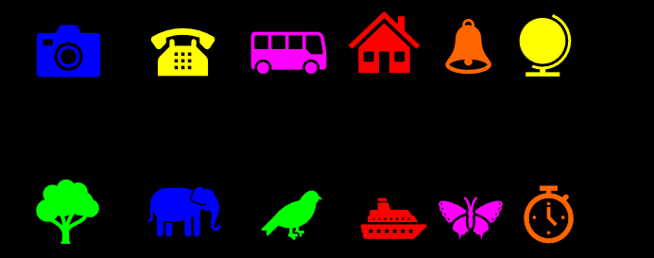
Note: RGB = RGB stands for Red, Green, and Blue. It is the primary colour model used in digital design and electronic displays.

Procedure: In the experimental setup, the stimuli were presented against a black background. The experiments were divided into three distinct sessions: experiment 1 involved colour blocks, experiment 2 involved shapes without colour, and experiment 3 involved shapes with colour. Before commencing the formal experiments, a comprehensive demonstration of the experimental procedure was provided to the participating children to ensure their understanding. Once their comprehension was confirmed, the formal experiment commenced. Each trial began with the appearance of a white gaze point “+” at the centre of the screen, which remained visible for 500 milliseconds (ms). Subsequently, the respective stimulus was presented. The duration of stimulus presentation varied based on the cognitive load level: 200 ms for high cognitive load, 600 ms for medium cognitive load, and 1000 ms for low cognitive load, for each of the three types of stimuli (colour blocks, shapes without colour and shapes with colour). Following the stimulus presentation, the white gaze point “+” reappeared for another 500 ms, after which the search set was displayed on the screen. Participants had to identify the items that appeared from the search set as rapidly and accurately as possible within a given timeframe of 5 seconds. Every correct response contributed to the participant’s score, representing the accuracy rate. This experimental procedure was systematically repeated for each level of cognitive load (low, medium, and high) and for each set of stimuli (colour blocks, shapes without colour, and shapes with colour).

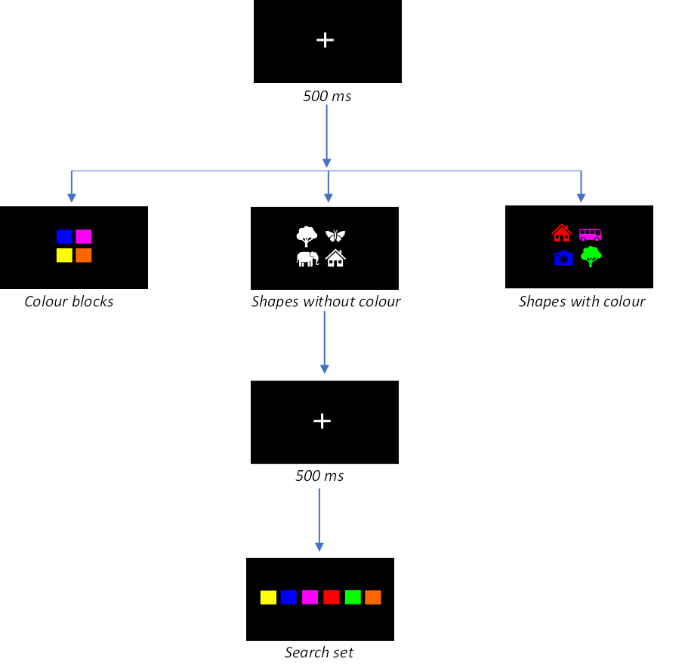

Fig.1: Diagrammatic representation of the experimental flow

3. results and discussion

An analysis of variance (ANOVA) of three cognitive loads and three stimuli was carried out for accuracy. At different cognitive loads, the accuracy for three stimulus types is shown in Figs. 2(a,b,c). The analysis indicated that the main effect of the cognitive loads was significant, and the main effect of the stimulus type was significant. This indicated that both cognitive load and stimulus type significantly impacted the cognitive performance of young children.

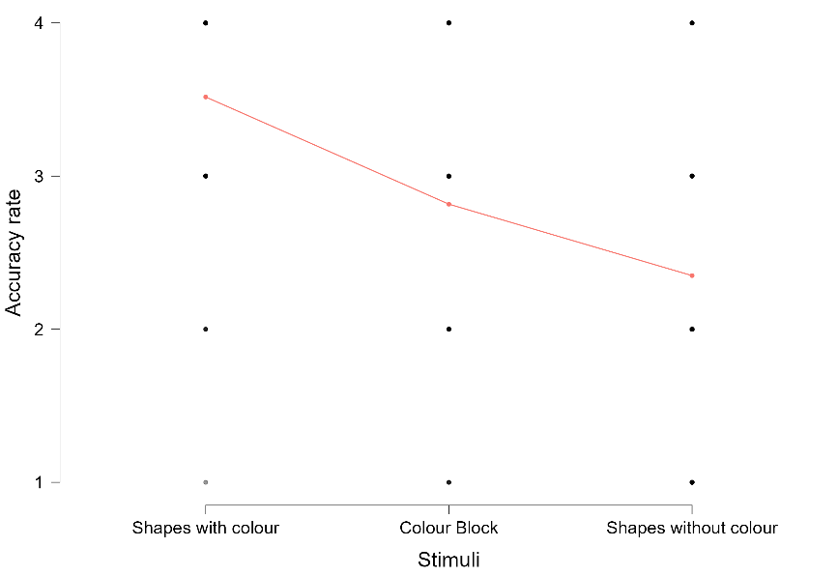

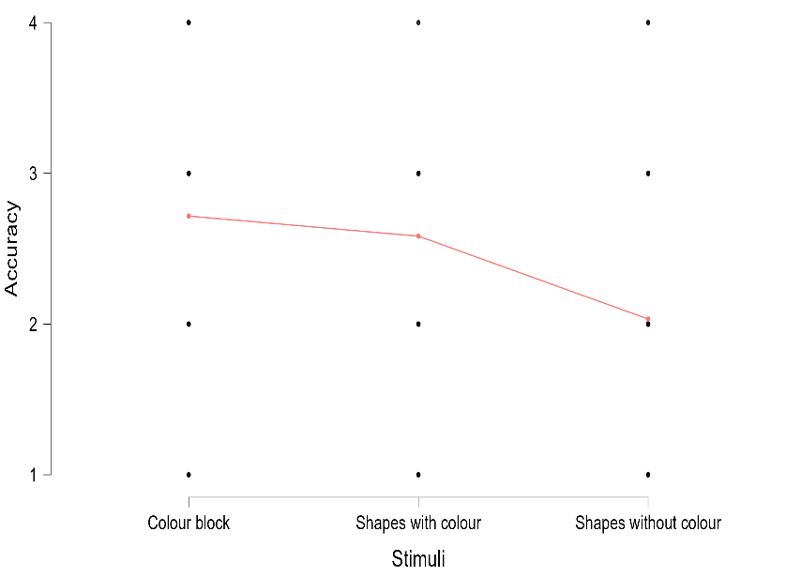
Fig. 2(a): Mean accuracy rate of the participants in high cognitive load (200 ms)

Fig. 2(b): Mean accuracy rate of the participants in medium cognitive load (600 ms)

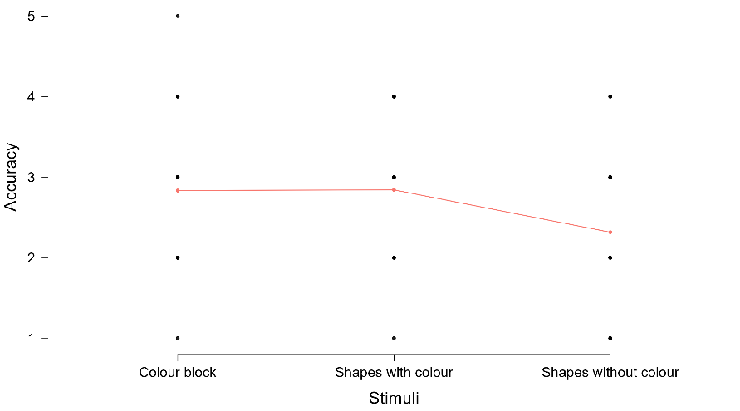

Fig. 2(c): Mean accuracy rate of the participants in low cognitive load (1000 ms)

Furthermore, the accuracy of different stimuli types (colour blocks, shapes with and without colour) at different cognitive loads were compared. The result showed that, at high cognitive load, there was a significant difference in the average accuracy between colour blocks and shapes with colour (p < 0.05), shapes with colour and shapes without colour (p < 0.05) and colour blocks and shapes without colour (p < 0.05). The accuracy rate of colour blocks and shapes with colour was significantly higher than shapes without colours. At medium cognitive load, the accuracy rate of shapes without colour significantly differed from colour blocks (p < 0.05) and shapes with colour (p < 0.05). However, there was no significant difference between the accuracy rate of colour blocks and shapes with colour (p > 0.05). At low cognitive load, the accuracy rate of shapes without colour significantly differs from colour blocks and shapes with colour (p < 0.05). However, no significant difference was found between colour block and shapes with colour (p > 0.05). (Table: 2).

Table 2: Impact of stimuli on the accuracy rate across varied cognitive load level.
Cognitive load | Stimuli
Cognitive load | Colour block | Shapes without colour | Shapes with colour
High load (200ms) | 30 ± 2^{BC} | 12 ± 1^{A} | 42 ± 2DE
Medium load (600ms) | 43 ± 2DE | 26 ± 2^{B} | 40 ± 2^{D}
Low load (1000ms) | 46 ± 2E | 33 ± 2^{C} | 46 ± 2E
F value SEd CD (5%)
For Stimuli 102.87 1.425 3.198
For Cognitive load 48.21 1.424 3.197
For Stimuli x Cognitive load 9.20 2.468 5.539
*Note: Each value is expressed in mean ± SD (standard deviation); N=120; Means within rows separated by Duncan’s Multiple range test (DMRT); Means followed by the same superscripts are not significantly different.

In the experimental study conducted under high cognitive load, the average accuracy for colourless shapes was notably lower than for both coloured blocks and coloured shapes. This discrepancy indicated superior cognitive performance for colour-based stimuli, as opposed to purely shape-based stimuli. This observation led to the inference that, under conditions of high cognitive load, colour emerged as the predominant factor influencing cognitive encoding, rendering the role of shape information relatively insignificant. Furthermore, across all three levels of cognitive load (high, medium, and low), it was consistently observed that cognitive performance pertaining to shapes with colour surpassed that of colour blocks and shapes without colour. This consistent pattern of results supported the inference that the combined presence of colour and shape notably enhances cognitive performance among young children, irrespective of the cognitive load level. However, it is noteworthy that, specifically under conditions of low cognitive load, there existed no substantial disparity between the mean accuracies associated with colour blocks and shapes with colour. This finding suggested that, in situations of low cognitive load, the inherent characteristics of shape might not significantly contribute to item recognition, with colour alone being sufficient to stimulate recognition processes effectively.

These findings shed light on the potential pedagogical and cognitive implications that can positively impact educational practices and interventions. The incorporation of both colour and shape can serve as a cognitive scaffolding mechanism, aiding young learners in processing information more effectively, even when faced with complex cognitive tasks. One practical implication of our findings is the design of educational materials that leverage the combination of colour and shape. Educational resources that embrace this approach could potentially enhance engagement and retention among young learners. For instance, in mathematics education, geometric shapes and colour-coded problem-solving activities may help students better grasp abstract concepts. Moreover, the evidence from the present study will be beneficial for further extensive research exploration on the effect of visual features and semantic information in different cognitive loads separately; a combination of these findings will be a strong consideration while designing complex educational materials.

4. Conclusion

The present study investigated the influence of colour and shape on the cognitive performance of young children under varying levels of cognitive load using the perceptual load paradigm. By systematically manipulating visual attributes and time-based cognitive demands, this research aimed to clarify the independent and combined effects of colour and shape on children’s attention and cognitive processing. The findings provide clear evidence that both visual features and cognitive load significantly impact cognitive performance in early childhood. From an applied perspective, the results have important implications for the design of instructional materials, educational tools, and learning environments for young children. Thoughtful integration of colour and shape, combined with appropriate management of cognitive load, can enhance attention, comprehension, and memory while minimising cognitive overload. Overall, this study contributes to more profound understanding of visual cognition in childhood and offers empirical evidence to support perceptually informed design strategies that promote effective learning and cognitive development.

Disclaimer (Artificial intelligence)

Author(s) hereby declare that NO generative AI technologies such as Large Language Models (ChatGPT, COPILOT, etc.) and text-to-image generators have been used during the writing or editing of this manuscript.

References

- Schacter, D. L., Gilbert, D. T., & Wegner, D. M. (2009). Introducing psychology. Macmillan.URL- http://bergenhighschool.com/Psychology%20Assignments/Introducing%20Psychology%20Table%20of%20Contents.pdf
- Jin, T., Zhou, S., Lang, X., He, J., & Wang, W. (2022). “Combined effect of color and shape on cognitive performance.” Mathematical Problems in Engineering, 2022(1), 3284313. URL: https://onlinelibrary.wiley.com/doi/abs/10.1155/2022/3284313
- Singh, P. & Jena, S. P. K. (2022). “Does Low Cognitive Load Lead to Delayed Performance?” Journal of Positive School Psychology vol. 2022 URL: http://journalppw.com.
- Kerzel, D., Barras, C. & Grubert, A. (2018). “Suppression of salient stimuli inside the focus of attention.” Biol Psychol 139, 106–114.
- Danaci, E. G. & Ikizler-Cinbis. N. (2016). “Low-level features for visual attribute recognition: An evaluation.” Pattern Recognit Lett 84, 185–191
- Forster, S. & Lavie, N. (2008) “Attentional capture by entirely irrelevant distractors.” Vis cogn 16, 200–214.
- Hagen, S., Vuong, Q. C., Scott, L. S., Curran, T. & Tanaka, J. W. (2014) “The role of colour in expert object recognition.” J Vis 14.
- Frank H. Farley & Alfred P. Grant. (1976) “Arousal and Cognition: Memory for Colour Versus Black and White Multimedia Presentation.” The Journal of Psychology, 94:1, 147-150. DOI: 10.1080/00223980.1976.9921410
- Greene, T.C., Bell, P.A. & Boyer, W.N. (1983). “Colouring the environment: Hue, arousal, and boredom.” Bull. Psychon. Soc. 21, 253–254. https://doi.org/10.3758/BF03334701
- MacKay, D. G., & Ahmetzanov, M. V. (2005). “Emotion, Memory, and Attention in the Taboo Stroop Paradigm: An Experimental Analogue of Flashbulb Memories.” Psychological Science, 16(1), 25-32. URL: https://doi.org/10.1111/j.0956-7976.2005.00776.x
- Mehta, Ravi, and Rui Zhu. (2009) "Blue or red? Exploring the effect of colour on cognitive task performances." Science 323, no. 5918. 1226-1229.
- Jadhao, A., Bagade, A., Taware, G. & Bhonde, M. (2020). “Effect of background colour perception on attention span and short-term memory in normal students.” Natl J Physiol Pharm Pharmacol 1 doi:10.5455/njppp.2020.10.06162202017072020
- Abdul, A., Eze, R. & Juliet, T. (2005) Effect of colour on memory; does colour background affect the rate of retention?
- Saikia H, Bhattacharyya N & Baruah M. (2023). “Influence of colour in short-term memory performance of young children.” Pharma Innovation 12(4):1903-1905.
- Chaves, L. A. P., Malone, S., Löber, J., & status, u. (2026). Effects of coloured feedback in virtual reality on drumming performance and cognitive load. Journal of Music, Technology & Education. https://intellectdiscover.com/content/journals/10.1386/jmte_00072_1
- Cömert, Z., & Samur, Y. (2025). Digital educational game design: Music, speed, colour and collectible item. Learning and Motivation, 89, 102045.
- Harding, D., & Chaggar, R. S. (2025). Effects of colour-coded, compartmentalised syringe trays on anaesthetic drug error detection under cognitive load: The world through orange-tinted glasses. Comment. British Journal of Anaesthesia, 134(2), e12-e14. https://doi.org/10.1016/j.bja.2024.11.002
- He, X., Yang, Y., Li, R., & Gong, X. (2025). Visualization design and color preference in medical application interfaces for older adults: The impact on cognitive load and user experience. International Journal of Human–Computer Interaction. https://doi.org/10.1080/10447318.2025.2562959
- Kapelle, O., & Flecken, M. (2025). Perceiving colour through a language lens: A scoping review of experimental work on effects of language on colour perception. Language and Cognition, 1–32. https://doi.org/10.1017/langcog.2024.52
- Namrouti, H., Sik-Lanyi, C., & Guzsvinecz, T. (2025). Demographic influences on virtual reality colour matching: Performance, presence, usability, cognitive load, accuracy, and physiological response-pilot study (Preprint). SSRN. https://doi.org/10.2139/ssrn.5272691
- Namrouti, H., Sik-Lanyi, C., & Guzsvinecz, T. (2026). Gender influences on virtual reality colour matching task: Performance, presence, usability, cognitive load, accuracy, and physiological response. The Visual Computer. https://doi.org/10.1007/s00371-025-04334-5
- Pei, L., Jong, M. S. Y., Shang, J., & status, u. (2025). Design and validation of an electroencephalogram‐supported approach to tracking real‐time cognitive load variations for adaptive video‐based learning. British Journal of Educational Technology. https://doi.org/10.1111/bjet.13535
- Schneider, S., Scheller, N., & Pak, D. (2025). The impact of color as a cue for aesthetics on cognitive load and learning performance in digital environments. EDULEARN25 Proceedings, 1–10. https://library.iated.org/view/SCHNEIDER2025IMP
- Xu, L., Hou, B., Wang, X., & Zhang, Z. (2025). Exploring the effects of background colour and gender on cognitive performance of visual attention: A multimodal approach using fNIRS and eye-tracking. Journal of the International Colour Association, 36, 45–58. https://www.aic-publishing.org/ojs/index.php/JAIC/article/view/295

