Green Synthesis and Physicochemical characterization of NiO-ZnO nanocomposites derived from Aloe barbadensis Miller leaf extract

Abstract
​This study investigates the structural, optical, and biological properties of NiO-ZnO nanocomposites synthesized via a sustainable green sol-gel method using Aloe vera (Aloe barbadensis Miller) leaf extract. X-ray diffraction (XRD) analysis confirmed the formation of crystallite size ranging from 19 to 20 nm. The nanocomposites exhibited a hexagonal wurtzite structure for ZnO and a fcc structure for NiO. Fourier transform infrared (FTIR) spectroscopy confirmed the presence of metal-oxide stretching vibrations in the 400–600 cm⁻¹ range. Scanning electron microscopy (SEM) identified hexagonal and spherical morphologies with particle clusters measuring 250–350 nm. Dielectric studies indicated that the dielectric constant and loss tangent can be tuned by varying the NiO doping concentration, with the 5% NiO-ZnO composite exhibiting the highest dielectric constant. Furthermore, the 10% NiO-ZnO composite demonstrated superior antimicrobial activity against Bacillus cereus and Klebsiella pneumoniae compared to the standard antibiotic Tetracycline. These results suggest that green-synthesized NiO-ZnO nanocomposites are promising candidates for advanced dielectric and biomedical applications.

​Keywords: Green synthesis, Zinc-Nickel oxide nanocomposite, Barbadensis Miller, antimicrobial activity, Dielectric properties.

1. Introduction
Green nanotechnology has emerged as a vital and sustainable paradigm within nanoscience, offering innovative strategies to mitigate the environmental risks typically associated with traditional chemical synthesis. As a nascent but rapidly evolving field, green nanotechnology serves as a critical solution for reducing the ecological footprint of nanomaterial production and application [1-2]. In this context, the use of plant extracts such as phytochemical-rich Aloe vera provides a natural source of flavonoids that act as effective reducing and stabilizing agents during synthesis.The fundamental properties of nanomaterials, including their optical, magnetic, catalytic, and electrical characteristics, are highly dependent on the synthesis process. Achieving precise control over nucleation, morphology, and particle size distribution is essential, yet maintaining environmental sustainability remains a significant challenge for researchers. Various factors, such as temperature, reactant concentration, reaction duration, the mixing ratio of the reactants. [3] and pH, play pivotal roles in the successful stabilization of nanoparticles [4]. While nanoparticles can be synthesized in diverse geometries including hexagonal, spherical, and triangular forms biosynthesis via plant extracts is preferred for its ability to minimize toxic byproducts and facilitate fine-tuning of particle size.Among the various methodologies available for preparing doped and undoped zinc oxide (ZnO), such as co-precipitation and chemical vapor deposition, the sol-gel route is particularly advantageous. This method is favoured for its operational simplicity, mild reaction conditions, and its ability to produce materials with high crystallinity and precisely controlled microstructures. Specifically, the sol-gel process allows for the punctual management of the physical, mechanical, and chemical characteristics of the final outputs [5-6].The incorporation of transition metals into the ZnO lattice is of significant scientific interest. Nickel (Ni) doping is especially attractive because Ni and Zn share similar oxidation states, allowing for the substitution of ions without significantly distorting the wurtzite crystal structure of ZnO. Ni-doped ZnO nanostructures exhibit enhanced properties suitable for applications in spintronics, optoelectronics, and medicine, including magnetically controlled drug delivery, magnetic resonance imaging (MRI), and cancer therapy. These materials typically demonstrate a wide bandgap, ranging from 3.6 to 4.0 eV [6-16].Furthermore, the green synthesis of ZnO nanoparticles using plant extracts has been shown to yield superior antimicrobial activity compared to chemically synthesized versions, notably without promoting antibiotic resistance. Aloe barbadensis Miller (Aloe vera), a perennial succulent of the Liliaceae family, is renowned for its immunomodulatory, anti-inflammatory, and wound-healing properties. While various extracts like Zingiber officinale and Allium sativum have been explored in the literature, this study utilizes Aloe vera gel as a pre-treatment agent [17-20]. Aloe vera has the anti-bacterial property along with the anti-inflammatory property which helps to cure mouth and gum problems and severe gum diseases. [21] Acemannan, a β-(1, 4)-acetylated soluble polyominoes, is the primary bioactive polysaccharide extracted from Aloe vera gel , it is used to treat oral diseases, wounds, heart problems and tumours. New research focuses on its use in materials and drug delivery.[22]
According to research findings, the dielectric and AC electrical properties of ZnO nanoparticles (NPs) are closely linked to microstructural features, such as crystallite size, grain boundaries, and lattice defects, as well as the presence of additional charge carriers. Specifically, dielectric permittivity is governed by interfacial (Maxwell-Wagner) and orientation (dipolar) polarization, while AC conductivity arises from charge carrier hopping and defect-mediated transport mechanisms.Grain boundaries, in particular, act as charge-trapping sites and influence space charge (interfacial) polarization at low frequencies, which in turn affects both dielectric constant and loss characteristics. These properties can change significantly when ZnO NPs are doped or alloyed with other metals or materials. Furthermore, variations in nanoparticle size can lead to changes in the dielectric constant.The high dielectric loss observed at low frequencies is typically attributed to impurities and crystal defects within the ZnO NPs. In composite systems, both the dielectric constant and dielectric loss generally increase with particle size. Notably, doping ZnO nanoparticles with metals or carbon-based materials significantly enhances their dielectric constant and electrical conductivity, making such modified compositions promising candidates for advanced energy storage applications [23-24].
The primary objective of the present research is to synthesize pure and Ni-doped ZnO nanoparticles (at concentrations of 5%, 10%, and 20%) using Aloe vera gel via the sol-gel method. These work as reducing agents to convert metal ions into nanoparticles and as capping agents to keep them stable and prevent clumping.[25] This study aims to leverage the synergistic potential of green synthesis and transition metal doping to enhance the structural, optical, and antimicrobial performance of the resulting nanostructures
2. Experimental Section
2.1 Materials
All chemical reagents utilized in this study were of analytical grade and used as received without further purification. Nickel (II) chloride hexahydrate (NiCl₂. 6H₂O 99.9%) and zinc acetate (Zn(CH₃COO)₂, 99.99% trace metals basis) were procured from Sigma-Aldrich Pvt. Ltd.
2.2 Plant Collection and Extraction
Aloe vera leaves were collected and thoroughly washed with distilled water to remove surface impurities. The leaf extract was prepared by mixing 100gm of finely cut leaves with 100 ml of distilled water. The mixture was boiled at 70°C for 1 hour, followed by filtration through Whatman No. 1 filter paper. The resulting filtrate, used for the green synthesis of NiO and ZnO nanoparticles, was stored at 4°C.
2.3 Synthesis of ZnO and NiO Nanoparticles
For the synthesis of ZnO nanoparticles, 50 ml of zinc precursor solution was mixed with 100 ml of Aloe vera extract. The solution was heated at 80°C until it reached a dry powder state. The resulting white powder was then calcined in a muffle furnace at 700°C for 7 hours.A similar procedure was adopted for NiO nanoparticles by mixing 50 ml of NiCl₂. 6H₂O solution with 100 ml of Aloe vera extract. Heating at 80°C yielded a green powder, which was subsequently calcined at 700°C for 7 hours. The furnace temperature was precisely monitored throughout the process [26].
2.4 Synthesis of NiO-ZnO Nanocomposites
The NiO-ZnO nanocomposites were synthesized by incorporating specific weight percentages of NiO into the zinc precursor solution. For the 5% NiO-ZnO sample, 0.2 gm of NiO was added to 50 ml of zinc precursor solution and 50 ml of Aloe vera extract. The mixture was heated at 100°C until dry. Following this, the powder was calcined at 700°C for 7 hours in a muffle furnace. This procedure was repeated for 10% (0.4 gmNiO) and 20% (0.8 gmNiO) concentrations.

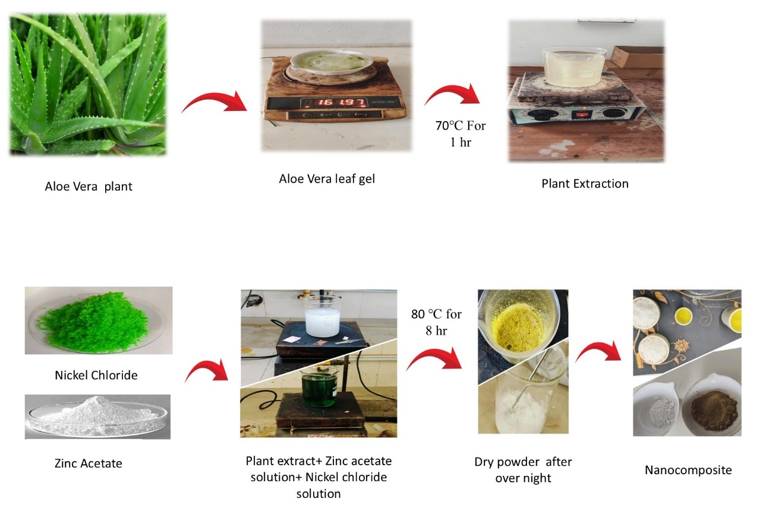
Fig. 1 Schematic illustration of the green synthesis process: Extraction of Aloe vera leaf gel and subsequent formation of NiO-ZnO nanocomposites

3. Results and Discussion
3.1 Structural Analysis (XRD)
X-ray diffraction (XRD) was employed to evaluate the phase purity and crystallinity of the synthesized ZnO,NiO, and NiO-ZnO nanocomposites. The diffraction patterns, as illustrated in Figure 2, confirm the phase composition of the samples. X-ray diffraction (XRD) was employed to identify the phase purity and crystallinity of the synthesized nanoparticles. The analysis was conducted based on Bragg’s Law
nλ=2dsinθ ------ (1)
where n is an integer, λ is the wavelength of CuKα radiation, dis the interplanar spacing, and θ is the diffraction angle [27-29].
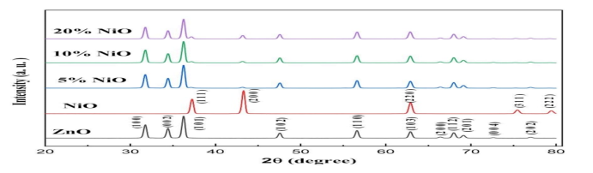
Fig. 2 X-ray diffraction (XRD) patterns of pure ZnO, pure NiO, and NiO-ZnO nanocomposites with varying NiO doping concentrations (5%, 10%, and 20%)

The ZnO nanoparticles exhibited characteristic diffraction peaks at 2θ values of 31.75°, 34.43°, 36.24°, 47.55°, 56.61°, 62.86°, 66.40°, 67.96°, 69.10°, 72.58°, and 77.06°. These correspond to the (101), (002), (101), (102), (110), (103), (200), (112), (201), (004), and (202) planes, respectively, identifying a hexagonal wurtzite structure (JCPDS Card No. 36-1451). The lattice parameters were determined as a = 3.250 Å and c ranging from 5.2030 to 5.2060 Å. Slight variations in these parameters are attributed to the substitution of Ni into the ZnO lattice.
For the NiO nanoparticles, diffraction peaks observed at 2θ values of 37.10°, 43.32°, 62.81°, and 76.51° correlate to the (111), (200), (220), and (311) planes, confirming a face-centered cubic (FCC) structure (JCPDS Card No. 00-047-1049). The absence of peaks related to metallic Zn or secondary phases confirms high phase purity. Upon the addition of NiO, the diffraction peaks became narrower and more intense, indicating improved crystalline structure formation. The average crystallite size (D) was calculated using the Debye-Scherrer formula:
D=$\frac{0.9λ}{βcosӨ}$ ------ (2)
where β represents the full width at half maximum (FWHM) in radians. The average crystallite size for the synthesized nanostructures was determined to be approximately 19–20 nm. Upon the addition of NiO, the diffraction peaks became narrower and more intense, indicating an improvement in crystalline structure.
The Zn-O bond length (L) was calculated using the following relation:
$L= \sqrt{\frac{a^{3}}{3}+ {\left(0.5-μ \right)}^{2 }c^{2}}$ ------ (3)
Where (μ) is the positional parameter of the wurtzite structure, representing the atomic displacement relative to the adjacent plane along the c-axisas expressed with equation (4)
$μ= \frac{a^{2}}{3c^{2}}+0.25$ ------ (4)
The calculated bond length values are in excellent agreement with the 1.9767 Å reported in the literature.
The presence of various polysaccharides, such as acemannan and glucomannan found in Aloe Vera extracts, can influence the growth of metal oxide nanoparticles. These substances act as capping agents or stabilizers, effectively regulating the morphology and crystallite size during the synthesis process.
3.2 Elemental and Morphological Analysis (SEM/EDAX)
Scanning Electron Microscopy (SEM) was used to investigate the surface morphology of the NiO-ZnO nanocomposites. The images revealed hexagonal shapes (Fig.3), with particles appearing as spheres approximately 250–350 nm in diameter.
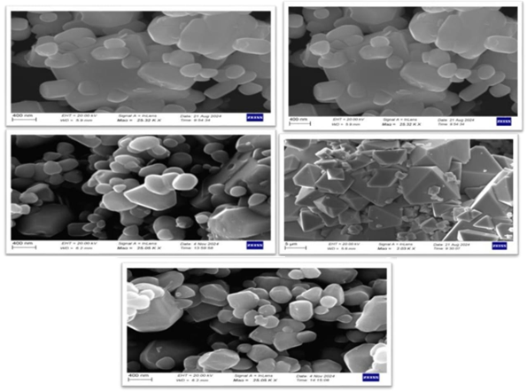
Fig. 3 Scanning Electron Microscopy (SEM) micrographs displaying the morphology of synthesized pure ZnO, NiO, and NiO-ZnO nanocomposites
Energy Dispersive X-ray Analysis (EDAX) confirmed the presence of Ni, Zn, and O as the primary elemental constituents. The weight percentages and atomic percentages for the 5%, 10%, and 20% NiO-ZnO samples were recorded (Table 1) and showing (Fig. 3) a consistent increase in Nickel content in line with the doping concentrations.
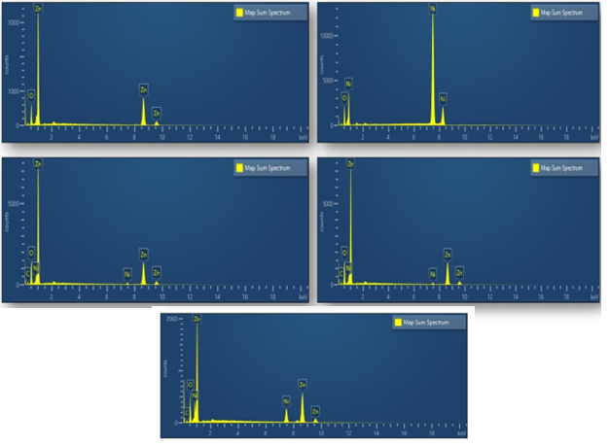
Fig. 4 Energy dispersive X-ray Analysis (EDAX) of ZnO, NiO, 5%, 10% and 20% NiO-ZnO composite
Table 1Elemental composition of synthesized pure ZnO, NiO, and NiO-ZnO nanocomposites determined by EDAX (Weight % and Atomic %)
Sample | Element | Wt% | Atomic%
Zno(S4) | O  Zn | 17.79  82.21 | 46.92  53.08
Nio (S5) | O  Ni | 5.96  94.04 | 18.87  81.13
5%Nio-Zno (S6) | C  O  Ni  Zn | 7.69  16  0.45  75.87 | 22.79  35.61  0.27  41.33
10%Nio-Zno(S7) | C  O  Ni  Zn | 10.99  20.81  1.64  66.56 | 28.05  39.88  0.86  31.21
20%Nio-Zno(S8) | C  O  Ni  Zn | 7.74  16.06  14.04  62.16 | 22.70  35.37  8.42  33.50

3.3 Functional Properties (FTIR)
FTIR analysis (Fig. 5) identified the functional groups and chemical interactions. Broad absorption bands observed in the 400–600 cm⁻¹range are attributed to M-O (Metal-Oxygen) stretching vibrations, confirming the formation of the NiO-ZnO composite. The presence of peaks near 3400cm⁻¹and 1635 cm⁻¹are assigned to O-H stretching and bending vibrations, respectively, likely originating from moisture or phytochemical residues from the Aloe vera extract.
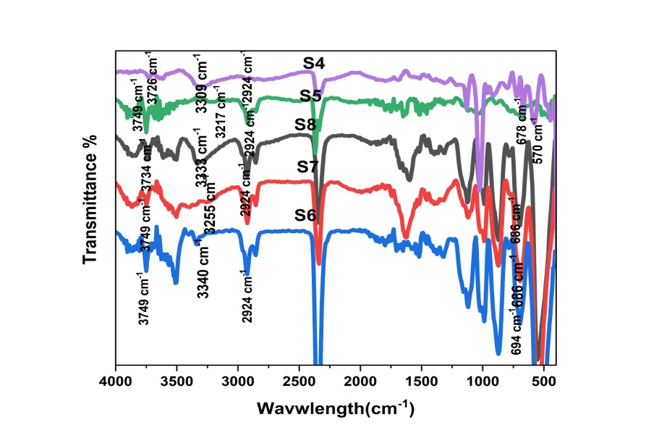
Fig. 5 Function Analysis (FTIR) ofZnO, NiO, 5%, 10% and 20% NiO-ZnO composite

3.4 Dielectric Properties
The frequency-dependent dielectric parameters, including dielectric constant (Ԑ’), loss tangent (tan δ), and complex impedance (Z), were evaluated at room temperature for pure ZnO, pure NiO, and NiO-ZnO composites.

3.4.1 Dielectric Constant (Ԑ’)
Figure 6 illustrates the frequency dependence of the dielectric constant for pure samples and NiO-ZnO composites with varying NiO concentrations (5%, 10%, and 20%). All samples exhibit a characteristic decrease in (Ԑ’), as the applied field frequency increases from 100 Hz to 2 MHz. This phenomenon is attributed to the dispersion caused by interfacial (space-charge) and dipolar polarization. At lower frequencies, these polarizations can follow the alternating field, resulting in higher(Ԑ’) values, whereas at higher frequencies, they fail to keep pace, causing the dielectric constant to diminish. Interestingly, pure ZnO possesses a higher dielectric constant compared to pure NiO. The incorporation of NiO significantly modulates the dielectric response; specifically, the 5% NiO-ZnO composite demonstrates the highest dielectric constant among all studied samples, exceedingly even that of pure ZnO. However, further increasing the NiO concentration to 10% and 20% results in a progressive decrease indielectric constant (Ԑ’).

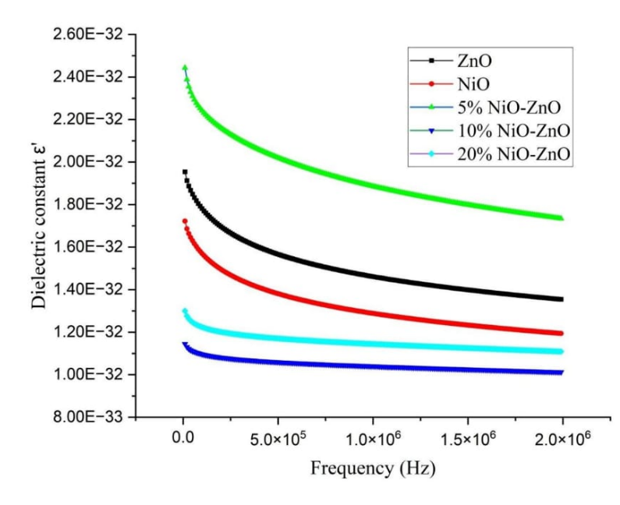
Figure 6 Variation of the dielectric constant of pure samples ZnO and NiO and NiO-ZnO composites with varying NiO concentrations (5%, 10%, and 20%)

3.4.2 AC Conductivity (σ)
The electrical conductivity behaviour at higher frequencies is presented in Figure 7. For all samples synthesized via the green route, the AC conductivity remains relatively stable up to approximately 5 Hz, followed by a gradual increase beyond this threshold. This frequency-dependent increase in conductivity is characteristic of the hopping of charge carriers between localized defect states.Overall, the composite materials exhibit lower conductivity compared to pure ZnO. This reduction is primarily due to the formation of p-n heterojunctions at the interfaces between n-type ZnO and p-type NiO. These junctions act as potential barriers, hindering carrier transport. Furthermore, the substitution of Ni into the ZnO lattice may introduce lattice strain and additional defects, which further restrict the concentration and mobility of charge carriers.

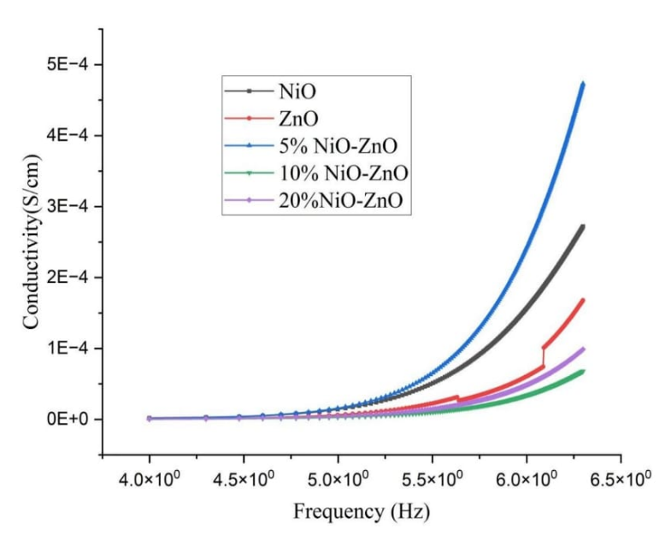
Figure 7 The relation between electrical conductivity and frequency
3.4.3 Complex Impedance Analysis
Figure 8 displays the Nyquist plots (Z' vs. Z''), revealing the impedance response dictated by grain and grain boundary resistances. The distinct responses observed for pure ZnO and NiO shift significantly upon composite formation. As the NiO content increases, a clear trend of increasing overall resistance is observed, particularly at lower frequencies, confirming the resistive nature of the formed p-n interfaces.
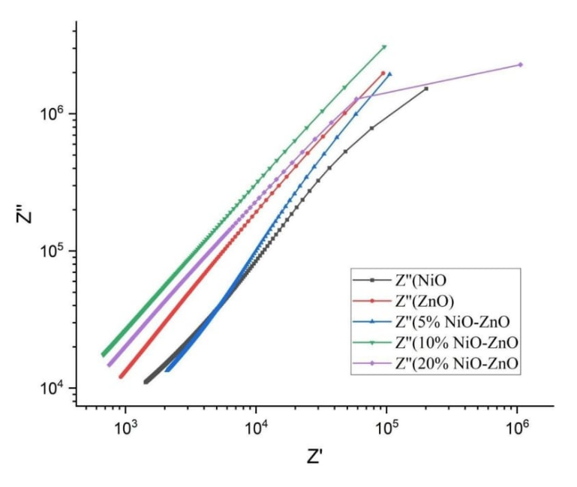
Figure 8 Nyquist plots (Z′ vs. -Z″) of pure samples ZnO and NiO and NiO-ZnO composites with varying NiO concentrations (5%, 10%, and 20%)
3.4.4 Dielectric Loss (tan δ)
The variation of the loss tangent with frequency is shown in Figure 9. Pure NiO exhibits a significant loss owing to its inherent conductivity and polarization mechanisms. While the 5% NiO-ZnO composite shows the highest loss (most dissipative) due to enhanced interfacial effects, higher NiO loadings (10% and 20%) lead to a marked reduction intan δ. This suggests that at higher concentrations, suppressed loss mechanisms and microstructural changes contribute to the development of high-quality dielectric materials.

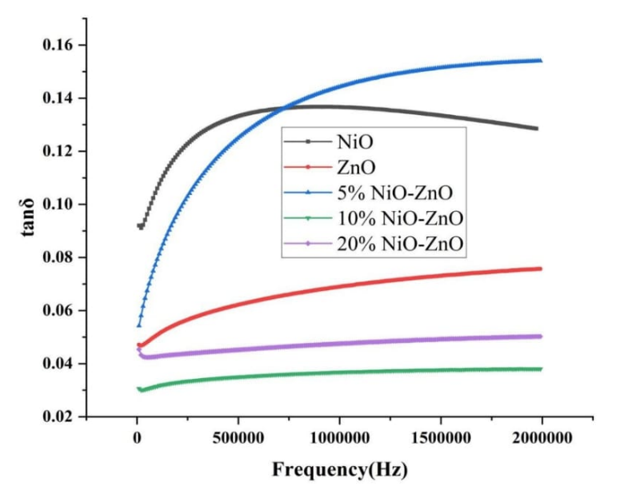
Figure 9 Graph of Tangent Loss vs Frequency of pure samples ZnO and NiO and NiO-ZnO composites with varying NiO concentrations (5%, 10%, and 20%)

3.5 Antimicrobial activity

The antibacterial potential of the nanomaterial was evaluated alongside a standard antibiotic, Tetracycline, using the agar well diffusion method [27-29]. The study targeted three Gram-positive bacterial strains—Staphylococcus aureus (ATCC 25923), Bacillus cereus (ATCC 11778), and Corynebacterium rubrum (ATCC 14898)—and three Gram-negative strains—Escherichia coli (NCIM 2931), Klebsiella pneumoniae (NCIM 2719), and Pseudomonas aeruginosa (ATCC 27853).All microorganisms were sourced from the National Chemical Laboratory (NCL), Pune, India, and maintained at 4°C. Molten Mueller-Hinton Agar (MHA), cooled to 40–42°C, was seeded with 200 μL of microbial inoculum (standardized to 1 × 10⁸CFU/mL) and poured into sterile Petri dishes.Subsequently, wells were created in the solidified agar, and 100 μL of the test agent (20 mg/mL dissolved in 100% DMSO) was introduced into each well. Pure DMSO served as the negative control to ensure that any observed inhibition was not due to the solvent. The plates were incubated at 37°C for 24 hours. Antibacterial efficacy was quantified by measuring the diameter of the Zone of Inhibition (ZOI) in mm. All experiments were performed in triplicate, and the results are reported as mean values.
The results of the antimicrobial assay are illustrated in Figure 10 and summarized in Table 2. The test sample 10% NiO-ZnO composite (S4) exhibited measurable inhibitory effects across various strains, with the highest activity observed against Staphylococcus aureus.
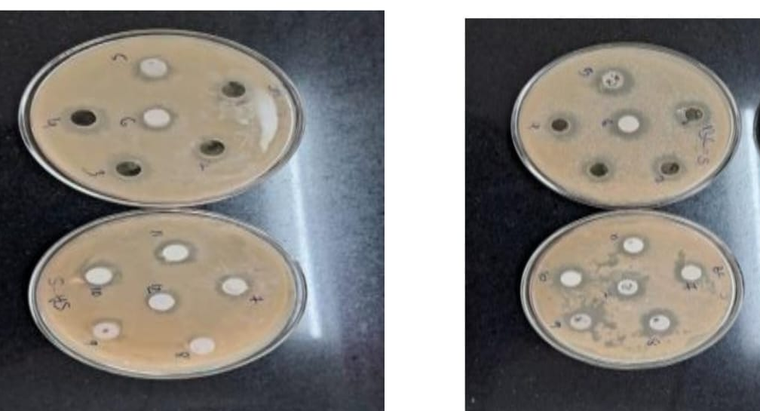

Fig 10 Inhibition zone of pure samples ZnO and NiO and NiO-ZnO composites (5%, 10%, and 20%) and standard antibiotic

Table 2: Zones of Inhibition (mm) of SamplesZnO and NiO and NiO-ZnO composites (5%, 10%, and 20%) against various bacterial strains

Sr.No | SA | BC | CR | EC | KP | PA
S4 | 19 | 15.5 | 13.5 | 19 | 15.5 | 13.5
S5 | 14.5 | 16 | 12.5 | 14.5 | 16 | 12.5
S6 | 14 | 21 | 14.5 | 14 | 21 | 14.5
S7 | 15.5 | 16.5 | 15.5 | 15.5 | 16.5 | 15.5
S8 | 13.5 | 17.5 | 13 | 13.5 | 17.5 | 13
T | 14.5 | 15 | 12.5 | 19.5 | 27.5 | 15.5

4. Conclusion
This research successfully demonstrated the green synthesis of NiO-ZnO nanocomposites using Aloe vera leaf extract via a sustainable sol-gel route. XRD analysis confirmed the characteristic hexagonal wurtzite structure of ZnO and the FCC phase of NiO, with average crystallite sizes ranging between 19 and 20 nm. SEM imaging revealed a mixture of hexagonal and spherical morphologies. Notably, the 10% NiO-ZnO composite exhibited superior antimicrobial efficacy against both Gram-positive and Gram-negative bacteria compared to the standard antibiotic Tetracycline. Furthermore, the tuneable dielectric properties suggest that these nanocomposites are highly suitable for advanced electronic and biomedical applications.
Acknowledgments: The authors are grateful to the Department of Physics at Bhartiya Vidya Bhavan’s Shri Ishvarlal L. P. Arts-Science & J. Shah Commerce College, Dakor, for providing the necessary facilities and encouragement. Special thanks are extended to the Department of Physics at Sardar Patel University, Vallabh Vidyanagar, for their consistent support throughout the study. We sincerely appreciate the technical assistance and resources provided by the Department of Nanoscience at Saurashtra University, Rajkot. The contribution of the Department of Chemistry at Saurashtra University, Rajkot, in facilitating specific experimental requirements is gratefully acknowledged. We would also like to thank the Department of Biosciences at Saurashtra University, Rajkot, for their cooperation and for making their laboratory space available. The authors recognize the Center for Nanoscience & Nanotechnology at Sathyabama Institute of Science and Technology for their invaluable expertise and instrumental support.

Conflicts of Interest:
The authors declare that there are no conflicts of interest.
This study was conducted in accordance with ethical standards. This study did not involve human or animal participants, and ethical approval was not required.

References

[1] A. M. El Shafey, "Green synthesis of metal and metal oxide nanoparticles from plant leaf extracts and their applications: A review," Green Process. Synth. 9, 304 (2020).
[2] T. Mazhar, "Green Synthesis of Bimetallic Nanoparticles and its Applications: A review," J. Pharm. Sci. Res. 9, 102 (2017).
[3] Tebelay Liknaw (2025) Aloe Vera leaf extract as a sustainable route for silver nanoparticle synthesis with enhanced antimicrobial activity. Scientific reports (2025)
[4] S. Kumari, "A comprehensive review on various techniques used for synthesizing nanoparticles," J. Mater. Res. Technol. 27, 1739 (2023).
[5] M. Y. Ghotbi, "Nickel doped Zinc Oxide nanoparticles produced by hydrothermal decomposition of nickel-doped Zinc hydroxide nitrate," Particuology10, 492 (2012).
[6] M. Patel, "Synthesis of ZnO&CuO nanoparticles via Sol gel method and its characterization by using various technique," Discover Mater.2, 1 (2022).
[7] A. K. Azfar, "Comparative study on photocatalytic activity of transition metals (Ag & Ni) doped ZnO nanoparticles synthesized via sol-gel method," R. Soc. Open Sci. 7, 191590 (2020).
[8] S. S. Hasson, "Synthesis of Nickel Oxide nanoparticles by Sol-gel method," Int. J. Health Sci. 6, 6915 (2022).
[9] S. Singh, "Green Synthesis of Zinc Oxide Nanoparticles using Aloe Vera: A study on optical properties & Photocatalytic activity," ORCID (2024).
[10] M. Swain, "A review on green Synthesis of ZnO nanoparticles," Discover Appl. Sci. 7, 997 (2025).
[11] N. Goswami, "Structural Transformation in nickel doped zinc oxide nanostructures," Mater. Res. Bull. 48, 346 (2013).
[12] K. L. Mary, "Phytochemical assisted synthesis of Ni doped ZnO nanoparticles using aloe vera extract for enhanced photocatalytic and antimicrobial activities," Dig. J. Nanomater. Biostruct. 17, 634 (2022).
[13] Z. H. Alhashem, "Ni-doped ZnO nanoparticles derived by the sol-gel method: structural, optical, & magnetic characteristics," Arab. J. Chem. 17, 105701 (2024).
[14] M. I. Din, "Recent advances in the synthesis and stabilization of nickel & nickel oxide Nanoparticles: A green Adeptness," Int. J. Anal. Chem. 2016, 3512145 (2016).
[15] C. Vijayaraj, "Synthesis & Characterization of Ni Doped ZnO Nanoparticles and Study of their Antimicrobial Activity," Indian J. Sci. Technol. 16, 3927 (2023).
[16] D. Mohammadyani, "Characterization of nickel oxide nanoparticles synthesized via rapid microwave–assisted route," Int. J. Mod. Phys. Conf. Ser. 5, 270 (2012).
[17] J. Xu, "A review of the green synthesis of ZnO nanoparticles using plant extracts & their prospects for application in antibacterial textiles," J. Eng. Fibers Fabr. 16, 1 (2021).
[18] B. Naiel, "Green synthesis of Zinc Oxide nanoparticles using Sea Lavender (Limonium pruinosum L. Chaz.) Extract: Characterization, evaluation of anti-skin cancer, antimicrobial and antioxidant potentials," Sci. Rep. 12, 20370 (2022).
[19] A. Haider, "Green synthesized Phytochemically (Zingiber officinale & Allium Sativum) Reduced Nickel oxide nanoparticles Confirmed Bactericidal and Catalytic potential," Nanoscale Res. Lett. 15, 50 (2020).
[20] G. Sangeetha, "Green synthesis of Zinc oxide nanoparticles by aloe barbadensis miller leaf extract: Structure and optical properties," Mater. Res. Bull. 46, 2560 (2011).
[21] [21] K.P. Sampath kumar, Debjit Bhowmik, Chiranjib, Biswajit (2010) Aloe vera : A potential Herb abd its Medicinal Importance. Journal of chemical and pharmaceutical research,2010,2(1):21-29
[22] Chang Liu, (2019) Extraction,purification,Structural Charecteristics, Biological Activities and Pharmacological Applications of Acemannan,a polysaccharide from Aloe vera: A Rivew. Molecules 2019,24(8),1554

[23] A. Lins, "Facile Synthesis of Ni-Doped ZnO Nanoparticles Using Cashew Gum: Investigation of the Structural, Optical & Photocatalytic Properties," Molecules28, 7772 (2023).
[24] Jha, A. K. (2024). Dielectric properties of Dual phase (Cu-Zn-Ni-Mg-Fe) O High Entropy Oxide. Indian Journal of Pure & Applied Physics, 62, 133-143.
[25] Mohit Bhatt, kajal Gautam, Akarsh Verma, A.K. Sinha(2025) Structural, Optical, surface chemical, and electrochemical characterization of Aloe vera-assisted ZnO nanostructures for supercattery applications. Material Advances , volume 6, Issue 16, 8 July 2025, pages 5618-5632

[26] Yadav, A. (2025). Structural, morphological, dielectric and semiconducting properties of ZnO nanoparticles calcined at 500℃. RSC Advances, 15, 36749
[27] Haider, A., Ijaz, M., Ali, S. et al. Green Synthesized Phytochemically (Zingiber officinale and Allium sativum) Reduced Nickel Oxide Nanoparticles Confirmed Bactericidal and Catalytic Potential. Nanoscale Res Lett 15, 50 (2020).
[28] Barrett, C. S. (1943). Structure of Metals. New York: McGraw-Hill Book Company, Inc.
[29] Yogamalar, R., et al. (2009). X-ray peak broadening analysis in ZnO nanoparticles. Solid State Communications, 149, 1919–1923.
[30] Ismail, M. A. (2018). ZnO nanoparticles: Surface & X-Ray profile analysis. Journal of Ovonic Research, Vol. 14, No. 5, pp. 381–393
[31] Balouiri, M., Sadiki, M., & Ibnsouda, S. K. (2016). Methods for in vitro evaluating antimicrobial activity: A review. Journal of Pharmaceutical Analysis, 6(2), 71–79.
[32] Bonev, B., Hooper, J., & Parisot, J. (2008). Principles of assessing bacterial susceptibility to antibiotics using the agar diffusion method. Journal of Antimicrobial Chemotherapy, 61(6), 1295–1301.
[33] Gonzalez-Pastor, R., Carrera-Pacheco, S. E., Zúñiga-Miranda, J., Rodríguez-Pólit, C., Mayorga-Ramos, A., Guamán, L. P., & Barba-Ostria, C. (2023). Current Landscape of Methods to Evaluate Antimicrobial Activity of Natural Extracts. Molecules, 28(3), 1068.

