Original Research Article

Design of Models and Approaches for commercialization strategy of armored catfish (Pterygoplichthys spp.) in fishing cooperatives in Southeastern Mexico

.
ABSTRACT

Aims: This study aimed to design a strategic framework for the commercialization of armored catfish (Pterygoplichthys spp.) as raw fillet in fishing cooperatives in Southeastern Mexico, integrating organizational, technical, commercial, and sustainability components.
Study design: The research followed a design science research approach focused on the development and validation of a conceptual strategic model without direct field intervention.
Place and Duration of Study: The study was contextualized in the state of Tabasco, Mexico, considering approximately 150 fishing cooperatives involved in armored catfish capture activities. The research was conducted between 2024 and 2025.
Methodology: The strategy was developed through the integration of scientific literature, conceptual frameworks related to economy, cooperative management, and technical considerations for fish processing and commercialization. The model was validated through expert evaluation by a panel of seven specialists in fisheries, sustainability, food processing, and cooperative management using an iterative feedback process.
Results: The proposed model integrates five interconnected components: organizational strengthening, technical processing, financial structure, commercialization strategy, and sustainability integration. Expert evaluation indicated high relevance, feasibility, and adaptability of the model for fishing cooperatives operating in socio-ecological contexts affected by invasive species. The results also highlighted the importance of WhatsApp-based training and artificial intelligence-supported infographics as accessible mechanisms for improving knowledge transfer in rural communities. Previous practical training experiences involving more than 80 cooperative members demonstrated the technical viability of filleting armored catfish and reinforced the practical applicability of the proposed framework. Socially, the model may contribute to alternative income generation, strengthening cooperative organization, and promoting sustainable rural development through the productive utilization of an invasive species.
Conclusion: The study provides a structured and replicable strategy for transforming an invasive species into an economic opportunity. The model contributes to sustainable fisheries development by linking environmental management, value-added commercialization, and community-based capacity building. Future research should focus on pilot implementation and longitudinal evaluation of the model in real cooperative contexts.

Keywords: Aquaculture; Invasive species; Fisheries; Cooperatives; Sustainable development

1. INTRODUCTION

In recent decades, the transformation of underutilized and invasive aquatic species into economically valuable resources has received increasing attention (Rodríguez Gregorio et al., 2024). This approach has been proposed as a strategy to address environmental degradation and economic vulnerability in fisheries-dependent regions. At a global scale, invasive fish species represent a major ecological challenge because they alter trophic dynamics, displace native species, and generate significant economic losses in fisheries and aquatic ecosystems. Emerging approaches within sustainable development and circular economy frameworks increasingly promote the productive utilization of invasive species. These species can serve as alternative protein sources and as components of value-added production chains.
In Mexico, the armored catfish (Pterygoplichthys spp.), commonly known as “Bagre Armado” or “Pez Diablo” has become one of the most problematic invasive species in freshwater ecosystems. Its rapid reproductive capacity, environmental adaptability, and lack of natural predators have facilitated its expansion across rivers, lagoons, and wetlands in Southeastern states such as Tabasco, Chiapas, and Veracruz. The species has generated ecological impacts associated with competition against native fish populations, alteration of benthic habitats, and interference with artisanal fishing activities. At the same time, its increasing abundance represents an underutilized productive opportunity, particularly in southeastern Mexico, where fishing communities face declining catches of traditional species and increasing economic pressures. Recent initiatives have explored the use of armored catfish as a food resource in rural communities, highlighting its potential contribution to food security and regional development (Rodríguez Gregorio et al., 2024).

In Tabasco, inland fisheries represent an important economic activity for rural communities, where fishing cooperatives contribute to employment generation, regional food provision, and regional development. Approximately 150 fishing cooperatives participate directly or indirectly in freshwater fisheries in the region. Within the framework of the social and solidarity economy, cooperatives promote collective action, social inclusion, and shared economic benefits (Díaz de León et al., 2021). However, several studies have documented structural limitations affecting fishing cooperatives in Mexico, including weak organizational capacity, limited professionalization in administrative management, insufficient commercialization strategies, and restricted market access, all of which reduce competitiveness and long-term sustainability (Gladstone et al., 2025, 2012; García Rodríguez et al., 2021).

At the regional level, fishing cooperatives operate within socio-ecological systems increasingly affected by environmental degradation, overfishing, climate variability, and institutional transformations (Espinoza-Guzmán et al., 2024). Furthermore, neoliberal restructuring processes and market liberalization have weakened organizational cohesion and adaptive capacity within cooperative fisheries systems (Espinoza-Tenorio et al., 2017). These conditions highlight the need for integrative strategies that combine environmental management, economic diversification, organizational strengthening, and sustainable commercialization.

Despite the ecological relevance and growing availability of armored catfish, there remains a lack of structured strategies integrating organizational, technical, and commercial dimensions for its productive utilization. Existing initiatives have primarily focused on ecological control measures or isolated productive experiences without addressing the systemic conditions required to transform this invasive species into a viable economic resource within cooperative frameworks. In particular, the commercialization of armored catfish as raw fillet remains insufficiently explored from an organizational and strategic perspective, despite its potential to generate value-added products and improve income opportunities for fishing communities.

Recent studies have emphasized the importance of strengthening business development capacities, sustainability awareness, and participatory training processes in rural communities as mechanisms for economic transformation and resilience (Oropeza-Tosca et al., 2024). Likewise, governance processes, collective participation, and sustainability-oriented management strategies have been identified as key elements for improving the adaptive capacity and performance of fishing cooperatives (Sari & Rahmayanti, 2022; Torre et al., 2019).

To address this gap, this study adopts a design science research approach focused on the development of a structured and replicable strategy for the commercialization of armored catfish as raw fillet. The study emphasizes the conceptual and methodological design of a strategic framework grounded in scientific evidence and validated through expert evaluation rather than direct field intervention (Hevner et al., 2004).

Therefore, the objectives of this study were: (1) To design a strategic framework for the commercialization of armored catfish (Pterygoplichthys spp.) as raw fillet in fishing cooperatives in Southeastern Mexico. (2) To integrate organizational, technical, financial, commercial, and sustainability components into a replicable cooperative model. (3) To evaluate the relevance and feasibility of the proposed framework through expert validation. (4) To identify accessible digital training mechanisms capable of supporting knowledge transfer processes in rural fishing communities.
Because this study follows a design science research approach focused on conceptual model development, no statistical hypothesis testing was conducted.

2. material and methods

2.1 Research design
This study adopted a design science research approach focused on the creation and evaluation of practical solutions to real-world problems (Hevner et al., 2004). The proposed artifact consisted of a strategic framework for the commercialization of armored catfish as raw fillet within fishing cooperatives in Southeastern Mexico.

The research was applied, non-experimental, and cross-sectional. It did not involve direct field intervention or quantitative data collection from cooperatives. Instead, the study focused on the conceptual development of a commercialization strategy based on scientific literature, sustainability principles, cooperative management, and technical criteria for fish processing.

The methodological process included literature review, integration of organizational and commercial components, development of the strategic framework, and expert validation through iterative feedback. This approach allowed the development of a structured and replicable model adapted to regional fishing cooperatives.

2.2 Study area and context
The study was conducted in Southeastern Mexico, particularly in the state of Tabasco, where small-scale fisheries represent an important component of regional livelihoods. The region is characterized by lagoon, riverine, and coastal ecosystems that support fishing cooperatives as relevant economic actors. The increasing presence of armored catfish, an invasive species that has affected ecological balance and traditional fishing activities, provides a relevant context for the design of alternative commercialization strategies. This scenario highlights the need for integrative approaches that connect environmental management with economic opportunities through value-added utilization (Berkes, 2018; Armitage et al., 2011).

2.3 Target population and scope
The target population consisted of approximately 150 fishing cooperatives in Tabasco engaged in armored catfish capture activities. These cooperatives operate within socio-ecological systems that combine productive, organizational, and environmental dimensions.

The cooperatives were considered as the reference context for the development of the proposed strategy. However, no direct data collection, surveys, or fieldwork activities were conducted with cooperative members. The study maintained a conceptual and design-oriented approach to ensure that the proposed framework reflected realistic operational conditions within regional fishing cooperatives.

2.4 Strategy development approach
The commercialization strategy was developed through a structured design process based on scientific literature and conceptual frameworks related to fishing cooperatives, commercialization, value chains, social and solidarity economy, and sustainable resource management. Technical considerations associated with fish processing, handling, and raw fillet commercialization were also incorporated.

The proposed strategy was designed to address limitations identified in previous studies, including weak organizational capacity, limited value addition, and restricted market access. The resulting framework integrates organizational, productive, and commercial components into a coherent and replicable model for regional fishing cooperatives.

2.5 Model design
The strategic model was developed as a conceptual and operational framework that enables fishing cooperatives to transition from extractive activities to value-added commercialization of armored catfish. The model includes organizational structure and role definition, technical guidelines for processing and filleting, financial and cost considerations, identification of commercialization channels and market opportunities, and sustainability criteria related to invasive species management.

These components were integrated to ensure internal coherence and practical applicability. The model was designed to be adaptable to similar socio-ecological contexts and to support decision-making processes within cooperative systems.

2.6 Model validation
The proposed strategy was validated through expert evaluation. A panel of seven specialists was selected based on their experience in fisheries, cooperative management, sustainable development, and food processing.

The validation process included delivery of the initial model, individual evaluation according to relevance, coherence, feasibility, and applicability criteria, collection of recommendations, and refinement of the framework based on expert feedback.

This iterative process contributed to the robustness and credibility of the proposed strategy and supported its alignment with technical and contextual requirements (Reed et al., 2018).

2.7 Ethical considerations
This study does not involve direct interaction with human subjects or the collection of primary data. Therefore, no personal or sensitive information is processed. Nevertheless, ethical principles are observed throughout the research process, including transparency in the design methodology, proper acknowledgment of expert contributions, and responsible use of scientific information.

3. results and discussion

3.1 The state of the art and empirical background

Current literature indicates that studies on fishing cooperatives in Mexico and similar contexts have mainly focused on organizational strengthening, governance, and sustainability. Previous research highlights the importance of improving administrative capacities, promoting collective action, and integrating sustainability principles to strengthen the resilience of cooperative systems (Díaz de León et al., 2021; García Lozano et al., 2023; Espinoza-Guzmán et al., 2024).

Research on invasive species management has primarily emphasized ecological control strategies, while limited attention has been given to their economic valorization. Although some initiatives have explored armored catfish as a food resource, these efforts remain fragmented and lack structured commercialization frameworks (Rodríguez Gregorio et al., 2024).

As an empirical reference, previous training experiences conducted in the community of Ismate y Chilapilla 2da sección, Tabasco, involved three fishing cooperatives with more than 80 participants. During these activities, a fish processing specialist provided hands-on training focused on filleting techniques for armored catfish. These experiences demonstrated the technical feasibility of processing the species and the willingness of cooperative members to adopt value-added practices.

Recent advances in digital education strategies in rural contexts suggest that platforms such as WhatsApp can support training processes due to their accessibility and flexibility. Likewise, the use of artificial intelligence-supported visual materials, including infographics, has been associated with improved comprehension and engagement in community-based learning environments (Jiménez-Márquez et al., 2025).

Despite these advances, there remains a limited integration of organizational, technical, and commercial dimensions into structured strategies capable of transforming armored catfish into a viable economic product within cooperative systems.

3.2 Strategic model for the commercialization of Armored Catfish

The proposed model was conceived as an integrative framework that enables fishing cooperatives to transition from extractive activities to value-added commercialization of armored catfish as raw fillets.

The model was structured around five interconnected components:
- Organizational strengthening: defines roles, coordination mechanisms, and decision-making processes that support productive and commercial activities within cooperatives.
- Technical processing: incorporates standardized guidelines for handling, filleting, processing, and preservation based on previous training experiences with cooperative members.
- Financial structure: includes cost estimation, pricing strategies, and income distribution mechanisms to evaluate the economic viability of commercialization.
- Commercialization strategy: identifies regional market opportunities, potential buyers, distribution channels, and value-added opportunities associated with armored catfish products.
- Sustainability integration: links productive activities with environmental management by promoting the utilization of an invasive species as an economic resource.

These components operate as an interconnected system designed to be adaptable and replicable across similar socio-ecological contexts.

3.3 Results of model validation
The model was validated through expert evaluation involving seven specialists in fisheries, cooperative management, sustainability, and food processing. Overall, the experts reported strong agreement regarding the relevance, coherence, feasibility, and applicability of the proposed framework. The evaluation indicated that the model adequately integrates organizational, technical, commercial, and sustainability dimensions required for armored catfish commercialization within regional fishing cooperatives.

Experts particularly emphasized the importance of organizational strengthening and commercialization planning as critical elements for improving cooperative competitiveness and market participation. Likewise, the integration of sustainability principles was considered relevant because the model connects environmental management of an invasive species with value-added economic opportunities.

The results of the expert validation are summarized in Table 1, highlighting the main evaluation criteria and the corresponding adjustments incorporated into the model.

Table 1. Expert validation of the proposed strategic model

Criterion | Description | Experts’ Assessment | Key Observations | Model Adjustment
Relevance | Alignment of the model with cooperative needs | High | Addresses organizational, technical, and market gaps | No major changes
Internal coherence | Logical integration among model components | High | Strong linkage between components | Minor wording refinements
Feasibility | Practical applicability in fishing cooperatives | Moderate–High | Requires accessible training mechanisms | Inclusion of WhatsApp-based delivery
Applicability | Adaptability to regional contexts | High | Suitable for similar socio-ecological systems | Emphasis on replicability
Knowledge transfer | Effectiveness of training approach | High | Visual tools improve comprehension | Integration of AI-based infographics
Technological accessibility | Ease of use of proposed digital tools | High | WhatsApp widely used by cooperative members | Formal inclusion of mobile learning strategy

A key recommendation derived from the validation process was the use of WhatsApp as the primary platform for delivering training content. Experts highlighted its accessibility, familiarity among users, and capacity to facilitate continuous communication and asynchronous learning.

Additionally, the incorporation of visual educational materials, particularly artificial intelligence-supported infographics, was identified as an important element for improving knowledge transfer. These tools facilitate the communication of technical processes in a simplified and accessible manner, consistent with findings reported in rural training models (Jiménez-Márquez et al., 2025).

Based on expert feedback, the model was refined to include a digital training component supported by WhatsApp and AI-supported visual materials.

3.4 Program for Implementation

Although this study did not include direct implementation, a structured program was proposed to guide future application of the model (Fig. 1). The program was designed considering previous training experiences conducted with fishing cooperatives in Tabasco, where more than 80 participants received practical instruction related to filleting and processing activities.

The implementation program consists of four stages:

Stage 1. Introduction and awareness: presentation of the strategy, including its economic, environmental, and organizational relevance. This stage aims to increase awareness regarding the productive utilization of armored catfish as a value-added resource and to promote cooperative participation.

Stage 2. Training and capacity building: delivery of training modules through WhatsApp supported by infographics and visual educational materials. This stage reinforces technical skills related to filleting, handling, preservation, hygiene, and commercialization processes. Artificial intelligence-supported infographics are incorporated to simplify technical information and improve accessibility in rural contexts.

Stage 3. Pilot application: initial implementation of the framework in selected fishing cooperatives to evaluate operational organization, processing activities, commercialization channels, and product acceptance under regional conditions.

Stage 4. Evaluation and adjustment: assessment of implementation outcomes and refinement of the framework based on practical experience, cooperative feedback, and operational observations to improve future scalability and adaptability.
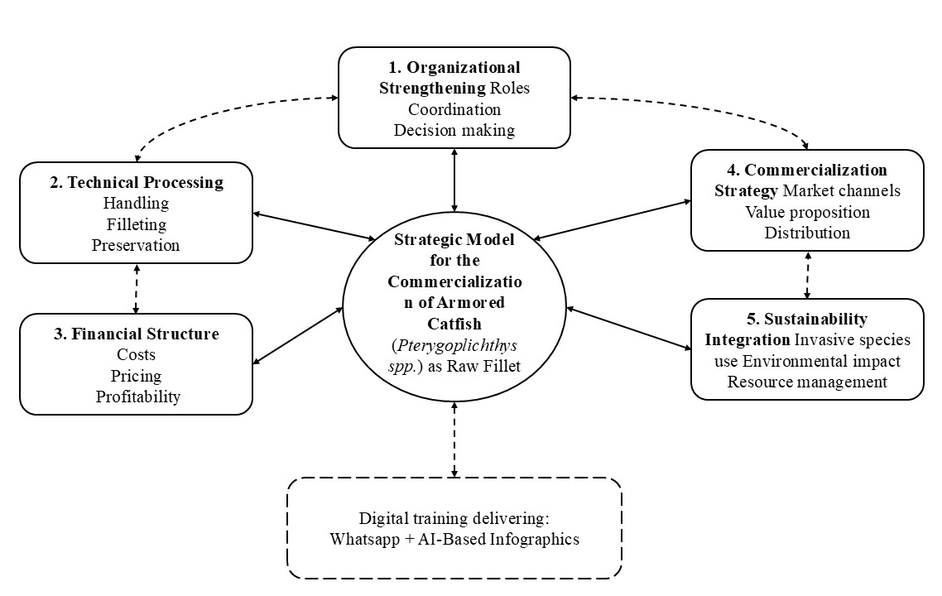

Fig. 1. Strategic model for the commercialization of armored catfish as raw fillet in fishing cooperatives

As shown in Fig. 2, the preparation of raw marinated fillets using traditional ingredients represents a practical example of value addition at the community level. Ingredients such as salt, black pepper, sour orange juice, and crushed garlic improve flavor and contribute to basic preservation, facilitating short-term storage and commercialization. During training activities associated with government-supported programs, fishermen also developed the initiative of presenting armored catfish as vacuum-packed raw fillets, demonstrating interest in developing products with greater commercial value. This experience suggests a potential pathway toward small-scale private industry development led by the cooperatives themselves, while reducing uncertainty and fear associated with productive investment. Overall, these products demonstrate the feasibility of transforming armored catfish into a marketable food item with regional identity.

Additionally, previous training and community-based activities developed in Tabasco have demonstrated growing interest among fishing cooperatives in the productive utilization of armored catfish through value-added strategies. During workshops and practical demonstrations, cooperative members participated in filleting, vacuum packaging, marinating, and product presentation activities oriented towards regional commercialization. These experiences revealed that fishermen perceived armored catfish not only as an invasive species, but also as a potential economic resource capable of generating alternative income opportunities. Community participation also showed increasing interest in developing cooperative-led microenterprises, improving product presentation, and accessing new commercialization channels in regional markets. Furthermore, educational and training processes supported by visual materials and digital communication tools facilitated knowledge transfer and strengthened confidence regarding the feasibility of future productive investment and commercialization initiatives.

Fig. 2. Raw marinated fillets of armored catfish prepared in a rural community in Southeastern Mexico.

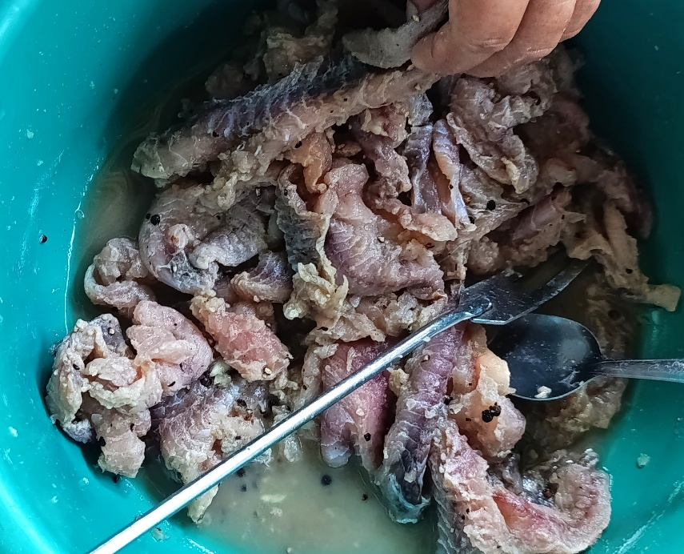

4. Discussion

The findings of this study contribute to current discussions on the integration of environmental management, cooperative development, and sustainable commercialization within fisheries-dependent socio-ecological systems. Unlike conventional approaches focused mainly on the ecological control of invasive species, the proposed framework promotes the productive utilization of armored catfish as a value-added economic resource. This perspective aligns with recent circular economy approaches emphasizing the transformation of environmental challenges into productive and sustainable opportunities (Ziegler et al., 2025; Ndoka et al., 2025).
From an organizational perspective, the proposed model reinforces the importance of fishing cooperatives as strategic actors for regional development and community resilience. Previous studies have shown that governance, collective participation, and organizational strengthening are fundamental for improving the sustainability and adaptive capacity of cooperative fisheries systems (Díaz de León et al., 2021; García Lozano et al., 2023). Similarly, Espinoza-Guzmán et al. (2024) highlighted that sustainability-oriented management practices are essential for strengthening fishing cooperatives operating under environmental and economic pressures in the Gulf of Mexico. In this study, these organizational principles were integrated with commercialization and processing strategies to develop a more comprehensive and operational framework.
The inclusion of technical processing and training components was supported by previous practical experiences conducted in Ismate y Chilapilla 2da sección, Tabasco, where cooperative members participated in filleting and processing activities. These experiences demonstrated that hands-on training can facilitate the transition from extractive activities to value-added commercialization processes. In this sense, participatory and action-oriented learning approaches become particularly relevant in cooperative environments. According to Elliott (1993), learning processes become more effective when participants actively engage in practical problem solving and reflection within their own contexts. This perspective supports the incorporation of experiential and community-based learning into commercialization strategies for regional fisheries.
Another important contribution of the study was the integration of digital training mechanisms through WhatsApp and artificial intelligence-supported visual materials. Expert validation indicated that these tools may improve accessibility, comprehension, and communication in rural training processes. Similar findings were reported by Jiménez-Márquez et al. (2025), who identified that digital and visual educational strategies can strengthen knowledge transfer and participation in rural communities through accessible technological platforms. In the present study, AI-supported infographics were considered especially useful for simplifying technical information related to processing, commercialization, and sustainability practices.
Regarding commercialization, the proposed framework addresses a significant gap identified in previous studies related to the limited development of structured market strategies within fishing cooperatives. By positioning armored catfish as both an environmental management alternative and a marketable product, the model creates a dual economic and ecological value proposition. This approach is consistent with recent literature emphasizing that circular business models can contribute to sustainability transitions by integrating economic, environmental, and organizational dimensions into cooperative systems (Ziegler et al., 2025; Ndoka et al., 2025).
The integration of sustainability principles into the model also represents an important contribution. The productive utilization of armored catfish may reduce ecological pressure associated with invasive species while simultaneously generating alternative income opportunities for fishing communities. This relationship between environmental management and economic diversification is particularly relevant in regional fisheries affected by declining traditional catches, market instability, and environmental degradation.
Despite these contributions, the study has limitations that should be acknowledged. The proposed model remains conceptual and was not empirically implemented within fishing cooperatives, limiting the evaluation of operational performance under real commercialization conditions. Additionally, the validation process was based on expert judgment rather than field experimentation or longitudinal assessment. Future research should focus on pilot implementation, economic feasibility analysis, and long-term evaluation of the framework within regional cooperative systems.
5. Conclusion

This study presents a design science based strategic model for the commercialization of armored catfish as raw fillet in fishing cooperatives in Southeastern Mexico. The model integrates organizational strengthening, technical processing, financial structure, commercialization pathways, and sustainability principles into a coherent and replicable framework. Expert validation supports its feasibility and highlights the relevance of digital training through WhatsApp and AI based infographics. Although the model has not yet been implemented, it provides a practical foundation for transforming an invasive species into an economic opportunity. Future research should focus on pilot testing and evaluating its impact in real cooperative contexts.

Limitations of the study

This study has several limitations that should be acknowledged. First, the proposed framework was conceptual and was not empirically implemented within fishing cooperatives, limiting the evaluation of operational performance under real commercialization conditions. Second, the validation process was based on expert evaluation rather than long-term field experimentation or quantitative economic analysis. Third, the study focused on regional fishing cooperatives in Tabasco, Southeastern Mexico, which may limit the direct applicability of the framework to other socio-ecological contexts without adaptation. Finally, market acceptance, production scalability, and long-term profitability of armored catfish products were not evaluated during this research.

Recommendations

Future research should focus on pilot implementation of the proposed framework within fishing cooperatives to evaluate operational feasibility, economic performance, and market acceptance under real conditions. Additional studies should analyze consumer perception, profitability, and long-term sustainability of armored catfish commercialization strategies. It is also recommended to strengthen training programs through digital educational tools, including WhatsApp and artificial intelligence-supported visual materials, to facilitate knowledge transfer in rural communities. Furthermore, public institutions and cooperative organizations should promote support mechanisms that encourage value-added production, sustainable commercialization, and regional microenterprise development associated with invasive species utilization.

AcknowledgEments

The authors thank the fishing communities of Tabasco, particularly the Federación de Cooperativas Pesqueras y Permisionarios de Tabasco (FEDECOOPTAB), for their collaboration. They also acknowledge the support of the Tecnológico Nacional de México and its campuses in Villahermosa, Tuxtla Gutiérrez, Tlaxiaco, and La Chontalpa, as well as the Academic, Research and Innovation Secretariat.

No funding sources were involved in the design, analysis, or publication of this study.

Competing interests

Authors have declared that no competing interests exist.

Authors’ Contributions

Karina González-Izquierdo, Omar Jiménez-Márquez, and Diana Rubí Oropeza-Tosca conceptualized and designed the study and developed the strategic model. Gaudencio Lucas-Bravo contributed to project administration, including coordination of administrative procedures, organization of field visits, and facilitation of project approval processes. Víctor Manuel Ruiz-Valdiviezo provided expertise in biotechnology and food preservation, contributing to the technical components of the model. Pedro Ramón-Santiago and Rosario Pérez-Belmonte supported the validation process and contributed to the contextual and regional analysis. Alexandre Baptista contributed to the analytical review and strengthening of the scientific approach.
All authors read and approved the final manuscript.

Consent

Not applicable.

Ethical approval

This study did not involve human or animal experimentation, nor the collection of personal or sensitive data. Therefore, formal approval from an Institutional Review Board or Ethics Committee was not required. The research focuses on the design of a strategic model and its validation through expert evaluation. All procedures were conducted in accordance with ethical principles for social research, ensuring voluntary participation of experts and confidentiality of their feedback.
Abbreviations
FEDECOOPTAB: Federación de Cooperativas Pesqueras y Permisionarios de Tabasco

Disclaimer (Artificial intelligence)
Author(s) hereby declare that NO generative AI technologies such as Large Language Models (ChatGPT, COPILOT, etc.) and text-to-image generators have been used during the writing or editing of this manuscript.

References

- Rodríguez Gregorio, L. L., Pantoja Sánchez, A. J., Montejo López, J., Oropeza-Tosca, D. R., Rivera Rodríguez, M., González Izquierdo, K., Angles Falconi, S. I., & Moreno García, B. V. (2024). Alimentación con bagre armado (Pterygoplichthys spp.) para escuelas de educación básica en comunidades rurales en el sureste de México. In Un puente innovador en las matemáticas y ciencias naturales - Chetumal 2024 (Vol. 16, No. 4, pp. 47–51). Zenodo. https://doi.org/10.5281/zenodo.13759836
- Díaz de León, D., Díaz Fragoso, O., Rivera, I., & Rivera, G. (2021). Cooperatives of Mexico: Their social benefits and their contribution to meeting the Sustainable Development Goals. Social Sciences, 10(5), 149. https://doi.org/10.3390/socsci10050149
- Gladstone, F. J., Basurto, X., Frawley, T., Nenadovic, M., Villalejo Navarro, J. E., Rodriguez-Van Dyck, S., Weaver, A. H., Micheli, F., Torre, J., & Leslie, H. M. (2025). Governing access and agency: Cooperative and non-cooperative forms influence small-scale fisher livelihood vulnerability and adaptation. Ecology and Society, 30(3), 23. https://doi.org/10.5751/ES-15964-300323
- García Rodríguez, L., Fuentes Guevara, D., & Pico González, B. (2021). Análisis de la actitud emprendedora en sociedades cooperativas pesqueras en México. REVESCO. Revista de Estudios Cooperativos, 139, e76632. https://doi.org/10.5209/reve.76632
- García Lozano, A., Méndez-Medina, C., Basurto, X., & Tercero Tovar, M. (2023). Multi-scalar politics of collective action among fishing cooperatives in Mexico. Environment and Planning E: Nature and Space. https://doi.org/10.1177/23996544231194426
- Espinoza-Guzmán, Barretto, J., M. A., Cruz-Cruz, C., & Pineda-López, M. R. (2024). Sustainability of fishing cooperatives in the Gulf of Mexico: A case study. Fisheries Research. https://doi.org/10.1016/j.fishres.2024.107105
- Espinoza-Tenorio, A., et al. (2017). The influence of neoliberalization on fishing cooperatives in Mexico. Marine Policy, 80, 96–106. https://doi.org/10.1016/j.marpol.2016.06.024
- Oropeza-Tosca, D. R., Rincón-Molina, C. I., Baptista, A., & Notario-Priego, R. (2024). Perspective chapter: Development of business in rural Southeastern Mexican communities and environmental awareness. In Sustainable Development. IntechOpen. https://doi.org/10.5772/intechopen.1007675
- Sari, D. K., & Rahmayanti, A. Y. (2022). Fishery Cooperatives and Sustainable Blue Economy: Scoping Review from a Business Perspective. Proceedings, 83(1), 30. https://doi.org/10.3390/proceedings2022083030
- Torre, J., Hernández-Velasco, A., Fernández Rivera-Melo, F., López, J., & Espinosa-Romero, M. J. (2019). Women’s empowerment, collective actions, and sustainable fisheries: Lessons from Mexico. Maritime Studies, 18, 373–384. https://doi.org/10.1007/s40152-019-00153-2
- Hevner, A. R., March, S. T., Park, J., & Ram, S. (2004). Design science in information systems research. MIS Quarterly, 28(1), 75–105.
- Berkes, F. (2018). Sacred ecology (4th ed.). Routledge. https://doi.org/10.4324/9781315114644
- Armitage, D., Berkes, F., Dale, A., Kocho-Schellenberg, E., & Patton, E. (2011). Co-management and the co-production of knowledge: Learning to adapt in Canada’s Arctic. Global Environmental Change, 21(3), 995–1004. https://doi.org/10.1016/j.gloenvcha.2011.04.006
- Reed, M. S., Vella, S., Challies, E., de Vente, J., Frewer, L., Hohenwallner-Ries, D., Huber, T., Neumann, R. K., Oughton, E. A., Sidoli del Ceno, J., & van Delden, H. (2018). A theory of participation: What makes stakeholder and public engagement in environmental management work? Restoration Ecology, 26(S1), S7–S17. https://doi.org/10.1111/rec.12541
- Jiménez-Márquez, O., Martínez-Gutiérrez, R., Manzano-Gómez, L. A., González-Izquierdo, K., Rincón-Molina, C. I., Lucas-Bravo, G., Rincón-Rosales, R., & Oropeza-Tosca, D. R. (2025). A replicable rural model, integrating corn, culture, and technology for sustainable experiential tourism: Case Tlaxiaco. Preprints. https://doi.org/10.20944/preprints202509.0811.v1
- Elliott, J. (1993). El cambio educativo desde la investigación–acción. Ediciones Morata.

- Ziegler, R., Rey-Sierro, J., Novkovic, S., Buendía-Martínez, I., Ballon, J., Teasdale, S., & Roy, M. J. (2025). How cooperatives embed circularity in their business models and governance—Results from an international survey. Business Strategy and the Environment, 34(7), 8832–8846. https://doi.org/10.1002/bse.70045

- Ndoka, E., Alimehmeti, G., Shulla, K., & Voigt, B.-F. (2025). Transitioning to circular business models in developing countries: A systematic literature review of barriers, enablers, and future directions. Discover Sustainability, 6, 605. https://doi.org/10.1007/s43621-025-01339-x

