Review Article

Digital Agriculture and Smart Farming: A Review of Emerging Technologies and Their Adoption Barriers

Abstract
The integration of digital agriculture and smart farming technologies represents a transformative evolution in modern agronomy, offering unprecedented solutions to the intertwined crises of global food security, climate change, and resource depletion. This comprehensive review article critically examines the landscape of emerging technological innovations—including the Internet of Things (IoT), artificial intelligence (AI), unmanned aerial vehicles (UAVs), and blockchain—and their profound impact on optimizing agricultural productivity. By transitioning from traditional, intuition-based practices to precision-driven, data-centric methodologies, smart farming facilitates the precise management of crucial inputs such as water, fertilizers, and pesticides, thereby enhancing the yields of staple crops like Zea mays and Glycine max. Despite these proven agronomic and environmental benefits, the global diffusion of digital agriculture remains highly uneven. This review provides an in-depth analysis of the formidable adoption barriers that impede the proliferation of smart farming, with a specialized focus on the Indian agricultural context. In India, where the sector is dominated by smallholder farmers with fragmented landholdings, the transition is significantly hindered by severe economic constraints, a lack of robust rural digital infrastructure, and pervasive digital illiteracy. Furthermore, the absence of standardized data governance policies and localized, language-accessible software platforms exacerbates the technological divide. Through a thorough synthesis of current literature, this paper identifies the critical bottlenecks in technology transfer and highlights the urgent necessity for cohesive policy interventions. By mapping both the technological potential and the socioeconomic limitations, this review aims to guide policymakers, agritech developers, and agricultural stakeholders in formulating targeted strategies to accelerate the inclusive adoption of digital agriculture in developing economies.
Keywords: Digital agriculture, smart farming, IoT, artificial intelligence, unmanned aerial vehicles, blockchain, adoption barriers
Introduction
The global agricultural sector is currently standing at crossroads, confronting the dual challenges of a rapidly expanding global population and the accelerating impacts of global climate change. By the year 2050, it is projected that the global population will surpass nine billion people, necessitating a minimum sixty percent increase in comprehensive agricultural production (Dawn et al., 2023).. To effectively address these formidable challenges, the agricultural industry is undergoing a profound structural transformation through the integration of cutting-edge digital technologies, a transition broadly categorized as Digital Agriculture or Smart Farming. This paradigm leverages the power of data-driven decision-making, utilizing advanced technological frameworks to optimize crop yields, enhance operational efficiency, and significantly minimize environmental footprints. Within the specific context of India, an agrarian economy where agriculture supports over half of the national workforce and contributes substantially to the Gross Domestic Product, this digital transition is not merely advantageous but existentially imperative. Indian agriculture is predominantly characterized by heavily fragmented landholdings, high dependency on erratic monsoon patterns, and a vast majority of smallholder farmers who cultivate staple crops such as Oryza sativa (rice) and Triticum aestivum (wheat). The integration of smart farming technologies offers a promising pathway to mitigate the adverse effects of unpredictable weather, optimize the targeted application of agricultural inputs like chemical fertilizers and pesticides, and ultimately improve the socioeconomic livelihoods of millions of rural farmers. However, the theoretical promise of digital agriculture frequently clashes with the complex realities of field-level implementation in developing nations. The widespread adoption of these sophisticated technologies is systematically hindered by a multitude of multifaceted barriers, ranging from prohibitive initial capital requirements and severe deficits in rural digital infrastructure to a critical lack of technological literacy among the farming populace. Therefore, this comprehensive review aims to critically analyze the emerging technologies driving this revolution, evaluate their specific applications, and thoroughly investigate the adoption barriers that impede their integration, ultimately ensuring long-term food security and resilient farming ecosystems for future generations. This paper delineates the core digital technologies, including remote sensing, IoT, AI/ML, big data analytics, drones, mobile platforms, and blockchain, that underpin this transformation, particularly highlighting their disruptive potential in addressing agricultural issues for smallholder farmers (Beerge et al., 2025). This includes the application of sensors, GPS, and various data-driven tools to optimize crop yields and enhance profitability (Dawn et al., 2023). This integration of advanced tools facilitates real-time monitoring and predictive analytics, enabling more informed decision-making regarding irrigation, pest control, and nutrient management (Bandopadhyay et al., 2024; Sarkar et al., 2023). Specifically, the Internet of Things combined with artificial intelligence and machine learning (AI/ML) is transforming traditional agricultural practices into sophisticated, data-driven systems, enabling capabilities such as precise soil health monitoring and early disease detection via multispectral cameras (Kumar, 2024; Patel & Bhatia, 2024). These integrated digital technologies represent the cornerstone of the fourth agricultural revolution, offering significant opportunities to address critical challenges such as climate change, food security, and labor shortages while improving overall productivity and farmer livelihoods (Geng et al., 2024; Parra-López et al., 2024). However, despite the immense potential for enhanced efficiency and sustainability, the actual adoption rates of these sophisticated technologies, particularly in developing nations, remain notably gradual and uneven, often impeded by a confluence of socioeconomic and infrastructural impediments (Manzoor et al., 2025; Vijayakumar et al., 2025). For instance, a significant challenge lies in the high acquisition and maintenance costs associated with many smart farming technologies, rendering them unsuitable for small-scale family farms (Vijayakumar et al., 2025). Moreover, the digital divide, characterized by insufficient digital literacy and limited access to reliable internet infrastructure, further exacerbates this disparity, thereby limiting the widespread integration of advanced agricultural technologies (Dogeje, 2025; Gyamfi et al., 2024). These barriers disproportionately affect smallholder farmers, who constitute a significant portion of the agricultural workforce in developing economies and often lack the financial resources and technical expertise required for implementation (Satpathy, 2022; Xie, 2025). Further compounding these issues are the prevalent challenges of low connectivity, fragmented extension services, and ethical considerations surrounding data governance (Satpati, 2026).
Emerging Technologies in Smart Farming
The Internet of Things (IoT) and Sensor Networks
The foundational architecture of smart farming relies heavily on the Internet of Things (IoT), a network of interconnected physical devices capable of collecting and exchanging data. In agricultural environments, IoT deployments consist of ubiquitous sensor networks placed throughout fields, greenhouses, and livestock enclosures. These sensors continuously monitor critical environmental parameters, translating analog physical conditions into digital data streams. These data streams encompass metrics such as soil moisture levels, nutrient content, ambient temperature, humidity, and light intensity, providing a granular understanding of micro-environmental conditions crucial for optimized crop management (Kabato et al., 2025). This real-time data acquisition enables dynamic adjustments to irrigation schedules, fertilization regimes, and pest control strategies, moving beyond traditional, generalized farming practices towards highly specific, data-informed interventions. However, the initial investment required for such extensive sensor deployment and associated IoT infrastructure can be substantial, posing a significant hurdle for widespread adoption, particularly among smallholder farmers (Cisse et al., 2025; Otieno, 2023). Furthermore, the efficacy of these IoT systems is heavily dependent on robust digital infrastructure, including reliable internet access and stable power grids, which are often lacking in rural agricultural regions (Chowdhury et al., 2025).
Figure 1: Global Architecture of Smart Farming Systems
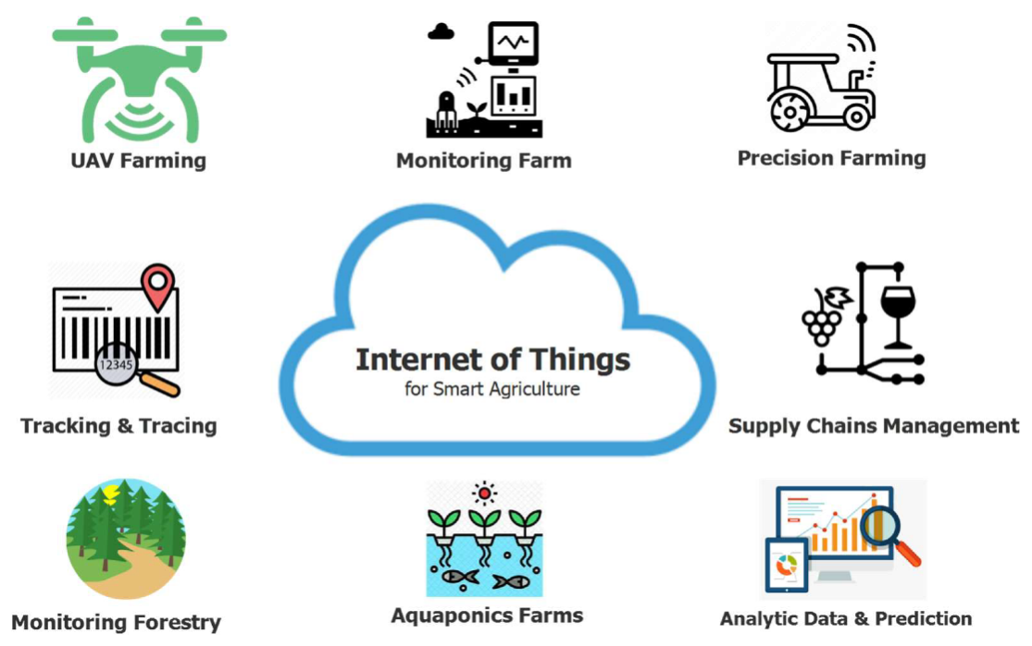
For instance, sophisticated soil moisture sensors measure the dielectric constant of the soil to determine the exact volumetric water content allowing for highly precise, automated irrigation regimes. Similarly, electrochemical sensors can continuously monitor soil pH and macronutrient levels, such as nitrate and phosphate facilitating variable rate nutrient application. This transition from uniform application to site-specific management prevents both the over-application of chemicals, which leads to toxic runoff, and the under-application, which causes stunted crop growth. These interconnected sensors form the backbone of precision agriculture, providing real-time data on various parameters like soil moisture, temperature, and nutrient levels, thereby enabling farmers to monitor conditions remotely and make informed decisions (Mota et al., 2023; Ongadi, 2024). pH sensors, for example, measure the acidity or alkalinity of soil by detecting the electrical potential difference between electrodes, enabling precise adjustments to optimize soil conditions for specific crops (Kumar et al., 2025). Furthermore, the integration of these pH measurements with other soil parameters, such as electrical conductivity and organic matter content, provides a holistic assessment of soil health, crucial for sustainable agricultural practices (Mansoor et al., 2025.. This granular data allows for targeted interventions, such as adjusting irrigation based on real-time soil humidity or optimizing fertilizer application according to specific nutrient deficiencies (Vemuri et al., 2023). Moreover, advanced spectral sensors can detect early signs of crop stress due to disease or nutrient deficiencies by analyzing changes in light reflectance patterns, facilitating proactive rather than reactive management strategies (Geetha et al., 2025). These technological advancements collectively contribute to enhanced resource efficiency and reduced environmental impact, aligning with the growing imperative for sustainable agricultural intensification (Singh & Singh, 2024; Vemuri et al., 2023).
Table 1: Key Sensors Used in Smart Agricultural Applications (Hussein et al., 2020)
Sensor Category | Primary Application | Data Generated | Deployment Phase | Component Tracked | Precision Level | Energy Usage | Calibration Frequency
Soil Moisture | Irrigation scheduling | Volumetric water | Pre-planting | H₂O | High | Low | Monthly
Electrochemical | Nutrient management | Macronutrients | Growth phase | NO₃, PO₄ | Moderate | Low | Bi-weekly
Optical | Crop health analysis | NDVI index | Maturation | Chlorophyll | High | Moderate | Annually
Meteorological | Weather forecasting | Temp/Humidity | Continuous | Microclimate | High | Low | Semi-annually
Acoustic | Pest detection | Sound waves | Vegetative | Insect density | Moderate | High | Weekly
Thermal | Water stress monitoring | Canopy heat | Mid-season | Evapotranspiration | High | Moderate | Monthly
Biosensors | Pathogen detection | Disease presence | Early growth | Fungal spores | Very High | High | Daily
Location (GPS) | Asset tracking | Spatial data | Harvesting | Machinery | High | High | Rarely
Artificial Intelligence and Machine Learning
While IoT provides the sensory input, Artificial Intelligence (AI) and Machine Learning (ML) act as the cognitive processing center of digital agriculture. Vast volumes of heterogeneous data generated by farm sensors are impossible to analyze manually. Machine learning algorithms, particularly deep learning models like Convolutional Neural Networks (CNNs), are engineered to identify complex patterns within this agricultural big data. These neural networks leverage statistical models to predict outcomes and recognize patterns, replicating the adaptive functioning of the human brain to find optimal solutions (Sridhar et al., 2023). For instance, deep learning systems analyze images captured by drones or ground-based sensors to detect diseases, identify pests, assess soil conditions, and estimate crop yield with high accuracy (Ameer et al., 2024). Furthermore, AI and ML models can analyze historical weather data, current sensor readings, and predictive analytics to forecast crop illnesses or pest outbreaks, enabling proactive intervention rather than reactive treatment strategies (Eze et al., 2025; Laskar, 2024). These AI algorithms, through methods such as regression analysis and classification, can elucidate the intricate relationships between various environmental factors and crop health, offering actionable insights for farmers (Nitin & Gupta, 2023). This enables the optimization of resource allocation and mitigation of risks, ultimately leading to enhanced productivity and sustainability in agricultural practices (Issa et al., 2024; Sobue, 2023; Tatiya et al., 2025).
Figure 2: Integration of AI in Modern Agriculture (Sharma et al., 2023)
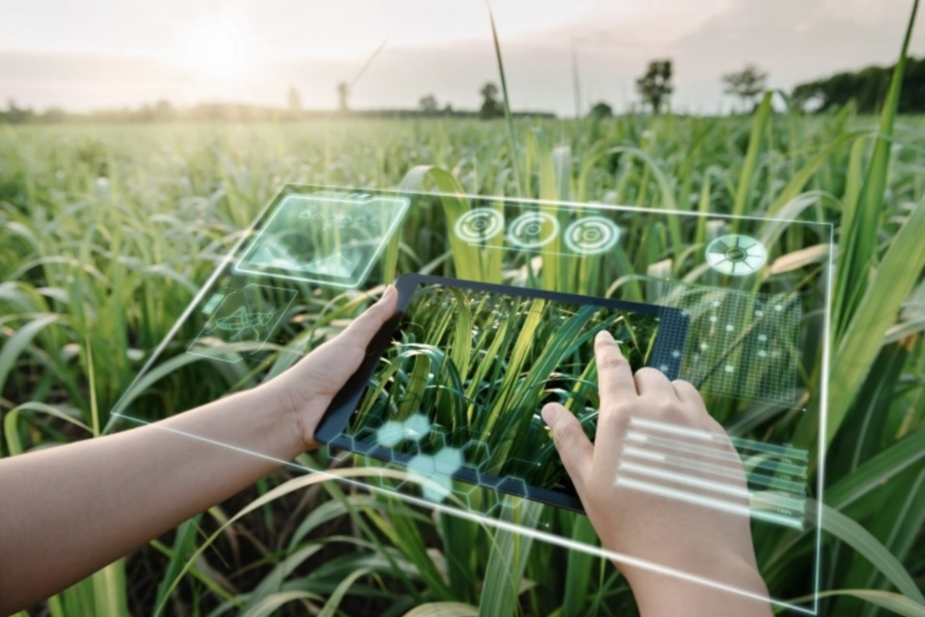
One of the most prominent applications of AI is in the early detection of phytopathology. By analyzing multispectral images of crop canopies, AI models can detect minute discolorations or morphological changes indicative of early disease onset in crops like Solanum tuberosum (potato) before visible symptoms manifest to the human eye. Furthermore, predictive analytics models are utilized to forecast crop yields based on historical weather patterns, real-time soil data, and current market dynamics. This capability enables farmers to optimize crop management strategies and plan for potential climate variability by predicting outcomes like drought or heavy rainfall (Rane et al., 2024). The integration of AI with climatological data thus represents a significant innovation in crafting climate adaptation strategies, facilitating the maximization of crop outputs without overusing resources (Zidan & Febriyanti, 2024). For example, machine learning models have been successfully employed to forecast pest outbreaks and disease spread, allowing for timely and targeted interventions (Zidan & Febriyanti, 2024). AI and ML also play a transformative role in optimizing various aspects of livestock production by using predictive analytics to enhance animal health and welfare (Gupta & Pal, 2025). Similarly, these sophisticated algorithms process extensive datasets to predict potato tuber yields with high accuracy, enabling efficient logistical planning and resource allocation while minimizing financial losses (Piekutowska, 2025).
Table 2: Comparison of Wireless Communication Protocols in Agriculture
Protocol Name | Range Capacity | Data Transfer Rate | Power Consumption | Network Topology | Deployment Cost | Suitability | Interference Risk | Security Level
LoRaWAN | Long (Up to 15km) | Very Low | Very Low | Star-of-stars | Moderate | Large farms | Low | Moderate
Zigbee | Short (10-100m) | Low | Low | Mesh | Low | Greenhouses | Moderate | Moderate
Wi-Fi | Medium (100m) | High | High | Star | Low | Farm facilities | High | Moderate
Bluetooth | Short (10m) | Medium | Low | Point-to-point | Low | Local sensors | Moderate | Low
Cellular (4G/5G) | Very Long | Very High | High | Cellular | High | Remote access | Low | High
NB-IoT | Long (Up to 10km) | Low | Low | Star | High | Deep rural | Low | High
Sigfox | Long (Up to 50km) | Very Low | Very Low | Star | Moderate | Basic telemetry | Low | Moderate
RFID | Very Short (1m) | Low | Very Low | Point-to-point | Low | Livestock tracking | High | Low
Unmanned Aerial Vehicles and Drone Technology
Unmanned Aerial Vehicles (UAVs), commonly known as drones, have transitioned from niche experimental gadgets to indispensable agronomic tools. Drones equipped with LiDAR, RGB, and multispectral cameras provide high-resolution aerial imagery that surpasses satellite data in both clarity and temporal frequency. This granular data collection allows for detailed crop health assessments, precise irrigation scheduling, and early detection of localized issues such as nutrient deficiencies or pest infestations across vast agricultural areas (Pardo-Pardo & Cuervo-Bejarano, 2023; Ruksar et al., 2025). These advanced imaging capabilities enable farmers to conduct targeted interventions, thereby optimizing resource allocation and minimizing environmental impact (Ongadi, 2024; Patil et al., 2025). Furthermore, the integration of drone technology with AI-driven analytics allows for real-time monitoring and predictive insights, significantly enhancing decision-making in crop management (Akintuyi, 2024). For instance, drones can provide precise insights into plant characteristics, soil properties, and weather conditions, facilitating data-driven decision-making for optimal planting, fertilization, and harvesting strategies (Atanasov, 2023).
Figure 3: Drone Applications for Crop Health Monitoring
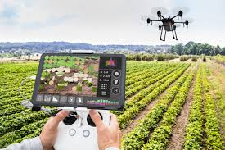
In the context of large-scale plantations, drones are utilized for precise topographic mapping, creating 3D digital elevation models that assist in planning efficient drainage and irrigation networks. Furthermore, heavy-lift agricultural drones have revolutionized pesticide and fertilizer application. By programming specific flight paths, these automated UAVs can spray targeted areas with extreme precision, reducing chemical drift and minimizing human exposure to hazardous agricultural chemicals. This targeted application not only enhances efficacy but also substantially lowers operational costs and environmental contamination associated with conventional broadcast methods. The advent of drone technology has also enabled advanced crop scouting for pest and disease identification, as well as yield estimation and irrigation management, further contributing to sustainable and efficient farming practices (Ballabh et al., 2022).
Blockchain in the Agricultural Supply Chain
Transparency and traceability have become paramount concerns for modern consumers and global food markets. Blockchain technology—a decentralized, immutable digital ledger—is increasingly being integrated into agricultural supply chains to address these concerns. This distributed ledger system ensures that every transaction, from farm to fork, is recorded securely and transparently, providing an unalterable history of product origin, processing, and transportation (Britvina et al., 2023). This enhanced transparency builds consumer trust and facilitates compliance with increasingly stringent regulatory standards for food safety and sustainability (Rushchitskaya et al., 2024). Moreover, blockchain’s inherent immutability ensures data integrity, significantly mitigating issues such as food fraud and contamination, thereby safeguarding public health and enhancing product authenticity (Çokkızgın et al., 2025).
Figure 4: Blockchain Architecture for Agricultural Supply Chains

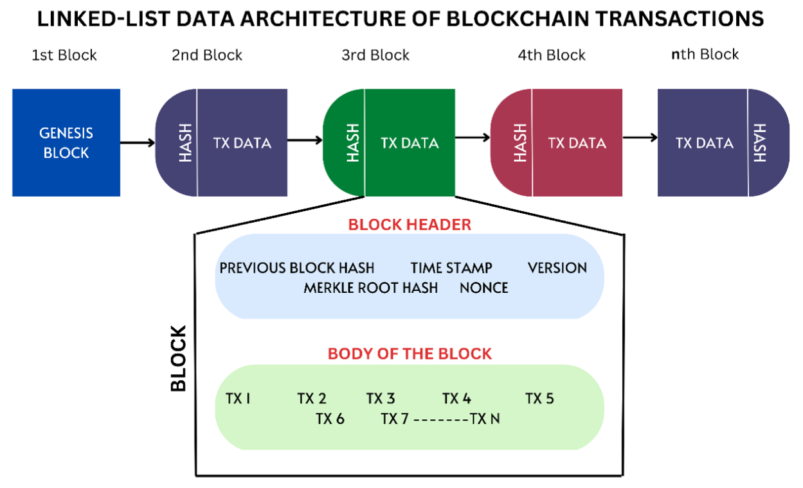
From the moment a seed of Zea mays is planted, a blockchain can record its entire lifecycle: the fertilizers applied, the harvest date, the storage temperature, and transit logistics. This cryptographic assurance eliminates the possibility of data manipulation by middlemen, guaranteeing food safety, enabling rapid recalls in the event of contamination, and ensuring that farmers receive fair compensation by removing opaque intermediary layers. This decentralized record-keeping paradigm fosters accountability across the entire supply chain, from initial production to final consumption, and can be integrated with IoT and drone technologies to further enhance efficiency and reduce costs (Shamshiri et al., 2024). The integration of blockchain with other advanced agricultural technologies, such as IoT and AI, therefore offers a comprehensive solution for developing resilient and sustainable food systems that can meet the demands of a growing global population while mitigating environmental impact (Said-Usmanovich et al., 2023; Vanza et al., 2024). This integration facilitates enhanced traceability and transparency, ultimately bolstering consumer confidence and enabling more efficient supply chain management (Obaid et al., 2024; Samanta et al., 2026).
Impact on Crop Yield and Resource Management
Precision Agronomy and Yield Optimization
The fundamental philosophy of digital agriculture is precision. By abandoning the "one-size-fits-all" approach to crop management, smart farming recognizes the inherent spatial variability within a single field. Variable Rate Technology (VRT) integrated into modern tractors and seeders allows for real-time adjustments to seeding densities and fertilizer application rates based on GPS-guided prescription maps. This hyper-localized management optimizes nutrient delivery to match specific soil conditions and plant requirements, preventing over-application in some areas and under-application in others, thereby maximizing yield potential while minimizing input waste.
Figure 5: Yield Improvements Using Precision Irrigation Techniques
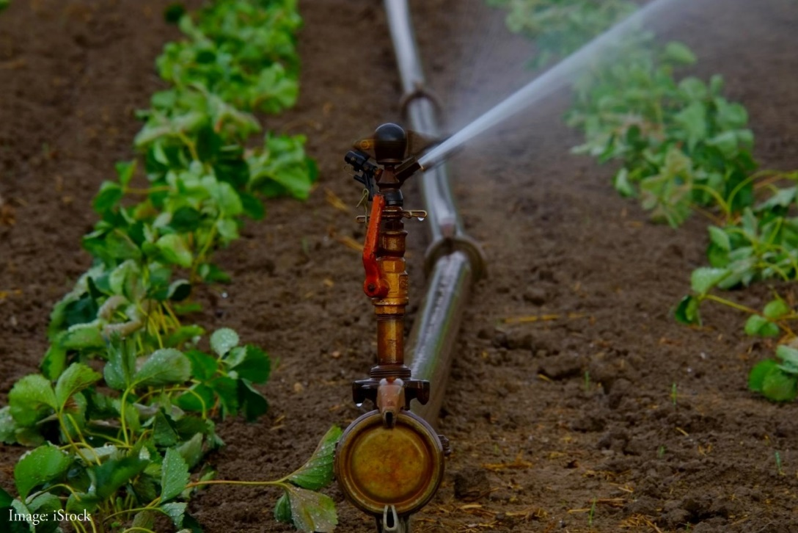
Research demonstrates that precision agriculture significantly enhances the genetic yield potential of major commercial crops. For example, in the cultivation of Gossypium hirsutum (cotton), precision irrigation combined with localized nutrient management has shown to increase boll retention rates and overall lint yield while utilizing 30% less freshwater. Such advancements not only contribute to higher agricultural productivity but also promote sustainable resource management by optimizing water usage and reducing nutrient runoff.
Table 3: Comparison of Major Crop Yields from Traditional Versus Smart Farming
Crop Species | Common Name | Traditional Yield (t/ha) | Smart Farming Yield (t/ha) | Yield Increase (%) | Water Saved (%) | Fertilizer Saved (%) | Primary Tech Used
Oryza sativa | Rice | 3.5 | 4.8 | 37.1 | 25.0 | 15.0 | Alternate Wetting
Triticum aestivum | Wheat | 3.1 | 4.2 | 35.4 | 18.0 | 20.0 | Variable Seeding
Zea mays | Maize | 5.2 | 7.1 | 36.5 | 22.0 | 18.0 | Precision Fertilization
Glycine max | Soybean | 2.8 | 3.6 | 28.5 | 15.0 | 12.0 | Weed Mapping
Gossypium hirsutum | Cotton | 1.8 | 2.5 | 38.8 | 30.0 | 25.0 | Drip Irrigation IoT
Saccharum officin. | Sugarcane | 70.0 | 88.0 | 25.7 | 40.0 | 20.0 | Soil Moisture Sensors
Solanum tuberosum | Potato | 20.0 | 26.5 | 32.5 | 20.0 | 15.0 | Disease Forecasting
Brassica juncea | Mustard | 1.2 | 1.7 | 41.6 | 10.0 | 22.0 | Automated Spraying
Adoption Barriers in Developing Nations: The Indian Context
While the technological mechanics of smart farming are globally standardized, the socio-economic context of implementation dictates the success or failure of digital agriculture. India presents a unique paradox: it possesses a rapidly booming Information Technology (IT) sector and an expansive startup ecosystem, yet its core agricultural foundation remains largely traditional and technologically isolated. This dichotomy necessitates a critical examination of the infrastructural, educational, and financial impediments that hinder widespread adoption of advanced digital agricultural practices, despite their proven benefits in enhancing productivity and sustainability (Balkrishna et al., 2023).
Economic Constraints and Financial Viability
The primary bottleneck for digital agriculture in India is economic feasibility. The demographic structure of Indian agriculture is highly skewed toward small and marginal farmers, who account for over 85% of all agricultural landholdings, typically managing plots smaller than two hectares. For these farmers, the capital outlay for sophisticated precision agriculture technologies, such as IoT sensors, GPS-guided machinery, and advanced data analytics platforms, often remains prohibitively high (Rani et al., 2025).
Figure 6: Digital Agriculture Startup Ecosystem in India
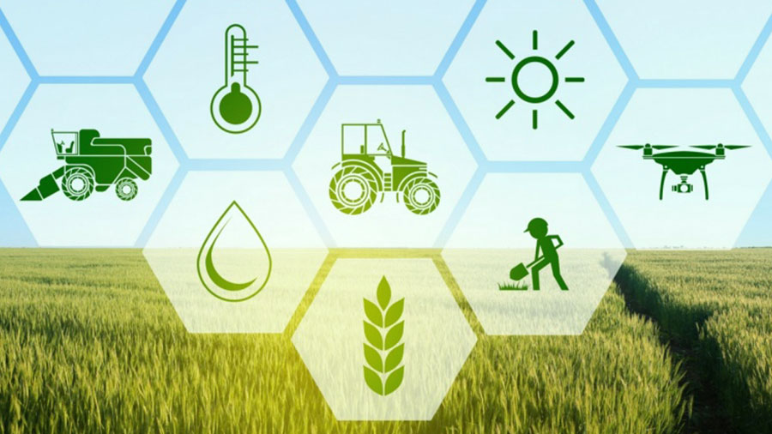
For a subsistence farmer cultivating Brassica juncea (mustard) or coarse cereals, the capital required to purchase a specialized agricultural drone, automated weather stations, or IoT soil sensors is astronomically prohibitive. Advanced robotic systems and high-end sensors are predominantly manufactured in developed nations, subjecting them to severe import tariffs and unfavorable currency exchange rates. Furthermore, even when initial acquisition costs are overcome, the ongoing operational expenditures associated with maintenance, software subscriptions, and specialized technical support further burden small-scale farmers, making sustainable integration challenging (Ashoka et al., 2023; Behuria et al., 2024).
Table 4: Economic Barriers to Digital Farming Adoption in India
Economic Factor | Description | Severity Level | Impact on Smallholders | Mitigation Strategy | Policy Requirement | Subsidization Need | Long-term Effect
Hardware Costs | Initial purchase of devices | Critical | Extreme | Cooperative leasing | Tariff reduction | High | Delayed adoption
Subscription Fees | Monthly SaaS data costs | High | Major | Open-source tools | Public digital goods | Moderate | Financial drain
Maintenance Exp. | Sensor repair and upkeep | Moderate | Moderate | Localized training | Skill development | Low | Tech abandonment
Loan Interest | High rates for agri-tech | High | Major | Priority sector loans | Credit restructuring | High | Debt accumulation
Hidden Costs | Installation and calibration | Moderate | Moderate | Transparent pricing | Consumer protection | Low | Budget overruns
Depreciation | Rapid tech obsolescence | High | Major | Modular upgrades | R&D funding | Moderate | Sunk cost fears
Input Unpredictability | Fluctuating sensor inputs | Moderate | Minor | Standardized inputs | Quality control | Low | Output errors
Consultancy Fees | Agronomist interpretations | High | Major | AI automated advice | Extension services | High | Dependency creation
Infrastructure Deficits in Rural Geographies
Digital agriculture is inextricably dependent on a robust digital infrastructure. While urban India boasts high-speed fiber optics and 5G connectivity, the rural hinterlands—where the actual farming takes place—frequently suffer from digital isolation. This pervasive lack of reliable internet connectivity, coupled with limited access to essential digital infrastructure such as smartphones and computers, creates a substantial barrier to the effective deployment and utilization of digital farming platforms for a significant portion of the agricultural population (Gandhi, 2023).
Figure 7: Climate Variables Impact on Crop Production
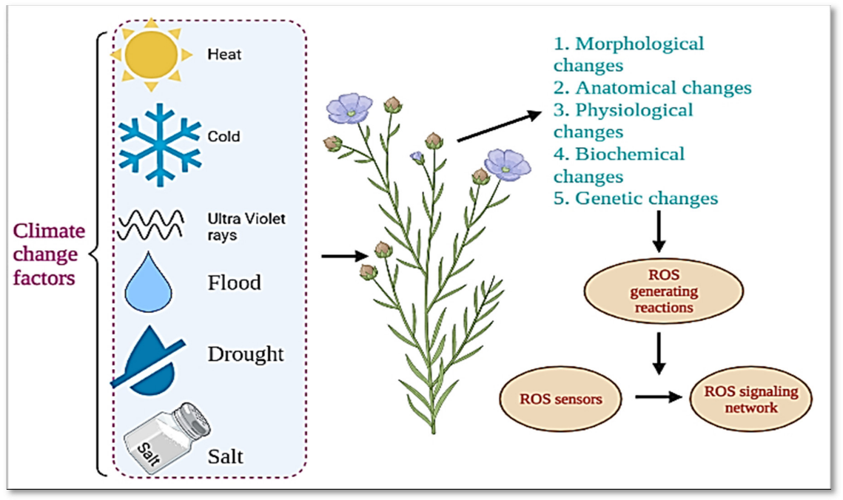
IoT devices require continuous, uninterrupted low-latency data transmission protocols to function effectively in real-time. In many Indian villages, network connectivity drops to rudimentary 2G or 3G levels, rendering high-bandwidth applications like drone video streaming or cloud-based AI analytics entirely useless. Furthermore, the erratic power supply in rural grids poses a severe threat to smart farming infrastructure. The intermittent availability of electricity not only compromises the functionality of sensor networks but also impedes the charging of essential devices, thereby limiting their operational lifespan and data collection capabilities (Balkrishna et al., 2024).
Digital Literacy and the Educational Divide
Even if financial and structural barriers were hypothetically eliminated, a profound human capital challenge remains: digital literacy. The average age of an Indian farmer is steadily increasing, and formalized education levels in rural agrarian communities remain relatively low. Operating a smart farm requires a multidisciplinary skill set that intersects agronomy, data science, and mechanical troubleshooting. The lack of familiarity with digital interfaces and the inherent resistance to adopting novel methodologies among older generations of farmers significantly impede the uptake of sophisticated digital tools (Belmir et al., 2025).
Figure 8: Overcoming Technological Adoption Barriers in Agriculture
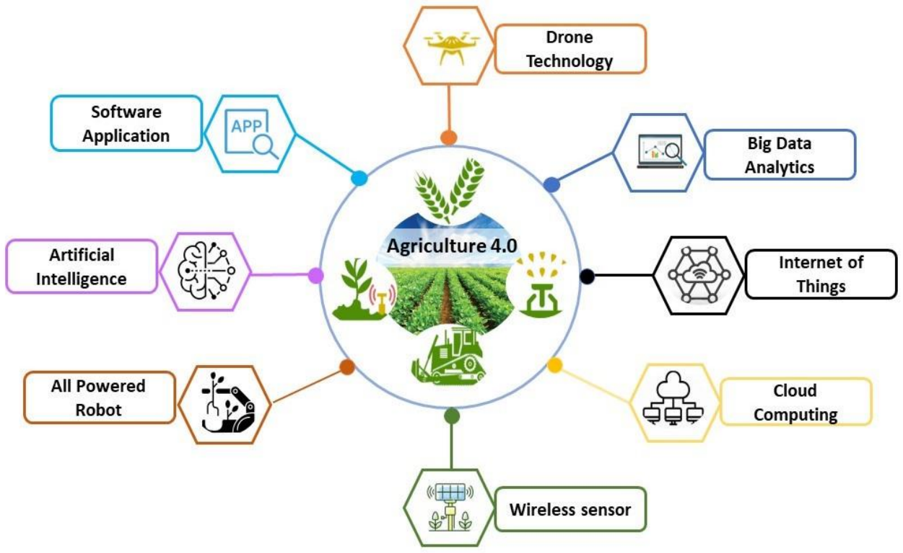
Translating complex data outputs—such as interpreting a false-color NDVI crop map to adjust soil nitrogen application—into actionable agronomic decisions is highly challenging for traditional farmers who have relied on generational intuition. Moreover, a significant portion of agricultural software and mobile applications are developed entirely in English. In a country with 22 officially recognized languages and hundreds of dialects, this linguistic barrier effectively gatekeeps vital technological tools from the farmers who need them most. This linguistic fragmentation, combined with low IT literacy rates, severely limits the scalability and impact of even well-designed agricultural applications (Balkrishna et al., 2024).
Table 5: Government Initiatives for Promoting Indian Digital Agriculture
Initiative Name | Launch Year | Primary Objective | Target Audience | Technological Focus | Funding Source | Current Status | Impact Level
AgriStack | 2021 | Unified digital farmer ID | All farmers | Data integration | Central Govt | Pilot Phase | High Potential
e-NAM | 2016 | National agri-market | Traders & Farmers | E-commerce | Central Govt | Active | High
PM-Kisan | 2019 | Direct income support | Marginal farmers | Direct Benefit Transfer | Central Govt | Active | Very High
Kisan Suvidha | 2016 | Omni-channel info app | Rural farmers | Mobile access | Central Govt | Active | Moderate
Digital Agri Mission | 2021 | Tech adoption framework | Ag-tech Startups | AI, IoT, Drones | Public-Private | Ongoing | Moderate
Sub-Mission Mechan. | 2014 | Subsidy for farm tech | Smallholders | Robotics, Drones | State-Central | Active | High
Agmarknet | 2000 | Price trend tracking | Economists & Farmers | Database analytics | Central Govt | Active | Moderate
Crop Insurance Portal | 2016 | Risk management | Insured farmers | Satellite verification | Central Govt | Active | High
Advanced Data Analytics and Crop Forecasting
As Indian agriculture integrates more deeply with digital frameworks, predictive analytics utilizing advanced ML models are becoming a cornerstone for national food security planning. Accurate crop forecasting helps the government manage buffer stocks, regulate export/import policies, and anticipate price volatility. Furthermore, these analytical insights enable proactive interventions such as targeted subsidies or credit restructuring in regions projected to face significant yield deficits, thereby mitigating potential economic instability for agricultural stakeholders. The precision offered by these sophisticated models significantly enhances resource allocation efficiency, moving beyond traditional statistical methods to incorporate real-time environmental and market data for optimized agricultural management. This integration of AI and ML-enabled services is critical for addressing the widespread operational inefficiencies inherent in the Indian agricultural sector, particularly given the challenges posed by fragmented land holdings and insufficient data infrastructure (Goswami et al., 2023).
Figure 9: Automated Robotic Harvesting Systems Flowchart Model
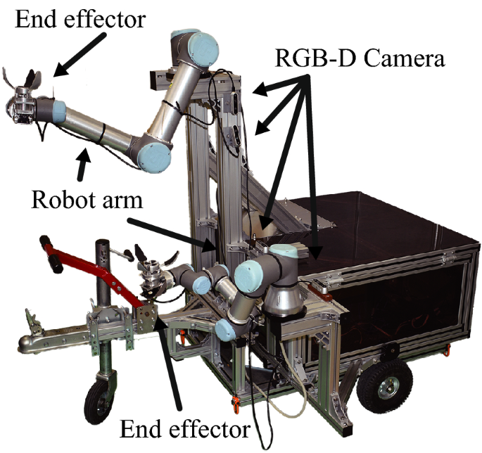
By utilizing historical yield data, current remote sensing imagery, and hyper-local meteorological forecasts, researchers are training sophisticated algorithms to predict the yield of essential commodities. These predictive capabilities enable more strategic planning for agricultural inputs, optimizing planting schedules and resource distribution to maximize productivity and ensure food supply stability (Gandhi, 2023; Goswami et al., 2023).
Table 6: Predictive Analytics Models Used in Crop Forecasting
Algorithm Model | Processing Type | Primary Use Case | Data Input Requirement | Accuracy Potential | Computational Cost | Interpretability | Typical Application
Random Forest | Ensemble Learning | Multi-variable yield | High dimensional | High | Moderate | High | Regional yield estimates
Support Vector Mach. | Supervised Learning | Classification/Regression | Non-linear data | Moderate | High | Moderate | Soil type classification
Convolutional Neural | Deep Learning | Image processing | Pixel data (UAV/Sat) | Very High | Very High | Low | Disease manifestation
Recurrent Neural | Deep Learning | Time-series data | Sequential weather | High | Very High | Low | Price trend forecasting
Artificial Neural | Deep Learning | Complex patterns | Mixed heterogeneous | High | High | Low | Overall biomass prediction
Decision Trees | Supervised Learning | Rule-based outcomes | Categorical & numerical | Moderate | Low | Very High | Pest outbreak likelihood
K-Nearest Neighbors | Instance Learning | Spatial interpolation | Geographic coordinates | Moderate | Low | High | Missing sensor data fill
Gradient Boosting | Ensemble Learning | High-accuracy regression | Clean structured data | Very High | High | Moderate | Final crop yield output
Policy Interventions and Future Outlook
To bridge the massive chasm between technological potential and field-level adoption, robust, targeted policy interventions are urgently required. The Indian government must pivot from broad agricultural subsidies to highly specific digital modernization grants. Promoting "Farming as a Service" (FaaS) models, where farmer cooperatives lease advanced equipment (like spraying drones) rather than purchasing them outright, offers a highly viable economic workaround. Furthermore, incentivizing private sector participation in developing localized, multilingual AI tools through tax breaks and competitive grants could significantly accelerate the integration of cutting-edge technology at the grassroots level (Saruk & Rayalu, 2024; Tripathi, 2024).
Figure 10: Future Indian Smart Farming Ecosystem Trajectory
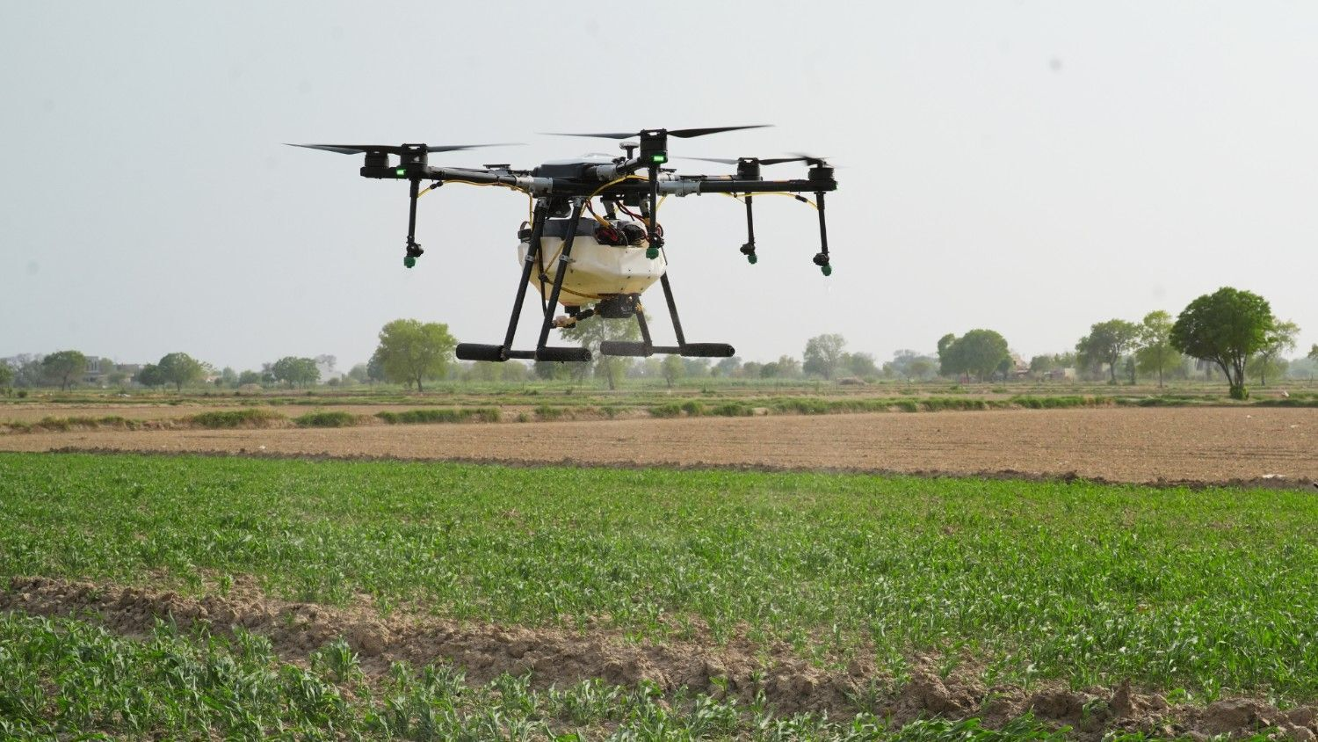
Furthermore, there is a critical need to localize agricultural software. Developing user-friendly interfaces equipped with voice-recognition systems in regional languages like Hindi, Marathi, Tamil etc. will democratize data access. Establishing rural tech-hubs or "Agri-clinics" operated by tech-savvy youth can serve as the necessary bridge for technology transfer, providing immediate, localized solutions to troubleshooting and advisory services.
Ultimately, the digital transformation of agriculture is not a singular event but an ongoing evolutionary process. As technological costs inevitably decrease due to scaling and localized manufacturing, and as rural broadband penetration deepens, the adoption barriers will organically diminish. Concurrently, public policy frameworks must adapt to foster an environment conducive to technological integration, specifically through investment in digital infrastructure and targeted farmer education programs (Kashyap et al., 2025).
Conclusion
In conclusion, the transition towards digital agriculture and smart farming represents an unavoidable paradigm shift necessary for ensuring global food security and sustainable resource management. While emerging technologies such as artificial intelligence, the Internet of Things, and unmanned aerial vehicles offer unprecedented opportunities for optimizing crop yields and reducing environmental impact, their successful implementation remains heavily constrained by socioeconomic barriers. In the Indian context, fragmented landholdings, prohibitive initial investments, inadequate rural digital infrastructure, and low technological literacy among traditional farmers significantly impede widespread adoption. Overcoming these entrenched obstacles requires synchronized efforts from government bodies, private sector innovators, and agricultural extension services. By prioritizing targeted financial subsidies, fostering localized technological innovations, and enhancing farmer education, developing nations can successfully unlock smart farming potential.
Disclaimer (Artificial intelligence)
Author(s) hereby declare that NO generative AI technologies such as Large Language Models (ChatGPT, COPILOT, etc.) and text-to-image generators have been used during the writing or editing of this manuscript.

References
Akintuyi, O. B. (2024). Adaptive AI in precision agriculture: A review: Investigating the use of self-learning algorithms in optimizing farm operations based on real-time data. Open Access Research Journal of Multidisciplinary Studies, 7(2), 16. https://doi.org/10.53022/oarjms.2024.7.2.0023
Ameer, S., Alkhafaji, M. A., Jaffer, Z., & Al-Farouni, M. (2024). Empowering Farmers with IoT, UAVs, and Deep Learning in Smart Agriculture. E3S Web of Conferences, 491, 4007. https://doi.org/10.1051/e3sconf/202449104007
Ashoka, P., Singh, N., Sunitha, N. H., Saikanth, D. R. K., Singh, O., Sreekumar, G., & Singh, B. V. (2023). Enhancing Agricultural Production with Digital Technologies: A Review. International Journal of Environment and Climate Change, 13(9), 409. https://doi.org/10.9734/ijecc/2023/v13i92250
Atanasov, S. (2023). State-of-the-art technologies for remote sensing of crops water status and nutrients in agriculture: A review [Review of State-of-the-art technologies for remote sensing of crops water status and nutrients in agriculture: A review]. Scientific Horizons, 26(9), 167. https://doi.org/10.48077/scihor9.2023.167
Balkrishna, A., Pathak, R., Kumar, S., Arya, V., & Singh, S. K. (2023). A comprehensive analysis of the advances in Indian Digital Agricultural architecture. Smart Agricultural Technology, 5, 100318. https://doi.org/10.1016/j.atech.2023.100318
Balkrishna, A., Singh, S. K., Pathak, R., & Arya, V. (2024). E-governance paradigm in the Indian agricultural sector. Discover Agriculture, 2(1). https://doi.org/10.1007/s44279-024-00012-7
Ballabh, J., Bhatt, A., Joshi, R., Prakash, S., & Prasad, R. (2022). Advancements In Precision Agriculture Technologies For Enhancing Crop Yields. Journal of Survey in Fisheries Sciences. https://doi.org/10.53555/sfs.v8i3.2399
Bandopadhyay, S., Dey, S., Grover, L., Ghosh, S., & Das, B. (2024). Sensing The Dynamics of Small Landholding in India through Earth Observation: A Comprehensive Review [Review of Sensing The Dynamics of Small Landholding in India through Earth Observation: A Comprehensive Review]. EarthArXiv (California Digital Library). California Digital Library. https://doi.org/10.31223/x5n13s
Beerge, R., Devarmani, S., &Kumbar, D. (2025). Scope and challenges of farm digitization in India. Proceedings of the Indian National Science Academy. https://doi.org/10.1007/s43538-025-00651-4
Behuria, P. R., Ojha, S., Nayak, L., Kar, J. K., Gochhayat, D., Jaiswal, N. K., &Rajvir, A. (2024). The transformative potential of precision farming in India: A comprehensive review. International Journal of Research in Agronomy, 7(10), 732. https://doi.org/10.33545/2618060x.2024.v7.i10j.1887
Belmir, M., Difallah, W., &Ghazli, A. (2025). A Systematic Review of the Implementations of Artificial Intelligence and Internet of Things Solutions in Smart Irrigation Systems [Review of A Systematic Review of the Implementations of Artificial Intelligence and Internet of Things Solutions in Smart Irrigation Systems]. Journal of Engineering Science and Technology Review, 18(3), 137. Eastern Macedonia and Thrace Institute of Technology. https://doi.org/10.25103/jestr.183.14
Britvina, V., Gavrilyuk, A. V., Nurgazina, G., Муханов, С. А., &Borisova, E. V. (2023). Multispectral drone imaging technology in agriculture. E3S Web of Conferences, 463, 1034. https://doi.org/10.1051/e3sconf/202346301034
Chowdhury, K., Rahman, M. A., Mallik, S. K., Chowdhury, L. N., & Nova, N. A. (2025). Bridging the Global Digital Divide in Agriculture: The Role of AI in Equitable Technology Access. International Journal of Sustainable Development and Planning, 20(6), 2469. https://doi.org/10.18280/ijsdp.200616
Cisse, A., Diallo, O., Ndoye, E. H. M., &Sène, O. N. (2025). Review of smart agriculture for resource-limited areas highlighting limits, opportunities and key-challenges for sustainable IoT and AI-based solutions. Discover Computing, 28(1). https://doi.org/10.1007/s10791-025-09883-w
Çokkızgın, H., Çokkızgın, A., &Girgel, Ü. (2025). REDUCING THE CARBON FOOTPRINT OF FIELD CROPS: A COMPREHENSIVE REVIEW OF STRATEGIES AND INNOVATIONS [Review of REDUCING THE CARBON FOOTPRINT OF FIELD CROPS: A COMPREHENSIVE REVIEW OF STRATEGIES AND INNOVATIONS]. Applied Ecology and Environmental Research, 23(4), 7641. Hungarian University of Agriculture and Life Sciences. https://doi.org/10.15666/aeer/2304_76417661
Dawn, N., Ghosh, S., Saha, A., Chatterjee, S., Ghosh, T., Guha, S., Sarkar, S., Mukherjee, P., &Sanyal, T. (2023). A Review on Digital Twins Technology: A New Frontier in Agriculture [Review of A Review on Digital Twins Technology: A New Frontier in Agriculture]. Artificial Intelligence and Applications, 2(4), 250. https://doi.org/10.47852/bonviewaia3202919
Dogeje, F. (2025). Leveraging Blockchain, IoT, and AI to Reduce Transaction Costs: Implications for Cash Crop Smallholders Market Access in Developing Nations. Journal of the Knowledge Economy. https://doi.org/10.1007/s13132-025-02872-w
Eze, V. H. U., Eze, E. C., Alaneme, G. U., Bubu, P. E., Nnadi, E. O. E., &Okon, M. B. (2025). Integrating IoT sensors and machine learning for sustainable precision agroecology: enhancing crop resilience and resource efficiency through data-driven strategies, challenges, and future prospects. Discover Agriculture, 3(1). https://doi.org/10.1007/s44279-025-00247-y
Gandhi, A. P. Ms. P. B. (2023). The Power of Ai In Addressing The Challenges Faced By Indian Farmers In The Agriculture Sector: An Analysis. TuijinJishu/Journal of Propulsion Technology, 44(4), 4753. https://doi.org/10.52783/tjjpt.v44.i4.1788
Geetha, R., Rakhi, R., &Anith, K. N. (2025). Innovative Sensor Technologies in Agriculture- Applications and Challenges: A Review. Agricultural Science Digest - A Research Journal. https://doi.org/10.18805/ag.d-6344
Geng, W., Liu, L., Zhao, J., Kang, X., & Wang, W. (2024). Digital Technologies Adoption and Economic Benefits in Agriculture: A Mixed-Methods Approach. Sustainability, 16(11), 4431. https://doi.org/10.3390/su16114431
Goswami, R., Dutta, S., Misra, S., Dasgupta, S., Chakraborty, S., Mallick, K., Sinha, A., Singh, V. K., Oberthür, T., Cook, S. J., & Majumdar, K. (2023). Whither digital agriculture in India? Crop and Pasture Science, 74(6), 586. https://doi.org/10.1071/cp21624
Gupta, G., & Pal, S. (2025). Applications of AI in precision agriculture. Discover Agriculture, 3(1). https://doi.org/10.1007/s44279-025-00220-9
Gyamfi, E. K., ElSayed, Z., Kropczynski, J., Yakubu, M. A., &Elsayed, N. (2024). Agricultural 4.0 Leveraging on Technological Solutions: Study for Smart Farming Sector. 1. https://doi.org/10.1109/icmi60790.2024.10585910
Issa, A. A., Majed, S., Ameer, S., & Al–Jawahry, H. M. (2024). Farming in the Digital Age: Smart Agriculture with AI and IoT. E3S Web of Conferences, 477, 81. https://doi.org/10.1051/e3sconf/202447700081
Kabato, W., Getnet, G. T., Sinore, T., Németh, A., &Molnár, Z. (2025). Towards Climate-Smart Agriculture: Strategies for Sustainable Agricultural Production, Food Security, and Greenhouse Gas Reduction. Agronomy, 15(3), 565. https://doi.org/10.3390/agronomy15030565
Kashyap, A., Shukla, O. J., Prakash, S., & Kumar, R. (2025). Artificial intelligence in agriculture: Unveiling trends in supply chain advancements. Sustainable Futures, 9, 100708. https://doi.org/10.1016/j.sftr.2025.100708
Kumar, R. (2024). Transforming Agriculture: Exploring Diverse Practices and Technological Innovations. arXiv (Cornell University). https://doi.org/10.48550/arxiv.2411.00643
Kumar, S. N., Kannadhasan, S., Jacob, A. T., Varghese, A., & Francis, E. (2025). Smart farming for a sustainable future: implementing IoT-based systems in precision agriculture. Bulletin of the National Research Centre/Bulletin of the National Research Center, 49(1). https://doi.org/10.1186/s42269-025-01366-8
Laskar, A. A. (2024). Exploring the Role of Smart Systems in Farm Machinery for Soil Fertility and Crop Productivity. International Journal for Research in Applied Science and Engineering Technology, 12(12), 2063. https://doi.org/10.22214/ijraset.2024.66157
Mansoor, S., Iqbal, S., Popescu, S. M., Kim, S. L., Mansoor, S., &Baek, J. (2025). Integration of smart sensors and IOT in precision agriculture: trends, challenges and future prospectives. Frontiers in Plant Science, 16, 1587869. https://doi.org/10.3389/fpls.2025.1587869
Manzoor, F., Wei, L., Siraj, M., Lu, X., &Qiyang, G. (2025). Digital agriculture technology adoption in low and middle-income countries—a review of contemporary literature. Frontiers in Sustainable Food Systems, 9. https://doi.org/10.3389/fsufs.2025.1621851
Mota, G. de A., Santos, R. C., Santos, J. A. D., Lovatto, J., Geisenhoff, L. O., Machado, C. A. C., Diallo, M. C. A., Lopes, A. L. N., Nascimento, D. O., & Carvalho, M. M. A. J. de. (2023). Smart sensors and Internet of Things (IoT) for sustainable environmental and agricultural management. CadernoPedagógico, 20(7), 2692. https://doi.org/10.54033/cadpedv20n7-014
Mawlood Hussein, S., López Ramos, J. A., & Alvarez Bermejo, J. A. (2020). Distributed key management to secure IoT wireless sensor networks in smart-agro. Sensors, 20(8), 2242.
Nitin, & Gupta, S. B. (2023). Artificial Intelligence in Smart Agriculture: Applications and Challenges. Current Applied Science and Technology. https://doi.org/10.55003/cast.2023.254427
Obaid, M. K., Abood, B. Sh. Z., Alazzai, W. K., & Jasim, L. (2024). From Field to Fork: The Role of AI and IoT in Agriculture. E3S Web of Conferences, 491, 2006. https://doi.org/10.1051/e3sconf/202449102006
Ongadi, P. A. (2024). A comprehensive examination of security and privacy in precision agriculture technologies. GSC Advanced Research and Reviews, 18(1), 336. https://doi.org/10.30574/gscarr.2024.18.1.0026
Otieno, M. (2023). An extensive survey of smart agriculture technologies: Current security posture. World Journal of Advanced Research and Reviews, 18(3), 1207. https://doi.org/10.30574/wjarr.2023.18.3.1241
Pardo-Pardo, A. M., & Cuervo-Bejarano, W. J. (2023). Assessing the impact of emerging technologies on sustainable fruit production: A systematic review of the literature [Review of Assessing the impact of emerging technologies on sustainable fruit production: A systematic review of the literature]. AgronomíaColombiana, 41(3). Centro Editorial of Facultad de CienciasAgrarias, Universidad Nacional de Colombia. https://doi.org/10.15446/agron.colomb.v41n3.107255
Parra-López, C., Abdallah, S. B., Garcia‐Garcia, G., Hassoun, A., Sánchez‐Zamora, P., Trollman, H., Jagtap, S., & Carmona‐Torres, C. (2024). Integrating digital technologies in agriculture for climate change adaptation and mitigation: State of the art and future perspectives. Computers and Electronics in Agriculture, 226, 109412. https://doi.org/10.1016/j.compag.2024.109412
Patel, B., & Bhatia, J. (2024). A Comprehensive Review of Internet of Things and Cutting-edge Technologies Empowering Smart Farming [Review of A Comprehensive Review of Internet of Things and Cutting-edge Technologies Empowering Smart Farming]. Current Science, 126(2), 137. Indian Academy of Sciences. https://doi.org/10.18520/cs/v126/i2/137-152
Patil, N., Sankpal, S. V., &Madavi, H. (2025). Advances in precision agriculture: Integrating AI, Drones, IoT and GIS for efficient water, nutrients management and plant protection. International Journal of Research in Agronomy, 8, 276. https://doi.org/10.33545/2618060x.2025.v8.i11sd.4257
Piekutowska, M. (2025). Using artificial intelligence for sustainable crop production – a comprehensive review with a focus on potato production [Review of Using artificial intelligence for sustainable crop production – a comprehensive review with a focus on potato production]. Journal of Water and Land Development. De Gruyter Open. https://doi.org/10.24425/jwld.2025.153522
Rane, J., Kaya, Ö., Mallick, S. K., & Rane, N. L. (2024). Smart farming using artificial intelligence, machine learning, deep learning, and ChatGPT: Applications, opportunities, challenges, and future directions. https://doi.org/10.70593/978-81-981271-7-4_6
Rani, H. V., Kakkar, P., & Singh, D. P. (2025). Advancements in Precision Agriculture for Maximizing Crop Yield and Minimizing Waste via Innovative Technological Solutions. International Journal of Research and Review in Applied Science Humanities and Technology, 1. https://doi.org/10.71143/7fhb8x91
Ruksar, P., Kundathil, C., & Vardhan, M. S. C. N. (2025). Artificial intelligence in climate smart agronomy. International Journal of Research in Agronomy, 8, 325. https://doi.org/10.33545/2618060x.2025.v8.i7se.3424
Rushchitskaya, O., Kulikova, E., Кот, Е., &Kruzhkova, T. (2024). Sustainable practices and technological innovations transforming agribusiness dynamics. E3S Web of Conferences, 542, 3003. https://doi.org/10.1051/e3sconf/202454203003
Said-Usmanovich, M. K., Багов, А. М., &Разина, И. С. (2023). Application of new technologies in narrow Fields. E3S Web of Conferences, 460, 4036. https://doi.org/10.1051/e3sconf/202346004036
Samanta, S., Sarkar, A., Yadav, J. S., Srivastava, A., Sharma, V. S., Kallimani, D. J. S., & Singh, S. K. (2026). Managing sustainable agricultural supply chains in smart cities with IoT and blockchain. Environment Development and Sustainability. https://doi.org/10.1007/s10668-025-07294-x
Sarkar, N. C., Mondal, K., Das, A., Mukherjee, A., Mandal, S., Ghosh, S., Bhattacharya, B. K., Lawes, R., & Huda, S. (2023). Enhancing livelihoods in farming communities through super-resolution agromet advisories using advanced digital agriculture technologies. Journal of Agrometeorology, 25(1). https://doi.org/10.54386/jam.v25i1.2080
Saruk, B. S., &Rayalu, G. M. (2024). Integrating Machine Learning for Enhanced Agricultural Productivity: A Focus on Bananas and Arecanut in the Context of India’s Economic Growth. Journal of Statistical Theory and Applications. https://doi.org/10.1007/s44199-024-00090-y
Satpathy, B. (2022). Digital transformation for sustainable agriculture: a progressive method for smallholder farmers. Current Science, 123(12), 1436. https://doi.org/10.18520/cs/v123/i12/1436-1440
Satpati, S. (2026). AI-Enabled Precision Agriculture for Smallholder Farmers. https://doi.org/10.21203/rs.3.rs-8808017/v1
Sensors for Smart Agriculture and Beyond…. (2023). The Electrochemical Society Interface, 32(4), 1. https://doi.org/10.1149/2.20234if
Sharma, A., Sharma, A., Tselykh, A., Bozhenyuk, A., Choudhury, T., Alomar, M. A., & Sánchez-Chero, M. (2023). Artificial intelligence and internet of things oriented sustainable precision farming: Towards modern agriculture. Open Life Sciences, 18(1), 20220713.
Shamshiri, R. R., Sturm, B., Weltzien, C., Fulton, J. P., Khosla, R., Schirrmann, M., Raut, S., Basavegowda, D. H., Yamin, M., & Hameed, I. A. (2024). Digitalization of agriculture for sustainable crop production: a use-case review [Review of Digitalization of agriculture for sustainable crop production: a use-case review]. Frontiers in Environmental Science, 12. Frontiers Media. https://doi.org/10.3389/fenvs.2024.1375193
Singh, R., & Singh, K. K. (2024). Enhancing Agricultural Efficiency Through Smart Farming and Internet of Things Enabled Precision Agriculture. Agricultural Science Digest - A Research Journal. https://doi.org/10.18805/ag.d-6039
Sobue, S. (2023). Space Based Data Usage for Smart Farming. BIO Web of Conferences, 80, 6009. https://doi.org/10.1051/bioconf/20238006009
Sridhar, A., Ponnuchamy, M., Kumar, P. S., Kapoor, A., Vo, D. N., &Rangasamy, G. (2023). Digitalization of the agro-food sector for achieving sustainable development goals: a review [Review of Digitalization of the agro-food sector for achieving sustainable development goals: a review]. Sustainable Food Technology, 1(6), 783. Royal Society of Chemistry. https://doi.org/10.1039/d3fb00124e
Tatiya, M., Choudhari, P., Suneel, A. S., Soni, S. K., Saxena, V., & Gore, R. D. (2025). Integration Of Smart Sensors, AI And Iot In Precision Agriculture: Advancing Crop Productivity And Sustainability. International Journal of Environmental Sciences, 11, 255. https://doi.org/10.64252/2k6kcb97
Tripathi, A. (2024). Forecasting Agricultural Crop Profitability and Yield in India. International Journal for Research in Applied Science and Engineering Technology, 12(2), 308. https://doi.org/10.22214/ijraset.2024.58316
Vanza, J., Dave, K., &Siddhapura, M. (2024). Integrating Technology and Agriculture with Advanced Machinery. International Journal for Research in Applied Science and Engineering Technology, 12(5), 53. https://doi.org/10.22214/ijraset.2024.61394
Vemuri, N., Thaneeru, N., &Tatikonda, V. M. (2023). Smart Farming Revolution: Harnessing IoT for Enhanced Agricultural Yield and Sustainability. Journal of Knowledge Learning and Science Technology ISSN 2959-6386 (Online), 2(2), 143. https://doi.org/10.60087/jklst.vol2.n2.p148
Vijayakumar, S., Murugaiyan, V., Ilakkiya, S., Kumar, V., Sundaram, R. M., & Kumar, R. M. (2025). Opportunities, challenges, and interventions for agriculture 4.0 adoption. Discover Food, 5(1). https://doi.org/10.1007/s44187-025-00576-3
Xie, C. (2025). The role of modern agricultural technologies in improving agricultural productivity and land use efficiency [Review of The role of modern agricultural technologies in improving agricultural productivity and land use efficiency]. Frontiers in Plant Science, 16. Frontiers Media. https://doi.org/10.3389/fpls.2025.1675657
Zidan, F., &Febriyanti, D. E. (2024). Optimizing Agricultural Yields with Artificial Intelligence-Based Climate Adaptation Strategies. IAIC Transactions on Sustainable Digital Innovation (ITSDI), 5(2), 136. https://doi.org/10.34306/itsdi.v5i2.663

