Optimizing Sugarcane Detrashing: Design, Evaluation, and Predictive Modeling of a Mechanical Detrasher

ABSTRACT
The evaluation of the developed whole-stalk sugarcane detrasher was conducted under various operational conditions to assess its effects on residual trash, detrashing efficiency, and overall performance. The detrasher was equipped with feeding and detrashing components powered by a 0.5 hp electric motor. Six distinct treatments (T1-T6) were examined, varying the speed ratio between the feeding and detrashing rollers and the speed of the feeding roller. One-way ANOVA revealed significant differences (p < 0.001) among the treatments for all three response variables. Trash left percentage ranged from 12.80 ± 2.74% (T2) to 30.20 ± 3.69% (T5), detrashing efficiency varied from 69.80 ± 3.19% (T5) to 87.45 ± 3.16% (T4), and output ranged from 0.82 ± 0.05 t h⁻¹ (T6) to 1.42 ± 0.19 t h⁻¹ (T1). Tukey's test identified distinct performance categories, with T4 demonstrating high efficiency, minimal residual trash, and a satisfactory output. Random Forest (RF) and Gradient Boosting (GB) regression models were employed to predict the response variables based on the operational parameters. GB outperformed RF in terms of efficiency (R² ≈ 0.89, RMSE ≈ 2.682%, MAE ≈ 1.543%) and residual trash (R² ≈ 0.90, RMSE ≈ 2.507%, MAE ≈ 1.391%), whereas RF slightly surpassed GB in predicting the output (R² ≈ 0.795, RMSE ≈ 0.101 t h⁻¹, MAE ≈ 0.073 t h⁻¹). The results suggest that ensemble tree-based methods provide an accurate framework for data-driven monitoring in agro-industrial detrashing applications and offer a foundation for advanced process control in the field.
Keywords: Sugarcane, trash, detrasher, detrashing mechanism, detrashing efficiency.
- INTRODUCTION
Sugarcane (Saccharum officinarum L.) is a globally significant vegetatively propagated crop cultivated for both sugar and bioenergy (Viswanathan, 2016; Solomon, 2016), with a production volume of 1.91 billion tons (Gonzaga et al., 2019; Perillo et al., 2022). India, as the second-largest producer, contributes 24.47% to global production, followed by Brazil, which accounts for approximately 39% of the total. India is also the world's leading sugar consumer, with a production of 329 million tons and a productivity rate of 73 t ha⁻¹ (Solomon, 2024). The states of Uttar Pradesh, Maharashtra, Karnataka, and Tamil Nadu collectively account for 81% of India's total sugar production (Solomon, 2016). Globally, sugarcane is harvested using either burnt or green cane harvesting methods (Cardoso et al., 2017). In burnt cane harvesting, the crop is pre-burnt to remove leaves, thereby reducing its bulk before it is cut. This process removes 70-80% of the leaf material, enhancing harvester productivity by 30-40% (Elwakeel et al., 2025; Gonzaga et al., 2019). However, burning accelerates sucrose deterioration, resulting in biomass and nutrient losses, contributing to emissions and pollution, and is subject to regulatory scrutiny (Kishore et al., 2017; Perillo et al., 2022). Green cane harvesting involves cutting the cane without pre-burning and utilising a mechanical detrasher to separate and return the trash to the field. This mulch improves soil organic matter, structure, and moisture conservation (Perillo et al., 2022; Braunbeck et al., 2014). These harvesting systems influence sugarcane quality, as high levels of extraneous matter adversely affect the sucrose content, commercial cane sugar, and factory recovery (Gonzaga et al., 2019; Solomon et al., 2016). Burnt cane harvesting destroys above-ground trash, leading to a loss of organic carbon and nutrients and diminishing the potential for improving soil quality. In contrast, green cane harvesting with mechanical detrashing results in trash forming a mulch that reduces soil temperature fluctuations, suppresses weeds, conserves moisture, and releases nutrients (Da Silva et al., 2021; Rasche & Sos Del Diego, 2020). Avoiding pre-harvest burning reduces the emissions of CO₂, CH₄, N₂O, and particulates, thereby enhancing environmental metrics (Perillo et al., 2022; Silva-Olaya et al., 2013; Vargas et al., 2014).
Sugar mills typically establish upper limits for extraneous matter, often below 10-12% by weight, to ensure operational efficiency (Da Silva et al., 2021; Misra et al., 2020; Solomon, 2024). Elevated levels of trash contribute to increased equipment wear, decreased boiler efficiency when co-fired with bagasse, and disruption of mill feeding processes. In green cane harvesting systems, the absence of pre-harvest burning results in a higher quantity of leaves and trash at harvest (Rasche & Sos Del Diego, 2020; Robertson & Thorburn, 2007a, 2007b). Without effective detrashing, this can lead to an increase in extraneous matter, potentially exceeding mill limits. Consequently, field-level detrashing is essential (Da Silva et al., 2021; Omprabha et al., 2025). Most Indian sugarcane farmers have small landholdings, which hinders the adoption of large-scale mechanical harvesters (Cardoso et al., 2017; Chaya et al., 2019; Silva-Olaya et al., 2013). Although mechanisation in cereal production has advanced, sugarcane harvesting remains slow and labour-intensive. While mechanical harvesting is expanding, detrashing remains predominantly manual in smallholder systems in India. If cutting requires 23 person-days ha-1 for a 73 t ha⁻¹ yield, detopping, detrashing, and stacking require 120 person-days (Kishore et al., 2017; Patel et al., 2022). Manual detrashing with knives exposes workers to injuries and physical stress.
Srivastava & Singh (1990) developed a mechanised sugarcane detrasher featuring counter-rotating rollers, feeding and takeoff beaters, and a blower system, achieving an output of > 10 t h⁻¹. Singh & Solomon (2015) introduced a tractor PTO-operated sugarcane detrasher, with trash removal efficiency, percentage of trash remaining on the cane, and output ranging from 77.5-94.5%, 1.5-6.6%, and 2.4 t h⁻¹, respectively. Kumar et al., (2025) developed a mini tractor-operated hydraulic sugarcane leaf detrasher, achieving 78-92% leaf removal efficiency, ≤5% cane damage, and a throughput of 2.5-4.5 t h⁻¹, reducing labour requirements by 40-60% compared to manual detrashing, and demonstrating suitability for smallholder sugarcane harvesting. Bastian and Shridar (2014) examined the detrashing mechanism on a sugarcane detopper-cum-leaf stripper with brush-type cleaning, incorporating adjustable spiral angles, detrasher roller speeds, and input roller speeds. Despite extensive research on sugarcane detrashing devices, most systems are either tractor-mounted or designed for large-scale operations, limiting their accessibility to smallholder farmers. Most studies have predominantly focused on mechanical components, with insufficient attention paid to optimising processes under actual field conditions. This study presents a compact, low-power (0.5 hp) sugarcane detrasher suitable for smallholders and green cane harvesting systems. It integrates field-oriented machine design with data-driven modelling, utilizing ensemble machine learning to predict detrashing efficiency, trash left percentage, and output based on operational parameters. This methodology provides practical decision-making support for determining optimal operating conditions, thereby enhancing field applicability and efficiency with the objectives of a) developing a whole-stalk sugarcane detrasher, and b) evaluating its performance under different speeds using machine learning models.
- MATERIALS AND METHODS
  - Experimental Plan
A mechanized whole-stalk sugarcane detrasher was developed at the All India Coordinated Research Project on Farm Implements and Machinery (AICRP on FIM) Laboratory, Department of Agricultural and Food Engineering, Indian Institute of Technology, Kharagpur, India. A portable prototype of this detrasher was designed specifically for smallholder farming contexts. To evaluate its performance, the sugarcane variety Co 1148 was cultivated in the research fields of the institute. The soil composition was sandy clay loam, comprising 30% clay, 23% silt, and 47% sand, with a bulk density of 1.22 g cm⁻³. The Co 1148 variety, a late-season type common in West Bengal, was selected because of its larger stalk diameter and thicker leaves, which are suitable for assessing the detrashing capability of the machine. The average stalk diameter and leaf thickness were 40 mm and 5 mm, respectively. Field trials were conducted to test the detrasher efficacy in removing both green and dry trash from the entire sugarcane stalks. The machine was assessed under six distinct operating conditions (T1-T6), involving combinations of two speed ratios (1:1.5 and 1:3.0) and three feeding roller speeds (1.5, 2.0, and 2.5 m s⁻¹). Treatments T1, T2, and T3 employed a speed ratio of 1:1.5 with feeding roller speeds of 1.5, 2.0, and 2.5 m s⁻¹, whereas T4, T5, and T6 operated at a 1:3.0 ratio with the same roller speeds. All tests involved manually feeding whole-stalk sugarcane, with measurements taken for detrashing efficiency (%), trash left (%), and machine output (t h⁻¹) for each treatment.
  - Power Requirement of the Detrasher
The portable whole-stalk sugarcane detrasher was powered by a 0.5 hp single-phase A.C. electric motor, selected for small-scale operation. The power requirement was governed by the force needed to detach leaves and dry trash from cane stalks, and the drive system losses. The detrashing strength of sugarcane has been reported as approximately 30 kN m⁻¹ (Bastian and Shridar 2014), which was used for sizing the mechanism and selecting the power source. Considering stalk processing rate, contact length, and safety factors for stalk variations, a 0.5 hp motor adequately drove both feeding and detrashing rollers through belt–pulley and chain sprocket drives. This low-power motor is aligned with developing a cost-effective machine for small farmers.
  - Development of different mechanisms of the detrasher unit
The different phases of detrasher development for smallholder applications are shown in Fig. 1. The feeding mechanism had two parallel horizontal rollers of equal size, lower and upper feeding rollers. These rollers grip the incoming cane stalks and convey them to the detrashing unit. A 15 mm vertical clearance between the rollers allowed stalks to pass without damage while ensuring contact with the rollers. The rollers were equipped with rubber belts to enhance their grip. The lower roller was driven by a 0.5 hp electric motor through a belt-pulley drive, whereas the upper roller was free-rolling and spring-loaded. The spring specifications were as follows: mean coil diameter, 6.1 mm; outer coil diameter, 7.32 mm; number of turns 96, free length, 151.52 mm; pitch, 1.6 mm; and spring stiffness, 10.6 N mm⁻¹. The effective outer diameter of each feeding roller was 100 mm. The detrashing mechanism has two counter-rotating rollers and a delivery chute. Each detrashing roller was made from a mild steel shaft with a flat mild steel strip welded circumferentially and covered with a rubber canvas belt. The belt had triangular segments ("fingers") to enhance flexibility and improve roller surface conformity around the cane stalk. The outer diameter of the detrashing rollers was 180 mm. The cane stalks were conveyed by feeding rollers into the detrashing rollers, which stripped the leaf sheath and dry trash from the stalks. A cone pulley on the lower detrashing roller enabled a speed variation. The lower roller received power through a belt-pulley arrangement, whereas the upper roller was driven via chain-sprocket transmission. The 15 mm vertical clearance between the detrashing rollers was based on stalk diameter and stripping intensity. The design combines cushioned surfaces, triangular patterns, adjustable speeds, and controlled clearance for efficient detrashing.
A rectangular feeding chute (600 mm × 220 mm) was installed at the front frame at a height of 800 mm for stalk feeding purposes. The adjustable chute angle enhances operator comfort and ensures smooth cane entry into the feeding rollers. A guide system directs the stalks towards the rollers. The upper feeding roller moves vertically for varying cane diameters, whereas the lower roller is fixed to the bearings. The feeding rollers maintained a vertical clearance of 15 mm and rotated in the same direction as the feeding rollers. The detrashing rollers feature 2.5 mm deep grooves at four intervals, with 200 mm mild steel flats welded in and rubber canvas belts bolted on. The rubber canvas minimises cane damage while removing leaves. Each rubber piece measured 200 mm × 55 mm × 10 mm in size. A 0.5 hp, 1440 rpm single-phase A.C. motor with variable frequency control powers the system. The step pulley enabled the roller speed adjustment. The upper detrashing roller is driven by the lower roller via a chain-sprocket system with 30-tooth sprockets, ensuring counterrotation. The contact surfaces of the detrashing rollers move in the opposite direction to enhance stripping. A 60 mm gap between the feeding and detrashing mechanisms ensured smooth stalk transfer. A delivery chute guides the cleaned cane away.
Fig. 1 Different phases of the development of smallholder whole stalk sugarcane detrasher
Table 1 Technical specifications of the developed sugarcane detrasher
SI. No. | Particulars | Specifications
1. | Feeding chute  - Length (mm)  - Width (mm)  - Angle with horizontal  - Height from the ground (mm) | 600  220  15° (adjustable)  700
2. | Main frame  - Length (mm)  - Width (mm)  - Height (mm) | 350  220  980
3. | Feeding roller  - Length (mm)  - Effective outer diameter (mm)  - Effective length of feeding roller (mm)  - Thickness of the rubber belt (mm)  - Clearance between the feeding rollers (mm) | 400  100  200  10  15
4. | Detrashing roller  - Length (mm)  - Effective outer diameter (mm)  - Effective length (mm)  - Material for flaps  - Number of rubber flaps  - Height of rubber flap (mm)  - Clearance between detrashing rollers (mm) | 400  180  200  Rubber  4  35  15
5. | Delivery chute  - Length (mm)  - Width (mm)  - Height from the ground (mm) | 250  220  700
6. | Overall dimensions  - Length (mm)  - Width (mm)  - Height (mm)  - Overall weight of the machine (kg) | 1200  220  980  50

  - Performance evaluation, data analysis and validation
The performance of the whole-stalk sugarcane detrasher was evaluated at the Farm Implements and Machinery Laboratory of the Indian Institute of Technology, Kharagpur. The machine was driven by a 0.5 hp, 1440 rpm single-phase A.C. electric motor powered through a variable frequency controller for different roller speeds. The detrashing rollers were tested at speeds ranging from 750 rpm (peripheral speed ≈ 5.50 m s⁻¹) to 1600 rpm (peripheral speed ≈ 11.73 m s⁻¹). For each detrashing roller speed, the feeding roller speed was adjusted according to the predetermined speed ratios. The clearance between the feeding rollers was set at 15 mm, with the upper roller moving upward against the compression spring when the cane diameter exceeded this clearance. The axial load on the spring corresponded to the weight of the upper feeding roller assembly of 32 N. The feeding rollers provided initial gripping and preliminary trash removal, whereas the main detrashing was performed by the detrashing rollers with rubber canvas belts. The rubber canvas elements prevented structural damage to the cane rind during detrashing. For each speed setting, whole-stalk sugarcane was fed manually through the feeding chute, with the processing time being recorded and the components weighed using a platform balance. Detrashing efficiency (Eq. 1), trash left on cane (Eq. 2), and machine output (Eq. 3) were calculated using standard relationships like those used for cleaning efficiency and capacity evaluation of sugarcane and grain cleaning machinery (Srivastava and Singh 1990; Singh and Solomon 2015).
Detrashing efficiency (%) = $\frac{W_{1}}{W_{2}}$ × 100 (1)
Trash left on cane (%) = $\frac{W_{3}}{W_{4}}$ × 100 (2)
Machine output (t h⁻¹) = $\frac{W_{5}}{t}$ × 3.6 (3)
Where, W₁ is trash removed by the detrasher (kg), W₂ is initial trash on the cane (kg), W₃ is weight of trash remained after detrashing (kg), W₄ is weight of cleaned cane (kg), W₅ is weight of uncleaned cane (kg) and t is detrashing time (s)
  - Statistical and Machine Learning Framework for Performance evaluation and prediction
The performance metrics of the detrasher were systematically analysed to evaluate the impact of the detrashing roller speed and ratio of feeding to detrashing speed. Each experimental condition was replicated thrice to calculate the mean values of detrashing efficiency, trash left percentage, and machine output, along with their standard deviations. A one-way ANOVA was employed to assess the significance of roller speed on efficiency, trash left, and output values. In instances where ANOVA indicated significant differences (p < 0.05), Tukey's HSD test was used to differentiate group means. Regression analyses were conducted to elucidate the relationships between roller speed, efficiency, residual trash, and output values. Standard statistical software was used for these analyses, and the results are presented as mean ± standard deviation and 95% confidence intervals. Random Forest (RF) and Gradient Boosting (GB) regression models were developed to predict detrashing efficiency (%), output (t h-1), and residual trash (%) based on operational variables (Bentéjac et al., 2021; Garge et al., 2013; Ghosal & Hooker, 2020; Hengl et al., 2018). The dataset comprised continuous and categorical variables, with records containing missing values being excluded. The data were divided into training (70%) and testing (30%) sets for analysis. The model hyperparameters were optimised using 5-fold cross-validation. Random Forest regression constructs decision trees from bootstrap samples with random predictor subsets by averaging the outputs of the trees. RF models utilised the Random Forest Regressor from scikit-learn, with adjustments made to the number of trees, depth, minimum samples, and predictors per split. Gradient Boosting regression builds trees sequentially, fitting each to the residuals of the ensemble. GB models employed the Gradient Boosting Regressor, with tuning of the boosting stages, learning rate, tree depth, and minimum leaf sample size (Bentéjac et al., 2021). The models were evaluated using R², RMSE, and MAE on the test data (Eq. 4-6). The analysis was conducted using Python with Pandas, NumPy, Scikit-learn, and Matplotlib, with fixed random seeds.
Coefficient of determination (R²) = 1 - $\frac{\sum_{i=1}^{n}{{(y_{i} - {\hat{y}}_{i})}^{2}}}{\sum_{i=1}^{n}{{(y_{i} - {\overline{y}}_{i})}^{2}}}$ (4)
Root mean squared error (RMSE) = $\sqrt{\frac{1}{n} \sum_{i=1}^{n}{{(y_{i} - {\hat{y}}_{i})}^{2}}}$ (5)
Mean absolute error (MAE) = $\frac{1}{n} \sum_{i=1}^{n}{|y_{i} - {\hat{y}}_{i}|}$ (6)
Where y_{i} is observed value of the response (efficiency, output, and trash left), ${\hat{y}}_{i}$ is model predicted value, ${\overline{y}}_{i}$ is mean of the observed values, n is number of observations.
- RESULTS
  - Impact of Operating Parameters on Trash left, Detrashing Efficiency, and Output Dynamics
The operational parameters of the developed detrashing unit exerted a significant influence on the percentage of trash left, as evidenced by a one-way ANOVA (F = 24.02, p < 0.0001), which revealed substantial differences among treatments T1-T6 (Table 2). The mean percentage of trash left ranged from 12.80 ± 2.74% to 30.20 ± 3.69%. The minimal trash left was observed under T2 (12.80 ± 2.74%), followed by T1 (17.90 ± 3.06%), and T4 (18.18 ± 2.71%). Intermediate levels of trash left were recorded at T3 (25.53 ± 1.72%) and T6 (23.62 ± 2.64%), whereas the maximum trash left was observed at T5 (30.20 ± 3.69%). Tukey’s multiple comparison test further classified the operating conditions into distinct statistical groups. Treatments with lower trash left levels (T2, T1, T4) were assigned different grouping letters compared to those with higher trash left levels (T3, T5, T6), confirming that the numerical differences in trash left were statistically significant at p < 0.05. The detrashing efficiency was also markedly affected by the operating conditions of the machine. A one-way ANOVA for detrashing efficiency (%) indicated a highly significant treatment effect, reflecting the patterns observed for the trash left percentage. The mean detrashing efficiency varied from 69.80 ± 3.19% to 87.45 ± 3.16%, respectively. The highest efficiency was achieved at T4 (87.45 ± 3.16%), closely followed by T1 (82.10 ± 2.26%) and T3 (81.82 ± 2.41%). Lower efficiencies were observed under T2 (74.47 ± 1.42%) and T6 (76.39 ± 2.46%), with the lowest efficiency observed in T5 (69.80 ± 3.19%). Consequently, Tukey’s test grouped T4, T1, and T3 in the higher efficiency category, T2 and T6 in the intermediate group, and T5 in the lowest efficiency group. Within each response, means followed by the same letter did not differ significantly at p < 0.05. The impact of the operating conditions also extended to the output (t h⁻¹) of the detrashing unit. One-way ANOVA again demonstrated a highly significant effect of treatment on output, with a large F value and p < 0.0001. Across T1–T6, the detrashing unit produced distinct mean throughputs, with the highest outputs associated with higher capacity settings and reduced outputs under conditions favoring more intensive detrashing. The Tukey grouping letters in Table 1 clearly differentiate the operating conditions that shared statistically similar output levels from those that differed at p < 0.05, thereby identifying combinations in which higher capacity could be achieved without a proportional increase in residual trash or a decrease in detrashing efficiency. Overall, the integrated ANOVA and Tukey analysis demonstrated that all three key performance indicators trash left, detrashing efficiency, and output were significantly influenced by the operating conditions T1-T6, and that the treatments could be divided into statistically distinct groups for each response variable.
Table 2 : Treatment means (± standard deviation), ANOVA F-values, p-values, and Tukey grouping letters for trash left, detrashing efficiency and output of the developed detrashing unit under different operating conditions (T1–T6).
Output variable | Response | T1 | T2 | T3 | T4 | T5 | T6
Trash left (%) | Mean ± SD | 17.90 ± 3.06^{c} | 12.80 ± 2.74ª | 25.53 ± 1.72^{b} | 18.18 ± 2.71^{c} | 30.20 ± 3.69ª | 23.62 ± 2.64^{b}
Trash left (%) | F value | 24.02 | 24.02 | 24.02 | 24.02 | 24.02 | 24.02
Trash left (%) | p-value | <0.0001 | <0.0001 | <0.0001 | <0.0001 | <0.0001 | <0.0001
Detrashing efficiency (%) | Mean ± SD | 82.10 ± 2.26ª | 74.47 ± 1.42^{b} | 81.82 ± 2.41ª | 87.45 ± 3.16ª | 69.80 ± 3.19^{c} | 76.39 ± 2.46^{b}
Detrashing efficiency (%) | F value | 23.36 | 23.36 | 23.36 | 23.36 | 23.36 | 23.36
Detrashing efficiency (%) | p-value | <0.0001 | <0.0001 | <0.0001 | <0.0001 | <0.0001 | <0.0001
Output (t h⁻¹) | Mean ± SD | 1.42 ± 0.19ª | 1.18 ± 0.17^{b} | 1.07 ± 0.07^{c} | 0.91 ± 0.06^{b} | 0.96 ± 0.04^{b} | 0.82 ± 0.05^{c}
Output (t h⁻¹) | F value | 18.56 | 18.56 | 18.56 | 18.56 | 18.56 | 18.56
Output (t h⁻¹) | p-value | <0.0001 | <0.0001 | <0.0001 | <0.0001 | <0.0001 | <0.0001
SD is Standard Deviation; Within each response, means followed by the same letter do not differ significantly at p < 0.05 (multiple comparison based on the pooled error term from one-way ANOVA).
  - Predictive Performance of RF and GB Models for Process Indicators
Both Random Forest and Gradient Boosting exhibited robust predictive capabilities for the three process indicators: efficiency (%), output (t h⁻¹), and trash left (%), with performance varying according to the target and algorithm employed. Regarding efficiency (%), both models demonstrated high accuracy, although Gradient Boosting surpassed Random Forest. The Random Forest model accounted for approximately 82.9% of the variability in efficiency, with an R² of approximately 0.828 and prediction errors of approximately 2.619% RMSE and 2.102% MAE as shown in Fig. 2. In contrast, the Gradient Boosting model (Fig. 3) increased the R² ≈ 0.89 and reduced errors to approximately 2.682% RMSE and 1.543% MAE. In the predicted-observed plots, both models produced points near the 1:1 line, but the Gradient Boosting points were more tightly clustered, and its fitted regression line was closer to the reference line, indicating less dispersion and bias. For output (t h⁻¹), both algorithms achieved moderate to good predictive accuracy, with Random Forest slightly outperforming the others. The RF model (Fig. 4) attained an R² of approximately 0.795, capturing approximately 79.5% of the variability in output, with an RMSE of approximately 0.101 t h⁻¹ and an MAE of approximately 0.073 t h⁻¹. The Gradient Boosting model achieved an R² of approximately 0.671, explaining approximately 67.1% of the variation in output, with a slightly higher RMSE of approximately 0.112 t h⁻¹ and a slightly lower MAE of approximately 0.075 t h⁻¹ as shown in Fig. 5. This pattern indicates that Gradient Boosting produced slightly smaller typical errors but a few larger deviations, whereas Random Forest captured the overall variance better in the output.
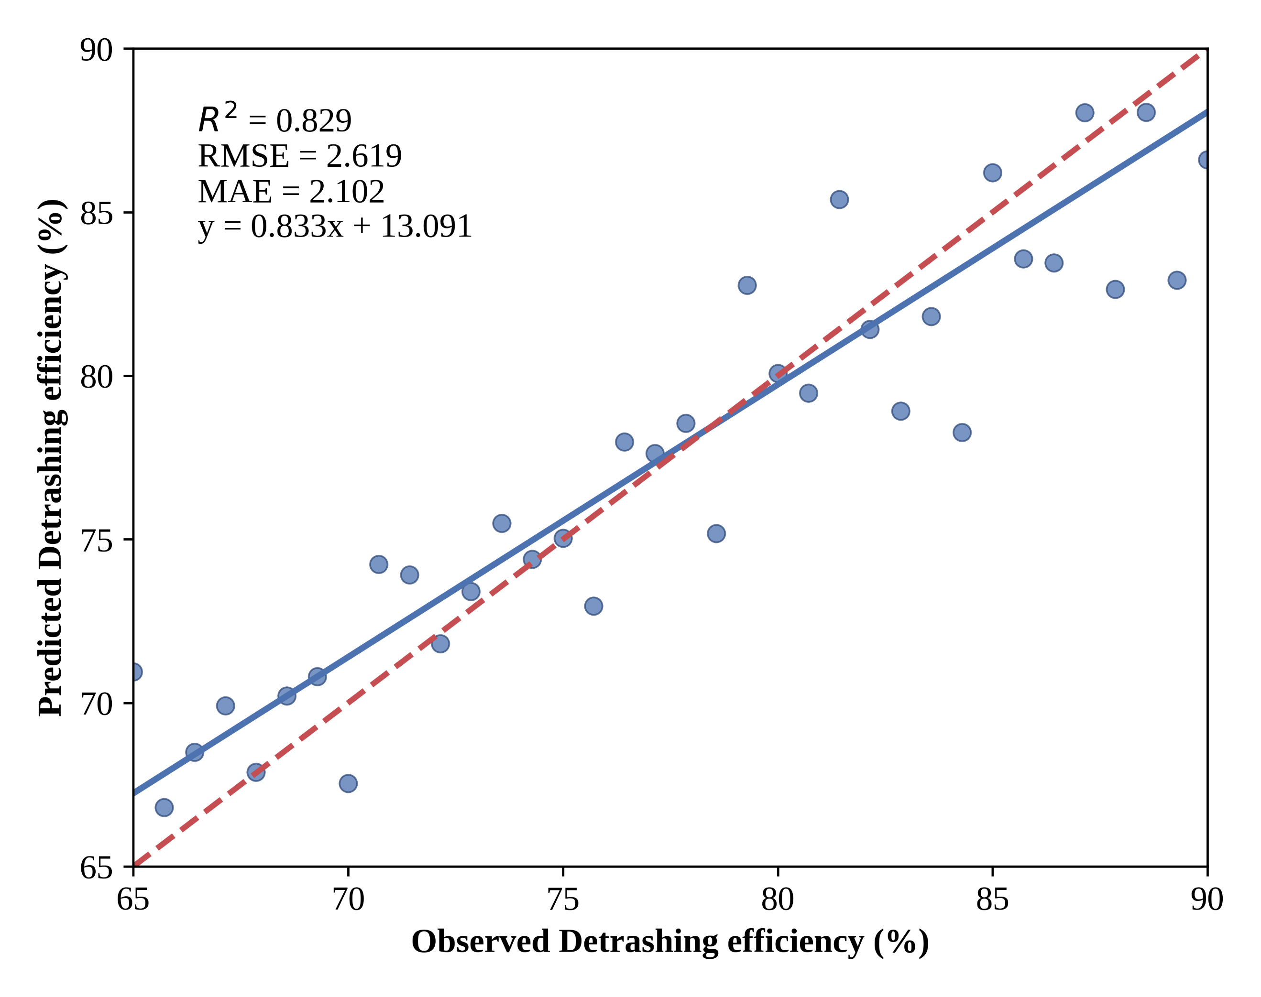
Fig. 2 Random Forest regression performance for predicting detrashing efficiency (%) on the independent test dataset.
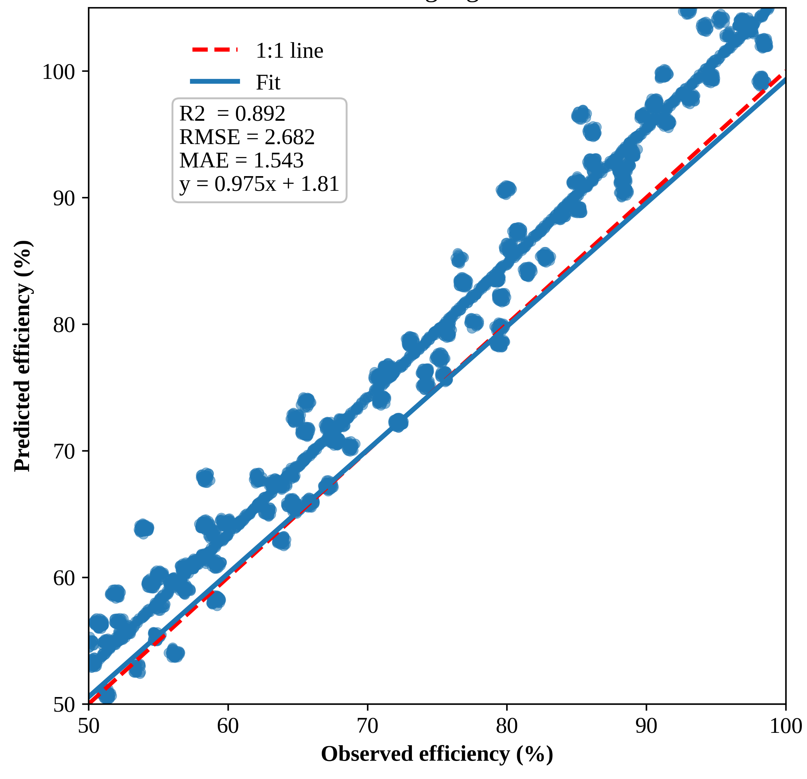
Fig. 3 Gradient Boosting regression performance for predicting detrashing efficiency (%) on the independent test dataset.
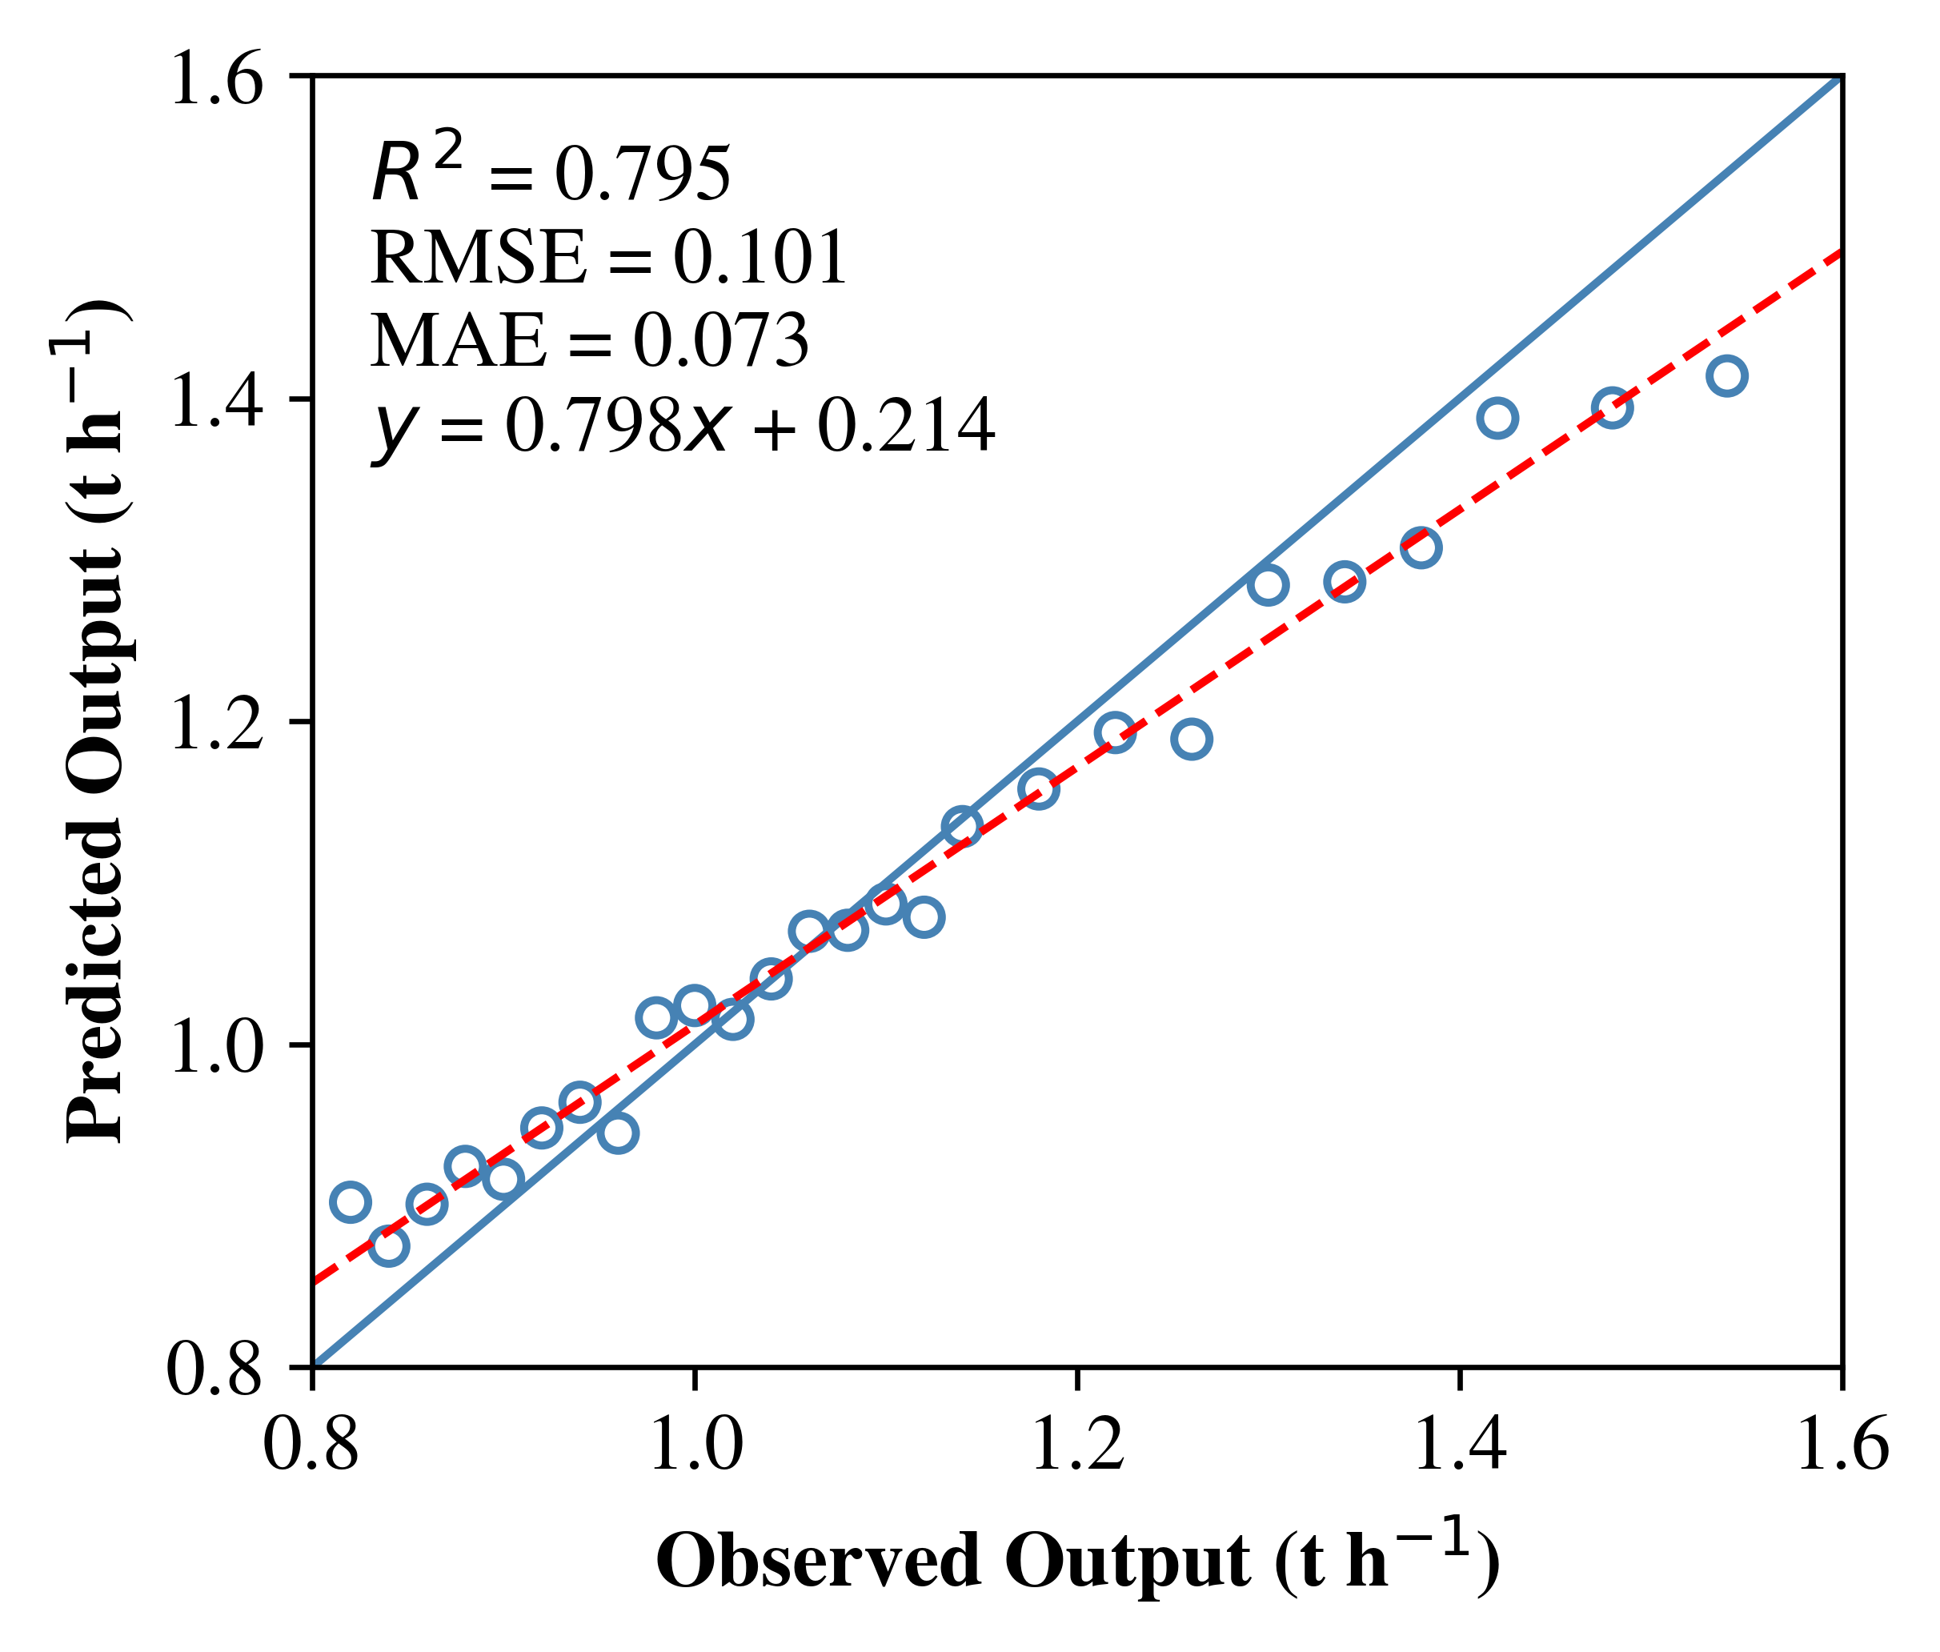
Fig. 4 Random Forest regression performance for predicting output (t h⁻¹) on the independent test dataset.
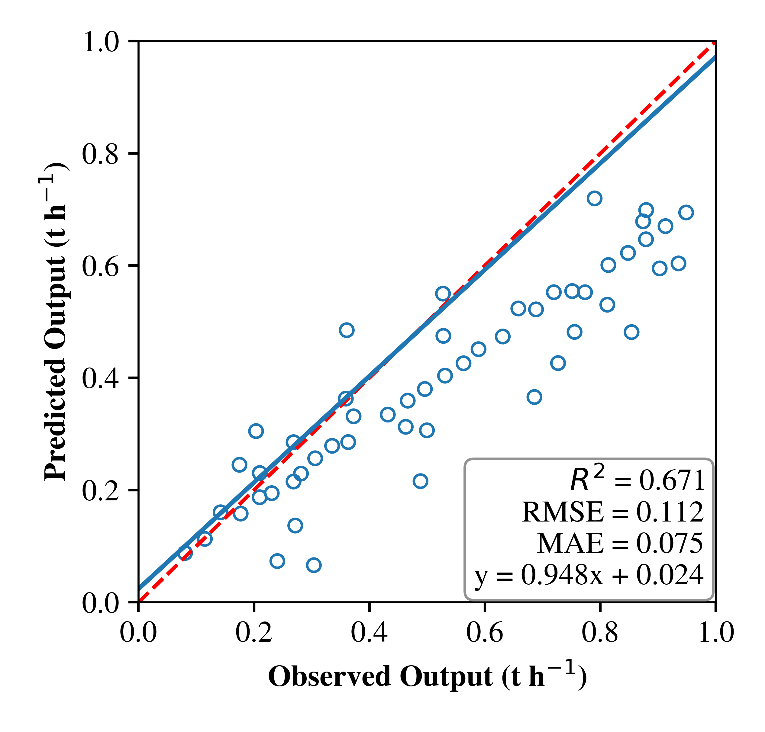
Fig. 5 Gradient Boosting regression performance for predicting output (t h⁻¹) on the independent test dataset.
In terms of the percentage of trash left, Gradient Boosting exhibited superior performance, although Random Forest also demonstrated strong results. The Random Forest model (Fig. 6) accounted for approximately 83.3% of the variance (R² ≈ 0.833), with a Root Mean Square Error (RMSE) of approximately 2.555 % and a Mean Absolute Error (MAE) of 2.07 %. Gradient Boosting further improved these metrics, increasing R² to approximately 0.90 and reducing the RMSE and MAE to approximately 6.265% and 4.9731%, respectively as shown in Fig. 7. Overall, these findings suggest that both ensemble tree methods are highly effective for modelling process indicators, but their strengths vary depending on the target. Gradient Boosting is evidently the superior choice for efficiency (%) and trash left (%), consistently achieving higher R² and lower error metrics than Random Forest. For output (t h⁻¹), Random Forest maintained a slight but consistent advantage in terms of explained variance and RMSE, although Gradient Boosting achieved a marginally lower MAE. This complementarity aligns with existing evidence that Random Forest and Gradient Boosting often exhibit distinct strengths based on the error structure and complexity of the response surface.
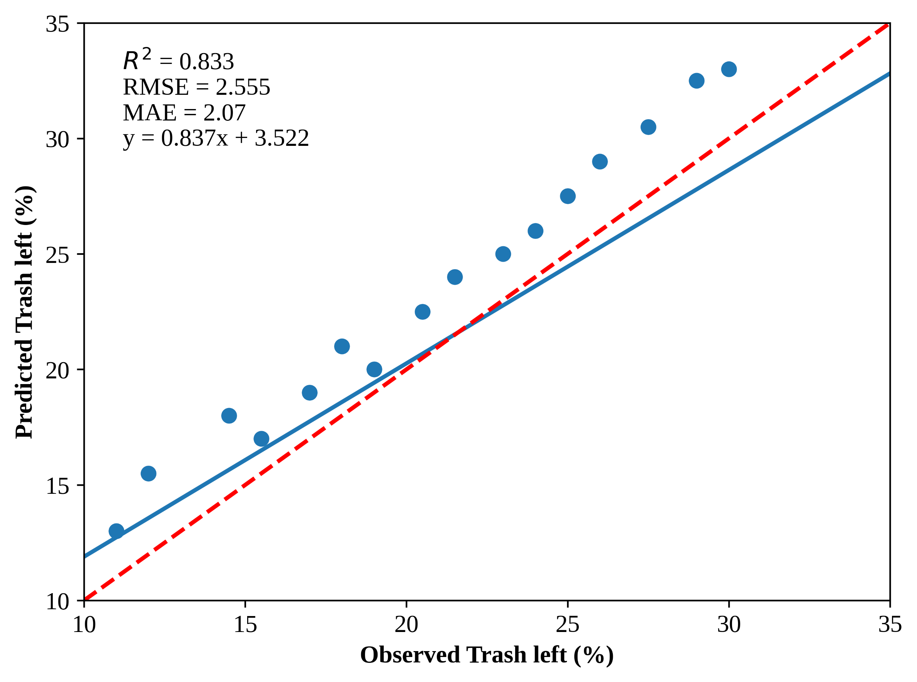
Fig. 6 Random Forest regression performance for predicting trash left (%) on the independent test dataset.
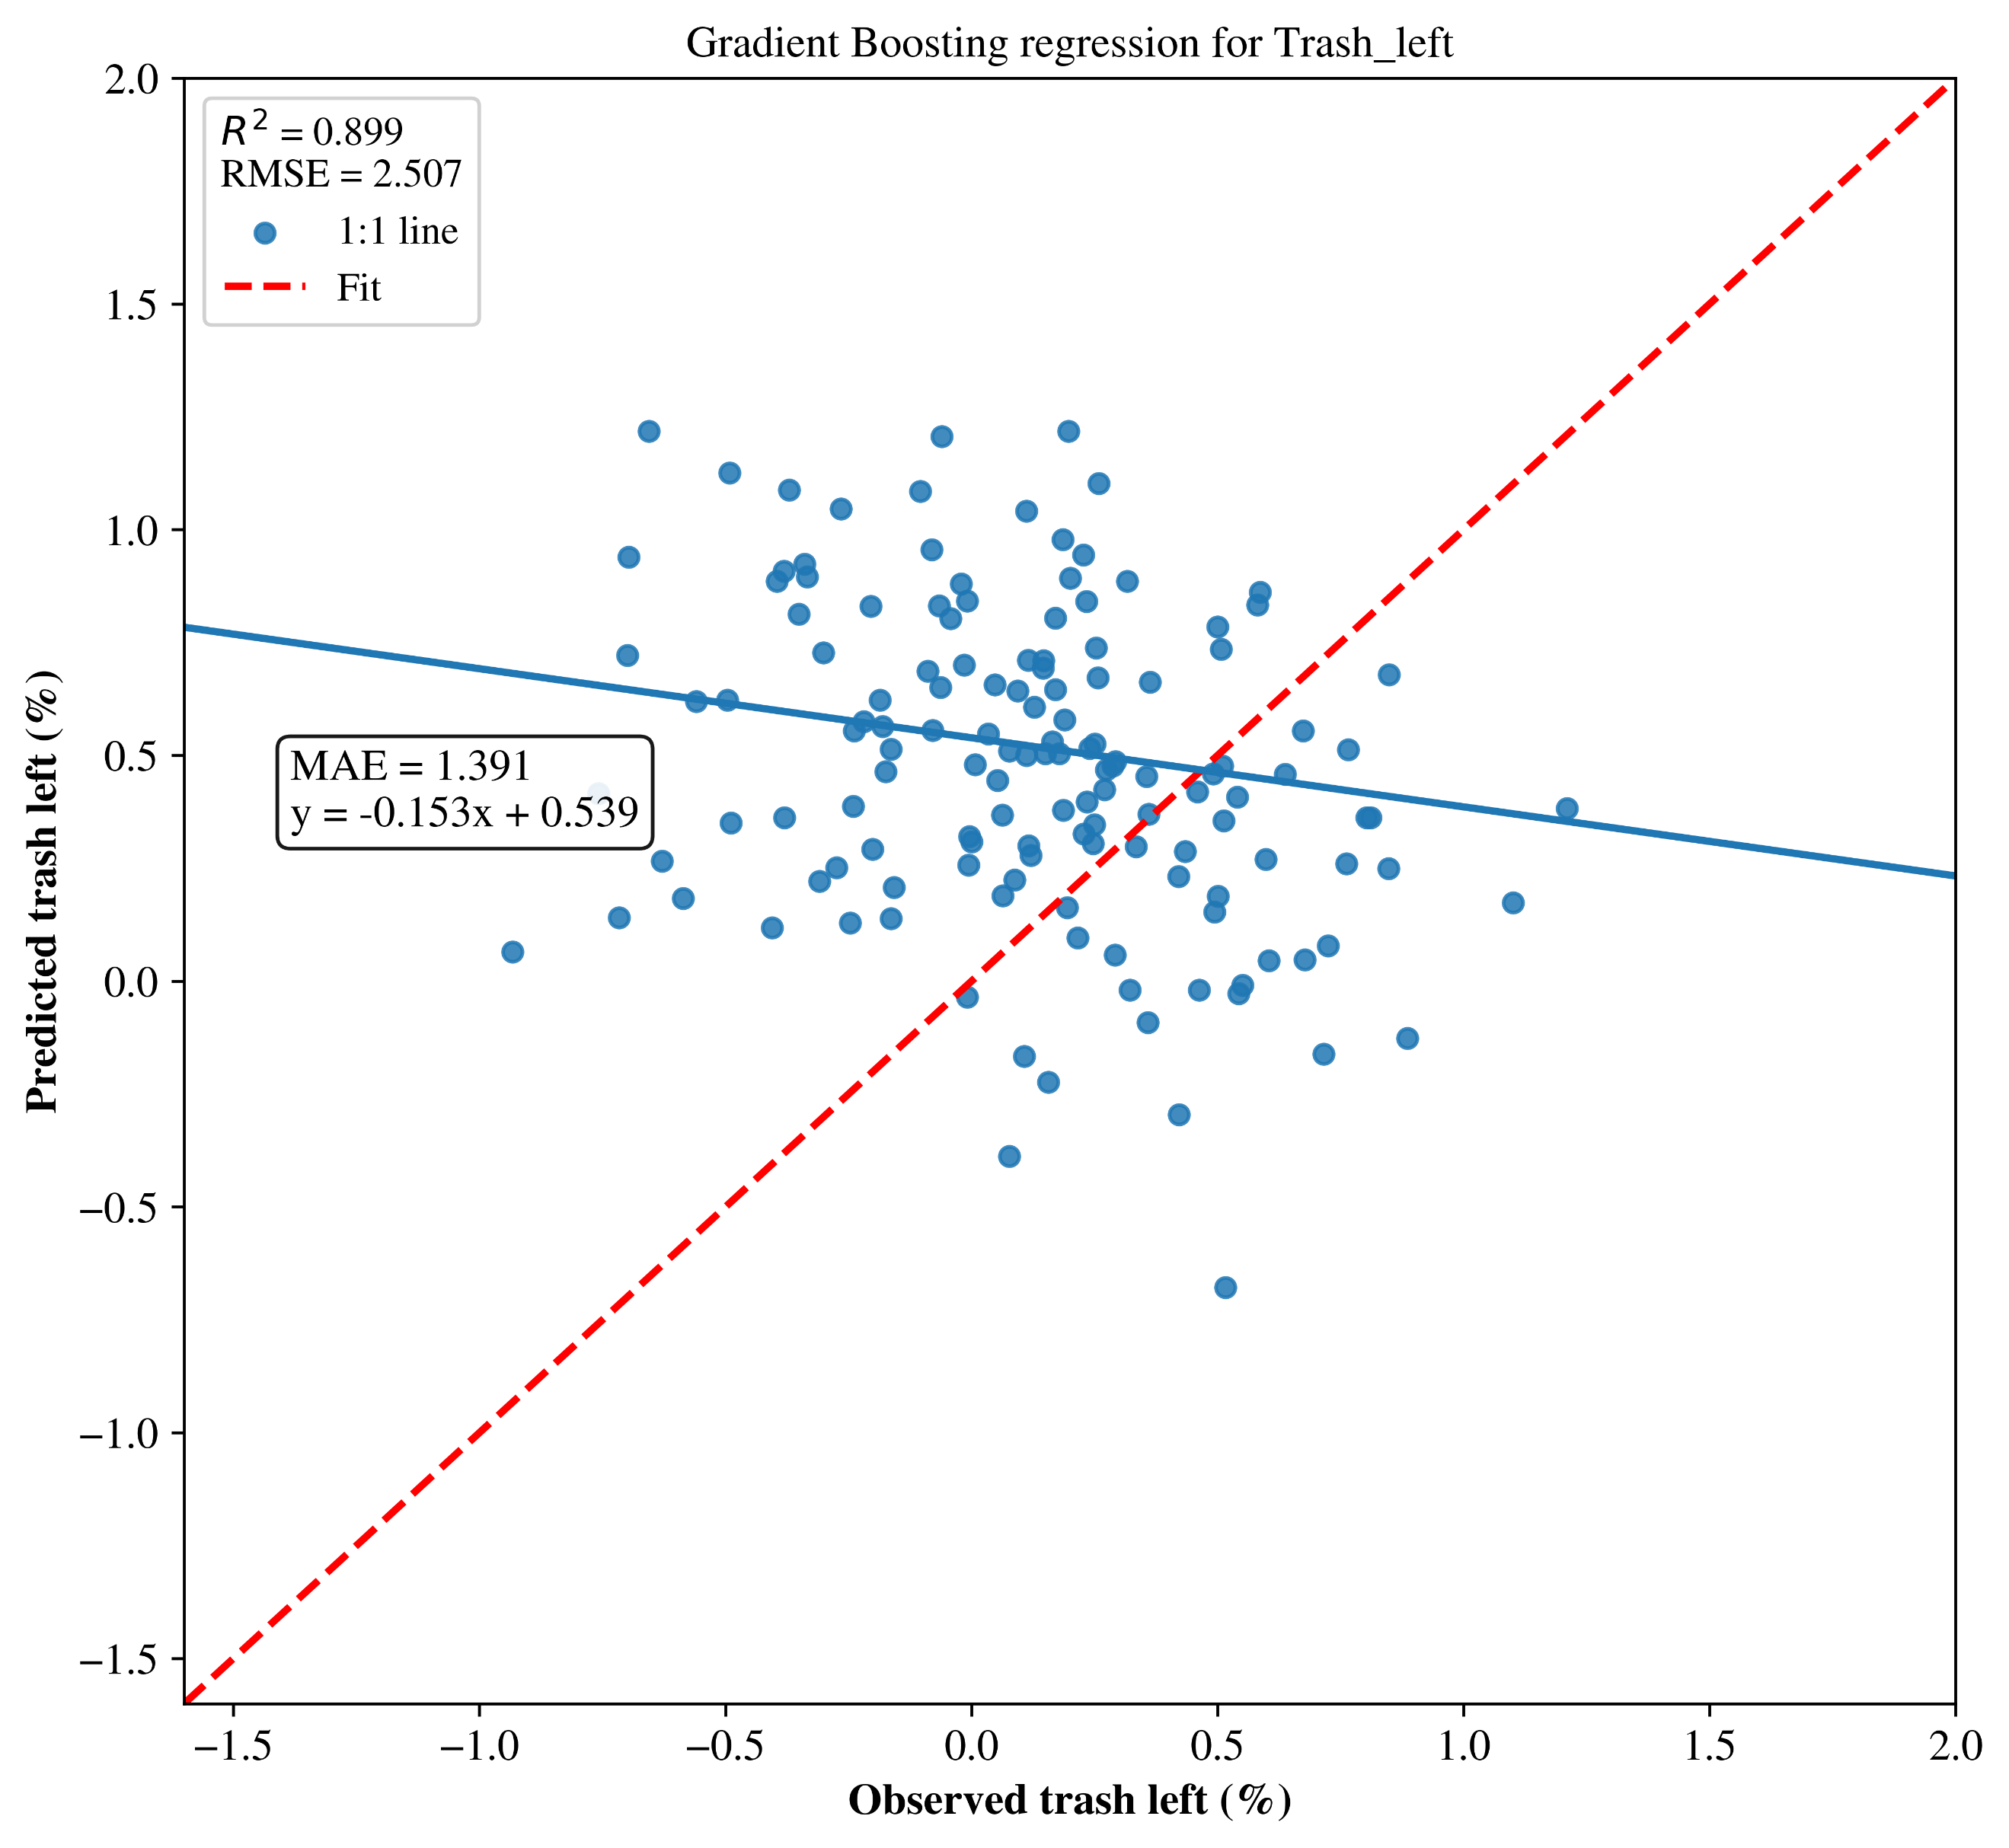
Fig. 7 Gradient Boosting regression performance for predicting trash left (%) on the independent test dataset.
- Discussion
The findings of this study unequivocally demonstrate that the operational parameters of the developed whole-stalk sugarcane detrasher significantly impacted trash removal, detrashing efficiency, and machine output. Among the six operational treatments (T1–T6), there was considerable variation in the percentage of trash remaining on the cane, indicating that even minor adjustments in roller speed and feeding–detrashing speed ratio can markedly affect the efficacy of the detrashing process. A similar sensitivity of trash removal to operational settings has been documented in sugarcane cleaning and preparation systems, where the equilibrium between cane throughput and stripping intensity dictates cleaning performance (Srivastava & Singh, 1990; Singh & Solomon, 2015; Omprabha et al., 2025). The lower residual trash levels observed in T2, T1, and T4 suggest that optimal coordination between the feeding rate and detrashing roller speed enhances the interaction between the cane stalk and the stripping elements. Under these conditions, the leaves and dry trash were effectively detached without excessive carryover. Conversely, the consistently higher trash levels recorded for T5 indicate a less favorable interaction, owing to insufficient residence time or ineffective contact with the detrashing elements. The categorization of treatments into distinct statistical groups further implies that the detrashing process does not respond in a purely linear fashion but rather operates within defined performance zones. This behaviour is characteristic of mechanical cleaning systems, where performance often stabilises within certain operational ranges before undergoing significant shifts when the thresholds are crossed (Franco et al., 2013; Cardoso et al., 2017).
The efficiency of detrashing exhibited trends that were generally inverse to those of residual trash, underscoring the interrelated nature of these two parameters. The highest efficiencies were observed under T4, followed by T1 and T3, indicating that these operational conditions facilitated adequate stripping action while ensuring controlled handling of the cane. The superior performance of T4 suggests that the selected speed ratio allowed for effective trash removal without causing excessive slippage or damage to the cane surface. Similar findings have been reported in studies on sugarcane dry cleaning and preparation equipment, where an optimal range of operational intensity maximises cleaning efficiency while preserving cane quality (Braunbeck et al., 1999; Kumar et al., 2025). Conversely, the diminished efficiency observed under T5 reflects the suboptimal engagement of the cane with the detrashing elements, leading to ineffective trash removal. Machine output was also significantly influenced by the operational conditions, highlighting the inherent trade-off between the cleaning performance and throughput (Zhao & Yang-Rui, 2015). Treatments associated with higher feeding speeds generally resulted in greater output but tended to compromise detrashing efficiency and increase the proportion of trash remaining on the cane after harvest. This trade-off is well documented in the literature on sugarcane harvesting and preparation, where improvements in cleanliness often come at the expense of capacity, and vice versa (Singh & Solomon, 2015; Elwakeel et al., 2025). In the present study, treatment T4 emerged as a favorable compromise, combining high detrashing efficiency and relatively low residual trash with an acceptable output. The statistically distinct output groups identified through Tukey’s test provide a practical basis for selecting operational conditions that balance cleanliness and capacity under actual field conditions.
In addition to performance outcomes, the practical applicability of the developed detrasher represents a significant contribution to this study. The machine was intentionally designed to accommodate smallholder and decentralized sugarcane production systems, where access to tractor-mounted or high-capacity machinery is frequently limited in Brazil. Its operation with a low-power (0.5 hp) single-phase electric motor ensures compatibility with rural power availability, while maintaining low energy requirements. The compact construction, moderate weight, and utilization of simple belt–pulley and chain–sprocket drives facilitate transport, installation, and maintenance. Manual feeding of whole-stalk cane allows for flexible operation under variable field conditions, whereas the rubberized detrashing elements minimize the risk of rind damage and help preserve cane quality. The capability to adjust roller speeds and feeding–detrashing speed ratios further enables adaptation to variations in cane diameter, moisture content, and trash load, which are commonly encountered during green-cane harvesting. The application of ensemble machine learning models adds an additional layer of practical value to the experimental findings. Both Random Forest and Gradient Boosting models effectively captured the nonlinear relationships between operational parameters and key performance indicators, enabling reliable prediction of detrashing efficiency, residual trash, and output (Garge et al., 2013; Hengl et al., 2018). Gradient Boosting proved particularly effective for predicting cleanliness-related parameters (Bentéjac et al., 2021), whereas Random Forest demonstrated slightly better performance for output prediction. Rather than serving solely as analytical tools, these models provide a means of translating experimental data into practical guidance, allowing operators to identify suitable operating ranges without extensive trial-and-error in the field. When combined with the low-power, compact, and adaptable design of the detrasher, the modeling framework supports the informed adjustment of operating parameters to achieve consistent field performance. Overall, this integrated experimental and data-driven approach offers a practical pathway for enhancing cane cleanliness and operational efficiency in smallholder sugarcane-harvesting systems.
- CONCLUSIONS
This study proved that a mechanized whole-stalk sugarcane detrasher designed for smallholder applications can achieve effective cleaning under optimal conditions. The device significantly reduced trash on the cane and achieved high detrashing efficiencies across all treatments. One-way ANOVA and Tukey's HSD confirmed the significant impact of operating conditions on the trash left behind, detrashing efficiency and throughput. Top-performing settings combined low residual trash with detrashing efficiencies above 80–85% while maintaining practical output. Minor adjustments in roller speed and feeding–detrashing speed ratio led to significant performance improvements. The analysis revealed trade-offs between cleaning quality and throughput, highlighting the need to balance the mill cleanliness with the capacity limitations. The statistically distinct groups identified provide a foundation for selecting robust operating windows. The Random Forest and Gradient Boosting regression models accurately predicted the key process indicators from the operating parameters. Gradient Boosting excelled in cleanliness predictions, while Random Forest performed better for output. These models provide a framework for data-driven monitoring and optimization of the processes. This study confirmed that careful speed adjustment can enhance cane cleanliness without compromising throughput and that ensemble learning techniques support operational decision-making. The combination of low-cost design with optimization and predictive modeling presents a promising pathway for enhancing quality in the small-scale sugar industry.

Disclaimer (Artificial intelligence)
Author(s) hereby declare that NO generative AI technologies such as Large Language Models (ChatGPT, COPILOT, etc.) and text-to-image generators have been used during the writing or editing of this manuscript.

REFERRENCES
Bastian, J., and Shridar. B. 2014. Investigations on sugarcane detrashing mechanisms. International Journal of Engineering Research, 3(7): 453-457.
Bentéjac, C., Csörgő, A., and Martínez-Muñoz. G. 2021. A comparative analysis of gradient boosting algorithms. Artificial Intelligence Review, 54: 1937-1967. https://doi.org/10.1007/s10462-020-09896-5
Braunbeck, O., Baueh, A., Calle, F. R., and Cortez. L. 1999. Prospects of green cane harvesting and cane residue use in Brazil. Biomass and Bioenergy, 17(6): 495-506. https://doi.org/10.1016/S0961-9534(99)00063-X
Braunbeck, O. A., and Magalhães. P. S. G. 2014. Technological Evaluation of Sugarcane Mechanization. Sugarcane bioethanol – R&D for productivity and sustainability. 451-464. http://dx.doi.org/10.5151/BlucherOA-Sugarcane-SUGARCANEBIOETHANOL_42
Cardoso, T. F., Leal, M. R. L. V., Morais, E. R., Souza, A., Bonomi, A., Cavalett, O., Chagas, M. F., Cortez, L. A. B., Braunbeck, O. A., Nogueira, L. A. H. and Watanabe. M. D. B. 2017. Economic, environmental, and social impacts of different sugarcane production systems. Biofuels, Bioproducts and Biorefining, 12(1): 68-82. https://doi.org/10.1002/bbb.1829
Chaya, W., Gheewala, S. H., and Bunnag. B. 2019. Adoption, Cost and Livelihood Impact of Machinery Services Used in Small-Scale Sugarcane Production in Thailand. Sugar Tech, 21(4): 543-556. https://doi.org/10.1007/s12355-018-0651-x
Da Silva, M. J., Neves, L. D. O., Correa, M. H. F., and de Souza. C. H. W. 2021. Quality Indexes and Performance in Mechanized Harvesting of Sugarcane at a Burnt Cane and Green Cane. Sugar Tech, 23(3): 499-507. https://doi.org/10.1007/s12355-021-00957-9
Elwakeel, A. E., Elden, A. Z., Ahmed, S. F., Issa, S., Li, C., Ali, K. A. M., Hanafy, W. M., Ali, G., Alzahrani, F., and Ahmed. A. F. 2025. Development, performance evaluation and prediction of optimal operational conditions for a double-row sugarcane harvester using deep learning. Scientific Reports, 15: 42942. https://doi.org/10.1038/s41598-025-30739-2
Franco, H. C. J., Vitti, A. C., Carvalho, J. L. N., Braunbeck, O. A., Magalhães, P. S. G., Pimenta, M. T. B., Kölln, O. T., Rossell, C. E. V., and Neto. J.R. 2013. Assessment of sugarcane trash for agronomic and energy purposes in Brazil. Scientia Agricola, 70(5): 305-312. https://doi.org/10.1590/s0103-90162013000500004
Garge, N. R., Bobashev, G., and Eggleston. B. 2013. Random forest methodology for model-based recursive partitioning: the mobForest package for R. BMC Bioinformatics, 14(1): 125. https://doi.org/10.1186/1471-2105-14-125
Ghosal, I., and Hooker. G. 2020. Boosting Random Forests to Reduce Bias; One-Step Boosted Forest and Its Variance Estimate. Journal of Computational and Graphical Statistics, 30(2): 493-502. https://doi.org/10.1080/10618600.2020.1820345
Gonzaga, L. C., de Zotelli, L., de Castro, S. G. Q., de Oliveira, B. G., de Bordonal, R., Cantarella, H., and Nunes. J.L. 2019. Implications of Sugarcane Straw Removal for Soil Greenhouse Gas Emissions in São Paulo State, Brazil. BioEnergy Research, 12: 843-857. https://doi.org/10.1007/s12155-019-10006-9
Hengl, T., Gräler, B, Wright, M. N., Heuvelink, G. B. M., and Nussbaum. M. 2018. Random forest as a generic framework for predictive modeling of spatial and spatio-temporal variables. PeerJ, 6(8): e5518. https://doi.org/10.7717/peerj.5518
Kishore, N., Gayathri, D., Venkatesh, J., Rajeswari, V., Sangeeta, B., and Chnadrika. A. 2017. Present Mechanization Status in Sugarcane – A Review. International Journal of Agricultural Sciences, 9(22): 4247-4253.
Kumar, A. P. M., Kavitha, R., Thiyagarajan, R., and Surendrakumar. A. 2025. Development of mini tractor operated hydraulic powered sugarcane leaf de-trasher. Sugar Tech, 27: 1056-1065. https://doi.org/10.1007/s12355-025-01559-5
Misra, V., Solomon, S., Hashem, A., Allah, E. F. A., Al-Arjani, A. F., Mall, A. K., Prajapati, C. P., and Ansari. M. I. 2020. Minimization of post-harvest sucrose losses in drought affected sugarcane using chemical formulation. Saudi Journal of Biological Sciences, 27(1): 309-317. https://doi.org/10.1016/j.sjbs.2019.09.028
Omprabha, Singh, S., and Dave. A. K. 2025. Engineering Properties of Sugarcane for the Development of Efficient Sugarcane Machinery. Sugar Tech, 27: 272-283. https://doi.org/10.1007/s12355-024-01492-z
Patel, A., Moses, S. C., D’souza, P. M., and Alam. R. N. 2022. Performance evaluation of tractor operated sugarcane leaf stripper through analysis of effect of length, girth and number of buds of sugarcane. International Journal of Environment and Climate Change, 12(11): 2337-2350. 10.9734/ijecc/2022/v12i1131229
Perillo, L. I., Moitinho, M. R., Aguiar, D. A., De Oliveira, R. B., De Figueiredo, E. B., Scala, N. L., Rudorff, B. F. T., and Panosso. A.R. 2022. Avoiding burning practice and its consequences on the greenhouse gas emission in sugarcane areas southern Brazil. Environmental Science and Pollution Research, 29(1): 719-730. https://doi.org/10.1007/s11356-021-15318-y
Rasche, L., and Sos Del Diego. R. 2020. Pros and Cons of Sugarcane Straw Recovery in São Paulo. BioEnergy Research, 13(1): 147-156. https://doi.org/10.1007/s12155-019-10078-7
Robertson, F. A., and Thorburn. P. J. 2007a. Decomposition of sugarcane harvest residue in different climatic zones. Soil Research, 45(1): 1-11. https://doi.org/10.1071/sr06079
Robertson, F. A., and Thorburn. P.J. 2007b. Management of sugarcane harvest residues: consequences for soil carbon and nitrogen. Soil Research, 45(1): 13-23. https://doi.org/10.1071/sr06080
Silva-Olaya, A. M., Scala, N. L. J., Dias, C. T. S., Cerri, C. E. P., and Cerri. C.C. 2013. Carbon dioxide emissions under different soil tillage systems in mechanically harvested sugarcane. Environmental Research Letters, 8(1): 015014. https://doi.org/10.1088/1748-9326/8/1/015014
Singh, A. K., and Solomon. S. 2015. Development of sugarcane detrasher. Journal of sugarcane research, 17(2): 189-194. https://doi.org/10.1007/s12355-014-0306-5
Solomon, S. 2016. Sugarcane Production and Development of Sugar Industry in India. Sugar Tech, 18: 588-602. https://doi.org/10.1007/s12355-016-0494-2
Solomon, S., and Misra. V. 2024. Sugarcane By-Product-Based Industries in Asian Countries. Value Addition and Product Diversification in Sugarcane. Springer, 1-31. https://doi.org/10.1007/978-981-97-7228-5_1
Srivastava, A. C., and Singh. K. 1990. Development of a power-driven sugarcane detrasher. Journal of Agricultural Mechanization in Asia, Africa and Latin America, 21(2): 985-990.
Vargas, V. P., Cantarella, H. Soares, J. R., Carmo, J. B. D., De Andrade, C. A., and Martins. A.A. 2014. Sugarcane Crop Residue Increases N₂O and CO₂ Emissions Under High Soil Moisture Conditions. Sugar Tech, 16(2): 174-179. https://doi.org/10.1007/s12355-013-0271-4
Viswanathan, R. 2016. Varietal Degeneration in Sugarcane and its Management in India. Sugar Tech, 18: 1–7. https://doi.org/10.1007/s12355-015-0369-y
Zhao, D. L., and Yang-Rui. 2015. Climate Change and Sugarcane Production: Potential Impact and Mitigation Strategies. International Journal of Agronomy, 547386: 1-10. https://doi.org/10.1155/2015/547386

