Original Research Article

Fish Marketing Dynamics in the Modern Fish Market of Ludhiana, Punjab, India

ABSTRACT
Efficient fish marketing has critical role in resolving issues of food security and sustainable livelihood, hence, this study was intended to provide detailed study of such key characteristics on prevailing domestic fish marketing dynamics of the modern fish market in Ludhiana. The information with respect to current fish market trends, including infrastructure facilities, species composition, seasonal availability, price index, waste management and consumer preference for fish, was collected at two monthly intervals by direct observation and interviews through developed questionnaire. The market was functional throughout the year, from where a total of 38 fish species were recorded, of which 80.35% was from capture fisheries. However, species-wise, 46.66% of market share was attributed to fish from capture fisheries resources of Punjab and 62.5% were sourced from other states of the total fish species. Besides, approximately, 5-10 tons of fishes transported daily to Himachal Pradesh, Jammu & Kashmir, Haryana and Assam. Among consumers, the higher demands for spineless fishes were observed, mostly during winters/specific occasions. Though this modern fish market has significant role in supplying fish, several challenges have also been observed, including inappropriate waste management and storage facilities. Therefore, the findings of the present study reveals that the database generated can be utilized for planning and upgrading the domestic market related strategies and to improve the post-harvest management practices.
Keywords: Punjab Fish market, Species composition, Price variability, Marketing infrastructure, Consumption pattern
Introduction
The fisheries and aquaculture sectors have a substantial role in ensuring food and nutritional security, employment generation and livelihood maintenance globally. Nationwide, the fisheries sector is contributing 1.09 % of total Gross Value Added (GVA) and about 6.72% of agriculture GVA. India contributes about 8% of global fish production, with a total fish production of 17.54 MT in 2022-23 (DoF, 2023). Being the source of good quality animal protein, omega-3 fatty acids, vital vitamins (B₂, B₁₂, D & E) and minerals (iron, zinc, iodine, magnesium and potassium), fish and fishery products fetch higher demand and price at both national and international levels. Fish marketing has a critical role in resolving the issues of food security and sustainable livelihood, especially in developing countries like India. Basically, a fish marketing chain starts right from the conception of fish/fishery products up to the final consumers with the involvement of various stakeholders, including fishermen, wholesalers, retailers, and consumers. Marketing is the bridging link between producers and consumers through various distributional channels or direct or indirect routes. Fish marketing in India is an intricate and complex system that takes place through various networks, including wholesale or retail markets, auction centers, and direct sales from fishing boats. The development of technology also added the option of digital marketing or online sale of fish. From an infrastructure point of view, the fish markets vary from traditional markets in small towns to large wholesale markets in major cities. Efficient fish marketing systems are the driving force behind the growth of fish production, promotion of fish consumption and overall development of the fisheries sector (Chourey et al., 2014). The perishable nature of the commodity, insufficient storage, lack of cold chain system, inappropriate waste management practices, less demand elasticity and a wide price spread are the major barriers in the development of a well-organized fish marketing system (Ravindranath, 2008; Bunkar, Waghmare & Garg, 2022).
Punjab, being the land-locked state of India, has fisheries resources in the form of rivers, canals, wetlands, small reservoirs and cultivable ponds, with a total fish production of 1.9 lakh tons. The fish markets of Punjab are occupied by the fishes reared in private and village ponds as well as captured from natural resources. There is also a significant presence of frozen freshwater and marine fish coming from other states like- Andhra Pradesh, Rajasthan, West Bengal, Gujarat, Maharashtra, and Karnataka (Datta et al., 2017; Arjunsinh et al., 2024). The per capita fish consumption is lower in Punjab than in southern and northeastern states (DoF, 2023). The curtailed demand by local people for fish (around 40% fish eater population) (Kaur et al., 2023) is also one of the major challenges for fish marketing in Punjab. Besides market infrastructure, basic facilities, including cold chain and waste management, are the other major issues affecting the fish market dynamics. The present study was taken up to assess the market dynamics of a modern fish market, including major fish species availability, their price structure, prevailing marketing channels, gender participation and waste management practices. This is the first such fish market in Punjab, which has been established as a pilot project with financial assistance from the National Fisheries Development Board and the Punjab Mandi Board with the objective of providing an organized area for fish retailers and wholesalers as well as neat and hygienic environment to customers. Hence, it becomes necessary to keep tracking the market dynamics to assure and sustain the food security and livelihood of the dependents in the state.
Material & Methods
Modern fish market, Ludhiana, (30.918608661126356, 75.90106024509544) is one of the most common and well-known fish markets in Punjab for both wholesalers and retailers. To trail the market dynamics, survey was conducted during December, 2022 – 2023 and the data was collected at two monthly intervals in a developed questionnaire by interviewing the fish traders, group discussions with intermediaries and fishermen and also people to track fish consumption patterns in the state. During the survey and interviewing the shop owners/workers in the market, the data were recorded in the developed questionnaire and compiled for statistical analysis and further interpretation. The collected data was then statistically analyzed in MS Excel software in the form of averages and percentages. The principal component analysis was performed to analyze the trends in market share dynamics on the basis of price index and species spectrum in the Ludhiana fish market.
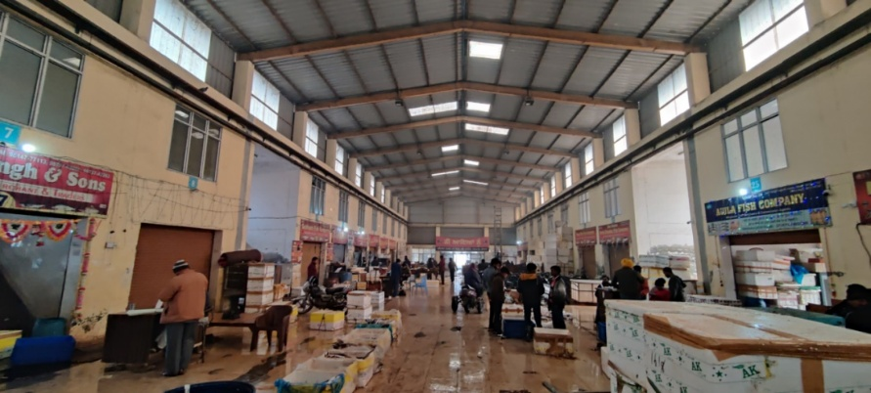
Figure 1. Modern Fish Market, Tajpur road, Ludhiana

Results and Discussion
The outcomes of the present study are summarized and tabulated below.
Fish market system
The conducted survey assessed the current status of the modern fish market in Ludhiana (figure 1). It was found that the urban wholesale market is functional throughout the year (except the 2-month ban period, 15 June – 15 August) during 08:00 am to 05:00 pm (retail market after 5:00 pm only). The fish marketing system is exclusively a private sector that is associated with the sale and purchase of captured as well as cultured/farmed fishes of Punjab and other states. Besides, there is an organization for all the fish dealers, i.e., the Tajpur Fish Association, and they are under the control of the chairman of this association. However, they are not a part/member of any of the fishery co-operative societies or other trade-related organizations.
During the survey, it was observed that the market is operated by males only and women's involvement was found to be negligible. The majority (50-60%) of the male operators in the fish market were in the age group of 40-50 years with education levels from matriculation to higher secondary. It was also recorded that they are involved in agriculture (25-35 %) other than being a fish market operator. Besides, the laborers working as daily paid labor (Rs. 400-500/day) for handling, cutting, processing (removal of unwanted and non-edible parts from fishes) and packaging was minor (20-30%), mostly illiterate (60-70%) and are mainly from Uttar Pradesh and Bihar (upto 60%). Similarly, Kishor et al., (2024) revealed that fishers are dependent mainly on fisheries as their primary occupation with minimal education and slight involvement in the agriculture sector in the Khammam district of Telangana.
Table 1. Total number of fishing operators, processors, and traders in the fish market
Total number of shops | Wholesale shops | Retails shops | Ownership of shops | No. of people associated per shop | Owner from Punjab / other state
43 | 32 (out of which 05 shops are closed) | 16 | Private | 4-5 | Punjab & Uttar Pradesh, Bihar, West Bengal

Infrastructure facilities and cold chain
Infrastructure facilities in the fish market include a proper building facility, water supply, knives, wooden platforms for fish cutting and filleting, waste collection containers, and proper electricity supply. There was a sufficient supply of water and manpower for washing the fish and containers, cutting tables, and cleaning the area (Figure 5). Waste generated after the fish processing collected by the Municipal Corporation workers for proper disposal at the designated areas (Figure 6).
Cold chain is an integral part of any fish market as fish is a highly perishable commodity (Markad, Gaikwad, Patil & Shinde, 2019). Most of the sellers used to keep fish with ice in alternative layers to maintain the fish quality. During sale time, they either spread the fish on the ground or in the thermocol boxes with (1:1) ice (Figure 3). Moreover, deep freezer facilities were also available with some of the traders to store the fish and maintain the quality of fish meat. Apart from this, the live-farmed fish were kept in big water enclosures. However, live fish from other districts of Punjab to market was being transported by large trucks/vanes and pick-up from the nearby areas whereas fish from other states transported by large trucks packed in thermocol with alternative layers of ice to prevent the spoilage (Figure 4).
The maintenance of hygienic conditions is important to keep the market clean. Different types of waste generated include used thermocol boxes, gunny bags, and fish waste which is collected by the daily paid laborer of the municipal corporation and disposed of by dumping it into the nearby areas, whereas thermocol waste is incinerated. Besides, the hygienic condition of the nearby area of the fish was found to be in very bad condition due to the disposal of used waste thermocol, polythene bags and the accumulation of unclean water around the fish market, producing bad odour (Figure 9). Moreover, fish was also found spread on the floor for the display in an unhygienic way, which needs to be addressed as it is a matter of public health concern. Similarly, Venkatappa et al., (2025) also stated that post-harvest losses significantly impact the quantity and quality of fish which may further influence the consumer health, livelihoods and food security.
Fish distribution and marketing chain
The distribution of fish generally happens through a simple chain is from fishermen to wholesalers followed by retailers and end users, i.e. consumers (George & Hossain, 2021). During the present survey, privately maintained similar marketing channels were observed. During the marketing and distribution of fishes, the quality of fish was maintained mainly by using the alternative layers of fish and ice that accelerated the fish preservation to keep the fish in good quality till it reached the end consumer. Besides, farmed live fishes were kept in small shallow enclosures containing water & ice to maintain the quality (Figure 7). However, it was observed that several middlemen were also involved between fish farmers and consumers in the fish marketing system. Presently, the following market chains were reported for the distribution of fish from fishermen/farmers to the consumer (Figure 2).
Figure 2. Marketing channels observed at Modern Fish Market, Ludhiana
Among the three marketing channels, channel 1 and channel 2 was found most prevalent in the Ludhiana fish market. However, during interviewing the consumers, it also has been observed that they prefer to buy live fish either directly from the fish farmer/producer or from the retail market due the quality constraint. Similarly, Sasmal and Bhagat (2025) revealed that channel 1 and channel 2 followed by channel 3 was most prevalent method of fish selling in the district Raipur, Chhattisgarh. Besides, Verma et al., (2025) revealed that channel 3 was being most preferred mode by fish farmers cooperative society whereas channel 1 was popular among individual fish farmers for selling fish.
Fish catch composition and price variability
Fish catch in the market comprises captured and cultured/farmed fish species. The fishes captured from the natural fisheries resources (river, canal and dam) were sold in iced conditions, and only farmed fishes were sold live/fresh. The major source of captured fish in the fish market consists of river Sutlej, Sidhwan Canal, Rajasthan dam and sometimes from West Bengal (Howarah) & Mumbai. The farmed live/fresh fish were brought to the market from various adjuvant districts (like Dhuri, Sangrur, Patiala, Fazilka, and Bathinda) and other states (Uttar Pradesh and Andhra Pradesh). During the survey, it was found that carp and catfishes were the dominant groups among the captured and farmed fishes. A total 38 fish species were recorded during the survey, of which 80.35% was from capture fisheries. However, species-wise, 46.66% of the market share was attributed to fish from the capture fisheries resources of Punjab. Moreover, out of the total fish species available in the market, 62.5% were sourced from other states (Andhra Pradesh, West Bengal, Rajasthan, Maharashtra, Haryana and Uttar Pradesh). Besides, price variability was observed in terms of seasonal availability, freshness, size, and form of fish (dead/live/raw/processed). Similar findings were reported by Deshmukh and Jawale (2014) and Alam et al., (2010), related to the variations in the market price of fish. Moreover, Shyam et al., (2023) evaluated the fish species diversity and price instabilities in the wholesale and retail markets of Kerala and also identified that existing price variations are mainly due to fish arrivals from other states. Besides, Shyam et al., (2021) observed market and fish species diversity in the major fish markets of Andhra Pradesh and Telengana along with the constraints faced by the traders.
Figure. 10: fisheries resources of Punjab 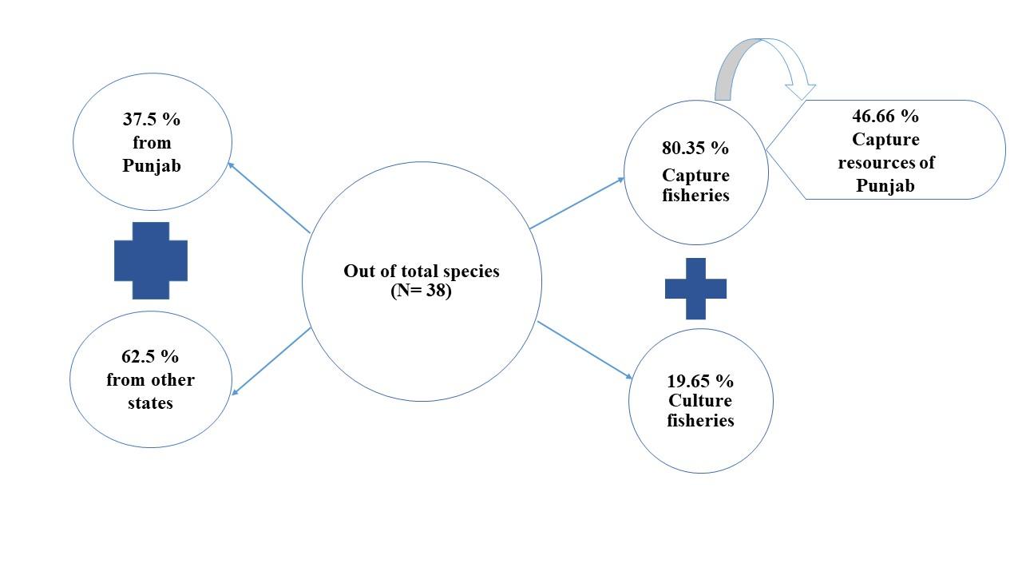

The composition of fish species, along with the size and price range, is given below in Table 2.
Table 2. Fish species composition and price variability in the fish market
Source | Name of species & family | Size Range (Kg) | Price Range (Rs.)
Sutlej | Labeo catla (Catla), Cyprinidae | 2-5 kg | 220-250/kg
Sutlej | L. rohita (Rohu), Cyprinidae | 1-3 kg | 200/kg
Sutlej | L. calbasu (Kalbans), Cyprinidae | 10 g – 1kg | 110/-
Sutlej | L. bata (Bata), Cyprinidae | 50-60 g | 120/-
Sutlej | L. dyocheilus (Kali), Cyprinidae | 1-2.5 kg | 120/-
Sutlej | Cirrhinus mrigala (Mrigal), Cyprinidae | 1-2 kg | 130-150/kg
Sutlej | C. reba (Sunee), Cyprinidae | 50-60 g | 110/-
Sutlej | Cyprinus carpio (Golden), Cyprinidae | 2.5-3 kg | 180/-
Sutlej | Wallgo attu (Malhi), Siluridae | 5-6 kg | 280-450/-
Sutlej | Sperata seenghala (Sanghara), Bagridae | 4-5 kg | 250-400/-
Sutlej | Mystus vittatus (Tengra, Palwa), Bagridae | 20-40 g | 350-400/-
Sutlej | Channa striatus (Saul), Channidae | 2.5-3 kg | 320/-
Sutlej | Chitala chitala (Cheetal), Notopteridei | 2.5-3 kg | 250-350/-
Sutlej | Chela laubuca (Chelwa), Danionidae | 10 g | 100-200/-
Sutlej | Bagarius bagarius (Goonch), Sisoridae | 20-25 kg | 300/-
Sutlej | Mastacembalus armatus (Bahm), Mastacembelidae | 10-50 g | 350/-
Sutlej | Chanda nama (Chanda), Ambassidae | 3-4 g | 200/kg
Sutlej | Gudusia chapra (Suiya), Clupeidae | 10-40 g | 70-80/-
Sutlej | Eutropiicthys vacha (Bachwa), Schilbeidae | 30-150 g | 210-300/-
Sidhwan Canal, Doraha | C. carpio (Golden/Common carp), Cyprinidae | 1-3 kg | 170/-
Sidhwan Canal, Doraha | L. bata (Bata), Cyprinidae | 0.1-0.4 kg | 140/-
Rajasthan Dam | L. catla (Catla), Cyprinidae | 8-12 kg | 200/kg
Rajasthan Dam | L. rohita (Rohu), Cyprinidae | 3-4 kg | 200/kg
Rajasthan Dam | L. gonius (Kursa), Cyprinidae | 0.25 – 4 kg | 180/kg
Rajasthan Dam | Hypophthalmichthys nobilis (Bighead carp), Xenocyprididae | 5-15 kg | 100/kg
Rajasthan Dam | Hypophthalmichthys molitrix  (Silver carp), Cyprinidae | Up to 5 kg | 110-140/kg
Rajasthan Dam | Ctenopharyngodon idella (Grass carp), Cyprinidae | 1-3 kg | 110-120/kg
Rajasthan Dam | C. carpio (Golden), Cyprinidae | 2-10 kg | 150-160/kg
Rajasthan Dam | W. attu (Malhi), Siluridae | 0.5-3.0 kg | 300-350/-
Rajasthan Dam | Sperata seenghala (Sanghara), Bagridae | 0.5-3.0 kg | 320/-
Rajasthan Dam | Mystus tengaram (Tengara), Bagridae | 5-15 kg | 200/-
Rajasthan Dam | Channa striatus (Saul), Channidae | 1-3 kg | 280-340/kg
Rajasthan Dam | Notopterus notopterus (Battu), Notopteridei | 2-10 kg | 200-250/-
Rajasthan Dam | Chitala chitala (Cheetal), Notopteridei | 1-3 kg | 260-360/kg
Rajasthan Dam | Bagarius bagarius (Goonch), Sisoridae | 8-12 kg | 300/-
Rajasthan Dam | Puntius (Pathia), Cyprinidae | 20-300 g | 80-100/-
Rajasthan Dam | Anabas testudineus (Kowai), Anabantidae | 50-150 g | 160-250/-
 | Clupisoma garua (Bachwa), Schilbeidae | 100-150g | 150-200/-
 | Parambassis ranga (Chanda /Glassfish), Ambassidae | 10-20g | 70-80/-
West Bengal, Maharashtra | Rastrelliger kanagurta (Ayala), Scombridae | 400g – 1 kg | 220-250/-
West Bengal, Maharashtra | Sardinella longiceps (Mathi), Clupeidae | 100-120 g | 100-120/-
Andhra Pradesh | Piaractus brachypomus (Roopchand), Serrasalmidae | 700 – 1.7 kg | 120/kg
Andhra Pradesh | Pangasianodon hypophthalmus (Pangas), Pangasiidae | 2.5 - 8 kg | 100-110/-
West Bengal to Delhi | Scylla serrata (Kekdha/Mud crab), Portunidae | 80 - 100 count | 140-250/-
West Bengal to Delhi | Pila sp. (Ghonga), Ampullariidae | 80 - 100 count | 120-140/-
Punjab, Haryana and Uttar Pradesh farms  (Farmed fish) | Pangasianodon hypophthalmus (Pangas), Pangasiidae | 1 – 2.5 kg | 140/-
Punjab, Haryana and Uttar Pradesh farms  (Farmed fish) | L. catla (Catla), Cyprinidae | 400 g -1.5 kg | 220-250/-
Punjab, Haryana and Uttar Pradesh farms  (Farmed fish) | L. rohita (Rohu), Cyprinidae | 400 g -1.5 kg | 140/-
Punjab, Haryana and Uttar Pradesh farms  (Farmed fish) | Cirrhinus mrigala (Mrigal), Cyprinidae | 400 g -1.5 kg | 130-150/-
Punjab, Haryana and Uttar Pradesh farms  (Farmed fish) | H. molitrix (Silver carp), Cyprinidae | 500 g – 1kg | 100-140/-
Punjab, Haryana and Uttar Pradesh farms  (Farmed fish) | C. carpio (Golden/Common carp), Cyprinidae | 500 g – 1kg | 100-140/-
Punjab, Haryana and Uttar Pradesh farms  (Farmed fish) | C. idella (Grass carp), Cyprinidae | 500 g – 1kg | 100-140/-
Punjab, Haryana and Uttar Pradesh farms  (Farmed fish) | H. nobilis (Bighead carp), Xenocyprididae | 1-2 kg | 100/-
Punjab, Haryana and Uttar Pradesh farms  (Farmed fish) | Oreochromis niloticus (Tilapia), Cichlidae | 50 – 150 g  Max. 500 g
Punjab, Haryana and Uttar Pradesh farms  (Farmed fish) | Litopenaeus vannamei (Shrimp), Penaediae | 50-70 count | 250-260/-
Retail market | L. rohita (Rohu), Cyprinidae | 800 g – 1 kg | 140/kg
Retail market | Cirrhinus mrigala (Mrigal), Cyprinidae | 500 g – 1 kg | 120/kg
Retail market | Pangasianodon hypophthalmus (Pangas), Pangasiidae | Farmed but not live | 140/kg
Retail market | Pangasianodon hypophthalmus (Pangas), Pangasiidae | Pangas Fillet | 300/kg
Retail market | Pangasianodon hypophthalmus (Pangas), Pangasiidae | Live Pangas | 160-180/kg
Retail market | Litopenaeus vannamei (Jhinga/Shrimp), Penaediae | Farmed | 400/kg

The survey evaluated the composition & abundance of fish in the market and found that captured fishery is mainly dominated by catfishes (Sperata seenghala, Wallago attu), whereas farmed fishes mainly include carps (Labeo catla, Labeo rohita, Cirrhinus mrigala, Hypophthalmichthys nobilis), and Pangasianodon hypophthalmus. Besides, fish from the Ludhiana wholesale market are being distributed to different states like Jammu & Kashmir, West Bengal, and Assam via Delhi. Especially the Pangas, imported from Andhra Pradesh, which is being exported to Jammu & Kashmir and Himachal Pradesh as a whole (raw) as well as in fillet form.
Figure. 11. Principal Component Analysis of price index of Fish species available from Sutlej River system
1Labeo catla | 2L. rohita | 3L. calbasu | 4L. bata | 5L. dyocheilus
6Cirrhinus mrigala | 7C. reba | 8Cyprinus carpio | 9Wallgo attu | 10Sperata seenghala
11Mystus vitatus | 12Channa striatus | 13Chitala chitala | 14Chela laubuca | 15Bagarius bagarius
16Mastacembalus armatus | 17Chanda nama | 18Gudusia chapra | 19Eutropiicthys vacha
Figure. 12. Principal Component Analysis of price index of Fish species available from Rajasthan Dam
1L. catla | 2 L. rohita | 3 L. gonius | 4Hypophthalmichthys nobilis | 5Hypophthalmichthys molitrix
6Ctenopharyngodon idella | 7 C. carpio | 8 Wallgo attu | 9Sperata seenghala | 10Mystus tengaram
11Channa striatus | 12Notopterus notopterus | 13Chitala chitala | 14Bagarius bagarius | 15Puntius sp.
16Anabas testudineus | 17Clupisoma garua | 18Parambassis ranga
Figure. 13. Principal Component Analysis of price index of Fish species available from other states
1Rastrelliger kanagurta | 2Sardinella longiceps | 3Piaractus brachypomus | 4Pangasianodon hypophthalmus
5Scylla serrate | 6Pila sp.

Principal component analysis of the price index of fish species available from the Sutlej River, Rajasthan Dam, and other states indicates that fish species falling in the PC1 and PC2 ranges are the major driving force behind the market dynamics and species spectrum. It is mainly comprised of Indian major carps, cat fishes and small indigenous species in the market which are playing significant role in the fish marketing dynamics variations. On the other side, in figure 13, the graph indicating that the contribution of fishes from other states in market dynamics is not significant as they are available either seasonally or occasionally. However, Pangasianodon hypophthalmus, Scylla serrate and Sardinella longiceps among the species coming from other states are the major driving forces impacting the fish marketing dynamics in Ludhiana fish market.
Seasonal variations in the fish catch composition
Fish species were available all around the year except during the monsoon period, whereas pangas were found to be available throughout the year. The observations recorded during the survey are tabulated below:
Table 3. Seasonal availability of fish in the fish market
S. No. | Name of species | Pre-monsoon (April-June) | Monsoon  (July-August) | Post-monsoon  (Sept-Nov.) | Winter  (Dec-Jan) | Post -winter (Feb-march)
Carps
1 | Catla catla |  | ⁺ | ⁺
2 | Labeo rohita |  | ⁺ | ⁺ | √ | ⁺
3 | L. bata |  | ⁺ | ⁺
4 | L. calbasu |  | ⁺ | ⁺
5 | L. gonius |  | ⁺ | ⁺
6 | L. dyocheilus | √ | ⁺ | ⁺
7 | Cirrhinus mrigala |  | ⁺ | ⁺
8 | C. reba |  | ⁺ | ⁺
9 | Ctenopharyngodon idella (Grass carp) |  |  | ⁺ | √ | ⁺
10 | Hypophthalmichthys molitrix (Silver carp) |  |  | ⁺ | √ | ⁺
11 | Cyprinus carpio (Golden) | ⁺ | ⁺ | ⁺ | ⁺ | ⁺
12 | Hypopthalmichthys nobilis (Bighead) | √ | √ | √ | √ | √
Catfish
13 | Wallago attu (Malhi) | √ | √ | ⁺ | ⁺ | ⁺
14 | Sperata seenghala, (Seenghara) | √ | √ | ⁺ | ⁺ | ⁺
15 | Mystus vittatus |  |  | ⁺ | ⁺ | ⁺
16 | Mystus tengara |  |  | ⁺ | ⁺ | ⁺
17 | Bagarius bagarius | √ | √ | ⁺ | ⁺ | ⁺
18 | Pangasianodon hypophthalmus | ⁺ | ⁺ | ⁺ | ⁺ | ⁺
Snakehead / Murrels
19 | Channa striatus (Saul) | √ | √ | √ | ⁺ | ⁺
Featherbacks
20 | Chitala chitala (Cheetal) |  |  |  | √  (rarely available)
21 | Notopterus notopterus |  |  |  | √ | √
Eel
22 | Mastacembalus spp. |  |  |  | ⁺ | ⁺
Miscellaneous
23 | Chela spp. (Chelwa) | √ |  | √ | √ | √
24 | Chanda nama (Glass fish) | √ |  | √ | √ | √
25 | Gudusia chapra (Suiya)
26 | Eutropiicthys vacha (Bachwa) | √ |  | √ | √ | √
27 | Puntius spp.
28 | Anabas testudineus |  |  | √ | √ | √
29 | Piaractus brachypomus (Roopchand) | √ | √ | √ | √ | √
30 | Oreochromis niloticus (Tilapia)
Marine fishes
31 | Rastrelliger kanagurta (Ayala) | √ |  | √ | √ | √
32 | Sardinella longiceps (Mathi) | √ |  |  |  | √
Shell fishes
33 | Litopenaeus vannamei (Shrimp) |  | ⁺ | ⁺
34 | Scylla serrata (Kekdha/Mud crab) | √ | √ | √ | √ | √
35 | Pila sp. (Ghonga) | √ | √ | √ | √ | √
 | + = abundance - = rare √ = present
During the survey, it was observed that different fish species (occasionally some shellfishes and marine fishes also, Figure 8) are being imported and exported from Punjab as mentioned in the Table 3. For the transportation of fish, they used large trucks for long distances (e.g., supply of pangas from Andhra Pradesh), whereas local suppliers used pickup and loaders. Besides, local fish sellers used bikes and cycles to transport fish from the fish market to the nearby areas.
Table 4. Export and import of fish in the fish market
Parameter |  | Information
No. of fishing parties associated per shop |  | 4-5
No. of people per fishing parties |  | 5-15
Import (On daily basis) | No. of fishing vehicles arrived from other states to Punjab | - Fish Species: Pangas  - Total amount of fish: 13,200 kg (330 boxes /truck x 40 kg per box)  - 2-3 trucks/week  - During season, one truck per day
Import (On daily basis) | No. of fishing vehicles from different districts of Punjab | - Fish Spp.: Carps (From Ludhiana, Bathinda, Patiala, Sangrur)  - Total amount of fish: 10-12 Qtl.  - Farmed fish available on one-two shops  - Tilapia also reported (from Fazilka)
Export  (On daily basis) | Local retail markets | - Fish Spp.: Live fish – carps, farmed pangas, shrimp
Export  (On daily basis) | Outside Punjab | - Fish spp.: Pangas (raw whole fish, heads & fillets), Carps, Chelwa & Cheetal (to Howrah& Assam as per the availability)  - Supply to Jammu & Kashmir, Himachal Pradesh, Uttar Pradesh & Bihar  - Total amount of fish: 18-20 quintal/ day

Table 5. Consumption patterns in the state
Fish species | Consumers | Consumption frequency
W. attu (Malhi)  S. seenghala (Sanghara)  C. striatus (Saul)  L. rohita (Rohu)  C. mrigala (Mrigal)  Pangasianodon hypophthalmus | Punjabis | Occasionally and mainly during the winter season (malhi being the first preference of Punjabis followed by sanghara & saul)
Chella spp. (Chelwa)  C. carpio (Golden)  L. catla (Catla)  L. rohita (Rohu)  L. bata (Bata)  C. idella (Grass Carp)  H. nobilis (Bighead carp)  Pangasianodon hypophthalmus | People from other states like Uttar Pradesh, Bihar, West Bengal | Throughout the year

The assessment of consumer preference provided the insights that Punjabi preferred spineless fishes (malhi, sanghara, saul and pangas) mostly during the winter (occasionally also) whereas carps were mainly preferred by people from Uttar Pradesh, Bihar, and West Bengal (all around the year) residing in Punjab. However, after analyzing the consumption patterns and preference of spineless fish species among the Punjabis, it has been revealed that majority of these species including W. attu, S. seenghala, C. striatus except Pangasianodon hypophthalmus are being captured from the natural fisheries resources only, the culture technology for these species has not been standardized yet. It also has been observed that the population of these species in the catch is declined in the recent years which might be the impact of the higher fishing pressure due to increased consumption demand in the state. Hence, declining natural stock and increasing consumption demand of these species in the state warrants the continuous monitoring of the stock to frame the suitable conservation and management strategies to maintain the sustainable fish production from natural capture fisheries resources.
Conclusion
This modern fish market in Ludhiana has a significant role in supplying the fish within Punjab and to other states as well. Although it is a source of livelihood for fish traders, it is required that the marketing channels should be simplified to uplift the socio-economic conditions of fish producers (fish farmers/fishermen). Moreover, during the survey, it was found that catch of commercially important fish species including S. seenghala, W. attu and Indian Major carps is declining due to overfishing & natural habitat destruction. More demand of spineless species for consumption among Punjabi people also warrants the conservation and management of natural fish stock for which the captive culture is still not possible. However, inappropriate waste management and improper storage facilities in the market need to be addressed to create a hygienic and consumer-friendly environment. Hence, emphasis should be given towards the fisheries and management of the capture fisheries sector in Punjab to increase the overall contribution of locally produced fish in the market within the state. Besides, the study provides the useful baseline database for researchers and policy makers to improve the supply chain efficiency and food security.
Disclaimer (Artificial intelligence)
We hereby declare that NO generative AI technologies such as Large Language Models (ChatGPT, COPILOT, etc.) and text-to-image generators have been used during the writing or editing of this manuscript.
References
- Alam MJ, Yasmin R, Rahman A, Nahar N, Pinky NI, Hasan M. A study on fish marketing system in Swarighat, Dhaka, Bangladesh. Nature and Science. 2010; 8(12): 96-103.
- Arjunsinh PN, Datta SN, Singh P, Tewari G. Catch Composition, Trade Practices and Market Structure Dynamics: In-Depth Analysis of Fish Markets in Punjab. Indian Journal of Ecology. 2024; 51(4): 921-925.
- Bunkar K, Waghmare SD, Garg CK. Supply chain management in fisheries and its challenges. Just Agriculture. 2022; 2(8): 1-5.
- Chourey P, Meena D, Varma A, Saxena G. Fish marketing system in Bhopal (MP). Biological Forum-An International Journal. 2014; 6(1): 19-21.
- Datta SN, Dhawan A, Singh A. Trends of fish marketing strategy and trade in Punjab-A survey. Indian Journal of Ecology. 2017; 44(3): 637-643.
- Deshmukh DR, Jawale CS. Study of fish markets in Paithan, Dist. Aurangabad, Maharashtra. Trends in Fisheries Research. 2014; 3(3): 5-6.
- George G, Md. Hossain B. Promoting Innovations in the Fisheries Value Chain for Improving Human Nutrition in South Asia. SAARC Agriculture Centre, Dhaka, Bangladesh. 2021; p.232.
- Handbook on Fisheries Statistic. Department of Fisheries, Ministry of Fisheries, Animal Husbandry & Dairying, Government of India, New Delhi. 2023.
- Kaur R, Tewari G, Kaur S, Kumar J. Study of factors influencing fish consumption pattern in Punjab (India). Indian Journal of Ecology. 2023; 50(4): 1184-87.
- Kishor K M, Krishna Teja I, Sreedeepya Ch, Shivani S. A Study on Socio-Economic Status of Fishers in Khammam District of Telangana, India. Journal of Scientific Research and Reports. 2024; 30 (9):809-15. https://doi.org/10.9734/jsrr/2024/v30i92407.
- Markad SS, Gaikwad JM, Patil DW, Shinde VD. Marketing system and state of fish markets in Hingoli district, Maharashtra. Advances in Fisheries, Biological & Allied Research. 2019; 1(2): 105-110.
- Ravindranath K. Domestic marketing of fish and fishery products in India – Opportunities and challenges. In: National Workshop on Development of Strategies for Domestic Marketing of Fish and Fishery Products held at College of Fisheries Science, Nellore, India. 2008; pp. 43-48.
- Sasmal S, Bhagat RK. Analysis of Marketable Surplus and Marketing Efficiency in Fish Production in Raipur District of Chhattisgarh State, India. Journal of Scientific Research and Reports.2025; 31 (9):457–462. https://doi.org/10.9734/jsrr/2025/v31i93510.
- Shyam SS, Athira NR, Sunil PV, Akhila K, Harshan NK. Price fluctuations and species diversity across fish markets in Kerala. Indian Journal of Fisheries. 2023; 70(1): 126-135.
- Shyam SS, Stanley L, Athira NR, Lakshmanadinesh K. Species diversity across fish markets in Andhra Pradesh and Telengana. Indian Journal of Economics and Development. 2021; pp.1-9.
- Venkatappa, Sreedevi MS, Krishnamma PN. Reducing Post-Harvest Losses in Small-Scale Fisheries: Causes, Impacts, and Sustainable Solutions. Journal of Scientific Research and Reports. 2025; 31 (11):1048–1065. https://doi.org/10.9734/jsrr/2025/v31i113734.
- Verma T, Gauraha AK, Pathak H, Sasmal S. An Economic Analysis of Production and Marketing of Fish in Raipur District of Chhattisgarh, India. Journal of Scientific Research and Reports. 2025; 31 (6):749-55. https://doi.org/10.9734/jsrr/2025/v31i63170.

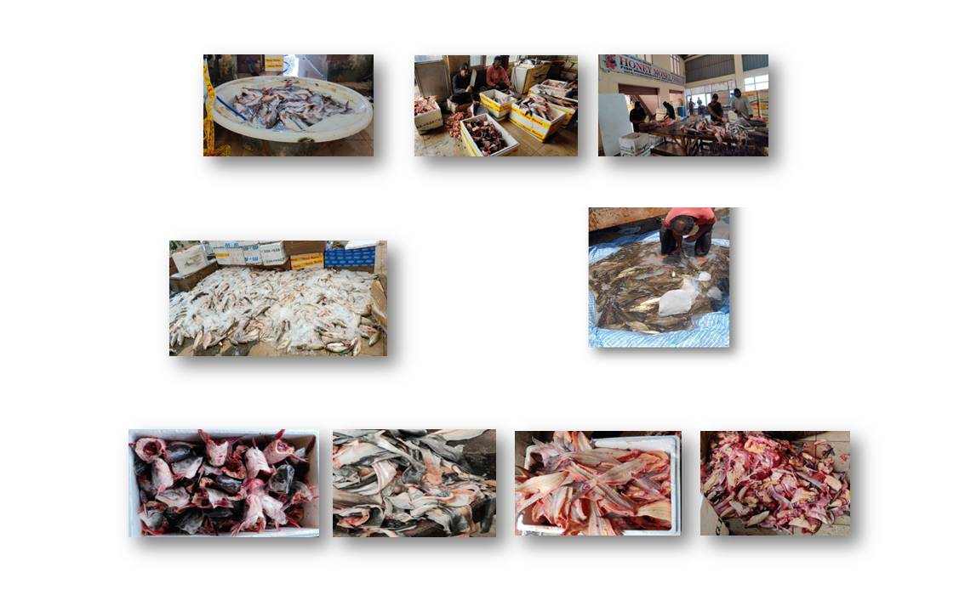
Figure 3. Fishes spreaded on the floor with ice for sale
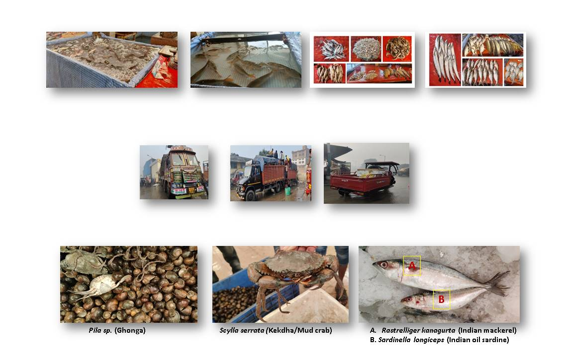
Figure 4. Mode of transportation of fish for import and export
Figure 5. Processing facilities in the fish market
Figure 6. Fish waste in the market
Figure 7. Fish species in the retail fish market in Ludhiana
Figure 8. Marine fish and shellfish species in the market
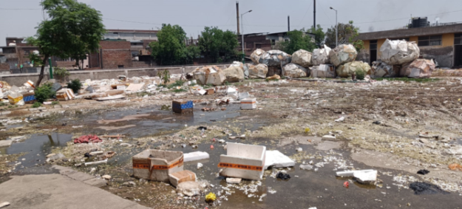
Figure 9. Waste discarded in nearby areas of fish market

