Hydrogeochemical Evaluation of Surface and Groundwater for Irrigation Suitability and Corrosion Potential in a Semi-Arid Coastal Region of Western Gujarat, India

Abstract
This study presents a comprehensive hydrogeochemical and statistical assessment of surface and groundwater quality in the Gir Somnath District and Diu region of Gujarat (GSDD), India. A total of 57 various water samples were systematically collected and analysed for major physicochemical parameters to evaluate their suitability for drinking, irrigation, and industrial purposes. GSDD region’s surface and groundwater is mostly alkaline in nature. However, its composition varies greatly depending on geological formations, evaporation, and human activities. The ionic dominance pattern is Na⁺ > Mg²⁺ > Ca²⁺ > K⁺ and Cl⁻ > HCO₃⁻ > SO₄²⁻ > CO₃²⁻ > NO₃⁻ > F⁻ indicating strong salinity control in coastal aquifers. The irrigation suitability indices and USSL(US salinity laboratory) classification show that most of the samples are either suitable or moderately suitable. However, the presence of salinity and magnesium could potentially harm soil structure and reduce crop yields. Industrial indices indicate a dual tendency of scaling and corrosion, suggesting the need for appropriate water treatment before industrial use. Multivariate statistical analysis and hydrochemical facies (Piper diagrams) confirm that groundwater chemistry is primarily governed by rock–water interaction, ion exchange processes, and salinity impact. This study of the GSDD region reveals that its surface and groundwater resources exhibit moderate suitability for various applications. However, it is very important to use sustainable water management strategies and salinity control measures to prevent deterioration and make sure that these water resources will be useful for a long-term stability.

Keywords: Hydrogeochemistry, Coastal aquifer, Irrigation indices, Salinity intrusion, Corrosion potential, Piper diagram

- Introduction
Freshwater resources are very important for keeping ecological systems, farming, industry, and people's need going around the world (CHAVDA et al., 2026). Agriculture uses the most freshwater resources in the world, taking up almost seventy percent of all water withdrawals while industrial activities use about twenty percent, and domestic use uses about twelve percent(United Nations educational, n.d.). This means that having required good quality freshwater is very important for keeping the economy growing and the environment stable. Groundwater is one of the most important sources of freshwater in the world (Behura et al., 2025). In account of arid and semi-arid climatic condition groundwater become only source for all the utilities for human being and ecological sustainability. Due to Lack of the hydrochemical study in Gujarat’s specific region, Gir Somnath coastal region was selected (Bhagat et al., 2021; Patel et al., 2023). The chemical composition of groundwater is also highly essential, in addition to its availability, since the quality of the water has a direct influence on how well it can be used for various activities such as drinking, irrigation, and industrial for human being (Lakhdari et al., 2025; Nabil et al., 2025). Rapid population growth, urbanisation, and industrialisation in India have greatly increased the need for water resources. The Saurashtra Peninsula in Gujarat, which is a hydrogeologically significant region, groundwater plays a significant role in satisfying the water requirements of residential and agricultural establishments as well as commercial enterprises (Vekariya et al., 2017). Study area which is one of the important coastal areas of Saurashtra peninsula of Western Gujarat, India. The geological framework, oceanic influence, and anthropogenic activities within these locales exert a substantial impact on the availability and chemical characteristics of groundwater of study area.
This investigation involved a systematic hydrogeochemical analysis surface and groundwater of the Diu region and Gir Somnath District. Sixteen physicochemical parameters were tested using standard laboratory techniques to determine the chemical characteristics of the water samples (APHA, 2017). To evaluate the degree of contamination and safety of the water, we also compared the analytical results to national and international drinking water standards (BIS, 2012, 2015; Ram et al., 2021). The Simpson ratio was used to calculate the amount of salinity level of water in the coastal aquifers and the likelihood of seawater entering them. The water's suitability for irrigation was assessed using various irrigation indices and the United States Salinity Laboratory diagram method for classification in various classes (Xu et al., 2019). Also used the Ryznar Stability Index, and Larson–Skold Index to assess how well water could be used in industry and how likely it was to scale or corrode (Hu et al., 2024). Graphical methods such as Piper diagrams used to assess the impact of hydrochemical facies and geochemical processes on the evolution of groundwater within the GSDD aquifers (Lakhdari et al., 2025; Mohammed et al., 2022). Additionally, Mifflin diagrams were used to calculate groundwater residence times, and the relationship between Total Hardness and Total Dissolved Solids was investigated to understand salinity variations throughout the study area (Ramos-Leal et al., 2022; Tang et al., 2025). A comprehensive quality assessment of both surface and groundwater is essential to ascertain the spatial variability of hydrochemical characteristics and also evaluate the water's suitability for diverse applications. This study is facilitating the management of water resources in this ecologically sensitive coastal region for the sustainability of both ecology and humanity.
- Study Area Profile
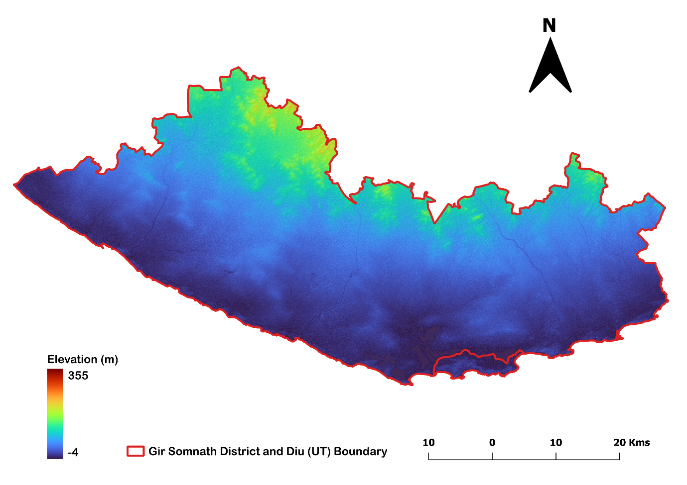
Study area located in the southwestern portion of Gujarat, beside the Arabian Sea. It covers about 3,754 km² in the Saurashtra Peninsula and is located between 20°42′N and 21°21′N latitude and 70°14′E and 71°01′E longitude. The district is bounded by Junagadh to the north, Amreli to the east, and the Arabian Sea along its southern and western margins. The region has coastal plains, gently rolling uplands, and forested hill tracts that are part of the Gir ecosystem. The geology of the Gir Somnath District is primarily composed of Deccan Trap basaltic formations, coastal sedimentary deposits, alluvium, laterites, and miliolite limestone (geological survey of India, 2012; Prizomwala et al., 2018). The coastal plains of GSDD have clayey-silty soils, while the black cotton soils that come from basalt weathering are farther inland (Pathak, 2024). The district does not have a lot of rivers, ponds, or reservoirs. Most of the flood-prone areas are near the shore, while the hill ranges are in the north that influencing regional drainage and groundwater recharge. The district has a semi-arid to subtropical climate, with hot summers, mild winters, and an average of 900 to 1,000 mm of rain each year, mostly from monsoons (Yadav et al., 2021). In Figure 1, the Digital Elevation Model (DEM) map of Gir Somnath District and Diu (GSDD) represents the spatial variation of terrain elevation across the study area which is controlling drainage of the district. The Hiran, Saraswati, Machchundari, and Shingoda rivers are seasonal rivers that start in the uplands and flow to the sea (Jha et al., 2024; Prizomwala et al., 2018). Many check dams and reservoirs help store water during the monsoon season and recharge groundwater, but groundwater is still the main source of water for homes and farms. People mostly make a living by farming, and the most important crops are groundnut, cotton, wheat, sesame, sugarcane, coconut, Kesar mango, and pearl millet (Pandey, 2023). Fishing, tourism, and some small level industries help in district's economical growth such as a Diu, Somnath Mandir, and forest range, especially around Sasan Gir National Park, which famous for The Asiatic lion lives. Groundwater salinisation and rising human pressure are all environmental problems that make hydrogeochemical assessment necessary for managing water resources over the long term.
Figure 1 DEM (Digital Elevation Model) map of Study area
- Methodology
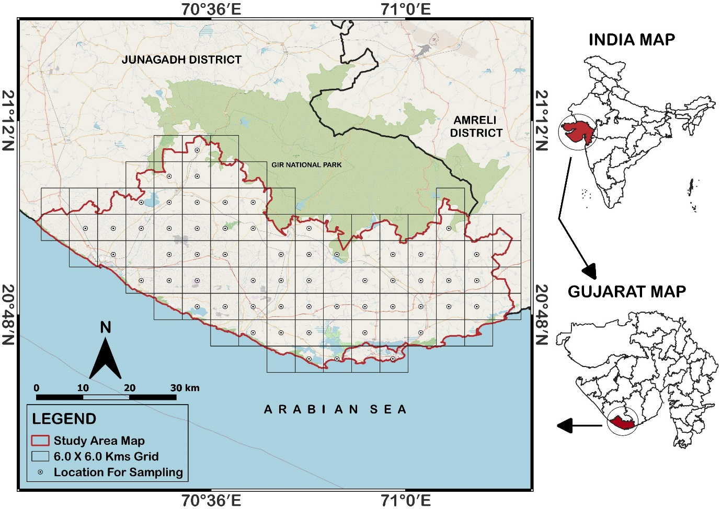
In this Investigation, initially QGIS 3.28 was used to prepare the study area grid map and obtain sampling coordinates. That Co-ordinates are used during the pre-monsoon season (May-2024) to conduct a hydrochemical investigation in the Gir Somnath District and Diu (GSDD) region of Gujarat. In Figure 2, a total of 57 water samples (G1–G57) were collected using a 6 × 6 km² grid-based sampling approach to ensure uniform spatial coverage of the study area. The samples included 20 borewells, 32 dugwells, one sample hand pump, one dam, one lake, one river, and one supply water sample. Water samples were collected in pre-cleaned 1-L HDPE (high-density polyethylene) bottles after flushing the source for 10–15 minutes to avoid contamination. We used Piper and Mifflin diagrams made in Grapher 24.1.213 to understand the hydrochemical properties of the water. These diagrams helped us sort the water into different types and find the main geochemical processes. Additional graphical analyses such as USSL (United states salinity laboratory) diagrams plots were also prepared using the same software. Spatial distribution of parameters was mapped using the IDW (Inverse Distance Weighted) interpolation method in ArcGIS 3.1.5 software. A comprehensive set of various physicochemical parameters was analysed to evaluate the hydrochemical characteristics of surface and groundwater in the GSDD region. To ensure methodological consistency, analytical precision, and reproducibility of results the Standard protocols of American public health association used for this study of GSDD region of Gujarat (APHA, 2017). Field measurements of pH (Potential of Hydrogen), temperature, EC (Electronic conductivity), and TDS (Total dissolved solids) were taken using a Systronics Water Analyzer 371. Major ions were determined using volumetric titration, flame photometry, and spectrophotometric methods. Calcium, magnesium, and total hardness were analysed by EDTA (Ethylenediaminetetraacetic acid) titration, while alkalinity, carbonate, bicarbonate, and chloride were determined using acid–base and AgNO₃ (Silver Nitrate) titration methods.
Figure 2 Study area (Gir Somnath District and Diu) location details and sampling grid map
Sodium and potassium were measured using a flame photometer, and anions such as sulphate, nitrate, and fluoride were analysed using UV–Visible spectrophotometry. Charge Balance Error (CBE) was calculated to evaluate analytical accuracy. Quality assurance and quality control (QA/QC) procedures were followed throughout the sampling and analytical processes to ensure the reliability and accuracy of the dataset of study area. In the laboratory, water samples were pre-filtered to remove suspended particles before analysis. Field instruments were calibrated using standard solutions; the pH meter was standardized with buffer solutions of pH 4.0, 7.0, and 9.2, while the EC meter was calibrated using a 1413 µS/cm KCl solution. Analytical-grade reagents and deionized water were used in all determinations. Reference standards, replicate samples, and procedural blanks were included to maintain analytical consistency.
3.1 Simpson ratio
The Simpson ratio was applied to evaluate the extent of salinity deterioration in groundwater. Simpson ratio (SR) applied to quantify the relative dominance of conservative chloride over carbonate alkalinity and to evaluate groundwater salinization intensity (Asare et al., 2021). Elevated SR values denote saline or marine/evaporative influence, whereas lower ratios indicate fresh recharge conditions and bicarbonate-controlled hydrochemical facies. Calculation of SR commutated by Equation 1. During calculation SR, all ion taken in meq/L unit.
Simpson Ratio (SR) = $\frac{{Cl}^{-} }{HCO₃⁻ + CO₃²⁻ }$………. (1)
3.2 Irrigation suitability assessment
In this study, several standard irrigation indices such as Salinity Hazard (SH), Sodium Adsorption Ratio (SAR), Magnesium Hazard (MH), Potential Salinity (PS), and Sodium Percentage (Na %) were calculated (Chaudhari et al., 2024; Singh et al., 2020). Mathematical representation of SAR, PS, MAR and Na% are given in Equation 2 to 5 respectively. Ion concentrations measured in mg/L were converted into milliequivalents per liter (meq/L) which are used for calculate these indices for individual sampling location of GSDD region of Gujarat. Also, the USSL diagram was used to assess salinity and sodium hazards in study area (Al-Awah et al., 2023).
SAR = $\frac{{Na}^{+}}{\sqrt[2]{\frac{{Ca}^{+2}+ {Mg}^{+2}}{2}}}$ ……….(2) MAR/MH =$\frac{{Mg}^{+2 }}{{( Ca}^{+2}+{ Mg}^{+2 })}$ X 100……….(4)
PS = $\frac{{Cl}^{-}}{\frac{{SO}_{4}^{2-}}{2}}$ ………(3) Na % =$\frac{({Na}^{+}+K^{+})}{{( {Na}^{+}+K^{+}+Ca}^{+2}+{Mg}^{+2 })}$X 100…...….(5)
3.3 Industrial suitability and corrosion potential assessment
Industrial water suitability was evaluated using indices to determine scaling and corrosion potential (Anshar et al., 2023). Elevated salinity and ionic concentration, particularly in coastal regions, may increase corrosion risk and scaling tendencies. That impact on life of equipment of industrial zones of GSDD region. In this study, industrial water quality was assessed using indices such as the Ryznar Stability Index (RSI) and Larson–Skold Index (LS). These indices were calculated using parameters including temperature, TDS, alkalinity, and major ions ( given in below questions). All parameters are in mg/L unit. Mathematical representation of RSI and LS corrosion indices are given in Equation 6 and Equation 7.
$RSI=2 x pHs-pH$….(6) LS = $\frac{{Cl}^{-}{+ SO}_{4}^{-2}}{{CO}_{3}^{2-}+{HCO}_{3}^{-} }$ …….(7) CR = $\frac{\frac{{Cl}^{-}}{35.5}+\frac{{SO}_{4}^{-2}}{48} }{\frac{{(CO}_{3}^{2-}+{HCO}_{3}^{-})}{50} }$ ..........(8)
Here pHs=(9.3+A+B)-(C+D) and terms are A=Log₁₀(TDS)-1/10, $B=-13.12 x {Log}_{10}(°C+273)+34.55$,$C=\log_{10}\left({Ca}^{+2}x 2.497\right)-0.4$ & $D={Log}_{10}TA$ & pHeq = 1.465 × log₁₀ (TA) + 4.54 are used for evaluate RSI value.
3.4 Hydrogeochemical Characterisation
Hydrochemical facies represent the chemical framework of surface and groundwater that reflects its interaction with geological formations and geochemical reactions. To identify these facies, various graphical tools are used. Piper diagram and Mifflin diagram type graphical representation used for identification of hydrogeochemistry by evaluate and hydrochemical facies ,water type and retention time of GSDD region (Hwang et al., 2017). TH vs TDS and Mifflin diagram become helpful to understand the groundwater salinity level and resident time with local lithological framework (Chaudhari et al., 2025; Liu et al., 2020).
- Result and Discussion
4.1 General hydrochemistry of GSDD region
In this Investigation parameters such as a pH, Total Dissolved Solids (TDS), Electrical Conductivity (EC), Temperature (T), Total Hardness (TH), Total Alkalinity (TA), Sodium (Na⁺), Potassium (K⁺), Calcium (Ca²⁺), Magnesium (Mg²⁺), Carbonate (CO₃²⁻), Bicarbonate (HCO₃⁻), Chloride (Cl⁻), Sulphate (SO₄²⁻), Fluoride (F⁻), and Nitrate (NO₃⁻) are analysed. All fifteen parameters (Except Temp.), along with their statistical measures such as mean, minimum, maximum and standard deviation are given in Table 1. Also this table have Permissible limit (PL) and desire limit (DL) of BIS-2012/15 and WHO-2017 (BIS, 2012, 2015; WHO, 2017).
Table 1 Statistical representation of surface and groundwater parameters in the GSDD region with BIS-2012/15 and WHO-2017 drinking water standards
Parameters (Unit) | MAX | MIN | MEAN | SD | BIS-2012/15 | WHO-2017
p^{H} (no scale) | 10.44 | 7.11 | 8.20 | 0.67 | 6.5 – 8.5 | 7 – 8
EC (µS/cm) | 5180.00 | 209.00 | 1399.12 | 1014.04 | 750 – 3000 | –
TDS (mg/L) | 2590.00 | 112.00 | 768.53 | 519.85 | 500 – 2000 | 600 – 1000
TA (mg/L) | 497.00 | 84.00 | 217.61 | 87.03 | 200–600 | –
TH (mg/L) | 1298.47 | 99.88 | 454.43 | 265.98 | 200 – 600 | 200
Na⁺ (mg/L) | 944.00 | 3.62 | 142.27 | 183.98 | – | 50 – 200
K⁺ (mg/L) | 136.80 | 0.10 | 7.63 | 22.09 | – | 12
Ca⁺² (mg/L) | 321.28 | 3.21 | 41.17 | 51.30 | 75 – 200 | 100 – 300
Mg⁺² (mg/L) | 251.25 | 17.45 | 85.46 | 47.21 | 30–100 | -
Cl⁻ (mg/L) | 1715.78 | 14.18 | 263.77 | 344.26 | 250 – 1000 | 250
SO₄²⁻ (mg/L) | 350.00 | 8.00 | 64.91 | 56.48 | 200 – 400 | 250
CO₃²⁻ (mg/L) | 98.00 | 14.00 | 32.42 | 17.78 | – | 100
HCO₃⁻ (mg/L) | 497.00 | 35.00 | 182.25 | 102.87 | 300–600 | –
NO₃⁻ (mg/L) | 46.00 | 6.00 | 25.42 | 10.40 | 45 | 50
F⁻ (mg/L) | 1.51 | 0.28 | 0.57 | 0.21 | 1–1.5 | 1.5

Total Dissolved Solids (TDS) varied between 112 and 2590 mg/L (mean ± SD, 768.53 ± 519.85 mg/L), indicating that half samples fall within the acceptable range of DL while approximately 18% of samples exceeded the permissible limit (PL= 2000 mg/L). The temperature of surface and groundwater varied from 25.50 to 31.50 °C during sample collection with Mean and SD of 28.18 ± 1.11 °C.
Among the major cations, sodium (Na⁺) ranged from 3.62 to 944 mg/L with a mean and SD of 142.27 ± 183.98 mg/L, and around 78 % of samples exceeded the WHO guideline value of DL. High Na⁺ in daily water consumption can causes increases risk of cardiovascular disease (Adimalla & Li, 2018). Magnesium (Mg²⁺) ranged from 17.45 to 251.25 mg/L, with a mean and SD of 85.46 ± 47.21 mg/L. approximately 21% of samples exceeded PL and 91.38% samples are exceeded DL. Among the major anions, Chloride (Cl⁻) concentrations ranged from 14.18 to 1715.78 mg/L with a mean and SD of 263.77 ± 344.26 mg/L, where about 30% of samples exceeded the Desire limit (250 mg/L). High Chloride concentration was most relevant indicator affecting the laxative effect and noncarcinogenic health risks (Barathkumar et al., 2025). Based on the mean concentration values of your dataset, the ionic dominance trend can be expressed as follows: major cations (mean values, mg/L): Na⁺ (142.27) > Mg²⁺ (85.46) > Ca²⁺ (41.17) > K⁺ (7.63) and major anions (mean values, mg/L): Cl⁻ (263.77) > HCO₃⁻ (182.25) > SO₄²⁻ (64.91) > CO₃²⁻ (32.42) > NO₃⁻ (25.42) > F⁻ (0.57). These results indicate that Na⁺ and Mg²⁺ in cations and Cl⁻ and SO₄²⁻ in anions are the dominant ions influencing groundwater chemistry in the study area (Sun et al., 2024). The high concentration of Cl⁻ and Na⁺ suggests the influence of salinity sources, while bicarbonate dominance reflects rock-water interaction within the aquifer system (Krishna kumar et al., 2015). These results indicate that salinity, moderate mineralization and hardness are the primary factors influencing groundwater quality in the study area. Therefore, it is necessary to prevent and control saline water intrusion and to improve groundwater quality of GSDD region.
4.2 Identification salinity level in groundwater by Simpson ratio
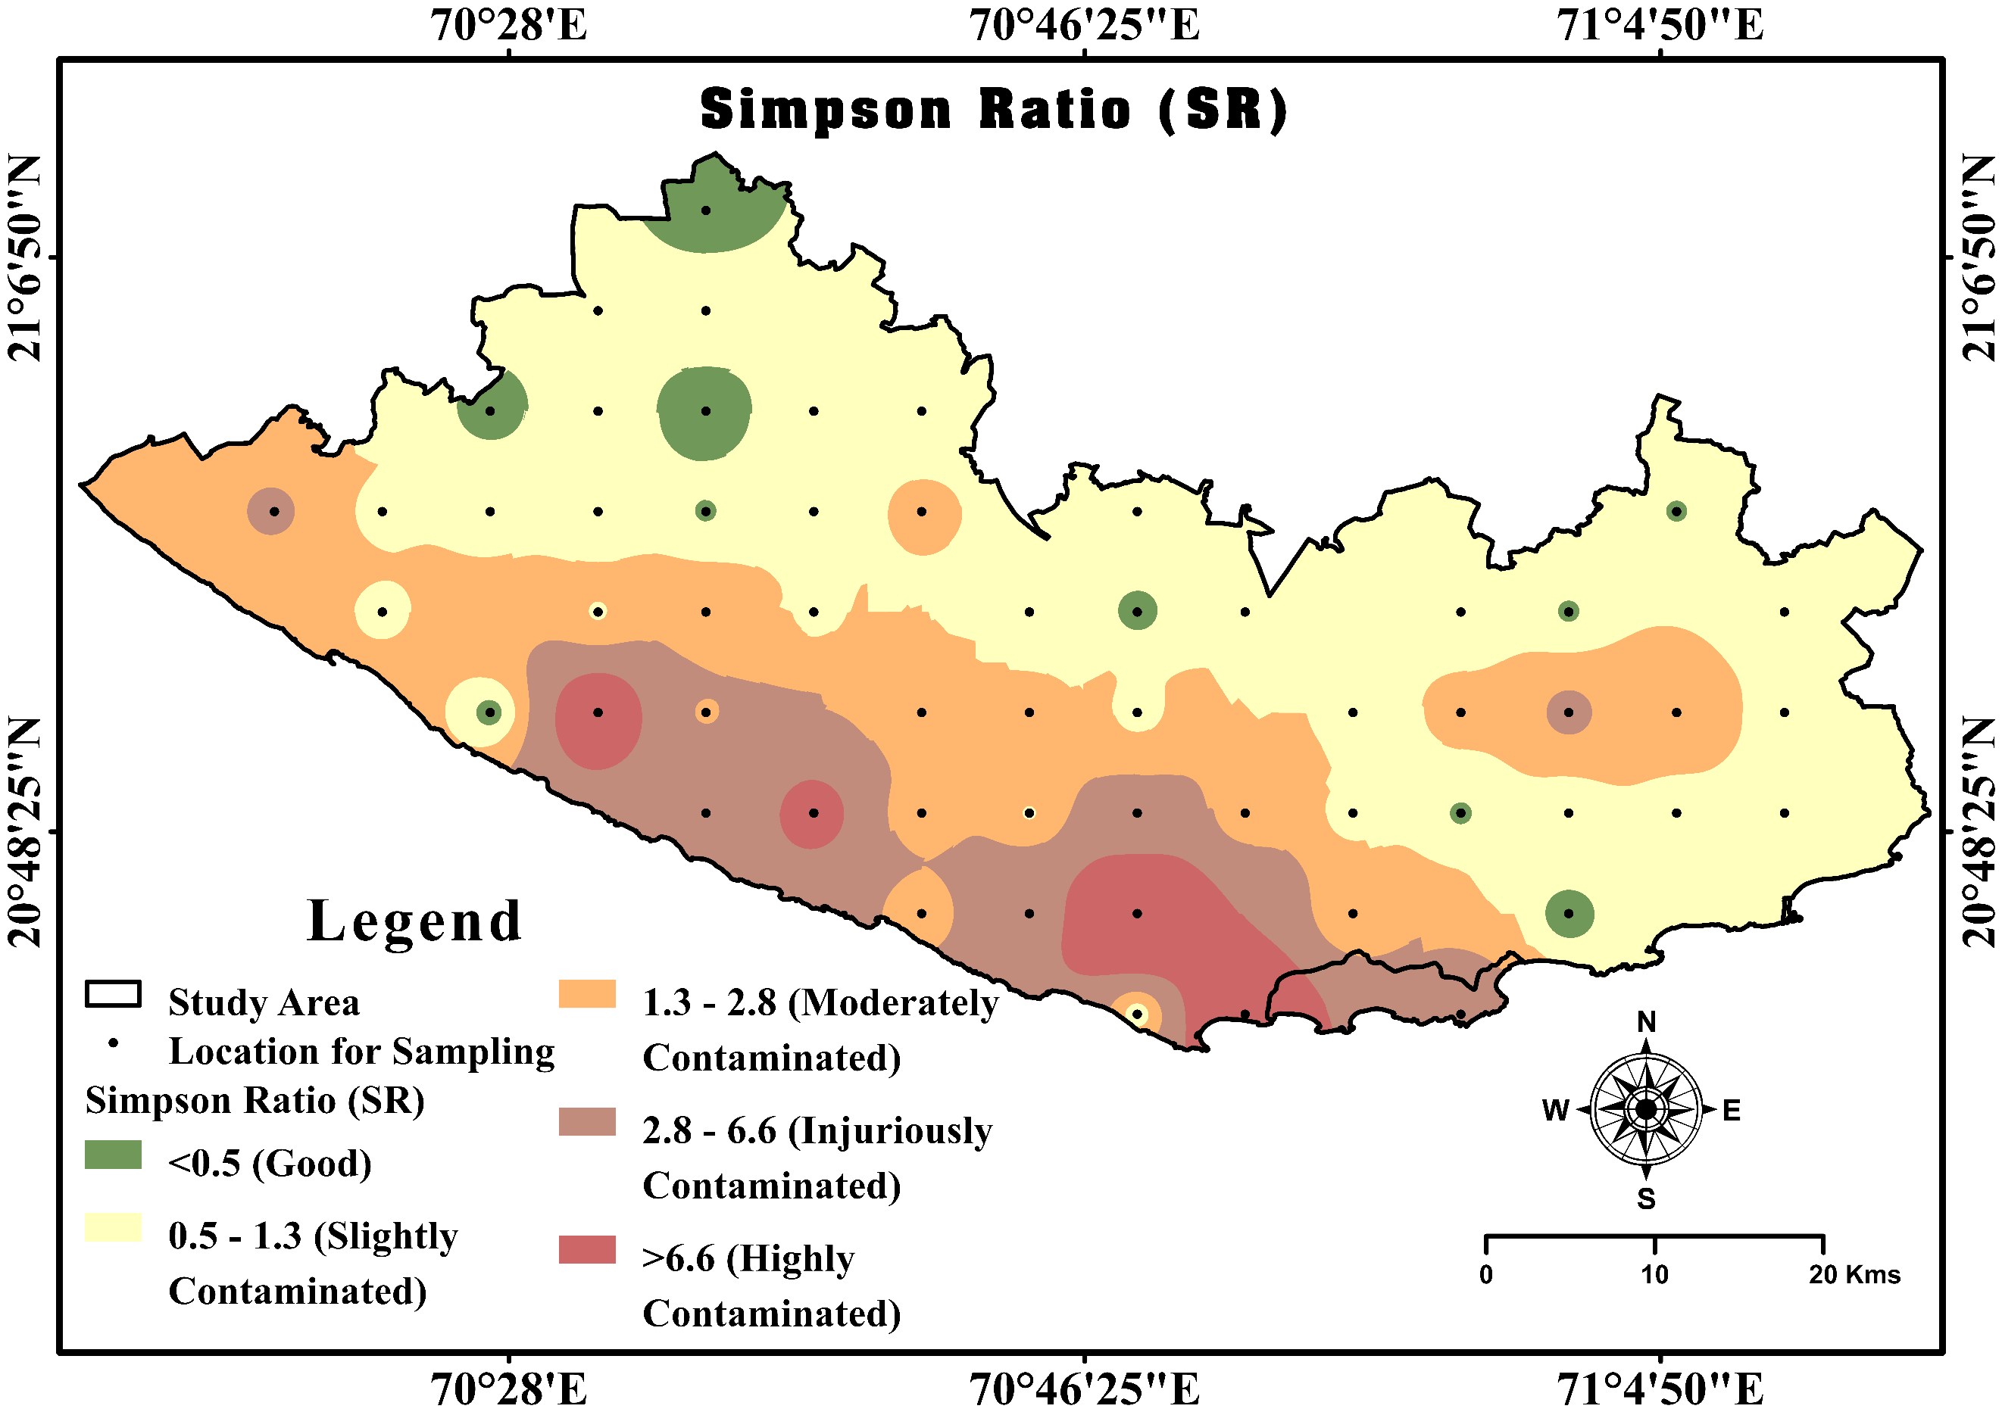
The calculated values of SR range from 0.38 to 20.24, with a mean and SD of 1.83 ± 4.26, indicating considerable spatial variation in salinity influence within the study area (Figure 3). Based on classification criteria, 9.88% of samples fall in the good category (<0.5), indicating fresh water conditions with minimal salinity impact. About 27.16 % of samples are slightly contaminated (0.5–1.3), while 23.46% fall under moderately contaminated (1.3–2.8) conditions. A significant proportion, 24.69% of samples, are categorized as injuriously contaminated (2.8–6.6), and 14.81% show highly contaminated conditions (>6.6). These results suggest that although some groundwater sources remain fresh, a considerable number of samples show moderate to high salinity contamination, likely influenced by marine intrusion, evaporation, and geochemical processes within the coastal aquifer system (Al-shihmani et al., 2025; Jena et al., 2026).
Figure 3 Simpson Ratio (SR) Spatial distribution map of GSDD region of Gujarat, India
4.3 Irrigation suitability evolution of GSDD region of Gujarat
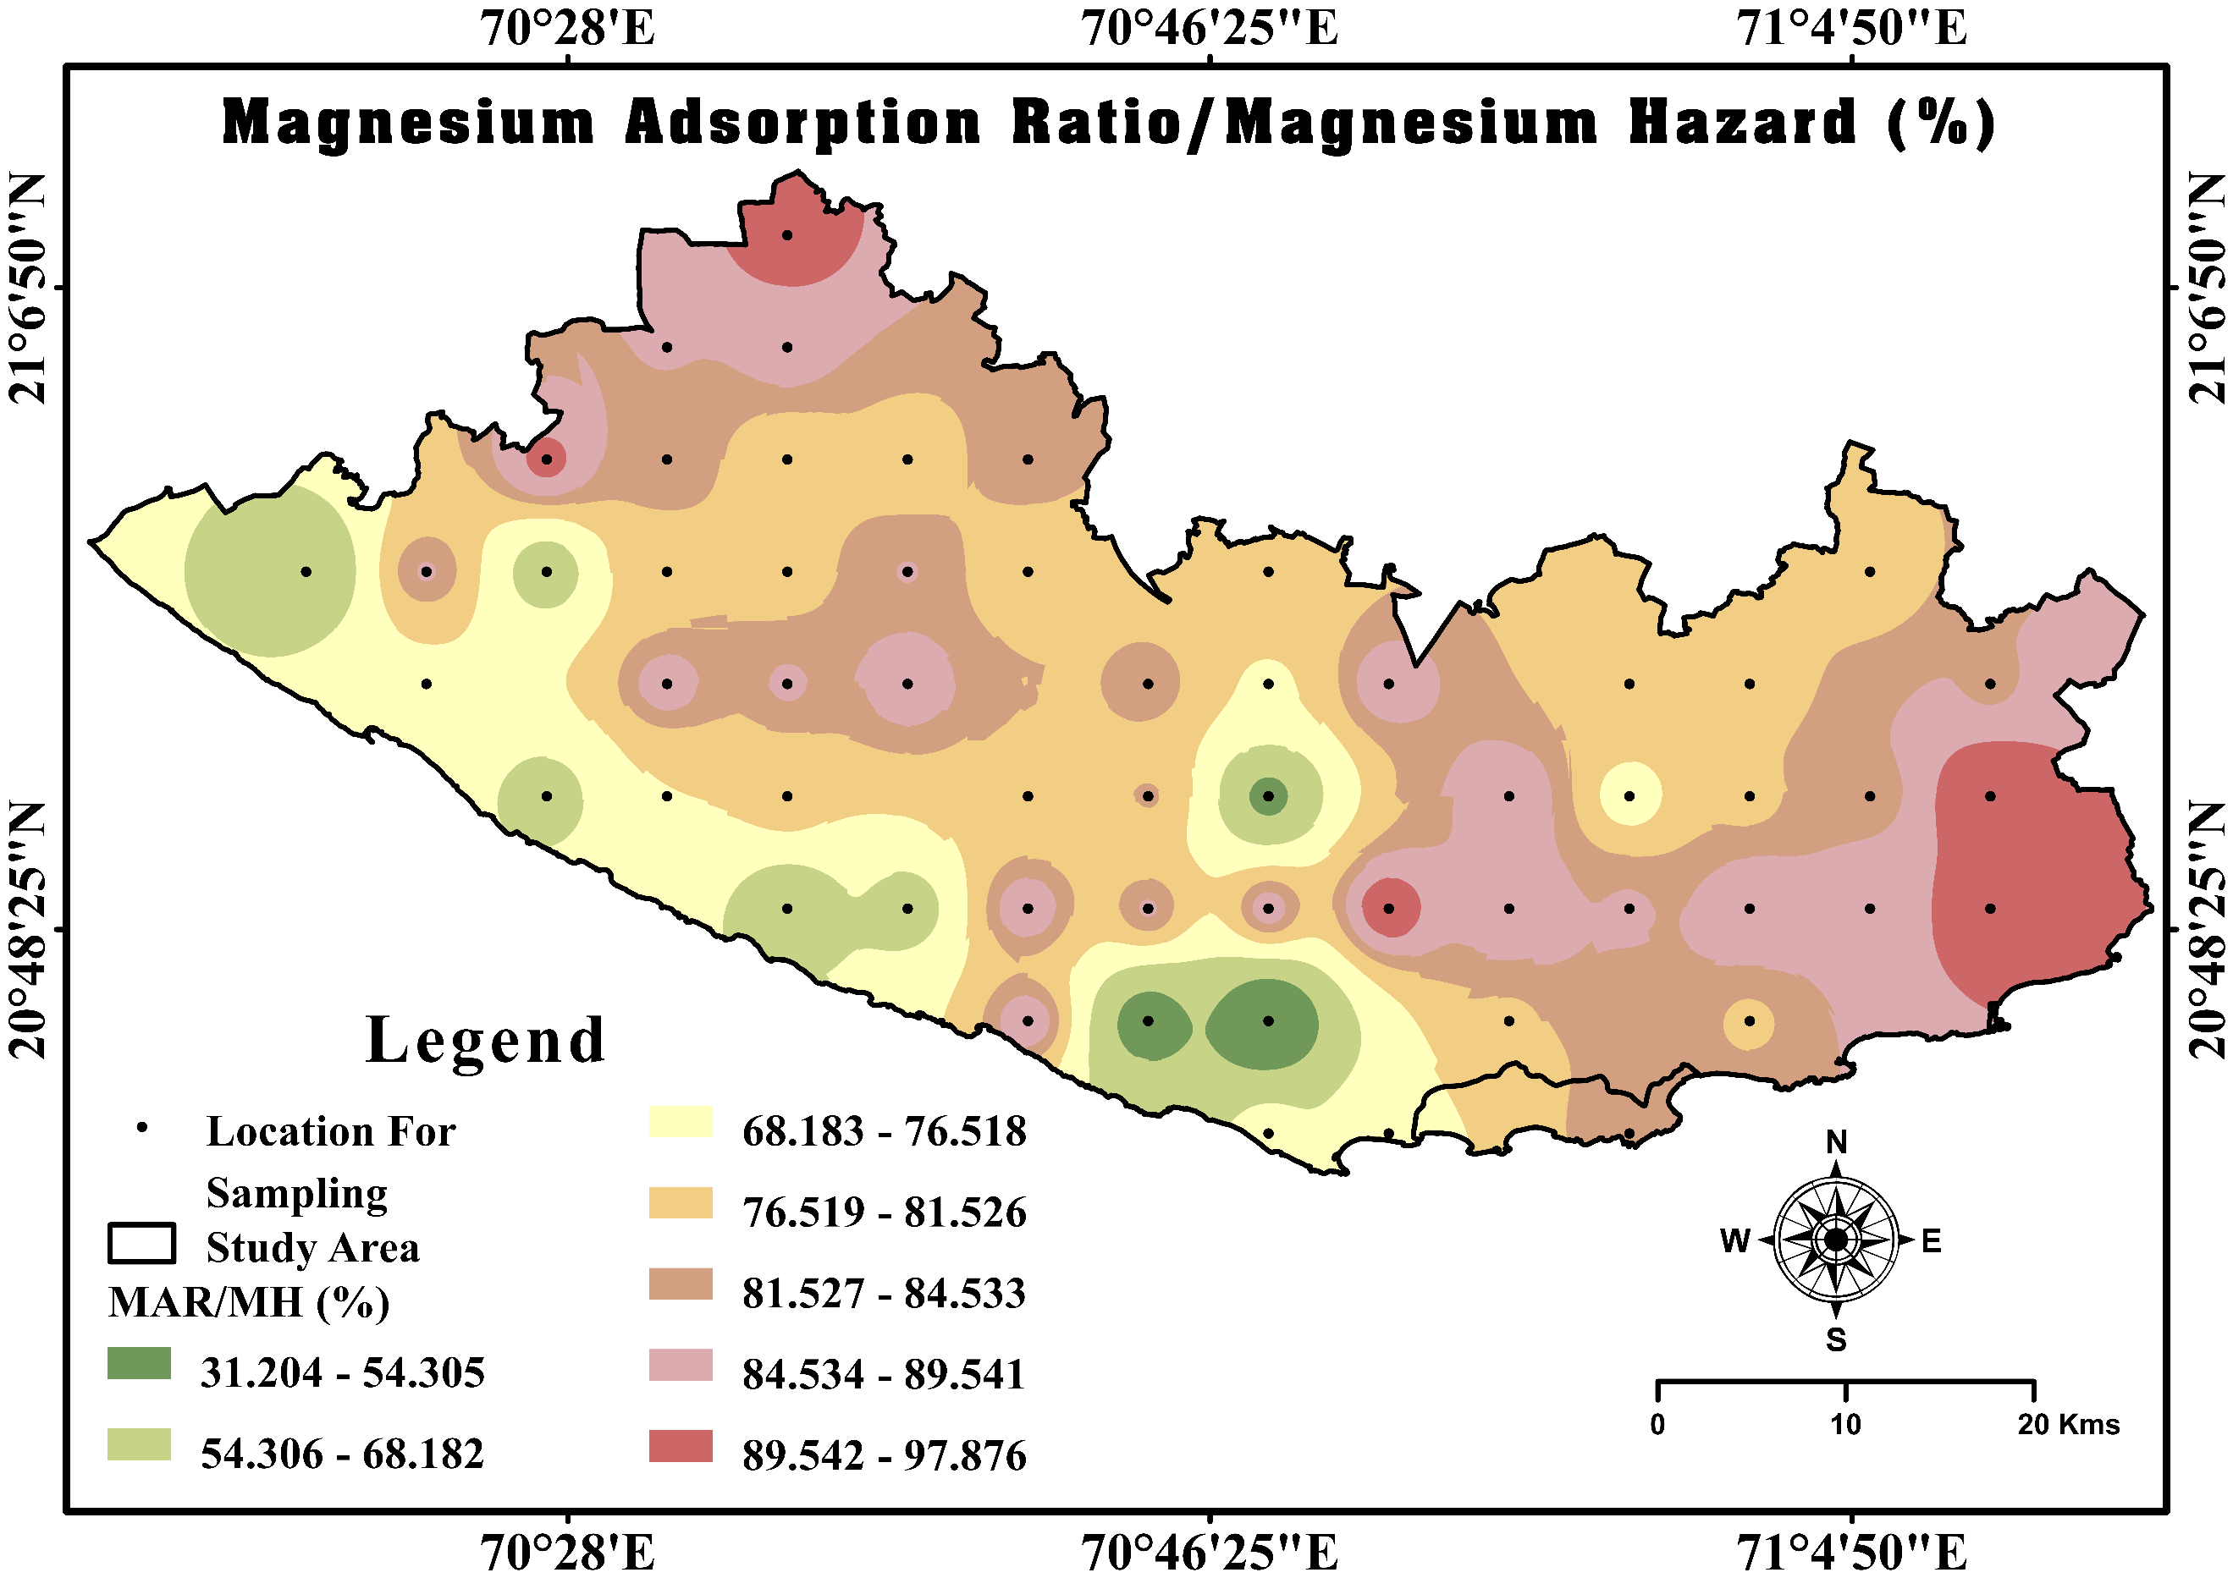
Salinity Hazard indicates the concentration of dissolved salts in irrigation water. SH Range from 209.00 to 5180 µS/cm, Mean ± SD ( 1399.12 ± 1014.04). Individual location SH value shown spatial distribution map of GSDD in Figure 4. Based on classification, water is excellent (<250 µS/cm), good (250–750 µS/cm), permissible (750–2000 µS/cm), doubtful (2000–3000 µS/cm), and unsuitable (>3000 µS/cm) (Sharma et al., 2017). Based on EC classification, 3.51% samples are excellent, 26.32% good, 54.39% permissible, 7.02% doubtful, and 8.77% unsuitable for irrigation. The Sodium Adsorption Ratio (SAR) values ranged from 0.09 to 12.18 meq/L with a mean ± SD of 2.64 ± 2.56, and also individual location SAR value shown spatial distribution map of GSDD in Figure 5. SAR represents the relative abundance of sodium compared with calcium and magnesium in irrigation water (Rawat et al., 2018). Irrigation water quality is classified as excellent (<10), good (10–18), doubtful (18–26), and unsuitable (>26). It is indicating that most samples fall within the excellent 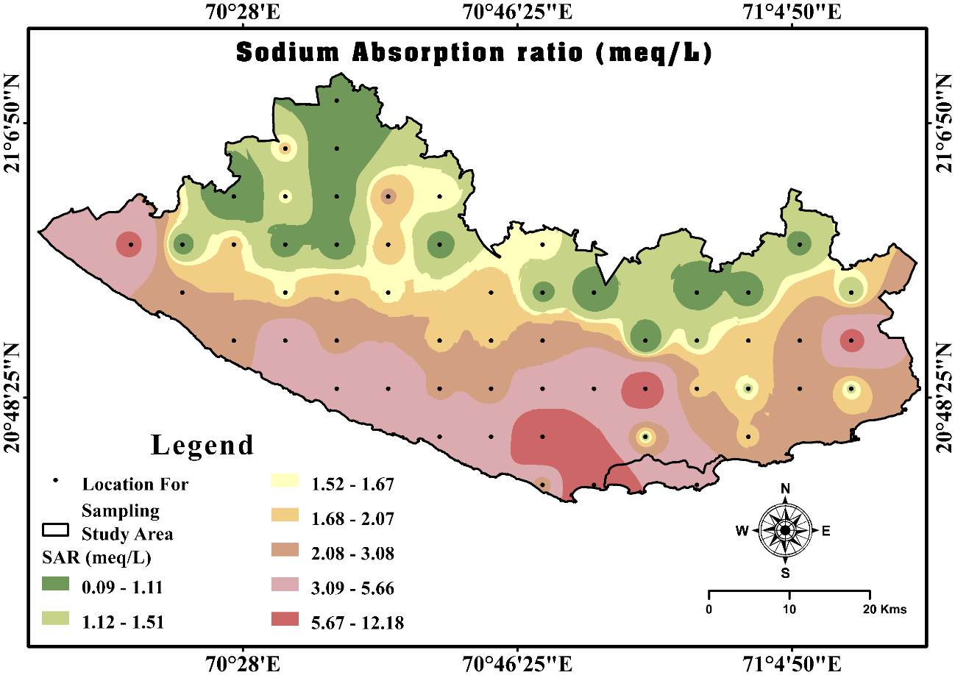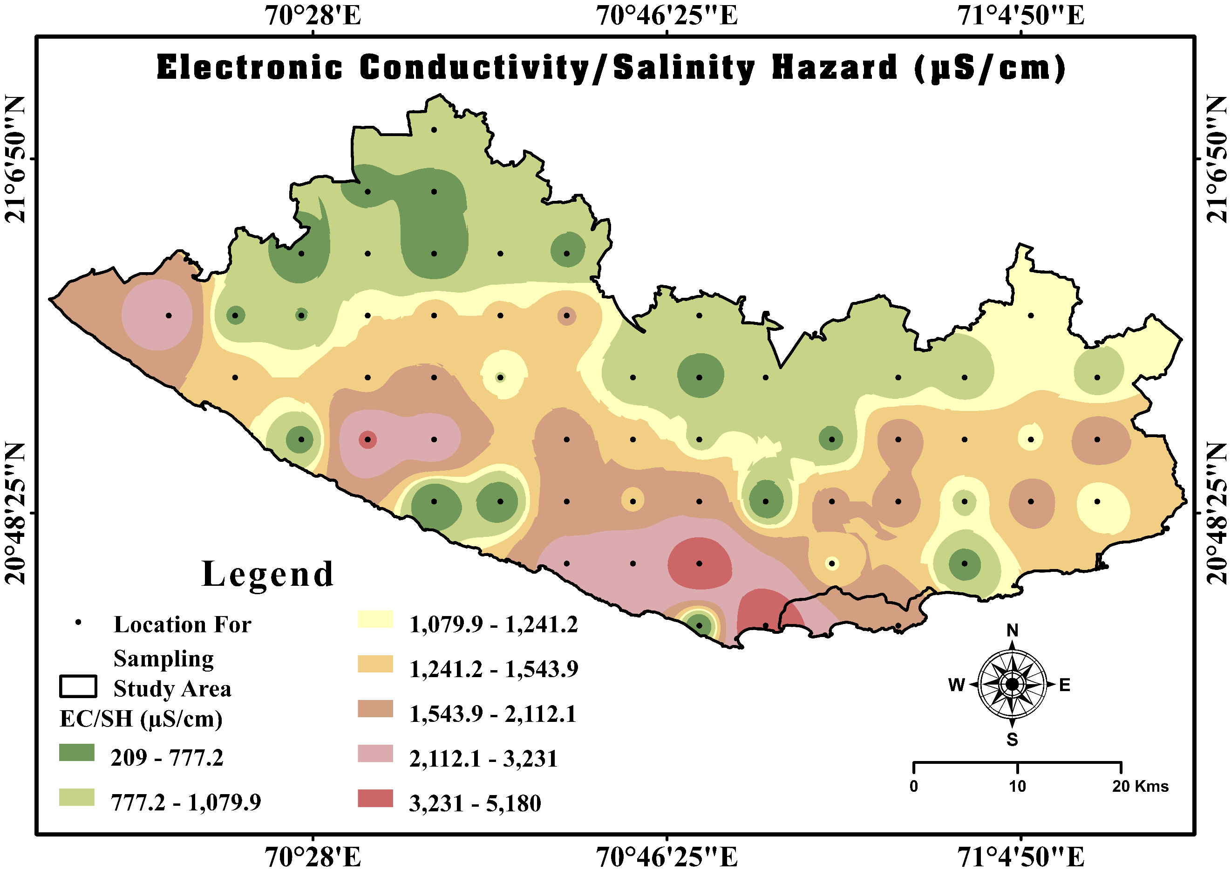category; 96.49 % of samples are in excellent and 3.51% are good. The Magnesium Adsorption Ratio (MAR) ranged between 31.20 and 97.88 with a mean ± SD of 79.25 ± 12.39. Individual location MAR value shown spatial distribution map of GSDD in Figure 6. MAR measures the dominance of magnesium over calcium in irrigation water (Pan et al., 2019). For MAR, water is considered suitable (<50%) and unsuitable (>50%) for irrigation. where 94.74% samples exceed the safe limit, indicating magnesium hazard in GSDD region of Gujarat.
Figure 5 Sodium Adsorption Ratio (SAR in meq/L) Spatial distribution map of GSDD region of Gujarat, India
Figure 4 Salinity Hazard (SH in µS/cm) Spatial distribution map of GSDD region of Gujarat, India
Figure 6 Magnesium Adsorption Ratio/Magnesium Hazard (MAR/MH %) Spatial distribution map of GSDD region of Gujarat, India
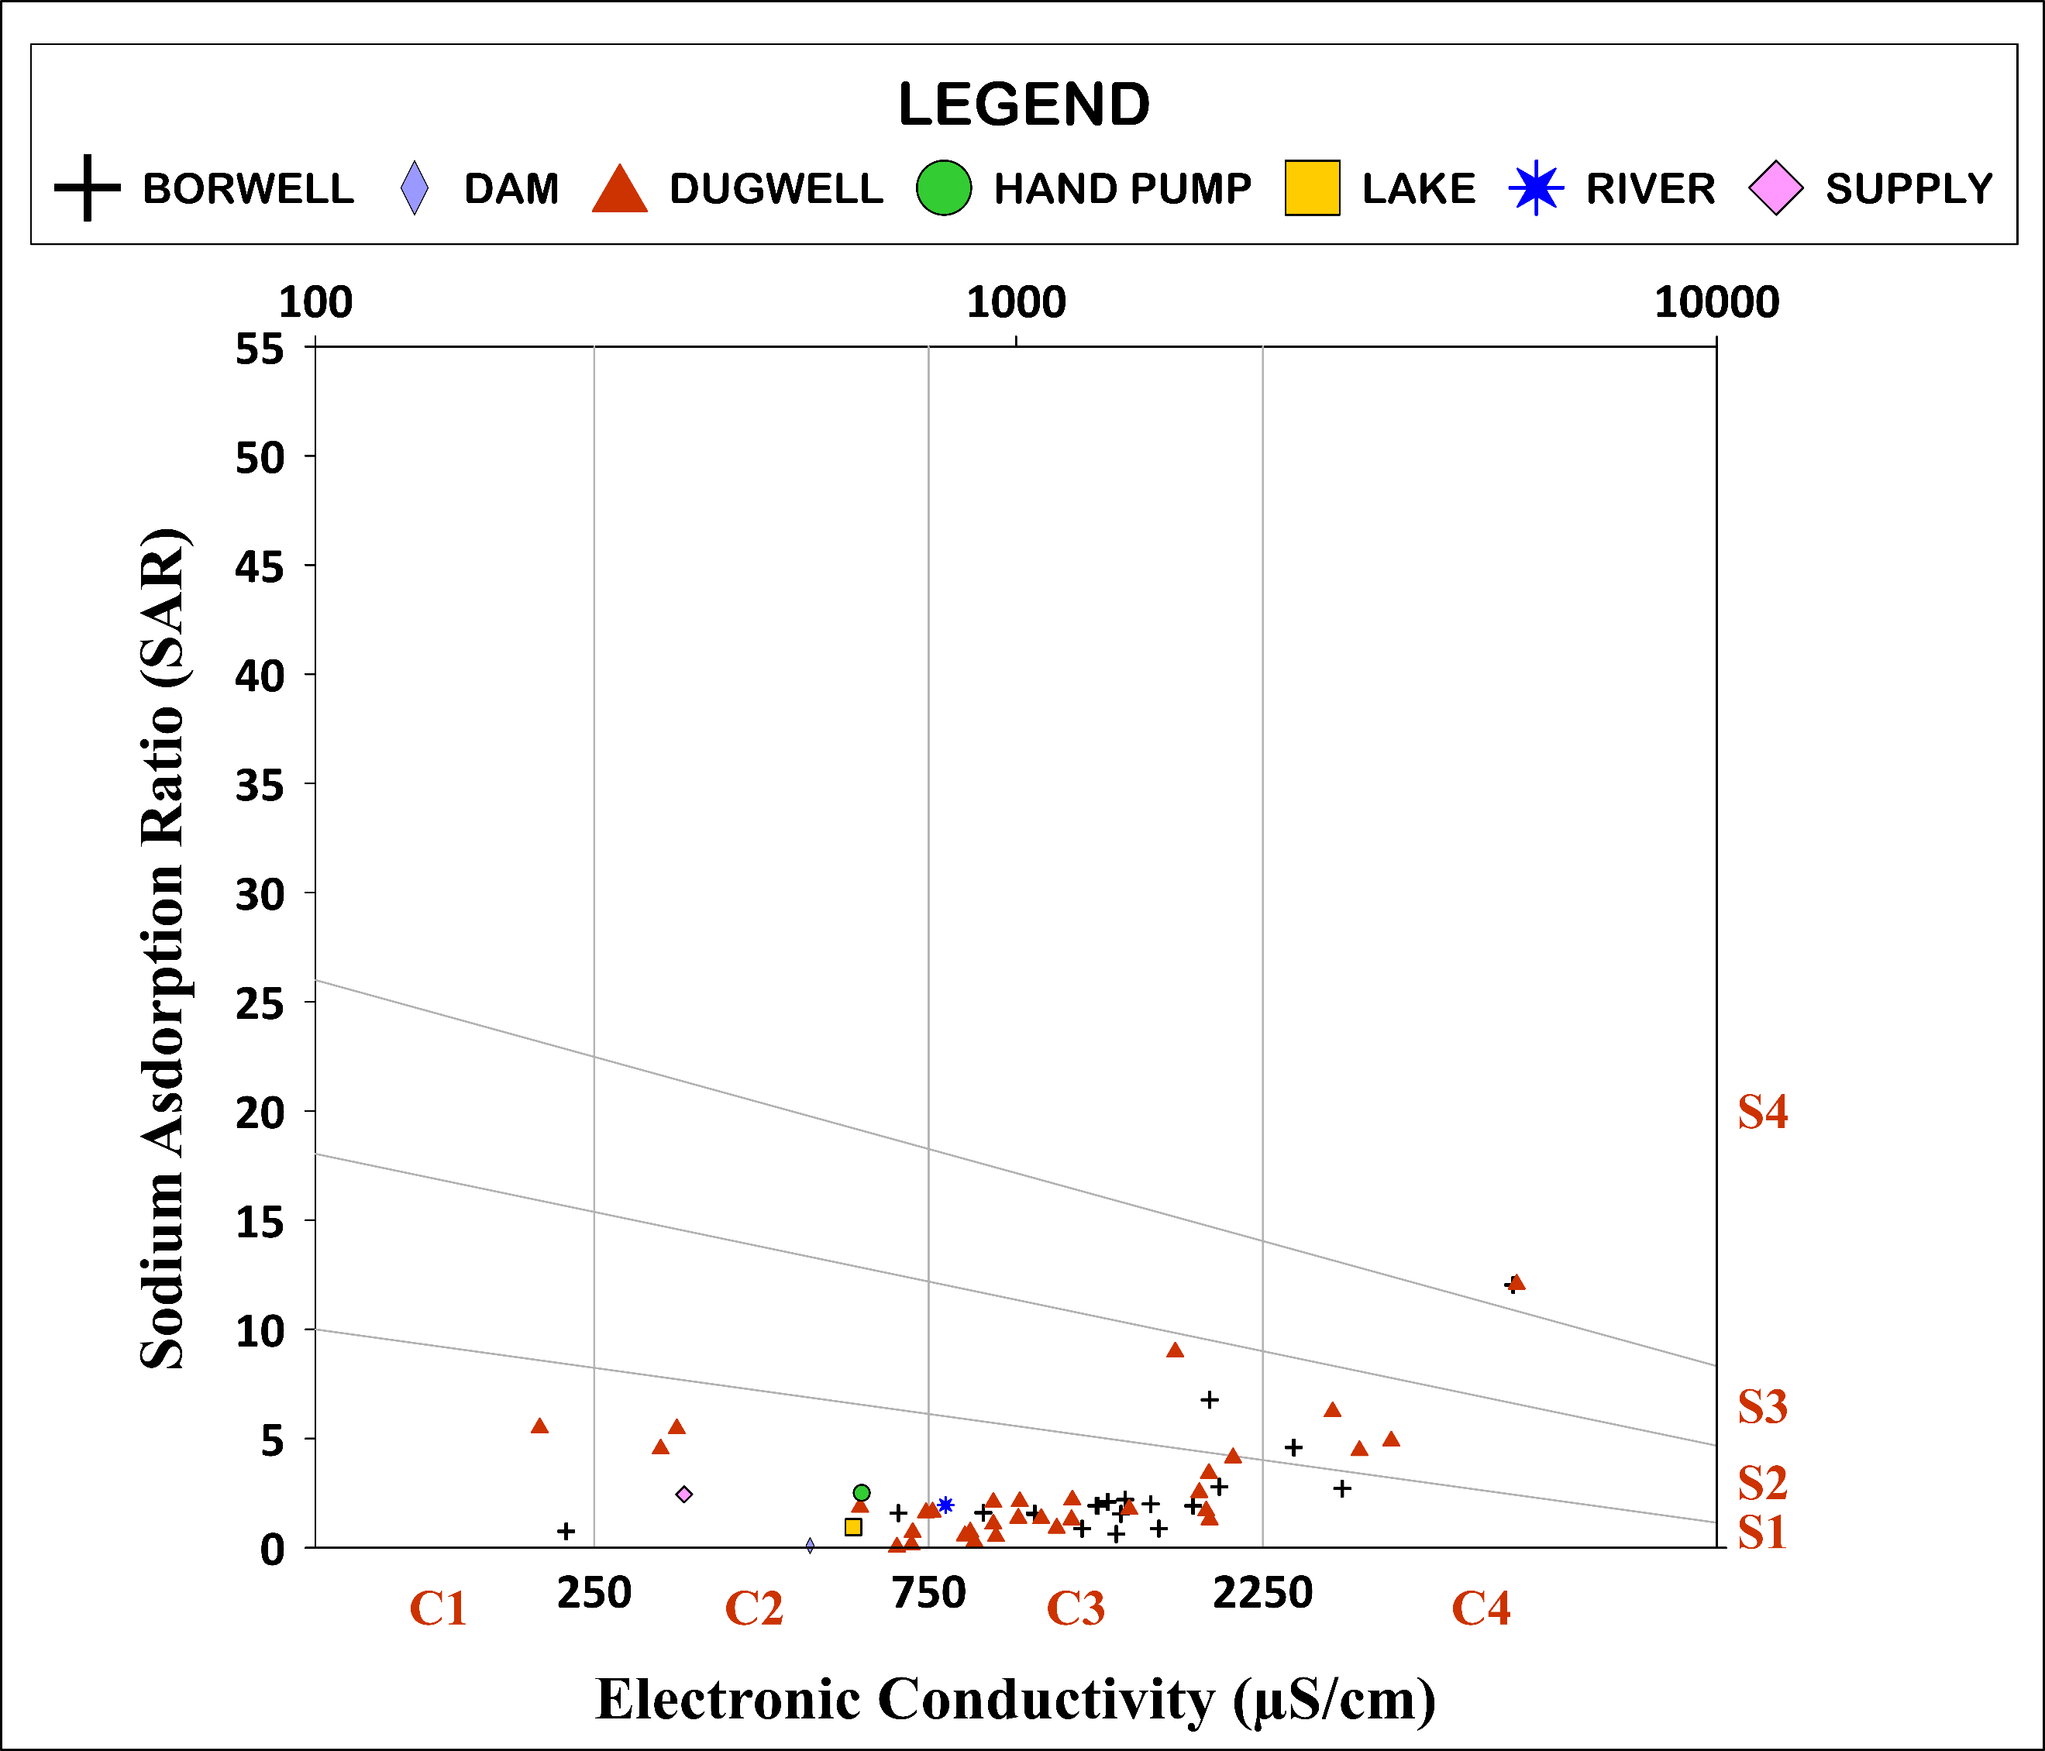
Sodium percentage (Na %) ranged from 2.75 to 75.71 % with a mean ± SD of 33.28 ± 15.54. Individual location Na % value shown spatial distribution map of GSDD in Figure 7. Na% represents the proportion of sodium among total cations in irrigation water (Tejashvini et al., 2024). Na % is classified as excellent (<20%), good (20–40 %), permissible (40–60%), doubtful (60–80%), and unsuitable (>80%). Data showing 19.30 % excellent, 49.12% good, 24.56% permissible, and 7.02% doubtful categories. Potential Salinity (PS) ranged from 0.51 to 52.04 meq/L with a mean ± SD of 8.12 ± 10.22. Individual location PS value shown spatial distribution map of GSDD in Figure 8. Potential Salinity reflects the long-term salt accumulation effect of irrigation water on soil(Xu et al., 2019). 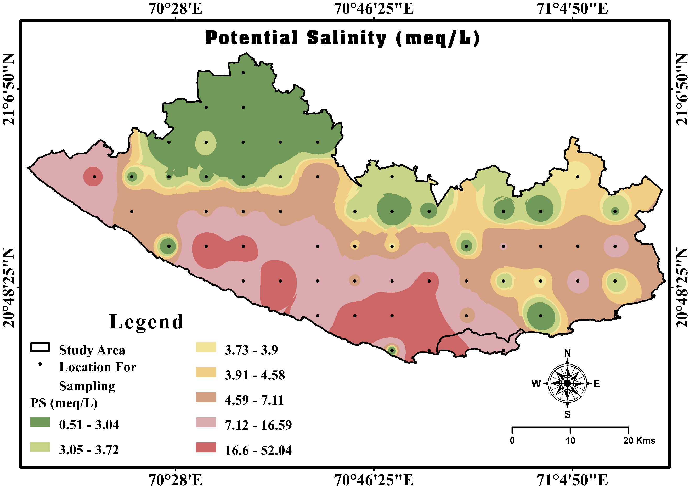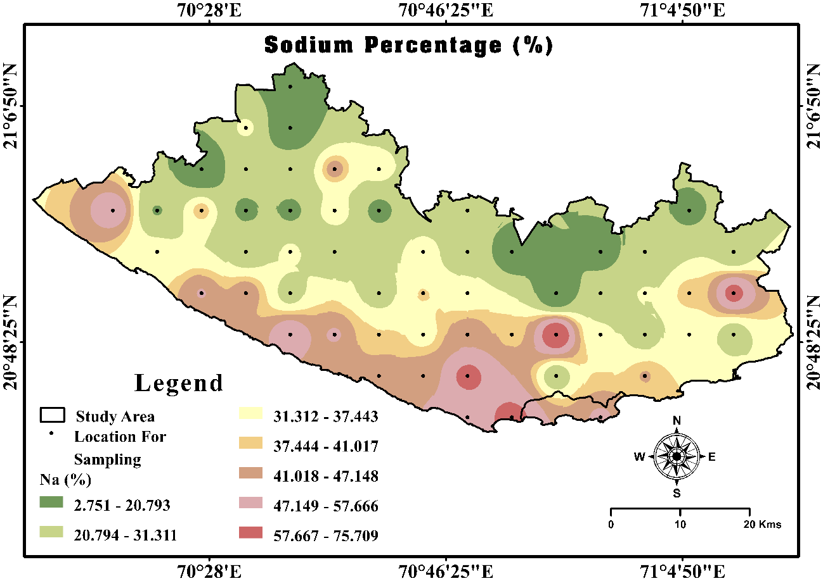Water is classified as excellent (<3.0 meq/L), moderate (3.0–5.0 meq/L), and unsuitable (>5.0 meq/L). PS Indicating sample % 35.09 % lie in excellent, 21.05% in moderate, and 43.86% in unsuitable category.
Figure 8 Potential Salinity (PS in meq/L) Spatial distribution map of GSDD region of Gujarat, India
Figure 7 Sodium Percentage (Na %) Spatial distribution map of GSDD region of Gujarat, India
Figure 9 USSL diagram (SAR vs EC) of groundwater irrigation suitability in the Study area (GSDD region of Gujarat)
In Figure 4.19, the USSL diagram (SAR vs EC) was used to evaluate the suitability of groundwater for irrigation by assessing both salinity hazard (C1–C4) and sodium hazard (S1–S4). The plot shows that most samples cluster within the C3S1 and C2S1 fields, indicating medium to high salinity with low sodium hazard, suggesting that water can be used for irrigation with moderate management practices (Ravikumar & Somashekar, 2012). A few samples extend into C4S2 and C4S3 zones, reflecting higher salinity conditions that may require soil drainage and salt-tolerant crops.
Based on the classification ranges, the irrigation suitability distribution is approximately, good range (C1S1, C2S1): ~36%, Moderate range (C1S2, C2S2, C3S2, C3S1): ~ 49%, Poor range (C1S3, C1S4, C2S3, C2S4, C3S3): ~12% and Unsuitable range (C3S4, C4S1, C4S2, C4S3, C4S4): ~3%. Overall, salinity and Magnesium hazard main causes in GSDD region also the USSL diagram indicates that the majority of groundwater samples fall within the moderate irrigation suitability class, where salinity is the primary limiting factor rather than sodium hazard. Proper soil management and irrigation practices are necessary to prevent long-term soil salinization.
4.4 Corrosion and Scaling potential evaluation for Industrial suitability
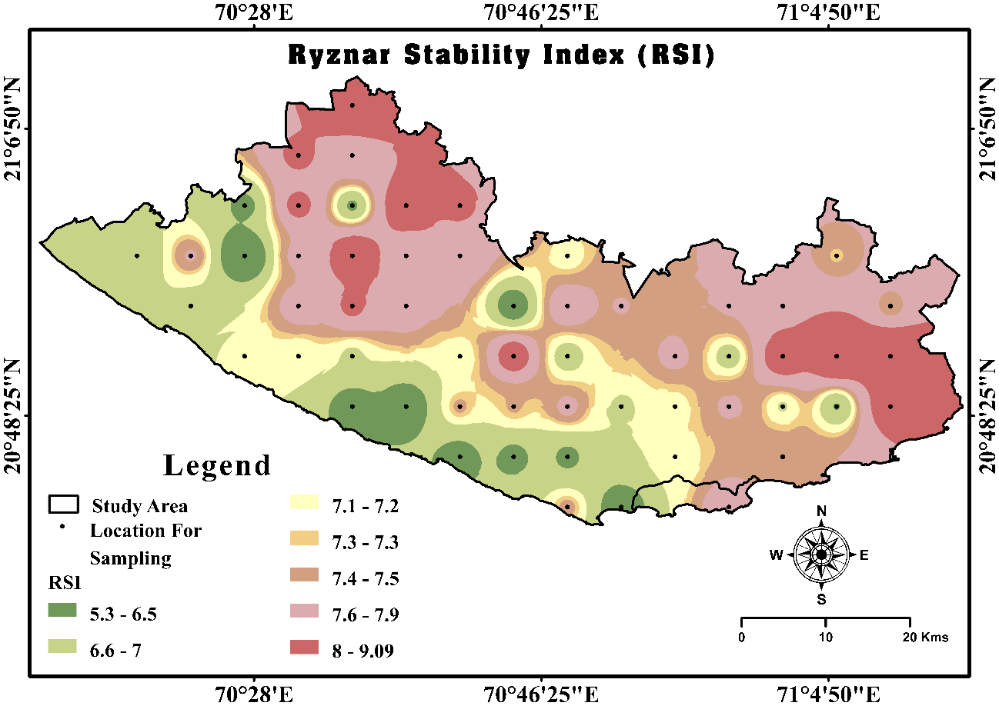
The RSI values ranged from 5.33 to 9.09 with a mean ± SD of 7.33 ± 0.72. GSDD region’s Spatial Distribution of RSI given in Figure 10. The dataset reveals a complex water chemistry profile. RSI shows 66 % of samples are corrosive, with 12 % heavily corrosive, while only 6 % indicate scaling (Kalyani et al., 2017). indicating that most samples show corrosive tendencies with a few samples approaching heavy corrosive conditions. The Larson–Skold Index (LS) ranged from 0.25 to 22.14 with a mean ± SD of 2.84 ± 3.96. GSDD region’s Spatial Distribution of LS given in Figure 11. 76% in the high corrosive range, 14% in non-corrosive and 18 % have Scaling and Corrosive (Ahmed et al., 2021). GSDD region’s both indices sample percentage class wise distribution of sample and status are given in Table 2. Overall, the water is predominantly corrosive across both indices, yet simultaneously prone to scaling, reflecting a dual risk of both deposition and material degradation. which may affect industrial pipelines and equipment if untreated water is used.
Figure 10 Ryznar Stability Index (RSI) Spatial distribution map of GSDD region of Gujarat, India
Table 2 Industrial suitability indices ranges, Status and sample % of GSDD region
INDICES | RANGES | STATUS | SAMPLE %
Ryznar Stability Index (RSI) | <5.5 | Heavy Scaling | 0
Ryznar Stability Index (RSI) | 5.5-6.2 | Scaling | 6
Ryznar Stability Index (RSI) | 6.2-6.8 | Balance | 16
Ryznar Stability Index (RSI) | 6.8-8.5 | Corrosive | 66
Ryznar Stability Index (RSI) | >8.5 | Heavy Corrosive | 12
Larson-Skold Index (LS) | <0.8 | Less Scaling / Non-Corrosive | 14
Larson-Skold Index (LS) | 0.8-1.2 | Scaling and Corrosive | 18
Larson-Skold Index (LS) | >1.2 | Heavy Corrosive | 68
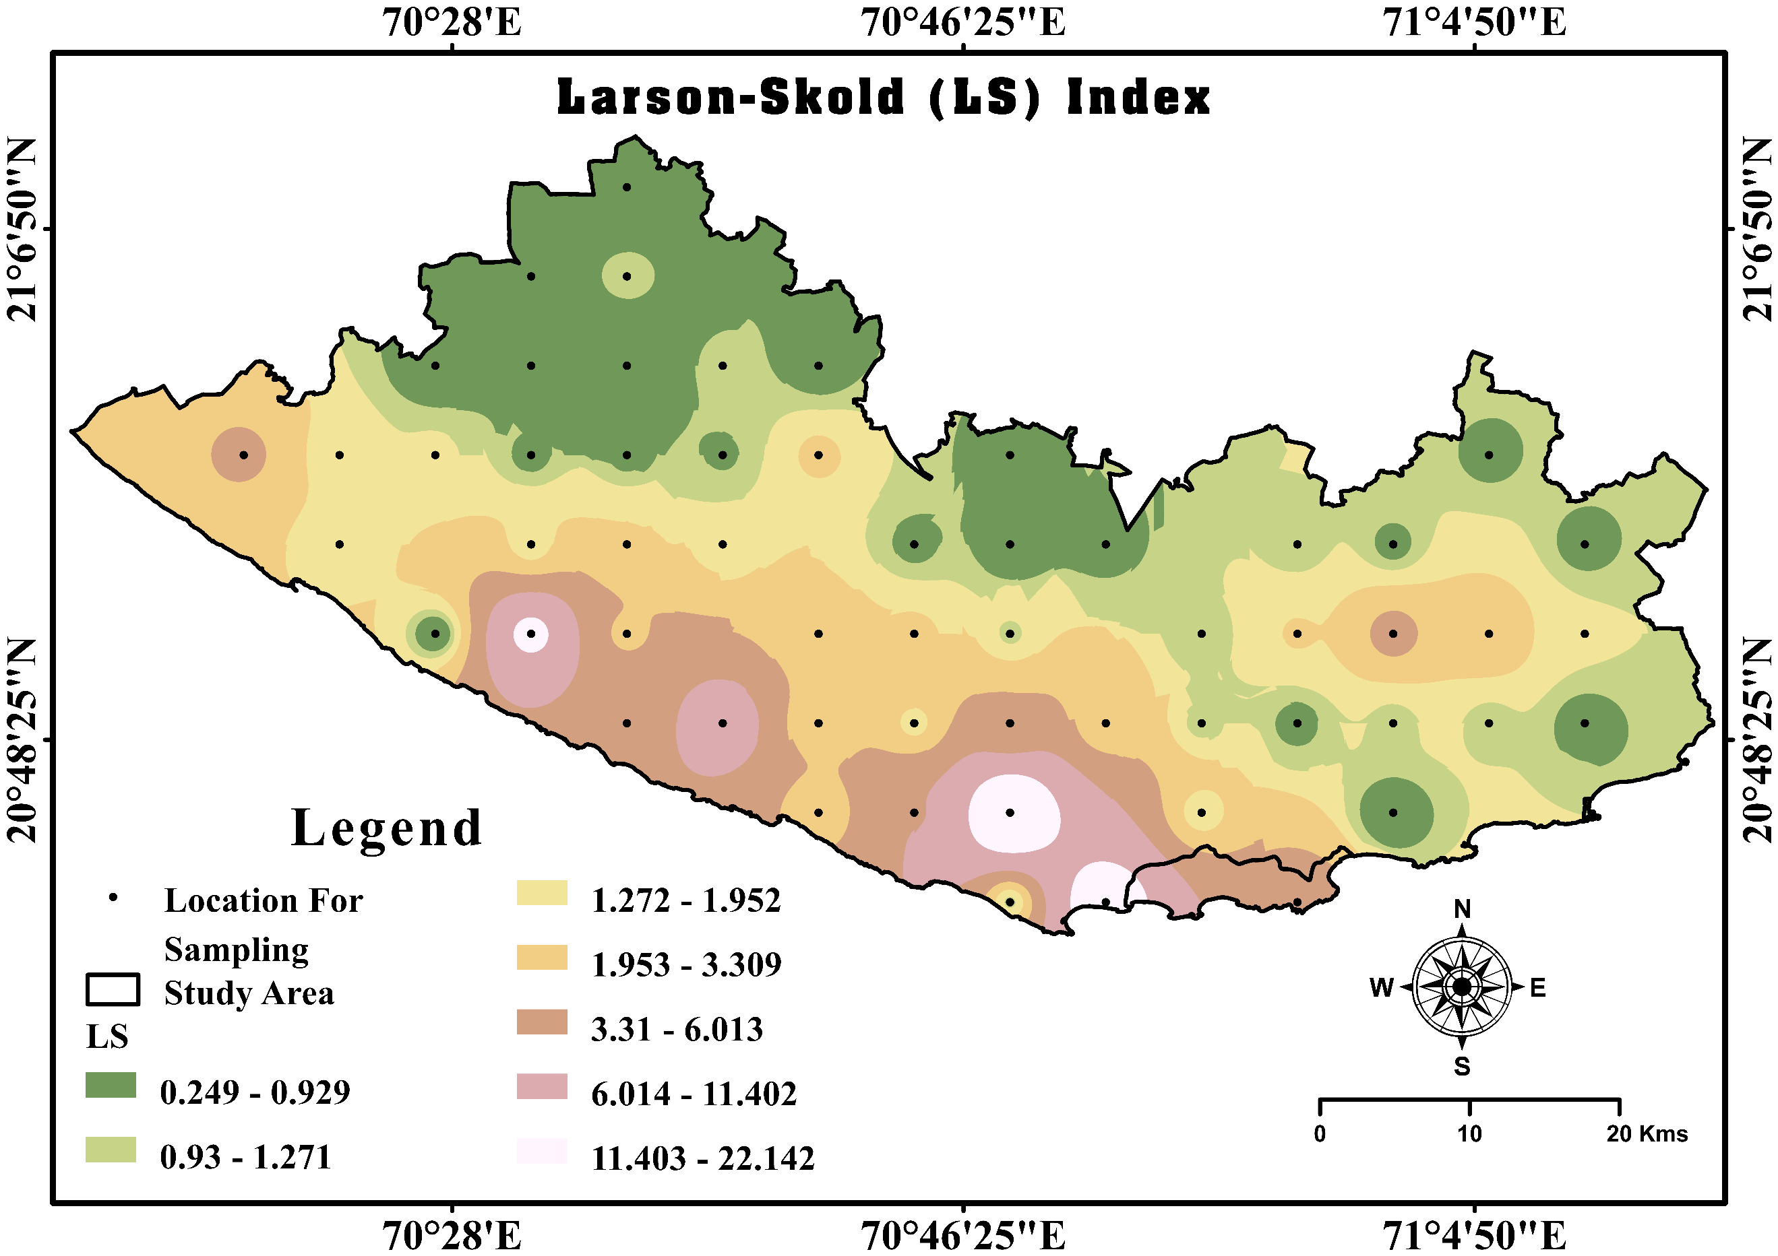
Figure 11 Larson Scold Index (LS) Spatial distribution map of GSDD region of Gujarat, India

4.5 Evaluation of Hydrogeochemistry in GSDD region of Gujarat
The Piper diagram was included to simplify classification, ionic composition imaging, Hydrochemical facies, water type and quality variations that support comprehensive and sustainable water quality assessment (W.O et al., 2025). TDS in mg/L, p^{H} (no scale), and all the other ions are expressed in meq/L % for graphical output. In Figure 12, the Piper diagram illustrates the hydrochemical facies and dominant ionic composition of groundwater in the GSDD region. In the cation triangle, most samples cluster toward the Mg²⁺–Ca²⁺ field, indicating the dominance of alkaline earth metals over alkali metals (Ram et al., 2021). In the anion triangle, samples are mainly concentrated in the Cl⁻ field, suggesting chloride as the dominant anion. When projected into the central diamond, the majority of samples fall within the mixed Ca²⁺–Mg²⁺–Cl⁻ facies, indicating mixed water type influenced by rock–water interaction and salinity inputs. A few samples lie in Ca²⁺–Mg²⁺–HCO₃⁻ (freshwater) facies, reflecting recharge conditions. Overall, the hydrochemical facies suggests mixed saline water influenced by weathering and possible marine interaction in GSDD region.
Figure 12 Trilinear Piper diagram of Study area (GSDD region of Gujarat)
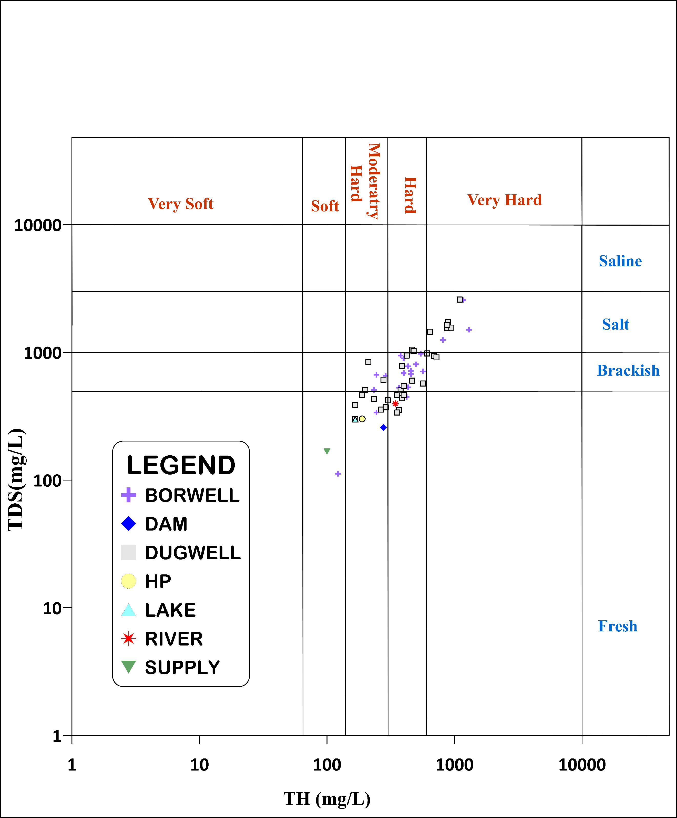
Figure 13 TH vs TDS diagram of Study area (GSDD region of Gujarat)

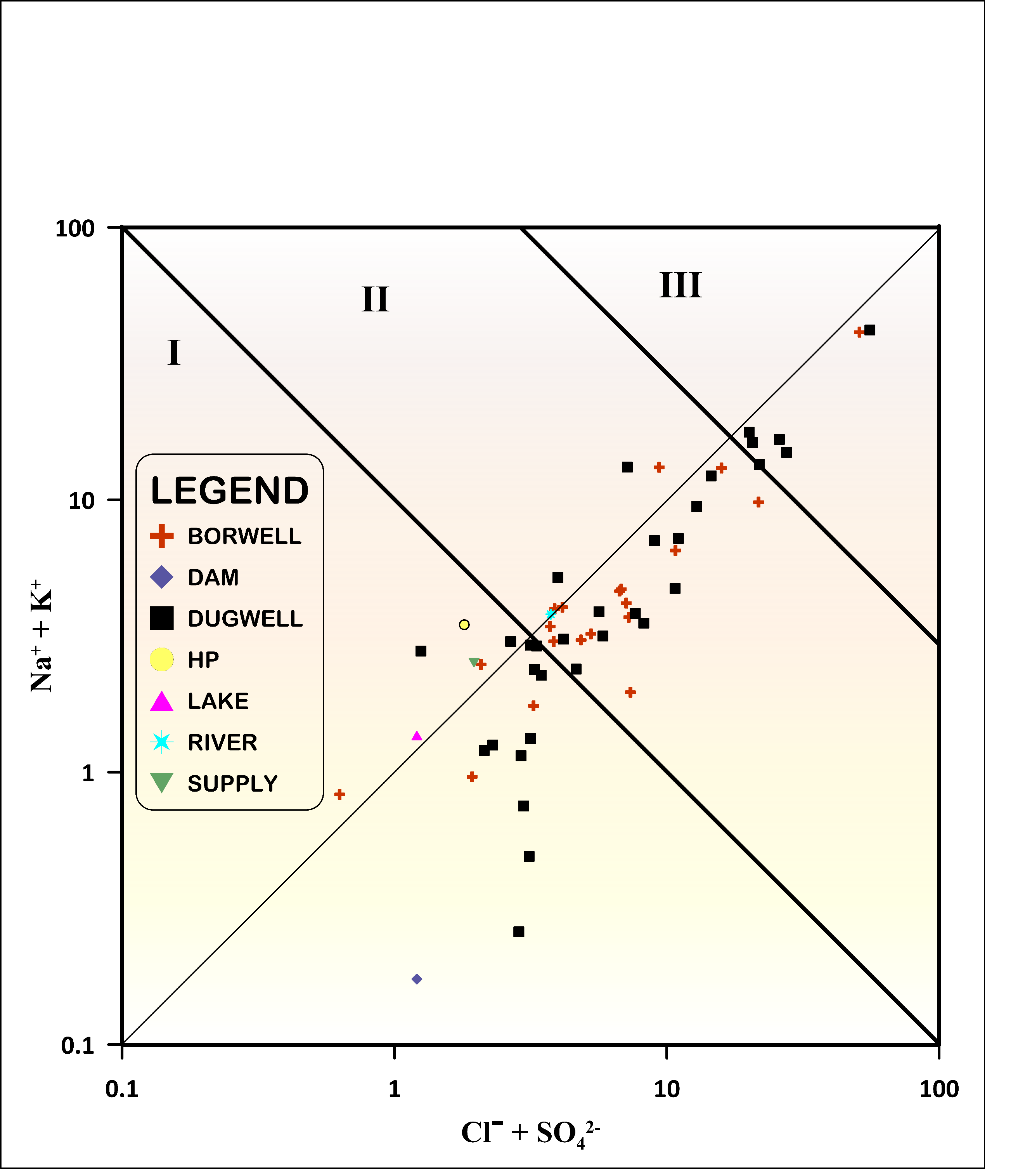
In
Figure 14 Mifflin diagram of Study area (GSDD region of Gujarat)

Figure 13, the TH vs TDS plot shows that most groundwater samples fall within the hard to very hard water category, with TDS values mainly indicating brackish to slightly saline conditions (Chaudhari et al., 2025). This distribution suggests that groundwater chemistry is influenced by mineral dissolution, rock–water interaction, and salinity effects, reflecting moderate to high hardness and dissolved salt concentrations in GSDD region. The Mifflin diagram (Figure 14) helps determine groundwater origin and residence time by plotting Na⁺ + K⁺ versus Cl⁻ + SO₄²⁻ (Mifflin, 1968). In Calculation of axis all ion value taken in meq/L unit. Most samples fall within Zone I and II, indicating regional groundwater flow systems with moderate residence time with water–rock interaction (Vázquez-Guevara et al., 2026). Some samples appear near Zone III, representing saline interaction and long resident time with rock (Ramos-Leal et al., 2022). The clustering toward Zones suggests that groundwater chemistry is mainly controlled by deep to medium circulation, mineral dissolution, and prolonged interaction with aquifer materials, reflecting evolved groundwater conditions in the study area GSDD region of Gujarat.
- Objectives
To evaluate the hydrochemical characteristics of surface and groundwater
To analyse spatial variation in water quality across the coastal region GSDD
To identify dominant geochemical processes controlling water chemistry To assess irrigation suitability using standard indices and USSL classification plotting method To evaluate corrosion and scaling potential for industrial applications in GSDD region
- Conclusion
This study was conducted to evaluate the hydrogeochemical characteristics of surface and groundwater in the GSDD coastal region, identify the dominant geochemical processes controlling water quality, and assess its suitability for irrigation and industrial applications. EC and TDS value higher near to coastal area samples. A considerable number of samples exceed desirable limits for Na⁺, EC, TH, and Mg²⁺. The results clearly indicate that surface and groundwater chemistry in the study area is primarily influenced by salinity intrusion, rock–water interaction leading to moderate to high mineralization particularly in near to coastal zones of GSDD region and TH and Mg²⁺ concentrations are much higher in many samples, which means the water is hard to very hard. Additionally, spatial distribution maps also reveal that surface and groundwater quality deteriorates towards the coastal belt, while inland areas show relatively better water quality. The SR indicates moderate to high salinity contamination in several locations, confirming marine and evaporative influence. Irrigation indices, especially SAR and Na % indicate that most samples are lie in suitable to moderately range of irrigation suitability. The PS values shows more than half samples lie in moderate to unsuitable range and MAR values shows high magnesium hazard in GSDD region. The USSL diagram indicates a predominance of samples within the C2S1 and C3S1 zones. suggests a medium to high salinity level, coupled with a low sodium hazard. These data suggest that soil permeability and crop yields could be negatively affected by irrigation water. Industrial indices RSI and CR, reveal that surface and groundwater has the potential to cause both scaling and corrosion that impact industrial equipment life and increased maintenance costs. The Mifflin diagram shows that most groundwater samples are in Zone I to II reflecting that there are regional flow systems with local to intermediate residence times. TH vs TDS plot shows water samples nature is moderate hard and brackish to slightly saline. Hydrochemical facies by Piper, show that the water is a mix of Ca⁺²–Mg²⁺–Cl⁻ types, which is caused by the interaction between rocks and water and the exchange of ions in aquifer of GSDD region.
- Limitations
This study is based on a single-season (pre-monsoon) dataset, Future studies should include seasonal monitoring and higher sampling density for improved accuracy.
Acknowledgements
The authors acknowledge Department of Chemistry, Gujarat University, Ahmedabad, India for supporting this work. One of the authors, Pratik Chavda (Student Ref. No. 2021013833) gratefully acknowledges Knowledge Consortium of Gujarat (KCG), Education Department, Government of Gujarat for Scheme of Developing High Quality Research (SHODH) fellowship.
- References
Adimalla, N., & Li, P. (2018). Hydrogeochemical Evaluation of Groundwater Quality for Drinking and Irrigation Purposes and Integrated Interpretation with Water Quality Index Studies. 126.
Ahmed, S., Sultan, M. W., Alam, M., Hussain, A., Qureshi, F., & Khurshid, S. (2021). Evaluation of corrosive behaviour and scaling potential of shallow water aquifer using corrosion indices and geospatial approaches in regions of the Yamuna river basin. Journal of King Saud University - Science, 33(1), 101237. https://doi.org/10.1016/j.jksus.2020.101237
Al-Awah, H., Redwan, M., & Rizk, S. (2023). Groundwater Hydrogeochemistry Impacted by Industrial Activities in Ain Sukhna Industrial Area, North-Western Part of the Gulf of Suez, Egypt. Sustainability (Switzerland), 15(17). https://doi.org/10.3390/su151712787
Al-shihmani, L. S. S., Al-sarraji, A. J., Al-shammary, A. A. G., Fernández-gálvez, J., & Caballero-calvo, A. (2025). Groundwater Quality Near Riverbanks and Its Suitability for Agricultural Use in Semi-Arid Regions. 1–21.
Anshar, A. M., Musa, B., Ayaz, M., Kasim, S., Raya, I., Ramírez-Coronel, A. A., Chowdhury, S., Zabibah, R. S., Romero-Parra, R. M., Barboza-Arenas, L. A., Mustafa, Y. F., & Al-Khafaji, A. H. D. (2023). A Critical Review on Corrosion and Fouling of Water in Water Distribution Networks and Their Control. Acta Chimica Slovenica, 70(2), 173–183. https://doi.org/10.17344/acsi.2022.7939
APHA. (2017). Standard Methods for the Examination of Water and Wastewater Standard Methods for the Examination of Water and Wastewater. In W. APHA, AWWA (Ed.), Public Health (23rd editi). American public health association. http://www.ajph.org/cgi/doi/10.2105/AJPH.51.6.940-a
Asare, A., Appiah, E. K., Bukari, A., Frederick, A., & Nimo, O. (2021). Assessment of seawater intrusion using ionic ratios : the case of coastal communities along the Central Region of Ghana. Environmental Earth Sciences. https://doi.org/10.1007/s12665-021-09601-x
Barathkumar, S., Sellamuthu, K. M., Sathiyabama, K., Malathi, P., Kumaraperumal, R., Devagi, P., & Pazhanivelan, S. (2025). Groundwater quality assessment in selected polluted hotspots of Tamil Nadu, India using geospatial and statistical approaches. Desalination and Water Treatment, 322(February), 101047. https://doi.org/10.1016/j.dwt.2025.101047
Behura, K. B., Mohanty, S., Partha Pratim, & Ghosh, S. (2025). Hydrogeochemical Assessment of Groundwater Quality and Salinity Intrusion in Coastal Aquifers of Eastern India. Journal of Agricultural Engineering (India), 62(1), 152–166. https://doi.org/10.52151/jae2025621.1913
Bhagat, C., Puri, M., Mohapatra, P. K., & Kumar, M. (2021). Imprints of seawater intrusion on groundwater quality and evolution in the coastal districts of south Gujarat, India. Case Studies in Chemical and Environmental Engineering, 3. https://doi.org/10.1016/j.cscee.2021.100101
BIS. (2012). Indian Standard Drinking Water Specification (Second Rev). Bureau of Indian Standards. https://bis.gov.in
BIS. (2015). Indian Standard Drinking Water Specification (Second Rev). Bureau of Indian Standards. https://bis.gov.in
Chaudhari, M. P., Ali, G., Nair, R., Chavda, P., & Shrivsatav, P. S. (2025). Assessment of groundwater quality and geochemical characteristics in the desertic zone of Banaskantha region of western India.
Chaudhari, M. P., George, A., Sanyal, M., & Shrivastav, P. S. (2024). Hydrochemistry and groundwater quality assessment of Gujarat, India: A compendious review. Physics and Chemistry of the Earth, 135(April), 103635. https://doi.org/10.1016/j.pce.2024.103635
CHAVDA, P., CHAUDHARI, M. P., SOMAIYA, C., SHRIVASTAV, P. S., & PATEL, H. (2026). Hydrochemical Characteristics and Sustainable Quality Assessment of Reservoir Water in the Junagadh District of Saurashtra Peninsula, India1. Asian Journal of Chemistry, 38(3), 723–735.
geological survey of India. (2012). Geological and mineral map of Gujarat daman & Diu Geological Maps » State Map (Gujarat). Commissioner of Geology and Mining. https://cgm.gujarat.gov.in/uploads/staticData/Geological_map_gujarat_diu_daman.pdf
Hu, D., Indika, S., Makehelwala, M., Titus, C., Zhu, L., Pang, Z., Zhong, H., Weragoda, S. K., Jinadasa, K. B. S. N., Weerasooriya, R., & Wei, Y. (2024). Chemical characteristics and water stability evaluation of groundwater in the CKDu Zone of Sri Lanka. Journal of Environmental Sciences (China), 146, 67–80. https://doi.org/10.1016/j.jes.2023.05.034
Hwang, J. Y., Park, S., Kim, H.-K., Kim, M.-S., Jo, H.-J., Kim, J.-I., Lee, G.-M., Shin, I.-K., & Kim, T.-S. (2017). Hydrochemistry for the Assessment of Groundwater Quality in Korea. Journal of Agricultural Chemistry and Environment, 06(01), 1–29. https://doi.org/10.4236/jacen.2017.61001
Jena, M. R., Tripathy, J. K., Sahu, P., Sahoo, D., & Sahu, C. (2026). Integrated geochemical and geophysical assessment of groundwater salinization, Kujang block, eastern India. Environmental Geochemistry and Health, 48(2), 1–23. https://doi.org/10.1007/s10653-025-02965-0
Jha, G., Sinha, D. K., Jha, D. K., & Ajithprasad, P. (2024). Coasting into India? - Assessing lithostratigraphic context of Middle Palaeolithic occupation in Saurashtra Peninsula. Quaternary Environments and Humans, 2(6), 100034. https://doi.org/10.1016/j.qeh.2024.100034
Kalyani, D. S., Rajesh, V., Reddi, E. U. B., Kumar, K. C., & Rao, S. S. (2017). Correlation between corrosion indices and corrosiveness of groundwater: a study with reference to selected areas of Krishna District, Andhra Pradesh, India. Environmental Earth Sciences, 76(16). https://doi.org/10.1007/s12665-017-6908-y
Krishna kumar, S., Logeshkumaran, A., Magesh, N. S., Godson, P. S., & Chandrasekar, N. (2015). Hydro-geochemistry and application of water quality index (WQI) for groundwater quality assessment, Anna Nagar, part of Chennai City, Tamil Nadu, India. Applied Water Science, 5(4), 335–343. https://doi.org/10.1007/s13201-014-0196-4
Lakhdari, A. S., Bouselsal, B., Saibi, H., & Ouarekh, M. (2025). Assessment of groundwater quality and hydrogeochemical properties in the adrar continental intercalaire aquifer of the Algerian Sahara. Applied Water Science, 15(7). https://doi.org/10.1007/s13201-025-02552-9
Liu, J., Wang, M., Gao, Z., Chen, Q., Wu, G., & Li, F. (2020). Hydrochemical characteristics and water quality assessment of groundwater in the Yishu River basin. Acta Geophysica, 68(3), 877–889. https://doi.org/10.1007/s11600-020-00440-1
Mifflin, M. D. (1968). Delineation of ground-water flow systems in Nevada. University of Nevada, Reno.
Mohammed, M. A. A., Szabó, N. P., & Szűcs, P. (2022). Multivariate statistical and hydrochemical approaches for evaluation of groundwater quality in north Bahri city-Sudan. Heliyon, 8(11). https://doi.org/10.1016/j.heliyon.2022.e11308
Nabil, H., Wahiba, H., Azzedine, R., Wahiba, B., & Hakim, K. (2025). Hydrogeochemical Characterization and Assessment of Groundwater Quality in the Touffana Region, Northeastern Algeria: Implications for Irrigation and Water Resource Management. Water Resources, 52(6), 1356–1365. https://doi.org/10.1134/S0097807825700265
Pan, Y. R., Wang, X., Ren, Z. J., Hu, C., Liu, J., & Butler, D. (2019). Characterization of implementation limits and identification of optimization strategies for sustainable water resource recovery through life cycle impact analysis. Environment International, 133(July 2019), 105266. https://doi.org/10.1016/j.envint.2019.105266
Pandey, V. (2023). Climate variability, trends, projections and their impact on different crops: A case study of Gujarat, India. Journal of Agrometeorology, 25(2), 224–238. https://doi.org/10.54386/jam.v25i2.2151
Patel, D. D., Mehta, D. J., Azamathulla, H. M., Shaikh, M. M., Jha, S., & Rathnayake, U. (2023). Application of the Weighted Arithmetic Water Quality Index in Assessing Groundwater Quality: A Case Study of the South Gujarat Region. Water (Switzerland), 15(19). https://doi.org/10.3390/w15193512
Pathak, Y. P. (2024). Geostatistics & GIS-based thematic Modelling. June, 96–104.
Prizomwala, S. P., Yadav, G., Bhatt, N., & Sharma, K. (2018). Late Pleistocene relative sea-level changes from Saurashtra, west coast of India. Current Science, 115(12), 2297–2301. https://doi.org/10.18520/cs/v115/i12/2297-2301
Ram, A., Pandey, S. K. T. H. K., Kumar, A., Supriya, C., & Singh, S. Y. V. (2021). Groundwater quality assessment using water quality index ( WQI ) under GIS framework. Applied Water Science, 11(2), 1–20. https://doi.org/10.1007/s13201-021-01376-7
Ramos-Leal, J. A., Moran-Ramírez, J., Rodríguez-Robles, U., León, G. S. De, Roy, P. D., Fuentes-Rivas, R. M., & de Oca, R. M. G. F. M. (2022). Hydrogeochemical and isotopic characterizations of an aquifer in the semi-arid region of the Mexican Highlands. Geochemistry, 82(2). https://doi.org/10.1016/j.chemer.2022.125872
Ravikumar, P., & Somashekar, R. K. (2012). Assessment and modelling of groundwater quality data and evaluation of their corrosiveness and scaling potential using environmetric methods in Bangalore South Taluk, Karnataka state, India. Water Resources, 39(4), 446–473. https://doi.org/10.1134/S0097807812040112
Rawat, K. S., Singh, S. K., & Gautam, S. K. (2018). Assessment of groundwater quality for irrigation use: a peninsular case study. Applied Water Science, 8(8), 1–24. https://doi.org/10.1007/s13201-018-0866-8
Sharma, D. A., Rishi, M. S., & Keesari, T. (2017). Evaluation of groundwater quality and suitability for irrigation and drinking purposes in southwest Punjab, India using hydrochemical approach. Applied Water Science, 7(6), 3137–3150. https://doi.org/10.1007/s13201-016-0456-6
Singh, K. K., Tewari, G., & Kumar, S. (2020). Evaluation of Groundwater Quality for Suitability of Irrigation Purposes: A Case Study in the Udham Singh Nagar, Uttarakhand. Journal of Chemistry, 2020. https://doi.org/10.1155/2020/6924026
Sun, Z., Yang, X., Liu, S., Wang, J., & Li, M. (2024). Spatial Distribution and Health Risk Assessment of Saline Water Intrusion and Potentially Hazardous Pollutants in a Coastal Groundwater Environment. Water (Switzerland), 16(18). https://doi.org/10.3390/w16182573
Tang, N., Chen, M., Zhou, M., Xie, Z., Liu, W., & Huang, X. (2025). Hydrochemical Characteristics and Drinking Water Quality Assessment of Phreatic Groundwater in the Northwest of the Sichuan Basin, SW China. Water (Switzerland), 17(7). https://doi.org/10.3390/w17071074
Tejashvini, A., Subbarayappa, C. T., Mudalagiriyappa, M., Chowdappa, H. D., & Ramamurthy, V. (2024). Assessment of irrigation water quality for groundwater in Semi-Arid Region, Bangalore, Karnataka. Water Science, 38(1), 548–568. https://doi.org/10.1080/23570008.2024.2414131
United Nations educational, scientific and cultural organisation(UNESCO). (n.d.). UN World Water Devlopment report 2024. https://www.unesco.org/reports/wwdr/en/wwdr/en/2024/statistics
Vázquez-Guevara, L. G., Ventura-Houle, R., Peña-Alonso, T. A., Guevara-Mansilla, O., Requena-Lara, G. N., Andrade-Limas, E. del C., & Macías-Hernández, B. A. (2026). Groundwater origin and circulation within a karst watershed recharge zone: the case of the Upper Guayalejo-Tamesí River Basin, southern Tamaulipas, Mexico. Journal of South American Earth Sciences, 172(August 2025), 105933. https://doi.org/10.1016/j.jsames.2025.105933
Vekariya, P. B., Rank, H. D., Vadher, P. G., & Gontia, N. K. (2017). Groundwater utilization and management: policy guidelines for the South West Saurashtra region. Sustainable Water Resources Management, 3(3), 241–255. https://doi.org/10.1007/s40899-017-0086-7
W.O, N., Hosny, R., Ghareeb, M., Abd-Elhamid, H. F., Zelenáková, M., & Gad, M. (2025). Assessment of Groundwater Quality and Contamination Hazardous using Water Quality Index and Physicochemical Analysis in Assiut Governorate, Upper Egypt. Water, Air, and Soil Pollution, 236(3), 1–26. https://doi.org/10.1007/s11270-025-07789-3
WHO. (2017). Guidelines for Drinking-Water Quality (W. H. Organization (ed.); 4th editio). https://www.who.int/publications/i/item/9789241549950
Xu, P., Feng, W., Qian, H., & Zhang, Q. (2019). Hydrogeochemical characterization and irrigation quality assessment of shallow groundwater in the central-Western Guanzhong basin, China. International Journal of Environmental Research and Public Health, 16(9). https://doi.org/10.3390/ijerph16091492
Yadav, S. M., Bhagat, S. R., & Yadav, V. G. (2021). Temporal analysis of precipitation in Saurashtra, Kutch, and Diu sub-division of Western Indian region. Theoretical and Applied Climatology, 144(1–2), 521–533. https://doi.org/10.1007/s00704-021-03564-6

