Original Research Article
COMPARATIVE EVALUATION OF BRACKET POSITIONING ACCURACY USING MBT GAUGE AND MGBP POSITIONER: A SPLIT-MOUTH CLINICAL STUDY
ABSTRACT
Background:
Accurate bracket placement is essential for achieving optimal orthodontic treatment outcomes. Errors in vertical or axial positioning can alter torque expression, tip, and in–out relationships, thereby affecting the final occlusal result. Although several gauges assist in vertical positioning, their ability to ensure accuracy in both vertical and horizontal planes remains limited. Therefore, the present study aimed to compare the accuracy of bracket positioning between the MBT gauge and the self-designed Mirror-Guided Bracket Positioner (MGBP) in maxillary anterior teeth.
Materials and Methods:
This prospective split-mouth in vivo clinical study was conducted on 25 orthodontic patients. The maxillary arch was divided into right and left segments (central incisor to canine), with each patient serving as their own control. A balanced randomization protocol was followed, wherein in 12 patients the right side was bonded using the MBT gauge and the left side using the MGBP positioner, while in the remaining 13 patients the allocation was reversed to minimize site bias. Bracket positioning was performed by a single operator using composite resin and LED curing. The accuracy of bracket positioning between the two devices was assessed using a digital Vernier caliper, by measuring distances from the bracket scribe line to mesial, distal, incisal, and gingival reference points. Data were analyzed using appropriate paired statistical tests, with P < 0.05 considered statistically significant.
Results:
The MGBP group demonstrated higher mean surface scores across all tooth surfaces compared to the MBT group. Statistically significant differences were observed in the mesial and occlusal surfaces of central incisors, the gingival surface of lateral incisors, and the mesial, distal, and occlusal surfaces of canines, indicating superior bracket positioning accuracy with the MGBP technique.
Conclusion:
The MGBP technique demonstrated enhanced accuracy and more favorable surface outcomes compared to the conventional MBT gauge. Its dual-arm design improves visualization, reduces parallax error, and facilitates precise bracket placement, making it an efficient and reliable alternative for clinical use.
Keywords:
Bracket positioning, MBT gauge, Mirror-guided bracket positioner, Orthodontic accuracy, Split-mouth study
1. INTRODUCTION
Precision in bracket placement is a critical determinant of successful orthodontic treatment, as inaccuracies in initial positioning can lead to improper torque expression, tip discrepancies, and in–out errors that may persist throughout treatment and compromise final occlusal outcomes (Rathor et al., 2024; Shenoi et al., 2021). Accurate vertical and axial positioning of brackets is therefore essential for optimal expression of built-in appliance prescriptions (Gaur et al., 2020). MBT gauge is primarily designed to aid vertical placement; however, they provide limited control over horizontal and axial accuracy, which may result in positioning errors (Mohammadi et al., 2011; Bhide et al., 2019). Several modified gauges and positioning instruments have been introduced to improve placement accuracy, yet an instrument that consistently ensures precision in both planes remains lacking (Raghuraj et al., 2011; Hattarki RS, Malag S, 2011; Sharma et al., 2011).
A custom-made MGBP positioner was developed by modifying a William’s periodontal probe. In this modification, a dental mouth mirror was soldered to the probe at a right angle to facilitate improved visualization of the tooth surface during bracket bonding. Additionally, a 0.017 × 0.025-inch stainless steel wire measuring approximately 8 mm in length was welded 6 mm from the probe tip to minimize errors in horizontal bracket positioning. The present study aimed to evaluate and compare the accuracy of bracket positioning using the MBT gauge and the MGBP positioner in maxillary anterior teeth. The null hypothesis of the study was that there would be no statistically significant difference in the accuracy of bracket positioning between the MBT gauge and the MGBP positioner.
2. MATERIALS AND METHODS:
This prospective split-mouth in vivo clinical study was conducted in the Department of Orthodontics and Dentofacial Orthopedics, Chhattisgarh Dental College and Research Institute, Rajnandgaon, Chhattisgarh, after obtaining approval from the Institutional Ethics Committee (Approval No: CDCRI/DEAN/ETHICSCOMMITTEE/ORTHO-01/2024). Written informed consent was obtained from all participants prior to enrollment. A total of 25 patients requiring fixed orthodontic treatment and fulfilling the inclusion criteria were selected using a convenient sampling technique. Patients with normal tooth size and morphology were included in the study. Patients with a history of previous orthodontic treatment, tooth wear (attrition, abrasion, or abfraction), fractured incisal edges, or developmental dental anomalies were excluded.

The maxillary arch was divided into right and left anterior segments extending from the central incisor to the canine, with each patient serving as their own control in the split-mouth design. Prior to bracket bonding, allocation of the bonding technique to either the right or left side was performed using a balanced randomization protocol to minimize site-related bias. A simple random allocation sequence was generated before the clinical procedure. In 12 patients, the right maxillary anterior segment was bonded using the MBT gauge and the contralateral left side using the MGBP positioner, whereas in the remaining 13 patients, the allocation was reversed, with the right side bonded using the MGBP positioner and the left side using the MBT gauge. This near-equal distribution ensured balanced application of both techniques on either side of the arch and helped reduce the influence of operator handedness, visual accessibility, and side preference during bracket positioning procedures.

2.1 Sample Size Calculation
The sample size was calculated using G*Power software version 3.0.1. An a priori power analysis was performed based on comparison of two related means (paired design), considering the split-mouth nature of the study. The level of significance (α) was set at 5% (0.05), with a power of 80% (1–β = 0.80) and a two-tailed test. The expected effect size (d) was 1.35. The minimum required sample size was estimated to be 20 subjects. However, the final sample size was increased to 25 subjects to enhance the reliability of the results and to compensate for potential dropouts.
2.2 Study Intervention

Upper and lower alginate impressions were made for all participants, and dental casts were prepared. Cervico-incisal and mesiodistal dimensions of the maxillary anterior teeth were measured on the casts using a digital Vernier caliper. The study focused on maxillary anterior teeth due to the higher probability of positioning errors during indirect vision bonding. The maxillary arch was divided into right and left sides. Brackets from the central incisor to canine on one side were bonded using the MBT gauge, while the contralateral side was bonded using the MGBP. All brackets were bonded by the same operator using composite resin and cured with an LED curing light.
Fig. 1 - Photograph of the MGBP instrument. A) Lateral view; B) Frontal view
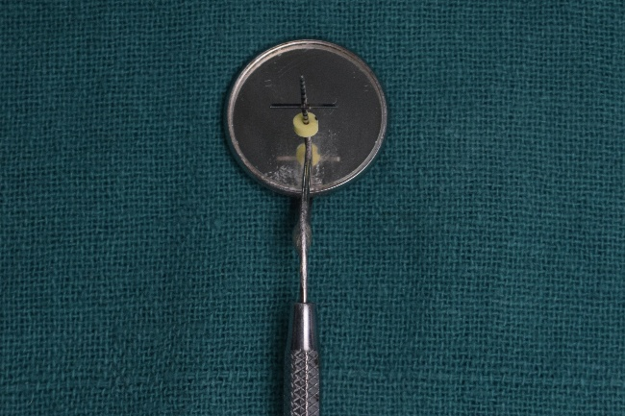
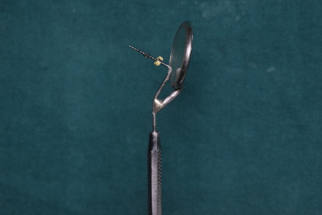

(A) (B)
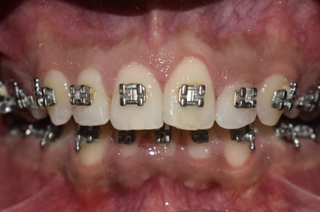
Fig.2 – Diagrammatic representation of measurements in mesial, distal, occlusal and gingival directions.

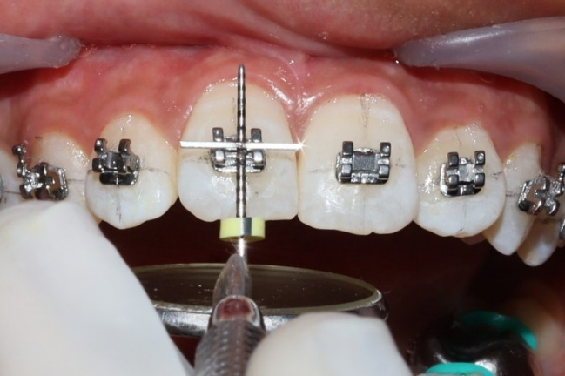
Fig. 3 – Clinical photograph showing bracket positioning using MGBP gauge.

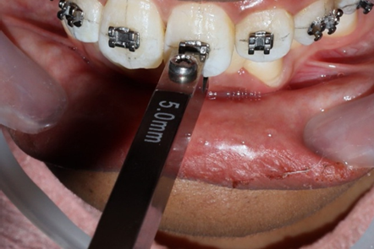
Fig. 4 – Clinical photograph showing bracket positioning using MBT gauge.

2.3 Measurement of Bracket Positioning Accuracy
Measurements were recorded using a digital Vernier caliper from the center of the vertical scribe line on the bracket to the following reference points:
- Mesial – to the adjacent mesial interproximal surface
- Distal – to the adjacent distal interproximal surface
- Incisal – to the incisal edge or cusp tip
- Gingival – to the gingival zenith
All measurements were recorded by the same investigator to ensure consistency.

2.4 Statistical Analysis
Data were tabulated using Microsoft Excel and analyzed using SPSS software version 26.0 (IBM Corp., Chicago, IL, USA). Descriptive statistics were expressed as mean and standard deviation. Data normality was assessed using the Shapiro–Wilk test. As this was a split-mouth study, intergroup comparisons between the MBT gauge and MGBP Positioner sides were performed using the paired t-test. A P-value of less than 0.05 was considered statistically significant.

3. RESULTS
A total of 25 patients were included in the study, and all participants completed the evaluation. Comparison of bracket positioning accuracy between the MBT gauge and MGBP positioner was performed using paired statistical analysis.
For the central incisors (Table 1), the mean mesial surface score was significantly higher on the MGBP side (4.17 ± 0.24) compared to the MBT side (4.01 ± 0.26) (P = 0.030). The mean distal surface scores were 4.18 ± 0.20 on the MGBP side and 4.02 ± 0.33 on the MBT side, with no statistically significant difference between the two sides (P = 0.052). The occlusal surface score was also significantly greater on the MGBP side (4.57 ± 0.35) compared to the MBT side (4.33 ± 0.37) (P = 0.021). However, no statistically significant difference was observed in the gingival surface scores between the MGBP side (4.45 ± 0.34) and the MBT side (4.26 ± 0.45) (P = 0.104).
Table 1: Comparison of mean surface scores between MBT group and MGBP group for central incisors
Surface | MBT group  Mean ± SD | MGBP group  Mean ± SD | P-value
Mesial | 4.01 ± 0.26 | 4.17 ± 0.24 | 0.030^{b}
Distal | 4.02 ± 0.33 | 4.18 ± 0.20 | 0.052ª
Occlusal | 4.33 ± 0.37 | 4.57 ± 0.35 | 0.021^{b}
Gingival | 4.26 ± 0.45 | 4.45 ± 0.34 | 0.104ª
aP>0.05: no significant difference, bP<0.05: significant difference, cP<0.001: highly significant difference
For the lateral incisors (Table 2), the mean mesial surface scores were 3.61 ± 0.28 on the MGBP side and 3.49 ± 0.31 on the MBT side, with no statistically significant difference (P = 0.156). Similarly, no significant difference was observed in the distal surface scores between the MGBP side (3.58 ± 0.25) and the MBT side (3.47 ± 0.32) (P = 0.152), or in the occlusal surface scores (4.00 ± 0.35 vs 3.94 ± 0.38; P = 0.557). However, the gingival surface score was significantly higher on the MGBP side (4.07 ± 0.33) compared to the MBT side (3.83 ± 0.36) (P = 0.021).
Table 2: Comparison of mean surface scores between MBT group and MGBP group for lateral incisors
Surface | MBT group  Mean ± SD | MGBP group  Mean ± SD | P-value
Mesial | 3.49 ± 0.31 | 3.61 ± 0.28 | 0.156ª
Distal | 3.47 ± 0.32 | 3.58 ± 0.25 | 0.152ª
Occlusal | 3.94 ± 0.38 | 4.00 ± 0.35 | 0.557ª
Gingival | 3.83 ± 0.36 | 4.07 ± 0.33 | 0.021^{b}
aP>0.05: no significant difference, bP<0.05: significant difference, cP<0.001: highly significant difference
For the canines (Table 3), the mean mesial surface score was significantly higher on the MGBP side (4.31 ± 0.35) compared to the MBT side (4.03 ± 0.38) (P = 0.009). The distal surface score also demonstrated a statistically significant difference, with higher values observed on the MGBP side (4.26 ± 0.31) compared to the MBT side (3.92 ± 0.37) (P = 0.001). Similarly, the occlusal surface score was significantly greater on the MGBP side (4.57 ± 0.31) than on the MBT side (4.31 ± 0.32) (P = 0.004). No statistically significant difference was found in the gingival surface scores between the two sides (P = 0.226).
Table 3: Comparison of mean surface scores between MBT group and MGBP group for canines
Surface | MBT group  Mean ± SD | MGBP group  Mean ± SD | P-value
Mesial | 4.03 ± 0.38 | 4.31 ± 0.35 | 0.009^{b}
Distal | 3.92 ± 0.37 | 4.26 ± 0.31 | 0.001^{b}
Occlusal | 4.31 ± 0.32 | 4.57 ± 0.31 | 0.004^{b}
Gingival | 4.41 ± 0.41 | 4.55 ± 0.38 | 0.226ª
aP>0.05: no significant difference, bP<0.05: significant difference, cP<0.001: highly significant difference
Overall, the MGBP positioner demonstrated consistently higher mean surface scores across most parameters compared to the MBT gauge. Statistically significant differences were primarily observed in the mesial and occlusal surfaces of central incisors, the gingival surface of lateral incisors, and the mesial, distal, and occlusal surfaces of canines, indicating superior bracket positioning accuracy with the MGBP technique.
4. DISCUSSION
The present study evaluated the accuracy of bracket positioning using the MBT gauge and the MGBP positioner in maxillary anterior teeth using a split-mouth design. The findings demonstrated that the MGBP positioner provided significantly greater accuracy compared to the MBT gauge in several parameters, particularly in the mesial and occlusal surfaces of central incisors, the gingival surface of lateral incisors, and the mesial, distal, and occlusal surfaces of canines. However, no statistically significant differences were observed in certain parameters, indicating that both methods performed comparably in selected regions.
Accurate bracket placement is a critical step in orthodontic treatment, as it directly influences the expression of built-in bracket prescriptions and overall treatment outcomes. Inaccurate placement of orthodontic brackets at the initial stage can adversely affect the expression of built-in prescription features, leading to undesirable torque control, tipping discrepancies, and in–out variations that may continue throughout the course of treatment, often necessitating additional wire adjustments at later stages. McLaughlin et al. stated that precise bracket positioning is necessary to express the built-in characteristics of the bracket system completely and effectively. In the original edgewise appliance, standard millimeter measurements were collected from each tooth's incisal edge, regardless of tooth size, and bracket installation was often done using gauges. For large incisors, this resulted in incisal bracket placement, which changed the torque and in–out that the brackets produced. It is necessary to visualize the vertical long axis of the clinical crown of each tooth to achieve accuracy because errors may cause incorrect tip positioning of the teeth. McLaughlin et al. proposed that the bracket wings need to be parallel to the long axis. However, obtaining axial accuracy remains the most difficult aspect.
The superior performance of the MGBP positioner observed in the present study can be attributed to its design characteristics. The incorporation of a mirror enables improved indirect visualization during bracket bonding, particularly in regions where direct access is limited. Furthermore, the presence of both vertical and horizontal reference components allows better alignment of the bracket with the long axis of the tooth, thereby reducing errors in both vertical and mesiodistal positioning. This dual-plane control likely contributed to the significantly higher accuracy observed in multiple parameters with the MGBP positioner compared to the MBT gauge, which primarily aids vertical positioning and offers limited control over horizontal and axial alignment.
The greater differences observed in canines compared to incisors may be explained by anatomical and clinical considerations. Canines are positioned more posteriorly in the arch and exhibit greater crown convexity, making accurate bracket placement more challenging using conventional gauges. In such situations, enhanced visualization and guidance provided by the MGBP positioner may have a more pronounced effect, resulting in significantly improved accuracy in mesial, distal, and occlusal parameters. In contrast, the relatively accessible position of incisors may explain the lack of statistically significant differences in certain measurements.
Several modified bracket positioning instruments have been introduced to improve accuracy. Droschl (1986) introduced a modification of the Boone gauge in which the sharp metal pins were replaced by pencil leads at various heights. Samuels (2005) designed the TN3™ bracket positioning instrument to facilitate bracket placement and removal of excess composite. Geron (2002) introduced a height gauge tweezer that measures bracket height simultaneously at two points, thereby minimizing angulation errors and in–out discrepancies. Sharma et al. (2011) introduced a two-dimensional bracket positioning gauge, while other modified gauges have also been reported in the literature. However, most of these instruments are designed for specific applications and may require precise positioning during use. Improper handling or variation in angulation during placement can lead to bracket positioning errors.
Aguirre et al. (1982) reported that measurement error in bracket placement was greater in angulation compared to vertical and mesiodistal positioning. Similarly, Balut et al. (1992) reported average vertical errors of 0.34 mm in placing preadjusted brackets. Ousehal and Lazrak (2011) and Mohammadi et al., (2011) evaluated bracket positioning accuracy using photographic methods; however, measurements obtained using a digital Vernier caliper have been shown to provide greater precision and reliability. The present study utilized a digital Vernier caliper for measurement, thereby enhancing the accuracy of recorded values.

5. CONCLUSION
Within the limitations of the present study, the Mirror-Guided Bracket Positioner demonstrated superior accuracy in bracket positioning compared to the conventional MBT gauge, particularly in the mesial and occlusal surfaces of central incisors, gingival surface of lateral incisors, and mesial, distal, and occlusal surfaces of canines. These findings indicate that the enhanced visualization and dual-plane guidance provided by the MGBP positioner contribute to improved precision in bracket placement. The null hypothesis was therefore rejected. Clinically, the use of the MGBP positioner may facilitate more accurate bracket positioning, potentially reducing the need for finishing adjustments and improving overall treatment efficiency.
6. STRENGTHS AND LIMITATIONS
A notable strength of the present study is its split-mouth design, in which each participant served as their own control. This approach minimizes inter-individual variability and allows a more reliable comparison between the two bracket positioning methods. Additionally, the use of a single operator for bracket bonding and a single investigator for measurements ensured procedural consistency and reduced operator-related bias.
Nevertheless, certain limitations must be acknowledged. The present study was conducted at a single center with a relatively small sample size, which may limit generalizability. The evaluation was restricted to maxillary anterior teeth and immediate bracket positioning accuracy, without assessing long-term outcomes such as torque expression or treatment efficiency. Although procedures were standardized using a single operator, operator-dependent bias cannot be completely eliminated. Measurements obtained using a digital Vernier caliper may be subject to minor variations. Additionally, the split-mouth design, while reducing inter-individual variability, may introduce a potential crossover effect.
7. FUTURE DIRECTIONS
Future studies with larger sample sizes and multicenter designs are recommended to improve the generalizability of the findings. Long-term studies should evaluate the effect of improved bracket positioning on torque expression, treatment efficiency, and finishing outcomes. Further research should include posterior teeth, mandibular arches, and different malocclusion patterns. Comparative studies with other conventional and digital bracket positioning techniques are also warranted. The use of three-dimensional digital assessment methods may provide more precise evaluation of bracket positioning accuracy. In addition, further refinement of the MGBP design may enhance its clinical applicability and ease of use.
CONSENT AND ETHICAL APPROVAL
Ethical approval was obtained from the Institutional Ethics Committee of Chhattisgarh Dental College and Research Institute (Approval No: CDCRI/DEAN/ETHICSCOMMITTEE/ORTHO-01/2024). Written informed consent was obtained from all participants prior to enrollment.
DISCLAIMER (ARTIFICIAL INTELLIGENCE)
Author(s) hereby declares that NO generative AI technologies such as Large Language Models (ChatGPT, Copilot, etc.) and text-to-image generators have been used during writing or editing of this manuscript.
COMPETING INTERESTS DISCLAIMER:
Authors have declared that they have no known competing financial interests OR non-financial interests OR personal relationships that could have appeared to influence the work reported in this paper.
REFERENCES
- Rathor, A. S., Jani, B., Shah, A., Prasad, A., & Thakore, K. (2024). A new versatile tool for accurate bracket positioning—an in vitro study. Journal of Indian Orthodontic Society, 58, 268–275.https://doi.org/10.1177/03015742241226513
- Shenoi, S. B., Deshpande, S., & Hattarki, R. S. (2021). Multipurpose bracket positioning tool: a modified probe for accurate bracket placement. Journal of Indian Orthodontic Society, 56, 186–188.DOI:10.1177/03015742211013754
- Gaur, G., Mehta, S., Bajaj, K., et al. (2020). Visiogauge: a modified MBT gauge. Journal of Mahatma Gandhi University of Medical Sciences and Technology, 2, 66–68. https://doi.org/10.5005/jp-journals-10057-0140
- Mohammadi, A., & Moslemzadeh, S. H. (2011). Comparison of the accuracy of bracket placement with height bracket positioning gauge and Boone gauge. Journal of Dental Research, Dental Clinics, Dental Prospects, 5, 111–118. DOI: 10.5681/joddd.2011.026
- Bhide, D. V., Hazarey, P. V., Atram, D. H., Kale, D. G., Waghmare, S., & Dharmadhikari, D. M. (2019). A comparative study of accuracy in bracket positioning with modified height bracket positioning gauge and Boone gauge: an in vivo study. International Journal of Medical Science and Current Research, 2, 132–141.
- Raghuraj, M. B., Shetty, N., & Sharan. (2011). Modified bracket positioning holder. Contemporary Clinical Dentistry, 2, 142. DOI: 10.4103/0976-237X.83070
- Hattarki, R. S., & Malag, S. (2011). A modified bracket-positioning gauge. Orthodontics (Chic), 12, 268–269. PMID: 22022698
- Sharma, N. S., Shrivastav, S. S., & Hazarey, P. V. (2011). A new two-dimensional bracket positioning gauge. Journal of Indian Orthodontic Society, 45, 202–204. DOI:10.5005/jp-journals-10021-1036
- Ousehal, L., & Lazrak, L. (2011). The accuracy of bracket placement in direct bonding technique: a comparison between the pole-like bracket positioning gauge and the star-like bracket positioning gauge. Open Journal of Stomatology, 1, 121–125.DOI: 10.4236/ojst.2011.14019
- Samuels, R. H. (2005). TN3—a bracket positioning instrument. Journal of Orthodontics, 32, 98–99. DOI: 10.1179/146531205225020961
- Geron, S. (2002). A new instrument for controlled bracket positioning. Journal of Clinical Orthodontics, 36, 206–207. PMID: 12025355
- Balut, N., Klapper, L., Sandrik, J., & Bowman, D. (1992). Variations in bracket placement in the preadjusted orthodontic appliance. American Journal of Orthodontics and Dentofacial Orthopedics, 102, 62–67.DOI: 10.1016/0889-5406(92)70015-3
- Droschl, H., & Bantleon, H. P. (1986). Bracket positioning gauge. Journal of Clinical Orthodontics, 20, 266–268. PMID: 3519674
- Aguirre, M. J., King, G. J., & Waldron, J. M. (1982). Assessment of bracket placement and bond strength when comparing direct bonding to indirect bonding techniques. American Journal of Orthodontics, 82, 269–276. DOI: 10.1016/0002-9416(82)90461-4

