Original Research Article
Unveiling the therapeutic potential: Cylicodiscus gabunensis (FABACEAE) aqueous stem bark extract-derived silver nanoparticles for enhanced anti-inflammation in Wistar rats

.
ABSTRACT

Aims: The present study investigates the anti-inflammatory activity of silver nanoparticles (AgNPs) biosynthesized using the aqueous stem bark extract of Cylicodiscus gabunensis. The aqueous extract was prepared by infusion and reacted with silver nitrate to generate AgNPs.
Study design:Experimental.
Place and Duration of Study:Department pharmaceutical Sciences, Faculty of Medicine and Pharmaceutical Sciences, University of Douala, Cameroon, between November 2021 and June 2022.
Methodology:Comprehensive physicochemical characterization was carried out using UV-Vis spectrophotometry to confirm nanoparticle formation, Fourier-transform infrared spectroscopy (FTIR) to identify functional groups at the metal-biomolecule interface, powder X-ray diffraction (XRD) to assess crystallinity and purity, scanning electron microscopy (SEM) to examine morphology, and energy-dispersive X-ray spectroscopy (EDX) to determine elemental composition.Acute toxicity was evaluated in accordance with OECD Guideline 425, while anti-inflammatory activity was assessed in vitro using the bovine serum albumin (BSA) denaturation assay and in vivo using the carrageenan-induced rat paw edema model.
Results:The synthesized AgNPs were stable, crystalline, composed of elemental silver, and no signs of acute toxicity were observed. Notably, the AgNPs exhibited pronounced anti-inflammatory activity, achieving 95% inhibition of BSA denaturation at 200 µg/mL in vitro and 91% inhibition of paw edema at 400 µg/kg in vivo.
Conclusion: Overall, silver nanoparticles biosynthesized from Cylicodiscus gabunensis stem bark demonstrated potent anti-inflammatory effects coupled with low toxicity, highlighting their promise as a plant-derived, biocompatible alternative for the management of inflammatory disorders.

Keywords: Cylicodiscus gabunensis, silver nanoparticles, green synthesis, acute toxicity, anti-inflammatory activity

1. INTRODUCTION

The use of plants in human health dates back to antiquity, as plants synthesize a wide range of bioactive molecules through secondary metabolism to protect themselves against pathogens and environmental stressors. Many of these metabolites exhibit significant biological activities, including pronounced anti-inflammatory effects [1].Inflammation is a body's immune response triggered by harmful stimuli such as pathogens, injured cells, toxic substances, or radiation [2].It may also arise as a consequence of tissue injury or infection, processes often accompanied by oxidative stress that ultimately amplifies inflammatory responses [3]. Plant-derived compounds exert anti-inflammatory effects through several mechanisms. They downregulate the expression of pro-inflammatory cytokines such as IL-1β, IL-6, and TNF-α, while enhancing anti-inflammatory mediators like IL-10. In addition, these compounds inhibit key enzymes of the arachidonic acid pathway, such as cyclooxygenase (COX) and lipoxygenase (LOX), thereby decreasing the production of inflammatory mediators like prostaglandin E2 (PGE2). They further attenuate oxidative damage by inhibiting inducible nitric oxide synthase (iNOS) and tyrosinase, neutralizing excess reactive oxygen species (ROS), reducing tissue edema, promoting wound healing, and modulating immune responses via ion channels [4]. Following a systematic review of randomized, placebo-controlled, double-blind clinical trials, Ernst and Chrubasik proposed that plant-based anti-inflammatory therapies may representviable alternatives or adjuncts to nonsteroidal anti-inflammatory drugs (NSAIDs) for patients suffering from mild to moderate chronic pain. Such approaches may help mitigate the adverse effects commonly associated with long-term NSAID use [5]. Indeed, misuse of conventional anti-inflammatory treatments is often associated with adverse effects such as immunosuppression and renal and gastrointestinal toxicity [6]. Consequently, increasing research efforts have focused on identifying medicinal plants with effective anti-inflammatory properties and improved safety profiles [1]. Despite their therapeutic potential, the bioavailability and pharmacological consistency of plant extracts remain challenging due to their chemical complexity. Factors such as solubility control, degradation of active compounds, and organoleptic properties must be carefully managed to ensure reproducible biological responses [7].
Cylicodiscus gabunensis, a member of the Fabaceae family, is widely distributed across various regions of Cameroon, including Babeng in the Centre Region, the Lomié forest in the East Region, and the forest edges of Mujuka, Loum, and Manjo in the Littoral Region. Ethnobotanical surveys indicate that the stem bark of this plant is traditionally used to treat a variety of ailments, including diarrhea, malaria, bacterial infections, rheumatism, migraines, and stomach pain [8]. Previous studies have demonstrated that ethyl acetate extracts of C. gabunensis stem bark exhibit protein anti-denaturation, analgesic, anti-inflammatory, antioxidant, and bactericidal activities against Staphylococcus aureus and Bacillus cereus [9].
Silver nanoparticles (AgNPs) have increasingly been synthesized using environmentally benign biological approaches, employing plant extracts or microorganisms as natural bioreactors, thereby eliminating the need for toxic organic solvents [10]. Green synthesis strategies, which rely on the self-assembly of plant- or microbe-derived metabolites at the metal interface, offer a promising platform for the development of novel therapeutics, particularly for inflammatory diseases [11]. A comprehensive review of studies published between 2013 and 2023, conducted by Carvalho-Silva and Reis (2024), identified two major mechanisms responsible for the anti-inflammatory activity of AgNPs: a) AgNPs interact with inflamed cell membranes, releasing Ag⁺ ions and generating controlled levels of ROS, which inhibit the NF-κB signaling pathway and subsequently reduce the expression of pro-inflammatory cytokines, including IL-1, IL-1α, IL-1β, IL-6, IL-9, IL-12, IL-18, IFN-γ, and TNF-α. In healthy cells, intracellular glutathione neutralizes excess nanoparticles, thereby limiting cytotoxicity [12] b) M1 macrophages phagocytose AgNPs, leading to ROS-mediated apoptosis and repolarization toward the anti-inflammatory M2 phenotype. This process, together with regulatory T-cell activation and receptor-mediated signaling, promotes the secretion of cytokines such as IL-4, IL-5, IFN-α, IL-10, IL-13, CXCL1, GM-CSF, and G-CSF, ultimately facilitating tissue repair and resolution of inflammation [12]. Green synthesis further enhances the biocompatibility and biological efficacy of nanoparticles, as plant- or microbe-derived secondary metabolites act as natural capping agents that prevent agglomeration and improve stability [13]. Using this approach, Theobroma cacao metabolites have been successfully immobilized on the surface of silver nanoparticles for applications in drug quality control [14]. Similarly, AgNPs derived from Selaginella myosurus [15], AuNPs synthesized from Eutrema japonicum [16], and ZnONPs from Aframomum citratum [17] have demonstrated pronounced anti-inflammatory effects. Moreover, polyphenols extracted from Tetrapleura tetraptera fruits and encapsulated within cellulose–chitosan capsules exhibited enhanced anti-inflammatory activity [18]. In this context, this study explores the anti-inflammatory potential of silver nanoparticles biosynthesized using the stem bark aqueous extract of Cylicodiscus gabunensis, with the aimof developing a biocompatible and effective alternative strategy for inflammation management.

2. experimental details

2.1 Collection, authentication, and preparation of extract
The stem bark of Cylicodiscus gabunensis (Cg) (Figure 1) was collected from Babeng, a locality situated approximately 4 km from Makak, along the road to Ngouatè in the Central Region of Cameroon. The botanical identification was carried out at the Cameroon National Herbarium by comparison with a reference specimen (Voucher No. 43972/HNC). Fresh stem bark samples were cut into small fragments and air-dried under shaded for three weeks to prevent photodegradation of metabolites. The dried material was mechanically grounded into a fine powder. To prepare the aqueous extract (Cg-AE), 10 g of the powdered stem bark was immersed in 100 mL of distilled water, heated to 80°C, and maintained at this temperature for 5 minutes under continuous magnetic stirring. The resulting decoction was filtered through Whatman No.1 filter paper to remove insoluble residues [15]. The extract was divided into three portions: one for silver nanoparticle synthesis, one for phytochemical screening, and one for drying at 55 °C to determine extraction yield according to the following equation:

𝜏 = $\frac{m}{M}$×100 (1)

where τ represents the extractable content (%), m is the mass of dry extract (g), and M is the mass of dry plant material (g).

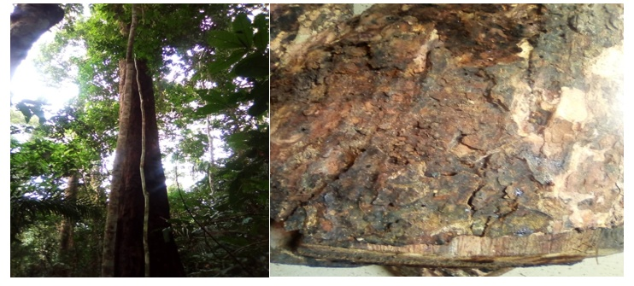

Figure 1: Cylicodiscus gabunensis stem bark

2.2 Phytochemical screening
Qualitative phytochemical screening of the aqueous extract was conducted to detect alkaloids, flavonoids, terpenoids, coumarins, saponins, tannins, anthraquinones, polyphenols, steroids, and reducing sugars, using standard procedures described in the literature [19].

2.3 Synthesis of silver nanoparticles
Silver nanoparticles (Cg-AgNPs) were synthesized following an established protocol with minor modifications [15]. Briefly, 10 mL and 20 mL aliquots of Cg-AE were adjusted to pH values of 2, 4, 6, 8, 10, and 12 using 0.1 mol/L sulfuric acid or sodium hydroxide solutions. Each pH-adjusted extract was then mixed with 50 mL of silver nitrate (AgNO₃) solutions at concentrations of 10⁻¹, 10⁻², and 10⁻³ mol/L.The reaction mixtures were incubated at room temperature in the dark to prevent photo-oxidation of silver ions [20]. Nanoparticles formation was preliminarily indicated by a visible color change to brown. To monitor reaction kinetics, 1 mL aliquots were collected at predefined time intervals (5 min, 1 h, 6 h, 12 h, 24 h, 1 week, 2 weeks, and 1 month) and analyzed by UV–Vis spectrophotometry to detect surface plasmon resonance (SPR) [15]. The synthesized nanoparticles were recovered by centrifugation at 4000 rpm for 1 h, washed twice with deionized water and ethanol, and dried at 50 °C for 24 h.
2.4 Characterization

2.4.1 Ultraviolet-visible characterization (UV-Vis)
Optical absorption spectra were recorded using a P9 double-beam spectrophotometer (VWR) over a wavelength range of 200-800 nm, using 2 mL aliquots of the nanoparticle suspensions.

2.4.2 Ultraviolet-visible characterization (UV-Vis)
FTIR analysis was conducted on a Bruker Tensor 37 spectrometer equipped with an attenuated total reflection (ATR) accessory, with spectral data collected in the range of 600-4000 cm⁻¹.

2.4.3 Powder X-ray diffraction (PXRD)
Crystalline structure analysis was performed using a Bruker D2 Phaser diffractometer with Cu Kα\alpha radiation (wavelengths: Kα1\alpha_1 = 1.54060 Å, Kα2\alpha_2 = 1.54443 Å, Kβ\beta = 1.39225 Å). Samples were prepared as thin films on low-background silicon holders,and diffraction patterns were recorded over a 2θ range of 20-80°.
2.4.4 Scanning electron microscopy (SEM) and energy-dispersive X-ray spectroscopy (EDX) investigations
Surface morphology and elemental composition were examined using a Jeol JSM-6510LV QSEM Advanced electron microscope equipped with a LaB6_6 cathode operating at 20 kV. EDX analysis was conducted using a Bruker Xflash 410 silicon drift detector. Before imaging, nanoparticle samples were coated with gold using a JEOL JFC-1200 Fine Coater.
2.5 Animal and ethical considerations
Female albino rats (Rattus norvegicus), aged 8-12 weeks and weighing 120–180 g, were obtained from the Animal Facility Laboratory of the Faculty of Medicine and Pharmaceutical Sciences, University of Douala, Cameroon. The animals were housed in standard polypropylene cages (three per cage) under controlled conditions (temperature: 24 ± 2°C; light/dark cycle: ~12 h) with ad libitum access to food and water.

2.6 Evaluation of acute toxicity of the aqueous extract and silver nanoparticles of C. gabunensis
Acute toxicity was carried out according to the Organization for Economic Cooperation and Development (OECD) Guideline 425,_using a limit dose of 2000 mg/kg body weight (Supplementary file 1) [21].
2.7 Evaluation of the anti-inflammatory activity
2.7.1 The Bovine Serum Albumin (BSA) denaturation assay
The in vitro anti-inflammatory potential of Cg-AgNPs was assessed using the BSA denaturation method, adapted from Belle et al. with slight modifications (Supplementary file 1) [22].
2.7.2 The Carrageenan-induced rat paw edema method
The in vivo anti-inflammatory activity was evaluated using the carrageenan-induced rat paw edema model, initially described by Winter et al. (1962) with modifications [23]. The rats were divided into six experimental groups (n = 5 per group) and treated as follows: Group 1: 10 mL/Kg b.w of distilled water, (Control);_Group 2: 10 mg/Kg b.w of diclofenac, (Standard);_Group 3: 100 µg/Kg b.w of Cg-AgNPs, (test 1);_Group 4: 200 µg/Kg b.w of Cg-AgNPs, (test 2);_Group 5: 400 µg/Kg b.w of Cg-AgNPs, (test 3);_Group 6: 200 mg/Kg b.w of Cg-AE, (test 4) (supplement 1).
2.8 Statistical analysis
Data were expressed as mean ± standard error of the mean (SEM). Statistical significance was determined by two-way analysis of variance (ANOVA) followed by Dunnett’s post hoc test with analyses performed using GraphPad Prism (version 10.5.0). A p-value < 0.05 was considered statistically significant.
3. results and discussion

3.1 Synthesis and characterization of silver nanoparticles of the aqueous extract of C. gabunensis
Aqueous extraction of C. gabunensis stem bark yielded 4.09 g of dry extract from 25 g of powdered material, corresponding to an extraction yield of 16%. Phytochemical analysis (Table 1) revealed the presence of polyphenols, flavonoids, alkaloids, coumarins, saponins, triterpenes, steroids, reducing sugars, and tannins in the aqueous extract, while anthraquinones were absent. In contrast, the post-synthesis supernatant tested positive only for saponins, indicating consumption of most secondary metabolites during Ag⁺ reduction and nanoparticle stabilization.

Table 1 Phytochemical screening of plant extract and supernatant
Secondarymetabolites | Aqueous extract | Supernatant
Polyphenols and phenols | + | -
Flavonoids | + | -
Alkaloids | + | -
Coumarins | + | -
Saponins | + | +
Triterpenes | + | -
Steroids | + | -
Reducing sugar | + | -
Anthraquinone | - | -
Tanins | + | -
(+) present; (-) absent

The aqueous extract from the dried stem bark powder of Cylicodiscus gabunensis yielded an extraction yield of 16% which is higher than the 4% previously reported by Fannang et al. This discrepancy suggest that extraction yield is influenced by methodological parameters including the type of aqueous extraction employed (decoction in this study), the harvest period, and the efficiency of the filtration process [24]. Phytochemical screening of the aqueous extract of C. gabunensis confirmed the presence of polyphenols, phenols, flavonoids, alkaloids, coumarins, saponins, triterpenes, steroids, reducing sugar and tannins whereasanthraquinones were not detected. This phytochemical profile aligns with earlier findings reported by Fannang et al [24]. These secondary metabolites are widely recognized for their pharmacological relevance and likely responsible for the reported anti-malarial, anti-psoriasis, anti-rheumatic, anti-migraine, gastroprotective, and anti-diabetic activities of the plant[9].

3.2 Synthesis of silver nanoparticles with the aqueous extract of C. gabunensis
A key indicator of nanoparticle formation is a color change. After mixing the aqueous extract (B) of C. gabunensis (orange) with a 10⁻¹ mol/L silver nitrate solution (A, colorless), a brown color (C) appeared within five minutes of incubation, confirming the synthesis of silver nanoparticles.

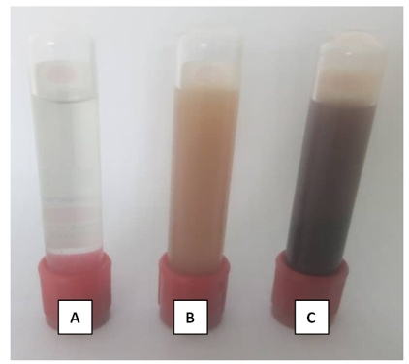
Figure 2: Silver nitrate solution (A), C. gabunensis aqueous extract (B) and C. gabunensis silver nanoparticles (C)

UV-Vis spectra exhibited a characteristic SPR band between 380 and 550 nm, appearing within 5 min of reaction initiation. Absorbance intensity increased progressively, reaching a maximum at day 4, consistent with increasing nanoparticle density. A slight red shift observed after 1 h indicated particle growth. Nanoparticle formation was strongly influenced by pH, extract volume, and silver nitrate concentration, with optimal synthesis observed at pH 10.

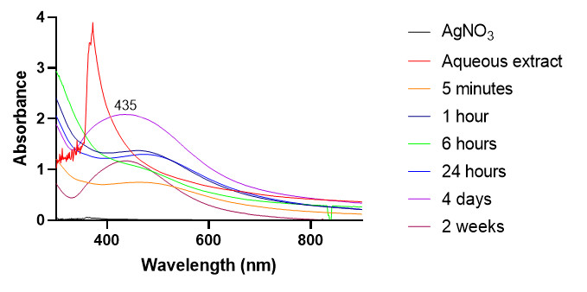

Figure 3a: UV-Vis spectrum of AgNPs as a function of contact time

Moreover, the optical characteristics of the nanoparticles were significantly affected by changes in pH, extract volume, and silver nitrate concentration. At pH 10, a pronounced plasmon resonance peak was observed, indicating more efficient reduction of Ag⁺ ions and better stabilization of Ag⁰, likely due to the enhanced activity of polyphenols under alkaline conditions [20]. Similarly, increasing the volume of plant extract boosted nanoparticle yield, while higher concentrations of silver nitrate supplied more Ag⁺ ions, promoting further nanoparticle growth.

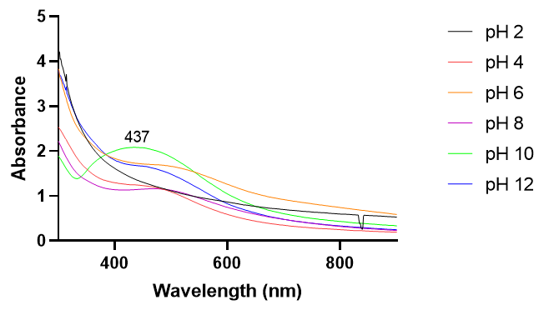

Figure 3b: UV-Vis of AgNPs as a function of pH

Figures 3c present an increase in the intensity of the plasmonic resonance band proportional to the extract volume due to increase density of nanoparticles in solution.

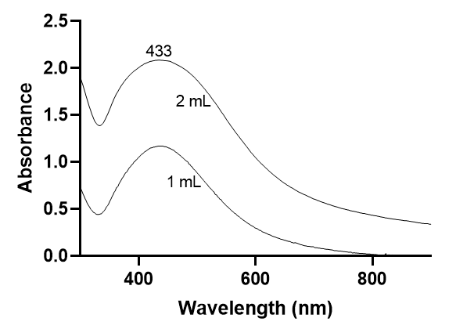
Figure 3c: UV-Vis spectrum of AgNPs as a function of extract volume

Figures 3d presents an increase in the intensity of the plasmonic resonance band proportional to the increase in the concentration of silver nitrate solution due to the availability of free Ag⁺ to react with secondary metabolites.

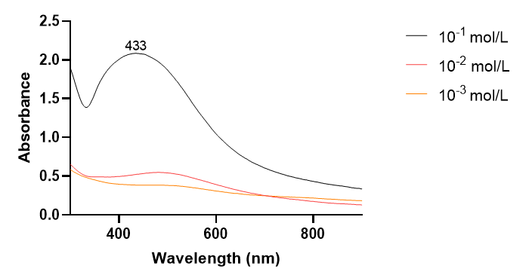

Figure 3d: UV-Vis spectrum of AgNPs as a function of silver nitrate concentration.

The absence of secondary metabolites in the synthetic supernatant medium indicates that these metabolites were consumed during the reduction of Ag⁺ ions and subsequently involved in the stabilization of the resulting metallic silver (Ag⁰) nanoparticles. The formation of AgNPs was visually observedby a visible color change within 5 minutes of incubation indicative of Ag⁺reduction to Ag⁰ by the plant phytochemicals present in the extract. This change results from the excitation of surface plasmon resonance (SPR) associated with silver nanoparticles [25].
UV-Vis spectrophotometric analysis confirmed nanoparticle formation, showing a SPR band between 380 and 550 nm. The breadth of this band indicates a distribution of nanoparticleswith large sizes. AgNPs formation initiated within 5 minutes of incubation, continued for four days until reaching a maximum intensity, and remained stable for at least two weeks. This prolonged stability is attributed to the encapsulation of the nanoparticles by a secondary metabolites ligand layer, which prevents aggregation. The formation of AgNPs was monitored under varying experimental conditions, including pH, silver nitrate concentration, extract volume, and reaction time (Figure 3). Optimal synthesis and stability of Cg-AgNPs were achieved at pH 10, a silver nitrate concentration of 10⁻¹ M, an extract volume of 1 mL, and a reaction time of four (4) days. These findings are consistent with previous reports indicating that alkaline conditions favor silver nanoparticle formation [20].

3.3 Characterization
FTIR spectra (Figure 4; Table 2) revealed Ag–O stretching vibrations at 669 and 541 cm⁻¹, along with peaks corresponding to O–H/N–H stretching (3264 cm⁻¹), CH₂/CH₃ stretching (2914 and 2844 cm⁻¹), and carbonyl (1610 cm⁻¹) and C–O (1020 cm⁻¹) groups, confirming the involvement of phytochemicals in nanoparticle capping.

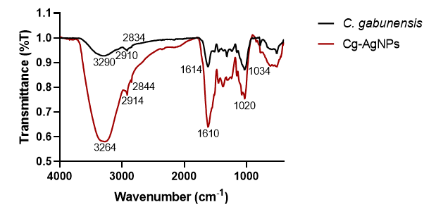

Figure 4: IR spectra of dried C. gabunensis extract and Cg-AgNPs

Table 2: Functional groups obtained from the IR spectra of AgNPs.
AgNPs (cm⁻¹) | Functional Group | Compound class
3264 | O-H, N-H | Alcohol, phenol, amine
2914 | C-CH₃ (Stretching vibration) | C-H (Methyl)
2844 | CH₂ (Stretching vibration) | Methylene
1610 | RCH=CH₂, C=O | Terminal Alkene, Carbonyl
1020 | C-O (Stretching) | C-O, alcohol, carbonyl
669 | Ag-O Stretching | Silver oxide
541 | Ag-O | Silver oxide

Fourier-transform infrared (FTIR) spectroscopy analysis identified the functional groups present on the surface of the synthesized nanoparticles, supporting the involvement of plant-derived biomolecules in nanoparticle capping. This resultis consistent with Zhu et al.(2012), research, who demonstrated that phenolic compounds play a dual role in the reduction and stabilization of silver nanoparticles [26].
PXRD analysis was conducted to confirm the crystalline structure of the AgNPs. PXRD patterns (Figure 5) displayed diffraction peaks at 2θ = 38°, 44°, 64°, and 77°, corresponding to the (111), (200), (220), and (311) planes of face-centered cubic silver (ICDD No. 04-0783). The average crystallite size was estimated at ~10 nm using the Scherrer equation based on the most intense (111) reflection.

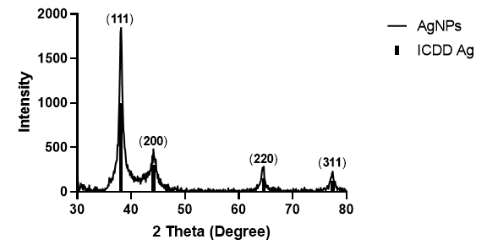

Figure 5: PXRDof AgNPs from C.gabunensis and bar diffractogram of AgICDD 04-0783

X-ray powder diffraction (PXRD) confirmed the formation of crystalline, phase-pure silver nanoparticles within the nanometer size range, comparable to those obtained using Pedalium murex leaf extract [27].
SEM images (Figure 6) revealed spherical, agglomerated nanoparticles, while EDX spectra (Figure 7) confirmed Ag, O, and C as the major elemental components.
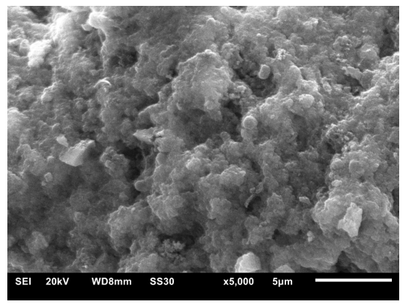

Figure 6 SEM image of AgNPs

Element | Atomic %
C | 55.8
O | 20.3
Ag | 15.8
S | 3.3
Cu | 1.8
Au | 1.5
Zn | 1.4

Figure 7 X-ray energy dispersive spectroscopy and element mapping.

Scanning electron microscopy (SEM) further revealed that the nanograins tended to form aggregates in the solid state.

3.4 Acute toxicological profile of silver nanoparticles of the aqueous extract of C. gabunensis

Table 3 presents the clinical parameters of rats following the administration of the aqueous extract and silver nanoparticles derived from C. gabunensis at a limit dose of 2000 mg/kg body weight. Throughout the 14-day observation period, no death occurred, and no visible signs of toxicity were detected in the test subjects.

Table 3: Effect of the aqueous extract and silver nanoparticles of C. gabunensis on the clinical parameters of rats submitted to acute toxicity over a period of 14 days
Clinicalsigns | Water  (1 mL/100 g) | Cg-AE  (2000 mg/Kg) | Cg-AgNPs  (2000 mg/kg)
Hair modification | A | A | A
Eye modification | A | A | A
Trembling | A | A | A
Convulsion | A | A | A
Stool texture | N | N | N
Salivation | A | A | A
Mobilityalteration | A | A | A
A: absent; N: normal

Effect of silver nanoparticles of the aqueous extract of C. gabunensis on the variation in the weight of the rats during the toxicity period

No mortality or clinical signs of toxicity were observed over 14 days following administration of 2000 mg/kg b.w. Cg-AE or Cg-AgNPs (Table 3). Body weight gain (Figure 8) and relative organ weights (Figure 9) showed no biologically concerning alterations. Among organs, a statistically significant increase in liver weight was observed.
Figure 8 Effect of aqueous extract and silver nanoparticles of C. gabunensis on the evolution of the weight of rats over a period of 14 days
Figure 9 Effect of silver nanoparticles of the aqueous extract of C. gabunensis on the weights of organs of rats after toxicity test.

Acute toxicity assessment of silver nanoparticles synthesized from the aqueous stem bark extract of C. gabunensis (Cg-AgNPs) revealed no observable signs of toxicity indicating that the median lethal dose (LD₅₀) exceeds 2000 mg/kg of body weight. These agree with previous studies, including that of Tchangou_Njiemou et al. (2022), which also reported an absence of toxicity at this dose level. Protein denaturation, particularly involving blood proteins, is known to play a critical role in inflammatory disorders such as rheumatoid arthritis [28, 29]. This process, triggered by external stressors such as heat, leads to the disruption of protein secondary and tertiary structures and ultimately results in loss of biological function [27].

3.5 Anti-inflammatory effect of silver nanoparticles of the aqueous extract of C. gabunensis

Cg-AgNPs exhibited strong concentration-dependent inhibition of BSA denaturation, reaching 95% inhibition at 200 µg/mL, surpassing both Cg-AE (76%) and diclofenac (58%) (Table 4).

Table 4 Effect of silver nanoparticles of the aqueous extract of C. gabunensis on BSA denaturation
Sample | Concentration (µg/ml) | Optical density (±SEM) | % inhibition
Control | _ | 2.98±0.02 | _
Cg- AgNPs | 25 | 0.93±0.01^{d} | 69
Cg-AgNPs  Cg- AgNPs | 50  100 | 0.73±0.02^{d}  0.53±0.01^{d} | 76  82
Cg- AgNPs  Cg-AgNPs | 150  200 | 0.34±0.02^{d}  0.15±0.01^{d} | 87  95
Cg-AE  Cg-AE  Cg-AE  Cg-AE  Cg-AE | 25  50  100  150  200 | 2.00±0.02^{d}  1.6±0.4^{d}  1.09±0.05^{d}  0.09±0.03^{d}  0.73±0.02 | 33  47  63  69  76
Diclofénac | 25 | 2.02±0.02^{d} | 32
Diclofénac  Diclofénac | 50  100 | 1.78±0.04^{d}  1.36±0.01^{d} | 40  47
Diclofénac  Diclofenac | 150  200 | 1.36±0.03^{c}  1.25±0.02^{c} | 54  58
Values are expressed as means ± SEM in each test group (n=3); values having no letter are significantly identical compared with the control, a = P<.05, b = P<.01, c = P<.001, d = P<.0001.

Table 5 details the time course of edema development and the corresponding percentage inhibition in the various treatment groups. Following carrageenan injection, localized edema was observed within 30 minutes. Peak edema occurred at 30 minutes post-administration for both the Cg-AgNPs and Cg-AE groups, while the diclofenac group reached maximum edema at 1 hour. Edema gradually subsided in all groups up to the 6th hour. Cg-AgNPs significantly reduced carrageenan-induced edema, with maximum inhibition of 85% at 0.4 mg/kg b.w., exceeding diclofenac (66%) at 5 hours post-carrageenan administration. All treatment groups showed statistically significant differences in edema and inhibition compared to the negative control group.

Table 5Effect of silver nanoparticles of the aqueous extract of Cylicodiscus gabunensis on rat hind paw edema (Please try to fit the table to the page layout)
Treatment | Dose  (mg/kg) | Diameter ± SEM (cm) (% inhibition)
 |  | 30 min | 1 h | 2 h | 3 h | 4h | 5 h | 6 h
Control | _ | 0.69 ± 0.07 | 0.74 ± 0.03 | 0.77 ± 0.04 | 0.7 ± 0.6 | 0.60 ± 0.04 | 0.54 ± 0.07 | 0.5 ± 0.7
Diclofenac | 10 | 0.65±0.02^{d}  (20) | 0.7±0.2^{d}  (23) | 0.62±0.04^{d}  (46) | 0.56±0.0^{d}  (43) | 0.50±0.04^{d}  (58) | 0.46±0.03^{d}  (66) | 0.51±0.02ª  (-4)
Cg- AgNPs | 0.1 | 0.75±0.09^{d}  (-11) | 0.68±0.03^{d}  (26) | 0.66±0.03^{d}  (38) | 0.50±0.05^{d}  (71) | 0.50±0.01^{b}  (64) | 0.51±0.02^{b}  (40) | 0.47±0.08  (49)
Cg- AgNPs | 0.2 | 0.6±0.4^{d}  (21) | 0.60±0.02^{d}  (40) | 0.57±0.05^{d}  (54) | 0.5±0.3^{d}  (56) | 0.43±0.07^{d}  (87) | 0.42±0.02^{d}  (83) | 0.44±0.02^{d}  (64)
Cg-AgNPs | 0.4 | 0.59±0.05^{d}  (46) | 0.58±0.07^{d}  (56) | 0.52±0.05^{d}  (76) | 0.49±0.02^{d}  (76) | 0.45±0.02^{d}  (90) | 0.44±0.04^{d}  (91) | 0.44±0.03^{d}  (85)
Cg-AE | 400 | 0.70±0.04ª  (-0.3) | 0.68±0.03^{d}  (20) | 0.61±0.01^{d}  (46) | 0.52±0.05^{b}  (58) | 0.57±0.02^{d}  (18) | 0.4±0.1^{d}  (29) | 0.4±0.1^{d}  (76)

Values are expressed as means ± SEM in each group (n=5); values having no letter are significantly identical compared with the control, a = P<.05, b = P<.01, c = P<.001, d = P<.0001. Values within parentheses are the percentage of inhibition. The negative values show that the drug action has reduced and therefore there is a decrease in the diameter of the hind paw of the negative control group compared to that of the treated group in question.

Carrageenan-induced inflammation in rats occurs via a biphasic mechanism characterized by the sequential release of vasoactive mediators [30]. The early phase (within the first two hours) involves the release of histamine, serotonin, and kinins, whereas the late phase (after three hours) is dominated by prostaglandins and cyclooxygenase-derived products. These mediators collectively increase vascular permeability, leading to edema formation.
In thepresent study, pre-treatment with Cg-AgNPs and the C. gabunensis aqueous extract (Cg-AE) significantly reducedcarrageenan-inducededema. Notably, Cg-AgNPs showed superior anti-inflammatory activity compared to the crude extract and the reference anti-inflammatory drug. These resultssuggest that Cg-AgNPs effectively inhibit the release or activity of key mediators involved in acute inflammation [15]. The enhanced efficacy of Cg-AgNPs is likely attributable to synergistic interactions among the phytochemicals adsorbed on the nanoparticle surface.

4. Conclusion

This study successfully demonstrated the synthesis of silver nanoparticles (AgNPs) using an aqueous extract derived from the stem bark of Cylicodiscus gabunensis. The resulting Cg-AgNPs nanoparticles exhibited pronounced anti-inflammatory activity in both in vitro and in vivo models, significantly inhibiting edema in a rat model of acute inflammation. Importantly, the AgNPs appear to be biocompatible, showing no signs of acute toxicity at the tested dose. The presence of plant-derived metabolites at the nanoparticle interface likely contributes to both the stability of the AgNPs and their enhanced biological activity.
Overall, these findings highlight the potential of C. gabunensis-derived silver nanoparticles as promising candidates for the development of novel anti-edematous therapeutic agents. Further studies focusing on their molecular mechanisms of action and long-term safety are warranted.

Ethical approval

All authors hereby declare that "Principles of laboratory animal care" (NIH publication No. 85-23, revised 1985) were followed, as well as specific national laws where applicable.The animals were examined and adapted to the new environmental conditions for a week before the formal experiment. All experimental procedures were in strict compliance with theapproved protocol by the Institutional Ethic Committee for Human Research of the University of Douala (Protocol approval number 3144IEC-UD/06/2022/T) and have therefore been performed in accordance with the ethical standards laid down in the 1964 Declaration of Helsinki.” Animals were monitored daily for signs of distress and discomfort following ARRIVE guidelines (https://www.arriveguidelines.org)

Disclaimer (Artificial intelligence)

Author(s) hereby declare that NO generative AI technologies such as Large Language Models (ChatGPT, COPILOT, etc.) and text-to-image generators have been used during the writing or editing of this manuscript.

References (Starting with reference 22, there is a larger space between the references!)

1 Nunes, C. D. R., Arantes, M. B., de Faria Pereira, S. M., da Cruz, L. L., Passos, M. S., de Moraes, L. P., Vieira, I. J. C., & de Oliveira, D. B. (2020). Plants as sources of anti-inflammatory agents. Molecules, 25(16), 3726. https://doi.org/10.3390/molecules25163726
2 Medzhitov, R. (2010). Inflammation 2010: New adventures of an old flame. Cell, 140(5), 771–776. https://doi.org/10.1016/j.cell.2010.03.006
3 Mittal, M., Siddiqui, M. R., Tran, K., Reddy, S. P., & Malik, A. B. (2014). Reactive oxygen species in inflammation and tissue injury. Antioxidants & Redox Signaling, 20(8), 1126–1167. https://doi.org/10.1089/ars.2012.5149
4 Zhao, Q., Zhu, L., Wang, S., Gao, Y., & Jin, F. (2023). Molecular mechanism of the anti-inflammatory effects of plant essential oils: A systematic review. Journal of Ethnopharmacology, 301, 115829. https://doi.org/10.1016/j.jep.2022.115829
5 Ernst, E., & Chrubasik, S. (2000). Phyto-anti-inflammatories: A systematic review of randomized, placebo-controlled, double-blind trials. Rheumatic Disease Clinics of North America, 26(1), 13–27.
6 Hannoodee, S., & Nasuruddin, D. N. (2025). Acute inflammatory response. In StatPearls. StatPearls Publishing.
7 Bonifácio, B. V., Silva, P. B., Ramos, M. A., Negri, K. M., Bauab, T. M., & Chorilli, M. (2014). Nanotechnology-based drug delivery systems and herbal medicines: A review. International Journal of Nanomedicine, 9, 1–15. https://doi.org/10.2147/IJN.S52634
8 Wanda, G. J. M. K., Gamo, F., & Njamen, D. (2015). Medicinal plants of the Fabaceae family used to treat various ailments. In Fabaceae: Classification, Nutrient Composition and Health Benefits (pp. 1–20).
9 Keugni, B. A., Longo, F., Fotio, L. A., Fogue, S. K., Dimo, T., & Etoundi, L. S. (2014). Analgesic and anti-inflammatory properties of the ethyl acetate extract of Cylicodiscus in rodents. World Journal of Pharmaceutical and Pharmaceutical Sciences, 3(4), 1538–1554.
10 Chugh, D., Viswamalya, V. S., & Das, B. (2021). Green synthesis of silver nanoparticles with algae and the importance of capping agents in the process. Journal of Genetic Engineering and Biotechnology, 19(1), 126. https://doi.org/10.1186/s43141-021-00228-w
11 Singh, H., Desimone, M. F., Pandya, S., Jasani, S., George, N., Adnan, M., Aldarhami, A., Bazaid, A. S., & Alderhami, S. A. (2023). Revisiting the green synthesis of nanoparticles: Influence of plant extracts and biomedical applications. International Journal of Nanomedicine, 18, 4727–4750. https://doi.org/10.2147/IJN.S419369
12 Carvalho-Silva, J. M., & Reis, A. C. D. (2024). Anti-inflammatory action of silver nanoparticles in vivo: A systematic review and meta-analysis. Heliyon, 10(4), e34564. https://doi.org/10.1016/j.heliyon.2024.e34564
13 Thomas, S., Gonsalves, R. A., Jose, J., Zyoud, S. H., Prasad, A. R., & Garvasis, J. (2024). Plant-based synthesis, characterization, applications and toxicity of silver nanoparticles. Journal of Biotechnology, 394, 135–149. https://doi.org/10.1016/j.jbiotec.2024.08.009
14 Somba, A. V., Njanja, E., Deffo, G., Fotsop, C. G., Tajeu, K. Y., Tchangou Njiemou, A. F., Eya’ane Meva, F., & Kamgaing, T. (2023). Evaluation of silver nanoparticles based on fresh cocoa pods extracts as new potential electrode material. Journal of Chemistry, 1–14. https://doi.org/10.1155/2023/6447994
15 Kedi, P. B., Meva, F. E., Kotsedi, L., Nguemfo, E. L., Zangueu, N. B., Ntoumba, A. A., Mohamed, A. E. H., Dongmo, A. B., & Maaza, M. (2018). Eco-friendly synthesis and anti-inflammatory activity of silver nanoparticles mediated by Selaginella myosurus. International Journal of Nanomedicine, 13, 8537–8548.
16 Nanga, C. C., Takano, M., Eya’ane Meva, F., & Usuki, T. (2025). Synthesis of gold nanoparticles using Eutrema japonicum: Antioxidant and anti-inflammatory studies. Materials Advances. https://doi.org/10.1039/D5MA00065C
17 Eya’ane Meva, F., Essama, D. M. N., Nguemfo, E. L., Bamal, H.-D., Ntoumba, A. A., Kedi, P. B., Beglau, T. H. Y., Djimefo, A. K. T., Djuidje, A. G., Tchatchouang, G. C., Nanga, C. C., Nyuyfoni, G. F., Njimou, A. F. T., Evouna, M. I. D., Fongang, A. U. M., & Janiak, C. (2025). Anti-inflammatory assessment of zinc oxide nanoparticles mediated by Aframomum citratum. Journal of Inorganic and Organometallic Polymers and Materials. https://doi.org/10.1007/s10904-025-03725-4
18 Fokou, J. B. H., Nsegbe, A. C., Yen, B. T. H., Fetzer, M. N. A., Mbogbe, E. N., Nkouankam, M. J. C., Mponge, P. N., Baleng, M. T. M. N. Y., Songue, S. P., Kuissi, C. R. N., Koube, J., Enone, B. S., Ntoumba, A. A., Eya’ane Meva, F., & Janiak, C. (2024). Anti-inflammation study of cellulose–chitosan biocomposites. BioNanoScience, 1–11. https://doi.org/10.1007/s12668-024-01364-6
19 Thi, V. A. L., Nguyen, N. L., Nguyen, Q. H., Dong, Q. V., Do, T. Y., & Nguyen, T. K. O. (2021). Phytochemical screening and antibacterial activity of Paramignya trimera peels. Scientifica, 4233615.
20 Eya’ane Meva, F., Segnou, M. L., Ebongue, C. O., Ntoumba, A. A., Kedi, P. B., Vandi, D., Etoh, M.-A., & Mpondo, E. A. M. (2016). Spectroscopic monitoring of silver nanoparticle synthesis from Megaphrynium macrostachyum. Brazilian Journal of Pharmacognosy, 27(1), 110–118. https://doi.org/10.1016/j.bjp.2016.06.002
21 Saleem, U., Amin, S., Ahmad, B., Azeem, H., Anwar, F., & Mary, S. (2017). Acute oral toxicity evaluation of aqueous ethanolic extract of Saccharum munja Roxb. roots in albino mice as per OECD 425 TG. Toxicology Reports, 4, 580–585. https://doi.org/10.1016/j.toxrep.2017.10.005
22 Balakrishnan, B. M., Arumugam, A. A., Elumalai, N., Kaliyaperumal, G., Prasanth, K., Sangeetha, S., & Kumar, A. (2022). Green synthesis and characterization of zinc oxide nanoparticles using Andrographis paniculata leaf extract and their antimicrobial, antioxidant, anti-inflammatory and larvicidal activities. Materials Today: Proceedings, 68, 1218–1224. https://doi.org/10.1016/j.matpr.2022.09.130
23 Winter, C. A., Risley, E. A., & Nuss, G. W. (1962). Carrageenin-induced edema in hind paw of the rat as an assay for anti-inflammatory drugs. Proceedings of the Society for Experimental Biology and Medicine, 111(3), 544–547. https://doi.org/10.3181/00379727-111-27849
24 Fannang, S. V., Nko’o, M. H. J., Dakam, W., Bamal, H. D., Manaoda, A. V., Bayoi, N. E., Sone, B., Ngene, J. P., & Eya’ane Meva, F. (2022). Gastroprotective activity and acute toxicity of the aqueous extract of Cylicodiscus gabunensis trunk bark. International Journal of Biochemistry Research & Review, 31(2), 21–23.
25 Alzoubi, F. Y., Ahmad, A. A., Aljarrah, I. A., Migdadi, A. B., & Al-Bataineh, Q. M. (2023). Localized surface plasmon resonance of silver nanoparticles using Mie theory. Journal of Materials Science: Materials in Electronics, 34(25), 2128. https://doi.org/10.1007/s10854-023-11304-x
26 Zhu, H., Du, M., Zou, M., Xu, C., & Fu, Y. (2012). Green synthesis of Au nanoparticles immobilized on halloysite nanotubes for surface-enhanced Raman scattering substrates. Dalton Transactions, 41(35), 10465–10471.
27 Anandalakshmi, K., Venugopal, J., & Ramasamy, V. (2016). Characterization of silver nanoparticles by green synthesis using Pedalium murex leaf extract and their antibacterial activity. Applied Nanoscience, 6(3), 399–408.
28 Tchangou Njiemou, A. F. T., Gbambie, A. P., Fannang, S. V., Manaoda, A. V., Gvilava, V., Spiess, A., Nyuyfoni, G. F., Kegne, N. A. M., Ntoumba, A. A., Kedi, P. B., Enone, B. S., Ngolsou, F., Fouda, J. Y. S., Mbeng, J. O. A., Akweh, M. N., Kouemegne, A. M. H., Yana, D. A., Chimi, G., Somba, A. V., Vandi, D., Nga, E. N., & Eya’ane Meva, F., & Janiak, C. (2022). Antimicrobial properties of Strychnos phaeotricha secondary metabolites at the interface of nanosilver particles and nanoencapsulation by chitosan. Journal of Nanomaterials, 2022419. https://doi.org/10.1155/2022/2022419
29 Chandra, S., Chatterjee, P., Dey, P., & Bhattacharya, S. (2012). Evaluation of in vitro anti-inflammatory activity of coffee against protein denaturation. Asian Pacific Journal of Tropical Biomedicine, 2(Suppl. 1), S178–S180.
30 Leelaprakash, G., & Dass, S. M. (2011). In vitro anti-inflammatory activity of methanol extract of Enicostemma axillare. International Journal of Drug Development & Research, 3(3), 189–196.

Supplement
Evaluation of acute toxicity of the aqueous extract and silver nanoparticles of C. gabunensis
Three groups of 3 female rats were used; two groups received 2000 mg/Kg b.w of C. gabunensis aqueous extract and silver nanoparticles respectively and the other batch which served as the control group received 10 mL/Kg b.w of distilled water. Rats were repartitioned evenly based on their masses before being subjected without food but not water 12 hours before the test and weighed before the administration of the samples.
Observation of clinical signs was done after 30 minutes, 1, 2, and 4 hours after administration of the samples and distilled water. 4 hours later the rats were hydrated and fed. The observation of the clinical signs was carried out every day for 14 days. The following clinical signs were observed: modification in the skin; hair on the rats; nature of their eyes; presence or absence of trembling; convulsions; salivation; diarrhea; sleep.
Similarly, the mass of the rats was taken every day for the first 2 days and later, taken after 2 days and the growth rate calculated. After 14 days, the rats were sacrificed by ether aspiration. The organs (heart, lung, liver, kidney, and spleen) removed after dissection, were rinsed with 0.9% saline solution, then weighed [21].

Evaluation of the anti-inflammatory activity of the aqueous extract and silver nanoparticles of Cylicodiscus gabunensis
The Bovine Serum Albumin (BSA) denaturation test
A 5 mL reaction mixture was prepared consisting of 0.2 mL of 1% BSA solution, 2.8 mL of phosphate-buffered saline (PBS, pH 6.4), and 2.0 mL of varying concentrations (25, 50, 100, 150, and 200 µg/mL) of either the aqueous extract or the silver nanoparticles. An equivalent volume of distilled water was used as the negative control, while diclofenac at the same concentrations (25, 50, 100, 150, and 200 µg/mL) served as the positive control (reference drug). The reaction mixtures were incubated at 37 °C for 15–20 min, followed by heating at 70 °C for 5 min. After cooling to room temperature, the absorbance was measured at 600 nm using a UV–Vis spectrophotometer. The percentage inhibition of albumin denaturation was calculated using Equation (2).

Percentage inhibition = $\frac{Absorbance of sample-Absorbance of control}{Absorbance of control}x 100$ [22] (2)

The Carrageenan-induced rat paw edema method:
Rats were randomly divided into 6 groups of 5 rats each and treated as follows: Group 1: 10 mL/Kg b.w of distilled water, (Control); Group 2: 10 mg/Kg b.w of diclofenac, (Standard);Group 3: 100 µg/Kg b.w of Cg-AgNPs, (test 1); Group 4: 200 µg/Kg b.w of Cg-AgNPs, (test 2); Group 5: 400 µg/Kg b.w of Cg-AgNPs, (test 3); Group 6: 200 mg/Kg b.w of Cg-AE, (test 4).Inflammation was induced by sub-plantar injection of 0.1 mL of carrageenan (1% carrageenan suspended in 0.9% NaCl) in the right hind paw of each rat. The injection was made one hour following oral administration of the various substances (distilled water, diclofenac, silver nanoparticles, and the aqueous extract). Measurement of paw size was done before carrageenan injection and 30 min, 1, 2, 3, 4, 5, and 6 hours after the carrageenan injection using a digital calliper. The anti-inflammatory activity was evaluated as percentage inhibition of oedema in each treated group compared to control using the formula 3:
Percentage inhibition = $\frac{\left(Dt-D0\right)control-\left(Dt-D0\right)treated}{\left(Dt-D0\right)control}x 100$ (3) [23]

Dt = average diameter for each group after treatment
D0 = average diameter for each group before treatment

