Original Research Article

Evaluation of the Nootropic Activity of the Ethanolic Leaf Extract of Couroupita guianensis in Scopolamine-Induced Amnesia Models

ABSTRACT
Background: Alzheimer’s disease and related cognitive disorders are characterized by progressive impairment of learning and memory, often associated with cholinergic dysfunction. Natural plant-derived compounds are being explored as potential nootropic agents with neuroprotective properties. Therefore, this study was undertaken to evaluate the nootropic potential of the ethanolic leaf extract of Couroupita guianensis (ELECG) in mice.
Methods: The nootropic activity of ELECG was assessed at selected dose levels using established behavioral models of learning and memory. Donepezil was used as the standard reference drug, while Scopolamine (1 mg/kg, i.p.) was administered to induce experimental amnesia. Cognitive performance was evaluated using the Elevated Plus Maze, Radial Arm Maze, and Y-maze paradigms in scopolamine-induced amnesic mice. Brain acetylcholinesterase (AChE) activity was estimated in whole-brain homogenates to assess cholinergic function.
Results: Treatment with ELECG significantly improved behavioral performance and increased spontaneous alternation behavior in the Y-maze test from 20.83 ± 3.81% in the disease control group to 71.14 ± 14.49% (p < 0.01) and 77.38 ± 11.42% (*p < 0.001) at 400 mg/kg, indicating enhancement of spatial working memory. In the Elevated Plus Maze model, ELECG significantly reduced transfer latency and memory errors in scopolamine-treated mice, with working memory errors decreasing from 4.9 ± 0.52 in the disease control group to 1.6 ± 0.24 (p < 0.01) at 400 mg/kg, suggesting improved learning and memory retention. The extract also enhanced locomotor activity and markedly reduced brain AChE activity from 3.03 ± 0.11 in the disease control group to 2.20 ± 0.12 (p < 0.01) at 400 mg/kg, comparable to donepezil treatment (1.95 ± 0.08; p < 0.01), indicating restoration of cholinergic neurotransmission disrupted by scopolamine.
Conclusion: These findings demonstrate that ELECG enhances learning and memory across multiple experimental paradigms. The reduction in brain AChE activity further supports its neuroprotective and cognition-enhancing effects. Therefore, the leaf extract of Couroupita guianensis may represent a promising therapeutic candidate for the management of Alzheimer’s disease and related cognitive disorders.
Keywords: Nootropic activity, Couroupita guianensis, Alzheimer’s disease, Donepezil, scopolamine

Fig 1: GRAPHICAL ABSTRACT
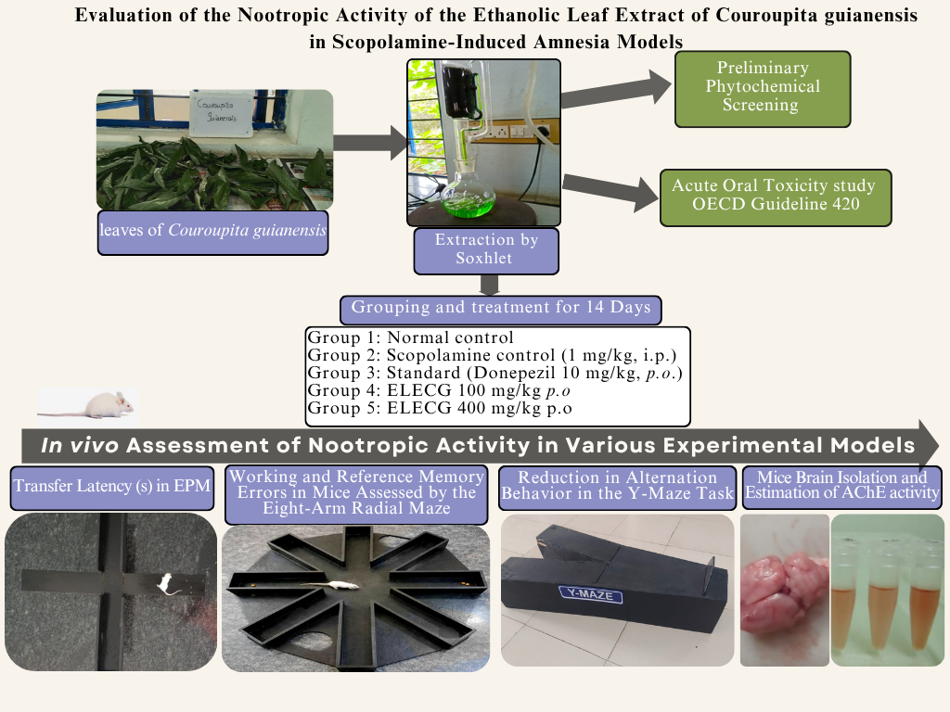

INTRODUCTION
According to the World Health Organisation, in 2021, 57 million people had dementia worldwide, over 60% of whom lived in low-and middle-income countries. Every year, there are nearly 10 million new cases. According to the World Health Organisation’s 2022 blueprint for dementia research, an estimated 55.2 million individuals globally are affected (“2024 Alzheimer’s Disease Facts and Figures,” 2024; Breijyeh & Karaman, 2020; B. Singh et al., 2024). Dementia, a progressive age-associated cognitive syndrome, represents one of the principal clinical manifestations of Alzheimer’s disease. Alzheimer’s disease is a chronic neurodegenerative disorder often accompanied by cerebrovascular dysfunction, leading to gradual neuronal loss and progressive impairment of brain function. Clinically, it is characterized by memory decline, impaired reasoning, behavioral abnormalities, personality changes, and loss of functional independence, which may ultimately result in death. Neuropathologically, the disease is marked by the accumulation of neurofibrillary tangles and neuritic plaques, along with widespread neuronal degeneration. The cholinergic neurotransmitter system, particularly Acetylcholine, plays a central role in learning, attention, and memory processes. Reduced cerebral levels of Acetylcholine are considered a major contributor to cognitive decline and dementia associated with Alzheimer’s disease. Experimental agents such as Scopolamine are widely used to induce transient learning and memory deficits in both animals and humans by disrupting cholinergic neurotransmission. Cognitive dysfunction, including memory impairment, amnesia, anxiety-related symptoms, schizophrenia-associated deficits, and dementia, may arise from multiple factors such as ageing, chronic stress, and emotional disturbances (Sharma et al., 2025). Substances such as scopolamine induce learning and memory deficits in both animals and humans. Memory loss, amnesia, dementia, anxiety, schizophrenia, and Alzheimer’s disease can arise due to various factors, including ageing, stress, and emotional disturbances (Rizi et al., 2024)
Nootropic agents are a group of psychotropic medications used to manage Alzheimer’s disease (AD). The term nootropic originates from the Greek words noon (mind) and tropos (turn), reflecting their role in enhancing cognitive functions. Often referred to as “smart drugs,” nootropics improve memory, promote cerebral blood flow, and enhance oxygen delivery to the brain(Solmaz & Erbaş, 2023). Synthetic nootropics, such as tacrine, donepezil, aniracetam, piracetam, and rivastigmine, are widely prescribed for cognitive impairment and memory decline associated with AD. Although clinically beneficial, these drugs are often associated with adverse effects, dependency concerns, and limited bioavailability. To address these limitations, scientific interest has shifted toward herbal formulations with nootropic potential. Many plant-based compounds exhibit strong antioxidant properties that help protect neuronal cells from oxidative damage and may serve as safer and more effective alternatives to conventional synthetic agents (Yu et al., 2021). A wide range of medicinal herbs has been extensively investigated, and many have demonstrated notable memory-enhancing properties. The current selected plant, Couroupita guianensis (family: Lecythidaceae), is an important medicinal plant widely used in traditional systems of medicine, including Ayurveda. The plant has been reported to possess several pharmacological activities such as antipyretic, antidepressant, antiseptic, anticancer, antiulcer, antimicrobial, antifertility, anti-inflammatory, analgesic, antioxidant, antimalarial, antihepatotoxic, diuretic, and laxative effects (Chandana et al., 2025; Gupta et al., n.d.).Traditionally, it has also been used for the management of wound healing, anxiety, stress, and pain. Phytochemical investigations have revealed the presence of various bioactive constituents, including steroids, glycosides, carbohydrates, ellagic acid glucoside, couroupitone A and B, isatin, triterpenoids, eugenol, linoleic acid, nerol, tryptanthrin, linalool, phenolic compounds, sitosterol, tannins, indirubin, and natural dyes. Several of these phytoconstituents have been reported to exhibit neuroprotective and antioxidant properties.
Antioxidant and anti-inflammatory substances are known to exhibit significant neuroprotective activity(Pritam et al., 2022). Based on these pharmacological properties, the selected plant was chosen for the present investigation. Previous studies have demonstrated the strong antioxidant potential and in vitro anti-Alzheimer activity of C. guianensis, suggesting its possible therapeutic role in the management of dementia and cognitive impairment(Augusco et al., 2023). In particular, C. guianensis of plant active components like ellagic acid glucoside, sitosterol, tannins, and indirubin have shown significant neuroprotective effects in earlier studies (Kim et al., 2022; Li et al., 2024; Swarnkar & Rajput, 2025). Based on these findings, the present study was designed to evaluate the nootropic activity of the ethanolic leaf extract of Couroupita guianensis (ELECG) using experimental animal models.

MATERIALS AND METHODS

Experimental animals
Swiss albino mice of either sex weighing between 22 and 30 g, respectively, were used in the present study. They were housed under standard laboratory conditions (temperature 25°C ± 1°C), relative humidity 55% ± 5%, and 12.00:12.00 h dark: light cycle) with a standard pellet diet and water ad libitum. The experiment was conducted according to the standard procedure prescribed by the CPCSEA, India. The study protocol was approved by the Ethical Committee of the IAEC (Regd. No. 1362/C/10/CPCSEA) at Sri Vasavi Institute of Pharmaceutical Sciences, Pedatadepalli, Andhra Pradesh, India.

Drugs and chemicals
Donepezil (Dr Reddy’s, India), Scopolamine hydrobromide (APP Pharmaceuticals, India), and normal saline were used in this study. All other reagents and chemicals were of analytical grade and procured from Loba Chemie (Mumbai, India).

Plant material and preparation of extracts
Fresh leaves of C. guianensis were collected from the Andhra Pradesh region of India in October 2025. The plant material was authenticated by Dr M. Madhavi, Y.S.R. Horticultural University, Venkata Ramannagudem, Andhra Pradesh. The leaves were shade-dried, powdered, and sieved to obtain a uniform fine powder. The powdered material (700 g) was Soxhlet-extracted with 99.9% as the solvent for 6 cycles at a controlled temperature of 70°C. The extract was concentrated using a rotary evaporator, yielding a dark green, sticky mass with an 8.8% yield. The extract was designated as the ethanolic leaf extract of Couroupita guianensis (ELECG) (Pattnaik et al., 2023).

Preliminary phytochemical investigation
The ethanolic extract (ELECG) was screened for major phytochemical constituents, including alkaloids, flavonoids, glycosides, saponins, carbohydrates and tannins (Latif & Nawaz, 2025).

Acute toxicity study
An acute toxicity study was conducted in accordance with OECD Guideline 420 (Fixed Dose Procedure). Six female Swiss albino mice (20–25 g) were administered the test extract at a dose of 2,000 mg/kg. Following administration, the animals were monitored at 30 min, 1 h, 2 h, 4 h, 24 h, 48 h, and 72 h, and thereafter, daily for 14 days to assess clinical signs, behavioural changes, and mortality (Test No. 420: Acute Oral Toxicity - Fixed Dose Procedure, 2002).

Behavioural study
The mice underwent one week of behavioral training using the Elevated Plus Maze, Y-maze, and multi-maze/radial arm maze tests without administration of any extract or drug. A 15-minute interval was maintained between each test, and the tests were performed in the same sequence throughout the training period. Only animals that demonstrated complete training responses were included in this study. All behavioral assessments were conducted during the light phase between 9:00 a.m. and 4:00 p.m. in a soundproof environment (Ojiakor et al., 2026).

Scopolamine-induced amnesia in mice
Scopolamine, a muscarinic antagonist that crosses the blood–brain barrier, impairs short-term memory and learning by blocking acetylcholine receptors. A dose of 1 mg/kg is widely used to induce cognitive deficits without causing severe peripheral anticholinergic effects and is considered a suitable model for mimicking Alzheimer-like memory impairment (Yadang et al., 2020). For the evaluation of nootropic activity, the animals were divided into five groups:
Group 1: Normal control
Group 2: Scopolamine control (1 mg/kg, i.p.)
Group 3: Standard (Donepezil 10 mg/kg, p.o.)
Group 4: ELECG 100 mg/kg
Group 5: ELECG 400 mg/kg
Only fully trained animals were included in the study. Treatments were administered daily for 14 consecutive days. The animals were trained daily using the Elevated Plus Maze, Y-maze, and multi-maze/radial arm maze tests during the period of 14 days. A 15-minute interval was maintained between each behavioral task, and the tests were conducted in the same sequence throughout the study. On the 14th day, scopolamine was administered 30 minutes prior to behavioral evaluation to assess acquisition and learning performance. On the 15th day, retention of memory was assessed without administration of any treatment or scopolamine. The behavioral and cognitive parameters obtained on the 14th and 15th days were considered for comparative evaluation of nootropic activity among the experimental groups (Matta et al., 2026).

Transfer latency test by the Elevated Plus Maze
The Elevated Plus Maze (EPM) served as an exteroceptive behavioural model for assessing memory in mice. The apparatus consisted of two open arms (50 × 10 cm) and two closed arms (50 × 10 × 40 cm) arranged perpendicular to each other, connected by a central platform (5 × 5 cm), and elevated 50 cm above the floor in a dimly lit room. Each animal was placed individually at the end of an open arm, and the time taken to move from the open arm to one of the closed arms was recorded as transfer latency (TL). A cutoff time of 120 s was applied. A significant reduction in TL during retention assessment was considered indicative of improved memory performance.

Radial arm maze:
The radial arm maze is an exteroceptive behavioral model used to evaluate learning and memory in rodents. It consists of an octagonal central platform with eight radial arms, each containing food cups. The animals were food-restricted to 85% of their normal intake to ensure motivation. Before treatment, the mice were trained to explore all eight arms within 300 seconds, and training was considered complete when each animal successfully visited all arms. The time taken to locate food and the number of re-entries into previously visited arms were recorded as the baseline performance (Kohler et al., 2022).
Mice were then treated with donepezil for 14 days, followed by scopolamine (1 mg/kg, i.p.) to induce amnesia on day 15. 60 minutes later, the animals were retested in the maze. Learning and memory were assessed using the number of days required to learn the task, latency to find food, and the number of initial correct entries. Errors were categorized as Working Memory Errors (re-entering visited arms) and Reference Memory Errors (entering arms that never contained food) (Cordner & Tamashiro, 2015).

Y-maze task
The Y-maze task is a simple method for evaluating memory-enhancing activity in laboratory animals. It is generally used to check the behavioral patterns of animals. A wooden Y-maze was used in this study. It consists of three arms with an angle of 120° between each of the two arms. Each arm was 8 cm wide, 30 cm long, and 15 cm deep. The arms were designated as the start arm (A), the novel arm with food stimuli (B), and the other arm (C). In the first trial, the mice were placed just inside the arm and allowed to move freely through the apparatus for 6 min. In the second trial, the mice were placed in the maze and systematically explored arms A, B, and C. The ability to alternate requires that the mice know which arm they have visited. A total of 13 entries were recorded for each mouse, and the percentage of spontaneous alteration was calculated using the following formula:(Hu et al., 2024; Liu et al., 2023)
% Alternations = Number of positive alternations X100
Total arm entries −2

Estimation of acetylcholinesterase enzyme
Animals of the same group were grouped in the Y-maze task after 15 days, mice were decapitated, and the whole brains were removed quickly and stored in ice-cold saline. The frontal cortex, hippocampus, and septum were quickly dissected onto a chilled Petri dish containing crushed ice. The tissues were weighed and homogenized in 0.05 M phosphate buffer (pH 7.2). The homogenate (0.4 mL) was added to a test tube containing 2.6 mL phosphate buffer and 100 µL of 5,5-dithiobisnitrobenzoic acid, and the mixture was mixed thoroughly. The absorbance of the resulting mixture was measured at 412 nm using a spectrophotometer. The stable absorbance value was recorded. Acetylthiocholine iodide (20 µL) was added, and the change in absorbance per minute was determined. The mean change in absorbance was calculated using the following formula, and acetylcholinesterase activity was measured as µM/L/min/g of tissue (S. Singh et al., 2022).
R = (δ OD volume of assay / E) × mg of protein
Where R is the AChE enzyme activity in “n” mole of Ach iodide hydrolyzed per minute per mg of protein, δ OD is the change in absorbance per minute, and E is the extinction coefficient (1.36x10⁴ M⁻¹cm⁻¹).

Statistical analysis
Statistical analysis was performed using GraphPad Prism software version 8.0, and the results were compared using one-way analysis of variance (ANOVA) followed by Tukey’s multiple comparison test. Statistical significance was set at p < 0.05.

RESULTS

Preliminary phytochemical investigation
Results of preliminary phytochemical screening of the ethanolic leaf extract of Couroupita guianesis (ELEGC). are given in Table 1. The ELECG extract tested positive for alkaloids, flavonoids, amino acids, glycosides, and saponins. Proteins, steroids, and phenols were not detected.
Table 1: Phytochemical analysis of the ethanolic leaf extract of Couroupita guianesi (ELECG).
S.No | Chemical Test | ELECG
1  2  3  4  5  6  7  8  9 | Tests for steroids  Tests for saponin  Tests for Alkaloids  Tests for carbohydrates  Test for Amino acids  Tests for Flavonoides  Tests for Tannins  Tests for Cardiac Glycosides  Tests for Proteins | +  +  +  -  +  +  +  +  +

Acute toxicity test
Because female mice are more sensitive to drugs than males, female mice were used in the acute oral toxicity study in accordance with OECD Guideline 420(Ito & Yamamoto, 2022). ELECG did not show any toxic effects at an oral dose of 2000 mg/kg. Central nervous system (CNS) stimulation parameters, such as hyperactivity, irritability, tremors, and convulsions, were not observed in mice. CNS depressant parameters, such as hypoactivity, narcosis, and ataxia, were found to be negative in mice (Chiranthanut et al., 2022).

Reduction of transfer latency in mice by ELECG using the Elevated Plus Maze.
In the Elevated Plus Maze, transfer latency is considered an index of exploratory drive and cognitive performance. Scopolamine administration significantly increased transfer latency (77.3 ± 3.10 on day 14 and 93.3 ± 2.86 on day 15, p < 0.01), confirming impairment of learning and memory. Donepezil treatment markedly reduced transfer latency (56.53% on day 14 and 41.62% protection on day 15; p < 0.01), indicating significant protection against scopolamine-induced amnesia. The ELECG extract also demonstrated dose-dependent improvement in memory, as evidenced by a decrease in transfer latency (51.37 ± 3.06 at 100 mg/kg and 42.36 ± 1.92 at 400 mg/kg). The results were represented
Table 2: Effect of Ethanolic leaf extract of Couroupita guianensis (ELECG) and Donepezil on Transfer latency of mice using Elevated plus maze
Group | Transfer latency (Seconds)  (Percent of memory protection)
Group | DAY 14 | DAY 15
Normal Control | 38.5 ± 2.28 | 39.00 ± 2.57
Disease Control (Scopolamine 1 mg/kg) | 77.3 ± 3.10# | 93.3 ± 2.86#
Standard (Donepezil Hcl 10 mg/kg) + Scopolamine 1mg/kg | 44.5 ± 2.95**  (41.62) | 40.67 ± 4.25**  (56.53)
ELECG 100 mg/kg p.o. + Scopolamine 1mg/kg | 65.8± 2.51*  (52.33) | 51.37±3.06*  (45.08)
ELECG 400 mg/kg p.o+ Scopolamine 1mg/kg | 46.2± 2.44**  (39.33) | 42.36 ±1.92**  (58.7)
All values are expressed as mean ± SEM (n = 6). # indicates p < 0.05 when compared to the Normal Control group; ns = not significant; * indicates p < 0.05 and ** indicates p < 0.01 when compared to the Disease Control group.

Reduction of Working memory and reference memory errors in mice by ELECG using the radial arm maze.
Scopolamine administration produced a pronounced increase in both reference and working memory errors during the acquisition and retention phases, confirming significant cognitive impairment in the mice. Specifically, reference memory errors increased to 4.70 ± 0.81 on day 14 and 6.21 ± 0.32 on day 15, whereas working memory errors increased to 3.90 ± 0.43 on day 14 and 4.9 ± 0.52 on day 15. Treatment with Donepezil markedly reduced these deficits, demonstrating the effective prevention of scopolamine-induced memory impairment. Similarly, ELECG produced dose-dependent protection on both days, significantly lowering memory errors and indicating improvements in both reference and working memory performance.
Table 3: Effect of ELECG on Working memory error and reference memory error in mice using the Radial Arm Maze.
Group | Working memory error -frequency (Number) |  | Reference memory error-frequency (Number)
Group | DAY 14 (Acquisition) | DAY 15(Retention) | DAY 14 (Acquisition) | DAY 15  (Retention)
Normal control | 1.20 ± 0.37 | 1.0 ± 0.45 | 2.20 ± 0.37 | 1.80 ± 0.37
Disease control (Scopolamine 1mg/kg) | 3.90 ± 0.43# | 4.9 ± 0.52# | 4.70 ± 0.81 # | 6.21 ±0.32#
Standard (Donepezil Hcl 10 mg/kg) + Scopolamine 1mg/kg | 2.00 ± 0.32** | 1.8 ± 0.37** | 2.00 ± 0.32** | 2.20± 0.37**
ELECG 100 mg/kg p.o + Scopolamine 1mg/kg | 1.60 ± 0.25^{ns} | 2.0 ± 0.32* | 2.20 ± 0.37* | 2.40±0.25*
ELECG 400 mg/kg p.o + Scopolamine 1mg/kg | 1.40 ± 0.245** | 1.6 ± 0.24** | 2.00 ± 0.32** | 2.20± 0.20*

Reduction in Alteration in the mice Y-maze task
The Y-maze model is a sensitive measure of spatial recognition memory. In the Y-maze, Scopolamine markedly decreased the percentage of alternation compared to the normal control on both Day 14 (21.8 ± 1.52) and Day 15 (22.7 ± 2.10), indicating reduced short-term spatial working memory. Donepezil significantly increased the number of squares crossed on both test days. ELECG also produced a dose-dependent increase in alteration activity in Scopolamine-treated mice on days 14 and 15. The results are shown in Graph 1.

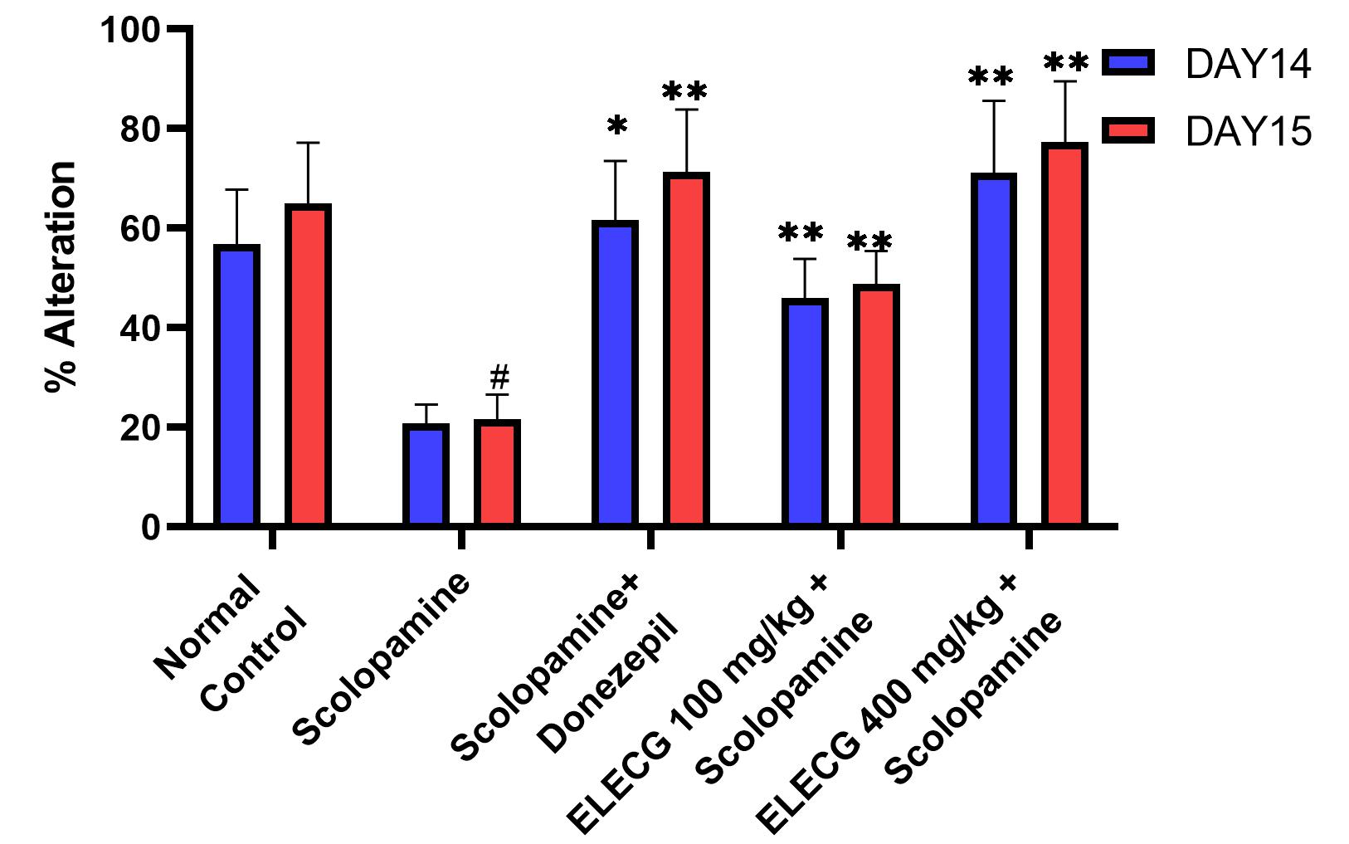
Graph 1: Effect of ELECG on the % Alteration by Y maze

Reduction of Aetylcholinesterase (AChE) enzyme by EELC
The results for AChE levels are shown in Graph 2. In the normal control group, scopolamine administration significantly increased brain AChE activity in mice compared to the control group. Donepezil treatment markedly decreased AChE activity (1.95 ± 0.08) compared to the disease control group. Similarly, ELECG produced a dose-dependent, significant reduction in AChE activity compared with the disease control group.
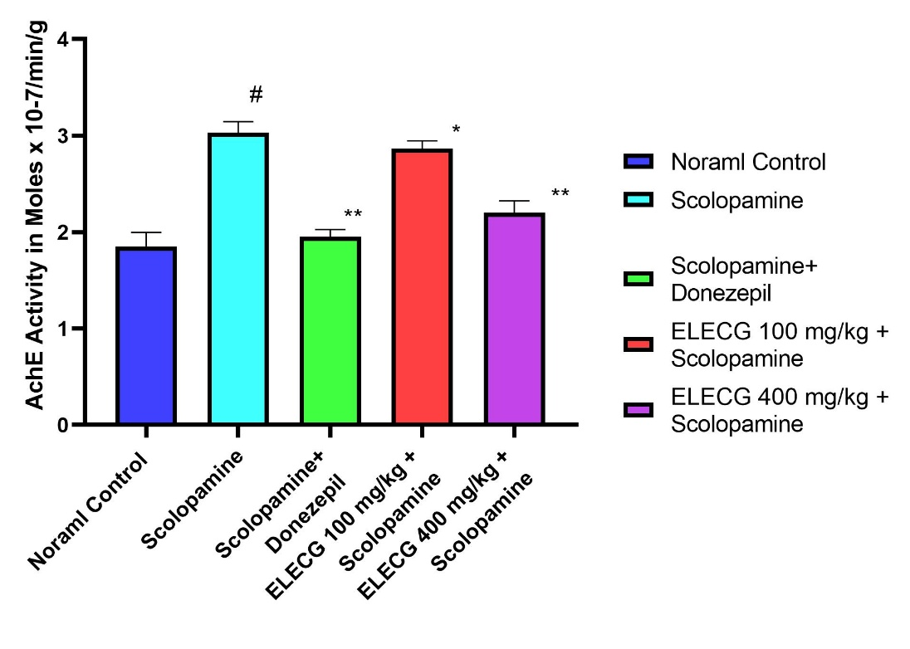
Graph 2: Effect of ELECG and donepezil on acetylcholinesterase (AChE) levels challenged with scopolamine.

DISCUSSION
Nootropics are drugs, also known as smart drugs, cognitive enhancers, supplements, functional foods, or nutraceuticals, that improve mental functions such as attention, concentration, motivation, intelligence, and memory (Malík & Tlustoš, 2022). The other Nootropic agents are: Aniracetam, Fosracetam, Nefiracetam, Pramiracetam, Nebracetam and Oxiracetam, Deprenyl, Modafinil, Piracetam, Centrophenoxine, and Human growth hormone.
The current study aimed to explore the nootropic effect of the ethanolic leaf extract of Couroupita guianensis (ELECG) using different screening methods. To explore the nootropic activity, amnesia was induced by scopolamine at a dose of 1 mg/kg body weight to produce cognitive and memory changes (KOTHARI & SAHU, 2022). First, the animals were trained for 1week for the elevated plus maze test, radial arm maze test, and Y maze test.
In the Elevated Plus Maze test, mice received ELECG (100 or 400 mg/kg, p.o.) or vehicle 30 min before placement in the open arm, and the transfer latency (time taken to enter a closed arm) was recorded. Shorter transfer latency reflects improved memory performance (Miravalles et al., 2025). Scopolamine (1 mg/kg) produced a marked increase in transfer latency compared with the normal control group (p < 0.001), confirming its memory-impairing effect through cholinergic blockade. In contrast, treatment with ELECG significantly reduced transfer latency in a dose-dependent manner on both acquisition (Day 14) and retention (Day 15), indicating improvement in learning and memory retention against scopolamine-induced cognitive deficits. ELECG at 100 mg/kg showed significant protection (*p < 0.05), while ELECG at 400 mg/kg produced a highly significant reduction in transfer latency (**p < 0.01), with effects comparable to the standard drug donepezil (**p < 0.01). These findings suggest that ELECG possesses notable nootropic and memory-enhancing activity.
In the Radial Arm Maze test, animals were administered the standard drug donepezil for 14 consecutive days, and 24 h after the final dose (Day 15), amnesia was induced with scopolamine (1 mg/kg, i.p.). Reference Memory Errors (RME) were recorded when the animal entered an arm that never contained food, while Working Memory Errors (WME) were counted when the animal revisited an already explored arm within the same session. These parameters reflect short-term and long-term memory performance, respectively. Following 60 min of scopolamine administration, each animal was exposed to the radial arm maze. Scopolamine treatment markedly increased both working memory errors (WME) and reference memory errors (RME) compared with the normal control group (p < 0.001), confirming successful induction of amnesia. On Day 14, the disease control group showed significant increases in WME (3.90 ± 0.43) and RME (4.70 ± 0.81), which further increased on Day 15 to 4.9 ± 0.52 and 6.21 ± 0.32, respectively. Treatment with ELECG significantly reduced both WME and RME in a dose-dependent manner on Days 14 and 15, indicating improvement in learning and memory retention. ELECG at 100 mg/kg produced a moderate reduction in memory errors, showing significant effects on Day 15 (*p < 0.05), whereas ELECG at 400 mg/kg significantly decreased both WME and RME on both days (**p < 0.01). The higher dose showed effects comparable to the standard drug donepezil hydrochloride (10 mg/kg), which also significantly reduced memory errors (**p < 0.01). These findings demonstrate the protective effect of ELECG against scopolamine-induced cognitive impairment.
In the Y-maze test, the total number of arm entries and the number of positive alternations were recorded. Scopolamine markedly reduced spontaneous alternation behavior, indicating impaired spatial awareness and cognitive performance Scopolamine administration markedly reduced the percentage of spontaneous alternations in the Y-maze task compared with the normal control group, indicating impairment of short-term spatial working memory due to cholinergic dysfunction (Ansari et al., 2025). On the 14th day, the disease control group showed a significant decrease in alternation behavior (20.83 ± 3.81 and 21.74 ± 4.94) when compared with the normal control group (56.76 ± 10.99 and 65.03 ± 12.44), confirming successful induction of cognitive deficits.Treatment with donepezil significantly increased the percentage of alternations on both observation periods (61.72 ± 11.86 and 71.40 ± 12.51; **p < 0.01), demonstrating its protective effect against scopolamine-induced memory impairment. Similarly, ELECG treatment improved spontaneous alternation behavior in a dose-dependent manner. ELECG at 100 mg/kg moderately increased alternation percentages (45.92 ± 7.97 and 48.82 ± 6.68), showing significant improvement over the disease control group (*p < 0.05 to **p < 0.01). The higher dose of ELECG (400 mg/kg) produced a marked enhancement in alternation behavior (71.14 ± 14.49 and 77.38 ± 11.42), with highly significant effects (**p < 0.01 to ***p < 0.001), comparable to or greater than those of donepezil.
Scopolamine administration significantly increased brain acetylcholinesterase (AChE) activity compared with the normal control group (3.03 ± 0.11 vs 1.85 ± 0.15; #p < 0.05), indicating enhanced breakdown of acetylcholine and impairment of cholinergic neurotransmission associated with memory deficits (Hussain et al., 2022). Treatment with donepezil hydrochloride (10 mg/kg), a standard AChE inhibitor, significantly reduced AChE activity (1.95 ± 0.08; **p < 0.01) compared with the disease control group, thereby restoring cholinergic function. Similarly, treatment with ELECG showed a protective effect against scopolamine-induced elevation of AChE activity. ELECG at 100 mg/kg produced a moderate reduction in AChE levels (2.87 ± 0.08; *p < 0.05), whereas ELECG at 400 mg/kg markedly decreased AChE activity (2.20 ± 0.12; **p < 0.01), showing a dose-dependent effect.
Dose-dependent cognitive improvement with ELECG was consistently observed in the Elevated Plus Maze, radial arm, and Y-maze assessments on both days 14 and 15, suggesting sustained memory-enhancing effects. These behavioural findings were further supported by significant inhibition of AChE activity in mouse brain tissue. The cognitive enhancement produced by ELECG may be attributed to the diverse bioactive constituents present in Couroupita guianensis leaves, including alkaloids, flavonoids, glycosides, polyacetylenes, triterpenoids, phenolic acids, saponins, sterols, and sesquiterpene lactones

CONCLUSION:
The present study demonstrated that the ethanolic leaf extract of Couroupita guianensis exhibited significant nootropic activity in a Scopolamine-induced cognitive dysfunction model in mice. Scopolamine administration produced marked impairments in learning, memory acquisition, retention, and consolidation, whereas treatment with ELECG improved cognitive performance in a dose-dependent manner. These findings suggest that the memory-enhancing effects of the extract may be associated with modulation of the cholinergic system. The observed neuroprotective and cognitive benefits may also be attributed to the presence of diverse phytoconstituents, including alkaloids, flavonoids, glycosides, polyacetylenes, triterpenoids, and phenolic acids. Although the study demonstrated promising behavioral and biochemical outcomes in an experimental animal model, further investigations are required to isolate and characterize the active constituents, elucidate the underlying mechanisms, and establish the safety and therapeutic relevance of Couroupita guianensis in neurocognitive disorders through advanced preclinical and clinical studies.

COMPETING INTERESTS DISCLAIMER:
Authors have declared that they have no known competing financial interests OR non-financial interests OR personal relationships that could have appeared to influence the work reported in this paper.
Disclaimer (Artificial intelligence)

Author(s) hereby declare that NO generative AI technologies such as Large Language Models (ChatGPT, COPILOT, etc.) and text-to-image generators have been used during the writing or editing of this manuscript.

REFERENCES
- 2024 Alzheimer’s disease facts and figures. (2024). Alzheimer’s & Dementia : The Journal of the Alzheimer’s Association, 20(5), 3708–3821. https://doi.org/10.1002/ALZ.13809
- Ansari, A. Z., Park, G. S., Park, S. J., Goh, A. R., & Je, K. H. (2025). Sobrerol Improves Memory Impairment in the Scopolamine-Induced Amnesia Mouse Model. International Journal of Molecular Sciences, 26(10), 4613. https://doi.org/10.3390/IJMS26104613/S1
- Augusco, M. A. C., Sarri, D. A., Panontin, J. F., Rodrigues, M. A. M., Fernandes, R. de M. N., Silva, J. F. M. da, Cardoso, C. A. L., Rambo, M. K. D., & Scapin, E. (2023). Extracts from the Leaf of Couroupita guianensis (Aubl.): Phytochemical, Toxicological Analysis and Evaluation of Antioxidant and Antimicrobial Activities against Oral Microorganisms. Plants 2023, Vol. 12, Page 2327, 12(12), 2327. https://doi.org/10.3390/PLANTS12122327
- Breijyeh, Z., & Karaman, R. (2020). Comprehensive Review on Alzheimer’s Disease: Causes and Treatment. Molecules, 25(24), 5789. https://doi.org/10.3390/MOLECULES25245789
- Chandana, Y., Suchitra, M., & Chandra, Y. P. (2025). A potential review on Couroupita guianensis aubl: A sacred botanical treasure of India, known for its numerous medicinal uses. Journal of Pharmacognosy and Phytochemistry, 14(5), 563–570. https://doi.org/10.22271/PHYTO.2025.V14.I5G.15620
- Chiranthanut, N., Lertprasertsuke, N., Srisook, E., & Srisook, K. (2022). Acute and subchronic oral toxicity assessment of extract from Etlingera pavieana rhizomes. Toxicology Reports, 9, 1472. https://doi.org/10.1016/J.TOXREP.2022.07.005
- Cordner, Z. A., & Tamashiro, K. L. K. (2015). Effects of high-fat diet exposure on learning & memory. Physiology and Behavior, 152, 363–371. https://doi.org/10.1016/j.physbeh.2015.06.008
- Gupta, V. H., Gunjal, M. A., Wankhede, S. S., Deshmukh, V. S., & Juvekar, A. R. (n.d.). Neuropharmacological Evaluation of the Methanolic Extract of Couroupita guianensis Aubl. Flower in Mice. International Journal of Pharmaceutical and Phytopharmacological Research, 242(5), 242–246. Retrieved April 23, 2026, from www.eijppr.com
- Hu, J., He, K., Yang, Y., Huang, C., Dou, Y., Wang, H., Zhang, G., Wang, J., Niu, C., Bi, G., Zhang, L., & Zhu, S. (2024). Amino acid formula induces microbiota dysbiosis and depressive-like behavior in mice. Cell Reports, 43(3), 113817. https://doi.org/10.1016/J.CELREP.2024.113817
- Hussain, H., Ahmad, S., Shah, S. W. A., Ullah, A., Ali, N., Almehmadi, M., Ahmad, M., Khalil, A. A. K., Jamal, S. B., Ahmad, H., & Halawi, M. (2022). Attenuation of Scopolamine-Induced Amnesia via Cholinergic Modulation in Mice by Synthetic Curcumin Analogs. Molecules, 27(8), 2468. https://doi.org/10.3390/MOLECULES27082468/S1
- Ito, L., & Yamamoto, H. (2022). Prediction of acute oral toxicity using the Hansen solubility parameter. Toxicology in Vitro : An International Journal Published in Association with BIBRA, 83. https://doi.org/10.1016/J.TIV.2022.105408
- Kim, S. W., Kim, D. Bin, & Kim, H. S. (2022). Neuroprotective effects of tannic acid in the postischemic brain via direct chelation of Zn2+. Animal Cells and Systems, 26(4), 183. https://doi.org/10.1080/19768354.2022.2113915
- Kohler, J., Mei, J., Banneke, S., Winter, Y., Endres, M., & Emmrich, J. V. (2022). Assessing spatial learning and memory in mice: Classic radial maze versus a new animal-friendly automated radial maze allowing free access and not requiring food deprivation. Frontiers in Behavioral Neuroscience, 16, 1013624. https://doi.org/10.3389/FNBEH.2022.1013624/FULL
- KOTHARI, S., & SAHU, M. (2022). EFFECT OF AQUEOUS EXTRACT OF CYNODON DACTYLON (DOOB GRASS) ON NORMAL AND IMPAIRED MEMORY IN MICE. Asian Journal of Pharmaceutical and Clinical Research, 130–133. https://doi.org/10.22159/AJPCR.2022.V15I9.45109
- Latif, R., & Nawaz, T. (2025). Medicinal plants and human health: a comprehensive review of bioactive compounds, therapeutic effects, and applications. Phytochemistry Reviews 2025, 1–44. https://doi.org/10.1007/S11101-025-10194-7
- Li, H., Zhang, H., Chen, L., Shen, Y., Cao, Y., Li, X., & Yao, J. (2024). Indirubin alleviates retinal neurodegeneration through the regulation of PI3K/AKT signaling. Journal of Biomedical Research, 38(3), 256. https://doi.org/10.7555/JBR.37.20230078
- Liu, T., Su, K., Cai, W., Ao, H., & Li, M. (2023). Therapeutic potential of puerarin against cerebral diseases: From bench to bedside. European Journal of Pharmacology, 953. https://doi.org/10.1016/j.ejphar.2023.175695
- Malík, M., & Tlustoš, P. (2022). Nootropics as Cognitive Enhancers: Types, Dosage and Side Effects of Smart Drugs. Nutrients, 14(16), 3367. https://doi.org/10.3390/NU14163367
- Matta, S., Sayyad Arshiya, M., Sai, D., Nallajerla, K., & Satapathy, D. K. (2026). Evaluation of the Nootropic Activity of the Ethanolic Leaf Extract of Neolamarckia cadamba in Experimental Animal Models. Journal of Drug Delivery and Therapeutics, 16(4), 1–7. https://doi.org/10.22270/JDDT.V16I4.7655
- Miravalles, C., Cannon, D. M., & Hallahan, B. (2025). The effect of scopolamine on memory and attention: a systematic review and meta-analysis. European Psychiatry, 68(1), e50. https://doi.org/10.1192/J.EURPSY.2025.2446
- Ojiakor, V. O., Ben-Azu, B., Finbarrs-Bello, E., Esom, E. A., Anibeze, C. P., & Anyanwu, E. G. (2026). Naringin exhibits adaptogen-like and neuroprotective effects on mice under chronic stress, reversing cortical neuroinflammation and neurodegeneration. European Journal of Medicinal Chemistry Reports, 16, 100323. https://doi.org/10.1016/J.EJMCR.2026.100323
- Pattnaik, S., Mishra, M., Singh, H., & Naik, P. K. (2023). Novel perspectives on phytochemicals-based approaches for mitigation of biofilms in ESKAPE pathogens: recent trends and future avenues. Recent Frontiers of Phytochemicals: Applications in Food, Pharmacy, Cosmetics, and Biotechnology, 433–454. https://doi.org/10.1016/B978-0-443-19143-5.00005-0
- Pritam, P., Deka, R., Bhardwaj, A., Srivastava, R., Kumar, D., Jha, A. K., Jha, N. K., Villa, C., & Jha, S. K. (2022). Antioxidants in Alzheimer’s Disease: Current Therapeutic Significance and Future Prospects. Biology, 11(2), 212. https://doi.org/10.3390/BIOLOGY11020212
- Rizi, A. A., Amjad, L., Shahrani, M., & Khoei, A. H. (2024). Investigating the Mechanisms Involved in Scopolamine-induced Memory Degradation. Archives of Razi Institute, 79(3), 555. https://doi.org/10.32592/ARI.2024.79.3.555
- Sharma, A., Srivastava, S., Gupta, P., Sridhar, S. B., Tariq, M., Rao, G. S. N. K., Kumar, S., & Malik, T. (2025). Targeting protein misfolding in Alzheimer’s disease: The emerging role of molecular chaperones. Biomedicine and Pharmacotherapy, 191. https://doi.org/10.1016/J.BIOPHA.2025.118531
- Singh, B., Day, C. M., Abdella, S., & Garg, S. (2024). Alzheimer’s disease current therapies, novel drug delivery systems and future directions for better disease management. Journal of Controlled Release, 367, 402–424. https://doi.org/10.1016/J.JCONREL.2024.01.047
- Singh, S., Sapra, A., Kakkar, S., Bhan, M., & Jangra, A. K. (2022). To Evaluate In Vitro Acetylcholinesterase Inhibitory Activity of Various Indian Medicinal Plants. Asian Pacific Journal of Health Sciences, 9(2), 205–212. https://doi.org/10.21276/APJHS.2022.9.2.41
- Solmaz, G. D., & Erbaş, O. (2023). Nootropics as Cognitive Enhancers: Pharmacological Properties and Therapeutic Use. Journal of Experimental and Basic Medical Sciences, 4(1), 052–061. https://doi.org/10.5606/JEBMS.2023.1046
- Swarnkar, P., & Rajput, P. (2025). Beta-sitosterol mitigates type 2 diabetes-induced cognitive deficits: a behavioral and molecular investigation in Swiss albino mice. Brain Research, 1865, 149858. https://doi.org/10.1016/J.BRAINRES.2025.149858
- Test No. 420: Acute Oral Toxicity - Fixed Dose Procedure. (2002). OECD Guidelines for the Testing of Chemicals, Section 4. https://doi.org/10.1787/9789264070943-EN
- Yadang, F. S. A., Nguezeye, Y., Kom, C. W., Betote, P. H. D., Mamat, A., Tchokouaha, L. R. Y., Taiwé, G. S., Agbor, G. A., & Bum, E. N. (2020). Scopolamine-Induced Memory Impairment in Mice: Neuroprotective Effects of Carissa edulis (Forssk.) Valh (Apocynaceae) Aqueous Extract. International Journal of Alzheimer’s Disease, 2020, 6372059. https://doi.org/10.1155/2020/6372059
- Yu, H., Jeong, H., Yang, K. Y., Cho, J. Y., Hong, I. K., & Nam, S. H. (2021). Synthesis of ellagic acid glucoside using glucansucrase from Leuconostoc and characterization of this glucoside as a functional neuroprotective agent. AMB Express, 11(1), 108. https://doi.org/10.1186/S13568-021-01265-X

