Medicinal Plants Used for Female Reproductive Disorders among Indigenous Communities in Akwa Ibom State, Nigeria: A Quantitative Ethnogynaecological Study

ABSTRACT
Background: Ethnogynaecological knowledge in Akwa Ibom State reflects a deeply rooted reliance on medicinal plants for women’s reproductive healthcare, yet this indigenous medical heritage remains underdocumented and increasingly vulnerable to cultural erosion.
Aims: To document and quantitatively assess medicinal plants used by Traditional Birth Attendants (TBAs) in the management of female gynaecological conditions among the Ibibio, Annang, and Oro ethnic groups of Akwa Ibom State, Nigeria.
Study Design: Cross-sectional ethnobotanical survey.
Place and Duration of Study: Nine Local Government Areas across three ethnic groups in Akwa Ibom State, Nigeria: Uyo, Ibesikpo Asutan, and Etinan (Ibibio); Abak, Ikot Ekpene, and Essien Udim (Annang); Oron, Urue Offong Oruko, and Okobo (Oro); between 2022 and 2024.
Methodology: Data were collected from 184 TBAs using structured questionnaires, key informant interviews, and focus group discussions. Seven gynaecological ailment categories were investigated: amenorrhea, dysmenorrhea, leucorrhea, menorrhagia, abnormal pain in pregnancy, anaemia, and bleeding in pregnancy. Botanical information including plant family, vernacular names, parts used, and mode of preparation and administration was recorded. Quantitative indices, Use Value (UV), Relative Frequency of Citation (RFC), Fidelity Level (FL), and Informant Consensus Factor (ICF) were computed for each species, and the Jaccard Similarity Index was used to evaluate inter-ethnic knowledge overlap.
Results: A total of 103 medicinal plant species belonging to 49 botanical families were documented. Fabaceae and Asteraceae were the most represented families (8.7% each). Leaves were the most frequently used plant part (69%), and maceration was the dominant preparation method (75.78%). Oral administration accounted for 64.9% of all routes. ICF values ranged from 0.625 (menorrhagia, Annang) to 0.880 (anaemia, Annang), indicating very high cultural consensus across all ailment categories and ethnic groups. Jaccard similarity indices (0.416–0.427) reflected moderate inter-ethnic knowledge overlap, with the highest similarity observed between the Annang and Oro groups. Eighty-one plant species recorded 100% Fidelity Level, confirming strong ailment-specific use. Culturally dominant species included Vernonia amygdalina, Lasianthera africana, Solenostemon monostachyus, Eremomastax polysperma, and Musa paradisiaca.
Conclusion: The three major ethnic groups of Akwa Ibom State possess a rich, structured, and largely consensus-driven ethnogynaecological knowledge system. The high ICF and FL values across ailment categories indicate culturally validated plant use with strong therapeutic specificity. The study highlights culturally important medicinal species with strong ethnomedicinal consensus that warrant phytochemical, pharmacological, and toxicological investigation for possible development into evidence-based reproductive healthcare therapies.
Keywords: Ethnogynaecology; Medicinal plants; Traditional Birth Attendants; Fidelity Level; Female reproductive health; Ethnobotanical indices

- INTRODUCTION
Across human history, the instinct to heal has never been separate from the natural world. Long before hospitals and pharmacies, communities built their healthcare around plant knowledge passed down not through textbooks but through observation, experience, and oral tradition. This legacy endures. Despite the remarkable growth of modern medicine, the World Health Organization reports that between 40% and 90% of populations across its member states still rely on traditional medical practices for their health needs, particularly where modern healthcare remains geographically distant, financially out of reach, or culturally unfamiliar (WHO, 2025).
Within this broader tradition, ethnogynaecology occupies a distinct and deeply human space. It encompasses the indigenous knowledge, beliefs, and practices that communities have developed over generations to address women's reproductive health, including menstruation, fertility, pregnancy, childbirth, postpartum recovery, and menopause. These practices are not merely medical; they are cultural. They reflect how communities understand the female body, how they respond to its rhythms, and how they care for women at the most vulnerable moments of life. Herbal formulations, traditional massage techniques, dietary prescriptions, and spiritual rituals have all formed part of this knowledge system, passed down primarily among women from mothers to daughters, from healers to apprentices.
In Nigeria, as across much of sub-Saharan Africa, this dependence on traditional medicine is not simply a matter of preference. It is shaped by necessity. The WHO estimates that up to 80% of populations in some African countries depend on traditional medicine for their primary healthcare needs, with reliance being especially pronounced in rural communities where formal health infrastructure is inadequate or absent (Kafle et al., 2021; Chali et al., 2021). In many Nigerian communities, traditional healers and birth attendants are not a last resort; they are the first and sometimes only point of care available to women. The trust placed in them reflects not just proximity but a depth of cultural and social embeddedness that orthodox medicine has rarely matched in these settings.
Medicinal plants sit at the heart of this system. Beyond their therapeutic value, many plants used in women's healthcare carry significant cultural and spiritual meaning. In numerous African societies, certain plants are regarded as possessing properties that extend well beyond the physical, capable of influencing emotional, spiritual, and social dimensions of health and well-being. This holistic orientation, rooted in an intimate relationship between people and their natural environment, continues to shape healthcare choices despite increasing urbanisation and the growing influence of Western medicine (Rao et al., 2023; Khatun and Rahman, 2021). Official figures in Nigeria estimate that approximately 80% of the population use traditional remedies, with some community-level studies reporting usage as high as 81.6% (FGN, 2023).
The documentation of this knowledge is therefore not an academic exercise alone. It is urgent. As younger generations move into cities, as formal education distances people from indigenous practice, and as older healers age without successors, the oral chains through which this knowledge travels are becoming increasingly fragile. Once broken, they are rarely repaired. The gynaecological plant knowledge held by traditional communities in Akwa Ibom State, spanning three distinct ethnic groups, the Ibibio, Annang, and Oro, represents a significant repository of empirical understanding accumulated over centuries. Yet it remains largely undocumented, unvalidated, and at risk of disappearing quietly.
Several ethnobotanical studies have been conducted in Nigeria, but quantitative investigations specifically focused on gynaecological plant use in Akwa Ibom State are sparse (Nduche et al., 2015). The studies that exist tend to be limited in geographic scope, do not capture the full breadth of ailments addressed, and rarely apply the quantitative indices needed to assess the cultural significance and inter-community consistency of plant use. This gap matters, because without rigorous documentation, the potential contribution of these plants to drug discovery, conservation planning, and community health policy remains unrealised.
This study was therefore undertaken to systematically document the medicinal plants used by Traditional Birth Attendants (TBAs) across the three major ethnic groups of Akwa Ibom State in the management of gynaecological conditions, to document the plant pats used, method of preparation and routes of administration, to assess the cultural significance of these plants using established quantitative ethnobotanical indices and to identify culturally important medicinal plant species that may warrant further pharmacological and conservation studies. In doing so, it aims to preserve a body of knowledge that deserves both scientific attention and cultural respect.

- MATERIAL AND METHODS
  - Study Area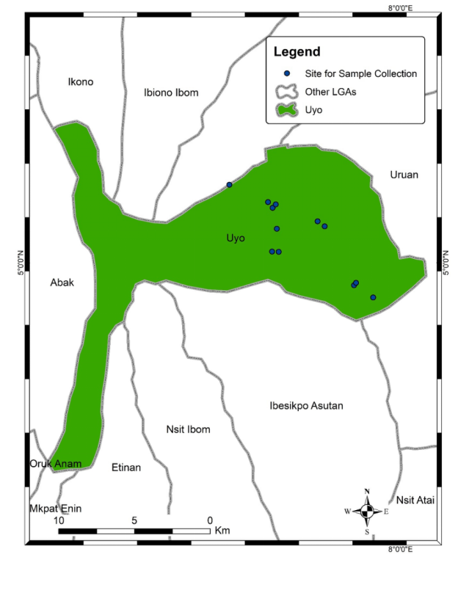
Map 1. Study Area

This study was conducted in Akwa Ibom State, located in the Niger Delta region of southern Nigeria. The state is bordered by Rivers State to the west, Cross River State to the east, Abia State to the north, and the Atlantic Ocean to the south, covering a total land area of 8,412 km². It lies between Latitudes 4°32′N and 5°33′N and Longitudes 7°25′E and 8°25′E. The climate is tropical, characterised by a wet season from April to October and a dry season from November to March, with an average annual rainfall of approximately 3,000 mm. Vegetation is diverse, ranging from rainforest and mangroves to swamp forests, providing a rich environment for medicinal plant growth and use.
The state comprises 31 Local Government Areas and is home to three major ethnic groups: Ibibio, Annang, and Oro each with distinct cultural traditions and indigenous healthcare practices. Three Local Government Areas were randomly selected from each ethnic group, giving a total of nine study sites. Uyo, Ibesikpo Asutan, and Etinan represented the Ibibio; Abak, Ikot Ekpene, and Essien Udim represented the Annang; and Oron, Urue Offong Oruko, and Okobo represented the Oro.
2.2 Target Population and Data Collection
The study focused exclusively on Traditional Birth Attendants (TBAs), who were selected because of their direct and sustained involvement in the preparation and administration of herbal remedies for gynaecological and maternal health conditions. Unlike other categories of traditional practitioners, TBAs occupy a unique position within their communities because they are actively engaged in women's reproductive care, making them the most relevant and knowledge-rich source for this investigation.
Data were collected through structured questionnaires, key informant interviews, and focus group discussions. A total of 184 TBAs participated across the nine Local Government Areas. For each plant reported, information was recorded on the botanical name, common name, family name, vernacular name in the local language, plant part used, method of preparation, and route of administration. Seven gynaecological ailment categories guided data collection: amenorrhea, dysmenorrhea, leucorrhea, menorrhagia, abnormal pain in pregnancy, anaemia, and bleeding in pregnancy.
2.3 Plant Specimen Collection and Identification
Plant materials cited by respondents were collected within Uyo Local Government Area during the dry season. Fresh specimens were collected, labelled, and georeferenced using a Global Positioning System (GPS). Identification and authentication were carried out, and voucher specimens were deposited at the University of Uyo Herbarium (UUYH).
2.4 Quantitative Ethnobotanical Indices
To assess the relative cultural importance of documented plant species and the level of agreement among respondents, four quantitative ethnobotanical indices were computed.
Use Value (UV) was calculated to reflect the relative importance of each plant species as reported by informants, using the formula:
UV = ΣUi / N
where Ui is the number of uses reported by each informant for a given species, and N is the total number of informants (Phillips and Gentry, 1993).
Relative Frequency of Citation (RFC) was used to determine how widely known and cited a particular species was across the study population:
RFC = Fc / N
where Fc is the number of informants who cited a given species and N is the total number of informants (Tardío and Pardo-de-Santayana, 2008).
Fidelity Level (FL) measured the degree to which a plant species was cited for one specific ailment relative to all its cited uses:
FL = Ns / N × 100
where Ns is the number of citations of a species for a particular ailment and N is the total number of citations for that species across all ailments (Friedman et al., 1986).
Informant Consensus Factor (ICF) was calculated for each ailment category to quantify the degree of agreement among informants on which plants were used to treat that condition:
ICF = (nur − nt) / (nur − 1)
where nur is the total number of use citations for a given ailment category and nt is the number of plant species reported for that ailment (Fisseha et al., 2009). Values range from 0 to 1, with higher values indicating stronger consensus.
2.5 Inter-Ethnic Knowledge Comparison
To evaluate the degree of overlap in medicinal plant knowledge across the three ethnic groups, the Jaccard Similarity Index (JI) was applied to pairwise comparisons:
JI = C / (A + B − C)
where A is the total number of plant species cited by community one, B is the total number cited by community two, and C is the number of species cited by both communities (Faruque et al., 2018). Results were compiled into a similarity matrix for comparative interpretation.

- RESULTS AND DISCUSSION
Table 1: Ethnomedicinal plants documented among the Ibibio, Annang and Oro Ethnic Group with their Botanical Classification, Local names, Parts Used, Mode of Preparation and Mode of Administration
S/n | Botanical name | Family name | Ibibio names | Parts used | Method of Preparation | Mode of administration
1 | Abelmoschus esculentus (L.) Moench | Malvaceae | Etikke | Fruit, leaf | Maceration | Oral
2 | Abrus precatorius L. | Fabaceae | Ndukpo ibene mfid | Leaf | Maceration | Enema
3 | Acanthus montanus (Nees) T.Anderson | Acanthaceae | Mbara ekpe | Leaf, root | Decoction, maceration | Oral, enema
4 | Achyranthes aspera L. | Amaranthaceae | Mkpiburibu/udok mbiet | Whole plant | Maceration, decoction | Enema, oral
5 | Adenostemma mauritianum DC. | Asteraceae | Afuk ikot | Leaf | Maceration | Enema
6 | Aframomum melegueta K.Schum. | Zingiberaceae | Ntuen ibok | Seed | Maceration | Oral
7 | Ageratum conyzoides L. | Asteraceae | Ntan mbiara | Leaf, stem | Maceration | Oral
8 | Allium cepa L. | Amaryllidaceae | Anyim | bulb | Maceration | Oral
9 | Aloe vera (L.) Burm.f. | Asphodelaceae | Aloe vera | Leaf | Decoction | Oral
10 | Ananas comosus (L.) Merr. | Bromeliaceae | Pineapple | Leaf | Decoction | Oral
11 | Andrographis paniculata (Burm.f.) Nees | Acanthaceae | Vinegar | Leaf, stem | Maceration | Oral
12 | Annona muricata L. | Annonaceae | Shawa shawa | Leaf | Maceration | Oral
13 | Anthocleista djalonensis A.Chev. | Gentianaceae | Ibuh | Leaf, bark, root | Maceration, decoction | Enema, oral
14 | Arthraxon hispidus (Thunb.) Makino | Fabaceae | Asaka | Leaf | Maceration | Enema
15 | Aspilia africana (Pers.) C.D.Adams | Asteraceae | Edem erong | Leaf, stem | Maceration | Enema
16 | Baphia nitida Lodd. | Fabaceae | Afuo | Bark, leaf, root | Maceration, decoction | Enema, oral
17 | Boerhavia diffusa L. | Nyctaginaceae | Nditia idang | Leaf | Maceration | Oral, enema
18 | Boerhavia repens L. | Nyctaginaceae | Okponkorong | Leaf | Maceration | Enema
19 | Brachystegia eurycoma Harms | Fabaceae | Nkpatotong | Leaf | Maceration | Oral
20 | Caladium bicolor (Aiton) Vent. | Araceae | Ikpong ekpo | Root | Maceration | Enema
21 | Carica papaya L. | Caricaceae | Popo | Fruit, root, leaf | Decoction, chew raw, maceration | Oral, enema
22 | Carpolobia lutea G.Don | Polygalaceae | Ikpafum | Leaf | Maceration | Enema
23 | Chromolaena odorata (L.) R.M.King & H.Rob. | Asteraceae | Awolowo | Leaf | Maceration | Enema
24 | Citrus aurantiifolia (Christm.) Swingle | Rutaceae | Mkpre sokoro | Fruit | Maceration | Oral
25 | Citrus aurantium L. | Rutaceae | Udang aya/ntom | Leaf, fruit | Decoction | Oral
26 | Citrus limon (L.) Osbeck | Rutaceae | Lemon | Fruit | Maceration | Oral
27 | Citrus sinensis (L.) Osbeck | Rutaceae | Sokoro | Fruit | Chewing/sucking | Oral
28 | Cola nitida (Vent.) Schott & Endl. | Malvaceae | Ibong | Leaf, root, bark | Maceration, decoction | Oral
29 | Commelina diffusa Burm.f. | Commelinaceae | Ekpa ekpa ikpaha | Whole plant | Maceration | Oral, enema
30 | Costus afer Ker Gawl. | Costaceae | Mbritem | Leaf, stem | Decoction, maceration | Oral, enema
31 | Cucumis sativus L. | Cucurbitaceae | Cucumber | Leaf | Maceration | Oral
32 | Cucurbita pepo L. | Cucurbitaceae | Ndise | Leaf | Maceration | Oral
33 | Cylicodiscus gabunensis Harms | Fabaceae | Nyan | Bark, root | Maceration, decoction | Enema, oral
34 | Cymbopogon citratus (DC.) Stapf | Poaceae | Ebana | Leaf | Decoction | Oral
35 | Desmodium adscendens (Sw.) DC. | Fabaceae | Mmansang ekpo | Leaf | Decoction | Oral
36 | Dioscorea rotundata Poir. | Dioscoreaceae | Udia | Leaf | Maceration | Enema
37 | Dioscorea villosa L. | Dioscoreaceae | Udia orung | Root | Decoction | Oral
38 | Dissotis rotundifolia (Sm.) Triana | Melastomataceae | Nyin/ndang isong | Leaf | Maceration | Oral
39 | Eleusine indica (L.) Gaertn. | Poaceae | Nkim enang | Leaf, stem | Decoction, maceration | Oral, enema
40 | Emilia sonchifolia (L.) DC. | Asteraceae | Utimense | Whole plant | Maceration, decoction | Enema, oral
41 | Eremomastax polysperma (Benth.) Cufod. | Acanthaceae | Edem ididuot | Leaf | Maceration, decoction | Enema
42 | Euphorbia hirta L. | Euphorbiaceae | Etinkene ekpo | Leaf | Maceration | Enema
43 | Ficus exasperata Vahl | Moraceae | Ukwok | Leaf | Maceration, decoction, | Oral, enema
44 | Fleurya aestuans (L.) Gaudich. ex Miq. | Urticaceae | Ntan nkere | Whole plant | Maceration | Oral, enema
45 | Garcinia kola Heckel | Clusiaceae | Efiat | Seed | Decoction | Oral
46 | Glyphaea brevis (Spreng.) Monach. | Malvaceae | Ndotido | Leaf | Maceration | Enema
47 | Gongronema latifolium Benth. | Apocynaceae | Utasi | Leaf | Maceration, decoction | Enema, oral
48 | Gossypium hirsutum L. | Malvaceae | Afor | Leaf | Maceration | Oral
49 | Guarea thompsonii Sprague & Hutch. | Meliaceae | Afia ikpok eto | Bark | Maceration | Enema
50 | Heinsia crinita (Afzel.) G.Taylor | Rubiaceae | Atama | Leaf | Maceration | Enema
51 | Heliotropium indicum L. | Boraginaceae | Ntokeyen | Leaf | Maceration, | Enema, oral
52 | Hibiscus sabdariffa L. | Malvaceae | Ifuk ebot | Leaf | Maceration | Enema
53 | Hunteria umbellata (K.Schum.) Hallier f. | Apocynaceae | Nsewa ubo | Leaf | Maceration, decoction | Enema, oral
54 | Hura crepitans L. | Euphorbiaceae | Eto nkukim | Leaf | Maceration | Enema
55 | Icacina trichantha Oliv. | Icacinaceae | Efik isong | Leaf, root | Maceration | Enema
56 | Imperata cylindrica (L.) Raeusch. | Poaceae | Ndan inwang | Root | Maceration | Enema
57 | Ipomoea batatas (L.) Lam. | Convolvulaceae | Ediam | Leaf | Decoction, maceration, | Oral, enema
58 | Ipomoea triloba L. | Convolvulaceae | Udia ekrok | Leaf | Maceration, | Enema, oral
59 | Irvingia gabonensis (Aubry-Lecomte ex O’Rorke) Baill. | Irvingiaceae | Uyo | Leaf | Maceration | Oral
60 | Jatropha curcas L. | Euphorbiaceae | Mbubok | Leaf | Maceration | Oral
61 | Jatropha tanjorensis J.L.Ellis & Saroja | Euphorbiaceae | Hospital too far | Leaf | Maceration | Oral
62 | Justicia schimperiana (Hochst. ex Nees) T.Anderson | Acanthaceae | Mmeme | Whole plant | Maceration | Oral, enema
63 | Justicia secunda Vahl | Acanthaceae | Blood of jesus | Leaf | Maceration, decoction | Oral, enema
64 | Kalanchoe pinnata (Lam.) Pers. | Crassulaceae | Ndodop | Leaf | Maceration | Oral, enema
65 | Kigelia africana (Lam.) Benth. | Bignoniaceae | Ntabinum | Leaf | Maceration | Enema
66 | Lasianthera africana P. Beauv | Euphorbiaceae | Editan | Leaf | Maceration, decoction | Enema, oral
67 | Lonchocarpus griffonianus (Baill.) Dunn | Fabaceae | Ududu | Leaf | Maceration | Enema, oral
68 | Solanum lycopersicum L. | Solanaceae | Tomato | Fruit | Chewing | Oral
69 | Maesobotrya barteri (Baill.) Hutch. | Phyllanthaceae | Ayara nyayatet | Root | Maceration | Enema
70 | Maesobotrya dusenii (Pax) Hutch. | Phyllanthaceae | Nyayatet | Leaf, root | Maceration | Enema
71 | Mangifera indica L. | Anacardiaceae | Mango | Bark, leaf | Maceration | Enema
72 | Manihot esculenta Crantz | Euphorbiaceae | Iwa | Leaf, stem, root | Maceration, decoction, | Enema, oral
73 | Melanthera scandens (Schumach. & Thonn.) Roberty | Asteraceae | Ayara edem erong | Leaf | Maceration | Enema, oral
74 | Mikania micrantha Kunth | Asteraceae | Nyaha udia | Leaf, whole plant | Maceration | Enema
75 | Musa paradisiaca L. | Musaceae | Ukom | Leaf | Maceration, decoction | Enema, oral
76 | Nauclea latifolia Sm. | Rubiaceae | Mbomo ubong | Leaf, root | Decoction, maceration, | Oral, enema
77 | Nephrolepis undulata (Afzel ex Sw.) J.Sm. | Nephrolepidaceae | Nyama eyop | Leaf | Maceration | Enema
78 | Newbouldia laevis (P.Beauv.) Seem. ex Bureau | Bignoniaceae | Itumo | Leaf, bark, stem | Decoction, maceration | Oral, enema
79 | Ocimum basilicum L. | Lamiaceae | Ikor | Leaf, stem | Maceration, | Enema, oral
80 | Ocimum gratissimum L. | Lamiaceae | Ntong | Leaf, stem | Maceration, | Enema, oral
81 | Piper guineense Schumach. & Thonn. | Piperaceae | Odusa | Leaf, seed | Maceration | Oral
82 | Piper umbellatum L. | Piperaceae | Mweweb | Leaf | Maceration | Enema, oral
83 | Platostoma africanum P. Beauv. | Lamiaceae | Ayara ntorikwod | Leaf | Maceration | Enema
84 | Plumbago zeylanica L. | Plumbaginaceae | Efehe itok | Leaf | Maceration | Oral
85 | Portulaca oleracea L. | Portulacaceae | Uton ekpu | Leaf,stem | Maceration | Enema
86 | Psidium guajava L. | Myrtaceae | Guava | Leaf | Maceration, decoction | Enema, oral
87 | Selaginella kraussiana (Kunze) A.Braun | Selaginellaceae | Mkpatatad | Whole plant | Maceration | Oral, enema
88 | Senna alata (L.) Roxb. | Fabaceae | Okon eyo | Leaf, root | Maceration | Oral
89 | Setaria megaphylla (Steud.) T.Durand & Schinz | Poaceae | Nkwoho | Leaf, whole plant | Maceration | Enema
90 | Sida acuta Burm.f. | Malvaceae | Akan anwan isi kpekeke | Leaf,stem | Maceration, decoction | Enema, oral
91 | Solenostemon monostachyus (P.Beauv.) Briq. | Lamiaceae | Awak mmong/ntod ikwot | Whole plant | Maceration | Enema, oral
92 | Spondias mombin L. | Anacardiaceae | Nsukakara | Leaf, bark | Maceration | Enema
93 | Sterculia tragacantha Lindl. | Malvaceae | Udud eto | Leaf, stem, bark | Maceration | Enema
94 | Talinum triangulare (Jacq.) Willd. | Talinaceae | Mmong mmong ikong | Whole plant | Maceration, decoction | Oral, enema
95 | Taraxacum officinale F.H.Wigg. | Asteraceae | Dandelion | Whole plant | Maceration | Oral
96 | Telfairia occidentalis Hook.f. | Cucurbitaceae | Nkong ubong | Leaf | Maceration | Oral
97 | Terminalia superba Engl. & Diels | Combretaceae | Eka ubok abasi | Leaf | Maceration | Oral, enema
98 | Tetrapleura tetraptera (Schumach. & Thonn.) Taub. | Fabaceae | Uyayak | Fruit | Decoction | Oral
99 | Urtica dioica L. | Urticaceae | Stinging nettle | Whole plant | Maceration | Oral
100 | Vernonia amygdalina Delile | Asteraceae | Etidot | Leaf | Decoction, maceration | Oral, enema
101 | Viscum album L. | Viscaceae | Ndot oyong | Leaf | Decoction | Oral
102 | Xylopia aethiopica (Dunal) A.Rich. | Annonaceae | Ata | Fruit | Decoction | Oral
103 | Zingiber officinale Roscoe | Zingiberaceae | Ginger | Rhizome, leaf | Decoction | Oral

A total of 103 medicinal plant species distributed across 49 botanical families were documented from the 184 Traditional Birth Attendants surveyed across the three ethnic groups (Table 1). Fabaceae and Asteraceae were the most represented families, each contributing nine species (8.7%), followed by Malvaceae with seven species (6.8%), Euphorbiaceae with six species (5.8%), and Acanthaceae with five species (4.9%). Poaceae, Rutaceae, and Lamiaceae each contributed four species (3.9%). Collectively, the five most represented families accounted for approximately 35% of the total documented flora.

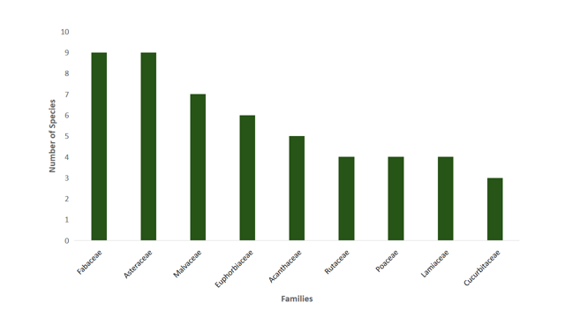
Figure 1: Distribution of medicinal plant families used for ethnogynaecological treatments among the Ibibio, Annang, and Oro ethnic groups

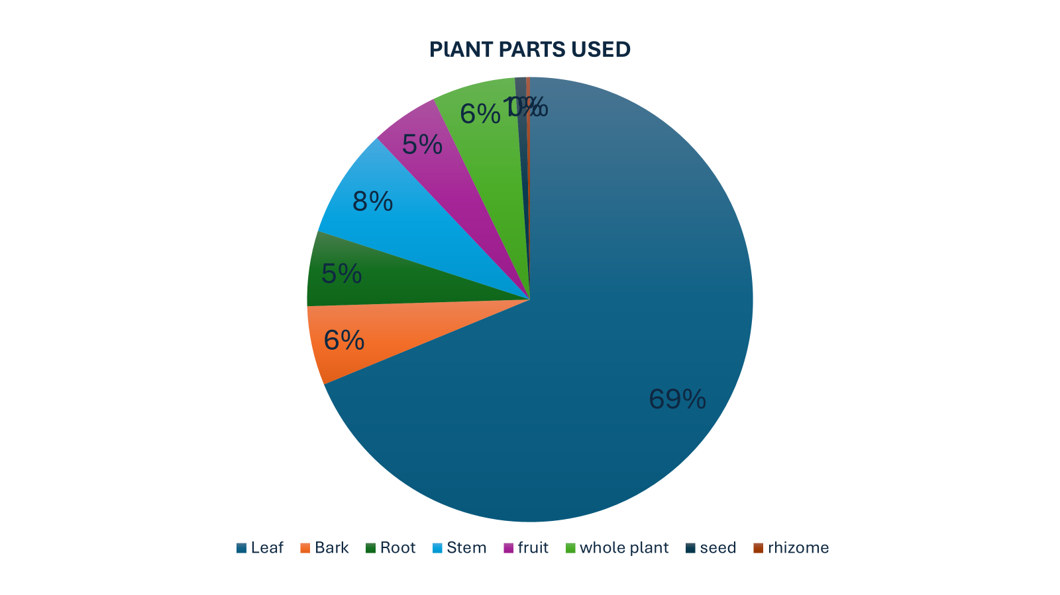
Figure 2: Plant parts used

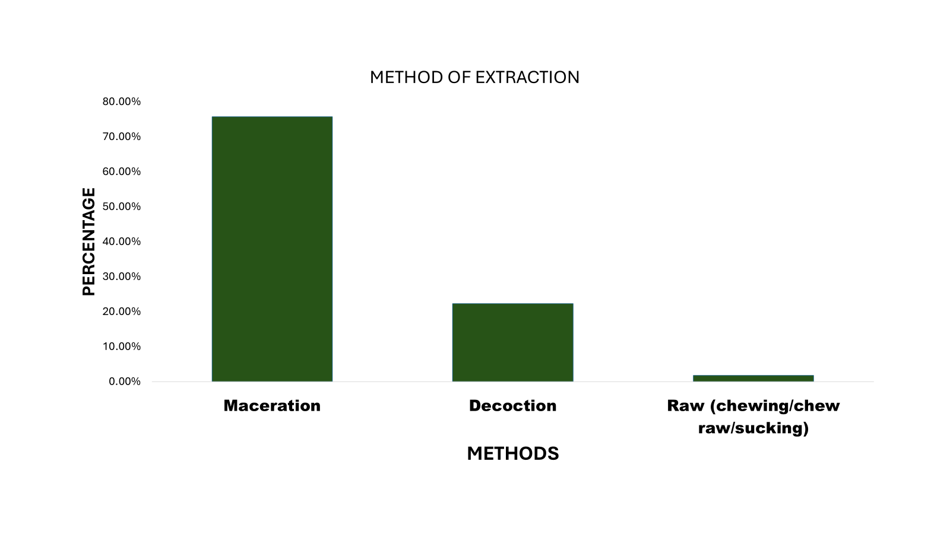

Figure 3: Mode of Extraction

Leaves were the most frequently used plant part, accounting for 69% of all reported uses, followed by stems (8%), bark (6%), whole plant material (6%), roots (5%), and fruits (5%), with seeds (1%) and rhizomes (less than 1%) being the least used (Table 1). Maceration was the predominant method of preparation, accounting for 75.78% of all reported preparations, with decoction comprising most of the remainder. The oral route accounted for approximately 64.9% of modes of administration, with enema constituting the remaining 35.1%.

Table 2: Top 15 plant species by Use Value (UV) across the three ethnic groups
Botanical Name | Ibibio UV | Annang UV | Oro UV
Musa paradisiaca | 0.770 | 0.081 | 0.177
Lasianthera africana | 0.639 | 0.323 | 0.290
Solenostemon monostachyus | 0.623 | 0.274 | 0.452
Eremomastax polysperma | 0.590 | 0.548 | 0.548
Guarea thompsonii | 0.413 | 0.032 | —
Justicia schimperiana | 0.410 | 0.468 | 0.065
Vernonia amygdalina | 0.197 | 0.403 | 0.645
Citrus aurantium | 0.377 | — | 0.194
Jatropha tanjorensis | 0.311 | 0.290 | 0.226
Baphia nitida | 0.279 | 0.145 | 0.323
Piper umbellatum | 0.279 | 0.065 | 0.097
Spondias mombin | 0.295 | — | 0.081
Achyranthes aspera | 0.295 | — | 0.113
Telfairia occidentalis | 0.213 | 0.339 | 0.435
Carica papaya | 0.262 | 0.258 | 0.419

Use Value scores varied considerably across species and ethnic groups (Table 2). Among the Ibibio, Musa paradisiaca recorded the highest UV (0.770), followed by Lasianthera africana (0.639) and Solenostemon monostachyus (0.623). In the Annang group, Eremomastax polysperma recorded the highest UV (0.548), closely followed by Justicia schimperiana (0.468) and Vernonia amygdalina (0.403). Among the Oro, Vernonia amygdalina recorded the highest UV (0.645), followed by Solenostemon monostachyus (0.452) and Telfairia occidentalis (0.435).

Table 3: Top 15 plant species by Relative Frequency of Citation (RFC) across the three ethnic groups
Botanical Name | Ibibio RFC | Annang RFC | Oro RFC
Musa paradisiaca | 0.623 | 0.080 | 0.177
Solenostemon monostachyus | 0.541 | 0.241 | 0.387
Lasianthera africana | 0.525 | 0.258 | 0.290
Eremomastax polysperma | 0.443 | 0.452 | 0.387
Justicia schimperiana | 0.377 | 0.419 | 0.032
Citrus aurantium | 0.361 | — | 0.193
Vernonia amygdalina | 0.196 | 0.355 | 0.629
Emilia sonchifolia | 0.163 | 0.355 | 0.096
Jatropha tanjorensis | 0.262 | 0.258 | 0.419
Telfairia occidentalis | 0.213 | 0.290 | 0.435
Carica papaya | 0.229 | 0.209 | 0.274
Baphia nitida | 0.213 | 0.112 | 0.306
Anthocleista djalonensis | 0.229 | 0.096 | 0.290
Boerhavia diffusa | — | 0.193 | 0.209
Gongronema latifolium | — | 0.209 | 0.306

RFC values closely mirrored UV patterns across the three groups (Table 3). Musa paradisiaca recorded the highest RFC among the Ibibio (0.623), followed by Solenostemon monostachyus (0.541) and Lasianthera africana (0.525). In the Annang group, Eremomastax polysperma led with an RFC of 0.452, followed by Justicia schimperiana (0.419) and Vernonia amygdalina (0.355). The Oro group was led by Vernonia amygdalina (0.629), Telfairia occidentalis (0.435), and Jatropha tanjorensis (0.419).

Table 4: Fidelity Level (FL = 100%) across Ethnic Groups
S/N | Botanical Name | Specific Ailment | Ethnic Group(s)
1 | Ananas comosus | Amenorrhea | Oro
2 | Arthraxon hispidus | Amenorrhea | Oro
3 | Cola nitida | Amenorrhea | Annang
4 | Cylicodiscus gabunensis | Amenorrhea | Ibibio, Annang
5 | Dioscorea rotundata | Amenorrhea | Ibibio
6 | Euphorbia hirta | Amenorrhea | Oro
7 | Fleurya aestuans | Amenorrhea | Ibibio
8 | Glyphaea brevis | Amenorrhea | Ibibio
9 | Guarea thompsonii | Amenorrhea | Annang
10 | Heliotropium indicum | Amenorrhea | Ibibio
11 | Hura crepitans | Amenorrhea | Ibibio
12 | Imperata cylindrica | Amenorrhea | Ibibio
13 | Ipomoea triloba | Amenorrhea | Ibibio
14 | Kigelia africana | Amenorrhea | Annang
15 | Nephrolepis undulata | Amenorrhea | Ibibio
16 | Newbouldia laevis | Amenorrhea | Oro
17 | Piper guineense | Amenorrhea | Oro
18 | Portulaca oleracea | Amenorrhea | Oro
19 | Sida acuta | Amenorrhea | Annang
20 | Tetrapleura tetraptera | Amenorrhea | Ibibio
21 | Viscum album | Amenorrhea | Oro
22 | Xylopia aethiopica | Amenorrhea | Annang
23 | Zingiber officinale | Amenorrhea | Ibibio, Annang
24 | Citrus sinensis | Anaemia | Ibibio
25 | Eremomastax polysperma | Anaemia | Annang
26 | Fleurya aestuans | Anaemia | Annang, Oro
27 | Justicia schimperiana | Anaemia | Oro
28 | Solanum lycopersicum | Anaemia | Ibibio
29 | Urtica dioica | Anaemia | Annang
30 | Desmodium adscendens | Abnormal pain in pregnancy | Ibibio
31 | Eleusine indica | Abnormal pain in pregnancy | Oro
32 | Gossypium hirsutum | Abnormal pain in pregnancy | Ibibio
33 | Plumbago zeylanica | Abnormal pain in pregnancy | Annang
34 | Spondias mombin | Abnormal pain in pregnancy | Oro
35 | Abelmoschus esculentus | Bleeding in pregnancy | Ibibio
36 | Costus afer | Bleeding in pregnancy | Annang
37 | Cucurbita pepo | Bleeding in pregnancy | Ibibio, Annang
38 | Irvingia gabonensis | Bleeding in pregnancy | Ibibio
39 | Piper umbellatum | Bleeding in pregnancy | Ibibio, Annang, Oro
40 | Abrus precatorius | Dysmenorrhea | Ibibio
41 | Adenostemma mauritianum | Dysmenorrhea | Ibibio
42 | Aframomum melegueta | Dysmenorrhea | Ibibio, Oro
43 | Aloe vera | Dysmenorrhea | Oro
44 | Caladium bicolor | Dysmenorrhea | Ibibio
45 | Carpolobia lutea | Dysmenorrhea | Ibibio, Annang
46 | Citrus limon | Dysmenorrhea | Ibibio
47 | Commelina diffusa | Dysmenorrhea | Annang
48 | Dioscorea villosa | Dysmenorrhea | Ibibio
49 | Garcinia kola | Dysmenorrhea | Annang
50 | Guarea thompsonii | Dysmenorrhea | Ibibio
51 | Icacina trichantha | Dysmenorrhea | Oro
52 | Ipomoea batatas | Dysmenorrhea | Oro
53 | Ocimum gratissimum | Dysmenorrhea | Ibibio, Oro
54 | Selaginella kraussiana | Dysmenorrhea | Ibibio
55 | Sterculia tragacantha | Dysmenorrhea | Annang
56 | Achyranthes aspera | Leucorrhea | Oro
57 | Adenostemma mauritianum | Leucorrhea | Oro
58 | Aspilia africana (Pers.) | Leucorrhea | Ibibio
59 | Chromolaena odorata | Leucorrhea | Ibibio
60 | Heliotropium indicum | Leucorrhea | Annang
61 | Justicia secunda | Leucorrhea | Ibibio
62 | Kalanchoe pinnata | Leucorrhea | Ibibio, Oro
63 | Maesobotrya barteri | Leucorrhea | Oro
64 | Maesobotrya dusenii | Leucorrhea | Ibibio
65 | Nauclea latifolia | Leucorrhea | Annang
66 | Newbouldia laevis | Leucorrhea | Ibibio
67 | Psidium guajava | Leucorrhea | Ibibio, Oro
68 | Senna alata | Leucorrhea | Oro
69 | Setaria megaphylla | Leucorrhea | Ibibio
70 | Brachystegia eurycoma | Menorrhagia | Ibibio, Annang, Oro
71 | Citrus aurantiifolia | Menorrhagia | Annang
72 | Cucumis sativus | Menorrhagia | Ibibio
73 | Cymbopogon citratus | Menorrhagia | Annang
74 | Heinsia crinita | Menorrhagia | Annang, Oro
75 | Hunteria umbellata | Menorrhagia | Annang
76 | Manihot esculenta | Menorrhagia | Annang
77 | Mikania micrantha | Menorrhagia | Ibibio
78 | Ocimum basilicum | Menorrhagia | Annang, Oro
79 | Platostoma africanum | Menorrhagia | Ibibio
80 | Sida acuta | Menorrhagia | Ibibio
81 | Talinum triangulare | Menorrhagia | Annang

A total of 81 plant species recorded a Fidelity Level of 100%, indicating that informants consistently cited these species for one specific ailment with no crossover to other conditions (Table 4). Among the Ibibio, 42 species achieved 100% FL, with dysmenorrhea being the most frequently targeted ailment (12 species), followed by amenorrhea (10 species) and leucorrhea (9 species). The Annang group contributed 30 high-FL species, predominantly targeting menorrhagia and dysmenorrhea, while the Oro community recorded 26 species, chiefly for amenorrhea and leucorrhea. Notably, Piper umbellatum recorded 100% FL for bleeding in pregnancy across all three ethnic groups, and Brachystegia eurycoma achieved the same for menorrhagia across all three groups.

Table 5: Informant Consensus Factor (ICF) across Ethnic Groups
S/N | Specific Ailment | Ibibio | Annang | Oro
1 | Amenorrhea | 0.804 | 0.819 | 0.827
2 | Anaemia | 0.851 | 0.88 | 0.844
3 | Abnormal pain in pregnancy | 0.733 | 0.732 | 0.833
4 | Bleeding in pregnancy | 0.823 | 0.76 | 0.825
5 | Dysmenorrhea | 0.747 | 0.707 | 0.815
6 | Leucorrhea | 0.829 | 0.72 | 0.825
7 | Menorrhagia | 0.794 | 0.625 | 0.83

ICF values across the three ethnic groups and seven ailment categories are presented in Table 5. Among the Ibibio, anaemia recorded the highest ICF (0.851), followed by leucorrhea (0.829) and bleeding in pregnancy (0.823), while dysmenorrhea recorded the lowest (0.747). In the Annang group, anaemia also recorded the highest ICF (0.880), with amenorrhea second (0.819), and menorrhagia the lowest (0.625). Among the Oro, ICF values clustered narrowly between 0.815 and 0.844, with anaemia (0.844) and menorrhagia (0.830) recording the highest values. Across all three groups and ailment categories, ICF values ranged from 0.625 to 0.880, indicating very high to near-perfect consensus throughout.

Table 6: Jaccard Similarity Index Matrix
Ethnic Groups | Ibibio | Annang | Oro
Ibibio | 1 | 0.416 | 0.419
Annang | 0.416 | 1 | 0.427
Oro | 0.419 | 0.427 | 1

Pairwise comparison of plant use across ethnic groups revealed moderate inter-ethnic knowledge overlap (Table 6). The Ibibio–Annang pair recorded a Jaccard index of 0.416, the Ibibio–Oro pair recorded 0.419, and the Annang–Oro pair recorded the highest similarity at 0.427. All values fell below 0.5, indicating that while shared species exist, each ethnic group maintains a largely distinct ethnomedicinal tradition.
4. DISCUSSION
4.1 Medicinal Plant Diversity and Botanical Classification
The documentation of 103 plant species across 49 families reflects the botanical richness of Akwa Ibom State and the depth of ethnogynaecological knowledge held by its traditional communities. The dominance of Fabaceae and Asteraceae is consistent with patterns reported widely across sub-Saharan Africa. At a continental level, Asteraceae accounts for approximately 13% and Fabaceae for around 8% of plants used for pain and inflammation management across Africa (Aremu and Pendota, 2021), while surveys in Lagos State similarly identified Fabaceae, Asteraceae, Malvaceae, and Euphorbiaceae as the most represented medicinal plant families (Lawal et al., 2022). These families are known for their chemical diversity, particularly their production of flavonoids, alkaloids, tannins, and terpenoids; compound classes that are associated with anti-inflammatory, antimicrobial, and analgesic activities. Their recurrence across independent ethnobotanical studies from different regions suggests not only their wide distribution but also their genuine therapeutic utility as perceived by traditional communities.
4.2 Plant Parts Used and Methods of Preparation
The strong preference for leaves across all three ethnic groups aligns with findings from multiple Nigerian ethnobotanical studies. In Lagos State, Lawal et al. (2022) similarly reported leaves as the most regularly used plant part among indigenous communities, and Chijindu et al. (2020) found leaves constituting 53.8% of plant-part use in Delta State. Leaves are available year-round, can be harvested without destroying the plant, and are generally rich in secondary metabolites, factors that collectively make them the most practical and sustainable choice for traditional practitioners (Mekonnen et al., 2022; Olowo et al., 2022).
The predominance of maceration (75.78%) is particularly notable in a reproductive health context. Maceration avoids the application of heat, which can degrade thermolabile and volatile bioactive compounds. Sharma et al. (2023) documented a similar preference for maceration (67%) among the Gujjar tribe of Uttarakhand, India, for female reproductive healthcare preparations, while Noura et al. (2024) reported maceration accounting for 58% of preparations used for childbirth complications in Niger. The consistency of this preference across geographically and culturally distinct communities suggests that traditional practitioners have empirically recognised — without formal chemical knowledge — that cold preparation better preserves the therapeutic properties of plant material.
The significant proportion of enema administration (35.1%), alongside oral use, is a distinctive feature of gynaecological ethnomedicine in this region. The enema route allows direct local delivery to the pelvic and reproductive tract area, which may reflect an intuitive understanding of bioavailability and targeted action for conditions such as leucorrhea, menorrhagia, and postpartum complications.
4.3 Use Value and Relative Frequency of Citation
The high UV and RFC values recorded for Eremomastax polysperma, Lasianthera africana, Solenostemon monostachyus, Musa paradisiaca, and Vernonia amygdalina across the three ethnic groups identify these species as culturally central to ethnogynaecological practice in Akwa Ibom State. The consistent prominence of Vernonia amygdalina across both the Annang and Oro groups, and its appearance among highly cited species in numerous Nigerian ethnomedicinal surveys (Lawal et al., 2022; Rafiu et al., 2025), strengthens its status as one of the most broadly accepted medicinal plants in southern Nigeria. Vernonia amygdalina has been widely reported to possess antimicrobial, anti-inflammatory, antioxidant, and haematinic properties, which may explain its recurrent use in reproductive and pregnancy-related conditions across southern Nigeria (Degu et al., 2024; Kadiri and Olawoye, 2016). Similarly, the high RFC of Eremomastax polysperma in the Annang group aligns with ethnobotanical evidence from Nigeria and Cameroon documenting its use by traditional birth attendants for female infertility and postpartum conditions (Mboso et al., 2013). That certain species achieve high UV and RFC across ethnically distinct communities points toward either shared ancestral knowledge or active inter-community circulation of herbal practice, both of which have implications for how these plants should be prioritised in conservation and pharmacological research.
4.4 Fidelity Level
The 81 plant species recording 100% FL represent the most therapeutically specific and culturally reliable remedies in this dataset. A FL of 100% means that every informant who cited a given plant cited it for exactly one ailment, a level of specificity that reflects deep, stable, and transmitted knowledge rather than generalised or experimental use. The finding that Piper umbellatum achieved 100% FL for bleeding in pregnancy across all three ethnic groups, and that Brachystegia eurycoma did the same for menorrhagia, is particularly significant. Cross-ethnic consensus of this kind substantially strengthens the case for prioritising these species in pharmacological investigation. Comparable patterns have been reported by Khadim et al. (2023) in Punjab, Pakistan, where species with FL of 100% for dysmenorrhea and leucorrhea were interpreted as culturally indispensable remedies, and by Balamurugan et al. (2018) in South India, where high FL values for specific gynaecological conditions identified plants that subsequently demonstrated relevant biological activity on pharmacological testing.
4.5 Informant Consensus Factor
The ICF values obtained across all three ethnic groups and all seven ailment categories (0.625–0.880) indicate a consistently high level of agreement on plant selection for gynaecological healthcare. In practical terms, high ICF values mean that a relatively small number of plant species are repeatedly and reliably used across many informants for a given condition — a signal of both cultural confidence and likely therapeutic efficacy. The highest ICF values for anaemia across all three groups (Ibibio: 0.851, Annang: 0.880, Oro: 0.844) suggest that the management of anaemia is the most standardised area of ethnogynaecological practice in the region, with the fewest species commanding the greatest agreement. Similar high consensus for anaemia management has been documented in South India (Balamurugan et al., 2018) and South Asia (Bhatia et al., 2015; Khadim et al., 2023), suggesting that the convergence of traditional knowledge around a small set of haematinic plants may reflect genuine pharmacological reliability.
The comparatively lower ICF values for menorrhagia in the Annang group (0.625) and for dysmenorrhea across the Ibibio (0.747) and Annang (0.707) groups may reflect the broader symptom variability associated with these conditions, which can prompt practitioners to draw from a wider range of plant options depending on severity, duration, or individual patient presentation. A similar pattern was observed by Tugume et al. (2016) in Uganda, where menstrual pain management was associated with greater species diversity and correspondingly moderate ICF values.
4.6 Jaccard Similarity Index
The moderate Jaccard similarity indices (0.416–0.427) indicate that while the three ethnic groups share a meaningful core of commonly used medicinal plants, each group also maintains a distinct body of ethnogynaecological knowledge shaped by its own ecological environment, cultural history, and healing traditions. The slightly higher similarity between the Annang and Oro groups (0.427) compared to their respective similarities with the Ibibio may reflect closer geographical proximity or stronger historical interactions between these two communities. Comparable Jaccard values have been reported among culturally related groups in southern Nigeria by Ogwu et al. (2024), who recorded indices ranging from 0.382 to 1.00 among Afenmai communities, and in Bangladesh by Faruque et al. (2018), where moderate overlap between indigenous communities was similarly interpreted as evidence of both shared knowledge and community-specific adaptation. The implication for conservation is important: the species unique to each ethnic group's pharmacopoeia represent knowledge that would be lost if documentation focused only on the most widely shared plants.
5. CONCLUSION
This study has demonstrated that ethnogynaecological practices in Akwa Ibom State represent a rich, structured, and internally consistent system of traditional healthcare for managing women's reproductive health conditions. The widespread use of medicinal plants by Traditional Birth Attendants across the Ibibio, Annang, and Oro ethnic groups reflects a strong dependence on indigenous knowledge for the treatment of ailments including amenorrhea, dysmenorrhea, leucorrhea, menorrhagia, anaemia, and pregnancy-related complications.
The consistently high Informant Consensus Factor values across all three ethnic groups and all seven ailment categories indicate strong inter-informant agreement on plant selection, suggesting perceived efficacy rooted in long-term empirical use. The high Fidelity Level observed for 81 plant species further supports the specificity and reliability of these traditional remedies, with cross-ethnic agreement on medicinal plant use for particular conditions providing a particularly strong signal for pharmacological prioritisation.
The moderate Jaccard similarity indices (0.416–0.427) confirm that while shared species exist across communities, each ethnic group retains a distinct body of botanical knowledge; knowledge that is at risk of disappearing unless systematically documented. These findings provide a critical baseline for conservation planning, drug development research, and the integration of indigenous plant knowledge into evidence-based women's reproductive healthcare policy in Nigeria. Priority species identified include Musa paradisiaca, Solenostemon monostachyus Vernonia amygdalina, Eremomastax polysperma, and Lasianthera africana, all of which warrant further pharmacological investigation.
5.1 Limitation of the Study
This study provides important ethnogynaecological information from Traditional Birth Attendants (TBAs) across the three major ethnic groups of Akwa Ibom State. However, certain limitations should be acknowledged.
First, the study relied primarily on self-reported ethnobotanical information obtained through interviews, questionnaires, and focus group discussions. As with most ethnobotanical surveys, the accuracy of some responses may have been influenced by recall bias, selective disclosure of indigenous knowledge, or differences in individual experience among respondents.
Second, although the study documented 103 medicinal plant species and quantitatively assessed their cultural significance, the therapeutic claims associated with these plants were not experimentally validated through pharmacological, phytochemical, toxicological, or clinical investigations. Consequently, the reported medicinal uses reflect indigenous knowledge and cultural practices rather than scientifically confirmed efficacy.
Third, the study focused exclusively on Traditional Birth Attendants because of their specialised role in women’s reproductive healthcare. While this strengthened the relevance of the data, it excluded other categories of indigenous healers and herbal practitioners who may also possess important ethnogynaecological knowledge.
Despite these limitations, the study provides a valuable baseline for future pharmacological validation, conservation planning, and integration of indigenous reproductive healthcare knowledge into evidence-based healthcare research.

COMPETING INTERESTS
Authors have declared that no competing interests exist.
ETHICAL APPROVAL AND CONSENT
Ethical approval for this study was obtained from the appropriate institutional research ethics committee prior to commencement of fieldwork. Permission was also obtained from community leaders and relevant local authorities within the selected study areas. Prior informed consent was obtained from all participants before interviews were conducted. Informants participated voluntarily and were informed of the purpose of the study. No personal identifying information was collected, and confidentiality was maintained throughout the study.
Disclaimer (Artificial intelligence)

Author(s) hereby declare that NO generative AI technologies such as Large Language Models (ChatGPT, COPILOT, etc.) and text-to-image generators have been used during the writing or editing of this manuscript.

REFERENCES
Aremu AO, Pendota SC. Medicinal plants for mitigating pain and inflammatory-related conditions: An appraisal of ethnobotanical uses and patterns in South Africa. Frontiers in Pharmacology. 2021;12:758583.
Balamurugan S, Vijayakumar S, Prabhu S, Morvin Yabesh JE. Traditional plants used for the treatment of gynaecological disorders in Vedaranyam taluk, South India: An ethnomedicinal survey. Journal of Traditional and Complementary Medicine. 2018;8(2):308–323.
Bhatia H, Sharma YP, Manhas RK, Kumar K. Ethnomedicinal plants used by the villagers of district Udhampur, J&K, India. Journal of Ethnopharmacology. 2014;151(2):1005–1018.
Chali BF, Hasana A, Dessie A, Temesgen MM. Traditional medicinal plant knowledge and use among local healers in Omo Nada District, Jimma Zone, Southwest Ethiopia. Journal of Ethnobiology and Ethnomedicine. 2021;17:21.
Cheikhyoussef A, Shapi M, Matengu K, Ashekele HM. Ethnobotanical study of indigenous knowledge on medicinal plant use by traditional healers in Oshikoto Region, Namibia. Journal of Ethnobiology and Ethnomedicine. 2011;7:10.
Chijindu P, Okpoma MO, Atubi O. Ethnobotanical survey of medicinal plants used in Erhuwaren Community in Ughelli South Local Government Area of Delta State. UNILAG Journal of Medicine, Science and Technology. 2020;8(1):176–206.
Degu, S., Meresa, A., Animaw, Z., Jegnie, M., Asfaw, A., & Tegegn, G. (2024). Vernonia amygdalina: A comprehensive review of the nutritional makeup, traditional medicinal use, and pharmacology of isolated phytochemicals and compounds. Frontiers in Natural Products, 3, 1347855.
Faruque MO, Uddin SB, Barlow JW, Hu S, Dong S, Cai Q, et al. Quantitative ethnobotany of medicinal plants used by indigenous communities in the Bandarban District of Bangladesh. Frontiers in Pharmacology. 2018;9:40.
Federal Government of Nigeria (FGN). Over 80 percent of Nigerians use traditional medicines. The Nation Newspaper. 2023.
Fisseha M, Sebsebe D, Tilahun T. An ethnobotanical study of medicinal plants in Wonago Woreda, SNNPR, Ethiopia. Journal of Ethnobiology and Ethnomedicine. 2009;5:28.
Friedman J, Yaniv Z, Dafni A, Palewitch D. A preliminary classification of the healing potential of medicinal plants, based on a rational analysis of an ethnopharmacological field survey among Bedouins in the Negev Desert, Israel. Journal of Ethnopharmacology. 1986;16(2–3):275–287.
Kafle PP, Pant P, Dhakal N. Assessment of health-seeking behavior regarding complementary and alternative medicine in Solukhumbu District, Nepal. Nepal Medical College Journal. 2021;23(1):23–30.
Khadim S, Malik K, Qureshi R, Misbah, Rehman S. Ethnogynaecological study of traditional therapeutic plants used by the indigenous communities: A case study from District Gujrat, Punjab, Pakistan. Ethnobotany Research and Applications. 2023;26:1–23.
Kadiri, O., & Olawoye, B. (2016). Vernonia amygdalina: An Underutilized Vegetable with Nutraceutical Potentials – A Review. Turkish Journal of Agriculture - Food Science and Technology, 4(9),
Khatun MH, Rahman AM. Traditional knowledge and formulation of medicinal plants used by the herbal practitioners in Puthia Upazila of Rajshahi District, Bangladesh. Southeast University Journal of Biotechnology. 2021;41:22–45.
Lawal IO, Rafiu BO, Ale JE, Majebi OE, Aremu AO. Ethnobotanical survey of local flora used for medicinal purposes among indigenous people in five areas in Lagos State, Nigeria. Plants. 2022;11(5):633.
Mboso OE, Eyong EU, Odey MO, Osakwe E. Comparative phytochemical screening of Eremomastax speciosa and Eremomastax polysperma. Journal of Natural Products and Plant Resources. 2013;3(2):37–41.
Mekonnen AB, Mohammed AS, Tefera AK. Ethnobotanical study of traditional medicinal plants used to treat human and animal diseases in Sedie Muja District, South Gondar, Ethiopia. Evidence-Based Complementary and Alternative Medicine. 2022;2022:7328613.
Nduche MU, Omosun G, Okwulehie IC. Ethnobotanical survey of plants used as remedy for fertility conditions in Ebonyi State of Nigeria. Scholars Academic Journal of Biosciences. 2015;3(2):214–221.
Noura OM, Ilagouma AT, Compaore S, Mahamane Idi Issa A, Bogninou GSR, Ouedraogo R, et al. Ethnopharmacological investigation of plants used for the management of childbirth complications in Niger. Scientific African. 2024;24:e02216.
Ogwu M, Ojo A, Osawaru M. Quantitative ethnobotany of Afenmai people of Southern Nigeria. Genetic Resources and Crop Evolution. 2024;72:5807–5829.
Olowo S, Omotayo A, Lawal I, Ndhlovu P, Aremu A. Ethnobotanical use-pattern for indigenous fruits and vegetables among selected communities in Ondo State, Nigeria. South African Journal of Botany. 2022;145:501–511.
Phillips OL, Gentry AH. The useful plants of Tambopata, Peru: I. Statistical hypothesis tests with a new quantitative technique. Economic Botany. 1993;47:15–32.
Rafiu BO, Omotayo AO, Lawal IO, Aremu AO. Ethnobotanical uses of plants in Nigeria: An analysis of current research trends and patterns. Journal of Ethnobiology and Ethnomedicine. 2025;21:57.
Rao PVK, Bhasha MJ, Kumari J, Padal SB. Medicinal plants used by Khondu tribes of Dumbriguda Mandal, Alluri Sitaramaraju District, Andhra Pradesh, India. World Journal of Biology Pharmacy and Health Sciences. 2023;14(3):171–176.
Sharma J, Singh K, Gairola S. Plants used in female reproductive healthcare by the Gujjar tribe of the sub-Himalayan region of Uttarakhand, India. Journal of Herbal Medicine. 2023;42:100786.
Tardío J, Pardo-de-Santayana M. Cultural importance indices: a comparative analysis based on the useful wild plants of southern Cantabria (Northern Spain). Economic Botany. 2008;62:24–39.
Tugume P, Kakudidi EK, Buyinza M, et al. Ethnobotanical survey of medicinal plant species used by communities around Mabira Central Forest Reserve, Uganda. Journal of Ethnobiology and Ethnomedicine. 2016;12:5.
World Health Organization (WHO). Traditional medicine use is now a global reality. WHO News Release. Geneva; 2025.

