Conversion of Mango Wood Sawdust into Biochar: Preparation & Structural characterization

Abstract
Effective and affordable methods for removing heavy metals (HMs) are urgently required, as these contaminants pose significant risks to both human health and the environment. Adsorption has emerged as a highly promising therapeutic technique in recent years due to the difficulty of biodegrading and transforming heavy metals. Due to its wide range of potential applications, biochar (BC), a sustainable and inexpensive adsorbent substance made from agricultural waste, has recently garnered a lot of research interest. Mango wood sawdust was converted into biochar utilizing the pyrolysis process in an oxygen-limited environment. The pyrolysis process was carried out until the temperature reached 600 degrees Celsius while the heating rate was kept at 5 degrees Celsius per minute. While XRD analysis shows a broad diffraction peak around 26 degrees (2 theta), indicating the presence of amorphous carbon with partially ordered graphite structures with 3.34865 A⁰ d-spacing. SEM analysis clearly shows highly porous sites that increase surface area, attachment sites, and water retention capacity as well as increase adsorption of heavy metals and increase cation exchange capacity. Dynamic Light Scattering (DLS) method showed peak position between 600 and 800 nm indicates that most biochar is of a comparable size, carefully regulated synthesis conditions with the average particle size about 700 nm. This work helps to sustainable waste management and environmental protection by highlighting the efficient use of agricultural waste to create value-added carbon products. In order to determine its true effectiveness, future research will employ this biochar in real-world water treatment procedures across a range of industries. Future research will also examine the prepared biochar's recyclable and reusable qualities.

Key Words: Biochar, Heavy metal, Mango wood sawdust, Pyrolysis,

1. Introduction:
The amount of waste produced is directly correlated with the global population. As a result, there is an enormous amount of garbage produced as a result of the world's population growth and ongoing human demands [1]. Sawmill operations generate significant amounts of waste, such as wood sawdust, which need to be properly managed but are nevertheless disregarded by small mill owners [2]. About 10–13% of the wood logs that are chopped off during milling operations is made up of powdery wood dust, which is produced throughout the timber processing process [3, 4]. Ground and surface water pollution results from the management of agricultural animal and crop wastes, which is a major environmental burden [5]. These wastes can be used as resources for pyrolysis bioenergy, together with other byproducts.
Charring not only produces energy but also drastically reduces the waste material's volume and weight, which is crucial when handling cattle manure, for instance. Green urban wastes and some clean industrial wastes, including those from paper mills, have similar prospects [6]. Many of these waste or organic by-products might occasionally present business prospects, with a sizable, dependable supply of feedstock produced at a single place [7].
The term ‘biochar’ is a relatively recent development, emerging in conjunction with soil management and Carbon sequestration issues [8]. The carbon-rich byproduct of biomass, such as wood, manure, or leaves, is called biochar is heated in a sealed container with minimal or no air. Technically speaking, biochar is created through the "thermal decomposition" of organic material at relatively low temperatures and with a restricted supply of oxygen (O₂) [9]. The Green Revolution can be transformed into sustainable agro-ecosystem practices with the help of biochar. Carbon and minerals with various pore diameters make up the majority of the skeletal structure of biochar [10]. The fruit of the mango (Mangifera indica L.), which is grown throughout the world, especially in tropical nations, is a member of the Anacardiaceae family in the order Sapindales. There are more than a thousand mango types in the world [11]. Mango sawdust is a common agricultural leftover that is frequently seen as trash [12].

Utilizing these waste materials, carbon-rich biochar production can provide an effective solution for both waste management and heavy metal remediation. This sawdust is rich in lignocellulosic components such as cellulose, lignin which makes it suitable for producing carbon-rich biochar.
Lignocellulosic biomass such as sawdust is considered an ideal precursor for biochar production due to its high carbon content and inherent porous structure, which can be further enhanced during pyrolysis [13]. The preparation conditions, such as pyrolysis temperature, heating rates, and pressures, are expected to have the second greatest influence since they affect the physical mass transfer of volatiles evolving at the given temperature from their acting particles [14]. Higher pyrolysis temperatures generally promote the formation of more aromatic and carbon-rich structures, enhancing adsorption performance [15]. The efficacy of biochar in contaminant management depends on its surface area, pore size distribution, and ion-exchange capacity. In recent years, biochar has gained considerable attention as a low-cost and sustainable adsorbent for the removal of heavy metals from aqueous environments due to its high surface area and tunable surface chemistry [16].
The potential biochar applications include carbon sequestration, soil fertility improvement, pollution remediation, and agricultural by-product/waste recycling. Several approaches have been taken to provide first estimates of the large-scale potential of biochar sequestration to reduce atmospheric 𝐶𝑂₂ [17]. Biochar works as a sorbent for contaminant management in soil and water [18]. Furthermore, modified and engineered bio-chars have demonstrated enhanced adsorption capacities, making them promising materials for environmental remediation applications [19]. Capturing energy during biochar production and, conversely, using the biochar generated during pyrolysis bioenergy production as a soil amendment is mutually beneficial for securing the production base for generating the biomass [20]. A main benefit may be that pyrolysis offers clean heat, which is needed to develop cooking technology with lower indoor pollution by smoke than is typically generated during the burning of biomass [21]. Therefore, this study focuses on the preparation of carbon-rich biochar from mango wood sawdust using a controlled pyrolysis process. The research aims to explore an effective method for converting mango wood waste into a valuable carbon material, contributing to sustainable biomass utilization and environmental management.

2. Materials & Method:-
Mango wood sawdust is one type of agricultural debris that may be found throughout Bangladesh. Mango wood was gathered from Kushtia, Bangladesh, for the inquiry. Distilled water is used to wash the collected agricultural waste in order to remove contaminants and dirt particles from the surface. After that, the moisture was removed by drying it in an oven at 105°C for almost an hour. To get a consistent particle size (typically 0.5–1 mm), the dried sawdust is crushed and sieved.
An oxygen-limited pyrolysis process was used to create biochar. In particular, a 50 g sample of mango wood sawdust was weighed and placed in a furnace (Nabertherm, manufactured in West Germany). The pyrolysis process was carried out until the temperature reached 600 degrees Celsius while maintaining a heating rate of 5 degrees Celsius per minute. Because of the low oxygen content, the biomass is able to transform into biochar that is rich in carbon instead of completely burning.
3. Characterization:
3.1.X-Ray Diffraction: A non-destructive analytical method for determining the atomic and molecular structure of crystalline materials, powders, and thin films is X-ray diffraction (XRD) [22]. While amorphous solids lack regular patterns but do display local order, crystalline substances feature organised arrangements of ions or molecules in a repeating three-dimensional array (a crystal lattice). The three main parts of a laboratory X-ray diffractometer are an X-ray tube, a sample holder, and an X-ray detector.
The XRD analysis tool was a Rigaku Smart Lab Model from Japan. Both a ball mill and an agate pestle and mortar were used to finely grind the biological samples. Using a razor blade, the ground was packed into the cavity to create a random orientation of crystallites. To reduce the preferred orientation of the particles, direct pressing of the ground materials was avoided [23]. Characteristic X-ray was produced using a copper X-Ray tube (Cuka = 0.154060 nm), which was run with a voltage of 40 kV and a current of 50 mA. To reduce Kβ-ray interference in the diffracted beam path, a Ni-Kβ filter was employed. All tests were conducted using Bragg-Brentano para focusing geometry, and a silicon reference was utilised to calibrate the apparatus. A 10.00 mm length-limiting slit, a 1/2-degree incidence slit box, and a 1D scan at 35.00°/min were all part of the usual working mode. With a horizontal theta-theta goniometer installed and the reception and secondary slit boxes open, a Hybrid Pixel Array Detector (HPAD) system—more precisely, the Hypix-400 horizontal array—was employed. The positions of peaks observed in an XRD pattern are related to lattice spacing in the crystal according to Bragg’s Law
nλ = 2dhkl sinθ

3.2. FTIR:
By detecting the amount of infrared light that solids, liquids, or gases absorb, Fourier Transform Infrared Spectroscopy (FTIR), a quick and non-destructive analytical method, may ascertain the chemical makeup and structure of these materials [24]. It recognises organic substances, functional groups, and molecular vibrations by generating a distinct molecular "fingerprint" spectrum [25].
FTIR observations were performed using a Shimadzu IR Prestige-21 Fourier Transform Infrared Spectroscopy from Japan. The crystal was a ZnSe, and 128 scans with a resolution of 4 cm-1 were taken between 400 and 4000 cm-1. A background was gathered before to each sample, and the auto gain function was employed. At least four duplicate spectra were obtained for every specimen. The spectra were first ATR corrected and then baseline corrected using a linear extrapolation.
3.3. Scanning Electron Microscope (SEM):
SEM is a device that uses electrons rather than light to create an image that is significantly magnified [26]. An electron gun at the top of the microscope creates an electron beam. The electron beam travels vertically through the vacuum-filled microscope. After passing through electromagnetic fields and lenses, the beam is focused in the direction of the sample. Electrons and X-rays are expelled from the sample when the beam strikes it. The sample needs to be prepared specifically since the SEM employs vacuum conditions and electrons to create an image. Since water would evaporate in the vacuum, all water must be eliminated from the samples. Since all metals are conductive, they don't need to be prepared before usage. A small layer of conductive material must be applied to the sample in order to make all non-metals conductive. A tool known as a "sputter coater" is used to accomplish this. By using an electron to trace a material in a raster pattern, a scanning electron microscope may offer detailed surface information [27]. Here, we examined the surface structure and appearance of the nanoparticles using a German ZEISS Sigma 500 VP Field Emission Scanning Electron Microscope. This device operated at 5 kV and had magnifications of 30.00 KX, 50.00 KX, 100.00 KX, and 150.00 KX.
3.4. DLS Method:
Particle size (nano-metres to microns) and size distribution of particles in suspension are measured using DLS, a highly sensitive and non-invasive method [28]. The sample inside the cell is illuminated by light from the laser light source. One of two detectors is used to gather the dispersed light signal at a scattering angle of either 173 degrees (back angle) or 90 degrees (right angle). More freedom in selecting measurement settings is made possible by the availability of both detectors. A wide range of liquids can disperse particles. To interpret the measurement findings, one only needs to know the liquid's viscosity and refractive index. Due to the particles' randomly shifting relative positions, the resultant optical signal exhibits random changes. The particle size will be extracted from the "noise," which is actually caused by particle motion [29]. DLS measurements are usually taken at a single angle, unlike laser diffraction, though data collected at multiple angles can be helpful. Furthermore, the method is entirely noninvasive; the particle motion persists whether or not DLS is probing it. The particles' random Brownian motion is what causes the signal's fluctuations. An autocorrelation function can be used to interpret the signal.

4. Result & Discussion:
4.1.X-Ray Diffraction:
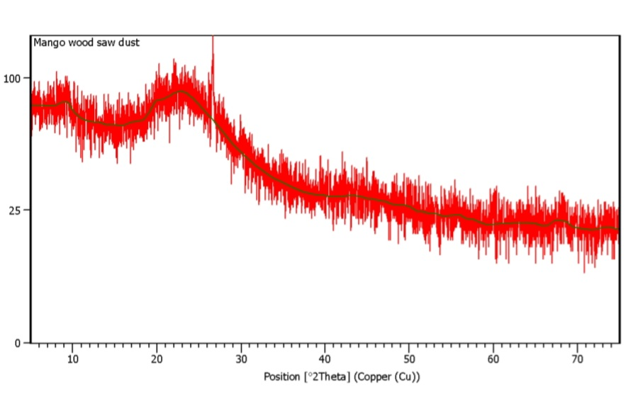
Fig. 1: XRD pattern of Mango wood Sawdust
The crystalline structure and phase of the mango wood sawdust biochar were determined by X-ray diffraction analysis, and the results are shown in Figure 1 & table 1, which uses Cu Kα radiation to plot the diffraction intensity against the diffraction angle (2θ), which ranges from roughly 5° to 75°. Amorphous carbon structures are characterized by a broad and diffused peak at about 2θ = 20–26° in the pattern. Disordered carbon layers created during the pyrolysis of lignocellulosic biomass are indicated by this broad peak. Similar broad diffraction peaks indicating amorphous carbon structures have been widely reported for biochars derived from lignocellulosic biomass, particularly at moderate pyrolysis temperatures [30]. The absence of sharp and intense peaks suggests that the material does not possess a highly crystalline structure. This wide peak suggests that low-crystallinity, disordered carbon structures make up the majority of the biochar [31]. The presence of disordered carbon structures is known to enhance adsorption performance due to increased surface heterogeneity and active sites [32]. Because it offers more active sites and surface heterogeneity, which improves adsorption and catalytic characteristics, the predominance of amorphous carbon structures is advantageous for environmental applications [33].

Table 1: Phase identified or possibly present in the random powder diffraction of mango wood saw dust Bio-char Sample

Pos. [°2Th.] | Height [cts] | FWHM Left [°2Th.] | d-spacing [Å] | Rel. Int. [%]
26.5980 | 44.30 | 0.2880 | 3.34865 | 100.00

According to ICDD, the phase identified in the random power diffraction of mango wood saw dust is quartz (2) [34].
4.2. FTIR Analysis:
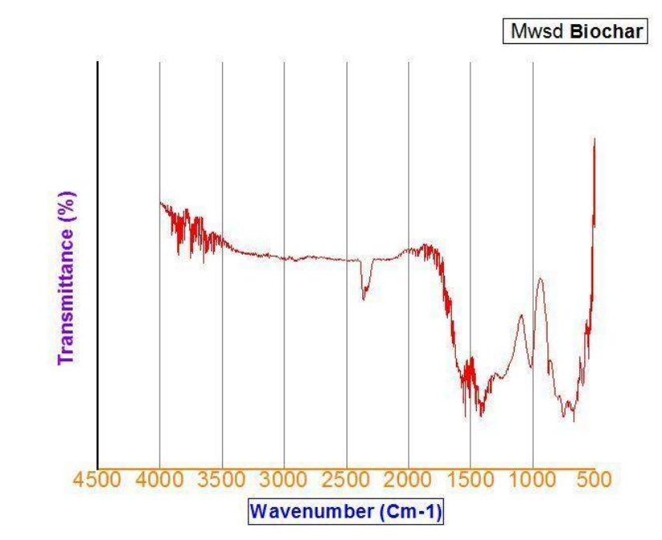
Fig. 2: FTIR spectra of Mango wood saw dust bi-char sample
Figure 2 demonstrates the FTIR spectra of the Mango wood saw dust bio-char sample. The acid axial deformation C=O, mainly aldehydes and ketones produced by the dissociation of cellulose and hemicellulose, is responsible for the peaks seen between 1750 cm⁻¹ and 1650 cm⁻¹ [7]. The detected bands in the 1600–1580 cm⁻¹ range are connected to aromatic C=C and C=O, which are connected to ketones and quinones [35]. The presence of oxygen-containing functional groups such as hydroxyl, carbonyl, and aromatic structures plays a significant role in heavy metal adsorption through surface complexation and electrostatic interactions [36]. We were able to determine from the FTIR study that although cellulose and hemicellulose are broken down during the gasification process, certain lignin-related aromatics are still present in the biochar samples. These qualities could enhance the utilisation of biochar as a soil supplement, according to [37]. Here, the large peak between 3200 and 3600 cm-1 shows that the hydroxyl groups in the biochar are derived from moisture, alcohols, and phenolic chemicals.2800-3000 cm⁻¹ represents C-H stretching(alkanes) & shows the presence of organic carbon structure.

4.3. Dynamic Light Scattering (DLS) Method:
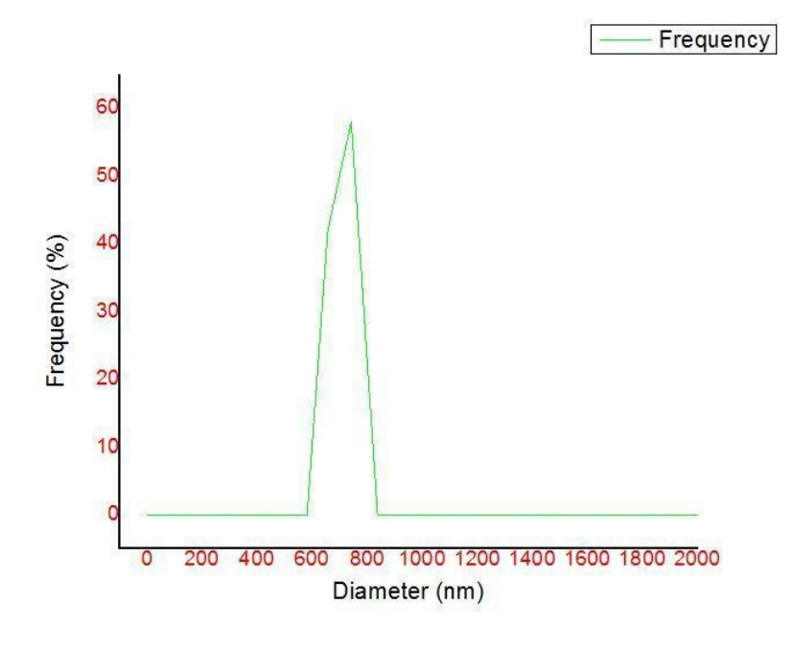
Fig. 3: Particle size distribution analysis of Mango wood saw dust Bio- char
Mango wood sawdust biochar that is between 600 and 800 nm in size has been successfully produced; its frequency versus diameter curve, which is examined using the DLS principle from a Horiba Scientific nanoparticle analyser, is displayed in figure. Although the particle size falls within the submicron range, such materials can still exhibit significant adsorption efficiency due to their surface properties and porosity [38]. e to its single, sharp peak, this graph demonstrates good particle homogeneity. The highest frequency occurs in the 55–60% range, while the peak position is between 600 and 800 nm. This tight peak indicates that most biochar is of a comparable size, indicating carefully regulated synthesis conditions. This suggests that the average particle size is about 700 nm. Additionally, it shows low polydispersity, which is advantageous for catalytic and adsorption applications. The average particle size (~700 nm) falls within the submicron region rather than the real nanoscale (<100 nm), despite the investigation being referred to as nanoparticle characterisation. It is important to distinguish between true nanoparticles (<100 nm) and submicron particles when interpreting DLS results [39]. The physicochemical qualities of biochar, such as surface area, pore structure, and adsorption effectiveness, can be greatly impacted by these particle size features [18].
4.4. SEM Analysis:
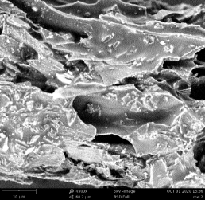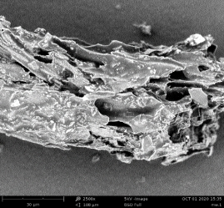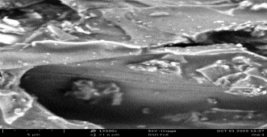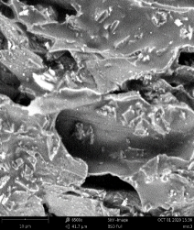
Fig. 4: SEM analysis of mango wood sawdust

Effective volatilization during pyrolysis is shown by the SEM micrographs in figure 4, which show a highly porous, uneven, and heterogeneous surface morphology with well-developed pores and cavities. The development of porous structures during pyrolysis is crucial for enhancing adsorption capacity, as it increases surface area and provides more active binding sites for contaminants [40]. During pyrolysis, flake-like sheets and cracked surfaces are seen, which show that the mango wood's original lignocellulosic structure broke down. There are smooth and rough areas in the figure. Macropores and micropores are probably created when volatile stuff is released during the pyrolysis process, leaving spaces in the carbon matrix. The creation of these holes greatly increases the biochar's surface area and adsorption capacity. Additionally, certain areas have comparatively compact and smooth surfaces, which could be explained by localized thermal melting or tar residue deposition during carbonization. The biochar's well-developed porous structure makes it appropriate for a variety of desirable applications, including the removal of heavy metals from wastewater and the cleanup of CO₂ from the environment [18].
5. Conclusion:
The present study successfully demonstrated the preparation of biochar from mango wood sawdust through a controlled pyrolysis process and its subsequent physicochemical characterization using X-ray diffraction (XRD), scanning electron microscopy (SEM), Dynamic Light scanning (DLS) and Fourier transform infrared spectroscopy (FTIR). The generated biochar primarily showed an amorphous carbon structure with few crystalline phases, indicating incomplete graphitisation and the presence of disordered carbon matrix, according to the XRD examination. The development of a porous and heterogeneous surface morphology—a desired characteristic for applications related to adsorption—was confirmed by SEM micrographs. The physicochemical aspects of biochar, such as surface area, pore structure, and adsorption effectiveness, can be greatly impacted by the maximum particle size, which is confirmed by the DLS method to be in the sub-micron range. Functional groups and porosity were validated by characterization techniques. However, pyrolysis parameters like temperature, heating rate, and residence duration, quantitative measurement of surface area (e.g., BET analysis) and pore size distribution were not thoroughly investigated in this work. Future studies should concentrate on improving the pyrolysis conditions to increase the biochar's yield, porosity, and surface functioning. In order to assess its true effectiveness, this manufactured biochar will also be employed in practical applications in the future, such as the removal of heavy metals from wastewater and the sequestration of CO₂ from the environment. Furthermore, research on the biochar's regeneration, reusability, and life-cycle assessment would offer important insights into its sustainability both economically and environmentally.

Disclaimer (Artificial intelligence)

Author(s) hereby declare that NO generative AI technologies such as Large Language Models (ChatGPT, COPILOT, etc.) and text-to-image generators have been used during the writing or editing of this manuscript.

References:
[1] | Maqsood, A., Abbas, J., Rehman, G., & Mubeen, R. (2021). The paradigm shift for educational system continuance in the advent of COVID-19 pandemic: Mental health challenges and reflections. Current research in behavioral sciences, 2, 100011.
[2] | Brefo, V. (2018). Environmental effects of smallscale sawmills woodwaste disposal in the Kumasi Metropolis (Doctoral dissertation, University Of Education, Winneba.).
[3] | Maharani, R., Yutaka, T., Yajima, T., & Minoru, T. (2010). Scrutiny on physical properties of sawdust from tropical commercial wood species: Effects of Different Mills and Sawdust's Particle Size. Indonesian Journal of Forestry Research, 7(1), 20-32.
[4] | Paulrud, S., Mattsson, J. E., & Nilsson, C. (2002). Particle and handling characteristics of wood fuel powder: effects of different mills. Fuel processing technology, 76(1), 23-39.
[5] | Carpenter, B. H. (2014). Biochar's fitness as an amendment in bell pepper transplant and field production (Master's thesis, Iowa State University).
[6] | Haile, A., Gelebo, G. G., Tesfaye, T., Mengie, W., Mebrate, M. A., Abuhay, A., & Limeneh, D. Y. (2021). Pulp and paper mill wastes: utilizations and prospects for high value-added biomaterials. Bioresources and Bioprocessing, 8, 35. https://doi.org/10.1186/s40643-021-00385-3.
[7] | Matteson, G. C., & Jenkins, B. M. (2005). Food and processing residues in California: Resource assessment and potential for power generation. In 2005 ASAE Annual Meeting (p. 1). American Society of Agricultural and Biological Engineers.
[8] | Lehmann, J., Gaunt, J., & Rondon, M. (2006). Bio-char sequestration in terrestrial ecosystems–a review. Mitigation and adaptation strategies for global change, 11(2), 403-427.
[9] | Harris, P. (1999). On charcoal. Interdisciplinary Science Reviews, 24(4), 301-306.
[10] | Lu, W., Ding, W., Zhang, J., Li, Y., Luo, J., Bolan, N., & Xie, Z. (2014). Biochar suppressed the decomposition of organic carbon in a cultivated sandy loam soil: a negative priming effect. Soil Biology and Biochemistry, 76, 12-21.
[11] | Jahurul, M. H. A., Zaidul, I. S. M., Ghafoor, K., Al-Juhaimi, F. Y., Nyam, K. L., Norulaini, N. A. N., ... & Omar, A. M. (2015). Mango (Mangifera indica L.) by-products and their valuable components: A review. Food chemistry, 183, 173-180.
[12] | Nworie, F. S., Nwabue, F. I., Oti, W., Oroke, C., Oguji, P., & Onele, M. (2024). Production And Characterization of Biobriquette from Biomass of Mango Leaf, Saw Dust and Rice Husk As Efficient Energy Sources For Cooking. Journal of Chemical Society of Nigeria, 49(5).
[13]. | Piluharto, B., Muharja, M., Larasati, K. A., Puspitasari, R. Y., Indarti, D., Widiastuti, N., ... & Ali, B. T. I. (2026). Structure-performance relationship of biochars derived from agricultural wastes for nitrate adsorption: The role of surface charge and porosity. Results in Chemistry, 103334.
[14] | Lun, L. W. (2016). Adsorption Of Copper (Ii) Ion By Palm Oil Sludge Biochar Prepared By Pyrolysis: Equilibrium And Kinetic Studies.
[15]  [16] | Wang, T., Ren, P., Liu, Q., Zhang, Q., Zheng, Y., Jia, D., & Wu, D. (2026). Coal Tar Pitch‐Based Porous Carbon: Synthetic Strategies and Their Applications in Energy Storage. Advanced Functional Materials, 36(1), e04092  Kumar, P., Singhania, R. R., Sumathi, Y., Kurrey, N. K., Chen, C. W., Patel, A. K., & Dong, C. D. (2025). Investigating innovative techniques for biochar modification to enhance the removal of heavy metals from aqueous environments: a comprehensive review: P. Kumar et al. Clean Technologies and Environmental Policy, 27(8), 3271-3293.
[17] | Al Rawi, M., Al Kindi, G., & Al Refaae, J. K. (2021). A review about preparation and properties of biochar and application fields in the environment. Engineering and Technology Journal, 39(12), 1894-1904.
[18] | Ahmad, M., Rajapaksha, A. U., Lim, J. E., Zhang, M., Bolan, N., Mohan, D., ... & Ok, Y. S. (2014). Biochar as a sorbent for contaminant management in soil and water: a review. Chemosphere, 99, 19-33.
[19] | González Fernández, L. A., Medellín Castillo, N. A., Sánchez Polo, M., Navarro Frómeta, A. E., & Vilasó Cadre, J. E. (2025). Algal-based carbonaceous materials for environmental remediation: Advances in wastewater treatment, carbon sequestration, and biofuel applications. Processes, 13(2), 556.
[20] | Lehmann, J. (2007). A handful of carbon. Nature, 447(7141), 143-144.
[21]  [22]. | Joseph, S., Xu, C. Y., Wallace, H. M., Farrar, M., Nguyen, T. N., Bai, S. H., & Solaiman, Z. M. (2017). Biochar production from agricultural and forestry wastes and microbial interactions. In Current developments in biotechnology and bioengineering (pp. 443-473). Elsevier.  Sharma, R., Bisen, D. P., Shukla, U., & Sharma, B. G. (2012). X-ray diffraction: a powerful method of characterizing nanomaterials. Recent research in science and technology, 4(8).
[23] | Armynah, B., Tahir, D., Tandilayuk, M., Djafar, Z., & Piarah, W. H. (2019). Potentials of biochars derived from bamboo leaf biomass as energy sources: effect of temperature and time of heating. International Journal of Biomaterials, 2019(1), 3526145.
[24] | Al-Amin, K., Kawsar, M., Mamun, M. T. R. B., & Hossain, M. S. (2025). Fourier transform infrared spectroscopic technique for analysis of inorganic materials: a review. Nanoscale Advances, 7(21), 6677-6702.
[25] | Zhang, S., Qi, Y., Tan, S. P. H., Bi, R., & Olivo, M. (2023). Molecular fingerprint detection using Raman and infrared spectroscopy technologies for cancer detection: a progress review. Biosensors, 13(5), 557.
[26] | Zhou, W., Apkarian, R., Wang, Z. L., & Joy, D. (2006). Fundamentals of scanning electron microscopy (SEM). In Scanning microscopy for nanotechnology: techniques and applications (pp. 1-40). New York, NY: Springer New York.
[27].  [28]. | Hall, D. H. (1995). Electron microscopy and three-dimensional image reconstruction. Methods in cell biology, 48, 395-436.  Shukla, V., Niveria, K., Shashidhar, P., & Verma, A. K. (2023). Dynamic light scattering (DLS) particle size analysis for biomedical nanotechnology. In Analytical techniques for biomedical nanotechnology (pp. 16-1). Bristol, UK: IOP Publishing.
[29] | Allen, T. (2013). Particle size measurement. Springer.
[30]. | Demir, Z., &amp; Bozkurt, P. A. (2026). Co-pyrolysis of agricultural biomass for potentially  functional biochar: combined influence of both feedstocks and structural characterization.  Scientific Reports.
 | [31]. Chen, C., Sun, K., Huang, C., Yang, M., Fan, M., Wang, A., ... &amp; Liu, J. (2023). Investigation on the mechanism of structural reconstruction of biochars derived from lignin and cellulose during graphitization under high temperature. Biochar, 5(1), 51.
[32] | Li, W., Yang, X., Yuan, C., Wang, X., Huo, X., Ye, Y., ... &amp; Qin, Z. (2026). Optimizing the degree of structural disorder in coal-based porous carbon for enhancing supercapacitor  capacitance performance. Fuel, 404, 136378.
[33] | Zhang, L., Ren, Y., Xue, Y., Cui, Z., Wei, Q., Han, C., & He, J. (2020). Preparation of biochar by mango peel and its adsorption characteristics of Cd (II) in solution. RSC advances, 10(59), 35878-35888.
[34] | Harhash, M. M., Ahamed, M. M., & Mosa, W. F. (2022). Mango performance as affected by the soil application of zeolite and biochar under water salinity stresses. Environmental Science and Pollution Research, 29(58), 87144-87156.
[35]  [36]  [37]  [38]  [39]  [40]. | Komnitsas, K. A., & Zaharaki, D. (2016). Morphology of modified biochar and its potential for phenol removal from aqueous solutions. Frontiers in Environmental Science, 4, 26.  Tewari, S., Kaur, J., Tandon, S., &amp; Das, D. K. (2026). Recent advances in functionalized  nanocarbon adsorbents for toxic pollutant removal: challenges and future  perspectives. Discover Nano, 21(1), 57  Shahrun, M. S., Rahman, M. H. A., Baharom, N. A., Jumat, F., Saad, M. J., Mail, M. F., ... & Suherman, F. H. S. (2024). Design of a pyrolysis system and the characterisation data of biochar produced from coconut shells, carambola pruning, and mango pruning using a low-temperature slow pyrolysis process. Data in Brief, 52, 109997.  Lv, C., Ying, Y., Ding, Y., Ji, L., Li, W., Wei, Y., ... &amp; Wang, S. (2026). Hierarchically  microstructured supraparticles via electrospraying for structurally stable and multifunctional  liquid marbles. Advanced Functional Materials, 36(22), e22972.  Coones, R. T., Kestens, V., & Minelli, C. (2025). A comparison of hydrodynamic diameter results from MADLS and DLS measurements for nanoparticle reference materials. Journal of Nanoparticle Research, 27(7), 170.  Xiong, X., Liu, J., Xiao, T., Lin, K., Huang, Y., Deng, P., ... & Wang, J. (2025). Remediation of uranium-contaminated water and soil by biochar-based materials: a review. Biochar, 7(1), 41.

