Environmental Sanitation Practices and Water-Related Health Risks in Mamfe Central Sub-Division, South West Region of Cameroon

ABSTRACT
Environmental sanitation and water quality remain critical determinants of public health, particularly in rapidly urbanising towns across sub-Saharan Africa. In Mamfe Central sub-division, inadequate waste management systems, deteriorating drainage infrastructure and limited sanitation coverage have heightened population vulnerability to water-related health risks. This study evaluates the effectiveness of environmental sanitation practices in mitigating water quality deterioration, with emphasis on waste management systems, sanitation access, hygiene behaviours, water-health linkages and institutional support mechanisms. This study was guided by the use of a mixed research design consisting of qualitative and quantitative designs, the duration spans from 2019- 2024. Primary data were collected through structured questionnaires administered to 218 households across multiple quarters of the sub-division. Descriptive statistics, Pearson correlation analysis, and linear regression modelling were employed for data analysis. Findings indicate that burning (35.2%) and open dumping (31.9%) are the dominant waste disposal methods, while municipal waste collection services reach only 11% of households. Additionally, 72.4% of drainage infrastructure is classified as poor to very poor. Water quality test results are largely positive, with 57.2% of respondents rating their water as poor to very poor in terms of physio-chemical and biological analysis. Statistical analysis reveals a strong positive relationship between environmental sanitation and water quality (r = 0.876, P < 0.001), with sanitation conditions explaining 76.7% of the variation in water quality (R² = 0.767). These results confirm that inadequate environmental sanitation is a primary driver of water quality deterioration in the study area. The study recommends the expansion of municipal waste collection services, rehabilitation of drainage systems, strengthened enforcement of sanitation regulations, and the promotion of community-based sanitation initiatives.
Keywords: Environmental sanitation · Waste management · Water quality · Public health · Mamfe Central sub-division · Cameroon · Urban health

INTRODUCTION
Globally, environmental sanitation practices and water-related health risks with insights from 2025-2026 show that inadequate water, sanitation and hygiene (WASH) continue to cause significant water-related health diseases such as, cholera, typhoid, diarrhoea and polio affecting over 1.7 billion people worldwide and causing over 1.4 million deaths annually (WHO, 2025). An estimated 2 billion people lack access to safely managed sanitation services globally with the burden disproportionately concentrated in low- and middle-income urban centres where informal settlement expansion and limited municipal capacity exacerbate infrastructure deficits (WHO, 2020). In the developed world, Water management strategies centred on water catchment management, management of riparian areas, pipe borne water resource management and surface and underground water resource management, (The Organisation for Economic Cooperation and Development [OECD], 2020). This is very severe in Southern Europe and Western Asia as a result of environmental degradation and competition for water resulting in water scarcity where human institutions and financial capital limits access to water. This is highly orchestrated by lack of under-developed water infrastructures, high vulnerability to short and long-term drought and difficult access to reliable water supplies especially for the rural people thus exposing them to waterborne diseases (WHO, 2020). Measures are being put in place to implement preventive measures and this is done through the understanding of the ways in which water management practices influence the health of the population and the formulation of integrated policies and strategies accordingly (Pratts, 2019). Environmental sanitation encompasses a broad spectrum of interventions and practices that regulate the interaction between human populations and their environment, including solid and liquid waste management, drainage systems, sanitation infrastructure, and hygiene behaviour (Satterthwaite et al., 2005). Deficiencies in these systems create multiple pathways for environmental contamination. For instance, improperly managed solid waste generates leachate that infiltrates groundwater and surface water systems; poorly maintained drainage systems facilitate stagnant water accumulation, encouraging vector breeding and contaminant concentration; and inadequate sanitation facilities contribute to faecal contamination through surface runoff and groundwater seepage (Prüss-Üstün et al., 2019). These processes collectively increase the incidence of water-related diseases such as diarrhoea, cholera, typhoid, and helminth infections (Fewtrell et al., 2005). In the developing world access to adequate environmental sanitation and safe water constitutes a fundamental requirement for public health and human well-being, particularly in rapidly urbanising regions (Fewtrell et al., 2005). In sub-Saharan Africa, urban population growth has consistently outpaced the expansion of sanitation infrastructure, resulting in increased exposure to waterborne diseases, vector-borne illnesses, and environmental contamination (WHO/UNICEF, 2019; UNEP, 2016). Urban and peri-urban settings in developing countries focusing on waste, as excreta, wastewater and solid waste influences food quality and related pathogens, nutrients and chemical pollutants (Nguyen-Viet, et al., 2009). In Cameroon, sanitation conditions vary significantly between cities and across neighbourhoods within urban centres. While major cities such as Yaoundé and Douala have been widely studied, smaller and rapidly expanding towns such as Mamfe remain under-documented despite facing comparable sanitation challenges. As the administrative headquarters of Manyu division, Mamfe typifies the conditions of secondary urban centres characterised by rapid population growth, inadequate waste management systems, uneven access to sanitation facilities, and a complex interaction between waste disposal practices and water source quality that directly influences public health outcomes. Despite the well-established relationship between sanitation and water quality, there remains a critical need for context-specific empirical studies that quantify this relationship in secondary urban centres. This study addresses this gap by examining environmental sanitation practices and their implications for water-related health risks in Mamfe Central sub-division. This study is guided by the following research questions:
- What are the dominant waste management practices in Mamfe Central sub-division, and how are they spatially distributed across different quarters?
- To what extent do households have access to adequate sanitation facilities and adopt appropriate hygiene practices?
- What types of water sources are used by residents, and how do their quality and accessibility influence health outcomes?
- What is the nature and strength of the relationship between environmental sanitation conditions and water-related health risk in the study area?
The objectives of the study is
- To assess the dominant waste management practices and their spatial distribution across the different quarters
- To evaluate the extent to which households have access to adequate sanitation facilities and adopt appropriate hygiene practices
- To investigate the type of water sources used by the residents and how its quality and accessibility affect health outcomes
- To assess the level of effectiveness of environmental sanitation practices in reducing water-related health risks in the study area

2 Study Area and Methodology

2.1 Study Area
Mamfe Central sub division in Manyu division, also known as the Mamfe basin found in the northern part of the South West Region of Cameroon. She is the headquarters of the Manyu division being an intracratonic rift in eastern West Africa, and found within the region located at Latitude 5º30´ and 6º10´ north of the Equator and Longitude 8º30´ and 9º35´ east of the Greenwich meridian. It is about 74km away from the Cameroon-Nigeria border and has a total surface area of 7044km² (Mamfe Council Development Plan [MCDP], 2012). Mamfe is bordered to the North by Akwaya Sub-division, to the South and East by Eyumojock sub-division and to the West by Upper Bayang sub-division (Figure 1)
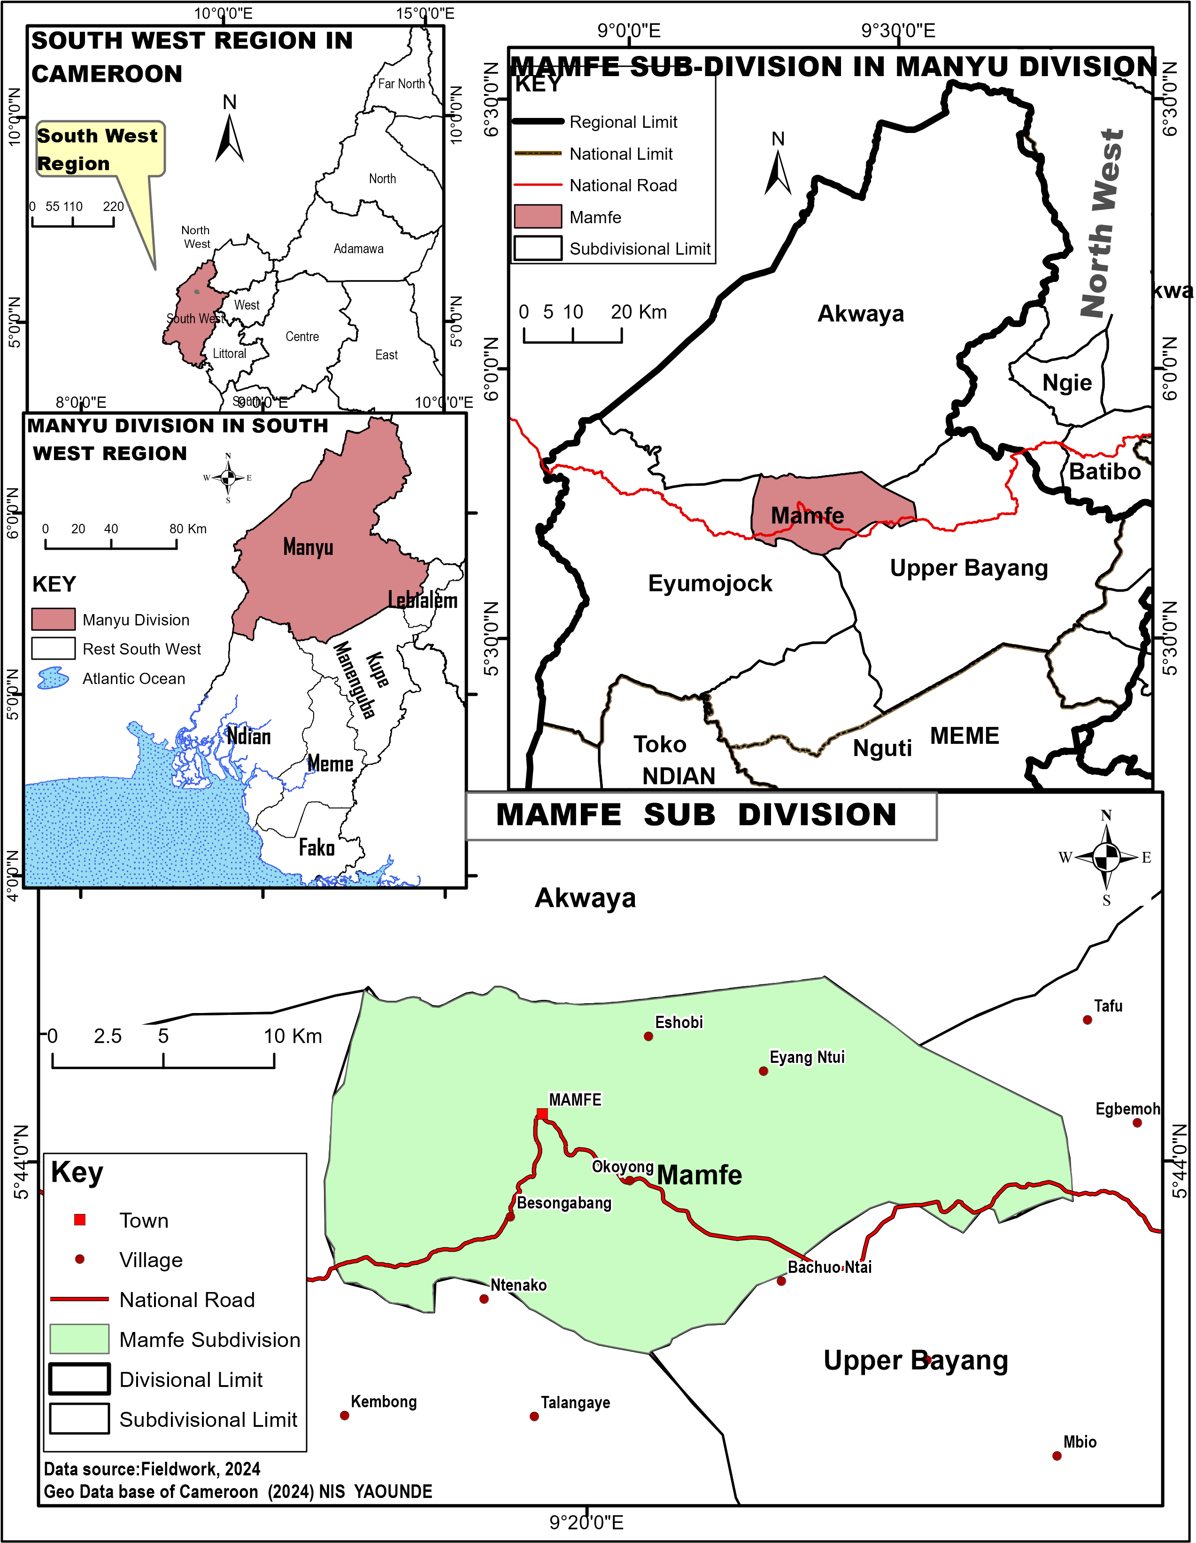
Figure: 1 Location of Mamfe Central sub-division in Mamyu Division, South West Region of Cameroon
Source: Geo-database of Cameroon (2024)
The Mamfe Central sub-division is also found along the Bamenda-Enugu corridor linked by the trans-African highway. The study covers the following villages Small Mamfe, Egbekaw, Besssongabang, Okoyong, Bachou-ntai, Eyangnchang, Eshobi and Nchang.

2.2 Data Collection

This study was guided by the use of a mixed research design consisting of qualitative and quantitative designs. A qualitative research design is a type in which a group of people or items are studied by collecting and analysing data from few people or items considered to be representative of the entire group. It enabled the study to collect data on how effective are existing environmental sanitation practices in reducing water-related health risks in Mamfe Central sub-division. The total population of Mamfe central sub-division stood at 31641 inhabitants in 2005 with a growth rate of 2.8% according to 2005 Population Housing Census with a growth rate of 2.8 % (BUCREP, 2005). The population of 2024 can be projected using the formulae Siegel and Swanson (2004). The study area population and target population;

The total population of Mamfe central Sub-division stood at 31641 inhabitants in 2005 with a growth rate of 2.8% according to 2005 Population Housing Census with a growth rate of 2.8 % (BUCREP, 2005). The population of 2024 was projected using the formulae Siegel and Swanson (2004) as follows:
Pt= (P₁)( e^{rz})
Where:
Pt= Population in the target year or current year
P1= Population in the base year
e= the base of the system natural logarithm approximately 2.71828
r= the average exponential rate of increase or the growth rate of the population
z= the number of years in the projected horizon or the time period.
Based on 2005 BUCREP census result considered as the base year for 2024 population projection, the population of 2024 is gotten as follows:
Population in 2024= 31641 (2.8/100) ¹⁴$=44045$inhabitants
The sample size for this study was calculated using standard statistical formulas to ensure adequate representation and statistical power for hypothesis testing. The calculation considered the study population size, expected effect sizes, confidence levels, and practical constraints related to time and resource availability. For the quantitative component, the sample size was calculated using the formula for finite populations:
Sample Size Calculation
n = (Z²pq N) / (e²(N-1) + Z²pq)
Where:
- n = required sample size
- Z = confidence level (1.96 for 95% confidence)
- p = estimated proportion (0.5 for maximum variance)
- q = 1-p (0.5)
- N = population size (51,000 adults)
- e = margin of error (0.06)
n = (1.96² × 0.5 × 0.5 × 51,000) / (0.06²(51,000-1) + 1.96² × 0.5 × 0.5)
n = (3.8416 × 0.25 × 51,000) / (0.0036 × 50,999 + 0.9604)
n = 48,979.8 / (183.5964 + 0.9604)
n = 48,979.8 / 184.5568
n ≈ 265. Accounting for non-response and potential data quality issues, the sample size was increased by 6% to 280 respondents to ensure statistical adequacy while maintaining practical feasibility for comprehensive data collection in the rural setting. Primary data were collected in 2024 using structured questionnaires administered to 218 respondents drawn from households across the quarters of Mamfe Central sub-division. Respondents were selected through systematic random sampling from household rosters. The questionnaire covered waste disposal practices, collection frequency, drainage conditions, toilet types and functionality, hand washing practices, hygiene education exposure, water sources and quality testing, water storage and handling, and perceptions of institutional support and law enforcement. Key informant interviews were conducted with municipal officials, health workers, and community leaders. Field observation documented physical sanitation conditions, drainage infrastructure, dumpsite management, and proximity of waste disposal sites to water sources, supported by photographic documentation across multiple quarters. Table.1 presents the distribution of questionnaires amongst various villages and stakeholders.
Table:1(A): Questionnaire distribution among Various vilages
Villages | Total Population | No of questionnaire administered | No of questionnaire retrieved
Egbekaw | 2622 | 30 | 25
Eshobi | 1549 | 15 | 10
Eyangntui | 1020 | 15 | 9
Small Mamfe | 23178 | 67 | 50
Bessongabang | 6940 | 35 | 28
Bachou-Ntai | 4758 | 35 | 20
Nchang | 3678 | 30 | 27
Total | 43745 | 227 | 169
Source: BUCREP, 2010, and 2024 projection
Table:1(B): Questionnaire distribution among Stakeholders
Stakeholders in water resource management | Total Population | No of questionnaire administered | No of questionnaire retrieved
Health care personnel | 100 | 30 | 26
Village Development Associations | 40 | 6 | 6
CAMWATER | 40 | 4 | 4
Village Water Development Authorities | 40 | 6 | 6
The Council | 40 | 6 | 6
Water Catchment Authorities | 40 | 3 | 3
Total | 300 | 53 | 51
Source: BUCREP, 2010, and 2024 projection

2.3 Data Analysis
Questionnaire data were entered in Microsoft Excel and analysed using SPSS version 25. Frequencies, percentages and cross-tabulations were computed for all key variables. To test the hypothesis that there is no significant difference between improper waste disposal and inadequate sanitation practices that contribute to the degradation of water quality in Mamfe Central sub-division.
Pearson correlation analysis was performed on paired environmental sanitation and water quality scores derived from composite indicators across the study sample. Linear regression modelling was employed to quantify the proportion of variance in water quality explained by sanitation conditions, expressed as the coefficient of determination (R²). The null and alternative hypotheses tested were:
H: There is no significant difference between improper waste disposal and inadequate sanitation practices that contribute to the degradation of water quality in Mamfe Central sub-division.

3 Results

3.1 Waste Management Systems

Waste management is a major problem in almost all the cities and towns of Cameroon; Mamfe is not exempted from this trend of events.
3.1.1 Waste Disposal Methods
The distribution of waste disposal methods employed by residents across Mamfe Sub-division is presented in Table 2. Burning in backyards emerges as the most prevalent disposal method at 35.2%, particularly common in residential areas such as New Layout, Hospital Quarter, and Small Mamfe where municipal collection services are absent or inadequate. Open dumping in vacant lots accounts for 31.9% of practices, creating unsightly waste accumulation sites that serve as breeding grounds for disease vectors. Municipal collection services reach only 11% of residents, primarily concentrated in more affluent areas such as GRA and parts of the commercial district.
Table 2: Waste Disposal Methods in Mamfe Central Sub-Division
Disposal Method | Frequency | Percentage (%)
Open dumping in vacant lots | 67 | 31.9
Burning in backyards | 74 | 35.2
Municipal collection service | 27 | 11.0
Burying in compound | 30 | 13.3
Disposal in streams/rivers | 20 | 8.6
Total | 218 | 100.0
Source: Fieldwork, 2024
The 8.6% of households disposing of waste directly into streams and rivers represents a particularly acute contamination pathway, creating direct linkages between solid waste management deficits and surface water quality deterioration. During rainy seasons, waste accumulated at open dumpsites is additionally washed into drainage systems and water bodies, further extending the spatial reach of contamination.
3.1.2 Waste Collection Frequency
Waste collection frequency data reveal critical inadequacies in service provision across the sub-division (Table 3). Irregular or sporadic collection affects 42.4% of residents, while 18.1% have no access to collection services whatsoever. Only 3.8% benefit from daily collection, concentrated in commercial establishments and high-income residential areas. The combined 22.3% receiving weekly or more frequent collection illustrates the limited reach of effective waste management infrastructure across the sub-division.
Table 3: Waste Collection Frequency in Mamfe Central Sub-Division
Collection Frequency | Frequency | Percentage (%)
Daily | 10 | 3.8
Twice weekly | 18 | 7.1
Weekly | 32 | 15.2
Monthly | 30 | 13.3
Irregular/Sporadic | 90 | 42.4
No collection service | 38 | 18.1
Total | 218 | 100.0
Source: Fieldwork, 2024

3.1.3 Drainage Systems and Dumpsite Management
Assessment of drainage infrastructure reveals that a combined 72.4% of areas have poor to very poor drainage conditions (Table 4 and figure 2). Areas with poor drainage (42.4%) feature blocked or damaged channels filled with solid waste, creating stagnant pools that serve as mosquito breeding sites. Only 21.9% of areas have a good to excellent drainage, primarily concentrated in newer developments and commercial areas. Dumpsite management shows severe deficiencies across all assessed categories: 59.5% of dumpsites have no waste segregation practices, 76.2% have no leachate management systems, and 72.4% have no access control, allowing indiscriminate dumping and creating safety risks particularly in residential quarters such as Banya, Lala, and New Layout.
Table 4: Drainage System Condition in Mamfe Central Sub-Division
Drainage Condition | Frequency | Percentage (%)
Excellent condition | 12 | 5.7
Good condition | 34 | 16.2
Poor condition | 89 | 42.4
Very poor condition | 67 | 30.0
No drainage system | 16 | 5.7
Total | 218 | 100.0
Source: Fieldwork, 2024
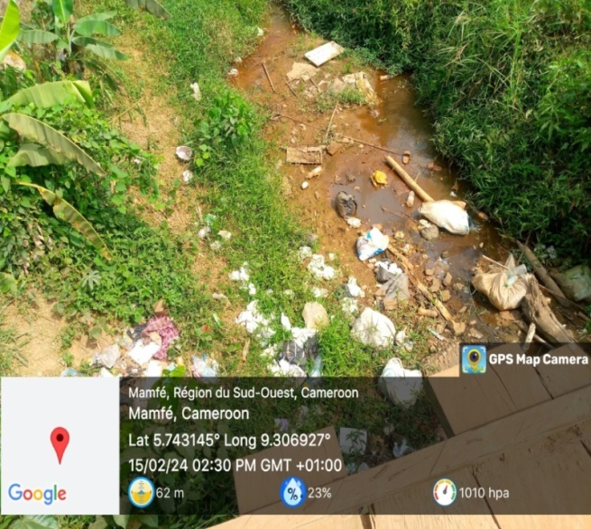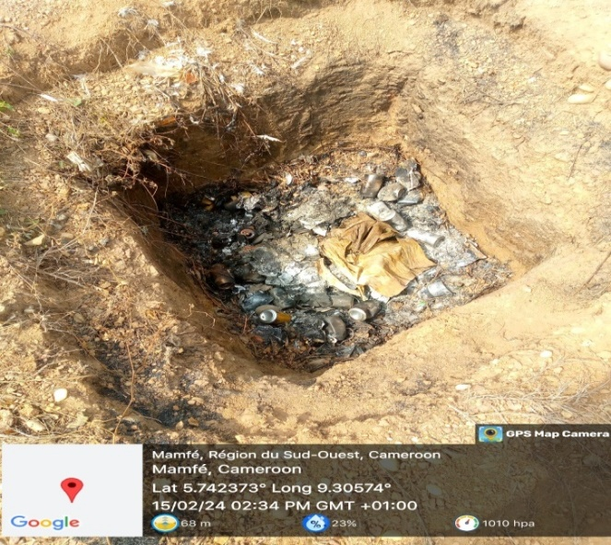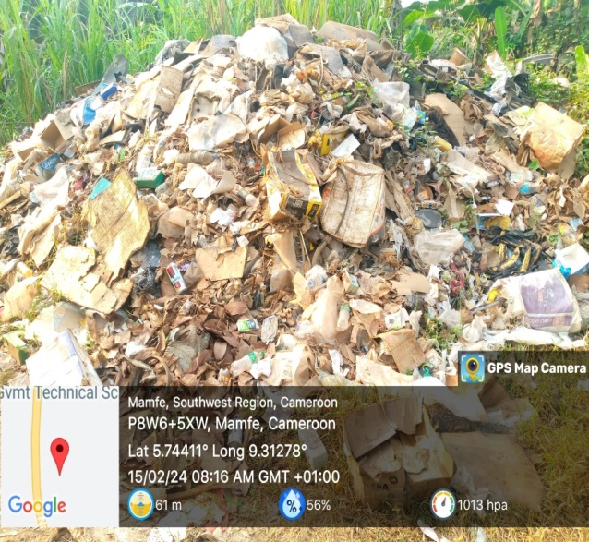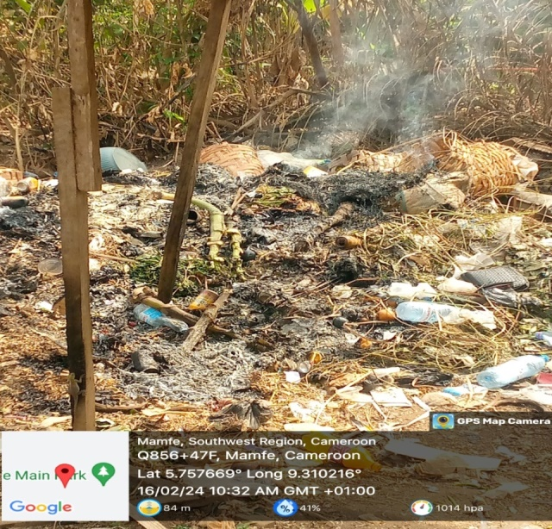
D
C
B
A
Figure: 2: Waste Disposal Methods in Mamfe sub-division
Source: Fieldwork, 2024
The image (A) shows domestic waste management through a dug-pit in “Laterite-pit quarter”, while (B) gives a glim on how waste is disposed in stream channels causing direct water pollution in Lala quarter. Photo (C) presents an open dump-site in Banya quarter along the street; lastly (D) shows the burning of waste in a dump-site in the Mamfe main-market area causing environmental pollution.

3.2 Sanitation Access
3.2.1 Toilet Types and Coverage
Flush toilets represent only 16.2% of sanitation facilities, primarily concentrated in affluent areas such as GRA and newer commercial developments (Table 5). Pit latrines with slabs constitute the largest category at 42.4%, serving middle-income residential areas. A concerning 31.9% of households rely on pit latrines without slabs, prevalent in low-income areas and informal settlements including parts of Banya, Lala, and peripheral quarters. These unimproved facilities pose significant health risks through inadequate waste containment and increased exposure to faecal matter. Open defecation affects 2.4% of households, concentrated in the most resource-constrained peripheral areas.
Table 5: Distribution of Toilet Types in Mamfe Central Sub-Division
Toilet Type | Frequency | Percentage (%)
Flush toilet (water closet) | 34 | 16.2
Pit latrine with slab | 89 | 42.4
Pit latrine without slab | 67 | 31.9
Pour-flush latrine | 19 | 7.1
No facility (open defecation) | 9 | 2.4
Total | 218 | 100.0
Source: Fieldwork, 2024
3.2.2 Sanitation Functionality and Public Facilities
Of existing sanitation facilities, 60% are fully functional, 27.6% partially functional and 10% non-functional, with 2.4% under construction or repair. Public and institutional sanitation shows particularly critical conditions: transport station toilets have a functionality rate of only 25%, and public market toilets only 37.5%, both well below the 83.3% recorded for health facility toilets. Primary school toilets show a functionality rate of 64.3%, creating challenges for maintaining hygiene in educational environments in areas such as New Layout and Banya where high enrolment intersects with limited functional infrastructure.

3.3 Hygiene Practices
Hand washing practices show encouraging frequency patterns, with 90% of respondents reporting hand washing after toilet use, 79.5% before food preparation and 74.3% before meals. However, dedicated hand washing facilities with soap are available in only 21.4% of households, primarily in higher-income areas like GRA, Clerks quarter and Small Mamfe Mobile hand washing facilities represent the most common arrangement at 42.4%, while 31.9% of households have only a basic water source with no dedicated hand washing infrastructure. Hygiene education exposure is highest through school programmes and media campaigns (both at 74.3% combined high and moderate exposure), while NGO campaigns reach only 31.5% of the population at high or moderate levels, indicating significant gaps in the reach of formal health promotion activities.
Community waste management practices show moderate engagement: 58.6% of households practice some form of household waste sorting and 69% participate in organic waste composting always or sometimes. Community clean-up activities engage 68.1% of residents at least occasionally, with participation highest in Hospital Quarter and organised sections of central residential areas like Clerks quarter, GRA, and Small Mamfe. Recyclable material separation shows lower engagement at 42.9%, reflecting limited infrastructure for formal recycling collection and processing.

3.4 Water-Health Linkages
Water has a direct strong positive relationship on health, the consumption of unsafe water sources mostly lead to health outcomes like cholera, malaria, typhoid and diarrhoea. Table 6 shows a typology of water-related diseases and number of patients in Mamfe
Table.6 Prevalence of Water-Related Diseases in Mamfe (2019–2023)
Health Condition | 2019 | 2020 | 2021 | 2022 | 2023
Typhoid Fever | 1,215 | 1,089 | 1,436 | 1,001 | 1,227
Diarrhea/Dysentery | 802 | 1,089 | 1,059 | 964 | 890
Cholera | 211 | 122 | 137 | 209 | 198
Malaria (Severe cases) | 4,326 | 4,098 | 4,811 | 5,120 | 4,982
Skin Infections/Rashes | 674 | 555 | 684 | 699 | 738
Intestinal Worms | 1,243 | 1,089 | 1,178 | 1,256 | 1,187
Source: Divisional delegation of public Health Manyu

3.4.1 Water Sources and Quality Evaluation
Protected wells and boreholes serve 42.4% of households, primarily in established residential areas with prioritised infrastructure investment (Table 7 and figure 3). Unprotected wells serve 31.9% of households, primarily in areas such as New Layout, Banya and peripheral quarters where contamination risks from surface runoff and nearby sanitation facilities are elevated. Surface water dependence (16.2%) presents serious health risks, particularly in communities along water courses in Small Mamfe and areas near river systems, where contamination from waste disposal, agricultural runoff and upstream activities is documented.
Table 7: Primary Water Sources in Mamfe Central Sub-Division
Water Source | Frequency | Percentage (%)
Protected wells/boreholes | 89 | 42.4
Unprotected wells | 67 | 31.9
Surface water (streams/rivers) | 34 | 16.2
Rainwater harvesting | 15 | 7.1
Vendor/truck water | 13 | 2.4
Total | 218 | 100.0
Source: Fieldwork, 2024
Water quality perceptions reveal widespread concern, with 57.2% of residents rating their water quality as poor to very poor, particularly in areas dependent on unprotected wells and surface water. Only 42.9% rate their water as good to excellent. Water treatment practices are broadly practised, with 84.3% of households employing some form of treatment: boiling (46.7%), filtration systems (21.4%), and chemical treatment (16.2%). The 15.7% with no treatment practice are most concentrated in lower-income peripheral areas like Laterite-pit, LaLa and Banya with least access to treatment knowledge or materials.
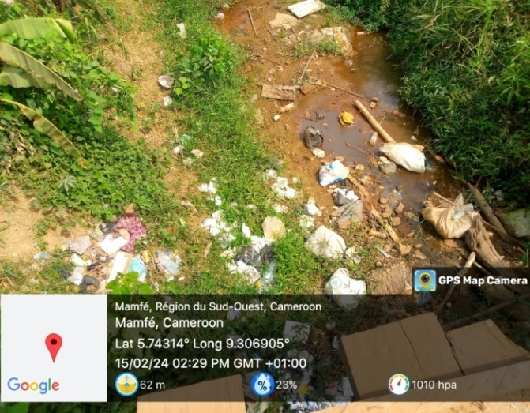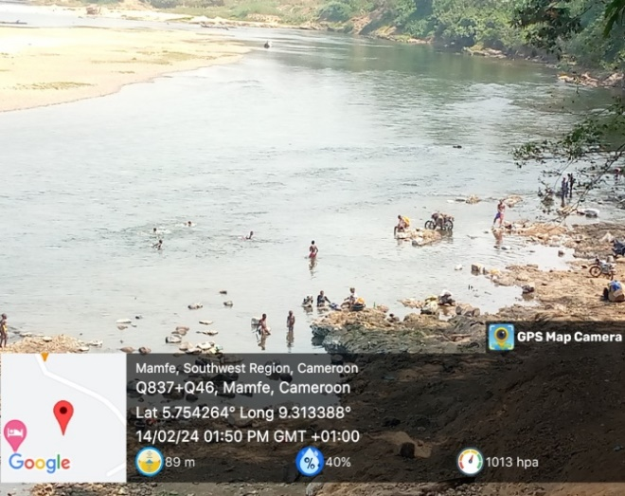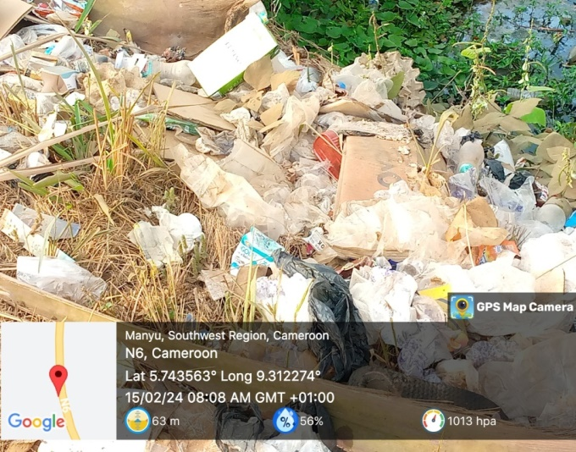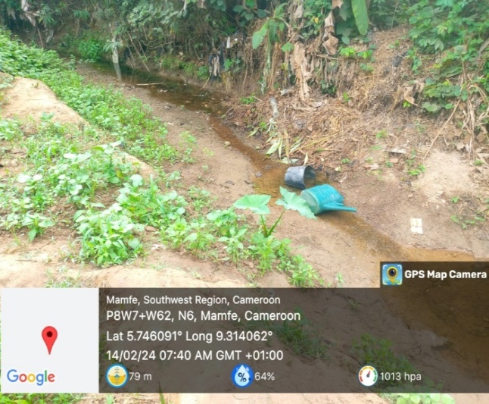
C
D
B
A
Figure.3: The state of environmental sanitation in Mamfe
Source: Fieldwork, 2024

Photo (A) shows disposal of waste in a stream channel in mile-one thereby polluting the water source, (B) presents the washing of cloths, bathing and fetching of water in the Manyu River in Johnholt quarter. Image (C) on it part shows open waste disposal along the roadside to Okoyong and (D) is a small stream channel used for agriculture in the dry season leading agricultural products of phyto-chemicals to leach into the water body.
3.4.2 Water Source Proximity and Health Impacts
A clear correlation between water source distance and reported health outcomes is documented in Table 8. Households with water sources within their compounds (31.9%) report the lowest health issue rate at 15.2%, while households accessing water at distances exceeding 500 m (5.2%) report health issues at 67.3%. The progressive increase in reported health impacts with increasing distance reflects both the substitution toward lower-quality sources at greater distances and the compromised hygiene practices that result from constrained water availability.

Table 8: Water Source Proximity and Health Impact Relationships
Distance to Water Source | Frequency | Percentage (%) | Reported Health Issues (%)
Within compound (0–20m) | 67 | 31.9 | 15.2
Short distance (21–100m) | 89 | 42.4 | 28.4
Medium distance (101–500m) | 43 | 20.5 | 45.7
Long distance (>500m) | 19 | 5.2 | 67.3
Total | 218 | 100.0 | –
Source: Fieldwork, 2024

3.5 Institutional Support

Law enforcement assessments reveal severe inadequacies across all environmental sanitation categories. Water quality protection enforcement is rated ineffective to very ineffective by 78.6% of respondents, and waste disposal regulation enforcement is similarly rated by 74.3%. Building sanitation codes show relatively better enforcement outcomes at 37.7% effective to very effective, reflecting the more visible nature of building violations and the involvement of multiple agencies in building approval processes. Funding assessments reveal critical deficiencies: 73.4% rate municipal waste collection funding as inadequate to very inadequate, 79.5% rate sanitation infrastructure development funding similarly, and 81.4% consider public toilet maintenance funding inadequate. Religious institution partnerships demonstrate the highest effectiveness among stakeholder collaboration mechanisms, with 63.8% rating them effective to very effective, reflecting their role in community mobilisation for sanitation activities, health education, and environmental clean-up. Inter-agency coordination receives the poorest effectiveness rating at only 19% effective to very effective. The bacteriological analysis during the rainy season reveals intensified contamination patterns across all water sources. Coliform bacterial counts show significant increases compared to the dry season, with streams exhibiting the highest contamination (490.2 CFU/100ml), followed by wells (453.1 CFU/100ml). The introduction of pipe-borne water during this period shows concerning contamination levels (226.5 CFU/100ml), indicating possible infrastructure-related contamination during the rainy season. Boreholes maintain the lowest but still elevated coliform counts (15.2 CFU/100ml) compared to dry season levels. Salmonella contamination follows a similar intensification pattern, with streams showing the highest levels (71.3 CFU/100ml), followed by wells (60.5 CFU/100ml) and pipe-borne water (45.3 CFU/100ml). Rivers and springs also show increased contamination (34.3 and 16.5 CFU/100ml respectively) compared to dry season measurements. Streptococcus contamination is particularly severe in wells (220.4 CFU/100ml), nearly doubling from dry season levels. Streams (90.2 CFU/100ml) and pipe-borne water (81.4 CFU/100ml) also exhibit high contamination levels. The overall pattern indicates that rainy season conditions significantly worsen bacteriological water quality across all sources, with increased surface runoff, infrastructure stress, and dilution effects contributing to widespread microbial contamination. This seasonal deterioration poses heightened public health risks and underscores the need for improved water treatment and protection measures during the rainy season.
Table:9 Bacteriological Parameters (Rainy Season)
Sample | GIS COOR | Coliform bacterial (CFU/100ml) | Salmonella (CFU/100ml) | Streptococcus (CFU/100ml) | LOCATION
Borehole | Lat.5.760526⁰  Lon.9.308535⁰ | 15.2 | ND | ND | EGBEKAW
Well | Lat.5.758166⁰  Lon.9.308535⁰ | 453.1 | 60.5 | 220.4 | MAINSTREET  MAMFE
Spring | Lat.5.728255⁰  Lon.9.352221⁰ | 170.5 | 16.5 | 7.6 | OKOYONG
River | Lat.5.754264⁰  Lon.9.313388⁰ | 290.4 | 34.3 | 36.5 | JOHNHOLT  MAMFE
Stream | Lat.5.754264⁰  Lon.9.313388⁰ | 490.2 | 71.3 | 90.2 | BANYA QUARTER
Pipe borne | Lat.5.758088⁰  Lon.9.311017⁰ | 226.5 | 45.3 | 81.4 | LALA QUARTER
Source: URASCE of the University of Dschang

3.6 Statistical Verification of the Hypothesis
To test the relationship between environmental sanitation and water quality in Mamfe Central Sub-Division, Pearson correlation analysis was performed on composite sanitation and water quality scores. Results show a strong positive correlation (r = 0.876, p < 0.001) between environmental sanitation conditions and water quality, confirming that as sanitation conditions deteriorate through increased waste dumping, poor drainage, and inadequate sewage management, water quality deteriorates correspondingly (Table 10).
Table 10: Correlation between Environmental Sanitation and Water Quality
Variable | Environmental Sanitation | Water Quality
Environmental Sanitation | 1.000 | 0.876**
Water Quality | 0.876** | 1.000
Note: Correlation is significant at the 0.01 level (2-tailed). Source: Fieldwork, 2024
Linear regression analysis established that 76.7% of the variability in water quality is explained by the state of environmental sanitation (R² = 0.767, adjusted R² = 0.762), as shown in Table 11. The high explanatory power of the model confirms that environmental sanitation is a key determinant of water quality in the sub-division. These statistical findings support the rejection of the null hypothesis: improper waste disposal and inadequate sanitation practices significantly contribute to the degradation of water quality in Mamfe Central Sub-Division.
Table 11: Regression Model Summary of the Effect of Sanitation on Water Quality
Model | R | R² | Adjusted R² | Std. Error of Estimate
1 | 0.876 | 0.767 | 0.762 | 4.873
Source: Fieldwork, 2024

4 Discussion
The dominance of informal waste disposal practices in Mamfe Central Sub-Division, with 35.2% of residents burning waste and 31.9% open-dumping in vacant lots while only 11% access municipal collection services, reflects the structural waste management deficits that characterise secondary Cameroonian towns. The findings confirm a pattern of informal and environmentally harmful disposal practices that characterise secondary town waste management in Cameroon (Manga et al., 2011 and Nwankwo et al., 2024). This pattern is consistent with the broader sub-Saharan African urban pattern documented by Guerrero et al., (2013), Mercy. E. et al., (2024) in which the expansion of informal settlement areas systematically outpaces municipal waste management capacity, and with Manga et al.'s (2011) documentation of waste management deficiencies in Cameroonian secondary urban centres. The severe deficiency in collection frequency, with 60.5% of residents experiencing irregular or absent collection, mirrors the findings of Henry et al., (2006) for West African cities, where service irregularity functions as a proximate driver of informal and environmentally hazardous disposal behaviour.
The 72.4% combined poor to very poor drainage condition documented across the sub-division is particularly significant as a water quality risk factor. Drainage failure in tropical urban environments creates the hydrological conditions for contaminant mobilisation and concentration identified by Prüss-Üstün et al., (2019) ; Frempong et al., (2024) as principal pathways connecting sanitation deficits to waterborne disease. The near-total absence of leachate management systems at dumpsites (76.2% with no management) compounds this risk by creating chronic groundwater contamination pathways from the 31.9% of households dependent on unprotected wells, which are most concentrated in the quarters nearest to informal dumpsites.
The documented water quality perception pattern, with 57.2% of residents perceiving their water as poor to very poor and the correlation between proximity to sanitation deficits and health outcomes showing health issue rates ranging from 15.2% for in-compound water sources to 67.3% for distant sources, aligns with the established relationship between urban sanitation infrastructure, water source quality, and waterborne disease incidence documented by Fewtrell et al., (2005) and Hunter et al., (2010) for comparable low-income urban settings in sub-Saharan Africa. The high adoption of water treatment practices (84.3%), led by boiling at 46.7%, reflects community awareness of water contamination risks and represents an important adaptive strategy, though it does not address the upstream sanitation conditions generating contamination.
The strong positive correlation (r = 0.876, P < 0.001) between environmental sanitation and water quality, with regression modelling establishing an explanatory power of 76.7% (R² = 0.767), provides statistical confirmation of the sanitation-water quality pathway at the community scale. This finding is consistent with the systematic review by Fewtrell and Colford (2004), which established that water source sanitation improvements are among the most impactful interventions for reducing waterborne disease burden, and with the quantitative analysis by Prüss-Üstün et al., (2014), which attributed 58% of diarrhoeal disease burden globally to inadequate water, sanitation, and hygiene conditions. The magnitude of the correlation found in this study places Mamfe Central Sub-Division among the highest-risk urban settings in terms of the documented sanitation-water quality relationship.
The institutional analysis reveals a governance environment characterised by weak enforcement, severe funding inadequacies, and fragmented stakeholder coordination. The 74.3–78.6% ineffective enforcement ratings across waste disposal and water quality protection categories indicate a regulatory gap that sustains informal disposal practices by removing the deterrent effect of sanitation regulation. This governance failure is consistent with the pattern documented by Guerrero et al., (2013) and Yhdego (1995) for secondary towns in sub-Saharan Africa, where enforcement capacity at the municipal level is structurally underfunded relative to the scale of the sanitation challenge. The relatively strong effectiveness of religious institution partnerships (63.8% effective to very effective) offers a potential governance resource, as faith-based organisations have been documented as effective community mobilisation agents for sanitation improvement in comparable settings (Nawab et al., 2006), (IPCC, 2022).

5 Conclusion, Implication & Future Research
This study has documented the environmental sanitation conditions and their relationship to water quality and health outcomes in Mamfe Central Sub-Division, South West Region of Cameroon. Environmental sanitation conditions are predominantly poor across multiple dimensions: waste management is dominated by burning and open dumping in the absence of reliable municipal collection; drainage infrastructure is severely degraded across 72.4% of the sub-division; sanitation facility coverage is inequitable with over 30% of households relying on unimproved pit latrines; and institutional enforcement and funding mechanisms are critically inadequate. These conditions collectively produce a sanitation-water quality relationship confirmed by strong statistical evidence (r = 0.876; R² = 0.767), establishing that poor environmental sanitation is the principal determinant of water quality deterioration across the sub-division.
Despite these challenges, the study documents promising community-based capacities including high rates of organic waste composting, active community clean-up participation, and widespread adoption of water treatment practices that provide a foundation for sustainable sanitation improvement. Priority policy interventions identified by this study include: expansion and regularisation of municipal waste collection services to peripheral and low-income quarters currently without coverage; rehabilitation of drainage infrastructure in flood-prone low-lying areas; enforcement of waste disposal regulations through consistent penalty application and community monitoring; improvement and maintenance of public sanitation facilities in markets, schools, and transport stations; and investment in protected water source infrastructure for households currently dependent on unprotected wells and surface water. Strengthening inter-agency coordination, expanding NGO-community collaborations, and formalising the role of religious institutions as sanitation promotion partners represent institutional pathways for improving governance of environmental sanitation in the sub-division.
Some challenges faced in the study are;
The implications for public health are immediate and profound. It is confirms that a significant portion of the population in Mamfe Central Sub-Division is exposed to contaminated water and associated health risks, especially in rural communities with limited access to piped water. Seasonal peaks in disease outbreaks reflect vulnerabilities in both the water infrastructure and the health system’s preparedness to manage them but are resistant to give out information freely for fear of the unknown. This calls for a paradigm shift in health planning from a reactive, treatment-focused approach to a proactive, preventive public health strategy rooted in environmental hygiene and safe water access.The findings urge public health stakeholders to prioritize health promotion campaigns, community-based disease surveillance, and cross-sectorial collaboration with water and sanitation actors. The inclusion of traditional leaders and indigenous knowledge systems in health sensitization efforts is also recommended as a culturally appropriate strategy to improve outreach and compliance. The research also points to the need for synergies between traditional and modern health systems. In the absence of functional healthcare facilities, many households rely on indigenous practices for the treatment of waterborne diseases. While these methods offer temporary relief, their unregulated use poses risks of delayed treatment or health complications. Therefore, the findings encourage public health planners to explore integration models where traditional healers are trained and included in broader disease surveillance and water hygiene education initiatives.
Environmentally, the unregulated land use, deforestation, and chemical-intensive farming that compromises watershed health and reduce the resilience of ecosystems posed as a major challenge in the acquisition of information in the field. This not only affects water quality and availability but also undermines climate adaptation efforts. The findings advocate for the enforcement of watershed protection policies, including reforestation, afforestation, and prohibition of harmful farming practices near springs and streams. The study also emphasizes the importance of watershed rehabilitation as a low-cost, high-impact strategy to enhance both water security and environmental quality. Planting water-loving tree species, building terracing and buffer zones, and involving youth in environmental clubs or school-based water protection initiatives are some of the practical approaches proposed. Additionally, the research presents a compelling case for community-based environmental monitoring systems, where local actors can take ownership of protecting and reporting the status of their water sources. These systems, when supported with basic training and tools, offer cost-effective alternatives to centralized regulatory systems that are often underfunded and overstretched.
Further Research can be carried out with the following themes:

Climate Variability and Water Quality Dynamics in Mountainous and Lowland Zones

Effectiveness and Sustainability of Traditional Water Management Practices
- Gender Dynamics and Health Vulnerabilities in Water Access and Management
- Geospatial Modelling of Waterborne Disease Outbreaks and Pollution Source

Consent

As per international standards or university standards, respondents’ written consent has been collected and preserved by the author(s).

Disclaimer (Artificial intelligence)

Author(s) hereby declare that NO generative AI technologies such as Large Language Models (ChatGPT, COPILOT, etc.) and text-to-image generators have been used during the writing or editing of this manuscript.

References
Frempong D, Umana AU, Umar MO, Akinboboye O, Okoli I, Omolayo O.(2024). “Multi-tool collaboration environments for effective stakeholder communication and sprint coordination in agile project teams”. Int J Sci Res Comput Sci Eng Inf Technol.;10(4):606-45. doi:10.32628/IJSRCSEIT
Fewtrell, L., & Colford, J. M. (2004). Water, sanitation and hygiene: Interventions and diarrhoea. A systematic review and meta-analysis. World Bank.
Fewtrell, L., Kaufmann, R. B., Kay, D., Enanoria, W., Haller, L., & Colford, J. M. (2005). Water, sanitation, and hygiene interventions to reduce diarrhoea in less developed countries: A systematic review and meta-analysis. The Lancet Infectious Diseases, 5(1), 42–52. https://doi.org/10.1016/S1473-3099(04)01253-8
Guerrero, L. A., Maas, G., & Hogland, W. (2013). Solid waste management challenges for cities in developing countries. Waste Management, 33(1), 220–232. https://doi.org/10.1016/j.wasman.2012.09.008
Henry, R. K., Yongsheng, Z., & Jun, D. (2006). Municipal solid waste management challenges in developing countries: Kenyan case study. Waste Management, 26(1), 92–100. https://doi.org/10.1016/j.wasman.2005.03.007
Hunter, P. R., MacDonald, A. M., & Carter, R. C. (2010). Water supply and health. PLoS Medicine, 7(11), e1000361. https://doi.org/10.1371/journal.pmed.1000361
Mamfe Council Development Plan. (2012). Participatory and Decentralised Rural Development Project-GPDERUDEP, 189
Intergovernmental Panel on Climate Change. Climate change (2022): “impacts, adaptation and vulnerability”. Contribution of Working Group II to the Sixth Assessment Report of the Intergovernmental Panel on Climate Change. Cambridge: Cambridge University Press;
Manga, V. E., Forton, O. T., Mofor, L. A., & Woodard, R. (2011). Health care waste management in Cameroon: A case study from the Southwestern Region. Resources, Conservation and Recycling, 57, 108–116. https://doi.org/10.1016/j.resconrec.2011.10.002
Mercy Egemba , Simeon Ayo-Oluwa Ajayi , Costly Aderibigbe-Saba , Patrick Anthony, (2024). “Environmental Health and Disease Prevention”: Conceptual Frameworks Linking Pollution Exposure, Climate Change, and Public Health Outcomes International Journal of Multidisciplinary Research and Growth Evaluation : https://doi.org/10.54660/.IJMRGE.2024.5.3.1133-1153
Nawab, B., Nyborg, I. L., Esser, K. B., & Jenssen, P. D. (2006). Cultural preferences in designing ecological sanitation systems in North West Frontier Province, Pakistan. Journal of Environmental Psychology, 26(3), 236–246. https://doi.org/10.1016/j.jenvp.2006.07.005
Ngnikam, E., & Tanawa, E. (2006). Les villes d’Afrique face à leurs déchets. Université de Technologie de Belfort-Montbéliard.
Nguyen-Viet, H., Zinsstag, J., Schertenleib, R., Zurbrügg, C., Obrist, B., Montangero, A., ... & Tanner, M. (2009). “Improving environmental sanitation, health, and well-being: a conceptual framework for integral interventions”. EcoHealth, 6(2), 180-191.
Nwankwo TC, Ejairu E, Awonuga KF, Usman FO, Nwankwo EE. (2024). “Conceptualizing sustainable supply chain resilience: critical materials manufacturing in Africa as a catalyst for change”. Int J Sci Res Arch.;11(1):2427 37.
OECD (2020). Interim Economic Assessment, Coronavirus: The world economy at risk. Oecd.org/economic-outlook
Pratt, A. (2019). “Sachet Water Consumption and Health Effects in Low Income Neighbourhoods Formality as Exception.” Urban Studies, Vol.56, Issue (3) 612-615. https://Doi.Org/10.1177/0042098018810600
Prüss-Üstün, A., Bartram, J., Clasen, T., Colford, J. M., Cumming, O., Curtis, V., & Cairncross, S. (2014). Burden of disease from inadequate water, sanitation and hygiene in low- and middle-income settings: A retrospective analysis of data from 145 countries. Tropical Medicine & International Health, 19(8), 894–905. https://doi.org/10.1111/tmi.12329
Prüss-Üstün, A., Wolf, J., Bartram, J., Clasen, T., Cumming, O., Freeman, M. C., & Johnston, R. (2019). Burden of disease from inadequate water, sanitation and hygiene for selected adverse health outcomes: An updated analysis with a focus on low- and middle-income countries. International Journal of Hygiene and Environmental Health, 222(5), 765–777. https://doi.org/10.1016/j.ijheh.2019.05.004
Satterthwaite, D., McGranahan, G., & Mitlin, D. (2005). Community-driven development for water and sanitation in urban areas. WHO/UNICEF.
United Nations Environment Programme. (2016). Global waste management outlook. UNEP.
World Health Organization. (2020). Progress on household drinking water, sanitation and hygiene: 2000–2020. WHO.
World Health Organization & United Nations Children’s Fund. (2019). Progress on household drinking water, sanitation and hygiene 2000–2017. WHO/UNICEF Joint Monitoring Programme.
World Health Organization (2025), Water, Sanitation, Hygiene and Waste strategy 2026-2035 Genva, https//doi.org/10.2471/B09661.liciene:cc BY-NC-SA3:0 IGO.
Yhdego, M. (1995). Urban solid waste management in Tanzania: Issues, concepts and challenges. Resources, Conservation and Recycling, 14(1), 1–10. https://doi.org/10.1016/0921-3449(94)00042-6

