Rethinking Cement Production: Environmental Impacts and Sustainable Solutions

Abstract
The cement industry is a fundamental pillar of modern infrastructure development; however, it is also one of the most environmentally intensive industrial sectors due to its high energy consumption, greenhouse gas emissions and depletion of natural resources. Cement manufacturing contributes nearly 8–9% of global anthropogenic CO₂ emissions, primarily due to limestone calcination and fossil fuel combustion during clinker production. With increasing urbanization and infrastructure demand, reducing the environmental footprint of cement production has become a major global challenge. This review critically examines the environmental impacts associated with cement manufacturing, including carbon emissions, energy use, air and water pollution, land degradation and resource exploitation. The study further evaluates various sustainable mitigation strategies such as supplementary cementitious materials (SCMs), alternative fuels, waste-derived materials, energy-efficient kiln technologies, carbon capture and storage (CCS) and low-carbon binders. Comparative analysis of previous studies indicates that SCMs and alternative binders can significantly reduce clinker consumption and associated CO₂ emissions, while CCS technologies have the potential to capture up to 90% of process-related carbon emissions. The review also highlights the growing role of circular economy approaches, industrial waste utilization and digital process optimization in sustainable cement production. Despite substantial progress, several challenges remain regarding large-scale implementation, economic feasibility, durability assessment and policy support. Future research should focus on AI-assisted process optimization, advanced low-carbon binders, integrated life-cycle assessment, industrial scalability of carbon-neutral technologies and sustainable utilization of agricultural and industrial wastes. The study emphasizes that achieving a low-carbon and resource-efficient cement industry requires coordinated efforts involving technological innovation, policy intervention and sustainable construction practices.
Keywords: Cement industry, Environmental impact, CO₂ emissions, Sustainable construction, Supplementary cementitious materials, Carbon capture and storage, Circular economy

- Introduction
As the cornerstone of modern infrastructure, cement binds together the very fabric of contemporary civilization, from towering skyscrapers and expansive bridges to essential housing and critical transportation networks. Concrete—the composite material whose primary binder is cement—stands as the second most consumed substance on Earth after water, with global production exceeding 4.3 billion tonnes annually (Ashour et al., 2024). This colossal scale of utilization underscores cement’s indispensable role in enabling urbanization, economic development and poverty alleviation, particularly in emerging economies. The increasing demand for cement has led to greater consumption of aggregates, particularly limestone, which is the primary raw material used in the production of Portland cement. However, the extraction of non-renewable resources, such as limestone, is a major concern. As energy consumption has risen rapidly in the 21st century, the extraction of these resources is causing their depletion. Yet, this vital driver of human progress carries a profound and escalating environmental burden, positioning the cement industry at the critical nexus of developmental necessity and ecological sustainability.
The environmental implications of cement production are multifaceted and severe, extending across climate systems, natural resources and local ecosystems. Most prominently, the sector is a major contributor to global anthropogenic CO₂ emissions, accounting for an estimated 8–9% of the total—a footprint that, if attributed to a nation, would rank as the world’s third-largest emitter (Yang et al., 2024). This climate impact arises from an inherent chemical process: the calcination of limestone (CaCO₃) to lime (CaO), which releases CO₂ as an unavoidable byproduct, coupled with intensive fossil fuel combustion required to achieve kiln temperatures exceeding 1400°C. Beyond greenhouse gases, the industry drives significant resource depletion, including the large-scale extraction of finite geological limestone deposits, alongside substantial consumption of water and energy. Furthermore, cement manufacturing generates considerable air pollution (particulate matter, NOₓ, SO₂) land degradation from quarrying and water contamination, collectively threatening local environmental health and biodiversity.
As the cornerstone of modern infrastructure, cement forms the foundation of contemporary civilization, supporting the construction of buildings, bridges, highways, dams and transportation systems. Concrete, whose primary binding material is cement, is the second most consumed substance globally after water, with annual cement production exceeding 4.3 billion tonnes (Ashour et al., 2024). Rapid urbanization, industrialization and population growth, particularly in developing nations, continue to accelerate global cement demand. Consequently, the extraction and consumption of natural resources, especially limestone—the principal raw material used in Portland cement manufacturing—have increased substantially. Several researchers have highlighted that continuous large-scale limestone quarrying contributes to resource depletion, land degradation and ecosystem disturbance, raising serious sustainability concerns (Scrivener et al., 2018; Habert et al., 2020). Furthermore, the cement industry is highly energy-intensive, relying heavily on fossil fuels for clinker production, thereby increasing pressure on non-renewable energy resources.
The environmental impacts associated with cement production have emerged as a major global concern due to the sector’s substantial contribution to greenhouse gas emissions and environmental pollution. The cement industry accounts for approximately 8–9% of global anthropogenic CO₂ emissions, making it one of the largest industrial contributors to climate change (Yang et al., 2024). A significant proportion of these emissions originates from the calcination of limestone during clinker production, where calcium carbonate (CaCO₃) is converted into lime (CaO), releasing large quantities of CO₂ as an unavoidable byproduct. In addition, high-temperature kiln operations exceeding 1400°C require extensive combustion of fossil fuels, further increasing carbon emissions and energy consumption. Previous studies have shown that process emissions alone contribute more than half of the total CO₂ emissions from cement manufacturing, indicating the limitations of relying solely on energy efficiency improvements for decarbonization (Lehne and Preston, 2018). Apart from carbon emissions, cement production also generates particulate matter, nitrogen oxides (NOₓ), sulfur oxides (SO₂) and heavy metal pollutants that adversely affect air quality and human health. Quarrying operations further contribute to land degradation, biodiversity loss, noise pollution and groundwater contamination.
In recent years, significant research efforts have focused on developing sustainable and low-carbon alternatives for cement production. These include the use of supplementary cementitious materials (SCMs) such as fly ash, blast furnace slag, silica fume, calcined clay and agricultural waste ashes to partially replace clinker and reduce associated emissions. Studies have reported that clinker substitution through SCMs can significantly decrease energy consumption and CO₂ emissions while improving certain durability properties of concrete (Juenger et al., 2019). Similarly, alternative fuels derived from biomass and industrial waste have been investigated to reduce fossil fuel dependency in cement kilns. Emerging technologies such as carbon capture, utilization and storage (CCUS), waste heat recovery systems and novel low-carbon binders are also gaining increasing attention for achieving carbon-neutral cement production. However, despite considerable technological advancements, several challenges remain regarding large-scale implementation, economic feasibility, long-term durability and policy support. Moreover, many previous studies primarily focus on individual mitigation strategies, while limited research integrates environmental, economic and circular economy perspectives into a comprehensive sustainability framework.
This review article seeks to provide a comprehensive and critical synthesis of the current state of knowledge regarding the environmental impact of cement production, with a particular focus on the interconnected challenges of climate change and resource depletion. The analysis then extends to an evaluation of emerging mitigation strategies and innovative pathways aimed at decarbonizing the industry, including material substitution, alternative fuels, carbon capture and storage (CCS) and the development of novel low-carbon binders. By integrating findings from recent scientific literature, technological assessments and policy analyses, this review highlights both the urgent constraints imposed by planetary boundaries and the transformative opportunities for transitioning toward a circular and sustainable cement economy. Ultimately, we argue that reconciling the world’s infrastructure needs with ecological limits represents one of the most pressing material challenges of the 21st century, demanding coordinated innovation across science, industry and governance.
- Materials and Methods
This review employs a systematic and interdisciplinary approach to analyze and synthesize the environmental impacts of cement production, with a focus on resource depletion and decarbonization pathways. The methodology is structured to ensure comprehensiveness, transparency and replicability.
A systematic literature search was conducted using Scopus, Web of Science and Google Scholar for peer-reviewed articles (2010-2025), complemented by key reports from the International Energy Agency (IEA), the Intergovernmental Panel on Climate Change (IPCC), and the Global Cement and Concrete Association (GCCA). Search queries combined terms like ("cement production" AND "CO₂ emissions"), ("alternative binder" AND "LCA"), and ("carbon capture" AND "cement"). Initial identification yielded over 800 records. After duplicate removal and screening of titles/abstracts against inclusion criteria (focus on environmental impact or mitigation), approximately 250 full-text articles were assessed. A final corpus of 35 references was selected for in-depth synthesis.
2.1 Global Use of Concrete and Cement Production
The 21st century is being built with concrete. As the essential substrate of urbanization, industrialization and modern infrastructure, concrete is more than a construction material—it is a geological signature of the Anthropocene (Miller et al., 2024). The widespread use of concrete is driven by its strength, durability, versatility and relatively low cost. Concrete structures have long service lives and can withstand harsh environmental conditions, making them suitable for a wide range of applications.
Cement production has grown in response to this rising demand for concrete. Today, billions of tonnes of cement are produced annually worldwide, making it one of the most manufactured materials on Earth. China is the largest producer and consumer of cement, followed by countries such as India, the United States, Vietnam and Turkey (Miller and Moore, 2020). Developing economies account for a major share of cement consumption due to large-scale housing projects, transportation networks and industrial expansion, while developed countries maintain steady demand for maintenance and modernization of existing infrastructure. The pie chart (Figure 1) shows the geographical distribution of cement production, emphasizing China's dominant share and the composition of the rest of the world. China dominates cement production, contributing nearly half of the world’s total output due to its extensive construction and infrastructure activities. India is the second-largest producer, driven by rapid urbanization and infrastructure development. The rest of Asia also accounts for a significant share, reflecting growing construction demand in developing economies. Overall, the chart highlights Asia’s dominance in global cement production.
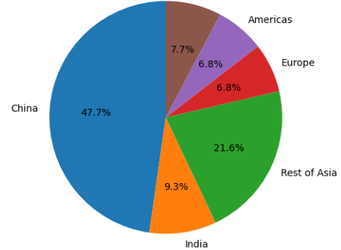
Figure 1. Geographical distribution of cement production
  - Environmental Impact of Cement Production and Resource Depletion
The scale of global cement production required to support concrete use has raised serious environmental concerns, including high energy consumption, greenhouse gas emissions and depletion of natural resources. Cement production requires significant energy and raw materials. One of the major environmental impacts of cement production is resource depletion. Large quantities of limestone, clay and sand are extracted from the earth through mining and quarrying. Quarrying for limestone involves heavy machinery and raw materials like calcium, silicon, aluminum and iron are mixed to form clinker. This clinker is then heated in cement ovens at temperatures between 1200°C and 1450°C to produce cement. These activities lead to the depletion of non-renewable natural resources, alteration of landscapes, soil erosion, deforestation and loss of biodiversity (Telschow et al., 2012). Continuous extraction also affects local ecosystems and can disrupt groundwater systems, reducing water availability in surrounding areas.
Another serious concern is high energy consumption. Cement manufacturing requires extremely high temperatures (about 1400–1450°C) to produce clinker in rotary kilns. This process depends heavily on fossil fuels such as coal, petroleum coke and natural gas, leading to excessive use of non-renewable energy resources. The burning of these fuels releases large amounts of pollutants into the atmosphere. Significant quantities of carbon dioxide (CO₂) are released both from fuel combustion and from the chemical process of calcination, where limestone decomposes into lime. The cement industry alone contributes a substantial share of global CO₂ emissions, thereby intensifying climate change (Andrew, 2019). In addition, emissions of particulate matter, nitrogen oxides (NOₓ) and sulfur oxides (SOₓ) degrade air quality and pose health risks to nearby communities. Furthermore, cement plants consume large amounts of water for cooling and processing, which can lead to water scarcity, especially in water-stressed regions. Dust generation and solid waste from production further contribute to environmental degradation.
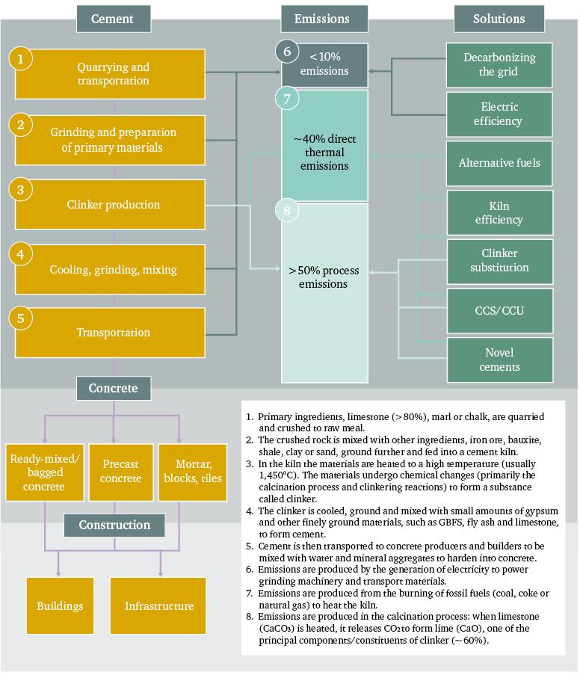Figure 2. Cement production stages, emission sources and decarbonization strategies (Lehne & Preston, 2018)
Lehne & Preston, (2018) presented the major stages of cement and concrete production, the corresponding sources of carbon emissions and the potential technological solutions for decarbonization within the cement industry (Figure 2). The framework illustrates the complete cement manufacturing chain, including quarrying and transportation of raw materials, grinding and preparation, clinker production, cooling and mixing processes and transportation of the final product. Among these stages, clinker production is identified as the most emission-intensive process due to high-temperature kiln operations and limestone calcination. The figure categorizes emissions into electricity-related emissions, direct thermal emissions from fuel combustion and process emissions generated during calcination, with process emissions accounting for more than 50% of total CO₂ emissions. To mitigate these environmental impacts, the framework highlights several sustainable solutions such as grid decarbonization, electrical efficiency improvement, alternative fuels, kiln efficiency enhancement, clinker substitution using supplementary cementitious materials, carbon capture and storage/utilization (CCS/CCU) and the development of novel low-carbon cements. The lower section of the figure further demonstrates the integration of cement into concrete products including ready-mix concrete, precast elements, mortars and construction applications for buildings and infrastructure. Overall, the figure emphasizes that reducing the carbon footprint of cement production requires a combination of process optimization, energy transition, material substitution and carbon management technologies. Table 1 summarizes key findings from previous studies related to cement production and its environmental impacts.
Table 1. Key findings of previous studies related to cement production and its environmental impacts
Study | Focus Area | Major Finding | Environmental Impact
Ashour et al. (2024) | Global cement production | 4.3 billion tonnes annually | High CO₂ emissions
Yang et al. (2024) | Carbon emissions | Cement contributes 8–9% global CO₂ | Climate change
IEA (2023) | Energy consumption | High thermal energy demand | Fossil fuel dependency

2.2.1 Impact of Cement Production on Air Pollution
Cement production is a major source of air pollution. One of the most harmful emissions from cement manufacturing is carbon dioxide (CO₂), a key greenhouse gas that contributes to global warming. During the production process, CO₂ is released when limestone (CaCO₃) is heated to form calcium oxide (CaO). Cement production is responsible for about 5% to 7% of global CO₂ emissions (Andrew, 2019) and 5% to 9% of greenhouse gases (Kajaste & Hurme, 2016). It accounts for 12% to 15% of total industrial energy use and contributes 5% to 8% of industrial CO₂ emissions (Miller, 2021). Although CO₂ is not a traditional air pollutant, its accumulation in the atmosphere intensifies the greenhouse effect and leads to long-term environmental and climatic impacts.
Other most significant air pollutants released is particulate matter (PM), including fine dust generated during quarrying, crushing, grinding, clinker production and cement packaging. Dust emissions occur during various stages, such as transportation, loading and unloading of clinker. These particles can remain suspended in the air and when inhaled, cause respiratory problems, eye irritation and other health issues in nearby communities.
Another major contributor to air pollution from cement plants is the emission of nitrogen oxides (NOₓ) and sulfur oxides (SOₓ), which are produced during high-temperature fuel combustion in kilns. These gases can react in the atmosphere to form smog and acid rain, damaging crops, soil, water bodies, and infrastructure. Cement manufacturing also releases carbon monoxide (CO) and volatile organic compounds (VOCs), further degrading air quality.
Overall, emissions from cement plants can significantly reduce air quality, harm human health and contribute to environmental degradation, emphasizing the need for effective pollution control technologies and cleaner production methods.
2.2.2 Impact of Cement Production on Water and Noise Pollution
Cement production also leads to water and noise pollution. Dust generated during the process can lower air quality and visibility. When the dust settles, it can contaminate water sources, affecting both human and animal health. Wastewater runoff from cement manufacturing can pollute rivers and groundwater supplies. This pollution is a serious concern, especially in areas with growing populations and urbanization, where poor land management can cause soil erosion and water runoff.
Noise pollution is another major issue in cement production. Noise comes from various stages such as raw material preparation, clinker burning, and heavy machinery used in the process. Cement plants produce different types of noise, including gas noise from blowers, mechanical noise from crushers and milling machines, and electromagnetic noise from electric motors. Continuous exposure to high noise levels can harm human health, leading to problems such as hearing loss, memory loss, hypertension, insomnia and fatigue. Long-term exposure to noise can also increase the risk of cardiovascular disease. Additionally, workers in cement plants may struggle to detect hazards due to the loud noise, affecting safety in the workplace (Canfeng et al., 2012).
2.2.3 Use of Chemical Additives in Cement Production:
Cement production is a complex process that involves several steps to produce high-quality cement. In this process, cement plants often use chemical additives to improve efficiency, control emissions and enhance the quality of the cement produced. Some of these chemical additives may contain oil-based components, which can end up in wastewater.
This wastewater generation during cement production, especially when it contains oil-based chemical additives, can have significant negative effects on the environment. These effects can range from contamination of water bodies to harming ecosystems, human health, and even the broader environmental balance. The incorporation of zinc oxide nanoparticles in cement grinding significantly reduces energy consumption while enhancing early hydration and maintaining mechanical performance (Osman et al. 2020).
Mohamad et al., (2022) illustrated the cement manufacturing process and showed how different stages contribute to air, water and noise pollution (Figure 3). The diagram highlights that cement production not only consumes natural resources and energy but also creates significant environmental impacts through dust, emissions, noise, and pollution at every major production stage.
Quarry limestone,
clay, and other
materials
Crush
material
Pre-heat
mixture
Heat mixture to 1500°C to
calcinate limestone and
produce clinker
Ship, bag and
distribute dry
cement
Grind and cool
mixture
Heavy particle and dust and
noise emission from machine
Hazard gas, dust and
noise emission from
machine
Greenhouse gas emission
from limestone
decomposition and fuel
Vehicle, equipment
emission
Dusts from
atmosphere gather
on the water
surface
Dusts from
atmosphere gather
on the water
surface
Heavy particle and dust from
atmosphere gather on the water surface
Figure 3 Summarization diagram on the impact of cement production (Mohamad et al., 2022)
- Sustainable Alternatives and Solutions in Cement Manufacturing
One important solution is the use of blended cements such as Portland Pozzolana Cement (PPC) and Portland Slag Cement (PSC), which partially replace clinker with industrial by-products like fly ash and blast furnace slag. This reduces carbon emissions, energy consumption and waste disposal problems. Another sustainable approach is the development of geopolymer cement, which uses industrial wastes such as fly ash and slag instead of limestone, significantly lowering CO₂ emissions.
Another promising approach is the use of recycled materials in cement production to reduce the consumption of natural resources and minimize environmental pollution. Industrial by-products and construction waste such as fly ash, blast furnace slag (Prosek et al., 2019), silica fume, recycled concrete powder, waste glass and demolished construction debris can be partially used as raw materials or clinker substitutes in cement manufacturing (Imbabi et al., 2012). This approach not only reduces landfill waste but also lowers energy consumption and carbon dioxide emissions associated with limestone extraction and clinker production. In addition, recycling materials helps conserve natural resources and promotes a circular economy in the construction industry. However, the quality, consistency and proper processing of recycled materials are critical to ensuring the strength and durability of the final cement product.
Sousa & Bogas, (2021) investigated the comparison of energy consumption and carbon emissions between traditional clinker production and recycled cement production to evaluate their environmental sustainability. The findings showed that, under conservative conditions, recycled cement production generates only about 58–74% of the carbon emissions produced during clinker manufacturing. Sensitivity analysis revealed that the major factors affecting emissions in recycled cement production are the moisture content of waste cement, the proportion of cement paste present in the waste material, and the energy required for the drying process. A major limitation of the recycling process is the pretreatment stage, particularly the washing and drying of waste materials, which increases energy demand and emissions. However, the study suggests that if these pretreatment stages are eliminated through the development of an efficient dry recycling process, carbon dioxide emissions could potentially be reduced to as low as 13% of those associated with traditional clinker production.
The production of ordinary Portland cement (OPC) contributes significantly to global carbon dioxide emissions due to the use of raw materials and the extremely high kiln temperature of about 1500°C required during manufacturing. To reduce these emissions, He et al., (2019) developed two types of recycled cement, namely RC-450°C and RC-800°C, produced by heating waste OPC paste at 450°C and 800°C respectively, followed by grinding in a ball mill. The use of recycled cement not only lowers CO₂ emissions but also helps reduce environmental problems associated with landfill disposal of demolished concrete waste. The study compared the carbon emissions generated during the production of OPC, RC-450°C, and RC-800°C by considering emissions from both fuel combustion and clinker materials. The results showed that RC-450°C production could reduce CO₂ emissions by about 94% compared to conventional OPC production. In addition, when mixed with water, RC-450°C was capable of capturing an extra 4% CO₂ by weight through the formation of calcium carboaluminate and calcite compounds. RC-450°C also demonstrated higher paste strength and lower carbon emissions than RC-800°C. Furthermore, the strength of RC-450°C paste was found to be comparable to that of OPC paste, indicating its potential to completely replace ordinary Portland cement in construction applications.
Carbon capture technologies offer substantial potential for emission reduction; however, their large-scale industrial implementation remains constrained by high capital costs, energy penalties and infrastructure limitations, particularly in developing economies.
Habert et al., (2020) provided a schematic framework for sustainable cement production based on circular economy principles and low-carbon material strategies (Figure 3). The framework demonstrates the complete lifecycle of cement and concrete production, beginning with raw material extraction and extending through cement manufacturing, construction, building use, demolition and material recycling. It highlights the incorporation of alternative raw materials, supplementary cementitious materials (SCMs) and alternative fuels such as biomass, municipal solid waste and industrial by-products to reduce dependence on conventional fossil fuels and virgin resources. The figure also emphasizes energy-efficient measures including heat recovery during clinker production and the utilization of recycled concrete fines and recycled aggregates in new construction applications. Furthermore, the framework presents a closed-loop approach in which construction and demolition waste is recovered, processed and reintegrated into the production cycle, thereby minimizing landfill disposal and promoting resource conservation. Overall, the schematic demonstrates how sustainable technologies, waste valorization and circular material flows can collectively contribute to reducing CO₂ emissions, conserving natural resources and advancing environmentally responsible cement production.

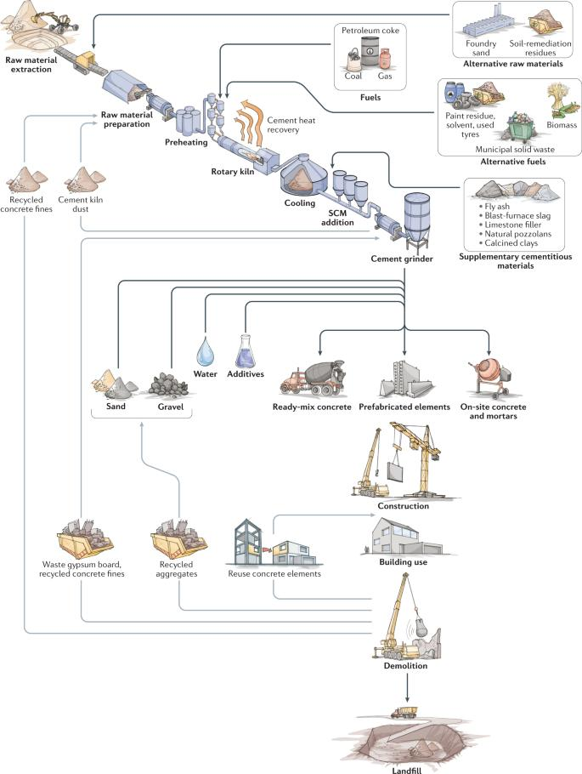
Figure 4 A schematic framework for sustainable cement production (Habert et al., 2020)
In addition to improving energy use, researchers have also explored using waste materials as partial substitutes for cement in concrete. Emphasize the potential for using waste products to replace a portion of the cement used in concrete (Ekincioglu et al., 2013). This not only reduces the need for limestone, a key raw material, but also helps decrease the environmental impact of cement production.
The use of agricultural waste materials as supplementary cementitious materials can significantly reduce cement consumption, save energy, and lower carbon dioxide (CO₂) emissions, thereby contributing to environmental sustainability. The use of paddy straw ash (rice straw ash) in cement production is an emerging sustainable approach for reducing environmental pollution and improving waste utilization. Paddy straw, an agricultural residue produced after harvesting rice, is often burned openly in fields, causing severe air pollution and greenhouse gas emissions. When this straw is burned under controlled conditions, the resulting ash contains a high amount of silica, which has pozzolanic properties similar to fly ash. This ash can be partially used as a substitute for cement or clinker in concrete and cement manufacturing. The use of paddy straw ash helps reduce cement consumption, lower carbon dioxide emissions, conserve natural resources, and manage agricultural waste effectively. It can also improve certain properties of concrete such as durability and resistance to chemical attack. In this study, rice husk ash (RHA) and wheat straw ash (WSA) were used together as ternary cementitious materials (TCM) to partially replace Portland cement in concrete mixtures. Concrete mixes containing 0%, 5%, 10%, 15%, and 20% replacement levels of RHA and WSA were investigated to evaluate their effects on fresh, physical, and hardened properties of concrete. A total of 240 specimens, including cubes, cylinders, and beams, were prepared using a 1:2:4 mix proportion with a water-cement ratio of 0.50 and cured for 7 and 28 days. The results indicated that the workability of fresh concrete decreased as the amount of TCM increased. However, at an optimum replacement level of 10% TCM (5% RHA and 5% WSA), the compressive strength, splitting tensile strength, and flexural strength improved by 12.65%, 9.40%, and 9.46% respectively after 28 days of curing. Additionally, the density and water absorption of concrete decreased with increasing TCM content, while drying shrinkage was also reduced. These findings demonstrate that the combined use of RHA and WSA can improve concrete performance while reducing the environmental impact associated with Portland cement production.
Several waste materials are being investigated for their ability to replace cement, including oyster shells, cockle shells, and eggshells (Olivia & Oktaviani, 2017). These materials, often discarded as waste, can provide an eco-friendly alternative. Additionally, industrial by-products such as fly ash, slag, rice husk ash, palm oil fuel ash, and waste ceramic powder have been used as supplementary cementitious materials (Diliberto et al., 2017). These materials have pozzolanic properties, meaning they can react with lime to form compounds that help strengthen concrete, making them valuable in reducing cement usage.
Chen et al., (2002) proposed an innovative method for utilizing waste glass in cement production through both laboratory experiments and industrial-scale testing in a cement plant. Laboratory analysis of 32 different glass samples indicated that the chemical composition of glass is influenced more by its application than by its color or source. The alkali content, which is a key concern in cement manufacturing, was found to range between 0 and 22%. For waste glass bottles commonly generated in Hong Kong, the sodium oxide (Na₂O) content varied from 10% to 19%, with an average value of approximately 15%. During plant trials, around 1.8 t/h of waste glass bottles were introduced into the rotary kiln along with 280–290 t/h of raw materials. The results showed no significant increase in sulfur dioxide (SO₂) emissions, while nitrogen oxide (NOx) emissions also remained stable since they mainly depend on kiln temperature. The sulfur trioxide (SO₃) content of the produced clinker was similar to that obtained without glass addition. Although the alkali content of the clinker increased slightly, it remained within acceptable statistical limits. Detailed quality assessment of the final cement demonstrated that the tested level of waste glass addition did not significantly affect cement performance or quality.
Incorporation of industrial by-products such as fly ash, ground granulated blast-furnace slag (GGBS), silica fume and limestone powder significantly improves the sustainability of cement pastes. Low-carbon cement pastes incorporating industrial by-products exhibit improved workability and controlled setting behavior when properly proportioned (Balestra et al., 2025)
Thermally converted sawdust acts as a reactive, porous additive, improving CO₂ uptake and refining the microstructure of cement-based materials. CO₂ curing synergizes with the sawdust-derived material to enhance early strength and durability while achieving significant carbon sequestration and overall CO₂ reduction (Song et al., 2025). Replacing high volumes of cement with limestone powder is an effective and practical strategy to reduce the carbon footprint of concrete while maintaining performance at optimized replacement levels. Cement replacement with limestone powder can reduce CO₂ emissions by 15–25%, depending on replacement level and mix design (Zydek & Tanner, 2025)
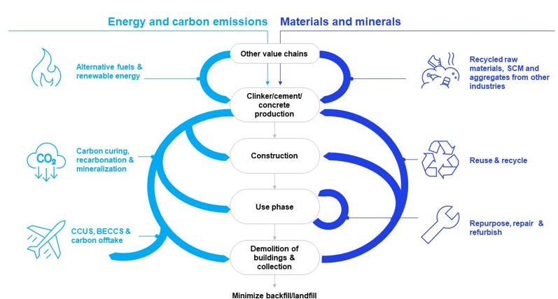
Figure 5. Energy and carbon emission reduction strategies (Jorgen et al., 2022)
Jorgen et al., (2022) provided a framework (Figure 5) to highlight the interconnection between energy and carbon emission reduction strategies and efficient materials and mineral management throughout the lifecycle of cement and concrete production. It emphasizes the use of alternative fuels and renewable energy sources to reduce fossil fuel dependency and greenhouse gas emissions during clinker, cement and concrete manufacturing. The figure also demonstrates the role of carbon curing, recarbonation, mineralization technologies and carbon capture, utilization and storage (CCUS) in mitigating process-related CO₂ emissions. On the materials side, the framework promotes the use of recycled raw materials, supplementary cementitious materials (SCMs) and recycled aggregates obtained from industrial by-products and construction waste. Furthermore, it highlights sustainable practices such as reuse, recycling, repair, refurbishment and repurposing of building materials to extend service life and minimize waste generation. The inclusion of demolition waste recovery and closed-loop material circulation demonstrates the importance of reducing landfill disposal and promoting resource efficiency. Overall, the framework presents a holistic pathway toward low-carbon, resource-efficient and circular cement production aligned with sustainable construction goals.
3.1 Solutions for Air & Noise pollution:
The cement industry’s harmful effects on the environment and human health have led to continuous efforts to reduce pollution caused by industrial activities. Various strategies are being applied to minimize these impacts. One effective method to reduce dust emissions is by frequently spraying water, oil, or other materials that help stabilize the soil, as suggested by (Jadoon et al 2016). This reduces the dust in the air. Additionally, dust emissions can be controlled by maintaining bag house filters properly (Zainudeen et al 2004), which trap dust particles. Electrostatic Precipitators, when designed and operated correctly, can also help minimize dust emissions from cement plants.
Noise pollution is another significant issue in cement manufacturing. To address this, technologies like noise attenuation, absorption, and insulation are used to reduce noise levels (Zhang et al., 2012). Administrative measures, such as rotating workers from noisy to quieter areas, can also help reduce their exposure to harmful noise. In addition, workers can use ear protection such as earplugs and earmuffs. Earplugs can reduce noise by around 30 dBA, while earmuffs can reduce it by 40-50 dBA, helping to protect workers' hearing. Many cement companies already offer ear protection devices to workers and have standard operating procedures (SOPs) in place to manage noise levels in the workplace (Anwar & Afrizalmi, 2016).
Another challenge is the impact of oily wastewater on water systems. To address this, superhydrophobic materials are being used to separate oil from water in cement plants (Gou et al 2020). Several methods are available for producing these materials, such as electrostatic assembly, condensation, anodization, hydrothermal treatment, and plasma treatment, among others. These techniques help in creating materials that can efficiently separate oil and water, improving water quality. However, more work is needed to develop these solutions in a cost-effective, environmentally friendly way.
The carbon footprint of concrete can be reduced by using Portland-Limestone Cement, as it lowers clinker content and thereby reduces CO₂ emissions from calcination and fuel consumption (Zydek & Tanner, 2025).
- Research Gaps and Future Scope
Despite significant progress in sustainable cement technologies, several research gaps remain unresolved. Most studies focus primarily on reducing CO₂ emissions, while limited attention has been given to integrated environmental assessment involving water pollution, biodiversity loss and resource depletion. The long-term durability and large-scale field performance of alternative binders such as geopolymers and recycled cementitious materials are still insufficiently validated under diverse climatic conditions. Furthermore, economic feasibility and industrial scalability of carbon capture and storage technologies remain major challenges, particularly in developing countries.
Future research should focus on the development of low-energy clinker alternatives, AI-assisted process optimization, circular economy integration and hybrid cement systems utilizing industrial and agricultural wastes. More comprehensive life cycle assessment (LCA) studies are required to evaluate the overall sustainability of emerging cement technologies. Additionally, policy-driven frameworks and digital monitoring systems should be explored to support the transition toward carbon-neutral cement production.
- Conclusion
Cement production stands at a critical juncture. While its environmental impacts are severe, the breadth and depth of emerging sustainable solutions presented in this review offer a credible pathway for transformation. The journey from a linear, high-emission model to a circular, low-carbon industry will be complex and capital-intensive, demanding unprecedented collaboration between industry, academia, policymakers, and the construction sector. The imperative is clear: rethinking cement is not merely a technical challenge but a prerequisite for sustainable development. By aggressively pursuing the integrated hierarchy of solutions—from using less, to using better, to capturing the rest—the cement industry can transform itself from a climate problem into a vital part of a net-zero future. The time for incremental improvement has passed; the era of systemic re-invention must begin.

Disclaimer (Artificial intelligence)
Authors hereby declare that NO generative AI technologies such as Large Language Models (ChatGPT, COPILOT, etc.) and text-to-image generators have been used during the writing or editing of this manuscript.
References
- Andrew, R. M. (2019). Global CO 2 emissions from cement production, 1928–2018. Earth System Science Data, 11(4), 1675-1710.
- Anwar, S., & Afrizalmi, L. (2016). An Evaluation of Energy Efficiency in Cement Plants using Data Envelopment Analysis Approach. National IENASCO, 43-49.
- Ashour A., Wang X. & Han B. (Eds.). (2024). Sustainable Concrete Materials and Structures. Elsevier
- Balestra, C. E. T., Dragunski, D. C., Neckel, R. M., Silvestro, L., Savaris, G., & Schneider, R. (2025). Fresh Properties of Low-Carbon Cement Pastes Incorporating Industrial By-Products. Journal of Materials in Civil Engineering, 37(1), 04024443.
- Canfeng, Z., Shujie, Y., & Dong, L. (2012). Comprehensive control of the noise occupational hazard in cement plant. Procedia Engineering, 43, 186-190.
- Chen, G., Lee, H., Young, K. L., Yue, P. L., Wong, A., Tao, T., & Choi, K. K. (2002). Glass recycling in cement production—an innovative approach. Waste Management, 22(7), 747-753.
- Diliberto, C., Lecomte, A., Mechling, J. M., Izoret, L., & Smith, A. (2017). Valorisation of recycled concrete sands in cement raw meal for cement production. Materials and structures, 50(2), 127.
- Ekincioglu, O., Gurgun, A. P., Engin, Y., Tarhan, M., & Kumbaracibasi, S. (2013). Approaches for sustainable cement production–A case study from Turkey. Energy and Buildings, 66, 136-142.
- Gou, X., Zhang, Y., Long, L., Liu, Y., Tian, D., Shen, F., ... & Deng, S. (2020). Superhydrophilic and underwater superoleophobic cement-coated mesh for oil/water separation by gravity. Colloids and Surfaces A: Physicochemical and Engineering Aspects, 605, 125338.
- Habert, G., Miller, S. A., John, V. M., Provis, J. L., Favier, A., Horvath, A., & Scrivener, K. L. (2020). Environmental impacts and decarbonization strategies in the cement and concrete industries. Nature Reviews Earth & Environment, 1(11), 559-573.
- He, Z., Zhu, X., Wang, J., Mu, M., & Wang, Y. (2019). Comparison of CO2 emissions from OPC and recycled cement production. Construction and Building Materials, 211, 965-973.
- Hendriks, C. A., Worrell, E., De Jager, D., Blok, K., & Riemer, P. (1998, August). Emission reduction of greenhouse gases from the cement industry. In Proceedings of the fourth international conference on greenhouse gas control technologies (Vol. 30, pp. 939-944). IEA GHG R&D Programme Interlaken Austria.
- Imbabi, M. S., Carrigan, C., & McKenna, S. (2012). Trends and developments in green cement and concrete technology. International Journal of Sustainable Built Environment, 1(2), 194-216.
- Jadoon, S., A. Ahmad Amin, A. Malik, and H. Kamal. "Soil pollution by the cement industry in the Bazian vicinity, Kurdistan region." J. Environ. Anal. Toxicol 6, no. 1000413 (2016): 2161-0525.
- Jorgen Sandstrom, Yvonne Leung, Sebastian Reiter, & Sarah Heincke. (2022). Circularity: A key enabler to reach net-zero in cement and concrete. World Economic Forum.
- Juenger, M. C., Snellings, R., & Bernal, S. A. (2019). Supplementary cementitious materials: New sources, characterization, and performance insights. Cement and Concrete Research, 122, 257-273.
- Kajaste, R., & Hurme, M. (2016). Cement industry greenhouse gas emissions–management options and abatement cost. Journal of cleaner production, 112, 4041-4052.
- Lehne, J., & Preston, F. (2018). Making concrete change. Innovation in low-carbon cement and concrete, 1-66.
- Miller, S. A., Habert, G., Myers, R. J., & Harvey, J. T. (2021). Achieving net zero greenhouse gas emissions in the cement industry via value chain mitigation strategies. One Earth, 4(10), 1398-1411.
- Miller S. A., Juenger M., Kurtis K. E., & Weiss J. (2024). Cement and Alternatives in the Anthropocene. Annual Review of Environment and Resources, 49.
- Miller, S. A., & Moore, F. C. (2020). Climate and health damages from global concrete production. Nature Climate Change, 10(5), 439-443.
- Miller, S. A., Horvath, A., & Monteiro, P. J. (2018). Impacts of booming concrete production on water resources worldwide. Nature Sustainability, 1(1), 69-76.
- Mohamad, N., Muthusamy, K., Embong, R., Kusbiantoro, A., & Hashim, M. H. (2022). Environmental impact of cement production and Solutions: A review. Materials Today: Proceedings, 48, 741-746.
- Mokhtar, A., & Nasooti, M. (2020). A decision support tool for cement industry to select energy efficiency measures. Energy Strategy Reviews, 28, 100458.
- Oh, D. Y., Noguchi, T., Kitagaki, R., & Park, W. J. (2014). CO2 emission reduction by reuse of building material waste in the Japanese cement industry. Renewable and Sustainable Energy Reviews, 38, 796-810.
- Olivia, M., & Oktaviani, R. (2017). Properties of concrete containing ground waste cockle and clam seashells. Procedia engineering, 171, 658-663.
- Osman, D. A. M., Nur, O., & Mustafa, M. A. (2020). Reduction of energy consumption in cement industry using zinc oxide nanoparticles. Journal of Materials in Civil Engineering, 32(6), 04020124.
- Prošek, Z., Nežerka, V., Hlůžek, R., Trejbal, J., Tesárek, P., & Karra’a, G. (2019). Role of lime, fly ash, and slag in cement pastes containing recycled concrete fines. Construction and Building Materials, 201, 702-714.
- Scrivener, K., Martirena, F., Bishnoi, S., & Maity, S. (2018). Calcined clay limestone cements (LC3). Cement and concrete research, 114, 49-56.
- Song, S., Liu, G., Liu, Z., Liu, J., Teng, J., & Shi, H. (2025). Synergistic Effects of Thermally Converted Sawdust and CO 2 Curing on Cement-Based Materials. Journal of Materials in Civil Engineering, 37(8), 04025251.
- Sousa, V., & Bogas, J. A. (2021). Comparison of energy consumption and carbon emissions from clinker and recycled cement production. Journal of cleaner production, 306, 127277.
- Telschow, S., Frandsen, F., Theisen, K., & Dam-Johansen, K. (2012). Cement Formation A Success Story in a Black Box: High Temperature Phase Formation of Portland Cement Clinker. Industrial & engineering chemistry research, 51(34), 10983-11004.
- Yang Y., Liu Y., Liu L., Liu Z., & Wu H. (2024). Monitoring global cement plants from space. Remote Sensing of Environment, 302, 113954.
- Zainudeen, N., & Jeyamathan, J. (2008, February). Cement and its effect to the environment: A case study in SriLanka. In Proc. from Int. Conf. Build. Educ. Res (pp. 1408-1416).
- Zydek, C. J., & Tanner, J. E. (2025). Reducing the Carbon Footprint of Concrete by Replacing High Volumes of Cement with Limestone Powder. Journal of Materials in Civil Engineering, 37(4), 06025002.

