Original Research Article

Climate change and human displacement: emerging global trends

Abstract
This manuscript examines the impacts of climate change on human displacement caused by natural hazards and environmental processes, including floods, droughts, and global temperature variations.
The study employs a mixed-methods approach that combines quantitative data analysis with qualitative research techniques. Statistical analyses based on official datasets and scientific literature are integrated with simulations and fieldwork data collected in Spain.
The results provide future projections of the effects of climate change on global populations and migration patterns driven by its economic consequences. The spatial and temporal distributions of natural disasters reveal significant geographical inequalities, highlighting the heightened vulnerability of regions in Africa and Asia. A case study of climate-induced migration in southern Spain is also presented. In addition, the manuscript addresses the issue of energy poverty in Europe and especially Bulgaria, offering a comprehensive perspective on both the physical impacts of climate change and their broader societal consequences, particularly for vulnerable populations.
The study concludes that climate-driven mobility is a large-scale, complex, and interconnected process that requires more integrated and coordinated policy responses. In particular, it emphasizes the need to align humanitarian assistance, climate adaptation, and sustainable development strategies, while placing greater emphasis on prevention and anticipatory action.
Keywords: Climate change, Climate migrations, Adaptation, Energy poverty, Spain, Bulgaria

- Introduction
Climate change is intensifying environmental hazards including heatwaves, deteriorating air quality, and flooding. Across many regions, the frequency and intensity of extreme weather events have risen. In a recent publication, Ripple et al. (2024) highlighted the escalating severity of the global climate emergency, warning that the Earth system may be approaching irreversible tipping points. The authors argued that the fundamental conditions sustaining life are increasingly at risk as the climate system enters a critical and highly uncertain phase.
Recent studies have revealed that fossil fuel emissions have reached unprecedented levels and current policy trajectories are projected to result in approximately 2.7°C of warming by 2100 (UNEP, 2023). As emphasized by Ripple et al. (2024), the impacts of climate change are no longer theoretical; rather, they are already manifesting in the form of increasingly frequent and severe disruptions with global consequences.
During the period 2011–2020, global mean surface temperature was approximately 1.09°C above the 1850–1900 baseline (0.95–1.20°C). Warming has been spatially heterogeneous, with greater increases observed over land (1.34–1.83°C) than over the ocean (0.68–1.01°C). The observed rise in temperature is attributable primarily to anthropogenic influences, notably emissions of well-mixed greenhouse gases, dominated by carbon dioxide and methane (IPCC, 2023; UK Met Office, 2026).
Recent observational data further support these trends. Daily sea surface temperature records from the Climate Change Institute at the University of Maine indicate a clear upward trajectory over the past decade, with a pronounced peak in 2025 (Fig. 1) (ClimateAnalyzer1, 2025). A similar pattern is evident in global daily surface air temperatures (Fig. 2) (ClimateAnalyzer2, 2025). These changes are accompanied by a marked decline in daily sea ice extent (Fig. 3) (ClimateAnalyzer3, 2025), (Lindsey et al., 2023).

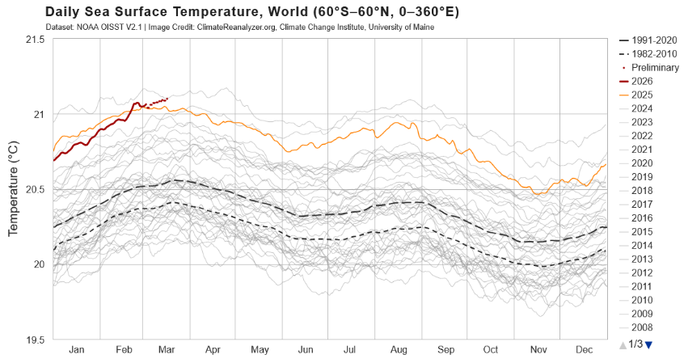
Figure. 1. Daily see surface temperature. Source: ClimateAnalyzer1, (2025).

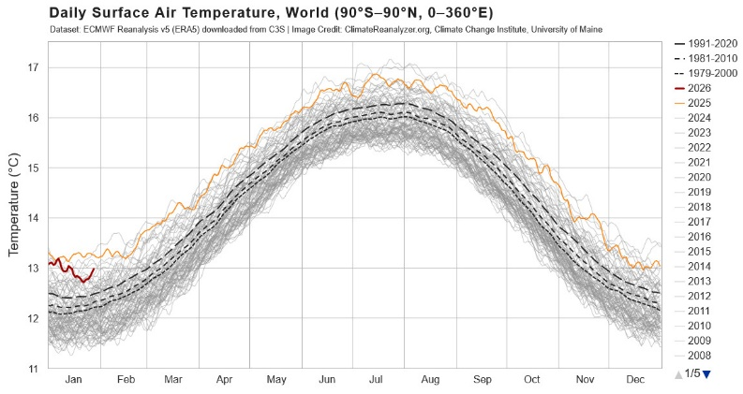
Figure. 2. Daily surface temperature. Source ClimateAnalyzer2, (2025)
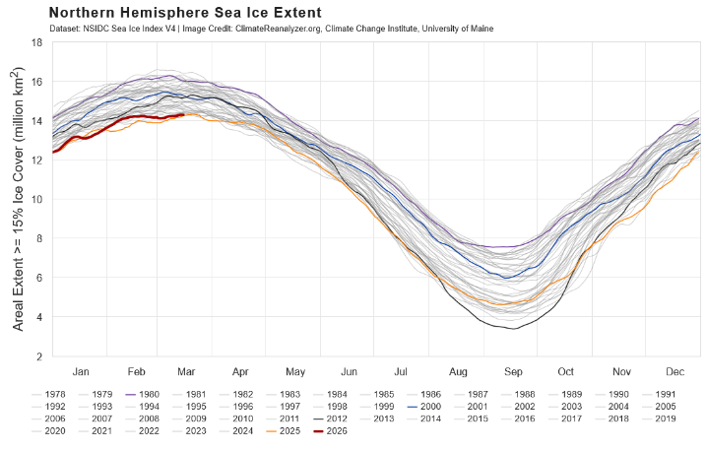
Figure. 3. Northern hemisphere sea ice extent. Source ClimateAnalyzer3, (2025)
Climate change intensifies displacement risks and exacerbates existing vulnerabilities among affected populations. It contributes to food and water insecurity, loss of livelihoods, territorial degradation, and broader environmental decline. These impacts can generate competition over scarce resources, strain social and cultural systems, and deepen economic hardship, ultimately forcing populations to migrate. In certain contexts, such displacement may also contribute to social instability and undermine governance structures. These risks are particularly acute in regions where climate hazards intersect with conflict, resulting in compounded and mutually reinforcing vulnerabilities.
Displacement itself constitutes a critical driver of loss and damage, as it both creates and perpetuates vulnerability beyond directly affected populations. Disruption of livelihoods reduces the capacity of Internally Displaced Persons (IDPs) to generate income, meet basic expenses, and contribute economically. At the same time, displacement increases pressure on housing, healthcare, education, and protection systems, thereby straining already limited resources and public services (WB, 2023; IDMC, 2024).
Looking ahead, climate change is expected to significantly affect access to essential resources, including freshwater, food, and energy. Concurrently, global adaptation and mitigation efforts will increasingly shape development pathways. The interlinkages between climate change and sustainable development are therefore profound, with developing countries, particularly the least developed, bearing a disproportionate share of the associated economic, social, and environmental burdens.
As a step acting towards a mitigation of the climate change, in 2005 the EU designed the so called European Union Emissions Trading System (EU ETS), which is widely regarded as the central instrument of the EU’s climate strategy and a leading example of a large-scale carbon pricing mechanism. It is based on a cap-and-trade framework in which a progressively tightening emissions ceiling is imposed on regulated sectors, while tradable permits grant firms the right to emit a specified quantity of greenhouse gases. By requiring regulated installations to match their verified emissions with allowances, the system embeds a carbon cost into production decisions and promotes cost-effective emission reductions across firms and sectors (Ellerman et al., 2016). Empirical analyses indicate that the EU ETS has delivered measurable emission abatement, largely driven by changes in the energy mix and incremental technological improvements, even during periods of relatively low carbon prices (Bayer and Aklin, 2020). Recent policy developments under the European Green Deal and associated legislative packages further reinforce the system by tightening the emissions cap and broadening its scope. From the other side, the expansion of the EU Emissions Trading System to buildings and road transport is expected to significantly increase household energy and mobility costs, with disproportionate effects on vulnerable population groups. To mitigate these distributional consequences, Regulation (EU) 2023/955 establishing the Social Climate Fund obliges Member States to systematically identify and prioritize populations experiencing energy and transport poverty, with the aim of mitigate the social impacts of the low-carbon transition (Peneva, 2025).
The research objective of the study can be formulated in the following way:
- Examine the impacts of climate change on human displacement and migration driven by natural hazards and environmental processes such as floods, droughts, and rising global temperatures.
- Analyse the spatial and temporal distribution of climate-related natural disasters and identify the regions and populations most vulnerable to their effects,.
- Investigate the socioeconomic consequences of climate change, including climate-induced migration and energy poverty in Europe.
- Integrate quantitative and qualitative research methods and fieldwork data collected in Spain, in order to provide a comprehensive assessment of climate-related mobility.
- Evaluate current challenges associated with climate change and the energy poverty and its quantification based on real data from Europe and from a given country (Bulgaria).
The study is organised as follows: In Section 2 the Methodology used in this paper is explained. Section 3 (Results) is devoted to the climate migration in general (3.1 and 3.2), geographic distribution of the natural hazards (3.3), a particular Spanish case of displaced people from climate hazards (3.4) and the problem of energy poverty in Europe (3.5). Finally Section 4 is devoted to the discussion concerning the results and Section 5 presents the conclusion of the study.

- Methodology
This study adopts a comprehensive methodological framework that integrates quantitative and qualitative techniques. It brings together statistical analyses derived from a range of official datasets and scientific literature with simulations as well as a real situation in Spain.
The analysis of the physical foundations of climate change is grounded in meteorological and oceanographic observations, particularly long-term records of sea surface temperature and sea ice extent. These datasets are sourced from the Climate Change Institute at the University of Maine. The assessment of climate-related migration relies on a mixed-methods approach, combining statistical evaluation of multiple data sources. Primary data are drawn from national authorities responsible for tracking disaster-related displacement and evacuations at national, regional and local scales. In addition, international organizations, non-governmental actors and United Nations agencies involved in humanitarian response contribute with context-specific data on affected populations. A key example is the International Organization for Migration’s Displacement Tracking Matrix.
The study incorporates a broad set of forward-looking global projections addressing climate hazards with implications for human mobility, including extreme heat, drought, wildfires, and riverine flooding. These projections are generated through an ensemble of climate impact models, each designed to simulate distinct physical processes associated with weather and climate extremes. They incorporate as well some tools focused on climate change dynamics and related human mobility. These include the En-ROADS simulator and the internal displacement platform.
A special attention is paid to the problem of energy poverty in Europe by using data from Eurostat, national statistical agencies and data collections. The methodology concerning the energy poverty in Bulgaria has been previously introduced by Peneva (2025). It is based on the definition of an energy-adjusted poverty line obtained from official data corresponding to 2023. The calculations incorporate different indicators related to the householders in Bulgaria, although they do not provide information on the specific regional distribution by district, neither account for energy sources, or household composition.
In parallel, the analysis draws on interviews, during a field work in the area, with local people from Grazalema (Spain), who have suffered severe floods at the beginning of 2026. The interviews have been collected from 10 participants (5 women and 5 men), whose names have been replaced with fictitious ones to ensure anonymity and confidentiality. Participants were recruited through snowball sampling, relying on social connections established during initial contacts. The interviews explored demographic characteristics and impressions of the solution of the crisis.
The maps were produced using Datawrapper software and display the values associated with the different indicators analysed in the study. The corresponding links have been included in the figure captions.
3. Results.
3.1. Effect of the climate change on the population
As early as 1990, the Intergovernmental Panel on Climate Change (IPCC, 2023) identified human mobility as one of the potential major consequences of climate change. According to the analysis, global mean temperature is projected to increase by approximately 1.8°C to 4.0°C by 2099. Large areas are expected to become progressively drier, with the proportion of land experiencing persistent drought rising from about 2% to 10% by 2050. By the end of the century, the extent of regions affected by extreme drought could expand to as much as 30%. At the same time, an intensified hydrological cycle is expected to alter precipitation patterns, increasing the frequency of heavy rainfall events in some regions. Such changes may accelerate soil erosion, heighten flood risks, and contribute to more frequent and severe extreme weather events, including droughts, storms, and floods (Beyer and Milan, 2022; MDP, 2024).
Climate change is expected to intensify environmental pressures in vulnerable regions, with projections suggesting that up to 143 million people in the Global South could be affected by 2050, potentially reshaping patterns of human mobility. A systematic review examining how rising temperatures, water scarcity and drought, and flooding and sea-level rise influence mobility outcomes across the Global South has been recently published (Almulhim.et al. 2024). Other analysis showed that these climate-related stressors have already displaced and affected millions of people, contributing to both internal and cross-border migration (Beyer and Milan, 2022; IDMC, 2024; MDP, 2024; MPI, 2025; MPI, 2026).
- Sea level rise

By 2050, more than one billion people are projected to face risks associated with climate hazards affecting coastal regions. Rapid coastal urbanization, combined with the impacts of climate change, is expected to significantly increase exposure, particularly in Africa, where an estimated more than 200 million people could be at risk from sea-level rise by 2060. Under scenarios in which global temperatures rise between 1.5 and 2.5°C above pre-industrial levels, approximately 430,000 inhabitants of small island developing states may experience permanent inundation by 2100. Nevertheless, many of these areas are likely to become uninhabitable before that point due to the increasing frequency of coastal flooding and progressive soil salinization. In the United States, projected sea-level rise of 0.9 meters by 2100 could expose around 4.2 million people to flooding risk, with this figure potentially increasing to 13.1 million under a higher-end scenario of 1.8 meters of sea-level rise (Beyer and Milan, 2022).

- Floods and Storms

At 2°C of global warming, the population exposed to river flooding is projected to increase by approximately 120%, with this figure potentially rising to 400% under a 4°C warming scenario. However, even in the absence of climate change, exposure to flooding in urban areas is expected to grow substantially by 2030 compared to year 2000, primarily driven by population growth and urbanization. This expansion is particularly pronounced in Africa, where urban areas exposed to frequent flooding are projected to increase by around 270% in North Africa and 800% in Southern Africa. In Indonesia, urbanization between years 2000 and 2030 is anticipated to raise river and coastal flood risks by 76% to 120%, with sea-level rise contributing an additional increase in exposure of 19% to 37% (Beyer and Milan, 2022).

- Extreme Heat

By 2100, it is estimated that approximately 50% of the global population under a low-warming scenario, and up to 75% under a high-warming scenario, could be exposed to periods of extreme heat and humidity that pose significant risks to human survival. In West Africa, potentially lethal heat conditions may occur on as many as 150 days per year at 1.6°C of global warming, while in Central Africa similar conditions could persist for up to 150 days annually at 2.5°C. South Asia is also projected to experience heatwaves that are more intense, more frequent, and longer in duration. Similarly, with 2°C of global warming, roughly half of Europe’s population is projected to experience a very high risk of heat stress during the summer months (Beyer and Milan, 2022).
- Drought

Under a high-warming scenario, climate change is projected to push an additional 65 million people into food insecurity by 2050. At the global level, a 2°C increase in temperatures is expected to raise the number of people exposed to agricultural drought by approximately 370%. Even under a more moderate warming scenario of 1.5°C, the likelihood of extreme agricultural drought is projected to at least double across extensive regions, including South America, the Mediterranean, western China, and high-latitude areas of North America and Eurasia. This risk is expected to intensify further with higher levels of warming, potentially increasing by up to 200% at 2°C and exceeding 200% at 4°C (Beyer and Milan, 2022).

3.2. Climate migration
Climate change is rarely the primary driver of migration, but it is becoming an increasingly important contributing factor. In most cases, environmental pressures rank well below economic motivations in shaping people’s decisions to move, even in countries heavily affected by climate impacts (Huang, 2023). This highlights a central difficulty in assessing the link between climate change and migration. Environmental pressures do influence mobility, but their role is rarely straightforward. Even when disasters lead directly to displacement, the connection to climate change is not always clear. Some hazards, such as earthquakes, are unrelated to climate, and not all extreme events can be attributed to it (Koroutchev, 2025).
The evolution of climate migration has also been reflected in the increasing frequency and intensity of extreme climate events. Since the 1970s, the number of climate-related disasters worldwide has increased by nearly fivefold, while global economic losses associated with these events have exceeded several hundred billion US dollars annually. Rising temperatures, prolonged droughts, declining agricultural productivity, and sea-level rise have progressively intensified migration pressures, particularly in vulnerable regions such as Sub-Saharan Africa, South Asia, and small island developing states (IPCC, 2023; WB, 2023).
Recent publications indicate that climate-related migration is predominantly internal rather than international. Approximately 80–90% of climate migrants relocate within their own countries, often moving from rural areas toward urban centers. In agricultural regions highly dependent on climate-sensitive livelihoods, a reduction of crop yields by 10–20% has been associated with measurable increases in seasonal and permanent migration flows. (IPCC, 2023; WB, 2023 and the references therein)..
Globally, natural disasters trigger more displacement each year than armed conflict, although such movements are usually temporary. By the end of 2022, there were 71.1 million internally displaced persons (IDPs) worldwide, of whom around 12% had been displaced by disasters (Huang, 2023).
Unlike conflict-related displacement, which often prevents safe return, most people forced to move by natural hazards are able to go back once conditions stabilize. Between 2019 and 2022, more than 20 million new displacements linked to natural disasters were recorded annually. However, the majority were short-term, with fewer than 9 million people still living in internal displacement at the end of each year. The number of IDPs caused by disasters between 2014 and 2023 has changed for a variety of reasons. Figure 4 illustrates the IDPs resulting from both weather-related and geophysical hazards over this period, showing a clear upward trend linked to these events (MDP 2024a, b).

Figure 4. IDPs in millions due to climate hazards during 2014-2023. Source C
The displacements for the same period, given by continents and represented in Figure 5, show that Asia experiences the highest number of displacements followed by Africa and the Americas (MDP 2024a, b).
It must be noticed that the average annual weather-related displacements in millions for the period 2012-2021 indicate that East Asia and Pacific and Southern Asia lead in numbers (Beyer and Milan 2022, IOM 2022).

Figure 5. IDPs due to disasters by continent during the period 2014-2023.Source (MDP 2024a, b).
Figure 6 represents IDPs caused by different hazards, highlighting a clear upward trend in flood-related displacements, while storm-related displacements peaked in 2020.

Figure 6. IDPs due to disasters by hazard during 2014-2023. Source (MDP 2024a, b).
According to a World Bank projection (WB, 2023), under a worst-case scenario, up to 216 million people could be forced to move within their own countries by 2050 due to water scarcity and threats to agriculture. However, if governments successfully slow climate change and implement adaptive measures, this figure could fall by as much as 80%, to around 44 million (Figure 7).

Figure 7. Average number of internal climate migrants predicted under different scenarios.
Source: Clement V. at al. (2021).
3.3. Geographic distribution of the Natural Disasters

During the interval between years 2008 and 2024, 22.1k disaster events have been reported with 448.6m displaments produces mainly by flood (213.7m), storm (177.2m), earthqueake (41.4m), drought (5.8m) and wildfire (5m) (Figure 8) (IDMC, 2024; IDMC, 2025).

Figure. 8. Natural disasters around the world in millions for the period 2008-2024. Source: IDMC (2024), IDMC (2025).
In Europe, the most affected countries are among the Mediterranean’s as Greece, Italy and Spain with reported internal displacements as 291k, 199k and 200k respectively represented in the following graphs in Fig. 9. The primary reasons for these disasters are wildfire and storm (Greece), earthquake and storm (Italy) and wildfire and flood (Spain). In contrast, Germany shows 84k internal displacements mainly due to flood disasters (IDMC, 2025).

Figure. 9. Natural disasters in millions in some European countries for the period 2008-2024. Source: IDMC (2024), IDMC (2025).

The above results have been also contrasted with those for different countries from Asia (Afghanistan and Philippines), Africa (Sudan) and South America (Brazil), known with their important natural disasters (Figures 10, 11) (IDMC, 2024; IDMC, 2025).

Figure 10. Natural disasters in millions in some most affected Asian countries for the period 2008-2024. Source: IDMC (2024), IDMC (2025).

The numbers are larger in magnitude compared to Europe. In Afghanistan there were 390 disaster events reported with 2.5m internal displacements caused mainly by flood (1.5m) and earthquake (605k). The situation in Philippines shows 732 disaster events reported with 71.2m displaced mainly due to storm (58.5m) and flood (10.2m). The situation in Sudan shows 142 events reported with 2.2m displaced mainly due to flood. Finally, Brazil has shown 867 disaster events reported for the same period (2008-2024) with 5.4m internal displacements mainly due to flood (3.5m) and storm (1.7m) (Figure 10) (IDMC, 2024; IDMC, 2025).

Figure 11. Natural disasters in millions in Sudan and Brazil for the period 2008-2024. Source: IDMC (2024), IDMC (2025).
Studies revealed that within optimistic scenario, flood-related displacement could rise, with an average annual displacement projected to be two to four times higher than current levels, varying by country. In pessimistic scenarios, the risk intensifies further, potentially increasing by a factor up to nine in Sudan. The results suggest as well that Sudan may see a slight decline in risk of drought displacement, ranging from 5% to 9% under both scenarios. Although Sudan lacks comprehensive empirical data on drought-induced internal displacement, millions of Sudanese are regularly affected by drought events. The findings indicate that, in years of severe drought, between 800,000 and 900,000 people could be displaced (IDMC, 2024a).
In order to complement the study, we employed the World Climate Simulator (Varga et al., 2021; EnRoads, 2025), which blends role-playing with interactive, science-based computer models to emphasize the urgency of climate change challenges. The aim was to estimate the effect of the extreme heat on the population. In Figure 12 the number of dead by extreme heat up to year 2010 has been represented.

Figure 12. Estimation of the number of dead people per 100.000 people/year by extreme heat until 2100 (EnRoads, 2025).

In 2100 the number of deaths per 100.000 persons/year in the case of Southeast Asia are expected to reach 29 (current scenario) and 51 (in baseline), being today 14, followed by Southern Europe 33 (current scenario), 49 (baseline) and 21(today) and Central Europe 23 (current scenario), 34 (baseline) and 13 (today). The smallest number corresponds to Australia 7(current scenario), 10 (baseline) and 5 (today).
3.4. The case of Spain – climate migration from Grazalema
In early February 2026, the municipality of Grazalema (Cádiz, Spain) experienced an extreme rainfall event that led to severe flooding and the temporary evacuation of the entire population. The episode was associated with the storm system “Leonardo,” which produced extraordinary precipitation across the region. Approximately 580 mm of rainfall were recorded within 24 hours, representing a historical record for the area. Within a nine-hour period alone, around 220 mm of rain fell, prompting the activation of a red weather warning for extreme precipitation.
The intense rainfall caused widespread flooding in the municipality. Streets were inundated, water entered homes through floors and electrical outlets, and several roads were closed due to damage or obstruction. Given the high risk of landslides and potential structural damage to buildings, authorities decided to carry out a precautionary evacuation of the entire town. Approximately 1,600 residents were temporarily displaced and relocated mainly to the nearby city of Ronda (Málaga), located about 30 km away. The evacuation was a preventative emergency operation, described as “orderly and phased”. The measure was adopted on February 5, 2026, by the Regional Government of Andalusia, activating the Emergency Plan for Flood Risk (PERI) due to the Storm Leonardo. Residents were asked to leave their homes following the instructions of the security forces. The evacuation was carried out without serious incident, giving priority to vulnerable people (Reuters, 2026).
Although Grazalema is already known as one of the rainiest locations in Spain, this event represented an exceptional episode of accumulated precipitation within a short time period. The high rainfall levels in the area are largely explained by its geographical location and topography. Grazalema is situated within the Sierra de Grazalema mountain range, where moist air masses arriving from the Atlantic Ocean frequently encounter mountainous terrain. As these air masses move inland from the west or southwest, they are forced to rise when reaching the mountains. The upward movement causes the air to cool, leading to condensation and intense precipitation (Figure 13). As a result, the Grazalema meteorological observatory recorded an average annual precipitation of approximately 2,000–2,200 mm. This is considerably higher than in many Spanish cities, such as Madrid (400 mm per year) or Seville (550 mm per year).
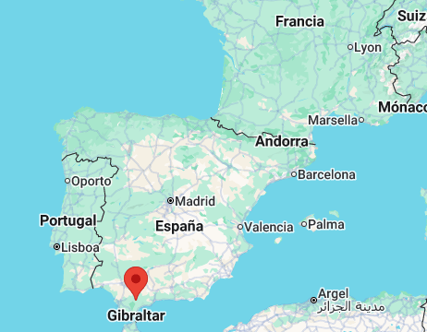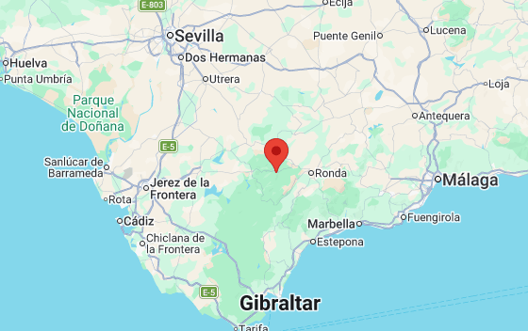
Fig. 13. Google map with the location of Grazalema in southern Spain.
Local geological conditions also influence hydrological processes in the region. The area is dominated by limestone formations typical of karst landscapes. These formations allow water to infiltrate rapidly into the subsurface, creating caves, sinkholes, and underground drainage systems. However, when rainfall intensity exceeds the soil’s infiltration capacity, surface runoff increases significantly, which can lead to flooding and rapid water accumulation. This mechanism contributed to the flooding observed during the February 2026 event.
Testimonies from residents, collected by the author, indicate that the event was perceived as highly unusual despite the region’s long history of heavy rainfall. Local business owners reported temporary closures due to flooding and the need for extensive cleaning and repairs. However, interviewees consistently emphasized the strong sense of community solidarity that emerged following the evacuation.
The testimonies were collected with the prior consent of the participants, and all names have been replaced with fictitious ones to ensure anonymity and confidentiality. Five of the interviewed were women and the other five - men.
María, a 62-year-old resident who has lived in Grazalema her entire life, described the event as unprecedented despite the village’s well-known exposure to frequent rainfall. According to her account, precipitation intensified continuously during the night until water began flowing through the streets. In the early morning hours, residents received warnings advising them to prepare for a possible evacuation. Emergency services later confirmed that the entire municipality would be evacuated as a precautionary measure. María reported that she and her husband quickly gathered essential belongings, including personal documents before leaving their home. They were temporarily relocated to the nearby city of Ronda, where public facilities and hotels were prepared to host evacuees.
Pedro, a 47-year-old bar owner located in the town centre, also experienced significant impacts from the storm. He explained that the event initially appeared to be a typical heavy storm, but rainfall soon intensified to the point that the street drainage system could not cope with the water flow. As a result, water entered his establishment and caused damage, mainly due to mud and flooding inside the premises. The business remained closed for several days while cleaning and repairs were carried out. Pedro noted that the economic impact was significant, although some equipment and furniture were not severely damaged. He emphasized the collective response of the community following the evacuation, with residents helping each other to clean streets, remove damaged items, and provide food and assistance.

3.5. The problem of energy poverty in Europe
The final problem discussed in this article concerns the so called energy poverty, which has emerged as a critical socio-economic and policy challenge across Europe, reflecting the intersection of income inequality, energy market dynamics, and housing conditions. It is commonly defined as the inability of households to secure adequate levels of essential energy services, including heating, cooling, lighting, and electricity for everyday activities. This condition not only constrains living standards but also generates adverse health and social outcomes (Energy statistics, 2024; Energy poverty, 2025).
Across the European Union, energy poverty remains widespread despite recent policy efforts. Recent estimates indicate that approximately 9.2% of EU households are unable to keep their homes adequately warm, corresponding to tens of millions of individuals affected (Energy statistics, 2024; Energy poverty, 2025).
Three structural drivers are typically highlighted by low household income, high energy prices, and poor energy efficiency of dwellings. These factors often interact cumulatively. For instance, low-income households are more likely to reside in inefficient buildings, thereby facing disproportionately high energy costs relative to their income. This dynamic reinforces existing socio-economic inequalities and creates persistent vulnerability.
Spatial disparities are also evident. Energy poverty tends to be more prevalent in Southern and Eastern European countries, where lower average incomes and less efficient housing stocks prevail. Additionally, rural areas frequently exhibit higher levels of vulnerability due to older housing, greater reliance on fossil fuels, and limited access to energy-efficient infrastructure. Certain population groups, including the elderly, low-income households, and tenants in poorly insulated buildings, are particularly exposed (Energy statistics, 2024; Energy poverty, 2025).
As an illustration the energy poverty rate in Europe, corresponding to 2024 is presented in Figure 14 by using Datawrapper software. The spatial inequalities are clearly seen in Southern and Eastern Europe (Energy statistics, 2024).
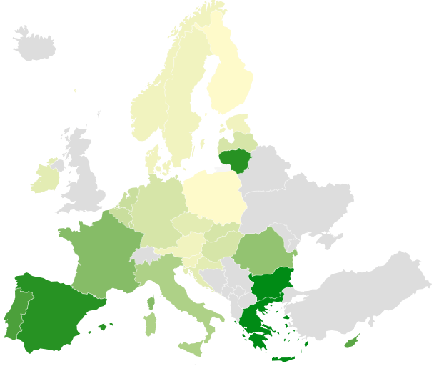
Figure 14. Energy poverty rate in % for EU corresponding to 2024. Own graphical representation with Datawrapper https://datawrapper.dwcdn.net/tBPxY/1/ Source: Energy statistics (2024).

A representation of the energy consumption per capita in EU for 2024 in units of Gigajoules per person is given in Figure 15. As in the previous case, the spatial inequalities are clearly seen in Southern and Eastern Europe (Energy statistics, 2024).
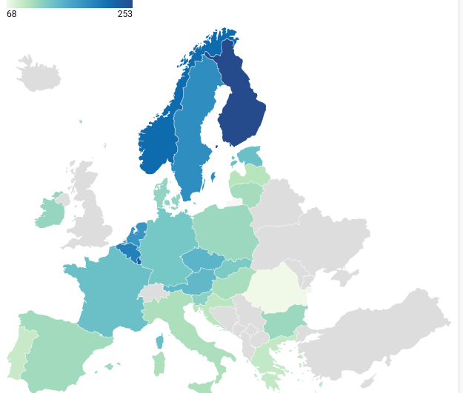

Figure 15 Energy consumption per capita in EU corresponding to 2024. Own graphical representation with Datawrapper https://datawrapper.dwcdn.net/EtIZ3/1/ Source: Energy statistics (2024).
As can be seen, there is a large dispersion among the countries. Although highly populated regions are expected to drive higher energy demand it is not always true. The relationship depends on regional infrastructure, climate, local economy and it is highly non-linear. This is clearly seen in the case of the Scandinavian countries and especially Finland, which counts of 5.66 million people (2025) and has the higher energy consummation in the EU.
Recently, an extensive project related to the energy vulnerability in Bulgaria has introduced an interesting methodology corresponding to quantitative measures by the so called energy vulnerability index (Peneva, 2025; Koroutchev et al. 2026). Its includes three sub-indexes related to: energy needs (days/degrees, householders using gas, diesel, carbon, wood and householders without energy measures), social vulnerability (unemployment coefficient, income, householders with income under the poverty threshold and high levels of mortality during winter) and energy poverty (leaking roof, financial difficulties to maintain normal temperature and financial difficulties to pay bills).
An exhaustive database across the country based on a large list of parameters has been built thus showing the most energy vulnerable regions (Fig. 16).
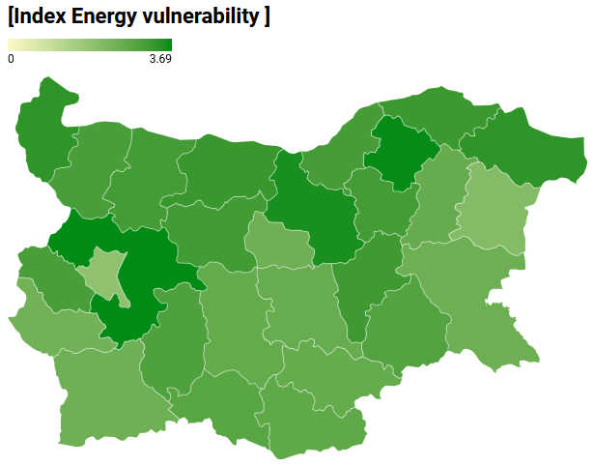
Figure 16. Representation of the energy vulnerability index in Bulgaria. The dark regions are those with the highest values of the index. Own representation by using Datawrapper: https://datawrapper.dwcdn.net/NCEuP/3 Source: Peneva (2025).
A brief explanation of the calculation of the social vulnerability sub index in the case of the region of Vidin (one of the poorest regions) is presented as follows.
The social vulnerability sub-index was calculated by aggregating a set of socioeconomic indicators at the regional level. For the region of Vidin, unemployment in 2023 reached 12%, corresponding to a contribution of 0.12 to the social vulnerability score. The share of households living below the poverty threshold amounted to 34%, contributing 0.34 to the index. Income vulnerability was estimated as the relative distance from the highest regional income level, represented by Sofia (capital region). In the case of Vidin, income levels were 34% lower than those of Sofia, resulting in another contribution of 0.34. Finally, winter mortality in Vidin was 21% higher compared to the rest of the year and thus it is corresponding to a contribution of 0.21.
The social vulnerability sub-index (SVI) for Vidin was obtained by summing the normalized contributions of all above mentioned indicators, i.e. SVI =0.12+0.34+0.34+0.21=1.01. Thus, the resulting social vulnerability index value for Vidin was 1.01. The same methodological procedure was subsequently applied to all regions and to the remaining three sub-indices. Lastly, the values of the sub-indices were aggregated in order to derive the final regional vulnerability index.
As can be seen in Fig. 16, the highest levels of energy vulnerability according to the general energy vulnerability index are observed in North-East and North-Central Bulgaria, while the most numerous vulnerable groups are in the South-West and South-East regions, which combine high shares of households using coal, wood and oil for heating, as well as many households without energy efficiency measures. In these regions, the energy needs index shows above average values ​​for the country, which is directly related to the large number of households in poverty and social vulnerability, especially the elderly and children. The largest number of people receiving heating benefits is in the least populated region, Northwestern Bulgaria, where more than a third of the population is at risk of poverty (Peneva, 2025; Koroutchev et al. 2026).
- Discussion
The findings of this study highlight climate change as a deeply multidimensional process whose impacts extend far beyond environmental degradation, affecting social systems, economic stability, governance structures, and ethical responsibilities across generations. The persistence of atmospheric CO₂ and the inertia of the Earth system, particularly the oceans, reinforce the long-term nature of climate change, implying that current emissions trajectories will continue to shape climatic and societal conditions for centuries. As emphasized by the IPCC (2023), climate change is not only a biophysical phenomenon but also a deeply social process whose impacts are mediated by vulnerability, governance structures, and development pathways.
A central contribution of this research is the demonstration that climate change acts as a catalyst for both sudden and gradual forms of human mobility. Extreme weather events are increasingly associated with abrupt displacement, while slower processes such as desertification, land degradation, and sea-level rise gradually erode livelihoods and habitability. Importantly, these processes do not operate in isolation; rather, they interact with pre-existing socioeconomic vulnerabilities, including poverty, inequality, and governance deficits. This interaction shapes not only the probability of displacement but also the diversity of mobility responses, ranging from forced migration to adaptive and planned relocation strategies. Consequently, climate-related mobility must be understood as a continuum rather than a single category of forced displacement (MDP 2024a, b; Clement V. at al. 2021; IDMC 2024, 2025).
The case of the Grazalema flooding event illustrates the importance of local capacity and governance in managing climate-related hazards. The effective organization and management observed in this case highlight how preparedness, coordination, and institutional responsiveness can significantly reduce the social impacts of extreme events. This example reinforces the argument that adaptive capacity at the local level is a critical determinant of outcomes in climate-induced crises.
In relation to energy vulnerability, the study situates the issue within the broader framework of the European energy transition. Policy responses increasingly focus on structural interventions, including energy-efficient building renovation, expansion of renewable energy systems, and targeted financial support for vulnerable populations. Initiatives such as the European Commission’s Social Climate Fund (SCF 2026) represent an important step toward addressing the distributive consequences of decarbonisation. However, the persistence of energy vulnerability indicates that these measures must be further strengthened and better integrated with broader social protection and climate adaptation policies.
The study’s limitations relate to the relatively small number of interviewees in Grazalema; however, the collective perception of the disaster and its management is still clearly captured and effectively presented. Additional limitations are identified in relation to the analysis of energy poverty. As noted in the methodology section, the study does not include information on the regional distribution of energy-poor households by district, nor does it account for dwelling characteristics, energy sources, or household composition. The research methodology for this issue is still in its early stages and will require further refinement and development in future studies.

5. Conclusions
Climate change represents a highly intricate challenge that spans multiple domains, including scientific understanding, economic systems, social structures, political decision-making, and ethical considerations. Although it is a global phenomenon, its consequences are experienced at the local level and are expected to persist over very long timescales. Carbon dioxide, the main greenhouse gas responsible for contemporary warming, remains in the atmosphere for centuries to millennia, while components of the Earth system, particularly the oceans, respond slowly to temperature increases. As a result, even an immediate cessation of greenhouse gas emissions would not prevent ongoing warming and its associated impacts on future generations.
Climate change is amplifying the frequency and intensity of extreme weather events, thereby increasing the likelihood of abrupt and large-scale population movements. On the other hand, it is also contributing to slow-onset environmental processes such as desertification, land degradation, and sea level rise that progressively undermine livelihoods, weaken resilience, and erode the habitability of affected regions. These gradual changes often interact with existing social, economic, and political vulnerabilities, making mobility decisions more complex and less predictable.
Climate-related mobility is not limited to forced displacement alone, but also encompasses a spectrum of responses, including planned relocation, seasonal migration, and adaptive mobility strategies. This diversity further complicates policy design and implementation, as it requires moving beyond emergency response toward longer-term, development-oriented approaches.
In this context, the scale, diversity, and interconnected nature of climate-induced mobility highlight the inadequacy of existing funding structures, which are often fragmented, reactive, and short-term in scope. Addressing these emerging challenges necessitates a paradigm shift in global financing mechanisms, one that integrates humanitarian assistance with climate adaptation and sustainable development objectives, enhances coordination across sectors and governance levels, and prioritizes anticipatory and preventive action (Huang, L. and Davidoff-Gore, S., 2025).
The interaction between these environmental pressures and pre-existing socioeconomic vulnerabilities further complicates the picture. Factors such as poverty, inequality, governance deficits, demographic pressures, and dependence on climate-sensitive livelihoods can amplify the impacts of environmental change, shaping not only the likelihood of displacement but also the capacity of individuals and communities to adapt. Consequently, climate-related mobility should be understood as a multidimensional and context-dependent phenomenon, encompassing a continuum of outcomes ranging from forced displacement and distress migration to voluntary, planned, and adaptive forms of mobility (Huang, L. and Davidoff-Gore, S., 2025). The example of the Grazalema’s flooding in South of Spain during February 2026 is an example of outstanding organization and management.
Regarding the problem of energy poverty and vulnerability, policy responses at the European level increasingly emphasize structural solutions. These include large-scale investments in building renovation and energy efficiency, expansion of renewable energy systems, and targeted financial support mechanisms for vulnerable groups. Instruments such as the European Commission’s Social Climate Fund aim to mitigate the social impacts of the energy transition and ensure a more equitable distribution of its costs and benefits. Specific methodology has been discussed, which include a rigorous way to quantify the energy vulnerability in the case of Bulgaria by introducing a three stage analysis, which concerned energy needs, social vulnerability and energy poverty. The analysis shows an important dispersion of the values of the energy vulnerability from a minimum value of 1.92 for Sofia capital to a maximal value of 3.69 for Sofia region due to the high concentration of industries and businesses in the capital.
In conclusion, many adaptation efforts need to be implemented at the local level, where both rural areas and cities play a key role. Such measures may include cultivating drought-resistant crops, adopting regenerative farming practices, enhancing water storage and management systems, managing land to lower wildfire risks, and reinforcing infrastructure to better withstand extreme weather events such as floods and heatwaves.
At the same time, effective adaptation requires coordinated action at national and international levels. Governments are responsible for developing policies that guide adaptation and for implementing large-scale strategies. These may involve strengthening or relocating infrastructure in coastal regions threatened by sea-level rise, constructing buildings designed to endure extreme weather, improving early warning and disaster response systems, developing climate-related insurance schemes, and ensuring stronger protection for ecosystems and wildlife (Adaptation 2024).
Acknowledgments: The author thanks Dr. Peneva for introducing him to the energy poverty’s problem. The study is partially supported by the Bulgarian Scientific Fund under project № КП-06-Н95/2 (ACTETS2).

Disclaimer (Artificial intelligence)

During the preparation of this work, the author used ChatGTP in order to improve the readability. After using this tool, the author reviewed and edited the content.

References
Adaptation (2024) What is climate change adaptation and why is it crucial? https://climatepromise.undp.org/news-and-stories/what-climate-change-adaptation-and-why-it-crucial
Almulhim, A. I. et al. (2024). Climate-Induced Migration in the Global South: An In-Depth Analysis, Climate Action, 3(47). https://www.nature.com/articles/s44168-024-00133-1?fromPaywallRec=false
Bayer, P. and Aklin, M. (2020). The European Union Emissions Trading System reduced CO₂ emissions despite low prices. Proceedings of the National Academy of Sciences, 117(16), pp. 8804–8812.
Beyer, R. and Milan, A. (2022). Climate change and future human mobility, IOM Global Data Institute, https://publications.iom.int/books/people-move-changing-climate-linking-policy-evidence-and-action.
Clement, V. et al. (2021). Groundswell Part 2: Acting on Internal Climate Migration, (Washington, DC: World Bank).
ClimateAnalyzer1 (2025). Daily sea surface temperature (world). https://climatereanalyzer.org/clim/sst_daily/?dm_id=world2
Climate Reanalyzer2 (2025). Daily sea ice extent (Northern Hemisphere). https://climatereanalyzer.org/clim/seaice_daily/?nhsh=nh
Climate Reanalyzer3 (2025). Daily sea ice extent (Northern Hemisphere). https://climatereanalyzer.org/clim/seaice_daily/?nhsh=nh
Ellerman, A. D., Marcantonini, C. and Zaklan, A. (2016). The European Union Emissions Trading System: Ten years and counting. Review of Environmental Economics and Policy, 10(1), pp. 89–107.
Energy poverty (2025). European Commission https://energy.ec.europa.eu/topics/markets-and-consumers/energy-consumers-and-prosumers/energy-poverty_en
Energy statistics (2024). Energy statistics - an overview (2024). Eurostat. https://ec.europa.eu/eurostat/statistics-explained/index.php?title=Energy_statistics_-_an_overview
En-Roads (2025). Climate Interactive & MIT Sloan School of Management. En-ROADS Simulator (Version 25.1.0) Climate simulation software. https://en-roads.climateinteractive.org/scenario.html?v=25.1.0&p1=75&p16=-0.04&p50=1.4
Eurostat (2024). Residential stock by energy source for 2023, https://ec.europa.eu/eurostat/statistics-explained/index.php?title=Energy_statistics_-_an_overview
Huang, L. (2023). Climate migration 101: An explainer. Migration Policy Institute. https://www.migrationpolicy.org/article/climate-migration-101-explainer

Huang, L. and Davidoff-Gore, S. (2025). Funding Climate Mobility Projects Key Players and Strategies for Growth, MPI Brief, https://www.migrationpolicy.org/research/funding-climate-mobility-projects?eType=EmailBlastContent&eId=8d66dd74-b65c-406a-846e-f98f2415c4a5
IDMC (2024). Internal Displacement Monitoring Centre. Global internal displacement database. https://www.internal-displacement.org/database/displacement-data/
IDMC (2024a). Internal Displacement Monitoring Centre. Estimating displacement risk using data-driven approaches: Flood and drought displacement risk in the Horn of Africa. https://story.internal-displacement.org/estimating-displacement-risk-using-data-driven-approaches-flood-and-drought-displacement-risk-in-the-horn-of-africa/
IDMC (2025). Global Report on Internal Displacement 2025. Internal Displacement Monitoring Centre. https://doi.org/10.55363/IDMC.XTGW2833
IPCC, (2023). Sections. In: Climate Change 2023: Synthesis Report. Contribution of Working Groups I, II and III to the Sixth Assessment Report of the Intergovernmental Panel on Climate Change [Core Writing Team, H. Lee and J. Romero (eds.)]. IPCC, Geneva, Switzerland, pp. 35-115, doi: 10.59327/IPCC/AR6-9789291691647
Khanh Doan, M. et al. (2023). Counting People Exposed to, Vulnerable to, or at High Risk From Climate Shocks. A Methodology, World Bank Group, Poverty and Equity Global Practice & Climate Change Group
Koroutchev, R. (2025). Sustainability and Climate Change: From Climate Migration to Education, Int.. J. of Soc. Science and Human Research, 8(8), pp. 6385-6396, https://ijsshr.in/v8i8/74.php
Koroutchev, R. et al. (2026). Geographical analysis of the energy poverty in Europe: the case of Bulgaria, in the Proceedings of EUROGEO 2026 Int. Conference, Tilburg, Netherlands.
Lindsey, R. et al. (2023). Climate.gov. Climate change: Global sea level. https://www.climate.gov/news-features/understanding-climate/climate-change-global-sea-level
MDP (2024). Environmental migration and statistics. Migration Data Portal. https://www.migrationdataportal.org/themes/environmental_migration_and_statistics_old
MDP (2024a). Climate Mobility Impacts, Migration Data Portal, https://www.migrationdataportal.org/climate-mobility-impacts
MDP (2024b). Internal Displacement Monitoring Center, https://www.internal-displacement.org/database/displacement-data/; https://www.migrationdataportal.org/themes/environmental_migration_and_statistics
MPI (2025). Migration Policy Institute. Special issue: Climate change and migration. https://www.migrationpolicy.org/programs/migration-information-source/special-issue-climate-change-and-migration
MPI (2026). Migration Policy Institute. Changing Climate, Changing Migration [Podcast]. https://mpichangingclimatechangingmigration.podbean.com/
Peneva, T. (2025). Mapping Energy Vulnerability of Households in Bulgaria, Economic Studies journal, Bulgarian Academy of Sciences - Economic Research Institute, issue 5, pp. 3-26, https://ideas.repec.org/a/bas/econst/y2025i5p3-26.html
Reuters (2026). Storm Leonardo forces evacuations in Spain and Portugal with more rain on the way, https://www.reuters.com/sustainability/land-use-biodiversity/more-storms-coming-leonardo-swells-rivers-bursts-aquifers-spain-portugal-2026-02-06/
Ripple, W. et al. (2024). The 2024 state of the climate report: Perilous times on planet Earth, BioScience, 74(12) 812–824, https://doi.org/10.1093/biosci/biae087
SCF (2026). Social Climate Fund, https://employment-social-affairs.ec.europa.eu/policies-and-activities/funding/social-climate-fund_en
UK Met Office. (2026). Current global warming. https://climate.metoffice.cloud/current_warming.html
UNEP (2023). United Nations Environment Programme, Emissions Gap Report 2023: Broken Record: Temperatures Hit New Highs, yet World Fails to Cut Emissions.
Varga, R. et al. (2021). Building consensus for ambitious climate action through the World Climate simulation. Earth's Future, 9, e2021EF002283, https://doi.org/10.1029/2021EF002283
WB (2023). Climate shocks: Estimates of people exposed, vulnerable, and at high risk, https://www.preventionweb.net/news/climate-shocks-estimates-people-exposed-vulnerable-and-high-risk

