Original Research Article

An Assessment of Local Governance Procedures and Urban Housing Stakeholders’ Actions in Bamenda, Northwest Region of Cameroon

.
ABSTRACT
Background: Urban housing challenges have intensified due to rapid urbanisation and weak governance systems. This study critically examines local governance procedures and urban housing stakeholders’ actions in Bamenda, Cameroon, within the context of decentralisation policy implementation.
Aim: The research assesses the effectiveness of various stakeholders’ actions in achieving sustainable urban housing standards and evaluates differences in their approaches.
Study design: A mixed-method approach was employed, combining quantitative and qualitative data.
Place and Duration of Study: The study was conducted in Bamenda, the largest city and regional headquarters of the Northwest Region of Cameroon, from June 2023 to August 2024.
Methodology: Relevant data were obtained from primary and secondary sources. Primary sources made use of surveys of 520 respondents, key informant interviews and spatial analysis. Secondary data sources included municipal records, government policy documents, NGO reports and academic publications related to the subject matter.
Results: Findings reveal that the Bamenda City Council emerges as the most dominant stakeholder (41.73%), with combined stakeholder approaches showing the highest success rates of 34.91%. The evolution of stakeholder actions from 2010-2024 demonstrates a shift from material prescription strategies (70.83% pre-2010) to enforcement-based approaches, with strict supervision increasing to 42.45% between 2016 and 2020. Major barriers include insufficient funding, lack of political will, and poor coordination.
Conclusion: The study concludes that enhanced stakeholders’ coordination, increased funding mechanisms and strengthening of community participation could improve urban housing outcomes in the context of decentralisation.

Keywords: Urban housing, local governance, decentralization, stakeholder actions, urban planning, housing standards

1. INTRODUCTION

Urban housing provision in sub-Saharan Africa faces unprecedented challenges as cities experience rapid population growth without commensurate infrastructure development. Affordability remains a critical concern, as a substantial portion of the urban population cannot access formal housing due to high costs and inadequate financing mechanisms. Similarly, accessibility challenges persist, with low-income households frequently marginalised from formal housing schemes, while sustainability considerations are often compromised by short-term planning horizons and the prevalence of informal construction practices (Kombe, 2022; Uduokhai et al., 2023). The United Nations projects that Africa's urban population will triple by 2050, placing enormous pressure on existing housing stock and urban services (UN-Habitat, 2008). In Cameroon, urbanisation rates have accelerated since the 1990s, with cities like Bamenda experiencing significant demographic and spatial expansion that often outpaces planning capacity and governance systems (Maluh et al., 2020).
The concept of local governance has gained prominence in urban development discourse, particularly through decentralisation policies aimed at bringing decision-making closer to communities. Local governance encompasses the formal and informal institutions, processes, and relationships through which local actors articulate their interests, exercise their rights, and mediate their differences at the community level (Kelkar, 2022). In the context of urban housing, local governance involves multiple stakeholders, including municipal authorities, government agencies, non-governmental organisations, and community members, working collectively to address housing challenges (Szemző et al., 2019).
Contemporary research emphasises the critical role of stakeholder engagement in urban housing governance. Studies from different African contexts demonstrate that effective housing outcomes depend on inclusive participation of diverse actors in decision-making processes. Jacobs and Baud (2016) examined stakeholder politics and knowledge use in the N2 Gateway housing project in Cape Town, revealing how power dynamics among different actors influence housing delivery outcomes. Similarly, Somers and Baud (2013) analyzed citizen participation in Brazil's Minha Casa, Minha Vida housing program, highlighting the importance of local decision-making processes in housing project success.
The stakeholder approach to urban housing governance recognizes that housing provision involves multiple actors with varying interests, capacities, and responsibilities. These stakeholders include formal institutions such as municipal councils and government agencies, as well as informal networks involving traditional authorities, community organizations, and private sector actors. Understanding how these stakeholders interact, coordinate their actions, and achieve housing outcomes is crucial for improving urban governance effectiveness (Mhlongo et al., 2024). Research from Malaysia demonstrates that exploring housing governance requires comprehensive understanding of multi-stakeholder interactions and institutional frameworks (Teoh et al., 2018).
Cameroon's decentralisation process, initiated through the 1996 Constitution and operationalized through Laws No. 2004/17 and 2004/18, transferred significant responsibilities to local government councils, including urban planning and housing development oversight. The issue of decentralisation is one of the most pressing topics in modern public administration, as it directly affects the development of local communities, ensuring their financial autonomy and democratisation of the management process. Decentralisation is a crucial instrument for modernising the governance mechanism, promoting the strengthening of local self-government and community development (Monastyrskyi et al., 2025). This decentralisation framework created opportunities for enhanced local autonomy in addressing housing challenges while maintaining alignment with national development policies (Ngoran & Mougoue, 2021). However, research suggests that the effectiveness of these decentralized governance arrangements varies considerably across different urban contexts, with secondary cities like Bamenda facing particular challenges in translating decentralization policies into improved urban outcomes (Nange & Ozturen, 2022).
Bamenda city has witnessed rapid spatial expansion characterized by informal settlements, inadequate infrastructure, and substandard housing conditions (Akenji & Neba, 2025). The proliferation of unplanned neighborhoods, environmental degradation, and limited access to basic urban services reflect broader governance challenges in managing urban growth effectively. Recent studies indicate that housing practices and policy implementation in Bamenda continue to face obstacles, with persistent issues of substandard construction and inadequate regulatory enforcement (Maluh, 2024).
Despite the implementation of decentralization policies and involvement of multiple stakeholders, Bamenda continues to experience significant housing challenges. These include the proliferation of substandard housing structures, inadequate enforcement of building codes, limited access to serviced land, and insufficient provision of basic urban infrastructure (Maluh et al., 2020). The persistence of these challenges raises important questions about the effectiveness of current governance arrangements and stakeholder actions in addressing urban housing needs. Land tenure practices have been identified as a particular constraint, with informal land acquisition processes contributing to substandard housing development patterns (Akenji & Neba, 2025).
The theoretical framework for this study draws from governance theory, stakeholder theory, and decentralization literature. Governance theory emphasizes the importance of institutional arrangements, power relationships, and coordination mechanisms in achieving development outcomes (UN-Habitat, 2010). Stakeholder theory focuses on how different actors with varying interests and capacities interact to influence policy outcomes, while decentralization theory examines how the transfer of authority and resources from central to local levels affects service delivery and development outcomes.
The global policy framework, particularly the New Urban Agenda adopted at Habitat III, emphasizes the need for inclusive urban governance approaches that engage multiple stakeholders in addressing housing challenges (United Nations, 2016). The Agenda recognizes housing as a central component of sustainable urban development and calls for enhanced local governance mechanisms to improve housing outcomes (United Nations, 2015). This international framework provides important context for examining local governance effectiveness in addressing urban housing challenges using Bamenda city as a case study.

2. material and methods

2.2.1 Study Area

Bamenda is the largest town in the North West Region of Cameroon and serves as the regional headquarters. It is located between latitudes 5°51’0’’ and 6°3’0’’ North of the Equator and longitudes 10°3’0’’ and 10°15’0’’ East of the Greenwich Meridian. It is bounded to the North by Tubah Subdivision, to the South by Santa Subdivision, to the West by Mbengwi Sub-division, to the South West by Bali Subdivision and to the North East by Bafut Subdivision. The urbanscape of Bamenda has three administrative regions namely; Bamenda I, Bamenda II and Bamenda II Sub-divisions (Image. 1).

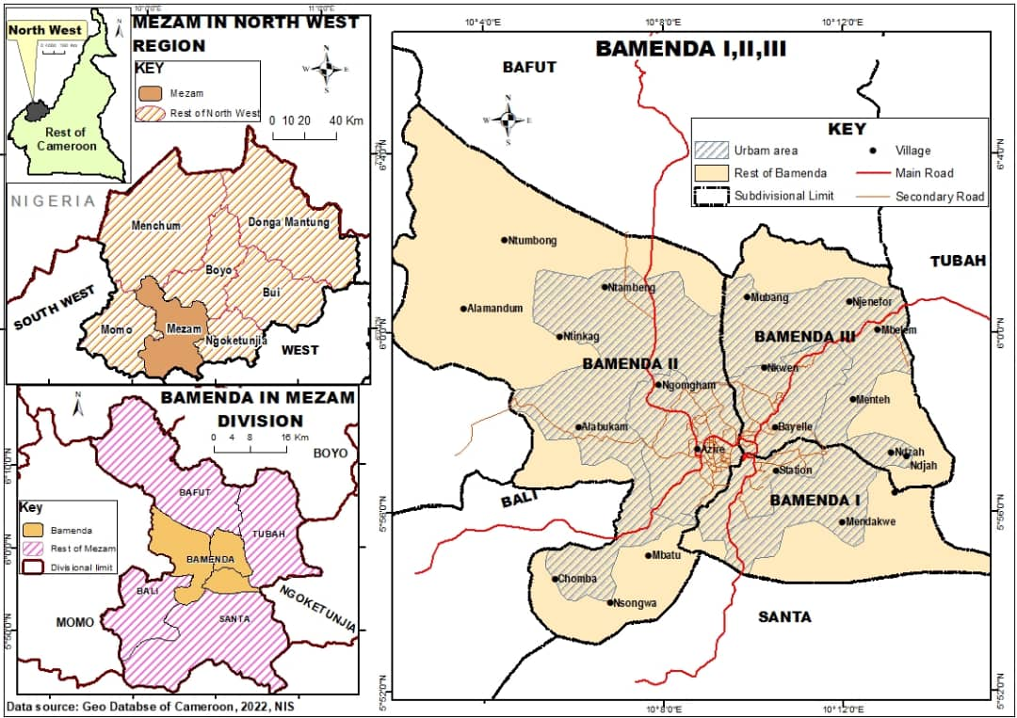
Image 1: Location of Bamenda municipality in the Northwest Region of Cameroon
Source: Mbaku (2025)

2.2 Research Methods
The study employed a mixed-methods approach, combining quantitative and qualitative research techniques to provide comprehensive insights into local governance procedures and stakeholder actions in urban housing. This methodological approach enabled a triangulation of data sources and validation of findings through multiple perspectives.
Data collection consisted of primary and secondary data sources. Primary data collection involved structured surveys, key informant interviews and spatial assessment of local government and stakeholder actions in the various municipalities between June 2023 and August 2024. A total of 520 respondents were surveyed using a stratified random sampling approach. The sample included household heads, community leaders, municipal officials and representatives of various stakeholder organizations. Key informant interviews were conducted with purposively selected participants, including municipal officials, government agency representatives, NGO leaders, traditional authorities and urban planning professionals. These interviews provided in-depth insights into governance procedures, stakeholder relationships and housing policy implementation challenges.
Secondary data sources included municipal records, government policy documents, NGO reports and academic publications related to urban governance and housing in Cameroon. Spatial data was obtained from municipal planning departments and satellite imagery analysis to understand urban growth patterns and housing development trends.
Numerical data was analyzed using Statistical Package for Social Sciences (SPSS) version 28.0. Descriptive statistics were employed to present the challenges faced in decentralised housing process and urban housing planning, the local urban housing stakeholders involved, their actions and success rates and the evolution of stakeholder actions in urban housing standards in Bamenda (2010-2024). Qualitative data from interviews was analyzed using thematic analysis to identify patterns, challenges and prospects in urban housing governance procedures and stakeholder actions. Spatial analysis was conducted using Geographic Information Systems (GIS) to map the land use zoning of the Bamenda urbanscape showing built-up areas across different areas of the city. This spatial dimension provided important insights into the geographical distribution of governance challenges and stakeholder interventions.

3. results

3.1 Local Governance Structure in Bamenda
The implementation of decentralization in Bamenda operates through a multi-tiered governance structure with the Bamenda City Council (BCC) serving as the central coordinating institution. The BCC oversees municipal development across the three sub-divisions, each headed by elected mayors and municipal councilors chosen through democratic process This governance arrangement provides a framework for local autonomy while maintaining alignment with regional and national policies. The BCC's responsibilities encompass urban planning and infrastructure management, public service provision including water supply and waste management, economic development and law enforcement coordination with security agencies. These functions position the BCC as a critical actor in urban housing governance, with direct authority over building permits, land use planning, and infrastructure development. Analysis of decentralization effectiveness reveals significant spatial variations across Bamenda's urban landscape, as illustrated in the land use zoning map (Fig. 1). The spatial distribution demonstrates the complex relationship between urban development patterns and governance effectiveness across different zones of the city.
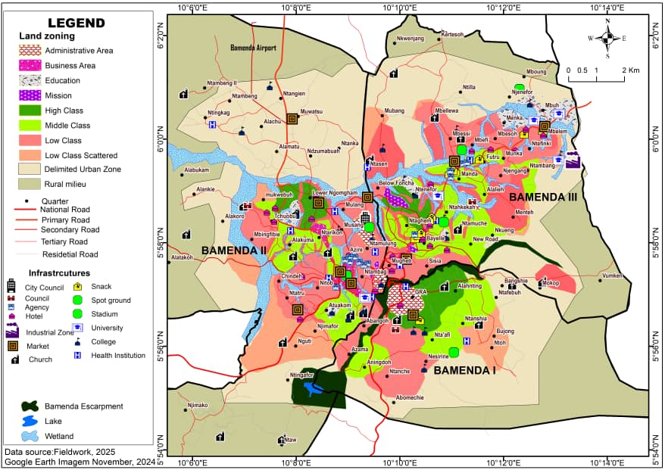
Figure 1: Land Use Zoning Map of the Bamenda Urbanscape
Source: Bamenda City Council (BCC), 2025

Figure 2 reveals a clear spatial hierarchy of decentralization effectiveness across Bamenda, with approximately 25% of the city area classified as high-performing areas concentrated in the urban core and established neighborhoods that benefit from better infrastructure, institutional presence, and civic engagement. About 45% of the city area shows moderate effectiveness, occurring within transitional areas and developing settlements, representing areas of ongoing institutional development and opportunities for targeted interventions. The remaining 30% of the city area, predominantly peripheral zones and informal settlements, exhibits low effectiveness, highlighting the persistent challenge of extending quality decentralized services to marginalized communities and demonstrating how urban development patterns directly influence governance outcomes, creating spatial inequities that require deliberate policy interventions to ensure inclusive and equitable decentralization across all areas of the city.

The challenges faced by local stakeholders in implementing decentralization housing policies provide important insights into the operational difficulties encountered in practice. These challenges reflect the complex realities on the ground and indicate areas requiring targeted intervention for improved housing governance outcomes (Figure 3).

Figure 2: Challenges faced in the decentralisation housing process by local housing stakeholders in Bamenda
Source: Fieldwork (June 2023–August 2024)

The analysis reveals that insufficient funding emerges as the greatest problem encountered in implementing decentralization policy in Bamenda by local housing stakeholders, as the potentials for decentralization were transferred but money held back, especially for councils with peculiar challenges requiring more funding. This was followed by poor habits of inhabitants who often refuse to give up their lands for development projects even with promised adequate compensation, constituting one of the greatest impediments to effective implementation. Other significant challenges include bribery and corruption, non-mastery of the decentralization process by mayors, absence of effective control by the Ministry of Decentralisation and Local Development (MINDDEVEL), state dominance where the central government still has a grip to power in Yaoundé, institutional conflicts, and poor sensitization methods by local council authorities. These challenges work collectively against improved urban housing standards within the context of local governance, creating a complex web of constraints that require comprehensive policy responses addressing both institutional capacity and resource allocation issues.

3.2 Urban Housing Stakeholders

The study identified multiple stakeholders involved in urban housing governance in Bamenda, each with distinct roles and capacities. Understanding the distribution of stakeholder involvement provides important insights into the governance landscape and power dynamics in housing provision (Table 1).

Table 1: Local Urban Housing Stakeholders in Bamenda city
Stakeholders | Frequency | %
Bamenda City Council | 217 | 41.73
Bamenda Sub-Divisional Councils | 20 | 3.85
Regional Delegation of Housing & Urban Development | 90 | 17.31
NGOs | 49 | 9.42
The community | 47 | 9.04
All of the above | 97 | 18.65
Total | 520 | 100.0
Source: Fieldwork (June 2023–August 2024)

The situation in Table 1 reveals that the Bamenda City Council (BCC) emerges as the most dominant stakeholder, representing 41.73% involvement in housing issues, reflecting its statutory mandate under decentralization laws and its comprehensive authority over urban development including building permits, land use planning, and infrastructure provision. The Regional Delegation of Housing and Urban Development follows with 17.31%, representing the Ministry of Housing and Urban Development's regional presence and demonstrating the continued importance of national government agencies in local housing governance through technical expertise, policy guidance, and regulatory oversight. The significant presence of collaborative approaches involving "All of the above" stakeholders (18.65%) indicates recognition of the complex, multi-faceted nature of housing challenges that require integrated responses from multiple actors working together. Non-Governmental Organizations account for 9.42% of stakeholders involvement, with examples including Love for Humanity Organization (LHO) at Mile 3 Nkwen, Helping Hands International (HHI) at Mile 4 Nkwen, SHUMAS Cameroon at Mile 5 Nkwen, and Fuller Centre for Housing, demonstrating the important role of civil society in addressing housing needs through direct service provision and advocacy. Community-based actors represent 9.04% of stakeholder involvement, reflecting grassroots participation in housing governance, while the three sub-divisional councils (Bamenda I, II, and III) account for only 3.85%, suggesting limited capacity or engagement at the sub-municipal level despite their proximity to communities and potential for localized interventions.

3.3 Urban Housing Planning Challenges
Planning for urban housing in Bamenda faces multiple interconnected challenges that impact housing development outcomes. The nature and magnitude of these challenges are crucial for developing effective interventions and policy responses as indicated in Table 2.

Table 2: Challenges in Planning Urban Housing Bamenda
Planning Challenges | Frequency | %
Lack of comprehensive master plan | 125 | 24.04
Inadequate zoning regulations | 98 | 18.85
Uncontrolled urban sprawl | 87 | 16.73
Poor road network | 76 | 14.62
Insufficient public space allocation | 65 | 12.50
Weak enforcement of building codes | 48 | 9.23
Limited technical expertise | 21 | 4.04
Total | 520 | 100.0
Source: Fieldwork (June 2023–August 2024)

The result in Table 2 shows that most urban housing challenges in Bamenda is the lack of a comprehensive master plan (24.04%), which serves as the foundational framework for organized urban development and whose absence creates cascading problems throughout the planning system. This is followed by inadequate zoning regulations (18.85%), which contribute to mixed land use patterns and conflicts between residential, commercial, and industrial activities, making it difficult to ensure appropriate development standards and service provision. Uncontrolled urban sprawl accounts for 16.73% of the challenges, reflecting the city's rapid expansion without proper planning controls, leading to uncontrolled development patterns that are expensive to service and difficult to regulate. Poor road network (14.62%) and insufficient public space allocation (12.50%) further compound urban housing development problems by limiting accessibility and reducing livability standards. Weak enforcement of building codes (9.23%) explains the prevalence of substandard structures throughout the city, while limited technical expertise (4.04%) represents a critical constraint for effective planning implementation, though its relatively low percentage may reflect underestimation of this fundamental capacity issue.
The urban housing planning process involves multiple stakeholders, each bringing different perspectives and capacities to the planning framework. Understanding stakeholder involvement patterns provides insights into the collaborative nature of planning and potential areas for strengthening participation (Fig. 3).

Figure 3: Stakeholders involved in the urban housing planning process in Bamenda
Source: Fieldwork (June 2023–August 2024)

Findings in Figure 3 show that the Bamenda City Council Planning Department is the most dominant stakeholder in urban planning processes (30.00%), reflecting its statutory mandate for local planning coordination and its central role in translating policy into implementation. The Regional Delegation of Housing & Urban Development follows with 18.27%, demonstrating the significant role of national government representation in local planning and the continued importance of its oversight in decentralized systems. Traditional Authorities contribute 15.00% to planning processes, highlighting the importance of customary land tenure systems and cultural considerations in urban development, particularly in contexts where formal and informal land systems coexist. Private Urban Planners/Consultants account for 12.12%, indicating the growing involvement of technical expertise from the private sector and the recognition of specialized skills needed for effective planning. Community Representatives (10.38%) show moderate participation, though this low level suggests significant room for improvement in participatory planning approaches and greater community engagement. The Ministry of Public Works (8.08%) and Academic Institutions (6.15%) represent smaller but important technical and research contributions to the planning process, providing specialized knowledge and capacity for evidence-based planning decisions.

3.4 Stakeholder Actions in Urban Housing Standards

An assessment of stakeholder actions reveals diverse approaches to addressing urban housing standards in Bamenda (Table 3). Understanding the specific strategies employed by different stakeholders provides insights into governance approaches and their relative emphasis on different intervention mechanisms.

Table 3: Stakeholder Actions in Urban Housing Development in Bamenda
Action | Frequency | %
Strict supervision of building constructions | 106 | 20.4
Demolition of substandard houses | 38 | 7.3
Implementation of non-land reclamation regulations | 3 | 0.6
Implementation of fines & sanction for building without a building permit | 104 | 20.0
Prescription of materials and cost for new buildings at specified locations | 24 | 4.6
All of the above | 160 | 30.8
None of the above | 85 | 16.3
Total | 520 | 100
Source: Fieldwork (June 2023–August 2024)

The findings in Table 3 reveal that despite the existence of different stakeholders’ actions like strict supervision of building constructions, demolition of substandard houses and Implementation of fines and sanction for building without a building permit, a combination of strategies represents the most dominant action taken by stakeholders towards achieving sustainable urban housing in Bamenda city (30.8%).

3.5 Evolution of Stakeholder Actions (2010-2024)

The temporal analysis reveals significant evolution in stakeholder approaches to urban housing standards over the past fourteen years. Understanding this evolution provides important insights into learning processes, policy adaptations and changing priorities in housing governance (Table 4).

Table 4: Evolution of Stakeholder Actions in Urban Housing Standards in Bamenda (2010-2024)
Periods | Actions taken to achieve standard housing
Periods | Strict supervision of building and construction |  | Demolition of substandard houses |  | Implementation of fines & sanctions |  | Materials and cost for new buildings
Periods | F | % | F | % | F | % | F | %
Before 2010 | 15 | 14.15 | 0 | 0.00 | 19 | 18.27 | 17 | 70.83
Between 2010-2015 | 12 | 11.32 | 23 | 60.53 | 18 | 17.31 | 0 | 0.00
Between 2016-2020 | 45 | 42.45 | 15 | 39.47 | 41 | 39.42 | 0 | 0.00
Between 2021-2024 | 7 | 6.60 | 0 | 0.00 | 26 | 25.00 | 0 | 0.00
Don't know | 27 | 25.47 | 3 | 7.89 | 0 | 0 | 7 | 29.17
Total | 106 | 100 | 38 | 100 | 104 | 100 | 24 | 100
Source: Fieldwork (June 2023–August 2024)
The analysis reveals transformations in stakeholder approaches across different time periods, reflecting evolving of effective housing governance strategies and changing contextual conditions. Before 2010, the dominant strategy was prescribing building materials and costs for new constructions (70.83%), reflecting a more advisory and facilitative approach to housing standards enforcement, with limited emphasis on strict supervision (14.15%) and no reported demolitions of substandard structures. Between 2010-2015, a dramatic policy shift occurred toward more assertive enforcement approaches, with demolition of substandard housing peaking at 60.53% of actions, indicating significant commitment to direct intervention and quality control, while implementation of heavy fines and sanctions remained relatively stable at 17.31% and strict supervision decreased to 11.32%. The period 2016-2020 marked another significant evolution, with strict supervision of building construction becoming the dominant approach at 42.45%, reflecting emphasis on preventive oversight rather than reactive demolition, while demolition activities decreased to 39.47% and heavy fines and sanctions increased to 39.42%, suggesting a more balanced approach combining prevention with enforcement. From 2021-2024, implementation of heavy fines and sanctions emerged as the primary strategy (25.00%), with strict supervision declining to 6.60% and no demolition activities reported, suggesting either improved compliance, reduced enforcement capacity, or policy emphasis on financial penalties as the preferred enforcement mechanism. The complete absence of material and cost prescription strategies in recent years reflects their perceived ineffectiveness in contexts where residents construct housing based on available resources rather than recommended standards, influenced by widespread poverty and the proliferation of informal settlements.

3.6 Success Rates of the Stakeholders Actions

Evaluation of stakeholder action effectiveness reveals varying success rates across different actors and approaches. These success rates (Table 5) provide crucial insights into which stakeholder configurations and strategies are most effective in achieving housing quality improvements.

Table 5: Extent of Success of Stakeholder Actions in Achieving Quality Urban Housing Standards in Bamenda
Stakeholders | Extent of Success
Stakeholders | Successful |  | Partially successful |  | Very successful
Stakeholders | F | % | F | % | F | %
Bamenda City Council | 57 | 37.75 | 124 | 47.15 | 36 | 33.96
Bamenda Sub-Divisional Councils | 4 | 2.65 | 13 | 4.94 | 3 | 2.83
NGOs | 19 | 12.58 | 25 | 9.51 | 5 | 4.72
The community | 15 | 9.93 | 30 | 11.41 | 2 | 1.89
Regional Delegation of Housing & Urban Development | 34 | 22.52 | 33 | 12.55 | 23 | 21.70
Combination or All | 22 | 14.57 | 38 | 14.45 | 37 | 34.91
Total | 151 | 100 | 263 | 100 | 106 | 100
Source: Fieldwork (June 2023–August 2024)

The analysis reveals important patterns in stakeholder effectiveness across different success categories, with the Bamenda City Council demonstrating consistently strong performance across all measures of success, achieving the highest ratings for successful actions (37.75%), partially successful actions (47.15%), and very successful actions (33.96%), reflecting its statutory mandate, resource availability, and institutional capacity relative to other stakeholders. The Regional Delegation of Housing and Urban Development shows the second-highest performance with 22.52% successful actions and 21.70% very successful outcomes, demonstrating the value of technical expertise and regulatory authority provided by national government representation at the regional level, though its moderate rating for partially successful actions (12.55%) suggests implementation challenges in translating policy into local practice. Non-Governmental Organizations achieve 12.58% successful actions, 9.51% partially successful, and 4.72% very successful outcomes, indicating meaningful contributions despite limited resources and lack of regulatory authority, with their performance reflecting commitment to housing issues and community engagement capabilities. Community-based actions show 9.93% successful, 11.41% partially successful and only 1.89% very successful outcomes, reflecting limited organizational capacity and resource constraints, though their participation demonstrates important grassroots engagement in housing governance processes. Sub-divisional councils record the lowest individual success rates across all categories (2.65% successful, 4.94% partially successful and 2.83% very successful), indicating significant capacity constraints at the sub-municipal level despite their potential for localized interventions. Most significantly, collaborative approaches involving multiple stakeholders attain high success rates, particularly in the "very successful" category (34.91%), with 14.57% successful and 14.45% partially successful outcomes, providing strong empirical evidence for the importance of coordination and resource pooling in addressing complex urban housing challenges.

4. DISCUSSION

Findings revealed a complex landscape of urban housing governance structure exist in Bamenda, characterized by multiple stakeholders operating within a decentralized framework that has evolved significantly over the past decade. The dominance of the Bamenda City Council in housing governance (41.73%) reflects both the institutional mandate created through decentralization laws and the practical reality that municipal governments possess the regulatory authority and local knowledge necessary for housing oversight. This finding aligns with Ngoran and Mougoue's (2021) observation that decentralization in Bamenda has enhanced citizen participation in local development, though it contrasts with broader concerns about municipal capacity limitations (Kelkar, 2022).
The identification of insufficient funding as the primary barrier (25.77%) strongly aligns with broader literature on decentralization in developing countries, where responsibilities are transferred to local levels without commensurate financial resources. This corroborates Nange and Ozturen's (2022) analysis of urban decentralization in Cameroon, which identified resource constraints as a major limitation of local governance effectiveness. The funding challenge also resonates with Maluh et al,.'s (2020) earlier documentation of resource limitations in Bamenda's housing sector, indicating that this constraint has persisted over time despite decentralization reforms.
The finding that collaborative stakeholder approaches achieve the highest success rates (34.91% very successful) provides important validation for stakeholder emphasis on coordination and resource pooling. This result strongly aligns with Jacobs and Baud's (2016) analysis of the N2 Gateway project in Cape Town, where stakeholder collaboration was identified as crucial for housing project success. Similarly, Teoh et al.,'s (2018) Malaysian housing governance study emphasized the importance of multi-stakeholder coordination, supporting the idea that integrated approaches outperform individual stakeholder actions. This convergence across different geographical contexts suggests that collaborative governance may be a universal principle for effective urban housing delivery.
The evolution of stakeholder actions from advisory approaches (material prescription at 70.83% pre-2010) to enforcement-based strategies (strict supervision at 42.45% in 2016-2020) indicates a learning process within the governance system. This temporal shift resonates with Maluh's (2024) analysis of urban housing practices in Bamenda, which documented the transition from informal advisory mechanisms to more formalized regulatory approaches. This evolution contrasts with Szemző et al.,'s (2019) emphasis on collaborative approaches in European contexts, suggesting that enforcement orientation may reflect specific challenges of weak regulatory culture in developing urban contexts. The recent emphasis on fines and sanctions (25% from 2021-2024) further reflects this enforcement orientation, though it raises questions about the sustainability and equity of punitive approaches, particularly given Somers and Baud's (2013) findings that punitive measures can exclude low-income communities from housing programs.
Considering that only 25% of Bamenda demonstrates high urban housing governance effectiveness highlights the uneven distribution of decentralization benefits. This pattern, where central urban areas receive better governance while peripheral zones lag behind is consistent with Mhlongo et al.,'s (2024) findings in the Gauteng City Region, where governance effectiveness varied significantly across different urban zones. The concentration of effective governance in established neighborhoods with better infrastructure and institutional presence supports UN-Habitat's (2010) observation that decentralization may inadvertently reinforce existing inequalities rather than promoting more equitable urban development. This spatial inequality contrasts with the theoretical expectations of decentralization as a mechanism for improving service delivery across entire urban areas.

5. Conclusion

This study critically examined local governance procedures and urban housing stakeholder actions in Bamenda, Cameroon, providing important insights into how multiple stakeholders operate within decentralized governance frameworks to address urban housing challenges in a rapidly growing secondary African city. The findings reveal that urban housing governance involves diverse stakeholders with the Bamenda City Council emerging as the most dominant, though effectiveness remains constrained by insufficient funding, limited technical capacity and coordination challenges. The evolution from advisory strategies to enforcement-based approaches demonstrates significant learning within the governance system, while collaborative stakeholder approaches achieve the highest success rates, supporting theoretical expectations about coordination importance. Findings indicated that despite variations in approaches and mandates, stakeholder actions do not differ significantly in effectiveness, suggesting that systemic constraints may be more important than individual stakeholder attributes. For policy and practice, the study indicates that improving urban housing governance requires comprehensive approaches addressing systemic constraints including establishing sustainable funding mechanisms, strengthening coordination platforms, enhancing technical capacity and improving community participation. The Bamenda experience demonstrates that while decentralization creates opportunities for improved local housing governance. Realising these benefits requires sustained attention to capacity building, resource allocation and institutional coordination, providing a foundation for evidence-based improvements in urban housing governance.
The research also contributes to stakeholder theory by demonstrating how context-specific factors influence stakeholder effectiveness in urban housing governance. The similar performance levels across different stakeholder types (despite their different mandates and capacities) contrasts with theoretical expectations that different stakeholder types would demonstrate varying effectiveness levels. This finding suggests that institutional coordination effectiveness may be more important than individual stakeholder attributes in determining housing governance outcomes, supporting institutional theory while challenging stakeholder-centric approaches. From a policy perspective, the findings indicate that improving urban housing governance in Bamenda requires addressing systemic constraints rather than focusing solely on individual stakeholder performance. This conclusion aligns with UN-Habitat's (2010) emphasis on institutional reform while providing specific evidence for priority intervention areas. The identification of funding mechanisms, coordination platforms, technical capacity, and community participation as priority areas supports the New Urban Agenda's (United Nations, 2016) call for integrated urban governance approaches while providing empirical guidance for their implementation.

Disclaimer (Artificial intelligence)

Author(s) hereby declare that NO generative AI technologies such as Large Language Models (ChatGPT, COPILOT, etc.) and text-to-image generators have been used during the writing or editing of this manuscript.

References

- United Nations Human Settlements Programme (UN-Habitat). (2008). The state of African cities report 2008. Nairobi, Kenya: UN-Habitat. Retrieved from https://unhabitat.org/sites/default/files/download-manager-files/The%20State%20of%20the%20African%20Cities%20Report%202008.pdf.
- Maluh, N., Nguh, B. S. & Kimengsi, J. (2020). Housing situation in the Bamenda urban space: Challenges and the way forward. Journal of Geography, Environment and Earth Science International, 23(4), 1–14. https://doi.org/10.9734/jgeesi/2019/v23i430188.
- Kelkar, A. (2022). Inclusive role of actors and stakeholders in sustainable urban governance of African cities. International Journal of Research and Analytical Reviews, Vol. 9, Iss. 4, pp. 19-21.
- Szemző, H., Gerőházi, É., Droste, C. & Soetanto, D. (2019). Towards a collaborative housing initiative: The role of local authorities. Built Environment, 45(3), 398–407. https://doi.org/10.2148/BENV.45.3.398.
- Jacobs, F. & Baud, I. (2016). The challenge of housing the poor: Stakeholders, politics and knowledge use in decision-making processes for the N2 Gateway housing project in Cape Town. ‎ LAP LAMBERT Academic Publishing, 128p.
- Somers, K. L. & Baud, I. (2013). My house, my life: Decision-making processes and local citizen participation in housing project Minha Casa, Minha Vida in Salvador da Bahia.
- Mhlongo, N. Z., Gumbo, T., Musonda, I. & Moyo, T. (2024). Sustainable low-income housing: Exploring housing and governance issues in the Gauteng City Region, South Africa. Urban Governance. https://doi.org/10.1016/j.ugj.2024.03.002.
- Teoh, C. T., Olanrewaju, A. & Tan, S. Y. (2018). Exploring housing governance in Malaysia. International Journal of Engineering & Technology, 7(3.21), 293–300. https://doi.org/10.14419/ijet.v7i3.21.17176.
- Ngoran, B. S. & Mougoue, B. (2021). Impulse of decentralisation to citizen’s participation in the local development of Bamenda, Cameroon. Saudi Journal of Humanities and Social Sciences, 6(4), 122–132. https://doi.org/10.36348/sjhss.2021.v06i04.003.
- Nange, R. Y. & Ozturen, A. (2022). Urban decentralization and quality of life: Insights of tourism sector stakeholders in Cameroon. International Journal of Research – Granthaalayah, 10(9), 153–172. https://doi.org/10.29121/granthaalayah.v10.i9.2022.4737.
- Maluh, N. (2024). Urban housing practices of policy implementation in Bamenda, Cameroon. Urban and Regional Planning. https://doi.org/10.11648/j.urp.20240903.15.
- Akenji, J. M. & Neba, W. S. (2025). Land tenure practices and substandard housing in Bamenda Urban, Northwest Cameroon. International Journal of Social Sciences and Humanities Invention, 12(1), 2–10. https://doi.org/10.18535/ijsshi/v12i01.02.
- United Nations Human Settlements Programme (UN-Habitat). (2010). The state of African cities 2010: Governance, inequalities and urban land markets. Nairobi, Kenya: UN-Habitat. Retrieved from https://unhabitat.org/state-of-african-cities-2010-governance-inequalities-and-urban-land-markets-2 UN Habitat.
- United Nations. (2016). New Urban Agenda. Outcome Document of the United Nations Conference on Housing and Sustainable Urban Development (Habitat III). New York, NY: United Nations.
- United Nations. (2015). Housing at the centre. In New Urban Agenda — Habitat III. New York: United Nations.
- Mbaku, R.C. (2025). Urban markets congestion and effectiveness of accessibility planning options in Bamenda city, Cameroon. Unpublished MSc Dissertation, The University of Bamenda, 176p.
- Monastyrskyi, G., Khudyk, D., Pilat, R., Fedenchuk, S., & Kisilevych, V. (2025). Decentralisation: Exploring challenges, opportunities, and its role in strengthening local governance. Journal of Information Systems Engineering and Management, 10(12s)
- Uduokhai, D. O., Nwafor, M. I., Sanusi, A. N., & Patrick, B. M. (2023). Critical Review of Housing Policy Implementation Strategies in Sub-Saharan African Urban Economies. DOI: https://doi. org/10.32628/SHISRRJ236927.
- KOMBE, W. J. (2022). A review of housing policies and their relevance to vulnerable households in Sub Saharan Africa. International Journal of Social Science Research and Review.

