Opinion Article

Finite Element Analysis and Optimization Design of the Metal Structure for a Trough-Making Machine

.
ABSTRACT

Trough-making machine is a key special equipment for aqueduct construction, which effectively solves the construction difficulties of long-span, large-volume and high-altitude operation. At present, most trough-making machines are non-standardized equipment designed by empirical methods, leading to material waste and difficulties in controlling structural strength, stiffness and stability. Taking a trough-making machine as the research object, this paper selects the dangerous working condition of full-load pouring under 8-grade wind, calculates wind load and other design loads, establishes a finite element model by ANSYS Parametric Design Language (APDL), and carries out strength and stiffness analysis on its metal structure. On this basis, a zero-order optimization algorithm is used to carry out lightweight optimal design for the main beam, with the minimum volume as the objective function and strength and stiffness as constraints. The results show that the maximum equivalent stress of the whole machine is 216.34 MPa, which is less than the allowable stress of Q355B material; the maximum mid-span deflection of the main beam meets the stiffness limit of L/1000, and all metal structures satisfy the strength and stiffness requirements. After optimization, the mass of the main beam is reduced by about 15.9%, and the overall weight of the trough-making machine is reduced by 5.83%, equivalent to about 54 tons of steel. The optimized structure still meets the design requirements under critical working conditions such as pouring and hole-crossing. The research provides a feasible finite element analysis and structural optimization method for the design of trough-making machines, which can give full play to material performance and realize lightweight design on the premise of ensuring construction safety and pouring quality.

Keywords: trough-making machine; aqueduct; finite element analysis; strength; stiffness; sliding formwork.

1. INTRODUCTION

As specialized construction equipment designed specifically for building aqueducts,its core function is to efficiently complete the fabrication and forming of the aqueduct’s main structural components—such as the trough body and support elements—through processes like on-site casting or prefabricated assembly. It effectively addresses the construction challenges associated with “long spans, large volumes, and high-altitude operations” in scenarios such as deep, wide river valleys and vast floodplains, facilitating the large-scale and standardized construction of aqueducts. At the same time, it provides structural assurance for the aqueduct to subsequently deliver advantages such as low head loss, convenient navigation, and easy management[1-3] .
Currently, trough-making machines are mostly non-standardized equipment tailored to the specific characteristics of individual projects, lacking universal design specifications. Design typically relies on empirical methods, employing relatively high safety factors to ensure structural strength. In practical use, such design principles lead to unnecessary material waste and result in excessive load-bearing capacity of the equipment.As construction spans increase and the weight of poured concrete rises, the loads borne by the trough-making machine increase significantly, making its stiffness, strength, and stability more difficult to control during both design and construction.These issues may trigger serious safety incidents during construction, such as structural deformation, component failure, or even complete overturning. Therefore, to ensure the rationality of the trough-making machine’s design and construction safety, it is crucial to perform finite element analysis on the strength, stiffness, and stability of its metal structure before it is put into service[4-6] .

2. Research Progress of Movable Formwork and Metal Structure Optimization Technology

2.1Current Status of Sliding Formwork Development at Home and Abroad

The technology of in-situ casting using sliding formwork, one span at a time, first emerged in Western Europe in the 1950s, initially developed by companies in Germany and Austria. In 1959, during the construction of the Kettinger Hang Bridge, the German company Strabag first employed a sliding formwork system; however, at that time, the technology was still immature and the equipment was extremely costly, leading the market to view its future prospects with skepticism.In 1964, after improvements were made to the equipment, it was applied to the construction of the Krahnenberg Bridge in Germany. During the construction of the Amsinck Interchange in 1969, the German company PZ first employed a cast-in-place method involving a single pass with double-beam support beneath the bridge deck; hence, this method is also known as the PZ Method [7, 8] .
In 1968, Japan introduced the moving formwork construction technology from Germany and first applied it to a bridge project on the Tokyo Expressway in 1969. Subsequently, through continuous research and improvement, Japan introduced a new type of suspended moving scaffold system in 1984.Tracking formwork technology has been widely adopted in the construction of large-scale bridges in Japan. Statistics show that during the 15-year period from the introduction to the refinement of this technology, it was utilized in the construction of nearly 30 major bridges, including the Kitagawa Line Railway Bridge, the Kuraishi Island Viaduct, and the Yotsuba-cho Viaduct.In 1970, Norwegian engineers designed a new type of mobile formwork equipment, which was named the Mobile Scaffold Bridge-Building Machine (MSS). By 1973, Norwegian engineers had developed a more practical double-span mobile formwork bridge-building machine—the[9, 10] —based on the original MSS design.
In summary, the development history and practical engineering applications of sliding formwork systems both domestically and internationally demonstrate that the use of sliding formwork construction methods not only improves bridge construction efficiency and reduces construction costs but also exhibits significant advantages in the construction of long-span bridges. Following extensive engineering practice and continuous research and improvement in various countries, sliding formwork technology has become increasingly mature, steadily advancing toward larger load-bearing capacities and longer spans.However, based on existing literature, research on mobile formwork systems and related technologies for the construction of large-scale hydraulic aqueducts remains relatively scarce both domestically and internationally[11-13].

2.2Metal Structure Optimization Technology
Against the background of energy saving, efficiency improvement and green innovation, high-quality products require repeated improvement and optimization during research and development to gain high market recognition. With the continuous improvement of computer computing capability and in-depth research on mathematical methods, optimal design has been increasingly widely applied in structural design. Optimal design is a design method that, under given limiting conditions and constraints, finds the optimal scheme from a set of alternatives based on mathematical optimization theory.
In the field of mechanical structural optimization, three mainstream methods are commonly used: size optimization, topology optimization and shape optimization. Topology optimization aims to achieve the optimal structural performance under constraint conditions by optimizing material distribution within a given design space. Shape optimization mainly improves structural performance by adjusting the boundary profile while keeping the topological layout unchanged. Compared with topology optimization, shape optimization is more suitable for the later engineering design stage and can realize the refined improvement of existing structures. Size optimization realizes structural optimization by adjusting geometric dimensions, which is a classic and widely adopted optimization technology [14-17]. The main girder of a trough-making machine generally adopts a box girder structure, whose cross-sectional dimension is positively correlated with the overall volume and mass. Therefore, many scholars at home and abroad have optimized the cross-sectional parameters of the main girder to achieve lightweight design of the whole machine [18].
Pei et al[19] established a dimensionless normalized evaluation framework combined with steady-state nodal analysis to optimize tubing size systematically. By adopting flow simulation and a penalized objective function, the study quantified production performance, took erosional velocity, choke flow rate and late-life production constraints into verification, and evaluated long-term gas recovery.The results show that the optimal tubing diameter can balance high gas deliverability, mechanical applicability and safe operating margin. Further increasing the diameter beyond the reasonable range only brings marginal production gains. This method can effectively distinguish flow bottlenecks caused by tubing limitation and surface choke restriction, providing a repeatable reference for tubing selection, completion design and field development planning of subsea gas wells.Peng et al[20] proposed a lightweight design method for the upper arm of mill relining manipulators to reduce excessive weight. Combining multi-condition topology optimization and size optimization, they adopted ANSYS Workbench for finite element simulation, determined working condition weights via AHP, and used RSM and NSGA-II for parametric optimization. Tests on a scaled prototype verified that the optimized structure meets strength and stiffness requirements, with the weight reduced by 12%.He et al[21] put forward an optimization method with safety constraints for crane bridge structures. Combining the limit state method, fuzzy analytic network process and artificial hummingbird algorithm, they optimized key section dimensions to minimize structural weight. Engineering examples show that this method cuts the weight by 19.709% while keeping good safety. Though lighter than the original structure, it is slightly heavier than schemes without safety constraints, yet achieves a notable safety improvement, proving its ability to balance safety and economy.
In summary, ANSYS is widely adopted as the primary tool for mechanical structural optimization, and some studies apply co-simulation by combining ANSYS with other software. Nevertheless, co-simulation is restricted by software compatibility, which limits its application in the optimization of complex models[22-24]. The built-in OPT module of ANSYS offers two well-established optimization methods capable of meeting most optimization requirements.The Trough-Making Machine used for large aqueduct construction features large overall dimensions and complex structures. Although parametric modeling with ANSYS poses certain difficulties, it delivers reliable calculation results. For optimization problems involving multiple working conditions and complex models, parametric modeling greatly shortens model modification time and boosts computational efficiency as complete model export is unnecessary. Compared with multi-software co-simulation, parametric modeling achieves better performance in both time efficiency and optimization results.

3. Finite Element Analysis of Aqueduct Equipment

3.1 Analysis of Critical Operating Conditions for Aqueduct Equipment

The pouring operation of the trough-making machine primarily relies on the pouring legs supported at the top of the piers, with the outer ribs closed at this stage. The analysis accounts for the self-weight of the trough-making machine, external wind conditions, and loads generated by the poured concrete beams. Based on the maximum wind resistance and maximum weight of the poured concrete beams before and after concrete pouring, the following hazardous design conditions were identified:
Wind Force 8 at Full Load: This scenario accounts for the maximum wind load the structure can withstand during pouring and the load from the concrete beam;

3.1.1 Wind Load Calculation
Wind loads primarily consider the impact of lateral wind forces on the stability of the trough-making machine. Since the windward surface area of the machine’s main beam, guide beams, outer ribs, and outriggers is relatively large, wind loads are applied to these components to simulate the wind effects experienced by the machine during outdoor construction[25].
During concrete pouring operations, the machine can withstand wind loads up to Wind Force 8. The formula for calculating wind pressure is as follows:
 | . | (1)
Where:
p — Calculated wind pressure (N/m²)
s— design wind speed (m/s).
According to the "Code for Design of Cranes" GB 3811-2008, the maximum average wind speeds for Wind Class 8 are 28.3 m/s, resulting in a calculated wind pressure of 500 N/m². The formula for wind load calculation is as follows:
 | . | (2)
Where:
C — wind coefficient;
P — maximum wind load acting on the trough-making machine (N);
A — total wind-facing area of each structure perpendicular to the wind direction (m²).

3.2 Strength Requirements for the trough-making machine

The main components of the trough-making machine are made of Q235B and Q355B, both of which are ductile materials. The allowable stress method is used to design the strength of the trough-making machine.The allowable stress method involves calculating the actual stress generated in parts or components under combined loads, then comparing it with the allowable stress determined based on material properties, part or component type, and specific service conditions to ensure that the actual stress does not exceed the allowable stress. For ductile materials, the yield strength of the material—taking into account the size of the parts, heat treatment methods, and load characteristics—is used to calculate the stress:
 | . | (3)
Where,
σ — Calculated stress at the critical section;
σ(s)—material yield strength;
n — safety factor;

3.3 Stiffness Requirements for the trough-making machine
When casting the aqueduct, the span L of the trough-making machine is 45 m. The stiffness criterion selected is such that, under load, the maximum allowable vertical deflection should not exceed L/1000. The maximum change in deflection at the front and rear of the main beam is:
 | . | (4)

3.4 Full-Load Finite Element Analysis
After concrete pouring under an 8-beaufort wind, a flow simulation was performed using the APDL command. A simplified schematic of the trough-making machine’s metal structure is shown in Figure 1 below
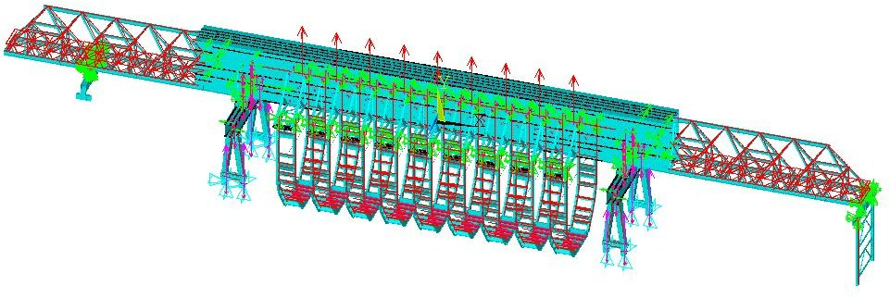
Figure 1 Structural Diagram of the trough-making machine

(1) Strength Analysis
The overall equivalent stress contour of the trough-making machine is shown in Figure 2. According to the contour analysis, the maximum overall stress is 216.34 MPa, which is located on the suspended outer rib structure. The material of the suspended outer rib is Q355B with an allowable stress of 236.7 MPa. Therefore, the whole trough-making machine and the suspended outer rib meet the strength requirements.
The equivalent stress contour of the main girder is shown in Figure 3. The maximum stress of the main girder is 170.59 MPa, which is located at the mid-span of the main girder. The material of the main girder is Q355B with an allowable stress of 236.7 MPa. Therefore, the main girder meets the strength requirements.
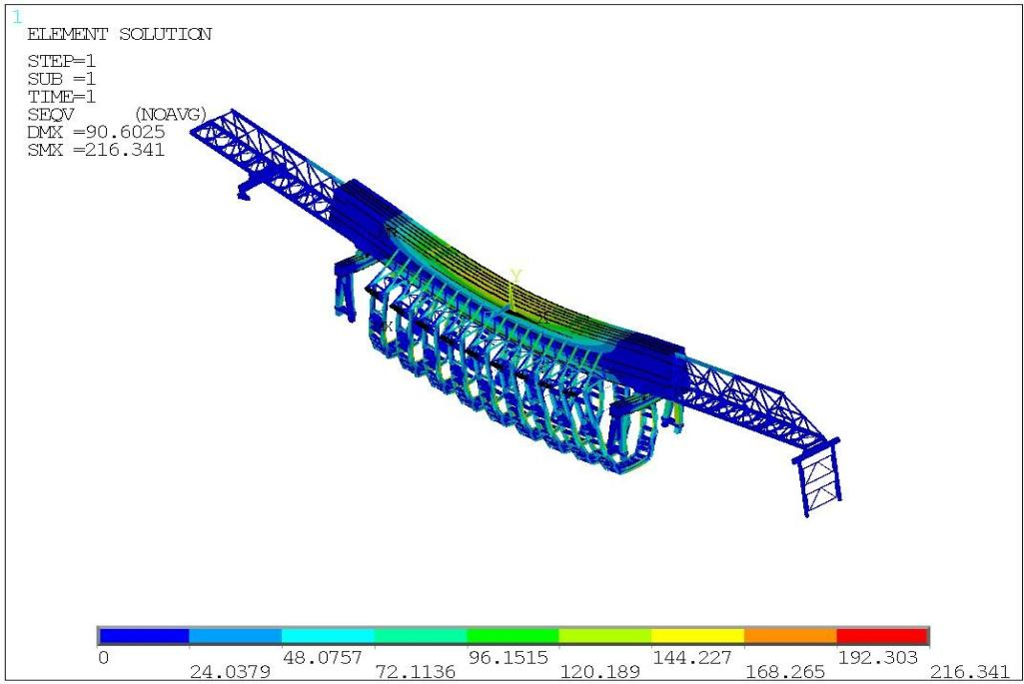
Figure 2 Overall Stress Analysis of the trough-making machine
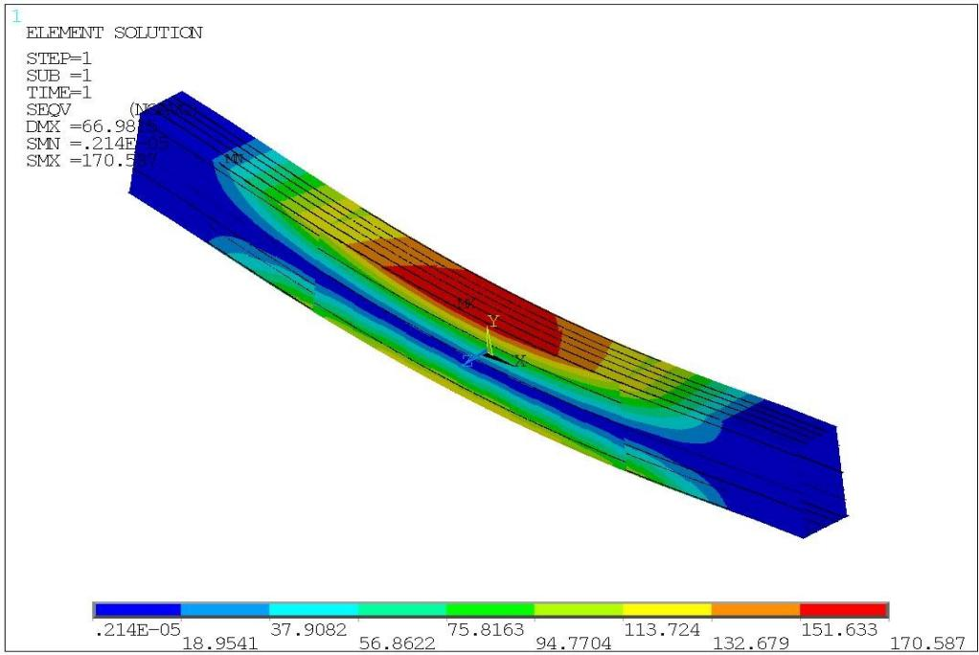
Figure 3 Stress Contour Plot of Main Girder
(2) Stiffness Analysis
The overall Y-direction deformation contour of the trough-making machine is shown in Figure 4. The maximum deformation is −88.37 mm, occurring at the middle suspended outer rib structure. The Y-direction deformation contour of the main girder is presented in Figure 5, where the maximum Y-direction deformation of the main girder is −66.25 mm at the mid-span position.In the deformation cloud map, positive values in the red region represent the upward camber of the trough-making machine, while negative values in the blue region denote the downward deflection of the machine. The original maximum Y-direction deformation of the main girder is −66.25 mm. After deducting the deformation of the intermediate supporting leg of 11.07 mm and the no-load deformation of the main girder of 25.40 mm, the actual mid-span Y-direction deformation of the main girder is 29.78 mm. The allowable deflection of the main girder is 45 mm. Comparison between the actual mid-span deformation and the allowable deflection indicates that the main girder satisfies the stiffness requirement.
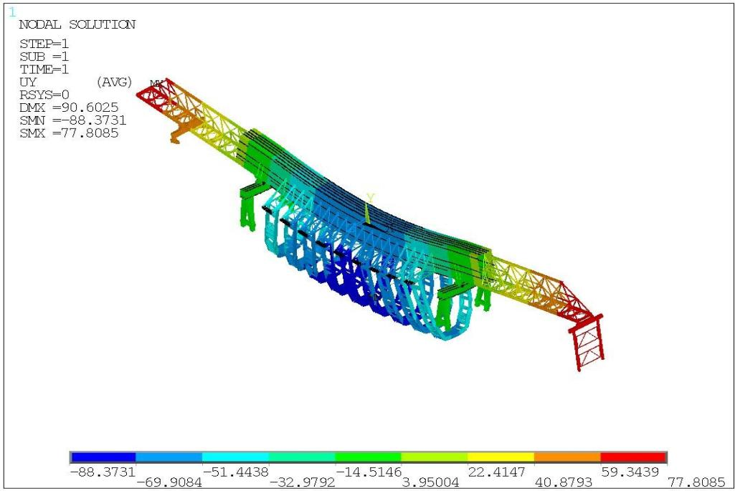
Figure 4 Overall Y-direction deformation contour plot of the trough-making machine
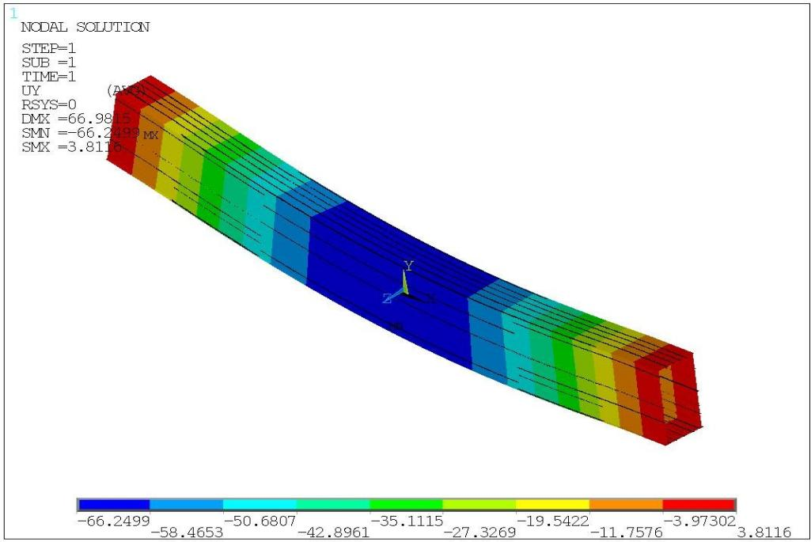
Figure 5 Deformation Diagram of Main Girder in Y-Direction

4 Optimal Design of Metal Structure for Trough-Making Machine Main Beam

4.1 Analysis of Optimization Scheme
As the primary load-bearing structure of the trough-making machine, the main beam weighs approximately 267.8 t, while the total weight of the trough-making machine is about 927 t. The main beam accounts for 28.8% of the machine’s total weight. According to the foregoing finite element analysis results, the actual maximum Y-direction deflection at the mid-span of the main beam under full-load condition with Grade-8 wind load is 29.78 mm, against an allowable deflection of 45 mm, leaving a 33.8% margin for optimization in maximum Y-direction displacement. The maximum stress of the main beam is 170.59 MPa, compared with the allowable stress of 236.7 MPa, providing a 27.9% optimization margin for maximum stress. Considerable safety margin exists in the load-bearing capacity, particularly the stiffness, of the main beam.
The following factors are taken into account in developing the optimization scheme:(1) The web plate and upper/lower flange plates of the main beam exert significant effects on beam deflection. Therefore, only the geometric dimensions of the main beam cross-section are optimized without altering its length.(2) Longitudinal stiffeners of the main beam web have minor impacts on overall stiffness and strength and are omitted in parametric modeling. The cross-sectional areas of stiffeners for upper and lower flange plates are equivalent-integrated into the respective flange plates, and the slideway area on the lower flange plate is also equivalent-integrated into the lower flange plate.

4.2 Optimization Program Design
Structural optimization design of the trough-making machine aims to minimize its mass under the constraints of strength, stiffness and stability. Since the cross-section of the main beam is proportional to its overall volume and mass, cross-sectional dimensions of components forming the main beam are selected as design variables. The total length of the main beam is 101 m, consisting of box-girder and truss structures.
(1) Design Variables
In this optimization, the original steel cross-section dimensions of the box-type main beam are taken as initial values. Cross-sectional dimensions are optimized by setting reasonable value ranges for design variables in the optimization program. The original cross-section contains numerous stiffeners, slideways and other components, resulting in complex geometry that hinders optimization. Hence, the main beam cross-section is simplified. For instance, longitudinal stiffeners on the main beam web have negligible effects on overall stiffness and strength and are omitted in parametric modeling. The cross-sectional areas of stiffeners for upper and lower flange plates are equivalently incorporated into the corresponding flange plates, and the slideway area on the lower flange plate is also equivalently incorporated into the lower flange plate.Initial calculation results of the simplified main beam slightly differ from those of the original model. The rationality of calculation results will be further verified by substituting the optimized results into the model.
The main beam design variables (DV) mainly include: cross-sectional width (X) and height (Y) of the main beam, web thickness (G), upper flange plate thickness (E), and lower flange plate thickness (F). The main beam cross-section and design variables are shown in Figure 6 and 7, with each variable listed in Table1 below:
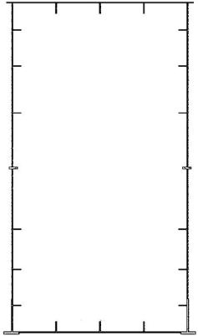 | 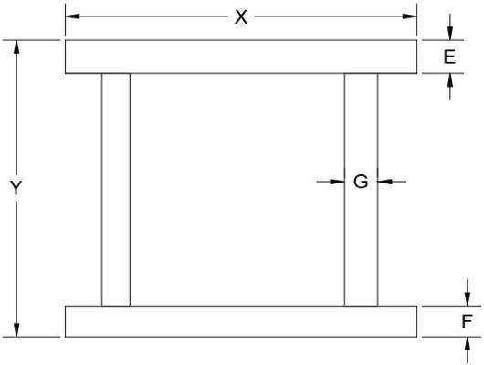
Figure. 6 Initial cross-section of main beam | Figure7 Cross-sectional design variables
Table 1 Main beam design variables
Design Variable Name | DV | Original Dimension (mm)
Cross-sectional width of main beam | X | 3400
Cross-sectional height of main beam | Y | 6400
Upper flange thickness of Main Beam 1 | E1 | 24
Lower flange thickness of Main Beam 1 | F1 | 24
Web thickness of Main Beam 1 | G1 | 12
Upper flange thickness of Main Beam 2 | E2 | 22
Lower flange thickness of Main Beam 2 | F2 | 20
Web thickness of Main Beam 2 | G2 | 12
Upper flange thickness of Main Beam 3 | E3 | 22
Lower flange thickness of Main Beam 3 | F3 | 20
Web thickness of Main Beam 3 | G3 | 14

(2) Objective Function
This optimization aims to realize lightweight design for the main beam of the trough-making machine. Given a constant material density, the weight is determined by the volume of the main beam. Therefore, the optimization objective of minimizing mass can be converted into minimizing volume. The objective function is defined as the total volume of the main beam, denoted as VOLUME.
(3) State Variables
The state variables for this optimization are the strength and stiffness under the full-load condition with Grade-8 wind load. This working condition represents the most complex stress state of the whole machine, so selecting it as the optimization condition can best ensure the validity of results. The strength and stiffness constraints during optimization are as follows:
 | σmax ≤ [σ]  . | (5)
 | YL ≤ [YL ]  . | (6)
Where σ_{max} is the maximum equivalent stress of the main beam; YL is the maximum Y-direction deflection of the main beam.
According to the aforementioned stiffness and strength requirements, the allowable stress of the trough-making machine main beam under all working conditions is [σ]=236.7 MPa, and the allowable deflection is YL=45 mm.
(4) Optimization Procedure
The optimization design procedure for the main beam is as follows:
/CLEAR
X=3400
Y=6400 E1=24 F1=24 G1=12
/PREP7 SECTYPE,3001,BEAM,HREC
SECOFFSET,CENT
SECDATA,X,Y,G1,G1,F1,E1
SOLVE
/POST1
*USE,SCRATCH
/OPT
OPANL,SCRATCH
OPVAR,X1,DV,3200,3600
OPVAR,Y1,DV,6200,6600 OPVAR,E1,DV,16,26 OPVAR,F1,DV,16,26 OPVAR,G1,DV,8,16
OPVAR,DY,SV,0,45
OPVAR,SMAX,SV,0,236.7
OPTYPE,SUBP
OPSUBP,40
OPEXE
PLVAROPT,DMAX,SMAX
PLVAROPT,VOLUME

4.3 Analysis of Optimization Results

4.3.1 Optimization Results of the Main Beam
Zero-order optimization algorithm is adopted in this optimization design to optimize the main beam structural model of the trough-making machine. The maximum number of iterations is set to 40 during optimization, and a total of 30 iterations are completed upon termination, with the optimal solution obtained at the 27th iteration. After optimization, the comparison between optimized results and initial data is shown in Table 2 below:
Table 2 Variation of each parameter of main beam before and after optimization

Optimization Variables | Before Optimization (mm) | After Optimization (mm) | Change Rate
X | 3400 | 3426.6 | 0.78%
Y | 6400 | 6409.9 | 0.15%
E1 | 24 | 20.253 | 15.61%
F1 | 24 | 21.713 | 9.52%
G1 | 12 | 9.7725 | 18.56%
E2 | 22 | 16.33 | 25.77%
F2 | 20 | 20.406 | 2%
G2 | 12 | 8.8245 | 26.46%
E3 | 22 | 21.835 | 0.75%
F3 | 20 | 21.341 | 6.7%
G3 | 14 | 10.138 | 27.59%
DY/mm | 61.132 | 70.917 | 16%
SMAX/MPa | 158.9 | 168.17 | 5.8%
V/mm3 | 0.16152E+11 | 0.13576E+11 | 15.9%
It can be seen from the change rates in the table that the upper flange thickness and web thickness of the 1st and 2nd main beam segments decrease significantly, while the web thickness of the 3rd main beam segment shows a notable reduction. The cross-sectional width and height of the main beam, as well as the upper and lower flange thicknesses of the 2nd main beam segment, have minor variations. Accordingly, it is proposed to reduce the upper flange thickness and web thickness of the 1st and 2nd main beam segments, and the web thickness of the 3rd main beam segment. Iteration diagrams of stress, displacement and volume of the main beam are plotted, as shown in Figures 8 and 9.
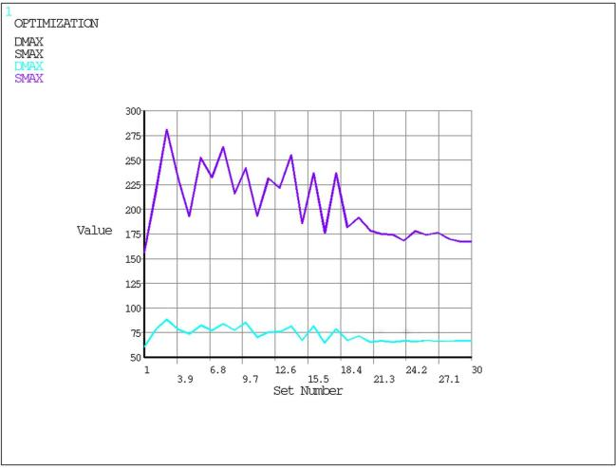 | 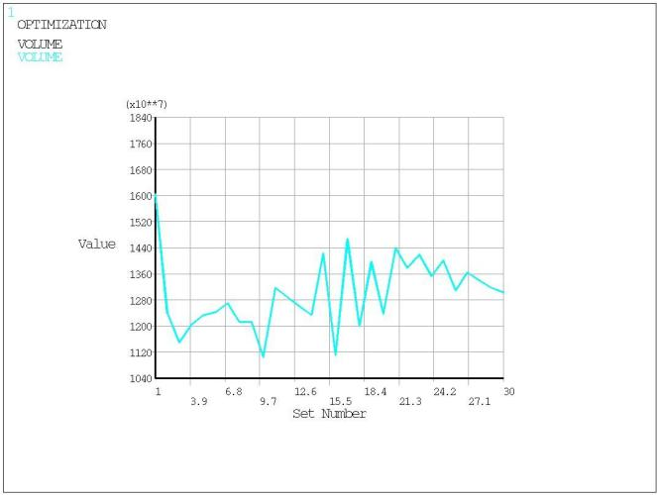
Figure 8 Stress and displacement iteration plot | Figure 9 .Volume iteration diagram
It can be observed from Figures 8 and 9 that with the increase in iteration times, the volume first decreases, then fluctuates within a certain range and tends to be stable. The maximum Y-direction deflection of the main beam varies slightly and fluctuates around a fixed value, while the maximum equivalent stress of the main beam rises first, then declines, and finally converges to a steady value. At the optimal solution, the maximum stress of the main beam is 168.17 MPa, and the maximum Y-direction deflection DY is 70.917 mm. After optimization, the mass of the main beam is reduced by approximately 15.9%, indicating favorable optimization performance for the main beam.

4 Discussion
Based on the finite element simulation and structural optimization results of the trough-making machine metal structure under the critical working condition of full-load pouring at Grade 8 wind, the structural mechanical performance and lightweight effect are further discussed in this section.
The finite element calculation results show that the maximum equivalent stress of the whole machine is 216.34 MPa, which is lower than the allowable stress of Q355B steel, indicating that the strength reserve of the original metal structure is sufficient and no local strength failure risk exists. After eliminating the interference deformation caused by intermediate supporting legs and no-load state, the actual mid-span deflection of the main girder is 29.78 mm, which is obviously lower than the allowable deflection limit of 45 mm. It is verified that the original design has a large safety margin in stiffness, which provides a reasonable premise for subsequent lightweight optimization.
In terms of structural optimization, adopting the zero-order optimization algorithm to optimize the cross-sectional dimensions of the main girder significantly reduces the plate thickness of webs and upper flanges on the premise of meeting strength and stiffness constraints. The mass of the main girder is reduced by 15.9%, and the overall weight of the trough-making machine is decreased by 5.83%, saving about 54 tons of steel. Compared with the traditional empirical design method, the finite element combined with parametric optimization method can effectively avoid excessive safety factor and material waste, realize reasonable matching between structural performance and material utilization rate, and provide a reference for the structural lightweight design of similar hydraulic aqueduct construction equipment.
In addition, the optimized structure still maintains good mechanical performance under typical working conditions such as concrete pouring and hole crossing, which proves that the optimized structural parameters have good applicability and engineering practicability. The technical scheme based on ANSYS APDL parametric modeling and zero-order optimization can be popularized for the structural design and optimization of large-scale mobile formwork and aqueduct construction machinery.

5 Conclusions
This paper introduces the current state of research on the development of trough-making machines. Taking the trough-making machine as the research object, ANSYS finite element analysis software was used to conduct a study on finite element calculation techniques for its metal structure. The main research findings are as follows:
Based on the trough-making machine’s operational workflow and performance parameters, the design conditions were determined. A typical operating condition during concrete pouring was selected for specific analysis, specifically a fully loaded pouring condition under a Category 8 wind.
Using the Parametric Design Language (APDL) and based on actual construction conditions, the wind load and other design loads were determined. By applying the corresponding loads and constraints to the overall model, a finite element model of the trough-making machine under critical operating conditions was established.
A finite element analysis was conducted on the hazardous operating conditions of the trough-making machine. The following conclusions were drawn: the maximum stress across the entire machine was 216.34 MPa, and the actual maximum deflection at the midspan of the main beam under full load during a Category 8 wind was -33.03 mm. The finite element analysis results indicate that all metal structures meet the strength and stiffness requirements during the machine’s operation.
Optimization design is carried out for the main beam, a critical metal structure of the trough-making machine. Based on the optimization results, the thicknesses of the upper flanges and webs of the 1st and 2nd main beam segments, as well as the web thickness of the 3rd main beam segment, are reduced. Meanwhile, the lower flange of the 2nd main beam segment is thickened to maintain structural strength. After optimization, the overall weight of the trough-making machine decreases by 5.83%, equivalent to approximately 54 tons of steel. While ensuring pouring quality, more reasonable structural parameters are obtained, and material performance is fully utilized. The optimized parameters are verified under critical working conditions of pouring and hole-crossing. Finite element calculation results indicate that the optimized trough-making machine still meets the design requirements.
Although this study has completed the finite element analysis and lightweight optimization design of the trough-making machine metal structure, there are still some limitations:This paper only carries out static finite element analysis under static load and fixed wind load, without considering the dynamic load impact caused by concrete pouring vibration, walking startup and braking of the trough-making machine. The dynamic mechanical characteristics of the structure are not explored.
On the basis of the current research, the following work can be further carried out in the follow-up:Conduct transient dynamic analysis and wind-induced vibration analysis of the trough-making machine, consider the coupling effect of dynamic load and wind load, explore the dynamic stress and vibration response of the structure, and optimize the structural damping and rigidity layout.

COMPETING INTERESTS DISCLAIMER:
Authors have declared that they have no known competing financial interests OR non-financial interests OR personal relationships that could have appeared to influence the work reported in this paper.

Disclaimer (Artificial intelligence)

Author(s) hereby declare that NO generative AI technologies such as Large Language Models (ChatGPT, COPILOT, etc.) and text-to-image generators have been used during the writing or editing of this manuscript.

References

[1] Chen G, Yang F, Chi JJ. Research on standardized design of aqueducts. Design of Water Resources & Hydroelectric Engineering. 2025;44(1):21‑25. https://doi.org/10.20275/j.cnki.issn.1007‑6980.2025.01.005
[2] Guo Q, Zhang T, Yang C. Structural design optimization of DZS40/500 aqueduct‑making machine. Water Conservancy Construction and Management. 2019;39(1):29‑34. https://doi.org/10.16616/j.cnki.11‑4446/TV.2019.01.05
[3] Huang P, Liu CY, Ma ZF, Wang MT. Construction of cross‑canal bridge cap using hoop method in the Middle Route of South‑to‑North Water Diversion Project. Yangtze River. 2014;45(10):55‑56,72. https://doi.org/10.16232/j.cnki.1001‑4179.2014.10.002
[4] Pu ZB, Yang ZH, Jin X. Application and practice of movable formwork in construction of large‑scale hydraulic aqueducts. Engineering Technology Research. 2019;4(4):88‑89. https://doi.org/10.19537/j.cnki.2096‑2789.2019.04.043
[5] Wen TY. Cast‑in‑situ beam construction technology of MZ900S overhead movable formwork for Wuhan‑Guangzhou Passenger Dedicated Line. Railway Investigation and Surveying. 2008(3):74‑77. https://doi.org/10.19630/j.cnki.tdkc.2008.03.024
[6] Pacheco, Coelho, Borges, Guerra. Technical challenges of large movable scaffolding systems. Structural Engineering International. 2011;21(4):450‑455. https://doi.org/10.2749/101686611x13131377725640
[7] Editorial Department of China Journal of Highway and Transport. Academic research review of road construction machinery in China·2018. China Journal of Highway and Transport. 2018;31(6):1‑164.
[8] Liu HG, You JQ, Zhang CF. Prospect of standardization and modernization of movable formwork technology in China. Railway Standard Design. 2014;58(4):37‑43. https://doi.org/10.13238/j.issn.1004‑2954.2014.04.009
[9] Lü PM. Innovation and development of movable formwork bridge‑building equipment in China. Construction Machinery. 2019(8):20‑24.
[10] Xiang YQ, Zhang SJ, Cheng Y, Wang JF, Jing Q, Wang LC. Application and research innovation of movable formwork construction technology. Journal of China & Foreign Highway. 2008(1):52‑56. https://doi.org/10.14048/j.issn.1671‑2579.2008.01.013
[11] Li Y B. Application of trough-making machine in construction of super-large U-shaped thin-walled prestressed aqueduct[J]. Sichuan Water Conservancy, 2025, 46(06): 75-78.
[12] Zhang Y J. Preloading Test of U‑shaped Aqueduct Trough‑making Machine[J]. Shaanxi Water Resources, 2018(05): 211‑212+215. DOI:10.16747/j.cnki.cn61‑1109/tv.2018.05.084.
[13] Zhang Y M, Jia J J, Ma C A, et al. Structural Design of Large‑flow Prestressed Thin‑walled Multi‑cell Rectangular Trough[J]. Yangtze River, 2013, 44(16): 12‑14. DOI:10.16232/j.cnki.1001‑4179.2013.16.012.
[14] Yuan C S ,Wang F C ,Xue H , et al.The Optimized Design of Tower Crane Hoisting System Based on the Improved Particle Swarm Optimization Algorithm[J].Applied Mechanics and Materials,2014,3147(548-549):444-448.DOI:10.4028/www.scientific.net/AMM.548-549.444.
[15]Chen Y L ,Xu J T ,Han T .Influence and mechanism of jacket foundation lightweighting design on marine integrated structure performance[J].Marine Structures,2026,109104099-104099.DOI:10.1016/J.MARSTRUC.2026.104099.
[16]Pervan N ,Muminovic J A ,Mesic E , et al.Dimensional Structural Mass Optimization of a Welded I-Profile Bridge Crane Girder[J].Tehnički glasnik,2020,14(2):186-193.DOI:10.31803/tg-20191106234034.
[17]Bin H ,Zhangyan Z ,Faju Q .Overhead crane bridge structure design optimization based on safety assessment[J].Proceedings of the Institution of Mechanical Engineers,2025,239(6):3413-3426.DOI:10.1177/09544089231223072.
[18]He H ,Cui Z ,Yang Y , et al.Research on structure optimization and application of hoisting equipment[J].Journal of Physics: Conference Series,2025,3126(1):012002-012002.DOI:10.1088/1742-6596/3126/1/012002.
[19]Kueh T P ,Perumal V ,Ovinis M , et al.Optimization of subsea gas well tubing size by penalized objective and nodal analysis[J].Results in Engineering,2026,30110945-110945.DOI:10.1016/J.RINENG.2026.110945.
[20]Jiao P ,Wang M ,Xue Y , et al.Topology and Size Optimization for Mill Relining Manipulator Under Multiple Operating Conditions[J].Machines,2026,14(4):441-441.DOI:10.3390/MACHINES14040441.
[21]Bin H ,Zhangyan Z ,Faju Q .Overhead crane bridge structure design optimization based on safety assessment[J].Proceedings of the Institution of Mechanical Engineers,2025,239(6):3413-3426.DOI:10.1177/09544089231223072.
[22]Min C ,Shan H .Structural Strength Analysis and Stress Testing of Portal Crane based on Finite Element Method[J].Journal of Physics: Conference Series,2022,2366(1):DOI:10.1088/1742-6596/2366/1/012003.
[23]Wenzhao L ,Ruigang Y ,Qisong Q , et al.Reliability and sensitivity analysis of bridge crane structure[J].Journal of Mechanical Science and Technology,2022,36(9):4419-4431.DOI:10.1007/S12206-022-0807-1.
[24]Leopold H ,Daniel Č ,Karel F .Detection of mechanical stress in the steel structure of a bridge crane[J].Theoretical and Applied Mechanics Letters,2021,(prepublish):100299-.DOI:10.1016/J.TAML.2021.100299.
[25] Tian J ,Chen X .Assessing probabilistic response of wind-excited structures under mixed wind climate with consideration of wind directionality using closed-form formulations[J].Journal of Wind Engineering & Industrial Aerodynamics,2026,274106491-106491.DOI:10.1016/J.JWEIA.2026.106491.

