Original Research Article
Investigating Yield Curve Inversions and Recession Forecasting: Evidence from 32 Economies

Abstract
Background: Yield curve inversions have long been considered an important indicator of future economic downturns and financial instability. This study investigates the relationship between yield curve inversions and recession forecasting across 32 economies, examining whether inverted yield spreads consistently predict economic contractions. The research contributes to the understanding of Macroeconomics and financial market behavior by assessing the reliability of yield curves as a global recession forecasting tool.
Aims: This study examined whether the 10-year/3-month government bond yield spread predicts recessions across a broad international sample and whether forecasting performance depends on monetary-policy structure, recession base rates, and country-level institutional regimes.
Study design: The paper used a quantitative, cross-country forecasting design based on monthly macro-financial panel data and country-level logistic regression models.
Place and Duration of Study: The analysis covered 32 advanced and emerging market economies from January 2000 to December 2025, using publicly available data from the Federal Reserve Economic Data database, the OECD, the IMF World Economic Outlook, and national recession chronologies.
Methodology: The main predictor was the 10-year minus 3-month yield spread. For each country and for forecast horizons from 1 to 24 months, recession probability was modeled using logistic regression. Predictive performance was evaluated using the receiver operating characteristic area under the curve (ROC-AUC), with country-level and grouped comparisons used to assess heterogeneity.
Results: Predictive power was highly uneven. The United Kingdom (AUC = 0.918) and the United States (AUC = 0.737 at the 12-month horizon and up to 0.870 at longer horizons) showed strong recession-prediction performance. In contrast, many eurozone economies clustered near the no-skill benchmark, including France (AUC = 0.488), Spain (AUC = 0.487), Greece (AUC = 0.449), and Ireland (AUC = 0.429). The pooled global panel reached only modest performance, with AUC peaking at approximately 0.633 around 7 to 9 months ahead.
Conclusion: The yield curve is not a universal recession indicator. It is most informative in countries with independent monetary policy and market-determined bond yields, while its usefulness is limited in monetary unions, policy-suppressed regimes, and countries with high unconditional recession frequency. The findings support the use of regime-aware models rather than a single global yield-curve rule.
Keywords: yield curve; recession forecasting; term spread; ROC-AUC; logistic regression; eurozone; monetary policy; financial economics; cross-country predictability

1. Introduction
The slope of the yield curve, commonly measured as the spread between long-term and short-term government bond yields, remains one of the most widely followed market-based indicators of future economic activity. A low or negative term spread may indicate that investors expect tighter current financial conditions to be followed by weaker output growth, lower inflation pressure, and eventual policy easing. Recent work continues to support the relevance of the term spread while also emphasizing that its information content depends on the decomposition of interest-rate expectations and term premia [1-3]. The sharp global tightening cycle after 2021 and the prolonged 2022-2023 yield-curve inversion renewed debate over whether the traditional signal remains reliable in a post-pandemic, high-inflation environment [4-6].
The empirical evidence is strongest for the United States, where the 10-year/3-month spread has historically provided useful medium-horizon recession information. However, recent research has become more cautious. Federal Reserve analyses during the 2022 tightening episode argued that the predictive interpretation of the curve should be conditioned on inflation expectations, the level of policy rates, and the near-term forward spread [4,5]. Other recent work has shown that the yield curve may remain informative, but that its power can weaken when unconventional monetary policy, global safe-asset demand, and changing term premia distort the relationship between the long and short ends of the curve [2,6].
The forecasting mechanism operates through several channels. An inverted curve can reflect expectations of future monetary easing, tighter credit supply, weaker investment incentives, or a decline in risk appetite before a downturn. The mechanism is especially plausible when the short end of the curve is set by a domestic central bank responding to domestic inflation and output conditions. The predictive channel becomes less direct when domestic rates are constrained by a monetary union, externally driven capital flows, or unconventional policy interventions such as quantitative easing and yield-curve control [7-9].
Cross-country evidence therefore requires a more regime-sensitive framework than single-country U.S. studies. Recent international research finds that the predictive power of the term spread and other financial variables varies substantially across countries, with weaker performance in many emerging economies and in settings where local spreads do not cleanly summarize local business-cycle risk [10]. Evidence from foreign yield curves also suggests that bond-market signals may transmit across borders rather than only predict domestic activity, complicating interpretation in open economies [11].
This study asks whether cross-country heterogeneity in yield-curve forecasting performance is systematic rather than random. The central argument is that two constraints explain much of the variation. First, countries with policy-suppressed or externally constrained spreads lose the domestic monetary signal that makes the yield curve informative. Second, countries with high unconditional recession frequency make it harder for any single predictor to discriminate recession months from non-recession months. The paper tests this argument across 32 economies using monthly data from 2000 to 2025, logistic regression at multiple forecast horizons, and ROC-AUC as the primary measure of predictive performance.

2. Literature Review

2.1 Recent evidence on yield-curve predictability
The modern literature no longer treats the yield curve as a mechanical recession clock. Bauer and Mertens showed that the U.S. yield curve continued to contain recession information after the global financial crisis, but their analysis also stressed that low interest rates and compressed term premia complicate interpretation [1,2]. Benzoni et al. further decomposed the yield-curve slope into expectations and risk-premium components, showing that the economic meaning of an inversion depends on which component drives the flattening [3]. These studies support the use of the 10-year/3-month spread, but also motivate additional caution when comparing countries with different monetary-policy structures.
Recent work directly addresses the post-2019 and 2022-2023 inversion episodes. Federal Reserve analyses in 2022 warned that recession probabilities inferred from the curve depend on inflation outlooks, the near-term forward spread, and the level of monetary-policy restraint [4,5]. The Federal Reserve Bank of St. Louis also reviewed nominal and real term-spread recession probabilities during the 2023 inversion episode, emphasizing that different spread definitions can generate different recession probabilities [6]. This literature is especially relevant because the present sample extends through 2025, a period that includes the unusually persistent U.S. inversion after aggressive post-pandemic rate increases.

2.2 Cross-country and monetary-regime evidence
A growing cross-country literature shows that yield-curve predictability is heterogeneous across economies. Chinn and Ferrara reported that the predictive power of the term spread, foreign term spreads, debt-service ratios, and financial-condition variables varies across countries, with particularly weak explanatory power in many emerging markets [10]. Ahmed and Chinn further found that foreign term spreads can predict U.S. recessions and GDP growth, implying that international bond markets contain shared global-cycle information rather than purely domestic signals [11]. These findings justify the present paper's country-stratified design and caution against interpreting the pooled global coefficient as a universal recession rule.
Euro-area studies are central to the present research question because member states share a supranational short-term policy rate. Sabes and Sahuc found that euro-area yield-curve inversions can predict aggregate euro-area recessions, but also reported weakening performance after the global financial crisis and stronger predictive content in core countries, especially Germany [8]. The European Central Bank has similarly emphasized that the information content of the euro-area curve depends on the term-spread definition and the OIS or Bund-based measure used [9]. This directly supports the present interpretation that country-level eurozone spreads may lack country-specific monetary-policy information.
Emerging-market evidence also supports a regime-aware interpretation. Tawose et al. examined Nigeria and concluded that yield-curve information should be interpreted within domestic monetary-policy conditions rather than transferred mechanically from advanced-economy models [7]. Chinn and Ferrara likewise found lower predictive content in emerging-market economies [10]. These findings are consistent with the present study's weaker AUC values in economies where exchange-rate shocks, commodity cycles, policy credibility, and external financing conditions can dominate the standard domestic yield-curve channel.

2.3 Forecast evaluation and complementary indicators
The recession-forecasting literature increasingly recommends evaluating binary forecasts with discrimination metrics rather than only coefficient significance. Lahiri and Yang discussed ROC and PRC approaches for recession forecasts, highlighting the importance of model evaluation in rare-event settings [12]. This supports the use of ROC-AUC as the primary performance metric in this study. Recent evidence also suggests that the yield curve may perform better when combined with broader financial-cycle variables, such as credit spreads, liquidity, debt-service ratios, house prices, and financial-condition indexes [10,13,14]. Therefore, the present paper positions the yield spread as a benchmark single-predictor signal, not as a complete recession model.
Overall, the recent literature supports three expectations. First, the yield curve should be most informative when the short end of the curve reflects domestic monetary policy. Second, its signal should weaken in monetary unions, policy-suppressed regimes, and externally exposed economies. Third, post-2019 and 2022-2023 episodes require caution because inflation shocks, unconventional policy legacies, and global bond-market repricing may have altered the traditional term-spread signal. The empirical sections below test these expectations in a 32-economy panel extending through 2025.

3. Methodology

3.1 Data sources and sample construction
Bond-yield data were collected from two primary sources. For the United States, 10-year and 3-month Treasury constant-maturity yields were obtained from the Federal Reserve Economic Data database using series GS10 and TB3MS [18]. For all other economies, 10-year government benchmark yields and 3-month money-market rates were obtained from OECD.Stat through the JSON-SDMX application programming interface [19].
Recession indicators were constructed as binary monthly series equal to 1 during officially recognized recession periods and 0 otherwise. The recession dating combined OECD Composite Leading Indicator information, IMF World Economic Outlook classifications, and, for the United States, the National Bureau of Economic Research business-cycle chronology [20,21]. After filtering for months with complete spread and recession data, the final panel contained 32 economies at monthly frequency from January 2000 to December 2025, yielding 8,206 country-month observations. Figure 1 summarizes the coverage of recession indicators by country.
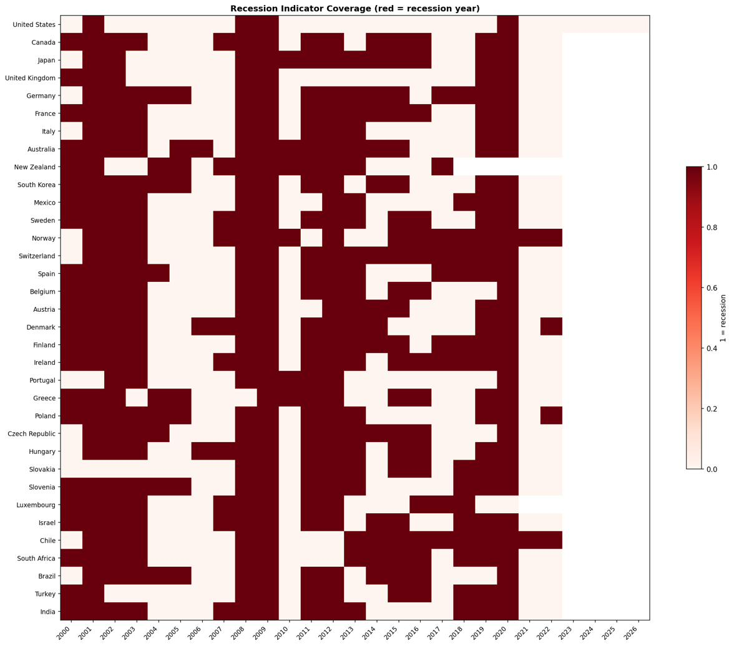
Figure 1. Monthly observations per country after filtering for complete spread and recession data. Red cells indicate recession months. The final panel contained 8,206 country-month observations across 32 economies.

3.2 Yield-spread variable
The main predictor was the term spread, defined as the difference between the 10-year government bond yield and the 3-month money-market or Treasury yield:
Spread_i,t = Yield10Y_i,t - Yield3M_i,t. (1)
A negative value denotes a yield-curve inversion. Figure 2 shows the monthly 10-year/3-month yield spread for selected economies, with recession periods shaded. Figure 3 provides the cross-country heatmap of 10-year yields and illustrates the broad post-2022 global repricing of government debt.
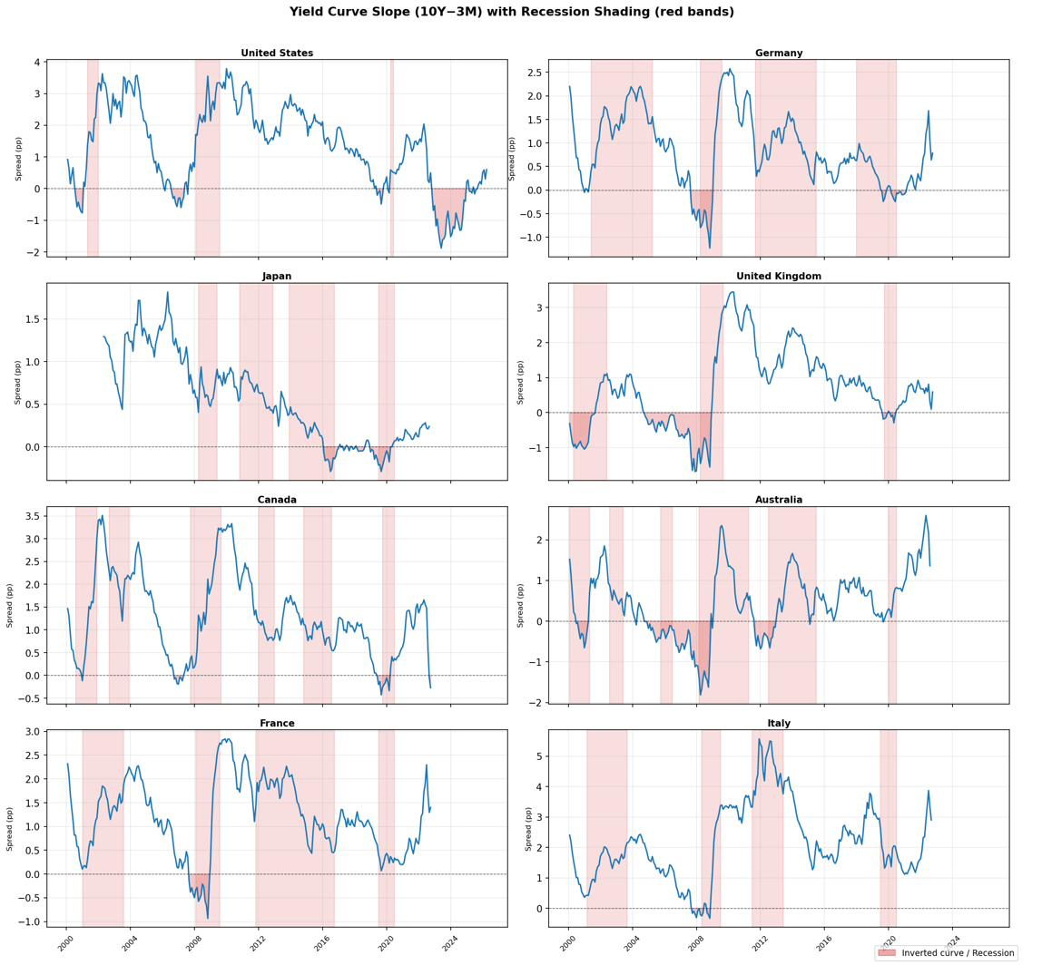
Figure 2. Monthly 10-year/3-month yield spreads for selected economies, 2000-2025. Shaded bands denote recession periods. Pre-recession compression and inversion are visible across multiple countries and episodes.
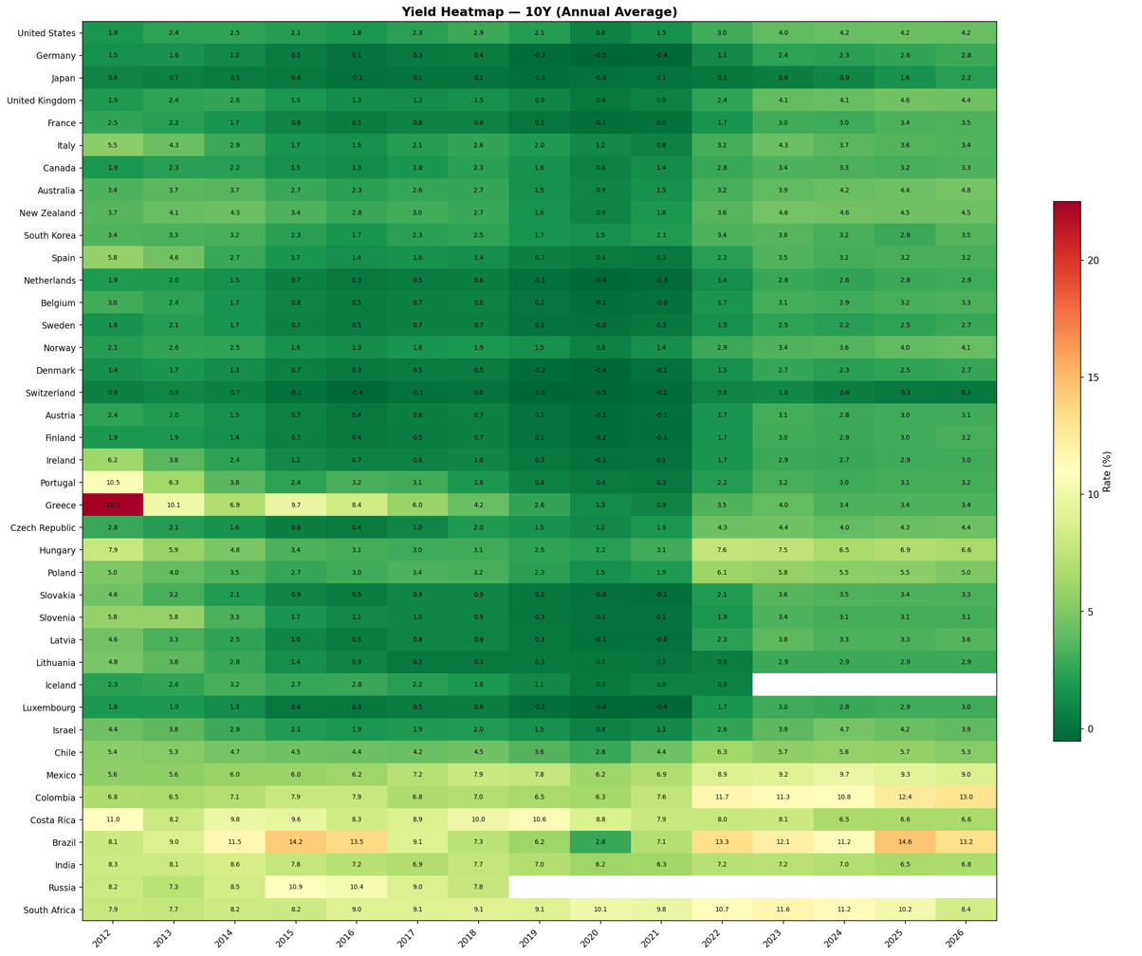
Figure 3. Heatmap of 10-year yields across 32 economies, 2000-2025. The post-2022 global repricing is visible as a broad darkening of the panel.

3.3 Econometric approach
For each country i and forecast horizon h from 1 to 24 months, recession probability was estimated using a logistic model:
Pr(Recession_i,t+h = 1) = Lambda(alpha_i + beta_h * Spread_i,t). (2)
In this specification, a negative coefficient indicates that a lower spread, or an inverted curve, is associated with a higher recession probability at horizon h. Predictive performance was evaluated using the area under the receiver operating characteristic curve (ROC-AUC), a discrimination measure suited to binary recession-forecasting problems and uneven recession base rates [12,22]. AUC values above 0.50 indicate better-than-random discrimination, while values close to or below 0.50 indicate little useful forecasting content. Incremental AUC was calculated as AUC minus 0.50, or against a country fixed-effect baseline when the pooled model was examined.
As a non-parametric check, an event-study plot was also produced around recession onset. Figure 4 traces average 10-year/3-month spreads from 24 months before to 24 months after recession start for each country. This visual inspection helps determine whether spreads tended to compress before recessions even in countries where logistic forecasting performance was weak.
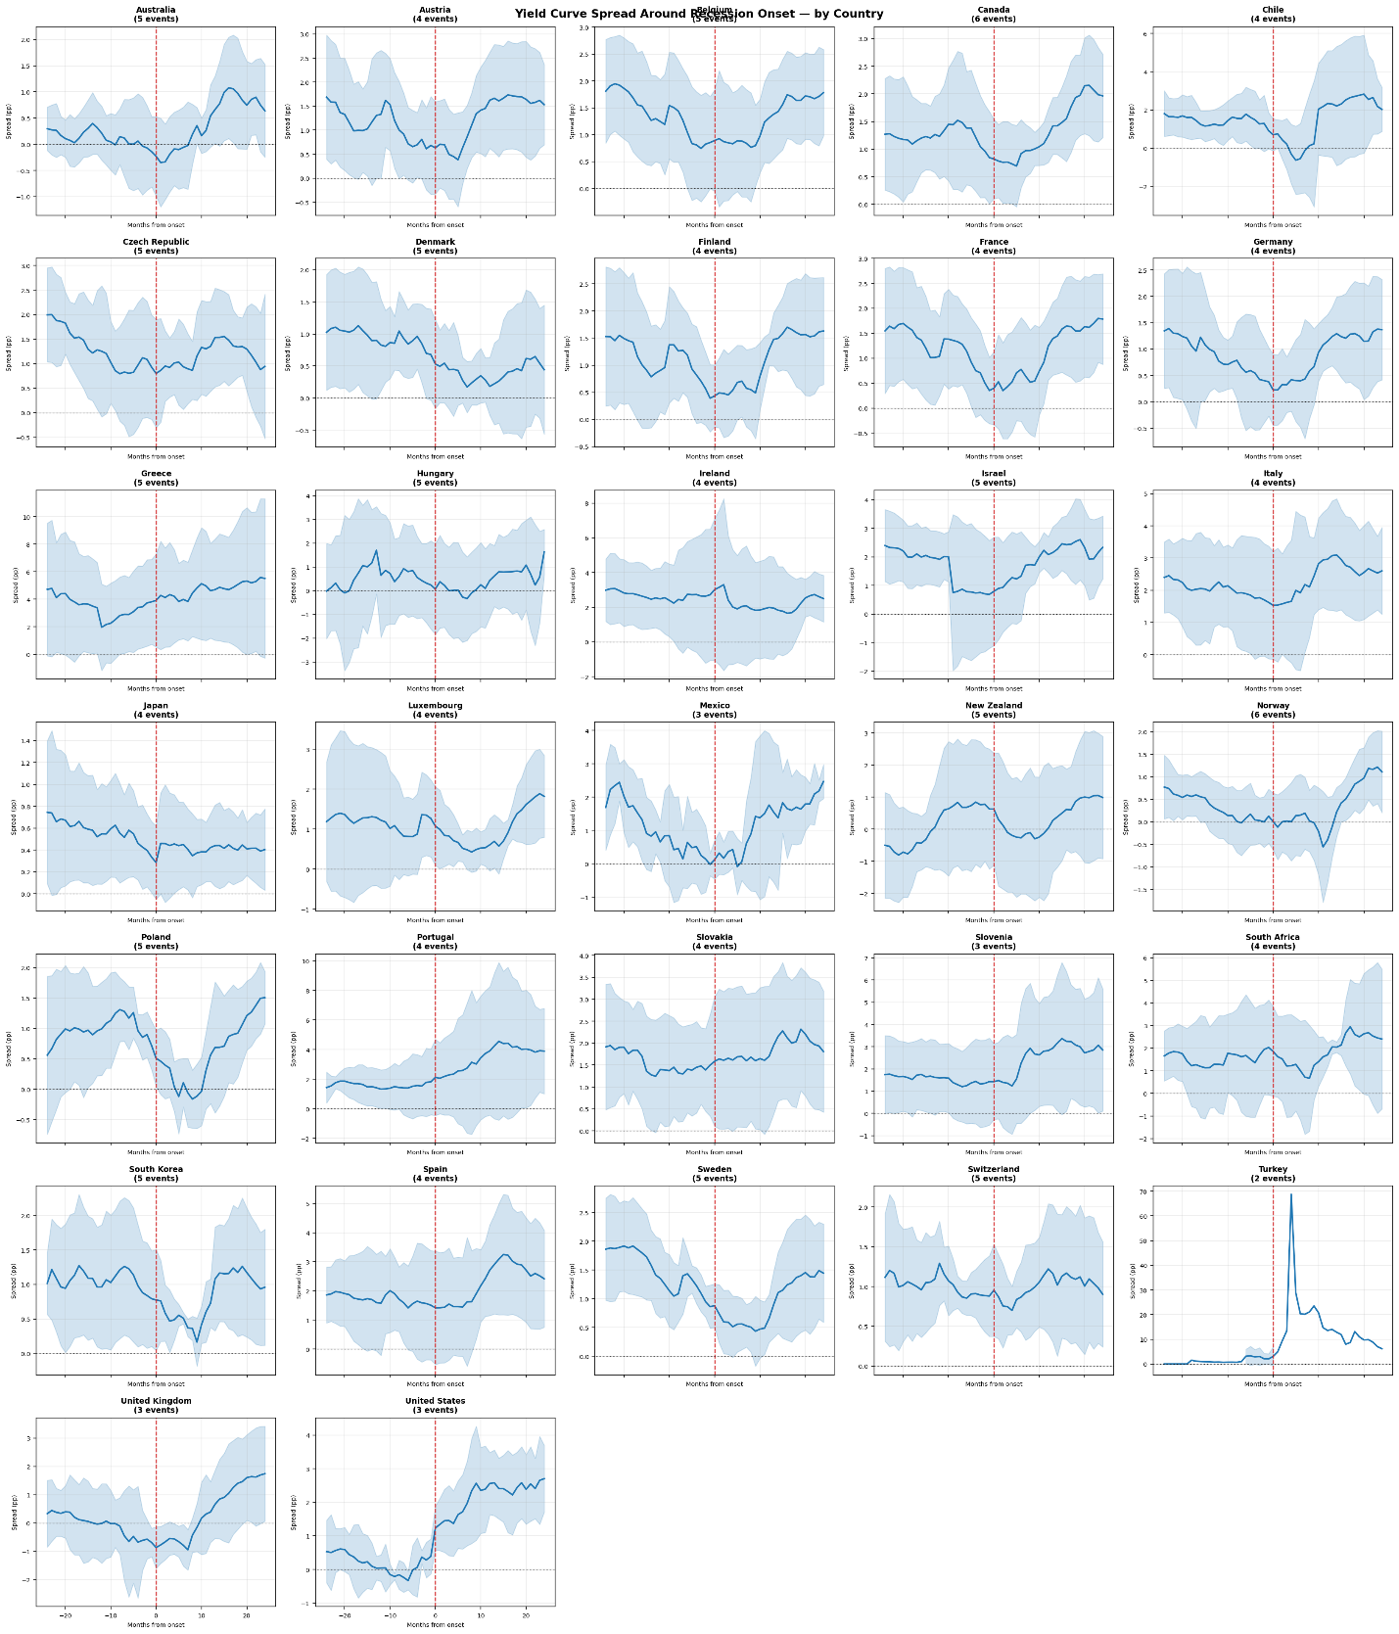
Figure 4. Event study of the 10-year/3-month spread around recession onset by country. Each line traces the average spread from 24 months before to 24 months after recession start (month 0). Pre-recession compression is visible for most economies, with substantial variation in depth and timing.

4. Results

4.1 Cross-country yield-curve slopes
Table 1 reports country-level logistic regression results. Twenty-seven of the 32 countries had negative slope coefficients, consistent with the inversion hypothesis. Fourteen countries were statistically significant at the 5% level. The United Kingdom showed the strongest result, with beta = -1.316, P < .001, and AUC = 0.918. The United States also showed strong predictive performance, with beta = -0.318, P < .001, and AUC = 0.737. Norway, Switzerland, Sweden, and Israel also had large negative coefficients. At the other end of the distribution, eurozone periphery members clustered near or below the no-skill benchmark, including France (AUC = 0.488), Spain (AUC = 0.487), Greece (AUC = 0.449), and Ireland (AUC = 0.429).
These results suggest that the yield curve was not equally informative across economies. Strong predictive power appeared mainly in economies with independent monetary policy and relatively market-determined yield curves, while weak predictive power appeared in economies where the short-rate signal was shared, suppressed, or distorted. This pattern is consistent with recent cross-country evidence showing that the predictive power of term spreads varies substantially across countries and monetary regimes [8,10,11].
Table 1. Country-level logistic regression results. Shaded rows: green = AUC >= 0.65 (strong); red = AUC < 0.50 (below random). ***P < .001, **P < .01, *P < .05.
Country | Coeff. (beta) | P value | AUC | Rec. rate | Eurozone
United Kingdom | -1.316*** | <.001 | 0.918 | 18.7% | -
United States | -0.318*** | <.001 | 0.737 | 8.9% | -
New Zealand | +0.239*** | <.001 | 0.692 | 38.6% | -
Norway | -0.472*** | <.001 | 0.670 | 44.3% | -
Chile | -0.316*** | <.001 | 0.670 | 44.8% | -
Israel | -0.361*** | <.001 | 0.651 | 39.6% | -
Slovakia | +0.209** | .001 | 0.649 | 27.9% | Yes
Mexico | -0.279** | .002 | 0.648 | 30.6% | -
Sweden | -0.447*** | <.001 | 0.638 | 38.8% | -
Hungary | -0.143*** | <.001 | 0.634 | 38.1% | -
Denmark | -0.271** | .005 | 0.612 | 46.0% | -
Poland | -0.223*** | <.001 | 0.599 | 38.8% | -
Switzerland | -0.450*** | <.001 | 0.596 | 44.0% | -
Luxembourg | -0.206 | .053 | 0.591 | 43.2% | Yes
Slovenia | -0.093 | .063 | 0.577 | 35.4% | Yes
Australia | -0.141 | .163 | 0.556 | 41.7% | -
Germany | +0.076 | .439 | 0.555 | 50.5% | Yes
Czech Republic | +0.124 | .157 | 0.551 | 38.3% | -
Canada | -0.093 | .278 | 0.541 | 35.2% | -
Austria | +0.023 | .805 | 0.540 | 39.0% | Yes
Japan | -0.274 | .108 | 0.534 | 34.7% | -
Finland | -0.165 | .106 | 0.534 | 43.4% | Yes
South Korea | +0.179 | .100 | 0.533 | 37.1% | -
Belgium | -0.044 | .612 | 0.525 | 31.6% | Yes
Italy | -0.024 | .701 | 0.524 | 29.0% | Yes
Turkey | -0.034 | .398 | 0.503 | 16.4% | -
Portugal | +0.042 | .162 | 0.491 | 22.3% | Yes
France | -0.002 | .981 | 0.488 | 44.0% | Yes
Spain | +0.005 | .928 | 0.487 | 44.1% | Yes
South Africa | -0.031 | .462 | 0.464 | 41.6% | -
Greece | -0.014 | .349 | 0.449 | 33.7% | Yes
Ireland | +0.021 | .597 | 0.429 | 57.7% | Yes

Figure 5 displays the same country-level slope estimates graphically. The figure highlights the clustering of eurozone members near zero and the larger negative estimates among Nordic and Anglo-Saxon economies.
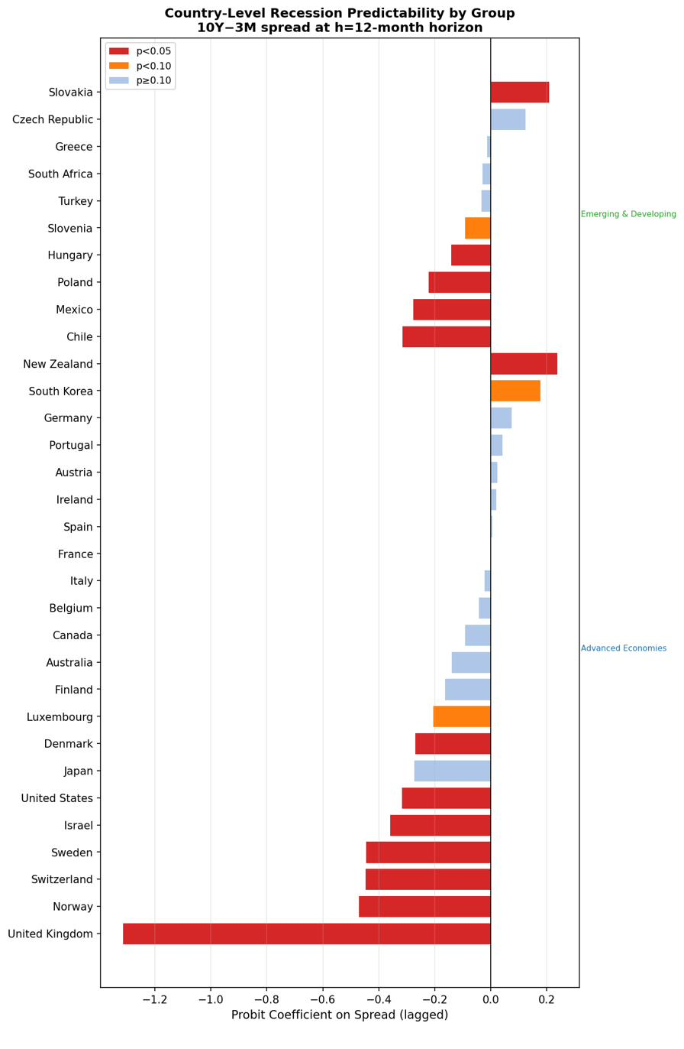
Figure 5. Estimated logistic coefficient by country, grouped by region. Filled markers indicate significance at 5%. Eurozone members cluster near zero, whereas Nordic and Anglo-Saxon economies show larger negative estimates.

4.2 Forecasting performance by horizon
The pooled panel model estimated at 24 forecast horizons revealed a consistent timing pattern. At the 1-month horizon, the spread coefficient was not statistically significant (beta = -0.003, P = .64, AUC = 0.615). Statistical significance emerged by the 3-month horizon. Predictive performance peaked at approximately 7 to 9 months ahead, with AUC reaching about 0.633, and the signal remained statistically significant but weaker through 24 months.
This timing pattern is consistent with the interpretation that yield-curve inversion operates as a medium-term leading indicator rather than an immediate recession signal. The strongest pooled performance appeared roughly two to three quarters before recession, broadly aligning with the lag structure highlighted in recent yield-curve and recession-probability studies [1,6,12]. However, the modest global AUC also shows that statistical significance should not be confused with strong forecasting accuracy.
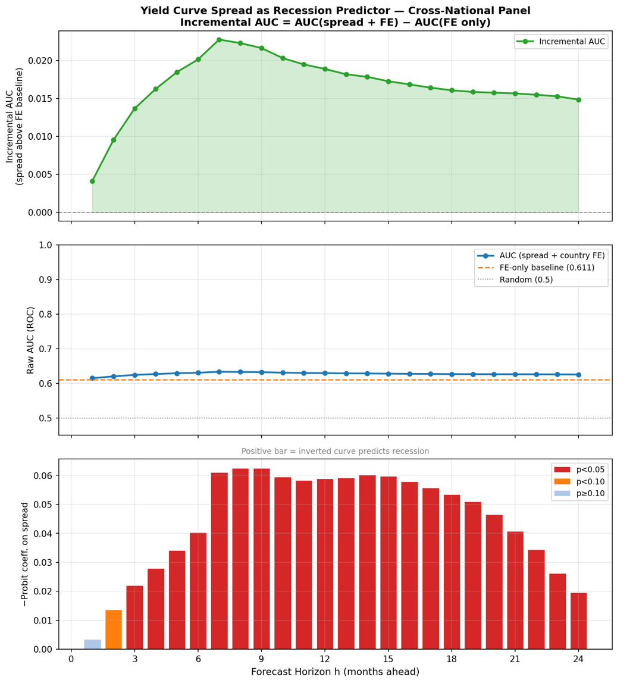
Figure 6. AUC as a function of forecast horizon in the pooled global panel. Predictive power peaks at approximately 7-9 months and remains statistically significant through 24 months.

4.3 Advanced and emerging economies
Grouping countries by economic classification further clarified the pattern (Figure 7). The United States was distinctive: its AUC increased from 0.661 at the 1-month horizon to 0.870 at the 24-month horizon. This rising pattern likely reflected the long and variable lag of U.S. monetary-policy transmission. Advanced economies excluding the United States peaked around AUC = 0.644 at month 7. Emerging and developing economies produced the weakest signal, with AUC values generally between 0.552 and 0.596 and with weaker statistical significance at the shortest and longest horizons.
These group-level results show that the pooled global average masks large structural differences. A single global coefficient is therefore not a reliable description of any individual country. Instead, regime-aware and country-stratified models are more appropriate for interpreting the yield curve as a recession predictor, especially when international spillovers and foreign yield curves may also contain information about domestic activity [10,11].
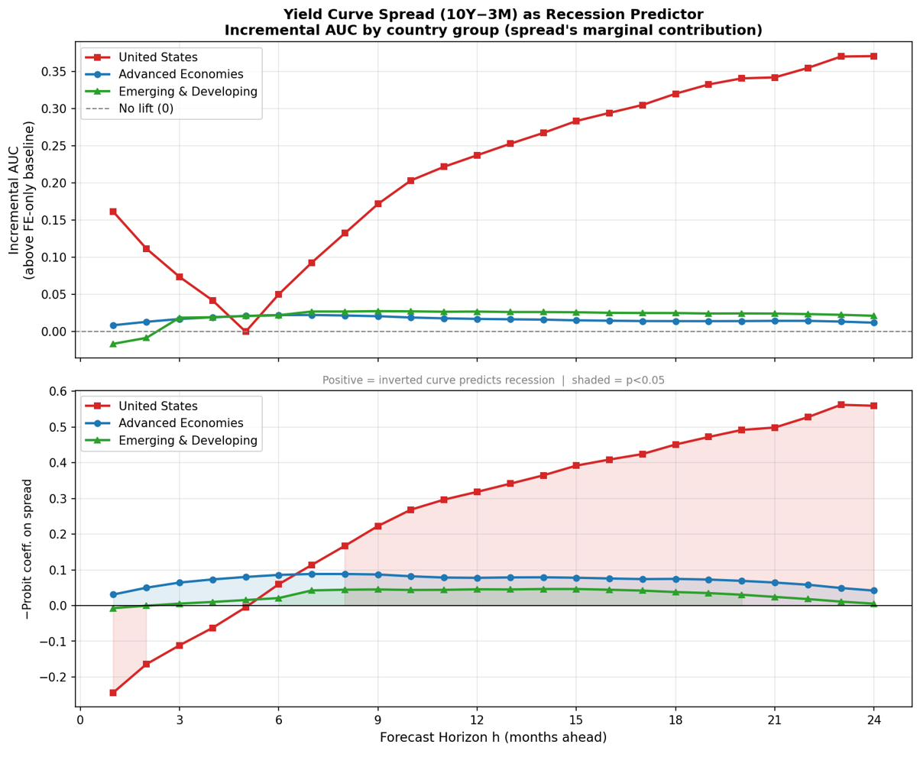
Figure 7. AUC by horizon for three groups: United States, advanced economies excluding the United States, and emerging and developing economies. The U.S. curve rises with horizon; other advanced economies peak around month 7; emerging markets remain persistently weaker.
The full country-level AUC distribution is shown in Figure 8. The distribution was clearly bimodal, with a small group of strong performers and a larger group clustered near the 0.50 no-skill benchmark.
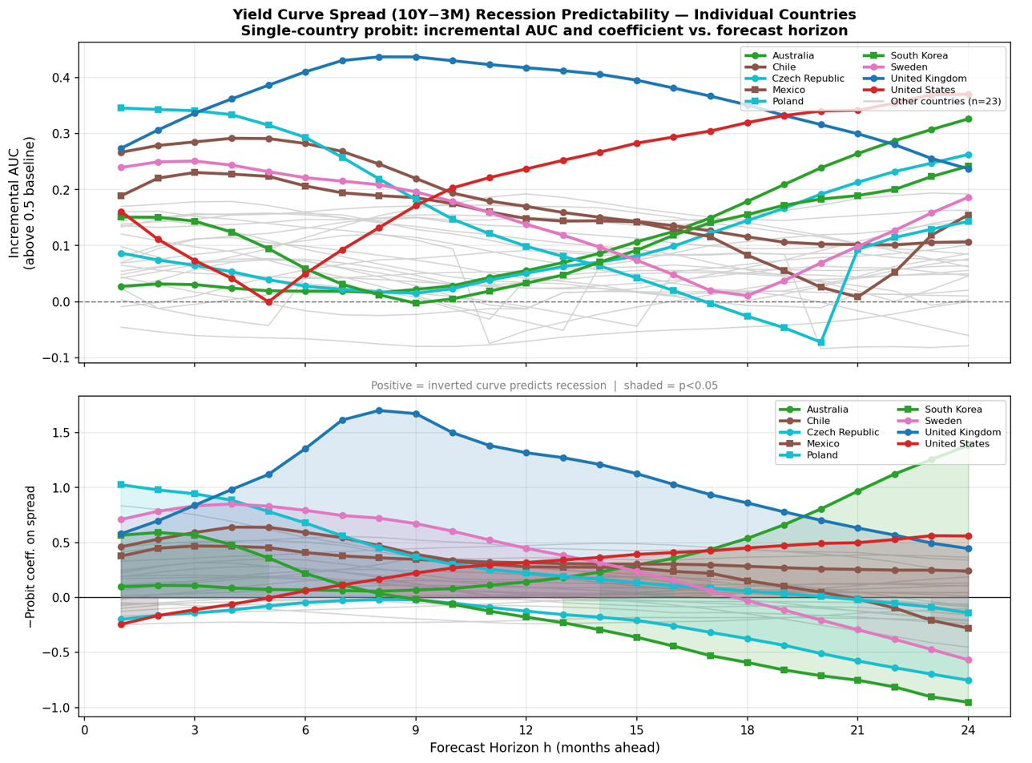
Figure 8. Country-level AUC values. The dashed line at 0.50 is the no-skill benchmark. The bimodal distribution, with a cluster of strong performers above 0.62 and a cluster near or below 0.50, motivates the structural interpretation developed in the discussion.

5. Discussion

5.1 Interpretation of monetary-regime heterogeneity
The cross-country results indicate that yield-curve forecasting success depends on whether the spread is a genuine market-based monetary-policy signal. The strongest predictors - including the United Kingdom, the United States, Norway, Chile, Israel, and New Zealand - share several features. Their short-term interest rates are set by domestic central banks, their bond markets are relatively deep, and their yield curves are not mechanically tied to a common supranational short-rate regime. In these settings, a low or inverted spread plausibly reflects expectations that current monetary tightening will be followed by economic weakness and future easing [1-3].
Eurozone economies illustrate the first weak-signal mechanism: policy-suppressed or shared short-rate signals. Member states share a common short-term rate set by the European Central Bank. As a result, the country-level 10-year/3-month spread reflects local long-term yields and risk premia, but the short end does not carry a country-specific policy signal. In this sample, eurozone members averaged AUC = 0.526, compared with 0.618 for non-eurozone economies. This finding is consistent with recent euro-area evidence showing that aggregate euro-area predictability can be present while country-level performance is uneven and concentrated in core economies [8,9].
The same principle applies, in attenuated form, to countries where yield curves are distorted by managed exchange rates, unconventional policy, risk premia, or commodity-cycle shocks. Turkey had a low recession rate but an AUC near 0.50, consistent with the idea that repeated currency and policy shocks weakened the business-cycle interpretation of its spread. South Africa also showed weak predictive performance, likely because exchange-rate and commodity-cycle dynamics dominated the standard domestic yield-curve channel. Japan represents an even clearer case of policy suppression because quantitative easing, negative interest-rate policy, and yield-curve control directly altered the information content of the term structure [15].
A second weak-signal mechanism operates through the base rate of recession. When the unconditional recession frequency is high, especially near 50%, a predictor must work harder to discriminate recession months from non-recession months. In this sample, the correlation between recession rate and AUC was -0.36. Ireland was the clearest case: it had the highest recession rate in the sample at 57.7% and an AUC of only 0.429. Greece and France also combined weak predictive performance with either high base rates, eurozone membership, or both. This supports the use of ROC-AUC and related classification metrics rather than relying only on coefficient signs or p-values [12,22].
High recession frequency alone, however, did not eliminate predictive power. Norway, Chile, and New Zealand had relatively high recession rates but still produced strong AUC values because they retained independent monetary policy and market-determined spreads. The most damaging combination was therefore high recession frequency together with a policy-constrained or distorted spread. This result tempers the interpretation of inversion signals: the yield curve may be useful in some national settings, but it should not be presented as a universal recession indicator.
Table 2. Summary of heterogeneity mechanisms. Countries are grouped by the dominant explanation for their AUC performance. Recession rate and average spread are shown as contextual variables.
Group | Dominant mechanism | Representative countries | Avg AUC | Avg rec. rate | EZ share
Strong signal | Independent policy and lower base rate | UK, US, Norway, Israel, Chile | 0.74 | 29% | 0%
Moderate signal | Independent policy and moderate base rate | Sweden, Hungary, Denmark, Poland | 0.62 | 40% | 0%
Weak signal | Eurozone constraint and moderate base rate | Germany, Austria, Belgium, Finland | 0.54 | 40% | 100%
Near-zero signal | Eurozone constraint plus high base rate or spread distortion | France, Spain, Ireland, Greece, South Africa | 0.47 | 47% | 80%
Finally, the country-level models do not explicitly estimate cross-border spillovers, although recent work shows that foreign yield curves can predict U.S. recessions and GDP growth [11]. Future research should therefore combine domestic spreads, foreign spreads, debt-service indicators, and broader financial-condition measures in regime-aware panel models. Such an extension would be especially useful for eurozone and emerging-market economies, where the present results show weak single-spread performance.
Second, the recession indicators combine multiple publicly available recession chronologies and international classifications. This was necessary for broad country coverage, but recession dating methods differ across institutions and may introduce measurement error. Third, the sample period begins in 2000, which allows inclusion of post-pandemic and 2022-2023 inversion dynamics but provides fewer historical recession cycles for some countries than long U.S.-only samples. Fourth, ROC-AUC measures discrimination rather than calibration; future work should examine probability calibration, out-of-sample testing, and real-time forecast vintages.
Several limitations should be acknowledged. First, the analysis uses a single-predictor benchmark model in order to isolate the information content of the 10-year/3-month spread. This design is transparent, but it does not imply that the yield curve is sufficient as a complete recession-forecasting system. Recent studies suggest that credit spreads, debt-service ratios, house prices, financial-condition indexes, labor-market variables, and survey information can improve recession forecasts when combined with the term spread [10,12-14].

5.2 Limitations and robustness considerations

6. Conclusion
This study examined the predictive power of the 10-year/3-month yield spread across 32 economies from 2000 to 2025. The main result is that the yield curve is a selective, not universal, recession indicator. The pooled global AUC of approximately 0.633 suggests modest overall forecasting value, but this average masks substantial heterogeneity across monetary regimes and national economic structures.
The yield curve performed best in countries with independent monetary policy, relatively deep bond markets, and market-determined short- and long-term interest rates. The strongest results were found for the United Kingdom and the United States, with additional meaningful signals in several other non-eurozone economies. In contrast, many eurozone countries produced AUC values near or below the no-skill benchmark because the shared ECB short-term rate removes much of the country-specific monetary-policy signal from the spread.
The analysis also showed that high unconditional recession frequency can reduce the incremental discriminatory value of the yield spread, especially when combined with policy-constrained interest rates. Ireland, France, Greece, and Spain illustrate this problem. However, high recession frequency did not by itself eliminate predictive power when countries retained independent monetary policy and market-determined yield curves.
The practical implication is that researchers and policymakers should avoid applying a single global yield-curve rule across all countries. In the United States and the United Kingdom, the yield curve remains a useful medium-term recession indicator. In much of the eurozone and in policy-suppressed regimes, it should be interpreted with caution and supplemented with country-specific indicators such as credit spreads, purchasing managers' indexes, labor-market indicators, and real-activity measures. Future research should improve forecasting in weaker-signal economies by combining the term spread with broader financial-condition and macroeconomic variables in regime-aware models.

Disclaimer (Artificial intelligence)
The author(s) are responsible for the study design, data analysis, scientific interpretation, reference verification, and final approval of this manuscript. Any editorial, formatting, or language-assistance tools used during revision should be disclosed according to the journal's current artificial-intelligence policy.

References
1. Bauer MD, Mertens TM. Economic forecasts with the yield curve. FRBSF Economic Letter. 2018;2018-07. Federal Reserve Bank of San Francisco.
2. Bauer MD, Mertens TM. Information in the yield curve about future recessions. FRBSF Economic Letter. 2018;2018-20. Federal Reserve Bank of San Francisco.
3. Benzoni L, Chyruk O, Kelley D. Why does the yield-curve slope predict recessions? Federal Reserve Bank of Chicago Working Paper. 2018;WP-2018-15. https://doi.org/10.21033/wp-2018-15
4. Engstrom EC, Sharpe SA. (Don't Fear) The Yield Curve, Reprise. FEDS Notes. Washington: Board of Governors of the Federal Reserve System; 2022. https://doi.org/10.17016/2380-7172.3099
5. Ajello A, Benzoni L, Chyruk O, Kiley MT, Kelley D, Kim S, et al. Monetary policy, inflation outlook, and recession probabilities. Economic Perspectives. Federal Reserve Bank of Chicago; 2022;46(4).
6. Federal Reserve Bank of St. Louis. What is the probability of a recession? The message from yield spreads. On the Economy Blog. 2023 Sep 7.
7. Tawose JB, Adedeji KE, Ajayi KJ, Onah AO, Emma-Nwachukwu F. Yield curve and monetary policy in Nigeria: Investigating the predictive power of the yield curve. South Asian Journal of Social Studies and Economics. 2021;12(4):41-54. https://doi.org/10.9734/sajsse/2021/v12i430314
8. Sabes D, Sahuc JG. Do yield curve inversions predict recessions in the euro area? Finance Research Letters. 2023;52:103416. https://doi.org/10.1016/j.frl.2022.103416
9. European Central Bank. The inversion of the yield curve and its information content in the euro area and the United States. ECB Economic Bulletin. 2023;Issue 7/2023.
10. Chinn MD, Ferrara L. The predictive power of the term spread and financial variables for economic activity across countries. NBER Working Paper. 2024;32084. https://doi.org/10.3386/w32084
11. Ahmed R, Chinn MD. Do foreign yield curves predict U.S. recessions and GDP growth? Journal of Money, Credit and Banking. 2025;57(8):2075-2098. https://doi.org/10.1111/jmcb.13164
12. Lahiri K, Yang C. ROC and PRC approaches to evaluate recession forecasts. Journal of Business Cycle Research. 2023;19(2):119-148. https://doi.org/10.1007/s41549-023-00082-4
13. Borio C, Drehmann M, Xia FD. Forecasting recessions: The importance of the financial cycle. Journal of Macroeconomics. 2020;66:103258. https://doi.org/10.1016/j.jmacro.2020.103258
14. Chatterjee UK, Zirgulis A, Huettinger M, French J. Reassessing the inversion of the Treasury yield curve as a sign of U.S. recessions: Insights from the housing and credit markets. The North American Journal of Economics and Finance. 2024;73:102185. https://doi.org/10.1016/j.najef.2024.102185
15. Bank for International Settlements. BIS Quarterly Review, March 2023: International banking and financial market developments. Basel: Bank for International Settlements; 2023.
16. Aramonte S, Schrimpf A, Shin HS. Yield curve inversion and recession risk. BIS Quarterly Review. 2019 Sep:1-2.
17. Federal Reserve Bank of Cleveland. Yield curve and predicted GDP growth. Cleveland Fed Indicators and Data. Accessed 2026 May 10.
18. Federal Reserve Bank of St. Louis. 10-Year Treasury Constant Maturity Minus 3-Month Treasury Constant Maturity (T10Y3M). FRED, Federal Reserve Economic Data. Accessed 2026 May 10.
19. Organisation for Economic Co-operation and Development. OECD.Stat: Main Economic Indicators and financial indicators database. OECD; Accessed 2026 May 10.
20. International Monetary Fund. World Economic Outlook Database. Washington, DC: International Monetary Fund; 2025.
21. National Bureau of Economic Research. U.S. business cycle expansions and contractions. NBER Business Cycle Dating Committee; Accessed 2026 May 10.
22. Lahiri K, Yang C. A tale of two recession-derivative indicators. Empirical Economics. 2023;65(2):925-947. https://doi.org/10.1007/s00181-023-02361-6

