Effect of Plant Growth Regulators on Cuttings and Air Layering of Indian olive (Elaeocarpus floribundus Blume)

Abstract
Indian Olive (Elaeocarpus floribundus Blume) is locally known as jalpai, a potential minor fruit crop in north-eastern parts of India. Because of the recalcitrant nature of the seed, short period of seed viability and hard seed coat, the present investigation was conducted to examine the rooting response of cuttings and air-layered branches of E. floribundus towards different types and doses of root-promoting plant growth regulators in combination with an auxin synergist. The cutting experiment was conducted during three planting periods viz., mid-March, mid-July and mid-November in a Completely Randomized Design (CRD) comprising nine treatments with three replications. Air-layering was carried out, comprising seven treatments, including a control (untreated) with three replications. Cuttings were treated with Indole-3-butyric acid (IBA) and Naphthalene acetic acid (NAA) of 1000, 2000, 4000, 6000 ppm, where air layerings were treated with IBA and NAA solution of 500, 1000 and 2000 ppm with p-hydroxybenzoic acid (phb) of 2000 ppm as auxin synergist. Both the varying concentrations of IBA and NAA failed to induce growth and sprouting in the cuttings. Air layerings treated with NAA 1000 ppm+2000ppm phb and IBA 500 ppm +2000ppm phb recorded the highest 100 and 98.33% callusing per cent, respectively. Rooting response was found to be maximum 93.33 and 91.67% in IBA 500 ppm+2000 ppm phb and NAA 1000 ppm+2000 ppm phb, respectively, while minimum (60%) was recorded in the control. The present study indicates that air-layering constitutes a viable, efficient, and economically feasible method for the vegetative propagation of Elaeocarpus floribundus, particularly in taxa that are recalcitrant to propagation through conventional cuttings. The technique is straightforward, cost-effective, and readily adoptable by farmers owing to its high success rate and low mortality. Consequently, it enables the rapid multiplication of high-quality planting material within a relatively short time frame.
Keywords: Plant growth regulators, Cutting, Air layering, Callusing, Indian olive

1. Introduction
Minor and underutilized fruit crops are often treated important due to their nutraceutical properties and their diversified value-added products which sometimes served as very good supplements of major fruits. These fruits not only play a very significant role to meet the dietary requirement in mostly poverty and rural areas where malnutrition is localized or prevailed but also plays as an integral part of their subsistence. This positive influence can be attributed to phytochemicals such as carotenoids, alkaloids, vitamins, minerals, flavonoids and other phenolics (Swapana et al., 2012). Indian olive (Elaeocarpus floribundus Blume), locally known as ‘jalpai’ belongs to family Elaeocarpaceae, is one of the promising minor fruit crops in the northern part of West Bengal. The edible portion of the fruit is the mesocarp around the seeds (Ghosh et al., 2017). It is a medium to tall evergreen tree attaining a height of 10 to 20 m with a spherical crown. It is widely distributed in the Sub-Himalayan terai region of West Bengal, from North Eastern states to the evergreen forests of North Kanara and Western coast down to Travancore of India up to an altitude of 3000 feet (Anonymous, 2003). This is also widely grown in homesteads under shady or semi-shady conditions with little or restricted management practices. Mature fruit pulp is pleasantly acidic and mainly used for preparation of chutney, pickles and other culinary items. Ripe fruits contain 4.91 pulp: seed ratio, 9.98 ⁰B TSS, 50 mg/100g ascorbic acid, 97.23 kcal/g food energy value, 46.31µg/g zinc, 53.86µg/g manganese, 7.8331µg/g copper of dried powder and 55.61 C:N ratio (Dey et al., 2017). Infusion of bark and leaves is used as a mouthwash against inflamed gums while the fruits possess antiseptic properties (Wiart, 2006). Previous investigations have reported the presence of a range of bioactive constituents, including flavonoids, triterpenoids, sterols, and phenolic acids, across different parts of the plant. In particular, gallic acid, a well-characterised antioxidant compound, has recently been isolated from the seeds of *E. floribundus* and demonstrated to exhibit pronounced free radical scavenging capacity alongside notable antimicrobial activity (Ogundele et al., 2025). Traditionally, it is used to cure diseases like diabetes, hypertension, dysentery and rheumatism. The various bioactive compounds in fruits have excellent antibacterial properties against food-borne bacteria (Sircar and Mandal, 2017). The phenolic compounds present in extra virgin olive oil are considered to play a central role in its therapeutic properties, including the reduction of serum cholesterol levels, blood pressure, and the overall risk of cardiovascular disease. In addition, these bioactive constituents contribute significantly to the oil’s oxidative stability and are key determinants of its characteristic organoleptic properties (Devi et al., 2025).
Because of its nutritional value, medicinal/ ethno-botanical uses and economic benefits still the management practices of different aspects have not yet standardized. The species is traditionally propagated through seed resulting high variability of performances. However, propagation from seeds has inherent biological problems largely due to erratic flowering behavior, irregular fruit setting, recalcitrant nature of seeds, hard seed coat, prolonged seed dormancy, poor seed germination and seedling establishment in natural habitat. The demand of fruits has affected the natural regeneration. That’s why, vegetative propagation assumes a great significance for large scale production of planting materials for plantation programme (Sarun et al., 2026). Mostly cuttings and air layering are popularly adopted because of the simplicity and cost effectiveness. Generally, the varying concentrations and combination of natural and synthetic auxins/ plant growth regulators are used to induce rooting in cuttings and air layered branches. Synergistic effect of mixture of two components of auxins on root induction in cuttings and air layers has earlier been reported. It is also observed that rooting percentage would be better if the phenolic compound like p-hydroxybenzoic (phb) acid is used as an auxin synergist (Bose Roy and Basu, 1972). Though, many workers have worked on the propagation practices of major fruit crops but few workers have reported the propagation of minor fruit crops (Mishra and Singh, 1990; Roy et al., 1998; Rahman et al., 2003; Reddy, 2004; Saravanan et al., 2011 and Tomar, 2016). Therefore, the present investigation was conducted to examine the rooting response of cuttings and air layered branches of E. floribundus towards different types and doses of root promoting plant growth regulators in combination with auxin synergist.
2. Materials and methods
The present study was carried out in the Central Forest Nursery of the Department of Forestry, Faculty of Horticulture, Uttar Banga Krishi Viswavidyalaya, Pundibari, Cooch Behar lying in the plains of terai zone of West Bengal at an altitude of 43 m above mean sea level during the year 2018.
Semi-hardwood cuttings measuring 15–20 cm in length and of uniform diameter (1.0–1.5 cm), each bearing at least 2–3 nodes, were collected from medium-sized superior trees located in the vicinity of the university campus. Each cutting was prepared by making a transverse cut just above a bud at the apical end, while the basal end was given an oblique cut using a sharp razor blade to maximise the exposed surface area for enhanced root induction and absorption. The basal portions of the cuttings were then immersed for 30 seconds in solutions of indole-3-butyric acid (IBA) and naphthalene acetic acid (NAA) at concentrations of 1000, 2000, 4000, and 6000 ppm, to a depth of 1 cm. Subsequently, the cuttings were air-dried for 10–15 minutes before being planted in polyethylene bags (7 cm × 10 cm) filled with a rooting medium composed of soil, sand, farmyard manure (FYM), and coco-peat in a ratio of 2:1:1:1. Following planting, the upper ends of the cuttings were sealed with wax to minimise moisture loss. Irrigation was carried out twice daily, in the morning and evening. The cuttings were planted in three period viz., mid-March, mid–July and mid–November to optimize the best time period and kept in a polyhouse. The cuttings were treated with two growth regulators of four concentrations comprising nine treatments of three replications with a control consisting twenty numbers of cuttings per replication with a total of sixty cuttings per treatment. The details of treatment were: T₁ - 1000 ppm IBA; T₂ - 2000 ppm IBA; T₃ - 4000 ppm IBA; T₄ - 6000 ppm IBA; T₅ - 1000 ppm NAA; T₆ - 2000 ppm NAA; T₇ -4000 ppm NAA; T₈ - 6000 ppm NAA and T₉ - control. The growth attributes like sprouting percentage, length of the sprout, time taken for sprouting, rooting percentage, average root length and number of roots per cutting was recorded after 30 days of planting.
Air-layering was performed on semi-hardwood, vigorous, and healthy branches of young, mature trees approximately 10 years of age. Secondary branches with a diameter of 1.0–1.5 cm were randomly selected, and a cylindrical bark ring of 2–5 cm in length was removed to facilitate rooting. Different concentrations of indole-3-butyric acid (IBA) and naphthalene acetic acid (NAA), namely 500, 1000, and 2000 ppm, were applied in combination with p-hydroxybenzoic acid at 2000 ppm, which was used as an auxin synergist. The experiment was comprised seven treatments including a control (untreated) with three replications comprising 20 number of air layers per replication having a total of 60 air layering and treats were as follows: viz., T₁ - 500 ppm IBA+2000 ppm phb, T₂ - 1000 ppm IBA+2000 ppm phb, T₃ - 2000 ppm IBA+2000 ppm phb, T₄ - 500 ppm NAA+2000 ppm phb, T₅ - 1000 ppm NAA+2000 ppm phb, T₆ - 2000 ppm IBA+2000 ppm phb and T₇ - control. Each treatment was performed separately in separate trees whereas untreated layer served as control. Firstly, the girdled portion of the branches were treated with the solution of 2000 ppm p-hydroxybenzoic acid using cotton and allowed to dry for few seconds and then treated with respective concentration of IBA and NAA. The cut area around the branch was covered with rooting media consisting of soil: cow dung: coco-peat 2:1:1, and then wrapped with polythene sheet and lastly tied at both ends to avoid any moisture loss. The air layering was laid out in mid-May with the onset of monsoons and monitored constantly for rooting response up to 45 days. At the end of the experiment the air layered branches were detached from the parent trees for recording the following observations like percentage of callus, rooting percentage, number of primary and secondary roots, root length, fresh and dry weight of root per air-layer. The experiment was set up under completely randomized design as per the procedure suggested by Gomez and Gomez (1984).
3. Results and Discussion
The result and discussion should be categorized on the basis of performance by cutting and air layering and presented in Table 1 and Figure 1.
3.1 Performance of Cutting
The results showed that the application of varying level of IBA and NAA didn’t induce the growth in the cuttings in all three periods. Even if, either callus or root formation did not take place. Similarly, no sprouting was occurred in the cuttings. Subsequently, the cuttings were gradually dried up and finally failed. Similar findings are reported by Kumar et al. (2014) in Salvadora oleoides and Thakur (2014) in Acacia catechu. The potentiality of the stimulating power of cutting to rejuvenate varies with species to species and mostly depends on its genetic make up. The success of rooting of cuttings is influenced by age, early selection of desired characters and environment (Ali and El-Tigani, 2003). Cuttings of certain species exhibit a high capacity for regeneration, whereas others root with difficulty, and some fail to regenerate altogether, thereby being regarded as recalcitrant. The absence of a well-defined “rhizocline”, as well as a deficiency of rooting co-factors, may constitute contributory factors to the poor rooting behaviour observed in such species. Furthermore, the presence of endogenous rooting inhibitors, including lignin, tannins, and abscisic acid, cannot be excluded as potential reasons for the limited rooting response in this species. Also, it was noticed that no sprouting was occurred in the cuttings in all three periods. This may be due to the capacity of absorption of less or higher amount of different concentration of growth hormone which causes inhibitory effect on rooting as well as sprouting of the species. Sometimes high level of secondary metabolites prevents root formation in the cuttings as reported by Yadav et al. (2005). This finding is strongly similar with the findings of Rai et al. (2022) in Elaeocarpus ganitrus.
3.2 Performance of Air Layering
3.2.1 Callusing %
The results pertaining to variation in callusing percent, rooting percent, mean number of primary and secondary roots, mean root length and average fresh and dry root weight in air layers after 45 days have been depicted in Table 1. IBA and NAA significantly (p ≤ 0.05) affected all parameters among the treatments. T₅ (NAA 1000 ppm+2000ppm phb) resulted the maximum (100%) callusing percent which was statistically at par with T₁ (IBA 500 ppm +2000ppm phb) showing 98.33 percent followed by T₂ (IBA 1000 ppm +2000ppm phb) and T₄ (NAA 500 ppm+2000ppm phb) comprising the value of 95 and 93.33 percent, respectively whereas minimum callusing (80.00%) was recorded in T₆ (NAA 2000 ppm+2000ppm phb) which did not differ significantly with T₃ (IBA 2000 ppm+2000ppm phb) and T₇ (Control) exhibiting 86.67 and 83.33 percent, respectively. Exogenous application of both IBA and NAA induced callus formation indicating a conduciveness environment for callus formation. However, callus formation decreased with increase in the concentration. The callus formation showed the decreasing trend with higher the concentration of IBA (Khosla et al., 1982) whereas it was increased with increase in concentration of NAA but up to certain level and then declined. The present finding is close agreement with the findings of Sanchez-Urdaneta et al. (2009) in guava where callus formation was reduced with increasing concentration of IBA (2000, 4000 and 6000 ppm) and its formation was completely stopped at the concentration of 6000 ppm but contradicts to the result of Tomar (2016) in Spondias pinnata.
3.2.2 Root Parameters
3.2.2.1 Rooting %
Table 1 and figure 1 revealed that T₁ (IBA 500 ppm+2000 ppm phb) stimulated highest (93.33%) rooting in air layers closely followed by T₅ (NAA 1000 ppm+2000 ppm phb) recording 91.67 percent whereas the lowest rooting (60.00%) was recorded in T₇ (control), which did not differ significantly with T₃ (IBA 2000 ppm+2000 ppm phb) exhibiting 70.00 percent. Both, T₂ (IBA 1000 ppm+2000 ppm phb) and T₆ (NAA 2000 ppm+2000 ppm phb) shared same value (80.00%) of rooting percentage. It was observed that callus formation was slightly more than root initiation in both IBA and NAA which proves callusing and root initiation to be independent phenomena but occupying same time and space, competing for similar resources. Lower concentrations of auxins have been reported to promote the formation of adventitious roots in Quercus serrata (Srivastava et al., 2000). The exogenous application of auxins in air-layering during periods of active growth, when endogenous auxin levels are already elevated, may result in supra-optimal hormonal concentrations, thereby reducing rooting efficiency (Moreira et al., 2009). Rooting response appears to be governed by a physiological equilibrium involving the internal translocation of carbohydrates, nitrogenous compounds, hormonal regulators, and rooting co-factors that act synergistically with auxins (Khosla et al., 1982). Indole-3-butyric acid (IBA) is widely regarded as an effective rooting hormone for many difficult-to-root species and is generally recommended for broad application due to its comparatively low phytotoxicity across a wide concentration range when compared with naphthalene acetic acid (NAA). This finding is in close conformity with the findings of Singh and Ansari (2014) and Kamila and Panda (2019).
3.2.2.2 Number of Primary and Secondary Roots per Air Layering
Number of primary and secondary roots per air-layering was significantly influenced by varying concentration of IBA and NAA (Table 1). The mean number of primary root produced by the air layers was recorded maximum (83.73) with T₆ (NAA 2000 ppm+2000 ppm phb) followed by T₃ (IBA 2000 ppm+2000 ppm phb) exhibiting 63.40 which were significantly superior over all the other treatments where the minimum (7.80) was in control (T₇). Mean maximum number of secondary roots (35.73 and 19.93) was observed in T₃ (IBA 2000 ppm+2000 ppm phb) and T₄ (NAA 500 ppm+2000 ppm phb), respectively which was significantly superior to rest of the treatments while minimum (8.80) was noticed in control (T₇). The average of primary and secondary root number did not follow any pattern but showed a consistent increase with increasing dose of growth regulator over the control. Auxins stimulate cell division and elongation, leading to the differentiation of cambial initials into root primordia. They also promote the mobilization of stored nutrients to sites of root initiation, thereby increasing number of roots per air layering. Differences in uptake and metabolism of the two auxins may be a cause for difference in number of roots. These results are in close agreement with the findings of Bhojvaid and Negi (2003) and Tomar (2016).
3.2.2.3 Average Length of Root
The data presented in the Table 1, found that the average root length ranged from 1.35 cm to 3.46 cm. The mean maximum length of roots (3.46 cm) was found with T₅ (NAA1000 ppm+2000 ppm phb) followed by 3.44 cm and 3.20 cm in T₂ (IBA1000 ppm+2000 ppm phb) and T₄ (NAA 500 ppm+2000 ppm phb) which was found statistically at par with each other, respectively, whereas, minimum root length (1.35 cm) was in T₇ i.e. control followed by T1 (IBA 500 ppm+ 2000 ppm phb showing 1.82 cm. The availability of the food materials to the root development by effective translocation of starch and nitrogen to the base of the air layered branch might have encouraged the growth of the root. The auxin activity likely promoted the hydrolysis and translocation of sugars and nitrogenous compounds to the base of the air layering, may have facilitated accelerated cell division and elongation under favourable conditions contributing to the development of the longest roots. Besides this, the early initiation of rooting and utilization of stored food reserves in the treated air layering may further explain this phenomenon. The finding of this study is well in line with the findings of Reddy (2004).
3.2.2.4 Average fresh and dry root weight
The data of the average fresh and dry weight of the roots per air layering presented in Table 1, indicated that the fresh and dry weight of root differed significantly among the treatments. The maximum fresh weight of the roots (7.97 g) was recorded in T₆ (NAA 2000 ppm+2000 ppm phb) followed by T₃ (IBA 2000 ppm+2000 ppm phb) exhibiting 5.63 g which were significantly superior to all other treatments among the treatments whereas T₇ (control) showed minimum (0.47 g). The dry weight of roots exhibited a pattern similar to that of root fresh weight across treatments. Application of indole-3-butyric acid (IBA) and naphthalene acetic acid (NAA) enhanced root fresh weight, primarily due to the development of a greater number of roots as well as increased root length. As roots matured, enhanced uptake of water and nutrients from the growth medium contributed to further biomass accumulation, thereby increasing overall root weight. The results of the present investigation are consistent with the findings reported by Reddy (2004) in Ficus carica.
4. Conclusion
In the present study, it is found that air layering method is a potential, viable and economical method of vegetative propagation for E. floribundus as it is difficult to root by cuttings. Among the treatments, IBA 500 ppm + 2000 ppm PHB performed slightly better than NAA 1000 ppm + 2000 ppm PHB for inducing rooting in air layers. This technique is relatively simple and very easily adopted by farmers due to high success rate and low mortality which helps in producing large number planting materials in short period of time.
Disclaimer
Author (s) hereby declare that No generative AI technologies and text-to-image generators have been used during the writing or editing of this manuscript.
References
Ali, Y. H., & El-Tigani, S. (2003). Vegetative propagation of Acacia senegal (Willd.) by stem cuttings. Sudan Silva., 9, 36-44.
Anonymous. (2003). Elaeocarpus. In: The Wealth of India – A Dictionary of Indian Raw Materials and Industrial Products (pp. 139-141). Publication and Information Directorate, CSIR, New Delhi, India.
Bhojvaid, P. P., & Negi, S. (2003). Propagation of Elaeocarpus ganitrus by air layering. Indian Forester, 12, 1185-1191.
Bose Roy, B.N., & Basu, R.N. (1972). Synergism between auxins and phenolic compounds in the rooting of cuttings. Indian Agriculture, 16, 171-176.
Dey, K., Ghosh, A., & Dey, A. N. (2017). Physico-chemical characterization of Indian olive (Elaeocarpus floribundus) grown in terai region of West Bengal. The Bioscan, 12, 1597-1599.
Gomez, K. A., & Gomez, A. A. (1984). Statistical Procedures for Agricultural Research, 2nd ed., John Willey and Sons, Inc. New York, USA.
Kamila, P. K., & Panda, P. C. (2019). Large-scale vegetative propagation of Lasiococca comberi by air layering. Journal of Tropical Forest Science, 31, 37-42.
Khosla, P. K., Nagpal, R., & Puri, S. (1982). Propagation of some agroforestry species by air layering. Indian Journal of Forestry, 5, 171-174.
Kumar, S., Deswal, M., & Laura, J. (2014). Study on seed germination and vegetative propagation of Salvadora oleoides Decne. International Journal of Current Research, 6, 8058-8062.
Misra, K. K., & Singh, R. (1990). Effect of growth regulators on rooting and survival of air layers of Kronda (Carissa corandas L.). Annals of Agricultural Science, 11, 208-210
Moreira, O., Martins, J., Silva, L., & Moura, M. (2009). Propagation of the endangered Azorean cherry Prunus azorica using stem cuttings and air layering. Arquipelago. Life and Marine Sciences, 26, 9-14.
Rahman, M. M., Amin, M. N., & Ahmad, S. (2003). Rapid clonal propagation of native olive (Elaeocarpus robustus Roxb.) using tissue culture technique. Journal of Biological Sciences, 3, 1107-1113.
Rai, Abigail, Dey, A. N., Bhowmick, N., Panda, M. R., Dinesha S., & Sarkar, B. (2022). Impact of growth hormones on vegetative propagation of Elaeocarpus ganitrus Roxb. Environmental conservation Journal, 23, 164-171.
Reddy, K. V. R. (2004). Studies on the effect of growth regulators on rooting of Fig (Ficus carica L.) cuttings. M. Sc thesis submitted to Acharya N. G. Ranga Agricultural University, Rajendranagar, Hyderabad.
Roy, S., Islam, M., & Hadiuzzaman, S. (1998). Micropropagation of Elaeocarpus robustus Roxb. Plant Cell Reports, 17, 810-813.
Sanchez-Urdaneta, A. B., Suarez, E., Gonzalez, M. R., Amaya, Y., Colmenares, C. B., & Ortega, J. (2009). Effect of indole butyric acid on the air layer rooting of guava (Psidium guajava L.) in the Baralt Country, Venezuela. Preliminary Evaluation. Revista Cientifica UDO Agricola, 9, 113-120.
Saravanan, S., Indra, M., Kamalraj, P., Venkatesh, D. R., & Muthuchelian, K. (2011). In-situ vegetative propagation of Elaeocarpus venustus Bedd. a threatened endemic tree of Agasthiamalai Biosphere Reserve, Western Ghats, India. Journal of Bioscience Research, 2, 46-49.
Singh, S., & Ansari, S. A. (2014). Callus formation impedes adventitious rhizogenesis in air layers of broadleaved tree species. Annals of Forest Reearch, 57, 47-54.
Sircar, B., & Mandal, S. (2017). Screening of Elaeocarpus floribundus fruit extracts for bioactive phytocomponents and antibacterial activity against food-borne bacteria. International Journal of Research in Medical Sciences, 5, 3665-3671.
Srivastava, P. K., Singh, T. S., & Singh, N. I. (2000). Clonal propagation of Quercus serrata Thunb. syn. Q. acutissima Carr. through air layering. Indian Forester, 126, 879-884.
Swapana, M., Jotinkumar, T. H., Devi, B. C. H., Singh, M. S., Singh, B. S., & Singh, C. B. (2012). Total phenolic, total flavonoids contents and antioxidant activity of a few indigenous fruits grown in Manipur. The Bioscan, 7, 73-76.
Thakur, L. (2014). Studies on vegetative propagation of Acacia Catechu Wild and Toona Ciliata M. Roemer. M.Sc. thesis submitted to Dr. Y. S. Parmar University of Horticulture and Forestry, Solan, India.

Tomar, A. (2016). Impact of seasonal changes on air layering and rooting hormone in Spondias pinnata (J. Koenig ex L.f.) Kurz. Tropical Plant Research, 3, 131-135.

Wiart, C. (2006). Medicinal Plant of Asia-Pacific-Drugs for the Future. World Scientific Publishing Co. Pte. Ltd., British Library Cataloguing-in-Publication Data.
Yadav, J. P., Saini, S., & Kalia, A. N. (2005). Botanical, cytological, phytochemical and pharmacognostical studies on Salvadora species. Journal of Medicinal and Aromatic Plant research, 28, 1-8.
Ghosh, A., Dey, K., Mani, A., Dey, A. N., & Bauri, F. K. (2017). Implication of Nanocomposite Edible Coating for Shelf Life Extension of Indian Olive (Elaeocarpus floribundus Blume). Current Journal of Applied Science and Technology, 22(2), 1–8. https://doi.org/10.9734/CJAST/2017/33111
Ogundele, A. V., Das, A. M., & Paz, C. (2025). Gallic Acid from Elaeocarpus floribundus Stem Bark: A Potent Natural Antioxidant with Enzymatic and Pharmacokinetic Validation. Antioxidants, 14(10), 1161. https://doi.org/10.3390/antiox14101161
Devi, K. I., Upadhyay, S., Bhutia, K. D., Sharma, L., & Rai, O. (2025). A study on morphological observations and biochemical parameters of wild olive (Elaeocarpus floribundus Blume) grown in Manipur. Journal of Applied and Natural Science, 17(3), 973.
Sarun, H. (2026). Vegetative Propagation Using Cuttings: Types, Techniques, and Applications. Journal of Agriculture and Environment, 3(3), 488-492.
Table 1. Effect of IBA and NAA on callusing percentage, rooting percentage, number of primary and secondary root, root length, fresh and dry root weight of air layered branches of Elaeocarpus floribundus
Treatments | Callusing (%) | Rooting (%) | Number of primary roots per air layering | Number of secondary roots per air layering | Average length of root (cm) | Fresh root weight (g) | Dry  root weight (g)
T₁ | 98.33ª  (85.69) | 93.33ª  (75.24) | 19.27^{d} | 31.80^{b} | 1.82de | 1.32^{ef} | 0.30e
T₂ | 95.00^{ab}  (82.40) | 80.00^{b}  (63.55) | 13.20e | 29.47^{b} | 3.44ª | 2.38^{d} | 0.54^{d}
T₃ | 86.67^{bcd}  (69.55) | 70.00^{bc}  (56.84) | 63.40^{b} | 35.73ª | 2.35^{cd} | 5.63^{b} | 1.27^{b}
T₄ | 93.33^{abc}  (77.71) | 75.00^{b}  (60.26) | 18.13^{d} | 19.93^{c} | 3.20^{ab} | 2.20de | 0.45de
T₅ | 100ª  (90.00) | 91.67ª  (73.40) | 29.33^{c} | 19.07^{c} | 3.46ª | 3.69^{c} | 0.75^{c}
T₆ | 80.00^{d}  (63.55) | 80.00^{b}  (63.55) | 83.73ª | 18.27^{c} | 2.76^{bc} | 7.97ª | 1.62ª
T₇ | 83.33^{cd}  (66.15) | 60.00^{c}  (50.85) | 7.80^{f} | 8.80^{d} | 1.35e | 0.47^{f} | 0.10^{f}
SE(m) (±) | 4.64 | 2.46 | 1.43 | 0.90 | 0.20 | 0.30 | 0.06
CD at 5% of level | 14.08 | 7.46 | 4.37 | 2.73 | 0.60 | 0.90 | 0.20

Values in parentheses are arc-sine value
T₁ = IBA 500 ppm + 2000 ppm para-hydroxy benzoic acid T₄ = NAA 500 ppm + 2000 ppm para-hydroxy benzoic acid
T₂ = IBA 1000 ppm + 2000 ppm para-hydroxy benzoic acid T₅ = NAA 1000 ppm + 2000 ppm para-hydroxy benzoic acid
T₃ = IBA 2000 ppm + 2000 ppm para-hydroxy benzoic acid T₆ = NAA 2000 ppm + 2000 ppm para-hydroxy benzoic acid
T₇ = Control
Mean with same letter is not significantly different among the treatments of the respective parameters

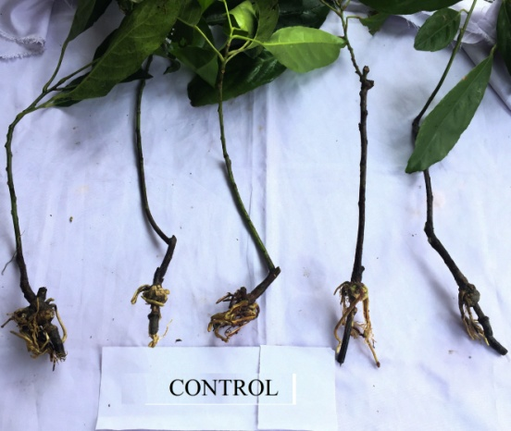
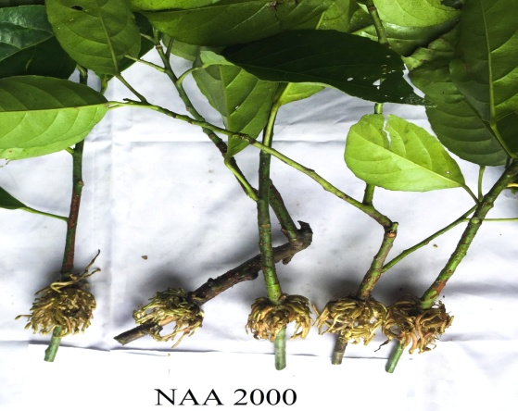
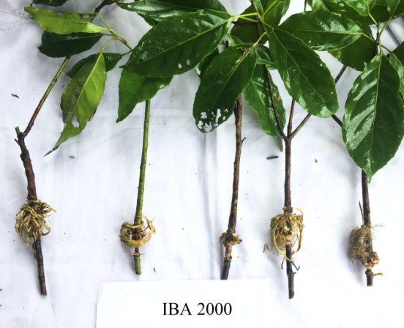
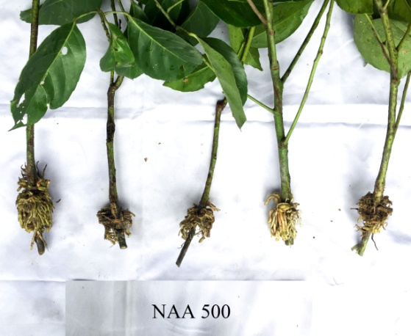
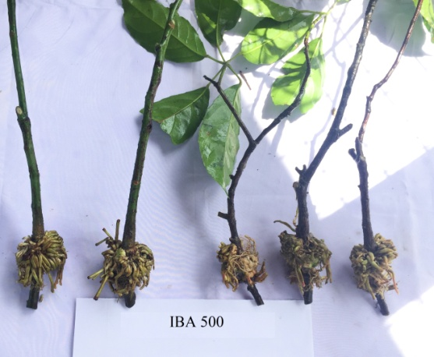
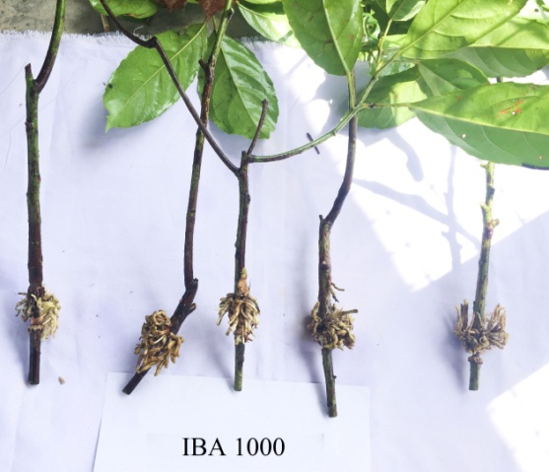
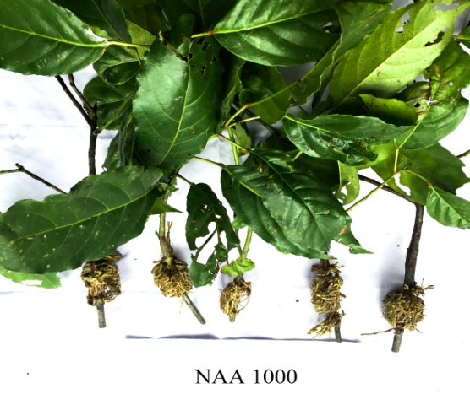

Fig 1. Air layering of Elaeocarpus floribundus in different concentration of IBA, NAA and control

