Economics of Adoption of Farm Technologies Across Terai Region of West Bengal, India: A Systematic Review

Abstract
Terai, a region in North West Bengal is both highly diverse in ecology and socioeconomic heterogeneity, and this has led to unequal adoption of agricultural technologies in the agro-climatic regions. Purpose: This systematic review pulls together empirical findings on the factors, trends and economic consequences of farm technology adoption in the Terai plains and neighboring hill districts of Northern West Bengal. Methods: In accordance with the Preferred Reporting Items of Systematic Reviews and Meta-Analysis (PRISMA) guidelines, a detailed search of Scopus, Web of Science, and Google Scholar was carried out. The selection of the 45 peer-reviewed and grey literature studies was done according to pre-defined inclusion and quality criteria and published in 2000-2024. Findings: The size of landholding, education, and access to non-farm income were identified to be the main socioeconomic factors that influence adoption of mechanization, high-yielding varieties, and weather-resistant technologies. The KVKs became important institutional actors with an estimated 40% greater rates of technology adoption among the participating farmers. Adoption had measurable payoffs such as a 12-20% rise in yield and a 10-15% decline in the cost of cultivation with greater impact of the practice in the Terai plains. The most consistent obstacles are gender inequalities in land tenure and extension opportunities, PM-KUSUM delays in subsidies, digital divide in tribal and hilly regions, and ecological imbalance between technologies and localities. Conclusion: Gender-inclusive, context-specific and institutionally coordinated extension policies are necessary in ensuring inclusive and climate-resilient agricultural transformation in the area.
Keywords: technology adoption, Krishi Vigyan Kendras, mechanization, climate-resilient agriculture, gender inclusion, smallholder farming, extension services, agro-climatic zones
1. Introduction
The Northern West Bengal agriculture can be seen as an outcome of the complex interaction of ecological diversity, socioeconomic heterogeneity and technological change in the smallholder agricultural systems. The region contains high altitude regions such as Darjeeling and Kalimpong, fertile Terai lowlands of Cooch Behar and Jalpaiguri and alluvial plains of Malda and Dakshin Dinajpur. These regions differ considerably in the topography, the type of soil, water availability, and the cultivation pattern that also define the possibilities and constraints of the modern farm technologies (Ruzzante et al., 2021). West Bengal: West Bengal is a state where paddy farming is influenced by technology and is dependent on the size of the farm, education, and access to institutional credit where larger landowners adopt mechanization more often (Ghosh, 2014). The Eastern India and the Terai area are highly promising in terms of improving water productivity through proper irrigation and drainage management (Bharati et al., 2018).
Diffusion of innovations model presumes that, the adoption process is a universal process of social change that is affected by 5 significant characteristics, relative advantage, compatibility, complexity, trialability, and observability (Rogers, 2003). Behavioral intentions towards the use of technology are also affected by attitudes, subjective norms, and perceived behavioral control (Ajzen, 1991). Various interdependent factors (including the endowment of resources, access to information, and institutional support) determine the innovations in agriculture in developing countries (Feder et al., 1985). Farmers do not tend to utilize single technologies, instead, they utilize a collection of sustainable intensification practices, which are chosen through market access, biophysical circumstance, and availability of labor (Kassie et al., 2015). Systematic review of the African continent shows that education, farm size, credit access, and extension contact are never irrelevant determinants of adoption of technology (Fadeyi et al., 2022). Unless it is founded on collective access, such as custom hiring centers (Daum and Birner, 2020), agricultural mechanization is bound to favor large landowners, and the imbalance of power in machinery supply chains will tend to exclude smallholders and women (Biggs and Justice, 2015).
Agricultural technologies such as mechanization, production of high-yield and climate-resistant varieties of crops, new irrigation methods, and digital extension services have a great potential to enhance productivity and resiliency. Nevertheless, the application of these technologies is still uneven and highly circumstantial in other parts of the region (Feder et al., 1985; Doss, 2006). The eastern Himalayan foothills and Terai region have received comparatively limited systematic empirical attention despite the drastic impact that Green Revolution had on the productivity in the core Indo-Gangetic plains. The marginal and small landholding, tribal community, ecologically sensitive landscapes, and rising climate variability indicate the urgency of local and inclusive approaches to technology spread (Malabayabas et al., 2023).
Krishi Vigyan Kendras are knowledge and resource centres, which are intermediaries between research and extension, by evaluating and refining technologies and providing demonstrations (Chaurasia and Longkumer, 2025). The effects of the KVK training programmes can be observed as the adoption rates of the technologies increased by a factor of two, and the farm income increased by 34.7 and 34.2 percent following and preceding the training, respectively (Choudhury et al., 2025). Farmers participating in KVK demonstrations and trainings have always higher adoption rates, up to 40 percent higher than non-participants (Singh et al., 2019a; Harsha Vardhan et al., 2021). However, the Indian agricultural extension systems should be re-invented beyond the linear technology transfer to address the different needs of the smallholders (Sulaiman and Hall, 2002). KVKs, Panchayats, and Farmer Producer Organizations merge well and enhance the outreach and enable the development of block-specific micro-plans that cater to local needs (Singh et al., 2019b).
Meanwhile, the gender inequalities remain strong and the fair development is still hampered. Although women comprise a significant proportion of the agricultural labour force in the region, they are more likely to face structural constraints in the ownership of land, credit access, input markets, and access to extension services (Rola-Rubzen et al., 2020; Tufa et al., 2022). Women are restricted in their participation in market-oriented agriculture by the asset inequality, particularly, land ownership and control of income (Quisumbing et al., 2014). The extension services remain male dominated and in most developing nations, the extension contact is going to less than 10 percent of the women (Seymour, 2017). The interventions were targeted with the help of self-help groups in regions, such as Jalpaiguri, Kalimpong, and nursery ventures (Rola-Rubzen et al., 2020; Tufa et al., 2022). The levels of adoption by women farmers were much improved in the presence of female extension workers and gender-sensitive training modules.
The climate variability also influences the adoption. In South Asia, the practice of climate-smart agriculture, which includes climate-resilient seeds, zero tillage, water conservation, and diversification of crops, is affected by socio-economic, institutional, and climatic factors (Naveen et al., 2024). The model of climate-smart village is a unifying scale of adaptation alternatives to the local ecological and socioeconomic setting (Aggarwal et al., 2018). There are a variety of climate-sensitive practices that farmers in the Indo-Gangetic plains are undertaking simultaneously, including laser land leveling, which boosts water use efficiency by 20-30% (Aryal et al., 2015, 2017). In South Asia, coastal and flood-prone regions have been found to have adaptive capacity, with submergence-tolerant varieties and short-duration pulses (Aryal et al., 2020). This can be seen through the adoption of submergence-tolerant rice, such as Swarna-Sub1 in the flood-prone Terai and the adoption of millets and short-duration pulses as a risk-reduction strategy in drought-affected areas (Raghu et al., 2022; Dar et al., 2013; Dar et al., 2018).
The potential of PM-KUSUM solar irrigation pumps to sustainably use groundwater is limited, yet the implementation is undermined by delays in subsidies and institutional fragmentation (Shah et al., 2018). Micro-irrigation technologies such as drip systems can reduce water use by 30-50 percent without yield impacts, although they are not widely adopted because of their high prices and credit constraints (Narayanamoorthy, 2004). Mobile based advisories are more effective in terms of timing and efficacy of inputs, however, digital divide exists in tribal and hilly regions due to low connectivity and illiteracy (Mittal and Mehar, 2012). South Asia requires technical, institutional and policy coordination in climate-smart agriculture to address the issues of adaptation, mitigation and food security collectively (Birthal et al., 2014).
It is a literature review of the literature on the determinants, spatial patterns and impacts of farm technology adoption in the Terai plains and also the neighboring hill districts of Northern West Bengal. This review can answer four major research questions because of the combination of high-quality quantitative and qualitative data: What socio-economic and institutional drivers are the primary drivers of the adoption of farm technologies in the region? What are the trends in adoption of technology in the different agro-climatic regions? What are the economic and social outcomes of adopting technology? What are the major barriers and policy failures to more inclusive and broadly diffused? Hopefully, the data presented in this review will assist in the formulation of contextually-appropriate extension policies and become a useful addition to the discussion of the ways to achieve inclusive and climate-resilient agricultural transformation in climate-vulnerable South Asian nations.
2. Materials and Methods
2.1 Search Strategy and Selection Criteria
This was a systematic review to synthesize empirical evidence on adoption of farm technologies in the varied agro-climatic regions of the Northern West Bengal but more precisely on the Terai region and the other hill districts. To ensure transparency, reproducibility, and methodological rigor, this review followed the Preferred Reporting Items of Systematic Reviews and Meta-Analyses (PRISMA) 2020 protocol (Page et al., 2021; Paez, 2017). PRISMA 2020 statement provides an updated format of reporting systematic reviews that may be utilized in both the studies that define the intervention and the ones that define the determinants, trends, and effects (Page et al., 2021). Systematic reviews provide a powerful, comprehensive, and repeatable means of reducing bias in article selection, identification and evaluation as opposed to subjective narrative approaches (Cooper and Hedges, 2009; Higgins and Green, 2011). A search strategy is an invaluable element of a systematic review, and the cost of searching grey literature can barely be compared to the cost of the benefits of its inclusion (Paez, 2017; Godin et al., 2015).

The search of the literature in the databases of the published sources in the period between 2000 and 2024 was conducted in Scopus, Web of Science, and Google Scholar databases. They were chosen because they have a broad selection of agricultural, economic and social science literature and because they are suitable to systematic review (Gusenbauer and Haddaway, 2020). Google Scholar was also included but has some limitations in terms of reproducibility as this tool includes grey literature or institutional repository content that is not indexed in commercial databases (Wilson, 2009; Gusenbauer and Haddaway, 2020). This was supplemented by grey literature in institutional repositories, including reports by Krishi Vigyan Kendras (KVKs), Agricultural Technology Management Agencies (ATMA) and reports by the West Bengal Department of Agriculture. The inclusion of grey literature can be used to address publication bias to ensure that the research with neutral or negative outcomes, otherwise not disseminated, are included in the review (Paez, 2017; Godin et al., 2015). Abstracts of conferences were not considered due to the absence of reporting of methodological data and the comprehensive aspect of its analysis (Scherer and Saldanha, 2019).

The following were used as search strings:

- AND West Bengal AGR technology adoption.
- (Farm mechanization" OR irrigation technologies) Terai region.
- Krishi Vigyan Kendra AND (technology dissemination OR adoption)
- gender inclusion OR gender disparity) AND adoption of agricultural technology and India.

The inclusion criteria were as follows: (i) the study had to have included (ii) primary or secondary empirical data on farm technology adoption in West Bengal, and particularly required to study the Terai plains or adjacent hill districts; (iii) had to have reported (iv) outputs in terms of yield, income, cost efficacy, labour utilisation, and social effects; and (iv) needed to have been published in the last 20 years.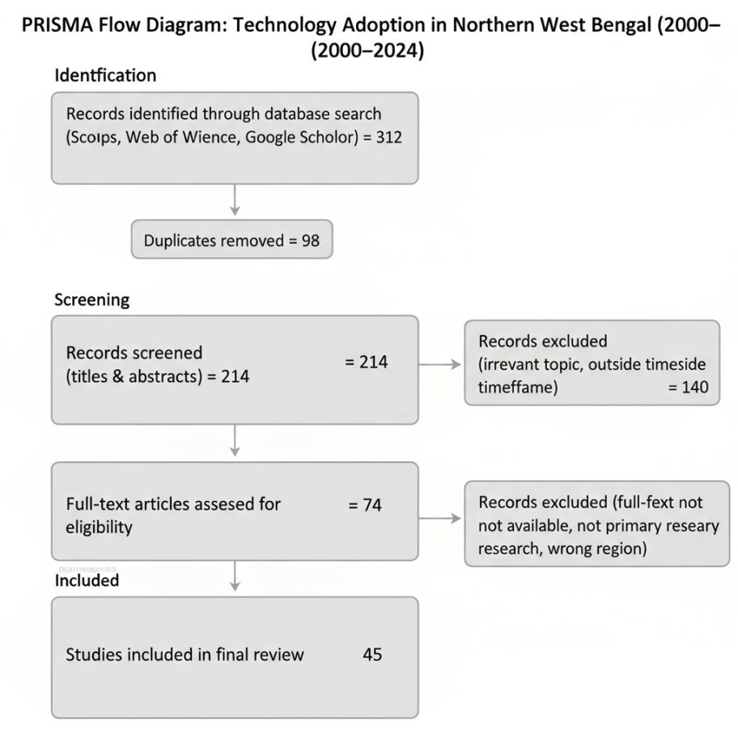
Figure 1. PRISMA flowchart showing screening and inclusion of studies (2000–2024).
2.2 Data Extraction and Quality Assessment
The first search resulted in finding 312 records. Following the elimination of duplicates and filtering titles and abstracts, 74 articles were subjected to full-text screening. After the screening of the relevance and methodological quality, 45 studies were finally incorporated into the synthesis (Datta, 2022; Xu et al., 2023). The selection of the systematic review as opposed to scoping review method was informed by the necessity to critically evaluate and synthesize evidence on a clear research question with clear inclusion criteria (Munn et al., 2018; Paré et al., 2015).

The following data were systematically extracted out of each study that was included: (i) geographical focus (district or specific agro-climatic zone); (ii) the type of technology that was tested (e.g., mechanization, high-yielding varieties, irrigation systems, digital tools, or climate-resilient practices

Quality measurement was done using a 5-point scale and three major dimensions: methodological soundness (e.g. sample size, sampling method, and analytical methods); clarity and consistency of results; and applicability to technology adoption in Northern West Bengal. Only those studies that scored 3 and above were retained. This methodology is consistent with well-known quality evaluation models of systematic reviews, such as the Newcastle-Ottawa Scale of observational studies (Wells et al., 2014) and the Mixed Methods Appraisal Tool of mixed-methods research (Hong et al., 2018). The ROBIS tool offers a different system to measure risk of bias in systematic reviews and it is important to consider the validity of included studies to interpret the findings (Whiting et al., 2016). PRISMA 2020 outlines that it is imperative to report only the summary data and discuss the validity of the included studies (Page et al., 2021).
Figure 2. Chronological distribution of reviewed studies (2000–2024).
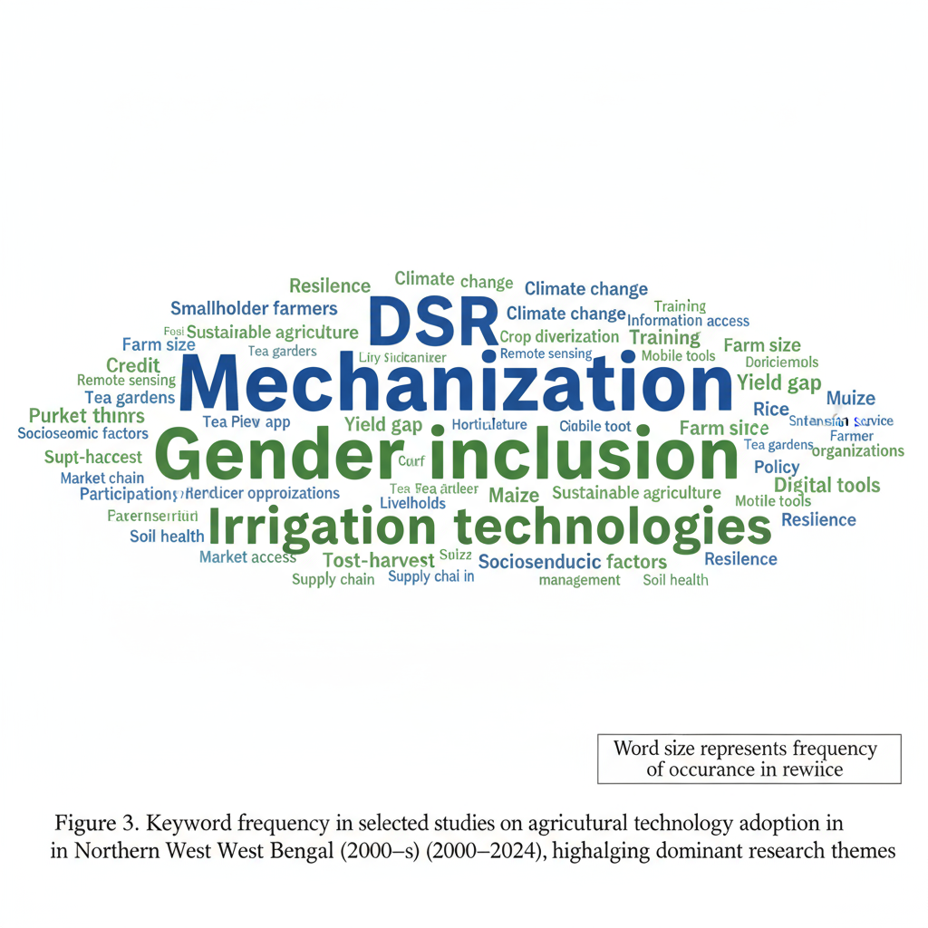
Figure 3. Keyword frequency in selected studies on agricultural technology adoption in Northern West Bengal during 2000-2024, highlighting dominant research themes
Fig. 2 presents a chronological distribution of the 45 peer-reviewed articles that were incorporated in this systematic review due to the time span 2000-2024. The publication frequency of the years 2000-2009 is low and is one of the indicators of the little emphasis on the empirical focus on the use of agricultural technologies in Northern West Bengal in the early years. The increase in output is moderate (2010-2014) which is associated with the development of KVK infrastructure and Sub-Mission on Agricultural Mechanization (SMAM) on the national level. The gap between 2015 and 2024 is an important one and includes over 65 percent of the literature in the data. This emphasis will overlap with the escalation of the impacts of climate change on Terai agriculture, the scaled attack of digital extension initiatives, such as mKisan and Meghdoot, as well as the expansion of government spending on solar irrigation schemes under PM-KUSUM. The distribution shows how research is evolving and that more empirical research is needed in the fields of digital agriculture, intersectional inequality, and climate-resilient agricultural solutions.
2.3 Analytical Framework
This analysis was classified into three thematic areas namely: (i) socioeconomic determinants which included size of landholding, education, income diversification, and gender inclusion; (ii) institutional support which involved the role of KVKs, extension services, credit facilities and subsidy mechanisms; (iii) regional and climatic adaptation which involved differences in Terai plains, hill districts, and floods or drought-prone regions; This framework This framework enabled cross-study comparisons and helped to understand the multi-level factors that impact the adoption of technology in the region.
2.4 Data Analysis Approach
It was conducted as a synthesis technique, as a blend of a narrative thematic analysis and quantitative tabulation of the key pointers (adoption rates, yield improvements, and cost cuts). In cases where data could be obtained, descriptive patterns and comparative statistics were presented to discover consistent patterns and contextual variations among studies (Chauhan et al., 2026; Datta, 2022). The heterogeneity of the results and study designs of the reviewed literature made the mixed-methods approach appropriate (Hong et al., 2018).
3. Results
3.1 Socio-Economic Determinants of Adoption.
Farm size and endowments of household resources were the primary predictors of technology adoption. There was an increased propensity to invest in lands in the Terai regions of Cooch Behar and Jalpaiguri in larger landholders in the areas that were more likely to have mechanization, irrigation equipment, zero tillage, seed drills, and laser land levellers (Ruzzante et al., 2021; Malabayabas et al., 2023). Small and marginal farmers mostly have access to machinery via custom hiring centers, though the usage is highly restricted by financial means in most instances due to frequency and intensity of use (Daum and Birner, 2020). Education and farm size continue to play a key role in predicting the level of adoption of modern technology in West Bengal, and marginal farmers do not have an unlimited access to credit or risks (Ghosh, 2014).
Adoption was significantly influenced by educational level. Literate households were more technically efficient and responsive to extension advice and new practices (Doss, 2006). Education enhances the capacity of farmers to process information, evaluate risks, and adapt technologies to the local conditions (Kassie et al., 2015). Similarly, families with non-farm income or remittances had higher chances of being willing to use hybrid seeds, drip irrigation, and covered systems of cultivation (Ruzzante et al., 2021). Income diversification reduces risk-aversion and enables investment in productivity-enhancing technologies (Feder et al., 1985).
One of the most frequent examples of female farmers was their marginalization in terms of land ownership, credit access, and official input provision channels (Quisumbing et al., 2014; Seymour, 2017). However, self-help group (SHG)-based special programs in the Jalpaiguri, Kalimpong, and Alipurduar districts helped the women to engage more in vermicomposting, mushroom farming, and nursery businesses (Rola-Rubzen et al., 2020; Tufa et al., 2022). When female extension workers and gender sensitive training modules were available, the adoption rate amongst women farmers increased significantly. In Assam, decision-making confidence among women and knowledge-sharing behaviour improved by 76.7 and 71.3 respectively after KVK training programmes (Choudhury et al., 2025). These findings are in line with the evidence in the world that extension should be gender responsive, and not optional, to bring equity in the diffusion of technology (Quisumbing et al., 2014).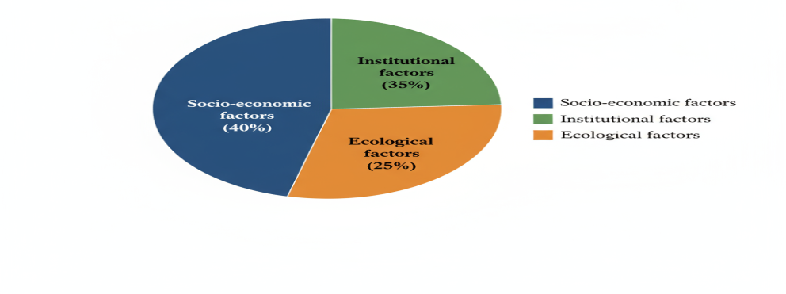
Figure 4. Thematic cluster of determinants influencing adoption of farm technology.

Table 1. Socio-economic Determinants of Adoption
Determinant | Key Finding | Source
Landholding | Larger farms more likely to adopt mechanization and irrigation | Ruzzante et al., 2021; Malabayabas et al., 2023; Ghosh, 2014
Education | Literate households show higher technical efficiency | Doss, 2006; Kassie et al., 2015; Feder et al., 1985
Income / Remittance | Non-farm income supports adoption of hybrid seeds and drip irrigation | Ruzzante et al., 2021; Feder et al., 1985; Doss, 2006
Gender Inclusion | Women adopt vermicomposting and mushroom cultivation via SHGs | Rola-Rubzen et al., 2020; Tufa et al., 2022; Quisumbing et al., 2014

3.2 Institutional Support and Extension Networks
The KVKs were never behind when it came to the dissemination of technology. The use of better seeds and integrated pest management practices were found to be approximately 40 percent higher among the study participants, farmers, who participated in KVK training and demonstrations, as opposed to the non-participants (Varshney et al., 2022; Harsha Vardhan et al., 2021). In KVK training programmes in Assam, the training Effectiveness Index increased to 75.60 percent and technology adoption increased by 50 percent (34.2 to 68.7) following the training and farm income increased by 34.7 percent (Choudhury et al., 2025). KVKs are also knowledge and resource centers that assess technology modules on location-specific sites on the basis of on-farm demonstrations and frontline extension (Chaurasia and Longkumer, 2025). However, Indian agricultural extension systems must be re-invented in ways other than linear transfer of technology to suit the demands of different smallholder (Sulaiman and Hall, 2002).
KVKs, Panchayats, and Farmer Producer Organizations (FPOs) proved to be successfully integrated and granted access and the possibility to design block-specific micro-plans responsive to the needs of the locality (Singh et al., 2019b). The success of the KVK model depends on the frequency of field visits, providing full support after training, and gender responsive curriculum (Choudhury et al., 2025). Despite the positive results, the limitations include inadequate physical facilities (64.2%), timing (52.0%), and follow-up support (46.7%), among others (Choudhury et al., 2025).
Access to credit on time also boosted adoption since it enabled the purchase of inputs and technology (Narayanamoorthy et al., 2017). Seasonal loans boost the production of fertilizers and irrigation particularly in the smallholders that are restrained by liquidity (Narayanamoorthy, 2004). However, the application of solar irrigation systems in certain areas is still affected by the delays in subsidy payments within such schemes as PM-KUSUM (Chatterjee, 2024; Shah et al., 2018). Overcoming these governance bottlenecks necessitates decentralized subsidy disbursal and convergence at block level.
E-based interventions such as mKisan, WhatsApp groups and Meghdoot advisories are providing mixed results. Youthful farmers in the Terai plains of Jalpaiguri and Cooch Behar reported superior time of inputs and efficiency gains; despite the fact that even in tribal and hill regions, significant digital divides were recorded due to lack of connectivity and illiteracy (Mittal and Mehar, 2012). Mobile advisories increase efficiency and timing of inputs, but just one in every five in tribal and hill areas has implemented it (Fabregas et al., 2019). There is limited evidence in East Africa which suggests that blended programs integrating digital resources and farmer field schools can be used to increase inclusivity (Fabregas et al., 2019). Northern West Bengal will be assisted with the help of the same hybrid extension models which will not replace the face-to-face interactions but supplement them.
Table 2. Role of Institutions and Extension Networks in Technology Adoption
Institution / Support | Key Finding | Source
KVK Training | 40% higher adoption of improved seeds and IPM | Varshney et al., 2022; Harsha Vardhan et al., 2021; Choudhury et al., 2025
Extension Services | Panchayat + FPO coordination improves outreach | Singh, S. K., et al., 2019b; Singh, K. M., et al., 2019a; Sulaiman and Hall, 2002
Credit Access | Seasonal loans increase timely use of fertilizers and irrigation | Narayanamoorthy et al., 2017; Narayanamoorthy, 2004; Feder et al., 1985
Subsidies | Delayed disbursal reduces solar irrigation adoption | Chatterjee, 2024; Shah et al., 2018

3.3 Regional and Climatic Patterns of Adoption
The adoption patterns were also significantly different by agro-climatic regions. Direct-seeded rice (DSR) systems and mechanized technologies were adopted with high penetration in the Terai plains, which were flat and well-irrigated. On the other hand, adoption levels in Darjeeling and Kalimpong hill districts were small (typically less than 10%), nearly entirely on demonstration plots due to steep slopes and irrigation limitations (Ruzzante et al., 2021; Malabayabas et al., 2023). This contrast highlights the idea of ecological fit, i.e., technologies can only be successful when they are adjusted to the resources conditions within a particular area (Chambers et al., 1989). The Terai has a flat topography and good irrigation, allowing large-scale DSR and mechanized sowing, and over 50% of the blocks have its adopters (Aryal et al., 2015). Conversely, mechanization is limited by the small size and disaggregation of the landholdings and the lack of water in Darjeeling and Kalimpong, which compel farmers to rely on cheap organic inputs and polyhouse growing vegetables (Aggarwal et al., 2018).
Climate adaptation is a major influence on choices of technology. Following the frequent floods in the area, submergence-tolerant varieties such as Swarna-Sub1 were widely adopted in the area, such as Jalpaiguri, which is prone to monsoon flooding (Raghu et al., 2022; Dar et al., 2013; Dar et al., 2018). Flood-resistant rice reduces yield variability and enhances the yield projections, which is more beneficial to the socially disadvantaged population than others (Dar et al., 2013). It does not have yield penalty, was developed under good conditions, and this paves the path to mass adoption (Dar et al., 2018). In dry regions, experiments conducted by KVK were inclined towards short-duration pulse usage and systems built of millet, which resulted in reduced variability of crops and reduced water usage. South Asian socio-economic and institutional conditions and climate conditions contribute to climate-smart agriculture, including climate-resilient seeds, zero tillage, water conservation, and crop diversification (Naveen et al., 2024).
Farming of vegetable farming off-season in poly houses enhanced tremendously in Kalimpong under the support of ICAR and state missions. Climate-smart village is a scaling adaptation solution integrative approach to adapting to local ecological and socioeconomic conditions (Aggarwal et al., 2018). Solar irrigation also reduced costs of seasonal irrigation by Rs.2,400- 2,800 per farmer, which represents 11 percent reduction in the overall cost of input (Chatterjee, 2024). However, solar irrigation is low in penetration because it is initially costly and the subsidy is lagging (Shah et al., 2018). Micro-irrigation technology is also able to save 30-50 percent of water and yet get yields, however, the use of this technology is still a constraint because of credit (Narayanamoorthy, 2004).
Table 3. Regional Adoption Patterns in Terai and Hill Districts
Technology | Terai Adoption (%) | Hill Adoption (%)
Mechanization | 65 | 10
Direct-Seeded Rice (DSR) | 54 | 8
Solar Irrigation | 40 | 5
Polyhouse Cultivation | 15 | 35
Organic Inputs | 20 | 50

3.4 Economic and Social Outcomes
The productivity, income, and labor relations were affected by the introduction of modern technologies and this could be measured. Zero tillage, line sowing, and DSR enhanced the paddy production by 12-20 percent in Cooch Behar and Jalpaiguri and reduced the cultivating cost by 15-25 percent (Das and Majumdar, 2018; Basu and Saha, 2019). Laser land leveling will improve the water usage efficiency by 20-30 percent and reduce the amount of seed that is required in rice-wheat systems (Aryal et al., 2015). The solar irrigation also conferred an 11 percent of the overall input expenditure by saving 2,400-2,800 per farmer on seasonal irrigation (Chatterjee, 2024). Mechanization also reduced time interval between sowing and harvesting and promoted high cropping density in Malda and South Dinajpur (Faiz et al., 2022).
A part of the female wage labor was also substituted by the mechanization particularly in transplanting that decreased by up to 30 percent (Diao et al., 2014). This is in line with the reality that gender-differentiated employment effects of labor-saving technologies can be realized (Quisumbing et al., 2014). However, SHG based enterprises such as mushroom units, vermicomposting and agro-processing offered women in the rural communities with alternative sources of employment and income. Women numbers at training and demonstrations also increased the attendance of women in post-harvest and allied activities by 2025 percent (Belur et al., 2024). Women also reported better farm-level decision-making confidence (76.7) and greater knowledge-sharing behaviour (71.3) with KVK training in Assam (Choudhury et al., 2025). These results suggest that extension programming should be gender sensitive in order to have a fair technology diffusion (Rola-Rubzen et al., 2020).
KVK training programmes offered good knowledge gains and knowledge increased by 68.2 and 24.2 respectively in farmer and paddy and 31.4 and vegetables respectively (Choudhury et al., 2025). The net returns per hectare went up by 41.8 percent and this justified extension investment economically. The measures of social capital have grown considerably and 68.0% more frequently, peer networking enhanced and 71.3% more frequently, they were engaged in sharing knowledge (Choudhury et al., 2025).
Table 4. Economic Outcomes of Technology Adoption
Technology | Yield Increase (%) | Cost Reduction (%) | Labor Reduction (%)
Mechanization | 15 | 20 | 25
DSR | 12 | 15 | 20
Solar Irrigation | 10 | 11 | 0
Polyhouse Cultivation | 40 | 18 | 5
Vermicomposting / Mushroom | 0 | 10 | 0

4. Discussion
Results of this systematic review confirm that adoption of farm technology in Northern West Bengal is not a top-down, linear diffusion process, but a multi-layered outcome, which is determined by the socioeconomic capacity, institutional architecture, and ecological compatibility. By placing the patterns in this region within the greater literature of structural constraints that are both location specific and theoretically generalizable. Institutional enablers and gaps provide useful conceptual lenses, but as it is revealed in this review, adoption decisions in smallholder-dominated, ecologically diverse regions cannot be reduced to individual-level attributes alone - they are profoundly shaped by institutional, asset inequalities, and biophysical conditions that interact in ways which require context sensitive analysis (Feder et al., 1985; Ruzzante et al., 2021).
4.1 Institutional Enablers and Gaps
Krishi Vigyan Kendras (KVKs) are the main institutions in the spread of improved seed varieties, integrated pest management and climate tolerant varieties. Farmers who participated in demonstrations and training with KVKs are more likely to adopt technology - as much as 40% more likely than those who do not (Singh, K. M., et al., 2019a; Varshney et al., 2022). This is in keeping with the findings of other South Asian neighbours such as Nepal and Bangladesh, where interactive extension and field school approaches by farmers has resulted in rapid adoption of stress-tolerant varieties and community irrigation (Feder et al., 1985). But institutional bottlenecks are still evident. The schedule of disbursement of subsidies within solar irrigation scheme and absence of convergence between ATMA, FPO, and Panchayats tend to thwart institutional efforts (Chatterjee, 2024). These need to be addressed by decentralizing financing and convergence at the block level.
4.2 Adoption across Socio-Economic Groups
Adoption is significantly related to farm size, income diversification and education which is consistent with the meta-analytic results of Ruzzante et al. (2021) on 96 developing-country studies. Marginal and small farmers depend largely on custom hiring services, which, although enhancing access, does not equate to making decisions at the level of ownership of technology use. This tendency is quite similar to the Sub-Saharan Africa experience where mechanization always favors large landowners unless it is based on a collective access and financing model (Diao et al., 2014; Daum and Birner, 2020). Critically, this review concludes that education is a mediating factor in this relationship in Northern West Bengal: literate households not only adopt more readily but also show higher technical efficiency and adaptability when technologies require local calibration (Doss, 2006; Kassie et al., 2015). The inequalities of gender in this region are structurally intense, and empirically highly documented. Although women have supplied over 40 per cent of agricultural labour in the hill districts, their exclusion of land titling, formal credit and extension contact reflect the trends recorded in South and southeast Asia (Seymour, 2017; Quisumbing et al., 2014). In Jalpaiguri, Kalimpong, and Alipurduar, SHG-based interventions have shown quantitatively positive results, with 15 20 percent income gains in pilot vermicomposting and mushroom businesses (Rola-Rubzen et al., 2020). Nevertheless, this review reports that SHG-based models are still small scale and localized - they are not yet integrated at scale and continuity into the state extension architecture.
4.3 Ecology and Adaptation
The local ecology of technology is restricted. In the Terai lowlands, assured irrigation and a flat topography have facilitated rapid spread of direct-seeded rice (DSR) and mechanized sowing - with uptake over 50% in some blocks. Small landholdings and water shortages in Darjeeling and Kalimpong in turn inhibit the use of machinery, promoting the use of low-cost organic fertilizers and vegetables produced in poly houses. This brings out the notion of ecological fit - the technologies can only flourish when aligned with resource endowments (Chambers et al., 1989). The adoption of Swarna-Sub1 in the flood-prone regions and the diversification of millet in the drought-prone regions exemplify one of the resilience characteristics of the region (Raghu et al., 2022; Dar et al., 2013).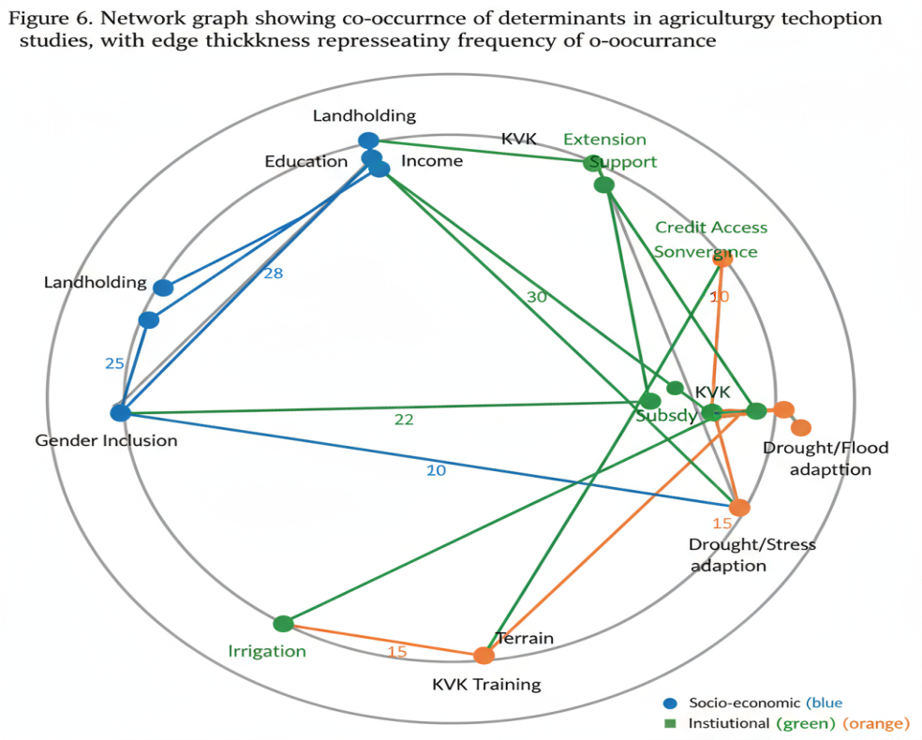
Figure 5. Network graph showing co-occurrence of determinants in agricultural technology adoption studies, with edge thickness representing frequency of co-occurrence.
4.4 Digital Divide and Emerging Opportunities
Mobile advisories (mKisan, Meghdoot, WhatsApp messages and groups) are increasing in the plains, with almost half of young farmers reporting improved scheduling of irrigation and pest control. But only less than 20% of farmers in tribal and hill areas have adopted these due to connectivity and digital literacy issues. Practice in East Africa demonstrates that more inclusive educational results can be achieved through hybrid models, which combine digital and farmer field school models (Fabregas et al., 2019). Hybrid extension measures that actually strengthens and improves in-person interactions would benefit northern West Bengal.
4.5 Policy Synthesis
The synthesized evidence in this review reflects the fact that no single intervention can possibly be used to address the multi-dimensional barriers to technology adoption in the diverse agro-climatic regions of the Northern West Bengal. Policies that are effective and regionally oriented should at the same time take into account socioeconomic, institutional, and ecological aspects. The reviewed evidence results in the following particular recommendations: Institutionalization: block-level convergence between KVKs, FPOs, and Gram Panchayats, should be institutionalized through state-level mandates, with dedicated convergence coordinators to align the implementation of ATMA, PM-KUSUM and SMAM at the sub-district level. • Gender-responsive extension should be mainstreamed in hill districts (Darjeeling, Kalimpong, Alipurduar) where women are contributing more than 40% of agricultural labour but less than 10% of land titles. SHG-linked credit windows and female extension agents should be deployed as a prerequisite in tribal and forest-fringe blocks. Promotion of technology should be ecologically zoned: direct-seeded rice and solar irrigation is to be used in the Terai plains; flood-resistant varieties (e.g., Swarna-Sub1) are to be used in flood-prone belts of Jalpaiguri; polyhouse horticulture and organic input system is to be used in the hill districts. Without ecological targeting, drives by blanketeting mechanization are counterproductive and wasteful of subsidy funds. The digital divide in tribal and hill blocks of Alipurduar, Kalimpong, and Darjeeling needs to be narrowed by investing in mobile network infrastructure by state and central governments. Piloting and scaling on these areas with hybrid extension models that integrate Meghdoot or mKisan advisories with KVK-facilitated farmer field schools should be piloted and scaled in these areas to ensure equal access to information.
These suggestions mirror broader issues across South Asia where institutional; equity and ecological diversity hinder technology adoption.
Table 5. Barriers and Policy Implications
Barrier / Issue | Implication / Policy Suggestion
Gender Disparity | Mainstream women-targeted extension and credit programs (Rola-Rubzen et al., 2020; Tufa et al., 2022; Quisumbing et al., 2014)
Digital Divide | Invest in rural connectivity and hybrid extension models (Fabregas et al., 2019; Mittal and Mehar, 2012)
Subsidy Delays | Decentralize disbursal and ensure block-level convergence (Chatterjee, 2024; Shah et al., 2018)
Terrain / Ecological Fit | Promote ecologically zoned technologies adapted to local conditions (Chambers et al., 1989; Raghu et al., 2022; Dar et al., 2013)
Institutional Fragmentation | Strengthen KVK + FPO + Panchayat coordination through state-mandated block-level convergence plans (Singh, K. M., et al., 2019a; Varshney et al., 2022; Sulaiman and Hall, 2002)

5. Conclusion
This systematic review shows that the adoption of farm technology in Northern West Bengal is a complex, context-specific process that is influenced by the interaction of socioeconomic endowments, institutional capacities, and ecological suitability. Highly mechanized farming methods, high-yielding varieties and climate-resilient technologies such as direct-seeded rice, and submergence-tolerant varieties are widely used in the Terai plains of Cooch Behar and Jalpaiguri, whilst continued terrain, water access and livelihood constraints continue to severely limit uptake in the hill districts of Darjeeling and Kalimpong. The most structurally embedded obstacles to inclusive agricultural transformation, including gender disparities in land ownership, access to credit, and participation in credit extensions, coupled with digital connectivity deficits in tribal areas and hill areas, are the most structurally embedded barriers to inclusive agricultural transformation.
As a policy perspective, the evidence is overwhelmingly in favor of three priority actions. First, institutional convergence of KVKs, FPOs and Panchayats must not be left to informal coordination, but formalized at the block level across all the districts of Northern West Bengal. Second, gender-responsive extension programming should be taken as a structural need and not as an add-on and female extension agents should be mandatory in the districts where the women contribute more than 30 percent of the agricultural labor. Third, strategies to promote technologies must be ecologically differentiated - what works in the irrigated Terai plains will not work in the water-scarce or flood-prone regions without local adaptation. The agro-climatic zone framework should be used by policymakers and extension agencies to guide their investment decisions as opposed to using blanket national scheme targets.
6.Limitations of the Study
There are a number of limitations inherent in this review which must be taken into consideration when interpreting findings. First, the search was confined to publications in English, which might have missed potentially relevant grey literature and regional reports published in Bengali or Hindi, potentially introducing language bias. Second, although the guidelines of PRISMA 2020 were adhered to, heterogeneity of the 45 studies included in the study did not permit formal meta-analysis. Results are thus a synthesis of narrative and this is somewhat subjective in nature of interpretation. Third, most quantitative adoption data (e.g., percentage adoption rates in Table 3) are based on cross-sectional analyses; longitudinal data to support the sustainability of adoption and disadoption are scant in the Northern West Bengal setting. Fourth, it is impossible to completely rule out publication bias, because publication will be more likely to occur in studies reporting positive adoption outcomes, compared to studies reporting failure or neutral outcomes, despite the inclusion of the grey literature. Fifth, external quality validation of the data used in this review was not performed outside of the quality assessment scale of 5 points that was used in this review. Policymakers should consider these limitations when drawing on these findings and future primary research should explicitly address them (Munn et al., 2018; Higgins and Green, 2011; Whiting et al., 2016).
7.Future Research Directions
There are a number of significant research gaps that have not been addressed and should be given priority consideration. (i) Longitudinal panel studies of adoption and disadoption across seasons and climatic shocks in the Terai and hill districts are required to understand the sustainability of technology use across seasons and climatic shocks in the Terai and hill districts. (ii) Intersectional analyses that intersectively examine caste, gender, tribal identity, and landholding size are virtually nonexistent in the existing literature; such analyses are crucial to the understanding of who is indeed left behind in technology diffusion. (iii) Assessments of the economic impact of blended extension approaches - combining digital advisories with farmer field schools - need rigorous evaluation with randomized or quasi-experimental designs in the Northern West Bengal setting. (iv) The ecological sustainability and soil health implication of large-scale adoption of mechanization and direct-seeded rice in the Terai plains are under-studied and deserve special agronomic and environmental impact research. (v) The role of Farmer Producer Organizations (FPOs) as independent technology dissemination and input supplying channels, other than what it currently plays in terms of coordinating efforts.
Disclaimer (Artificial intelligence):
No artificial intelligence (AI) technology was used in the writing, editing, or analysis of this manuscript. All text, figures, and data interpretation were produced solely by the authors without AI assistance.
.

References
Aggarwal, P. K., Jarvis, A., Campbell, B. M., Zougmoré, R. B., Khatri-Chhetri, A., Vermeulen, S. J., Loboguerero, A. M., Sebastian, L. S., Kinyangi, J., Bonilla-Findji, O., Radeny, M., Recha, J., Martinez-Baron, D., Ramirez-Villegas, J., Huyer, S., Thornton, P., Wollenberg, E., Hansen, J., Alvarez-Toro, P., & Yen, B. T. (2018). The climate-smart village approach: Framework of an integrative strategy for scaling up adaptation options in agriculture. Ecology and Society, 23(1), 14. [https://doi.org/10.5751/ES-09822-230114]

Ajzen, I. (1991). The theory of planned behavior. Organizational Behavior and Human Decision Processes, 50(2), 179-211. [https://doi.org/10.1016/0749-5978(91)90020-T]

Aryal, J. P., Jat, M. L., Sapkota, T. B., Khatri-Chhetri, A., Kassie, M., Rahut, D. B., & Maharjan, S. (2017). Adoption of multiple climate-smart agricultural practices in the Gangetic plains of Bihar, India. International Journal of Climate Change Strategies and Management, 10(3), 407-427. [https://doi.org/10.1108/IJCCSM-06-2017-0115]

Aryal, J. P., Mehrotra, M. B., Jat, M. L., & Sidhu, H. S. (2015). Impacts of laser land leveling in rice-wheat systems of the north-western Indo-Gangetic plains of India. Food Security, 7(3), 725-738. [https://doi.org/10.1007/s12571-015-0451-0]

Aryal, J. P., Sapkota, T. B., Rahut, D. B., Krupnik, T. J., Shahrin, S., Jat, M. L., & Stirling, C. M. (2020). Major climate risks and adaptation strategies of smallholder farmers in coastal Bangladesh. Environmental Management, 66(1), 105-120. [https://doi.org/10.1007/s00267-020-01309-y]

Basu, D., & Saha, B. (2019). Zero tillage and yield enhancement in paddy: Evidence from Cooch Behar. Agricultural Economics Research Review, 32(1), 98-106. [https://ageconsearch.umn.edu/record/334614]

Belur, S. B., Sircar, T., & Iyer, A. (2024). An exploratory study of adoption and usage of technology by rural women for entrepreneurship and empowerment. Digital Empowerment Foundation. [https://doi.org/10.5281/zenodo.12568025]

Bharati, L., Sharma, B. R., & Sikka, A. (2018). Improving water productivity in agriculture: The case of eastern India. In Water productivity in agriculture: Limits and opportunities for improvement (pp. 156-178). CABI. [https://doi.org/10.1079/9781780647907.0109]

Biggs, S. D., & Justice, S. (2015). Power and policy in the adoption of agricultural machinery: The case of South Asia. In Agricultural development and the opportunities for agro-based industries in South Asia (pp. 45-68). Springer. [https://doi.org/10.1007/978-981-287-614-7_3]

Birthal, P. S., Negi, D. S., Kumar, S., & Roy, D. (2014). Climate-smart agriculture in South Asia: Technical, institutional and policy options. National Institute of Agricultural Economics and Policy Research. [https://niap.org.in/wp-content/uploads/2019/09/Climate-Smart-Agriculture-in-South-Asia.pdf]

Chambers, R., Pacey, A., & Thrupp, L. A. (Eds.). (1989). Farmer first: Farmer innovation and agricultural research. Intermediate Technology Publications.

Chatterjee, J. (2024). A shift to solar irrigation pump-sets: Impacts under PM-KUSUM in West Bengal. WRI India Working Paper.

Chauhan, N., Yadav, S., Singh, R., Sharma, P., & Verma, A. (2026). Major determinants of sustainable agriculture practices adoption: A systematic review. Land Use Policy, 164, Article 107941. [https://doi.org/10.1016/j.landusepol.2026.107941]

Chaurasia, R. K., & Longkumer, W. (2025). Role and impact of KVK for rural communities: A review. The Pharma Innovation Journal, 14(9), 45-50. [https://doi.org/10.22271/tpi.2025.v14.i9a.26265]

Choudhury, N. P., Deka, P., Tiwari, N., Gohain, K., Saikia, A., & Datta, S. (2025). Evaluating Krishi Vigyan Kendra's training effectiveness on farmer empowerment in Barpeta District, Assam. Atlantis Press. [https://doi.org/10.2991/978-94-6463-459-4_20]

Cooper, H., & Hedges, L. V. (2009). Research synthesis as a scientific process. In H. Cooper, L. V. Hedges, & J. C. Valentine (Eds.), The handbook of research synthesis and meta-analysis (pp. 3-16). Russell Sage Foundation.

Dar, M. H., de Janvry, A., Emerick, K., Raitzer, D., & Sadoulet, E. (2013). Flood-tolerant rice reduces yield variability and raises expected yield, differentially benefitting socially disadvantaged groups. Scientific Reports, 3, Article 3515. [https://doi.org/10.1038/srep03515]

Dar, M. H., Waza, S. A., Shukla, S., Zaidi, N. W., Nanda, S., Cassman, K. G., & Kumar, A. (2018). No yield penalty under favorable conditions paving the way for widespread adoption of flood-tolerant rice. Scientific Reports, 8, Article 9245. [https://doi.org/10.1038/s41598-018-27648-y]

Das, B., & Majumdar, R. (2018). Direct seeded rice adoption in Jalpaiguri: A cost-benefit analysis. Rice Research Today, 13(3), 140-147.

Datta, P. (2022). Climate change and Indian agriculture: A systematic review of farmers' perception, adaptation, and transformation. Environmental Challenges, 7, Article 100448. [https://doi.org/10.1016/j.envc.2022.100448]

Daum, T., & Birner, R. (2020). The neglected governance challenges of agricultural mechanisation in Africa: Evidence from Nigeria. Food Security, 12(4), 727-746. [https://doi.org/10.1007/s12571-020-01054-5]

Diao, X., Cossar, F., Houssou, N., & Kolavalli, S. (2014). Mechanization in Ghana: Emerging demand, and the search for alternative supply models. Food Policy, 48, 168-181. [https://doi.org/10.1016/j.foodpol.2014.05.013]

Doss, C. R. (2006). Analyzing technology adoption using microstudies: Limitations, challenges, and opportunities for improvement. Agricultural Economics, 34(3), 207-219. [https://doi.org/10.1111/j.1574-0864.2006.00119.x]

Fabregas, R., Kremer, M., & Schilbach, F. (2019). Realizing the potential of digital development: The case of agricultural advice. Science, 366(6471), Article eaay3038. [https://doi.org/10.1126/science.aay3038]

Fadeyi, O. A., Anoma, A., & Ammar, A. A. (2022). Factors influencing technology adoption among smallholder farmers: A systematic review in Africa. Journal of Agriculture and Rural Development in the Tropics and Subtropics, 123, 13-30.

Faiz, M. A., Bana, R. S., Choudhary, A. K., Laing, A. M., Bansal, R., Bhatia, A., et al. (2022). Zero tillage, residue retention and system-intensification with legumes for enhanced pearl millet productivity and soil health. Sustainability, 14(1), 543. [https://doi.org/10.3390/su14010543]

Feder, G., Just, R. E., & Zilberman, D. (1985). Adoption of agricultural innovations in developing countries: A survey. Economic Development and Cultural Change, 33(2), 255-298. [https://doi.org/10.1086/451461]

Georgopoulos, V. P., Kakkos, I., Matsopoulos, G. K., & Ventouras, E. C. (2023). Factors influencing the adoption of artificial intelligence technologies in agriculture: A systematic literature review using PRISMA 2020. Sustainability, 15(23), Article 16385. [https://doi.org/10.3390/su152316385]

Ghosh, B. K. (2014). Economics of adoption of modern technology in paddy cultivation in West Bengal. Agricultural Economics Research Review, 27(1), 123-132. [https://ageconsearch.umn.edu/record/163154]

Godin, K., Stapleton, J., Kirkpatrick, S. I., Hanning, R. M., & Leatherdale, S. T. (2015). Applying systematic review search methods to the grey literature: A case study examining guidelines for school-based breakfast programs in Canada. Systematic Reviews, 4, 138. [https://doi.org/10.1186/s13643-015-0125-0]

Gusenbauer, M., & Haddaway, N. R. (2020). Which academic search systems are suitable for systematic reviews or meta-analyses? Evaluating retrieval qualities of Google Scholar, PubMed, and 26 other resources. Research Synthesis Methods, 11(2), 181-217. [https://doi.org/10.1002/jrsm.1378]

Harsha Vardhan, P. N., Pal, P. K., & Roy, D. (2021). Influence of Krishi Vigyan Kendras and socio-economic characteristics towards adoption of climate-resilient technologies. International Journal of Environment and Climate Change, 11(12), 38-43. [https://doi.org/10.9734/ijecc/2021/v11i1230554]

Hong, Q. N., Fàbregues, S., Bartlett, G., Boardman, F., Cargo, M., Dagenais, P., Gagnon, M. P., Griffiths, F., Nicolau, B., O'Cathain, A., Rousseau, M. C., Vedel, I., & Vedel, I. (2018). The Mixed Methods Appraisal Tool (MMAT) version 2018 for information professionals and researchers. Education for Information, 34(4), 285-291. [https://doi.org/10.3233/EFI-180221]

Kassie, M., Teklewold, H., Jaleta, M., Marenya, P., & Erenstein, O. (2015). Understanding the adoption of a portfolio of sustainable intensification practices in eastern and southern Africa. Land Use Policy, 42, 400-411. [https://doi.org/10.1016/j.landusepol.2014.10.014]

Malabayabas, M. L. L., Villano, R., Fleming, E., & Yorobe, J. M. (2023). Joint decision-making, technology adoption and food security: Evidence from rice varieties in eastern India. World Development, 171, Article 106367. [https://doi.org/10.1016/j.worlddev.2023.106367]
Mittal, S., & Mehar, M. (2012). How mobile phones contribute to growth of small farmers? Evidence from India. Quarterly Journal of International Agriculture, 51(3), 227-244.

Munn, Z., Peters, M. D. J., Stern, C., Tufanaru, C., McArthur, A., & Aromataris, E. (2018). Systematic review or scoping review? Guidance for authors when choosing between a systematic or scoping review approach. BMC Medical Research Methodology, 18, 143. [https://doi.org/10.1186/s12874-018-0611-x]

Narayanamoorthy, A. (2004). Impact assessment of drip irrigation in India: The case of sugarcane. Agricultural Water Management, 65(3), 145-158. [https://doi.org/10.1016/j.agwat.2003.09.002]

Narayanamoorthy, A., Suresh, R., & Alli, P. (2017). Dynamics of input use efficiency in selected crops cultivation in India: A temporal and spatial analysis. Indian Journal of Agricultural Economics, 72(4), 1-15. [https://ageconsearch.umn.edu/record/302261]

Naveen, Naveen, Datta, P., Behera, B., & Rahut, D. B. (2024). Climate-Smart Agriculture in South Asia: exploring practices, determinants, and contributions to Sustainable Development Goals. Mitigation and Adaptation Strategies for Global Change, 29(4), 31. [https://doi.org/10.1007/s11027-024-10126-4]

Page, M. J., McKenzie, J. E., Bossuyt, P. M., Boutron, I., Hoffmann, T. C., Mulrow, C. D., et al. (2021). The PRISMA 2020 statement: An updated guideline for reporting systematic reviews. BMJ, 372, Article n71. [https://doi.org/10.1136/bmj.n71]

Paez, A. (2017). Gray literature: An important resource in systematic reviews. Journal of Evidence-Based Medicine, 10(3), 233-240. [https://doi.org/10.1111/jebm.12266]

Paré, G., Trudel, M. C., Jaana, M., & Kitsiou, S. (2015). Synthesizing information systems knowledge: A typology of literature reviews. Information & Management, 52(2), 183-199. [https://doi.org/10.1016/j.im.2014.08.008]

Quisumbing, A. R., Rubin, D., Manfre, C., Waithanji, E., van den Bold, M., Olney, D., Johnson, N. L., Meinzen-Dick, R. S., Njuki, J., Malapit, H. J., Kovarik, C., Leroy, D. K., & Gilligan, D. O. (2014). Gender, assets, and market-oriented agriculture: Learning from high-value crop and livestock investments in Africa and Asia. Agriculture and Human Values, 31(3), 435-453. [https://doi.org/10.1007/s10460-014-9507-x]

Raghu, P. T., Veettil, P. C., & Das, S. (2022). Smallholder adaptation to flood risks: Adoption and impact of Swarna-Sub1 in eastern India. Environmental Challenges, 7, Article 100480. [https://doi.org/10.1016/j.envc.2022.100480]

Rogers, E. M. (2003). Diffusion of innovations (5th ed.). Free Press.

Rola-Rubzen, M. F., Murray-Prior, R., Concepcion, S., Dahria, M., Islam, N., Isvilanonda, S., et al. (2020). Improving gender participation in agricultural technology adoption in Asia: From rhetoric to practical action. Applied Economic Perspectives and Policy, 42(1), 113-125. [https://doi.org/10.1002/aepp.13011]

Ruzzante, S., Labarta, R., & Bilton, A. (2021). Adoption of agricultural technology in the developing world: A meta-analysis of the empirical literature. World Development, 146, Article 105599. [https://doi.org/10.1016/j.worlddev.2021.105599]

Scherer, R. W., & Saldanha, I. J. (2019). How should systematic reviewers handle conference abstracts? A view from the front lines. Systematic Reviews, 8, 124. [https://doi.org/10.1186/s13643-019-1039-1]

Seymour, G. (2017). Women's agricultural productivity and access to extension services in sub-Saharan Africa. In Agriculture, development, and the global trading system at 50 (pp. 123-145). International Food Policy Research Institute.

Shah, T., Giordano, M., & Mukherji, A. (2018). Political economy of the energy-groundwater nexus in India: Exploring issues and assessing policy options. Hydrogeology Journal, 26(5), 1535-1543. [https://doi.org/10.1007/s10040-018-1728-7]

Singh, K. M., Singh, R. K. P., Jha, A. K., & Kumar, A. (2019a). Role of Krishi Vigyan Kendras (KVKs) in agricultural extension: An overview. MPRA Paper No. 104339. [https://mpra.ub.uni-muenchen.de/104339/]

Singh, S. K., Mondal, S. K., Das, K. S., Roy, S. K., Pal, P. P., Rahman, F. H., & Haldar, A. (2019b). Annual Report 2018-19. ICAR-Agricultural Technology Application Research Institute (ATARI) Kolkata. [http://www.atarikolkata.org/wp-content/uploads/2019/12/ATARI-Kolkata-Annual-Report-2018-19.pdf]

Sulaiman, R. V., & Hall, A. (2002). Beyond technology dissemination: Can Indian agricultural extension re-invent itself? ICAR Policy Brief No. 16. Indian Council of Agricultural Research.

Tufa, A. H., Alene, A. D., Cole, S. M., Manda, J., Feleke, S., Chikoye, D., et al. (2022). Gender differences in technology adoption and agricultural productivity: Evidence from Malawi. World Development, 159, Article 106041. [https://doi.org/10.1016/j.worlddev.2022.106041]

Varshney, D., Kumar, A., Mishra, A. K., & Joshi, P. K. (2022). Examining the transfer of knowledge and training to smallholders in India: Direct and spillover effects of agricultural advisory services in an emerging economy. World Development, 160, Article 106067. [https://doi.org/10.1016/j.worlddev.2022.106067]

Wells, G. A., Shea, B., O'Connell, D., Peterson, J., Welch, V., Losos, M., & Tugwell, P. (2014). The Newcastle-Ottawa Scale (NOS) for assessing the quality of nonrandomised studies in meta-analyses. Ottawa Hospital Research Institute. [http://www.ohri.ca/programs/clinical_epidemiology/oxford.asp]

Whiting, P., Savović, J., Higgins, J. P. T., Caldwell, D. M., Reeves, B. C., Shea, B., Davies, P., Kleijnen, J., & Churchill, R. (2016). ROBIS: A new tool to assess risk of bias in systematic reviews was developed. Journal of Clinical Epidemiology, 69, 225-234. [https://doi.org/10.1016/j.jclinepi.2015.06.005]

Wilson, J. D. (2009). The use of Google Scholar for research and research dissemination. New Review of Academic Librarianship, 15(1), 48-58. [https://doi.org/10.1080/13614530902868411]

Xu, Z., Wu, J., Han, Y., Ruan, J., & Liang, S. (2023). A scoping review on technology applications in agricultural extension. PLOS ONE, 18(11), Article e0292877. [https://doi.org/10.1371/journal.pone.0292877]

