Hybrid statistical models for forecasting of Rice production in Karnataka State, India

ABSTRACT
Rice (Oryza sativa L.) is a vital staple crop underpinning food security and agricultural livelihoods in Karnataka and across India. The current study used both linear and nonlinear time series techniques to anticipate Rice production in Karnataka state from 1962–1963 to 2021–2022. First, the Autoregressive Integrated Moving Average (ARIMA) model was used, and the best fit was chosen using diagnostic metrics like the Coefficient of Determination (R²), Mean Absolute Error (MAE), Mean Absolute Percentage Error (MAPE) and Root Mean Square Error (RMSE). The ARIMA (2,1,2) model was found to be the best suitable of the linear models. Advanced machine learning techniques like Time Delay Neural Network (TDNN), Nonlinear Support Vector Regression (NLSVR) and their hybrid combinations with ARIMA (ARIMA–TDNN and ARIMA–NLSVR) were used to identify potential nonlinear patterns in the data. The adoption of hybrid models was justified by the BDS test on ARIMA residuals, which verified the existence of nonlinearity. RMSE, MAE and MAPE were used to assess the model performance for the nonlinear and hybrid techniques. The most recent three years of data were used for testing, while 57 years of data were used for training in the adopted training and testing framework. In terms of forecast accuracy, the ARIMA (2,1,2)–TDNN (3–7–1) hybrid model outperformed the other models. Forecasts up to 2027–28 was also produced using the model, estimating that Karnataka would produce 4432.68 thousand tons of Rice. These findings imply that, in comparison to individual models, hybrid models that include linear and nonlinear features offer more accurate and consistent forecasts for agricultural production series.
Key words: - Rice, ARIMA, TDNN, TIME SERIES FORECASTING and HYBRID MODEL
- INTRODUCTION
Karnataka is the eighth largest state in India, with a total size of 192 lakh square kilometres, or 6.3 per cent of the nation's total land area. According to the 2011 Population Census, 13.74 million people are employed in agriculture, with farmers accounting for 23.61 per cent and agricultural labourers for 25.67 per cent of the workforce. In Karnataka, during economic survey 2022-23 it is estimated that 81.56 lakh ha of area under food crops will be cultivated with the production of 1348.9 thousand metric tonnes. Food crops cover 76.46 per cent of the total cropped area, while non-food crops occupy the remaining 23.54 per cent in Karnataka. The food grains alone constitute 56.9 per cent of the cropped area with total food grain production reaching about 146 lakh tonnes during 2020-21 in Karnataka (Nagaveni et al, 2024).
Rice, scientifically known as Oryza sativa L., is a staple crop for more than half of the world's population and is crucial to India's food security system. In India, Rice is a tropical and subtropical crop which is widely farmed in a variety of agroclimatic zones, from irrigated lowlands to rainfed uplands. It is an important commodity in the public distribution system and makes a substantial contribution to the livelihood of millions of farmers.
India is the world's top producer and consumer of Rice, followed by China (USDA, 2024-25). With an average productivity of 2882 kg/ha, Rice was grown on around 47828.29 thousand hectares in India during the 2023–24 crop year, yielding about 137824.58 thousand tonnes. One of Karnataka's main food crops, Rice is typically farmed in both rainfed and irrigated areas. Rice was grown on around 953 thousand hectares, yielding an average of 3282 kg/ha and a production of 3127.44 thousand tonnes (Indiastat,2023–24). Among Karnataka's most notable Rice-growing districts are Uttara Kannada, Haveri, Hassan, Kalburgi, Kodagu, Belagavi, Shivamogga, Udupi, Yadgir, Mysuru and Mandya (Economic Survey, 2022-23).
Over the period 2000–2020, rice production in Karnataka exhibited substantial variation, reflecting the combined influence of policy interventions and market-driven dynamics. Inter-annual fluctuations reveal pronounced non-linear patterns, shaped by climatic variability, including rainfall uncertainty and temperature anomalies, as well as exogenous shocks affecting input availability and price stability. Such complexity highlights the limitations of conventional linear forecasting techniques in capturing the underlying data-generating processes. In this context, rice has been identified as a focal crop for the present study. The research investigates the efficacy of advanced and hybrid forecasting frameworks, including Autoregressive Integrated Moving Average (ARIMA), Time Delay Neural Networks (TDNN), Nonlinear Support Vector Regression (NLSVR), and their hybrid variants (ARIMA–TDNN and ARIMA–NLSVR), in modelling and predicting production trends. By integrating linear and non-linear modelling paradigms, these approaches are expected to enhance predictive accuracy and robustness. The findings are intended to generate reliable, data-driven insights to support stakeholders engaged in agricultural planning, policy formulation, and market regulation (Sanketh et al., 2025).
Statistical forecasting serves as a critical tool for supporting informed decision-making and enhancing the efficiency and effectiveness of future planning processes. It constitutes a fundamental component of economic development, enabling policymakers and stakeholders to undertake systematic and evidence-based planning aimed at achieving sustainable growth at the national and regional levels. In light of these considerations, the present study was undertaken to model and forecast rice production in the state of Karnataka, India. By employing rigorous analytical frameworks, the study seeks to generate reliable projections that can inform strategic interventions in agricultural planning and resource allocation (Sanketh et al., 2025).
A principal limitation of the Autoregressive Integrated Moving Average (ARIMA) model lies in its inability to adequately capture non-linear structures within time series data. The model is inherently based on the assumption of linear dependence, thereby restricting its capacity to represent the complex, non-linear relationships that are frequently observed in agricultural datasets.

In practice, time series such as rice production in Karnataka State often embody a combination of linear and non-linear components, arising from fluctuations in climatic conditions, market dynamics, and the pace of technological adoption. Consequently, the standalone application of ARIMA may yield suboptimal forecasting performance when confronted with such heterogeneous data structures. To address this limitation, recent methodological advancements have emphasised the development of hybrid forecasting frameworks that integrate the linear modelling strengths of ARIMA with the non-linear approximation capabilities of machine learning techniques. In the present study, hybrid ARIMA–TDNN and ARIMA–NLSVR models, alongside their respective individual counterparts, are employed to forecast rice production in Karnataka. Within this framework, ARIMA is utilised to model the linear component of the time series, while Time Delay Neural Networks (TDNN) and Non-linear Support Vector Regression (NLSVR) are applied to model the residual non-linear patterns that remain unexplained by ARIMA. Notably, TDNN, as a dynamic extension of conventional neural network architectures, leverages time-lagged inputs to effectively learn temporal dependencies embedded within the data (Sanketh et al., 2025). Nonlinear Support Vector Regression (NLSVR) is a machine learning technique that uses kernel functions to capture complex nonlinear relationships between input variables and outputs.
Previous empirical investigations, including those by Zhang (2003), Kumar and Prajneshu (2015), and Ray et al. (2016), have demonstrated that hybrid modelling approaches can substantially improve the accuracy and reliability of time series forecasts. By effectively combining linear and non-linear modelling techniques, such frameworks are better equipped to capture the inherent complexity of real-world data. Accordingly, the integration of ARIMA with either TDNN or NLSVR in the present study provides a more comprehensive and robust forecasting framework, particularly well suited to agricultural time series characterised by mixed data structures. The adoption of these hybrid approaches facilitates improved model performance and predictive precision. Consequently, the resulting models are expected to generate more reliable and actionable insights for stakeholders engaged in planning, policy formulation, and resource allocation in relation to maize cultivation in Karnataka State.
The manuscript is relevant to the scientific community and it demonstrates the use of hybrid and machine learning models for agricultural production forecasting. The study addresses both linear and nonlinear patterns in long term Rice production data to improve the forecast accuracy with the help of agricultural time series. This will help future researches to develop forecasting frameworks more efficiently.
1.1 OBJECTIVES OF THE STUDY
(1) To examine the trend of the Rice production in Karnataka State.
(2) To modelling time series model (ARIMA, TDNN and NLSVR) and hybrid models (ARIMA-TDNN, ARIMA-NLSVR) for the Rice production in Karnataka state.
(3) To forecast Rice production by suitable model for Karnataka State.
- MATERIALS AND METHODOLOGIES
2.1 Data Source
The study has been illustrated with the time series data. The secondary data on the Rice production in Karnataka state for 60 years (from 1962-63 to 2021-22) was obtained from the Directorate of Economics and Statistics, Dept. of Agriculture, Cooperation and Farmers Welfare, Ministry of Agriculture, Govt. of India.
2.2 Statistical Methodologies
This study utilises Auto Regressive Integrated Moving Average (ARIMA), Time Delay Neural Network (TDNN), Nonlinear Support Vector Regression (NLSVR), and a proposed hybrid framework integrating ARIMA with TDNN or NLSVR to forecast rice production in Karnataka, India. The analysis is conducted using R. Stationarity of the time series is assessed through the Augmented Dickey-Fuller test (ADF). Nonlinear dependence in the residuals is examined using the Brock-Dechert-Scheinkman test (BDS), thereby supporting appropriate model specification. Furthermore, the Ljung-Box test (Box–Pierce/Ljung–Box) is employed to evaluate residual autocorrelation, ensuring the adequacy of the fitted models. Model performance is evaluated using Root Mean Square Error (RMSE), Mean Absolute Error (MAE), and Mean Absolute Percentage Error (MAPE), which collectively provide robust measures of forecasting accuracy and reliability.
2.2.1 Box-Jenkins ARIMA model
Before ARIMA, the concept of validation of data and Stationary was discussed briefly.
validation of data: For model development and evaluation, the dataset comprising 60 annual observations was divided into training and testing sets. Out of these, 57 data points (1962–63 to 2018–19) were utilized for training the models, while the remaining 3 data points (2019–20 to 2021–22) were reserved as a testing set to assess the predictive accuracy and generalization performance of the models. This split ensures that the models are trained on a sufficiently large sample while also being validated on unseen data to avoid overfitting and to obtain realistic forecasting performance.
Stationary: A stochastic process is defined as stationary when its mean and variance remain constant over time, and the covariance between any two time points is determined solely by the lag separating them, rather than the specific time at which the covariance is evaluated.

Stationarity may be assessed using the Autocorrelation Function (ACF) of the observed series. If the ACF exhibits a slow decay, this is indicative of non-stationarity, as autocorrelations across a wide range of lags tend to be statistically significant.

To render a non-stationary series stationary, a transformation through differencing is applied. First-order differencing (d = 1) is undertaken initially. If the ACF of the differenced series shows a rapid decline, the transformed data may be considered stationary. If this condition is not satisfied, second-order differencing (d = 2) is performed. This procedure is continued iteratively in a similar manner until stationarity is achieved, thereby determining the appropriate order of differencing, denoted by ‘d’.
Test of Stationary: The appropriate order of differencing may be determined through the application of unit root tests. Among the most widely adopted procedures for identifying a unit root, and consequently non-stationarity in a time series, is the Augmented Dickey–Fuller (ADF) test. The conventional Dickey–Fuller (DF) test is based on the assumption that the error term is serially uncorrelated. However, this assumption is frequently violated in empirical settings where serial correlation is present. To overcome this limitation, Dickey and Fuller (1979) developed an extended form of the test, commonly referred to as the Augmented Dickey–Fuller (ADF) test.
This test is conducted by augmenting the regression $(ΔY_{t}=β_{1}+δY_{t-1}+e_{t})$, by adding the lagged values of dependent variable$(ΔY_{t})$. The ADF test consist of estimating following regression,
$ΔY_{t}=β_{1}+δY_{t-1}+\sum_{i=1}^{m}{α_{i}}ΔY_{t-i}+e_{t}$ ...(1)
Where:
- m is number of lagged difference terms required so that the error term
- e_{t} is serially independent.
- The test can be carried out by performing a t (= τ) -statistic of $'δ'$ with dickey fuller table values at 5% and 10% LOS. If absolute t (= τ) statistic of $'δ'$ is greater than its table value, it indicates that the series is Stationary.

ARIMA (Auto Regressive Integrated Moving Average): It’s denoted as ARIMA(p, d, q), representing a combination of the AutoRegressive (AR) and Moving Average (MA) components, together with an order of integration or differencing (d). In this specification, p and q denote the respective orders of the autoregressive and moving average processes (Box and Jenkins, 2015).
The Auto-regressive model of order p denoted by AR (p) is as follows:
Y_{t} = c + Ø₁ Y_{t-1} + Ø₂ Y_{t-2} + … + Ø_{p} Y_{t-p} + e_{t} ...(2)
The Moving Average (MA) model of order q or MA (q) can be written as:
Y_{t} = c – θ₁ e_{t-1} – θ₂ e_{t-2} –… θ_{q} e_{t-q} + e_{t} ...(3)
Where:
- c is constant term.
- Ø_{p} is the p^{th} autoregressive parameter.
- θ_{q} is the q^{th} moving average parameter and
- e_{t} is the error term at time ‘t’.
ARIMA in general form is as follows:
Δ^{d} Y_{t} = c + (Ø₁ Δ^{d} Y_{t-1} + … + Ø_{p} Δ^{d} Y_{t-p}) – (θ₁ e_{t-1} + … + θ_{q} e_{t-q}) + e_{t} ...(4)
where Δ denotes difference operator like
- Δ Y_{t} = Y_{t} - Y_{t-1}(data form of first order differentiation) ... (5)
- Δ² Y_{t-1} = ΔY_{t} - ΔY_{t-1} (data form of second order differentiation) ... (6)
Here, Y_{t-1}, …, Y_{t-p} are values of past series with lag 1, …, p, respectively.
ARIMA methodology consists of four steps viz., model identification, model estimation, diagnostic checking and forecasting (Box and Jenkins, 2015).
(1) Model Identification: The identification of an ARIMA(p, d, q) model is grounded in time-domain analysis, particularly through the examination of the autocorrelation function (ACF) and partial autocorrelation function (PACF). These functions are fundamental in revealing the underlying structure of the time series under investigation. In this study, the Augmented Dickey–Fuller (ADF) test was employed to assess stationarity and to detect the presence of a unit root in the time series data of the variables considered. Following the determination of the appropriate order of differencing, the resulting differenced univariate time series can then be analysed within the time-domain framework.

(2) Estimation: After identifying suitable values of p and q for the model, the parameters corresponding to the autoregressive and moving average components are subsequently estimated. In this study, the relevant parameters were computed using the standard statistical software package R, employing an iterative estimation procedure.
(3) Diagnostic checking: Later, the estimated model is checked to verify as it adequately represents the series or not further. For evaluating the adequacy of ARIMA process, various diagnostic checks have been selected in this present study, were R² value, Root Mean Square Error (RMSE), Mean Absolute Error (MAE) and Mean Absolute Percentage Error.

Formulas of these diagnostics are mentioned in the following page.
$R^{2}=1-\frac{{\sum_{i=1}^{n}{(Y_{i}-{\hat{Y}}_{i})}}^{2}}{\sum_{i=1}^{n}{(Y_{i}-\bar{Y})^{2}}}$ ...(7)
$RMSE={\left[\sum_{i=1}^{n}{(Y_{i}-{\hat{Y}}_{i})^{2}/n}\right]}^{1/2}$ ...(8)
$MAE=\frac{1}{n}\sum_{t=1}^{n}{\left|Y_{t}-{\hat{Y}}_{t}\right|}$ ...(9)
MAPE =$\frac{100}{n}\sum_{t=1}^{n}{\left|Y_{t}-{\hat{Y}}_{t}\right|}/\left|{\hat{Y}}_{t}\right|$ ….(10)
Where, ‘$Y_{i}$’ be actual value of data, ‘$\hat{Y}$’ be the forecasted value, ‘$\bar{Y}$’ be the mean value of the actual data, ‘n’ be the number of data points.
In the present study, the model exhibiting the minimum values of Root Mean Square Error (RMSE) and Mean Absolute Error (MAE), together with a comparatively high coefficient of determination (R²), was selected as the most appropriate forecasting model (Kumar et al., 2022). In addition to these diagnostic measures, the Ljung–Box test was also employed to examine the presence of autocorrelation in the residual series.
Ljung-Box test: It is a classical hypothesis testing procedure designed to determine whether the autocorrelations of the residual series obtained from a fitted time series model are significantly different from zero. Rather than assessing each lag individually for randomness, the test evaluates the joint randomness of autocorrelations over a set of lags.
The test statistic,
$Q(h)=n(n+2)\sum_{k=1}^{h}{\frac{{\overset{̑}{ρ}}_{k}^{2}}{n-k}}$ ...(11)
Where n is the length of time series, 𝜌̂_{𝑘} is sample autocorrelation at lag k and h is the number of lags under the test. Null hypothesis is rejected if $Q(h)>χ_{1-σ,m}^{2}$; Where ‘m’ must be equal to h-p-q, where p and q are the number of parameters in the ARIMA (p,q) model.
• Null Hypothesis (H₀):
There is no autocorrelation in the residuals up to the specified lag.
(i.e., residuals are independently distributed — white noise)
• Alternative Hypothesis (H₁):
There is autocorrelation in the residuals at one or more lags.
(i.e., residuals are not independently distributed)
(4) Forecasting: The optimal ARIMA model was selected based on the highest R², low RMSE and MAE values. The selected model used to forecast future values. The forecast values are the point forecasts along with the confidence intervals.
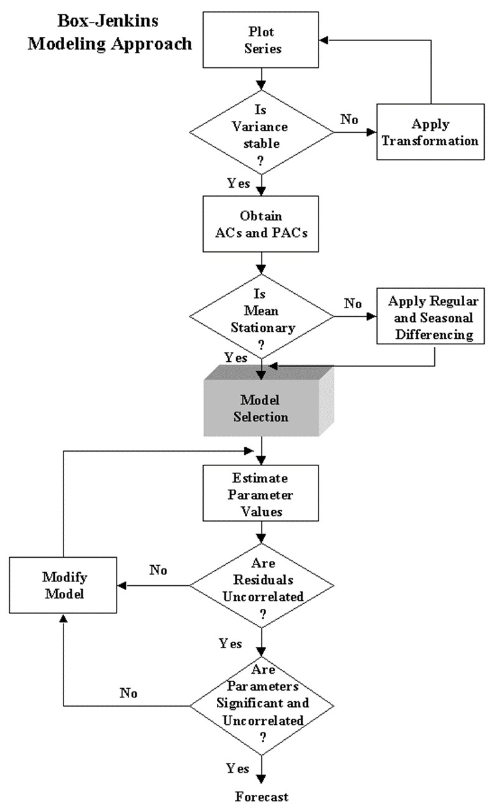
Figure. 1 Flow chart of Box-Jenkins Methodology

2.2.2 Time Delay Neural Network (TDNN)
The artificial neural network (ANN) designed for time series analysis is commonly referred to as a Time Delay Neural Network (TDNN). Time series processes can be modelled mathematically using neural networks that incorporate an implicit functional representation of time, in contrast to static architectures such as the multilayer perceptron, which can be endowed with dynamic characteristics (Haykin, 1999). A straightforward approach to constructing an ANN for time series modelling involves the incorporation of temporal delays, also known as time lags. These lagged values are typically introduced at the input layer of the network. The TDNN represents a class of architectures based on this principle. In this study, the R package “nnfor” was customized and implemented for developing Time Delay Neural Network (TDNN) models.
This package provides a flexible and powerful framework for fitting artificial neural networks specifically designed for time series forecasting problems. In view of the residual nonlinearity detected through the BDS test, Time Delay Neural Network (TDNN) models were employed to model the residual series obtained from the ARIMA models for Rice production in Karnataka. The TDNN models are well suited for capturing complex, nonlinear and dynamic dependencies in the time series data through their feedback and delay structure.
For each data series, multiple TDNN networks were trained by varying the number of neurons in the hidden layer from 1 to 10, with the sigmoid function employed as the activation function in the hidden layer, while keeping the output layers fixed and input layer varying from 2 to 5. To identify the optimal network configuration based on performance metrics such as RMSE, MAE, MAPE and model adequacy through the Ljung Box test p values. The structure of each network is denoted in the format Input-Hidden-Output. Following is the general expression for the final output Y_{t} of a multi- layer feed forward time delay neural network.
The TDNN can be mathematically expressed as:
Y_{t} =𝑓(𝑌_{t−1} ,Y_{t-2},…….,𝑌_{t-p};𝑊 ) …(12)
Where,
• 𝑌̂_{t} is the predicted value at time t
• 𝑓 (⋅) represents the non-linear activation function
• 𝑌_{t-1} ,𝑌_{t-2} ,…,𝑌_{t-p} are the lagged inputs
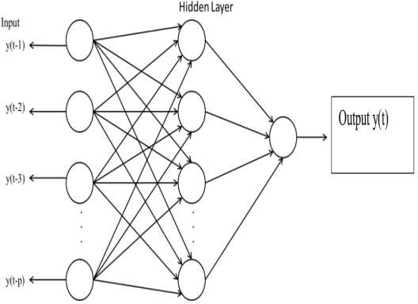
• 𝑊 represents the weights of the network
Figure. 2 Architecture of Neural Network
2.2.3 Non-Linear Support Vector Regression (NLSVR) model
Support Vector Machine (SVM) is a supervised machine learning approach that was initially formulated for linear classification tasks. Subsequently, in 1997, Vapnik introduced the extension of SVM to regression problems through the incorporation of the ε-insensitive loss function (Vapnik et al., 1997). This development enabled its application to more general regression settings, including nonlinear cases. The modelling of such problems within this framework is referred to as the Nonlinear Support Vector Regression (NLSVR) model. The basic principle involved in Non-Linear Support Vector Regression (NLSVR) is to transform the original input time series into a higher-dimensional feature space using a nonlinear kernel function, where a linear regression function is then fitted, enabling the model to capture complex, nonlinear relationships present in the data. The general form of NLSVR is:
𝑓(𝑥) = $\sum_{i=1}^{N}{α_{i}K(x_{i}, x) + b }$ .... (13)
Where:
    - 𝛼_{𝑖} are the coefficients,
    - 𝐾 (𝑥_{𝑖}, 𝑥) is the kernel function and
    - 𝑏 is the bias term.

In this study R package, “e1071” was customized and implemented. This package provides several options for SVR model fitting using different types of kernels like linear, radial basis, sigmoid and polynomial. Although the most often used and recommended function is radial basis.
After detecting potential nonlinear patterns in the ARIMA residuals using the BDS test, a nonlinear model such as Nonlinear Support Vector Regression was applied to capture the nonlinear structures not modelled by ARIMA. The NLSVR models were fitted to the residuals of the optimal ARIMA models for Rice production dataset. The radial basis function (RBF) kernel was chosen due to its flexibility and ability to model complex nonlinear relationships. The optimal hyperparameters for the NLSVR models, include Cost, Gamma, Epsilon were determined through iterative tuning to minimize the error while ensuring good generalization ability. A 10-fold cross validation procedure was adopted to ensure the robustness and generalization capability of the selected hyperparameters. This method involves dividing the datasets into ten subsets, iteratively training the model on nine subsets and validating it on the remaining one thereby minimizing overfitting and improving model reliability. The number of support vectors selected in each model reflects the complexity of the fitted regression function. The best performance value represents the minimal error achieved during the cross-validation process for each model.
- a high dimensional feature space and then build the regression model in a new feature space.
- Let us consider a vector of data set where is the input vector, y_{i} is the scalar output and N is the size of data set. The general equation of Nonlinear Support Vector Regression estimation function is given as follows:
f(x) = W^{T} ϕ (x) + b ... (14)
where, ϕ(.): R^{n} → R^{nh} is a nonlinear mapping function which maps the nonlinear mapping function which maps the original input space into a higher dimensional feature space vector. W ∈ R^{nh} is weight vector, b is bias term and superscript T denotes the transpose.
Hyperparameter Tuning
The performance of NLSVR depends significantly on the choice of three key hyperparameters:
- Cost (C): Controls the trade-off between model complexity and the degree to which deviations larger than ε are tolerated.
- Gamma (γ): Defines the influence of each data point on the regression function.
- Epsilon (ε): Specifies the margin of tolerance within which no penalty is given for prediction errors.
2.2.4 The Proposed Hybrid Methodology
The hybrid modelling framework assumes that the time series $y_{t}$ can be decomposed into both linear and nonlinear components, following the hybrid methodology proposed by Zhang (2003). Accordingly, the relationship between these components may be expressed as:
$y_{t}$ = ${\hat{L}}_{t}$ + ${\hat{N}}_{t}$ … (15)
Where, ${\hat{L}}_{t}$ and ${\hat{N}}_{t}$denote the estimated linear and nonlinear components, respectively. In the present study, the linear structure is captured using an ARIMA model, while the nonlinear structure is modelled using either a Time Delay Neural Network (TDNN) or a Nonlinear Support Vector Regression (NLSVR) approach. The proposed methodology is implemented in three stages. Firstly, an ARIMA model is employed to fit the linear component. Let the prediction series provided by ARIMA model be denoted as . In the second step, the residuals ( ) obtained from ARIMA model are tested for non-linearity by using BDS test (Brock et al., 1996) Once the residuals confirm the non-linearity, then, they are modelled and predicted using TDNN and NLSVR. Finally, the forecasted linear and nonlinear components are combined to generate aggregate forecast.
$\hat{y_{t}}$= ${\hat{L}}_{t}$ + ${\hat{N}}_{t}$ … (16)
Where ${\hat{L}}_{t}$ and ${\hat{N}}_{t}$ represent the predicted linear and nonlinear component, respectively.
2.2.4(a) Hybrid ARIMA-TDNN Model
The hybrid Auto Regressive Integrated Moving Average–Time Delay Neural Network model is developed by initially employing the ARIMA approach to model and extract the linear structure inherent in the data. Subsequently, the TDNN model is applied to the residuals obtained from the ARIMA model in order to capture any remaining non-linear dynamics.
The hybrid model can be formulated as:
${\hat{Y}}_{t}={\hat{Y}}_{{ARIMA}_{t}}+{\hat{Y}}_{{TDNN}_{t}}$ … (17)
Where:
- ${\hat{Y}}_{t}$is the final forecasted value
- ${\hat{Y}}_{{ARIMA}_{t}}$ is the ARIMA forecasted value at time $t$
- ${\hat{Y}}_{{TDNN}_{t}}$ is the TDNN forecasted residual value at time $t$

2.2.4(b) Hybrid ARIMA + NLSVR Model
A hybrid ARIMA + NLSVR (Non-Linear Support Vector Regression) model combines the strengths of both ARIMA and NLSVR to forecast time series data.
The hybrid model can be formulated as:
${\hat{Y}}_{t}={\hat{Y}}_{ARIMA}\left(t\right)+\hat{R} \left(t\right)$ .... (18)
Where:
- ${\hat{Y}}_{t}$is the final forecasted value
- ${\hat{Y}}_{{ARIMA}_{t}}$ is the ARIMA forecasted value at time $t$
- $\hat{R} \left(t\right)$is the NLSVR forecast applied to residuals R(t)
The graphical representation of hybrid methodology has shown below.
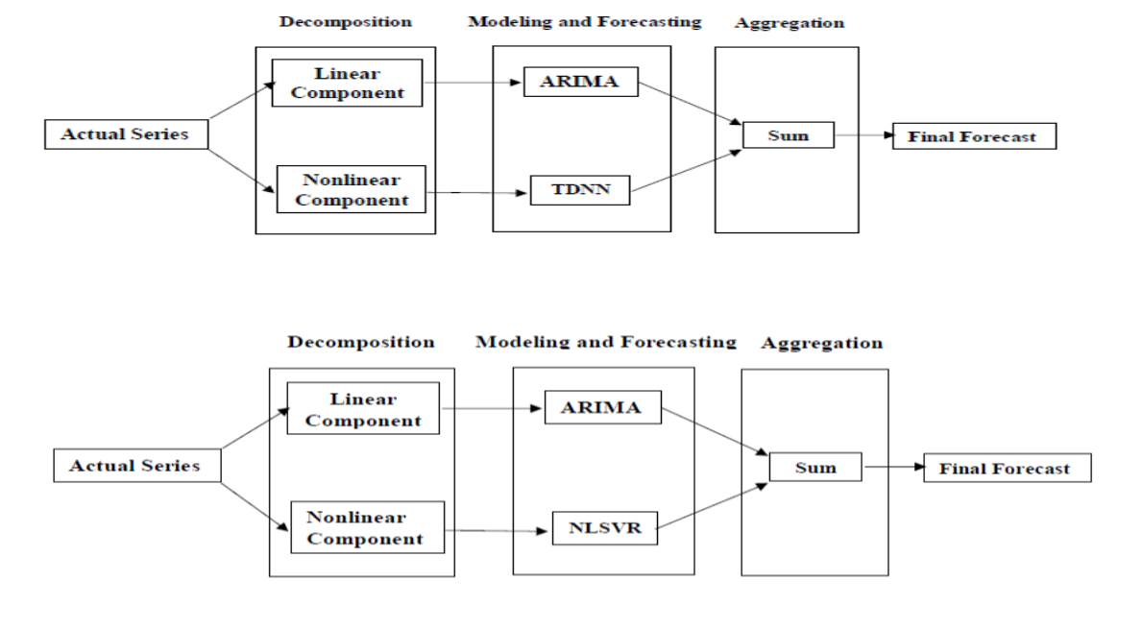
Figure. 3 Graphical representation of Hybrid Methodology

2.2.5 Performance Criteria, Non-Linearity Test and Stationarity test
The performance of the models was evaluated using the following criteria:
2.2.5(a) The coefficient of determination (R²):
The coefficient of determination (R²) is a statistical measure used to assess the goodness-of-fit of a model. It represents the proportion of the variance in the dependent variable that is predictable from the independent variable.

$R^{2}=1-\frac{{\sum_{i=1}^{n}{(Y_{i}-{\hat{Y}}_{i})}}^{2}}{\sum_{i=1}^{n}{(Y_{i}-\bar{Y})^{2}}}$ … (19)
Where:
- $y_{i}$​ = observed values.
- ${\hat{y}}_{i}$ = predicted values from the model.
- $\overline{y}$ = mean of observed values.
An R² value closer to 1 indicates a better fit of the model to the data, meaning that the model’s predictions closely match the actual observations.

2.2.5(b) Root Mean Square Error (RMSE):
RMSE is a measure of the differences between predicted values by a model and the actual observed values. It is calculated as the square root of the average of the squared differences between prediction and actual observations.
Formula:
$RMSE={\left[\sum_{i=1}^{n}{(Y_{i}-{\hat{Y}}_{i})^{2}/n}\right]}^{1/2}$ … (20)
Where:
- $Y$_{t} is the actual value at time $t$
- ${\hat{Y}}_{t}$ is the forecasted value at time $t$
- $n$ is the number of observations
2.2.5(c) Mean Absolute Error (MAE):
MAE is the average of the absolute differences between predicted and actual values. It measures the average magnitude of the errors in a set of predictions, without considering their direction.
Formula:
$MAE=\frac{1}{n}\sum_{t=1}^{n}{\left|Y_{t}-{\hat{Y}}_{t}\right|}$ … (21)
Where:
- $Y$_{t} is the actual value at time $t$
- ${\hat{Y}}_{t}$ is the forecasted value at time $t$
- $n$ is the number of observations
2.2.5(d) Mean Absolute Percentage Error (MAPE)
Mean Absolute Percentage Error (MAPE) is a forecasting accuracy metric that expresses the average absolute error between predicted and actual values as a percentage of the actual values.
MAPE =$\frac{100}{n}\sum_{t=1}^{n}{\left|Y_{t}-{\hat{Y}}_{t}\right|}/\left|{\hat{Y}}_{t}\right|$ …. (22)
Where:
- $Y$_{t} is the actual value at time $t$
- ${\hat{Y}}_{t}$ is the forecasted value at time $t$
- $n$ is the number of observations
2.2.5(e) BDS Test:
The Brock-Dechert-Scheinkman (BDS) test is a statistical method used to detect non-linear dependencies in time series data. It assesses whether the time series can be well-described by a linear model or if there are underlying non-linear structures that the linear model fails to capture. The BDS test evaluates the null hypothesis that the time series follows a linear process against the alternative hypothesis of non-linearity.
The BDS test statistic is given as:
$Z\left(m, τ, ∈\right)=\frac{C\left(m, τ, ϵ\right)-E\left[C\left(m, τ, ϵ\right)\right]}{Var\left[C\left(m, τ, ϵ\right)\right]}$ … (23)

where $E[C(m,τ,ϵ)]$ and $Var[C(m,τ,ϵ)]$ are the expected value and variance of the correlation integral under the null hypothesis of linearity.
3. RESULTS AND DISCUSSIONS
3.1 Descriptive Statistics of Rice Production of Karnataka State
A detailed descriptive statistical analysis was carried out to examine the characteristics and distribution of the production (in thousand tonnes) of Rice in Karnataka for the period from 1962-23 to 2021-22. These measures provide information on central tendency, dispersion, distribution pattern and behaviour of the data. The summary of descriptive statistics is presented in Table 1. The production data set been plotted vs time as seen in Figure 4

Table 1. Descriptive statistics of Rice production
Statistic | Value | Statistic | Value  (in thousand tonnes)
Mean (in thousand tonnes) | 2780.17 | Range | 4584.30
Median (in thousand tonnes) | 2529.95 | Minimum | 1159.70
SD (in thousand tonnes) | 893.74 | Maximum | 5744.00
CV % | 32.14 | Inter Quartile Range | 1346.20
Kurtosis | 0.52 | Lower limit | 104.25
Skewness | 0.62 | Upper limit | 5489.05

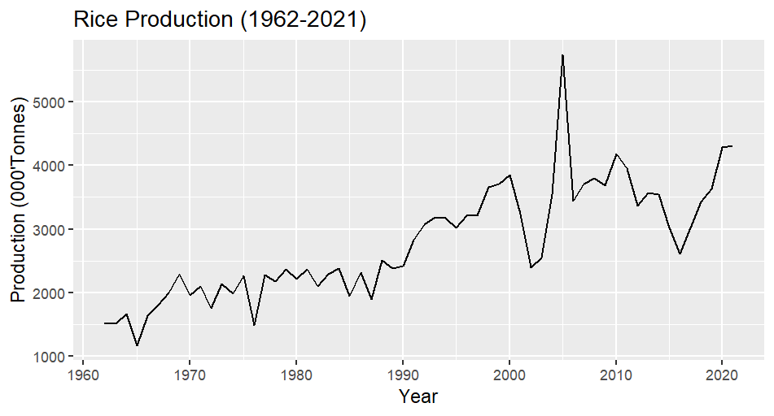
Figure: 4 Time series plot of Rice production
3.2 Fitting of Box Jenkins (ARIMA) model for Rice Production in Karnataka State
The ACF plots of the trained data series of Rice production displayed in the Figure 5, have a slow and gradual decay pattern, indicating the presence of significant autocorrelations at several lags. This pattern is characteristic of a non-stationary time series, suggesting that the data series required differencing to achieve stationarity. To statistically confirm this, Augmented Dickey-Fuller test was performed on the production of Rice in Karnataka State. From the Table 2 it is concluded that the data series was non-stationary and became stationarity at first difference as the null hypothesis was not accepted at 5 per cent Level of Significance as p value was less than 0.05.
Table 2. Augmented Dickey-Fuller Stationarity Test for Rice production
Rice crop | Data type | ADF statistic | critical value | Decision
Production | ADF at zero difference level | -2.43 | 0.4009 | Non-Stationary
Production | ADF at 1st difference | -6.41 | 0.01 | Stationary

Consequently, the ACF plots of the differenced series for production was examined in Figure 5. The differenced series exhibited a rapid decay of autocorrelations with most of the autocorrelation coefficients falling within the 95 per cent confidence limits, indicating that the data had attained stationarity.
After setting d=1 to achieve stationarity, several ARIMA models were developed. The models were compared using R², RMSE, MAE and MAPE criteria which was shown in Table 3. Among them, ARIMA (2,1,2) was identified as best model with high R², low RMSE, MAE and MAPE values.

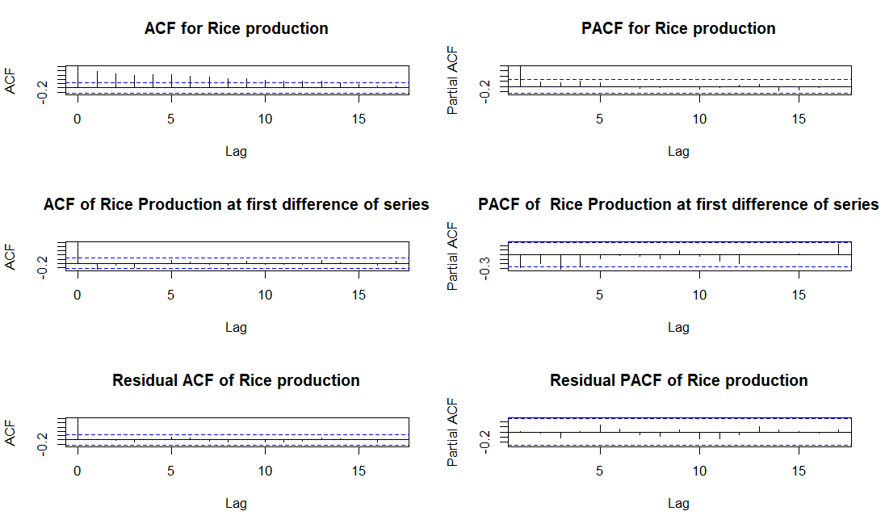
Figure: 5. ACF and PACF plots for Rice production

Table 3. Model fit statistics for Rice Production

ARIMA model | c | Parameters Estimate |  |  |  |  | Goodness of Fit
ARIMA model | c | Autoregressive Coefficient |  |  | Moving Average Coefficient |  | R² | RMSE | MAE | MAPE
ARIMA model | c | AR1 | AR2 | AR3 | MA1 | MA2
ARIMA (0,1,2) | 35.3 |  |  |  | -0.55 | -0.23 | 0.67 | 483.69 | 329.36 | 12.31
ARIMA (1,1,0) | 32.87 | -0.28 |  |  |  |  | 0.61 | 533.33 | 335.64 | 12.47
ARIMA (1,1,1) | 41.14 | 0.41 |  |  | -1 |  | 0.7 | 467.05 | 310.5 | 11.58
ARIMA (1,1,2) | 41.17 | 0.39 |  |  | -0.98** | -0.02 | 0.7 | 466.96 | 311.42 | 11.62
ARIMA (2,1,1) | 41.18 | 0.41** | -0.01 |  | -1 |  | 0.7 | 466.93 | 311.71 | 11.63
ARIMA (2,1,2) | 41.11 | -0.19** | 0.27 |  | -0.39 | -0.6 | 0.7 | 466.92 | 306.53 | 11.41
**Significant at 1%, *Significant at 5%
The ARIMA (2,1,2) fitted equation:
Rice production in Karnataka (Δ Y_{t}) = 41.11-0.19Y_{t-1}+0.27Y_{t-2}-0.39Ꜫ_{t-1} -0.6Ꜫ_{t-2} +e_{t}
Further, a residual analysis was conducted to assess the adequacy of the selected model. The analysis revealed that none of the lag values in the residual ACF and PACF plots were significant, as shown in the Figure 5. Additionally, Ljung-Box test and Kolmogorov-Smirnov test were conducted to check whether the residuals were independently and normally distributed or not. The Ljung-Box test statistic was Q = 2.89 (p = 0.71) K-S test statistic was D = 0.12 (p value = 0.28). The p values were greater than 0.05 indicating that the residuals were independently and normally distributed. This confirms the validity and goodness of fit of the selected ARIMA models for forecasting Rice production in the Karnataka State.
3.3 Fitting of Time Delay Neural Network (TDNN) for Rice Production in Karnataka State
From Table 4, it is shown that the best performing network was 3-6-1, which achieved low RMSE, MAE and MAPE values. Further, residual analysis was also carried out to check the adequacy of the selected neural network model and it was discovered that none of the lags of residual ACF chart were found to be significant as per Figure 6. Furthermore, the p-value (0.92) for the Ljung-Box test was greater than 0.05, indicating that the residuals were independently distributed.
Table 4. Performance of TDNN Models with Varying Network Structures on Rice production
Particulars | Network structure | RMSE | MAE | MAPE
Production | 3-1-1 | 458.43 | 320.91 | 12.59
Production | 3-2-1 | 344.93 | 248.93 | 9.83
Production | 3-3-1 | 247.29 | 194.82 | 8.01
Production | 3-4-1 | 207.81 | 160.63 | 6.76
Production | 3-5-1 | 193.67 | 141.49 | 5.98
Production | 3-6-1 | 172.16 | 132.48 | 5.61
Production | 3-7-1 | 187.03 | 137.64 | 5.89
Production | 3-8-1 | 185.63 | 135.95 | 5.67
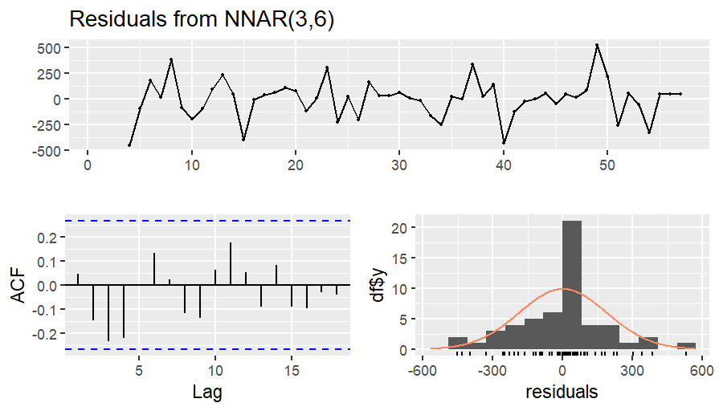

Figure: 6. Residual plot of NNAR (3,6)

3.4 Fitting of Nonlinear Support Vector Regression (NLSVR) Model on Rice production

The results of the Non-Linear Support Vector Regression (NLSVR) model for Karnataka Rice production are shown in Table 5. The model was built using a Radial Basis Function (RBF) kernel under the EPS-Regression type, with an Epsilon (ε) value of 0.1, a Cost (C) value of 256, and a Gamma (γ) value of 0.03125. The final model utilized 43 support vectors, indicating the number of data points that contributed to defining the regression function. This configuration aimed to enhance prediction accuracy while preventing overfitting. During tuning, the objective function, which usually represents the error measure, had a minimum value of 213571.1, which was the model's best performance value. In order to adequately capture the non-linear patterns found in the Rice production data, these parameter sets sought to strike a balance between model complexity and forecast accuracy.
Table 5. Parameters Specification of NLSVR on Rice production
Particulars | SVM  Type | SVM  Kernel | Cost | Gamma | Epsilon | No. Of  Support Vectors | Best  Performance
Production | EPS-  Regression | Radial | 256 | 0.03125 | 0.1 | 43 | 213571.1

3.5 BDS Test for Nonlinearity in ARIMA Residuals of ARIMA (2,1,2) model for Rice Production
The Brock-Dechert-Scheinkman (BDS) test was employed to detect the presence of nonlinearity in the residuals of the fitted ARIMA model for Rice production. A significant p-value was observed at Embedding Dimension 2 and 3, implying the presence of a nonlinear structure not captured by the fitted ARIMA model, as shown in the Table 6. These results indicated that, ARIMA models adequately captured the linear structure in the data series but some nonlinear structures remained. Hence it was justified to adopt a nonlinear model to capture the nonlinear structures.
In the present study, to enhance the forecasting accuracy nonlinear models are integrated with the ARIMA structure. Further the ARIMA residuals are fitted by nonlinear models such as Time Delay Neural Network (TDNN) and Nonlinear Support Vector Regression (NLSVR). This hybrid ARIMA-TDNN and ARIMA-NLSVR approach combines the strengths of ARIMA for capturing linear trends and nonlinear models for addressing remaining nonlinear structures in the data.
Table 6. BDS Test on ARIMA (2,1,2) Residuals
BDS Test |  |  |  |  |  |  |  |  | Decision
Embedding Dimension | 2 |  |  |  | 3 |  |  |  | Presence of nonlinearity
Epsilon | 235.48 | 470.97 | 706.46 | 941.95 | 235.48 | 470.97 | 706.46 | 941.95 | Presence of nonlinearity
p-value | 0.46 | 0.21 | 0.04* | 0.0064** | 0.57 | 0.24 | 0.09 | 0.0264* | Presence of nonlinearity
**Significant at 1%, *Significant at 5%

3.6 Fitting of Time Delay Neural Network (TDNN) Models on ARIMA Residuals
From Table 7, it is shown that the best performing network was 3-7-1, which achieved low RMSE, MAE and MAPE values. Further, residual analysis was also carried out to check the adequacy of the selected neural network model and it was discovered that none of the lags of residual ACF chart were found to be significant as per Figure 7. Furthermore, the p-value (0.89) for the Ljung-Box test was greater than 0.05, indicating that the residuals were independently distributed. These findings suggest that the selected model fits the ARIMA residuals well.

Table 7. Performance of TDNN Models with Varying Network Structures on ARIMA Residuals.

Particulars | Network structure | RMSE | MAE | MAPE
Production | 3-1-1 | 387.81 | 297.63 | 6.92
Production | 3-2-1 | 307.52 | 238.21 | 10.46
Production | 3-3-1 | 292.02 | 229.33 | 7.46
Production | 3-4-1 | 231.6 | 183.47 | 11.06
Production | 3-5-1 | 182.6 | 141.22 | 10.92
Production | 3-6-1 | 179.09 | 135.46 | 9.11
Production | 3-7-1 | 154.52 | 125.96 | 5.4
Production | 3-8-1 | 161.39 | 129.71 | 8.64
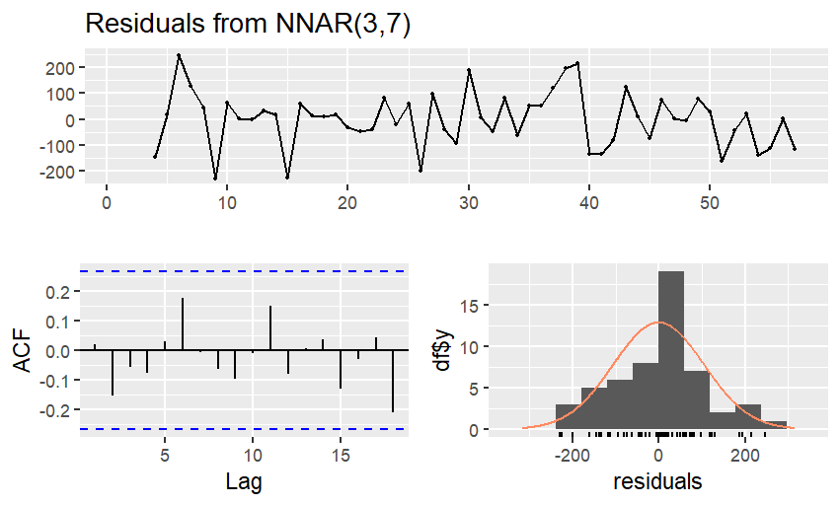
Figure: 7. Residual plot of NNAR (3,7)
3.7 Fitting of Nonlinear Support Vector Regression (NLSVR) Model on ARIMA Residuals
The results of the Non-Linear Support Vector Regression (NLSVR) model for Karnataka Rice production are shown in Table 8. The model was built using a Radial Basis Function (RBF) kernel under the EPS-Regression type, with an Epsilon (ε) value of 0.1, a Cost (C) value of 4, and a Gamma (γ) value of 0.25. The final model utilized 51 support vectors, indicating the number of data points that contributed to defining the regression function. This configuration aimed to enhance prediction accuracy while preventing overfitting. During tuning, the objective function, which usually represents the error measure, had a minimum value of 234910.6, which was the model's best performance value. In order to adequately capture the non-linear patterns found in the Rice production data, these parameter sets sought to strike a balance between model complexity and forecast accuracy.
Table 8. Parameters Specification of NLSVR on ARIMA (3,1,2) Residuals
Particulars | SVM  Type | SVM  Kernel | Cost | Gamma | Epsilon | No. Of  Support Vectors | Best  Performance
Production | EPS-  Regression | Radial | 4 | 0.25 | 0.1 | 51 | 234910.6

3.8 Performance Comparison of Fitted Models
Both training datasets (1962–63 to 2018–19) and testing datasets (2019–20 to 2021–22) were used to assess the fitted models using RMSE, MAE and MAPE. The accuracy of the hybrid techniques was higher than that of the individual models (ARIMA, TDNN, and NLSVR), which performed moderately well which is shown in the Table 9. On both datasets, ARIMA–TDNN consistently performed better than the others, demonstrating the benefit of combining linear and nonlinear approaches. Where the ARIMA-TDNN have the lowest RMSE, MAE and MAPE compare to the other models so the ARIMA-TDNN captures the forecasting values more precisely.
Table 9. Performance Metrics Comparison of the Fitted Models of Rice Production in Karnataka State
Model/Criteria | Training Dataset |  |  | Testing Dataset
Model/Criteria | RMSE | MAE | MAPE | RMSE | MAE | MAPE
ARIMA | 466.94 | 306.53 | 11.41 | 333.54 | 296.02 | 0.51
TDNN | 187.03 | 132.48 | 5.6 | 442.13 | 387.09 | 0.1024
NLSVR | 455.84 | 302.13 | 12.26 | 607.9 | 538.79 | 0.15
ARIMA-TDNN | 102.37 | 77.82 | 0.032 | 228.15 | 206.37 | 0.0519
ARIMA-NLSVR | 440.43 | 290.87 | 0.105 | 312.27 | 286.6 | 0.0734

Table 10. Forecasted Rice production in Karnataka State from 2022-23 to 2027-28 using the ARIMA-TDNN hybrid model.
Year | 2022-23 | 2023-24 | 2024-25 | 2025-26 | 2026-27 | 2027-28
Forecasted values  ('000 tonnes) | 4168.87 | 4282.28 | 3912.83 | 4298.77 | 3752.58 | 4432.68

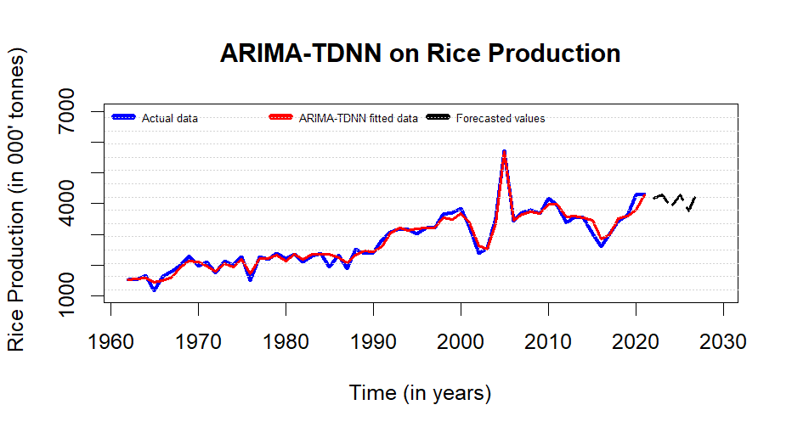
Figure: 8. Actual vs ARIMA-TDNN fitted for Rice production in Karnataka State

Finally, the actual and fitted values of Rice production in Karnataka State were generated using the ARIMA (2,1,2) -TDNN (3-7-1) hybrid model as shown in the Figure 8. The forecasted values of Rice production for the year 2027-28 were determined to be 4432.68 thousand tonnes. The results obtained from this hybrid model, as presented in Table 10, indicate a constant increasing trend in Rice production of Karnataka State.
4. CONCLUSION
The hybrid ARIMA–TDNN model produced the best accuracy of all fitted models, as demonstrated by the lowest error metrics on both training and testing datasets, according to a comparative analysis of several forecasting models. This hybrid model's improved performance shows how well linear and nonlinear techniques may be combined to produce accurate forecasts. This model was used to estimate Karnataka's Rice production through 2027–2028, revealing significant annual variations. When formulating plans for resource management and food security, farmers, planners, and legislators can all benefit greatly from these projections. All things considered, the ARIMA–TDNN hybrid model proves to be a reliable instrument for predicting agricultural output.
5. LIMITATIONS OF THIS RESEARCH
- The analysis can be extended to all districts of the Karnataka as well as states of India.
- In this analysis we have used only few testing datasets, there is a limitation of this, it can be used 7-10 testing dataset for 60 data points.
- Future research could expand the use of hybrid models to anticipate at the district or regional level, even though this study concentrated on state-level production data. As a result, more precise and useful projections would be available to direct policy interventions and micro-level planning.
- Using historical production values, univariate time series models were the only basis for the current investigation. Future research may use multivariate time series models (such as ARIMAX, VAR or hybrid VAR-TDNN) to incorporate exogenous variables like temperature, rainfall, fertilizer usage, irrigation coverage and MSP trends in order to increase forecasting accuracy.
- For food grain production forecasting, contemporary deep learning models like Temporal Convolutional Networks (TCN), Gated Recurrent Units (GRU) and Long Short-Term Memory (LSTM) networks could be investigated and contrasted with TDNN, especially in capturing intricate, non-linear, and long-range dependencies.

Disclaimer (Artificial intelligence)
Author(s) hereby declare that NO generative AI technologies such as Large Language Models (ChatGPT, COPILOT, etc.) and text-to-image generators have been used during the writing or editing of this manuscript.

REFERENCES
1. Ali AM, Mushi J. Investigation of a Suitable Hybrid Time Series Model for Predicting Clove Rice. Journal of ICT Systems. 2023;1(2):1-16.
2. Box GE, Jenkins GM, Reinsel GC, Ljung GM. Time series analysis: Forecasting and control. John Wiley & Sons; 2015.
3. Devra SJ, Patel DV, Shitap MS, Raj SR. Time series forecasting of price for oilseed crops by combining ARIMA and ANN. International Journal of Statistics and Applied Mathematics. 2023;8(4):40-54.
4. Jha GK, Sinha K. Time-Delay Neural Networks for Time Series Prediction: An Application to the Monthly Wholesale price of Oilseeds in India. Neural Comput Appl. 2014;24(3):563-571.
5. Khalili, M.Y., Sevinç, M.R., Palabıçak, M.A and Sevinç, G. 2025. Future Forecasting of Grain Maize Production in Turkey with ARIMA Model. International Journal of Social and Humanities Sciences Research .12(115):12-20
6. Kumar S, Arora K, Singh P, Gupta AK, Sharma I, Vatta K. Performance comparison of ARIMA and time delay neural network for forecasting of potato price in India. Agricultural Economics Research Review. 2022;35(2).
7. Kumar TM, Prajneshu. Development of hybrid models for forecasting time-series data using nonlinear SVR enhanced by PSO. Journal of Statistical Theory and Practice. 2015;9(4):699-711.
8. Kumar, S., Mehta, V., Mourya, K.K. and Kumar, A., 2024. Comparative Study of Forecasting for Finger Millet (Ragi) According to their Area and Production in Different States of India through ARIMA Model. Environment and Ecology, 42(4C):1994-2003.
9. Latha, K.N., Rao, V.S., Sarada, C., Reddy, A.A and Sreenivasulu, K.N. 2024. Enhancing Forecasting Accuracy of Palm Oil Import to India Using Machine Learning Techniques. Indian Journal of Agricultural Economics. 79(2):214-230.
10. Mishra, P., Alakkari, K.M., Lama, A., Ray, S., Singh, M., Shoko, C., Abotaleb, M and Karakaya, K. 2023. Modelling and forecasting of sugarcane production in South Asian countries. Current Applied Science and Technology. 23(1):1-15.
11. Nagaveni, M., Kulkarni, G., Guledagudda, S., Rajkumara, S and Venugopal, C. 2024. Dynamics of Major Food Grain Production in Karnataka. Mysore Journal of Agricultural Sciences. 58(3):199-209.
12. Navaneetha, C and Kathirvel, A. 2025, November. Optimizing Honeypot Mobility: A Hybrid ML Approach for Advanced DDoS Protection. International Conference on Electrical Engineering and Informatics 1-7.
13. Rathod S, Mishra GC. Statistical models for forecasting mango and banana yield of Karnataka, India. Journal of Agricultural Science and Technology. 2018;20(4):803 816.
14. Rathod Santosha, Singh KN, Patil SG, Naik RH, Ray M, Meena VS. Modelling and forecasting of oilseed production of India through artificial intelligence techniques. Indian J Agric Sci. 2018;88(1):22-27.
15. Ray M, Rai A, Ramasubramanian V, Singh KN. ARIMA-WNN hybrid model for forecasting wheat yield time-series data. J Ind Soc Agric Stat. 2016;70(1):63-70.
16. Sai, K.S., Sreenivasulu, K.N and Sitarambabu, V. 2023. Forecasting Models for Red gram Area, Production and Productivity in Karnataka. The Andhra Agricultural Journal. 70(2):233-245.
17. Sarica, D. 2024. Forecasting Sugar Beet Production in Turkey Using the Box-Jenkins Method. Journal of Agricultural Science and Technology. 26(1):1-11.
18. Vapnik, V., Golowich, S and Smola, A. 1997. Support Vector Method for Function Approximation, Regression Estimation and Signal Processing. In: “Advances in Neural Information Processing Systems”, (Eds.): Mozer, M., Jordan, M and Petsche, T. MIT Press, Cambridge, MA. 9:281 -287.
19. Yamuna, N., Kolekar, D.V and Rakesh, N. 2024. Trend and Instability Analysis of Area, Production, Productivity of Millets in India. Journal of Scientific and Reports. 30(8):686-699.
20. Zhang GP. Time series forecasting using a hybrid ARIMA and neural network model. Neurocomputing. 2003; 50:159-175.
21. Sanketh Raj, H., Murthy, B. R., Sreenivasulu, K. N., & Babu, V. S. R. (2025). Hybrid statistical model for forecasting production of maize crop in Karnataka State, India. International Journal of Statistics and Applied Mathematics, 10(5), 53–58. https://doi.org/10.22271/maths.2025.v10.i5a.2035

