Original Research Article

Effects of Light at Night and Methamphetamine on Reproductive Hormones, Estrous Cycle and Histology of the Reproductive Organs in Female Albino Wistar Rats

ABSTRACT
Aim: Light at night (LAN) and methamphetamine (Meth) are emerging environmental and pharmacological stressors implicated in neuroendocrine and reproductive dysfunction. This study investigated the independent and combined effects of LAN and Meth on reproductive hormone profiles, cortisol levels, estrous cyclicity and histological integrity of the ovaries and uterus in female Albino Wistar rats.
Methodology: Twenty-four adult female Albino Wistar rats (120–150 g) were randomly assigned into four groups of six (n = 6). Group A (control) received normal saline under a standard 12:12-hour light-dark cycle. Group B (LAN) was exposed to 24-hour continuous light for 28 days. Group C (Meth) received methamphetamine at 5mg/kgbw orally for 28 days under standard light-dark conditions. Group D (LAN + Meth) received both exposures simultaneously. Serum luteinizing hormone (LH), follicle-stimulating hormone (FSH), estrogen, progesterone, and cortisol were measured using ELISA. Estrous cycles were monitored through vaginal smear cytology. Ovarian and uterine tissues were weighed and examined histologically. Data were analyzed using one-way ANOVA with post hoc LSD at p ≤ 0.05.
Results: Significant reductions in LH were observed in all treated groups compared to control (F= 8.039, p ≤ 0.05). FSH levels decreased significantly in Groups B and C, while Group D showed a significant increase compared to Group C (p ≤ 0.05). Estrogen levels were significantly elevated in the LAN group, whereas progesterone changes were not significant. Serum cortisol was significantly suppressed in all treated groups, with the greatest reduction in Meth-exposed rats. Estrous cycles showed progressive irregularity in all treated groups. Histology revealed mild degenerative and inflammatory changes, most notable in the LAN group, with largely preserved architecture overall.
Conclusion: LAN and Meth disrupt hypothalamic–pituitary–gonadal axis function and stress hormone regulation, with LAN producing more pronounced endocrine and histological alterations.
Keywords: Light-at-night, Methamphetamine, Circadian disruption, Female fertility, HPG axis, Estrous cycle.

BACKGROUND OF THE STUDY
Light at night (LAN) is a form of circadian disruption caused by artificial lighting from streetlights, indoor illumination, and electronic devices. Its prevalence has increased substantially with urbanization, shift work, and widespread adoption of night-time technology use (Zhang et al., 2024; Jiménez et al., 2025). The circadian rhythm, the body's intrinsic 24-hour biological clock, governs hormonal release, metabolism, and reproductive function (Jiménez et al., 2025). Disruption of this rhythm by LAN suppresses pineal melatonin secretion, alters gonadotropin-releasing hormone (GnRH) pulsatility, and impairs the hypothalamic–pituitary–gonadal (HPG) axis, resulting in irregular reproductive cycles and reduced fertility (Zhang et al., 2024; Bedrosian and Nelson, 2017).
Female reproductive health is particularly susceptible to circadian disruption, as the precise temporal orchestration of the HPG axis is fundamentally dependent on intact circadian entrainment. LAN-induced melatonin suppression disrupts the pulsatile secretion of gonadotropin-releasing hormone (GnRH) from hypothalamic kisspeptin/KNDy neurons, impairing gonadotropin release, follicular development, ovulation, and corpus luteum function (Reiter et al., 2014; Marques et al., 2024). The resulting reproductive endocrine disruption manifests as aberrant LH and FSH secretion, dysregulated steroidogenesis, irregular menstrual cycles, luteal phase insufficiency, and anovulatory infertility (Beroukhim, Esencan and Seifer, 2022; Guerrero-Vargas et al., 2022).
Methamphetamine (Meth), a potent central nervous system psychostimulant locally known as mkpurummiri in South-Eastern Nigeria, has emerged as a major substance abuse concern, with the United Nations Office on Drugs and Crime reporting a drug use prevalence of 13.8% in South-Eastern Nigeria (UNODC, 2018;2019). Meth exerts its neurotoxic effects by inducing non-exocytotic reverse transport of dopamine through presynaptic dopamine transporters, flooding the synaptic cleft with supraphysiological dopamine concentrations while inhibiting dopamine reuptake and monoamine oxidase activity, and generating reactive oxygen species through dopamine auto-oxidation, collectively producing excitotoxic neuroinflammation, oxidative stress, and HPA axis activation (Zuloaga et al., 2015; Cruickshank and Dyer, 2009). At the reproductive axis level, dopaminergic excess directly inhibits GnRH neurons, and suppresses kisspeptin signaling, impairing gonadotropin secretion and disrupting ovarian steroidogenesis (Zuloaga et al., 2015; Chen et al., 2021). Women constitute a growing proportion of methamphetamine users, yet the gender-specific reproductive consequences of Meth exposure remain poorly characterized.
Both LAN and Meth disrupt the HPG axis through mechanistically distinct but converging pathways, and both independently activate the HPA axis, elevating glucocorticoid output that further suppresses GnRH pulsatility. Meth is further characterized by a pharmacological half-life of 10 to 12 hours and stimulatory effects persisting 8 to 24 hours, rendering co-exposure to artificial light at night an inevitable pharmacokinetic consequence of its use (Casteel and Singh, 2023). Despite this biological plausibility of their co-occurrence, no experimental study has examined their combined reproductive effects. The present study therefore investigated the independent and combined effects of LAN and Meth on reproductive hormone profiles, stress hormone regulation, estrous cycle and histological integrity of the ovaries and uterus in female Albino Wistar rats.
Based on existing literature on light-at-night and methamphetamine-induced reproductive toxicity, we hypothesized that exposure to these agents, individually and in combination, would significantly alter reproductive hormones, cortisol, estrous cyclicity, and ovarian and uterine histomorphology compared to controls.

MATERIALS AND METHODS
Ethical Approval and Animal Welfare
All experimental procedures were conducted in accordance with established guidelines for the care and use of laboratory animals (National Academy of Sciences, 1985). Ethical approval was obtained from the Animal Research Ethics Committee, Nnamdi Azikiwe University.
Animals were housed in standard cages with unrestricted access to standard rat chow and clean water throughout the study duration. A two weeks acclimatization period was provided prior to commencement of any experimental procedures to minimize handling stress and allow animals to adapt to the housing environment.
Methamphetamine was administered orally via gavage needle, a route selected over intraperitoneal or intravenous administration to minimize procedural pain and tissue trauma. All gavage procedures were performed by a trained investigator using appropriately sized gavage needles to minimize discomfort. Animals were monitored daily for signs of distress. No animals reached humane endpoint criteria during the study and no mortalities were recorded across any experimental group throughout the exposure period.
Vaginal smear collection for estrous cycle monitoring was performed using a cotton swab moistened with normal saline, gently inserted into the vaginal orifice with minimal penetration and carefully rotated to collect epithelial cells. This method was selected as the least invasive approach, avoiding the use of traumatic sampling techniques. The procedure was performed by the same trained investigator throughout the study to minimize animal stress. This was conducted on the experimental animals to track their cycle for three complete estrous cycle to confirm their regularity before the commencement of the experiment.
Anaesthesia for blood collection was administered by inhalation in a closed chamber. Blood collection via ocular puncture was performed immediately following confirmation of adequate anaesthesia. Animals were subsequently sacrificed by cervical dislocation, a humane method that minimizes suffering. Carcasses were disposed of by deep burial within the institutional animal facility grounds in accordance with the waste disposal guidelines of Nnamdi Azikiwe University, Nnewi Campus.
Animals and Study Location
Twenty-four adult female Albino Wistar rats (120–150 g) with confirmed regular 4 to 5 day estrous cycles were obtained from a certified animal farm. Animals were housed and acclimatized for two weeks in the Animal House of the Faculty of Basic Medical Sciences, College of Health Sciences, Nnamdi Azikiwe University, Nnewi Campus, under standard conditions with access to food and water ad libitum.
Experimental Design and Groups
Animals were randomly assigned into four groups of six (n = 6):
Group A (Control): maintained under a standard 12:12-hour light–dark cycle and received normal saline orally.
Group B (LAN): exposed to 24-hour continuous white light for 28 days and received normal saline orally.
Group C (Meth): maintained under a standard 12:12-hour light–dark cycle and received methamphetamine at 5 mg/kgbw orally for 28 days.
Group D (LAN + Meth): exposed to 24-hour continuous light and received methamphetamine at 5 mg/kgbw orally for 28 days.
The study duration of 28 days covered approximately seven complete estrous cycles, providing sufficient exposure time to observe meaningful neuroendocrine and histological changes.
Light Exposure Parameters
Groups B and D were exposed to 24-hour continuous light throughout the 28days. This was achieved by maintaining artificial white light from 5-watt bulbs from 6pm to 6am to target the natural dark phase, thereby eliminating the daily dark period entirely and producing a continuous light-light cycle with no dark phase. Light intensity from the 5-watt bulbs was selected based on published evidence confirming that low intensity artificial light of 2 to 5 lux is sufficient to suppress melatonin secretion, disrupt SCN circadian clock gene expression, and produce measurable neuroendocrine disruption in rodents (Rumanova et al., 2020; Bedrosian et al., 2013).. Groups A and C maintained the standard 12:12-hour light-dark cycle.
Methamphetamine Dose Preparation and Administration
A dose of 5mg/kgbw was selected based on established rodent literature documenting measurable neuroendocrine and reproductive effects without acute lethality (de Angelis et al., 2020; Zuloaga et al., 2015). Pharmacologic grade methamphetamine hydrochloride was dissolved in normal saline at a stock concentration of 1mg/ml. Volume administered was calculated weekly using: Volume (ml) = Dose (mg/kg) × Body weight (kg) ÷ Stock concentration (mg/ml). For example, a 130g rat receiving 5mg/kg from 1mg/ml stock received 0.65ml orally via gavage. Groups A and B received equivalent normal saline volumes by the same route.
Estrous Cycle Monitoring
Vaginal smears were collected using a cotton swab moistened with normal saline, smeared onto glass slides, air-dried, stained and examined under light microscopy. Stages: proestrus, estrus, metestrus, and diestrus, were classified by predominant cell types following Marcondes et al. (2002).
Sample Collection and Hormonal Analysis
At the end of the experiment, animals were anesthetized and blood collected via ocular puncture using capillary tubes. Serum was separated by centrifugation at 10,000 rpm for 20 minutes. Serum concentrations of LH, FSH, estrogen, progesterone, and cortisol were determined by Enzyme-Linked Immunosorbent Assay (ELISA) using commercially validated kits according to manufacturer instructions.
Organ Collection and Histological Analysis
The ovaries and uterus were carefully excised, trimmed of fat, and weighed for relative organ weight calculation (organ weight/body weight × 100). Tissues were fixed in 10% neutral buffered formalin, dehydrated, cleared, embedded in paraffin, and sectioned at 5 µm. Sections were stained with haematoxylin and eosin (H&E) and examined under light microscopy for structural alterations, follicular development, and endometrial changes.
Statistical Analysis
Data were analyzed using SPSS version 25 and expressed as mean ± standard error of mean (SEM). Body weight changes were analyzed using a paired t-test. Hormone and organ weight data were analyzed using one-way ANOVA with post hoc LSD test for inter-group comparisons. Statistical significance was set at p ≤ 0.05.

RESULTS & DISCUSSION
Effect of LAN and Methamphetamine on Body Weight in Female Albino Wistar Rats
An evaluation of the body weight changes in the female albino Wistar rats after exposure is shown in Table 1. Body weight changes did not reach statistical significance in any group (p > 0.05). Group A (control) showed a modest increase from 117.33 ± 2.07 g to 126.20 ± 4.61 g. Group B (LAN) showed a marginal non-significant decrease from 133.00 ± 2.26 g to 130.17 ± 2.83 g. Groups C and D showed modest non-significant increases.

Table 1: Effect of LAN and Methamphetamine on Body Weight in Female Albino Wistar Rats
Group | Initial Weight (g) Mean±SEM | Final Weight (g) Mean±SEM | p-value
Group A (Control) | 117.33±2.07 | 126.20±4.61 | 0.095
Group B (LAN) | 133.00±2.26 | 130.17±2.83 | 0.453
Group C (Meth) | 127.83±2.12 | 129.17±4.96 | 0.810
Group D (LAN+Meth) | 129.33±5.92 | 130.67±4.93 | 0.866

Effect of LAN and Methamphetamine on Relative Organ Weights in Female Albino Wistar Rats
An evaluation of the relative organ weight in the female albino Wistar rats after exposure is shown in Table 2. Relative ovarian and uterine weights showed non-significant differences across all groups (F = 0.792 and F = 0.803 respectively, p > 0.05). A trend toward increased relative ovarian weight was observed in treated groups, most notably in the Meth group (0.09 ± 0.01 g), while the LAN group showed a modest non-significant decrease in relative uterine weight.

Table 2: Effect of LAN and Methamphetamine on Relative Organ Weights in Female Albino Wistar Rats
Group | Rel. Ovary Weight (g) Mean±SEM | Rel. Uterine Weight (g) Mean±SEM
Group A (Control) | 0.06±0.01 | 0.12±0.01
Group B (LAN) | 0.08±0.01 | 0.11±0.01
Group C (Meth) | 0.09±0.01 | 0.09±0.00
Group D (LAN+Meth) | 0.08±0.01 | 0.13±0.01
F-ratio | 0.792 | 0.803

Effect of LAN and Methamphetamine on LH and FSH Levels in Female Albino Wistar Rats
An evaluation of the serum LH and FSH levels in the female albino Wistar rats after exposure is shown in Table 3. LH was significantly suppressed in all treated groups compared to control (F = 8.039, p ≤ 0.05). The greatest suppression was in Group C (1.43 ± 0.21 IU/L), followed by Group D (1.86 ± 0.55 IU/L) and Group B (2.19 ± 1.06 IU/L). FSH was significantly reduced in Groups B (1.32 ± 0.48 IU/L) and C (0.99 ± 0.16 IU/L) compared to control (2.59 ± 0.34 IU/L). Notably, Group D showed a significant FSH recovery (2.15 ± 0.33 IU/L) compared to Group C (F = 4.358, p ≤ 0.05).

Table 3: Effect of LAN and Methamphetamine on LH and FSH Levels in Female Albino Wistar Rats
Group | LH (IU/L) Mean±SEM | FSH (IU/L) Mean±SEM
Group A (Control) | 5.57±0.58 | 2.59±0.34
Group B (LAN) | 2.19±1.06* | 1.32±0.48*
Group C (Meth) | 1.43±0.21* | 0.99±0.16*
Group D (LAN+Meth) | 1.86±0.55* | 2.15±0.33#
F-ratio | 8.039 | 4.358
*Significant compared to Group A; #Significant compared to Group C (p ≤ 0.05)

Effect of LAN and Methamphetamine on Estrogen and Progesterone in Female Albino Wistar Rats
An evaluation of the serum estrogen and progesterone levels in the female albino Wistar rats after exposure is shown in Table 4. Estrogen was significantly elevated only in the LAN group (75.95 ± 4.04 pg/ml vs. control 64.66 ± 0.62 pg/ml; F = 2.546, p ≤ 0.05). Groups C and D showed non-significant estrogen elevations. Progesterone levels were highest in Group C (12.53 ± 0.72 ng/ml) and Group D (12.38 ± 1.05 ng/ml), though no between-group difference reached statistical significance (F = 1.678, p > 0.05).

Table 4: Effect of LAN and Methamphetamine on Estrogen and Progesterone in Female Albino Wistar Rats
Group | Estrogen (pg/ml) Mean±SEM | Progesterone (ng/ml) Mean±SEM
Group A (Control) | 64.66±0.62 | 10.35±0.76
Group B (LAN) | 75.95±4.04* | 10.77±0.85
Group C (Meth) | 71.12±4.02 | 12.53±0.72
Group D (LAN+Meth) | 70.91±0.85 | 12.38±1.05
F-ratio | 2.546 | 1.678
*Significant compared to Group A (p ≤ 0.05)

Effect of LAN and Methamphetamine on Cortisol Level in Female Albino Wistar Rats
An evaluation of the serum cortisol level in the female albino Wistar rats after exposure is shown in Table 5. Cortisol was significantly suppressed in all treated groups compared to control (F = 13.59, p ≤ 0.05). Group B recorded 51.53 ± 3.61 ng/ml, while Groups C (39.40 ± 2.87 ng/ml) and D (40.08 ± 2.93 ng/ml) showed the deepest suppression, with no significant difference between them.

Table 5: Effect of LAN and Methamphetamine on Cortisol Levels in Female Albino Wistar Rats
Group | Cortisol (ng/ml) Mean±SEM
Group A (Control) | 63.79±3.01
Group B (LAN) | 51.53±3.61*
Group C (Meth) | 39.40±2.87*
Group D (LAN+Meth) | 40.08±2.93*
F-ratio | 13.59

Effect of LAN and Methamphetamine on Estrous Cycle Length in Female Albino Wistar Rats
An evaluation of estrous cycle length in the female albino Wistar rats after exposure is shown in Table 6. Group A demonstrated regular estrous cyclicity consistent with the established 4 to 5 day cycle length for adult female Albino Wistar rats under normal photoperiodic conditions (Marcondes et al., 2002). Group B showed progressive cycle irregularity with a trend toward persistent estrus. Group C demonstrated diestrus predominance and reduced cycle regularity. Group D showed the most pronounced cyclical disruption across the study period. Differences in mean cycle length across groups did not reach statistical significance.

Table 6: Effect of LAN and Methamphetamine on Estrous Cycle Length in Female Albino Wistar Rats
 | week 1 | week 2 | week 3 | week 4
 | Cycle length (days) | Cycle length (days) | Cycle length (days) | Cycle length (days)
 | MEAN±SEM | MEAN±SEM | MEAN±SEM | MEAN±SEM
Group A | 1.00±0.22 | 0.92±0.23 | 1.16±0.27 | 0.91±0.24
Group B | 0.75±0.11 | 1.08±0.30 | 1.33±0.31 | 1.17±0.27
Group C | 1.00±0.31 | 0.91±0.23 | 1.58±0.27 | 1.00±0.22
Group D | 1.25±0.25 | 1.17±0.27 | 1.08±0.30 | 1.33±0.21
f-ratio | 0.740 | 0.222 | 0.579 | 0.596

Effect of LAN and Methamphetamine on the Ovarian Histoarchitecture in Female Albino Wistar Rats
The histoarchitecture of the ovaries of each group was evaluated and the photomicrographs presented in Figure 1. Ovarian histology of Group A (control) revealed normal follicular architecture with intact oocytes and follicular cells consistent with regular cycling. Group B (LAN) showed mild diffuse degenerative changes with oocytes and follicular cells exhibiting mild necrotic and inflammatory reactive changes. Group C (Meth) showed largely preserved ovarian architecture with only mild focal exudation within a primary follicle. Group D (LAN + Meth) showed architecture consistent with normal ovarian histology.

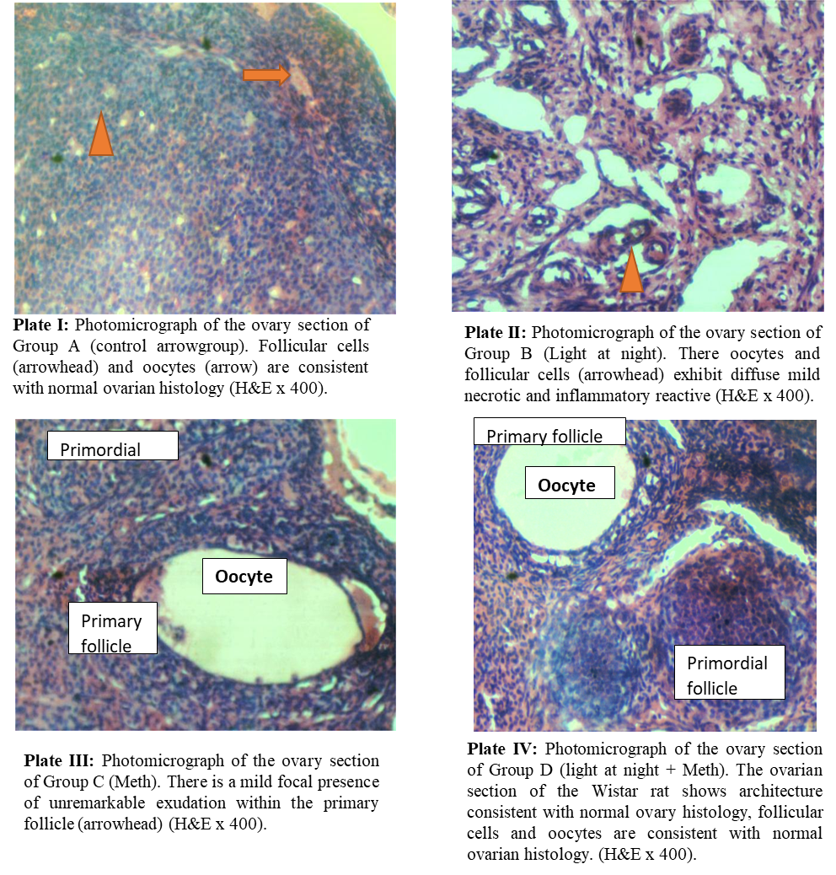
Figure 1: Effect of LAN and Methamphetamine on the Ovarian Histoarchitecture in Female Albino Wistar Rats
Effect of LAN and Methamphetamine on the Uterine Histoarchitecture in Female Albino Wistar Rats
The histoarchitecture of the uteri of each group was evaluated and the photomicrographs presented in Figure 2. Uterine histology of Group A revealed normal endometrial morphology with intact glands and stroma showing no inflammatory changes. Group B showed mild stromal and glandular inflammatory reactive changes in the endometrium and myometrium. Groups C and D showed uterine histology consistent with normal architecture, with no signs of inflammatory reaction.

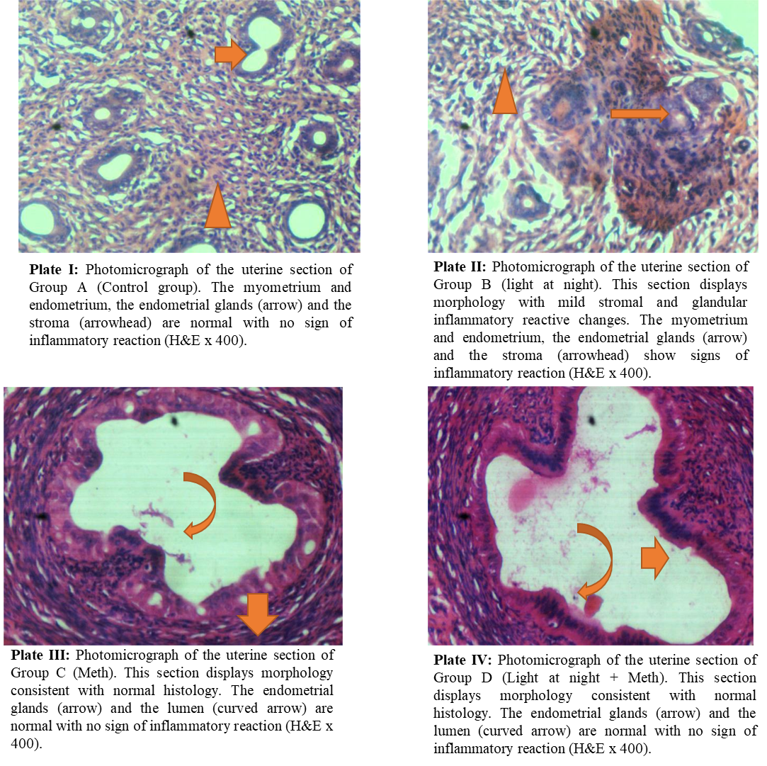
Figure 2: Effect of LAN and Methamphetamine on the uterine histoarchitecture in Female Albino Wistar Rats
This study investigated the reproductive endocrine and histological consequences of LAN, Meth, and their combination in female Albino Wistar rats. The findings demonstrate that both exposures independently suppress the HPG axis and disrupt cortisol regulation, with LAN producing more pronounced histological alterations and Meth producing the deepest cortisol and LH suppression.
Body weight changes did not reach significance in any group, confirming that the reproductive alterations observed were not secondary to nutritional compromise or systemic wasting but represent genuine neuroendocrine pathology. The marginal weight reduction in the LAN group is physiologically consistent with circadian disruption of feeding rhythmicity and metabolic regulation by the suprachiasmatic nucleus (Fonken and Nelson, 2014).
The significant suppression of LH in all treated groups (F = 8.039), the largest F-value in this study, establishes LH as the hormone most powerfully and consistently differentiated by the experimental treatments. In the LAN group, continuous light abolishes the SCN-mediated preovulatory GnRH surge by chronically suppressing melatonin, the dark-phase neuroendocrine cue that synchronizes the reproductive axis (Reiter et al., 2014). Without this circadian gating, the timed LH surge fails, ovulation does not occur, and the cycle becomes arrested in persistent estrus, reflected in the significantly elevated estrogen (75.95 ± 4.04 pg/ml) from retained preovulatory follicles continuously stimulated by FSH. The deeper LH suppression in the Meth group reflects methamphetamine's multi-targeted disruption: dopaminergic D2 receptor-mediated inhibition of GnRH neurons, HPA axis activation with glucocorticoid-mediated suppression of kisspeptin interneurons, and direct impairment of kisspeptin signaling, simultaneously removing the primary upstream driver of GnRH pulses (Zuloaga et al., 2015). The partial LH recovery in Group D relative to Group C reflects a physiologically meaningful antagonistic interaction, where LAN-induced hyperestrogenism exerts positive feedback on pituitary gonadotrophs, partially counteracting methamphetamine's GnRH suppression.
The significant FSH recovery in Group D (2.15 ± 0.33 IU/L) compared to Group C (0.99 ± 0.16 IU/L) represents the most physiologically informative finding in the gonadotropin data. Under LAN-induced persistent anovulation, accumulating retained follicles progressively lose the capacity to secrete adequate inhibin B, the primary ovarian signal that exerts negative feedback on pituitary FSH secretion. The withdrawal of inhibin B feedback removes the pituitary's brake on FSH production, driving a compensatory upregulation that overrides methamphetamine's suppressive effect at the FSH level specifically. This finding highlights the complexity of combined stressor interactions and the importance of studying co-exposure rather than individual effects in isolation.
The significant estrogen elevation in the LAN group and the contrasting progesterone pattern, highest in the Meth group, reflect opposing effects on the steroidogenic pathway. LAN drives estrogen upward through anovulatory follicular accumulation, while Meth impairs aromatase activity in granulosa cells, blocking conversion of progesterone to androgens and subsequently to estrogen, causing progesterone to accumulate upstream (Chen et al., 2021). The combined group's estrogen level (70.91 ± 0.85 pg/ml) lower than LAN alone confirms this counterbalancing: LAN drives estrogen up through follicular accumulation while Meth simultaneously impairs the steroidogenic machinery in the same follicles.
The significant suppression of serum cortisol observed across all treatment groups, supported by the second highest F-ratio in the study (F = 13.59), indicates marked sensitivity of the hypothalamic–pituitary–adrenal (HPA) axis to both light-at-night exposure and methamphetamine administration. Cortisol was employed as the primary stress biomarker based on established evidence for its validity in rodents. Although corticosterone is the predominant circulating glucocorticoid in rats, the rat adrenal cortex expresses functional 17α-hydroxylase activity, permitting the synthesis and release of cortisol in addition to corticosterone. Under stress, serum cortisol levels correlate strongly with corticosterone concentrations in rodents, supporting its use as a reliable indicator of HPA axis activation (Gong et al., 2015). Furthermore, multiple studies in Wistar rats have demonstrated reproducible, stress-induced elevations in serum cortisol that are quantifiable using validated ELISA platforms with high sensitivity and specificity (Jameel et al., 2014). The cortisol suppression under chronic LAN reflects not acute stress activation but rhythm abolition: 28 days of continuous light eliminates the diurnal cortisol amplitude by removing the light-dark entrainment cue, producing a flattened glucocorticoid rhythm (Bedrosian et al., 2013). The markedly deeper cortisol suppression in the Meth group reflects the well-characterized HPA axis burnout paradox of chronic stimulant exposure, while acute Meth activates the HPA axis robustly, chronic exposure desensitizes CRH neurons and downregulates glucocorticoid receptors, producing paradoxically low basal cortisol (Zuloaga et al., 2015; Carson et al., 2012). The near-identical cortisol values in Groups C and D indicate that methamphetamine's HPA desensitization was the dominant determinant of cortisol suppression in the combined group.
Estrous cycle findings across groups demonstrated progressive irregularity and prolongation in all treated animals, with LAN producing persistent estrus predominance consistent with anovulatory cycle arrest, and Meth producing diestrus predominance consistent with GnRH suppression and impaired follicular maturation. The combined group showed the most pronounced disruption, consistent with the additive convergence of two independent HPG axis disruptors acting through converging pathways (Russart and Nelson, 2017; Li et al., 2021). These findings align with de Angelis et al. (2020) who documented irregular estrous cycles alongside reduced follicle reserve and impaired granulosa cell steroidogenesis in chronically Meth-exposed female rats.
Histologically, the mild degenerative and inflammatory ovarian changes in the LAN group are the structural correlates of prolonged anovulatory estrus, persistent estrogenic stimulation without the counterbalancing effect of progesterone from a functional corpus luteum. The uterine inflammatory reactive changes in Group B reflect the direct tissue consequences of prolonged unopposed estrogenic stimulation of the endometrium, a state analogous to estrogen-dominant anovulatory cycles in women associated with endometrial proliferative risk (Guerrero-Vargas et al., 2022). The largely preserved architecture in the Meth and combined groups, despite significant hormonal disruption, suggests that 28 days of oral Meth at this dose produces its primary reproductive impact through neuroendocrine rather than structural mechanisms.
CONCLUSION
LAN and Methamphetamine independently disrupt HPG axis function and cortisol regulation in female Albino Wistar rats through converging but mechanistically distinct neuroendocrine pathways, with LAN producing more pronounced endocrine and histological alterations. Their combination produces complex, partly antagonistic interactions, particularly the LAN-induced compensatory FSH recovery overriding methamphetamine's gonadotropin suppression, highlighting that co-exposure effects cannot be predicted from individual stressor data alone. These findings have translational relevance for women in urban settings where chronic artificial light exposure and substance abuse increasingly co-occur, and underscore the need for reproductive health strategies that account for the combined neuroendocrine burden of modern lifestyle stressors.
LIMITATIONS
Several limitations of the study are acknowledged. First, cortisol rather than corticosterone was measured as the HPA axis stress biomarker, while it is justified on enzymatic and correlational grounds, future studies should include corticosterone for comparative completeness. Second, prolactin and melatonin were not measured, limiting direct quantification of their contributions to the gonadotropin and circadian disruption findings respectively. Finally, oxidative stress markers were not assessed, limiting mechanistic interpretation of the histological findings. These limitations are acknowledged as directions for future investigation.
DECLARATIONS

COMPETING INTERESTS DISCLAIMER:
Authors have declared that they have no known competing financial interests OR non-financial interests OR personal relationships that could have appeared to influence the work reported in this paper.

Disclaimer (Artificial intelligence)

Author(s) hereby declare that NO generative AI technologies such as Large Language Models (ChatGPT, COPILOT, etc.) and text-to-image generators have been used during the writing or editing of this manuscript.

REFERENCES
Bedrosian, T. A. and Nelson, R. J. (2013). Influence of the modern light environment on mood. Molecular Psychiatry, 18(7), 751–757. https://doi.org/10.1038/mp.2013.70
Beroukhim, G., Esencan, E. and Seifer, D. B. (2022). Impact of sleep patterns upon female neuroendocrinology and reproductive outcomes: a comprehensive review. Reproductive Biology and Endocrinology, 20(1). https://doi.org/10.1186/s12958-022-00889-3
Carson, D. S., Bosanquet, D. P., Carter, C. S., Pournajafi-Nazarloo, H., Blaszczynski, A., and McGregor, I. S. (2012). Preliminary evidence for lowered basal cortisol in a naturalistic sample of methamphetamine polydrug users. Experimental and Clinical Psychopharmacology. 20(6): 497–503. https://doi.org/10.1037/a0029976
Casteel, C. O. and Singh, G. (2023). Physiology, Gonadotropin-Releasing Hormone. StatPearls — NCBI Bookshelf. https://www.ncbi.nlm.nih.gov/books/NBK558992/
Chen, C.-Y. Chen, C.-R., Chen, C.-N., Wang, P. S., Mündel, T., Liao, Y.-H. and Tsai, S.C.. (2021). Amphetamine-decreased progesterone and estradiol release in rat granulosa cells: The regulatory role of cAMP- and Ca²⁺-mediated signaling pathways. Biomedicines. 9(5): 493. https://doi.org/10.3390/biomedicines9050493
De Angelis, C., Nardone, A., Garifalos, F., Pivonello, C., Sansone, A., Conforti, A., Di Dato, C., Sirico, F., Alviggi, C., Isidori, A., Colao, A., & Pivonello, R. (2020). Smoke, alcohol and drug addiction and female fertility. Reproductive Biology and Endocrinology, 18(1). https://doi.org/10.1186/s12958-020-0567-7
Fonken, L. K., Kitsmiller, E., Smale, L. and Nelson, R. J. (2012). Dim nighttime light impairs cognition and provokes depressive-like responses in a diurnal rodent. Journal of Biological Rhythms. 27(4): 319-327
Fonken, L. K. and Nelson, R. J. (2014). The effects of light at night on circadian clocks and metabolism. Endocrine Reviews, 35(4), 648–670.
Gong, S., Miao, Y., Jiao, G., Sun, M., Li, H., Lin, J., Luo, M., & Tan, J. (2015). Dynamics and Correlation of Serum Cortisol and Corticosterone under Different Physiological or Stressful Conditions in Mice. PLoS ONE. 10(2): e0117503. https://doi.org/10.1371/journal.pone.0117503
Guerrero-Vargas, N. N., Espitia-Bautista, E., Escalona, R., Lugo-Martínez, H., Gutiérrez-Pérez, M., Navarro-Espíndola, R., Setién, M. F., Boy-Waxman, S., Retana-Flores, E. A., Ortega, B., Buijs, R. M., & Escobar, C. (2022). Timed restricted feeding cycles drive daily rhythms in female rats maintained in constant light but only partially restore the estrous cycle. Frontiers in Nutrition. 9: 999156. https://doi.org/10.3389/fnut.2022.999156
Jameel, M. K. (2014). Effect of various physical stress models on serum cortisol level in Wistar rats. Journal of Clinical and Diagnostic Research, 8(3): 181–183. https://doi.org/10.7860/jcdr/2014/7210.4116
Jiménez, D., Arenas, L. N., Rincón, E. H. H., Céspedes, M. J. G., and Peñuela, C. L. J. (2025). Luminous Threats: The Health Impacts of Artificial Nighttime Light on Metabolic and Mental health: A Scoping Review. Wellbeing Space and Society. 100260. https://doi.org/10.1016/j.wss.2025.100260
Li, J., Liu, J., Zhang, K., Chen, L., Xu, J. and Xie, X. (2021). The Adverse effects of prenatal METH exposure on the offspring: a review. Frontiers in Pharmacology. 12. https://doi.org/10.3389/fphar.2021.715176
Marcondes, F. K., Bianchi, F. J. and Tanno, A. P. (2002). Determination of the estrous cycle phases of rats: some helpful considerations. Brazilian Journal of Biology, 62(4A): 609–614. https://doi.org/10.1590/s1519-69842002000400008
Meléndez-Fernández, O. H., Liu, J. A. and Nelson, R. J. (2023). Circadian rhythms disrupted by light at night and mistimed food intake alter hormonal rhythms and metabolism. International Journal of Molecular Sciences, 24(4), 3392. https://doi.org/10.3390/ijms24043392
Milad, R., Ramin, H., Gholamhassan, V. and Maryam B. (2025). Examining the effects of methamphetamine on amiontic sac compounds in pregnant rats and the ovaries of their offspring. Global Journal of Reproductive Medicine. 11(1):555810.
Radulovikj, S. and Stojchevska, M. (2024). Dopamine and prolactin — the inhibitory relationship and its clinical implications. Journal of Biomedical and Clinical Research, 17(1): 45–52.
Reiter, R. J., Tan, D. X., Korkmaz, A. and Ma, S. (2014). Melatonin and the circadian regulation of reproductive hormones. Endocrine Reviews, 35(5), 695–725.
Rumanova, V. S., Okuliarova, M., Foppen, E., Kalsbeek, A., and Zeman, M. (2022). Exposure to dim light at night alters daily rhythms of glucose and lipid metabolism in rats. Frontiers in Physiology. 13: 973461. https://doi.org/10.3389/fphys.2022.973461
Russart, K. L. and Nelson, R. J. (2017). Light at night as an environmental endocrine disruptor. Physiology and Behavior, 190: 82–89. https://doi.org/10.1016/j.physbeh.2017.08.029
Sattayasai, J., Phansuwan-Pujito, P. and Sripattanaporn, S. (2008). Methamphetamine-induced reproductive toxicity in female rats. Journal of the Medical Association of Thailand. 91(4): 559–565.
UNODC (2018). Drug use in Nigeria: 2018 National Drug Use Survey. United Nations Publications.
UNODC (2019). World Drug Report 2019. United Nations Publications.
Van Drunen, R., and Eckel-Mahan, K. (2021). Circadian Rhythms of the Hypothalamus: From Function to Physiology. Clocks & sleep. 3(1): 189–226. https://doi.org/10.3390/clockssleep3010012
Walton, J. C., Weil, Z. M. and Nelson, R. J. (2011). Influence of photoperiod on hormones, behavior, and immune function. Frontiers in Neuroendocrinology, 32(3), 303–319. https://doi.org/10.1016/j.yfrne.2010.12.003
Yaw, A., McLane-Svoboda, A. and Hoffmann, H. (2020). Shiftwork and light at night negatively impact molecular and endocrine timekeeping in the female reproductive axis. International Journal of Molecular Sciences, 22(1), 324. https://doi.org/10.3390/ijms22010324
Zhang, Y., Hu, K., Tang, Y., Feng, Q., Jiang, T., Chen, L., Chen, X., Shan, C., Han, C., Chu, W., Ma, N., Hu, H., Gao, H., and Zhang, Q. (2024). Interactive correlations between artificial light at night, health risk behaviors, and cardiovascular health among patients with diabetes: A cross-sectional study. Journal of diabetes. 16(10): e70008. https://doi.org/10.1111/1753-0407.70008
Zoubková, H., Tomášková, A., Nohejlová, K., Černá, M., and Šlamberová, R. (2019). Prenatal exposure to methamphetamine: Up-Regulation of brain receptor genes. Frontiers in Neuroscience. 13. https://doi.org/10.3389/fnins.2019.00771
Zuloaga, D. G., Jacobskind, J. S. and Raber, J. (2015). Methamphetamine and the hypothalamic–pituitary–adrenal axis. Frontiers in Neuroscience, 9, 178. https://doi.org/10.3389/fnins.2015.00178

