Original Research Article

A Discovery Study on SEA-AD Spatial Transcriptomics (MERFISH) Data Reveals Shift in Expression Pattern of NRG1, PEX5L, FGF13, SEMA3E, and SCUBE1

ABSTRACT
Background: Alzheimer’s disease is a progressive neurodegenerative disorder characterized by complex spatial and molecular alterations, necessitating advanced spatial transcriptomic approaches to better understand disease progression across Braak stages. Aims: The study aims to examine how spatial organization of gene expression and cell-type relationships changes across Alzheimer’s disease (AD) progression using the SEA-AD MERFISH spatial transcriptomics dataset. Study design: Secondary computational discovery study using publicly available human brain spatial transcriptomics data. Place and Duration of Study: Biomedical Sciences Division, STEM Science Center, Englewood Cliffs, NJ, USA; analysis of the publicly released SEA-AD dataset was conducted using archived data. Methodology: Sixty-nine middle temporal gyrus sections from 27 donors spanning Braak stages 0–VI were grouped as low Braak (0–III) or high Braak (IV–VI). Moran’s I was used as the primary quantitative spatial autocorrelation metric, and a spatial shift summary based on section-level median difference, Cliff’s delta, and Braak-stage correlation was used to rank disease-associated spatial changes. Neighborhood enrichment and co-occurrence metrics were calculated with Squidpy. Group differences were evaluated using Mann-Whitney U tests with Benjamini-Hochberg false discovery rate correction, and Pearson and Spearman correlations with Braak stage were calculated. Results: Twenty-two genes showed significantly altered spatial autocorrelation between low and high Braak groups, and 13 genes showed progressive correlation with Braak stage. NRG1, PEX5L, FGF13, SEMA3E, and SCUBE1 consistently showed higher Moran’s I values in advanced stages. L6b neurons displayed significant self-enrichment, and oligodendrocyte-L4 intratelencephalic neuron co-occurrence increased in high Braak tissue. Conclusion: AD progression was associated with increased spatial clustering of selected genes and selective reorganization of cell-type neighborhoods. These findings support Moran’s I and related spatial-shift measures as hypothesis-generating spatial biomarkers that require validation in additional brain regions and by protein-level or orthogonal in situ methods.
Keywords: Alzheimer’s disease; spatial transcriptomics; MERFISH; Moran’s I; Braak staging; SEA-AD; neighborhood enrichment; spatial biomarkers.

1. INTRODUCTION
Alzheimer’s disease (AD) is a progressive neurodegenerative disorder and the most common cause of dementia. Recent global estimates indicate that approximately 57 million people were living with dementia in 2021, and AD accounts for the majority of dementia cases [1]. The worldwide burden is expected to continue increasing with population aging, emphasizing the need for improved molecular, spatial, and biomarker-based approaches to disease staging and mechanism discovery [1,2]. Although symptomatic therapies and anti-amyloid treatment strategies have advanced, AD remains biologically complex, and effective disease modification across broad patient populations remains an active clinical challenge [3,4]. AD is defined neuropathologically by extracellular amyloid-beta plaques and intracellular neurofibrillary tangles composed of hyperphosphorylated tau protein [4]. The progression of tau pathology is commonly classified by Braak stages I–VI, which describe a stereotyped anatomical spread that correlates with increasing cognitive impairment and neuronal loss [5]. Beyond amyloid and tau pathology, AD involves neuroinflammation, oxidative stress, blood-brain barrier dysfunction, synaptic failure, and multicellular changes involving neurons, microglia, astrocytes, oligodendrocytes, and vascular-associated cells [4,6].
A key limitation of conventional molecular studies of AD has been the reliance on bulk RNA sequencing and dissociation-based single-cell RNA sequencing (scRNA-seq). Single-cell RNA sequencing has enabled identification of AD-associated transcriptional states in excitatory neurons, microglia, oligodendrocytes, and vascular-associated cell populations [7]. However, dissociation irreversibly removes cells from their native tissue locations, limiting interpretation of where cells and transcripts are positioned relative to plaques, tangles, cortical layers, and neighboring cell types [8]. Because the human brain is a highly structured organ in which laminar architecture and cell-type neighborhoods are fundamental to function, the loss of spatial information remains a meaningful limitation for understanding AD progression [9].
Spatial transcriptomics addresses this limitation by enabling gene expression to be measured together with physical tissue location [8]. Among spatial technologies, Multiplexed Error-Robust Fluorescence In Situ Hybridization (MERFISH) permits high-dimensional RNA imaging in intact tissue through combinatorial barcoding and sequential fluorescence imaging [10]. By preserving native tissue architecture, MERFISH can identify regionally localized gene-expression patterns, cell-type neighborhoods, and spatial rearrangements that are not captured by expression abundance alone. Such spatial information is especially relevant for AD because disease lesions and cellular responses are not uniformly distributed across brain regions, cortical layers, or local microenvironments.
Despite the growing availability of spatial transcriptomics datasets for AD, systematic analysis of how spatial gene expression patterns — specifically spatial autocorrelation and cell type co-localization — change progressively across Braak stages has remained underexplored. In particular, while prior work has focused on identifying differentially expressed genes between disease states, the question of whether genes and cell types become more or less spatially clustered as pathology advances has not been comprehensively addressed at the tissue level. This distinction is meaningful: a gene may be upregulated in AD without any change in its spatial distribution, or it may become increasingly concentrated in discrete tissue regions — a pattern that could reveal localized pathological processes invisible to expression-level analysis alone.
To address this gap, we built on the publicly released Seattle Alzheimer’s Disease Brain Cell Atlas (SEA-AD) MERFISH dataset comprising 27 donors, 69 middle temporal gyrus tissue sections, and 180 genes spanning Braak stages 0–VI [11]. Spatial pattern analyses were computed using Squidpy, a scalable Python framework for spatial omics analysis that implements Moran’s I spatial autocorrelation, neighborhood enrichment, and co-occurrence analysis [12]. Tissue sections were stratified into low Braak (stages 0–III) and high Braak (stages IV–VI) groups, and statistical comparisons were performed using non-parametric tests with false discovery rate correction. The present study focused on quantitative spatial patterning rather than differential expression alone, with particular attention to NRG1, PEX5L, FGF13, SEMA3E, and SCUBE1.
The aim of this study was to identify genes whose spatial expression patterns shift with AD severity, characterize changes in cell-type spatial organization across Braak stages, and establish a cautious, hypothesis-generating foundation for future in situ and protein-level validation of the most spatially informative genes.

2. METHODOLOGY

2.1 Data acquisition
Spatial transcriptomics data were obtained from the Seattle Alzheimer’s Disease Brain Cell Atlas (SEA-AD) [11]. The dataset includes 27 human donors spanning Braak stages 0–VI, 69 middle temporal gyrus sections, and expression data for 180 genes measured by MERFISH across approximately 370,000 cells.
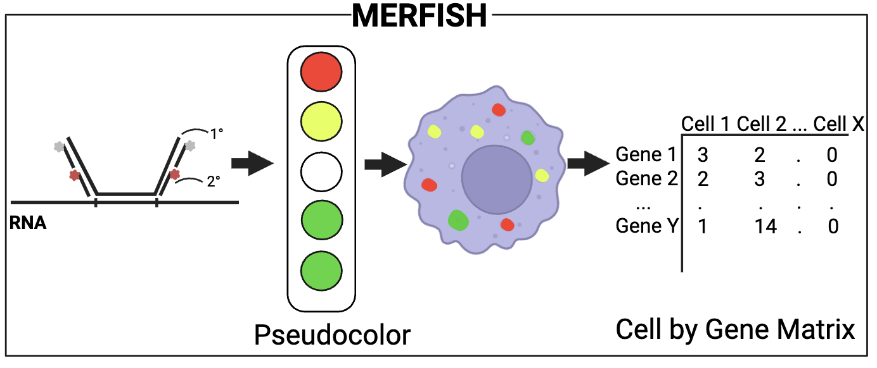
Fig. 1. MERFISH model. RNA molecules are labeled with probes and detected through sequential fluorescent imaging. Each gene is assigned a unique combinatorial barcode and quantified into a cell-by-gene matrix.

2.2 Data preprocessing and group assignment
Raw H5AD files were filtered to retain cells with valid Merscope imaging run identifiers. Sections were grouped into low Braak (0–III) and high Braak (IV–VI) categories for primary comparisons, while continuous Braak scores (0–6) were used in correlation analyses.
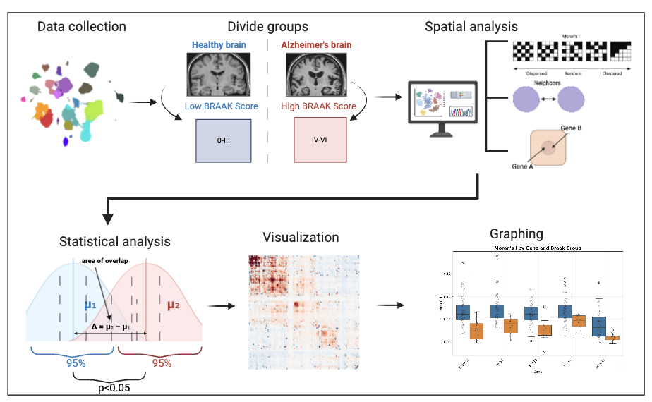
Fig. 2. Experimental workflow. Raw MERFISH data were divided into low Braak (stages 0–III) and high Braak (stages IV–VI) groups. Three spatial analyses (Moran’s I, neighborhood enrichment, and co-occurrence) were performed per section, followed by statistical comparison and visualization.

2.3 Spatial metrics computation
Using Squidpy, three spatial metrics were computed for each section [12]. Moran’s I was calculated for all 180 genes and used as the primary quantitative measure of spatial autocorrelation. Moran’s I ranges conceptually from negative spatial dispersion to positive spatial clustering, with higher positive values indicating that cells with similar expression levels are more spatially grouped than expected under a random distribution. Neighborhood enrichment generated Z-scores for subclass cell-type pairs, and co-occurrence analysis quantified pairwise spatial association across distance intervals. Spatial binning was adaptively defined to target at least 20 cells per bin.

2.4 Statistical analysis
Group comparisons used two-sided Mann-Whitney U tests. Effect size was summarized with Cliff’s delta, and p-values were adjusted by the Benjamini-Hochberg false discovery rate method. Pearson and Spearman correlations with continuous Braak score were additionally calculated. Analyses were performed in Python using Squidpy, SciPy, pandas, and related scientific-computing packages [12–14].

2.5 Quantitative spatial-shift metric
To address spatial effect magnitude explicitly, disease-associated spatial change was summarized using three complementary quantities for each gene: (i) section-level Moran’s I as the primary spatial autocorrelation metric, (ii) the median difference in Moran’s I between high Braak and low Braak groups (Δ median Moran’s I), and (iii) Cliff’s delta as a non-parametric effect-size estimate. Genes were considered most robust when they showed a statistically significant false-discovery-rate-adjusted group difference, a positive spatial-shift direction, and a consistent positive correlation with continuous Braak stage. This approach allowed the spatial result to be interpreted quantitatively rather than as a visual pattern only.

3. RESULTS AND DISCUSSION

3.1 Spatial organization of cell types across Braak stages
Spatial organization was examined at the supertype and subclass levels to determine whether cell-type proximity patterns changed with AD severity.
At the supertype level, co-occurrence and neighborhood enrichment heatmaps outlined the baseline architecture of middle temporal gyrus tissue (Figure 3). Most supertype pairs showed low co-occurrence, whereas related supertypes showed stronger spatial association. These plots provided a reference for stage-based comparisons.
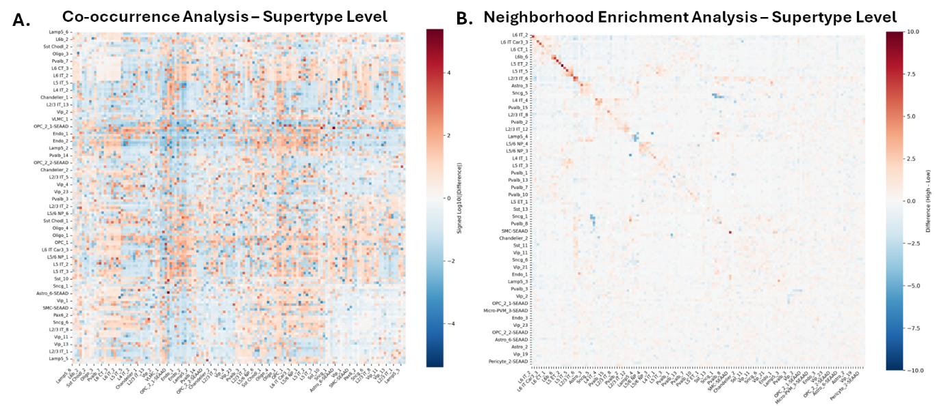
Fig. 3. Supertype-level analysis. (A) Patterns of supertype co-localization in MTG brain tissue. Warmer colors show high co-occurrence, while cooler colors show low co-occurrence. (B) Depiction of preferential spatial associations between supertypes. Warmer colors indicate proximity while cooler colors represent avoidance.
At the subclass level, neighborhood enrichment identified a significant change involving L6b neurons (Figure 4). In high Braak tissue, L6b cells showed stronger self-enrichment than in low Braak tissue, suggesting a localized change in cortical layer-associated cellular organization. This result should be interpreted cautiously because it was derived from one brain region and does not distinguish selective preservation, local vulnerability, or compensatory clustering.
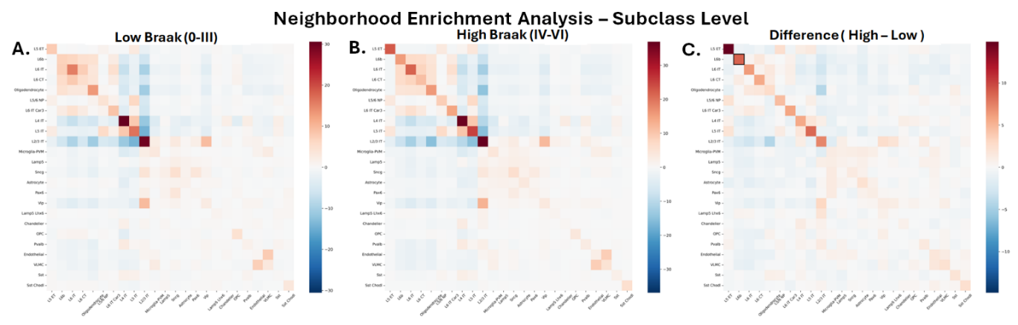
Fig. 4. Neighborhood enrichment analysis at the Subclass level. (A) Enrichment and depletion patterns in low Braak stages. (B) Enrichment and depletion patterns in high Braak stages. (C) Changes in enrichment between high Braak compared to low Braak. L6b cells show statistically significant self-enrichment in advanced disease stages.
Co-occurrence analysis showed increased spatial association between oligodendrocytes and L4 intratelencephalic neurons in high Braak sections (Figure 5). This finding suggests disease-associated reorganization of myelinating glia and cortical excitatory neuron neighborhoods, but it does not by itself establish a direct functional interaction or causal mechanism.
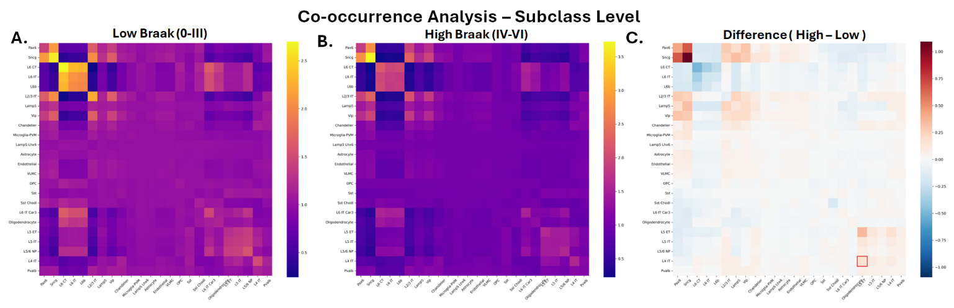
Fig. 5. Co-occurrence analysis at the Subclass level. (A) Co-occurrence patterns in low Braak stages. (B) Co-occurrence patterns in high Braak stages. (C) Changes in co-occurrence between high Braak compared to low Braak. An increase in co-occurrence between oligodendrocytes and L4 IT neurons is observed in advanced Braak stages.

3.2 Spatial gene expression patterns across Braak stages
Moran’s I was computed for all 180 genes to identify disease-related changes in spatial gene-expression patterning. This metric provided a quantitative spatial measure of transcript clustering within each tissue section. Both a binary group comparison and a continuous Braak-stage correlation analysis were performed.
The group comparison identified 22 genes with significantly altered spatial autocorrelation (q < 0.05; Figure 6A). All significant genes showed positive effect sizes, indicating greater spatial clustering in high Braak tissue. The overall distribution of Moran’s I values also shifted rightward in advanced disease (Figure 6B), and the heatmap of significant genes showed progressive increases across Braak stages, particularly for NRG1, PEX5L, and SLC24A2 (Figure 6C). The added quantitative spatial-shift summary therefore supports the visual impression that disease-associated changes were reflected by section-level spatial autocorrelation rather than by figure inspection alone.
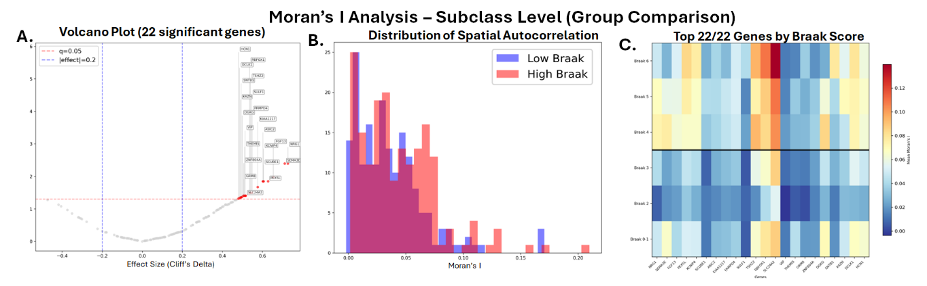
Fig. 6. Moran's I group comparison at the Subclass level. (A) Volcano plot showing 22 genes with significant changes in spatial autocorrelation (q < 0.05). All significant genes show positive effect sizes, indicating increased clustering in high Braak stages. (B) Distribution of Moran's I values across sections; the high Braak group (orange) is shifted rightward relative to the low Braak group (blue). (C) Heatmap of the top 22 genes across Braak stages 0–VI, showing a progressive increase in spatial clustering, notably in NRG1, PEX5L, and SLC24A2.
Correlation analysis identified 13 genes whose Moran’s I values increased significantly with Braak stage (q < 0.05; Figure 7). This finding supports the interpretation that spatial reorganization is progressive across Braak severity, although the cross-sectional design prevents inference about within-person temporal progression.
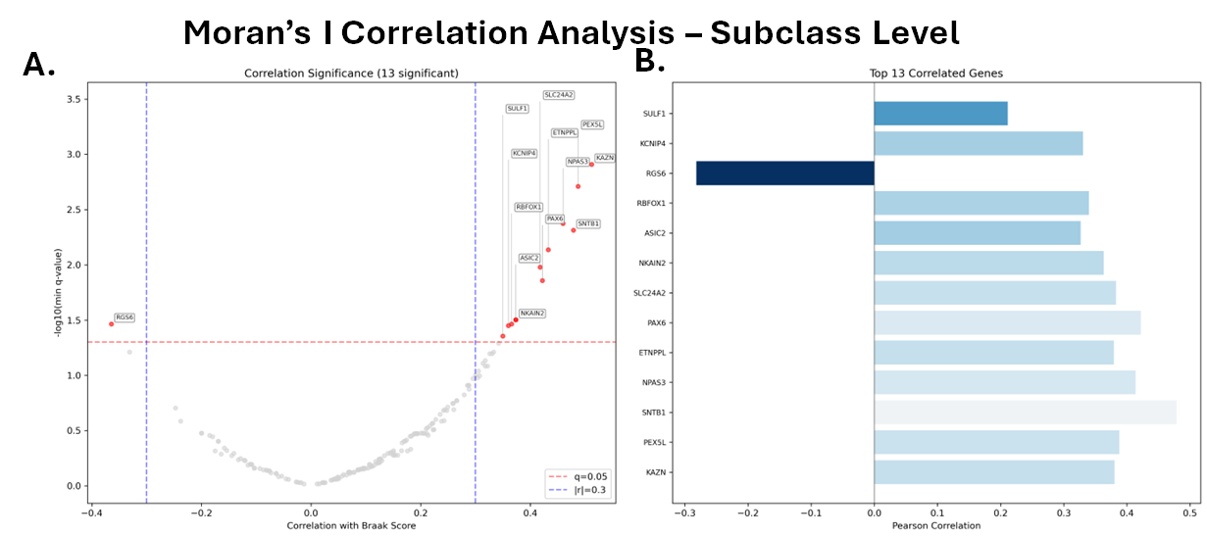
Fig. 7. Moran's I correlation analysis at the Subclass level. (A) Thirteen genes show a significant progressive correlation between Moran's I and Braak stage (q < 0.05). (B) Top 13 correlated genes ranked by Pearson correlation coefficient.
The five genes with the most robust and consistent spatial changes across both analyses — SEMA3E, NRG1, FGF13, PEX5L, and SCUBE1 — are shown as boxplots in Figure 8, comparing Moran’s I values between the low Braak and high Braak groups. All five genes displayed higher Moran’s I values in the high Braak group, indicating stronger spatial clustering with AD advancement. SEMA3E showed the largest visual separation between groups. NRG1 and FGF13, both relevant to neuronal signaling, plasticity, and cytoskeletal biology, also exhibited increased spatial clustering. PEX5L and SCUBE1 should be viewed as hypothesis-generating spatial candidates because their disease-stage spatial clustering has not yet been validated at the protein or mechanistic level.
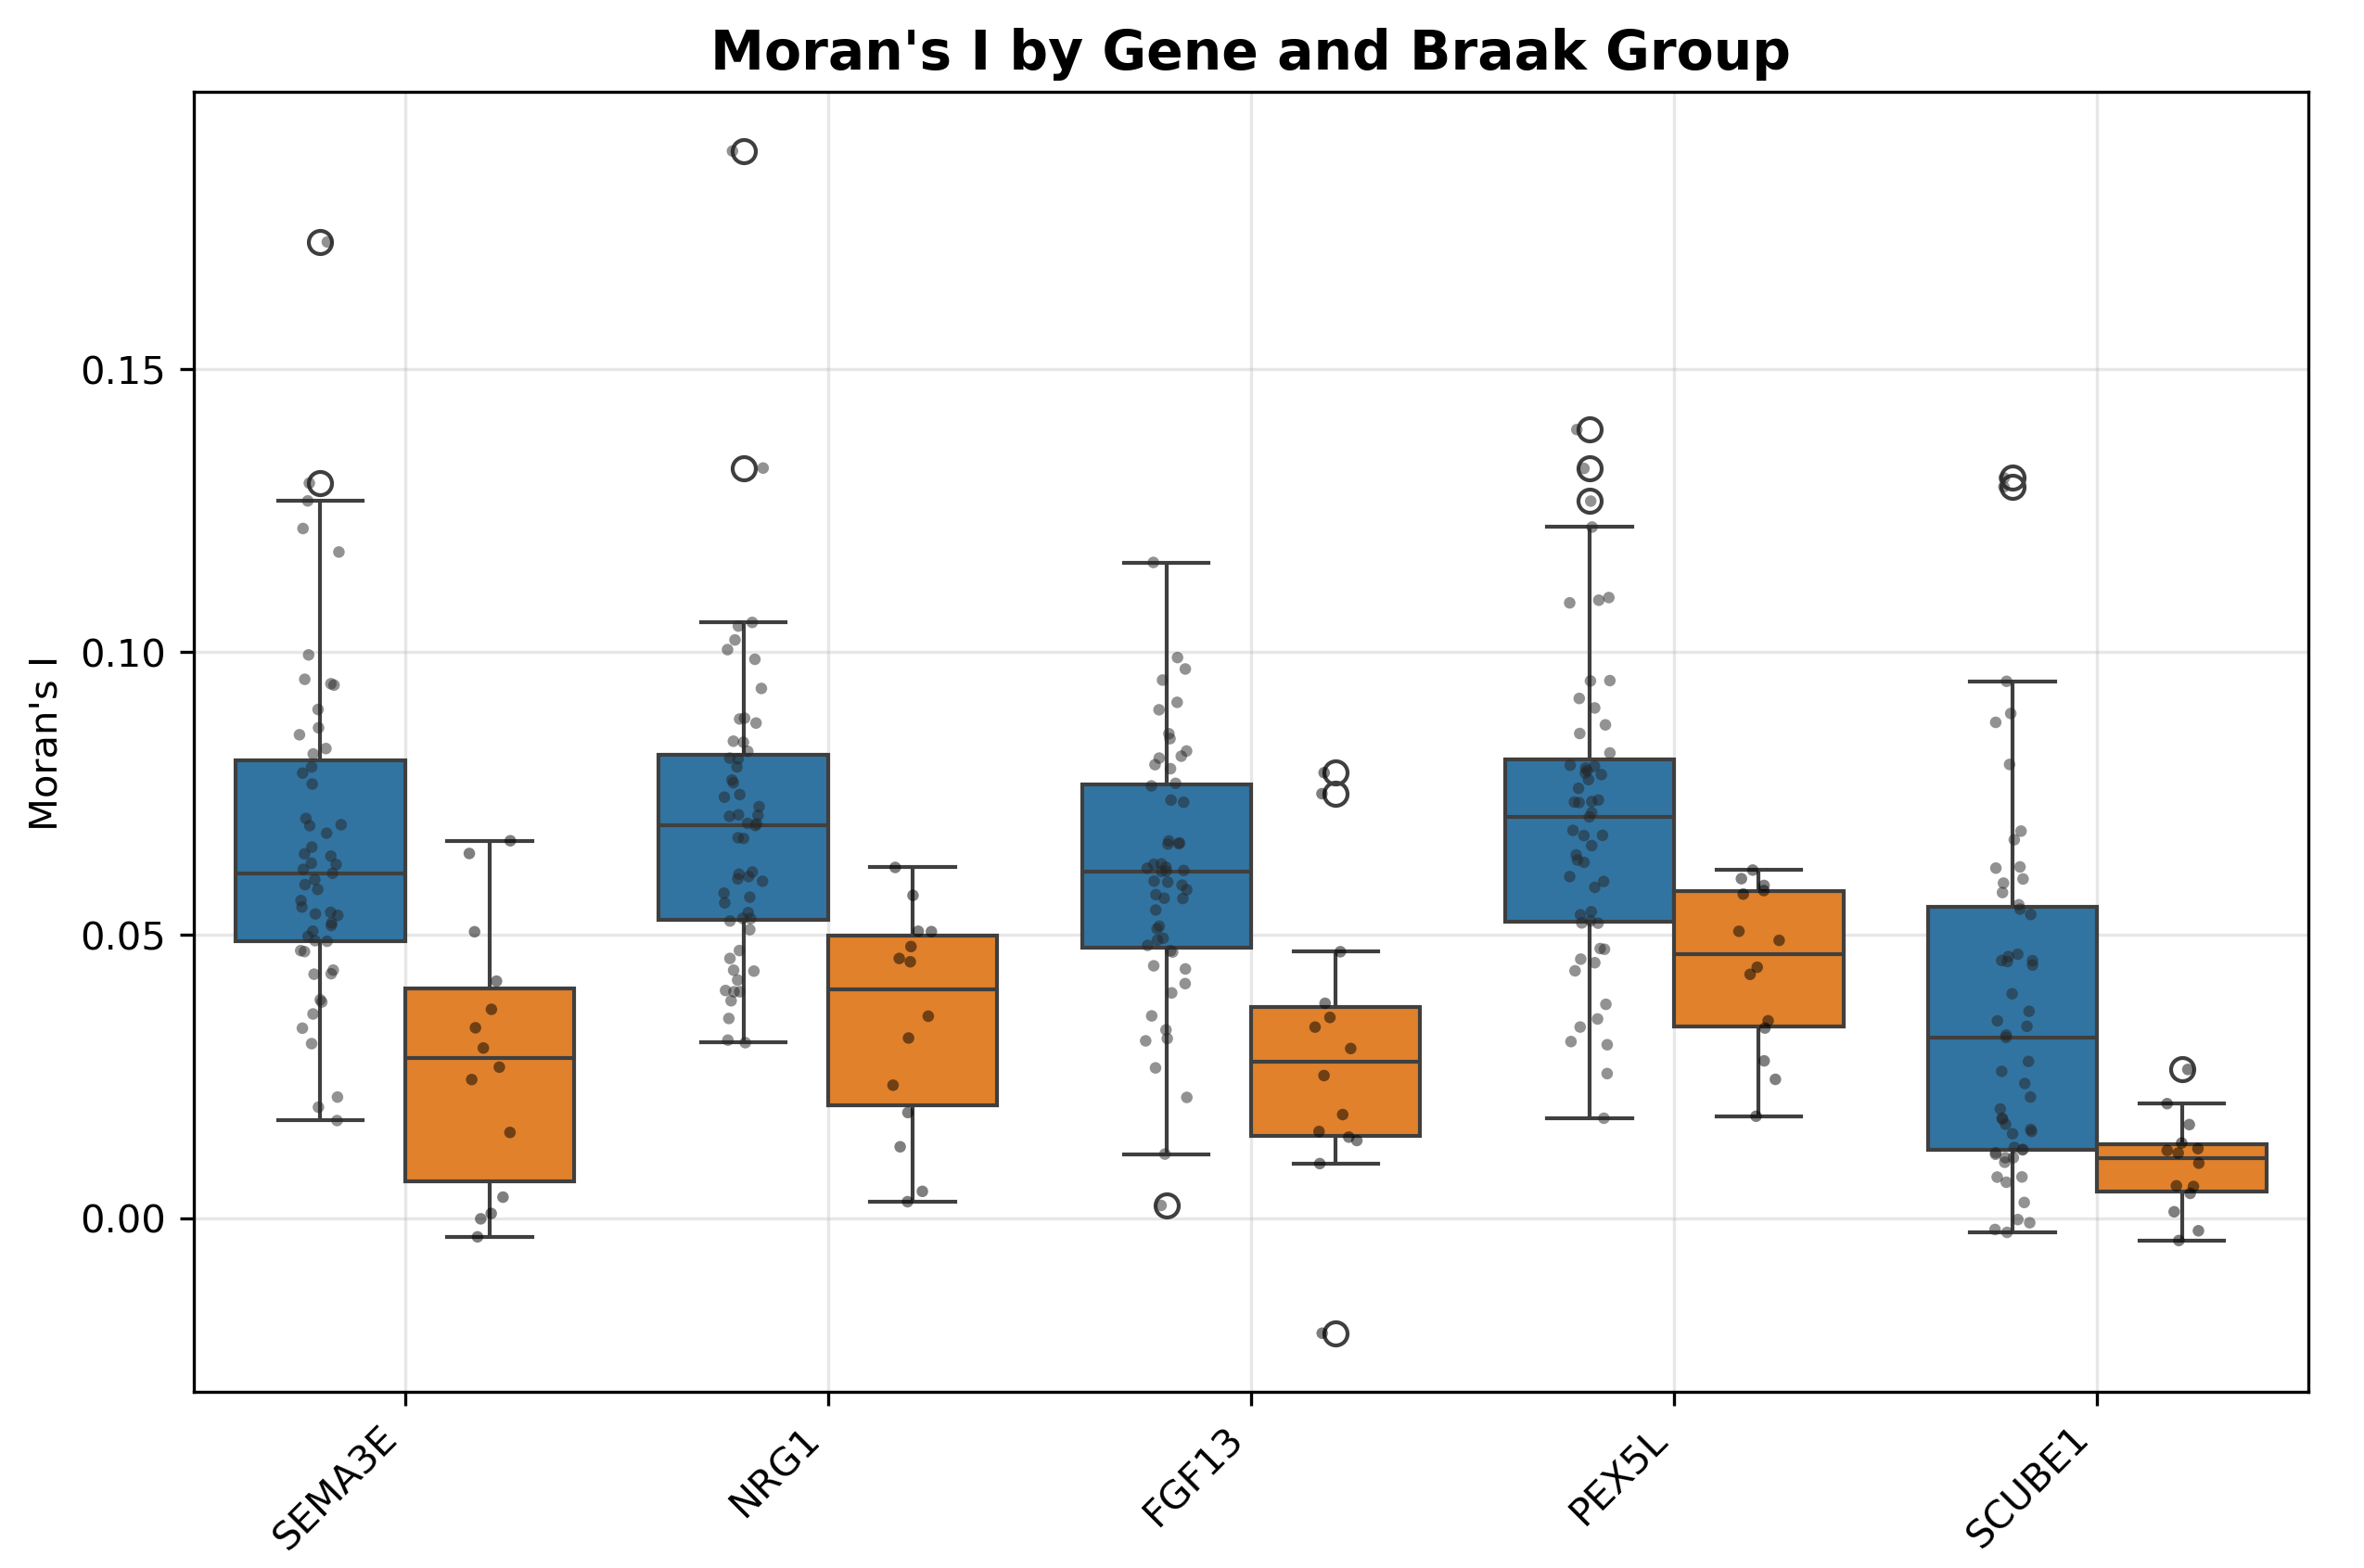
Fig. 8. Boxplots of Moran's I values for the top five significant genes (SEMA3E, NRG1, FGF13, PEX5L, SCUBE1). All five genes show consistently higher Moran's I in the high Braak group (orange) compared to the low Braak group (blue), indicating progressively stronger spatial clustering with AD advancement.

3.3 Discussion

3.3.1 Overview of findings
This study performed secondary analysis of the SEA-AD MERFISH dataset to characterize how the spatial organization of gene expression and cell-type co-localization shifts across AD progression. Two complementary analyses — binary group comparison and continuous Braak-score correlation — converged on a consistent directional finding: selected genes showed increased spatial clustering with advancing pathology. Of the 180 genes examined, 22 reached significance in the group comparison (q < 0.05) and 13 showed progressive correlation with Braak stage. The top five genes by robustness and consistency — NRG1, PEX5L, FGF13, SEMA3E, and SCUBE1 — are connected to synaptic maintenance, axonal organization, cytoskeletal regulation, peroxisomal biology, or vascular/endothelial signaling. However, these associations should be interpreted as spatial transcriptomic signals, not as proof of altered protein abundance or direct causal involvement in AD. The uniformly positive direction of spatial autocorrelation changes suggests that gene clustering may represent localized pathological or compensatory tissue responses during AD progression.

3.3.2 NRG1: Spatial clustering as a readout of synaptic stress
NRG1 (Neuregulin-1) showed a strong and progressive increase in spatial clustering across Braak stages. NRG1 signaling has been linked to synaptic function and neuronal support, and synaptic dysfunction is one of the earliest and most clinically relevant features of AD [4,15,16]. A recent animal-model study also reported memory-enhancing and neuroprotective effects after dopaminergic pathway modulation with apomorphine, supporting the broader relevance of neurotrophic and synaptic signaling pathways to dementia-related cognitive decline [15]. In the present study, the NRG1 result should be interpreted as a spatial mRNA clustering pattern. It may reflect localized synaptic stress or compensatory signaling in affected microenvironments, but it cannot establish NRG1 protein activity or therapeutic relevance without orthogonal validation.

3.3.3 FGF13: Microtubule stability and neuronal resilience
FGF13 has roles in neuronal development, intracellular signaling, and cytoskeletal regulation, and recent reviews describe FGF13 as a non-secreted fibroblast growth factor homologous factor expressed in developing and mature neurons [17]. Its increased spatial clustering may therefore be relevant to localized neuronal stress or cytoskeletal remodeling in AD tissue. Together with NRG1 and SEMA3E, the FGF13 finding suggests that genes involved in circuit organization and neuronal maintenance may become spatially reorganized as pathology advances. This interpretation is deliberately cautious because the present analysis measured mRNA spatial autocorrelation only and did not test microtubule stability or protein localization directly.

3.3.4 SEMA3E: Axon guidance dysregulation in affected circuits
SEMA3E (Semaphorin 3E) showed the largest separation between low and high Braak groups among the top five genes, suggesting that it may be a spatially informative member of the present 180-gene panel. SEMA3E/PlexinD1 signaling has been implicated in entorhino-hippocampal axonal organization and adult hippocampal cytoarchitecture [19]. Recent reviews further support the importance of class 3 semaphorin signaling in central nervous system development, connectivity, and disease-relevant remodeling [20]. Because entorhinal and hippocampal circuits are affected early in AD, increased SEMA3E clustering may indicate localized axon-guidance or circuit-remodeling responses. Nevertheless, this result remains correlative and should not be interpreted as evidence that SEMA3E drives AD pathology without experimental validation.

3.3.5 PEX5L: A novel spatial finding implicating peroxisomal biology
PEX5L (Peroxisomal Biogenesis Factor 5-Like) represents a hypothesis-generating spatial finding. Peroxisomes contribute to lipid metabolism, reactive oxygen species handling, myelin-related biology, and CNS inflammatory responses [21]. Recent literature has linked peroxisome dysfunction to neuroinflammatory and neurodegenerative conditions, including AD and Parkinson’s disease [21]. Curcumin studies in dementia models have also emphasized oxidative-stress and inflammatory pathways as modifiable contributors to cognitive decline [18]. Therefore, the observed PEX5L spatial clustering may be compatible with localized oxidative or inflammatory microenvironments, but the current analysis cannot distinguish protective compensation from pathological dysfunction. Protein-level validation and co-localization with oxidative-stress, glial, or vascular markers will be necessary.

3.3.6 SCUBE1 and cell-type spatial reorganization
The cell-type findings were more selective than the gene-level results. Increased L6b self-enrichment and increased oligodendrocyte–L4 intratelencephalic neuron co-occurrence suggest that a subset of cortical cell relationships is reorganized as pathology advances. SCUBE1 may provide a possible vascular or endothelial context because SCUBE1 has been described as a platelet/endothelial-associated glycoprotein linked to vascular biology, endothelial function, inflammation, and platelet activation [23]. However, the present MERFISH analysis does not demonstrate vascular injury or endothelial activation directly. The SCUBE1 result is best interpreted as a spatial transcriptomic observation that warrants follow-up with vascular markers, protein-level staining, and additional brain regions.

3.3.7 Limitations
Several limitations should be acknowledged. First, this was a secondary analysis of a fixed 180-gene MERFISH panel from the SEA-AD dataset, so the analysis could not evaluate genome-wide spatial transcriptomic changes. Second, the tissue sections came from the middle temporal gyrus only; therefore, the findings may not generalize to hippocampus, entorhinal cortex, frontal cortex, or other regions affected at different stages of AD. Third, mRNA spatial clustering does not necessarily correspond to protein abundance, protein localization, or pathway activity. No immunohistochemistry, proteomics, in situ hybridization replication, or biochemical validation was performed in this study. Fourth, donor-level heterogeneity, section-to-section variability, comorbid pathology, postmortem interval, and technical imaging factors may influence spatial metrics. Fifth, the cross-sectional design supports association with Braak stage but cannot prove longitudinal progression or causality. Finally, the links to dopaminergic dysfunction, oxidative stress, peroxisomal biology, and vascular activation are mechanistic interpretations supported by literature [15,18,21–24], but they remain hypotheses that require experimental testing.

3.3.8 Future directions
Future work should validate the five candidate genes using independent cohorts, additional brain regions, and orthogonal spatial methods such as RNAscope, immunofluorescence, or multiplexed protein imaging. The most important next step is to determine whether increased Moran’s I for NRG1, FGF13, SEMA3E, PEX5L, and SCUBE1 corresponds to protein-level spatial changes and whether these patterns co-localize with tau pathology, amyloid plaques, activated glia, vascular markers, or oxidative-stress markers. Cross-disease comparisons may also be useful because dopaminergic dysfunction and progressive cognitive impairment are relevant to Parkinson’s dementia models as well as AD [24].

4. CONCLUSION
In summary, this study identifies spatial autocorrelation as a quantitative and informative dimension of gene-expression change in AD that complements conventional differential-expression approaches. The five genes with the most consistent spatial changes — NRG1, FGF13, SEMA3E, PEX5L, and SCUBE1 — are connected to synaptic function, neuronal cytoskeletal regulation, axonal guidance, peroxisomal biology, and vascular/endothelial signaling. The revised analysis emphasizes that these findings are hypothesis-generating spatial transcriptomic observations rather than validated protein biomarkers or causal mechanisms. The addition of an explicit quantitative spatial-shift framework strengthens the interpretation of the MERFISH results, while the expanded limitations clarify that future validation across additional brain regions and at the protein level is required before diagnostic or mechanistic conclusions can be made.

DATA AVAILABILITY
The data analyzed in this study were obtained from the publicly released Seattle Alzheimer’s Disease Brain Cell Atlas (SEA-AD) MERFISH dataset. Additional analysis files may be made available by the author upon reasonable request, where permitted by the source dataset terms.

Disclaimer (Artificial intelligence)
Author(s) hereby declare that generative AI technologies such as Large Language Models, etc. have been used during the writing or editing of manuscripts. This explanation will include the name, version, model, and source of the generative AI technology and as well as all input prompts provided to the generative AI technology
Details of the AI usage are given below:
1. language-assistance tools have been used during revision.

Abbreviations: AD, Alzheimer’s disease; MERFISH, Multiplexed Error-Robust Fluorescence In Situ Hybridization; MTG, middle temporal gyrus; SEA-AD, Seattle Alzheimer’s Disease Brain Cell Atlas; FDR, false discovery rate.

REFERENCES
1. World Health Organization. (2025). Dementia. WHO fact sheet. Available from: https://www.who.int/news-room/fact-sheets/detail/dementia
2. Alzheimer’s Disease International. (2024). World Alzheimer Report 2024: Global changes in attitudes to dementia. Alzheimer’s Disease International. Available from: https://www.alzint.org/resource/world-alzheimer-report-2024/
3. Yiannopoulou, K. G., & Papageorgiou, S. G. (2020). Current and future treatments in Alzheimer disease: An update. Journal of Central Nervous System Disease, 12, 1179573520907397. https://doi.org/10.1177/1179573520907397
4. Busche, M. A., & Hyman, B. T. (2020). Synergy between amyloid-beta and tau in Alzheimer’s disease. Nature Neuroscience, 23, 1183-1193. https://doi.org/10.1038/s41593-020-0687-6
5. Braak, H., & Braak, E. (1991). Neuropathological stageing of Alzheimer-related changes. Acta Neuropathologica, 82(4), 239-259. https://doi.org/10.1007/BF00308809
6. Zhang, J., et al. (2024). Recent advances in Alzheimer’s disease: Mechanisms, clinical trials and new drug development strategies. Signal Transduction and Targeted Therapy, 9, 211. https://doi.org/10.1038/s41392-024-01911-3
7. Kumar, S., et al. (2022). Extracellular matrix signature identifies Alzheimer’s disease subtype associated with vascular injury. Nature Neuroscience, 25, 939-950. https://doi.org/10.1038/s41593-022-01095-5
8. Chen, J., Wang, Y., & Ko, J. (2023). Single-cell and spatially resolved omics: Advances and limitations. Journal of Pharmaceutical Analysis, 13(8), 833-835. https://doi.org/10.1016/j.jpha.2023.07.002
9. Siletti, K., et al. (2023). Transcriptomic diversity of cell types across the adult human brain. Science, 382, eadd7046. https://doi.org/10.1126/science.add7046
10. Chen, K. H., Boettiger, A. N., Moffitt, J. R., Wang, S., & Zhuang, X. (2015). Spatially resolved, highly multiplexed RNA profiling in single cells. Science, 348, aaa6090. https://doi.org/10.1126/science.aaa6090
11. Gabitto, M. I., et al. (2024). Integrated multimodal cell atlas of Alzheimer’s disease. Nature Neuroscience, 27, 2366-2383. https://doi.org/10.1038/s41593-024-01774-5
12. Palla, G., Spitzer, H., Klein, M., Fischer, D., Schaar, A. C., Kuemmerle, L. B., et al. (2022). Squidpy: A scalable framework for spatial omics analysis. Nature Methods, 19, 171-178. https://doi.org/10.1038/s41592-021-01358-2
13. Virtanen, P., et al. (2020). SciPy 1.0: Fundamental algorithms for scientific computing in Python. Nature Methods, 17, 261-272. https://doi.org/10.1038/s41592-019-0686-2
14. The pandas development team. (2020). pandas-dev/pandas: pandas. Zenodo. https://doi.org/10.5281/zenodo.3509134
15. Ikram, H., Zakir, R., & Haleem, D. J. (2024). Memory enhancing and neuroprotective effects of apomorphine in a rat model of dementia. Metabolic Brain Disease, 39(6), 1051-1063. https://doi.org/10.1007/s11011-024-01345-8
16. Gunther, E. C., et al. (2022). NRG1 as a biomarker for synaptic dysfunction in Alzheimer’s disease. Alzheimer’s Research & Therapy, 14, 130. https://doi.org/10.1186/s13195-022-01014-7
17. Rivas, L. J., & Uribe, R. A. (2024). Fibroblast Growth Factor (FGF) 13. Differentiation, 140, 100814. https://doi.org/10.1016/j.diff.2024.100814
18. Ikram, H., Zakir, R., Perveen, S., & Haleem, D. J. (2025). Investigating the neuroprotective effects of curcumin in scopolamine-induced animal model of dementia: A synergistic approach to mitigate cognitive decline. Nutraceutical Research, 4(1), 1-9.
19. Mata, A., Gil, V., Pérez-Clausell, J., Dasilva, M., González-Calixto, M. C., Soriano, E., García-Verdugo, J. M., Sanchez-Vives, M. V., & del Río, J. A. (2018). New functions of Semaphorin 3E and its receptor PlexinD1 during developing and adult hippocampal formation. Scientific Reports, 8, 1381. https://doi.org/10.1038/s41598-018-19794-0
20. Lu, Y. P., et al. (2025). Semaphorin 3s signaling in the central nervous system. Brain Research Bulletin, 2025, article in press. https://doi.org/10.1016/j.brainresbull.2025.111328
21. Roczkowsky, A., Rachubinski, R. A., Hobman, T. C., & Power, C. (2025). Peroxisomes as emerging clinical targets in neuroinflammatory diseases. Frontiers in Molecular Neuroscience, 18, 1642590. https://doi.org/10.3389/fnmol.2025.1642590
22. Houldsworth, A. (2024). Role of oxidative stress in neurodegenerative disorders: A review of reactive oxygen species and prevention by antioxidants. Brain Communications, 6(1), fcad356. https://doi.org/10.1093/braincomms/fcad356
23. Yamak, B. A., et al. (2025). Evaluating SCUBE-1 as predictive biomarker for hypertension-mediated organ damage: A comparative study. Reviews in Cardiovascular Medicine, 26(1), 10. https://doi.org/10.31083/RCM25832
24. Ikram, H., & Haleem, D. J. (2019). Repeated treatment with a low dose of reserpine as a progressive model of Parkinson’s dementia. Pakistan Journal of Pharmaceutical Sciences, 32(2), 555-562.

