Exaggerated Placental Site Mimicking Gestational Trophoblastic Neoplasia: A Multimodality Imaging and Histopathological Case Report

Abstract
Background: Exaggerated placental site (EPS) is a benign, physiologic infiltration of intermediate trophoblasts that can radiologically mimic malignant gestational trophoblastic neoplasia (GTN). Case Presentation: A 38-year-old female presented with suspected abnormal uterine bleeding (AUB) and a working diagnosis of GTN. Multimodality imaging, including ultrasound, magnetic resonance imaging (MRI), and computed tomography (CT), revealed a highly vascular, infiltrative uterine mass. Serum Beta-HCG was elevated. The patient underwent a hysterectomy. Histopathological examination ruled out malignancy, diagnosing products of conception with an exaggerated placental site. Discussion and Conclusion: Exaggerated Placental Site (EPS)—a benign, self-limiting physiological reaction—can perfectly mimic malignant Gestational Trophoblastic Neoplasia (GTN) both clinically and on advanced radiological imaging. By detailing a case where MRI and CT scans falsely flagged a uterine mass as an aggressive malignancy due to its deep myometrial infiltration and robust vascularity, the authors underscore the limitations of relying solely on radiological evaluations. Ultimately, this report reinforces that histopathological examination is strictly required to definitively differentiate EPS from true neoplasms, which is a critical step to prevent misdiagnosis and protect patients from receiving unnecessary oncological treatments like systemic chemotherapy.
Keywords: Exaggerated placental site, Gestational Trophoblastic Neoplasia, Histopathology, uterine mass

Introduction
Gestational trophoblastic disease (GTD) encompasses a heterogeneous group of pregnancy-related disorders, spanning a continuum from benign entities to malignant forms collectively termed gestational trophoblastic neoplasia (GTN), including choriocarcinoma and placental site trophoblastic tumour. Within this spectrum, an exaggerated placental site (EPS) represents a benign, non-neoplastic lesion characterised by an increased and diffuse infiltration of intermediate trophoblastic cells into the myometrium.
Despite its benign nature, EPS may present a significant diagnostic challenge. Its infiltrative growth pattern, coupled with prominent vascularity, can closely resemble malignant trophoblastic processes on radiological imaging modalities such as magnetic resonance imaging (MRI) and computed tomography (CT). This overlap in imaging features often leads to a presumptive diagnosis of GTN.
In this report, we describe a case of EPS that closely simulated GTN on both MRI and CT imaging. The case underscores the importance of careful histopathological evaluation and clinicoradiological correlation to establish an accurate diagnosis and to avoid unnecessary aggressive therapeutic interventions.

Case Presentation
Patient Information and Clinical Findings
A 38-year-old female patient presented for clinical evaluation under the care of her referring physician for suspected abnormal uterine bleeding (AUB), with a clinical question of Gestational Trophoblastic Neoplasia (GTN).
Laboratory analysis revealed a serum Beta-HCG level of 1870.00 mIU/ml corresponds to 6 weeks of gestation.

Radiological Evaluation The patient underwent a comprehensive imaging workup:

- Ultrasonography (USG):
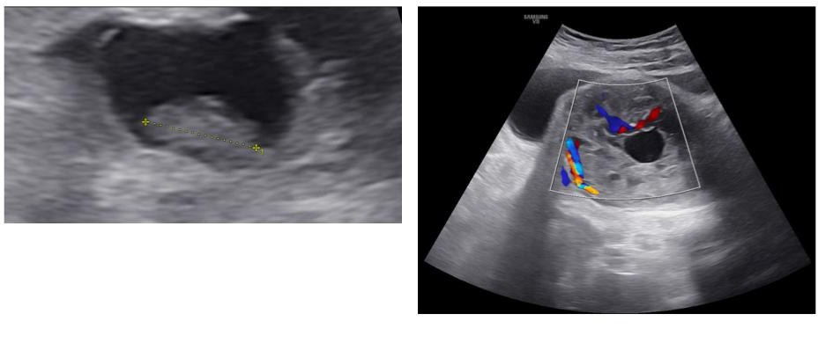

FIG 1: A transvaginal fetal viability scan revealed a single intrauterine gestational sac containing an embryo with a
crown-rump length (CRL) of 0.97 cm, corresponding to a gestational age of 7 weeks and 1 day. No fetal cardiac
activity was detected, leading to a diagnosis of a missed abortion. Additionally, a large fundal fibroid measuring
7.8 x 7.6 x 5.7 cm was noted.

- Magnetic Resonance Imaging (MRI): .

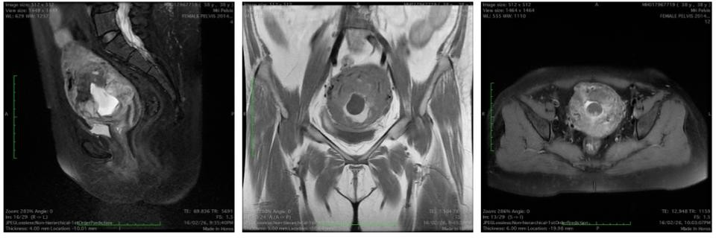

FIG 2: Contrast-enhanced MRI of the pelvis demonstrated a bulky uterus measuring 13 cm. A large, ill-marginated lesion measuring
64 x 75 x 67 mm was identified in the anterior junctional zone and myometrium, extending to the serosal surface and
underlying endometrium. The lesion was T1-hypointense and T2-heterogeneously hyperintense. Key findings suspicious for
malignancy included multiple T1-hyperintense areas indicative of intralesional hemorrhage, multiple peripheral flow voids
signifying a highly vascular lesion, and intense heterogeneous post-contrast enhancement. The radiological impression was
strongly suggestive of gestational trophoblastic neoplasia

- Computed Tomography (CT):

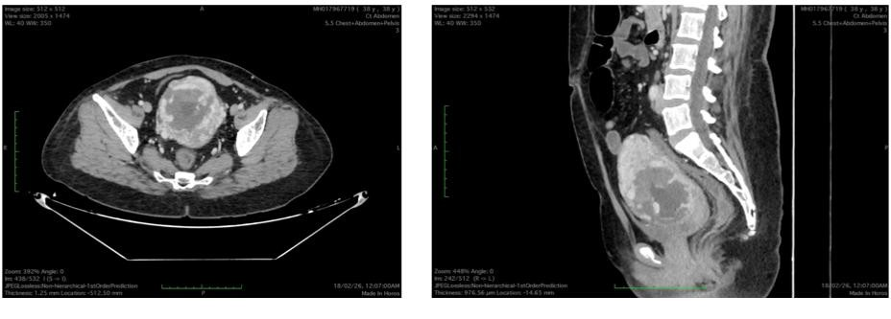

FIG 3: Contrast-enhanced CT of the abdomen and pelvis confirmed a bulky uterus with diffuse increased myometrial vascularity and
a widened endometrial canal. An ill-defined, heterogeneous, hypodense focus showing avid, predominantly peripheral
enhancement was seen involving the entire thickness of the anterior myometrium and extending into the posterior
myometrium.

Surgical and Pathological Findings Given the highly suspicious clinical and radiological profile, a hysterectomy was performed.

- Macroscopic Examination: The surgical specimen consisted of the uterus, cervix, and bilateral fallopian tubes. The endometrial cavity contained a tan-brown, clotted, fungating mass measuring 12.0 x 7.0 x 4.0 cm. This infarcted mass visibly infiltrated both the endometrium and myometrium, but did not invade the serosa.
- Microscopic Examination: Sections from the uterine wall and mass revealed a hemorrhagic infarct, fibrin, and enmeshed, degenerated chorionic villi. Crucially, there was extensive infiltration of intermediate trophoblasts into the endometrium and myometrium, accompanied by decidualisation and the presence of syncytiotrophoblasts. No hydropic villi were identified, ruling out a molar pregnancy. The cervix was free of trophoblastic reaction. An incidental paratubal cyst was found in one fallopian tube.
- Final Diagnosis: The histopathology definitively concluded the lesion was products of conception with an exaggerated placental site.

Discussion
This case illustrates the profound diagnostic dilemma presented by an exaggerated placental site. Radiologically, the lesion exhibited hallmark signs of an aggressive, malignant process: deep myometrial infiltration extending to the serosa, significant intralesional hemorrhage, prominent flow voids, and intense, heterogeneous enhancement. Consequently, both the MRI and CT scans flagged the mass as highly suspicious for GTN.

However, imaging alone cannot reliably distinguish the physiologic trophoblastic invasion of an EPS from the destructive, neoplastic invasion of GTN . The definitive diagnosis relies entirely on microscopic examination. Pathologically, the presence of enmeshed chorionic villi

mixed with the infiltrating trophoblasts—without the confluent, destructive sheets of cells seen in choriocarcinoma or placental site trophoblastic tumors—confirmed the benign nature of the lesion .

Overview of Exaggerated Placental Site (EPS)
An Exaggerated Placental Site (EPS) is a rare, benign, and non-neoplastic condition characterized by an exuberant physiological reaction where extravillous intermediate trophoblasts excessively infiltrate the underlying endometrium and myometrium at the site of implantation. It can occur following a normal pregnancy, spontaneous miscarriage, ectopic pregnancy, or molar pregnancy. Unlike true neoplasms, EPS is generally self-limiting and does not possess malignant features such as local organ destruction or distant metastasis.

How EPS Mimics GTN: Clinical and Radiological Aspects
The primary diagnostic dilemma with EPS is its striking clinical and radiological resemblance to malignant gestational trophoblastic neoplasms.

Clinical Mimicry: Patients with EPS often present with symptoms highly suspicious for GTN, including persistent abnormal uterine bleeding (AUB), postpartum hemorrhage, and persistently detectable, slowly rising, or plateauing serum beta-hCG levels. This can falsely suggest a chemoresistant trophoblastic tumor, sometimes leading to unnecessary systemic chemotherapy. EPS can even cause severe complications like uterine perforation and hemoperitoneum due to thinning of the uterine wall from deep trophoblastic invasion.

Radiological Mimicry: Because EPS involves deep infiltration of tissues and blood vessels to establish fetomaternal circulation, imaging studies often flag it as an invasive malignancy.

  - Ultrasonography: EPS can present as a thickened endometrium with a fleshy mass and localized areas of highly increased vascularity on Doppler imaging.
  - MRI and CT Scans: On advanced imaging, EPS mimics the destructive invasion seen in GTN. It can present as a bulky uterus with a highly vascular, extensively infiltrating lesion that involves the lower uterine segment, cervix, or deep myometrium.
  - Connection to previous case: As seen in this case discussed earlier, the deep myometrial involvement, prominent peripheral flow voids (hypervascularity), and intralesional hemorrhage on MRI and CT perfectly mirror the aggressive hallmarks of invasive moles or choriocarcinomas, leading radiologists to strongly suspect GTN.

Histological Aspects: The Definitive Differentiator
Because imaging cannot reliably differentiate the benign infiltration of EPS from the destructive invasion of GTN, the diagnosis is fundamentally histological.

Microscopic Features of EPS:

  - Infiltration without Destruction: EPS features extensive infiltration by mononuclear and multinucleated intermediate trophoblastic cells into the myometrium, separating smooth muscle fibers and engulfing endometrial glands and spiral arteries. Crucially,

despite this massive infiltration, the overall architecture of the placental site remains undisturbed.
  - Absence of Malignant Markers: The hallmark of EPS is the complete absence of mitotic activity and tissue necrosis.
  - Presence of Villi: Chorionic villi are often present or enmeshed within the tissue, further supporting a benign diagnosis.

Immunohistochemistry: Trophoblastic cells in EPS maintain the profile of normal implantation site cells. They are strongly positive for Mel-Cam, human placental lactogen (HPL), and propyl 4-hydroxylase. The most critical marker for differentiating EPS from malignancy is the Ki-67 labeling index, which is near zero in EPS.

Other differential Diagnoses
Placental Site Trophoblastic Tumor (PSTT): PSTT is the most important and challenging differential diagnosis because, like EPS, it arises from intermediate trophoblasts at the implantation site. However, PSTT is a true neoplasm with metastatic potential.

  - Differentiating Factors: While EPS lacks necrosis and mitosis, PSTT exhibits significant mitotic activity, tissue necrosis, and a much higher Ki-67 labeling index (approximately 14%).

Invasive Mole: An invasive mole presents as a complex vascular mass but is characterized by the loss of the endometrial-myometrial interface due to destructive tumor invasion into the myometrium. Unlike EPS, it typically involves hydropic (swollen) villi and is a direct progression from a molar pregnancy.

Choriocarcinoma: This is a highly malignant, solid, hypervascular tumor that can present with distant metastasis and very high beta-hCG levels. Choriocarcinoma displays confluent, destructive growth patterns with extensive necrosis and hemorrhage, easily distinguishable from the architecturally preserved cellular infiltration of EPS.

Placental Site Nodule (PSN) & Epithelioid Trophoblastic Tumor (ETT): While these also arise from intermediate trophoblasts, they differentiate from the cells of the chorionic
leave (the outer membrane), whereas EPS and PSTT arise from the implantation site. PSN is benign, but 10-15% of cases can coexist with or develop into PSTT or ETT, which have malignant potential.

Conclusion
Exaggerated placental site is a benign entity that can perfectly mimic gestational trophoblastic neoplasia both clinically and radiologically. While imaging techniques like MRI and CT are invaluable for assessing the vascularity and extent of myometrial involvement, histopathological examination is strictly required to prevent misdiagnosis and avoid unnecessary oncological treatments for a benign, self-limiting condition

Consent
Written informed consent was obtained from the patient for the publication of this case report and any accompanying images.

Ethical approval
The publication of this case report was reviewed and approved by the Institutional Ethics Committee (IEC) of Manipal Hospital, Bhubaneswar.

Disclaimer (Artificial intelligence)
Author(s) hereby declare that NO generative AI technologies such as Large Language Models (ChatGPT, COPILOT, etc.) and text-to-image generators have been used during the writing or editing of this manuscript.

References
  - Wijesinghe, R. D. (2025). A Rare Case of Exaggerated Placental Site Reaction. Cureus, 17(8): e90139.
  - Kadian, N. D., et al. (2015). Exaggerated Placental Site: A Cause of Postpartum Collapse? Journal of South Asian Federation of Obstetrics and Gynaecology, 7(3): 148-151.
  - Jayakrishnan, N., & Jayakrishnan, K. (2016). A placental dilemma: exaggerated placental site tumour. International Journal of Reproduction, Contraception, Obstetrics and Gynecology, 5(7): 2425-2427.
  - Nigam S, Dass R. Exaggerated placental site reaction mimicking choriocarcinoma. Acta Obstet Gynecol Scand. 2003; 82:587-8.
  - Menczer J, Livoff A, Malinger G, Girtler O, Zakut H. Exaggerated placental site erroneously diagnosed as non-metastatic trophoblastic disease: a case report. Eur J Gynecol Oncol. 1999; 20(2):115-116.
  - Collins RJ, Ngan HY, Wong LC. Placental site trophoblastic tumor: with features between an exaggerated placental site reaction and a placental site trophoblastic tumor. Int J Gynecol Pathol. 1990; 9(2):170-177.
  - Chen, Z., & Shuai, H. (2024). A Case of Placental Implantation with Exaggerated Placental Site. Journal of Gynecology and Obstetrics, 12(2), 31-34.
  - Lukinovic, N., Malovrh, E. P., Takac, I., Sobocan, M., & Knez, J.
(2022). Advances in diagnostics and management of gestational trophoblastic disease. Radiology and Oncology, 56, 430-439.
  - Hancock, B. W., & Tidy, J. (2021). Placental site trophoblastic tumour and epithelioid trophoblastic tumour. Best Practice & Research Clinical Obstetrics & Gynaecology, 74, 131-148.
  - Kaur, B. (2021). Pathology of gestational trophoblastic disease (GTD). Best Practice & Research Clinical Obstetrics & Gynaecology, 74, 3-28.
  - Ngan, H. Y., Seckl, M. J., Berkowitz, R. S., et al. (2021). Diagnosis and management of gestational trophoblastic disease: 2021 update. International Journal of Gynecology & Obstetrics, 155, 86-93.
  - Tidy, J., Seckl, M., & Hancock, B. W. (2021). Management of gestational trophoblastic disease. BJOG: An International Journal of Obstetrics & Gynaecology, 128, e1-27.
  - Höhn, A. K., Brambs, C. E., Hiller, G., et al. (2021). 2020 WHO Classification of Female Genital Tumors. Geburtshilfe und Frauenheilkunde, 81(10), 1145-1153.
  - National Comprehensive Cancer Network (NCCN). (2021). NCCN Clinical Practice Guidelines in Oncology: Gestational Trophoblastic Neoplasia (Version 1.2022).

  - Sen, R., Sharma, B., Sheorain, R. K., Prasad, N., Bisht, P., & Dalakoti, S. (2020). Exaggerated Placental Site Reaction Following a Term Pregnancy: A Case Report. Saudi Journal of Pathology and Microbiology, 5(8), 385-387.
  - Yordanov, A., Nikolova, M., Slavchev, S., Kostov, S., & Strashilov, S.
(2020). Exaggerated placental site reaction mimicking a trophoblastic tumor: a case report. Archives of the Balkan Medical Union, 55(1), 163-167.

