Stability analysis on the one-dimensional ODE system based on CPTA model

ABSRTACT
The Concrete-Pictorial-Abstract (CPA) paradigm is a recognised method in educational strategy. This paradigm has been enhanced by integrating "Technology," a crucial element of learning. The research elaborates on the enhanced CPTA model and formulates an Ordinary Differential Equation (ODE) system to comprehend the model mathematically. To analyse the model, we identified the equilibrium solutions or critical points and examined the stability of each equilibrium point. We have constructed the phase line and direction field to augment comprehension of the topic. The analysis is corroborated by numerical simulations, justifying the incorporation of technology into the existing model to achieve more accurate findings. This paper's findings mathematically demonstrate that technology catalyses learners, facilitating their progression from concrete to abstract levels more rapidly.

KEYWORDS: CPTA model, CPA model, Local stability, Bifurcation analysis, Ordinary differential equation.

INTRODUCTION:
Mathematics is a subject which is completely based on concepts ^{[1]}. If you learn mathematics without understanding concepts, it will be a burden for you and over a period of time, you try to avoid it. Hence, in order to teach or learn mathematics in a better way, you should link the actions of the students to the conceptual understanding.

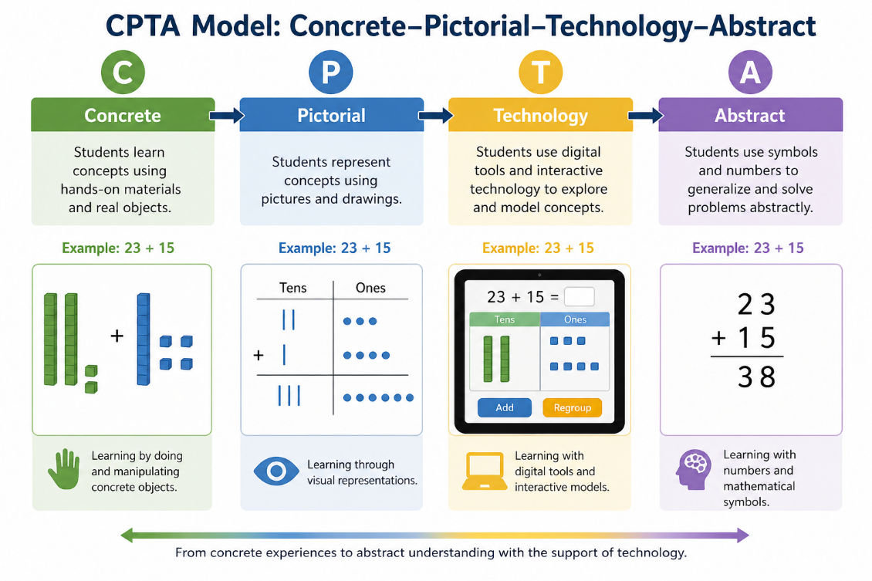

Figure 1: CPTA model

We have observed that a lot of papers are there on Concrete–Pictorial–Abstract approach of learning ^{[2-8]}, however, the enhanced use of technology, ICT and AI in education demands some modification in this approach, therefore, the proposed Concrete–Pictorial–Technological–Abstract (CPTA) model is a natural generalization of the classical Concrete–Pictorial–Abstract (CPA) framework. While the CPA model (see Figure 1) describes learning as a progression from concrete experiences to pictorial representation and finally to abstract reasoning, it does not explicitly account for the growing role of technology in modern education. To address this limitation, we extend the CPA structure by incorporating a technological stage, which captures the use of digital tools, simulations, and interactive platforms in the learning process. This additional stage serves as an intermediate facilitator that enhances visualisation and conceptual understanding, thereby accelerating the transition toward abstraction. Hence, the CPTA model provides a more comprehensive and realistic representation of contemporary learning dynamics.

Mathematical modelling can be a powerful tool to understand any model in a precise, mathematical and logical way ^{[9-15]}. Following this, we have proposed a model on CPTA approach by using a one-dimensional differential equation; thereafter, we have found the stability of the equilibrium points. We elaborated the model in the discussion part, which shows that our findings are relevant to the educational approach of teaching.

This model is significant for the scientific community as it presents an innovative mathematical framework for examining learning progression using the generalised Concrete–Pictorial–Technological–Abstract (CPTA) approach. This study actually enhances the standard CPA model by incorporating the influence of technology, so offering a more accurate depiction of contemporary educational systems and digital learning settings. The suggested nonlinear dynamical model provides theoretical insight into the shift of learners from concrete understanding to abstract reasoning and illustrates the impact of technological help on cognitive growth. Most importantly, this manuscript creates a connection between educational theory and mathematical modelling, so facilitating new avenues for interdisciplinary study in applied mathematics, educational technology, and learning sciences.

In the next section, we have formulated the model taking x(t) as the cognitive maturity score, which will change with time. We have also provided a table and given its interpretation in terms of cognitive score. The local stability using linearization has been executed in the next subsection here. After that, we have provided the numerical simulations using the MATHEMATICA software. This paper ends with a realistic discussion. In the last discussion section, we have provided some relevant limitations of the proposed ODE model.

MODEL FORMULATION

We assume that x(t) is the average cognitive maturity score, then we categorize this score as shown in Table 1.

Table 1: CMC and its interpretation
S. No. | Cognitive maturity score (CMC) | Interpretation
1 | x=0 | Purely concrete learning
2 | 0<x<a | Mostly concrete
3 | x=a | Concrete + Pictorial (Transition phase)
4 | a<x<1 | Developing abstract understanding
5 | x=1 | Fully Abstract understanding

Based on above criteria, we can give the 1D ODE model as follows
$$\frac{dx}{dt}=rx\left(1-x\right)\left(x-\left(a_{0}-kT\right)\right)=f(x)$$
where x(0) is the initial cognitive maturity score (CMC).

Stability analysis

In order to find out its equilibrium Solutions, we need to put derivative equal to zero, that is,
$$\begin{matrix} \frac{dx}{dt}=0 \\ rx(1-x)\left(x-\left(a_{0}-kT\right)\right)=0\end{matrix}$$
Here, we get three equilibrium solutions, namely
$$\begin{matrix} & x_{1}=0 \\ & x_{2}=1 \\ & x_{3}=a_{0}-kT\end{matrix}$$
We can also visualize these three equilibrium points by plotting the function f(x) in Figure 2.

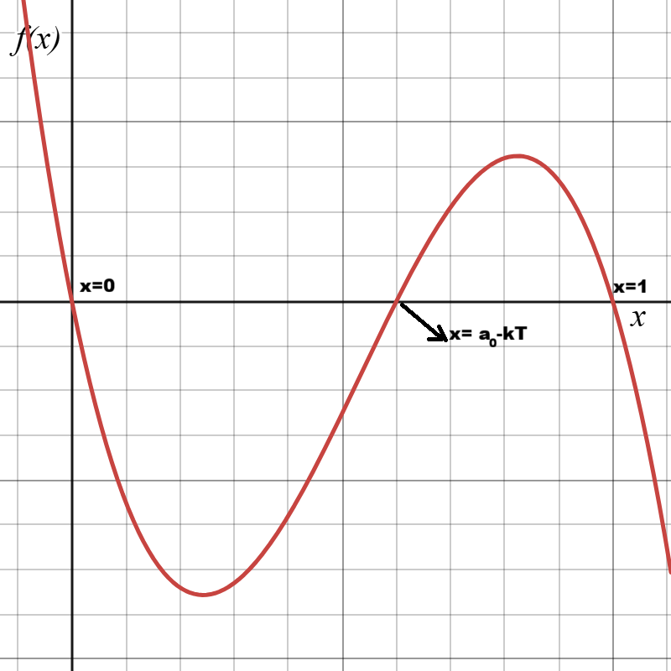

Figure 2: ‘x’ versus ‘f(x)’ graph
If we see the third equilibrium then we notice that more will be the value of $T$, lesser will be the value of $x_{3}$.

A graph between $x_{3}$ and $T$ is shown in the Figure 3 (for various $a_{0}$ values).
This is known as technology shift transition level. This means that learners can shift to the next Stage quite easily, thereby, due to this technology factor, more learners can cross into abstract thinking stage.
To find out stability, we rewrite the equation once again
$$\begin{matrix}\frac{dx}{dt} & =rx(1-x)\left(x-\left(a_{0}-kT\right)\right) \\ & =f(x) \text{ (say) }\end{matrix}$$
In order to determine the stability, we need to find derivative of $f(x)$, that is,

$$\begin{matrix}f^{'}(x)= & r(1-x)\left(x-\left(a_{0}-kT\right)\right) \\ & -rx\left(x-\left(a_{0}-kT\right)\right) \\ & +rx(1-x)\end{matrix}$$
At $x_{1}=0$, we get
$$f^{'}\left(x_{1}\right)=-r\left(a_{0}-kT\right)<0$$

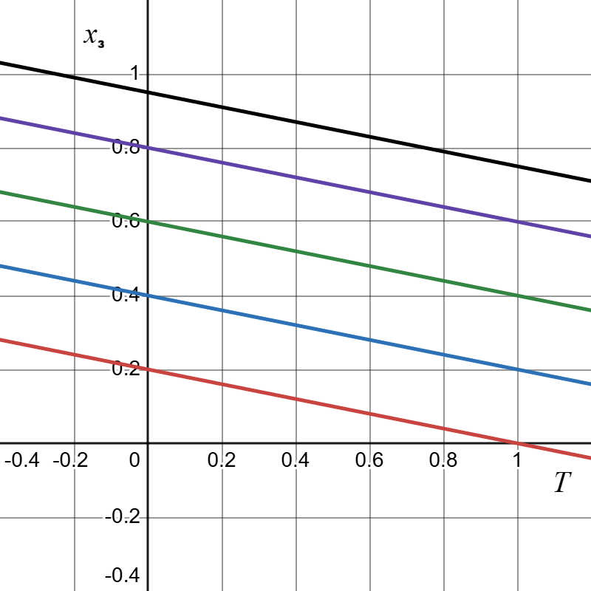

Figure 3: x₃ versus T graph

Hence $x_{1}=0$ is stable provided $a_{0}>kT$. However, if $T$ is quite high then the $x_{1}=0$ is unstable.
At $x_{2}=1$
$${ f}^{'}\left(x_{2}\right)=-r\left(1-\left(a_{0}-kT\right)\right)<0.$$
Hence, $x_{2}=1$ is stable equilibrium point.
At $x_{3}=\left(a_{0}-kT\right)>0$, we get
$$\begin{matrix}f^{'}\left(x_{3}\right) & =γ\left(a_{0}-kT\right)\left(1-\left(a_{0}-kT\right)\right) \\ & >0\end{matrix}$$
because $1>\left(a_{0}-kT\right)$ as $a_{0}-kT$ is the level lies between 0 and 1 explicitly. Hence $x_{3}=\left(a_{0}-kT\right)$ is unstable. Hence, we categorize the points as shown in Table 2
Table 2: EP and its stability
S. No. | EP | Stability
1 | $x_{1}=0$ | Stable
2 | $x_{2}=1$ | Stable
3 | $x_{3}=\left(a_{0}-kT\right)$ | Unstable

If we try to plot the phase lines of these steady states, then we get the following phase line as shown in Figure 4.
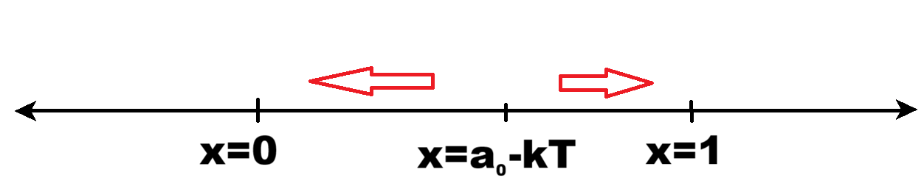

Figure 4: phase line
Solution of the ODE
Let us assume that $a_{0}-kT=A$, then we rewrite the equation as follows
$$\frac{dx}{dt}=rx(1-x)(x-A)$$
To solve it, we separate variables and get
$$\frac{dx}{x(1-x)(x-A)}=rdt$$
We apply partial fractions here
$$\frac{1}{x(1-x)(x-A)}=-\frac{1}{A}\frac{1}{x}+\frac{1}{1-A}\frac{1}{1-x}+\frac{1}{A(1-A)}\frac{1}{x-A}$$
We integrate both sides,
$$-\frac{1}{A}ln⁡|x|-\frac{1}{1-A}ln⁡|1-x|+\frac{1}{A(1-A)}ln⁡|x-A|=rt+C$$
We multiply both sides by $A(1-A)$
$$-(1-A)ln⁡|x|-Aln⁡|1-x|+ln⁡|x-A|=A(1-A)rt+C$$
Hence, solution is written as follows
$$ln⁡\left|\frac{x-A}{x^{1-A}(1-x)^{A}}\right|=A(1-A)rt+C$$
or we can write
$$\frac{x-A}{x^{1-A}(1-x)^{A}}=Ce^{A(1-A)rt}$$
This is the solution of our ODE model.

Direction field plot diagram

We can plot the phase plane diagram for the proposed model

$$\frac{dx}{dt}=rx\left(1-x\right)\left(x-\left(a_{0}-kT\right)\right)=f(x)$$

which is actually direction field instead. We have plotted the direction field plot in Figure 5. It shows how the trajectory actually tends towards various equilibrium points, which indeed depends on the initial conditions as well.

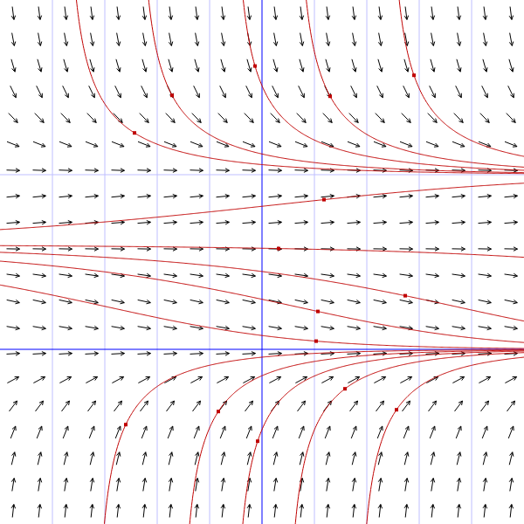

Figure 5: Direction field plot $\dot{x}$ versus t

The scenario, which can be observed in the model, is shown in Table 3.

Table 3: Bifurcation scenario
$$a_{0}<kT$$  (No interior equilibrium in $(0,1)$ )  $$\begin{matrix} & x=0:\text{ unstable } \\ & x=1:\text{ stable }\end{matrix}$$ | $$\begin{matrix}kT<a_{0}<1+kT \\ \left(x_{3}=a_{0}-kT\text{ lies in }(0,1)\right) \\ x=0 :\text{ stable } \\ x=a_{0}-kT :\text{ unstable } \\ x=1 :\text{ stable }\end{matrix}$$ | $$a_{0}>1+kT$$  (No interior equilibrium in $(0,1)$ ) $\begin{matrix} & x=0 :\text{ stable } \\ & x=1 :\text{ stable }\end{matrix}$
Only one bifurcation occurs at $a_{0}=kT$, where the equilibrium $x=a_{0}-kT$ is created at $x=0$.
The equilibrium $x=1$ remains stable for all $a_{0}$.

Based on above table, we can plot bifurcation diagram showing BP, as shown in Figure 6.

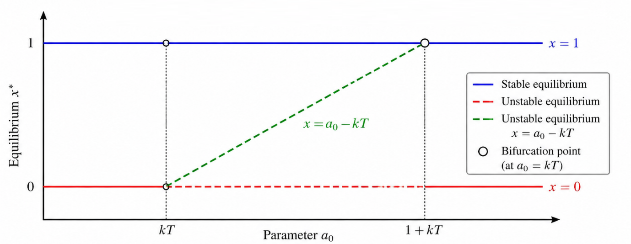

Figure 6: Bifurcation diagram

NUMERICAL SIMULATIONS

Now, we will perform the numerical analysis for the given system. To do so, we take two set of values in which different dynamics is obtaining for each set:

Set 1: We take following values in Set 1 as shown in Table 4.

Table 4: Parameter values of set 1
S. No. | Parameter/Variable initial condition | Value
1 | r | 1
2 | a₀ – k T | 0.3
3 | x(0) | 0.2

In this set, we have plotted the time series and obtained that it is tending towards the zero steady state which is indeed stable equilibrium. Diagram is shown in Figure 7.

Set 2: We take following values in Set 2 as shown in Table 5.

Table 5: Parameter values of set 2
S. No. | Parameter/Variable initial condition | Value
1 | r | 1
2 | a₀ – k T | 0.3
3 | x(0) | 0.5

In this set, we have plotted the time series and obtained that it is tending towards the 1 steady state which is also stable equilibrium. So, depending upon the initial conditions, we get different dynamics here. The time series plots are made by MATHEMATICA software. This scenario is shown in Figure 8.

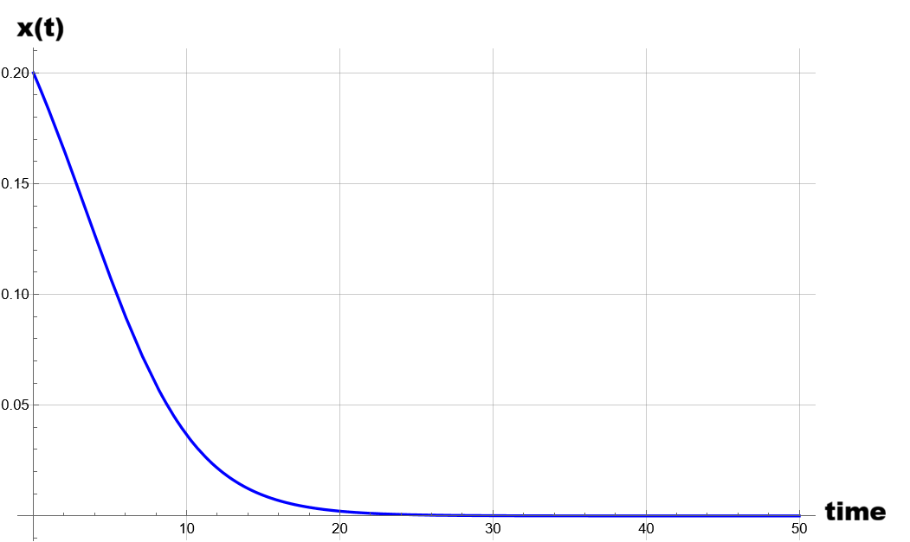
Figure 7: Time plot for x(0) = 0.2

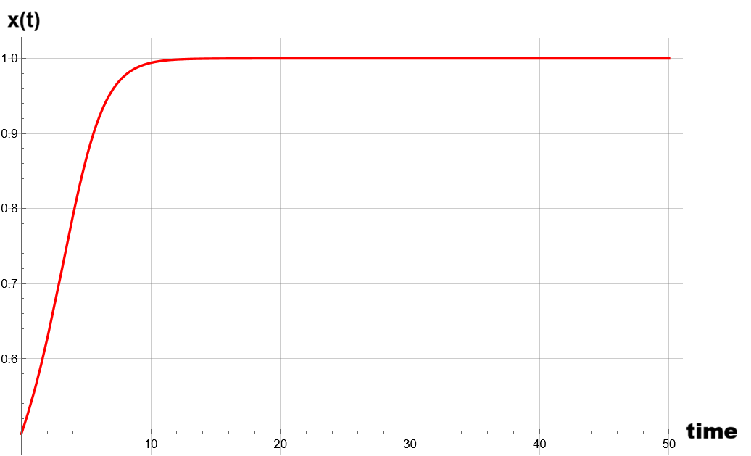
Figure 8: Time plot for x(0) = 0.5

DISCUSSION AND CONCLUSION:
The present study extends the classical Concrete-Pictorial-Abstract (CPA) framework by incorporating technology as an essential intermediate component, leading to the proposed Concrete-Pictorial-Technological-Abstract (CPTA) model. It is not the same as the conventional CPA model, because there is a direct transfer from pictorial to abstract understanding. However, nowadays, the role has changed and understanding can be fasten using digital tools, interactive platforms and online learning. Use of MALL, CSCL, LXP, LCMS etc. is an easier way to learn in a fast manner. Incorporation of technology will permit us for a more realistic and pedagogically relevant representation of cognitive development.
As far as our model is concerned, it is a one-dimensional ordinary differential equation model in which we have taken x(t) is a function of time, representing the average cognitive maturity score. As we perform the analysis of the model, we put x’ equal to zero and get 3 distinct equilibrium points, namely $x=0,x=1$, and $x=a_{0}-kT$. The stability investigation shows that the boundary equilibrium $x=1$, corresponding to complete abstract understanding, remains stable for all parameter values, indicating that the abstract stage is always an attainable and stable end state of learning. The equilibrium $x=0$, representing purely concrete learning, is also stable; however, the twist is in the stability of the third equilibrium point $x=a_{0}-kT.$ It is unstable, but technology is making this equilibrium small, and therefore, using technology, it’s easy to pass this threshold as early as possible; consequently, we can shift towards abstract learning more easily with the help of technology.
A key outcome of the model is the emergence of a single bifurcation at $a_{0}=kT$, as also illustrated in the bifurcation diagram (Figure 6). At this threshold, the interior equilibrium $x=a_{0}-kT$ is generated, which lies within the interval $(0,1)$ for $kT<a_{0}<1+kT$. This equilibrium is always unstable, acting as a transition point that separates different learning regimes. From a pedagogical perspective, this unstable equilibrium represents a critical cognitive threshold between concrete and abstract understanding.
Overall, the most significant contribution of this study lies in interpreting the role of technology parameter $T$. The expression $x_{3}=a_{0}-kT$ clearly indicates that an increase in technology reduces the transition threshold $x_{3}$. In other words, higher technological support lowers the cognitive barrier required for learners to move toward abstract thinking. This aligns with the graphical interpretation shown in the $x_{3}$ versus $T$ plot (Figure 3), where increasing $T$ shifts the transition level downward. Consequently, learners can reach higher levels of understanding more efficiently when supported by appropriate technological tools.
Furthermore, the presence of bistability in the region $kT<a_{0}<1+kT$ suggests that learning outcomes depend not only on system parameters but also on initial conditions. In this regime, both $x=0$ and $x=1$ are stable, implying that learners may either remain at a low cognitive level or progress to full abstraction depending on their initial state and the extent of technological intervention. This highlights the importance of guided instruction and structured use of technology in education.
By and large, the CPTA model is overall perceptive for qualitative as well as quantitative approaches to the learning process. This shows that technology nowadays is quite important, not only as a supportive role but also plays a decisive role in quickening conceptual understanding and enabling the transition to abstract thinking. The model thereby emphasises the well-known fact that adding technology into pedagogical frameworks can significantly enhance learning efficiency and outcomes, making the CPTA model a reasonable, wide-ranging and genuine extension of the traditional CPA approach.
Limitations of the model
The suggested one-dimensional CPTA ODE model offers a simplified mathematical representation of learning process; yet, it possesses numerous limitations. The model consolidates the complete Concrete–Pictorial–Technological–Abstract learning process into a singular state variable, hence precluding the independent analysis of the unique dynamics of each step. The model presumes uniform learners and uniform learning behaviour, although actual educational systems encompass variations in cognitive capacity, motivation, background, and technological access. The transition between learning phases is depicted using deterministic continuous dynamics, but actual learning frequently occurs in discrete increments and may incorporate randomness or external disruptions. Furthermore, technology is integrated solely in an indirect manner via parameters, and its qualitative dimensions, like the nature, efficacy, or accessibility of technical instruments, are not openly represented. The approach excludes external pedagogical elements, like instructor influence, peer interaction, emotional engagement, and socio-economic conditions, all of which can substantially impact learning outcomes. Consequently, the current model is to be regarded as a conceptual and theoretical approximation rather than a comprehensive depiction of actual educational processes.

Abbreviations

CPA : Concrete-Pictorial-Abstract
CPTA : Concrete-Pictorial-Technology-Abstract
ICT : Information and Communication Technology
AI : Artificial Intelligence
EP : Equilibrium point
CMC : Cognitive maturity score
MALL : Mobile-Assisted Language Learning
CSCL : Computer-Supported Collaborative Learning
LXP : Learning Experience Platform
LCMS : Learning Content Management System
BP : Bifurcation point
ODE : Ordinary Differential Equation
1D : One-dimensional

Disclaimer (Artificial intelligence)

Author(s) hereby declare that generative AI technologies such as Large Language Models, etc. have been used during the writing or editing of manuscripts. This explanation will include the name, version, model, and source of the generative AI technology and as well as all input prompts provided to the generative AI technology

Details of the AI usage are given below:

Authors recognize the utilization of artificial intelligence (AI) techniques in the manuscript's preparation to enhance linguistic quality, grammatical precision, clarity of expression, and general readability. The scientific material, mathematical modeling, analysis, interpretations, and findings in this work were exclusively generated and validated by the authors. AI technologies served solely as auxiliary writing and editing aids, without independently influencing the research outcomes or scientific determinations.

REFERENCES:

1. Jäder, J., & Johansson, H. (2025). Exploring students’ conceptual understanding through mathematical problem solving: Students’ use of and shift between different representations of rational numbers. Research in Mathematics Education. 1–18. https://doi.org/10.1080/14794802.2025.2456840.

2. Seto, C., Goh, Y. Y., Teh, W., & Chang, S. H. (2020). Concrete-pictorial-abstract approach: Fostering understanding in mathematics. In Mathematics teaching in Singapore (pp. 35–51). World Scientific. https://doi.org/10.1142/9789811220159_0003.

3. Abrenica, E. (2025). Concrete–pictorial–abstract approach in developing students' understanding of surface area of solids. Psychology and Education: A Multidisciplinary Journal, 47(9), 1071–1075. https://doi.org/10.70838/pemj.470903.

4. Putri, H. E. (2019). Influence of concrete pictorial abstract approach to the improvement of spatial sense ability of elementary school students. Journal of Physics: Conference Series, 1157(4), 042083. https://doi.org/10.1088/1742-6596/1157/4/042083.

5. Iyamuremye, E., & Burns, D. (2025). Concrete-pictorial-abstract instruction: Enhancing students’ learning motivation and achievement in mathematics. Cogent Education, 12(1), Article 2558303. https://doi.org/10.1080/2331186X.2025.2558303.

6. Hoong, L. Y., Kin, H. W., & Pien, C. L. (2015). Concrete-pictorial-abstract: Surveying its origins and charting its future. The Mathematics Educator, 16(1), 1–19.

7. Williams, R. (2018). Developing a consistent concrete, pictorial, abstract approach to the teaching of mathematics in upper key stage two. In F. Curtis (Ed.), Proceedings of the British Society for Research into Learning Mathematics, 38(2).

8. Lee, N. H., & Tan, J. B. L. (2015). The role of virtual manipulatives on the concrete-pictorial-abstract approach in teaching primary mathematics. National Institute of Education, Nanyang Technological University. https://hdl.handle.net/10497/15918.

9. Ejiko, S. O., Ejiko, S. O., & Filani, A. O. (2021). Mathematical modeling: A useful tool for engineering research and practice. International Journal of Mathematics Trends and Technology, 67(9). https://doi.org/10.14445/22315373/IJMTT-V67I9P506.

10. Sible, J. C., & Tyson, J. J. (2007). Mathematical modeling as a tool for investigating cell cycle control networks. Methods, 41(2), 238–247. https://doi.org/10.1016/j.ymeth.2006.08.003.

11. Bajuri, M. R., Siri, Z., & Abdullah, M. N. S. (2022). Mathematical modeling research output impacting new technological development: An axiomatization to build novelty. Axioms, 11(6), 264. https://doi.org/10.3390/axioms11060264.

12. Kaushik, R. (2026). Mathematical epidemic model having two latent stages of exposed individuals. Transactions on Computational Modeling and Intelligent Systems, 3, 10045. https://doi.org/10.65112/tcmis.10045.

13. Siller, H.-S., Kaiser, G., & Geiger, V. (Eds.). (2024). Researching mathematical modelling education in disruptive times. Springer. https://doi.org/10.1007/978-3-031-53322-8.

14. Aris, R. (1994). Mathematical modeling techniques. Dover Publications.

15. Caldwell, J., & Ram, Y. M. (1999). Mathematical modelling: Concepts and case studies. Springer Science+Business Media. https://doi.org/10.1007/978-94-017-2201-8.

