Nanoparticle-Based Drug Delivery for Hemodynamic Disruption in Idealized Aneurysmal Arteries

.
ABSTRACT

Background & Aims: Cardiovascular disease continues to pose a significant global health challenge in modern society. Aneurysmal dilation markedly modifies hemodynamic patterns, potentially leading to thrombus formation and vascular complications. Nanoparticles (NPs) represent potential agents for targeted drug delivery; however, their effects on arterial flow behaviour and hemodynamic parameters necessitate additional research. This study investigates nano-therapeutic transport and its impact on blood flow characteristics in idealized aneurysmal arteries through computational fluid dynamics (CFD).
Study design: A three-dimensional computational model was created for a healthy artery (Case 1) and an aneurysmal artery (Case 2). The aneurysmal artery models featured diameters of 5 mm, 8 mm, and 10 mm to examine the impact of aneurysm size on hemodynamic behavior. Comparative analyses were conducted with and without nanoparticles in pulsatile blood flow conditions.
Methodology: A pulsatile velocity profile was applied at the inlet, with a constant outlet pressure of 16,000 Pa sustained. Blood was characterised as a non-Newtonian fluid through the application of the Carreau–Yasuda model. Computational hemodynamic parameters, such as velocity magnitude, wall shear stress, oscillatory shear index, and relative residence time, were examined with and without the presence of nanoparticles. A detailed computational mesh was utilized to guarantee the numerical stability and accuracy of the simulations.
Results: The healthy artery in Case 1 had a WSS of 11.3543 Pa, while Case 2 with nanoparticles had 10.9176 Pa. As aneurysm diameter increased, WSS decreased in the sac. Due to nanoparticles, the Case 2 WSS distribution was smoother than that of Case 1. The healthy artery and aneurysm diameters of 5 mm, 8 mm, and 10 mm had OSI values of 0.1429 with nanoparticles, while those without nanoparticles were 0.142857, 0.142804, 0.1428571, and 0.1428571. Both patients had moderate to high RRT values, indicating prolonged blood particle occupancy near the aneurysm wall. The results also showed that (1) arteries with nanoparticles had lower velocity, (2) Case 1 without nanoparticles had 3.85% higher WSS than Case 2 with nanoparticles, (3) nanoparticles produced a smoother WSS profile, and (4) prolonged residence time near the aneurysm wall may increase thrombosis risk. Local flow dynamics and hemodynamic indicators were greatly altered by aneurysmal dilatation. Nanoparticles lowered flow velocity and smoothed the WSS curve while marginally altering OSI and RRT. These findings shed light on nanoparticle-assisted medicine delivery in vascular diseases and may improve treatment methods.
Conclusion: The outcomes demonstrate the substantial influence of hemodynamic variables on the progression and remodelling of curved arteries with aneurysms, especially when nanoparticles are present. The results of the research are
- The artery containing nanoparticles (Case 2) demonstrates a reduced velocity in comparison to the artery devoid of nanoparticles (Case 1).
- The Case -1 demonstrates a 3.85% increase in WSS relative to Case -2.
- An inverse relationship exists between aneurysm diameter and velocity in both instances.
- The RRT values in the 10 mm aneurysmal artery exceed those in the healthy artery by 99.90% in both instances.
This indicates a high-risk area, where the extended residence time of blood particles adjacent to the vessel wall may facilitate vascular remodeling.

Keywords: Nanoparticles; Computational Hemodynamics factors; Cardiovascular-disorder; non-Newtonian; Computational fluid dynamics

1. INTRODUCTION

Cardiovascular diseases characterized by aneurysmal dilatation markedly modify blood flow dynamics and elevate the risk of thrombosis and arterial rupture. Nanoparticles have emerged as effective vehicles for targeted drug delivery because to their improved transport and therapeutic efficacy in intricate vascular areas[1]. The researcher showed that in the aneurysmal regions, both the 4.75 mm and 7.75 mm models showed increased WSS with nanoparticles, indicating enhanced near-wall shear effects compared to the non-nanoparticle cases. [2]. Computational fluid dynamics (CFD) offers a robust method for examining blood flow properties and nanoparticle movement in pathological arteries. This study develops a three-dimensional model of an aneurysmal artery to examine the impact of nanoparticles on velocity distribution, wall shear stress (WSS), oscillatory shear index (OSI), and relative residence time (RRT) under pulsatile non-Newtonian blood flow circumstances. Nanoparticles have been identified as promising drug delivery and targeting vehicles because of their unique physicochemical qualities, such as extremely small size, large surface-area-to-volume ratio, and greater capacity to traverse complicated biological settings. In recent years, nanoparticle-assisted therapeutic techniques have attracted great interest in cardiovascular studies, especially for the treatment of vascular diseases such as stenosis and aneurysms. These nanoscale carriers can improve medication absorption, prolong the time they circulate, and deliver therapeutic agents to the sick artery areas while minimizing systemic negative effects. In aneurysmal arteries, where aberrant dilatation greatly affects the blood flow patterns, knowledge of the transport and dispersion of nanoparticles becomes very crucial to optimize the therapeutic efficiency and minimize problems such as thrombosis and rupture. Thus, CFD has become an essential technique to evaluate the migration of the nanoparticles and the hemodynamic behavior in sick arteries.
A number of studies have helped to comprehend the intricate link between artery geometry, blood rheology, and nanoparticle transport. Researchers revealed that proximal stenosis leads to more severe hemodynamic disruptions than distal stenosis, but both generate the same degree of lumen loss. This is owing to higher flow acceleration and enhanced recirculation zones around the restricted region [3]. The results emphasize the importance of lesion location in blood flow interruption and treatment delivery efficiency. Moreover, it has been shown that the size of nanoparticles is an important factor in regulating dispersion properties and drug transport efficiency in vascular systems. Smaller nanoparticles are usually more penetrative and diffusive but larger particles may suffer more inertial effects and different residence periods in aneurysmal sacs.
The effect of Brownian motion on the transport of nanoparticles has also been studied extensively. It has been found that the random movement of nanoparticles is increased with the increase of the Brownian motion parameter, which causes the enhanced particle diffusion and mixing inside the blood flow field [3]. This effect is especially critical in low velocity recirculation zones inside aneurysms, where increased particle dispersion may result in improved targeted medication deposition. Furthermore, the study of the non-Newtonian blood flow behavior showed that the fluid velocity increases with the growing of the coupling stress inverse parameter, which indicates the substantial dependency of hemodynamic characteristics on the rheological properties [4][5][6][7][8]. Accurate rheological modeling of blood, especially in diseased arteries, is required for realistic prediction of flow patterns and nanoparticle delivery, due to its shear-thinning nature.
Commonly accepted as essential markers of vascular disease development and thrombus formation are the hemodynamic parameters of WSS, OSI and RRT. They showed that an increase in aneurysm diameter and magnetic field strength resulted in a decrease in WSS while OSI and RRT values increased at the same time [9]. Reduced WSS areas are associated with endothelial dysfunction and thrombus formation, whereas increased OSI and RRT signify disrupted oscillatory flow and increased particle residence times near the artery wall. These hemodynamic anomalies may have a considerable effect on the aggregation of nanoparticles and medication delivery efficiency in the aneurysmal regions.
Cerebral aneurysms are a major public health problem globally. Studies have revealed that about 3–5% of the global population may develop cerebral aneurysms, and nearly 1–2% of these aneurysms rupture annually, sometimes leading to severe neurological problems or death [10][11]. The significant risk of aneurysm rupture drives the demand for novel therapeutic techniques that could potentially improve localized treatment and reduce the necessity for invasive operations. In this context, nanoparticle-based drug delivery systems provide a promise for the selective targeting of sick sections of the artery wall and the improvement of therapeutic accuracy.
In addition, studies comparing healthy, stenosed, and aneurysmal arteries have shown that non-Newtonian blood modeling gives much greater values of velocity and wall shear stress than Newtonian assumptions. In particular, maximal velocity increased by 7.96% and WSS increased by 220.98% during systole in stenosed and aneurysmal arteries compared to healthy and treated arteries [12][13][14][15]. These results highlight the importance of genuine non-Newtonian blood behaviour in CFD models to accurately anticipate the hemodynamic circumstances and nanoparticle transport dynamics. This research work holds significant relevance for the scientific and research community, as outlined below:
This research promotes the development of targeted drug therapy for aneurysmal arteries.
This enhances the comprehension of hemodynamic behavior within cardiovascular systems.
The findings endorse precision-based approaches in cardiovascular research and medical innovation. This facilitates the advancement of sophisticated biomedical and computational research.
Furthermore, the researchers found that the variation in the fluid rheology can alter the velocity, temperature and concentration distribution, and the particle absorption rates, and therefore, directly affect the efficiency of drug delivery systems [16]. Such rheological effects are particularly relevant in nanoparticle-mediated therapies, where variations in flow behavior have a strong impact on particle deposition, residence time and therapeutic dispersion within sick arteries. Previous studies generally show that nanoparticle transport in aneurysmal arteries is influenced by a complicated interplay of vascular geometry, blood rheology, hemodynamic factors and particle dynamics. The CFD-based studies provide useful insights into these mechanisms and lead to the development of safer and more effective nanoparticle-assisted treatment options for cardiovascular disorders.

2. material and methods

A three-dimensional computational model of healthy and aneurysmal arteries was created to study nanoparticle transport and hemodynamics using CFD. We considered 5 mm, 8 mm, and 10 mm aneurysms. The Carreau–Yasuda model modelled blood as non-Newtonian. A constant outflow pressure of 16,000 Pa and pulsatile inflow were used. Velocity magnitude, WSS, OSI, and RRT were simulated with and without nanoparticles. Fine computational meshes ensured numerical accuracy and solution stability.

2.1 Governing Equations

The blood flow within the aneurysmal artery was considered to be incompressible, laminar, and non-Newtonian. The governing equations include the continuity equation and the Navier–Stokes momentum equations. The governing equations of the research work are follows
(1)
(2)
. (3)
Here C is the concentration, is the velocity of blood flow, D is the diffusion coefficient of nanoparticle with radius r, K_{B} is the Boltzmann constant, is the viscosity and T is temperature.
The non-Newtonian Carreau-Yasuda equation is
$μ=μ_{∞}+\left(μ_{0}-μ_{∞}\right){[1+{(λ\dot{γ)}}^{a }]}^{\frac{n-1}{a}}$ (4)
where a and $λ$ $>0$, the shear rate of blood flow is explained by
where . (5)

Here $μ$ is the apparent viscosity, $λ$ is the relaxation time, $μ_{0}$ is the zero shear rate viscosity, $μ_{∞}$is the infinite shear rate viscosity, n is the power index and a is the transition parameter. In this study the following simulation parameters are used D = 4.86×10⁻¹²[m^2/s], kB =1.38×10⁻²³ m²kg/ (s².K), $μ$ = 0.0035 [Pa.s], r = 40 [nm], μ₀ = 0. 03568 [Pa.s], μ∞ = 0.035 [Pa.s], a = 2, λ = 8.1313 [s], n= 1.5, ρ = 1060 [kg*m⁻³] and T = 310 [k].that more precisely represent the rheology of blood than considering a constant viscosity.

2.2 Physical Model

This study uses free CAD software to make 3D models of curving arteries. The segmented data is utilized to construct idealized 3D models featuring aneurysms of varying dimensions. To replicate various stages of aneurysm development, the study analyzes a model free of aneurysms (healthy), along with models featuring aneurysm dimensions of 5 mm, 8 mm, and 10 mm, as illustrated in Fig. 1. The boundary conditions included a pulsatile velocity profile at the intake to replicate physiological blood flow, a constant pressure or zero-gradient output, and no-slip artery walls.
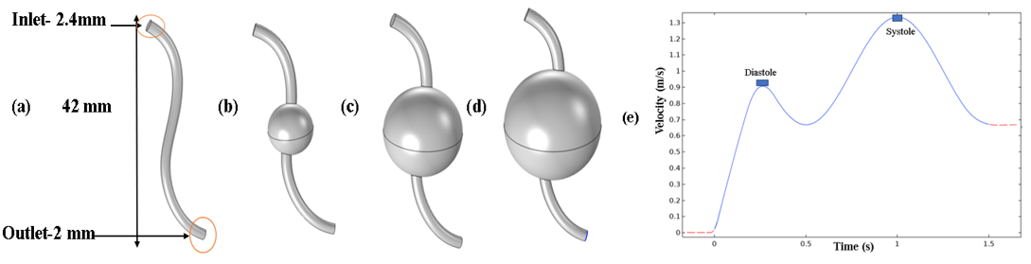

Figure 1: a) a healthy, b), c) and d) are the 5 mm, 8 mm, 10 mm aneurysmal arteries respectively, e) pulsatile flow profile used as arterial input function.

The variation in aneurysm size facilitates the examination of hemodynamic variables across multiple geometric shapes. Figure 1 illustrates the models in 1(a–d). Each artery in Fig. 1 presents an idealised artery model created with aneurysms of varying diameters. The single stenosis models, each of which has a 0% area of stenosis in the artery, are illustrated in Figure 1 (b-d). The models are shown in Figure 1. (a–d). Case-1 represents the artery without nanoparticles, while Case-2 represents the artery with nanoparticles

2.3 Appropriate Grid and Boundary Conditions

A pulsatile flow waveform is implemented at the inlet boundary to accurately simulate physiological blood flow conditions throughout the cardiac cycle, while a constant outlet pressure of 15,600 Pa is set at the outlet boundary. The specified boundary conditions facilitate precise predictions of transient hemodynamic behaviour in the aneurysmal artery. To enhance numerical accuracy and stability in CFD simulations, a fine mesh configuration is utilized across the computational domain. The mesh is refined in proximity to the arterial wall and aneurysmal sac to accurately capture critical gradients in velocity, pressure, and WSS. The numerical model employed in this study is validated against the results published by Hussain et al. [17], demonstrating strong agreement and confirming the reliability and accuracy of the computational methodology. The simulation results indicate that aneurysm geometry and local flow characteristics have a significant impact on nanoparticle transport and dispersion behavior. Proximal regions of the aneurysm demonstrate increased nanoparticle accumulation, attributed to disturbed flow recirculation and extended particle residence time. A suitable computational grid, as depicted in Fig. 2(a), is established to effectively resolve blood flow dynamics and nanoparticle transport within the artery. A grid independence analysis is conducted by progressively refining the computational mesh until minimal variations in hemodynamic parameters are detected [18]. The grid independence results shown in Fig. 2(b) demonstrate that the chosen mesh yields accurate and mesh-independent numerical solutions.
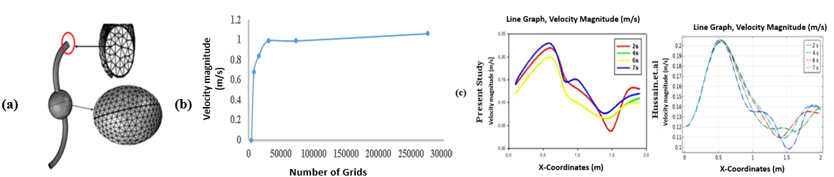
Figure 2: a) Mesh, b) Grid independence test and c) Validation between present study with published literature Hussain et.al [17].

TABLE 1: Material Properties
Material property name | Gold (Au) | Blood
Density [kg/m³] | 19300 | 1060
Viscosity [Pa*s] | 0 | 0.0035
Thermal Conductivity[W/(m*K] | 317 | 0.5
Specific Heat[J/kg⁰C] | 129 | 3600

Table 1 above illustrates the various material characteristics of nanoparticles and blood.

3. results and discussion

The findings indicate that the shape of aneurysms and the presence of nanoparticles significantly influence blood flow dynamics. Nanoparticles reduce flow intensity, while a decrease in aneurysm diameter results in lower velocity. Healthy arteries exhibited greater WSS compared to aneurysmal regions, with Case-1 consistently demonstrating higher WSS than Case-2. OSI remains largely stable, suggesting minor flow oscillations across all models. A longer RRT in larger aneurysms indicates an increased risk of thrombosis and vascular remodeling. Nanoparticles modify wall shear stress and decrease velocity, thereby influencing localized drug delivery and arterial flow. Figures 3 and 4 display the computational results derived from the non-Newtonian Carreau–Yasuda blood flow model utilised in this research. The figures illustrate the impact of aneurysmal dilation and nanoparticle incorporation on velocity distribution and WSS characteristics in the arterial domain.
Figure 3 presents the velocity contours along with the associated velocity profiles for two distinct cases. Figures 3.1(a–d) illustrate the velocity contours for a healthy artery and aneurysmal arteries with dilation diameters of 5 mm, 8 mm, and 10 mm, respectively, excluding nanoparticles. Figures 3.2(a–d) illustrate the same arterial configurations with the incorporation of nanoparticles into the blood flow. Figures 3.3(a–b) present the corresponding velocity graphs, facilitating a quantitative comparison between the two cases.
Figures 3.1(a) and 3.2(a), representing healthy artery models, demonstrate the highest velocity magnitudes, attributed to the lack of aneurysmal enlargement and diminished flow disturbance. The velocity depicted in Figure 3.1(a) is approximately 3.85% greater than that presented in Figure 3.2(a). This reduction suggests that the incorporation of nanoparticles elevates the effective resistance in the bloodstream, consequently resulting in a minor decrease in flow velocity within the healthy artery. Nanoparticles influence the rheological properties of fluids and enhance momentum dissipation.
The velocity within the aneurysmal sac region decreases markedly in both instances due to the abrupt expansion of the arterial lumen, leading to flow deceleration and recirculation. The velocity profiles presented in Figure 3.3(b) indicate that the flow behaviour within the aneurysm is largely consistent across both cases, with the nanoparticle-laden flow displaying marginally reduced velocity values. Moreover, an increase in aneurysm diameter from 5 mm to 10 mm leads to a systematic decrease in velocity magnitude. Larger aneurysms produce wider recirculation zones and diminished core flow, leading to extended particle residence time and altered hemodynamic conditions.
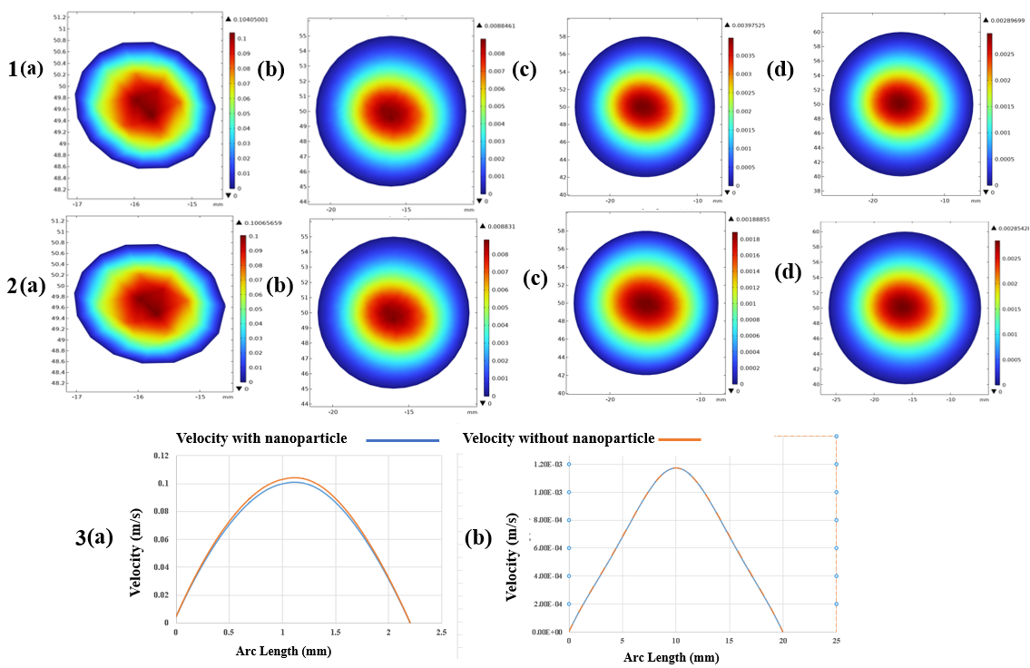
Figure 3: Velocity contours1(a-d) (without nanoparticle) and 2(a-d) (with nanoparticle) ,3(a-b) show velocity graph.
Figure 4 illustrates the contours of WSS for the four arterial models, accompanied by their respective graphical representations. Wall shear stress is an important hemodynamic parameter linked to endothelial function, vascular remodeling, and thrombus formation. Figure 4.1(a) presents the WSS distribution for the healthy artery in Case 1, with a maximum WSS value of 11.3543 Pa noted. Figure 4.2(a), representing the healthy artery with nanoparticles (Case 2), indicates a marginally reduced WSS value of 10.9176 Pa. The reduction in WSS further substantiates the role of nanoparticles in diminishing flow intensity and smoothing velocity gradients adjacent to the arterial wall. In the region of the aneurysmal sac, wall shear stress significantly decreases in both scenarios as the diameter of the aneurysm increases. The expansion of the arterial cavity diminishes the near-wall velocity gradient, resulting in decreased shear stress values along the aneurysm wall. Regions of low WSS are significant due to their strong correlation with endothelial dysfunction, blood stagnation, and thrombus formation. The results indicate that larger aneurysms generate more adverse hemodynamic conditions.
Figure 4.3(a) illustrates that the WSS profile for Case 2 exhibits greater smoothness and uniformity in comparison to Case 1. The smoother behaviour results from nanoparticles, which alter flow characteristics and diminish abrupt changes in shear stress distribution. The incorporation of nanoparticles in flow dynamics seems to stabilise local hemodynamic fluctuations and result in a more gradual variation of wall shear stress along the arterial wall. The findings indicate that the incorporation of nanoparticles can affect both therapeutic transport and the overall hemodynamic environment in aneurysmal arteries.
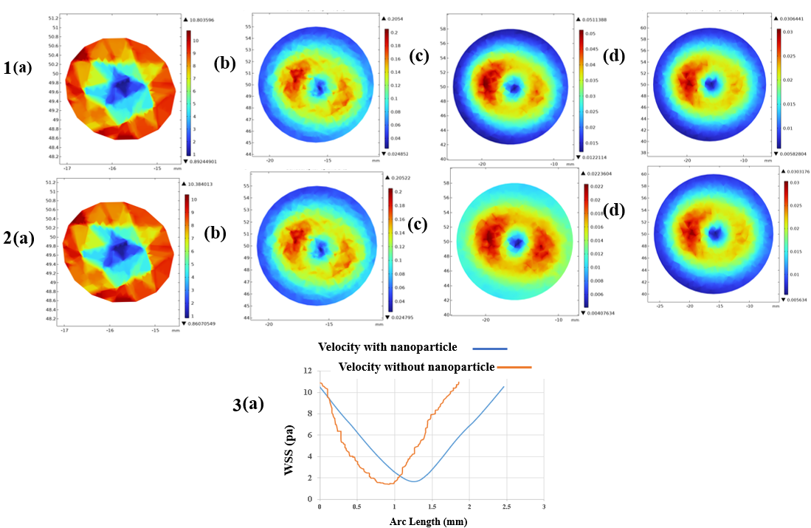
Figure 4: WSS contours 1(a-d) without nanoparticle and 2(a-d) with nanoparticle ,3(a) shows WSS graph.
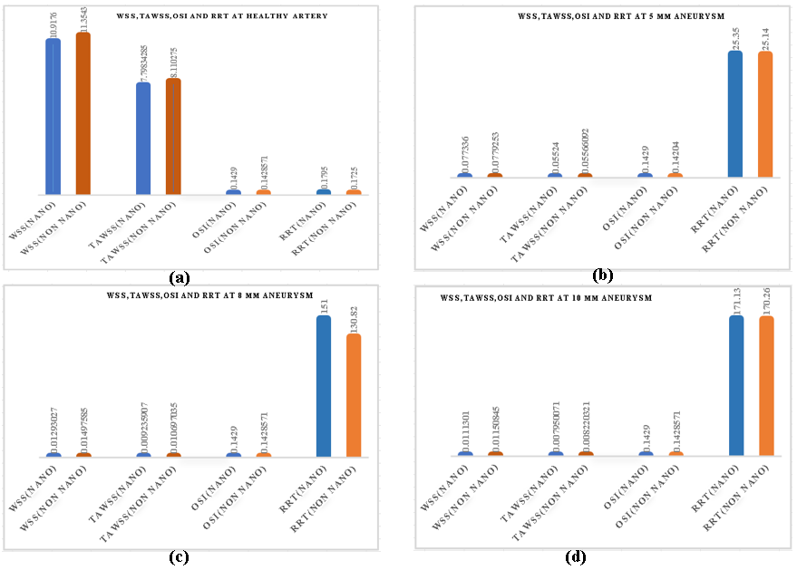
Figure 5: WSS, TAWSS, OSI and RRT values for a) a healthy, b), c) and d) are the 5 mm, 8 mm, 10 mm aneurysmal arteries
Figure 5 presents a detailed comparison of hemodynamic parameters, specifically WSS, OSI, and RRT, across all arterial models examined in this study. The comparison illustrates the impact of aneurysmal dilation and nanoparticle incorporation on local blood flow dynamics and vascular wall conditions. The WSS analysis indicates that wall shear stress values are consistently elevated in Case-1 (without nanoparticles) compared to Case-2 (with nanoparticles) across all arterial configurations. In the healthy artery model, the WSS value is recorded as 11.354 Pa in Case 1, while Case 2 shows a marginally lower value of 10.918 Pa. The observed reduction in WSS suggests that nanoparticles alter the rheological properties of blood flow, leading to a decrease in the near-wall velocity gradient. The nanoparticles enhance momentum dissipation and facilitate a more uniform hemodynamic environment within the artery. In aneurysmal artery models with diameters of 5 mm, 8 mm, and 10 mm, the WSS values significantly decrease in both scenarios compared to the healthy artery. The enlarged aneurysmal sac induces flow deceleration and the development of recirculation zones, which markedly decrease the shear stress exerted on the arterial wall. In the 5 mm aneurysm model, the WSS value in Case-1 is approximately 0.76% greater than in Case-2. The 8 mm aneurysm model demonstrates a 13.66% increase in WSS in Case-1 compared to Case-2, whereas the 10 mm aneurysm model shows a 3.29% rise in WSS for Case-1 relative to Case-2. The findings demonstrate that the incorporation of nanoparticles consistently reduces wall shear stress across the arterial system. A clear inverse relationship exists between aneurysm diameter and wall shear stress in both instances. With an increase in aneurysm diameter from 5 mm to 10 mm, there is a progressive decrease in WSS values. Larger aneurysmal expansions lead to broader flow separation and recirculation zones, which in turn result in diminished near-wall flow velocity gradients. The decrease in WSS holds clinical significance, as low WSS is closely linked to endothelial dysfunction, vascular inflammation, and atherogenic mechanisms. Regions subjected to consistently low WSS exhibit increased vulnerability to pathological vascular remodeling, potentially facilitating the onset of thrombosis and the formation of atherosclerotic plaques. Figure 5 presents the distributions of the OSI for all models. The OSI values in Case-1 exhibit minor variations between healthy and aneurysmal arteries; nonetheless, all values consistently approximate 0.1429 in both scenarios. The comparable OSI values suggest that the incorporation of nanoparticles does not significantly affect the oscillatory characteristics of pulsatile blood flow. An OSI value of approximately 0.1429 indicates a moderate level of shear stress oscillation, suggesting that the flow experiences only mild directional fluctuations. Moderate oscillatory shear can contribute to endothelial cell dysfunction, particularly when it occurs alongside low wall shear stress and extended blood residence times. Combined hemodynamic conditions can expedite vascular wall degeneration and the progression of disease in aneurysmal regions.
The analysis of RRT underscores the altered flow conditions within the aneurysmal arteries. The RRT values for the healthy artery model are 0.1795 in Case-1 and 0.1725 in Case-2. The values are considerably below the established critical threshold of 1, suggesting physiologically stable flow conditions and a low risk of pathological particle accumulation. The low RRT values indicate that blood particles do not persist near the vessel wall for prolonged durations in a healthy artery. The 8 mm aneurysm model demonstrates the most significant difference in RRT between Case-1 and Case-2, suggesting that this intermediate size may be especially responsive to flow disturbances and nanoparticle influences. The other aneurysmal models exhibit persistently high RRT values that surpass the critical threshold of 1. Elevated RRT values suggest the existence of significantly disturbed flow regions, where blood particles remain in close proximity to the arterial wall for extended periods. RRT values between 35 and 171 indicate moderate to high-risk hemodynamic zones linked to endothelial dysfunction, vascular remodeling, inflammatory responses, and the onset of plaque formation. Extended residence time promotes greater interaction between blood components and the arterial wall, consequently increasing the risk of thrombosis and pathological alterations within the aneurysm. The findings indicate that aneurysmal enlargement significantly alters local flow dynamics and generates adverse hemodynamic conditions, potentially facilitating disease progression and vascular complications. It is important to be aware of the study's limits. First, the study used artificial aneurysmal artery shapes, which might not fully show the anatomical complexity and variability seen in real vascular systems that are unique to each patient. Second, the models of blood flow were based on simple physiological conditions and may not fully reflect how blood flows in real life. The interactions between nanoparticles were modelled using strict computer assumptions, but they didn't include biological processes, particle aggregation, or effects on the permeability of vessel walls. Also, the artery walls were thought to be hard, but in reality, blood vessels are flexible and can change how blood flows through them. The study only looked at gold nanoparticles, so it can't be used with other types of nanoparticles or medicine carriers. Lastly, the results were confirmed using computers, but they need to be tested in the real world and in clinical settings to be sure they can be used in specific cardiovascular drug delivery systems.
4. ConclusionS

The results demonstrate the hemodynamic variables affect the evolution, remodeling, and pathological behavior of curved aneurysmal arteries, especially when nanoparticles are added to the blood flow. Varying velocity distribution, WSS, and RRT greatly impact the local vascular environment and may cause endothelial dysfunction, thrombosis, and aneurysm growth. Nanoparticles affect artery flow and hemodynamic response. The simulation findings show that Case-2's artery has lower velocity magnitudes than Case-1's. Nanoparticles increase effective flow resistance and change blood rheology, reducing velocity. The interaction between nanoparticles and surrounding fluid particles increases circulatory momentum dissipation. Thus, Case-2 flow is smoother and less explosive. The aneurysmal sac's increased artery geometry already slows and recirculates flow, reducing velocity. The analysis shows that Case-1 has 3.85% higher WSS than Case-2. This decrease in WSS suggests that nanoparticles diminish the near-wall velocity gradient and smooth the artery wall shear stress distribution. WSS directly affects endothelial cell activity and vascular health, hence such reductions may affect artery biology. Lower WSS areas often have flow disturbances, endothelial dysfunction, inflammation, and thrombus development. Thus, nanoparticle-induced WSS decrease may affect vascular wall remodeling. Both cases show an inverse association between aneurysm diameter and blood flow velocity. Velocity decreases with aneurysm dilatation. This happens because the increased aneurysmal cavity suddenly enlarges the flow domain, reducing axial momentum and creating huge recirculation zones. Larger aneurysms cause slower and more disrupted flow patterns than smaller ones or healthy arteries. The reduced velocity inside the aneurysm sac enhances particle stagnation and blood retention near the artery wall. RRT research shows how hemodynamics is disrupted in big aneurysmal arteries. The RRT values in the 10 mm aneurysmal artery are 99.90% greater than those in the healthy artery in both situations. A large increase in RRT implies a high-risk hemodynamic zone with prolonged blood particle residence near the artery wall. High RRT values stimulate blood constituent-endothelium contact, which can produce inflammatory reactions, platelet aggregation, thrombus formation, and vascular remodelling. Thus, aneurysm geometry and nanoparticle integration greatly affect local hemodynamic behaviour and may influence vascular disease development and nanoparticle-assisted treatment options.
AcknowledgEments

We are greatly appreciative of the Grant for Advanced Research in Education (GARE), Bangladesh Bureau of Educational Information & Statistics (BANBEIS), Ministry of Education, Government of the People’s Republic of Bangladesh to provide funding under the project ID: ET20233003(স্মারক নং-৩৭.২০.০০০০.০০৪.৩৩.০২০.২৩ (পার্ট-৫)- ১২৪১).
Competing interests

The authors declare that there are no competing interests related to this study.

Authors’ Contributions

M. A. K. Khan: Writing—Original Draft, Review and Editing, Conceptualization, Methodology, Software Development, Formal Analysis, Software information, Literature Reviewing, Validation, Data Collection, Data Analysis, Mesh Testing, Simulations, Model Design, Visualization, Contour Editing, Graph Generation.
K. E. Hoque: Conceptualization, Methodology, Software information, Literature Reviewing, Formal Analysis, Writing—Review and Editing, Data Analysis, Mesh Testing, Simulations, Model Design, Visualization, Contour Editing, Supervision, Project Administration.
M. Osman Gani: Methodology, Software information, Formal Analysis, Data Analysis, Mesh Testing, Simulations, Literature Reviewing, Supervision, Writing—Review and Editing, Visualization.
M. Masum Billah: Methodology, Software information, Formal Analysis, Data Analysis, Mesh Testing, Simulations, Literature Reviewing, Supervision, Writing—Review and Editing, Visualization.

DATA AVAILABILITY STATEMENT

Data are available on reasonable request. All data are accessible from the corresponding author upon request.

References

[1] Hoque, K. E., Ferdows, M., Sawall, S., Tzirtzilakis, E. E., & Xenos, M. A. (2021). Hemodynamic characteristics expose the atherosclerotic severity in coronary main arteries: One-dimensional and three-dimensional approaches. Physics of Fluids, 33(12). https://doi.org/10.1063/5.0069106

[2] Khan, M. A. K. and Hoque, K. E. and Osman Gani, Mohammad and Billah, Md. Masum, Computational Simulation of Nanoparticle Behavior Using Artificial Neural Networks (February 9, 2026). Available at SSRN: https://ssrn.com/abstract=6200838 or http://dx.doi.org/10.2139/ssrn.6200838

[3] Ardahaie, S. S., Amiri, A. J., Amouei, A., Hosseinzadeh, K., & Ganji, D. (2017). Investigating the effect of adding nanoparticles to the blood flow in presence of magnetic field in a porous blood arterial. Informatics in Medicine Unlocked, 10, 71–81. https://doi.org/10.1016/j.imu.2017.10.007
[4] Ferdows, M., Hoque, K. E., Bangalee, M., & Xenos, M. A. (2022). Wall shear stress indicators influence the regular hemodynamic conditions in coronary main arterial diseases: cardiovascular abnormalities. Computer Methods in Biomechanics & Biomedical Engineering, 26(2), 235–248. https://doi.org/10.1080/10255842.2022 .2054660

[5] Noor, R., Hoque, K., Billah, M., & Subah, S. (2025). Hemodynamic simulation of anterior cerebral artery aneurysm progression under magnetic field: a study of vessel segmentation and 3D modeling. International Journal of Thermofluids, 28, 101306. https://doi.org/10.1016/j.ijft.2025.101306

[6] Inagawa, T. (2022). Prevalence of cerebral aneurysms in autopsy studies: a review of the literature. Neurosurgical Review, 45(4), 2565–2582. https://doi.org/10.1007/s10143-022-01783-7

[7] Hoque, K. E., Billah, M. M., Alam, M. S., & Noor, R. E. (2026). Role of wall shear hemodynamic characteristics in determining cerebral aneurysms severity: A stroke-related study. Results in Engineering, 29, 109596. https://doi.org/10.1016/j.rineng.2026.109596

[8] Billah, M. M., Hoque, K., Habiba, U., & Paul, T. K. (2025). Impact of hemodynamic factors on medical image-based cardiovascular disease prediction. Progress in Engineering Science, 3(1), 100195. https://doi.org/10.1016/j.pes.2025.100195

[9] Sara, M., Billah, M. M., Hoque, K. E., Ifraj, N. F., Hossain, M. S., & Hoq, S. M. A. (2025). Computational analysis of hemodynamic parameters in coronary arteries: Effects of stenosis and bifurcation angle. JOURNAL OF MECHANICAL ENGINEERING AND SCIENCES, 10908–10922. https://doi.org/10.15282/jmes.19.4.2025.7.0855

[10] Salman, H. E., Ramazanli, B., Yavuz, M. M., & Yalcin, H. C. (2019). Biomechanical investigation of Disturbed Hemodynamics-Induced tissue degeneration in abdominal aortic aneurysms using computational and experimental techniques. Frontiers in Bioengineering and Biotechnology, 7, 111. https://doi.org/10.3389/fbioe.2019.00111

[11] Subah, S., Billah, M. M., Uddin, M. N., & Hoque, K. E. (2025). Multiphase CFD modeling of alumina nanoparticle drug delivery in bifurcated coronary arteries with stenosis, aneurysm, and bypass conditions. International Journal of Thermofluids, 29, 101367. https://doi.org/10.1016/j.ijft.2025.101367

[12] Chowdhury, B. I., Billah, M. M., Hossain, M. S., Ahmed, S., & Hoque, K. E. (2025). Unsteady mixed convective effect in a lid driven porous T-shaped cavity using nanofluid. Numerical Heat Transfer Part B Fundamentals, 87(1). https://doi.org/10.1080/10407790.2025.2532111

[13] Suma, U., Billah, M. M., Khan, A. R., & Hoque, K. (2024). Magnetohydrodynamic mixed convective heat transfer augmentation in a rectangular lid-driven enclosure with a circular hollow cylinder utilizing nanofluids. International Journal of Thermofluids, 25, 101014. https://doi.org/10.1016/j.ijft.2024.101014
[14] Uddin, M. N., Hoque, K. E., & Billah, M. M., “The Impact of Multiple Stenosis and Aneurysms on Arterial Diseases: A Cardiovascular Study” Heliyon, Vol. 10, no. 5(e26889), 2024, pp. 1-26.
[15] Zaman. N, Ferdows. M, Xenos.M. A, Hoque. K.E &Tzirtzilakis. E.E, “Effect of Angle Bifurcation and Stenosis in Coronary Arteries: An Idealized Model Study.,” BioMed Res. J., Vol. 4, No. 2, pp. 220–234, August 09, 2020.
[16] Choudhari, R., Vaidya, H., Prasad, K. V., Gudekote, M., Khan, M. I., Akermi, M., Hassani, R., Hejazi, H. A., & Ali, S. (2024). Analysis of peristalsis blood flow mechanism using non-newtonian fluid and variable liquid characteristics. Results in Engineering, 21, 101842. https://doi.org/10.1016/j.rineng.2024.101842

[17] Hussain, A., Dar, M. N. R., & Tag-Eldin, E. M. (2023). Effects of stenosis and aneurysm on blood flow in stenotic-aneurysmal artery. Heliyon, 9(7), e17788. https://doi.org/10.1016/j.heliyon.2023.e17788
[18] Hoque. K. E, Sawall. S, Hoque .M. A, and Hossain.M. A, “Hemodynamic Simulations to Identify Irregularities in Coronary Artery Models,” J. Adv. Math. Comput. Sci., vol. 28, no. 5, pp. 1–19, 2018. https://doi.org/10.9734/JAMCS/2018/43598

