Effect of temperature, pH and relative humidity on growth of Root rot disease of soybean

Abstract

Root rot of soybean constitutes a widespread and serious disease constraint in Maharashtra and several other soybean-growing regions of India, leading to substantial yield reductions. The incidence and severity of the disease are often exacerbated under conditions of high temperature and low soil moisture, as well as other unfavourable environmental stresses. Under such conditions, plants become physiologically weakened, thereby increasing their susceptibility to pathogen infection and disease development. Rhizoctonia bataticola causal agent of root rot and charcoal rot in various pulse crops. Due to fluctuation of temperature and climatic disturbance in the arid region is quite difficult to manage the root rot. Due to favourable weather circumstances, the disease spread widely across the state and resulting in significant yield losses. To reduce the number of sclerotia in soil or to minimise the contact of the inoculum and the host, six different temperatures and four pH levels were tested for their suitability on mycelial growth and sclerotial formation of the Rhizoctonia bataticola in vitro conditions. Maximum mycelial growth (88.33 mm) was observed at 30 ºC temperature followed by 25ºC (66.33 mm), 35ºC (64.00 mm), 20 ºC (54.33) and 40ºC (27.00 mm) and maximum dry mycelial diameter (86.25 mm) was observed at 6.5 pH followed by pH level 5.5, 7.5, and 8.5 with colony diameter 71.33, 55.58, mm and 47.00 mm of the R. bataticola respectively. Root rot of soybean constitutes a widespread and serious disease constraint in Maharashtra and several other soybean-growing regions of India, leading to substantial yield reductions. The incidence and severity of the disease are often exacerbated under conditions of high temperature and low soil moisture, as well as other unfavourable environmental stresses. Under such conditions, plants become physiologically weakened, thereby increasing their susceptibility to pathogen infection and disease development.

Keywords: Rhizoctonia bataticola, temperature, root rot disease, oil extraction processes

Introduction
Variations in disease severity are often governed by abiotic factors, including temperature and soil pH, which can significantly modify host–pathogen interactions and, consequently, the epidemiology of the disease. These environmental influences complicate the elucidation of the underlying mechanisms involved in the development and progression of soybean root rot, as they affect both pathogen activity and host susceptibility (Cruz et al., 2019; Liu et al., 2023). Soybean [Glycine max (L.) Merrill] possesses a very high nutritional value. It belongs to Leguminosae family, sub-family Papilionoideae and genus Glycine. China is considered the origin of soybean, it is predominantly cultivated in USA, Brazil, China, Argentina and India (Rathore, 1999). It has an unmatched composition of 40 per cent protein and 20 per cent oil and nutritional fatty acids, carbohydrates, vitamins, minerals and 5 per cent fiber. In addition to this, it also contains vitamins A, B, C, D, E, K and all other essential amino acids. Soybean meal or soybean cake resulting from oil extraction processes is used in feeding livestock, poultry and household pets. Soybean due to its various uses is called 'Wonder crop' and 'Golden gift' of nature to mankind. Soybean root rot caused by Fusarium spp. is a major disease, mainly transmitted in the soil. Fusarium root rot of soybeans can endanger any stage of soybean development, resulting in water-soaked decay after sowing and before germination, which affects the germination rate of seeds after infection. Seedling infection leads to the decay of the root epidermis, browning of vascular bundles, withered yellow leaves, and plant death in serious cases, along with shriveled grains and serious economic costs (Liu et al., 2025). The epiphytotic incidence of charcoal rot of soybean in areas where the temperature ranges from 35 to 40°C during the crop season and the disease may result in potential yield losses up to 80% (Gupta and Chauhan 2005). Khan et al. (2012) preserved the culture of Rhizoctonia bataticola at different temperature levels. A higher growth rate was recorded at 30⁰C temperature, followed by 35°C and minimum growth was noted at 10ºC.
Root rot of soybean is a prevalent and severe disease problem in Maharashtra and other states of India that vastly reduces yield. Disease symptoms usually appear under high temperature and low moisture or during unfavourable environmental situations, which cause stress to the plant. Fungi attack the roots and disrupt the proper functioning of the plant to uptake water and other nutrients.
In this paper, we report the response of isolates of Rhizoctonia bataticola at different temperatures and pH on the growth and disease development.
Materials and methods
The infected soybean plant showing typical symptoms of root rot, like yellowing, sudden wilting were collected from the Department of Plant Pathology, College of Agriculture, Ummedganj, (Kota). Collected samples of infected plants were brought to the laboratory for further investigations. Studies of the following physiological aspects Rhizoctonia bataticola were conducted in vitro.
Effect of temperature on the growth of Rhizoctonia bataticola
To determine the minimum, optimum and maximum range of temperature for
mycelial growth of Rhizoctonia bataticola, PDA was poured into the petri plates and a 6 mm mycelial disc from an actively growing culture of the fungus placed on the surface of the solidified medium (20 ml for each petri plate) in a laminar air flow. The inoculated plates were incubated at different regimes of temperature viz., 15, 20, 25 30, 35 and 40±1°C in a different BOD incubator. Three replications were maintained for each treatment. Radial growth of the colony was recorded by measuring colony diameter in millimetre at regular intervals of 96 hrs. The data obtained were analysed statistically.
Effect of hydrogen ion concentration (pH)
For determining the optimum level of pH for mycelial of Rhizoctonia bataticola, 100 ml of medium (PDA) was dispensed into the 5 Erlenmeyer flasks of 250 ml capacity and different regimes of pH viz., 5.5, 6.5, 7.5, and 8.5 were adjust by with the digital pH meter by using N/10 HCl or N/10 NaOH solution prior to sterilization. The sterilized medium was poured into petri plates after solidification. A 6 mm mycelial disc from an actively growing culture of fungus was cut and placed on the surface of medium (20 ml for each petri plate) under aseptic conditions. The inoculated plates were incubated at 25±1°C. Five replications were maintained for each treatment of pH level. Radial growth of the colony was recorded by measuring colony diameter in millimetre at regular intervals of 96 hrs. The data obtained were analysed statistically.
Results and Discussion
Temperature was known to have a profound effect on the growth of fungal organisms. Present studies were taken up to know the optimum, minimum and maximum temperature requirements for the growth of the pathogen.
Effect of different temperature level on radial growth of R. bataticola
Temperature is one of the most critical environmental factors influencing the growth, survival, and pathogenic behaviour of microorganisms. Each microorganism has a specific thermal range within which it can grow, reproduce, and express its pathogenic potential. In the case of plant pathogens, temperature not only affects the growth of the pathogen itself but also governs the dynamics of host–pathogen interactions, disease development, and epidemiology. Therefore, understanding the temperature requirements of Rhizoctonia bataticola is essential for predicting disease outbreaks and developing effective management strategies. In the present investigation, the effect of different temperature regimes on the radial growth of R. bataticola was studied under controlled laboratory conditions using potato dextrose agar (PDA) as the basal medium. Six temperature levels, namely 15, 20, 25, 30, 35, and 40°C, were selected to cover a broad spectrum ranging from low to relatively high thermal conditions. The observations on mycelial growth were recorded after a fixed incubation period and analyzed statistically to determine the optimum temperature for fungal development.

The results clearly indicated that R. bataticola possesses the ability to grow over a wide temperature range, from as low as 15°C to as high as 40°C. However, the extent of growth varied significantly across the tested temperatures, demonstrating the strong influence of thermal conditions on the metabolic activity and mycelial expansion of the pathogen. This adaptability to a broad temperature range highlights the ecological versatility of the fungus and explains its widespread occurrence in diverse agro-climatic regions.
Among the different temperature levels evaluated, the maximum radial growth of the fungus was observed at 30°C, where the colony diameter reached 88.33 mm. This growth was found to be statistically superior to all other temperature treatments, indicating that 30°C is the most favorable or optimum temperature for the growth of R. bataticola under in vitro conditions. At this temperature, the fungus exhibited vigorous mycelial development, suggesting that its enzymatic activities and physiological processes operate most efficiently in this thermal environment.
The second-highest growth was recorded at 25°C, with a colony diameter of 66.33 mm. Although this temperature supported substantial fungal growth, it was significantly lower than that observed at 30°C, indicating that even a slight deviation from the optimum temperature can reduce the growth rate of the pathogen. Similarly, at 35°C, the fungus showed a colony diameter of 64.00 mm, which was comparable to that at 25°C but still inferior to the optimum level. These observations suggest that R. bataticola can tolerate moderately high temperatures but does not achieve its maximum growth potential beyond 30°C.
At 20°C, the fungal growth was further reduced, with a colony diameter of 54.33 mm. This indicates that lower temperatures begin to impose constraints on the metabolic processes of the pathogen, leading to slower mycelial expansion. The reduction in growth at this temperature could be attributed to decreased enzymatic activity and limited nutrient uptake under cooler conditions.
A marked decline in growth was observed at the higher extreme of 40°C, where the colony diameter was restricted to 27.00 mm. Although the fungus was still able to grow at this temperature, the significantly reduced colony size indicates that such high temperatures are stressful and not conducive to optimal development. The inhibitory effect of high temperature may be due to the denaturation of enzymes, the disruption of cellular processes, and the reduced stability of fungal structures. The lowest growth among all treatments was recorded at 15°C, where the colony diameter was only 38.33 mm. This temperature appears to be near the lower threshold for the growth of R. bataticola, resulting in slow and restricted mycelial development. The reduced growth at this level suggests that the pathogen is less adapted to cooler environments and performs poorly under such conditions.
Overall, the trend observed in this study clearly demonstrates that R. bataticola exhibits maximum growth at 30°C, with a gradual decline in growth as the temperature deviates either below or above this optimum point. The ability of the fungus to grow across a wide temperature range, albeit with varying efficiency, underscores its adaptability and potential to survive under different environmental conditions.
The findings of the present study are in close agreement with earlier research conducted by various scientists. Khan et al. (2012) studied the effect of temperature on the growth of R. bataticola and reported that the highest growth rate was achieved at 30°C. Their observations confirm that this temperature provides the most favorable conditions for the physiological and metabolic activities of the fungus.
Similarly, Ratul and Singh (2018) investigated the environmental factors influencing the incidence of Rhizoctonia root rot disease in gram and found that 30°C was the most suitable temperature for disease development. This suggests that the optimum temperature for fungal growth also coincides with the conditions that favor disease expression in the host plant, thereby emphasizing the importance of temperature in disease epidemiology.
Table-1 Effect of different temperature level on mycelial growth by R. bataticola, in vitro.
S. No. | Temperature | Colony diameter in mm (96HAI) *
1. | T₁=15ºC | 38.33
2. | T₂=20ºC | 54.33
3. | T₃=25ºC | 66.33
4. | T₄=30ºC | 88.33
5. | T₅=35ºC | 64.00
6. | T₆=40ºC | 27.00
S Em. ± |  | 0.88
CD at 5% |  | 2.72
*Mean of three replications; HAI=Hours after inoculation.

Further supporting these findings, Calara et al. (2022) reported that dry root rot of chickpea caused by R. bataticola becomes particularly severe under conditions of moisture stress combined with temperatures exceeding 30°C. Their study highlights the role of high temperature in predisposing the host plant to infection and enhancing the aggressiveness of the pathogen. This indicates that while the fungus can grow at higher temperatures, its pathogenicity may be influenced by additional environmental factors such as soil moisture and host susceptibility.
More recently, Sunkad et al. (2023) observed that the maximum colony growth of R. bataticola and the highest severity of dry root rot disease in chickpea were recorded within the temperature range of 30–35°C. They identified this range as the optimum for both fungal growth and disease development. These findings are consistent with the results of the present study, where 30°C was identified as the most favorable temperature, followed by 35°C.
The consistency of results across different studies indicates that the temperature requirement of R. bataticola is relatively stable and well-defined. The optimum temperature of around 30°C appears to be a critical factor governing both the in vitro growth of the pathogen and its in vivo interaction with host plants. This information is particularly valuable for agricultural practices, as it can help predict periods of high disease risk and guide the implementation of timely management strategies.
From an ecological and epidemiological perspective, the ability of R. bataticola to grow over a wide temperature range, coupled with its preference for warm conditions, explains its prevalence in tropical and subtropical regions. In areas where temperatures frequently approach or exceed 30°C, especially during the cropping season, the pathogen can proliferate rapidly and cause significant damage to susceptible crops such as chickpea.
In conclusion, the present study demonstrates that temperature plays a crucial role in regulating the growth of R. bataticola. The fungus exhibits maximum radial growth at 30°C, which is identified as the optimum temperature for its development. Growth decreases progressively at temperatures below and above this level, with the least growth observed at 15°C and significantly reduced growth at 40°C. These findings, supported by earlier studies, provide valuable insights into the thermal biology of the pathogen and contribute to a better understanding of its behavior under varying environmental conditions. Such knowledge is essential for developing effective disease forecasting models and implementing integrated disease management practices.

Fig.-1 Graph showing the Effect of different temperature level on mycelial growth of R. bataticola

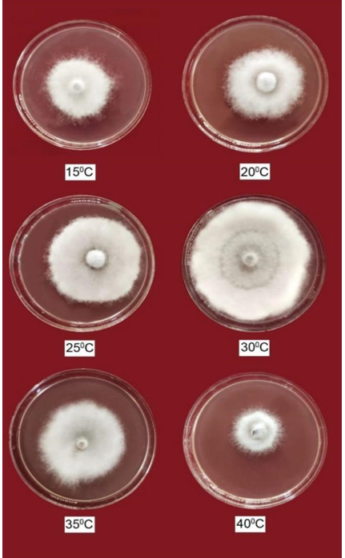
T₁=15ºC, T₂=20ºC, T₃=25ºC, T₄=30ºC, T₅=35ºC, T₆=40ºC
Plate 1: Images showing the Effect of different temperature level on mycelial growth of R. bataticola.
Effect of different pH level on mycelial growth of R. bataticola
The hydrogen ion concentration (pH) of the growth medium plays a critical role in influencing the physiological and metabolic activities of fungal pathogens, thereby directly affecting their growth, development, and pathogenic potential. In the present investigation, the impact of different pH levels on the radial growth of Rhizoctonia bataticola was systematically evaluated under controlled laboratory conditions. The study was conducted using Potato Dextrose Agar (PDA) medium, which was adjusted to four distinct pH levels, namely 5.5, 6.5, 7.5, and 8.5, to assess the suitability of each level for fungal growth. The observations pertaining to colony diameter and growth characteristics were carefully recorded and statistically analyzed, and the findings are summarized in Table 2, with visual representation provided in Plate 2.
The results of the experiment clearly demonstrated that the growth of R. bataticola varied significantly across the tested pH levels, indicating a strong dependence of the fungus on the acidity or alkalinity of the medium. Among the different treatments, the fungus exhibited the highest radial growth at pH 6.5, where the mean colony diameter reached 86.25 mm. This level was found to be statistically superior to all other pH treatments, suggesting that a slightly acidic to near-neutral environment is most conducive for the optimal growth of this pathogen. The luxuriant growth observed at pH 6.5 may be attributed to the favorable biochemical and enzymatic conditions that support efficient nutrient absorption, enzyme activity, and cellular metabolism in the fungus.
Following pH 6.5, the next best growth was observed at pH 5.5, where the colony diameter measured 71.33 mm. Although slightly lower than the maximum, this result still indicates that the fungus can thrive reasonably well under moderately acidic conditions. However, a noticeable decline in growth was recorded as the pH shifted towards neutrality and alkalinity. At pH 7.5, the colony diameter decreased to 55.58 mm, reflecting a reduction in mycelial expansion compared to the more acidic treatments. The least growth was observed at pH 8.5, where the colony diameter was restricted to 47.00 mm, indicating that alkaline conditions are less favorable for the development of R. bataticola.
The trend observed in the present study clearly highlights that both an increase and a decrease in pH from the optimal level (6.5) significantly effective the growth of the pathogen. This suggests that R. bataticola has a narrow pH range within which it can achieve maximum growth, and any deviation from this range leads to suboptimal physiological functioning. The reduction in growth at higher pH levels could be due to alterations in membrane permeability, enzyme denaturation, or reduced availability of essential nutrients, all of which can adversely affect fungal metabolism. Similarly, excessively acidic conditions, although still supportive to some extent, may also limit growth due to stress on cellular processes.
The influence of pH on fungal growth is closely associated with its effect on enzymatic activities, nutrient solubility, and ion availability. Fungi generally exhibit optimal growth within a specific pH range that supports the stability and activity of enzymes involved in metabolic pathways. In the case of R. bataticola, the findings indicate that the organism prefers a slightly acidic environment for its growth and proliferation. This preference may be linked to the natural soil conditions where the pathogen is commonly found, as many agricultural soils tend to have a pH range that is slightly acidic to neutral.
The results of the present investigation are in close agreement with earlier studies conducted by various researchers on similar pathogens. For instance, Bhupathi and Theradimani (2018) reported that pH 7.0 was most favorable for the growth of Macrophomina phaseolina, irrespective of the isolates tested. Their findings suggest that near-neutral pH conditions support maximum fungal activity, which aligns closely with the observations of the current study, where optimal growth was recorded at pH 6.5. Although there is a slight variation in the exact pH value, both studies emphasize the importance of a narrow optimal range for fungal development.
Similarly, Thombre and Kohire (2018) observed that Macrophomina phaseolina was capable of growing and sporulating within a pH range of 5 to 8. This indicates that the fungus has a relatively broad tolerance to pH variations, although its maximum growth still occurs within a specific optimal range. The present findings also support this observation, as R. bataticola demonstrated the ability to grow across all tested pH levels, albeit with varying degrees of efficiency. The reduction in growth at extreme pH levels further confirms that while the fungus can tolerate a range of conditions, its performance is significantly प्रभावित when the environment deviates from the optimum. In another study, Khendkar and Deshpande (2020) investigated the growth behavior of Rhizoctonia bataticola in soybean and reported that the pathogen exhibited variable growth within a pH range of 7 to 10. Their findings suggest that the fungus can adapt to slightly alkaline conditions, although the degree of growth may vary depending on other environmental factors and host interactions. In contrast, the present study recorded reduced growth at higher pH levels, particularly at pH 8.5, indicating that extreme alkalinity may not be ideal for the pathogen under in vitro conditions. This difference may be attributed to variations in experimental conditions, substrate composition, or fungal isolates.

Table 2: Effect of different pH level on mycelial growth by R. bataticola, in vitro at 30±1℃.

S. No. | pH level | Colony diameter in mm (96HAI) *
1. | T₁= 5.5 | 71.33
2. | T₂= 6.5 | 86.25
3. | T₃= 7.5 | 55.58
4. | T₄= 8.5 | 47.00
S Em. ± |  | 1.32
CD at 5% |  | 4.05
*Mean of five replications; HAI=Hours after inoculation

Fig.2- Graph showing the Effect of different pH level on mycelial growth of R. bataticola

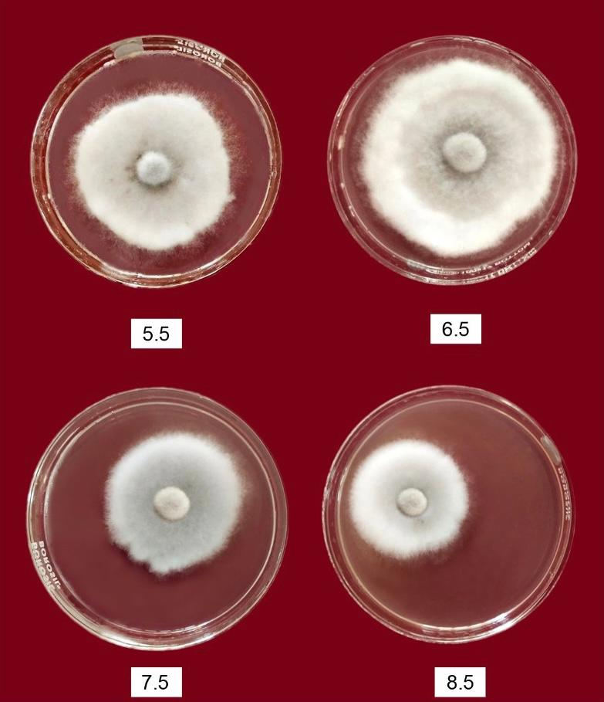
T₁= 5.5, T₂= 6.5, T₃= 7.5, T₄= 8.8
Plate-2 Images showing the Effect of different pH level on mycelial growth of R. bataticola.
Furthermore, Sathe and Kamble (2021) also reported that pH 6.5 was the most suitable for the mycelial growth of R. bataticola, which strongly corroborates the findings of the present investigation. Their study reinforces the conclusion that a slightly acidic pH provides the most favorable environment for the growth and development of this pathogen. The consistency of these results across different studies highlights the reliability of the observed trend and underscores the importance of pH as a critical factor influencing fungal biology. The practical implications of these findings are significant, particularly in the context of disease management and agricultural practices. Since soil pH can influence the survival and activity of soil-borne pathogens like R. bataticola, understanding the optimal pH conditions for fungal growth can help in developing effective strategies to suppress disease incidence. For example, modifying soil pH through the application of amendments such as lime or sulfur may help create unfavorable conditions for the pathogen, thereby reducing its growth and spread. Additionally, selecting crop varieties that can tolerate or thrive under specific pH conditions may also contribute to improved disease resistance.
It is also important to consider that the interaction between pH and other environmental factors, such as temperature, moisture, and nutrient availability, can further influence fungal growth. Therefore, while pH plays a crucial role, it should be studied in conjunction with other parameters to gain a comprehensive understanding of pathogen ecology. Future research may focus on exploring the combined effects of multiple environmental factors on the growth and pathogenicity of R. bataticola to develop more integrated disease management approaches. In conclusion, the present study clearly demonstrates that the pH of the growth medium has a profound effect on the radial growth of Rhizoctonia bataticola. Among the tested levels, pH 6.5 was found to be the most favorable for maximum mycelial growth, followed by pH 5.5, 7.5, and 8.5. The results indicate that both acidic and alkaline deviations from the optimal pH significantly effective fungal growth, highlighting the sensitivity of the pathogen to changes in environmental conditions. These findings are in agreement with previous studies and contribute valuable insights into the biology and ecology of the pathogen, which can be utilized for developing effective disease management strategies.

CONCLUSIONS
Overall the pathogen associated with root rot of soyabean was grow best on Potato dextrose agar media as well as Mycelium growth was maximum on potato dextrose agar (Natural) (88.00 mm), at 30°C temperature (87.02 mm) & pH level 6.5 (82.63 mm).
Disclaimer (Artificial intelligence)
Author(s) hereby declare that NO generative AI technologies such as Large Language Models (ChatGPT, COPILOT, etc.) and text-to-image generators have been used during the writing or editing of this manuscript.

REFERENCES
- Bhupathi, P., & Theradimani, M. (2018). In vitro Studies of carbon, Nitrogen sources and pH on mycelia growth Blackgram Root rot caused by Macrophomina phaseolina. The Pharma Innovation Journal, 7(6), 33-35.
- Calara, M., Avasiloaiei, D.I., Benchea, C.M., Brezeanu, C., Brezeanu, P.M., Ambăruş, S., Cristea, T.O., Iosob, G.A., Bouruc, D., Antal, A.T. and Bute, A., (2022). Pest and disease of chickpea (Cicer arietiunum l.) and their management: a review. Scientific Studies & Research. Series Biology/Studiisi Cercetari Stiintifice. Seria Biologie, 31(1).
- Gupta, G.K. and Chauhan, G.S. (2005). Symptoms, Identification and Management of Soybean Diseases. Technical Bulletin 10. Indore, India, National Research Centre for Soybean.
- Khan, R. A., Bhat, T. A., & Kumar, K. (2012). Management of chickpea (Cicer arietinum L.) dry root rot caused by Rhizoctonia bataticola (Taub.) Butler. International Journal of Research in Pharmaceutical and Biomedical Sciences, 3(4), 1539-1548.
- Khendkar, A. S., & Deshpande, A. R. (2020). Isolation, identification and antagonistic potential of streptomyces ansca22 for biocontrol of Rhizoctonia bataticola infection of soybean. Plant Archives, 20(1), 701-707.
- Rathore, P. S. (1999). Techniques and management of field crop production. Argi bios online (India) pp 59-266.
- Ratul, M. R. & Singh, H.B. (2018). Rhizoctonia bataticola: A serious threat to chickpea
production. International Journal of Chemical Studies. 6(4), 715-723.
- Sathe, B.G. and Kamble, S.S. (2021). Effect of physical factors on the bio-control potential of Trichoderma pseudokoningii against Rhizoctonia bataticola causing root rot of deccan hemp. BIOINFOLET. 18(1a); 47-50.
- Sunkad, G., Dore, D., Patil, M., Joshi, R., & Kumar, M. (2023). Impact of temperature, moisture and CO2 on growth of pathogen and severity of emerging dry root rot disease of chickpea in Karnatak. Journal of Agrometeorology, 25(2).
- Thombre, B.B. and Kohire, O.D. (2018). In vitro bio-efficacy of bioagents and botanicals against Macrophomina blight of mungbean caused by Macrophomina phaseolina (Tassi) Goid. International Journal of Chemical Studies, 6(2): 3063-3066.
- Liu, J., Cui, W., Zhao, Q., Ren, Z., Li, L., Li, Y., Sun, L., & Ding, J. (2025). Identification, Characterization, and Chemical Management of Fusarium asiaticum Causing Soybean Root Rot in Northeast China. Agronomy, 15(2), 388. https://doi.org/10.3390/agronomy15020388
- Cruz, D. R., Leandro, L. F., & Munkvold, G. P. (2019). Effects of temperature and pH on Fusarium oxysporum and soybean seedling disease. Plant disease, 103(12), 3234-3243.
- Liu Y, Wei X, Chang F, Yu N, Guo C, Cai H. Distribution and Pathogenicity of Fusarium Species Associated with Soybean Root Rot in Northeast China. Plant Pathol J. 2023 Dec;39(6):575-583. doi: 10.5423/PPJ.OA.06.2023.0086. Epub 2023 Dec 1. PMID: 38081317; PMCID: PMC10721389.

