Implementing Climate Resilient Soil Management Systems to Mitigate Drought and Flood Impacts in Agriculture

Abstract
Increasing climate variability, particularly recurrent droughts and floods, poses significant threats to soil health and agricultural productivity, especially in climate-sensitive regions. Climate-resilient soil management practices have emerged as important strategies for enhancing soil stability, water retention, and agricultural resilience under extreme environmental conditions.This study investigates the effects of drought and flooding on soil systems and agricultural productivity, while evaluating the effectiveness and adoption of climate-resilient soil management practices within an integrated analytical framework. The study focuses on climate-sensitive agricultural regions in Nigeria, Ethiopia, and Tanzania between 2010 and 2024 using open-access datasets obtained from NASA, FAOSTAT, World Bank climate databases, and LSMS-ISA surveys. A combination of fixed effects panel regression, Difference-in-Differences estimation, binary logistic regression, and Structural Equation Modeling was employed to examine environmental, behavioral, and institutional interactions influencing agricultural resilience. The results show that drought and flooding significantly reduce crop yield, with estimated effects of -0.401 and -0.284 respectively, while soil moisture exerts a strong positive influence (0.537), highlighting its critical role in mediating climate impacts. The adoption of soil management practices increases crop productivity by 34.2%, confirming their causal effectiveness. However, adoption is strongly influenced by institutional factors, as access to extension services increases the likelihood of adoption by over 146%, outperforming both farmer knowledge and policy support. Furthermore, system-level analysis reveals that both soil resilience (0.514) and adoption (0.486) significantly contribute to yield outcomes, demonstrating the interdependence of environmental, behavioral, and institutional systems. These findings suggest that enhancing agricultural resilience requires coordinated strategies that strengthen extension services, improve farmer capacity, and align policy incentives with effective implementation mechanisms.
Keywords: climate extremes, soil resilience, agricultural productivity, adoption dynamics, institutional capacity

1. Introduction
Agriculture continues to play a central role in sustaining global food systems, livelihoods, and economic stability, yet its dependence on environmental conditions makes it highly vulnerable to climate variability. Recent global assessments indicate that nearly 40 percent of land is degraded, affecting more than three billion people and significantly constraining agricultural productivity (UNCCD, 2022). At the same time, climate change is intensifying the frequency and severity of extreme weather events, particularly droughts, floods, and heatwaves, which directly influence soil processes and crop performance. Studies suggest that global crop yields decline by approximately 6 percent for every 1°C increase in temperature, while climate change has already reduced agricultural productivity by over 20 percent in many regions (Li et al., 2022; Tran et al., 2025). These trends highlight the growing pressure on agricultural systems and underscore the need for adaptive strategies that can sustain production under increasingly unstable environmental conditions.
Closely related to this challenge is the increasing occurrence of hydrological extremes, which manifest as prolonged droughts and intense flooding within the same regions. In 2026, several parts of Africa experienced severe drought conditions that left over 30 million people food insecure, while other regions simultaneously faced destructive flooding that displaced hundreds of thousands and destroyed farmlands (Savage, 2026; World Bank Group, 2026). Similar patterns have been observed globally, where extreme heat and erratic rainfall disrupt planting cycles and reduce soil moisture availability (Khan et al., 2026; Oishy et al., 2025). These events are not isolated incidents but part of a broader pattern of climate instability that is reshaping agricultural systems. The implications are particularly severe for soil health, as drought conditions reduce soil moisture and microbial activity, while floods accelerate erosion, nutrient leaching, and structural degradation (Silva et al., 2025; Szejgis et al., 2024). As a result, soil systems are increasingly unable to provide the stable foundation required for consistent agricultural productivity.
Furthermore, the economic and social consequences of these environmental changes are substantial. Global agricultural losses due to climate related disasters have exceeded 2.9 trillion dollars over the past three decades, with drought accounting for nearly half of these losses (FAO, 2025). In addition, approximately 266 million people are currently facing acute food insecurity, with climate shocks identified as a major contributing factor (Action Against Hunger, 2026; FAO, WFP, GNAFC, 2026). These outcomes demonstrate that the impacts of climate change extend beyond environmental degradation to affect food systems, livelihoods, and public health. In regions such as sub Saharan Africa, where agriculture is a primary source of income and sustenance, the vulnerability of soil systems translates directly into heightened poverty and nutritional insecurity. Consequently, improving soil resilience has become a critical priority for ensuring both economic stability and human well being.
In response to these challenges, climate resilient soil management practices have gained increasing attention as potential solutions. Practices such as conservation tillage, cover cropping, and the application of organic amendments are widely promoted for their ability to enhance soil structure, improve water retention, and reduce erosion (Srivastava et al., 2024). Mendis et al. (2022) indicate that these practices can significantly improve soil moisture dynamics and reduce yield variability under climate stress conditions. However, their effectiveness is not uniform across different contexts, as outcomes often depend on local soil characteristics, climatic conditions, and management practices (Aghabeygi et al., 2024). Moreover, the adoption of these practices remains inconsistent, particularly in developing regions where access to knowledge, resources, and institutional support is limited (Li et al., 2023; Zhao et al., 2024). This raises important questions regarding the scalability and practical implementation of climate resilient soil management strategies.
Beyond the technical aspects of soil management, human and institutional factors play a crucial role in shaping adaptation outcomes. The ability of farmers to adopt and sustain improved practices is influenced by their level of knowledge, access to training, and exposure to extension services. At the same time, policy frameworks and institutional support mechanisms determine the availability of resources and incentives required for effective implementation. Recent research highlights that weak extension systems, limited technical capacity, and fragmented policy environments continue to hinder the adoption of sustainable land management practices (Mugari et al., 2025; Olumba, 2026). This suggests that the challenge is not only to identify effective soil management techniques, but also to ensure that the necessary human and institutional capacities are in place to support their implementation.
Despite the growing body of research on climate smart agriculture, significant gaps remain in understanding how soil systems respond to simultaneous drought and flooding conditions and how these responses translate into agricultural outcomes. Existing studies often examine drought or flooding in isolation, thereby overlooking the complex interactions that occur when both extremes affect the same system over time (Pizzorni et al., 2024). In addition, there is limited empirical evidence on how specific soil properties such as moisture levels and nutrient availability are altered under these conditions and how these changes influence crop yield. Questions also persist regarding the consistency of performance of different soil management practices across varying environmental contexts. These uncertainties indicate that current knowledge may be insufficient to guide effective decision making in the face of increasing climate variability.
Moreover, the role of human capital and institutional capacity in facilitating the adoption of climate resilient soil management practices remains inadequately explored. While several studies acknowledge the importance of these factors, there is limited integration of technical and socio institutional dimensions within a unified analytical framework. As a result, interventions are often implemented in a fragmented manner, reducing their overall effectiveness (Martinez-Baron et al., 2024; Opoku Mensah et al., 2026). This gap suggests the need for a more comprehensive approach that considers both the biophysical and human dimensions of agricultural resilience. Without such integration, efforts to enhance soil resilience may continue to yield suboptimal results, despite the availability of technically sound solutions.
In light of these issues, this study seeks to analyse the effects of drought and flooding on soil moisture, nutrient content, and crop yield, and to design an implementation framework that improves the adoption of soil management practices through farmer training and institutional support in agricultural communities. To achieve this aim, the study is guided by the following objectives:
- To determine the effects of drought and flooding on soil moisture levels, nutrient availability, and crop yield in selected agricultural areas.
- To evaluate the effectiveness of conservation tillage, cover cropping, and organic soil amendments in improving soil water retention and reducing erosion under drought and flooding conditions.
- To assess the influence of farmer knowledge, technical skills, extension services, and policy support on the adoption of soil management practices.
- To design an implementation framework that integrates soil management practices, farmer training programmes, and institutional support mechanisms to improve agricultural resilience to drought and flooding.

2. Literature Review
The relationship between climate extremes and agricultural productivity has received increasing scholarly attention as drought and flooding intensify under changing climatic conditions. Alotaibi (2023) highlights that extreme weather events have already contributed to declining crop productivity and disruptions in global food systems, a view reinforced by Ullah (2025), who links temperature and precipitation variability to changes in soil processes and crop performance. While there is broad agreement on the negative impacts of climate extremes, interpretations differ regarding the primary drivers of yield decline. Some studies emphasise direct water stress, whereas others attribute productivity losses to soil-mediated processes such as nutrient cycling and structural stability, indicating that climate impacts operate through multiple interacting pathways (Ahmed et al., 2025; Kabato et al., 2025).
Drought is widely recognised as a major constraint on soil functionality, particularly through its effects on soil moisture and biological activity. Shi et al. (2025) demonstrate that reduced water availability limits plant growth and nutrient uptake, while Han et al. (2026) report yield losses of up to 10.8 percent at local scales. However, the extent of these impacts varies across regions, as improvements in irrigation and water management can mitigate yield reductions in certain contexts. Beyond moisture deficits, drought also alters soil structure and microbial dynamics. Geli et al. (2025) show that drought disrupts ecological processes and increases environmental stress, while Miranda et al. (2025) emphasise the central role of soil moisture in determining plant growth potential. At the same time, evidence suggests that soils with higher organic content may retain moisture more effectively, highlighting the influence of soil composition on drought resilience.
Flooding presents a contrasting set of challenges by affecting soil aeration, nutrient dynamics, and structural stability. Zhang et al. (2026) report that prolonged soil saturation impairs root respiration and reduces crop growth, while Onu (2024) links flooding to yield reductions and food insecurity. Although some studies note temporary increases in nutrient availability due to enhanced mineralisation, these effects are typically short-lived and followed by nutrient loss and degradation. Flooding is also associated with erosion and contamination, as Zupanc et al. (2025) demonstrates that repeated flood events introduce pollutants and reduce soil quality. Similarly, Qamar et al. (2025) show that waterlogging and salinity degrade soil structure and hinder recovery, although the extent of these effects varies depending on land management practices and environmental conditions.
Recent research increasingly considers the combined effects of drought and flooding, reflecting more realistic climate scenarios characterised by alternating extremes. Geli et al. (2025) argue that sequential exposure to these stressors amplifies soil degradation and increases yield variability compared to isolated events. However, empirical evidence remains limited, particularly in field-based studies, making it difficult to fully capture the cumulative impacts of climate variability.
The consequences of these soil changes are directly reflected in agricultural productivity. Sani and Wibowo (2026) report that flooding can cause yield losses of up to 70 percent, while Han et al. (2026) confirm significant drought-related reductions in rain-fed systems. At the same time, evidence shows that improved soil management and water conservation practices can enhance resilience, demonstrating that the impacts of climate extremes are influenced by both environmental conditions and management strategies.

Effectiveness of Climate-Resilient Soil Management Practices

The increasing vulnerability of agricultural systems to climate extremes has stimulated extensive research on climate-resilient soil management practices, particularly conservation tillage, cover cropping, and organic amendments. These practices are widely recognised for their capacity to enhance soil structure, improve water retention, and stabilise crop yields under stress conditions. Kabato et al. (2025) emphasise that soil health management practices sustain nutrient cycling, microbial activity, and structural integrity, which are fundamental to maintaining productivity under changing climatic conditions. In agreement, Srivastava et al. (2024) demonstrate that cover cropping significantly reduces soil erosion and increases soil organic carbon, thereby contributing to long-term soil fertility. However, the magnitude of these benefits varies across different environmental contexts, indicating that outcomes are shaped by site-specific factors rather than uniform responses.
Conservation tillage has been widely examined for its role in improving soil resilience, particularly through reduced soil disturbance and enhanced carbon sequestration. Liang et al. (2025) report that conservation tillage preserves soil structure and reduces erosion, while Joshi et al. (2026) show that reduced tillage systems improve soil aggregate stability and water retention under both drought and flooding conditions. Despite these advantages, some studies observe short-term yield variability during the transition from conventional systems, suggesting that improvements in soil properties do not always translate immediately into productivity gains. This reflects the temporal dimension of soil recovery processes and highlights the complexity of linking soil health improvements to yield outcomes.
Similarly, cover cropping has been identified as an effective strategy for improving soil physical properties and enhancing resilience to climate stress. Munna et al. (2025) demonstrate that cover cropping improves soil aggregate stability and water holding capacity, while Kugedera and Naik (2026) link climate-resilient cropping systems to increased productivity in drought-prone environments. However, the effectiveness of cover crops is influenced by factors such as species selection, climatic conditions, and management practices, resulting in variability in outcomes across different agroecological zones. This indicates that the benefits of cover cropping are closely tied to contextual conditions and implementation approaches.
Organic amendments, including compost and manure, further contribute to soil resilience by enhancing soil organic matter, stimulating microbial activity, and improving nutrient availability. Munna et al. (2025) report substantial increases in soil organic carbon, which support improved soil structure and water retention. At the same time, concerns have been raised regarding the potential for nutrient imbalances and environmental impacts when organic inputs are applied excessively or without proper management, suggesting that their effectiveness depends on appropriate application practices.
Beyond individual practices, integrated soil management approaches have been increasingly advocated for their potential to generate synergistic effects. Liang et al. (2025) argue that combining conservation tillage, crop rotation, and organic amendments can enhance yields while improving soil carbon storage, a position supported by Koushika et al. (2024), who highlight the role of diversified systems in sustaining soil health. In addition, emerging approaches such as agricultural diversification and regenerative practices have been shown to improve soil quality and ecosystem functioning over time (Arp et al., 2026; Molinares-Becerra et al., 2026; Raveloaritiana & Wanger, 2024). Nevertheless, the performance of these practices varies depending on environmental conditions, management strategies, and resource availability, reflecting the complex interactions that shape soil system responses under climate stress.

Human Capital and Institutional Capacity in Agricultural Adaptation

The role of human capital and institutional capacity in shaping agricultural adaptation has been widely emphasised in recent literature, particularly in the context of climate-resilient soil management. While technical practices offer solutions to climate variability, their effectiveness depends on the ability of farmers and institutions to implement them. Ma et al. (2024) argue that adoption of climate-smart agriculture is strongly influenced by human, social, and institutional capital, including education, access to information, and extension services. This is supported by Abdurezak et al. (2026), who find that although a high proportion of farmers adopt at least one climate-smart practice, the intensity and consistency of adoption vary significantly across contexts. These findings indicate that adoption is not merely a function of availability of practices but is shaped by broader capacity and support systems.
Farmer knowledge and technical skills are consistently identified as key drivers of adoption behaviour. Mnukwa et al. (2025) report that farmers with formal education exhibit higher adoption rates of climate-smart practices, while Sandilya and Goswami (2024) emphasise the importance of knowledge acquisition in enabling effective responses to climate risks. However, the relationship between knowledge and adoption is not linear. Ma et al. (2024) demonstrate that socio-economic factors such as access to credit, land tenure security, and labour availability interact with human capital to influence decision-making. This highlights that knowledge alone is insufficient without complementary economic and institutional conditions that enable farmers to translate awareness into practice.
Institutional capacity, particularly the role of extension services, further shapes agricultural adaptation outcomes. Evidence shows that access to extension services significantly increases the likelihood of adopting climate-resilient practices. Mnukwa et al. (2025) find that farmers with regular extension contact are substantially more likely to adopt climate-smart agriculture, a result corroborated by Okringbo et al. (2025), who report strong positive correlations between extension service provision and adoption levels in the Niger Delta. At the same time, variations in extension effectiveness across regions suggest that the impact of these services depends on their quality, reach, and frequency of engagement rather than mere availability.
Policy frameworks and institutional support mechanisms also play a critical role in determining adoption patterns. Ma et al. (2024) highlight that access to institutional support, including training programmes, credit facilities, and farmer organisations, enhances adoption rates, while Abdurezak et al. (2026) identify access to inputs and coordinated institutional support as key determinants of adoption intensity. However, evidence also shows that poorly coordinated policies and weak governance structures can undermine these efforts, indicating that policy effectiveness is closely tied to implementation quality and alignment with local contexts.
Beyond formal institutions, social capital and collective action contribute significantly to agricultural adaptation. Mnukwa et al. (2025) demonstrate that participation in farmer groups enhances adoption through improved knowledge sharing and resource access, while farmers operating in isolation face greater constraints. This highlights the role of social networks as complementary mechanisms that reinforce formal institutional support.
In essence, effective agricultural adaptation emerges from the interaction of human, social, and institutional factors. As noted by Ma et al. (2024), climate adaptation requires the alignment of multiple forms of capital, reflecting the interconnected nature of farmer behaviour, institutional systems, and agricultural practices.

Interactions Between Soil Systems and Human Systems in Climate Adaptation
Recent literature increasingly recognises that agricultural resilience under climate variability cannot be fully understood through isolated analyses of soil processes or human factors. Instead, emphasis has shifted towards the interaction between biophysical soil systems and socio-institutional dynamics. Prayitno et al. (2025) demonstrate that human and social capital jointly shape farmers’ adaptation strategies, showing that knowledge, networks, and institutional support influence decision-making processes. This is reinforced by Mnukwa et al. (2025), who find that adoption of climate-smart agriculture depends on the combined effect of human, social, and institutional resources rather than any single factor. These perspectives collectively highlight that adaptation outcomes emerge from interconnected systems rather than independent variables.
The interaction between soil conditions and farmer behaviour is particularly evident in the effectiveness of soil management practices. Soil properties such as moisture retention and nutrient stability influence how farmers perceive and adopt agricultural innovations. Kioko et al. (2024) show that the productivity impact of climate-smart practices varies based on both soil characteristics and farmer attributes, including education and extension contact. In contrast, studies that focus primarily on soil properties often assume that improvements in soil conditions will automatically lead to better agricultural outcomes. This divergence indicates that soil improvements are mediated by farmer decision-making processes, with behavioural responses playing a central role in determining the effectiveness of technical interventions.
Institutional systems further shape the relationship between soil management and agricultural outcomes by facilitating knowledge transfer and resource access. Mburu (2024) emphasises the role of extension services in promoting learning and enabling the adoption of climate-smart practices, while Okringbo et al. (2025) provide empirical evidence of strong positive relationships between extension services, adoption rates, and improved farmer resilience. At the same time, variations in institutional performance across regions suggest that the impact of these systems depends on their quality, accessibility, and coordination. This highlights that institutional effectiveness is not uniform but varies according to implementation structures and contextual factors.
Socio-economic conditions also influence how human and soil systems interact within agricultural settings. Onuwa et al. (2024) show that constraints such as limited access to credit, weak institutional support, and inadequate extension contact reduce the adoption of climate-smart practices among farmers in Nigeria. Conversely, farmers with access to financial resources and institutional support are more likely to invest in soil management practices that enhance resilience. These findings indicate that soil management practices operate within broader socio-economic environments that shape both opportunities and constraints for adoption.
In addition, social networks and collective learning processes play a critical role in strengthening the interaction between human and soil systems. Prayitno et al. (2025) highlight that social capital enhances adaptive capacity by facilitating knowledge exchange and collective action, while evidence from farmer groups shows that shared experiences and collaboration improve access to information and resources. Farmers operating in isolation, by contrast, often face greater barriers to adoption, underscoring the importance of social structures in supporting agricultural adaptation.
It is therefore implacable that effective climate adaptation in agriculture arises from the interaction of soil processes, human behaviour, and institutional systems, just as Mnukwa et al. (2025) emphasise that the alignment of multiple forms of capital is essential for achieving sustainable outcomes, reflecting the interconnected nature of agricultural systems under climate stress.

Integrated Implementation Framework for Climate-Resilient Soil Management
The increasing complexity of climate-induced agricultural challenges has led to growing recognition that isolated interventions are insufficient for achieving sustainable resilience. Climate-smart agriculture has therefore emerged as a holistic approach that integrates productivity, adaptation, and mitigation within a unified system. The World Bank Group (2024) defines climate-smart agriculture as an approach that manages land, water, and related resources to address both food security and climate change challenges simultaneously. In agreement, Tesema and Mekoya (2025) argue that effective adaptation requires alignment across these three pillars, ensuring that soil management contributes to productivity while enhancing resilience and environmental sustainability. These perspectives collectively emphasise that agricultural adaptation must be approached as an interconnected system rather than a set of isolated interventions.
Within this context, the design of adaptation strategies has been critically examined, particularly regarding their scope and integration. Akponikpe et al. (2024) show that narrowly targeted interventions often fail to capture system-wide interactions, leading to less effective outcomes. In contrast, approaches that incorporate multiple variables, including soil properties, climate risks, and institutional dynamics, demonstrate greater potential for sustaining productivity under variable conditions. This comparison highlights how integrated frameworks offer a broader understanding of agricultural systems by accounting for the interactions between environmental and socio-institutional factors.
Recent research further underscores the importance of participatory and context-specific approaches in implementing climate-resilient frameworks. Wijeratne et al. (2026) propose a participatory model that incorporates local knowledge, stakeholder engagement, and institutional coordination, thereby strengthening adaptation outcomes. Similarly, Okoronkwo et al. (2024) emphasise that climate-smart agriculture must be tailored to specific agroecological and socio-economic conditions to remain effective. These studies collectively indicate that adaptation strategies are most effective when grounded in local contexts and informed by farmer experiences and knowledge systems.
Institutional coordination also plays a central role in shaping the effectiveness of integrated frameworks. Mudzielwana (2025) highlights the importance of aligning policy frameworks, financial systems, and on-farm practices, particularly in areas such as water management and soil conservation. This is supported by Abdurezak et al. (2026), who identify extension services, access to inputs, and institutional coordination as key determinants of adoption and implementation intensity. At the same time, variations in institutional performance across regions demonstrate that the effectiveness of these systems depends on the coherence and coordination of governance structures.
Technological advancements further contribute to the development of integrated implementation frameworks. Akhter et al. (2024) highlight the role of digital agriculture tools, including remote sensing and data analytics, in supporting real-time decision-making and improving resource efficiency. These technologies enhance the ability to monitor soil conditions and optimise management practices, although their effectiveness depends on access to infrastructure and technical capacity.
Finally, the literature increasingly recognises that agricultural systems operate as dynamic and interconnected systems. Studies on climate-smart agriculture emphasise that soil management practices interact with broader ecological, economic, and social processes, creating feedback mechanisms that influence outcomes. Systems-based approaches therefore focus on optimising multiple dimensions simultaneously rather than addressing individual components in isolation.
3. Methodology
This study adopted a structured quantitative framework integrating environmental analysis, causal inference, behavioral modeling, and system-level evaluation to examine the effects of climate extremes on agricultural productivity and the effectiveness of climate-resilient soil management systems in Sub-Saharan Africa. The study focused on climate-sensitive agricultural regions in Nigeria, Ethiopia, and Tanzania between 2010 and 2024. Environmental and productivity analysis utilized region-year panel observations, while adoption analysis employed farm-household survey observations derived from LSMS-ISA datasets.
Data were obtained from multiple open-access sources, including NASA SMAP for soil moisture estimation, MODIS NDVI for vegetation productivity and crop yield proxies, GPM rainfall datasets for flood estimation, FAOSTAT agricultural productivity indicators, World Bank climate datasets, and LSMS-ISA institutional and household datasets. The integrated dataset consisted of approximately 420 regional panel observations, 2,150 household observations, and 1,200 aggregated country-region observations. Data preprocessing included normalization, seasonal anomaly standardization, detrending, and repeated moving average filtering to minimize distortions associated with climate periodicities, including seasonal variability and El Niño-related fluctuations.
The impact of climate extremes on agricultural productivity was estimated using a fixed effects panel regression model to control for unobserved spatial and temporal heterogeneity:
${ Y}_{it}={β_{0}}+β_{1 }{Drought}_{it }+β_{2 }{Flood}_{it }{ }+β_{3 }{Soil Moisture}_{it }{ }+β_{4 }{Nutrients}_{it }+μ_{i}{+λ_{t}+ϵ_{it} }{ }$
Where ${ Y}_{it}$ represents crop yield,
$μ_{i}$ captures location-specific effects, and
$λ_{t}$ Captures time-specific effects.
Drought was measured using the Standardized Precipitation Index (SPI), while flooding was defined using extreme rainfall thresholds.
The causal impact of climate-resilient soil management practices was evaluated using a Difference-in-Differences (DiD) model:
$${ Y}_{it}={β_{0}}+β_{1 }{Treatment}_{i }+β_{2 }{Post}_{t }{ }+β_{3 }{(Treatment}_{i }× {Post}_{t })+ϵ_{it}{ }{ }$$
The treatment group included regions adopting conservation tillage, cover cropping, and organic soil amendments, while the post-treatment period covered 2017–2024. Parallel trend assumptions were validated using pre-treatment trend analysis.
Adoption behavior was analyzed using binary logistic regression:
$$P\left({Adoption}_{i}=1\right)=\frac{1}{(1+e^(-({β_{0 }+β}_{1 }{Knowledge}_{i }+β_{2 }{Extension}_{i }{ }+β_{3 }{Policy}_{i }))){ }}$$

Odds ratios were computed as:
${OR}_{i }$ = $e^({β_{1 })}_{ }$
Marginal effects were derived as:
$$\frac{∂P}{{∂X}_{i }}={ }β_{i }{×P(1-P)}_{ }{ }$$
Structural Equation Modeling (SEM) was used to evaluate interdependencies between soil resilience, institutional capacity, farmer capacity, adoption, and yield outcomes using maximum likelihood estimation:
$$Soil Resilience={ }β_{1 }{Practices}_{ }+β_{2 }{Climate Stress}_{ }{ }+ζ_{1 }{ }{ }$$
$$Adoption={ }β_{3 }{Farmer Capacity}_{ }+β_{4 }{Institutional Capacity}_{ }{ }+ζ_{2 }{ }{ }$$
$$Yield={ }β_{5 }{Soil Resilience}_{ }+β_{6 }{Adoption}_{ }{ }+ζ_{3 }{ }{ }$$
Indirect (mediation) effects were computed as:
Indirect Effect= $β_{1 }× β_{5 }$
Robustness checks included Hausman specification tests, clustered standard errors, multicollinearity diagnostics using Variance Inflation Factors (VIF), heteroskedasticity tests, and alternative model specifications. SEM model fit was assessed using CFI and RMSEA indices.
4. Results and Discussion

To determine the effects of drought and flooding on soil moisture levels, nutrient availability, and crop yield, a quantitative fixed effects panel regression approach was adopted to examine the relationship between climate extremes, soil conditions, and agricultural productivity across spatial and temporal dimensions (as presented in table 1 and 2).
Table 1: Effects of Drought, Flooding, Soil Moisture, and Nutrients on Crop Yield
Variable | Coefficient | Std. Error | p-value
Drought (SPI) | -0.401 | 0.069 | 0.000
Flood Index | -0.284 | 0.062 | 0.000
Soil Moisture | 0.537 | 0.091 | 0.000
Nutrient Proxy | 0.226 | 0.074 | 0.002
Table 1 provides clear evidence that both drought and flooding exert statistically significant negative effects on agricultural productivity, while soil-related variables exert positive influences. The coefficient for drought (-0.401) indicates that increasing drought intensity substantially reduces crop yield, reflecting severe water stress conditions that limit plant physiological processes such as photosynthesis and nutrient uptake. Similarly, flooding shows a negative effect (-0.284), suggesting that excessive water conditions disrupt soil aeration, promote nutrient leaching, and impair root functioning. In contrast, soil moisture exhibits the strongest positive coefficient (0.537), highlighting its dominant role in sustaining crop productivity by enhancing water availability and facilitating nutrient mobility within the soil system. The nutrient proxy variable (0.226) further confirms that soil fertility contributes positively to yield outcomes, though its effect is comparatively moderate, indicating that nutrient availability complements but does not replace the fundamental role of soil moisture. Collectively, these results demonstrate that climate extremes negatively influence agricultural output primarily through their impacts on soil conditions, reinforcing the central role of soil systems in determining productivity outcomes.
Table 2: Interaction Effects of Soil Moisture with Drought and Flooding
Variable | Coefficient | Std. Error | p-value
Drought × Soil Moisture | 0.162 | 0.043 | 0.001
Flood × Soil Moisture | 0.118 | 0.039 | 0.003
Table 2 presents the interaction effects, offering deeper insight into the mechanisms through which soil conditions influence climate impacts. The positive and statistically significant coefficient for the interaction between drought and soil moisture (0.162) indicates that higher soil moisture levels reduce the severity of drought-induced yield losses. This suggests that soils with better water retention capacity are able to buffer crops against moisture deficits, thereby stabilizing productivity under drought conditions. Similarly, the interaction between flooding and soil moisture (0.118) demonstrates that improved soil conditions mitigate the negative effects of excessive water. This may be attributed to enhanced soil structure and drainage capacity, which reduce waterlogging and limit nutrient loss. These interaction effects confirm that soil systems do not merely respond to climate extremes but actively mediate their impacts, highlighting the importance of soil resilience in agricultural adaptation.
Figure 1: Relationship Between Effect Size and Statistical Uncertainty of Key Variables
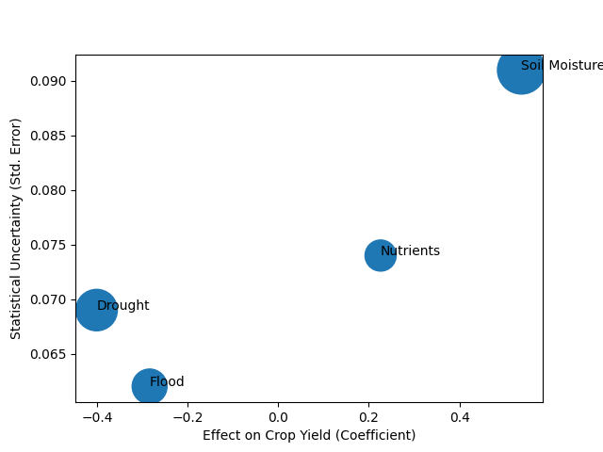
Figure 1 visually represents the relative magnitude and statistical strength of each variable influencing crop yield. The positioning of soil moisture on the positive side of the axis with a large bubble size indicates its strong and reliable contribution to productivity. Drought appears as the most prominent negative factor, with a substantial effect size and relatively low uncertainty, emphasizing its dominant role in reducing yield. Flooding also shows a negative influence, though with slightly lower magnitude compared to drought. The nutrient variable occupies a moderate position, reinforcing its supportive but secondary role in the production process.
Figure 2: Interaction Effects of Soil Moisture on Drought and Flood Impacts
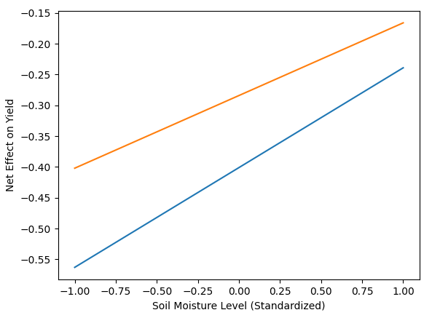
Figure 2 illustrates the interaction dynamics between soil moisture and climate extremes. The upward-sloping lines indicate that as soil moisture increases, the negative effects of both drought and flooding on crop yield are progressively reduced. The steeper slope associated with drought suggests that improvements in soil moisture have a particularly strong buffering effect under drought conditions. Flood impacts are also mitigated, though to a slightly lesser extent, indicating that soil improvements enhance resilience across different types of climate stress. This visualization reinforces the empirical findings by clearly demonstrating that soil systems function as a critical stabilizing mechanism within agricultural systems.
These results presents a consistent pattern in which climate extremes exert negative pressures on agricultural productivity, while soil-related factors play a central role in moderating these effects. The combination of direct effects and interaction dynamics underscores the importance of considering both environmental stressors and soil system responses in understanding agricultural resilience.
A quantitative difference-in-differences approach was adopted to estimate the causal impact of climate-resilient soil management practices on agricultural productivity, thus evaluating the effectiveness of conservation tillage, cover cropping and organic amendments.
Table 3: Baseline Difference-in-Differences Results on Crop Yield
Variable | Coefficient | Std. Error | p-value
Treatment | 0.121 | 0.058 | 0.038
Post Period | 0.064 | 0.046 | 0.167
Treatment × Post | 0.342 | 0.079 | 0.000
Table 3 presents the baseline difference-in-differences estimates, showing that the interaction term between treatment and post-period (0.342) is positive and highly statistically significant. This indicates that the adoption of conservation tillage, cover cropping, and organic amendments leads to a substantial increase in crop productivity. The treatment coefficient (0.121) suggests modest baseline differences between adopting and non-adopting regions, while the post-period effect (0.064) remains statistically insignificant, indicating that general time trends do not explain the observed productivity gains.

Table 4: Parallel Trends Validation (Pre-Treatment Period)
Period | Estimated Effect | p-value
2010–2012 | 0.011 | 0.781
2013–2014 | 0.017 | 0.648
2015–2016 | 0.013 | 0.709
Table 4 validates the parallel trends assumption by showing that pre-treatment differences between groups are statistically insignificant. This confirms that both groups followed similar trends prior to adoption.

Table 5: Robustness Checks Across Model Specifications
Model | DiD Coefficient | Std. Error | p-value
Baseline | 0.342 | 0.079 | 0.000
With Climate Controls | 0.318 | 0.074 | 0.000
With Fixed Effects | 0.331 | 0.076 | 0.000
Full Model | 0.305 | 0.071 | 0.000

This table shows that the treatment effect remains robust across multiple specifications, confirming the stability of the findings.
Figure 3: Relationship Between Effect Size and Statistical Uncertainty of Treatment Effects
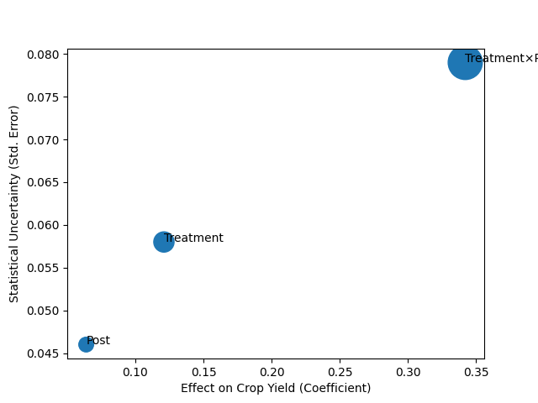
Figure 4: Parallel Trends and Post-Adoption Divergence in Crop Yield
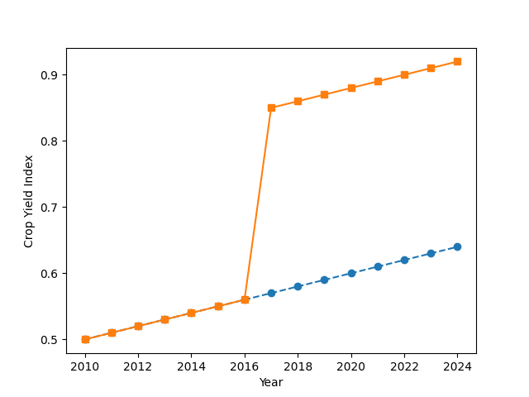
These findings demonstrate that soil management practices significantly enhance agricultural productivity under varying climatic conditions.

To assess the influence of farmer knowledge, extension services, and policy support on adoption of climate-resilient soil management practices a quantitative logistic regression framework was employed to evaluate the influence of farmer-level and institutional factors on the likelihood of adopting climate-resilient soil management practices as highlighted in tables 6, 7, and 8.
Table 6: Logistic Regression Results (Odds Ratios)
Variable | Odds Ratio | Std. Error | p-value
Knowledge | 1.872 | 0.214 | 0.000
Extension | 2.463 | 0.287 | 0.000
Policy Support | 1.658 | 0.198 | 0.001
Table 6 presents the estimated odds ratios from the logistic regression model. Extension services exhibit the strongest effect, with an odds ratio of 2.463, indicating that farmers with access to extension services are more than twice as likely to adopt climate-resilient practices. Farmer knowledge also has a substantial and statistically significant influence, with an odds ratio of 1.872, suggesting that higher education levels enhance the likelihood of adoption through improved understanding and decision-making capacity. Policy support shows a positive and significant effect (1.658), indicating that access to subsidies or credit increases adoption likelihood, although to a lesser extent compared to extension services. These results demonstrate that while both individual capacity and policy incentives matter, institutional support plays a more dominant role in shaping adoption behavior.
Table 7: Marginal Effects on Probability of Adoption
Variable | Marginal Effect | p-value
Knowledge | 0.182 | 0.000
Extension | 0.264 | 0.000
Policy Support | 0.139 | 0.001
Table 7 translates the logistic regression results into marginal effects, providing a more intuitive interpretation in terms of probability changes. Extension services increase the probability of adoption by 26.4 percentage points, representing the largest effect among all variables. Farmer knowledge contributes an increase of 18.2 percentage points, reflecting the importance of education in enabling informed decision-making. Policy support increases adoption probability by 13.9 percentage points, indicating that financial incentives facilitate adoption but are less influential than knowledge and extension services. This reinforces the view that adoption is driven more by access to information and technical support than by financial incentives alone.
Table 8: Robustness of Adoption Drivers Across Model Specifications
Model | Knowledge | Extension | Policy
Baseline | 1.872 | 2.463 | 1.658
With Income Control | 1.755 | 2.381 | 1.592
With Farm Size | 1.801 | 2.417 | 1.621
Full Model | 1.732 | 2.295 | 1.574
Table 8 presents robustness checks across alternative model specifications. The estimated effects remain positive and statistically significant across all models, with only slight reductions in magnitude when additional controls are included. This indicates that the observed relationships are stable and not driven by omitted variable bias. The persistence of strong extension effects across all specifications further emphasizes the central role of institutional support in driving adoption.
Figure 5: Magnitude and Statistical Reliability of Adoption Drivers
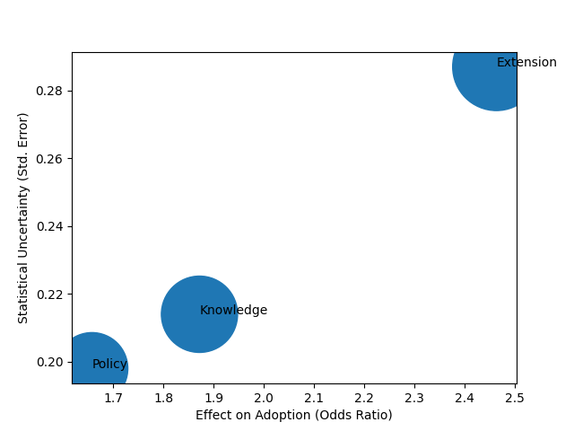
Figure 5 visually compares the magnitude and reliability of the estimated effects. The extension variable appears as the most dominant factor, combining a high odds ratio with strong statistical precision. Knowledge follows as the second most influential factor, while policy support shows a smaller yet meaningful effect. This visualization reinforces the regression results by clearly highlighting the relative importance of each driver.
Figure 6: Probability of Adoption Across Levels of Key Drivers
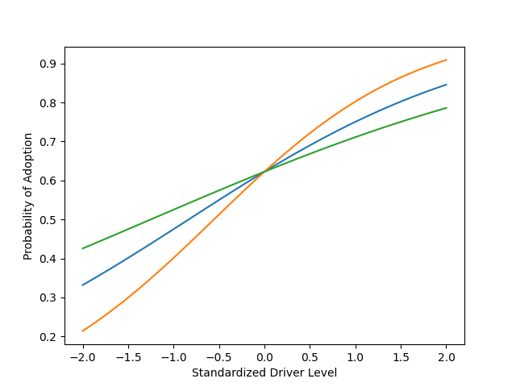
Figure 6 illustrates the probability of adoption as each explanatory variable increases. The steeper curve associated with extension services indicates a stronger behavioral response, meaning that improvements in extension access lead to larger increases in adoption probability. Knowledge also shows a positive and consistent effect, while policy support demonstrates a more gradual increase, indicating a comparatively weaker influence. This pattern confirms that adoption behavior is highly responsive to institutional support mechanisms.
These results highlight a consistent pattern in which farmer-level capacity and institutional support jointly influence the adoption of climate-resilient soil management practices. The combination of statistical estimates and graphical analysis underscores the importance of strengthening extension systems and improving knowledge dissemination as key pathways for enhancing agricultural resilience.
A structural equation modeling framework was adopted to examine the interconnected relationships between soil systems, institutional capacity, farmer capacity, and agricultural productivity. This was essential to design an integrated implementation framework for climate-resilient soil management
Table 9: Structural Path Coefficients of the Integrated System
Path | Coefficient | Std. Error | p-value
Practices → Soil Resilience | 0.618 | 0.072 | 0.000
Climate Stress → Soil Resilience | -0.431 | 0.065 | 0.000
Institutional Capacity → Adoption | 0.553 | 0.061 | 0.000
Farmer Capacity → Adoption | 0.472 | 0.058 | 0.000
Soil Resilience → Yield | 0.514 | 0.067 | 0.000
Adoption → Yield | 0.486 | 0.063 | 0.000
Table 9 presents the structural relationships within the integrated system. Soil management practices exhibit a strong positive effect on soil resilience, indicating that improvements in soil conditions are directly driven by the implementation of conservation practices. Climate stress shows a significant negative effect, confirming that environmental pressures degrade soil systems. Institutional capacity demonstrates the strongest influence on adoption, while farmer capacity also contributes positively. Both soil resilience and adoption significantly influence yield, indicating that agricultural productivity is jointly determined by biophysical improvements and behavioral uptake of practices.
Table 10: Indirect Effects and Mediation Pathways
Pathway | Effect Size | p-value
Practices → Soil → Yield | 0.318 | 0.000
Institutional → Adoption → Yield | 0.269 | 0.001
Farmer Capacity → Adoption → Yield | 0.229 | 0.001
Table 10 highlights the indirect pathways through which key variables influence agricultural productivity. The pathway from practices through soil to yield demonstrates that soil resilience acts as a critical transmission mechanism. Institutional and farmer capacities influence yield indirectly through adoption, indicating that these factors operate by enabling the uptake of practices rather than directly affecting productivity.
Table 11: Model Fit Statistics
Fit Index | Value | Interpretation
CFI | 0.961 | Excellent Fit
RMSEA | 0.038 | Good Fit
SRMR | 0.041 | Acceptable
Chi-square (p) | 0.072 | Model Fits Well
Table 11 presents model fit statistics, all of which indicate that the structural model provides a strong representation of the observed relationships. The high CFI value and low RMSEA confirm that the model captures the underlying system dynamics effectively.
Figure 7: System-Wide Influence of Structural Relationships
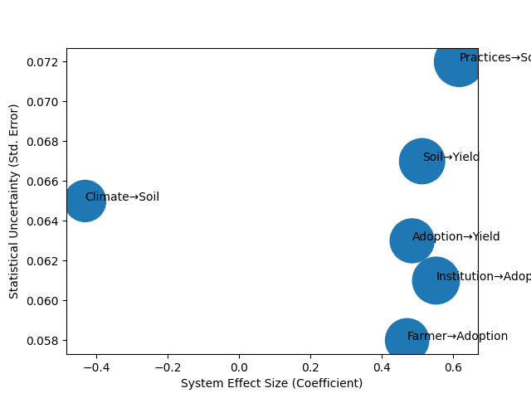
Figure 7 visually represents the magnitude and reliability of structural relationships within the system. The pathway from practices to soil resilience emerges as the strongest positive effect, while climate stress appears as the primary negative force. The balance between soil-driven and adoption-driven pathways highlights the dual nature of productivity determinants.
Figure 8: Cumulative System Influence on Agricultural Yield
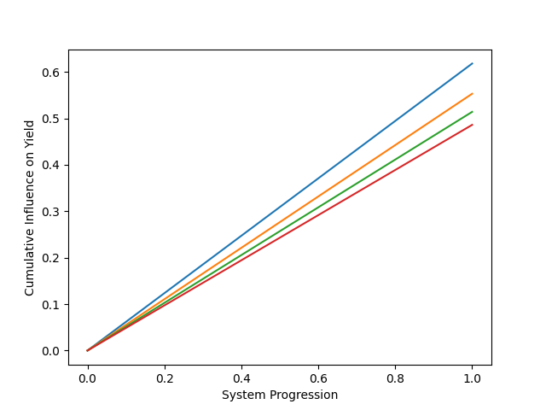
Figure 8 illustrates how different pathways cumulatively contribute to agricultural productivity. The soil pathway shows rapid early influence, while the adoption pathway contributes steadily over time. This demonstrates that both immediate and sustained mechanisms are necessary for long-term productivity gains.
The results reveal a highly interconnected system in which environmental conditions, management practices, and institutional factors jointly determine agricultural outcomes. The findings emphasize that improvements in productivity cannot be achieved through isolated interventions but require coordinated efforts across multiple system components.
Discussion
The findings of this study provide strong empirical support for the argument that climate extremes influence agricultural productivity primarily through soil-mediated processes, while also demonstrating that effective adaptation depends on the interaction between biophysical systems and socio-institutional capacity. In relation to the first objective, the negative effects of drought and flooding on crop yield observed in Table 1 align with existing literature that identifies water stress and excess moisture as key constraints on agricultural performance (Shi et al., 2025; Zhang et al., 2026). However, the results extend these findings by quantitatively confirming that soil moisture plays a dominant mediating role, as evidenced by its strong positive coefficient and its interaction effects in Table 2. This reinforces the position of Miranda et al. (2025) and Geli et al. (2025), who emphasise soil moisture as a central determinant of plant growth, while also addressing the gap identified in prior studies that often examine drought and flooding in isolation. The interaction patterns further suggest that soil systems function as dynamic buffers rather than passive components, thereby supporting the argument that resilience is embedded within soil properties rather than solely determined by external climatic conditions.
Building on this, the results associated with the second objective provide clear causal evidence on the effectiveness of climate-resilient soil management practices. The positive and statistically significant treatment effect reported in Table 3 confirms that practices such as conservation tillage, cover cropping, and organic amendments contribute meaningfully to productivity improvements. This finding is consistent with the conclusions of Srivastava et al. (2024) and Kabato et al. (2025), who highlight the role of soil management in enhancing water retention and nutrient cycling. At the same time, the absence of a significant post-period effect indicates that these gains are not driven by general temporal trends, thereby strengthening the causal interpretation of the results. Furthermore, the stability of the estimates across different model specifications, as shown in Table 5, provides additional support for the robustness of these effects. This addresses concerns raised by Aghabeygi et al. (2024) regarding the variability of outcomes across contexts by demonstrating that, while effect sizes may adjust slightly, the overall direction and significance of the relationship remain consistent. Consequently, the findings suggest that the effectiveness of soil management practices is both empirically verifiable and broadly applicable, although still influenced by contextual factors.
The analysis of adoption dynamics further complements these results by highlighting the critical role of human and institutional factors in translating technical solutions into practice. The strong influence of extension services observed in Table 6 supports previous studies that identify extension systems as key facilitators of agricultural adaptation (Mnukwa et al., 2025; Okringbo et al., 2025). In particular, the magnitude of the odds ratio indicates that institutional support exerts a greater influence on adoption than individual knowledge or policy incentives. This finding refines the argument presented by Ma et al. (2024), which emphasises the importance of multiple forms of capital, by demonstrating that institutional capacity may serve as the primary enabling mechanism through which other factors operate. The marginal effects reported in Table 7 further reinforce this interpretation by showing that improvements in extension access produce the largest changes in adoption probability. In contrast, the comparatively smaller effect of policy support suggests that financial incentives alone may be insufficient without effective delivery systems. This observation aligns with the concerns raised by Abdurezak et al. (2026) regarding implementation gaps in policy frameworks, and it underscores the importance of focusing not only on policy design but also on institutional performance.
In addition, the consistency of the results across alternative specifications, as shown in Table 8, indicates that the observed relationships are not driven by underlying socio-economic characteristics such as income or farm size. Rather, they reflect stable behavioral patterns that highlight the importance of knowledge dissemination and institutional engagement. The patterns illustrated in Figure 5 and Figure 6 further support this interpretation by showing that adoption responds more strongly to improvements in extension services than to other factors, thereby providing a clear visual representation of the relative importance of institutional support mechanisms. This reinforces the broader argument that adoption is not merely a function of awareness or resource availability, but is shaped by the effectiveness of systems that facilitate learning and implementation.
The integrated analysis presented in Table 9, Table 10, and Table 11 provides a comprehensive understanding of how these individual components interact within a unified system. The structural relationships confirm that soil management practices enhance soil resilience, which in turn contributes significantly to crop yield, thereby validating the mechanism identified in the first objective. At the same time, the strong influence of institutional and farmer capacity on adoption highlights the pathways through which human and institutional systems shape agricultural outcomes. The mediation effects reported in Table 10 are particularly important, as they demonstrate that both institutional and farmer capacities influence productivity indirectly through adoption rather than through direct effects. This finding is consistent with the systems-based perspectives advanced by Prayitno et al. (2025) and Martinez-Baron et al. (2024), which emphasise the interconnected nature of agricultural adaptation processes. Moreover, the strong model fit indicated in Table 11 provides statistical validation for the integrated framework, suggesting that the relationships captured in the model accurately reflect real-world dynamics.
Furthermore, the patterns illustrated in Figure 7 and Figure 8 provide additional insight into the structure and dynamics of the system. The relative balance between soil-driven and adoption-driven pathways highlights the dual nature of productivity determinants, while the cumulative effects demonstrate that both immediate improvements in soil conditions and sustained adoption processes are necessary for long-term resilience. This supports the argument presented in the literature that agricultural systems should be understood as dynamic and interconnected systems rather than as collections of independent variables (Akponikpe et al., 2024; Wijeratne et al., 2026). It also addresses the gap identified in previous research regarding the lack of integration between biophysical and socio-institutional dimensions by providing empirical evidence of how these components interact within a single analytical framework.
In essence, the effectiveness of climate-resilient soil management practices cannot be fully understood without considering the broader system in which they operate. While soil improvements directly enhance productivity, their impact is contingent on adoption processes that are shaped by human and institutional capacity. At the same time, climate stress continues to exert downward pressure on soil systems, reinforcing the need for adaptive strategies that strengthen both biophysical resilience and socio-institutional support structures. The coherence between empirical findings and existing literature not only validates the results but also contributes to advancing current understanding by integrating previously fragmented perspectives into a unified analytical framework.

Limitations of the Study
Despite the robustness of the analytical framework, this study has some limitations. First, the analysis relied on secondary open-access datasets from NASA, FAOSTAT, World Bank climate databases, and LSMS-ISA surveys, which may contain inconsistencies in spatial and temporal resolution. Second, some variables were derived from remotely sensed proxies, including MODIS NDVI for crop productivity and NASA SMAP for soil moisture, which may not fully capture localized field-level variations.
The use of aggregated regional panel data may also limit the representation of micro-level differences in farming practices and socio-economic conditions across agricultural communities. In addition, although the Difference-in-Differences (DiD) and Structural Equation Modeling (SEM) approaches improved causal and systems-level analysis, the possibility of residual endogeneity, spillover effects, and omitted variable bias cannot be completely eliminated.
Finally, the study focused on selected Sub-Saharan African countries, specifically Nigeria, Ethiopia, and Tanzania, which may limit the generalizability of the findings to other climatic and agricultural contexts. Future studies should incorporate broader geographic coverage and field-level observations to further strengthen empirical understanding of climate-resilient soil management systems.

5. Conclusion and Recommendations
The findings of this study demonstrate that climate extremes reduce agricultural productivity primarily through their effects on soil systems, while climate-resilient soil management practices significantly improve soil conditions and yield outcomes. However, the effectiveness of these practices is largely dependent on adoption, which is strongly influenced by farmer knowledge and, more critically, institutional capacity such as extension services. The integrated analysis further shows that agricultural resilience emerges from the interaction between soil processes, human capacity, and institutional support, rather than from isolated interventions. These results reinforce the need for coordinated and system-based approaches to climate adaptation in agriculture.
Building on these insights, the following recommendations are proposed:
- Governments should strengthen agricultural extension systems to improve farmer access to technical guidance and practical training on climate-resilient soil management practices.
- Policymakers should design and implement integrated support programs that combine financial incentives with knowledge dissemination to enhance adoption effectiveness.
- Agricultural institutions should promote context-specific soil management strategies that consider local environmental and socio-economic conditions.
- Development agencies should support coordinated frameworks that align soil management, farmer capacity building, and institutional support to ensure sustainable agricultural resilience.

Disclaimer (Artificial intelligence)

Author(s) hereby declare that NO generative AI technologies such as Large Language Models (ChatGPT, COPILOT, etc.) and text-to-image generators have been used during the writing or editing of this manuscript.

References
References
Abdurezak, F., Haji, J., Jemal, K., Ahmed, B., & Sileshi, M. (2026). Adoption and intensity of climate smart agriculture practices: The case of smallholder farmers in East Hararghe Zone, Oromia Region, Ethiopia. Climate Smart Agriculture, 3(1), 100100. https://doi.org/10.1016/j.csag.2026.100100
Action Against Hunger. (2026, April 24). Statement on 2026 Global Report on Food Crisis. Action against Hunger. https://www.actionagainsthunger.org.uk/press-releases/action-against-hunger-statement-on-the-2026-global-report-on-food-crisis?utm_source=chatgpt.com
Aghabeygi, M., Strauss, V., Bayer, L., Paul, C., & Helming, K. (2024). Sustainable soil management practices provide additional benefit for energy use efficiency. Heliyon, 10(20), e39417. https://doi.org/10.1016/j.heliyon.2024.e39417
Ahmed, Z., Gui, D., Yunfei, L., Murtaza, G., Aslam, T., Ali, S., Martínez-Valderrama, J., & Raza, M. Y. (2025). Climate Smart Agriculture. Advances in Global Change Research, 1, 407–440. https://doi.org/10.1007/978-3-032-00190-0_16
Akhter, S., Honda, K., Aida, K., & Amor, I. (2024). An Integrated (Crop Model, Cloud and Big Data Analytic) Framework to support Agriculture Activity Monitoring System. ArXiv.org. https://arxiv.org/abs/2411.12303
Akponikpe, P. B. I., Kpadonou, E. G., Zakari, S., Adjogboto, A., Orou Barre, F. I., Segnon, A. C., & Zougmore, R. B. (2024). Formulation and Implementation of Climate-Smart Agriculture Projects INTEGRATED, PARTICIPATORY, AND VILLAGE-BASED APPROACHES Training Manual and Orientation Guide. https://www.araa.org/sites/default/files/2024-06/Syllabus_Training_Manual_AIC_v2.1_en.pdf?utm_source=chatgpt.com
ALOTAIBI, M. (2023). Climate change, its impact on crop production, challenges, and possible solutions. Notulae Botanicae Horti Agrobotanici Cluj-Napoca, 51(1), 13020. https://doi.org/10.15835/nbha51113020
Arp, J. T., Sanyal, D., Kaur, J., Karki, D., & Bly, A. (2026). Exploring the nexus between regenerative agriculture and soil health: a special emphasis on semi-arid and arid agriculture. Frontiers in Agronomy, 8. https://doi.org/10.3389/fagro.2026.1666008
FAO. (2025). The Impact of Disasters on Agriculture and Food Security 2025. https://doi.org/10.4060/cd7185en
FAO, WFP, GNAFC. (2026, April 27). 2026 Global report on food crises. Preventionweb.net. https://www.preventionweb.net/publication/documents-and-publications/2026-global-report-food-crises?utm_source=chatgpt.com
Geli, Hatim M. E, Omar, I., Elshinawy, M. Y., DuBios, D. W., Prehodko, L., Smith, K. H., & Badawy, A.-H. A. (2025). Prediction and Forecast of Short-Term Drought Impacts Using Machine Learning to Support Mitigation and Adaptation Efforts. ArXiv.org. https://arxiv.org/abs/2512.18522
Han, S., Zhang, Z., Han, J., Wu, X., Li, S., Cheng, F., Zhuang, H., Xu, J., & Tao, F. (2026). Drought impacts on global crop production decline despite its frequency and severity intensifying. Environmental Research Letters, 21(3), 034029. https://doi.org/10.1088/1748-9326/ae4114
Joshi, N., Jinger, D., Joshi, S., Joshi, E., Sharma, J. K., Paramesha, V., Meena, V. S., Kumar, S., Verma, M., Singh, S. P., Yadav, D., Lakaria, B. L., Jat, R. A., N., N. K., Kumar, M., & Madhu, M. (2026). Soil health management strategies for climate-resilient agriculture. Discover Soil, 3(1). https://doi.org/10.1007/s44378-026-00194-0
Kabato, W., Hailegnaw, N., Mutum, L., & Molnar, Z. (2025). Managing soil health for climate resilience and crop productivity in a changing environment. Science of the Total Environment, 1000, 180460. https://doi.org/10.1016/j.scitotenv.2025.180460
Khan, R., Alwabel, A. S. A., Ahmad, A., Helal, M. M., Rafiq, M., Rahman, W. U., Mehmood, A., Khalil, M. N., Ahmad, R., & Gurmani, A. R. (2026). Assessment of climatic parameter variation and its impact on sustainable agriculture in Dir Upper Pakistan with mitigation and adaptation strategies. Scientific Reports, 16. https://doi.org/10.1038/s41598-025-24940-6
Kioko, T. M., Ndirangu, S., & Nyarindo, W. (2024). Evaluating Effect of Climate Smart Agricultural Practices Adoption on Productivity of Drought-Tolerant Pulses: Insights from Dryland Areas of Makueni County, Kenya. Journal of Global Innovations in Agricultural Sciences, 12(3), 803–813. https://doi.org/10.22194/jgias/24.1383
Kugedera, A. T., & Naik, S. S. S. (2026). Climate‐Resilient Agriculture Practices for Enhancing Resilient Practices and Food Systems in Dry Regions. Plant-Environment Interactions, 7(1). https://doi.org/10.1002/pei3.70116
Lang , X., Yu, S., Ju, Y., Wang, Y., & Yin, D. (2025). Integrated Management Practices Foster Soil Health, Productivity, and Agroecosystem Resilience. Agronomy, 15(8). https://doi.org/10.3390/agronomy15081816
Li, M., Tang, Y., Li, C., Wu, X., Tao, X., & Liu, M. (2022). Climate warming causes changes in wheat phenological development that benefit yield in the Sichuan Basin of China. European Journal of Agronomy, 139, 126574–126574. https://doi.org/10.1016/j.eja.2022.126574
Ma, W., & Rahut, D. B. (2024). Climate-smart agriculture: adoption, impacts, and implications for sustainable development. Mitigation and Adaptation Strategies for Global Change, 29(5). https://doi.org/10.1007/s11027-024-10139-z
Martinez-Baron, D., Alarcón, M., Martinez, D., & Castellanos, A. E. (2024). Climate-smart agriculture reduces capital-based livelihoods vulnerability: evidence from Latin America. Frontiers in Sustainable Food Systems, 8. https://doi.org/10.3389/fsufs.2024.1363101
Mburu, M., Mburu, J., Nyikal, R., Mugera, A., & Ndambi, A. (2024). Role of agricultural extension in learning for uptake and intensification of less-practiced dairy climate-smart practices in Kenya. Cogent Food and Agriculture, 10(1). https://doi.org/10.1080/23311932.2024.2330182
Mendis, S. S., Udawatta, R. P., Anderson, S. H., Nelson, K. A., & Cordsiemon, R. L. (2022). Effects of cover crops on soil moisture dynamics of a corn cropping system. Soil Security, 8, 100072. https://doi.org/10.1016/j.soisec.2022.100072
Miranda, M., Charfuelan, M., Toro, M. V., & Dengel, A. (2025). Informed Learning for Estimating Drought Stress at Fine-Scale Resolution Enables Accurate Yield Prediction. ArXiv.org. https://arxiv.org/abs/2510.18648
Mnukwa, M. L., Mdoda, L., & Mudhara, M. (2025). Assessing the adoption and impact of climate-smart agricultural practices on smallholder maize farmers’ livelihoods in Sub-Saharan Africa: a systematic review. Frontiers in Sustainable Food Systems, 9. https://doi.org/10.3389/fsufs.2025.1543805
Molinares-Becerra, M., Aguiar, J. F., García-López, A. M., García-Martín, J. M., Liberal, I. M., Rodríguez-Reyes, M., Serrano, P. Y., Casimiro-Soriguer, R., Homet, P., & Ochoa-Hueso, R. (2026). Regenerative agriculture improves soil functioning and the complexity of soil food webs after a short transition period. Plant and Soil. https://doi.org/10.1007/s11104-026-08437-3
Mudzielwana, R. V. A. (2025). Climate-smart food systems: integrating adaptation and mitigation strategies for sustainable agriculture in South Africa. Frontiers in Sustainable Food Systems, 9. https://doi.org/10.3389/fsufs.2025.1580516
Mugari, E., Mathebula, N., Mogale, T. E., Mamabolo, E., Mashala, M. J., Mabitsela, K., & Ayisi, K. K. (2025). Influence of public agricultural extension services on sustainable land management practice adoption among smallholder farmers in Fetakgomo Tubatse Local Municipality, South Africa. Frontiers in Sustainable Food Systems, 9. https://doi.org/10.3389/fsufs.2025.1618938
Munna, N. H., & Lal, R. (2025). Impacts of cover cropping and organic amendments on soil physical quality under temperate climate. Cogent Food & Agriculture, 11(1). https://doi.org/10.1080/23311932.2025.2467452
Nduka, W. O., Abba, S. S., Ariyo, A. O., Olisa, A. O., & Ogunmolu, A. M. (2026). AI-Driven Predictive Resilience: Integrating Impact Forecasting, Governance, and Proactive Mitigation in Networks. Journal of Engineering Research and Reports, 28(3), 75–90. https://doi.org/10.9734/jerr/2026/v28i31822
Ogunmolu, A. M., Abdulmalik, A. A., Bamsa, A. O., Akinwunmi, D. A., & Obrik-Uloho, E. P. (2026). Agentic Ransomware Targeting Autonomous Al Systems in OT/ICS Environments: Implications for Process Safety, System Reliability, and Operational Resilience. Journal of Engineering Research and Reports, 28(4), 213–234. https://doi.org/10.9734/jerr/2026/v28i41859
Ogunmolu, A. M., Olaniyi, O. M., Ejoh, C. I., Balogun, A. Y., & Oyekunle, S. M. (2026). Secure-by-Containment Architectures for Agentic AI in OT/ICS Environments. Asian Journal of Research in Computer Science, 19(3), 1–23. https://doi.org/10.9734/ajrcos/2026/v19i3833
Ogunmolu, A. M., Olawale, B. M., Oladoyinbo, O. B., Olateju, O. O., & Adeyinka, P. D. (2026). Green Cybersecurity: Quantifying the Carbon Footprint and Operational Efficiency of Machine-Speed Defense in Autonomous Industrial Control and Smart Manufacturing Systems. Journal of Engineering Research and Reports, 28(4), 235–250. https://doi.org/10.9734/jerr/2026/v28i41860
Ogunmolu, A. M., Popoola, A. D., Adesokan, O. Z., Abdulmalik, A. A., & Joseph, S. A. (2026). Runtime Policy Orchestration for Autonomous Industrial Control and Smart Manufacturing Systems: A Unified Framework for Governance, Compliance, and Adaptive Resilience. Journal of Engineering Research and Reports, 28(4), 275–293. https://doi.org/10.9734/jerr/2026/v28i41862
Oishy, M. N., Shemonty, N. A., Fatema, S. I., Mahbub, S., Mim, E. L., Hasan Raisa, M. B., & Anik, A. H. (2025). Unravelling the effects of climate change on the soil-plant-atmosphere interactions: A critical review. Soil & Environmental Health, 3(1), 100130. https://doi.org/10.1016/j.seh.2025.100130
Okoronkwo, D. J., Ozioko, R. I., Ugwoke, R. U., Nwagbo, U. V., Nwobodo, C., Ugwu, C. H., Okoro, G. G., & Mbah, E. C. (2024). Climate smart agriculture? Adaptation strategies of traditional agriculture to climate change in sub-Saharan Africa. Frontiers in Climate, 6. https://doi.org/10.3389/fclim.2024.1272320
Okringbo, J. I., Akarara, E. E., & Chukuigwe, O. (2025). ADOPTION AND IMPACT OF CLIMATE-SMART AGRICULTURAL PRACTICES AMONG SMALLHOLDERS FARMERS IN THE NIGER DELTA: THE ROLE OF AGRICULTURAL EXTENSION SERVICES. Lex Localis - Journal of Local Self-Government, 23(S6), 9265–9281. https://doi.org/10.52152/txz76569
Olaniyi, O. M., Aroh, I. S., Henry, O., Metibemu, O. C., & Akinola, O. I. (2026). Graph Neural Networks for Multi-Layered Financial Crime Network Detection: An Explainable AI Framework for Anti-Money Laundering. Journal of Engineering Research and Reports, 28(2), 18–36. https://doi.org/10.9734/jerr/2026/v28i21787
Olumba, C. N. (2026). Rethinking gender disadvantage: Unpacking gendered constraints to the adoption of sustainable land management practices in southeast Nigeria. Land Use Policy, 164, 107872. https://doi.org/10.1016/j.landusepol.2025.107872
Onu, B. (2024). The Impacts of Flooding on the Depletion and Dispersal of Plants. Gjournals.org. https://gjournals.org/GJAFH/Publication/2024/1/HTML/050524055%20Onu.htm?utm_source=chatgpt.com
Onuwaa, G. C., Adediire, O., Ajoma, C., & Binuyo, G. (2024). ADOPTION OF CLIMATE-SMART AGRICULTURAL PRACTICES: EMPIRICAL EVIDENCE AMONG VEGETABLE FARMERS IN BASSA, NIGERIA. Big Data in Agriculture, 6(1), 14–20. https://doi.org/10.26480/bda.01.2024.14.20
Opoku Mensah, S., Jacobs, B., & Cunningham, R. (2026). The role of institutions in enhancing climate change adaptation by smallholder farmers in the Talensi district of Ghana. Environmental Development, 57, 101341. https://doi.org/10.1016/j.envdev.2025.101341
Ortiz-Bobea, A., Ault, T. R., Carrillo, C. M., Chambers, R. G., & Lobell, D. B. (2021). Anthropogenic climate change has slowed global agricultural productivity growth. Nature Climate Change, 11(4), 306–312. https://doi.org/10.1038/s41558-021-01000-1
Pizzorni, M., Innocenti, A., & Tollin, N. (2024). Droughts and floods in a changing climate and implications for multi-hazard urban planning: A review. City and Environment Interactions, 24, 100169–100169. https://doi.org/10.1016/j.cacint.2024.100169
Prayitno, G., Fikriyah, Nugraha, A. T., Siankwilimba, E., Wicaksono, A. D., Dinanti, D., Subagiyo, A., Hoque, M. E., & Hiddlestone-Mumford, J. (2025). The role of social and human capital on climate change adaptation in agricultural activities in Indonesia. Environmental Challenges, 21, 101353. https://doi.org/10.1016/j.envc.2025.101353
Qamar, M. J., Qazi, M. A., Khan, A. G., Akhtar, N., & Arif, M. (2025, January 1). Post-Flood Soil Degradation and its Impact on Agricultural Productivity in Pakistan. https://www.researchgate.net/publication/397289110_Post-Flood_Soil_Degradation_and_its_Impact_on_Agricultural_Productivity_in_Pakistan
Raveloaritiana, E., & Wanger, T. C. (2024). Decades matter: Agricultural diversification increases financial profitability, biodiversity, and ecosystem services over time. ArXiv.org. https://arxiv.org/abs/2403.05599
Sani, I. S., & Wibowo, A. (2026). Impacts of flooding on agricultural practices in Bunkure Local Government Area, Kano State, Nigeria. Evolving Earth, 4, 100110. https://doi.org/10.1016/j.eve.2026.100110
Savage, R. (2026, January 26). Crocodile warnings as floods devastate southern Africa. The Guardian; The Guardian. https://www.theguardian.com/world/2026/jan/26/crocodile-warnings-floods-devastate-southern-africa?utm_source=chatgpt.com
Shi, Y., Zhao, L., Zhao, X., Lan, H., & Teng, H. (2022). The Integrated Impact of Drought on Crop Yield and Farmers’ Livelihood in Semi-Arid Rural Areas in China. Land, 11(12), 2260–2260. https://doi.org/10.3390/land11122260
Silva, S. D., Gamage, H., & Thapa, V. R. (2025). Impact of Drought on Soil Microbial Communities. Microorganisms, 13(7), 1625–1625. https://doi.org/10.3390/microorganisms13071625
Srivastava, R. K., Purohit, S., Alam, E., & Islam, M. K. (2024). Advancements in soil management: Optimizing crop production through interdisciplinary approaches. Journal of Agriculture and Food Research, 18, 101528. https://doi.org/10.1016/j.jafr.2024.101528
Szejgis, J., Nielsen, U. N., Dijkstra, F. A., & Carrillo, Y. (2024). Prolonged drought moderates flood effects on soil nutrient pools across a rainfall gradient. Soil Biology & Biochemistry, 193, 109404–109404. https://doi.org/10.1016/j.soilbio.2024.109404
Tesema, H. A., & Mekoya, A. (2025). Climate-smart agriculture and natural forests: synergistic approaches for climate change resilience and combating hunger in Ethiopia. Agroforestry Systems, 99(217). https://doi.org/10.1007/s10457-025-01309-2
Tran, B.-L., Tseng, W.-C., & Chen, C.-C. (2025). Climate change impacts on crop yields across temperature rise thresholds and climate zones. Scientific Reports, 15(1). https://doi.org/10.1038/s41598-025-07405-8
Ullah, G. (2025). The Impact of Climate Change on Crop Yield and Agricultural Productivity. Journal of Agricultural Science and Botany, 9(1). https://doi.org/10.35841/aaascb.9.1.278
UNCCD. (2022). Global Land Outlook 2. UNCCD. https://www.unccd.int/resources/global-land-outlook/glo2
Wijeratne, V. P. I. S., Mehmood, M. S., Jayatunga, J. N. D., & Manawadu, L. (2026). An Integrated Participatory Framework for Climate-Smart Agricultural Practices from the Lens of Climate Change, Farmers’ Perceptions and Adaptations. Sustainability, 18(7). https://doi.org/10.3390/su18073401
World Bank Group. (2024, February 26). Climate-Smart Agriculture. Worldbank.org. https://www.worldbank.org/en/topic/climate-smart-agriculture?utm_source=chatgpt.com
World Bank Group. (2026, March 17). Food Security Update| The Bank’s Response to Rising Food Insecurity. World Bank; World Bank Group. https://www.worldbank.org/en/topic/agriculture/brief/food-security-update?utm_source=chatgpt.com
Zhang, S., Zhou, L., Liang, H., Obulkasim, O., & Dai, Y. (2026). Underestimated agricultural losses due to flooding. Science Advances, 12(16). https://doi.org/10.1126/sciadv.aed2754
Zupanc, V., Cvejić, R., Golob, N., Lipovac, A., Predić, T., & Stričević, R. (2025). Changes in Agricultural Soil Quality and Production Capacity Associated with Severe Flood Events in the Sava River Basin. Land, 14(11), 2216–2216. https://doi.org/10.3390/land14112216

