An Update on Pathological changes in Canine Demodicosis

ABSTRACT
Canine demodicosis is an important parasitic skin disease associated with proliferation of Demodex mites in hair follicles and sebaceous glands, leading to dermatological and systemic alterations. A total of 240 dermatitis cases studied in dogs at Veterinary Clinical Complex, College of Veterinary and Animal Science, Bikaner, Rajasthan, from the period of September 2018 to February 2019. Out of these, 25 dogs were positive for demodicosis was diagnosed by examination of deep skin scrapings. In this study, 19 were affected with generalised demodicosis and 6 were affected with localized demodicosis. In deep skin scrapings, demodectic mites were detected.
Haematological studies in canine demodicosis cases revealed anemia, leucocytosis, neutrophilia, lymphopenia and eosinophilia. Serum biochemistry in canine demodicosis cases revealed hypoglycemia, hypoproteinemia, hypoalbuminemia, hyperglobulinemia, increased level of SGPT and SGOT. Mineral study in the canine demodicosis revealed decreased level of serum zinc, copper and iron.
Histopathological changes in canine demodicosis showed desquamation and degeneration of external root sheath cells with pigment deposition, necrotic hair follicle markedly distended and filled with keratin, debris and purulent material. In present study histopathology revealed cross section of the mite in the epidermis with hyperpigmentation.
Keywords: Demodicosis, Hematology, Biochemistry, Histopathological changes.

INTRODUCTION
Demodectic mange is a serious parasitic dermatological disorder in dogs, resulting from the excessive proliferation of follicular mites belonging to different species of the genus Demodex. Demodex canis (Figure 1) is recognised as the principal aetiological agent responsible for canine demodicosis (Scott et al. 2001).The mites spend their entire life cycle on the skin of host. The life cycle of Demodex is that an egg (fusiform shaped) develops into 6-legged larvae that then develops into an 8-legged nymph (Mueller, 2008). In addition to Demodex canis, two other mite species have been identified in dogs: Demodex injai, a long-bodied mite that inhabits sebaceous glands and the superficial dermis, and Demodex cornei, an unnamed short-bodied mite found on the skin surface (Hillier and Desch, 2002). Each species may produce distinct clinical presentations; D. injai is particularly associated with a dorsal greasy seborrhoeic phenotype predominantly in terrier breeds, while D. cornei tends to cause more superficial pruritic lesions. The prevalence of demodicosis varies considerably with breed predisposition, with Bulldog, Shar-Pei, German Shepherd, Doberman Pinscher and Boxer being among the commonly affected breeds in India (Dimri et al., 2006). Age at presentation further influences the clinical form: juvenile-onset generalised demodicosis most commonly occurs in dogs under 18 months of age and is postulated to have a genetic basis involving defective T-lymphocyte function, whereas adult-onset generalised demodicosis seen in dogs over two years of age is almost invariably a marker of significant systemic immunosuppression (Mueller et al., 2012). Prompt and accurate diagnosis using complementary diagnostic modalities, including deep skin scraping, trichoscopy, and histopathological examination, is therefore essential for successful clinical management.
It is postulated that immunosuppression or impairment of the cutaneous immune system facilitates the proliferation of mites within the hair follicles (Mueller et al., 2011).
Demodex mites multiply in hair follicles and sebaceous glands causing severe inflammation. The study of pathological changes in canine demodicosis serves multiple critical purposes beyond confirming a diagnosis established by routine deep skin scraping. Histopathological examination assumes particular diagnostic significance in cases where deep skin scrapings yield negative or equivocal results despite clinical signs that are strongly indicative of demodicosis. False-negative scraping results can occur due to several factors including improper sampling technique, localised lesions with minimal mite burden, scar tissue formation over mite-laden follicles, or severe perifolliculitis and furunculosis that physically obliterates the follicular lumen, making mite recovery difficult. In such challenging clinical scenarios, skin biopsy and histopathological examination serve as a definitive and irreplaceable diagnostic tool, enabling direct visualisation of Demodex mite cross-sections deeply embedded within distended and degenerated hair follicles. Beyond diagnosis, histopathology provides a comprehensive assessment of the severity and extent of follicular destruction, degree of secondary bacterial infection, and the nature of the inflammatory response, all of which directly influence therapeutic decision-making and prognosis. Moreover, histopathological evaluation allows for the differentiation of demodicosis from other follicular diseases such as dermatophytosis, pemphigus foliaceus, or bacterial folliculitis, which may present with clinically similar lesions but require fundamentally different treatment approaches.
To study the severity of damage caused, histopahological study of skin section was carried out. The aim of the article presented here was to describe the pathological findings in demodectic dogs.
Routine haematological and serum biochemical evaluation forms an indispensable part of the clinical workup in dogs diagnosed with or suspected for demodicosis. Blood tests are essential not merely for documenting the systemic consequences of the disease but also for identifying any underlying predisposing conditions that may be contributing to mite proliferation. Since demodicosis, particularly the generalised form is invariably linked to immune dysregulation, blood examination helps clinicians differentiate between primary (immunogenetic) and secondary demodicosis, the latter arising from debilitating systemic conditions such as hypothyroidism, hyperadrenocorticism, leishmaniasis, or neoplasia. Haematological parameters including haemoglobin, packed cell volume, total erythrocyte count, total and differential leukocyte counts provide information on the degree of anaemia, the nature of immune response, and the presence of secondary bacterial infections. Serum biochemical indices such as total protein, albumin, globulin, liver enzymes (ALT and AST), blood urea nitrogen and creatinine help assess the nutritional status, hepatic integrity, and renal function of the patient. Furthermore, serum mineral estimations (zinc, copper, and iron) are useful markers of oxidative stress and immune competence. Collectively, these investigations enable the clinician to formulate an appropriate therapeutic plan, monitor treatment response, and establish a prognostic index for the patient.

MATERIALS AND METHODS

Hematology and Serum Biochemistry analysis

Approximately 5 ml of blood was collected aseptically from the cephalic vein of affected dogs, following which serum was separated. Blood samples were collected in sterile tubes containing the anticoagulant disodium ethylene diamine tetra-acetic acid (EDTA). Similar blood and serum samples were also obtained from apparently healthy dogs for haemato-biochemical analysis. The separated serum was transferred into sterile microtubes and stored immediately at −20°C until further analysis.Hematology
The collected blood samples were analysed for haemoglobin concentration, packed cell volume, total erythrocyte count, total leukocyte count, and differential leukocyte count. The estimation of these haematological parameters was performed according to the methods described by Jain (1986), Weiss and Wardrop (2010), and Thrall et al. (2022).

Biochemical estimations
Biochemical analysis of serum samples were carried out to estimate serum glucose, serum total protein, albumin, globulin, A/G ratio, SGPT, SGOT, BUN and serum creatinine.
Above biochemical estimations were evaluated with autoanalyser (IDEXX VetAutoread IDEXX Lab.) using standard kits.
The biochemical parameters were recorded and interpreted according to the reference values and methodological standards described by Kaneko et al. (2008) and González and del Prado (2020), which represent the most current guidelines for veterinary clinical biochemistry.

Serum mineral estimation
Serum sample were digested as per the procedure described by Kolmer et al. (1951) with modifications as described by Suttle (2022) for improved precision in veterinary serum mineral analysis.
One millilitre of serum was mixed with 1 ml of double acid mixture comprising concentrated nitric acid (HNO₃) and 70% perchloric acid in a 2:1 ratio in a digestion tube. The mixture was digested at low temperature (70–80°C) using a heating bench until the sample became clear and watery, with the evolution of white fumes and reduction of the volume to approximately 0.5 ml. The final volume of the filtrate was adjusted to 25 ml using triple-distilled deionised water.Then the Zinc, cobalt and copper was estimated from digested serum sample using iCAP 7000 Series Spectrometer.

Histopathology
For histopathological examination, skin biopsy samples were collected from dogs affected with canine demodicosis. The affected sites were gently cleansed with 70% alcohol, followed by subcutaneous administration of a local anaesthetic solution containing 1–2% lignocaine hydrochloride to achieve desensitisation (Wilkinson and Harvey, 1994). Biopsy procedures were performed in accordance with the updated dermatological biopsy guidelines recommended by Gross et al. (2020).Punch biopsy instrument (4 mm diameter) was placed on the area of skin to be biopsied and the punch was drilled into the tissue with rotary motion in one direction applying moderate pressure (Muller and Kirk, 1969; Nesbitt, 1983). The punch biopsy instrument was carefully withdrawn, and the circular skin specimen was excised using a sterile scalpel while the tissue was gently held with plain forceps. The biopsy site was subsequently closed with a single skin suture. The collected skin biopsy samples were preserved in 10% formalin for fixation. Thereafter, the samples were processed for paraffin embedding and sectioning following the method described by Luna (1968). Paraffin sections of 6–8 µm thickness were prepared and stained using the routine Mayer’s Haematoxylin and Eosin staining technique, as well as the Periodic Acid–Schiff (PAS) staining method (Drury and Wallington, 1980).

Ethical Consideration

The owners were clearly explained the nature of the procedures to be carried out, including deep skin scraping, venepuncture for blood sample collection, and punch biopsy for histopathological examination. The owners were also informed about the potential discomfort to the animal associated with these diagnostic procedures, and formal written consent was obtained. All sampling procedures were conducted with the welfare of the animal as the primary consideration, and appropriate local anaesthesia (Lignocaine hydrochloride 1–2%) was administered prior to biopsy collection to minimise patient discomfort.

Animals presented to Veterinary Clinical Complex (VCC), College of Veterinary and Animal Science, Bikaner with dermatological signs were taken for present study. All the cases screened for dermatological disorders were clinically examined followed by routine haematological, serum biochemistry, mineral estimation, skin scrapping was done.

Statistical analysis
The data obtained was compiled and statistical analysis will be carried out as described by Snedecor and Cochran (1968).
The overall study design and clinical approach to diagnosis followed the updated international clinical guidelines for canine demodicosis as outlined by Mueller et al. (2012) and Beale (2022)

RESULTS AND DISCUSSION
In the present study hematological, Biochemical and mineral examination was done in 25 dogs positive for canine demodicosis which was compared with values of apparently healthy animals.

Haematological values
Haematological values in apparently healthy dogs and demodectic dogs are presented in Table 1.
The mean±S.E haemoglobin (gm/dl) value in canine demodicosis dogs was significantly lower compared to healthy animals. Similarly low haemoglobin content was reported by Pradhan et al. (2012), Chakraborty and Pradhan (2015) and Kumar et al. (2018). This condition might be due to reduced appetite, loss of blood during scratching and also loss of skin protein as mentioned by Chakraborty and Pradhan (2015) or due to the stress arising from the disease (Sakina et al., 2012).
In the present study mean±S.E PCV% of demodectic dogs was significantly lower than healthy group showing PCV%, which could be due to aneamia. This finding is in accordance with Nair and Nauriyal (2007), Srikala et al. (2010), Janus et al. (2014) and Haleem et al. (2015).
The haematological studies revealed a significantly (P<0.05) lower TEC in dogs with canine demodicosis. These findings were in agreement with the Singh et al. (2011), Oludunsin et al. (2014), Chakraborty and Pradhan (2015) and Haleem et al. (2015). The decrease in TEC could be related to the deteriorated condition of the dogs due to continuous itching and reduced appetite.

Total leukocyte count was significantly (p<0.05) higher in dogs with canine demodicosis. According to Dimri et al., 2006 the allergic reaction due to mites or their products coupled with the inflammatory process might have contributed to leukocytosis.
Neutrophilia condition accordance with Reddy et al. (2014a), Chakraborty and Pradhan (2015) and Kumar et al. (2018), who reported that generalized inflammation and response of leukocytes to prolonged antigenic stimulus might have resulted in leukocytosis and neutrophilia.
Lymphopenia condition accordance with Chakraborty and Pradhan (2015), Haleem et al. (2015) and Kumar et al. (2018). Lymphopenia might be due to the reason that cell mediated immunity plays important role in fighting against demodectic mites.
Increased eosinophil count was also reported and similar observation also reported by Reddy et al. (2014a), Chakraborty and Pradhan (2015) and Kumar et al. (2018). Dimri et al. (2000) suggested that D. canis induces irritation of the skin tissues, thereby stimulating mast cells to release increased amounts of histamine. As histamine exhibits chemotactic activity for eosinophils, it promotes the migration of eosinophils from the bone marrow into the circulation, ultimately resulting in eosinophilia.

In the present investigation, there was a significant decrease in monocyte value of demodectic dog as compare with healthy group while no significant changes in besophils.
The haematological abnormalities observed in the present study collectively reflect the immunopathological nature of canine demodicosis. The concurrent presence of lymphopenia and neutrophilia is of particular clinical interest as it indicates a shift in the immune response from cell-mediated immunity (CMI) to a predominantly humoral or innate inflammatory response. It has been well established that Demodex canis specifically suppresses CMI through induction of T-regulatory cells, downregulation of CD4+ helper T-lymphocytes, and increased production of immunosuppressive cytokines such as IL-10 and TGF-β (Singh et al., 2011). This selective suppression of CMI allows mite proliferation to proceed unchecked within the hair follicles. The leucocytosis and neutrophilia observed are indicative of a systemic inflammatory response triggered by secondary bacterial colonisation of demodicosis lesions, most commonly by Staphylococcus pseudintermedius and Pseudomonas aeruginosa. Eosinophilia in demodicosis is attributed to the release of histamine and other chemotactic factors from mast cells activated by mite antigenic products, driving eosinophil migration from bone marrow into peripheral circulation (Dimri et al., 2000). The moderate anaemia observed is consistent with anaemia of chronic inflammatory disease, compounded by reduced dietary intake, skin protein loss, and chronic blood loss due to self-trauma from pruritus.

Table1 Mean±S.E haematological values of healthy control and canine demodicosis dogs
Parameters | Healthy dog (n=6) | Positive dog (n=25)
Hb (g/dl) | 13.93±0.22 | 9.82±018*
PCV (%) | 40.67±1.2 | 26.52±0.48*
TEC (10⁶/μl) | 6.4±0.2 | 5.0±0.08*
TLC (10³/μl) | 11.3±0.82 | 15.570.29*
N (%) | 71±2.29 | 83.52±0.48*
L (%) | 21.83±2.34 | 9.24±0.28*

M (%) | 5.83±0.87 | 2.16±0.23*
E (%) | 1.17±0.31 | 4.88±0.37*
B (%) | 0.17±0.17 | 0.2±0.08
*Significant (p < 0.05)

Biochemical values
The mean serum biochemistry values of healthy control dogs and the dogs with demodicosis are given in table 2.
In the present investigation, the mean±SE total serum protein and albumin in dogs with canine demodicosis was significantly (p>0.05) lower when compared to healthy control dog. But the mean globulin was significantly higher in dogs with demodicosis when compared to apparently healthy dog. Significant hypoproteinaemia, hypoalbuminaemia, and hyperglobulinaemia were observed in the present study, which is in agreement with the findings reported by earlier workers, including Dadhich and Khanna (2008), Sakina et al. (2012), and Pradhan et al. (2012). The reduced serum albumin concentration observed may be attributed to excessive protein degradation resulting from cutaneous trauma and extensive mite proliferation. Conversely, the elevated globulin levels may reflect an enhanced immune response associated with severe mite infestation in canine demodicosis (Sakina et al., 2012; Haleem et al., 2015).

There was no statistically significant (p>0.05) difference found in the BUN and creatinine which was in similar to the findings of Haleem et al. (2015).
In the present study blood glucose level in demodectic dog was significantly lower as compare to healthy control dog. Blood glucose was similar to previous finding by Kumar et al. (2018). Hypoglycaemia might be due to increased need of glucose during inflammatory reactions as suggested by Gupta (2008) and Kumar et al. (2018).
The mean±SE values of ALT (U/L) and AST (U/L) values of demodectic dog were significantly higher as compare with healthy control dog. This was in agreement with Arora et al. (2013), Haleem et al. (2015) and Kumar et al. (2018). The elevation of these parameters could be due to the hepatic damage caused by toxic products from mites (Kaneko et al., 1997).

Table 2 Mean±S.E serum biochemical values of healthy and canine demodicosis positive dogs
Parameters | Healthy (n=6) | Positive dog (n=25)
Total protein (g/dl) | 6.63±0.16 | 6.03±0.1*
Albumin (g/dl) | 3.17±0.13 | 2.02±0.0+06*
Globulin (g/dl) | 3.47±0.09 | 4.01±0.07*
A:G ratio | 0.91±0.04 | 0.51±0.02*
Glucose (mg/dl) | 98.33±2.03 | 83.2±0.93*
ALT/SGPT U/L | 20.67±0.49 | 26.72±0.51*
AST/SGOT U/L | 23.5±0.43 | 29.64±0.40*
BUN (mg/dl) | 12.5±0.56 | 13.84±0.29
Creatinine (mg/dl) | 0.85±0.08 | 1.19±0.04
*Significant (p < 0.05)

Mineral Estimation
In the present investigation the mean±SE values of serum zinc, copper and iron concentration significantly low in canine demodicosis affected dog (Table3). The levels of serum zinc and copper concentrations are in agreement with Dimri et al. (2008) who reported that blood zinc and copper levels in dogs with canine demodicosis were significantly (P < 0.01) lower than healthy control and similarly Beigh et al. (2013) observed that in comparison to healthy control, zinc and copper levels were significantly (P < 0.01) lower in dogs with generalized demodecosis.
Arora et al. (2013) and Jyotsna et al. (2005) reported decreased serum iron levels in canine demodicosis affected dogs. According to Klasing (1998), during inflammatory processes interleukins released from activated phagocytes reduce circulating zinc concentrations through enhanced hepatic synthesis of metallothionein. Metallothionein, which binds seven gram-atoms of zinc per mole, serves as an efficient mechanism for sequestering zinc from the circulation. Furthermore, Nath et al. (1984) reported that the observed reductions in copper and zinc concentrations may be attributed to their increased utilisation in the synthesis of antioxidant enzymes as a response to oxidative stress.

Zinc plays a multifaceted role in immune function, serving as an essential cofactor for over 300 metalloenzymes and being critically required for the development and activation of T-lymphocytes, natural killer cells and macrophages (Prasad, 2008). Zinc deficiency, as observed in the present study, therefore potentially compounds the immunosuppression that predisposes to mite proliferation, creating a vicious cycle in which demodicosis perpetuates its own pathogenesis. Copper, similarly, is integral to the function of ceruloplasmin, a ferroxidase enzyme involved in iron transport and antioxidant defence. Decreased copper levels in demodicosis-affected dogs may thus contribute to the observed impairment in iron metabolism and the resultant iron-deficiency component of anaemia. The significantly reduced serum iron levels recorded in the present study are consistent with previous findings by Arora et al. (2013) and Jyotsna et al. (2005) and may reflect sequestration of iron within the reticuloendothelial system as part of the acute phase inflammatory response, a well-recognised mechanism by which the body restricts iron availability to pathogenic organisms. Collectively, the mineral deficiencies documented in this study suggest that dietary supplementation of zinc, copper and iron may form an important adjunctive component of the therapeutic regimen in canine demodicosis, alongside specific acaricidal therapy

Table 3 Mean±S.E values of serum Zn, Cu and Fe value in healthy and canine demodicosis positive dogs

Parameters | Healthy (n=6) | Positive dogs (n=25)
Zn (µg/ml) | 1.42±0.09 | 0.71±0.02*
Cu (µg/ml) | 1.13±0.1 | 0.496±0.02*
Fe (µg/ml) | 1.26±0.22 | 0.28±0.01*
*Significant (p < 0.05)

Histopathlogical changes
The histopathology of skin biopsy sections from positive cases of canine demodicosis revealed that there was excessive degeneration of the hair follicles in the affected dogs. The degenerative changes included desquamation of the papillary cells, detachment of the hair shaft and its extrusion from the follicle, loss of the hair cuticle as well as the inner root sheath, degeneration of the glossy membrane of the hair follicle, desquamation and degeneration of external root sheath cells with pigment deposition. A large number of dark pigmented granules of variable sizes were found accumulated at the periphery of the parasitized hair follicles suggesting hyperpigmentation. (Figure 1)
The hair follicles were necrotic, markedly distended and filled with keratin, debris, purulent material and numerous Demodex mites cut in different planes inside hairfollicles. (Figure 2 and 3)
The hyperpigmentation was due to increased melanocytic activity in the epidermis suggested by Solanki et al. (2011). The perilesional inflammatory infiltrate observed in skin sections of demodicosis-positive dogs in the present study predominantly consisted of lymphocytes, macrophages, and plasma cells, with variable neutrophilic infiltration in follicles showing concurrent bacterial furunculosis. In severely affected cases, mite fragments and extruded keratin debris in the dermis elicited a foreign-body granulomatous reaction, characterised by multinucleated giant cells and sheets of epithelioid macrophages. Such granulomatous folliculitis is a hallmark of chronic, deep-seated demodicosis and carries a more guarded prognosis as it indicates irreversible follicular destruction and fibrosis (Gross et al., 2005). The epidermal changes, including acanthosis, irregular epidermal hyperplasia, spongiosis and focal parakeratotic hyperkeratosis, are consistent with a chronic pruritic and inflammatory dermatitis secondary to mite infestation and associated dysregulation of keratinocyte proliferation. Sebaceous gland atrophy was a consistent finding in generalised demodicosis cases in the present study, which has been attributed to progressive obliteration of sebaceous acini by the expanding perilesional inflammatory infiltrate and follicular fibrosis. The dermal changes including oedema, vascular ectasia and perivascular lymphoplasmacytic infiltration further illustrate the systemic vascular and immunological consequences of chronic parasitic infestation. These histopathological features, taken together with the haemato-biochemical findings, underscore the need for a comprehensive multi-parameter diagnostic approach in canine demodicosis.
Similar results of histopathology changes in canine demodicosis were found by Ballari et al. (2009) which included dilated hair follicles with cross sections of demodex mites, hyperkeratosis, melanin pigment accumulation, furnculosis and extrafollicular inflammatory changes.

In the present study, Periodic Acid-Schiff (PAS) staining was performed in addition to routine Haematoxylin and Eosin (H&E) staining to supplement the histopathological evaluation. PAS staining selectively highlights polysaccharides, glycoproteins, glycolipids and mucins by oxidising their vicinal diol groups to produce aldehydes, which then react with Schiff reagent to give a characteristic magenta-pink coloration. This property makes PAS staining particularly valuable in skin sections where the chitin-rich cuticle of Demodex mites stains distinctly PAS-positive, thereby aiding in the clear delineation of mite cross-sections within the hair follicle lumen even in cases where H&E staining may yield ambiguous results. In the present investigation, the basement membrane of the hair follicles and the epidermal-dermal junction showed marked thickening and PAS-positive deposits, indicative of chronic follicular damage and reparative fibroplasia. PAS staining also proved useful in ruling out concurrent fungal infections such as Malassezia pachydermatis dermatitis and dermatophytosis, which commonly co-exist with demodicosis and may produce overlapping histopathological features. The PAS-positive granular material observed in some follicular lumen sections was consistent with keratin and mucous debris accumulation secondary to follicular occlusion by mites. These findings are in agreement with Sousa (1995) and Fondati et al. (2010), who emphasised the diagnostic utility of PAS staining in distinguishing demodicosis-associated follicular pathology from other causes of folliculitis and furunculosis. Employing PAS staining alongside H&E thus provided a more comprehensive and accurate histopathological characterisation of canine demodicosis lesions in the present study.

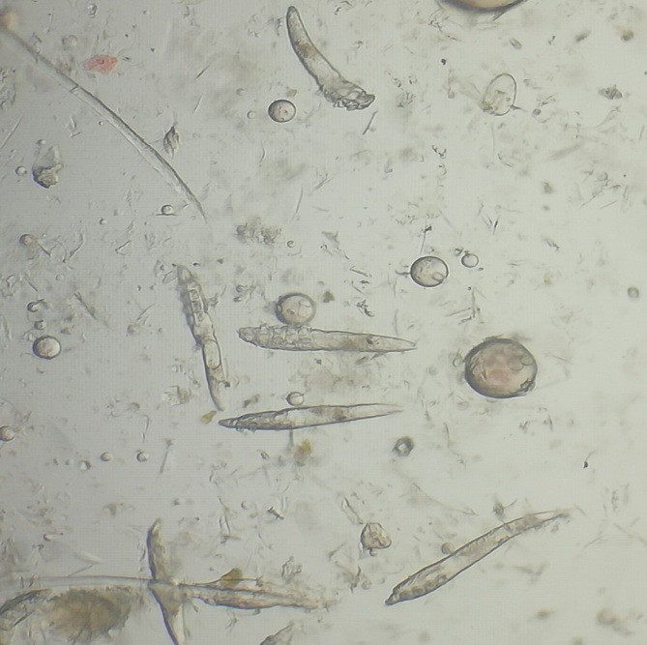 | 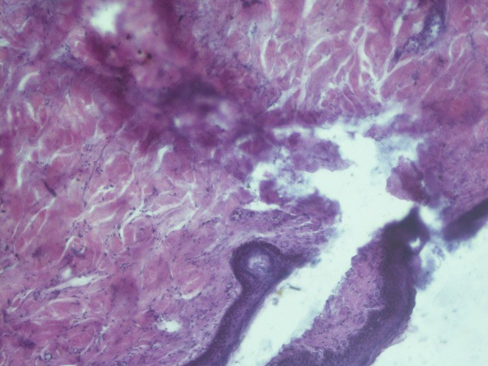
Figure 1 Demodex mite | Figure 2 Desquamation and degeneration of external root sheath cells with pigment  deposition.100x
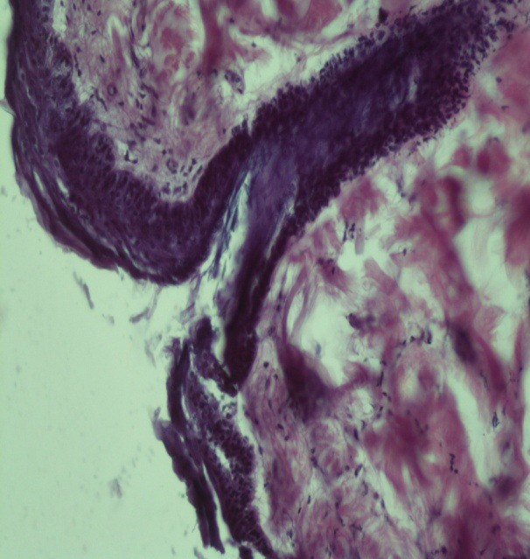 | 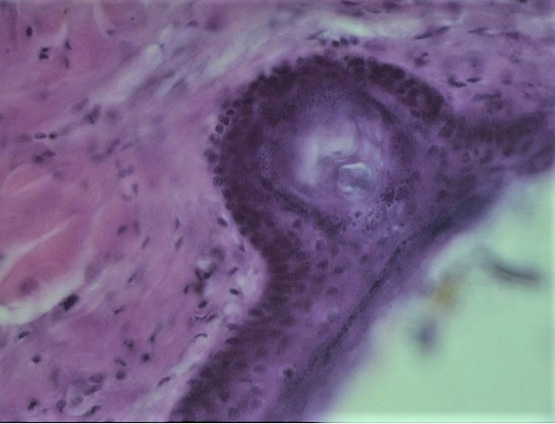
Figure 3 The hair follicle was necrotic, markedly distended and filled with keratin, debris, purulent material in hair follicles.200x | Figure 4 Cross section of mite in epidermis, dark pigmented granules as hyperpigmentation 400x

CONCLUSION
Canine demodicosis is associated with multi-systemic alterations that extend well beyond the integument. Haematologically, affected dogs consistently show anaemia, leucocytosis with neutrophilia and eosinophilia, and lymphopenia. Serum biochemistry reveals hypoproteinaemia, hypoalbuminaemia, hyperglobulinaemia, hypoglycaemia, and elevated hepatic enzymes (ALT and AST), while mineral analysis demonstrates significantly decreased serum zinc, copper and iron levels. Histopathologically, characteristic findings include distended, necrotic hair follicles packed with Demodex mite cross-sections, keratin and purulent debris, accompanied by perilesional hyperpigmentation and follicular degeneration. PAS staining provided valuable supplementary evidence by highlighting mite cuticle and follicular basement membrane changes. These comprehensive clinico-pathological findings collectively establish that a thorough haemato-biochemical and histopathological workup is imperative for the accurate diagnosis, severity assessment, and rational therapeutic management of canine demodicosis.

Ethical Approval and Owner Consent:

All procedures involving animals in this study were performed in accordance with the ethical guidelines of the Institutional Animal Ethics Committee (IAEC) of the College of Veterinary and Animal Science, Rajasthan University of Veterinary and Animal Sciences, Bikaner, Rajasthan, India. Prior to inclusion of each clinical case in the study, written informed consent was obtained from the owner of each animal.

Disclaimer (Artificial intelligence)

Author(s) hereby declare that NO generative AI technologies such as Large Language Models (ChatGPT, COPILOT, etc.) and text-to-image generators have been used during the writing or editing of this manuscript.

REFERENCES
- Arora, N., Vohra, S., Singh, S., Potliya, S., Lather, A., Gupta, A., Arora, D., & Singh, D. (2013). Therapeutic management of chronic generalized demodicosis in a pug. Advances in Animal and Veterinary Sciences, 1(2), 26–28.
- Ballari, S., Balachandran, C., George, V. T., & Manohar, B. M. (2009). Pathology of canine demodicosis. Journal of Veterinary Parasitology, 23(2), 179–182.
- Beale, K. M. (2022). Updates in the management of canine demodicosis. Veterinary Clinics of North America: Small Animal Practice, 52(1), 213–228. https://doi.org/10.1016/j.cvsm.2021.09.007
- Beigh, S. A., Soodan, J. S., Singh, R., & Khan, A. M. (2013). Trace minerals status and antioxidative enzyme activity in dogs with generalized demodecosis. Veterinary Parasitology, 198(1-2), 180–186.
- Chakraborty, S., & Pradhan, N. R. (2015). Canine demodicosis and its herbal and nonherbal treatments. Indian Journal of Canine Practice, 7(2), 115.
- Dadhich, H., & Khanna, R. (2008). Pathological, haemato-biochemical and immunological studies of cutaneous ectoparasitoses in dogs. Measurement, 40, 58–65.
- Dimri, U., Ranjan, R., Kumar, N., Sharma, M. C., Swarup, D., Sharma, B., & Kataria, M. (2008). Changes in oxidative stress indices, zinc and copper concentrations in blood in canine demodicosis. Veterinary Parasitology, 154(1-2), 98–102.
- Dimri, U., Sharma, M. C., Dwivedi, P., & Sharma, B. (2006). Clinico-pathological changes in canine demodicosis with particular reference to Dectomax therapy. Indian Journal of Veterinary Pathology, 30(1), 13–15.
- Drury, P. A. B., & Wallington, E. A. (1980). Carleton’s histological technique (5th ed.). Oxford University Press.
- Fondati, A., De Lucia, M., Furiani, N., Monaco, M., Ordeix, L., & Scarampella, F. (2010). Prevalence of Demodex canis-positive healthy dogs at trichoscopy. Veterinary Dermatology, 21(2), 146–151. https://doi.org/10.1111/j.1365-3164.2009.00805.x
- González, F. H. D., & del Prado, C. T. (2020). Veterinary clinical biochemistry: Reference values and interpretation (2nd ed.). Elsevier Saunders.
- Gross, T. L., Ihrke, P. J., Walder, E. J., & Affolter, V. K. (2005). Skin diseases of the dog and cat: Clinical and histopathologic diagnosis (2nd ed.). Blackwell Science.
- Gross, T. L., Ihrke, P. J., Walder, E. J., & Affolter, V. K. (2020). Histopathology of skin diseases in the dog and cat (3rd ed.). Wiley-Blackwell.
- Gupta, A. (2008). Investigation on dietary and environmental components vis-à-vis skin health in dogs [Doctoral dissertation, CSKHPKV, Palampur].
- Haleem, M. M. A., Salib, F. A., & Farag, H. S. (2015). Evaluation of haematological parameters, biochemical parameters and thyroxin level in dogs with generalized demodicosis. Global Veterinarian, 15(1), 133–136.
- Hillier, A., & Desch, C. E. (2002). Large-bodied Demodex mite infestation in 4 dogs. Journal of the American Veterinary Medical Association, 220(5), 623–627. https://doi.org/10.2460/javma.2002.220.623
- Janus, A., Tresamol, P. V., Mercey, K. A., Habeeb, B. P., & Shameem, H. (2014). A study on clinical and haematobiochemical parameters in canine demodicosis. Indian Journal of Canine Practice, 6, 92–94.
- Jyotsna, P., Maiti, S. K., Sanyal, P. K., & Tiwari, S. P. (2005). Haematobiochemical and mineral profiles in generalised canine demodicosis. Intas Polivet, 6(2), 331–334.
- Kaneko, J. J., Harvey, J. W., & Bruss, M. L. (1997). Clinical biochemistry of domestic animals (5th ed.). Academic Press.
- Kaneko, J. J., Harvey, J. W., & Bruss, M. L. (2008). Clinical biochemistry of domestic animals (6th ed.). Academic Press.
- Klassing, G. C. (1998). Nutritional aspects of leukocytic cytokines. Journal of Nutrition, 118, 1435–1443.
- Kolmer, J. A., Spandling, E. H., & Robinson, H. W. (1951). Applied laboratory technique (5th ed.). Appleton Century Craft Inc.
- Kumar, A., Das, A. K., Sinha, M., Arya, S. K. D., Kumar, A., & Kumar, B. (2018). Study on the prevalence of demodectic mange in dogs in and around Patna. International Journal of Current Microbiology and Applied Sciences, 7, 4216–4221.
- Luna, L. G. (1968). Manual of histologic staining methods of Armed Forces Institute of Pathology (3rd ed.). McGraw-Hill Book Company.
- Mueller, R. S. (2008). Demodicosis: A frequent problem in the dog. In Proceedings of the 33rd World Small Animal Veterinary Congress. Dublin, Ireland.
- Mueller, R. S., Bensignor, E., Ferrer, L., Holm, B., Lemarie, S., Paradis, M., & Shipstone, M. A. (2012). Treatment of demodicosis in dogs: 2011 clinical practice guidelines. Veterinary Dermatology, 23(2), 86–e21. https://doi.org/10.1111/j.1365-3164.2011.01026.x
- Muller, G. H., & Kirk, R. W. (1969). Small animal dermatology (2nd ed.). W. B. Saunders Co.
- Nair, S. S., & Nauriyal, D. S. (2007). Diagnostic significance of haematological changes associated with various canine dermatoses. Intas Polivet, 8(1), 68–72.
- Nath, N., Chari, S. N., & Rath, A. B. (1984). Superoxide dismutase in diabetic polymorphonuclear leukocytes. Diabetes, 33, 586–589.
- Nesbitt, G. H. (1983). Canine and feline dermatology: A systematic approach. Lea and Febiger.
- Oludunsin, F. O., Emmanuel, O., Olayide, A. J., Augustine, O. O., Jokotola, A. O., Tolulope, O. S., & Simon, S. (2014). Death of a four-year-old German shepherd dog due to Demodex canis in Ibadan, Southwest Nigeria: A case report. Research, 1, 887.
- Pradhan, N. R., Chatterjee, S., & Lodh, C. (2012). Demodicosis in dogs and its therapeutic management. Indian Journal of Canine Practice, 4(1), 44–48.
- Prasad, A. S. (2008). Zinc in human health: Effect of zinc on immune cells. Molecular Medicine, 14(5–6), 353–357. https://doi.org/10.2119/2008-00033.Prasad
- Reddy, B. S., Kumari, K. N., Sivajothi, S., & Venkatasivakumar, R. (2014). Dermatitis due to mixed Demodex and Sarcoptes mites in dogs. Case Reports in Veterinary Medicine, 2014, 1-4.
- Sakina, A., Mandial, R. K., & Mudasir, Q. (2012). Haematobiochemical changes in canine demodecosis. Vet Scan, 7, 75–78.
- Scott, D. W., Miller, W. H., & Griffin, C. E. (2001). Muller and Kirk’s small animal dermatology (6th ed.). WB Saunders.
- Singh, S. K., Dimri, U., Sharma, M. C., Swarup, D., Sharma, B., Pandey, H. O., & Kumari, P. (2011). The role of apoptosis in immunosuppression of dogs with demodicosis. Veterinary Immunology and Immunopathology, 144, 487–492.
- Snedecor, G. W., & Cochran, W. G. (1968). Statistical methods (6th ed.). Oxford and IBH Publishing Co.
- Solanki, J. B., Hasnani, J. J., Panchal, K. M., Naurial, D. S., & Patel, P. V. (2011). Histopathological changes in canine demodicosis. Haryana Veterinarian, 50, 57–60.
- Sousa, C. A. (1995). Feline demodicosis and the use of PAS staining in dermatopathology. Seminars in Veterinary Medicine and Surgery (Small Animal), 10(3), 166–171.
- Srikala, D., Satish, K. K., Amruth, K. V. V. V., Nagaraj, P., Ayodhya, S., & Rao, T. (2010). Management of mixed infestation of malasseziosis and demodicosis in dogs. Intas Polivet, 11(1), 74–76.
- Suttle, N. F. (2022). Mineral nutrition of livestock (5th ed.). CABI Publishing.
- Thrall, M. A., Weiser, G., Allison, R. W., & Campbell, T. W. (2022). Veterinary hematology and clinical chemistry (3rd ed.). Wiley-Blackwell.
- Weiss, D. J., & Wardrop, K. J. (2010). Schalm's veterinary hematology (6th ed.). Wiley-Blackwell.
- Wilkinson, G. T., & Harvey, R. G. (1994). Color atlas of small animal dermatology: A guide to diagnosis (2nd ed.). Mosby-Wolfe Publishers.

