Original Research Article

Economic Viability of Organic vegetable cultivation through Vermicompost Integration

ABSTRACT

This study assesses the economic viability of organic cultivation integrated with on-farm vermicompost production at the farm level. The experiment was conducted during the Rabi season of 2025-2026 at the College of Horticulture, Chinalataripi, Andhra Pradesh, on a 784 m² area. A vermicomposting unit of 150 m², utilizing Elucina foetida sps. and locally available organic residues, produced 1,000 kg of vermicompost within six months at a cost of Rs.11,000. The compost was valued at Rs.10 per kg, contributing to additional farm income. Simultaneously, nineteen vegetable crops representing diverse groups were cultivated mainly with organic inputs. The total cost of cultivation was Rs.2,830, generating a gross return of Rs.22,000 and a net income of Rs.19,170, with a benefit-cost ratio of 1:7.77. Integration of vermicompost production with crop cultivation resulted in a combined net income of Rs. 28,170 per season. The findings demonstrate that vermicompost-integrated organic farming is a financially viable and sustainable production system for small-scale horticultural enterprises.
Keywords: Vermicomposts, Benefit-Cost ratio, Sustainable production, Organic Farming, Soil fertility

INTRODUCTION
Organic farming is gaining prominence as a sustainable alternative to conventional agriculture, particularly in India where small and marginal farmers constitute a major share of the farming community. Recent studies have highlighted that integrated organic farming systems improve soil health, biodiversity, and long-term sustainability while reducing dependence on synthetic inputs The rising demand for residue-free food and the need for sustainable production systems have encouraged the adoption of eco-friendly organic farming practices (Reganold and Wachter, 2016; Folina et al., 2025).
Among organic inputs, vermicompost has gained importance as a nutrient-rich organic amendment that enhances soil fertility, improves crop productivity, and reduces dependence on synthetic fertilizers. It is produced through the decomposition of organic materials by earthworms, particularly Eisenia foetida, which efficiently converts organic waste into valuable compost (Edwards and Bohlen, 1996; Dominguez et al., 1997). Recent studies further indicate that vermicompost enhances nutrient availability, microbial activity, and sustainable vegetable production systems (Mohite et al., 2024; Sharma et al., 2024). Additionally, neem-based inputs provide effective and environmentally safe pest management (Schmutterer, 1990).
Integrating vermicompost production with organic crop cultivation offers both economic and ecological benefits. It reduces dependence on external inputs while generating additional income through compost sales. In this context, the present study was conducted in Andhra Pradesh to assess the cost-effectiveness and profitability of vermicompost-integrated organic vegetable production under field conditions, aiming to promote it as a sustainable livelihood option.
Therefore, the present study was undertaken to evaluate the profitability and sustainability of organic vegetable cultivation through on-farm vermicompost integration under chemical-free production practices.
MATERIALS AND METHODS
2.1 Study Location and Experimental Setup
The experiment was carried out during the Rabi season (October 2023 to February 2024) at the instructional farm of the College of Horticulture, Chinalataripi, located in Oguru village of Prakasam District, Andhra Pradesh. The study was conducted on a total area of 784 m² (28 × 28 m). This region falls under the Southern Agro-climatic zone of Andhra Pradesh and is characterized by a semi-arid climate, moderate rainfall, and well-drained red sandy loam soils, which are well suited for vegetable cultivation under organic farming. The Physico-chemical properties of the soil are given in the below table

Table 1: The Physico-chemical properties of the soil
S.No | Particulars | Details
1. | pH | 7.2
2. | EC | 1.08
3. | Organic Carbon (%) | 0.57
4. | N (Kg/ha) | 350
5. | P2O5(Kg/ha) | 15
6. | K2O(Kg/ha) | 390
The entire study was conducted under strictly organic conditions. No chemical fertilizers or synthetic pesticides were applied at any stage, ensuring that the production system remained completely eco-friendly and aligned with organic farming principles.

2.2 Vermicompost Unit - Establishment and Management
An on-farm vermicomposting unit was established within the college farm to serve as the primary source of organic nutrients for crop production. The unit covered an area of 15 m × 10 m (150 m²) and consisted of six beds, each measuring 4 m × 2.5 m. The beds were arranged to ensure proper aeration, maintain adequate moisture, and allow easy management during routine operations. The earthworm species Elucina foetida was used due to its efficiency in decomposing organic matter and its adaptability to different organic materials. Earthworm-derived vermiproducts are increasingly recognized for their role in sustainable nutrient recycling and eco-friendly agriculture (Ganapathy et al., 2025).
Locally available inputs such as crop residues, vegetable waste, and dried sticks were used as raw materials, which helped minimize input costs. These materials were layered systematically to maintain <20:1 carbon-to-nitrogen ratio, supporting efficient decomposition and active worm performance. Moisture levels were maintained at around 60 to 70 percent through regular watering, and partial shade was provided to regulate temperature. Over a period of six months, the unit produced approximately 1,000 kg of nutrient-rich vermicompost.

Table 2: Vermicompost Unit – Establishment and Economic Details
S.No | Particulars | Detail
1 | Area of Unit | 15 m × 10 m (150 m²)
2 | Number of Beds | 6 beds (each 4 m × 2.5 m)
3 | Worm Species | Elucina foetida (Red earthworms)
4 | Raw Materials | Crop residues, Vegetable waste, Dried sticks
5 | Production per 6-month cycle | 1,000 kg
6 | Cost of Establishment | Rs. 85,000
7 | Total Cost of Production | Rs. 11,000
8 | Selling Price | Rs. 10 per kg
9 | Annual Income from Sales | Rs. 20,000

2.3 Crop Selection and Layout
A total of nineteen vegetable crops were selected and cultivated across five major groups to ensure diversity and efficient use of the available area. These included cucurbits (bitter gourd, ridge gourd, bottle gourd, and cucumber), solanaceous crops (tomato, brinjal, bhendi, and chilli), leafy vegetables (fenugreek, amaranthus, coriander, palak, roselle, and green sorrel), tuber crops (carrot and radish), and legumes (cluster beans). All crops were systematically arranged within the 784 m² experimental plot to optimize space utilization, enhance crop diversity, and improve overall farm income (Table 2).
Table 3: Crop Groups, Species Cultivated, and Area Allocation in the 784 m² Organic Field
S.No | Crop Group | Crops Grown | Plot Area (m²) | % of Total Area
1 | Cucurbits | Bitter gourd, Ridge gourd, Bottle gourd, Cucumber | 196 | 25.0
2 | Tuber Crops | Carrot, Radish | 56 | 7.1
3 | Leafy Vegetables | Fenugreek, Amaranthus, Coriander, Palak, Roselle, Green Sorrel | 168 | 21.4
4 | Solanaceous Crops | Tomato, Brinjal, Bhendi (Okra), Chilli | 224 | 28.6
5 | Legumes | Clusterbeans | 84 | 10.7
6 | Border/Filler | Miscellaneous | 56 | 7.2
 | Total |  | 784 | 100

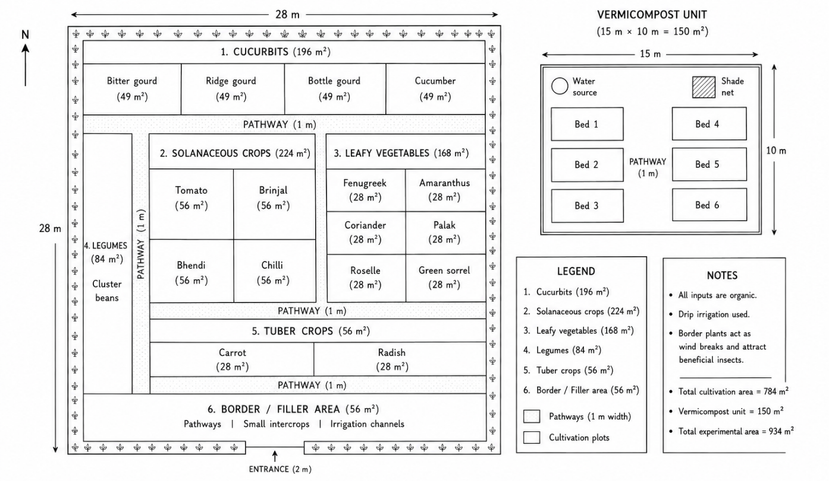
Fig 1 Layout of Vermicompost-Integrated organic vegetable cultivation system (934m² experimental area)
2.4 Organic Input Management
The experiment was carried out under a completely organic input regime, with no use of chemical fertilizers or synthetic pesticides at any stage. Nutrient and pest management relied on a combination of vermicompost (200 kg at ₹4/kg), farmyard manure (300 kg at ₹1.50/kg), neem oil 3% solution (2 L at ₹90/L) as a bio-pesticide, and neem cake (10 kg at ₹20/kg) applied as both a soil amendment and pest deterrent. In addition, polyethylene mulch was used to conserve soil moisture and effectively suppress weed growth. The detailed cost distribution of all organic inputs is provided in Table 3.
Table 4: External Organic Input Details, Quantities Applied, and Cost Breakdown for the 784 m² Field (Vermicompost Excluded as On-farm Produced)
S.No | Input Category | Input / Item | Quantity | Unit Cost (Rs.) | Total Cost (Rs.)
1 | Organic Input | Farm Yard Manure (FYM) | 300 kg | 1.50/kg | 450
2 | Bio-pesticide | Neem oil (3% solution) | 2 L | 90.00/L | 180
3 | Soil Amendment | Neem cake | 10 kg | 20.00/kg | 200
4 | Mulching | Polyethylene mulch (black) | 1 roll | 400.00 | 400
5 | Seeds & Seedlings | All crops combined | — | — | 1,600
 |  | Total External Input Cost |  |  | 2,830
Note: Vermicompost (200 kg) was produced on-farm and applied at no external cost to the crop enterprise.

2.5 Economic Parameters
The following economic parameters were computed to assess the financial performance of the vermicompost-integrated organic cultivation system (Palaniswamy and Gomez, 2001):
(i) Gross Income = Σ (Quantity Harvested × Prevailing Local Market Price) for each crop group
(ii) Net Profit = Gross Income − Total Input Cost
(iii) Benefit-Cost Ratio (BCR) = Gross Income / Total Input Cost
(iv) Return on Investment [ROI (%)] = (Net Profit / Total Input Cost) × 100
(v) Net Income per m² = Net Profit / Total Cultivable Area (784 m²)
Market prices used were prevailing local wholesale and retail prices recorded at Prakasam District markets during respective harvest windows, cross-verified against the Agmarknet portal for the corresponding period.
RESULTS AND DISCUSSION

3.1 Vermicompost Production and Economic Analysis
The on-farm vermicompost unit, developed over an area of 50 m² with six beds, efficiently generated 1,000 kg of high-quality vermicompost within a six-month production period. Utilization of readily available farm wastes such as crop residues, vegetable discards, and dried plant materials substantially minimized the cost of raw materials. The total expenditure incurred was Rs. 11,000, while the gross return from vermicompost sales reached Rs. 20,000, resulting in a net profit of Rs. 9,000. The benefit–cost ratio was calculated to be 1:1.82, indicating strong economic viability. These results align with earlier reports by Sinha et al. (2010), who highlighted the income-generating potential of vermicomposting when based on locally sourced organic inputs.
The vermicompost obtained was rich in readily available macro- and micronutrients, beneficial microbial populations, and plant growth-promoting substances, which contributed to improved soil fertility and crop performance. Similar findings have been reported in recent studies on vermicompost-based vegetable production systems (Mohite et al., 2024; Toor et al., 2024). The application of 200 kg of vermicompost over 784 m² as a basal dose was sufficient to meet the nutritional requirements of various vegetable crops grown during the Rabi season, thereby completely eliminating the need for chemical fertilizers.

3.2 Yield and Income by Crop Group
The 784 m² organic field produced 697 bunches of leafy vegetables and 264.71 kg of other vegetables over the Rabi season, generating a total gross income of Rs. 22,000. Table 4 presents the crop-group-wise yield, price, and income contribution.
Table 5: Crop-Group-wise Yield, Unit Price, Gross Income, and Income Share from the 784 m² Organic Field
S.No | Produce Category | Qty. Harvested | Unit Price (Rs.) | Gross Income (Rs.) | % of Income
1 | Leafy Vegetables | 697 bunches | 15/bunch | 10,455 | 47.5
2 | Solanaceous Vegetables | 126.21 kg | 35/kg | 4,417 | 20.1
3 | Cucurbits (Gourds) | 98.5 kg | 22/kg | 2,167 | 9.9
4 | Legumes | 40.00 kg | 28/kg | 1,120 | 5.1
5 | Tuber Crops | 28.00 kg | 30/kg | 841 | 3.8
6 | Others | — | — | 3,000 | 13.6
 | Total |  |  | 22,000 | 100
Leafy vegetables contributed the highest income share of 47.5% (Rs. 10,455) from just 21.4% of plot area, demonstrating their exceptional economic efficiency in integrated organic systems. These findings are consistent with Altieri (1999), who emphasized that multi-crop diversity in small-scale farming systems maximizes economic returns per unit area while reducing pest and disease pressure through ecological balance. The exclusive use of neem oil and neem cake for pest management proved effective in maintaining crop health without any synthetic pesticide inputs (Schmutterer, 1990).

3.3 Economic Performance of the Integrated Organic System
The overall economic performance of the fully organic vegetable production system integrated with vermicomposting is summarized in Table 5.
A benefit–cost ratio of 1:7.77 observed in crop cultivation using only externally sourced organic inputs indicates that every rupee invested generated Rs. 7.77 as gross returns, reflecting an impressive return on investment of 677.4%. As the vermicompost used in the system was produced within the farm and applied without any additional purchase cost, excluding it from the input expenses provides a clearer picture of the economic efficiency of such integrated organic systems. By combining the net income from vermicompost sales (Rs. 9,000) with the net profit from crop production (Rs. 19,170), the total net income from the integrated approach reaches Rs. 28,170 over a Rabi season lasting 4.5 months. These findings are consistent with earlier studies by Lazcano et al. (2008) and Palaniswamy and Gomez (2001), while recent studies also confirm that integrated vermicompost-based systems improve economic sustainability and resource-use efficiency in organic agriculture (Mohite et al., 2024; Folina et al., 2025).

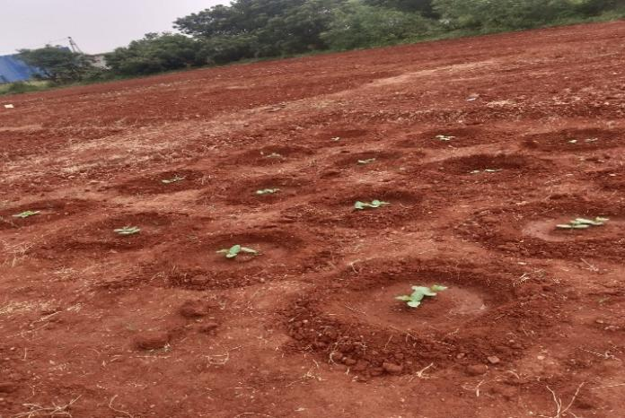
Picture 1. Vegetable cultivation under organic farming
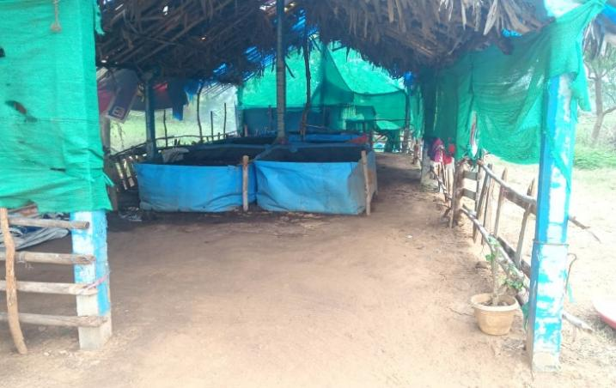
Picture 2. Vermicomposting Beds
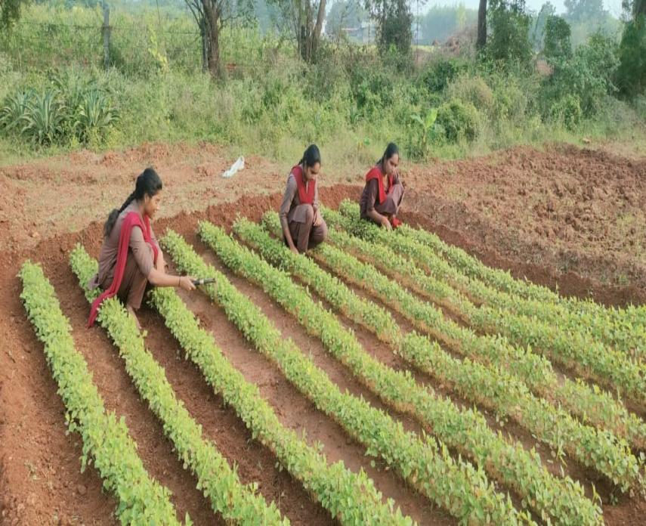

Picture 3. Leafy vegetable cultivation under organic farming

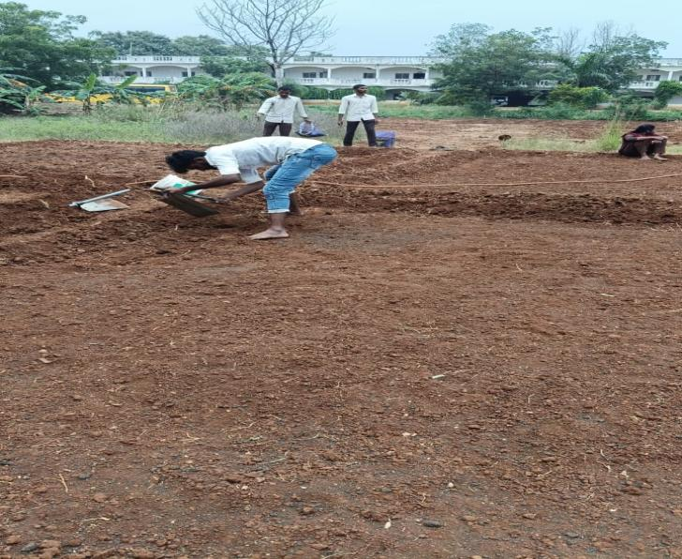
Picture 4. Land preparation
Table 6: Economic Summary of Vermicompost-Integrated Organic Vegetable Cultivation on 784 m² (Rabi Season, 4.5 Months)
S.No | Economic Parameter | Value
1 | Total External Input Cost (Crop Cultivation) | Rs. 2,830
2 | Gross Income from Sale of Produce | Rs. 22,000
3 | Net Profit from Crop Cultivation | Rs. 19,170
4 | Benefit-Cost Ratio (BCR) | 1 : 7.77
5 | Return on Investment – ROI (%) | 677.4 %
6 | Net Income per m² (per season) | Rs. 24.45 / m²
7 | Vermicompost Unit – Annual Income | Rs. 20,000
8 | Vermicompost Unit – Production Cost | Rs. 11,000
9 | Net Profit from Vermicompost | Rs. 9,000
10 | Combined Total Net Income (Crop + Vermicompost) | Rs. 28,170
11 | Duration of Experiment | 4.5 months (Rabi season)
When these outcomes are scaled up, a farmer adopting a similar fully organic production model on one acre (4,047 m²) could potentially realize a net crop income of about Rs. 98,990 per season. This clearly indicates that the model is not only profitable at a small scale but also suitable for expansion, making it a viable option for smallholder farmers in Andhra Pradesh and comparable agro-climatic regions.
3.4 Projection of Economic Parameters: 784 m² vs 1 Acre (4,047 m²)
To evaluate the scalability and field-level relevance of the vermicompost-integrated organic farming system for smallholder farmers, the economic data generated from the 934 m² experimental setup (comprising 784 m² under vegetable cultivation and a 150 m² vermicompost unit) were projected to a one-acre area (4,047 m²). In this assessment, the vermicompost unit was maintained at a constant size of 150 m² with six beds and a production capacity of 1,000 kg over a six-month period. The remaining 3,897 m² was designated for vegetable cultivation, applying a scaling factor of 4.97 (3,897 ÷ 784). A comparison of the major economic indicators between the experimental scale and the projected one-acre model is provided in Table 6.
Table 7: Comparison of Economic Parameters between Experimental Plot (934 m²) and Projected 1 Acre (4,047 m²) Scale
S.No | Economic Parameter | 934 m² (784 m² + 150 m²) | 1 Acre (4,047 m²)
1 | Area — Vegetable Cultivation | 784 m² | 3,897 m²
2 | Area — Vermicompost Unit | 150 m² | 150 m² (Fixed)
3 | Total Area | 934 m² | 4,047 m² (1 Acre)
4 | Total External Input Cost | Rs. 2,830 | Rs. 14,063
5 | Gross Income from Crop Sale | Rs. 22,000 | Rs. 1,09,340
6 | Net Profit from Crop | Rs. 19,170 | Rs. 95,277
7 | Benefit-Cost Ratio (BCR) | 1 : 7.77 | 1 : 7.77
8 | Return on Investment (ROI %) | 677.4 % | 677.4 %
9 | Net Income per m² (Crop) | Rs. 24.45 | Rs. 24.45
10 | Vermicompost Beds | 6 beds | 6 beds (Fixed)
11 | Vermicompost Production (6 months) | 1,000 kg | 1,000 kg (Fixed)
12 | Vermicompost Production Cost | Rs. 11,000 | Rs. 11,000 (Fixed)
13 | Vermicompost Income (Annual) | Rs. 20,000 | Rs. 20,000 (Fixed)
14 | Net Profit from Vermicompost | Rs. 9,000 | Rs. 9,000 (Fixed)
15 | Combined Net Income (Crop + Vermicompost) | Rs. 28,170 | Rs. 1,04,277
The projected results clearly indicate that the model is economically scalable. A farmer cultivating organic vegetables on 3,897 m² within a one-acre system, while maintaining a fixed vermicompost unit of 150 m², can achieve a gross crop return of about Rs. 1,09,340 per season with an external input cost of only Rs. 14,063, resulting in a net crop income of Rs. 95,277. When the steady net return of Rs. 9,000 from the vermicompost unit is included, the total net income increases to Rs. 1,04,277 for a 4.5-month Rabi season. This corresponds to an approximate annual income of Rs. 2,08,554 when two cropping seasons are considered.
Notably, the vermicompost unit remains constant at 150 m² across both scales; therefore, its production (1,000 kg), cost (Rs. 11,000), and gross income (Rs. 20,000) do not vary with changes in total farm size. The benefit–cost ratio of 1:7.77 and a return on investment of 677.4% are also maintained at both levels, indicating that the economic efficiency of the integrated organic farming system is not influenced by scale. These observations are in line with earlier findings by Altieri (1999) and Sinha et al. (2010), who emphasized that organic systems supported by on-farm input generation, such as vermicomposting, can deliver higher economic returns by reducing dependence on external inputs.

CONCLUSION
The findings of this study demonstrate that a fully organic vegetable production system integrated with on-farm vermicompost generation is both economically viable and environmentally sustainable. The system yielded high returns with a strong benefit–cost ratio and return on investment, while minimizing dependence on external inputs through in-situ vermicompost production. The consistent economic performance observed at both experimental and projected scales confirms the scalability and replicability of the model for smallholder farming systems.
In addition to enhanced profitability, the complete avoidance of synthetic fertilizers and pesticides supports the production of safe, residue-free vegetables and contributes to long-term soil health. The effective use of Elucina foetida and locally available organic residues further strengthens the feasibility of this low-cost approach. Recent scientific evidence further supports the role of vermicompost and integrated organic nutrient management in improving soil quality, crop productivity, and environmental sustainability in vegetable-based farming systems (Pan et al., 2025; Ganapathy et al., 2025).
The organic vegetable cultivation system in this study is in accordance with several government initiatives, including the Paramparagat Krishi Vikas Yojana (PKVY), the National Mission on Natural Farming (NMNF), and micro-irrigation promotion schemes, underscoring its significance for sustainable horticultural advancement.
LIMITATIONS
- Flucuations in market price
- Lack of Awarness
- Availability of Labour/Skilled Labour
- Lack of Training Programmes on Organic farming
- Poor maintenance & management
- Low range of adoption

Disclaimer (Artificial intelligence)

Author(s) hereby declare that NO generative AI technologies such as Large Language Models (ChatGPT, COPILOT, etc.) and text-to-image generators have been used during the writing or editing of this manuscript.

REFERENCES
- Altieri, M.A. (1999). The ecological role of biodiversity in agroecosystems. Agriculture, Ecosystems and Environment, 74(1–3): 19–31.
- Directorate of Horticulture, Andhra Pradesh (2022). Annual Report on Horticulture Statistics 2021–22. Government of Andhra Pradesh, Amaravati.
- Dominguez, J., Edwards, C.A. and Subler, S. (1997). A comparison of vermicomposting and composting. BioCycle, 38(4): 57–59.
- Edwards, C.A. and Bohlen, P.J. (1996). Biology and Ecology of Earthworms (3rd ed.). Chapman and Hall, London.
- Folina, A., Kakabouki, I., Baginetas, K. and Bilalis, D. (2025). Integration of bioresources for sustainable development in organic farming: A comprehensive review. Resources, 14(7): 102.
- Ganapathy, N.R.V., Elango, A.C., Balaji, G. and Sharma, M. (2025). A comprehensive review of earthworm-derived vermiproducts and their role in sustainable agriculture. Discover Applied Sciences, 7: 995.
- Lazcano, C., Arnold, J., Tato, A., Zaller, J.G. and Dominguez, J. (2008). Compost and vermicompost as nursery pot components: effects on tomato plant growth and morphology. Spanish Journal of Agricultural Research, 7(4): 944–951.
- Mohite, D.D., Chavan, S.S., Jadhav, V.S., Kanase, T. and Singh, A.S. (2024). Vermicomposting: a holistic approach for sustainable crop production, nutrient-rich bio fertilizer, and environmental restoration. Discover Sustainability, 5: 60.
- National Horticulture Board (NHB) (2022–23). Indian Horticulture Database 2022–23. Ministry of Agriculture and Farmers Welfare, Government of India, Gurugram.
- Palaniswamy, K.M. and Gomez, K.A. (2001). Integrated farming systems for small farms. Indian Journal of Agronomy, 46(2): 210–218.
- Pan, F., Zhang, J., Tang, J. and Chen, B. (2025). Soil aggregate and organic nitrogen distributions as influenced by vermicompost application in vegetable greenhouse. Scientific Reports, 15: 22407.
- Reganold, J. P., & Wachter, J. M. (2016). Organic agriculture in the twenty-first century. Nature Plants, 2, 15221. https://doi.org/10.1038/nplants.2015.221
- Schmutterer, H. (1990). Properties and potential of natural pesticides from the neem tree, Azadirachta indica. Annual Review of Entomology, 35: 271–297.
- Toor, M.D., Ay, A., Ullah, I., Demirkaya, S. and Jamal, A. (2024). Vermicompost rate effects on soil fertility and morpho-physio-biochemical traits of lettuce. Horticulturae, 10(4): 418.
- Sinha, R.K., Agarwal, S., Chauhan, K. and Valani, D. (2010). The wonders of earthworms and its vermicompost in farm production. Agricultural Sciences, 1(2): 76–94.

