Enhancing Banana Yield and Profitability Through Bunch Skirting

Abstract
Banana (Musa spp.) is a vital horticultural crop, yet achieving premium market quality remains a challenge due to biotic and abiotic stresses during bunch development. This study evaluates the multi-dimensional impact of bunch skirting technology through Front Line Demonstrations (FLDs) conducted over three consecutive years (2022-2023 to 2024-25) across various villages. The primary objective was to assess the technology against traditional farmer practices (control) by measuring agronomic improvements, economic viability, and the efficacy of FLDs as an extension methodology for accelerating technology adoption. Data from 39 participating farmers (13 per year) were analyzed.
Agronomic results indicated a consistent and statistically significant improvement in fruit girth and overall yield. In 2022-23, the average yield per hectare increased by 13.16%, with similar sustained growth in subsequent years. Economically, despite an additional expenditure of Rs. 54,450/ha for skirting bags, the intervention yielded a substantially higher average Benefit-Cost (B:C) ratio compared to the control, culminating in a B:C ratio of 2.78 in 2024-25. The Incremental Cost-Benefit Ratio (ICBR) proved the investment highly lucrative. Furthermore, the extension analysis revealed that the technology significantly reduced yield variability among farmers, mitigating perceived financial risks. The sustained positive outcomes across diverse geographical micro-climates within the study area underscore skirting as a highly profitable intervention and validate the participatory FLD model for bridging the lab-to-land gap in agricultural technology.
Key words: Bunch Skirting, Banana (Musa spp.), Field Level Demonstration (FLD), Cost- Benefit Ratio, Yield Enhancement

1. Introduction
The global agricultural landscape places a high premium on not just the total volume of crop yield, but the aesthetic and physiological quality of the produce. Banana (Musa sapientum) is an important fruit crop globally, and its commercial viability is heavily dependent on the visual appeal and size of the individual fingers. While India leads the world in banana production, accounting for around 18% of the worldwide crop of 139 million metric tonnes, its exports remain minimal for various quality-related reasons. In highly competitive export markets and local supermarkets, the physical appearance of the peel including key attributes such as uniform colour, shape, size, and freedom from defects is crucial for ensuring repeat purchases (Hewett, 2006; Shewfelt, 2009).
However, in tropical and subtropical growing regions, banana bunches are continuously exposed to a myriad of biotic and abiotic stress factors during the long four to six months it takes for the fruits to ripen. Fluctuating extreme temperatures, wind-borne debris hitting the delicate outer skin, intense solar radiation leading to sunscald, and the abrasive rubbing of adjacent leaves and petioles frequently cause superficial blemishes and cellular damage (Anon, 2003). Furthermore, pre-harvest feeding by insect pests, such as various species of thrips and fruit scarring beetles (Colaspis hypochlora), as well as damage from birds and bats, are primarily responsible for severe peel degradation. These factors lead to a significant downgrade in fruit quality, ultimately resulting in severe economic losses for the cultivator in both domestic and export markets where quality standards are strict.
To mitigate these challenges, the physical protection of the developing fruit bunch is required. Bunch skirting the practice of covering the banana bunch with specialized polyethylene or woven bags shortly after the emergence of the last hand has been recognized as a highly effective micro climate engineering technique. The skirting bag serves a dual purpose. First, it acts as a mechanical barrier against insect vectors, bird feeding, dust, light hail, and mechanical abrasions caused by adjacent leaves, while also preventing agrochemical residues from settling directly on the fruit. Second, it creates a favourable microenvironment around the developing fruit (Fan and Mattheis, 1998). The modified internal atmosphere, characterized by retained humidity and elevated temperatures which can increase on average by 0.5°C (Ganry, 1975) and up to 7°C during the warmest hours (Soto, 2010) accelerates physiological development. This leads to an increase in fruit girth, length, and overall bunch weight, and can reduce the flower-to-harvest interval by 4 to 14 days. Furthermore, covers protect the fruit from winter chilling and temperatures below 12°C to 13°C, which otherwise cause unacceptable under-peel discolouration (Hailu et al., 2013; Snowden, 2010). By adopting this physical protection technique, more emphasis is placed on reducing the use of chemical pesticides, thereby ensuring worker safety and environmental protection (Sharma et al., 2009).
Despite the proven physiological benefits of bunch skirting in controlled research environments, widespread adoption among small and marginal farmers remains sluggish. This delayed adoption is primarily attributed to the initial capital investment required for the bags and the intensive labour associated with their application. While modern innovations like UV-stabilized polypropylene spun-bond non-woven fabrics allow for better air and moisture circulation, the upfront cost is still a barrier. Farmers inherently operate in a risk-averse framework; without localized, visible proof of financial returns, theoretical yield increases are insufficient drivers for behavioural change.
Consequently, agricultural extension systems utilize Field Level Demonstrations (FLDs) to bridge the technology transfer gap. FLDs are not merely experimental trials; they are participatory, on-farm educational tools designed to demonstrate the techno-economic viability of a new practice alongside traditional methods. Because bunch covering is laborious, its benefit-cost ratio must be rigorously investigated and proven in the field to promote the widespread adoption of the method (Thakare U.G and Ingle, P. O.,2007; U G Thakare.,2025)
This paper presents a comprehensive, three-year longitudinal study evaluating the impact of banana bunch skirting through FLDs. The study is uniquely structured to analyse the intervention through three distinct lenses:
- Agronomic Impact: Quantifying the physical improvements in fruit girth and crop yield.
- Techno-Economic Feasibility: Assessing the cost-effectiveness, net profitability, and return on investment.
- Extension Efficacy: Analysing the consistency of results across different farmers to evaluate the technology's scalability and risk-mitigation potential.

2. Materials and Methods

2.1 Study Area and Site Selection
The study was conducted over three consecutive agricultural years: 2022-2023, 2023-24, and 2024-25. To ensure the robustness of the data and eliminate bias from highly localized soil or micro-climatic anomalies, the demonstrations were distributed across multiple villages, including Dongargaon, Masa, Akoli, Bochara, Rajura, Hiwarkhed, Gordha, and Ruikhed. A total of 39 progressive farmers (13 farmers per academic year) were selected purposively based on their willingness to participate, active engagement in banana cultivation, and ability to maintain meticulous field records.

2.2 Experimental Design
The Front-Line Demonstrations were laid out in the farmers' fields, with each farmer's field serving as an independent experimental replicate (13 replicates per year, totaling 39 replicates over the three-year study). Each demonstration covered a total sector area of 0.4 hectares per farmer, which was divided equally into two 0.2-hectare treatment blocks to facilitate direct comparison:
T1 (Control Group): Cultivation based on prevailing traditional farmer practices, which notably excluded the use of any physical bunch protection or skirting.
T2 (Demonstration Group): Cultivation incorporating the recommended technology of bunch skirting bags. The bags were applied uniformly after the complete emergence of the bunch and the removal of the male bud (denavelling)
.

The bags were applied uniformly after the complete emergence of the bunch and the removal of the male bud (denavelling). To maintain statistical integrity, the plant population was strictly standardized at 3,630 plants per hectare across all demonstration and control plots. Consequently, each 0.2-hectare treatment block (T1 and T2) contained exactly 726 plants. The cost of the skirting bags was calculated at Rs. 15 per unit, resulting in a fixed additional expenditure of Rs. 54,450 per hectare for the T2 plots.

2.3 Data Collection and Statistical Analysis
Quantitative field data was recorded meticulously at the time of harvest.
- Agronomic Parameters: The primary physical metrics recorded were the average girth of the fruits (measured in centimeters at the middle finger of the second hand) and the total yield. Yield was calculated both on a per-plant basis (kg) and aggregated to a per-hectare basis (quintals).
- Economic Parameters: Detailed ledgers of the cost of cultivation (expenditure per hectare) were maintained. Upon market sale, the gross income was recorded. From these figures, the Net Income and the Benefit-Cost (B:C) ratio were derived.
Furthermore, to isolate the specific financial efficacy of the skirting bags, the Incremental Cost-Benefit Ratio (ICBR) was calculated using the following formula:
$$ICBR=\frac{ExpenditureT2​-ExpenditureT1}{Gross IncomeT2​-Gross IncomeT1​​}$$
- Statistical Analysis: To validate the agronomic improvements, the data was subjected to statistical evaluation. A paired Student's t-test was utilized to compare the means of the agronomic parameters (fruit girth and yield) between the control (T1) and demonstration (T2) treatments across the 39 replicates. Differences were considered statistically significant at a probability level of p < 0.05.

3. Results and Discussion
The findings of the three-year study are categorized into three distinct analytical approaches to fully comprehend the impact of the FLDs.

3.1 Approach 1: Agronomic and Quality Enhancements
The primary biological objective of bunch skirting is to optimize the physiological development of the fruit. The data collected over the three years demonstrates a decisive and consistent agronomic advantage in the plots utilizing skirting bags (T2) compared to the traditional farmer practices (T1).
Table 1 summarizes the core agronomic outputs. The most immediate indicator of fruit quality for market grading is fruit girth. In the 2022-23 season, the average fruit girth in the control plots was 9.50 cm. In the demonstration plots, the micro-climate modification provided by the bags increased the average girth to 12.50 cm a substantial improvement that pushes the produce into a premium pricing tier. This trend was sustained in subsequent years, with the 2022-23 data showing an increase from 11.03 cm to 12.69 cm, and the 2024-25 data showing an increase from 10.76 cm to 12.92 cm.
Table 1: Agronomic Performance and Yield Metrics (Three-Year Average)

Parameter | Treatment | 2022-23 | 2023-24 | 2024-25
Average Fruit Girth (cm) | T1 (Control) | 9.50 | 11.03 | 10.76
 | T2 (Skirting) | 12.50 | 12.69 | 12.92
 | Net Improvement (cm) | +3.00 | +1.66 | +2.16
Average Yield per ha (q) | T1 (Control) | 731.58 | 745.54 | 737.37
 | T2 (Skirting) | 827.91 | 829.31 | 844.73
 | Percentage Increase | 13.16% | 11.23% | 14.56%

The increase in physical dimensions directly translated into higher overall yields. The traditional practice yielded an average of 731.58 q/ha in the first year, whereas the skirting technology boosted this to 827.91 q/ha, representing a 13.16% yield increase. The physiological mechanism behind this is well-documented: the bags reduce the transpiration rate from the fruit surface, preventing moisture loss, while concurrently raising the ambient temperature around the bunch during cooler nights, which accelerates cellular expansion and starch accumulation.
Across all three years, the micro-climate modification provided by the bags substantially increased the average fruit girth and overall yield. This aligns with existing research by Weerasinghe and Ruwanpathirana (2002), which indicated that bunches developed in bunch covers are bigger, cleaner, more attractive, and maintain a dark green colour. Furthermore, fruits of bagged bunches show neither scratches nor blemishes, whereas those from uncovered bunches frequently suffer from physical injury (Weerasinghe and Ruwanpathirana, 2002). The physiological mechanism behind this yield enhancement is well-documented: the microclimate enhances physiological and metabolic activities (Johns and Scott, 1989), leading to larger partitioning of nutrients to the developing bunches (Weerasinghe and Ruwapathirana, 2002) without adversely affecting the internal quality parameters of the fruit.

3.2 Approach 2: Techno-Economic Feasibility
While agronomic improvements are scientifically significant, farmer adoption is ultimately driven by farm economics. The primary barrier to the adoption of skirting bags is the upfront capital cost. Table 2 details the financial implications of the technology.
The standardized plant population of 3,630 plants/ha dictated a fixed additional expenditure of Rs. 54,450 for the skirting bags (at Rs. 15/bag). The critical analysis lies in determining whether the premium quality and increased yield offset this supplementary cost.
Table 2: Economic Viability and Profitability Indicators (Three-Year Average)

Financial Metric | Treatment | 2022-23 | 2023-24 | 2024-25
Expenditure per Ha (Rs) | T1 (Control) | 3,08,550 | 3,08,550 | 2,17,923
 | T2 (Skirting) | 3,63,000 | 3,63,000 | 2,34,000
 | Additional Cost | 54,450 | 54,450 | 16,077*
Gross Income per Ha (Rs) | T1 (Control) | 5,48,688 | 6,84,093 | 5,53,032
 | T2 (Skirting) | 6,97,797 | 8,58,494 | 9,29,203
Benefit-Cost (B:C) Ratio | T1 (Control) | 1.77 | 2.20 | 2.54
 | T2 (Skirting) | 1.91 | 2.37 | 2.78
Incremental C:B Ratio (ICBR) | - | 1 : 2.73 | 1 : 3.20 | N/A

The economic data resoundingly validates the intervention. In every single year, the Gross Income generated by the T2 plots vastly exceeded the T1 plots, entirely absorbing the cost of the bags. For example, in 2023-24, spending an extra Rs. 54,450 resulted in a Gross Income increase from Rs. 6,84,093 to Rs. 8,58,494 a staggering net gain of over Rs. 1.74 lakhs (Santosh et al., 2017).
The Benefit-Cost (B:C) ratio, a standard metric of agricultural profitability, showed consistent improvement. The most compelling metric, however, is the Incremental Cost-Benefit Ratio (ICBR). In 2022-23, the ICBR was 1:2.73, meaning for every 1 Rupee invested specifically in the skirting bags, the farmer received 2.73 Rupees in return. In 2023-24, this efficiency improved further to an ICBR of 1:3.20. This clearly demonstrates that bunch skirting is not just an agronomic tool, but a highly leveraged financial investment.

3.3 Approach 3: Extension Impact and Adoption Viability
The ultimate goal of a Field Level Demonstration is not merely to prove a technology works, but to prove it works consistently under the chaotic variables of real-world farming. Farmers are largely deterred by perceived risk; a technology that produces massive yields for one farmer but fails for another will not be adopted. Therefore, analyzing the variability and consistency of the results across the cohort is a crucial extension metric.
Table 3 breaks down the performance variability to assess the reliability of the skirting technology as an extension recommendation.
Table 3: Farmer Variability and Extension Risk Assessment

Extension Metric | 2022-23 | 2023-24 | 2024-25
Total Participating Farmers | 13 | 13 | 13
Number of Villages Covered | 5 | 2 | 3
Lowest B:C Ratio in T1 (Control) | 1.67 | 1.90 | 2.37
Lowest B:C Ratio in T2 (Skirting) | 1.65 | 2.20 | 2.58
Highest B:C Ratio in T1 (Control) | 1.85 | 2.32 | 2.65
Highest B:C Ratio in T2 (Skirting) | 2.04 | 2.53 | 2.97
Farmers Achieving Positive Return | 100% | 100% | 100%

The extension data presents a highly compelling narrative for widespread adoption. As noted by Johns (1996), market returns in international markets are generally greatest for large fruit that are blemish-free; therefore, the economic risk to the farmer is heavily mitigated when adopting covers to ensure this level of quality. Across all 39 distinct field trials over three years, 100% of the farmers utilizing the skirting bags achieved a positive return on their investment.
Crucially, the data demonstrates the technology's ability to elevate the "floor" of agricultural profitability. When examining the 2023-24 data, the absolute lowest performing farmer using the skirting bags (B:C of 2.20) still performed better than the average farmer using traditional practices. By 2024-25, the lowest B:C ratio in the demonstration group (2.58) was nearly equivalent to the highest-performing farmer in the control group (2.65).
This reduction in negative variability is the cornerstone of successful agricultural extension. It provides extension workers and Subject Matter Specialists with the empirical evidence required to confidently recommend the technology. The presence of "champion farmers" such as Shalini Gajanan Deshmukh in 2024-25 who achieved a B:C ratio of 2.97 serves as a localized catalyst for peer-to-peer learning, driving organic adoption within the village clusters.
Fig.1 Practical application of bunch skirting: On-site interaction and capacity building with participating farmers.
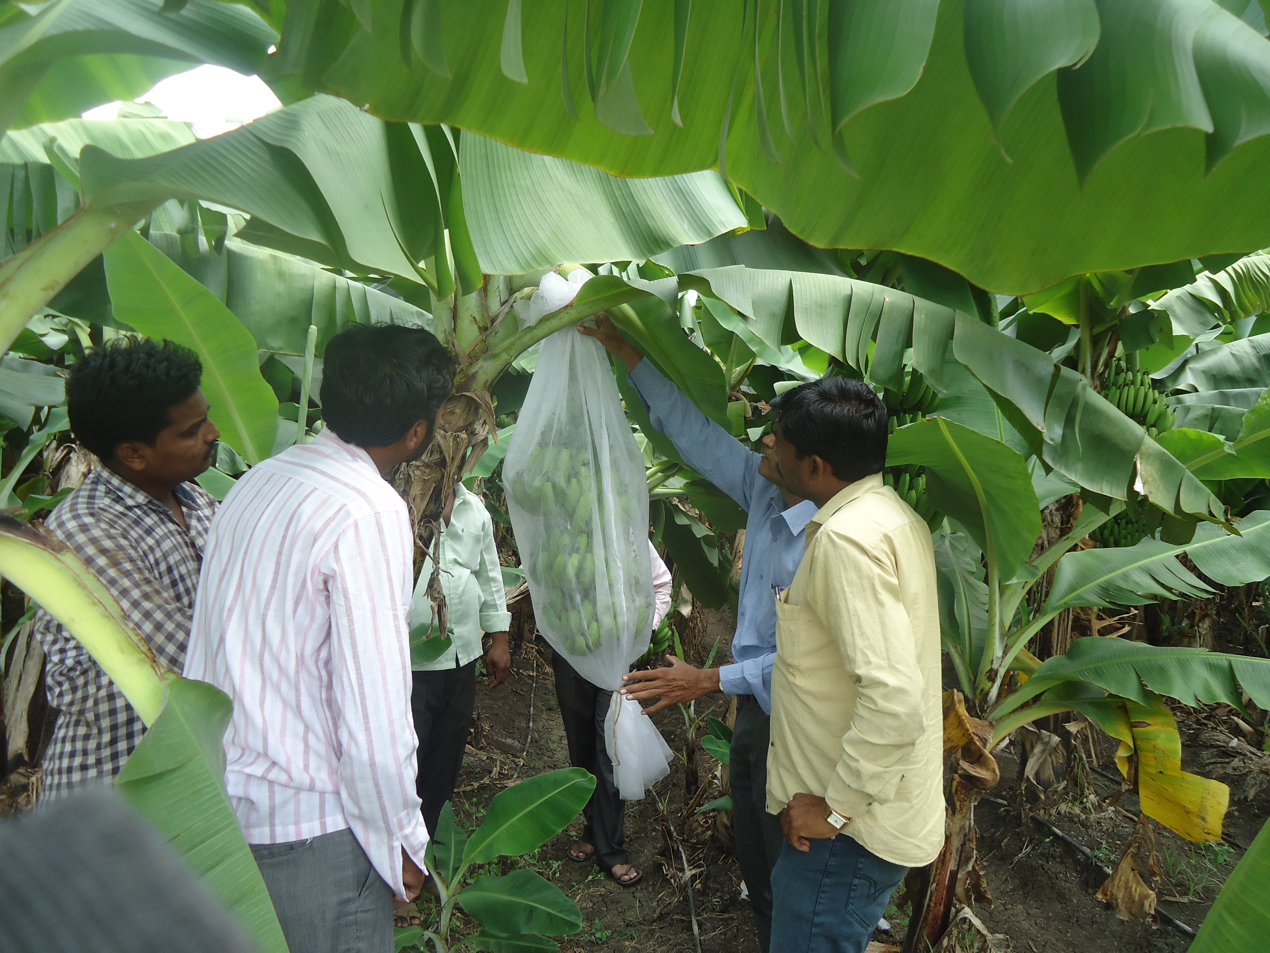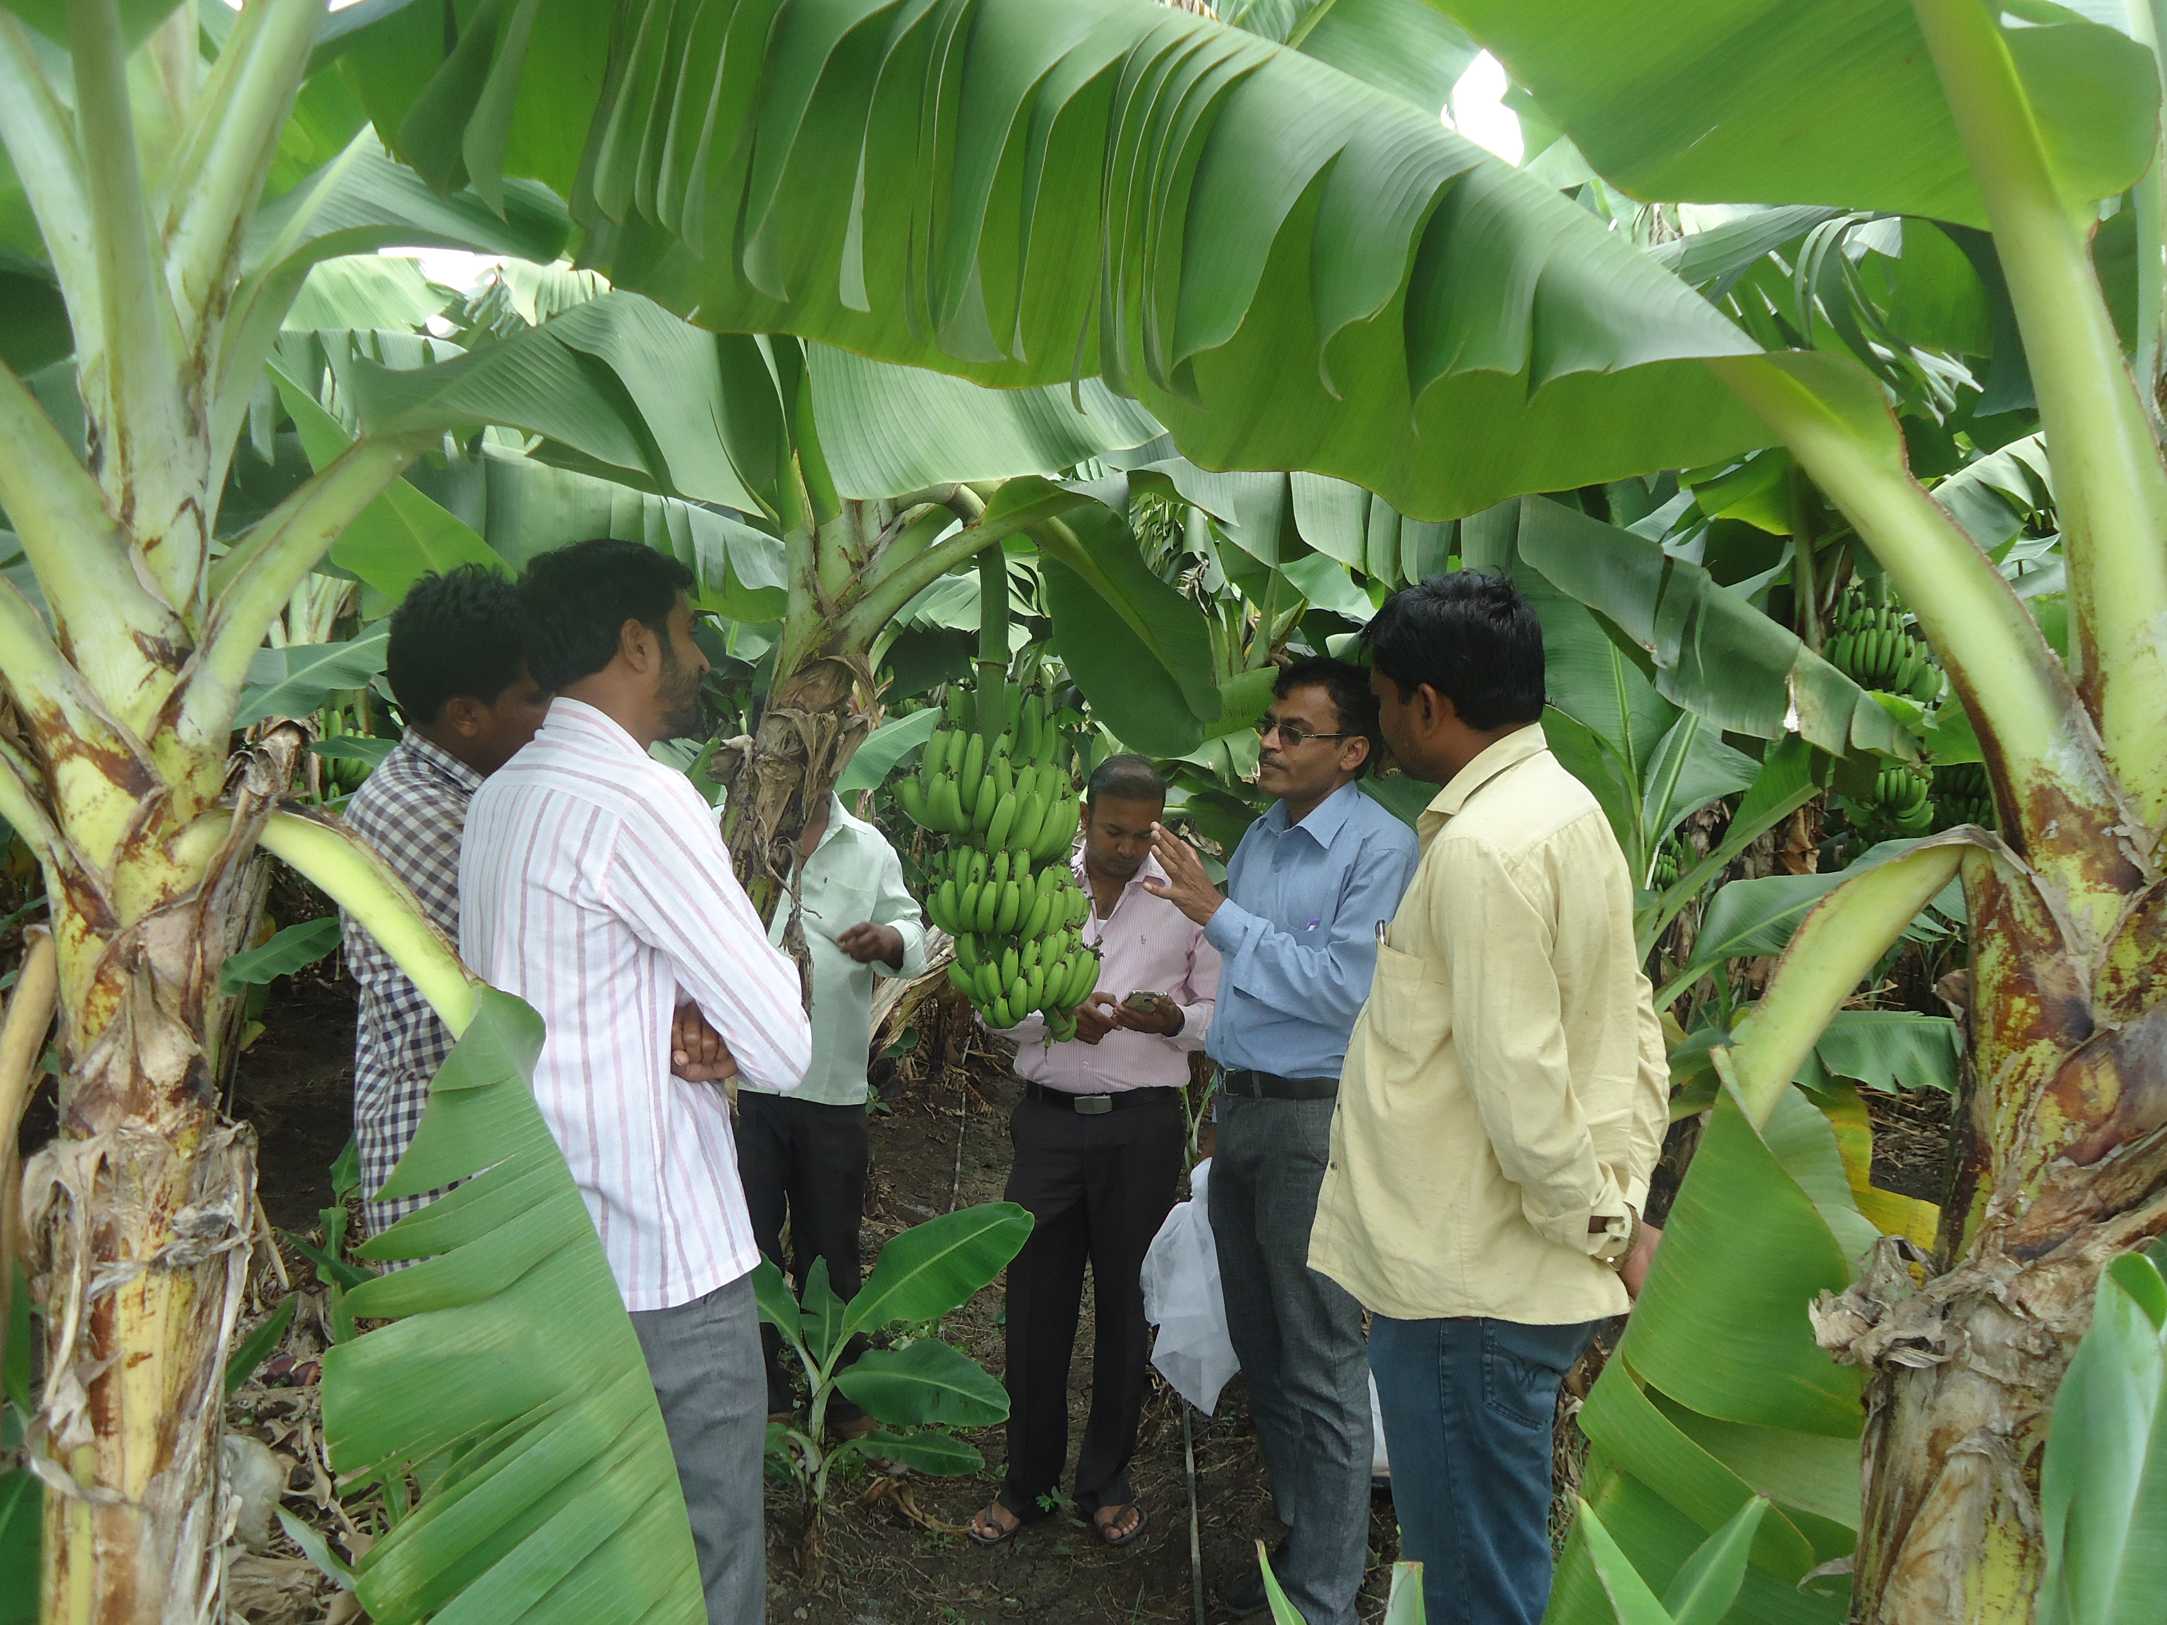

The significant agronomic improvements observed in this study align closely with recent international research, which confirms that pre-harvest bunch bagging serves as a crucial microclimate modifier and physical barrier. Modern studies have established that bagging mitigates severe environmental stresses, such as chilling injury and sunburn, while promoting cellular expansion and yield (Lima et al., 2020). For instance, recent trials have demonstrated that utilizing specific cover materials, such as waterproof nonwoven fabrics, actively prevents sunburn defects and enhances total soluble solids without compromising the ultimate fruit weight (Chaiwong et al., 2021). Furthermore, contemporary evaluations emphasize that bagging not only accelerates the physiological maturity of the fruit—shortening the flower-to-harvest interval by over two weeks—but also drastically diminishes both biotic pest infestations and disease occurrences (Imran et al., 2023). Broader reviews on the technique corroborate that these improvements in visual appeal and the reduction of blemishes are essential for meeting stringent premium market standards (Ali et al., 2021; Sant'Anna Cordeiro da Silva et al., 2022). Therefore, the localized success of the skirting technology in these Front-Line Demonstrations is supported by a robust, modern scientific consensus that recognizes bagging as an indispensable practice for sustainable, high-quality banana production.

4. Conclusion
The comprehensive three-year assessment of banana bunch skirting through Field Level Demonstrations provides unequivocal evidence of the technology's value. From an agronomic standpoint, the physical intervention of the bags successfully manipulates the micro-climate, leading to statistically significant increases in fruit girth and a sustained yield increase ranging from 11% to 14% across varying seasonal conditions.
Economically, the data dismantles the primary barrier to adoption the initial capital cost. The analysis proves that the supplementary expenditure of Rs. 54,450 per hectare is a highly leveraged investment. The consistently superior B:C ratios and strong Incremental Cost-Benefit Ratios (exceeding 1:3.0) confirm that the premium market price commanded by the superior, blemish-free fruit vastly outweighs the cost of the intervention.
Finally, from an extension perspective, the FLDs achieved their primary objective. The results showcased remarkable consistency across multiple villages and individual farmer management styles. The zero-percent failure rate among the 39 participants minimizes the perceived risk of adoption. This study reinforces the conclusion that bunch skirting is not an optional luxury for commercial banana cultivation, but a fundamental, highly profitable standard operating procedure. Furthermore, it highlights the enduring efficacy of the FLD methodology in translating established horticultural science into tangible economic empowerment for the farming community.

Disclaimer (Artificial intelligence)

Author(s) hereby declare that NO generative AI technologies such as Large Language Models (ChatGPT, COPILOT, etc.) and text-to-image generators have been used during the writing or editing of this manuscript.

5. References
- Ali, M. M., Anwar, R., Yousef, A. F., Li, B., Luvisi, A., De Bellis, L., Aprile, A., & Chen, F. (2021). Influence of bagging on the development and quality of fruits. Plants, 10(2), 358. https://doi.org/10.3390/plants10020358 Cited by: 144
- Anon. 2003. Bunch covers for improving plantain and banana peel quality. National Agriculture Research Institute. Technical Bull., no 4. www.agrinetguyana. org.gymoa.
- Chaiwong, S., Saengrayap, R., Ogunsua, J. M., Kitazawa, H., & Prahsarn, C. (2021). Performance of different bunch cover materials to improve quality of Cavendish banana cultivated during winter and summer in Thailand. Agronomy, 11(3), 610. https://doi.org/10.3390/agronomy11030610 Cited by: 7
- Fan, X., & Mattheis, J. P. (1998). BaggingFuji'Apples during fruit development affects color development and storage quality. HortScience, 33(7), 1235-1238.
- Ganry, J. (1975). Influence du gainage des régimes du bananier avec une housse de polyéthylène sur la température des fruits dans les conditions de Neufchateau (Guadeloupe). Fruits, 30(12), 735-738.
- Hailu, M., Workneh, T. S., & Belew, D. (2013). Review on postharvest technology of banana fruit. African Journal of Biotechnology, 12(7), 635-647.
- Hewett, E. W. (2006). An overview of preharvest factors influencing postharvest quality of horticultural products. International Journal of Postharvest Technology and Innovation, 1(1), 4-15.
- Imran, M. A., Rahman, M. H., Islam, M. T., & Hossain, M. S. (2023). Effect of pre-harvest fruit bagging on biotic stresses and postharvest quality of banana. The Journal of Applied Horticulture, 25(2), 194–198. https://doi.org/10.37855/jah.2023.v25i02.34 Cited by: 1
- Johns, G. G. (1996). Effects of bunch trimming and double bunch covering on yield of bananas during winter in New South Wales. Australian Journal of Experimental Agriculture, 36(2), 229-235.
- Johns, G. G., & Scott, K. J. (1989). Delayed harvesting of bananas with'sealed'covers on bunches. 1. Modified atmosphere and microclimate inside sealed covers. Australian Journal of Experimental Agriculture, 29(5), 719-726.
- Lima, J. D., Engelking, E. W., Rozane, D. E., Gomes, E. N., Silva, S. H. M. G. d., & Kluge, R. A. (2020). Effect of bunch protection material and bagging time on the yield of 'Nanica' banana and chilling control. Australian Journal of Crop Science, 574–580. https://doi.org/10.21475/ajcs.20.14.04.p1909 Cited by: 11
- Sant'Anna Cordeiro da Silva, M., Leonel, S., Arruda Ferreira, A. F., Mirellys Azevêdo Souza, J., Almeida de Oliveira Junior, M., Calsavara Martins, R., Bibiano Ferreira, R., & De Souza Silva, M. (2022). Banana bunch cover: evaluation of promising bag materials. Comunicata Scientiae, 13, e3741. https://doi.org/10.14295/cs.v13.3741 Cited by: 2
- Santosh, D. T., Tiwari, K. N., & Reddy, R. G. (2017). Banana bunch covers for quality banana production-a review. Int. J. Curr. Microbiol. Appl. Sci, 6(7), 1275-1291.
- Shewfelt, R. L. (2014). Measuring quality and maturity. In Postharvest handling (pp. 387-410). Academic Press.
- Snowden, A.L. 2010. A colour atlas of postharvest disease and disorders of fruits and vegetables. introductions and Vol. 1, fruits. General Manson Publishing Ltd. UK.
- Soto, M. (2010). Banano: Tecnologias de producción, Tomo II. Costa Rica.
- Thakare, U. G., & Ingle, P. O. (2007). A scale to measure socio-economic status of farmers in Vidarbha region. PKV Research Journal, 31(2), 65–70.
- UG Thakare. Attributers of the technologies intervened through frontline demonstrations. Int J Agric Extension Social Dev 2025;8(9):170-175. DOI: 10.33545/26180723.2025.v8.i9c.2394
- Weerasinghe, S. S., & Ruwanpathirana, K. H. (2002). Influence of bagging material on bunch development of banana (Musa spp.) under high density planting system. Annals of Sri Lanka Department of Agriculture, 4, 47-53.

