Original Research Article

Phenetic Analysis and Morphological Traits Evaluation of Convolvulus L. from Flora of Saudi Arabia

Abstract
The goal of the current investigation is to comprehend the patterns of morphological variation among species within the genus Convolvulus using Principal Component Analysis (PCA) and phenetic clustering. Principal Component Analysis (PCA) was accustomed to evaluate morphological variation in eighteen Convolvulus genera. Fifty two morphological characteristics, including 126 character states, were analyzed. PCA revealed that 47.55% of the variation was explained by the first two categories, with corolla color, stem strength, leaf shape and fruit surface making the most contribution. According to UPGMA clustering, genus Convolvulus divided into six phenetic groups at 0.06 taxonomic distance. Overall, the PCA results demonstrate that herbarium-based morphological data provide sufficient resolution to detect major patterns of variation within Convolvulus. The combination of vegetative and reproductive traits captured by the first two principal components effectively summarizes morphological diversity and supports their use in taxonomic and systematic interpretations.

Key words: Convolvuleae, Phenogram, Principle component analysis, UPGMA.

Introduction
The Convolvulaceae, or morning glory family, is a big family with about 1600–1700 species spread across 50–60 genera. (Mabberley, 2008), displaying a broad variety of ecological environments and a vast array of physical traits. Convolvulaceae members are easily distinguished by their morphology, but species-level identification is challenging. This is mostly because plants may adapt to a broad variety of habitat types through a variety of morphological and structural changes (Rabei & Khalik, 2012). (Hallier, 1893) split the family into two subfamilies after realizing the value of pollen characteristics Viz. Echinoconiae and Psiloconiae because the pollen has either a granulated or psilate surface, the species Convolvulus is included with the latter. Convolvulaceae are traditionally placed in Solanales (APG, 2009; Cronquist, 1988; Dahlgren, 1989; Thorne, 1992) along with the Solanaceae. (Takhtajan, 2009), however, isolates this family into its own order; Convolvulales, based on characteristics unique to other Solanales, such as the existence of articulate latex canals, latex cells, intraxylary phloem location, and seed and pollen shape. Khalik (2008) examined the Convolvulaceae's phenetic traits and identified five major groupings: Convolvuleae, Cuscuteae, Cresseae, Dichondreae and a mixed group from Ipomoeeae and Merremieae.
The genus that is second in size of the Convolvulaceae family is Convolvulus (Carine & Robba, 2010; Hasan, 2023). Members of the genus exhibit pronounced morphological diversity, particularly in vegetative and floral traits, which is often associated with adaptation to diverse ecological conditions such as drought, soil type, and altitude (Scotland et al., 2015). This high level of morphological variability frequently complicates species delimitation and infraspecific classification within Convolvulus.
The Saudi Arabian flora contained eighteen species of Convolvulus (Chaudhary, 1999). The great rate of variation in its phenotypic features made it difficult to classify the current genus at an intraspecific level. Differences can sometimes be seen within a species as it adapts to changes in its environment. Good proof of species delimitation and linkage was not presented in previous study since just a few traits were considered for classification (Khalik, 2008).
The species of genus Convolvulus divided into three portions. and six subsections (Menemen & Jury, 2002) Viz. Section I: Acanthocladi Boiss., Fl. Or. 4: 84 (1875), spiny shrub or subshrub, with branching shoots. Subsection 1: Spinescentes Boiss., Fl. Or. 4: 84 (1875), flowers sessile or subsessile, solitary or in a capitulum. Section II: Inermes Boiss., Fl. Or. 4: 84 (1875), shrubs or subshrubs, without spines, erect or prostrate, but not twining. Subsection 2: Floridi Sa’ad, the Convolvulus species of the Canary Isles, the Mediterranean region and the Near and Middle East, 288 (1967), shrubs with numerous flowers at the top of the branches in the form of a panicle. Subsection 3: Lanuginosi Peter in Engler and Prantl, Naturl. Pflanzenfam. 4 (3a): 33 (1897), flowers numerous, terminal in heads; base of the shoots ligneous. Subsection 4: Oleifolii Peter in Engler & Prantl, Naturl. Pflanzenfam. 4 (3a): 33 (1897), shoots with axillary and terminal flowers at the top. Subsection 5: Diffusi Boiss., Fl. Or. 4: 84 (1872), annual or perennial herbs, rarely subshrubs; shoots prostrate or ascending, never twining. Section III: Convolvulus, herbs or subshrubs; branches twining. Subsection 6: Convolvulus. annual or perennial herbs; shoots twining, never spiny. Phylogenetically, Nepomuceno et al. (2025) have been divided the genus into two clades depending on the morphological characters.
Phenetic analysis quantifies the similarities and differences between species and genera. It is capable of carrying out several data analysis and display tasks, such as statistical analysis and graphical data presentation (Sneath, 2005). The taxa in numerical analysis are usually referred to as OTU’s (Operational Taxonomic Units). In some studies, the species may be studied from more than one specimen, so it is more convenient to refer to taxa as OTU. This term indicates that in this specific numerical operation each OTU is a distinct taxon. Characters in numerical taxonomy should be carefully defined. There are three main types of characters: qualitative or two state, multi-state and quantitative characters (Xia & Sun, 2023). Clustering methods one of the most important algorithms that used in the numerical analysis and played a prominent role in classification or comparing the taxonomic relationships at various ranks (Tutlel et al., 2005). The PAST program or Paleontological Statistics Software package for education and data analysis using personal computers (Hammer et al., 2001) provides efficient modules uses a rather conservative approach and warn of ties when there actually only a single tree possible.
Multivariate statistical methods offer robust tools for analyzing complex morphological datasets. Among these, Principal Component Analysis (PCA) is widely applied to summarize variation, reduce dimensionality, and identify traits contributing most to phenotypic differentiation (Jolliffe & Cadima, 2016). In botanical research, PCA has been successfully employed to clarify taxonomic boundaries, reveal morphological gradients, and assess relationships among closely related taxa and populations (Sokal, 1985). By transforming correlated variables into independent principal components, PCA enables an objective assessment of morphological structure and diversity. Within Convolvulaceae, PCA and related multivariate approaches have proven effective in distinguishing taxa and supporting taxonomic interpretations based on morphological evidence (Ashfaq et al., 2019). Despite this, comprehensive multivariate evaluations of morphological traits in Convolvulus remain limited, particularly for taxa occurring in arid and semi-arid regions where morphological plasticity is pronounced (González & Gianoli, 2004).
The present investigation's goal was to identify the taxonomic relationships among the Convolvulus taxa from the flora of Saudi Arabia to draw a precise phenogram clarifying these relationships, in addition to evaluate their morphological traits and their extent of their contribution to the classification of the investigated genus.

Materials and Methods
The present investigation was based on herbarium specimens of Convolvulus L. from the flora of Saudi Arabia, deposited in the herbarium of King Saud University (KSU) and the herbarium of Tabuk University, in addition to some collected wild taxa from Madinah, Saudi Arabia (24º 25ʹ 12'' N and 39 º 36ʹ 47" E). The investigated taxa included 14 species and four subspecies (Table 1). The identification was matched against (Chaudhary, 1999; Collenette, 1999) and the nomenclature was authenticated from (IPNI, 2025; POWO, 2026). Some of the herbarium sheets have been photographed (Figures 1-3). Only well-preserved specimens bearing mature vegetative and reproductive structures were included to ensure reliable morphological assessment.
Table 1. Taxa under investigation
No. | Taxa
 | Convolvulus arvensis L., Sp. Pl. [Linnaeus] 1: 153 (1753).
 | Convolvulus asyrensis Kotschy, Sitzungsber. Acad. Wien, Math.-Nat. lii. Abth. I. (8166) 260.
 | Convolvulus austroaegyptiacus Abdallah & Sa'ad , Acta Bot. Neerl. 15: 190 (1966).
 | Convolvulus cephalopodus Boiss., Diagn. Pl. Orient. ser. 1, 7: 24 (1846).
 | Convolvulus excelsus R.R.Mill, Edinburgh J. Bot. 70(2): 368 (2013).
 | Convolvulus fatmensis Kunze, Flora 23(1): 172 (1840).
 | Convolvulus glomeratus Thunb., Mus. Nat. Acad. Upsal. App. 17: 4 (1809)
 | Convolvulus hamrinensis Rech.f., Anz. Österr. Akad. Wiss., Math.-Naturwiss. Kl. xcviii. 11 (1961).
 | Convolvulus hystrix Vahl, Symb. Bot. (Vahl) 1: 16 (1790).
 | Convolvulus oxyphyllus subsp. oxycladus Rech.f., Anz. Österr. Akad. Wiss., Math.-Naturwiss. Kl. 23: 11 (1961).
 | Convolvulus oxyphyllus subsp. sheilae R.R.Mill, Edinburgh J. Bot. 70(2): 376 (2013).
 | Convolvulus pilosellifolius Desr., Encycl. [J. Lamarck & al.] 3(2): 551 (1792).
 | Convolvulus prostratus Forssk., Fl. Aegypt.-Arab. 203 (1775).
 | Convolvulus rhyniospermus Hochst. ex Choisy, Prodr. [A. P. de Candolle] 9: 405 (1845).
 | Convolvulus sagittatus Thunb., Prodr. Pl. Cap. 1: 35 (1794).
 | Convolvulus siculus subsp. agrestis (Schweinf.) Verdc., Kew Bull.12: 344 (1957).
 | Convolvulus siculus subsp. siculus L., Sp. Pl. [Linnaeus] 1: 156 (1753).
 | Convolvulus spicatus Peter ex Hallier f., Bot. Jahrb. Syst. 18(1-2): 99 (1893).

Macro-morphological attributes of the whole plant, were described from the herbarium specimens that were matched with text books and some of published literatures such as (Chaudhary, 1999; Collenette, 1999; Rabei & Khalik, 2012). All collected data were systematically organized and tabulated in Microsoft Excel for subsequent analysis. Macro-photographs of the studied taxa were made from herbaria representatives. Table (2) summarizes the clearly observable (126) character states of (52) morphological characters together with their codes. Phenetic analysis was performed on the morphological character states to draw the interrelationships among the studied taxa of Convolvulus L. In addition to Principal Component Analysis (PCA) to summarize phenotypic variation and identify diagnostic traits using PAleontological STatistics Version 3.23 (Hammer et al., 2001).

Table 2. The extracted morphological characters, their states and codes of the studied taxa.
No. | Characters, their character states and codes
 | Plant life/ 1. Parasite/ 2. Not parasite/
 | Chlorophyll/ 1. Non-chlorophyllous / 2. chlorophyllous
 | Plant duration/ 1. Annual/ 2. annual or short lived perennial/ 3. Perennial/
 | Plant habit/ 1. herb/ 2. sub-shrub/ 3. shrub/
 | Stem nature/ 1. Herbaceous/ 2. Woody/
 | Stem strength/ 1. Prostrate/ 2. Prostrate to twining/ 3. Twining/ 4. Climbing/ 5. Prostrate to ascending/ 6. Ascending/ 7. Ascending to erect/ 8. Erect/
 | Mode of perennation/ 1. Rhizomatous/ 2. Not rhizomatous/
 | Nature of branches/ 1. Spinescent/ 2. Not spinescent/
 | Plant texture/ 1. Glabrous/ 2. Glabrous to sparsely hairs/ 3. Hairy/
 | Hairs patent/ 1. Spreading/ 2. Appressd/
 | Hair shape/ 1. Simple/ 2. Simple and glandular/ 3. Simple and vasculate/
 | Lower leaves arrangement/ 1. Rosette-forming/ 2. No rosette/
 | Green leaves/ 1. Present/ 2. Absent/
 | Leaves petiole/1. Sessile/ 2. Sessile to short petiolate/ 3. Petiolate/
 | Leaf venation/ 1. Pinnate/ 2. Palmate/
 | Leaf shapes/ 1. Linear to lanceolate/ 2. Oblong to lanceolate/ 3. Ovate to lanceolate/ 4. Spathulate to oblanceolate/ 5. Sagittate to hastate/ 6. Cordate to sagittate/ 7. Cordate to ovate/ 8. Reniform to elliptical/ 9. Reniform/ 10. Orbicular/
 | Leaf apex/ 1. Mucronate/ 2. Acuminate/ 3. Apiculate/ 4. Acute to acuminate/ 5. Acute/ 6. Obtuse to acute/ 7. Obtuse/ 8. Retuse/ 9. Emarginate/
 | Leaf margin/ 1. Entire/ 2. Crenate/ 3. Dentate to crenate/ 4. Undulate/ 5. Crenate to lobed/ 6. Dissected or divided/
 | Inflorescence Bracts/ 1. present/ 2. absent/
 | Inflorescence position/ 1. Terminal/ 2. Terminal and axillary/ 3. Axillary/
 | Flowers numbers/ 1. Solitary/ 2. Solitary or in pairs/ 3. 2 to 10/ 4. more than 10/
 | Flower pedicle/ 1. Sessile/ 2. Sessile to short-pedicellate/ 3. Pedicellate/
 | Flower bract/ 1. Present/ 2. Absent/
 | Sepal shape/ 1. Lanceolate/ 2. Lanceolate to oblong/ 3. Oblong/ 4. Oblong to obovate/ 5. Obovate/ 6. Ovate/ 7. Cordate to ovate/ 8. Orbicular to ovate/
 | Sepal apex/ 1. Acuminate/ 2. Apiculate/ 3. Acute/ 4. Obtuse to acute to mucronate/ 5. Obtuse/
 | Sepal surface/ 1. Glabrous/ 2. Glabrous to sparsely hairs/ 3. Hairy/
 | Sepals patent at fruit maturity/ 1. Erect/ 2. Erect to spreading/ 3. Spreading/
 | Corolla shape/ 1. Funnel- shape/ 2. Campanulate/ 3. Tubular shape/
 | Corolla margin/ 1. Deeply lobed/ 2. Shallowly lobed or bifid/
 | Corolla colour/ 1. White/ 2. Yellow to white/ 3. Yellow/ 4. Yellow to brown/ 5. Pink/ 6. Pink to white/ 7. Violet/ 8. Violet to pink/ 9. Blue/ 10. Blue to pink or white/
 | Corolla surface/ 1. Glabrous/ 2. Glabrous with hairy bands outside/ 3. Hairy/
 | Filament surface/ 1. Glabrous/ 2. With sessile glandular hairs at the base/ 3. Hairy/
 | Anther shape/ 1. Globose/ 2. Sagittate/ 3. Oblong to sagittate/ 4. Oblong/
 | Stamens and styles/ 1. Included/ 2. Exserted/
 | Style number/ 1. One/ 2. Two/
 | Style shape/ 1. Filiform/ 2. Stout/
 | Style surface/ 1. Glabrous/ 2. Hairy/
 | Style length (compared to stigma)/ 1. Shorter than stigma/ 2. Equal the stigma/ 3. Longer than stigma/
 | Styles branching/ 1. Forked/ 2. Not forked/
 | Stigma number/ 1. One or bi-lobed/ 2. 2/ 3. 4/
 | Stigma shape/ 1. Filiform/ 2. Cylindrical/ 3. Clavate to cylindrical/ 4. Clavate/ 5. Globose/ 6. Capitate/ 7. Peltate/
 | Fruit dehiscence/ 1. Dehiscent/ 2. Indehiscent/
 | Fruit shape/ 1. Globose/ 2. Subglobose/ 3. Obovate/ 4. Oblong/ 5. Conical/
 | Number of fruit locules/ 1. 1/ 2. 2/ 3. 2–3/ 4. 3/
 | Persistent calyx/ 1. Appressd/ 2. Erect/ 3. Erect to spreading/ 4. Spreading/ 5. Recurved/
 | Fruit surface/ 1. Glabrous/ 2. Glabrous to sparsely hairs/ 3. Hairy/ 4. Papillate/
 | Surface of fruit pedicel/ 1. Glabrous/ 2. Hairy/
 | Number of seeds in fruit/ 1. 1/ 2. 2/ 3. 2–4/ 4. 4/ 5. 6/
 | Seed shape/ 1. Oblong/ 2. Obovoid/ 3. Ovoid/ 4. Pyramidal/
 | Seed surface/ 1. Glabrous/ 2. Short hairy/ 3. Long hairy/
 | Seed architecture/ 1. Smooth/ 2. Tuberculate/
 | Seed colour/ 1. Black/ 2. Black to brown/ 3. Brown/ 4. Yellow to brown/ 5. Orange/

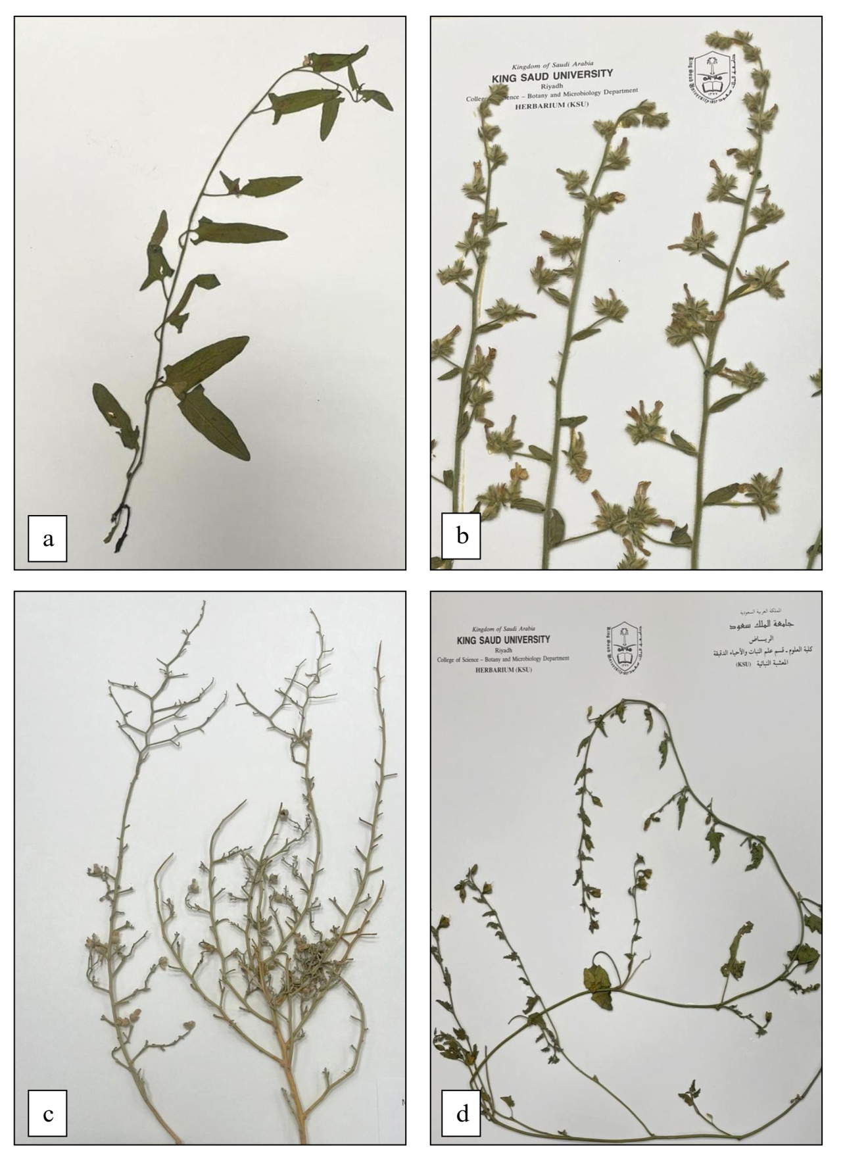

Figure 1. Photographs of herbarium sheets deposited at KSU Herbarium. a. C. arvensis. b. C. austroaegyptiacus. c. C. excelsus. d. C. fatmensis

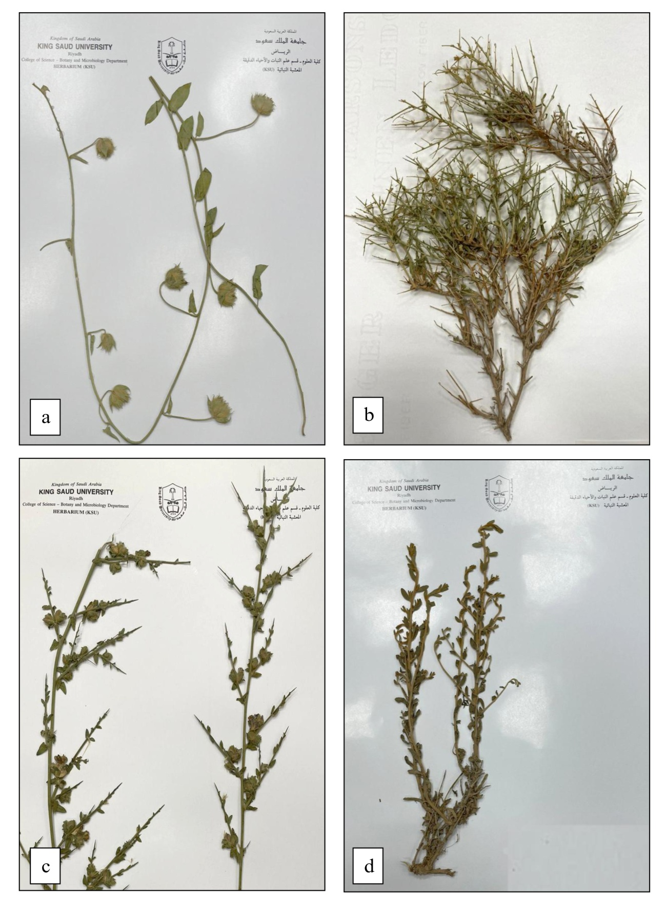

Figure 2. Photographs of herbarium sheets deposited at KSU Herbarium. a. C. glomeratus. b. C. hamrinensis. c. C. hystrix. d. C. oxyphyllus subsp. oxycladus

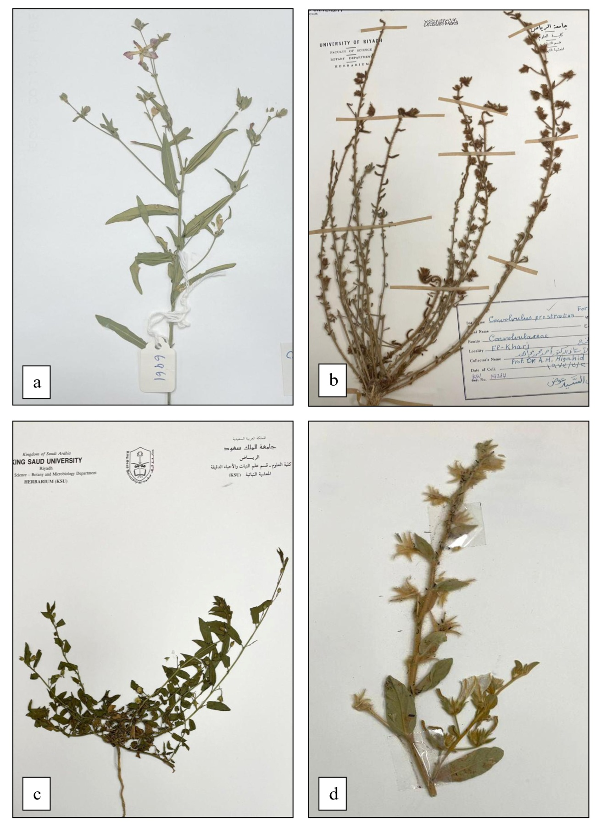

Figure 3. Photographs of herbarium sheets deposited at KSU Herbarium. a. C. pilosellifolius. b. C. prostratus. c. C. siculus subsp. siculus. d. C. spicatus

Results & Discussion
A dendrogram was created by the phenetics in light of the coded morphological data matrix of the species under investigation (Figure 4) in which the studied taxa were segregated into six groups at 0.06 taxonomic distance away from C. rhyniospermus that was segregated at the base of the phenogram (0.1 taxonomic distance); the first group included C. cephalopodus, C. oxyphyllus subsp. sheilae and C. hamrinensis. The second group segregated C. asyrensis and C. glomeratus. The third group included C. austroaegyptiacus, C. pilosellifolius and C. prostratus. The forth one nested C. hystrix and the two studied subspecies of C. siculus. the fifth group segregated C. excelsus, C. oxyphyllus subsp. oxycladus and C. spicatus. the last group included C. fatmensis, C. sagittatus and C. arvensis.
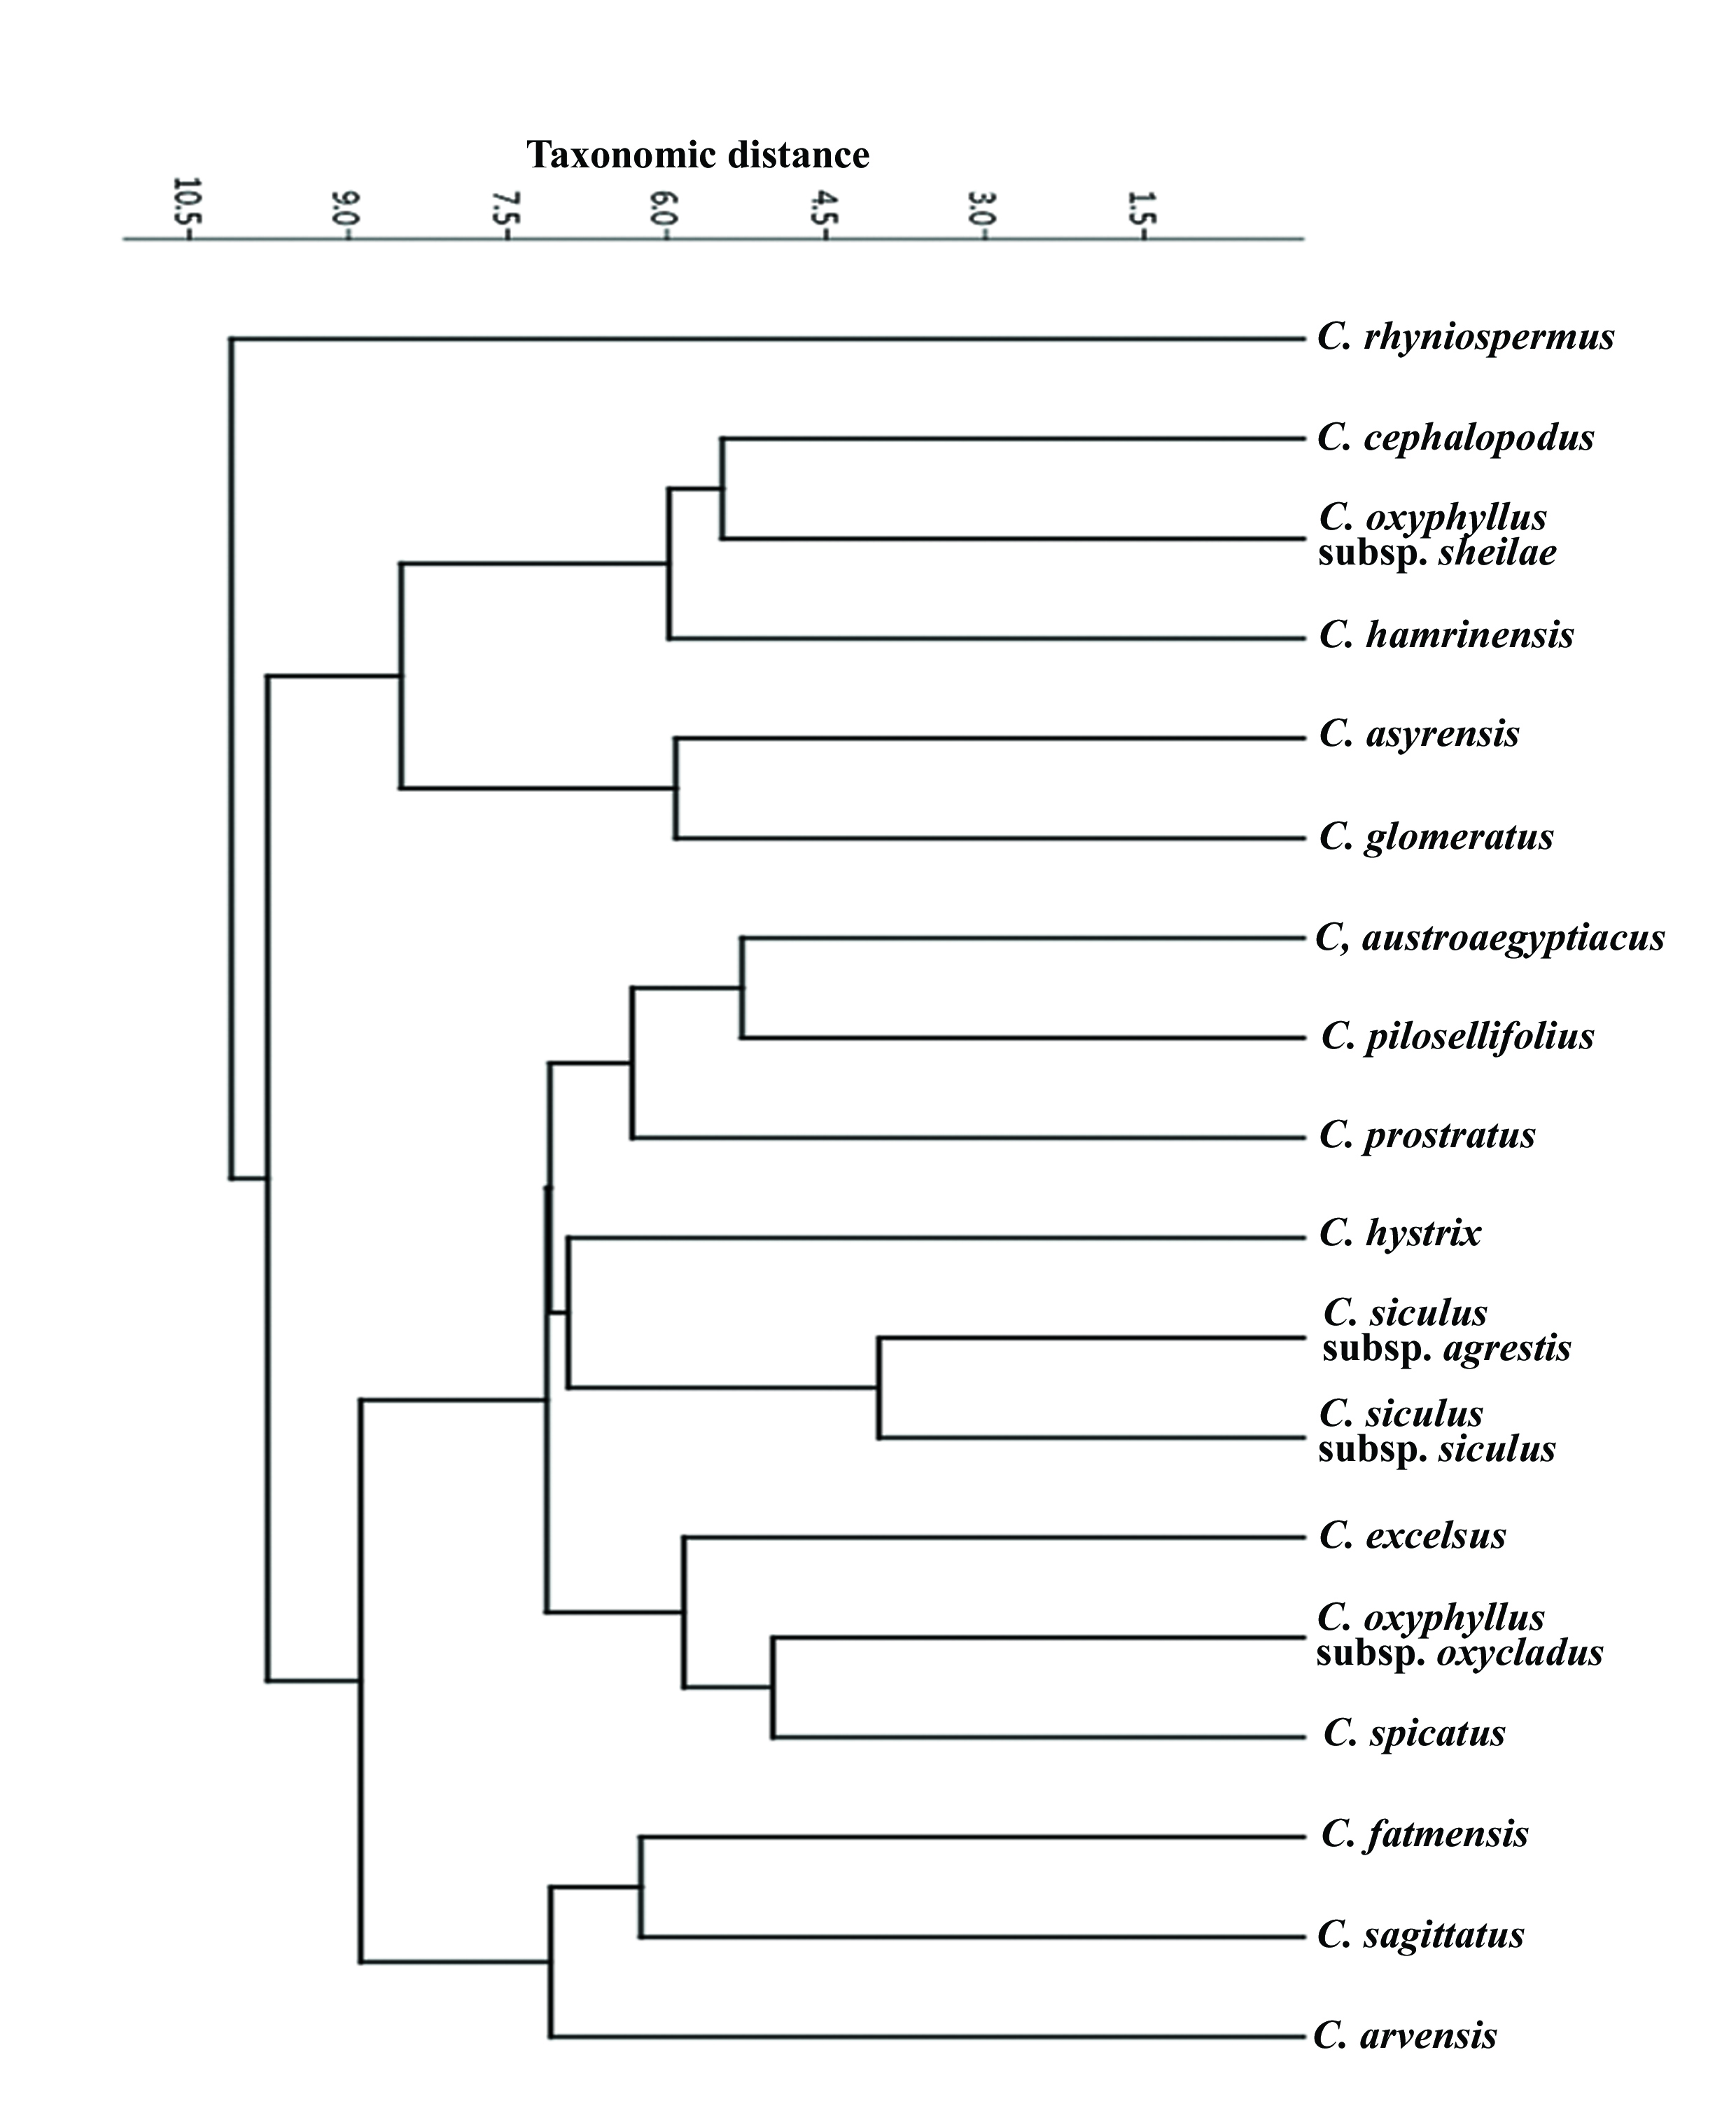
Figure 4. UPGMA clustering of the studied taxa based on morphological characters
The principal component analysis (PCA) biplot of the first two principal components (PC1 Vs. PC2) illustrates the distribution of Convolvulus specimens in multivariate morphological space and clarifies that, the first two principal components had eigenvalues and together explained a high percentage of the total variance (Table 3). the percentage reached 27.13% Concerning the first component PC1 and 20.42% due to PC2 (Figure 5). Ordination plots based on the first two principal components (Figure 6) shows a clear separation of specimens according to taxonomic identity, indicating that morphological traits captured from herbarium material are sufficient to distinguish among species. The two components' variability is directly correlated with the arrow's length, the extremely short arrow for example inflorescence position shows that there is nothing to know about this component with loading score (0.04) in the first two components, but the longest arrow's loading score for corolla color was 0.80, followed by stem strength (0.75) highlighting their role in explaining finer-scale morphological variation, these traits may contribute to the separation of morphologically similar taxa that are otherwise difficult to distinguish using size-related characters alone. The correlation is made clear by the angle between two arrows; an obtuse angle suggests a negative connection, a right angle shows no correlation, and an acute angle signifies a positive correlation.
Table 3. Eigenvalues, percentage of variance explained, and loadings of morphological characters on the first two principal components derived from PCA of Convolvulus herbarium specimens.
Table 3. Eigenvalues, percentage of variance explained, and loadings of morphological characters on the first two principal components derived from PCA of Convolvulus herbarium specimens.
PC  Character | PC 1 | PC 2
Plant life | 0 | 0
Chlorophyll | -4.34E-17 | 1.35E-16
Plant duration | -0.0964 | 0.049267
Plant habit | 0.004341 | 0.11109
Stem nature | -0.05465 | 0.1112
Stem strength | -0.06004 | 0.79511
Mode of perennation | -0.00718 | 0.03045
Nature of branches | 0.031763 | -0.05544
Plant texture | -0.01052 | 0.10157
Hairs patent | 0.016755 | 0.026667
Hair shape | 0.001668 | -0.03556
Lower leaves arrangement | 2.72E-25 | 3.64E-24
Green leaves | 1.41E-27 | 2.60E-26
Leaves petiole | 0.039928 | -0.20591
Leaf venation | -4.27E-29 | -1.18E-27
Leaf shapes | 0.050038 | -0.29446
Leaf apex | 0.053554 | 0.039859
Leaf margin | -0.23423 | 0.024226
Inflorescence Bracts | 4.28E-05 | 0.014198
Inflorescence position | -0.04638 | -0.05698
Flowers numbers | -0.0114 | 0.028298
Flower pedicle | 0.1876 | -0.00106
Flower bract | 0.023478 | -0.02835
Sepal shape | -0.04201 | 0.030874
Sepal apex | 0.008559 | 0.031177
Sepal surface | -0.05122 | 0.081105
Sepals patent at fruit maturity | -0.0789 | -0.05331
Corolla shape | -0.04073 | 0.05846
Corolla margin | -0.08253 | 0.035156
Corolla colour | 0.89801 | 0.080671
Corolla surface | -0.02839 | 0.088833
Filament surface | 0.035042 | -0.02622
Anther shape | -0.00283 | -0.02916
Stamens and styles | 0.023823 | 0.015054
Style number | 0.014802 | -0.00901
Style shape | 0 | 0
Style surface | -0.02547 | -0.00486
Style length (compared to stigma) | -0.07778 | -0.01268
Styles branching | -0.01371 | -0.03141
Stigma number | 0.004552 | 0.046163
Stigma shape | -0.08324 | -0.23486
Fruit dehiscence | 0 | 0
Fruit shape | 0.027793 | 0.079163
Number of fruit locules | -0.00511 | -0.03409
Persistent calyx | -0.05424 | -0.16065
Fruit surface | -0.14358 | 0.18689
Surface of fruit pedicel | -0.06033 | 0.026814
Number of seeds in fruit | 0 | 0
Seed shape | 0 | 0
Seed surface | 0.04654 | 0.054262
Seed architecture | 0 | 0
Seed colour | -0.1019 | -0.1597
Eigenvalue | 10.7831 | 8.11516
% variance | 27.126 | 20.415

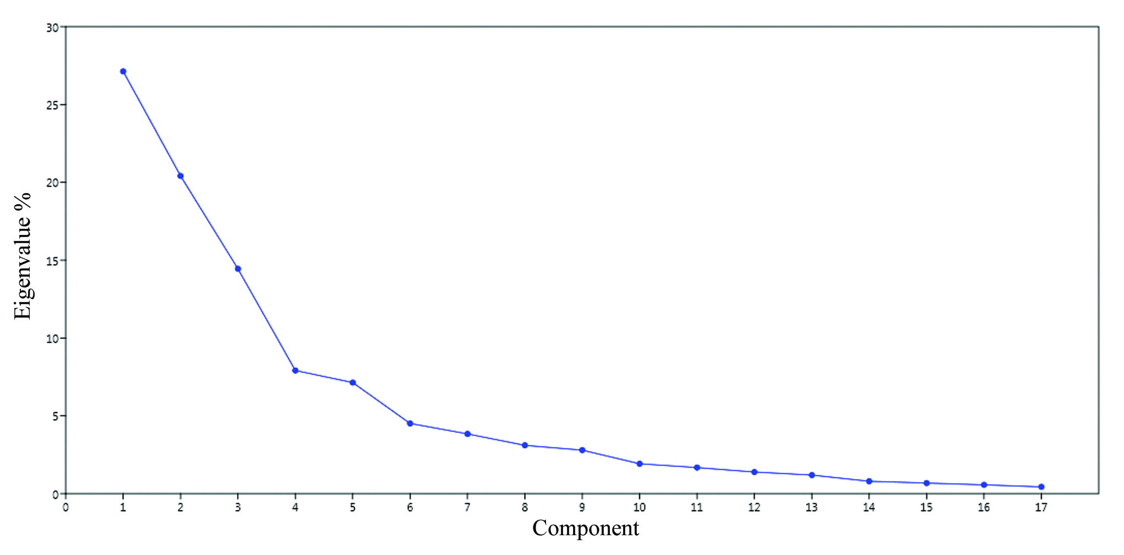
Figure 5. Scree plot indicating the percentage of explained variances Vs. principal components.
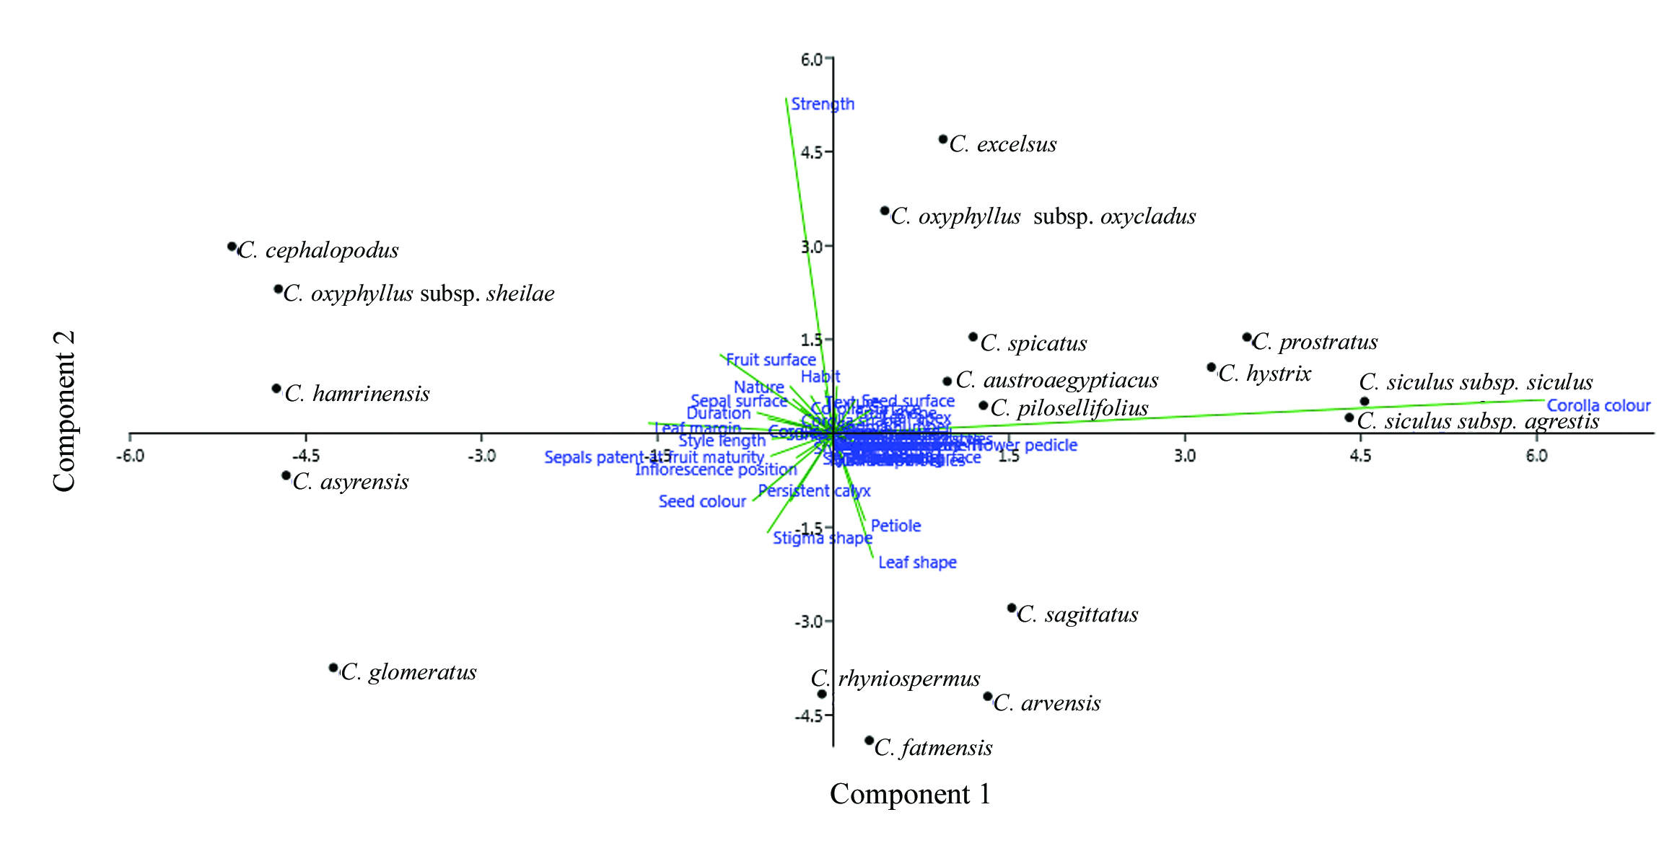
Figure 6. PCA biplot showing the distribution of Convolvulus specimens along the first two principal components (PC1 and PC2) based on standardized morphological characters.

UPGMA-derived phenogram (Figure 1), showed a clear clustering tendency among the studied taxa of genus Convolvulus with a taxonomic distance 0.09 into six phenetic groups excluding C. rhyniospermus at earlier level, this is in some extent comparable with (Hasan, 2023) who diverged Convolvulus into five lineages based on molecular phylogenetics.

(Menemen & Jury, 2002) divided genus Convolvulus into three sections Viz. Convolvulus, Acanthocladi Boiss. and Inermes Boiss. and six subsections Viz. Convolvulus, Spinescentes Boiss., Oleifolii Peter, Diffusi Boiss., Floridi Sa’ad, and Lanuginosi Peter depending on the morphological characters as the same as that used in the present study. In the current investigation, C. arvensis and C. sagittatus were phenetically clustered together and this is comparable with (Stefanovic, 2002) who joined them in one group based on molecular data, and in contrast to (Williams et al., 2014; Wood et al., 2015) where the two species have been separated with molecular supports. Two studied subspecies were nested together Viz. C. siculus subsp. agrestis and C. siculus subsp. siculus that is in line with the definition of the rank subspecies according to (Wood et al., 2015) where two closely related and often intergrading taxa are geographically separated but may have overlapping ranges, they are distinguished using the rank of "subspecies". Usually, one or two characters divide them. Throughout much of their range, they exhibit distinctive behaviors, this definition contradicts with what has concluded regarding C. oxyphyllus subsp. oxycladus and C. oxyphyllus subsp. sheilae where the two subspecies have been separated in two distinct phenetic groups.

Wood et al. (2015) used many of the present morphological traits in species delimitation of Convolvulus. (Sa’ad, 1967) highlighted the many hair forms in Convolvulus, but neither she nor we used this for species delimitation; instead, we have highlighted a few indumentum characteristics that we believe are taxonomically significant.

Morphological species delimitation is based on a small number of specimens and/or characteristics assessed. (Monro & Mayo, 2022). Principle component analysis can be helpful in the variety of characteristics (Ogwu & Osawaru, 2016). The morphological traits can be considered as a strong support for the classification of Convolvulus. PCA revealed that the first two principal components described most of the total morphological variance.
The Principal Component Analysis (PCA) effectively summarized complex morphological data and identified key traits contributing to interspecific and intraspecific differentiation. The clear structuring of variation along the first two principal components indicates that a limited number of morphological characters capture most of the observable diversity within the genus such as corolla color, stem strength, leaf shape and fruit surface as the same as may authors depending on the morphological characters to refine the inter-relationships among Convolvulus taxa (Khalik, 2008).
The results confirm the suitability of herbarium specimens for quantitative morphological analyses, herbarium-based datasets have been shown to reliably capture diagnostic morphological variation when carefully selected and standardized (Jolliffe & Cadima, 2016). The successful application of PCA in this study supports the continued use of herbarium collections as valuable resources for taxonomic and systematic research, particularly in regions where fresh material is difficult to obtain.

Conclusion
The chosen morphological characteristics of Convolvulus were shown to be essential for species differentiation. The morphological features showed a certain level of high variability that is useful for discrimination, as the first two primary components accounted for slightly fewer than half of all morphological variations (47.55%), and these characteristics illustrate the phenetic linkages of Convolvulus. The authors advise using molecular data in the future to confirm the taxa's morphological segregation..

Novelty statement:
- Estimating the phenetic relationships within some taxa of genus Convolvulus represented in Saudi Arabian flora.
- Evaluating the use of the morphological characters in systematics of Convolvulus.
- Detecting the most valuable characters delimiting the studied taxa of Convolvulus by aid of PCA.
- Unlike traditional descriptive treatments, the study provides a statistically supported identification of key morphological traits driving morphological differentiation within the genus.
- The work demonstrates the reliability of herbarium specimens for PCA-based morphological assessment and offers a reproducible analytical approach that strengthens taxonomic interpretation of morphologically complex taxa.

Declaration of Competing Interest
The authors affirm that the work described in this publication was not influenced by any known conflicting financial interests or personal ties.

Disclaimer (Artificial intelligence)

Author(s) hereby declare that NO generative AI technologies such as Large Language Models (ChatGPT, COPILOT, etc.) and text-to-image generators have been used during the writing or editing of this manuscript.
COMPETING INTERESTS DISCLAIMER:
Authors have declared that they have no known competing financial interests OR non-financial interests OR personal relationships that could have appeared to influence the work reported in this paper.

References
APG. (2009). An update of the Angiosperm Phylogeny Group classification for the orders and families of flowering plants: APG III. Botanical Journal of the Linnean Society, 161(2), 105–121. https://doi.org/10.1111/j.1095-8339.2009.00996.x
Ashfaq, S., Ahmad, M., Zafar, M., Sultana, S., Bahadur, S., Ullah, F., Zaman, W., Ahmed, S. N., & Nazish, M. (2019). Foliar micromorphology of Convolvulaceous species with special emphasis on trichome diversity from the arid zone of Pakistan. Flora, 255, 110–124.
Carine, M. A., & Robba, L. (2010). Taxonomy and evolution of the Convolvulus sabatius complex (Convolvulaceae). Phytotaxa, 14(1), 1–21.
Chaudhary, S. A. (1999). Flora of the Kingdom of Saudi Arabia, illustrated. v. 1, v. 2, pt. 1, 3, v. 3.
Collenette, S. (1999). Wildflowers of Saudi Arabia. National Commission for Wildlife Conservation and Development (NCWCD).
Cronquist, A. (1988). The Evolution and Classification of Flowering Plants (Second eds.). The New York Botanical Z Garden, Bronx, New York, USA, 503–517.
Dahlgren, G. (1989). An updated angiosperm classification. Botanical Journal of the Linnean Society, 100(3), 197–203.
González, A. V, & Gianoli, E. (2004). Morphological plasticity in response to shading in three Convolvulus species of different ecological breadth. Acta Oecologica, 26(3), 185–190.
Hallier, H. (1893). Convolvulaceae africanae- Bot. Jahrb. System. 18: 81–160.
Hammer, Ø., Harper, D. A. T., & Ryan, P. D. (2001). Past: Paleontological Statistics Software Package for Education and Data Analysis. Palaeontologia Electronica, 4(May), 1–9.
Hasan, H. H. (2023). Phylogenetic Relationships among some Species of the Genus Hypericum (Hypericaceae) in Kurdistan-Rgeion Iraq. Ann. For. Res, 66(1), 3982–3992.
IPNI. (2025). International Plant Names Index. Published on the Internet http://www.ipni.org,. The Royal Botanic Gardens, Kew, Harvard University Herbaria & Libraries and Australian National Herbarium. [Retrieved 19 March 2025].
Jolliffe, I. T., & Cadima, J. (2016). Principal component analysis: a review and recent developments. Philosophical Transactions of the Royal Society A: Mathematical, Physical and Engineering Sciences, 374(2065), 20150202. https://doi.org/10.1098/rsta.2015.0202
Khalik, K. A. (2008). A phenetic study of Convolvulaceae from Egypt based on analysis of morphological characters. Fl. Medit, 18, 65–87.
Mabberley, D. J. (2008). Mabberley’s plant-book. A Portable Dictionary of Plants, Their Classifications and Uses, 3.
Menemen, Y., & Jury, S. L. (2002). Pollen studies on some species of the genus Convolvulus L.(Convolvulaceae) from Morocco. Turkish Journal of Botany, 26(3), 141–148.
Monro, A. K., & Mayo, S. J. (2022). Cryptic species: Morphological stasis, circumscription, and hidden diversity (Number 89). Cambridge University Press.
Nepomuceno, S., Fay, M. F., Rita, A., Simões, G., & Buril, M. T. (2025). Character reconstruction and re-circumscription of the genus. Botanical Journal of the Linnean Society, (February), 359–380.
Ogwu, M. C., & Osawaru, M. E. (2016). Principal component analysis: A tool for multivariate analysis of genetic variability. African Journal of Plant Science, x(x), 1–5.
POWO. (2026). Plants of the World Online. Facilitated by the Royal Botanic Gardens, Kew. Published on the Internet; https://powo.science.kew.org/Retrieved 11 April 2026.
Rabei, S., & Khalik, K. A. (2012). Conventional keys for Convolvulaceae in the flora of Egypt. Fl. Medit, 22, 45–62.
Sa’ad, F. (1967). The Convolvulus species of the Canary Isles, the Mediterranean region and the Near and Middle East. Bronder-Offset, 258–261.
Scotland, R., Wood, J., RM Williams, B., Mitchell, T. C., Carine, M., & Harris, D. (2015). A foundation monograph of Convolvulus L.(Convolvulaceae). PhytoKeys, 51, 1–282.
Sneath, P. H. A. (2005). Numerical taxonomy. In Bergey’s manual of systematic bacteriology (pp. 39–42). Springer.
Sokal, R. R. (1985). The principles of numerical taxonomy: twenty-five years later. Computer-Assisted Bacterial Systematics, 15(1).
Stefanovic, R. I. G. O. (2002). Circumscription of Their Major Lineages Based. American Journal of Botany, 89(9), 1510–1522.
Takhtajan, A. (2009). Flowering plants. Publications de la Société Linnéenne de Lyon 79.5 (2010):179-182.
Thorne, R. F. (1992). An updated phylogenetic classification of the flowering plants. Aliso: A Journal of Systematic and Floristic Botany, 13(2), 365–389.
Tutlel, B., Kandemir, I., Ku\cs, S., & Kence, A. (2005). Classification of Turkish Plantago L. species using numerical taxonomy. Turkish Journal of Botany, 29(1), 51–61.
Williams, B. R. M., Mitchell, T. C., Wood, J. R. I., Harris, D. J., Scotland, R. W., & Carine, M. A. (2014). Integrating DNA barcode data in a monographic study of Convolvulus. Taxon, 63(6), 1287–1306.
Wood, J. R. I., Williams, B. R. M., Mitchell, T. C., Carine, M. A., Harris, D. J., & Scotland, R. W. (2015). A foundation monograph of Convolvulus L. (Convolvulaceae). PhytoKeys, 51(1), 1–282. https://doi.org/10.3897/phytokeys.51.7104
Xia, Y., & Sun, J. (2023). OTU methods in numerical taxonomy. In Bioinformatic and Statistical Analysis of Microbiome Data: From Raw Sequences to Advanced Modeling with QIIME 2 and R (pp. 161–225). Springer.

